Database Management Systems
SQL Database Assignment
M5X01130

Student: David Price
Student number: P131188
Lecturer: Dr Kemi Ademoye
Table of Contents
Abstract 3
Introduction 3
Performance Tuning 3
a. Data query requirements 3
b. Analysing data query transaction to improve performance 3
Distributed Database 5
a. Fragmentation 5
i. Horizontal fragmentation 5
ii. Vertical fragmentation 6
iii. Mixed fragmentation 8
iv. Derived fragmentation 9
b. Reconstruction of fragments 9
Conclusion 10
References 11
Bibliography 12

Abstract – This report will look at a case study and provide an overview of a possible solution to a database application showing an understanding of the knowledge and skills needed to design and maintain a multi-user database application.

Introduction
This report will look at a company called Book and Ride taxi company which has been based around the UK and are steadily growing. To adapt to this rate of growth, they are looking for suggested improvements to the performance and overall structure of their database to support their ever-growing business. Their two main problems are performance issues and distributed database solutions, and this report will look at possible outcomes and solutions to achieve the optimal outcome for this company.

Performance Tuning

a. Data query requirements
The requirements needed for Book and Ride taxi company are there to access vital information efficiently which are needed for the company to run smoothly. To determine what indexes are important and which ones are needed to be used to improve the database performance, identifying and analysing the data transaction will in return help identify the indexes that are needed to run frequently or that are of critical importance to the Ride and Book database. Of all the possible transactions listed that this database might face, the three data queries of highest importance are:
- Search to find if booking details are correct for the job
- Updating the drivers’ availability
- Checking if drivers’ car size is available and suitable for the job
These might get affected by peak times/high demand which would make the database slower and reduces the effectiveness of the database which will affect the company’s performance.

b. Analysing data query transaction to improve performance
“Indexes and materialized views have been traditionally considered as crucial physical design alternatives that impact performance”[1], to identify possible secondary indexes, must look at what could be the most used day to day queries the company may use and filter through them, so possible day to day queries might be (typical queries):
a. List details of driver and if status is available
b. Identify drivers by city alphabetically
c. Driver details and office that they work for including managers name
d. Display booking details and member made the booking
e. Display list of members in region area
f. Identify the license expiry date of drivers who will expire within the next 3 years
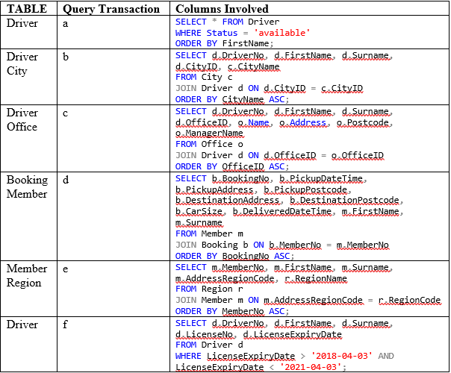
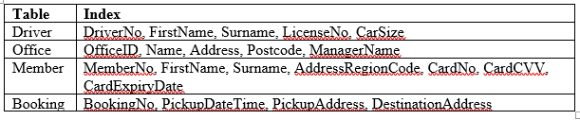
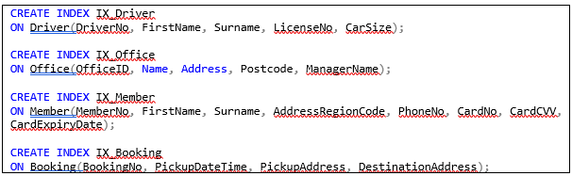
The purpose of indexing is to read through data quickly and efficiently, so indexing smaller tables in a database isn’t usually worth as they are small enough to read anyway, just providing an extra task for the database by indexing a table with a small amount of data. “Among all the techniques of improving the database performance, indexing and query optimization stand up as they provide visible results. On the other hand, abusing indexes and inappropriate indexes might harm the performance of the system.”[2]

Distributed Database

a. Fragmentation
Fragmentation is used to logically distribute the data over a network, relation may be divided into many sub-relations called fragments, which are then distributed. “Fragmentation is desirable for performance reasons: data can be stored at the location where it is most frequently used, so that most operations are purely local and network traffic is reduced.”[3]. Fragmentation “consists of dividing the database objects and/or entities into fragments, on the basis of common queries accesses, in order to distribute them over several distant sites.”[4].
There are 4 main schemas used when fragmenting a database.

i. Horizontal fragmentation
The first fragmentation is Horizontal, “horizontal partitioning consists in decomposing the whole warehouse schema into sub schemas, where each schema contains fragments of dimension and fact tables.”[5].
Office fragment O₁: ¥ OfficeID, Name, Address, CityID, Postcode, PhoneNo, ManagerName (Office)
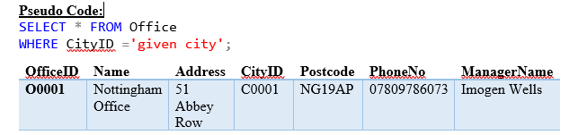In the example above, it just shows ‘C0001’, but a city might have multiple offices so a horizontal fragment would be suitable to divide and distinguish which offices are in which city by their CityID.
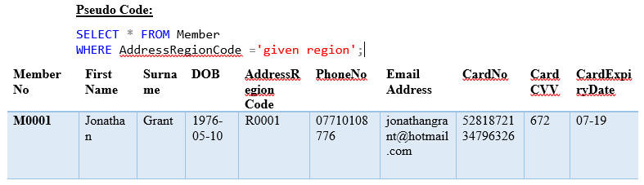
Member Region fragment M₁: ∞ MemberNo, FirstName, Surname, DOB, AddressRegionCode, PhoneNo, EmailAddress, CardNo, CardCVV, CardExpiryDate (Member)
The reasoning for horizontal fragmentation in the members table, is there could possibly be multiple members in a specific region so separating the members into a region category is more logical way of sorting members via their region code.

ii. Vertical fragmentation
“Vertical fragmentation consists of subdividing a relation into sub relations that are projections of the original relation according to a subset of attributes.”[6].
Payroll fragment D₁: ∑ DriverNo, AccountNo, AccountSortCode, NIN, DateRegistered, (Driver)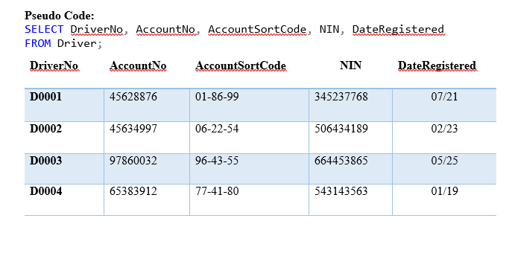Payroll fragment as each driver needs a salary and this fragment shows the information needed to do so.
Personnel fragment D₂: ∑ DriverNo, FirstName, Surname, DOB, Address, CityID, PostCode, PhoneNo, EmailAddress, (Driver)
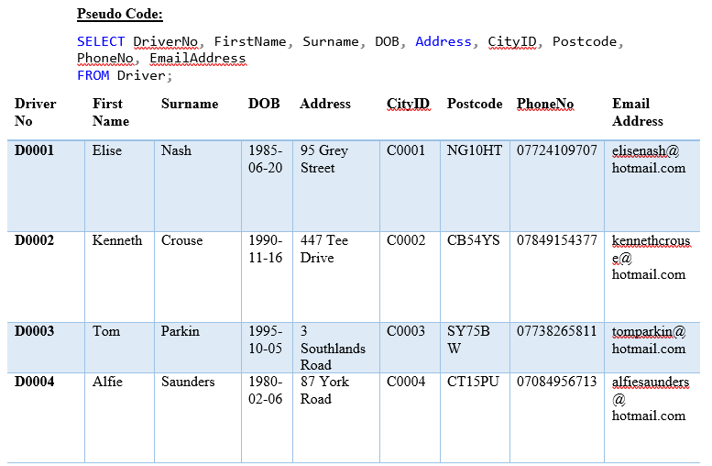
Personnel fragment as the company should be able to know who their employees are, in this case the drivers.
Drivers details fragment D₃: ∑ DriverNo, LicenseNo, LicenseExpiryDate, VehicleRegNo, CarSize, OfficeID, Status(Driver)
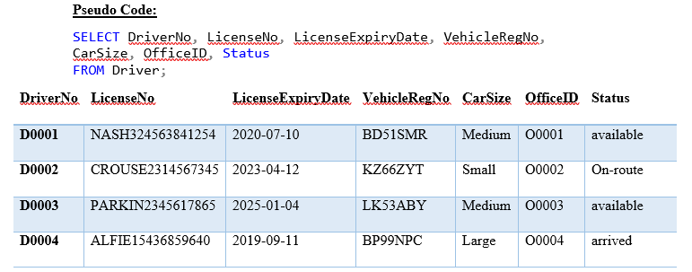
Before making bookings for the clients, the database needs to find a driver suitable for the job, so this fragment shows the drivers’ details, status and if they’re fit for a job.
Booking details fragment B₁: β BookingNo, BookingDateTime, PickupDateTime, PickupAddress, PickupCityID, PickupPostcode, DestinationAddress, DestinationCityID, DestinationPostcode, DeliveredDateTime (Booking)
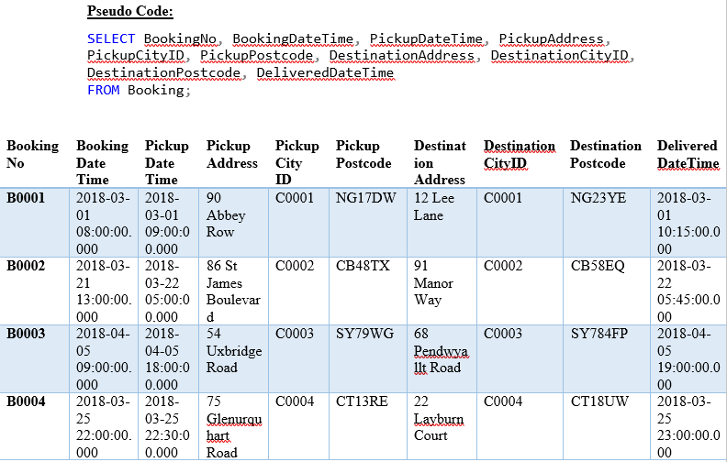
Booking details so they can be easily searched when making a booking or passing the information over to the driver.
Driver/member payment details fragment B₂: β BookingNo, MemberNo, JourneyMileage, CarSize, AssignedDriverNo, FareAmount, CancellationDateTime, CancellationCharge, PaymentDetails (Booking)
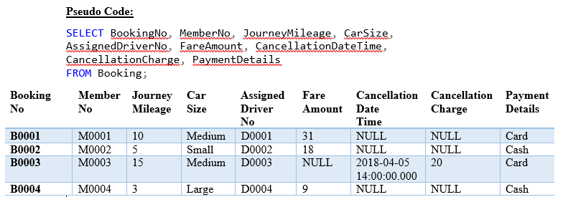
Sorting driver/member details into a fragment so when the assigned driver turns up for the job, they can know in advance the payment method also being able to update the driver if there was/is a cancellation and the fee amount.

iii. Mixed fragmentation
By using the vertical fragment D₂ personnel fragment.
- Personnel fragment D₂: ∑ DriverNo, FirstName, Surname, DOB, Address, CityID, PostCode, PhoneNo, EmailAddress, (Driver)
The fragmenting can be taken further, horizontally by CityID will give two fragments.
D₂₁: ∑ CityID=’C0001’
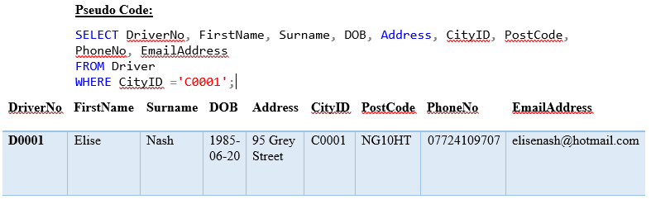

D₂₂: ∑ CityID=’C0002’
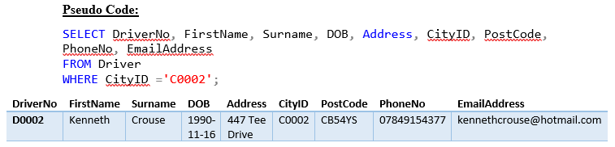
A city might have multiple drivers so by fragmenting the table further the sorting of drivers working in a specific city can be easily observed.
B₂₁: β MemberNo = ‘M0001’
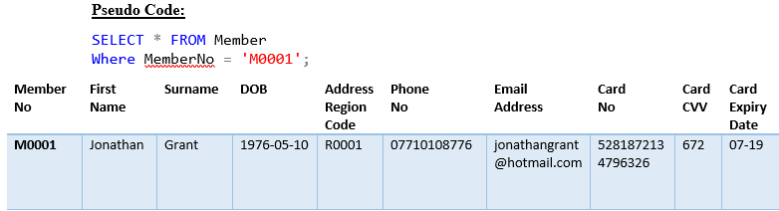
A member might have reoccurring bookings, as in going back and forth to school/work. Easier to manage and maintain a member who has consecutive bookings over a period.

iv. Derived fragmentation
“Derived fragmentation using fragmentation of an owner relation can indeed further reduce the total query costs and therefore should be employed when doing database distribution design.”[7].
Office is a parent relation to Driver, and office manages drivers within the database and it’d be useful to store driver data using similar fragmentation as the parent Office.
O₁ = O≠ CityID D₂₁ (D₂₁ is a mixed fragmentation =’C0001’)
O₂ = O≠ CityID D₂₂ (D₂₂ is a mixed fragmentation =’C0002’)

b. Reconstruction of fragments
The reconstruction of fragments within a distributed database design are different depending on which fragment strategy has been used. The following fragmentation are reconstructed by using the following operators:
- Horizontal fragmentation uses: Union
- Vertical fragmentation uses: Join into Natural Join
- Mixed fragmentation uses: Natural Join and Union
- Derived fragmentation uses: Union

Conclusion
To conclude, an overview has been provided to some of the possible solutions suggested for the case study of Book and ride company, there has been evidence of how to improve performance by suggesting possible secondary indexes in which can fasten and reliably access certain information that could prevent slower actions and give transparencies in the database that the user does not know about, there has also been evidence on how a distributed database design can be achieved and what tables are vital when fragmenting are vital to the database and for the company to run smoothly and efficiently.

References
[1] S. Agrawal, S. Chaudhuri, L. Kollar, A. Marathe, V. Narasayya, and M. Syamala, “Database tuning advisor for microsoft SQL server 2005,” Proc. 2005 ACM SIGMOD Int. Conf. Manag. data - SIGMOD ’05, p. 930, 2005.
[2] C. CIOLOCA and M. GEORGESCU, “Increasing Database Performance using Indexes,” Database Syst. J., vol. 2, no. 2, pp. 13–22, 2011.
[3] U. D. of C. Science, “Chapter 15. Distributed Database Systems,” Course Notes, pp. 1–18.
[4] F. Getahun, J. Tekli, S. Atnafu, and R. Chbeir, “Towards Efficient Horizontal Multimedia Database Fragmentation using Semantic-based Predicates Implication,” 2004.
[5] L. Bellatreche, K. Boukhalfa, P. Richard, and K. Y. Woameno, “Referential Horizontal Partitioning Selection Problem in Data Warehouses,” Int. J. Data Warehous. Min., vol. 5, no. 4, pp. 1–23, 2009.
[6] A. Runceanu, “Fragmentation in distributed databases,” Innov. Adv. Tech. Syst. Comput. Sci. Softw. Eng., pp. 57–62, 2008.
[7] H. Ma, “Distribution Design for Complex Value Databases,” 2007.

Bibliography
https://arxiv.org/ftp/arxiv/papers/1504/1504.02957.pdf
http://downloads.condusiv.com/pdf/The-Impact-Of-Disk-Fragmentation-On-Servers.pdf
http://www.dbjournal.ro/archive/16/16_4.pdf
https://sql-performance-explained.com/img/9783950307825_preview.pdf
https://www2.cs.duke.edu/courses/fall14/compsci316/lectures/08-sql.pdf
https://s3.amazonaws.com/academia.edu.documents/44219666/Developing_an_automatic_linguistic_trunc20160330-26390-qf4rxy.pdf?AWSAccessKeyId=AKIAIWOWYYGZ2Y53UL3A&Expires=1520457006&Signature=WswpfwEHw2Ca%2BekViS8Cg5u46YQ%3D&response-content-disposition=inline%3B%20filename%3DDeveloping_an_automatic_linguistic_trunc.pdf
http://www.qbic.almaden.ibm.com/cs/projects/iis/hdb/Publications/papers/vldb92.pdf
https://pdfs.semanticscholar.org/d894/496d6094df7e8b2ea178c56cf01acf5113a9.pdf

marking criteria and Student FEEDBACK

This section details the assessment criteria. The extent to which these are demonstrated by you determines your mark. The marks available for each criterion are shown. Lecturers will use the space provided to comment on the achievement of the task(s), including those areas in which you have performed well and areas that would benefit from development/improvement.

Common Assessment Criteria Applied (Assignment 1) | Marks available | Marks  awarded
1. Research-informed Literature
Extent of research and/or own reading, selection of credible sources, application of appropriate referencing conventions.
Good selection of reference sources has been provided, but application of material could be better. (Grade mark: 70.00%) | 5 | 3.5
2. Knowledge and Understanding of Subject
Extent of knowledge and understanding of concepts and underlying principles associated with the discipline.
Generally, demonstrates a very good understanding of the SQL Data Definition Language for creating tables, but your understanding of indexes needs to be improved. There is room for improvement in the choice of data types for some columns. For example, some date columns (e.g. DateRegistered) have used a CHAR type (07/21). It is better to use an appropriate Date type for columns containing dates to easily support date functions without having to convert the data first, as well as readily provide date and/or time validation. Unfortunately, your implementation of indexes is quite poor. Please see comments below. (Grade mark: 60.00%) | 20 | 12
3. Analysis
Analysis, evaluation and synthesis; logic, argument and judgement; analytical reflection; organisation of ideas and evidence
Although your identification of what data queries would be important and common is good, it appears you have misunderstood how to select what columns to index from your analysis of these queries. It is not the queries SELECTED as part of the query results, it is the columns involved in the WHERE, JOIN, ORDER BY, etc. clauses that are good candidates for secondary indexes. You have also misunderstood the concept of multi-column indexes - see your report.  Your analysis and solution of the case study scenario for a distributed database design is fair. Generally, your presentation of the distributed database design solution could be improved. It would have been better to provide the discussion on a table-by-table basis - the current format is somewhat difficult to follow. Your discussion also just provides a general discussion of how different types of fragments are reconstructed. You have also not identified what tables need to be replicated. (Grade mark: 55.00%) | 30 | 16.5
4. Practical Application and Deployment
Deployment of methods, materials, tools and techniques; application of concepts; formulation of innovative and creative solutions to solve problems.
Overall, a very good implementation but you have not implemented the required transaction. Some other things to note: for the car size range consider using a check constraint to restrict allowed values to the specified range. Although good use of check constraint to ensure DOB is before today, consider extending this to ensure driver is of a legal age to drive as currently someone who is a day old could register. CardCVV - note that some cards use 4 numbers. Specify your decimal sizes to improve efficiency. (Grade mark: 65.00%) | 40 | 26
5. Skills for Professional Practice
Attributes in professional practice: individual and collaborative working; deployment of appropriate media; presentation and organisation.
The report is of a good standard. (Grade mark: 60.00%) | 5 | 3

Assignment Mark (Assessment marks are subject to ratification at the Exam Board. These comments and marks are to give feedback on module work and are for guidance only until they are confirmed. ) | Late Submission Penalties (tick if appropriate) |  | 61%
 | Up to one week late |  | 61%
 | 1st/2nd/3rd attempt? |  | 61%

