
Strategic Management (LCMB7003)
Strategic Analysis of Apple INC


Student name: Shabaaz Ali Syed
Student Number: 2128679
Lecturer: Amare Desta
Word count:6000
Submission Date: 03/05/2023

Executive Summary
is a widely reputed company known for its innovative technological products. The report Apple has aimed in discussing the current business model of the company. However, in the future, the company has aimed to adopt a subscriptive business model. This will provide users to subscribe to their manufactured products. The maturity of the iPhone has been a promising product for Apple in generating a large revenue stream in the coming years. Furthermore, it has been planning on generating more models which will generate more income. The products developed by Apple have established dominance in the technological industry. The innovation of Apple is consecutively accumulated through technological advancement that not only helped the company in reaching a different height but also immaculate with heavy profitability. Porter’s generic strategies and Ansoff matrix emulsified the fact that Apple has greater inhibition of enthralling the experience of the customers through their high product differentiation. However, the cost leadership of the company is limited. Additionally, the company have effectively utilised sustainability or green strategy and embedded them in its corporate social responsibility for greater market positioning and achieving carbon neutrality.

Table of Contents
1. Introduction 5
2. Background information of Apple Inc. 5
2.1 Mission and Objectives 5
3. Macro-Environment Analysis 7
3.1 PESTEL Analysis 7
4. Micro-Environment Analysis 8
4.1 Industry Life Cycle 8
4.2 Porter’s Industry Five Forces Analysis 10
5. Internal Analysis 12
5.1 Strategic Resources and Capabilities 12
5.2 Value Chain Analysis 14
5.2.1 Primary Activities 14
5.2.2 Secondary Activities 16
5.3 VRIO Analysis of Distinctive Resources and Capabilities 16
5.4 SWOT Analysis 17
6. Strategies to Sustain Competitive Advantage 18
7. Growth Strategies 23
7.1 Ansoff Matrix 23
7.2 International Strategies 26
7.3 Entry Mode Strategies 27
8. Green Strategy and CSR (Corporate Social Responsibility) 27
9. Conclusion 28
10. Recommendation 29
11. Reference list 30
12. Appendices 36
Appendix 1: PESTEL Analysis 36
Appendix 2: Porter’s Five Forces Analysis 37

1. Introduction
Strategic Management is the procedure of setting various organisational goals and objectives required for the organisation to easily sustain the competitive business domain. Strategic Management is generally implemented within the companies by effectively employing more staff and other resources to achieve the organisational objectives. It involves the process of “strategic evaluation”, “internal organisational analysis” and implementation of “strategic execution” within the company. For instance, if a large organisation wants to develop an improved sales rate, it will create a strategized set of goals to achieve the plan. The following stage will involve the evaluation of strategies, effective analysis of the internal organisational culture and ensuring effective execution of the strategies, covering all the business aspects of the organisation (Abdul Halim, 2022, p. 24).
Successful and effective strategic management policies help the organisation in implementing a competitive environment within the organisation. The report aims in covering the business strategic analysis adopted by Apple in facing the change of dynamics within the business environment. Furthermore, it also discusses the strategies followed by the company to deal with the central issues. It has been discussed following the various models covered in the module. Furthermore, it also provides a detailed demonstration regarding the ways by which the company gains a competitive advantage through their effective implementation of strategic management.

2. Background information of Apple Inc.

2.1 Mission and Objectives
Apple Inc is an American-based multinational company based in the technological sector. The headquarters of the company are located in California. The total revenue of the company earned in the year 2022 was nearly 390 billion dollars. During the first quarter of 2023, it has been claimed as the world’s largest technological organisation with respect to market capitalisation. Furthermore, the company is also among the fourth-largest company dealing with the sales of personal computers and the second-largest manufacturer of cellular phones. It is categorised under the “Big Five American Multinational Corporations” under the technological domain along with “Alphabet Inc”, “Meta Platforms”, “Amazon” and “Microsoft”. Apple belongs to the industrial domain of “Consumer electronics”, “Software Services” and “Online Services”. Presently, the organisation has nearly 500 retail stores on a global scale, with over 160,000 employed people. Some of the most interesting facts about the company include the creation of over 2 million jobs in the United States. The total revenue earned by the organisation is worth more than the economy of some countries. It was the first multinational corporation which was publicly traded to cover the $3 trillion milestone (Amit and Zott, 2020, p. 20).
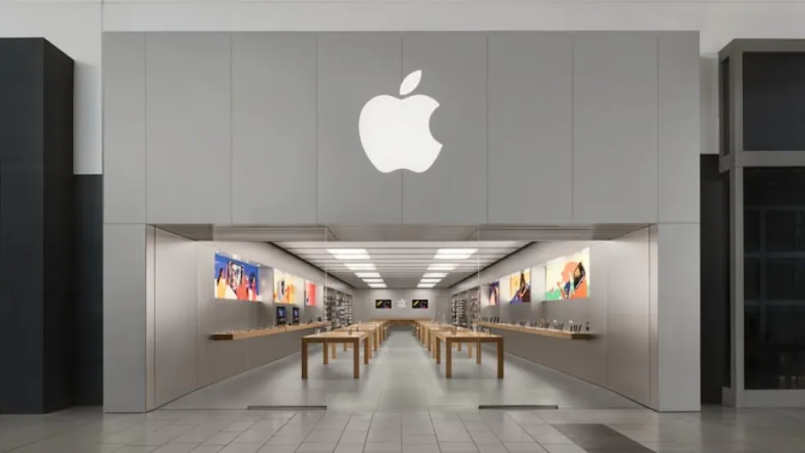
Figure 1: Apple Inc.
(Source: Bereznoy, 2019, p. 29)
The mission statement of the organisation is to provide the best experience to the customers of the company through the effective implementation of innovative software and hardware services. The vision statement of the organisation is to focus on creating a better planet by implementing sustainable business policies and manufacturing operations. The technological corporation has focused on implementing “innovation”, “elegance” and “design” since its foundation in the year 1976. The mission and vision of the company have successfully defined the strategies. These strategies are the key factors for the company in achieving organisational success. Furthermore, it has also enabled the company to expand its business over several countries, thereby becoming famous within the global technological domain (Bereznoy, 2019, p. 29). The leaders of the company motivate the workforce to perform their best to support the organisational objectives, thereby contributing to the competitive advantage of the business.

3. Macro-Environment Analysis

3.1 PESTEL Analysis
Factors | Discussion
Political | - The scope of the business is mainly aligned with the political rules and regulations.  - The business of the company has a huge amount of publicized cash which has led to questioning the legislation tax rules.  - The manufacturing of the company is generally outsourced to China. The rise in tensions in the political relationship between the United States and China has imposed restrictions on import and export policies [Refer to Appendix 1].
Environmental | - In recent days, there has been a greater demand for increased wages among the Chinese workforce, thereby affecting the company’s production costs. This in turn negatively impacts the cost advantage of the organisation.
Social | - The products manufactured by Apple have attracted a large consumer base for the company. The implementation of new and unique features has led more consumers in using smartphones.  - The company should invest in manufacturing new products, other than smartphones (Bohnsack, Kurtz and Hanelt, 2021, p. 40).  - Consumers are expecting products within affordable ranges which have advanced features. It is high time for the company to bring diversity to their manufactured products.
Technological | - The signature products manufactured by Apple are threatened by a wide range of products manufactured by Samsung.  - The price range of the products manufactured by Apple is extremely high compared to its implemented features. The company should invest in innovation (Bohnsack, Kurtz and Hanelt, 2021, p. 56).
Legal | - The company has planned on entering the financial markets which is a lucrative choice. Furthermore, the company has also planned in investing for manufacturing automobile accessories production.  - Insurance and compliance costs are ensured by the business domain. Furthermore, the company has to bear the litigation costs owing to safeguard the manufacturing operations.
Economic | - The company has resulted in stabilising the economy of various developed countries.  - The company has been the cause of rapid growth in developing countries (Cullen and De Angelis, 2020).
Table 1: PESTEL analysis
(Source: Self-Developed)

4. Micro-Environment Analysis

4.1 Industry Life Cycle
The concept of the “Industry life cycle” can be described as the duration of the lifecycle of the company’s business. It provides a detailed analysis of the business growth which helps in providing a detailed overview of the business. Certain organisational businesses have longer life cycles which show that business growth is a time-consuming process. However, a short life cycle depicts the immediate growth of the business of the company. The industrial life cycle consists of the following five stages which include the “Introduction Stage”, “Growth Stage”, “Shakeout Stage”, “Maturity Stage” and “Decline Stage”. The "Introduction Phase" is the period where new markets and businesses emerge. Consumers are unaware of its existence since it is entirely new (Cullen and De Angelis, 2020). The second phase involves the business growth of the company, which includes the growth in sales, thereby enhancing the business revenue. This benefits the companies to invest more in manufacturing customer-appealing goods. The third stage involves providing a competitive advantage to the company (Hague, 2019, p. 78). The company gains enough resources and its strong business policies help the company in sustaining the competitive environment. Once the company has gained popularity and goodwill among the customers by establishing the brand, it reaches the maturity phase. When the competition becomes immensely high, it leads to changes within the business domain. Larger companies tend to take over smaller businesses, thereby allowing them a steady income (Cullen and De Angelis, 2020, p. 50).
Apple Inc has already reached the mature phase in its business lifecycle. Reaching this phase means the company has to face a slowdown in its business revenue. Hence the company should invest in its innovation. However, the company has invested a lot in the development of unique products with newly added features which have resulted in the creation of a brand name. This has resulted in earning goodwill and a brand reputation for the company. Apple has established a large-scale business. Hence the pandemic was not able to negatively impact the revenue of the company. The management of the company ensures that the manufactured products maintain their quality (Hazlett, 2023, p. 34). Presently, the company has issued four important marketing strategies which include that the company focuses on the aspect of implementing unique designs for its products. This enables the company to gain a competitive advantage over similar companies. Secondly, the management of the company focuses on enhancing the customer experience by implementing a user-friendly interface. This enables the customers to have a smooth experience with the manufactured products (Liao and Yang, 2020, p. 65).
A beginner customer has a smooth experience while dealing with the user interface of the manufactured product. Thirdly, the company has been focusing on strengthening its business ecosystem by effectively leveraging strong bonds with the existing customer base of the company. Lastly, Apple Inc. has recently focused on providing excellent services to its customer base, thereby reducing its dependency on the development of iPhones. During the pandemic, the company adopted special strategies and effective implementation of social media platforms for its promotional purposes (Liao and Yang, 2020, p. 56). This has helped the company to target key business markets in countries like “Brazil”, “China”, “Thailand”, “Turkey” and “India”. The management of the company has emphasised more market penetration to enhance the company's products. This will help in providing strength to sustain the massive dynamics and competition within the technological business domain. The recent decades have witnessed more dependency on the company’s sales and the creation of different growth channels. Furthermore, the company has deployed software updates which are highly critical in securing the integrity of Apple’s platforms (Lu et al., 2022, p. 45). Furthermore, it also enables users to experience the benefits of implementing the latest features. The manufactured products undergo upgradation regularly and are updated by including the latest features. The clients of the organisation who has implemented its manufactured products benefit from the latest and more advanced security features. The platforms are ensured that they are free from any kind of security vulnerabilities. Apple implements a year-long approach to testing its software, thereby ensuring that it has been regularly upgraded (Mao et al., 2020, p. 24).

4.2 Porter’s Industry Five Forces Analysis
Factors | Discussion | Degree of Threat
Industrial Competition | - The company has direct competitors like Google, Meta, HP and many more.  - The level of competition within the technological domain is extremely high.  - The customers easily switch to alternatives. The company is advised to adopt strategies for manufacturing the latest featured devices at affordable prices [Refer to Appendix 2]. | High
The bargaining power of the consumers | - The customers have the opportunity to shift to buying products from rival companies.  - Nowadays, the consumer prefers cost-effective devices, implemented with new technical features.  - Hence, the bargaining power of the consumer base of the company is immensely high (Mao et al., 2020, p. 24). | High
The bargaining power of the suppliers | - Apple has a large number of suppliers providing raw materials for the company which reduces the impact of bargaining.  - The industries belonging to the component suppliers of Apple have a highly competitive domain, which also reduces their power. | Low
The threat imposed by new entries | - The entries of new startup companies do not impose much threat to the business of the company.  - In order to establish its business, a newly joined startup must consider two major factors which include, “high expenses which are required for the establishment of the startup” and “expenses required for the creation of the brand name” (Mao et al., 2020, p. 24).  - Newly emerging firms can't provide tough competition with the R&D aspects of the Big Five Technological corporations. | Low
The threat imposed by the substitutes | - The threat imposed by Apple’s substitutes is relatively low as the company has managed to implement the best, new and innovative features within their manufactured products.  - The substitute products have limited features as compared to Apple’s manufactured products. | Low
Table 2: Porter’s Five Forces Analysis
(Source: Self-Developed)

5. Internal Analysis

5.1 Strategic Resources and Capabilities
Apple is well-known for its unmatchable technological products such as Mac and iPhone. However, the marketing strategies adopted by the company are its main attraction. It has brought several products which have led the technological domain for a long period of time. Furthermore, it has also introduced many variations of the products. It has already successfully established a good reputation and brand name within the global market, thereby enhancing brand equity. It has been dominating the technological sector for quite some time. iPhone has been one of the revolutionary products manufactured by the company, equipped with smart technological features. This has been one of the largest revenue generators for the company. There are various resources which have helped the company to gain an added advantage over other companies (Shastitko, Pavlova and Kashchenko, 2020, p. 45):
Developing strong brand equity
The development of strong brand equity is highly essential for the company to sustain its leadership position within a highly competitive technical domain. It is a result of building strong relationships and developing a sense of trust among the customers. Maintaining mutual trust with its customer base had helped the company to maintain a high-profit margin. The company has maintained a high customer engagement which has helped in building a good image for the company.
Regular enhancement of the product quality
Apple has always prioritised innovation. The products manufactured by the company have always remained unchallenged owing to the regular upgradation within its implemented features. The mind-blowing manufactured products of the company range from “Mac PCs” to various other services. The company has always challenged the status quo by bringing technologically advanced products to the market.
Innovation procedures implemented within the company
Since the beginning of its establishment, the company has been focusing largely on innovation and research. The rivals of the company have also invested largely in innovation. However, the brand name of Apple has largely been built on innovation. In the year 2018, the company invested nearly 15 billion dollars in research purposes. In the year 2019, it invested 4 billion Dollars (Shastitko, Pavlova and Kashchenko, 2020, p. 56).
Global Presence
Apple has been successful in its internationalisation strategies. This has been a competitive advantage for the company. The business operations of the company are carried out on a global basis. The company possesses online channels. Furthermore, the products are sold through authorised resellers across the globe.

5.2 Value Chain Analysis
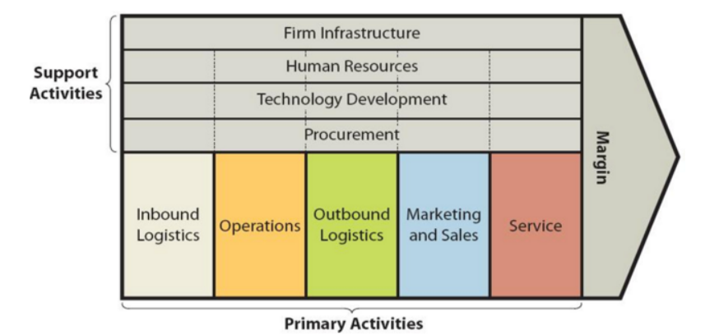
Figure2: Value Chain Analysis
(Source: Shastitko, Pavlova and Kashchenko, 2020, p. 45)

5.2.1 Primary Activities
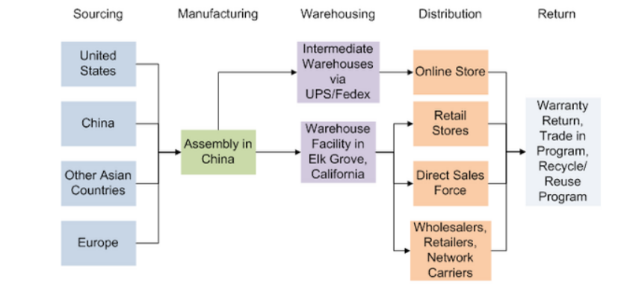
Figure 3: Supply Chain
(Source: Shastitko, Pavlova and Kashchenko, 2020, p. 45)
Inbound Logistics
Apple Inc. has a large number of potential suppliers for generating a smooth supply of electrical components required for the manufacturing of the products. Furthermore, the company also maintains a sophisticated supply chain network spread across the globe. The company exercises its power of bargaining over the suppliers thereby effectively managing to reduce the cost of buying products.
Operations
The company does not possess its manufacturing facilities, thereby outsourcing the manufacturing operations to other companies in various developing countries. It has its fair share of advantages and disadvantages. The main advantage of adopting this strategy helps the company to focus on core issues such as the implementation of new and unique designs for the products and innovation. However, the brand reputation is hampered owing to the labour issues while outsourcing (Szopinski et al., 2019, p. 24).
Outbound Logistics
Outbound logistics involves warehousing, storing and delivering manufactured items. The manufactured products have short life cycles which have resulted in depreciation rates of the inventory. The organisation continuously tries to reduce inventory within their warehouses.
Marketing and Sales
The company has adopted an efficient sales strategy. Furthermore, the company has unplanned on increasing the number of direct sales channels. It has been focussing on increasing the number of enterprise sales in recent decades.
Services
The management of the company always focuses on enhancing the levels of customer satisfaction. The innovative features implemented within the products have given a smooth and easier experience to the customers of the company.

5.2.2 Secondary Activities
Firm Infrastructure
From the beginning phase of its business, the company has been largely investing in building its infrastructure. This has acted as a driving force in contributing to the success of the business.
Human Resources
The employees working within the organisation have a large pay scale. They are immensely talented and skilled. Furthermore, the employees of the organisation belong to diverse backgrounds.
Technological Development
The innovative designs and features of Apple products are a constant source of attraction. Every new launch brings a new set of innovative features. Furthermore, it constantly invests money in its innovation procedures (Szopinski et al., 2019, p. 24).
Procurement
Apple maintains a healthy and cordial relationship with the suppliers of the company. Whenever the product is ready to launch, the vendors play an important role in the effective shipping process. Apple has a large number of vendors which ensures the smooth shipping of finished goods.

5.3 VRIO Analysis of Distinctive Resources and Capabilities
Capability | Valuable | Rare | Imitable | Organised | Result
Developing strong brand equity | Yes | Yes | Yes | Yes | Competitive Advantage
Maintaining a global presence | Yes | No | No | Yes | Temporary Advantage
The loyalty of the customers | Yes | Yes | No | Yes | Temporary Advantage
Supply Chain Network | Yes | Yes | No | Yes | Temporary Advantage
Marketing strategies | Yes | Yes | Yes | Yes | Competitive Advantage
Research and innovation strategies | Yes | Yes | No | Yes | Temporary Advantage
Table 3: VRIO Analysis
(Source: Self-Developed)

5.4 SWOT Analysis
Strengths  - It has a high brand name and reputation.  - It is globally famous.  - It has a large infrastructure.  - It has highly advanced technology. | Weaknesses  - The products are highly expensive.  - Limited promotional sources.  - The manufactured products are incompatible with other software.
Opportunities  - There has been consistent growth in the consumer base of the company.  - The engineers involved in manufacturing operations are immensely qualified. | Threats  - The company has not effectively implemented a sustainable business model.  - It has failed to implement the application of AI.
Table 4: SWOT Analysis
(Source: Self-Developed)

6. Strategies to Sustain Competitive Advantage
Following the accumulation of the case study regarding Apple Inc. it is observed that in the year 2020, the company reached $2 trillion with a strong market positioning. The main attribution of the company is implicated through creativity and innovation which have described its business model to be engulfed with luxury technology. This business model has helped the company in developing ground-breaking products like iPad and iPhone which are known as premium devices (Researchandmarkets.com, 2020). The technological performance of the products has the capability of increasing the experience of the customers and is renowned as exclusive premium products. However, the case study has also displayed the fact that the prowess of technology in the development of the products is becoming less important because its competitors are offering the same technological infrastructure in their products but in cost-effective attributions which brought uncertainty to the future of the company (Researchandmarkets.com, 2020). Apart from all this, Apple Inc. is very confident about its servicing infrastructure and the ecosystem it presents for the development of the marketing strategy representing future profitability. Personal devices have become the successive factor behind the immense profitability of Apple Inc.
The luxury technology of the business model of Apple Inc. is very customer-centric, the company have been successful in meeting the preferences and needs of the customers which has made it extremely difficult for its competitors to present their products with the same products in terms of desirability (Researchandmarkets.com, 2020). Islami, Mustafa and Latkovikj (2020) noted that Porter’s generic strategies are a composition of four divisions that highly defines the competitive strategy: cost leadership, differentiation, cost focus and differentiation focus. This strategic tool is handy in assisting management, profitability and growth. Additionally, the tool is also useful in the creation of sustainable competitive advantage creating a strong market positioning for different organisations. The above-mentioned elements of Porter’s generic strategies are inhibited for the organisation Apple Inc.:
Cost leadership
Kharub, Mor and Sharma (2019) pointed out that cost leadership is known as the projection of low pricing inhibitions for increasing profitability along with market share. Cost leadership lets the companies represent themselves as the cheapest manufacturers of products and services with the commodity of increasing the competitive advantage along with the retention of the customers and gaining new customers as well. From the statement of Nielson (2017), the pricing strategy of Apple Inc. is far from inhibiting cost-effectiveness, the main objective of the business model is to sell a premium infrastructure mobile device that procures great experience to the consumers. However, still, the company have been planning to implicate cost leadership for increasing product differentiation though in a different manner. The strategic pillar of the company mainly indicates the offering of a small number of products by focusing on the high-end results and giving importance to the profits of the market share with the creation of the halo effects making the customers starve the products of the company. Apple.com (2022a), Apple has encompassed flexibility in the pricing of the Apple application stores through the addition of 700 new price points. The price points have different categorisations according to the different countries with the management of the foreign exchange along with changes in the rates. The changes in the pricing inhibitions are going to provide the developers with expanding capabilities with transparent invoicing adding to the robustness of the marketing tools which is going to increase the growth of the business effectively.
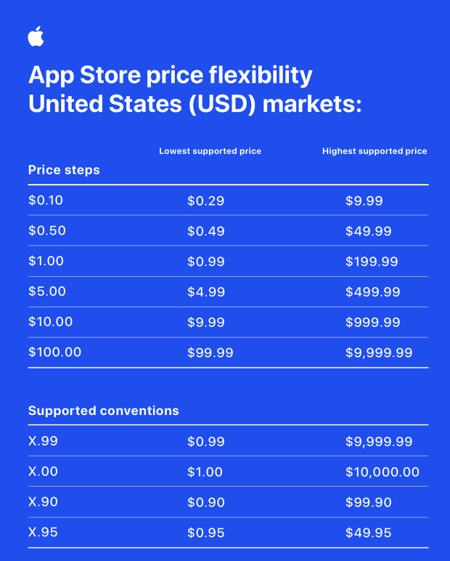
Table 5: Pricing inhibitions according to different regions for Apple Inc.
(Source: Apple.com, 2022a)
Differentiation
Apple.com (2020), Apple Inc. has brought innovation and creativity that led to the inhibition of creativity and innovation which is the outcome of product differentiation. The company have introduced Safari which is the fastest desktop browser that is engulfed with faster performance with the protection of privacy. iOS 14 the company have helped navigate the applications effectively with the arrangement of the messages. From the statement of Cantisano (2022), Apple has dominated the market in the United States and claimed a market share of 51%. The company also accumulated strong and affordable options through the development of the iPhone SE which has the capability of adopting new demographics. However, despite the development of the products by keeping the preferences of the customers intact, Leswing (2023) stated that the overall sales of the company have declined by 5% since the year 2019 and the rise of the pandemic. With the expectation of the services of growth, the company have witnessed a decline in the sales of the iPhone by 5.5%. Supply chain disruption was also witnessed that slowed down the supply of the iPhone 14 and Max indicating fewer cell phones to sell to the customers affecting their differentiation.
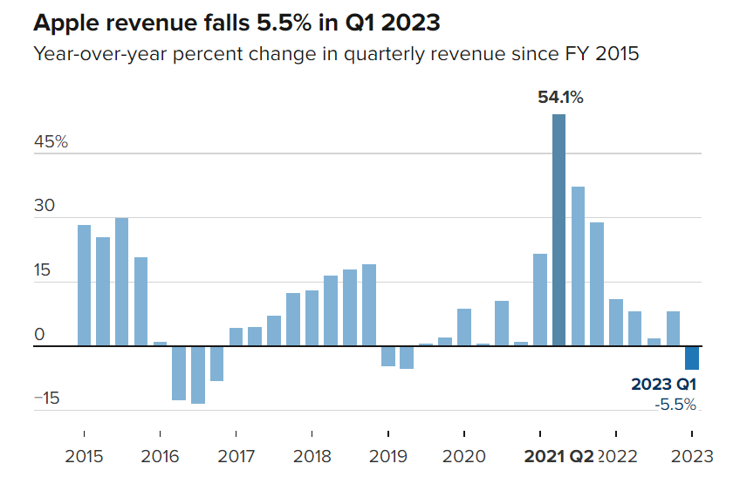
Figure 4: Fall in the revenue of Apple Inc.
(Source: Leswing, 2023)
Cost focus
Islami, Mustafa and Latkovikj (2020) stated that the cost-focus strategy is comprised of an attempt of attracting customers through the inhibitions of the price through the products and services for serving the segmented customers. The sales of Apple iPhone 14 have been slowly touching the plateau after which the company have shifted its cist focus to increasing its servicing inhibitions. It is in the frontier for the growth of revenue through the presentation of ongoing subscriptions. The servicing of Apple has generated a revenue of $10.9 billion. The demographical features of the iPhones along with the presentation of the smart and wearable accessories have increased the revenue of the company by $7.3 billion. Similarly, the products like iPad and Mac have generated profitability of $14.1 billion (Gartenberg, 2019). The highest profile entry of the company is Apple Music which has a total of 56 million subscribers beside the Apple application store that have decreased the purchase rate of the applications for bringing flexibility in the business along with an increase in the number of customers.
Differentiation focus
In the context of the differentiation focus, it is observed that Apple has introduced a spectrum of products that have not only garnered the attention of the customers due to the involvement of creativity and innovation along with the integration of technological advancement. The objective of the company was to enthral the experience of the customers with their products, the concentration towards the correct application of cost-effectiveness was limited but the differentiation of the products was maximum. For instance, Clover (2019) stated that the subscription to Apple News+ is $9.99 per month which is considered to be of premium categorisation with no customisation options in the context of arranging the recommendation options. While on the other hand, the digitalisation focus is helpful for the consumers to scroll through the different elements of the magazine with easy zooming options. Thus, all such factors outlined the fact that Apple has always and still now concentrates on increasing the validation and reliability of the products for gaining a better marketing position along with the retention of customers. To prove this point, Gonsalves (2022) stated that Apple has brought significant improvement in the cameras and other features in iPhones during the time of the high inflation rate in the US. the company have integrated a dynamic island where the consumers could be able to use the Apple applications along to tracking down other tasks. This was the most creative aspect of the iPhone along with the enhancement of low-light photography and extraordinary zooming capabilities. Hence all such factors elucidate identified the fact that Apple has a differentiation focus on bringing improvement in their servicing options with fewer inhibitions in changing the pricing strategies.

7. Growth Strategies

7.1 Ansoff Matrix
Dawes (2018) stated that an Ansoff matrix is a bi-directional framework that helps in the management of the teams for the construction of the strategies for the evaluation of growth. It involves the engagement of the stakeholders for the illustration of different growth strategies. The importance of this tool lies in the identification of opportunities for the generation of revenue in the context of developing new services and products. The matrix also indulges the activities of the organisation that helped it in tapping into new market inhibitions in the foreign country. The elements of the Ansoff matrix are inhibited for evaluating the business model of Apple in the followings:
Market penetration
Market penetration involves organisations selling their products in the existing market where it has been incepted. The existing product of Apple Inc that has garnered enough attention in the United States is iPhone and MacBook. In the year 2022, the company, Apple made a profit of over $258 million surpassing the profitable aspects of Amazon and Microsoft. The launch of the iPhone 14 and the new MacBook is the ultimate reason for the rise of the revenue and profitability of the company by 64.9% compared to that the year 2021. It is by far the most innovative and technological advancement company. Only the parent company of Google called Alphabet have been able to come close to $76 billion in terms of profitability (Timesnownews.com, 2023).
‘d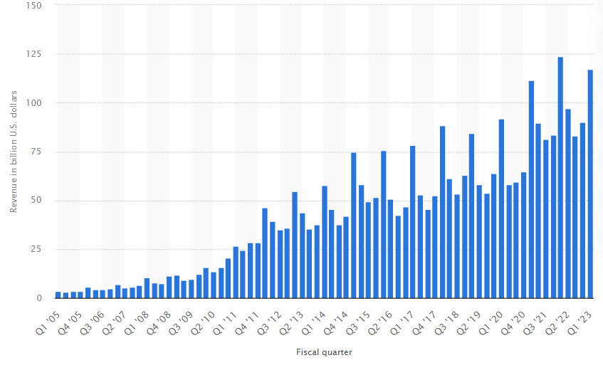
Figure 5: Revenue of Apple
(Source: Laricchia, 2023)
In the context of the consumer electronics market, Apple has active research and development department which has inhibited the ground-breaking phenomenon in the development of the iPhone and MacBook because of this the company has generated a revenue of 117.15 billion U.S., dollars (Laricchia, 2023). Apple.com (2021), in the markets of the United States, the company Apple is fulfilling its commitment to resting 20,000 additional jobs within the next five years. The commitment to $430 billion US investments also led to the opportunity of working with more than 8900 suppliers for the introduction of 5G inclusive of silicon engineering. In the year 2017, the company launched $5 billion as the fund for advanced manufacturing which led to the incorporation of laser technology, and the utilisation of materials that are implicated with sustainable development with cutting-edge fields for constructing the infrastructure of 5G. It has led to breakthrough innovation in the development of products and services in the United States. Hence the market penetration of Apple with existing products in the existing market of the United States is proactive and profitable simultaneously.
Product development
It mainly involves development of the new products in the existing market encapsulating the development of the products. Apple has concentrated both on the development of the products along with the amelioration of the services at the same time. In the year 2021, the servicing of the company has helped in the delivery of innovative applications besides the iPhone and MacBook (Apple.com, 2022c). The company have come up with powerful content which has harnessed the ability to improve the lives of the people. There was the introduction of Apple Fitness+ and Apple News+ with Apple Music that brought new releases just a click away for consumers with easy accessibility. The products of the company have unlocked the power of communication, connection along with collaboration by changing the lives of the consumers through digitalisation in the US.
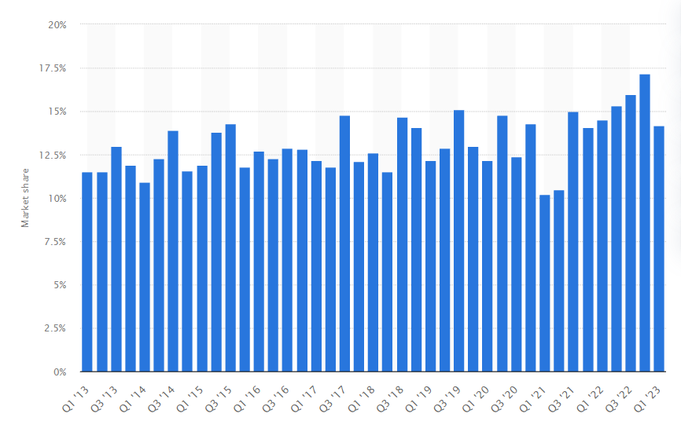
Figure 6: Share of the Apple PC shipment
(Source: Alsop, 2023)
Despite having strong technological advancement, the company, Apple have shipped over 13% of PC (personal computers) in different units of the United States (Alsop, 2023). Economictimes.indiatimes.com (2023), Apple has also planned the launch of a new MacBook in 2023 which is going to be manifested with silicon engineering for the alleviation of the brilliant performance with strong upgradation in the process of designing. Therefore, the product development of Apple in the existing market is inhibited with strong improvements.
Market development
Tendulkar (2023), Apple has generated 50% of its revenue in different countries like France, India and the UK through the distribution of the iPhone, iPad and MacBooks. The market share of the company has been hit by $3 trillion in the countries like Brazil, Australia, Canada and Italy. The price of Apple in the stock market increased by 300% in the past five years. The author, Tendulkar (2023) has also stated that Apple is the largest company with a market capitalisation of $2.6 trillion as the valuation and the effective GDP growth were record-breaking in France, the UK, India, South Korea and other countries. The company have garnered so much profitability due to the introduction of new products called wearable smart gadgets that brought a new dimension for it in different countries apart from the US.
Diversification
Apple.com (2022b), product differentiation and diversification are the main forte of the company, Apple and it has penetrated different foreign markets through its innovative and new products. The company have introduced self-service repair in eight countries in Europe. It is presented with repair manuals along with genuine tools and parts. There is the presence of 200 individual parts, it provides an opportunity for the customers to understand the complex inhibitions of repairing electronic devices. There is the presence of tools, parts and manuals in the Apple store helps the customers in understanding the method of repairing their devices easily. Apple.com (2023), Apple has also introduced iPhone 14 and iPhone 14 Plus which have offered longer battery life with innovative safety capabilities and crash detection in different countries. The product has gained immense popularity with ground-breaking safety capabilities and bionic chips. Ahaskar and Das (2023), the company has witnessed double-digit growth of iPhones during the time of the festive season in India. The company have witnessed a 42% increase in its market share which has increased its revenue tremendously.

7.2 International Strategies
The international strategy that Apple has considered is known as exporting. Wang and Ma (2018) stated that the transformation of the products from one country to another with the determination of the pricing strategies. Cnbctv18.com (2023), Apple has made history exporting smartphones for $1 billion in a single month in India. This exporting facilitation has boosted the government of the country India in alleviating the campaign called “Make in India”. The company have been exporting and producing multiple models of iPhone from 12 to 14+ by collaborating with three contract manufacturers called Wistron, Pegatron and Foxconn Hon Hai. Rathee (2023) noted that the exporting of the Apple iPhone model from India has surged by $5 billion depicting the 4 times normal profit inhibitions. The company have revamped its local production inhibitions by adding the country India to the list as the manufacturing hub.

7.3 Entry Mode Strategies
The entry mode that Apple has considered are franchising and joint venturing. Sharma (2023), in the recent context, the Chinese suppliers have gained clear approval from the Indian Government through the recapitulation of joint venturing with Apple. The company have submitted 17 suppliers list to the Indian authorities. iPhone and AirPods are the assemblers compelled from the companies of China called Sunny Optical Technology Group Co. which have gained approval that boosted the production of the products in India. As a part of joint venturing, Andriotis (2022) stated that Apple has partnered with Goldman Sachs Group Inc. in the US which has reshaped the financial institutions. The partnership has revamped the direction of consumer banking with the providence of affiliative services offering “buy now and pay later” options. The banking company with the inhibition of Apple is going to help the consumers in depositing the account balance through the digital wallets.

8. Green Strategy and CSR (Corporate Social Responsibility)
Investor.apple.com (2022) discussed that the corporate social responsibility of Apple has been embedded with accountable and transparent governance that fosters principles actions with the inhibition of efficacious decision-making that appropriately monitors the performance and compliance of the business. The company, Apple have empowered its workplace through the use of accessible technology that is engulfed with opportunistic and equity inhibitions through the creation of a diverse and inclusive work environment with respect to human rights. Another inhibition of corporate social responsibility of Apple is its inhibition of reaching carbon neutrality by the year 2030. The company have also introduced recycling innovations and green chemistry in the development of the products.
Apple.com (2019), Apple has announced its commitment to utilising 100% clean energy for gaining carbon neutrality by the year 2030. The company have solely concentrated on incorporating a green strategy in supply chain management. The company is slowly transitioning towards renewable energy through the incorporation of 9 gigawatts for surfacing clean power. Sourcing and collaboration with the suppliers is the main source that the company have considered for the construction of the circular economy. In the recent accumulation, it has been observed that there is a reduction of 11% in carbon footprint from the iPhone 13 Pro.
The company have also supported the local communities by providing renewable electricity in South Africa where access to it is limited. Apple has funded the educational institution through the providence of scholarships for under-resourced students with the installation of solar in the Philippines (Apple.com, 2019). The company have also increased the production of renewable production of energy through the storage and access to electricity for the reduction of pollution.
Apple.com (2018), Apple has also brought changes in its global supply chain management for the reduction of greenhouse gas emissions for the approach of decarbonisation. The company is also transitioning towards carbon neutrality through the incorporation of renewable electricity for the enhancement of carbon neutrality in the product life cycle. The company aims to reduce carbon emissions by 75% in the year 2030. As a part of the green strategy, the company have incorporated a strong commitment to making the planet better through the development of the green bond which is referenced to be the key tool in driving the environmental efforts. Apple has invested $4.7 billion through the advancement of breakthrough technologies for the reduction of the carbon footprint along with better recyclable facilitations for the conservation of energy (Apple.com, 2018). The company, Apple is also purchasing aluminium that is carbon-free through the major advancement of the technology for the reduction of the emissions. This aluminium is not going to create any direct emission of carbon through the process of smelting that it is intending to introduce in the iPhone SE (Apple.com, 2018). Therefore, all such factors inhibited the fact that Apple has incorporated green strategies well in their operations especially in the area of the supply chain for accumulating carbon neutrality by the year 2030 and helping the local communities in the process as well.

9. Conclusion
The business Apple is on a constant boom. The next innovative launch of Apple is smart goggles, implemented with the technology of "mixed reality". It has been earning good revenue for the past few years. The earnings of Apple per share are rising to 10.60% in the fiscal year 2024. The company will see massive growth in the forthcoming years owing to its increased innovation. However, the company must manufacture products at more affordable prices.

10. Recommendation
The company should implement the use of “Green Technology” within its business models. The manufacturing operations must consider eco-friendly product development operations. The management of the company is advised to expand its product domain beyond iPhones, Apple watches and AirPods (Yun et al., 2019, p. 24). It should invest more money in the development of smart and wearable technology. In order to see massive growth in the profit margin, the company must invest in the application of AI-based technology. Apple acquired a French-based AI company, Regained and an AI tool named “DeskConnect” in 2017. This has enabled the company in implementing intelligent features within the products manufactured by Apple. It should expand its streaming devices to various newly emerging markets.

11. Reference list
Abdul Halim, S. N. F. (2022) Apple Inc. / Siti Nur Fatihah Abdul Halim, ir.uitm.edu.my. Available at: https://ir.uitm.edu.my/id/eprint/60766/.
Ahaskar, A. and Das, S. (2023) Apple reports strong growth in India, Mint. Available at: https://www.livemint.com/companies/news/apple-reports-strong-growth-in-india-11675450234448.html (Accessed: 1 May 2023).
Alsop, T. (2023) Apple’s PC market share in the US 2013-2018 | Statistic, Statista. Available at: https://www.statista.com/statistics/576473/united-states-quarterly-pc-shipment-share-apple/ (Accessed: 1 May 2023).
Amit, R. and Zott, C. (2020) Business Model Innovation Strategy: Transformational Concepts and Tools for Entrepreneurial Leaders, Google Books. John Wiley & Sons. Available at: https://books.google.co.in/books?hl=en&lr=&id=utP5DwAAQBAJ&oi=fnd&pg=PR15&dq=business+model+of+apple&ots=p72PAVF8Tf&sig=VewbUMujDogbNXfF-8FJQ6REhCs&redir_esc=y#v=onepage&q=business%20model%20of%20apple&f=false (Accessed: 1 May 2023).
Andriotis, A. (2022) Goldman is banking on Apple partnership in consumer push, mint. Available at: https://www.livemint.com/technology/tech-news/goldman-is-banking-on-apple-partnership-in-consumer-push-11671723909278.html (Accessed: 1 May 2023).
Apple.com (2018) Apple calls on global supply chain to decarbonize by 2030, Apple Newsroom. Available at: https://www.apple.com/newsroom/2022/10/apple-calls-on-global-supply-chain-to-decarbonize-by-2030/ (Accessed: 1 May 2023).
Apple.com (2019) Apple charges forward to 2030 carbon neutral goal, adding 9 gigawatts of clean power and doubling supplier commitments, Apple Newsroom . Available at: https://www.apple.com/in/newsroom/2021/10/apple-charges-forward-to-2030-carbon-neutral-goal-adding-9-gigawatts-of-clean-power-and-doubling-supplier-commitments/ (Accessed: 1 May 2023).
Apple.com (2020) 13 new innovative technologies and features unveiled at WWDC20, Apple Newsroom. Available at: https://www.apple.com/in/newsroom/2020/06/13-new-innovative-technologies-and-features-unveiled-at-wwdc20/ (Accessed: 1 May 2023).
Apple.com (2021) Apple Commits $430 Billion in US Investments over Five Years, Apple Newsroom. Available at: https://www.apple.com/newsroom/2021/04/apple-commits-430-billion-in-us-investments-over-five-years/ (Accessed: 1 May 2023).
Apple.com (2022a) Apple announces biggest upgrade to App Store pricing, adding 700 new price points, Apple Newsroom. Available at: https://www.apple.com/newsroom/2022/12/apple-announces-biggest-upgrade-to-app-store-pricing-adding-700-new-price-points/ (Accessed: 1 May 2023).
Apple.com (2022b) Apple launches Self Service Repair in Europe, Apple Newsroom. Available at: https://www.apple.com/newsroom/2022/12/apple-launches-self-service-repair-in-europe/ (Accessed: 1 May 2023).
Apple.com (2022c) Apple services enrich peoples’ lives throughout the year, Apple Newsroom. Available at: https://www.apple.com/newsroom/2022/01/apple-services-enrich-peoples-lives-throughout-the-year/ (Accessed: 1 May 2023).
Apple.com (2023) Hello, yellow! Apple introduces new iPhone 14 and iPhone 14 Plus, Apple Newsroom . Available at: https://www.apple.com/newsroom/2023/03/hello-yellow-apple-introduces-new-iphone-14-and-iphone-14-plus/ (Accessed: 1 May 2023).
Bereznoy, A. (2019) ‘Changing Competitive Landscape Through Business Model Innovation: the New Imperative for Corporate Market Strategy’, Journal of the Knowledge Economy, 10(4), pp. 1362–1383. doi: https://doi.org/10.1007/s13132-015-0324-x.
Bohnsack, R., Kurtz, H. and Hanelt, A. (2021) ‘Re-examining path dependence in the digital age: The evolution of connected car business models’, Research Policy, 50(9), p. 104328. doi: https://doi.org/10.1016/j.respol.2021.104328.
Cantisano, T. (2022) Apple claims 51% market share in the US amid inflation and supply chain woes, XDA. Available at: https://www.xda-developers.com/apple-51-market-share-in-the-us/ (Accessed: 1 May 2023).
Clover, J. (2019) Apple News+: Is it Worth the $9.99 per Month Subscription Price?, MacRumors. Available at: https://www.macrumors.com/2019/04/05/apple-news-plus-hands-on/ (Accessed: 1 May 2023).
Cnbctv18.com (2023) Apple exports smartphones worth $1 billion in a month from India: Report, cnbctv18.com. Available at: https://www.cnbctv18.com/business/apple-exports-smartphones-worth-1-billion-in-a-month-from-india-report-15738551.htm (Accessed: 1 May 2023).
Cullen, U. A. and De Angelis, R. (2020) ‘Circular entrepreneurship: A business model perspective’, Resources, Conservation and Recycling, 168, p. 105300. doi: https://doi.org/10.1016/j.resconrec.2020.105300.
Dawes, J. (2018) The Ansoff Matrix: A Legendary Tool, But with Two Logical Problems, papers.ssrn.com. Rochester, NY. Available at: https://papers.ssrn.com/sol3/papers.cfm?abstract_id=3130530 (Accessed: 1 May 2023).
Economictimes.indiatimes.com (2023) ‘Apple’s plan for Mac launches in 2023: Everything we know so far’, The Economic Times, 17 January. Available at: https://economictimes.indiatimes.com/news/international/us/apples-plan-for-mac-launches-in-2023-everything-we-know-so-far/articleshow/97039384.cms?from=mdr (Accessed: 1 May 2023).
Gartenberg, C. (2019) How Apple makes billions of dollars selling services, The Verge. Available at: https://www.theverge.com/2019/3/20/18273179/apple-icloud-itunes-app-store-music-services-businesses (Accessed: 1 May 2023).
Gonsalves, A. (2022) Apple chases growing premium market with iPhone 14, SearchMobileComputing. Available at: https://www.techtarget.com/searchmobilecomputing/news/252524731/Apple-chases-growing-premium-market-with-iPhone-14 (Accessed: 1 May 2023).
Hague, P. (2019) The Business Models Handbook: Templates, Theory and Case Studies, Google Books. Kogan Page Publishers. Available at: https://books.google.co.in/books?hl=en&lr=&id=lHl_DwAAQBAJ&oi=fnd&pg=PP1&dq=business+model+of+apple&ots=j7gaFRVZob&sig=GDrif2lMSOrBhJxq3Nd03ZGcrzo&redir_esc=y#v=onepage&q=business%20model%20of%20apple&f=false (Accessed: 1 May 2023).
Hazlett, T. W. (2023) ‘U.S. Antitrust Policy in the Age of Amazon, Google, Microsoft, Apple, Netflix and Facebook’, Constitutional Political Economy. doi: https://doi.org/10.1007/s10602-022-09391-9.
Investor.apple.com (2022) Environmental Social Governance - Apple, investor.apple.com. Available at: https://investor.apple.com/esg/default.aspx#:~:text=Since%202020%2C%20we%20have%20been (Accessed: 1 May 2023).
Islami, X., Mustafa, N. and Latkovikj, M. T. (2020) ‘Linking Porter’s Generic Strategies to Firm Performance’, Future Business Journal, 6(1). doi: https://doi.org/10.1186/s43093-020-0009-1.
Kharub, M., Mor, R. S. and Sharma, R. (2019) ‘The relationship between cost leadership competitive strategy and firm performance’, Journal of Manufacturing Technology Management, 30(6), pp. 920–936. doi: https://doi.org/10.1108/jmtm-06-2017-0116.
Laricchia, F. (2023) Apple revenue by fiscal quarter 2023, Statista. Available at: https://www.statista.com/statistics/263426/apples-global-revenue-since-1st-quarter-2005/#:~:text=In%20its%202022%20financial%20year (Accessed: 1 May 2023).
Leswing, K. (2023) Apple sales drop 5% in largest quarterly revenue decline since 2016, CNBC. Available at: https://www.cnbc.com/2023/02/02/apple-aapl-earnings-q1-2023.html (Accessed: 1 May 2023).
Liao, S.-H. and Yang, L.-L. (2020) ‘Mobile payment and online to offline retail business models’, Journal of Retailing and Consumer Services, 57, p. 102230. doi: https://doi.org/10.1016/j.jretconser.2020.102230.
Lu, W. et al. (2022) ‘How does stakeholder engagement through environmental, social, and governance affect eco‐efficiency and profitability efficiency? Zooming into Apple Inc.'s counterparts’, Business Strategy and the Environment, 32(1). doi: https://doi.org/10.1002/bse.3162.
Mao, Y. et al. (2020) ‘Apple or Huawei: Understanding Flow, Brand Image, Brand Identity, Brand Personality and Purchase Intention of Smartphone’, Sustainability, 12(8), p. 3391. doi: https://doi.org/10.3390/su12083391.
Nielson, S. (2017) Apple’s premium pricing strategy and product differentiation. Available at: https://finance.yahoo.com/news/s/apple-premium-pricing-strategy-product-191247308.html?guce_referrer=aHR0cHM6Ly93d3cuZ29vZ2xlLmNvbS8&guce_referrer_sig=AQAAANgHkmD5iLqm2zAtwTL9AO_hw6Z3u_wccDH70jGABxDCTk-hWTof2ZeltWMvLi_XRxM58DBQqBtU1bE2H62Ap0ImxQ8-eDpZ9RlwJSIOd1KbwgoDMFcx_aJuplDjypkcF6RSTKQK5Bx5pQlBbpNDga46dwA7qPv5br_0z7EAnVSx (Accessed: 1 May 2023).
Rathee, K. (2023) ‘Bumper Apple harvest: iPhone FY23 exports jump 4x to top $5 billion’, The Economic Times, 13 April. Available at: https://economictimes.indiatimes.com/news/economy/foreign-trade/bumper-apple-harvest-iphone-fy23-exports-jump-4x-to-top-5-billion/articleshow/99419853.cms?from=mdr (Accessed: 1 May 2023).
Researchandmarkets.com (2020) Apple Inc. - World’s most valuable company has perfected the Luxury Tech Business Model, www.researchandmarkets.com. Available at: https://www.researchandmarkets.com/reports/5189735/apple-inc-worlds-most-valuable-company-has (Accessed: 1 May 2023).
Sharma, M. (2023) Apple to bring Chinese suppliers to boost production in India, WION. Available at: https://www.wionews.com/technology/apple-to-bring-chinese-suppliers-to-boost-production-in-india-553837 (Accessed: 1 May 2023).
Shastitko, A. E., Pavlova, N. S. and Kashchenko, N. V. (2020) ‘Antitrust regulation of product ecosystems: The case study of Kaspersky Lab. – Apple Inc’, Upravlenets, 11(4), pp. 29–42. Available at: https://ideas.repec.org/a/url/upravl/v11y2020i4p29-42.html.
Szopinski, D. et al. (2019) ‘Software tools for business model innovation: current state and future challenges’, Electronic Markets. doi: https://doi.org/10.1007/s12525-018-0326-1.
Tendulkar , R. (2023) Apple is more valuable than entire countries — here’s a closer look at the tech giant, cnbctv18.com. Available at: https://www.cnbctv18.com/business/companies/apple-is-more-valuable-entire-countries-heres-a-closer-look-at-the-tech-giant-16421141.htm (Accessed: 1 May 2023).
Timesnownews.com (2023) Apple made $259.4 million profits per day in FY2022; more than Microsoft and Amazon combined, But its still not the most profitable company in the world, TimesNow. Available at: https://www.timesnownews.com/technology-science/apple-made-259-4-million-profits-per-day-in-fy2022-more-than-microsoft-and-amazon-combined-but-its-still-not-the-most-profitable-company-in-the-world-article-98117567#:~:text=The%20Cupertino%20based%20Tech%20major (Accessed: 1 May 2023).
Wang, W. and Ma, H. (2018) ‘Export strategy, export intensity and learning: Integrating the resource perspective and institutional perspective’, Journal of World Business, 53(4), pp. 581–592. doi: https://doi.org/10.1016/j.jwb.2018.04.002.
Yun, J. J. et al. (2019) ‘The role of a business model in market growth: The difference between the converted industry and the emerging industry’, Technological Forecasting and Social Change, 146, pp. 534–562. doi: https://doi.org/10.1016/j.techfore.2019.04.024.

12. Appendices

Appendix 1: PESTEL Analysis
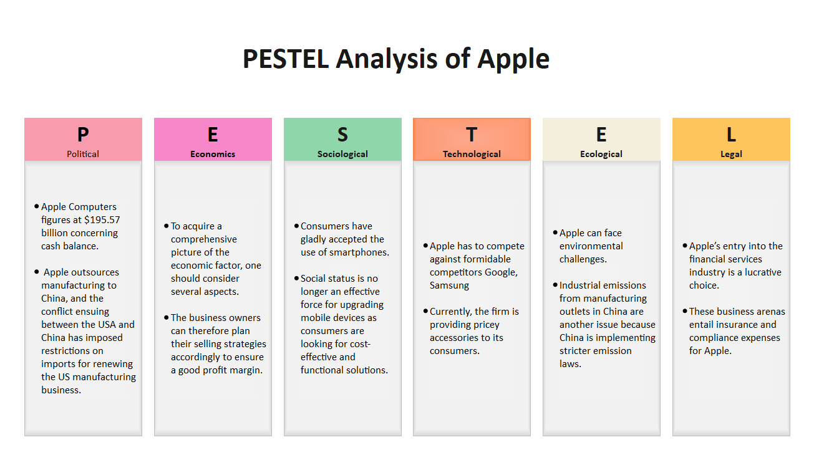
(Source: Yun et al., 2019, p. 24)

Appendix 2: Porter’s Five Forces Analysis
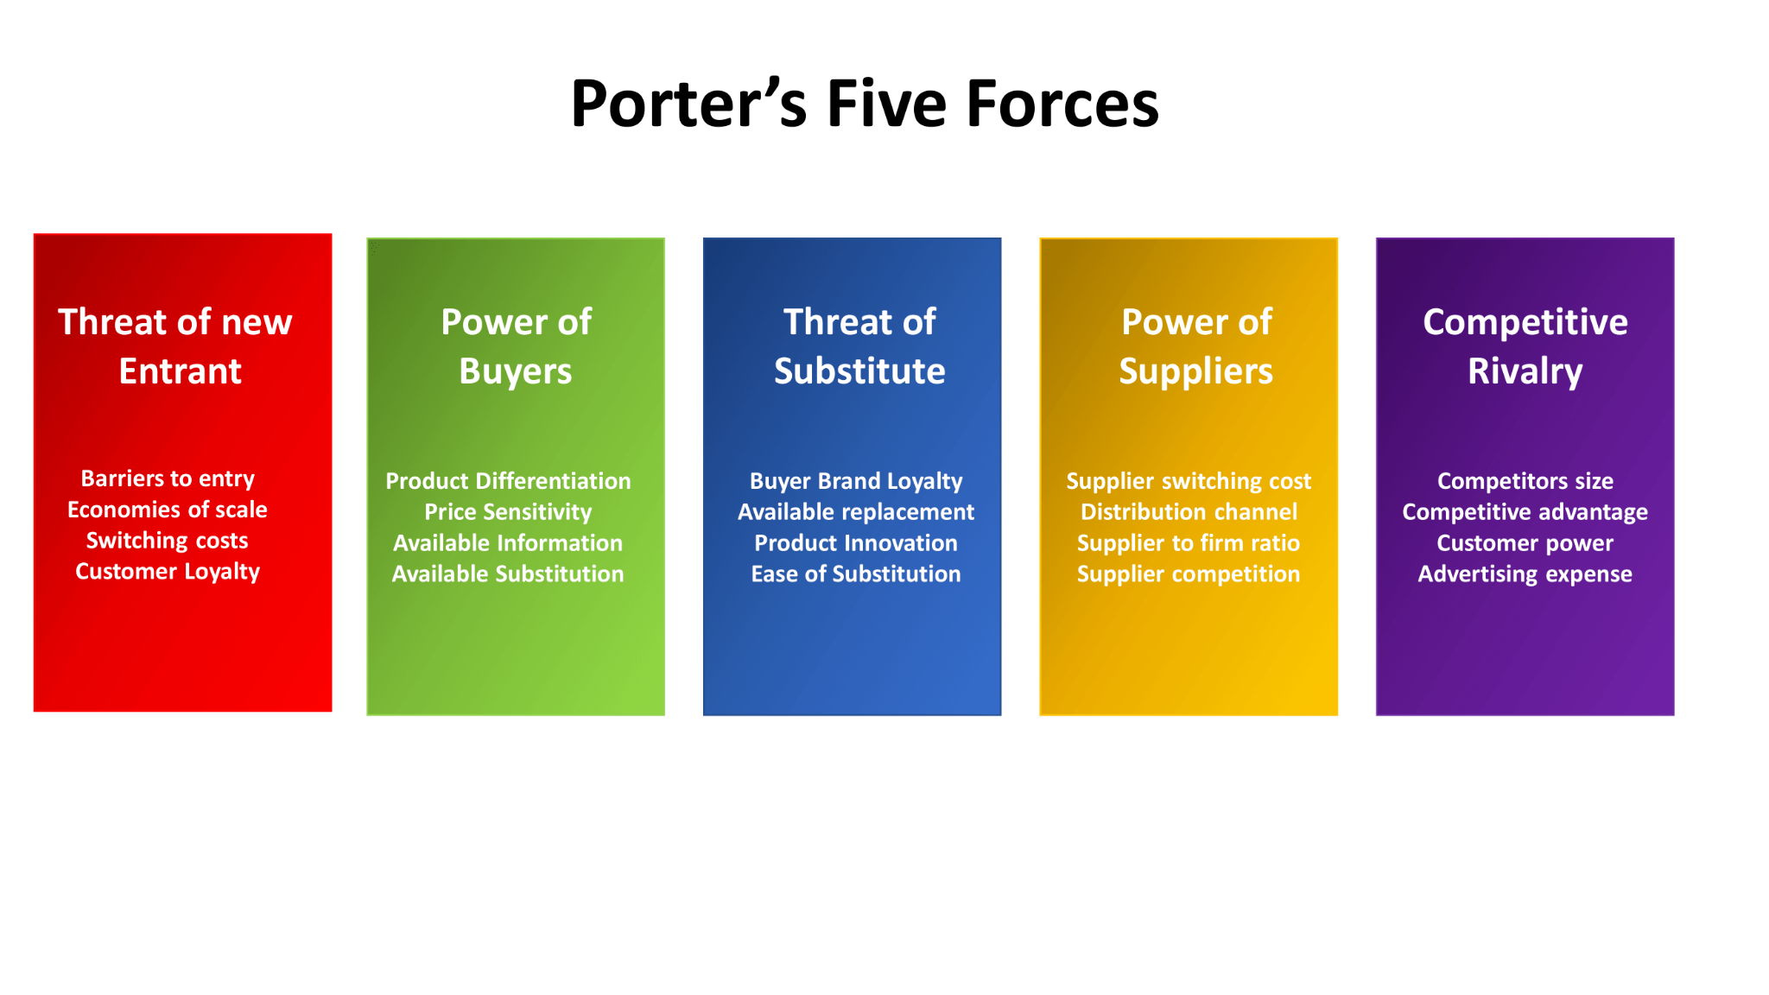
(Source: Yun et al., 2019, p. 56)

