Tutorial: L4 Computer Architecture: Using Linux to demonstrate CPU characteristics and performance.
- Recap cpu cores and threads.
- CPU characteristics.
1. A recap of how CPU executes instructions.
A program is a series of instructions and code, designed in such a way that it tells a computer what to do.
These instructions are executed by the CPU in a stage pipeline. This pipeline is commonly referred to as the Fetch – Decode – Execute cycle. The cycle is completed for every instruction in the program.
Example:
Fetch – CPU brings instructions from memory; it uses something referred to as the Program Counter (PC) which it uses to navigate to the exact memory address of the next instruction to be executed in the cycle.
Decode – This stage involves separating the opcode (the operation code, this specifies what operation the CPU is to perform) from the data (the operand) that the CPU will then perform this operation upon.
Execute – CPU then performs the opcode on specified operands (these could be arithmetic type operations or control operations).
Write-back – The result of the execute stage in the pipeline, is then written back to either memory or a register. This largely depends on the type of operation being performed.
The instructions are presented to the system CPU in Assembly language (Low level programming language).

Fig: Fetch – Decode – Execute cycle.
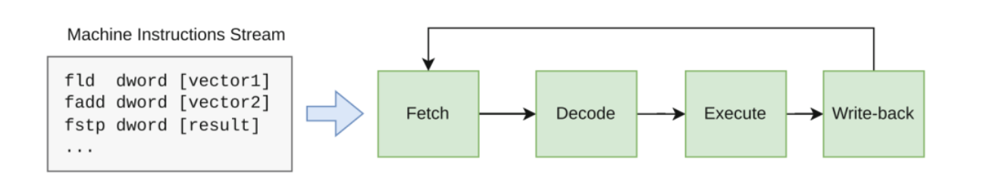

2. Multi-core CPUS.
Multi-core CPUs contain multiple processing units (referred to as ‘cores’) on one single physical silicon chip. This means that each core in a multi-core CPU can complete its own instruction pipeline, independently, thus making it capable of performing parallel computation. Multi-core CPUs provide solutions to the common computing problems shown below:
- The need to scale performance – Although it is possible to increase the clock speed of a CPU, there are physical and thermal limitations to this concept. Cores can perform operations simultaneously, so that rather than improving the time taken for one core to move through an instruction set, it is possible to have multiple cores working in parallel, improving the overall performance of programs and applications.
- Efficiency – since each core is able to run at lower frequency and voltages to complete instructions. This is more desirable than enhancing clock speeds of one physical chip, which requires more power and heat to improve performance.
- Demand for more ‘compute’ power – Modern applications ranging from Rendering in graphics to Data analytics entail larger more complex instructions. By having different cores, processing distinct types of tasks it is possible to achieve efficiency and lower latency in performance.
2.1. Core and Thread concepts (recap).
In the Operating System features such as CPU affinity, attempts to keep processes running on the same core for convenience and henceforth faster task completion utilising L1/L2 cache. The O/S uses a kernel scheduler to provide CPU affinity, aswell as functionality such as Load Balancing. Load balancing actively logs/monitors the workload of each CPU core and assigns and manages tasks to balance load.
A thread is a virtual representation of a physical core. It acts as a ‘logical core’ to achieve lower latency in tasks. Threads are a software level component that provide the core with the ability to work on several different tasks concurrently. A core can be thought of as a worker that executes ‘whole tasks’, while threads are the hands that provide different instructions (smaller parts of the whole tasks) to the core. Thus, giving the core the ability to work on several different tasks at the same time, rather than staying idle waiting for one task to be complete before undertaking the next one.
Multithreading technologies such as Intel Hyper-Threading or AMD SMT allow a single physical core to maintain two threads simultaneously. So, as an example, an 8 core CPU that supports hyperthreading is able to run up to 16 threads.
Modern CPU architectures from Intel provide P (Performance) cores and E (efficiency cores). P cores provide higher IPC (Instructions per cycle) and faster clock speeds. They P cores run single threaded workload, foreground tasks that require high priority and demand, such as gaming, rendering and mathematically complex computational tasks.. E cores provide the ability for the O/S to schedule and maintain hyperthreaded workloads. Using E cores makes it possible for the CPU to complete background tasks such as anti-virus programs and third-party software updates whilst concurrently assisting with parallel processing workloads.
How do Multicore CPUs implement parallel processing?
- “Data” parallelism – CPUs nowadays provide an instruction type known as SIMD (Single Instruction multiple data). This provides a way for the CPU to work on a range of data sets inside a single instruction. Common applications that make use of this parallel processing are video processing and multimedia software.
- ILP (Instruction level parallelism) – Multi core CPUs, just as their single core predecessors did, are able to process multiple instructions concurrently as part of the pipeline. The advantage here is that ILP now functions per core meaning that fetch decode and execute instructions are happening concurrently for each core in the CPU.
- Hyper-Threading – As discussed above, companies such as Intel and AMD utilise technologies such Hyperthreading and SMT which is based upon using ‘logical cores’. As modern CPUs are capable of complex methods of executing instruction pipelines, not all functional units necessarily need to be used during a single stage of the pipeline. Hyperthreading adds efficiency here by organising instructions into independently working ‘functional units’, so that hardware resources are not wasted or ‘idle’.
- Hyperthreading per core.
Task:
In this tutorial, we will demonstrate CPU characteristics and investigate techniques we can use to conceptualise their function, manage, benchmark and monitor their performance.
Again, we will utilise VM(s) to examine these concepts. It is possible to use Windows (Client and Server) O/S and the Task Manager/Resource Monitor and Performance Monitor utilities. In this tutorial, we will primarily be using a Linux Ubuntu VM and investigate the top and htop applications along with some other useful features and functions.
Htop is the Linux based equivalent of the Task Manager utility. It was designed with a more ‘intuitive interface’ (than its predecessor top). The principal function of htop, is to enable users to actively monitor resources and manage processes in the real time operating system environment.
Real time resources such as CPU, memory and swap usage are displayed utilising colour coded metrics/statistics.
Processes can be viewed in a ‘tree-system’ (to understand parent-child relationships/dependencies). They can then be prioritised, killed, or terminated using simple shortcut keys as opposed to the more complex shell commands that are required with top.

Download the Ubuntu Operating System.
- Download Ubuntu Desktop version 24.04.4LTS (Long Term Support) http://ubuntu.com/download/desktop
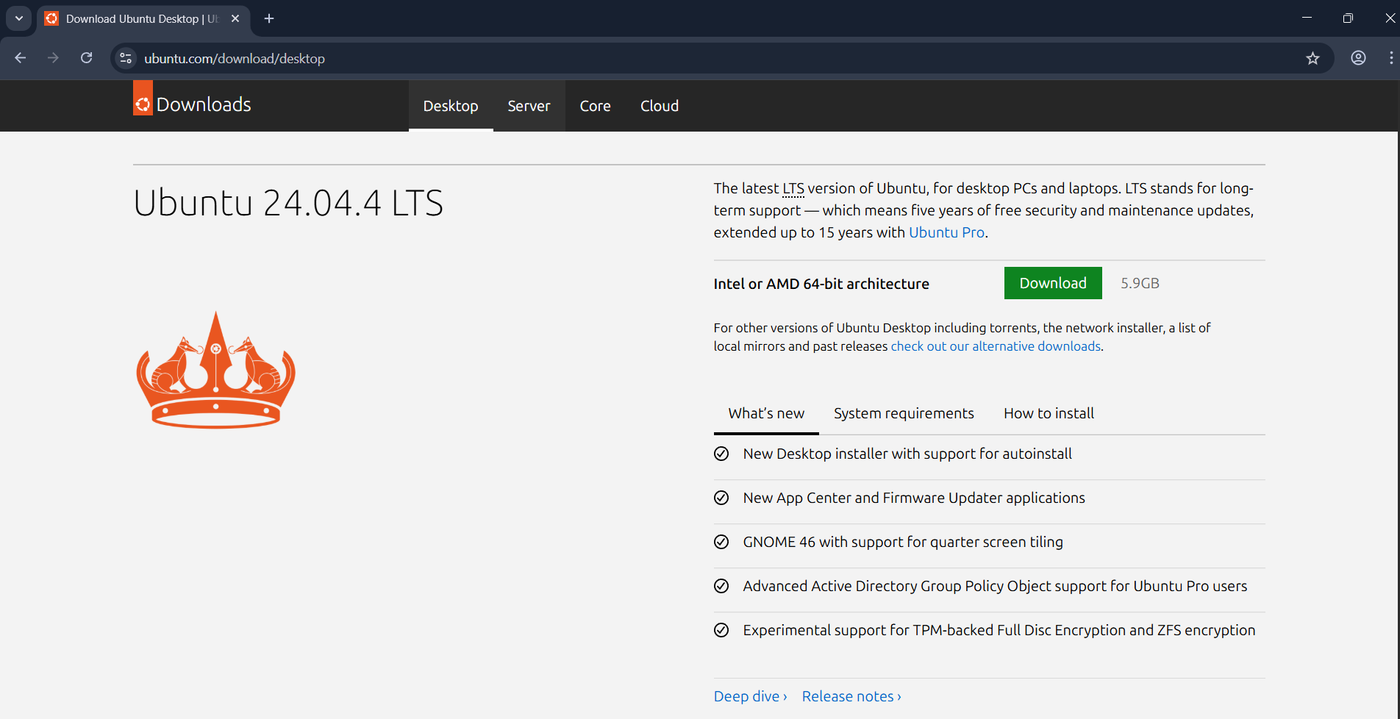
Creating a Virtual Machine in VirtualBox.
When installed Start > Oracle VirtualBox.
- In VirtualBox – Choose Expert View > from the main menu select New – you will see the following dialogue window.
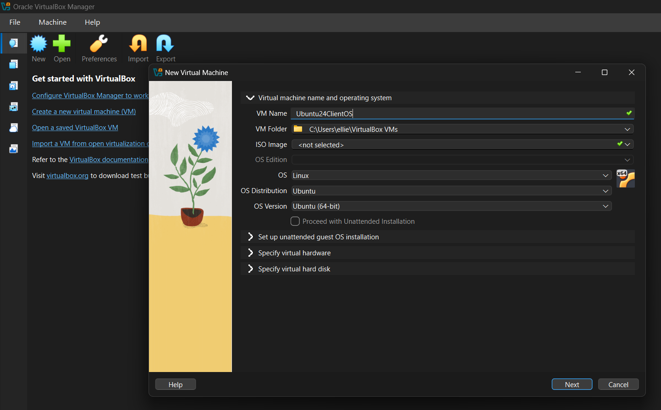
- Set the following values:
  - VM Name: Ubuntu24ClientOS
  - VM Folder [Accept Default]
  - ISO Image [Click drop down menu arrow > click Other > select the ISO file downloaded for Ubuntu (shown below)
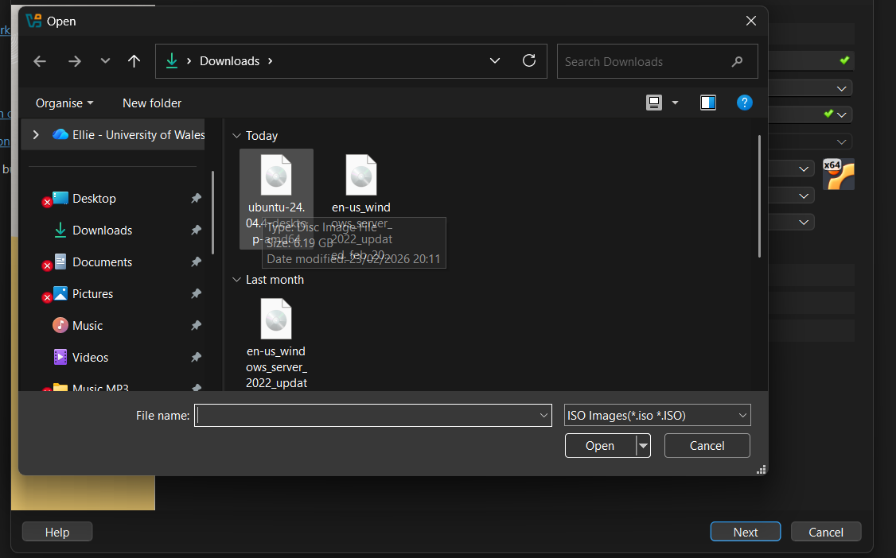
  - Unattended Installation: [Check off]
  - Expand Specify Hardware:
  - Base Memory: 4096MB (4GB RAM)
  - Number of vCPUs: 4
  - Use EFI: [Check on]
  - Expand Specify Virtual Hard Disk:
  - Disk Size: 25GB
  - Click Finish.
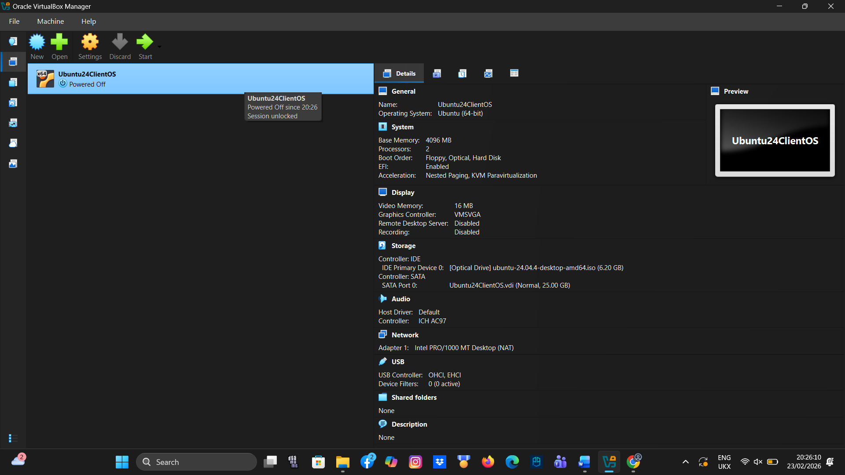
- To fine ‘tune’ VM settings for optimised performance:
  - Right click on the VM in the left hand side of the console window > Settings.
  - Display > Video Memory: Maximize to 128 MB.
  - Display > Graphics Controller: Select VMSVGA.
  - Display > Acceleration: Enable 3D Acceleration for smoother graphics.
  - Storage: Choose NVMe for the controller type to improve I/O throughput.

- Add in additional hard disks:
  - It is good practice to have an additional hard drive for backing up files with most operating systems. An effective strategy is to use a high performance SSD (using NVMe) over PCIe 4.0/5.0 technology for Operating systems and high performance requirement applications. To backup data, a less expensive legacy drive could be used. In the result of Operating system failure, this drive can keep important files archived. To add in an additional disk to the VM in VirtualBox:
Right click the VM and choose Settings
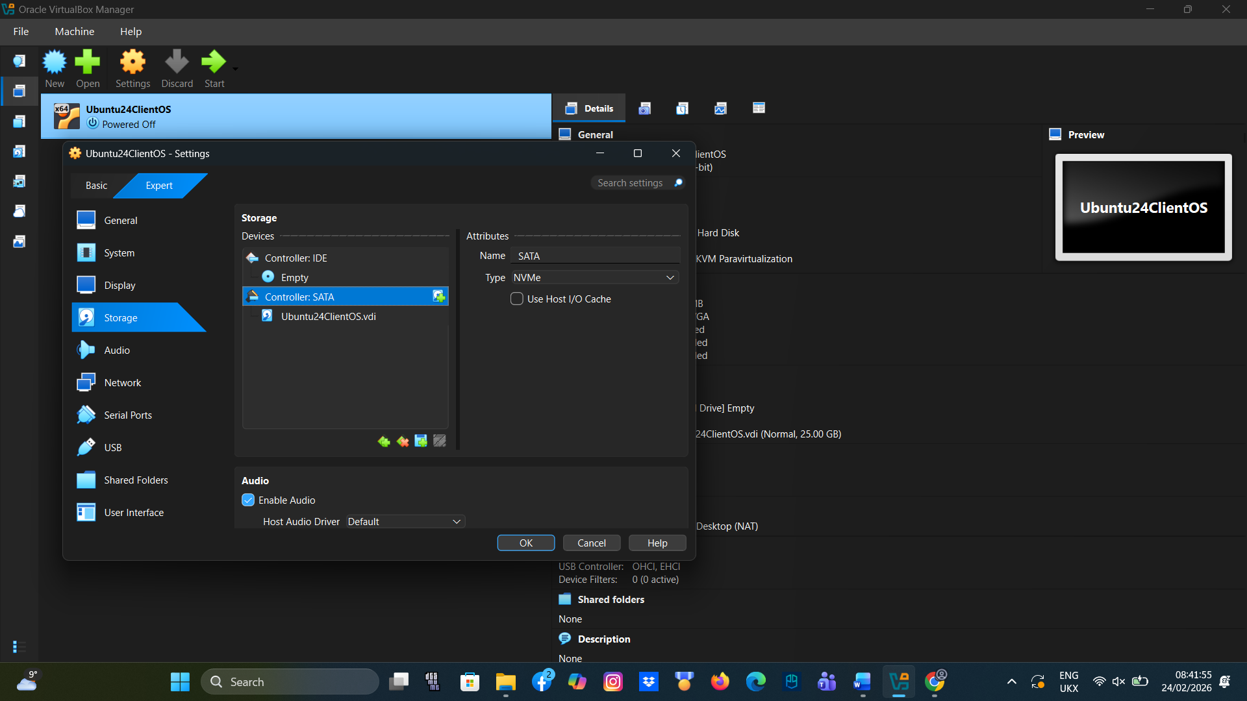
  - Choose Storage then click on the Controller SATA > choose the Add Disk button
  - Click Create, set the Disk Size to 25GB and then click Finish

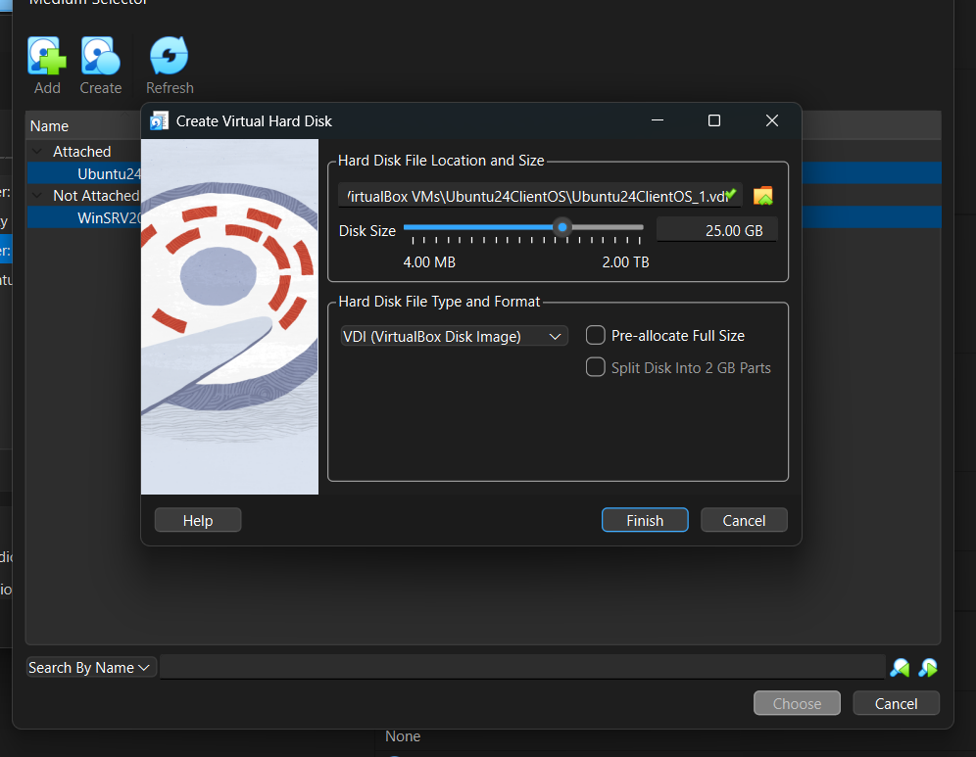
  - Now the newly installed disk needs to be added/attached to the VM
  - To do this click to select the new disk and then click the Choose button.

You will now see the disk available under the SATA Controller
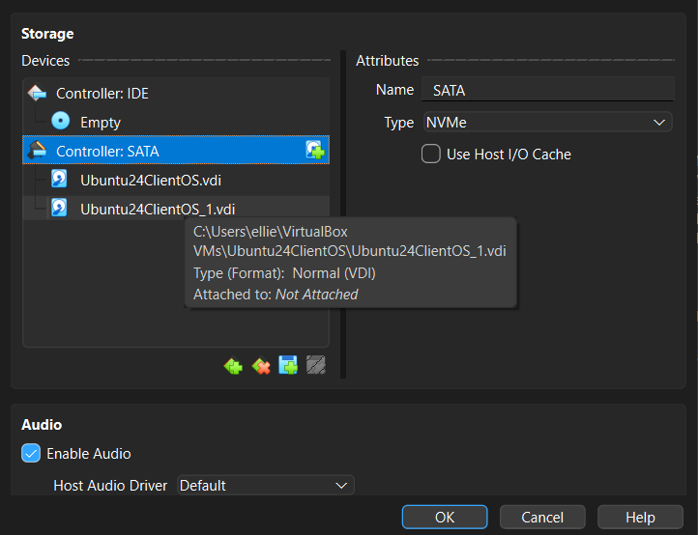
- To install Ubuntu 24.04.4LTS on the VM
  - Click Start – The console window will show the VirtualBox logo and Linux pre-installation screen
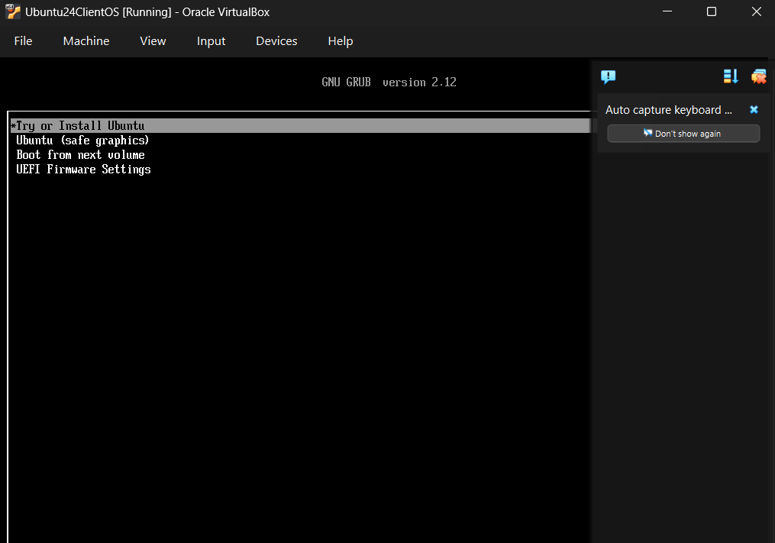
  - Click Enter on Try or Install Ubuntu
  - Wait for Ubuntu to load

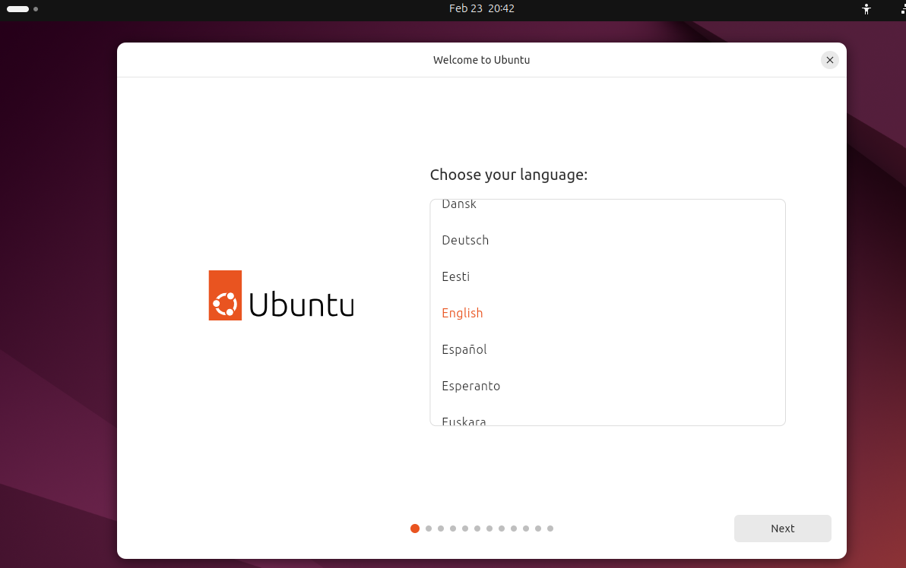
  - Choose English – Click Next
  - Accesibility in Ubuntu > Unless you have any special requirements > Next
  - Select your Keyboard layout > English United Kingdom
  - Connect to the Internet > Use Wired Connection > Next
  - What do you want to do with Ubuntu > Install Ubuntu > Next
  - How would you like to install Ubuntu > Interactive Installation
  - What apps would you like to install to start with > Default selection
  - Install Recommended Proprietary software > Check on third-party software support and Download and install support for additional media formats
  - How do you want to install Ubuntu > To follow good practice when install linux, click > Manual Installation and then set the following options:
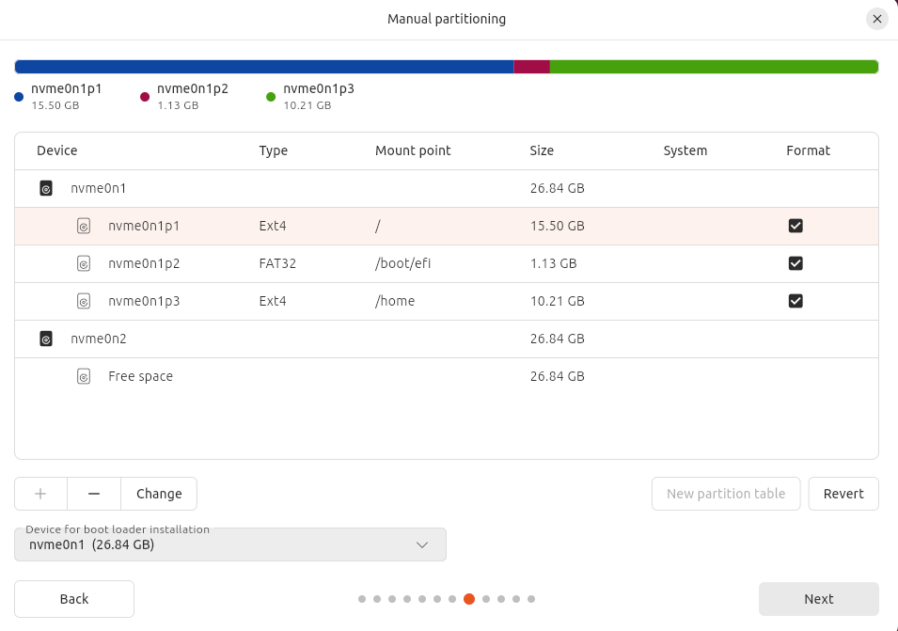
This disk/partition setup comprises:
- / (The root partition, set to roughly 15GB for running the OS
- /EFI (A boot partition set to around 1GB (created automatically) that stores the boot loader files for quick read access when starting up the OS
- /home (creates a partition on the disk that will occupy the remaining space. In the result the OS files become corrup and OS requires rebuilding or repair, having a /home partition separate, keeps your data files safe/sandboxed away from the OS. This partition can then be copied restored when O/S is rebuilt.
Once done click on the Root partition to install the OS and click Next.
- Now setup your user to login:
  - Username: [your name]
  - Computer Name (e.g. [your initials]Ubuntu24Client)
  - Password: Use a strong minimum 12 character password, good practice (e.g. The first letter in each word that makes up an easily memorable sentence]. NB use Caps in some words and letter/symbols to make things more complex for any potential hackers.
  - Require my password to login > Check on
  - Use Active Directory > Leave checked OFF
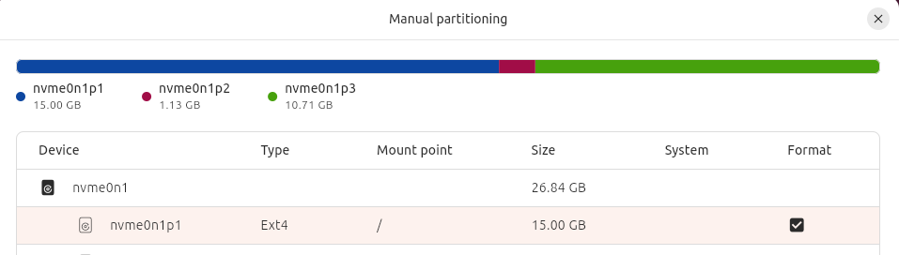
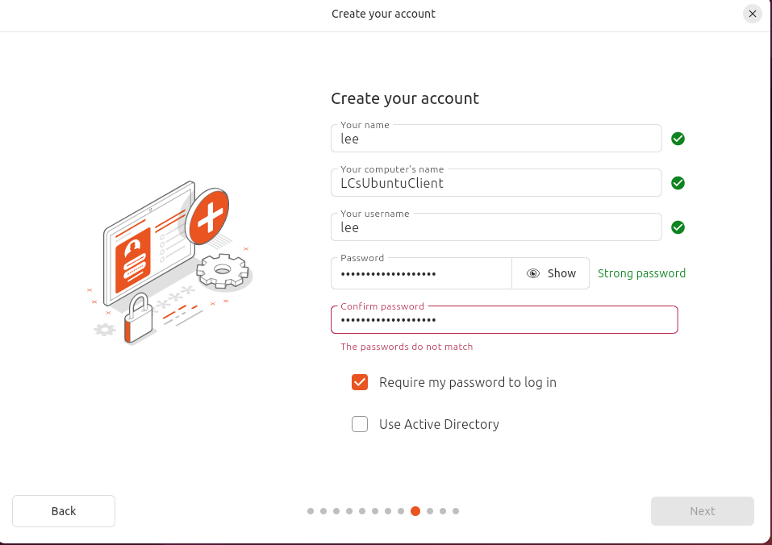

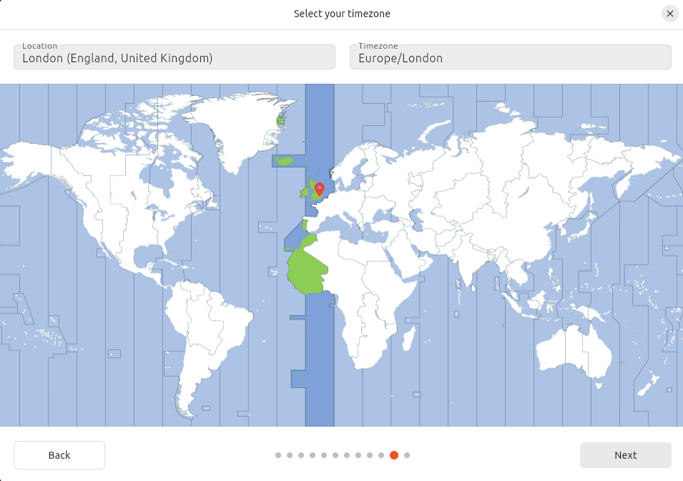
- Choose Next
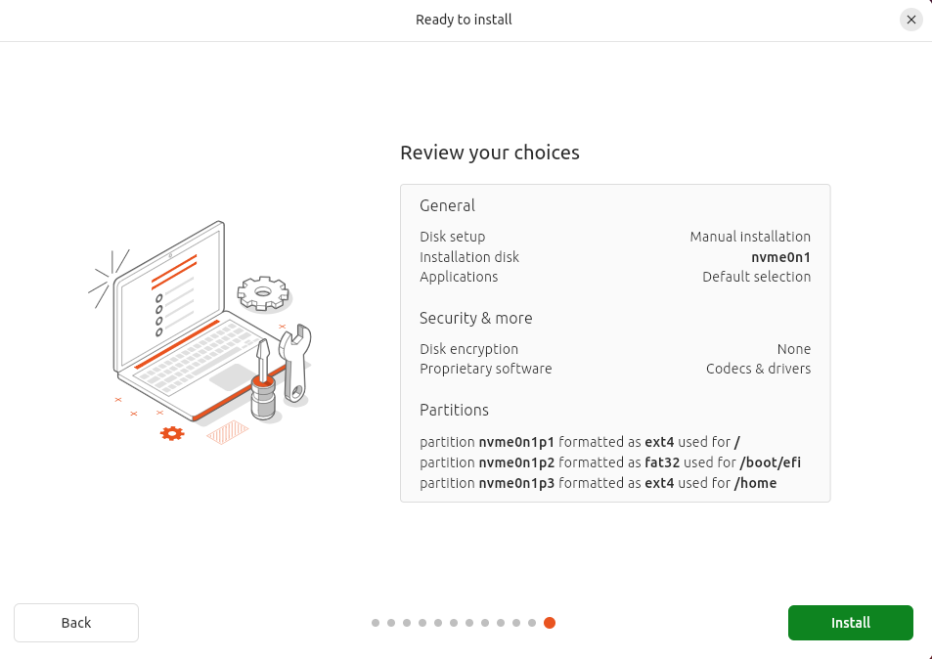

- Review summary selections and click Install.
Login to the Ubuntu OS with your username and password:
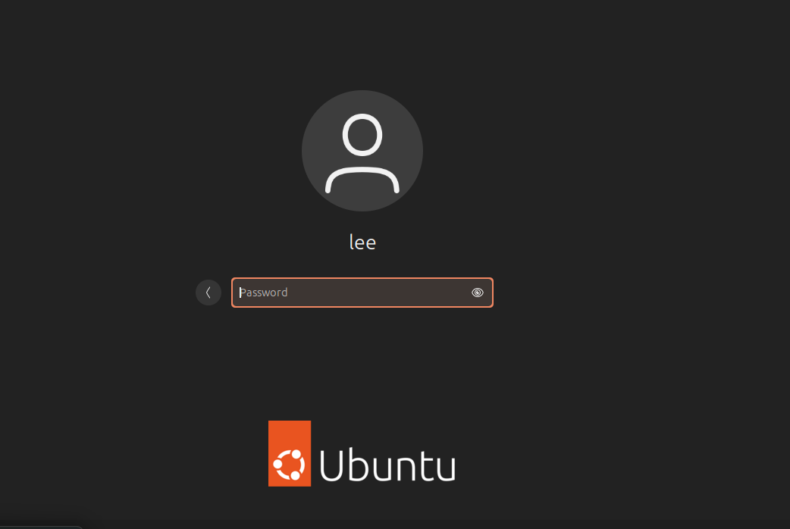
You can skip the first few screens, e.g. Collecting data for Ubuntu, you will find the App Center a useful OS utility/application
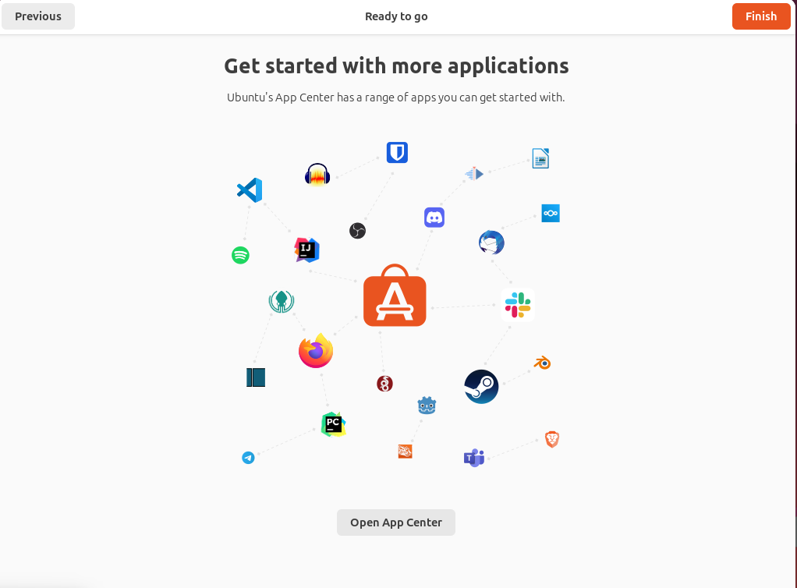
App Center categorises apps and utilities that can be used ranging from Productivity, Creativity and Design, Development, System Utlities, Communication, Entertainment and Gaming.
Applications of note, that can be used within Linux (Ubuntu):
- LibreOffice Suite – Default open source alternative in Ubuntu and other Linux distributions to Microsoft Office. It includes Writer (Word), Calc(Excel) and Impress(Powerpoint).
- Mozilla Thunderbird – Open source email client application
- Mozilla Firefox – The default web browser
- VLC media player – Media player for playing video/movie/audio files.
- Krita – Professional grade digital art/paint software
- GIMP – An open source alternative to Adobe Photoshop
- Timeshift – Very useful piece of system software for taking system snapshots for backup and restore purposes.
- Stacer – An all in one system monitor, can monitor performance and optimise the system.
- VirtualBox – Type 2 Hypervisor software for building VirtualMachines in a controlled environment.
- Docker - The tool for implementing/learning serverless/container technology.
- Remimina – A remote desktop client (similar to Remote Desktop Connection in Windows) that allows Linux to remotely connect to/be connected to with other machines over a network/internetwork.
- Telegram – A native client for secure messaging within the Linux OS
- Slack – An alternative work/team communication platform similar to Zoom/MS Teams.
- Steam – The principal gaming Platform for Linux systems.
Arguably the most critical system utility in Linux systems is the Terminal.
The Linux terminal is a text based terminal emulator (similar to the Command prompt in Windows). It provides users with a more efficient and powerful means of sending commands to interact with the operating system.
The Terminal utilises 3 key components in order to achieve this
- A command prompt – this allows you to enter commands and view the results
- A shell – Bash is one flavour of shell, it is the ‘interpreter’ that allows text based commands to be understood by the OS, so that the OS can complete its actions and tasks.
- Command syntax/arguments – When using the terminal, users will use a number of keywords that are conventions to the Linux Kernel. These tell the OS to perform its tasks. Examples include ls (List contents of a folder/directory), cd (Change directories in the OS file system) mv (move a file) and rm (Remove a file).
Terminal is used for a host of tasks in the OS including:
- System Administration
- System Controls
- File Management
- Automation of complex tasks, via shell scripts. Shell scripts are files containing a batch/sequence of commands).
Using the Terminal.
- Click on the Ubuntu start button > Terminal.
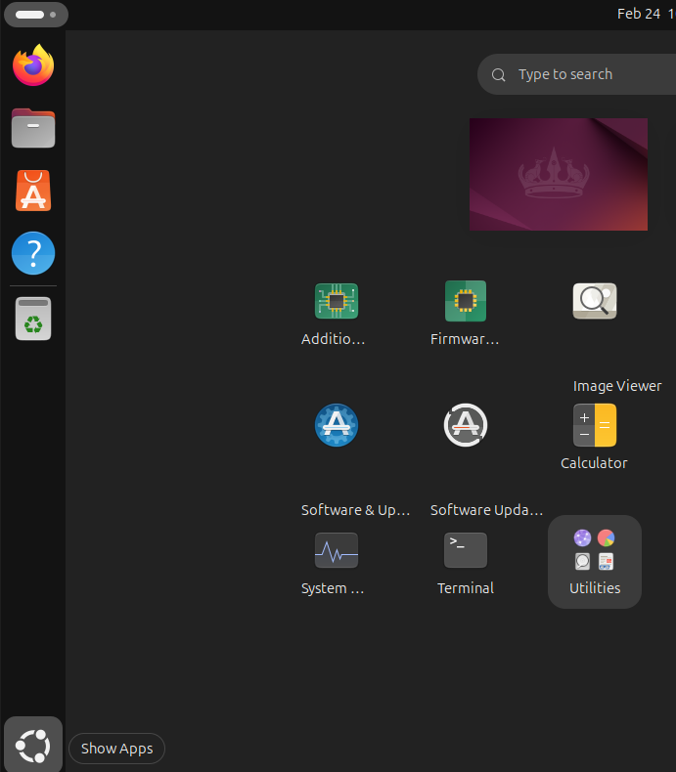
- Before entering any commands into the Terminal command prompt, it is important to take note of the command sudo.
sudo (stands for Super user do or substitute user do). It is the command required for executing ‘system admin/root level commands within the OS. You will need to enter this command in order to elevate privileges to perform many root level system changes. apt (Advanced package tool) is an advanced package management tool used by derivatives of the Debian Linux system (such as Ubuntu). It allows us to make changes to the application inventory on the OS as well as perform system level changes such as OS updates/upgrades. A package is a collection of files that make up a program.
- In terminal type the following command
  - sudo apt update -y
  - sudo apt upgrade -y
Here we use commands and their arguments to install the updates that we find for our Linux distribution from the Repositories (Servers) that host these updates on the Internet.
Task:
Using ‘top’
- Type into the terminal > top
Real time resources and their current workload.
- Make a note of key System Performance areas of note; these are displayed in the upper quadrant of the ‘top’ application’s console window. We will specifically focus on the aspects of CPU performance.
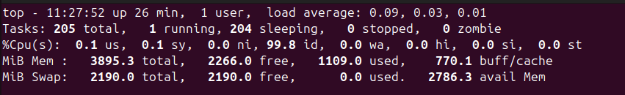

Breaking down the CPU usage metrics:
CPU Usage (%Cpu(s)):
- User space (us): Percentage of CPU time spent running user-level programs.
- System (sy): Percentage of CPU time spent running kernel code (system tasks).
- Idle (id): The amount of CPU time that is not being used (idle).
- Wait (wa): Percentage of time the CPU spends waiting for I/O operations to complete.
- Hardware interrupts (hi): The percentage of time spent handling hardware interrupts. These interrupts are signals sent to the CPU by hardware devices like disks or network cards.
- Software interrupts (si): The percentage of time spent handling software interrupts, which are generated by software (e.g., by the operating system or applications) rather than hardware.
- Steal time (st): The percentage of time the CPU was stolen by a hypervisor for managing other virtual machines.
Process Management – Running processes and their dependencies.
The bottom area of the console window for top, provides information on running processes and threads.
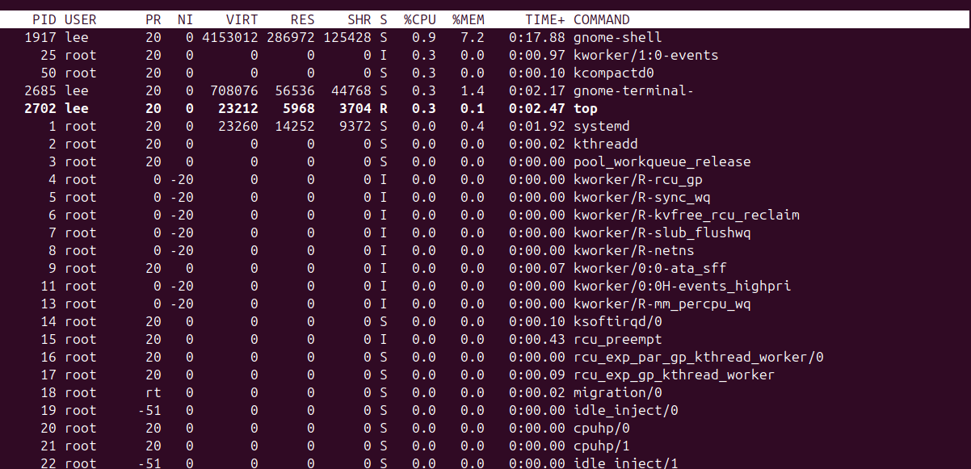
- NOTE: You need to run top -H in order to see the current threads running in top, htop provides a more convenient ‘tree view’ of processes in a parent – child dependency format.

Installing and using htop.
- In the terminal > sudo apt install htop
- When installed type in htop
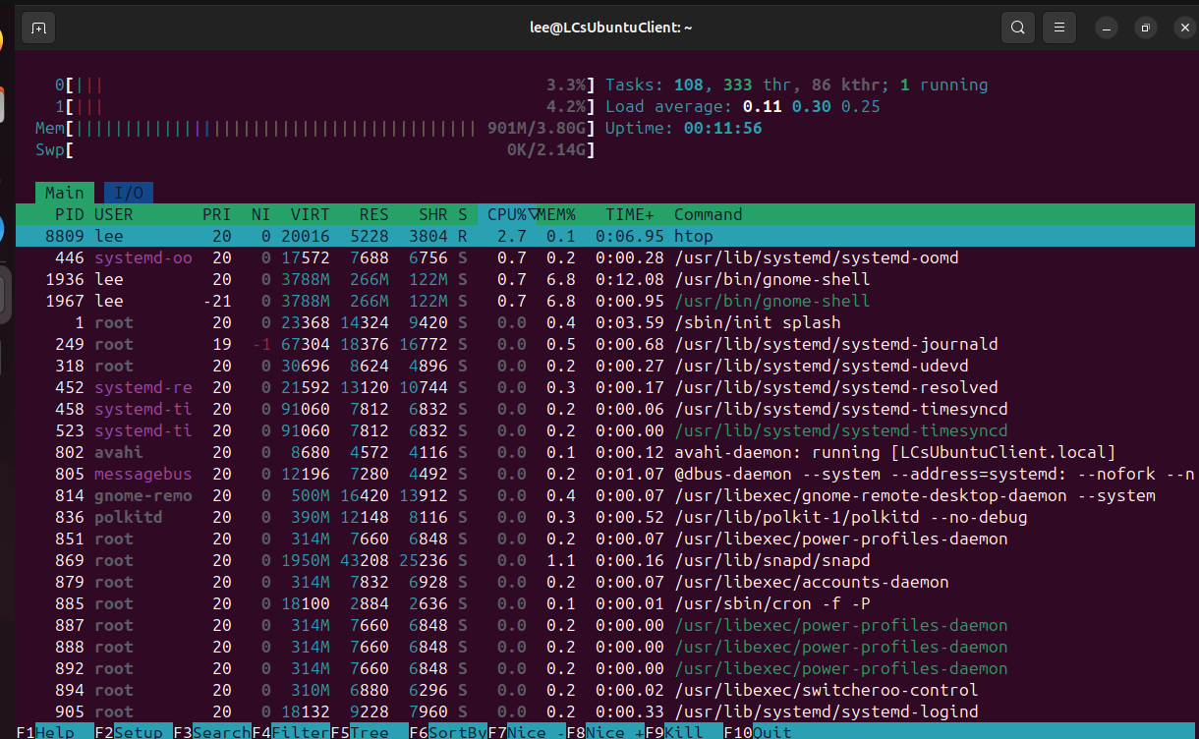
Installing and using stress-ng utility.
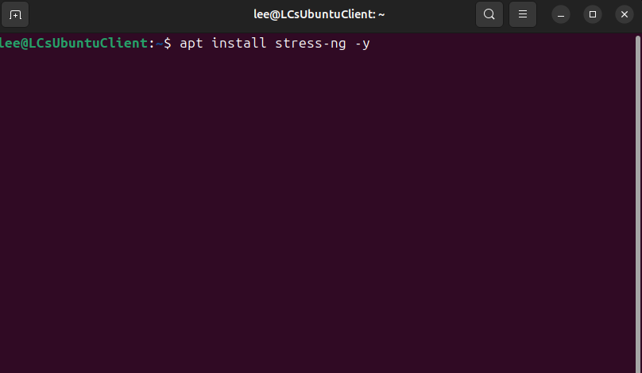

NB: You should use tools like stress-ng with a great deal of caution. This is because they can place resources under physical stress which could cause components to overheaT or fail. As a tip, always use a set interval using the - - timeout argument.

Stress Load all cores:
In the terminal> stress-ng - -cpu 0 - -timeout 60s
This bash shell command selects all cores detected ‘online’ and stresses them at 100% load capacity for 60 seconds.
[Check htop window to verify that all cores are at 100 load capacity and restore to normal load after 60 seconds].
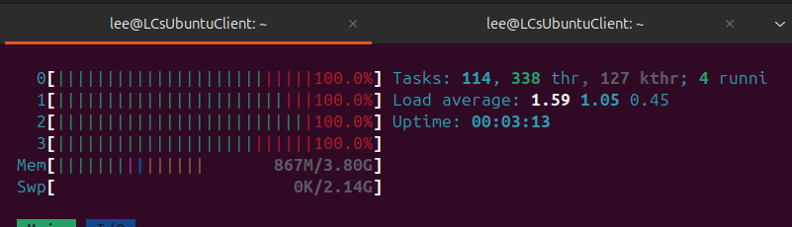

Loading CPU core 0 with 100% workload.
It is possible to load a specific cores’ workload using a single CPU stressor. Here we do this via a CPU intensive task (in the form of an infinite loop).
- In the terminal> taskset -c 0 bash -c “while true; do true; done”

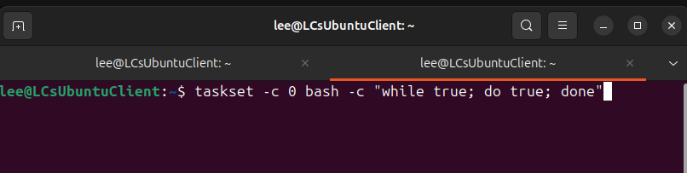
This command targets core 0 specifically and runs in bash using no I/O only the CPU. Core 0 is forced to continuously execute a ‘infinite busy loop’
- In the htop terminal window, click on the process, we can view it in the Process management component of the window. To kill the process with htop, select the right process and press the F9 key, to KILL it. You will need to confirm by pressing ENTER to send the signal.
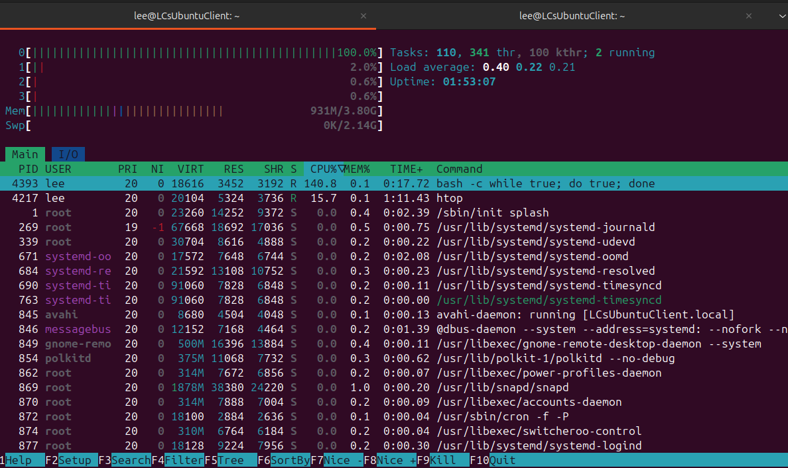
- Verify that CPU 0 is no longer at saturation (100%) usage.
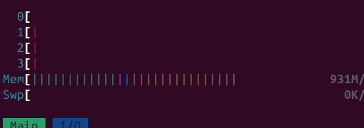
You can also ‘pin’ a specific process (already running) to a specific core (This is using CPU affinity to target workloads at specific cores):
- Close down all Terminal windows:
- Open Terminal > htop
- Click the create new terminal window button>

- In terminal as in the previous task, saturate core 0
- taskset -c 0 bash -c “while true; do true; done”
- Go to the terminal tab that is running htop and verify that core 0 is at 100% load. Take note of the PID (Process ID) associated with this command.
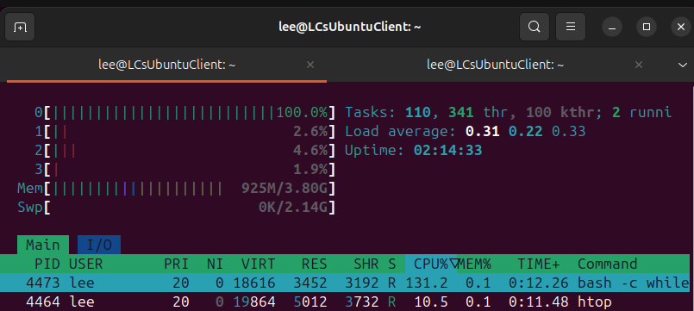
- Click the create new terminal window button>
- In terminal > taskset -cp 2 4473 (NOTE: your PID number may be different here, so use yours)

- Now return to the terminal tab running htop and verify that the process has been reallocated to core 2, core 0 is no longer saturated, the workload has been moved to Core 2.

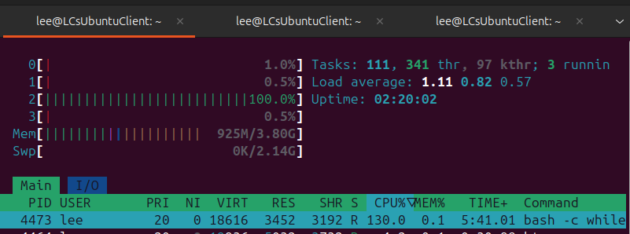
- Kill the PID above using F9 and Enter to send the KILL signal, as we did previously.
- Close down all terminal windows.

To visualise active threads and understand OS capabilities for threads:
- Terminal > ps -eLf (lists all running processes and threads on the system).
- Open a new Terminal tab > htop
- Press F5 > for Tree view (This will show you parent processes and all dependant threads (Can you determine which threads are dependent on which parent process)?
- Open a new Terminal tab > lscpu (This is a confirmation of how many threads your O/S can handle concurrently).
  - Check for the lines entitled: “Thread(s} per core and CPU(s)” lines to check this number and whether Hyper-threading is enabled.
IMPORTANT: ORACLE VIRTUALBOX IS A TYPE 2 HYPERVISOR PROGRAM. IT IS DEPENDANT UPON THE HOST FOR HYPERTHREADING SUPPORT. THE VM WILL ONLY SHOW THE AMOUNT OF CORES (vCPUs) IT CAN DETECT, BUT IF YOU GO INTO THE SETTINGS OF A VM; YOU WILL SEE THE NUMBER OF PHYSICAL (Cores) AND LOGICAL vCPUs (Cores+Available Threads) LISTED. NOTE: VIRTUALBOX DISTINGUISHES BETWEEN CORES AND LOGICAL CORES(THREADS) BY USING A GREEN TO RED INDICATOR (GREEN DENOTES THAT YOU ARE USING AVAILABLE PHYSICAL CORES, RED DENOTES THE START OF UTILISING SOFTWARE CONTROLLED LOGICAL CORES/THREADS).
THIS TOP END (RED) NUMBER WILL BE X2 of the PHYSICAL CORES IN YOUR COMPUTER. IF YOU ARE UNSURE OF WHAT THIS NUMBER SHOULD ACTUALLY BE, FOR YOUR PHYSICAL HOST, YOU CAN USE TWO METHODS.
- CONSULT THE DOCUMENTATION FOR YOUR SYSTEM HARDWARE
- OR, AN EASIER METHOD IS TO CHECK THE HOST OPERATING SYSTEM YOU ARE RUNNING ON (NOT THE VIRUAL OS).
IN WINDOWS THIS CAN BE DONE IN TASK MANAGER.
CTRL + ALT + DEL (NB: TAKE NOTE OF THE ‘CORES’ AND ‘LOGICAL PROCESSORS’ VALUES)
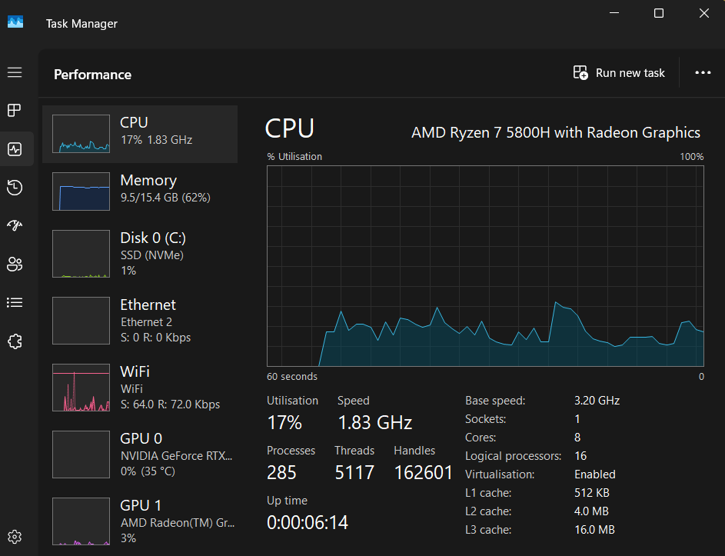
Q). What is the difference between processes and threads within the OS and CPU architecture?
Task.
Open up the htop app and then try opening some diverse types of applications on the Ubuntu system (e.g. simple tasks vs more demanding ones). You can also open the top app in a separate terminal window. Observe how many additional threads are opened each time and the workload on different cores.
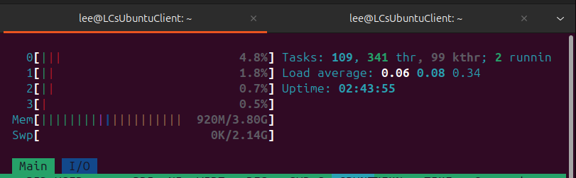

FIG: Using Terminal to run useful commands:
- OS navigation and File management commands
- pwd
  - pwd prints the working directory of the user, without the sudo command we should be in the /home directory
- ls -lh
  - This command lists files available in the current working directory along with the file sizes in human readable format
- cd \etc
  - An example of using the cd command to change directory with the argument /etc (takes us to the /etc) in the file system
Fig A: The Linux File system (an abstract, top-down view where the Penguin represents root!! /
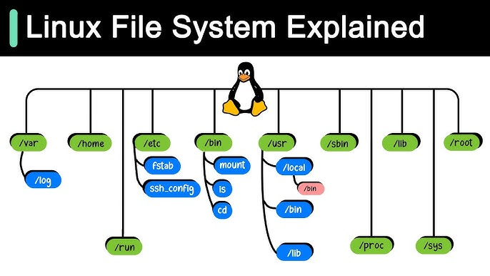
Task: Investigate what each of these branches in the Linux File System Tree is for?

- In terminal test the following types of System Maintenance, Monitoring and Troubleshooting commands.
  - top
  - htop

[The commands above present resource usage statistics in real time for system resources such as CPU, RAM and running processes, the latter are identifiable by their PID process ID].

  - df -h
  - du -sh *
[These commands firstly show available disk space on all mounted file systems in readable form and secondly a summary of file and directories within your current working directory].
  - kill -9 [PID]

NOTE: DO NOT USE the kill -9 command on PIDs at this stage as it will destroy your Linux system if used incorrectly.

  - neofetch

This command will display your system information

  - cmatrix

You will likely need to acquire this app
In terminal sudo apt install cmatrix

For fans of the matrix movie, that one should be self-explanatory!!

  - sudo !!

Will re-run whatever the last command was with sudo/root level access

  - clear

Clears all commands in the terminal window.

Task:
Install some useful applications, either from the above list, or for your own preferences using terminal and appropriate commands and arguments. Resolve any dependencies you may require, by carefully observing instructions provided in the terminal window.

