Business plan
Hope Restaurant

Valentina Garzon Gomez
2111132
Managing Enterprise in the 21st Century
Mushfiqur Rahman

Table of Contents
Introduction 3
Aims and objectives 3
Legal Requirements 4
Mission and Vision 4
Our products description 4
Marketing analysis and trends 5
SWOT Analysis 5
PESTLE Analysis 6
Operations 7
Technology plan 7
Management And Organization 8
Social Responsibility and sustainability 8
Development, milestone and exit plan 8
Financial Data 9
Conclusion 11
References 12

Introduction

Hope Restaurant is a mix of two big cultures, we offer Italian and British food to our customers, it was inspired first because the restaurant is ubicated in London and Italian food is recognized all over the world and most people love it, also we wanted to create a restaurant which is easy for people who want to eat nice and quick food between their workdays. Hope was founded for 5 students which had the idea to open a business in the hospitality area, we all have experience in this area and we are passionate about it, what we most love is that we provide good quality of food, healthy and also cheap so everyone loves it.

Hope is a small café with counter seating and takeaway service and is located in Spitalfields Market, in Liverpool Street which is a busy area and where there are a lot of offices so we get the perfect customers for the type of business, we also got a lot of tourists which is really good that they can see two different cultures in one place. We offer fresh food to go, deliver and also eat in, our prices are unbelievable, most of the dishes are under £10, we offer hot beverages, fresh juices, soft drink and also house wine it is the perfect place to go between your workday and also when you day has finished and you just want a nice food and a nice glass of wine to end the day in a nice way.

Aims and objectives

Our Aim is to create sustainable restaurant with delicious food and affordable prices, easy, quick and tasty.

Our objectives are to provide an exceptional customer service, offer diverse menu to attract all kind of customers, we want to create a brand where the guests will remember our name and our logo, we want to stablish customer loyalty offering a reward program and we also want to promote sustainable concept.

Why sustainability is important for us? “Sustainability for restaurants means operating in a way that protects, preserves or restores the natural environment, promotes social equity, enhances the lives of people and communities and contributes to economic prosperity for shareholders and stakeholders”. (Josh, 2017) it is true that now we live in a world where people are starting to care about it, there are a lot more of people now who wants a change and hope restaurant believes in this change and that working all together we can make the earth a best place to live, how we can help? We do not waste food, all the food we have left we give it to charities and to homeless people who need it, we do not use plastic in our restaurant, we have filter water, we recycle, our deliveries are by bicycle to reduce carbon emissions and we trying to do only marketing online and day after day we try to implement small changes that can help change the world.

Legal Requirements

- Register with HMRC
- Business insurance
- Register with the local authority
- we got food and hygiene certificate

Mission and Vision

- Our goal at hope is to dominate the market with dishes that appeal to our customers with affordable refreshing dishes
- Our mission is to inspire healthier communities by connecting people to real food
- The vision is to open more locations turning hope delicious food into a successful franchise
- Be a recognized brand in the local area and the number one place where people choose to fill their cravings.

Our business structure, we are five founders and we own equal shares in a business, each partner contributes to all aspects of the business, money, property, labour and skills, the business structure is broken down in 2 major parts, back of the house and front of the house.

Our products description

Food Menu

- Crispy chicken skins
- Baked sweet potato, feta and coriander
- Sauteed chicken liver, green lentils, harissa yoghurt
- Kale, apple and fennel salad, toasted pine nuts, pumpkin seeds
- Chicken pearls, bacon, marsala sauce, sourdough bread
- Half chicken oven roasted
- Vegan burger (beetroot, lentil and peanut patty)
- Grilled chicken burger
- Sunday roast, half chicken, beef striploin, leg of lamb, roast potato, vegetables and Yorkshire pudding

Desserts Menu

- Chocolate and pecan nuts brownie
- Rhubarb with shortbread

Drinks Menu

- Ernie’s Cosmo
- Island dreams
- Watermelon Negroni
- Spicy margarita
- Cranberry, apple and orange juices
- Coke and diet coke
- House red and white wine
- Drafts beer
- Hot drinks

Marketing analysis and trends

In summer we provide to our restaurant seating outside of the café, we also implement in Hope restaurant technological advancements such as online orders and contactless payments, we promote that we are a sustainable company and that we do care about the environment and we also offer to our customers a loyalty rewards program which help us to keep our customers with us.

SWOT Analysis

Strength: We are a company who provides flexibility to our customers, we offer good quality of food and good prices

Weakness: We have a lot of competition around us so that can be a disadvantage as we are a new brand

Opportunity: Our biggest opportunity is to attract people working around and tourist who wants to grab something quick, nice and healthy

Threats: All our ingredients are being locally sourced and that maybe affect us due costs are rising regularly.

PESTLE Analysis

Pestle analysis allows a company to form an impression of the factors that might impact a new business or industry. Some factors will be more important to different types of businesses.
All these factors have a big impact in our business, and as a company we want to stand out for fulfilling each of them

Political
Our job as a company is to keep updated about government policies as they may change overtime, we need to adapt them to our business plan strategies. Our business must take care of tax reforms, health and safety guidelines

Economical
Hope restaurant has a business plan for short-term and long-term, our goal as a company is to grow our economics, having a clear knowledge about interest rate, exchange rate and inflation.

Social
Our purpose is to grow as a company that cares for the community, social factor is important for us, such as our biggest goal is to reach different cultures and be affordable for everyone

Technological
Hope is a restaurant that will include innovation, automation, technical awareness and communication operations

Legal
Legal is an important factor for our company, food quality and hygiene are two crucial factors that come under the product safety of the legal factors

Environmental
Hope restaurant will also develop strategies for recycling and waste management, the restaurant must work in collaboration with the government, it will help to lower the risks of environmental damage.

Operations

- Hope restaurant will implement new technologies to have a smart management and a strong operating system and procedures, we will offer our staff a training program with guides which will help them to know what their task are every day.

- Establishing prices to achieve the maximum profit margin is a vital part of restaurant operation. Our goal is to be affordable for everyone and to create unique recipes, monitor food quality, track inventory usage and ensure customer satisfaction

- Our operation plan will be based on our customers, we want everyone to have a great experience, we want to listen to them and improve everyday our service.

Technology plan

- We will apply a POS system, which will be a center point of our restaurant where our serves and cashiers will fire orders to the kitchen, also our staff will have access to products, prices to clear checks for our customers.
- Online ordering will be part of our restaurant too, we want to offer our customers the option having our products from the comfort of their home.
- Inventory Tracking software is a tool who will help our company to save time and money in the future.

Management And Organization

Having a solid plan how your business will run is a key component to have a successful operation. It’s important to define the positions in the company, which job is responsible for what; probably overtime the structure may grow and change but we need to have an initial plan

- Julita Goralczyk - General Manager
- Cristian Ilie – Purchasing Manager
- Rodica Mihaela Patrunjei - Head of Food
- Valentina Garzon – Beverage Manager
- Rebecca Fasan – Floor Manager

Social Responsibility and sustainability

Hope Restaurant is offering a large selection of cold and hot dishes, eat in or takeaway, for lunch the menu includes soups, a variety of pasta, pies, fish and chips and desserts. We also offer in our deli counter, homemade cookies, biscuits and meal-box to take home, our chefs prepared the food in the restaurant every day, so our dishes are fresh and made in a sustainable and profitable way. All our ingredients are 100% British and locally sourced, and for the future we also want to bring products from Italy to make our customers have a closer experience with this culture.

Development, milestone and exit plan

Hope restaurant is already developed, we already got a business name, we have our licenses, we have our social media account and we are working to make it grow, we also got our orders manage system and our business email.

Our restaurant is already ubicated, we also have our supplier that they are 100% British how I said before, we are five partners and we all work in the restaurant in different departments that I mentioned before but we also got more employees who helps us to provide the best customer service, we are still working on our marketing, we are making grow our social media so we can make the restaurant known more in the city.

As a company we already created an exit plan which is, liquidate our business, sell to a 3rd part, refinance/recapitalize or sell to an employee.

Financial Data

Poor financial planning is known to be one of the most common mistakes of a new business, that is why Hope Café has a financial data plan and we have someone in charge of this part, effective financial planning is really important for a company, we want to be on control of our business.

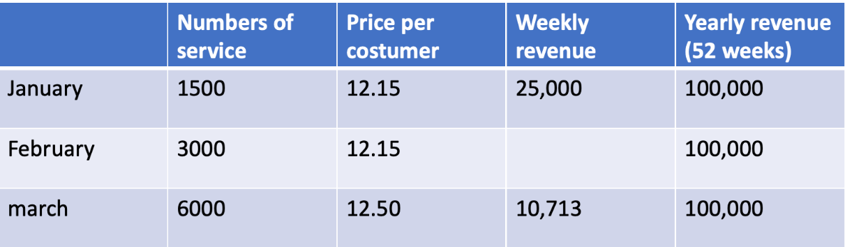

Profit and Loss Account

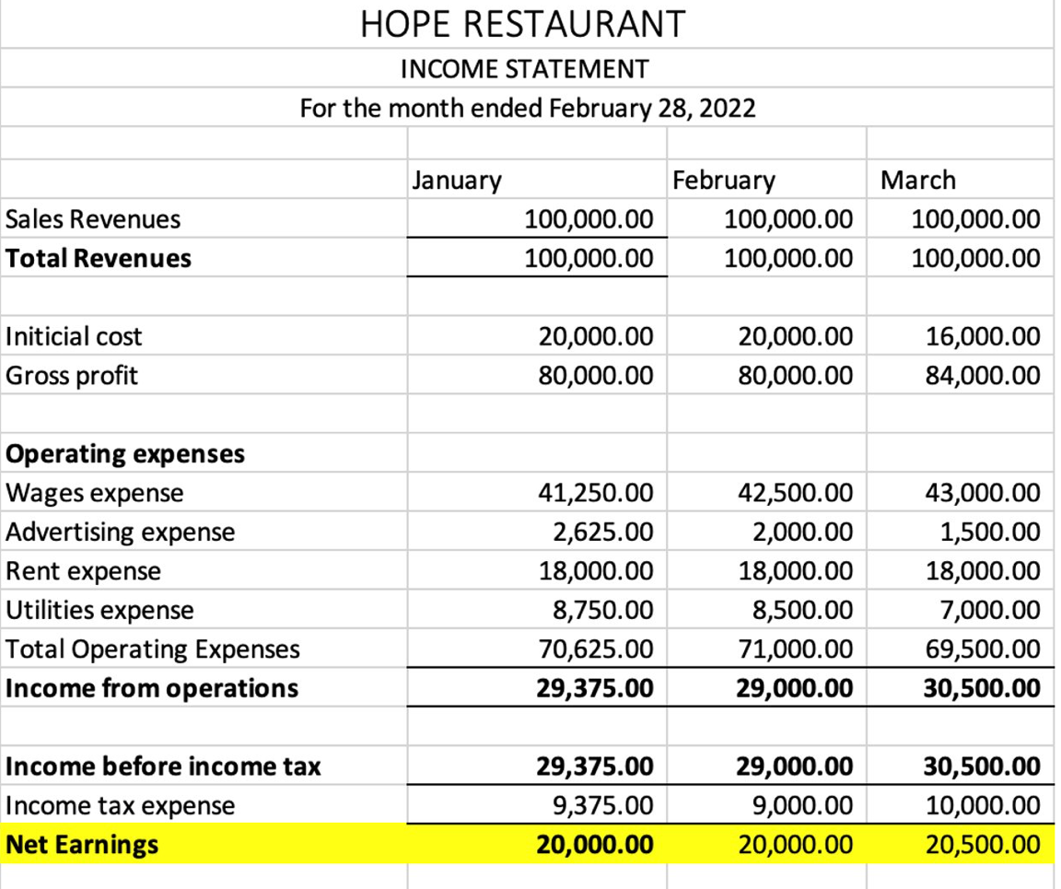

Cash flow statement

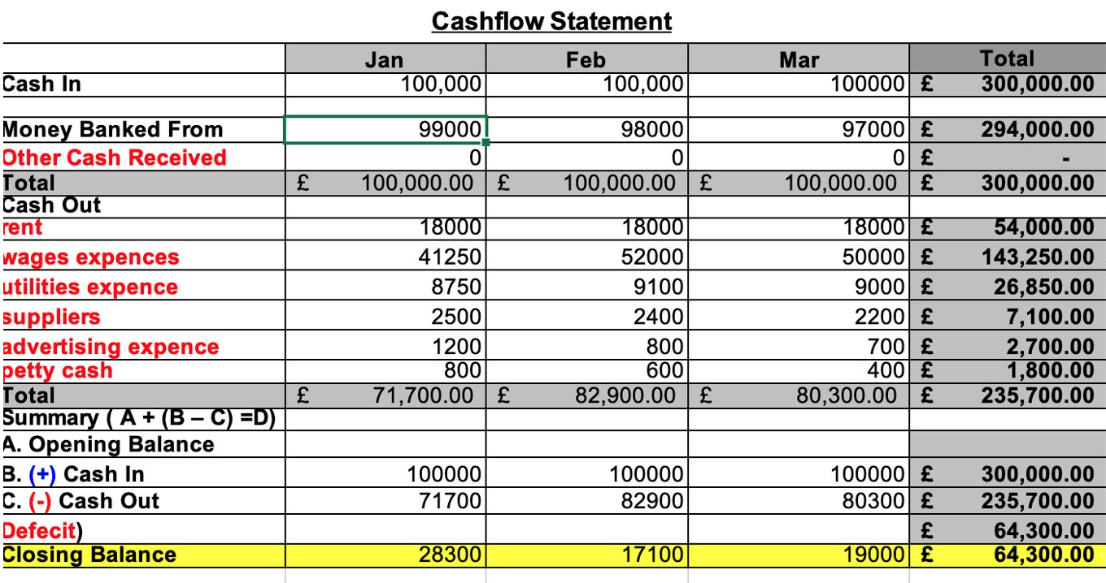

Balance sheet

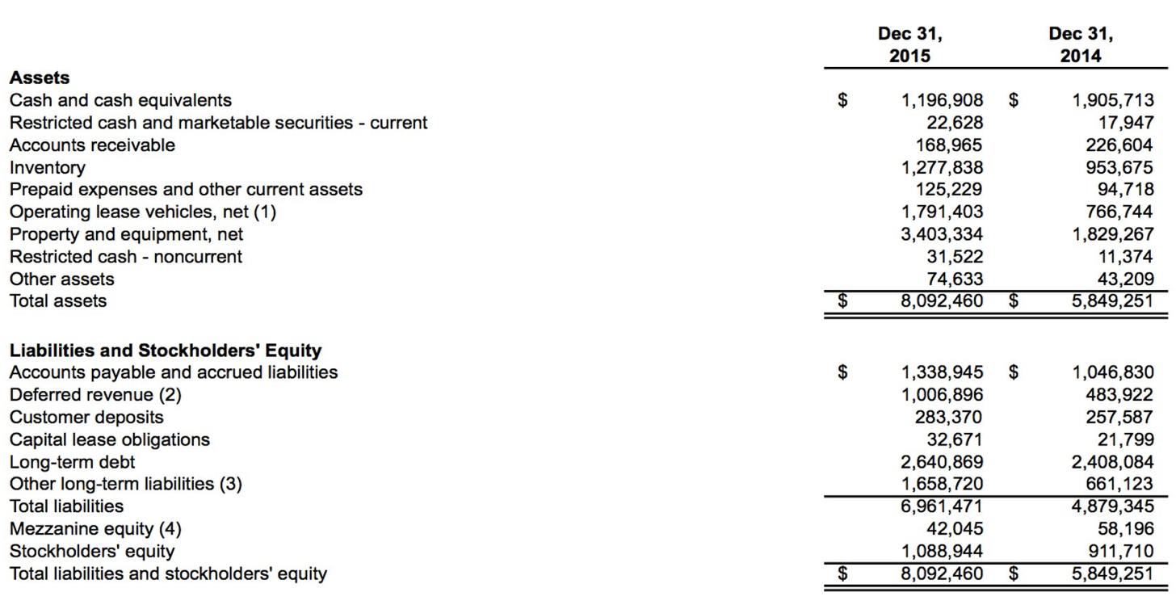

Conclusion

Hope restaurant is a dream come true, we all have dreamed this all our life and now we are making this happen, it is really excited, every part of it, we love going to work, sharing time with our employees and customers, building a brand is not easy but for sure it is worth it.
Our business has all the sources to be a successful company, we have done this business plan and we have listing the pross and cons we can stand and with our team we have no reason to fail, we know is not going to be easy and that we need to be persistent and we are ready to work hard for our dream and become this restaurant known, as a restaurant who provides de best quality of food, good prices and the best services. We will work on our brand and we will be focus on building a loyal customer base as that is what a successful business thrives off.

We are very happy to present this project to London in which we have worked really hard, we also want to be an example that when you work hard you can do everything you want.

References

Josh, P. (2017) Time to fire up restaurant sustainability- Here is how. Available at: https://www.environmentalleader.com/2017/12/time-fire-restaurant-sustainability-heres/#:~:text=Sustainability%20for%20restaurants%20means%20operating,prosperity%20for%20shareholders%20and%20stakeholders. (Accessed: 01/09/2022).

