Name: Indra Kumari Gurung
Student Number: 1809961
Course Title: BA Surface pattern Design
Module: Ways of Perceiving (ADAD4010)
Teacher: Julia Lockhart

Fashion Show exhibition

A fashion show exhibition is very essential for introducing new fashion designs and collections all over the world, as without fashion shows people will not be aware what types of design trend is coming in to the market. This assignment will explore the possibility of curating an imaginary fashion show to be hosted at High Street in Swansea. Also, five fashion designers will be discussed as a source of inspiration for the imaginary catwalk show. The five key fashion designers are: Alexander McQueen, Katharine Hamnett, Stella McCartney, Andre Courreges and Prabal Gurung, whose works are incredible. They are very influential in providing inspiration for the practical element in the discipline of the chosen pathway of design for fashion.

- Alexander McQueen was a famous British fashion designer and couturier. He worked at Giverny (1996-2001) and he won British Designer of the year awards four times in 1996, 1997, 2001 and 2003. He died in 2010 (Knox, 2010); in the same year Prince William and Kate Middleton were married. For the ceremony, Kate wore an Alexander McQueen bridal gown designed by Sarah Burton. In the cultural view, British people wear the white dress for their wedding.

White Wedding Dress

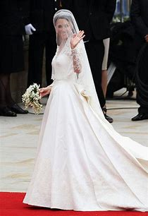
https://www.bing.com/images/search?q=alexander+mcqueen+wedding+dresses&qs=CustomSearch&pq=alexander+mcqueen&sc=8-17&

The traditional white cloth worn for a marriage ceremony is a symbol of purity and identified with the occasion where it is worn as fashion speaks itself is cultural semiotic. It represents the wedding and relationship ceremony on the female life and language of body. When you see some fashion then you can recognize what is happening there as sociological, cultural, political and philosophical aspects.
In the above picture, the princess wearing the dress is the signifier and the colour of the white dress and white bunch of flowers is signified. It shows British culture, social event and relationship between male and female. She is smiling and waving her hand to the public which means a moment of happiness in her life and this is very attractive to the public. In the philosophical view it was one kind of wedding dress fashion show which the audience could see very easily in a direct way and through the media all over the world. It is a high class of social status so that the context of fashion show space is at a wedding place.

- Katharine Hamnett is an English fashion designer. She designed the printed T-shirt: through that T-shirt she gives the different messages to the people for awareness. She is very conscious about the environment, so she designs more natural cottons t-shirts which is not harmful for the planet. She won the first of her British Fashion awards in 1996.

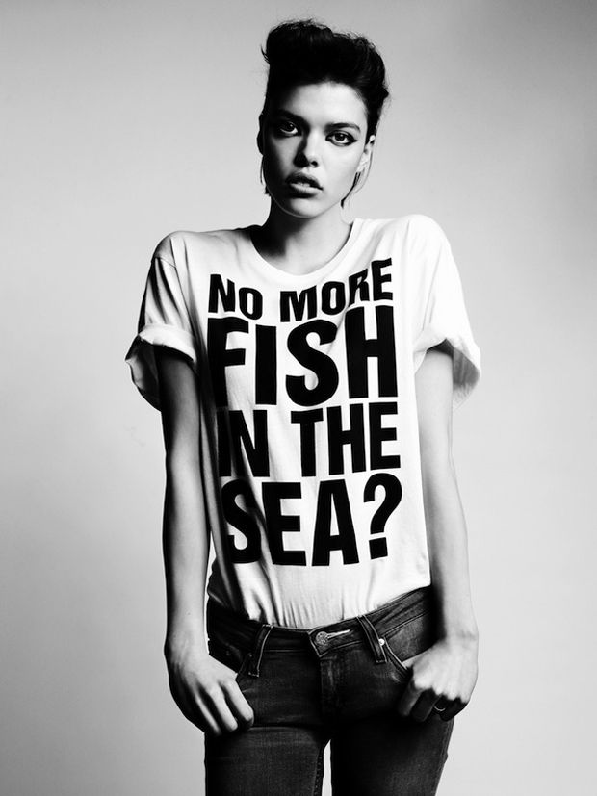

https://s-media-cache-ak0.pinimg.com/736x/f8/9d/cb/f89dcb5faff7849fb96cae1bf64b9cbe--katharine-hamnett-slogan-ideas.jpg

This T-shirt designed by Katharine Hamnett has a message about awareness on environment issues and sustainability. Fashion designers use different types of materials for making different fashionable products but Hamnett mostly uses sustainable cotton materials for her designer T-shirts. When we throw plastics and other wastes in the sea, the pollution will destroy sea life and there will not be left anymore fish; so the people must be think about the environment (Foley, 2019).
- Stella McCartney is an English fashion designer. Her mother was a photographer, musician and an animal rights activist. Stella McCartney was awarded the VHI/ VOGUE designer in 2000, in New York. She designed Meghan Markel’s wedding dress in 2018. She worked for cancer charities because her mother died of cancer.

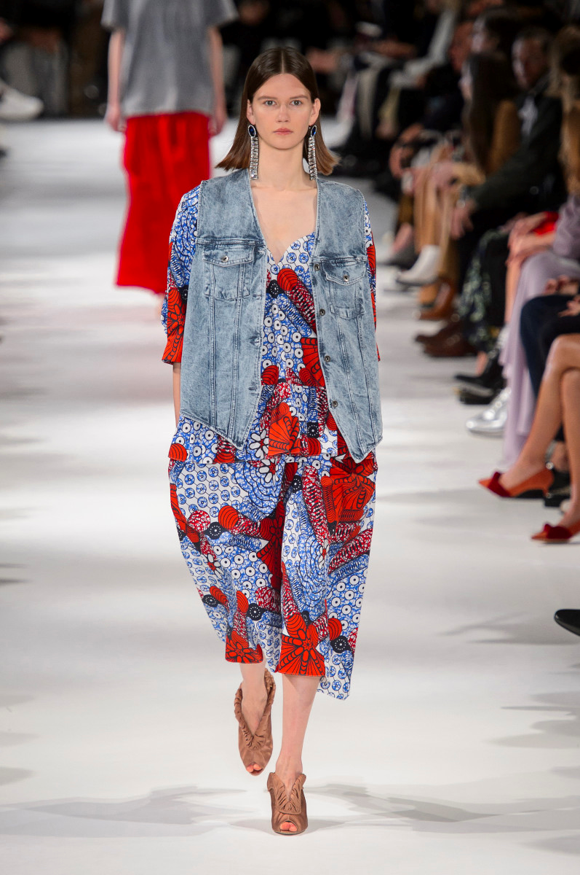
https://fashionista.com/.image/t_share/MTUwNDY1NTAyNTc2MTI0OTM4/mccartney-s18-083.jpg (accessed on 10 May2019)
This fashionable dress was designed by Stella McCartney for the 2019 spring collection. It was originally designed in the 80’s and now it has come back into fashion again. It represents contemporary fashion design. In this fashion show the model looks very glamorous with a Denim waist coat and a multi-colour half jumpsuit. This fashion dress indicates the changes in the seasons and the nature because when the season changes the fashionable clothes also change accordingly. In the above fashion show, the space is inside the room, full of audience and the catwalk surface is very bright and clean.

- Andre Courreges is a French fashion designer who was born in the Basque country of France in 1923. He studied as a civil engineer, although he was always interested in architecture and textile design. In the Second World War, he was a pilot in the Air Force.
https://www.fashionmodeldirectory.com/designers/andre-courreges/

Here is one of his fashion collection show.
- https://youtu.be/-oGI8KwNsFs?t=220 This YouTube video is Andre Courreges’s spring and summertime fashion show where all glamorous clothes are shown through the different models. Fashion show space is inside the room which is made by glasses and bright lights so all the audience can see perfectly and feel comfortable. When the set artist designed this space, he had in mind to put the close relationship between all the lights and the catwalk models so when the models walk on the stage all those lights come on at the same time. “It would seem, that it is through their “immensity” that there two kinds of space- the space of intimacy and world space- blends. When human solitude deepens, then the two immensities touch become identical” (Stilgoe,1969, p. 203). In history, fashion show space is different but now the space is changing so it is called ‘modernism’. This fashion show space made on modern style.

- Prabal Gurung is one of the most well-known fashion designers from the Gurung community. He was born in Singapore and grew up in Kathmandu, Nepal. After that he studied at New Delhi's Institute of Fashion Technology. In 1999, he moved to New York, USA. He has dressed some of the world’s most famous women; Oprah Winfrey, Michelle Obama and Demi Moore. Also, he designed for Kate Middleton, the Duchess of Cambridge (Wigham, 2011).
http://ste.india.com/sites/default/files/2014/08/11/241670-michelloprah540.jpg

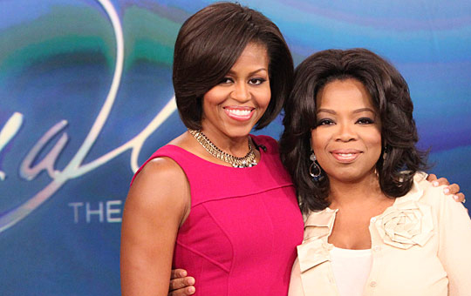

https://www.msn.com/sv-se/nyheter/utrikes/prabal-gurung-–-new-york-fashion-week-fw19/vi-BBTxrXG

This was Prabal Gurung’s fashion show week in New York in 2019. All fashionable clothes are contemporary. The context between the place of fashion show and cloth’s colour combination matches. The stage platform is very colourful and slightly dark where lots of audience are seated. The stage’s main message or theme is about colour which is related with the modern fashion, for example: clothes, shoes, bags, watch and make-up. His fashionable clothes designs are very attractive, perfect colour combination and the technique of design which inspires new learner generation.

Imagination fashion show on the High Street

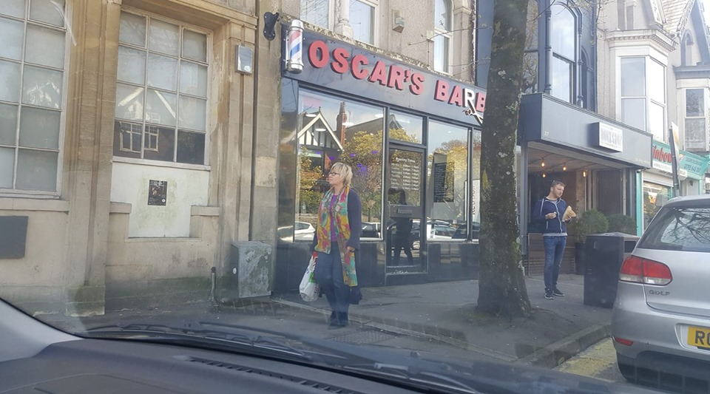
This picture is one of the imaginary fashion shows.
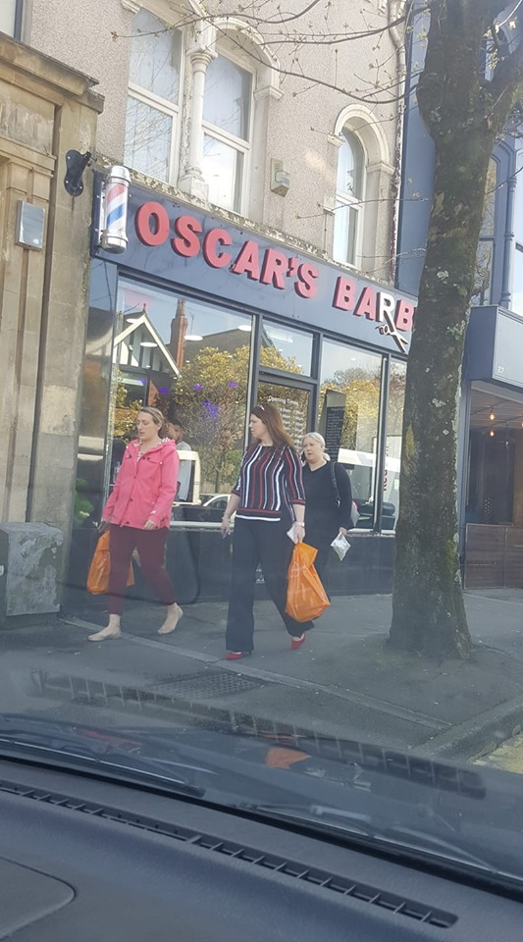
Fashion show (exhibition) will be held on the Swansea High Street because in this area is where most of the young generation of students. They come from different countries of the world, so the diversity of the places is present. Most of the students are modern and they love modern fashion. This is a very busy place where people walk everyday, public vehicles pass every second and they can see the show very easily through the window even though the people are not interested in fashion. However, different types of clothes and very attractive colourful dresses worn by models attract their eyes very easily. People are very curious about clothes, fashion and fashion shows. For the model also, feels natural just like walking on the street. This is a contemporary idea and a way to show the fashion.

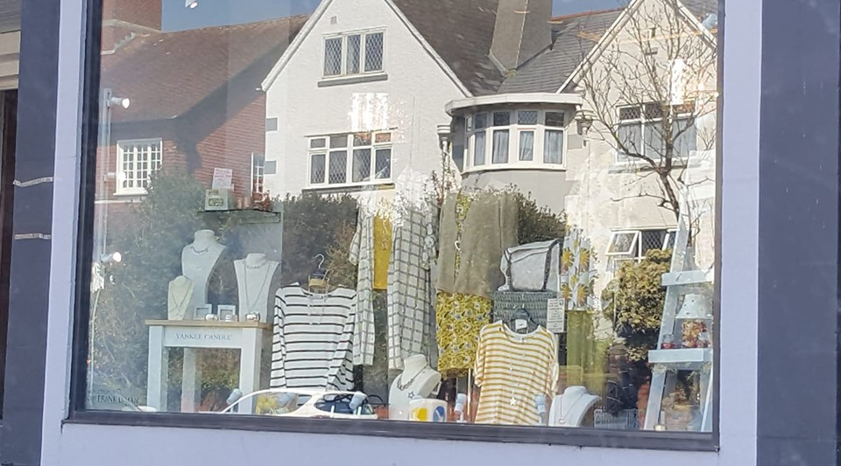

This shop is situated in High Street where lots of fashionable clothes are displayed. When people pass through the street they are able to explore and view the window displays to which their eyes are attracted. On the High Street when fashion shows are held, at the same time people can see the shop and they become curious about different types of fashionable clothes. Some of my collection will be displayed in this shop so customers will see and can examine them very comfortably. This is another idea to show fashion on the high streets. This shop’s picture is one of the advertisements which is true and real. “It is closely related to certain ideas about freedom: freedom of choice for the purchaser: freedom of enterprise for the manufacturer” (Berger,2008).

References:
Available at: https://www.bing.com/videos/search?q=andre+courreges+fashion+show&&view=detail&mid=CC8D74FCD00EC32205F3CC8D74FCD00EC32205F3&&FORM=VRDG/ (accessed on 12 May 2019).
Berger, J. (2008). Way of seeing, London: Penguin.
Design [online] Available: https://www.bing.com/images/search?q=alexander+mcqueen+wedding+dresses&qs=CustomSearch&pq=alexander+mcqueen&sc=8-17&cvid=9831D08AB71F42638EAF38F794439925&sp=7&form=QBIR (accessed on 4 May 2019).
Foley, B. (2019) ‘Bridget Foley’s Diary Views on Sustainability: Katharine Hamnett’, Fashion feature, 26th April. Available at: https://wwd.com/fashion-news/fashion-features/bridget-foleys-diary-views-on-sustainability-katharine-hamnett-1203116800/ (accessed on 8 May 2019).
Knox, K. (2010). Alexander McQueen Genius of a Generation, Great Britain.
Stilgoe, J. (1969). The Poetics of space, New York: Orion Press.
Wigham, H. (2011). Prabal Gurung. Available at: https://www.vogue.co.uk/article/prabal-gurung (accessed on 10 May 2019).

Bibliography:
Breward, C. and Evans, C. (2005). Fashion and modernity, Oxford: Berg.
Davis, F. (1994). Fashion, Culture, and Identity, Chicago: The University of Chicago press.
Barthes, R. (2006). The Language of Fashion, Oxford: Berg.
Black, J.A. and Garland, M. (1975). A History of Fashion, London: Orbis Publishing.

