Determination Of Concentration Of HCl using NaOH By Titration

Titration Lab Report

By Reece Allen, 222483

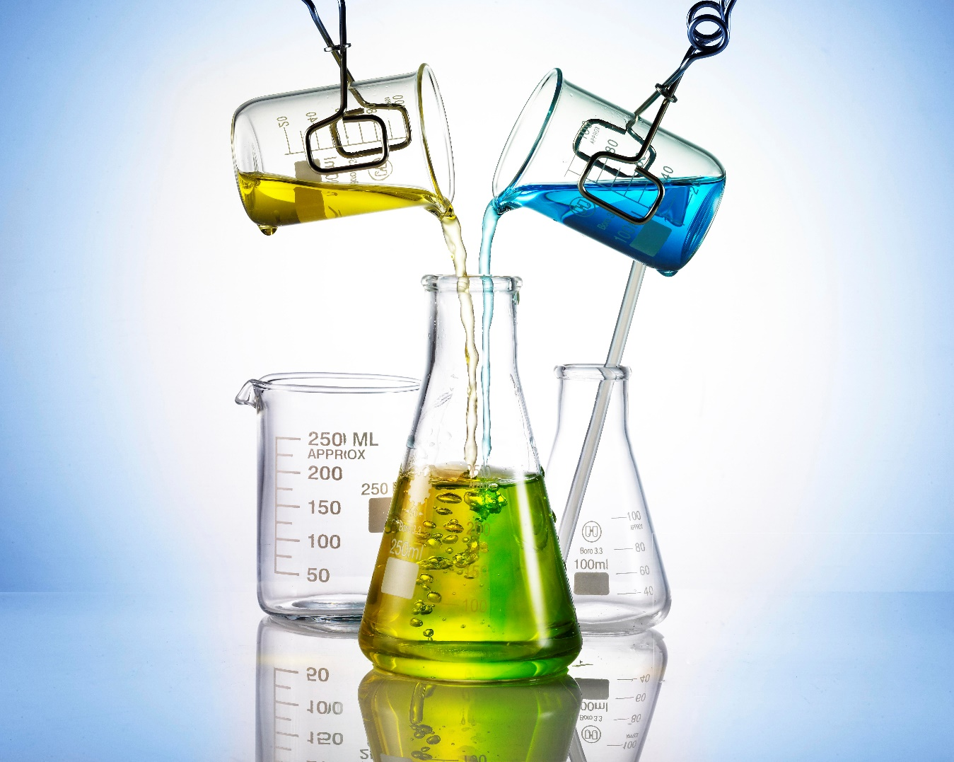

AIM
The aim of this experiment is to use a method of titration to determine the concentration of hydrochloric acid by using a solution of sodium hydroxide.

MAIN TASKS
Determine the volume of a standard solution of sodium hydroxide and how much is needed to neutralize a solution of hydrochloric acid by using titration.
Use the determined volume of sodium hydroxide recorded to calculate the unknown molarity of hydrochloric acid.

THEORY
Titration can be seen as a very precise method for measuring the concentration of a solution as its very simple and is an economical method. It is a quantitative and volumetric technique and is used to determine the unidentified concentration of a known analyte. There are several types of titrations such as acid-base, redox, precipitation, and complexometric. Titration is a gradual experiment as its important to apply small amounts of a solution to a known concentration (titrant) to a known volume of another solution of unknown concentration until reaction reaches neutralization. This procedure enhances the accuracy and purity of the colour of the solution as a change in colour will take place (indicator). The most common titration out of the four is acid base titration. This is usually used to identify the strength of an acidic or basic substance through acid base reactions. Throughout this report I will be discussing the experiment my partner and I carried out. The experiment involved the use of Sodium Hydroxide and Hydrochloric Acid.
The balanced equation for these 2 two substances is:
HCl (aq) + NaOH (aq) → NaCl (aq) + H2O (l)
Hydrogen Chloride + Sodium hydroxide → Sodium chloride + Water
As HCL is a strong acid and NaOH is a strong base these form sodium chloride and water due to a chemical reaction. NaCl is completely soluble in water as this is an acid-based reaction. When these reactants are situated in water, they disassociate from each other.
H+ + Cl- + Na+ + OH- → Na+ + Cl- + H2O (l)
Hydrogen + Chlorine + Sodium + Hydroxide → Sodium + Chlorine + Water
The spectator ions can now be removed simplifying the formula now making it.
H+ + OH- → H2O (l)
Hydrogen + Hydroxide → Water
To conclude this shows neutralisation of the experiment.

Definitions:
Analyte – A substance that is involved in any chemical properties to do with titration.
Indicator – A substance that goes under any type of visible change that occurs within a substance mostly a colour change.
Titrant – A substance of a known concentration that is added to a substance of an unknown concentration to cause a reaction.
Standard Solution – A solution that contains the exact amount of known concentration.
Neutralisation - A reaction that involves an acid and a base that reacts together to make it chemically neutral.
Formulae for experiment:
moles acid = moles base
We can then set the moles of acid equal to the moles of base
M_{A} + V_{A} = M_{B} + V
Where.
M_{A} is unknown and must be calculated
M_{B} is the molarity of standard base solution
V_{A} – volume of acid pipetted to conical flask
V_{B} – volume of base used to titrate acid in a conical flask
And solve it for M_{A}
M_{A} = $\frac{MB × VB }{VA}$
1 ml = 0.001 L (1 x $x{10}^{-3}$)

APPLICATION
Throughout my research of the method of titration I have learned that it can be used in various fields ranging from a scientific purpose to even the food industry. It is mostly used to determine the concentration in a substance. Scientists can use a standard form of titration to work out acidic measurements of rain and snow. This is caused due to the number of elevated hydrogen ions. Another example found with titration is the salt determination of cheese this is an extremely popular method within the cheese industry same as wine distilleries as its used to enhance the flavours of the products. It is also used by pharmaceutical companies and the OME (Ordnance, Munitions and Explosives) industry. From an explosive perspective titration can identify where and who made the explosives which can be beneficial to supporting our allies. It can also help our researchers to guarantee the explosive has not been altered by any chemical compounds ensuring it is stable and to measure the pH level.

APPARATUS

CHEMICALS
- 100ml of HCl solution
- 100ml of standard NaOH solution, c = 0.1002 mol/L
- Phenolphthalein Indicator

EQUIPMENT
- Calibrated volumetric glassware
- Burette, 50ml
- Pipette, 10ml
- Conical flask
- Small funnel
- Beaker for waste
- Pipette filler
- Burette stand with clamp

METHOD
Safety equipment and clothes must be worn when carrying out this experiment;
- To start with, pipette was washed out with a small volume of HCl and discarded in the waste beaker. These steps were then repeated with the burette and NaOH and the conical flask was washed with a small amount of de ionised water.
- Secondly, the burette was used to measure the NaOH solution ensuring that the bottom of the meniscus rests on 0.
- The initial reading was then recorded.
- 25ml of HCl was then placed in the conical flask by using a pipette and pipette filler.
- 3-4 drops of phenolphthalein indicator was added to the flask and swirled gently.
- Steps 3 and 4 were then repeated.
- The NaOH was put through the tap of the burette until a few millilitres before the rough titre value. It was then ran dropwise unto the flask ensuring it was being constantly swirled until the solution turned light pink.
- Lastly, steps 6 and 7 were repeated throughout until results wanted were obtained.

EXPERIMENTAL DATA

Titration data sheet
Flask | 1 rough titration | 2 | 3
V HCl (ml) from pipette | 25.00 | 25.00 | 25.00
Initial burette reading | 0.00 | 17.10 | 24.10
Final burette reading | 17.10 | 33.80 | 40.60
V NaOH (ml) | 17.10 | 16.70 | 16.50
Moles of NaOH | 1.713 x${10}^{-3}$moles | 1.673x${10}^{-3}$ moles | 1.653x${10}^{-3}$ moles
Moles of HCl | 1.713x${10}^{-3}$ moles | 1.673x${10}^{-3}$moles | 1.653x${10}^{-3}$ moles
Molarity of HCl | 0.069 mol/L | 0.067 mol/L | 0.066 mol/L

CALCULATIONS

From the titration data sheet:
Average titre = $\frac{titre 2+titre 3}{2}$
Average titre = $\frac{16.70+16.502}{2}$
Average titre = 16.60 mL = $16.6 x{10}^{-3}$ L = Vbase
At end point:
nacid = nbase
as n = cv:
cacid × Vacid = cbase × Vbase
To find concentration of HCl (cacid):
cacid = 𝑐𝑏𝑎𝑠𝑒 × 𝑉𝑏𝑎𝑠𝑒𝑉𝑎𝑐𝑖𝑑
cacid = 0.1002 ×0.01660.025
cacid = 0.067 mol/L

CONCLUSION
To conclude this experiment involving titration was a success as we met the aim as the end point was reached making sure the experiment was a light pink and with the results the molarity was calculated of the hydrochloric acid. Titration is a simple method and easy to understand which allowed me to fully understand the experiment and analyse the results. The only negative with the titration process is visually noticing what shade the results are as this can be different depending on who is carrying out the experiment as its human error.

DISCUSSION
Salt Analysis of Cheese by a Simplified Method - ScienceDirect
Titration | Definition, Types, & Facts | Britannica
3.13: Titrations - Chemistry LibreTexts

