Name: Rehman Ismail

Student ID: 1908396

Module: BMMB7003D Dissertation

Dissertation Supervisor: Roisin Mullins

Project Title: Investigation into the use of Artificial Intelligence (AI) Technologies to Sustain Business’s during Covid-19 Pandemic

Declaration

This work has not previously been accepted in substance for any degree and is not being concurrently submitted in candidature for any degree.

Signed: Rehman Ismail (candidate)
Date: 31/01/2023

STATEMENT 1
This work is the result of my own investigations, except where otherwise stated. Where correction services have been used, the extent and nature of the correction is clearly marked in a footnote(s).

Other sources are acknowledged by footnotes giving explicit references. A bibliography is appended.

Signed: Rehman Ismail (candidate)
Date: 31/01/2023

STATEMENT 2
I hereby give consent for my work, if accepted, to be available for photocopying and for inter-library loan, and for the title and summary to be made available to outside organisations.

Signed: Rehman Ismail (candidate)
Date: 31/01/2023

Acknowledgments

I would like to express my sincere thanks to my dissertation supervisor, Dr. Roisin Mullins for her guidance, advise, guidance and support throughout my MBA dissertation journey. I would like to express my appreciation as she has given me outstanding support and encouragement through this process.
I would also like to thank Dr. Alex Bell whose guidance has aided greatly.
Thank you.

Abstract

Project Title: Investigation into the use of Artificial Intelligence (AI) Technologies to Sustain Business’s during Covid-19 Pandemic. How Adoptive were Artificial Intelligence (AI) Technologies in aiding Small-to-Medium Sized Enterprises (SME’s) during COVID-19 Pandemic?
The purpose of the project is to undertake and investigation into the “The adoption of Artificial Intelligence technologies in Business Operations: An Examination of the use of Artificial Intelligence Technologies to Sustain Businesses during COVID-19 Pandemic for Small-to-Medium Sized Enterprises”.

It is important to investigate into how Artificial Intelligence was utilised during Covid-19 as the world went into lockdown during the pandemic and how Artificial intelligence technologies were used to sustain and support business’s competitiveness as many businesses went bankrupt and others survived. The investigation will try to examine if and how artificial intelligence technologies were utilised to enhance business standing during covid-19 and what barriers business may face in implementing such technology.

Aims, Objective & Deliverables of the Project are to research and carry out literature review on Artificial Intelligence (AI) technologies for SMEs, and what it means to be an SME – their problems and requirements during Covid-19 Pandemic in regard to applying AI technology. To analyse artificial intelligence (AI) technologies and carry out comparison of products available on market compared to standard systems used in business. This will provide scope on what type of artificial intelligence (AI) technologies are available for SME’s. Carry out a survey to measure SME’s attitude towards Artificial Intelligence (AI) technologies. A research survey will be carried out with SMEs to participate in to measure their views on Artificial Intelligence (AI) technologies and successfully conclude if Artificial Intelligence (AI) technologies are suitable for SME’s or not by analysing SME’s research survey data. And finally to recommend and document a set of guidelines of how SME could acquire and adopt artificial intelligence (AI) to their business operations. Produces a set of guidelines of how SME’s can acquire and adopt Artificial Intelligence (AI) technologies

The objective and deliverables will be achieved by following a project plan that follows tasks step by step and by meeting each milestone. Each objective will be regarded as a milestone which will be achieved accordingly on a timescale. This will be documented and organised in the form of a project plan and Gantt chart with regular meetings with project supervisor for support and guidance.
Contents
Declaration 2
Acknowledgments 3
Abstract 4
Introduction 7
Literature Review 9
What is Artificial Intelligence? 9
What is a SME (Small-to-Medium Sized Enterprise)? 11
What are AI requirements of an SME? 11
SWOT Analysis of Artificial Intelligence for SME’s 12
Artificial Intelligence Technologies 14
Current AI Platforms 14
AI Tools & Applications 16
Artificial Intelligence use in Business 20
Artificial Intelligence Utilisation in the Retail Sector 21
Artificial Intelligence Utilisation in the Hospitality Sector 24
Artificial Intelligence Utilisation in the Construction Sector 27
Artificial Intelligence Utilisation in the Manufacturing Sector 29
Covid-19 Pandemic Business Impact 32
Business Response to Covid-19 Pandemic 35
AI Adoption Gap in Business 39
Horizontal v Vertical Strategy 39
Investigators v Experimenters of AI 40
Adoption Barriers to implementing AI 41
Survey Research 45
Research Methodology 46
Research Design 47
Data Collection 47
Survey 47
Sampling Framework Selection and Size 49
Data Analysis and Technique 50
Ethics 51
Reliability and Validity 52
Limitations 53
Resources 54
Data Analysis of Results 55
Demography Analysis 55
Graphical Analysis 57
Analysis of AI adoption and utilisation 61
Normality Test 64
One-Sample Kolmogorov-Smirnov Test 64
Hypothesis 65
Analysis of Research Hypotheses 65
Binomial test results for hypotheses 1-4 66
Kruskal-Wallis test results for hypotheses 5-8 67
Key Findings 68
Conclusions and Recommendations 69
Conclusion 69
Recommendations 74
Project Artifact: How SME’s can acquire and adopt AI Technologies 75
References 76
Bibliography 94
Appendices 99
Ethics Form 99
Questionnaire Survey 117
Survey Data Results 126
Project Management Gantt Chart 128
Supervisor Logs 129

Introduction

The Covid-19 pandemic crisis presented unprecedented disturbance in the global economy especially to the prosperity of nations as well as to their internal well-being with business’s facing financial uncertainty and economic panic with lockdowns being announced around the world all over. The World Health Organisation initially received reports of unexpected virus infecting groups of people in China in late 2019 which then had spread all over the globe eventually reaching the UK therby affecting business and local economy (Zhang, 2021).

The pandemic took time to manifest itself which would eventually result in huge change of how societies operated especially how businesses dealt with the economic fallout and having to change the way they operated by investing in new technologies to continue to sustain themselves (Lu, H, 2020).

It was then on 11th March 2020 that the UK Government in conjunction with the Bank of England started to formulate and announce new financial and monetary policies that would support and deal with the unprecedented economic downturn the country faced as the economy came close to collapsing posing a national security matter as the system faced existential risk due to business downturn (Hourston, 2022). Furthermore, by February 2020 that OECD (Organisation for Economic Co-operation and Development) was raising alarm and alerting countries worldwide of severe global economic downturn. Upon the outbreak, the UK government then issued many public health guidelines, laws and rules for everyone in the country apart from front-line key workers to work from home if they can which led to the immediate shutting down of various sections of the economy and financial system (OECD, 2020).

The pandemic caused a very volatile sudden shift in the business environment especially how people and how society continued to function with the aid of technology. The pandemic has been linked to the cause of lower sales and profits for business’s due the consequences of the lockdown which acted to save lives and keep people safe from the virus but also caused a reduction in household income due to economic business downturn (Gopinath & Agarwal. 2021).

Kendrick (2021) states that “the pandemic crisis accelerated the adoption of analytics and AI, and this momentum will continue.” To maintain a decent and healthy functioning economy during the pandemic, a very high level of adoption of technology and digitisation was needed if businesses were to continue to remain in business and operate during the pandemic. Healthcare and retail were key sectors that were impacted by the use of artificial intelligence, which allowed these sectors to replicate human like intelligence through algorithms and machine learning applications.

In addition, AI has developed and evolved recently which allows for deeper computational analysis as we enter the age of Big Data as evident with the World Health Organisation also giving warning that artificial intelligence may be key if not critical to solving and managing the pandemic crisis to give rapid data analysis and solutions to possible future vaccines (Sivasubramanian, 2020).

Literature Review

What is Artificial Intelligence?

The term Artificial intelligence can stir many emotions in different people, as movies have portrayed it at a concept that can harm society but in business terms it has come to be used as a measure of success that aids business’s in solving problems in society. As Ertal (2018) states “artificial intelligence can outperform humans in many multiples” which been proven in recent feats where artificial intelligence was used in the Covid-19 pandemic (Ertal, 2018, p.2).
Ertel (2018) defines artificial intelligence as “an area of study in the field of computer science. Artificial Intelligence is concerned with the development of machines to engage in human like processes such as learning, reasoning and self-correction” (Ertal, 2018, p.2). However, Sabouret (2020) states that “artificial Intelligence is not about making computers intelligent. Computers are still machines, they simply do what we ask of them, nothing more ” (Sabouret, 2020, p.3). Simply put, AI is a very advanced field of technology. In addition, Joshi, P (2017) states that “artificial intelligence is a way to make machines think and behave intelligently. These machines are controlled by software inside them, so AI has a lot to do with intelligent software programs that control these machines. It is a science of finding theories and methodologies that can help machines understand the world and accordingly react to situations in the same way that humans do” (Joshi,2017,p.8)
Investment in Artificial Intelligence technologies by developed countries is growing year on year by governments around the world. As part of the UK Governments Cyber & Innovate UK strategy, the government is investing heavily into the AI sector. This is in addition to private capital investment by companies too where, Grech (2021) states that “AI is one of the UK’s fastest-growing tech sectors, with venture capital investment in UK AI companies currently at £3.3bn thus far in 2021, already surpassing the $3bn invested in 2020.” Regardless of the heavy investment in the UK AI sector, investment has been slow as Glover (2021) states “when it comes to AI adoption the UK is lagging behind the rest of Europe”.
Though there is a lot of investment into AI development by the UK government and the private sector, adoption of AI has been slow in the UK to be fully utilised and is still seen a niche area of development however this is set to change as AI develops further. With AI technology being developed very quickly, there is a concern of how easily it is able to be adopted and implemented by business organisations to enhance their operations especially during the Covid-19 pandemic (Hradecky et el, 2022).
El-Hanfy (2021) states “Innovate UK has largely supported start-ups and SMEs developing disruptive products. Less support is being received by firms looking to exploit the potential of AI to drive productivity within their organisations. AI developers struggle with end user engagement. There is also a lack of understanding about the effectiveness of using AI to address individual challenges within the firms looking to adopt AI.”
With current technological trends and countries are investing heavily in artificial technology, it can be argued that artificial intelligence will be key to enhancing and changing the way businesses operate to maintain their competitive edge. As Covid-19 pandemic hit the world forcing countries and businesses into lockdown, the way people and business’s operated changed across the world where business models had to be changed to adapt to online working during the pandemic.

Jakhar & Kaur (2020) state that “most of the organising bodies and institutions are shifting towards virtual meetings; e-conferences and digital learning. AI-powered platforms make these meetings more intelligent and interactive. For example, AI-based chatbots acts as virtual assistants and provide useful information as well as answer to questions of the end users” (Jakhar & Kaur, 2020, p.132)

Huang, L (2019) believes that there are four types of artificial intelligence:

- Reactive AI - is regarded as the most basic form of AI because it reacts to existing conditions. For example, Deep Blue, a supercomputer was made by IBM in the 1980s competed and won a chess match against the current reigning world champion at the time (Ward & Marr, 2020). It won the match because it was programmed to predict expected results based on the inputs it received. Champandard (2003) believes that reactive AI applications are only able to respond to situations they have been programmed to predict, for example spam filters and recommendation engines in Google, Amazon and Netflix utilise reactive AI applications.

- Limited AI - is regarded as having the ability to learn data and improve over time based on experience, this is often referred to deep learning where AI models are trained automatically to update themselves on complex and historical data to make predictions. Sestino et el (2022) believe that an example of AI deep learning AI is self-driving cars where the sensor on cars is constantly collecting data based on algorithms and observing its environment to adjust its speed and decision making when in use .

- Theory of mind AI – is an area that seeks to replicate the capability, understanding, behaviour and emotions of humans via android robotics and other applications. Although this area hasn’t been fully achieved there have been great advancements towards it for example with the development of humanoid robot, Sophia is able to replicate basic human characteristics, but development is still ongoing (Telving, 2022).

- Self-aware artificial intelligence - is regarded as the final frontier of AI where machines are aware of emotions and are self-aware and have become sentient to the same level of human consciousness if not supersede human intelligence. It is an advanced area of AI which is developing and being heavily invested into. However, some scientists believe that such self-aware AI will pose moral and ethical issues for society in the future (Takeno, 2020).

What is a SME (Small-to-Medium Sized Enterprise)?

SME is the abbreviation for Small to Medium Sized Enterprise. Sheehan (2013) believes that SME’s can be defined and classified by the number of employees and the turnover it has which can differ from region to region in the world.
The UK Government HMRC department defines a SME as a business that has fewer than 500 employees with a turnover less than £100 million. However, the EU defines a SME as a business which has less than 250 employees with a turnover below £50 million (HMRC, 2020).
Andrews (2022) states that “Small and medium-sized businesses are the backbone of much of the UK economy”, for this reason it can be viewed that UK is a nation of SME’s as they are a SMEs are a major employer in the UK.

What are AI requirements of an SME?

When developing AI applications and solution for SME’s, AI requirements will vary but will usually fall under four types of requirement classifications:
- Functional Requirements – Maciaszek (2007) states that “functional requirements define a service expected of the system” (Maciaszek, 2007, p.79). Simply put, functional requirement is what the systems should do, for example the AI system should follow the rules set by the parameters coded in its programming logic.

- User-Level Requirements – Carkenord (2009) states that “user Level requirements are specifically associated with the user problem to be solved” (Carkenord, 2009, p.26). It is what the user wants to do on the system, for example print, add and delete records.

- Non-Functional Requirements – Maciaszek (2007) defines non- functional requirement as “constraint that the system must obey” (Maciaszek, 2007, p.79). For example an AI system would need to operate on a daily basis for predictive analytics with 24/7 data feeds for forecasting.

- Business Level Requirements – Carkenord, (2009) states that “business requirements are High-level needs that will permit the organization to address issues such as increase revenue, avoid costs, improve service, and meet regulatory requirements” (Carkenord, 2009, p.34). For example, AI systems will allow organisation to automate most of its internal processes therby saving time and cost.

SWOT Analysis of Artificial Intelligence for SME’s

SWOT analysis has been carried for SME’s who may wish to adopt AI technology in their organisation:
Strengths
- Increases productivity - Davenport et el (2019) believes that AI can manage everyday tasks via automation which can save business’s money and time therby freeing up staff resources.
- Adaptable to many industries- AI is adaptable and applicable to many industries from marketing, health care to finance making it a commercially available technology to apply to different sectors
- Can improve better quality of life – AI is being applied outside of business workplaces such as within homes and social settings too, utilising smart AI devices such as smart doorbells, music systems, smart phone, virtual assistants etc (Sinonquel & Bisschops, 2021)
Weakness
- AI is in-human – AI can replicate human behaviour but is not able to fully replace humans as certain decisions would need human intervention and having a computer make instant in-human decisions based on automation can cause moral, ethical and social issues.
- Government investment is slow – investment by government is large but comes at a slow pace as at times which can cause countries to lose competitive edge as government may lack understanding of technology or not prioritise it as part of their governing brief (Ran, 2021)
Opportunities
- Adoptable to new technology- AI is now replacing old technology and simultaneously introducing new forms of technology such as Internet-of-Things (IoT) being applied to many different industries
- Enter new markets – Wagner (2020) believes that early adopters of AI can gain competitive advantage and allow them to enter new markets therby increasing sales and revenue
- Improve employee efficiency – AI allows for the automation of trivial processes which can free up employee to focus on other tasks and issues
Threats
- Loss of control due to automation- organisations could lose control of processes as automation takes over leading to companies being too dependent on AI
- Job Losses due automation – AI poses a threat to jobs as automation replaces human labour which can impact society with unemployment (Johnson et el 2022).

Artificial Intelligence Technologies

Current AI Platforms

There are many AI applications and technology platforms that are available to businesses of all sizes which they can acquire and adopt within their organisations:
Microsoft Azure AI

Azure AI, launched in in 2010 to offer businesses a strong platform for cloud computing and AI services and has advanced significantly in comparison to its rivals (Govindarajulu et el, 2022).
Microsoft Azure AI services is aimed towards programmers and data scientists. It has a large library of AI services which can be utilised. Tok et el (2018) believe that businesses can develop and deploy customised AI solutions by utilising Azure AI's flexibility, decades of ground-breaking research and ethical AI standards for which Microsoft is renowned for.
There are many advantages of Azure AI, first and foremost being costs. When compared to its main competitors, majority of services are very affordable (Barnes, 2015). In addition, it offers the finest AI, machine learning, & analytics services on the market and is regarded as having universal migration and integration services which are easy to implement. However, Xiao (2019) believes that Azure has fewer services than its rival Amazon and is aimed at corporations which may exclude smaller business due to limited budget constraints compared to big corporates.
Azure AI provides a serverless computing solution, as well as other IoT analytics and management services and cognitive service tools such as the Bing Web Search API, Face API etc (Pathak, 2017).
Amazon AI

Amazons offers a wide range if AI services, it most popular AI services is Amazon Alexa an Echo which were developed and launched in 2013.
Amazon Web Services (AWS), Amazon AI is a collection of AI solutions that provide deep learning and machine learning technology. It is aimed at business of all sizes as is cost model is adaptable from pay as you go to annual service. (Lorne & Gogireddy, 2021).
There are many advantages of Amazon AI services, for example it has the largest AI library of services in the market compared to its rivals which also includes robotics and networking. Song & Tripuraneni (2019) believe that amazon has the best AI security on the market and is very reliable compared to its rivals as it has more computing processing power than Azure AI, however Dabit (2020) states that that “for beginners of AI, amazon sheer number of services on offer can be overwhelming” (Dabit, 2020, p.4) as there is too much choice, furthermore Amazon requires third-party software vendors to pay if Amazon services are being used which can add extra cost (Golden, 2013).
Amazon web services key tools AI tools are Machine Learning and AI which allows developers to implement algorithms for character recognition, image recognition, and object recognition in addition to many other services.
Google AI

Google AI is Googles AI department, which formed in 2017 (Gibney, 2016). Google has been deploying AI systems since 2015, primarily to interpret English language which has been utilised to enhance its search engine. It launched machine learning and AI services for business of all sizes recently (Chojecki, 2020).
The key advantage of Google AI is that it is complements other google products and services, however as states Vieira & Ribeiro (2018) that “compared to Amazon and Azure, Google AI has limited services available” (Vieira & Ribeiro, 2018, p.32) In addition, there is very limited support and assistance for business users.
Google AI’s key tool range from speech recognition, translation, and natural language processing including IoT and cloud computing services which a leading area of AI development (Karkeraa, 2020).
Conclusion

The three AI service providers are engaged in intense competition to address the current trends to provide tools and services to its customers. Ismail (2018) states that “the AI Industry growing in the UK and the desire for AI roles is growing at a rate faster than in the US, Canada, & Australia”, therby AI is giving Britain's labour market a boost and enhancing its position as a global tech leader (Marr, 2019).
Azure AI is used to enhance the applications with speech, vision, language, & decision-making capabilities, develop chatbots, and find information with AI-powered search. The goal of Amazon's AI capabilities is to give customers the most precise and bespoke product possible.

Every service provider responds differently to the specific needs of every organisation, which has unique requirements. For instance, the way in which a software engineer, a financial company, and an e-commerce business employ AI service will vary and yield different results due to the differing regulatory compliance rules that apply to them. While AI providers may supply comparable services to other businesses, they usually carve out a niche that appeals to their customers.

AI Tools & Applications

There are many AI tools and application that can be used in business:

Machine Learning

Awad & Khanna (2015) define Machine learning as “branch of artificial intelligence that systematically applies algorithms to synthesize the underlying relationships among data and information” (Awad & Khanna, 2015, p.1). It can be applied to a wide range of tasks, for example photo recognition in phones powered by Apple or Google AI uses algorithms inspects the elements present in the images and categorises them, however as Mueller & Massaron (2021) states that “machine learning relies on algorithms to analyse huge datasets” (Mueller & Massaron, 2021, p.11). Machine learning can be utilised by many sectors where it can be utilised from online customer support to advanced data analysis and forecasting.

Deep Learning & Neural Network

Artificial neural network algorithms designed to mimic the functioning of the human brain are used in deep learning, which is a type of machine learning that learns from vast amounts of data. Mehlig (2021) states that “neural network algorithms for machine learning are inspired by the architecture and the dynamics of networks of neurons in the brain. The algorithms use highly idealised neuron models. Artificial neural networks learn by changing the connections between their neurons. Such networks can perform a multitude of information-processing tasks. Neural networks can for instance learn to recognise structures in a data set and, to some extent, generalise what they have learnt” (Mehlig, 2021, p.37). Simply put, Deep learning is a term for neural nets with many layers.
Deep learning requires very large data feeds for it to be fully trained in categorising data and predicting accurate models autonomously, as Abdou et el (2012) “deep learning system must be taught on big data sets, as the more data it is fed, the more effective it will be” (Abdou et el, 2012, p.151). For this reason, deep learning requires a lot of resources as states Alkhaddar et el (2012) “high-performance computers are crucial for deep learning models because they require a lot of time to train on massive volumes of data” (Alkhaddar et el, 2012, p24).
There are many are many advanced uses of deep learning:
- Social Media- it is used by social media companies where deep learning is applied to learn about online user behaviour and analysing the vast number of images and videos that are uploaded to online platforms allowing targeted advertisements to be focused on certain user segments to increase ad revenue.
- Banking & Finance – it is used to forecast stock and share prices, formulate trading plans and safeguard against fraud
- Healthcare – is used to analyse the vast amounts of data of patients to formulate best treatment plans and safeguard public health
- Cybersecurity – it is used to detect advanced online threats by analysing network traffic
- Digital assistants - it used in smart devices such as Siri, Alexa and Cortana which makes use of Natural-language processing (NLP) to respond to human requests and queries

Robotics

The automobile and manufacturing industry uses robotics heavily and is by far the greatest user of robotics however other sectors are also using robots too, most notably the hospitality, food and retail sector (Ford, 2016). In addition, Ngige (2022) states that “the food and beverage industry in the US installed 25% more robots last year to reach 3,402 units in 2021”, therby indicating robotics is being utilised at a consumer level within society rather than being used as a means of production.

The International Federation of Robotics (IFR, 2021) reported that “substantial" double-digit percentage growth in the market for robotic systems in the UK in 2021 and 2022.” It believes that governmental tax incentives will quicken the UK industrial sector's modernization. In addition, Autor et el (2021) believe that the pandemic didn’t stifle innovation or slow down the implementation of forward-thinking tactics of innovation but rather companies accelerated AI adoption to their businesses’ in order to deal with the pandemic's effects and prepare for future labour market shortages with the use of robotics.

In 2022, ABB Robotics conducted a study of 250 UK SME’s where the results of the study indicated that many of the SME surveyed see a shifts towards robotics and automation due to the pandemic (ABB Robotics, 2022).

Automation

Johannessen (2020) states that “AI automaton is on the rise with digital transformations occurring within society and organisation to improve efficiency and productivity with the aid of advanced automation technology” (Johannessen, 2020, p.37). AI automation has increased greatly in the finance industry, as Naqvi (2021) states that “around 80% of finance leaders have implemented or are planning to implement RPA (Robotic Process Automation)” as there has been a rapid growth in automaton in the finance industry and within others industry sectors too.

Automation increased greatly during the pandemic, and it is regarded that job creation may outpace job losses due to automation (Yoo et el, 2021). For this reason, leaders across the world including policy makers acted with the furlough scheme to restore the economy and ensure people weren’t forgotten about (Partington, 2020). Furthermore Schwab (2022) states that “COVID-19 hastened many companies transition into the era of the 4th Industrial Revolution of automation” (Schwab, 2022, p.28).

Virtual AI Assistant

Pieraccini (2021) states that “an Al virtual assistant is not just a large piece of monolithic software, but rather, it is made of a number of components, each designed to resolve a specific challenge, such as recognizing, understanding, and producing speech” (Pieraccini, 2021, p.4). Virtual AI assistants can do a range of tasks for consumers and companies.

Virtual AI assistants are frequently thought of as performing simple tasks for a company, however as Freed (2021) believes that their capabilities can go further with the aid of AI. The virtual AI assistant can handle and manage many tasks for example taking customer and company orders online, keep up a company's social media presence to taking payment on behalf of a company over the telephone including being an automated customer serviced chat-bot online (Soofastaei, 2021).

Virtual AI Assistant technology has become very ingrained in society and in people’s lives as many organisations and customers are reliant on it, as according to Hjartar (2020) “38% of consumers have used virtual assistant services on their smartphones with many enterprises adopting AI to deliver contextual conversational seamless and personalized banking services” (Hjartar, 2020, p.17). In addition, Virtual AI Assistants are able to make calendar appointment, automate tasks such as taking order and hotel bookings via smart learning and are able to be integrated to wider systems for commercial use for the consumer, for example a hotel may use a Virtual AI Assistant for its guests when it comes to room service and booking (Eboch, 2020).

Internet of Things (IoT)

Ismail (2019) states that “Internet of Things (IoT) is a recent technology that creates a global network of machines and devices that are capable of communicating and exchanging data with each other through the Internet” (Ismail, 2019, p.3) In addition, Hassan (2018) states that “IoT is a world of interconnected things which are capable of sensing, actuating and communicating among themselves and with the environment (i.e., smart things or smart objects) while providing the ability to share information and act in parts autonomously to real/physical world events and by triggering processes and creating services with or without direct human intervention” (Hassan, 2018. p.6).
It must be stressed that there is a between the Internet of Things and the Internet as Internet of Things is able to create information about the connected sensors, analyse it the data and make decisions based on the real-time flow of data. For this reason, it can be argued that the Internet of Things is ‘smarter’ and has more capabilities than the Internet as such (Greengard, 2015).
Security cameras, Smart TVs, smart fridges, smart vehicles and buildings with smart technology are just a few examples of the products that are part of this IoT rise. Businesses are increasingly connecting sensors to their internal systems and internet to transform them into artificial assets that will boost productivity, profit which will solve issues to existing problems for consumers and business (Tanczer et el, 2019)

Artificial Intelligence use in Business

The are many ways AI can be used in business:

- Better use of Data - artificial intelligence can be used to make better use of company data and understand trends and future forecasting with algorithms. In the world of big data there is more data than ever before allowing for more effective decision making to see if there are any important patterns. Modern cloud computing infrastructure allows the capability to basically automate some of the business processes and data analysis (Stephenson, 2018).

- Intelligent and personalised services – with huge amount of data on hand allowing for insights into customer habits , personalised services allow for a better and intelligent customer service. For example, Amazon and Netflix are famously known for providing personalised services to its online customer base by collecting huge amounts of data on likes and dislikes therby allowing it to promote certain content based off customer habits (McAuley, 2022).

- Smarter and more intelligence products – AI has been integrated in virtually all smart devices and sensors where it is always collecting data for example autonomous cars have AI built in them that slows them to monitor road and traffic to find best routes possible which leads to better intelligent products for future sustainability (Gawdat, 2021)

- Optimise business processes – AI allows business processes to be streamlined in addition to parts of the organisation to be automated making machines intelligently handle process’s therby saving manual human labour time and costs. For example, supply chains have become automated where robots handle and pick stock in certain sectors for example Ocado online shopping (Unhelkar et el, 2021).

Artificial Intelligence Utilisation in the Retail Sector

Retailers faced and experienced a crisis as well as an opportunity as a result of the pandemic outbreak. The pandemic forced retailers to operate in a more efficient manner and speeded up the sectors ongoing changes and transition to online selling. Physical bricks and mortar stores had to close due to the lockdown which led to customers and consumer shifting their focus to online retailers. This led to retailers having to digitise their business to online platforms in response to consumer and market habits changing.

Dickinson (2021) states that “non-essential retailers faced revenue losses of £22 billion and experienced a 40% drop in customer foot fall traffic in the year 2020”. In addition, the IMRG Capgemini Sales Index indicated that consumer shipping habits underwent a major shift where sales from online business retailers increased by 36% over 2020 (Sanlam Wealth, 2021).

The pandemic forced a significant re-organisation, development and diversification of supply chains across the world where countries faced supply issues of basic essentials such as from wheat to toilet paper which impacted manufacturing supplies including a short supply of electronic chips which impacted car manufacturers (Dathe et el, 2022).

Retailers were bound to adapt to the market and had to develop a strategy that would effectively manage their supply chain issues such as inventory and logistics including how to retain a customer base in a rapidly changing environment. Pre covid-19 pandemic, some retailers may have been hesitant to shift and invest to online, but the pandemic shifted customer shopping habits that it created a technology revolution where online stores are now being led and driven by artificial intelligence (AI) applications (Arora et el, 2020).

An increasing number of retailers are using AI technology to grow their long-term business strategy, for example AI is now being used for stock management in addition to demand forecast predicting, as well as automating profitability margins in addition to planning best delivery routes too in conjunction with optimising business efficiency and profitability (Borne et el, 2021). However not all retailers will be able to apply AI due to their size, lack of resources and capability to create, implement and apply AI solutions in their business (Lee & Trim, 2022).

Affronti (2020) states that “40% of the total of UK retail CIOs as well as CTOs stated their businesses must be making investments in AI prior towards the pandemic. Even by the climax of 2019, 72% of British businesses were already seeing a reasonable profit on their AI investments”.

As part of health and safety in line with COVID-19 guidelines, the general public were encouraged to download the NHS covid-19 app which would help track covid-19 exposure and cases in addition to logging their visit to retailers when shopping by scanning a QR code on arrival. This allowed retailers to effective management of footfall to report to the government if a covid case arose allowing real-time action and response to be taken by notification (Boudreaux et el, 2020). Retail businesses are now in a better position to identify such risks with the adoption of AI which has allowed decision makers within their respective organisations to take rapid decisions which safeguards their employees and the general public health whilst maintaining daily operational consistency (Li, 2020).

The pandemic put an enormous amount of economic pressure on retailers due to the resulting change of customers habits changing where customers stopped buying as demand fell and even where suppliers stopped or delaying payments which caused supply chains to collapse making it very difficult to change and find substitute suppliers.

Due to the nature of small-to-medium sized business limited resources the pandemic had a very negative impact on SME business’s profits where they faced cash flow issues, and as much as 80% of UK SMEs faced such issues (Drydakis, 2022). Nearly one-third of SME’s adopted and utilised AI chatbots on their online platforms as well as other AI-based digital technologies throughout 2020. Despite their size, 40% of UK businesses intended to absorb in AI in 2021 to aid in preparation of economic recovery following on from the pandemic (Drydakis, 2022).

There are very few risks to implementing AI applications for retailers as AI technology enables the increase of reach of customers online, provides accurate forecasting in addition to analysis of cash flow and aids HR department to make staffing decisions in regard to resource planning (Eubanks, 2022).

There are many ways AI can be applied to SMEs in regard to their business department functions internally and externally which allows for further improvements to be made to the organisation as a whole. For example, AI algorithms can predict better accurate sales trends and in addition to predicting consumer habits which can be used to enhance marketing with the use of sensor systems such as Internet of Things which monitors customer physical activity such as temperature analysis, crowd control and foot fall traffic in physical store fronts during the pandemic (Akpan et el, 2022).

In addition, AI can aid in risk planning as sales prices could go up or down in line with market volatility, and aid HR departments for resource planning, for this reason SME’s can take advantage of such technology which analysis internal and external data with the use of Machine Learning to make better informed decisions for financial management of the company.

For example, an omnichannel marketing retailer can ensure that its interactions with its customers is engaging and available 24/7 via the use of chatbots. Developing such personalising engaging programmes with AI can increase customer engagement in the UK retail sector (Duak, 2020). Additionally, it facilitates the customisation and personalization of customer interactions. meticulousness when managing the data with chatbots using artificial intelligence, for example online retailers such as Amazon, AO.com, Boohoo all have chatbot facilities that allow customers to interact and log automated customer service questions (Lok, 2019).

In addition, Virtual mirrors and visual search are two AI-based breakthroughs which can help clothing retailers communicate with customers more effectively and close the gap between in-person and online buying by allowing a virtual search and demo of the clothing products online thereby enhancing the customer engagement and experience online. For example ASOS, an online UK based retailer has already introduced visual search and virtual mirroring on its platform where it saw conversion rates from browsing to sales increase exponentially thanks investment in the AI powered application (Soloman et el, 2019).

Artificial Intelligence Utilisation in the Hospitality Sector

Shapoval et al (2021) state that “In 2019, the UK's hospitality industry contributed £59.3 billion, or about 3%, of the country's total financial output”. In addition, Shapoval et al (2021) state that “every region of the UK roughly 3 to 5% of businesses are hotel or restaurant employers”. The hospitality sector is a large employer of people and in March 2020, nearly 2.5 million hospitality vacancies were advertised showing that it makes up 7.1% of the total UK workforce employment market (Hardie et el, 2022).

The UK hospitality sector tends to hire a large population from abroad where work is usually part time and well suited to younger people who may be studying full time and working part time which leads to the hourly pay rate to be lesser in the hospitality sector compared to other sectors in the economy but none the less it is vital sector which creates employment.

Business’s all over the world had faced severe issues as a result of the pandemic, however the global lockdowns and curfew restrictions imposed by governments around the world also boosted technology use allowing for more data to be collected than ever before of human pattern behaviour during a pandemic particularly for the hospitality industry. Artificial intelligence (AI) has made advancements which have had the potential to transform the hospitality market for example with the use of AI and machine learning. Machine learning has become the most advanced and intelligent methods to be utilised for the industry to cut costs whilst increasing revenue and efficiency, such smart technology has become vital to the travel and hospitality sector (Hardie et el, 2022).

The hospitality industry has had to adapt in amongst the pandemic turmoil as travel restrictions were imposed during the pandemic lockdown, this led to the industry having to rethink the potential benefits of AI along with the use of other systems such as robotics and advanced virtual assistant chatbots to allow smoother booking online therby reducing headcount on physical staff to save costs as automation was introduced.

AI automation has allowed for a better delivery of services allowing AI-driven innovation to deliver services via robotic systems. The adoption of AI-driven innovation in delivering services is a result of recent advancements in AI and service robotic systems.

Hospitality businesses have been compelled to seek technical automated replacements because of decreased staff as well as heavy workloads in addition to facing severe staff shortages in the industry due to the pandemic where people in society have changed jobs and careers to other sectors in demand. The hospitality industry could save quite a lot of money by investing in such AI driven robot installations, even though Artificial intelligence is rarely inexpensive but the return on investments would pay for itself and yield greater returns for the long-term stability of the sector and business in it (Moxness & Moxness, 2021).

The core sections of the hospitality sector have been severely impacted by the COVID-19 pandemic. Although the sector was already in regional crisis prior to the pandemic and other economic shocks, the covid-19 pandemic had a profound effect and was unparalleled in comparison to earlier economic shocks like short term recessions or natural disasters, therby forcing the business to innovate new way to survive by adopting AI applications (Ntounis et el 2022).

The pandemic imposed restricted travel rules and regulations which restricted the movement of people leading to a negative effect on the world economy and the travel , tourism and hospital industries where air travel came to a standstill and tourism stopped. Schwab 2022) states that “impacts of the pandemic threaten approximately 100 million employments inside the travel, tourism and hospitality industry. These industries are struggling just to stay alive, let alone grow and need to adapt to new technology to survive” (Schwab, 2022, p.15).

The hospitality sector is interdependent on travel and tourism where accommodations enterprises such as hotels faced great disruption due to the pandemic. Hotels became very vulnerable due to the downturn in tourism where hotel bookings plummeted as well as commercial events were cancelled or postponed making business very difficult for hotels.

The pandemic was not anticipated by the hospitality industry and was very unwelcome leaving the sector very little or no time to prepare for the downturn. The pandemic brought about lack of organisational planning that what would have been expected compared to conventional crisis the sector has faced in the past. Earlier travel crisis’s that were brought on by health epidemics such as Ebola and Influenza had impacted the sector previously before but not as severely as the covid-19 pandemic where tourists may have felt hesitant in traveling and staying at a hotel where there might be health and safety risk in times of epidemic crisis’s.

In addition, sanitation and hygiene are crucial to hotel operations which has altered peoples' perspectives in staying in hotel rooms (Canhoto et el, 2021). To address sanitation issues and assure tourists, hotels are now adopting AI powered robots which clean and sanitise hotel room using sensor technology. For example, the Travelodge hotel chain in 2022 introduced AI robot vacuum cleaners that would aid its housekeeping teams across 579 of its UK hotels (Gill, 2022).

The COVID-19 pandemic has offered the hospitality industry a lot of opportunity to deepen their understanding of AI and robotics and expand their utilisation and as a result, it can be claimed that the pandemic was an ideal time to adopt to AI technologies. For example, many hotels have accelerated the adoption of artificial intelligence and robots in the hospitality sector. For example, the Crown Plaza in London has rolled out a robot service in its hotel where it delivers snacks and toiletries for room service during the pandemic (Abril, 2022)

In addition, to give guests access to a variety of alternatives from the convenience of their rooms, many hotels have now implemented AI voice-activated technologies like Amazon Alexa or Amazon Echo. Furthermore, hotels like the Radisson Blu in the UK have also recently implemented AI receptionists to check guests in and out, arrange room facilities, as well as always be available to answer queries from the touch of a smart screen app and not have to wait on someone to pick up the phone on the reception desk (Baskas, 2022).

Overall, the global hotel service and hospitality industry is rapidly transitioning towards AI and automation. AI and Robots are now being utilised by companies to provide guests with front-line desk services with self-service check in permitting for more smoother service with personalised automated booking. These frontend robots will greatly improve customer satisfaction, service and lower operating expenses for hospitality businesses (Thams et el, 2020).

Artificial Intelligence Utilisation in the Construction Sector

The construction sector in the UK was impacted greatly by the Covid-19 pandemic. The Office of National Statistics UK reported that construction sector reduced output by 40% in April 2020 (Allcoat, 2021). The pandemic guidelines of social distancing impacted the sector greatly as builders and staff on sites had to maintain and follow a set of government guidelines of social distancing which was established by the UK governments Construction Leadership Committee (CLC) which limited the amount of employees that were allowed to on a construction site at any given time during the pandemic and lockdown period therby impacting the growth and project deadlines of the sector (Clark, 2020).

Full compliance with these regulations, rules and standards imposed a great operating burden on the construction industry in addition to the challenges that were brought on by shutdowns which affected cash flow for companies and contractors in the industry (Ogunnusi et el, 2021).

The construction industry persevered with the use of advanced technologies such as using building information modelling (BIM) in addition to utilising other AI applications too (Burke, 2020). Many large construction companies adopted AI-powered services and applications during the pandemic period, for example the Mace Construction Group utilised AI-powered applications for a construction project in London in partnership with a property developer called Lodha UK (BIM, 2020)

Lodha UK had chosen the Mace Company as the lead contractor for a renovation project in London. The construction project had been on-going since 2017 but had been put on hold in 2020 due to the pandemic. To continue the project, Mace Group used advanced AI software that would enable it to continue work on the site. It used AI application called Disperse, which is an AI-enabled construction improvements remote monitoring application (Uriev, 2016). The application creates 3D images using a 360-degree camera system, which is then handled by an AI-powered application to produce documentation on the project's construction phase with advanced AI intelligence reporting. (Biswas et el, 2021).

With AI powered application, the project stakeholders were able to efficiently monitor the project and site remotely where project timelines and resource planning was automated based on the AI powered app (Sawers, 2022). The AI application allowed the construction companies to innovatively improve their workflow processes in order to comply to the pandemics strict construction working regulations during the lockdown (Haupt, 2022).

The AI solution proved very beneficial for Mace construction group as it was chosen by Lodha UK again as lead contractor for another construction project. The AI application proved that it was able to complete jobs on time even under pressure from pandemic regulations (Kim et el 2022).

In addition, AI powered robots were also utilised by some construction firms during the pandemic. The semi-automated mason known as SAM, was frequently used in the pandemic as it is regarded as one of the most cutting-edge applications of robotics for the UK construction industry (Li, 2018). It works by laying bricks quicker than a human brick player with laser precision. Although very expensive only a handful on construction firms were able to acquire it due to the large expense but it was regarded as a good investment during the pandemic where there were staff shortages (Miller et el 2022).

Artificial Intelligence Utilisation in the Manufacturing Sector

The covid-19 pandemic impacted the manufacturing sector greatly in every country where manufacturing made up a significant part of the economy causing great struggles for manufactures as supply chains collapsed and sourcing of materials became difficult. This led to manufacturing industries to quickly implementing digital tools, like AI in their manufacturing and processes in order to promote sustainable growth undergoing digital transformation called Industry 4.0 (Mohapatra et el, 2022).

Industry 4.0 refers to the broad digitalization of the manufacturing industry. The revolution to industrial digitalization over the past ten years has been largely driven by the need to increase efficiency and growth in a manufacturing environment where productions is to be scaled up with the aid of AI technology (Unal, 2022).

Ranasing (2020) states that “the post-Covid-19 manufacturing recovery (of starting operations again), diversification (looking into new products and markets), and resilience, all stand to benefit from digitalization.” The pandemic revealed numerous new drivers for speeding up the adoption of Industry 4.0 in the UK for industrial digitalization which ranged from quality assurance, demand forecasting, product turnaround to repurposing production (Iqbal et el 2021).

Demand, supply, and staff availability have all been impacted by pandemic internationally, which are basic resource requirements for modern means of production. Most manufacturers are highly dependent on such factors which were all impacted by the pandemic as these resources became unavailable leading to manufacturers to adopt to robotics and AI to keep production going. (Sharifi et el, 2021). Some business’s even prior to the pandemic had adopted to AI driven solutions, for example Siemens UK rolled out AI robotics and automated 3D printing on its production lines in its factories to close the productivity gap, increase output and enhance its competitive standing (Managhan, A, 2017).

Manufacturing accounts for nearly 20% of UK GDP, it had been under immense pressure to boost sales as a result of the lockdown (Luff, 2020). Due to the sector being a major employer, the economic instability of the pandemic had led to the sector adopting AI driven application to sustain operations and ensure business survival. (Evans et al, 2022).

It is estimated that the post-pandemic manufacturing recovery in the UK will see many low to medium skills roles being replaced with automation which put more than a million jobs at risk as reported by the Department of Business, Energy and Industrial Strategy (Fitri, 2022):

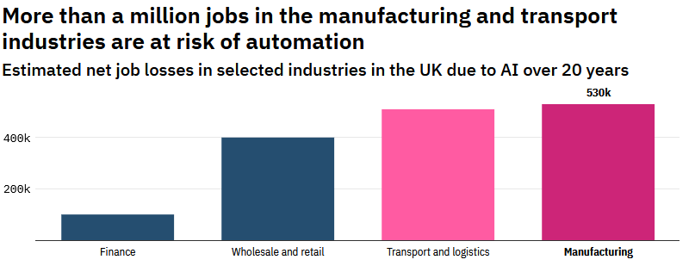
Figure Source: Fitri, A. (2022). Pandemic recovery gives high-risk jobs a ‘temporary reprieve’ from automation. [Online]. TechMonitor. Last Updated: 28th June 2022. Available at: https://techmonitor.ai/technology/ai-and-automation/pandemic-recovery-high-risk-jobs-temporary-repri [Accessed 3 October 2022].

For long term sustainability, manufacturers have come to realise that automation is the key to their future as evident with the Industry 4.0 digital transformation happening within the sector. The advancement of AI technologies, Industry 4.0 and intelligent smart factory production is the direction of the manufacturing industry. Digitally powered machines decrease the cost of production significantly since they enable task automation and improve engineering efficiency (Verhezen & Abeng, 2022).

AI is driven by data and the manufacturing sector generates and collects a lot of data as part of it manufacturing process, that data can be used to derive insights like machine processing efficiencies an apply AI techniques to optimisation and find huge efficiencies such as 20% cost reductions (McAfee et el, 2019).

IoT (Internet of Things) with sensor technology can aid the workforce with machine status monitoring and product tracking amongst other aspects of the delivery of the manufacturing process. Economically speaking, IoT lowers costs, improves diagnosis, aids in effective control, and contributes to better maintenance of equipment with less risks of machine breakdown due to AI sensor technology (Morris et el, 2015).

IoT uses AI deep learning analytics to provide precise analysis and forecasting to the large amounts of data generated. With the advancement of remarkable computer power and statistical AI technologies, AI is becoming more powerful and acquired into the manufacturing sector at a growing rate (Duan et el, 2019). For example, the food manufacturer, Danone Group in 2020 implemented machine learning to improve its demand forecasting, this led to the company achieving 20% decrease in forecasting errors, 30% decline in lost sales and 50% in reductions of demand planning departments workload therby improving efficiency and saving cost (Whiteside, 2021). Furthermore, the car manufacturer BMW Group, implemented AI computer vision which is an automated image recognition systems used for quality checks and inspection of car parts. This AI image check helps reduce and eliminates defective parts (Kamath, 2022).

Conclusion

Overall Covid-19 pandemic has had quite a negative effect on environmental, social, and economic variables for many sectors. In addition to the health crisis, social distancing, isolation and lockdowns and with the added pressure of falling exports, declining demand and the tightening of international financial constraints on the commercial market, the manufacturing sector along with other business sectors endured albeit under the immense instability of the UK economy (Sharma et el, 2020)

However, the adoption of digital technology saved businesses in many ways that may have not been possible before without the advancement of AI evolving and becoming more commercially available technology to be utilised by businesses of all shapes and sizes. Furthermore, AI doesn’t have to endanger workers livelihoods as such as it is also used to assist in planning the daily operations of a business and delivering a better user experience in the many sectors and businesses for customers (Rakha et el, 2021).

With digital transformation brought on by the pandemic and Industry 4.0, a smart supply chain particularly in the industrial sector is inevitable as it will help deliver services rapidly and to market. Virtual and augmented reality technology has also shown it is able to aid with design and training of products which makes it easier to carry out regular daily tasks for manufacturers (Ong et el 2013).

Covid-19 Pandemic Business Impact

The pandemic forced many businesses to adopt to new technologies to sustain themselves during the pandemic and during the lockdown. The pandemic impacted the global economy greatly where businesses had to adapt to new ways of working and operating.
The pandemic affected UK industry very greatly where businesses had to react to pandemic crisis and adapt to new ways of working which required adoption of technology in ways not seen nor utilised before the pandemic. Reenen (2020) believes that the pandemic had positive and negative impacts on technology adoption by business’s which are as followed:

Negative effect of the pandemic on technology adoption:

- Less Demand - during the pandemic there was a big fall in demand of product and services, which made investments by businesses and all investments less profitable where overall lower demand meant less investments in business’s affecting revenue of organisations (Lui et al, 2020).

- Financial shock - business’s which are under severe financial distress may not be able to make investments in new technologies as they don’t have the financial capital during times of poor cash flow into the business.

- Economic uncertainty – the pandemic created a lot of uncertainty in addition to the two-impacts mentioned prior which set out conditions of waiting to see how the commercial market reacts which created further uncertainty and reluctance in hiring new workers or investing in digital projects that will cost a lot of capital (Bloom et el, 2020).

- Managerial distraction - the pandemic created a lot of chaos in terms of communication in how to deal with the pandemic from government instructions and business advise. This often led to managers having to manage their staff rather than have the time to contemplate on how to invest in digital projects that would enable transformative change (Davim & Machado, 2022).

Positive effect of the pandemic on technology adoption:

- The need to adopt technology to deal with the pandemic- adopting to online remote working leading to remote online meetings via Zoom/Teams required investment, therby forcibly having to invest and adopt new technology due to the pandemic as business’s wouldn’t have considered otherwise to do so prior to the pandemic. Agile working methods may have been introduced in the workplace which may have also changed the way workers undertake work (Hamdan, 2022).

- Reallocation of resources- when companies experience negative shock this often leads to commercial exits and shrinking of low technology and low productivity. With resources being re-allocated to ensure business survival, priorities change where resources are re-allocated and restructured to ensure business survival becoming a leaner organisation (Barrero et el, 2020).

- Bad shock effect - bad and negative economic shock often force businesses to think of new ways of working and new ways of doing things they weren't doing before in a lean and efficient manner which can lead to a positive impact in restructuring internal processes to save cost and boost revenue.

- Reorganisation - Usually in recessions or in bad economic times businesses tend to save cost and time, the opposite in boom or growth times. Business’s that have more time because there's less demand for their products or services were able to utilise that time to reorganise the business and to make investments in growth areas therby making organisational change.

Many companies adapted to new way of working to adopting new technology to enduring and reacting to economic shocks, for example the China shock meant that firms in the UK and European Union faced greater competition from China. Bloom et el (2019) states that “UK firms and European firms in response to greater competition from China actually adopted more information technologies and innovated more responses to that Chinese competition”.

The pandemic was a huge global tragedy for the world which spurred companies to innovate new ways of operating which were never seen before the pandemic. Many firms changed their products and services quickly to adapt to the market. The pandemic has accelerated existing trends such as moving towards online activity and remote working and enhancing online operations.

Business Response to Covid-19 Pandemic

The Confederation of British Industry (CBI) conducted a survey of businesses and how they innovated and adapted technologically during the covid-19 pandemic 2020 conducted by Riom et el (2020)

Riom et el (2020) states “that there was large-scale adoption of new technologies and practices amongst the firms and these businesses expected to persist with these innovations beyond the immediate crisis of the pandemic”.

The survey found that businesses of different sizes faced large scale disruption with a reduction of turnover. 80% of the business surveyed had to close business sites and transition to remote working and more than 80% experienced a reduction in turnover with an average loss of 24%. The UK government furlough scheme was most popular government financial support available with 75% take-up of the scheme. Nearly all business’s made significant adjustments to operations where 75% had transitioned to remote working and 25% had to make made staff redundancies due to the economic crisis brought on by the pandemic (Riom et el, 2020). Overall, the business’s that were surveyed only 1% of them believed they wouldn’t be in business by the end of the year of 2021 therby showing that majority of businesses were resilient and optimistic on surviving and riding out the pandemic economic shock.

In addition, Riom et el (2020) states that “majority of firms had adopted productivity-enhancing technologies and practices or introduced new products/services in response to the pandemic” in addition to also finding that there was a “strong business innovation response to the COVID-19 crisis across four innovation categories (as shown in figure 1 below). Over 60% of business had adopted digital technologies and new management practices during the crisis and 38% adopted new digital capabilities”

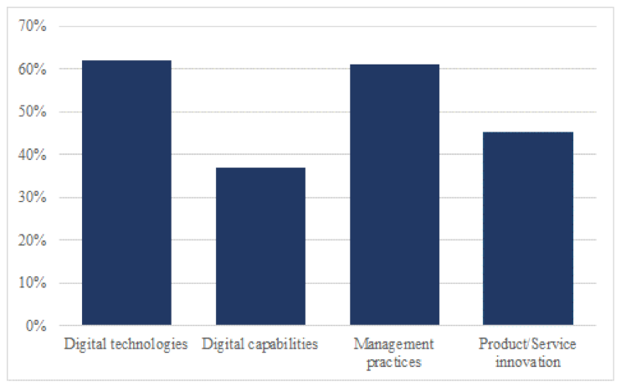
Figure 1 Source: Riom, C et el.. (2020). COVID has forced many firms to innovate, with possible lasting impacts. [Online]. London School of Economics. Available at https://blogs.lse.ac.uk/businessreview/2020/10/07/covid-has-forced-many-firms-to-innovate-with-possible-lasting-impacts/. [Accessed 26 September 2022].

Riom et el (2020) found as shown in Figure 2 below that that majority of firms surveyed had accelerated their adoption of new technologies such as AI during the pandemic.

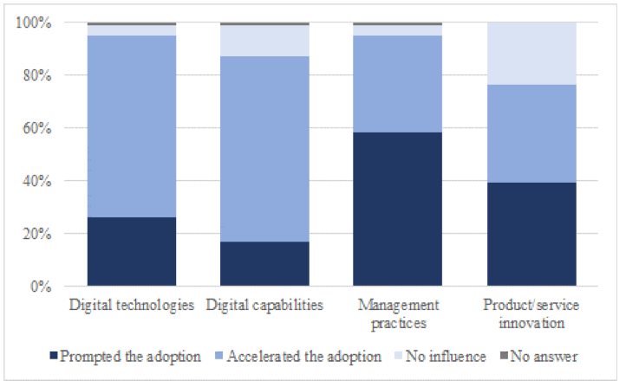
Figure 2 Source: Riom, C et el.. (2020). COVID has forced many firms to innovate, with possible lasting impacts. [Online]. London School of Economics. Available at https://blogs.lse.ac.uk/businessreview/2020/10/07/covid-has-forced-many-firms-to-innovate-with-possible-lasting-impacts/. [Accessed 26 September 2022].

With majority of firms accelerating their pace of innovation and adoption of new technologies, the survey found adoption patterns where smaller firms were less likely to innovate and adopt to new technologies due to lack or resources or capital to invest compared to larger firms as shown in figure 3 below.
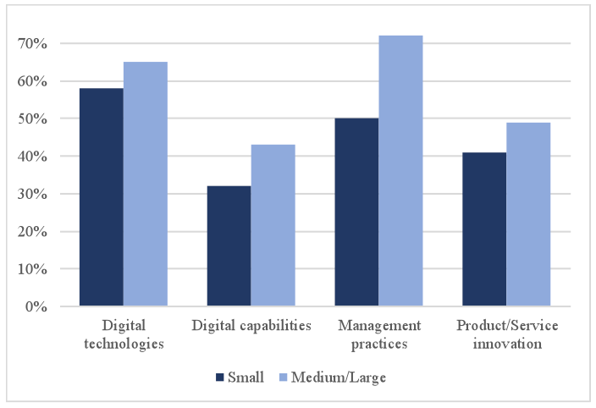
Figure 3 Source: Riom, C et el.. (2020). COVID has forced many firms to innovate, with possible lasting impacts. [Online]. London School of Economics. Available at https://blogs.lse.ac.uk/businessreview/2020/10/07/covid-has-forced-many-firms-to-innovate-with-possible-lasting-impacts/. [Accessed 26 September 2022].

Riom et el (2020) found as shown in Figure 4 below that that majority of firms surveyed with accelerated adoption of new technologies such as AI during the pandemic expected their workforce to being more productive and not directly replacing their workforce with new technology as such but enhancing productivity.
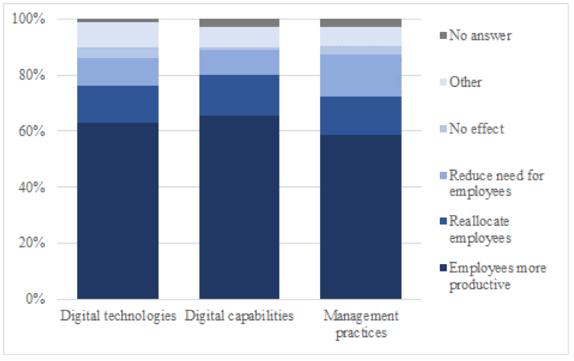
Figure 4 Source: Riom, C et el.. (2020). COVID has forced many firms to innovate, with possible lasting impacts. [Online]. London School of Economics. Available at https://blogs.lse.ac.uk/businessreview/2020/10/07/covid-has-forced-many-firms-to-innovate-with-possible-lasting-impacts/. [Accessed 26 September 2022].

Riom et el (2020) also found that financial government assistance in the form of tax incentives, loans and grants allowed businesses to invest into their business technology and aid in recruitment of a younger skilled workforce supported by the government to enter the labour market. Firms that had have taken up financial support schemes fared better in terms of surviving through adapting the pandemic crisis. Figure 5 below shows the uptake of how business intended to invest in their business technology:

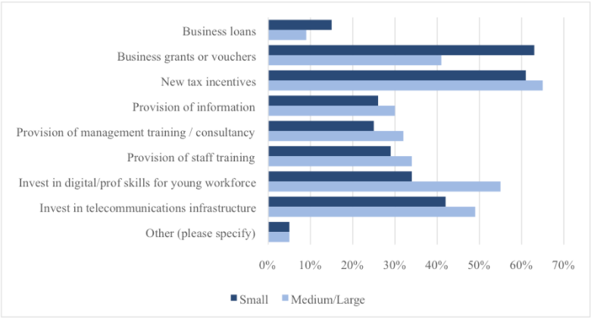
Figure 5 Source: Riom, C et el.. (2020). COVID has forced many firms to innovate, with possible lasting impacts. [Online]. London School of Economics. Available at https://blogs.lse.ac.uk/businessreview/2020/10/07/covid-has-forced-many-firms-to-innovate-with-possible-lasting-impacts/. [Accessed 26 September 2022].

Overall, the CBI survey conducted by Riom et el (2020) found many interesting insights as Riom et el (2020) found that “firms that were forced to adopt innovations during the pandemic expect these to persist after the crisis, to have a positive impact on firm performance and to augment productivity, without substituting workers (Riom et el, 2020)”

The pandemic appears to have accelerated certain types of innovation in a way that previous crises might not have done this could be due to the nature of the pandemic crisis that enforced large-scale change very quickly but also perhaps the readiness of very of relevant technologies being made available easily to implement very quickly by business with government support being made available rapidly during the pandemic.

AI Adoption Gap in Business

AI adoption in businesses still has a big gap between ambition and execution according to a global survey conducted by the Boston Consulting Group and MIT in 2018 (Ransbotham et el. 2018). It was reported in the study that less than 40 percent of the interviewed companies reported to have an ongoing AI strategy, although more than 80 percent responded that they believed that artificial intelligence would provide a real competitive advantage.

Ransbotham et el (2018) state that “executives in companies around the world are increasingly looking to artificial intelligence to create new sources of business value”, this further reinforces that companies are still increasing their investment in AI, therby widening the gap with other companies in gaining competitive advantage. This goes to show that the AI adoption gap has decreased than previously before and will continue to decrease over time as AI technologies become more and more adopted by companies worldwide.

There are many ways business can close the AI adoption gap in terms of investment, acquisition and
implementation strategies can be applied alongside new AI tools that can be used to scale up their operations to grow their business and adapt to a new technological advantageous landscape (Ganesan, 2022)

Horizontal v Vertical Strategy

The early implementers of AI are positioning themselves to reap the benefits of AI at scale frequently focusing on revenue generating activities alongside cost savings within their business.

It is regarded that these group of companies understand and practice AI within their business model and operations. The Boston Consulting Group and MIT study by Ransbotham et el (2018) regards these as ‘AI first companies’ and are pioneers of AI within their sector and industry.

These pioneer group are the companies, as Vorhies (2018) states are “implementing some kind of vertical or horizontal strategy for example the core of a horizontal strategy is to build an AI product or platform that can be used by many industries to solve problems more efficiently than before.” In addition, Vorhies (2018) also states “a vertical strategy tries to match one specific industry with solutions to problems that are suitable for AI”.

Investigators v Experimenters of AI

There are two types of businesses that have interests in AI but differ in terms of their engagement with the technology which can be regarded as the investigators and the experimenters of AI.

The group of investigators is researching and educating its workforce about the technological possibilities of AI, but they are not actually experimenters to test which applications and processes should be scaled up, this usually happens because of constraints such as not having human resources to lead and implement the technology strategy (Jules, 2022)

The experimenter’s group is learning by doing and emulating what larger companies usually do by performing several small tests in a controlled environment however their application of the technology is limited due to not knowing how to match a business problem with the appropriate AI solution to test or not improving the quality of the assumptions to be tested (William, 2020). Some companies are neither experimenting nor investigating AI applications because some of them are consciously inactive because they simply don't need AI in their current business model or because they believe that a competitor would not be able to discover an application earlier than them (Lakhani, 2020).

A business would need to review their priorities as to what they hope to achieve in applying AI within their business, as Rao (2022) believes that “adoption of AI-enabled processes allows some companies stand out. They’re far more likely to be advanced in their AI usage and to be achieving valuable business outcomes — ones that produce not only a functioning AI model, but also significant ROI”.

Adoption Barriers to implementing AI

There can be many challenges in rolling out an AI or Machine Learning system into an organisation. Lots of companies of many shapes and sizes face quite significant barriers to implementing and adopting AI new technologies to drive through digital growth for the business digital transformation.

Some of the biggest barriers are detailed as followed:

- Lack of understanding of AI - very often executive teams and senior management of organisations don't quite really understand what AI is, the possibilities of AI, what can be done and what is some of the leading edge in terms of using AI and machine learning. Successful digital transformation needs to have a good balance between AI knowledge and AI adoption, this is a difficult challenge for many organizations and managers have to work very hard to ensure that they meet this balance (Suseno et al , 2022).

Helping the decision maker understand of what can now be done for example with machine learning, neural language processing, deep learning, neural networks etc all these applications that allow computers to do more intricate and complex tasks than ever before gives business huge new opportunities to explore but can only be overcome and implemented by closing the big knowledge gap in organisations, for this reason more awareness needs to be raised of how AI can be applied in business to key decision makers (Ridley, 2022).

- Competition- there are a lot of companies that have started to collect data about their customers, this means that any one of them could become competitors and the ecosystem that's evolving is much more complex and more competitive (Kim & Kim, 2022).

The business itself might be moving its own IT systems to the cloud and the cloud vendor might in the future become a competitor as well there's a whole slew of technologies in addition to AI that management would have to worry about convergence of these technologies can offer powerful business models but at the same time the competitor also has access to these technologies (Gerrish, 2018).

- Organisational Culture - organizational culture and the mindset that people are in the organizations that are not quite ready for digital transformation can also play a part in resisting AI technological change. Humans are naturally fearful of change, which would also impact change management in a business. A natural fear of change might affect people’s jobs, jobs and roles which might transform what they do which therefore requires change in terms of what they do in terms of business processes, which can lead to an understandable fear and reluctance to implement new AI technological changes. Staff members may worry about their jobs and how AI may impact them this means that managers have to help people transition and enhance their roles, management would have to ensure that machines and people can collaborate better which enhances the company (Freidriksen & Skjaervik 2021).

Management team of organisations would need to communicate that artificial intelligence is much less likely to take over complete jobs as it is much more about enhancing their capabilities to transform and make the workplace more efficient by applying some of these AI tools and digital tools (Clifton & Harter, 2019).

- Technology investment – prior investments and new investments can be a contentious issue for some companies as companies may have invested heavily in technology over the last 10 years where they have had to put processes in place such as implementing new enterprise resource planning tools and now suddenly new trends like Big Data and artificial intelligence have popped up and are now having to invest again to keep up with new trends else they risk being left behind in terms of technological capability from their competitors (Lui et el, 2021).

In addition some companies have may invested in new technology such as cloud computing, distributed computing or migrated over to a completely new IT infrastructure whereas other companies have invested in the old technology in the past making it more difficult to transition over to AI, this may be why many start-ups and digital native tech companies are making so much progress with AI who are able to keep up to pace with new technology investment in their respective organisations, allowing them to be pro-active rather than reactive to the market due to their agility and ability to respond to market needs rapidly (Roland, 2021).

- Skills and talent- there is huge talent and skills gap around AI, Big Data, Augmented reality, blockchain etc. There can be many practical constraints to consider such as leadership support, internal politics, lack of resources , lack of available skills etc. All of these tools that companies now want to utilise but are struggling to find the talent to acquire and utilise these new advanced tools (Panth & Maclean, 2020).

Furthermore, companies post covid-19 pandemic are having to reskill their existing workforce to enhance their competitiveness, but this is an additional cost which not all companies will be able to afford. Huge corporations and companies such as Google, Facebook or Amazon are able to attract talented people with in-demand tech skills but small to midsize organizations may find it difficult to attract such skills set due to limited resources and budget (Foroughi, 2021).

- Strategy – the lack of a management strategic approach to technology can act as a barrier to implementing AI technologies in an organisation. Lots of organisations tend start to experiment with a little AI project such as a blockchain pilot in one area of the business but often the pilot experiment may not be coordinated very well across the board of the company leading to ineffective results (Berndtsson et el, 2020)

A long-term vision and strategy should be formulated and set for the business which address business challenges where the business then tries to apply AI to address these challenges across the board of the organisations which will then address and make a difference to the business performance of the company and add value to it. Businesses needs a strong data strategy to ensure that various aspects like data quality governance and ownership are well defined among other things (Janssen et el, 2020). Many businesses will have to redefine their goals and strategies to possibly change the fundamental business model companies for example Uber came into existence because of a combination of mobile phones and the Internet the same could happen with AI as the underlying technology which would cause companies to change the way they operate.

Senior management should ideally identify the future state of where they want to be but its not easy because the future state will keep changing depending on the changes in the larger ecosystem of the organisation, so building AI into the future that is in flux can be very challenging to pin down (Soltanifar et el 2021).

Overall, AI as a technology is very broad and can be applied to almost any area so it is critical for businesses to identify which capabilities should be prioritised first since there are so many possible choices to implement AI. For this reason, business’s need a good AI strategy and a framework, two different companies could have two different strategies on their AI implementation but the success of applying it is down to the business’s own leadership skills taking into consideration their own company values and innovation culture (Wright & Schults, 2018)

Survey Research

The project subject area is of academic importance whereby the project intends to investigate and answer the question, ‘How Adoptive were Artificial Intelligence (AI) Technologies in aiding Businesses’ during COVID-19 Pandemic?’
It is important to answer this question as it fundamentally asks weather Artificial Intelligence (AI) Technologies can support organisations better than standard systems in place and weather they offer far more superior support and efficiency than the standard systems in place especially during the pandemic.
The project addresses commercial business interests, academic interests and technology development in the area of Artificial Intelligence (AI) Technologies utilisation during Covid-19 Pandemic. Businesses will ideally want to know if there is a better and more efficient Artificial Intelligence (AI) Technologies on the market that could potentially aid them to improve their efficiency and business processes especially if they could have sourced it during the pandemic.
Artificial Intelligence (AI) has become an advanced topic within IT Business and computer science and generally within society too as technology advances year on year. Artificial Intelligence (AI) Technologies are widely seen as a great national security investment by governments and corporations and further development of Artificial Intelligence (AI) is expected in the future, this is evident with software vendors launching their own product lines of Artificial Intelligence (AI) Technologies such as Machine learning platforms.

Research Methodology

Creswell (2008) states that "research is a process of steps used to collect and analyse information to increase our understanding of a topic or issue" (Creswell, 2008, p.17). The aim of the research is to measure how adoptive AI technologies were during the pandemic for SME’S, to achieve this, the research would Pose a question, collect data to answer the question, and then present an answer to the question (Creswell, 2008).

There are many research methods and data collections methods that can have been applied to the project in gaining an understanding of factually knowing and understanding of how business’s applied and adopted Artificial Intelligence (AI) technologies during Covid-19 or if indeed if there are any barriers to applying Artificial Intelligence (AI) technologies and to see what these are which can be measured first-hand by conducting a survey and collecting data.

A quantitative questionnaire was designed to analyse input from SME organisations who have implemented and adopted Artificial Intelligence (AI) technologies during the covid-19 pandemic. The project is based around collecting facts related to the utilisation and challenges faced by businesses to adopt Artificial Intelligence (AI) technologies, for this reason the research will apply the philosophical paradigm of positivism (Easterby et al, 2012).

Using a positivism paradigm will ensure that the study is objective and leads to a deductive strategy being applied to the research allowing cross-sectional inferences to be arrived that with quantitative data being collected to be analysed with generalised conclusions being applied but this would require a large sample size to effectivity capture the overall picture and landscape of the survey results being shown at the time.

One key advantage of applying positivism paradigm is that the projects data collection can be collected efficiently in a timely manner, however on the other hand it may not generate new ground-breaking research theories being brought to the forefront of the subject topic as such, as such methods can be ineffective in generating new theories and ideas, but merely affirming pre-existing theories via data collection. (Easterby et al, 2012). In addition, Reichardt & Cook (1983) state that “the quantitative paradigm is said to have a positivistic, hypothetical-deductive, particularistic, objective, outcome-oriented, and natural science world view”.

Research Design

Adams et el (2014) states that “research design the blueprint for fulfilling research objectives and answering research questions”, which is the representative between the research query and results in the data collected in the survey (Yin , 2009).

The research intended to establish how adoptive AI was in supporting business’s during the pandemic, this will be achieved by undertaking a quantitative data analysis and collection approach which will allow for a conclusive analysis of the study.

Data Collection

Survey

The survey will utilise a variety of objective questions to collect data from participants. It is intended to use a positivist paradigm approach to collect survey data.
The survey will utilise an online tool called Microsoft Forms to design the survey and make the survey more accessible to participants via email rather than printed hard-copy questionnaires therby allowing it to reach more participants via online with a faster response rate and aids keepings costs low in comparison to having hard-copy paper based postal survey which can be time-consuming and have a slower response rate (Dilman, 2000) .
DeVaus (2002) believes that Surveys are generally very suitable for collecting quantitative data which can allow for and comparisons and measurements to be taken on the sample population.
The survey will be conducted in the UK in the English language medium as primary focus of the project is towards business’s based in the UK during the covid-19 pandemic.
The questionnaire was derived the literature review carried out in the project. Surveys are best used to collect data on large volume, as such typically around 150 Surveys will be intended to be sent out and data collected from it.

Pro & Cons of Online Surveys
Online surveys are used widely in comparison to hard-copy paper-based surveys as they are more efficient in delivery timing, widely accessible, save costs and response rates are far quicker than non-digital means. Online surveys have many advantages and disadvantages:
- Response rates: It is regarded that online surveys have a far more better performing response rate compared to traditional paper-based surveys as online surveys allow for more convenience to be completed in time by participants (Fricker et el , 2002)
- Timeliness: Online surveys allow for quicker completion and can be distributed quickly and processed with quick results (Sue et el , 2012).
- Accuracy: Online surveys should be accurate however they can create bias as survey participants may feel pressure to complete the survey quickly and may skip certain questions (Rips et el 2000).

Sampling Framework Selection and Size

The National Audit Office (2001) defines sampling as ‘means of gaining information about the population without the need to examine the population in its entirety’, where it is able to allow insight into the characteristics of a wider population (Fink, 2003).

Gunter (2002) believes that “probability sampling should be used when a random selection is needed” however for this study, non-probability sampling will be used which aims study a criteria accordingly to the aims of the project (Henry, 1990). Bryman (2011) state that selective sampling as “a non-probability form of sampling”. This means that the project will not look to sample the project participants on a chance basis but purposely sample a sample in a calculated manner so that the sample participants are relevant to the research projects questions, aims and objectives in answering the projects academic question.
The research project intends to target various sectors and industries but within the SME market size drawn from online companies’ directory of IT departments. The intended participants will be formed by targeting IT professionals typically senior level managers who are directly involved in the maintenance and implementation of Artificial Intelligence technologies within their respective organisations.
There are many benefits of using non-probability sampling:
- It uses less time and resources as it does not require the same amount of time and resources as probability sampling, making it a more cost-effective option (Babbie, 2016).
- Allows for greater flexibility as it allows researchers to be more flexible with the types of participants they include in their studies (Babbie, 2016).
- Allows for easier data collection to be obtained as, as it is often easier to obtain than probability sampling, this is because it does not require the same level of effort in terms of tracking down and obtaining participants (Lavrakas, 2008)

The sample population is intended to be collected across many sectors rather than one singular area as such, this is because the data collected will help identify if any correlations exist across different industries and sectors in use and adoption of AI across sectors.
The project aims to have a sampling frame of 150 participants, however the success rate of the respondent to the survey will determine what sample size is achieved overall in the end for the project, but as a minimum it is hoped that 25 responses are achieved if time-constraints prove to be a barrier in achieving a wider and larger sample size.
Boyd (2001) believes that two to around ten participants is sufficient enough to reach capacity of a study. The sample size may need to be explored further to increase the scale of the sample to include larger business’s that sit outside of the SME population. To achieve the sample size, the survey was sent out to IT professionals and aim to collect 25 responses at the minimum to produce a meaningful result which will allow for sufficient quantitative supportive weight to be completed to the study.

Data Analysis and Technique

A quantitative data analysis approach and technique was applied to analyse data collected from questionnaire and surveys conducted as part of the project. The data collected should be completed, correct and accurate which will be achieved by ensuring data fields in the questionnaire are set to mandatory therby eliminating missing values and answers to improve accuracy.
The data will be analysed and represented via visual representation to make the analysis easier to understand between variables and make inferences on what the data shows.
Data was collected via the use of online survey tool Microsoft Forms, which will collate all data collected in a centralised Excel spreadsheet, the data will then be will then be statistically analysed further using Excel and SPSS and presented in various visual charts such as Bar chart, pie chart, scatter graphs to see inferences and relationships across various sectors. (Easterby et al ,2012).
SPSS will be utilised to identify and investigate further into the dataset of the survey sample using various statistics such as normality tests to see what to see what inferences there are within the data set collected (Bryman, 2015). In addition, Burns & Burns (2008) believe that “non-probability sampling allows for quicker analysis of data since the data collected is often more focused and specific. This makes it easier to draw conclusions without having to analyse a large amount of data with the aid of SPSS and Microsoft forms” (Burns & Burns, 2008, p.18).

Ethics

Saunders & Lewis (2012) define ethics as “the appropriateness of the researcher’s behaviour in relation to the rights of those who become the subject of a research project, or who are affected by it”.
The researcher prior to starting the project submitted a completed ethics form (please see appendix) which ensures that all ethical considerations in line with the university ethics policies have been considered and adhered to prior to commencement of the research project (Blumberg et al,2005).
The main ethical risk for this research project is the collection of sensitive data from the survey participants. Lee et el (1990) believes that sensitive topics of a research project can compromise a project as it may involve a cost to the projects surveys participants. For example, a cost to the survey participant could be phycological costs such a guilt, embarrassment or shame which could follow upon collecting the discovery data from participants, for this reason all data collected from the survey will be collected anonymously.
In terms if of answering the project title, the project poses no direct ethical problems as such as it does not seek to have an impact of human philosophical ideas but merely answer a business case of how adoptive were Artificial Intelligence technologies during the pandemic by business in the UK. The investigation and conclusion of the research may positively impact business system models for SME’s and businesses as a whole.
The project will uphold personal ethics and will not break them to advance the project research aims and objectives. The project will follow an ethical code of conduct as stated by the British Computer Society (BCS) and as laid out by the University ethics committee. Codes of conducts exists which IT professionals must follow to uphold integrity and respect for the IT profession, the researcher intends to follow standard industry codes of conduct as dictated by the BCS - British Computer Society and by the University ethics committee as identified by the ethics form on Moodle too.
In terms of research ethics, the researcher will ensure all participants are made fully aware of the research survey and that information will be kept confidential and treatment of participants will be conducted professionally.
The survey will not exploit its subjects but measure their opinions and attitudes towards AI technologies utilisation. Participants will be made aware of the purpose of the survey and the project will gain informed consent of the participants before eliciting survey participation. In addition the anonymity and confidentiality will be maintained as the survey does not collect any personal sensitive identifiable data (Scott, 2005)
Overall, the project will adhere and has adhered to professional codes of conduct as set out by University Code of Ethics, complying with the universities ethical polices and uphold academic integrity.

Reliability and Validity

The questionnaire was designed to be very easy and simple to read allowing participants to fill it in easily, however there is a risk of there being inconsistent data where the data becomes compromised from participant error where answers become misunderstood giving inconclusive results. This was overcome by initially piloting and testing the questionnaire survey to ensure face validity with the project supervisor.
In addition, the literature review carried out in the project will aid in ensuring the content validity and internal validity is addressed which will form part of the questionnaire (Easterby et al (2012). Furthermore, Messick (1999) believes that “reliability and validity overlap each other which requires a balanced approach to support the interpretation of data” (Messick, 1989, p.19)
Saunders et al (2015) believes that there are two methods of defining validity:
- The methodology of the data collection method
- The degree of what the research findings are about counter to what it claims to be about.

The questions formulated for the survey were formulated and derived to the literature review that was conducted and discussed with the dissertation supervisor to reduce any risk of participant error during data collection stage.

Limitations

There are many limitations which may potentially affect the results of the research and the project itself:
- Lack of participation from wider industry sectors - One limitation maybe due to the lack of participant responses from a wider sample of industries from other sectors such as retail and hospitality sectors (Ritter et el, 2012).

- Limit of perspectives – by applying a positivism paradigm methodology it imposes a certain limitation on online survey questionnaires, for example, online survey may not allow deeper perspective of complicated business issues to be captured which might explain lack or adaptiveness of AI during the pandemic for example Brexit (Divakaran, 2014).

- Limit on responses, for examples the survey participates may have not responded in time before closing the survey timeframe which may have impacted the size of the sample. In addition the response rate could have been affected by festive seasonal periods as that can be a limitation as participants may have been too busy with work commitments to complete the survey.

- Lack of participant motivation to complete survey, as the survey is administered and conducted online without the presence of the researcher, this may impact the motivation to complete survey fully which may lead to incomplete data or even non-submission as the participant may not wish to complete the survey midway through or may have not even answered the questions honestly (Deci, 2012). However, it is hoped that the participants of the survey who were comprised of working IT professionals would minimise this reliability risk given the simple nature of the survey.

- Limited by researchers’ level of expertise, the study could have been affected by the researcher’s limited knowledge of survey conducting where some questions may have posed too lengthy to warrant a response from participants.

Resources

The research project was and is not awarded any financial resources from the university nor the researcher, for this reason dissertation project will utilise many free resources and software resources.
Primarily it utilised literature resources such as books, internet, and journals to base its investigation by gathering relevant and up-to-date information on the subject area of the project in addition to government data that is available in regard to the UK Innovate program where the government funded research and development into companies who are at the forefront of Artificial Intelligence (AI) in the UK during the pandemic.
Secondary resources were such as survey tools like Microsoft Forms were used in conjunction with data analysis tools such as IBM SPSS and Excel package to analyse results of data collected and generating visual results in the form of bar and pie charts to aid data visualisations of data results collected.
A crucial and important resource of the research project will be the survey participants which will consist of IT & Business strategy professionals who work for or work with SME’s; they will be used to measure attitudes towards Artificial Intelligence (AI) Technologies. Without survey participants, the project will not be able to critically analyse attitudes and utilisation towards Artificial Intelligence (AI) Technologies during Covid-19 pandemic.
A Gantt chart made in MS Project (please see appendix) was developed which aided in the project management of the research project and investigation.
The resources as detailed above will aid the project in achieving its aim and objectives.

Data Analysis of Results
The results of the survey (please see appendices) have been analysed using SPSS software and this section will provide insight into the data collected.

The survey questionnaire was successfully administered and distributed to 35 participants who come from an IT professional background in their respective SME sized organisations.

A normality test was conducted to ensure the results obtained from inferential analysis are not spurious. Furthermore 8 research hypotheses were formulated and analysed using appropriate statistical techniques using SPSS software.

Demography Analysis

A breakdown of the demographics of the participants with descriptive labels is shown in the below table formulated and computed in SPSS software:

Variables | Categories | Frequency | Percentage %
Age | Less than 18years | 0 | 0
Age | Above than 18years | 35 | 100
Age | Total | 35 | 100
Management Level | Management | 34 | 97.1
Management Level | Non-management | 1 | 2.9
Management Level | Total | 35 | 100
Occupation Profession | Business | 2 | 5.7
Occupation Profession | Information Technology | 33 | 94.3
Occupation Profession | Total | 35 | 100
Company of Residence | United Kingdom | 35 | 100
Company of Residence | Total | 35 | 100
Region in the UK | London | 6 | 17.1
Region in the UK | West Midlands | 29 | 82.9
Region in the UK | Total | 35 | 100
Number of employees | 25-100 | 1 | 2.9
Number of employees | 100-200 | 3 | 8.6
Number of employees | 250-500 | 31 | 88.6
Number of employees | Total | 35 | 100
Business’s Annual Revenue | £10-£50 million | 2 | 5.7
Business’s Annual Revenue | £50-£80 million | 7 | 20.0
Business’s Annual Revenue | More than £80 million | 26 | 74.3
Business’s Annual Revenue | Total | 35 | 100
Business Sector Type | Private | 35 | 100
Business Sector Type | Public | 0 | 0
Business Sector Type | Total | 35 | 100
Business’ Industry | Construction | 2 | 5.7
Business’ Industry | Retail | 7 | 20.0
Business’ Industry | Technology | 4 | 11.4
Business’ Industry | Wholesales | 22 | 62.9
Business’ Industry | Total | 35 | 100
Figure 7 Source: Researchers Computation using SPSS.

The demography analysis Table presents the demography statistics for the respondents. The table shows that all respondents selected for this research study are above 18 years of age.
The data also shows that 35 of the respondents (97.1%) are managers, while 1 of them is a non-manager (2.9%). In addition, 33 of the respondents (94.3%) are into information technology occupation function of their organisation, while 2 of them (5.7%) engage in core business practice.
All the participants organisations of the survey are from the United Kingdom, while 29 of them (82.9%) are based in the West Midlands region and 6 of them (17.1%) are based in the London region.
The data also shows that 31 of the businesses’ who participated (88.6%) have between 250 and 500 employees, 3 of them (8.6%) have between 100 and 200 employees, and only 1 of them have one between 25 and 100 employees.
26 of the businesses (74.3%) who participated in the survey generate more than £80 million in yearly revenue, 7 of them (20%) generate between £50 and £80 million in yearly revenue, while 2 of them (5.7%) generate between £10 and £50 million in yearly revenue.
All participants of the survey were from the public sector (100%). 2 of the participant organisations came were from the construction industry (5.7%), 7 participants from the retail industry (20%), 4 participants were from the technology industry (11.4%) whilst the remaining majority of the 22 participants operated within the wholesale industry (62.9%)

Graphical Analysis

A graphical representation of the demography statistics of the survey participants is presented below:
Graph 1: Age group of respondents

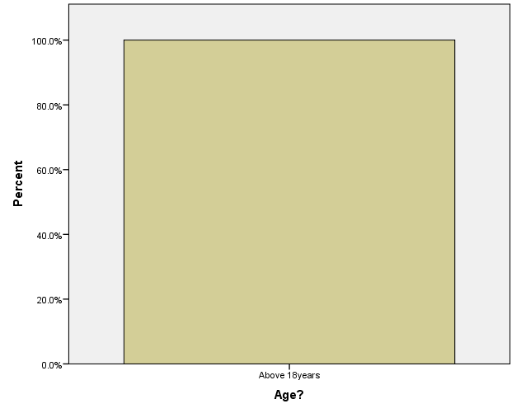
Age
 |  | Frequency | Percent | Valid Percent | Cumulative Percent
Valid | Above 18years | 35 | 100.0 | 100.0 | 100.0

Source: Researchers Computation using SPSS

Graph 2: Managerial level of participants

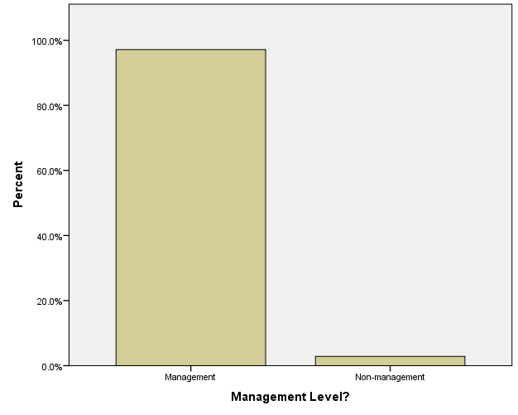
Management Level
 |  | Frequency | Percent | Valid Percent | Cumulative Percent
Valid | Management | 34 | 97.1 | 97.1 | 97.1
Valid | Non-management | 1 | 2.9 | 2.9 | 100.0
Valid | Total | 35 | 100.0 | 100.0

Source: Researchers Computation using SPSS

Graph 3: Occupation Profession of participants
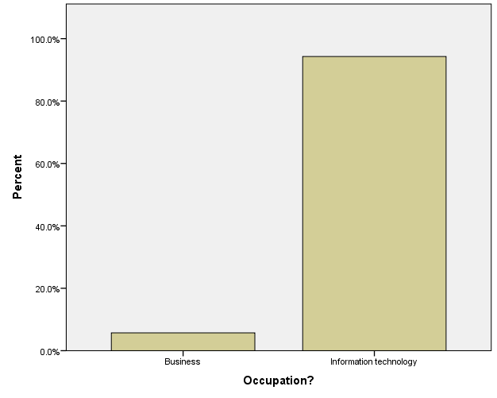
Occupation
 |  | Frequency | Percent | Valid Percent | Cumulative Percent
Valid | Business | 2 | 5.7 | 5.7 | 5.7
Valid | Information Technology | 33 | 94.3 | 94.3 | 100.0
Valid | Total | 35 | 100.0 | 100.0
Source: Researchers Computation using SPSS

Graph 4: Region of participant organisation base
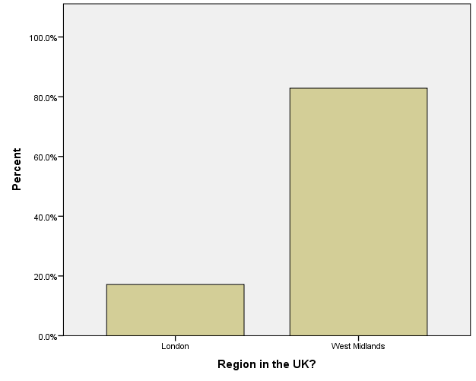
 |  | Frequency | Percent | Valid Percent | Cumulative Percent
Valid | London | 6 | 17.1 | 17.1 | 17.1
Valid | West Midlands | 29 | 82.9 | 82.9 | 100.0
Valid | Total | 35 | 100.0 | 100.0
Source: Researchers Computation using SPSS

Graph 5: Employees of respondents
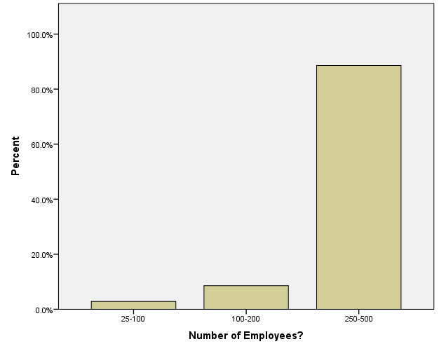
Number of Employees
 |  | Frequency | Percent | Valid Percent | Cumulative Percent
Valid | 25-100 | 1 | 2.9 | 2.9 | 2.9
Valid | 100-200 | 3 | 8.6 | 8.6 | 11.4
Valid | 250-500 | 31 | 88.6 | 88.6 | 100.0
Valid | Total | 35 | 100.0 | 100.0
Source: Researchers Computation using SPSS

Graph 6: Annual Revenue Income of participant organisations

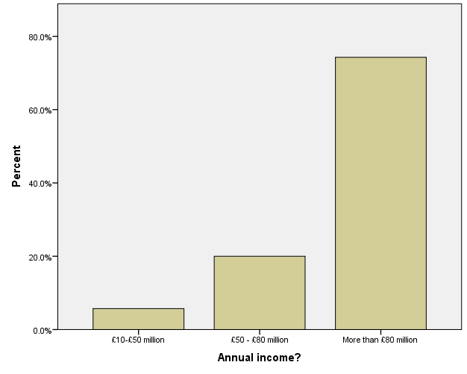
Annual Revenue
 |  | Frequency | Percent | Valid Percent | Cumulative Percent
Valid | £10-£50 million | 2 | 5.7 | 5.7 | 5.7
Valid | £50-£80 million | 7 | 20.0 | 20.0 | 25.7
Valid | More than £80 million | 26 | 74.3 | 74.3 | 100.0
Valid | Total | 35 | 100.0 | 100.0
Source: Researchers Computation using SPSS
Graph 7: Business Sector type

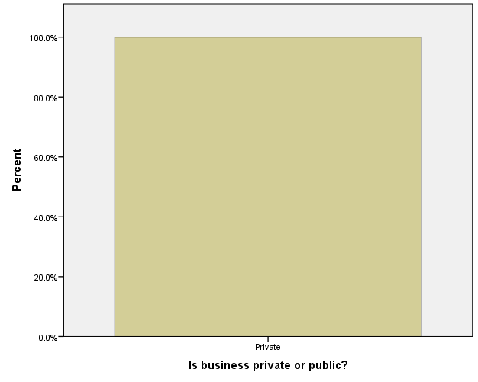
Private or public sector
 |  | Frequency | Percent | Valid Percent | Cumulative Percent
Valid | Private | 35 | 100.0 | 100.0 | 100.0
Source: Researchers Computation using SPSS

Graph 8: Business Industry
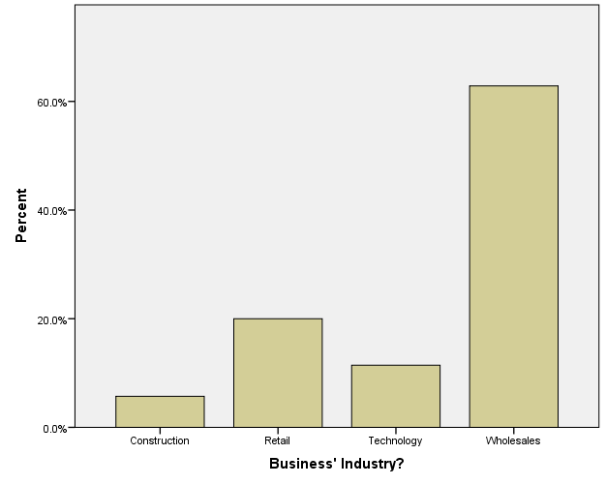
Business' Industry
 |  | Frequency | Percent | Valid Percent | Cumulative Percent
Valid | Construction | 2 | 5.7 | 5.7 | 5.7
Valid | Retail | 7 | 20.0 | 20.0 | 25.7
Valid | Technology | 4 | 11.4 | 11.4 | 37.1
Valid | Wholesales | 22 | 62.9 | 62.9 | 100.0
Valid | Total | 35 | 100.0 | 100.0
Source: Researchers Computation using SPSS

Analysis of AI adoption and utilisation

The below table shows the results of the survey which analyses the adoption and utilisation of AI in the participant organisations:

Variables | Categories | Frequency | Percentage %
Have IT Department | Yes | 35 | 100
Have IT Department | No | 0 | 0
Have IT Department | Total | 35 | 100
Prior Business knowledge about AI | Yes | 35 | 100
Prior Business knowledge about AI | No | 0 | 0
Prior Business knowledge about AI | Total | 35 | 100
Have Adopted AI in Business | Yes | 35 | 100
Have Adopted AI in Business | No | 0 | 0
Have Adopted AI in Business | Total | 35 | 100
Period of adopting AI | During pandemic | 35 | 100
Period of adopting AI | Prior to pandemic | 0 | 0
Period of adopting AI | Total | 35 | 100
Pandemic accelerated AI adoption | Yes | 35 | 100
Pandemic accelerated AI adoption | No | 0 | 0
Pandemic accelerated AI adoption | Total | 35 | 100
Years of using AI | 1year | 3 | 8.6
Years of using AI | 1-2years | 29 | 82.9
Years of using AI | More than 2years | 3 | 8.6
Years of using AI | Total | 35 | 100
Types of AI Technology adopted | Automation | 1 | 2.9
Types of AI Technology adopted | Computer vision | 1 | 2.9
Types of AI Technology adopted | Machine learning | 21 | 60.0
Types of AI Technology adopted | Machine learning & automation | 4 | 11.4
Types of AI Technology adopted | Machine learning and data science | 7 | 20.0
Types of AI Technology adopted | Machine learning and chatbot | 1 | 2.9
Types of AI Technology adopted | Total | 35 | 100
AI Platforms used | Microsoft | 33 | 94.3
AI Platforms used | Microsoft and Amazon | 1 | 2.9
AI Platforms used | Microsoft and SAP | 1 | 2.9
AI Platforms used | Microsoft | 33 | 94.3
AI Platforms used | Total | 35 | 100
How AI was adopted in organisation | Developed in-house | 35 | 100
How AI was adopted in organisation | Hired professionals | 0 | 0
How AI was adopted in organisation | Total | 35 | 100
Time it required to adopt and implement AI in business | More than 1 month | 4 | 11.4
Time it required to adopt and implement AI in business | Less than 6 months | 31 | 88.6
Time it required to adopt and implement AI in business | Total | 35 | 100
Cost spent on Adoption | £10-£20k | 29 | 82.9
Cost spent on Adoption | £20-£50k | 4 | 11.4
Cost spent on Adoption | £50-£100k | 2 | 5.7
Cost spent on Adoption | Total | 35 | 100
Count of AI applications adopted in business | 2-5 | 25 | 71.4
Count of AI applications adopted in business | More than 5 | 10 | 28.6
Count of AI applications adopted in business | Total | 35 | 100
Frequency of AI Usage in business | Daily | 35 | 100
Frequency of AI Usage in business | Not often | 0 | 0
Frequency of AI Usage in business | Total | 35 | 100
Level of satisfaction of AI use in business | Very satisfied | 35 | 100
Level of satisfaction of AI use in business | Very dissatisfied | 0 | 0
Level of satisfaction of AI use in business | Total | 35 | 100
Plans to invest in AI for future business use | Yes | 35 | 100
Plans to invest in AI for future business use | No | 0 | 0
Plans to invest in AI for future business use | Total | 35 | 100
Source: Researchers Computation using SPSS
The above table summarises the use and adoption of AI among the organisations which participated in the survey.
The results reveal that all organisations participated in the survey have an IT department which is in-charge of the use and maintenance of artificial intelligence technologies of the business. With a proficient IT department, it can be safely assumed that these businesses are knowledgeable about AI and its benefits as they have all already adopted AI in their business and daily operations.
Furthermore, the results reveal that they all adopted AI during the pandemic, implying that the pandemic motivated them to adopt AI technologies. About 82.9% of the respondents admit that they adopted AI with 1 and 2 years of AI utilisation, while most the respondents admit that machine learning is the commonly used AI technology adopted for their business daily operations.
These businesses apply AI technology on Microsoft, Amazon, and SAP platforms. These businesses admit that their AI technologies were adopted in- house as external professionals were not hired.
About 88.6% of the participant organisations revealed that it took them less than 6 months to adopt AI technologies while 11.4% said it took them little more than a month adopt to AI technologies.
Most of the businesses investigated (82.9%) note that they have spent between £10k and £20k on AI technologies, while most of them (71.4%) have between 2 and 5 AI live applications in use in their organisations.
All of the organisations admitted that they use AI technologies daily for their business operations. They all expressed satisfaction about the benefits of AI in their business performance and all mentioned that they will be investing more funds in the future to purchase and acquire more AI technologies for their organisations. This finding is further supported where Dobson (2023) states that “investments by organisations in AI is still increasing as value of tech evolves”.

Normality Test

One-Sample Kolmogorov-Smirnov Test

A one-sample Kolmogorov-Smirnov test is usually used to test if a sample comes from a specific distribution (Mallery, 2016), which is detailed in the below table:

 |  | AI Adoption improved business efficiency? | AI adoption increased revenue? | AI adoption decreased cost reduction? | AI adoption aided company growth? | Business' Industry?
N |  | 35 | 35 | 35 | 35 | 35
Poisson Parameter^{a,b} | Mean | 1.00 | 1.00 | 1.00 | 1.00 | 3.31
Most Extreme Differences | Absolute | .368 | .368 | .368 | .368 | .240
Most Extreme Differences | Positive | .264 | .264 | .264 | .264 | .240
Most Extreme Differences | Negative | -.368 | -.368 | -.368 | -.368 | -.206
Kolmogorov-Smirnov Z |  | 2.176 | 2.176 | 2.176 | 2.176 | 1.420
Asymp. Sig. (2-tailed) |  | .000 | .000 | .000 | .000 | .035
a. Test distribution is Poisson.
b. Calculated from data.
Source: Researchers Computation using SPSS
The data was tested to determine if they are normally distributed. The test was conducted using the One-Sample Kolmogorov-Smirnov test. According to the null hypothesis, at 5% level of significance, a variable tested is normally distributed, else the variable is not normally distributed (Rajaratnam, 2015).
If the datasets are normally distributed, it becomes appropriate to estimate them using parametric technique, otherwise non-parametric technique will be used to estimate the dataset if they are not normally distributed.
The p-values obtained from the test results (please see above table) are all lower than 5% which indicates that the null hypothesis not accepted. This implies the dataset are not normally distributed; hence, they will be analysed using non-parametric techniques.

Hypothesis

Analysis of Research Hypotheses

To analyse the benefits of AI adoption on business performance during the pandemic, 8 research hypotheses have been developed (Lavrakas, 2008). They are stated in null form which is as follows:
- H₀₁: AI does not improve the efficiency of businesses.
- H₀₂: AI does not increase the revenue of businesses.
- H₀₃: AI does not decrease the business cost.
- H₀₄: AI technologies do not aid business growth.
- H₀₅: There is not difference in the AI impact on business efficiency based on years of adopting AI among the companies investigated.
- H₀₆: There is not difference in the AI impact on business revenue based on years of adopting AI among the companies investigated.
- H₀₇: There is not difference in the AI impact on business cost reduction based on years of adopting AI among the companies investigated.
- H₀₈: There is not difference in the AI impact on business growth based on years of adopting AI among the companies investigated.

Hypotheses 1-4 will be analysed using binomial test. Cramer (2001) states that “binomial test is an exact test of statistical significance used to test if the proportion from a single dichotomous variable is equal to its presumed population value”. The 4 variables tested are all dichotomous in nature are stated below:
- “AI efficiency impact of business”
- “AI increase of business revenue”
- “AI business cost reduction impact”
- “AI effect on business growth”

The binomial test will be used to ascertain if the proportion of the positive values are equal to their presumed population value. If the proportion of the positive values are equal to their presumed population value, it implies that the null hypothesis 1-8 will be rejected.
However, on the other hand, hypotheses 5-8 will be analysed using the Kruskal-Wallis which is a nonparametric version of the analysis of variance (ANOVA) (Foreman, 2011). The Kruskal-Wallis nonparametric technique is used to determine if changes in a dependent variable is caused by outcomes of an independent variable.
At 5% of significance, the Kruskal-Wallis test asserts that there is no significant difference in AI impact on business efficiency, AI impact on the increase in business revenue, AI impact on business cost reduction, and AI impact on business growth based on the years of adopting AI among the companies investigated, otherwise the null hypotheses will not be accepted.

Binomial test results for hypotheses 1-4
The binomial test and Kruskal-Wallis were carried out using SPSS software. The results are tabulated and presented in the below table:

Binomial test results for hypotheses 1-4
 |  | Category | N | Observed Prop. | Test Prop. | Exact Sig. (2-tailed)
AI impact on business efficiency? | Group 1 | Yes | 35 | 1.00 | .50 | .000
AI impact on business efficiency? | Total |  | 35 | 1.00
AI impact on revenue? | Group 1 | Yes | 35 | 1.00 | .50 | .000
AI impact on revenue? | Total |  | 35 | 1.00
AI impact on cost reduction? | Group 1 | Yes | 35 | 1.00 | .50 | .000
AI impact on cost reduction? | Total |  | 35 | 1.00
Does adopting AI aid company growth? | Group 1 | Very adaptive | 35 | 1.00 | .50 | .000
Does adopting AI aid company growth? | Total |  | 35 | 1.00
Source: Researchers Computation using SPSS

The binomial test results are presented in above table. The p-values are all significant at 1% level, which indicates that the null hypothesis (1-4) are not accepted. This indicates that AI improves the efficiency of businesses, AI increases the revenue of businesses, AI decreases business cost, and AI technologies aid business growth.

Kruskal-Wallis test results for hypotheses 5-8

Table 4.5: Kruskal-Wallis test results for hypotheses 5-8
 | AI impact on business efficiency? | AI impact on revenue? | AI impact on cost reduction? | Does adopting AI aid company growth?
Chi-Square | .000 | .000 | .000 | .000
df | 2 | 2 | 2 | 2
Asymp. Sig. | 1.000 | 1.000 | 1.000 | 1.000
a. Kruskal Wallis Test
b. Grouping Variable: Years of using AI
Source: Researchers Computation using SPSS
The Kruskal-Wallis test results are presented in table 4.5. The p-values are all insignificant at 5% level, which indicates that the null hypothesis (1-5) are accepted (Knapp, 2017).
This indicates that there is not difference in the AI impact on business efficiency based on years of adopting AI among the companies investigated, there is not difference in the AI impact on business revenue based on years of adopting AI among the companies investigated, there is not difference in the AI impact on business cost reduction based on years of adopting AI among the companies investigated, and there is not difference in the AI impact on business growth based on years of adopting AI among the companies investigated. Simply put, the results indicate that AI helps to achieve greater performance among companies that adopt AI technologies.

Key Findings

Overall, the key findings of the survey results are as followed:
- All organisations that participated in the survey have an IT department which is in-charge of the use and maintenance of AI technologies of the business- this goes to show that AI is very easily adoptable by organisations with the right IT know-how and skills set.
- All participant organisation adopted AI during the pandemic, implying that the pandemic motivated them to adopt AI technologies and invest heavily in it.
- Most common AI technology adopted was Machine Learning which they have been utilising more than 1 to 2 years.
- Most common AI platform utilised is Microsoft Azure proving it is by far the most popular AI provider on the commercial market
- AI adoption was very quick to implement where most participant organisations revealed that it too them 6 months or less to implement their AI technology. This maybe due to the IT department resources being available with great investment made during the pandemic as work-from home policies were introduced during lockdown.
- Average spend of AI adoption technology was between £10-20K, this maybe purely down to the initial software costs and may not account for other ongoing resource cost such as labour.
- AI usage is on a daily basis with and average 3-5 AI applications being maintained by organisations surveyed.
- Most participant organisation revealed that by adopting AI it has decreased costs in other areas of the business and improved efficiency.
- All participants have revealed they will be investing further into their AI operations.
- Overall, all participants found AI technology very adoptive and effective in aiding their respective company operations.

Conclusions and Recommendations

The purpose of the project was to undertake and investigation into the adoption of Artificial Intelligence technologies in business operations. This has been achieved by undertaking a literature review and conducting a survey where the results were analysed. It can be said that AI technologies were very adoptive during the pandemic for SME’s.

Conclusion

The findings from this survey and literature review study shows that artificial intelligence is an important tool to promote business performance which was evidently adopted by many SME sized businesses.
The survey results have shown that the Adoption of AI seems to improve the efficiency of businesses, increase revenue of businesses, lowers business costs, and aids business growth. However, there is no significant difference in performance of businesses which adopt AI technologies. This shows that AI helps to achieve similar performance among firms that adopt it (Besterfield, 2009).
Studies in the literature review reveal that the adoption of artificial intelligence during the pandemic offers immense benefits to businesses and organisations such as accuracy in job delivery, labour savings, cost savings, material costs savings, and improvement in quality (Rehg et el, 2005).
The survey reveals that AI technology does not only increase production level, but also promotes competitiveness, and lower costs as companies are always in competition with each other to dominate the market (Autor, 2015).
Artificial intelligence offers competitive advantage because it helps to lower costs of production, increase efficiency and precision, and enhance quality control. These are benefits affords business to remain competitive within in their industry, both locally and globally especially during the Covid-19 pandemic. Also SMEs can exploit from the benefits of automation, in achieving economy of scales (lowering costs of production with increasing level of output); which in turn helps their growth (IFR, 2017).
Furthermore, from a macro level, increased level of productivity is paramount; because it promotes job opportunities, increase export base of the country, and improve balance of trade positions (Hossain et el, 2016).
A number of other studies agree that automation enhances labour efforts, such by carrying out physical-tasking jobs which are difficult for physical labour (Bessen, 2016). Essentially, automation the labour force to reskill and earn higher income and enjoy higher quality of living (McNeil & Steams, 2010). In addition, by complementing labour force, automation helps with safer jobs, such as making tasks less dangerous, harsh, and threat to health. It also promotes clear jobs needed to lower carbon emission (BSR, 2017).
However, some studies in the literature review dismiss the support of automation; stating that automation poses a threat to high unemployment because it competes with labour force, and poses a threat to human civilization (Ramaswamy, K, 2018). Automation may be gainful to businesses, yet it poses huge risk to job opportunities, which will affect welfare level of households and breed poverty. As observed during the Industrial Revolution, automation of production processes led to workers being made redundant, which raised competition against the few employed. In the long run, this lowers welfare of workers (Pham et el 2018).
Frey et el (2013) believed that automation of jobs in the US poses as high as 47% increase in unemployment. This is because lower wage jobs will be mostly affected by automation, which would increase the income inequality gap between the less skilled and skilled workers (Nagano, 2018).
It could be argued that the situation is worse for developing countries compared to developed countries in the West; where production is labour intensive, and there is higher rate of lower wage jobs, compared to high paying jobs. For BRICS countries (Brazil, Russia, India, China, and South Africa), automation would have serious adverse effect on job employment, because they are a labour-intensive economies. This could trigger a recession, because of low demand (Pham et el 2018). Furthermore, the World Bank revealed that two-third of jobs among developing countries will be lost to automation; whereas jobs in the ASEAN region textile sector are at highest risk to automation (Uddin, 2018). For example, in Bangladesh, where the textile industry is a major source of foreign earnings, there are more than 4 million textile workers who are at risk of automation. More than 80% of the country’s apparel industry is dominated by women who are breadwinners of their families (Hossain et el, 2016). Therefore, increase in automotive production would leave behind drastic negative effects.
An International Federation of Robotics (IFR) report in 2017 estimated that 700,000 low skill jobs would be lost to automation by 2022; showing the magnitude of harm automation would cause developing countries (Ramaswamy, 2018). This will bring about low income and poor social challenges to households, which would translate to lower aggregate demand and trigger recession. However, IFR (2017) argue that automation does not pose as risk factor to unemployment; rather, job loss arises from the inability of labour to be competitive. This borders on the skill acquired by an average worker in developing countries, which will determine the chances of getting another job in the possible displacement by automation. A competitive labour force will be able to switch jobs at ease and mitigate the challenges of automation. For this reason, skill acquisition plays an important role to circumvent the problems of automation.
Many corporations and industries are employing various artificial intelligence technologies to enhance innovation, effectiveness, and efficiency in productivity. For instance, financial technology (Fintech) firms make use of artificial intelligence to provide financial services at very low costs compared to traditional banks (Simon, 2017). This is made possible with the use of technologies that help to quickly analyse information of customers rather than making use of time-consuming credit score of customers. As such, the FinTech industry has experienced significant growth, as they are increasingly competing with traditional banks (Business Research Company, 2019). Furthermore, marketing firms do not make use of expensive traditional marketing; instead, they now rely on big data analytics such as Machine Learning to improve their customer reach, customer satisfaction, and customer retention (Geru et al, 2018). Also healthcare companies rely on expert systems, which is an artificial intelligence technology to effectively analyse patient’s health data and carry out accurate diagnosis of patient issues (Secinaro et al, 2021). Most artificial intelligence technology possesses sensors which makes it less costly for firms and businesses to obtain allowing them to measure and carry out analysis for accurately informed decision making in real-time (Crews et el, 2019).
The positive contributions of artificial intelligence to business performance are consistent with the survey findings as Basri (2020) states that “artificial intelligence increases the effectiveness of daily operations of businesses and helps to reduce costs too”. In addition, Alzaidi (2018) states that “the use of AI opens up the new opportunities for business’s by allowing them to reduce their operating costs and raising their profit levels” which in turn helps to mitigate risks and maximise their performance by adopting AI technologies.
Furthermore, Ellahham et al (2019) states that “artificial intelligence helps to improve on quality healthcare delivery through accurate diagnosis and cost reduction.” In addition , Elsaadani et al (2018) believed that artificial intelligence adoption would enhance capital efficiency, lower waste and help achieve sustaining growth and development for companies. Likewise, Solaimani et al (2020) states that “the use of artificial intelligence through machine learning improves cost control among firms through effective budgeting and efficient utilization of organisational resources; thus, showing the effectiveness of artificial intelligence to effectively manage costs in the workplace”. This is supported by the findings of the survey.
From the results it is clear that SMEs do indeed believe that AI is very adaptable to SME needs, this is evident from the questionnaire results. Adoption of artificial intelligence (AI) technologies is growing rapidly, as more businesses and organisations recognise the potential for AI to improve their operations and increase their competitive edge. Question 33 “How adoptive are AI technologies in aiding your company?” and Question 16 “Which AI technologies have you adopted?” clearly illustrates the purpose of the project by determining and asking these questions to SME participants, to see if SMEs themselves believe if AI is suitable for them both technologically and economically.
As the questionnaire research results have shown, SMEs largely agree that AI technology are very adaptable and highly suited to SME needs and believe that adopting AI technologies is very beneficial. AI technologies have been adopted in various ways, from automating tasks to providing insights and predictive analytics using machine learning.
It can be concluded that AI technologies have been very helpful in aiding small-to-medium sized enterprises (SMEs) during the COVID-19 pandemic. AI technologies have been used to automate mundane tasks which have allowed businesses to focus on core business functions. AI technologies have been used to help SMEs analyse data more efficiently and quickly with the utilisation of Machine Learning, providing them with better insights into their businesses and allowing them to make more better-informed decisions. Additionally, AI technologies have been used to provide customer service support via the use of chatbots, helping SMEs respond to customers in a timely manner and maintain customer relationships during the pandemic.
Overall, the survey has revealed that SMEs have been able identify potential opportunities for growth via the use of AI technology adoption.

Recommendations

The study survey evidently shows that the AI technologies are very adoptable by businesses. The use of AI technologies during the pandemic has been very beneficial for businesses. AI has enabled businesses to automate processes, identify potential cost savings, and improve customer experience. It is the researcher’s recommendation that as AI is a future growing area which can be very easily adopted and utilised, more businesses of all sizes should transition and adopt AI technology into their organisations.
There are 3 recommendations of how AI technologies can be adopted by business:
- Use AI to Automate Customer Support- AI-powered chatbots will allow automation of customer support, responding to customer inquiries quickly and accurately. This can save businesses time and money and improve customer satisfaction with quick resolutions (Brynjolfsson et el, 2019).

- Utilise AI for Predictive Analysis via Machine Learning- AI can be used to analyse data and make predictions and forecasts. Businesses’ can use this to identify potential opportunities, predict customer behaviour and create targeted customer campaigns (Finlay, 2021).

- Utilise AI for Process Automation- AI can automate mundane processes, such as data entry, payroll, accounting and general workflow administration. This can save businesses time and money, and free up employees to focus on more important tasks (Dasgupta, 2021).

To achieve the mentioned recommendations, the author has produced a set of guidelines which can be followed by businesses on how to adopt AI technologies which are detailed in the next chapter.

Project Artifact: How SME’s can acquire and adopt AI Technologies

How an SME can adopt and implement AI Technology

This is a set of guidelines for SMEs on how they can acquire and adopt AI Technology from an AI provider. Below are a set of guidelines that advise you on approach you should take when adopting AI Technology.
- Assess your needs, requirements and objectives.
- Review your user requirements, data needs and business requirements and identify areas which can benefits from AI such as customer service, marketing, finance, operation etc.
- Research into appropriate AI Technology Service providers
- Research into reputable certified AI Technology service providers such as Microsoft, IBM etc and understand the different AI technologies available such as Machine Learning, computer vision etc and see how they can be applied to your operations.
- Design and plan your AI Technology to specification.
- Design solution with ensuring all stakeholders are involved in design
- Develop and test your AI Technology
- Assemble software engineers to design and build AI solution.
- Test the AI Technology applications before rolling it for live use.
- Implement the AI Technology
- Implement the AI Technology efficiently and smoothly with effective rollout.
- Support AI operations by giving support and training to users and all stakeholders.
- Monitor and Evaluate
- After implementation of the AI Technology, evaluate performance and impact of the solution by undertaking a cost benefit analysis for the organisation and reassess the need for future adjustments of organisational requirements.

References

ABB Robotics. (2022, March 15). ABB predicts key trends that will change robotic automation in 2022. [Online]. ABB Robotics. https://new.abb.com/news/detail/88734/prsrl-abb-predicts-key-trends-that-will-change-robotic-automat
Abdou, H., Pointon, J., & El-Masry, A. (2012). Determinants of capital structure in the UK retail industry: A comparison of multiple regression and generalized regression neural network. Intelligent Systems in Accounting, Finance and Management, 19(3), 151-169.
Abril,D. (2022). Make room, bellhops: Robots and AI may soon predict what guests want. [Online]. The Washington Post. Last Updated: 9th August 2022. Available at: https://www.washingtonpost.com/technology/2022/08/09/rosewood-hotels-cheng/ [Accessed 2 October 2022].
Adams, J., Khan, H.T.A. and Raeside, R. (2014) Research methods for business and social science students. New Delhi: SAGE
Affronti, M. (2020). How UK retailers are using AI to enhance safety and operations. [Online]. Information Age. Last Updated: 30th September 2020. Available at: https://www.information-age.com/how-uk-retailers-are-using-ai-enhance-safety-and-operations-12349192 [Accessed 1 October 2022].
AI: changing the face of online retail, 2021. Sanlam Wealth.co.uk. Atomos.
Akpan, I.J., Udoh, E.A.P. and Adebisi, B., 2022. Small business awareness and adoption of state-of-the-art technologies in emerging and developing markets, and lessons from the COVID-19 pandemic. Journal of Small Business & Entrepreneurship, 34(2), pp.123-140.
Alkhaddar, R., Wooder, T., Sertyesilisik, B. and Tunstall, A., 2012. Deep learning approach's effectiveness on sustainability improvement in the UK construction industry. Management of Environmental Quality: An International Journal.
Allcoat,J. (2021). How has UK construction performed over the pandemic?. [Online]. Office for National Statistics. Last Updated: 19th October 2021. Available at: https://blog.ons.gov.uk/2021/10/19/how-has-uk-construction-performed-over-the-pandemic/ [Accessed 2 October 2022].
Alzaidi, A. A. (2018). Impact of Artificial Intelligence on Performance of Banking Industry in Middle East. International Journal of Computer Science and Network Security, 18(10).
Andrews, J. (2022). https://www.money.co.uk/business/business-statistics/small-business-statistics. [Online]. Money. Last Updated: 13th July 2022. Available at: https://www.money.co.uk/business/business-statistics/small-business-statistics [Accessed 4 October 2022].
Arora, A., Johnson, K., Levinson, M., & Tuff, G. (2020). Fast times: How digital winners set direction, learn, and adapt. United States: Amazon Publishing.
Autor, D. (2015). Why are there still so many jobs? The history and future of workplace automation. J. Econ. Perspect, 29, 3–30.
Autor, D., Sandvig, C., & Nissenbaum, H. (Eds.). (2021). The Work of the Future: Building Better Jobs in an Age of Intelligent Machines. MIT Press.
Awad, M., Khanna, R. (2015). Efficient Learning Machines: Theories, Concepts, and Applications for Engineers and System Designers. Germany: Apress.
Babbie, E (2016). The Basics of Social Research. United States: Cengage Learning.
Barnes, J. (2015). Microsoft Azure Essentials Azure Machine Learning. United States: Pearson Education.
Barrero, J. M., Bloom, N., & Davis, S. J. (2020). COVID-19 Is Also a Reallocation Shock. Brookings Papers on Economic Activity, 2020(2), 329-371.
Baskas, H. (2022). That front desk agent may be a bot. And more helpful than a live one. [Online]. The Points Guy UK. Last Updated: 11th March 2022. Available at: https://thepointsguy.co.uk/news/ai-virtual-front-desk-agent-hotel/ [Accessed 2 October 2022]
Basri, W. (2020). Examining the Impact of Artificial Intelligence (AI)-Assisted Social Media Marketing on the Performance of Small and Medium Enterprises: Toward Effective Business Management in the Saudi Arabian Context. International Journal of Computational Intelligence Systems, 13(1), 142-152.
BCS.(2020). Code of Conduct. Available: http://www.bcs.org/server.php?show=nav.6030. Last accessed 29th March 2022..
Berndtsson, M., Borg, M., & Olsson, J. (2020). Scaling Up Data-Driven Pilot Projects. The AI Magazine, 41(3), 94-102.
Bessen, J. (2016). How Computer Automation Affects Occupations: Technology, Jobs, and Skills. Boston Univ. School of Law, Law and Economics Research Paper No. 15-49, 1-45.
Besterfield, D. H. (2009). Quality Control, 8th ed. New Jersey: Pearson Prentice Hall.
BIM. (2020). Mace uses AI tech on Mayfair project to meet Covid-19 safety challenges. [Online]. BIM Plus. Last Updated: 1st October 2020. Available at: https://www.bimplus.co.uk/mace-turned-ai-tech-mayfair-project-meet-covid-19/ [Accessed 2 October 2022].
Biswas, A., Ghosh, A., Kar, A., Mondal, T., Ghosh, B. and Bardhan, P.K., 2021, February. The impact of COVID-19 in the construction sector and its remedial measures. In Journal of Physics: Conference Series (Vol. 1797, No. 1, p. 012054). IOP Publishing.
Bloom, N., Liang, J., Roberts, J., & Ying, Z. J. (2016). Trade-induced technical change? The impact of Chinese imports on innovation, IT and productivity. The Review of Economic Studies, 83(1), 87-117. doi: 10.1093/restud/rdv039
Bloom, N., Davis, S. J., & Terry, S. J. (2020). Economic uncertainty before and during the COVID-19 pandemic. National Bureau of Economic Research. https://www.nber.org/papers/w27157
Blumberg, B, Cooper D.R, and Schindler P.S. (2005) Business Research Methods. Berkshire: Mc Graw Hill
Dobson, S. (2023). Is AI adoption slowing down?. [Online]. HR Reporter. Last Updated: 13th Feb 2023. Available at: https://www.hrreporter.com/focus-areas/hr-technology/is-ai-adoption-slowing-down/373624 [Accessed 13 February 2023].
Mallery, P., George, D. (2016). IBM SPSS Statistics 23 Step by Step: A Simple Guide and Reference. United States: Taylor & Francis.
Rajaretnam, T. (2015). Statistics for Social Sciences. India: SAGE Publications.
Lavrakas, P. J. (2008). Encyclopedia of Survey Research Methods. United States: SAGE Publications.
Cramer, D. (2001). Quantitative Data Analysis with SPSS Release 10 for Windows: A Guide for Social Scientists. United Kingdom: Routledge.
Foreman, D, (2011). Nonparametric Statistics for Non-Statisticians: A Step-by-Step Approach. Germany: Wiley.
Knapp, H. (2017). Intermediate Statistics Using SPSS. United States: SAGE Publications.
Borne, K., Mohan, S., Natarajan, P., Rogers, B., Christensen, J., Wilkinson, L., Dixon, E. (2021). Demystifying AI for the Enterprise: A Playbook for Business Value and Digital Transformation. United States: Taylor & Francis.
Boudreaux, B., DeNardo, M. A., Sanchez, R., Feistel, K., Denton, S. W., Dayalani, H. (2020). Data Privacy During Pandemics: A Scorecard Approach for Evaluating the Privacy Implications of COVID-19 Mobile Phone Surveillance Programs. (n.p.): RAND Corporation.
Boyd, C. O., 2001. Phenomenology the method.. In: Nursing research: A qualitative perspective. third ed. Sudbury: Jones & Barlett, pp. 93-122.
Bryman, A. 2015. Social Research Methods. OUP Oxford Publishing. London.
Brynjolfsson, E., Mitchell, T., & Van Alstyne, M. (2019). Artificial Intelligence: The Insights You Need from Harvard Business Review. Harvard Business Review Press.
Buchanan, B.G. and Wright, D., 2021. The impact of machine learning on UK financial services. Oxford Review of Economic Policy, 37(3), pp.537-563.
Burke, L. M., Robinson, M. M., Sarns, M. P. (2020). Construction in the COVID-19 Pandemic: The 60-minute Lawyer. United States: MCLE New England.
Burns, R., & Burns, R. (2008). Business Research Methods and Statistics Using SPSS. Sage Publications.
Business Research Company (BSR). (2019). Global Fintech Market Value is Expected to Reach $309.98 Billion at a CAGR of 24.8% Through 2022. Available at: https://www.prnewswire.com/news-releases/global-fintech-market-value-is-expected-to-reach-309-98-billion-at-a-cagr-of-24-8-through-2022--300926069.html
Canhoto, A.I. and Wei, L., 2021. Stakeholders of the world, unite!: hospitality in the time of COVID-19. International Journal of Hospitality Management, 95, p.102922.
Carkenord, B. A. (2009). Seven Steps to Mastering Business Analysis. United States: J. Ross Pub..
Champandard, A. J. (2003). AI Game Development: Synthetic Creatures with Learning and Reactive Behaviors. Switzerland: New Riders.
Chojecki, P. (2020). Artificial Intelligence Business: How You Can Profit from AI: Expert Tips and Techniques for how to Profit from AI. United Kingdom: Packt Publishing.
Clark, T. R. (2020). The 4 Stages of Psychological Safety: Defining the Path to Inclusion and Innovation. United States: Berrett-Koehler Publishers.
Clifton, J. & Harter, J. K. (2019) It’s the manager : Gallup finds the quality of managers and team leaders is the single biggest factor in your organization’s long-term success. New York, NY: Gallup Press.
Creswell, J. (2008). Educational Research: Planning, conducting, and evaluating quantitative and qualitative research (3rd ed.). Upper Saddle River: Pearson.
Crews, C., Edwards, A. M., Kharas, K., & Moghaddam, K. (2019). What machine learning can learn from foresight: A human-centered approach. Research-Technology Management, 62(1), 30-33. doi: 10.1080/08956308.2019.1540527
Daniel, J(2016). Sampling Essentials: Practical Guidelines for Making Sampling Choices. United States: SAGE Publications.
Dasgupta, D. (2021). Intelligent Automation Simplified: Learn Enterprise Automation, AI-Led Automation, and Robotic Process Automation with Use-cases (English Edition). India: BPB Publications.
Dabit, N. (2020). Full Stack Serverless. United States: O'Reilly Media.
Dathe, T., Helmold, M., Flouris, T. G., Küçük Yılmaz, A. (2022). Supply Chain Risk Management: Cases and Industry Insights. Switzerland: Springer International Publishing.
Davim, J. P., & Machado, C. (2022). Organizational Management in Post Pandemic Crisis. Cham, Switzerland: Springer International Publishing AG.
Davenport, T. H., Wilson, H. J., Brynjolfsson, E., Review, H. B., McAfee, A. (2019). Artificial Intelligence: The Insights You Need from Harvard Business Review. United States: Harvard Business Review Press.
De Vaus, D. A. (2002) Surveys in Social Research 5th edition. London: Routledge
Deci, E, 2012). Intrinsic Motivation. Germany: Springer US.
DeVaus, D. (2002). Surveys in social research. Routledge.
Creswell, J. W., & Plano Clark, V. L. (2007). Designing and conducting mixed methods research. Sage publications.
Dickinson, H. (2021). £22bn cost of lockdown to retailers. [Online]. British Retail Consortium. Last Updated: 11th Febuary 2021. Available at: https://brc.org.uk/news/corporate-affairs/22bn-cost-of-lockdown-to-retailers/ [Accessed 1 October 2022].
Dillman, D. A. (2000). Mail and Internet Surveys: The Tailored Design Method. New York: Wiley.
Divakaran, P. (2014). RESEARCH METHODOLOGY. India: Ignited Minds Edutech Private Limited.
Drydakis, N., 2022. “Artificial Intelligence and reduced SMEs’ business risks. A dynamic capabilities analysis during the COVID-19 pandemic,” Information systems frontiers: a journal of research and innovation, pp. 1–25. Doi: 10.1007/s10796-022-10249-6.
Duak, N. (2022). https://www.bbc.co.uk/news/business-61793984. [Online]. BBC News. Last Updated: 16th June 2022. Available at: https://www.bbc.co.uk/news/business-61793984 [Accessed 2 October 2022].
Duan, Y., Edwards, J. S., Dwivedi, Y. K., & Williams, M. D. (2019). Artificial intelligence for decision making in the era of big data–evolution, challenges and research agenda. International Journal of Information Management, 48, 63-71. doi: 10.1016/j.ijinfomgt.2019.01.002
Easterby-Smith, M., Thorpe, R., & Jackson, P. R. (2012). Management research. Sage.
Eboch, C. E. (2020). How Do Virtual Assistants Work?. United States: Capstone.
El-Hanfy, S. (2021). https://www.ukri.org/blog/aiming-high-for-ai-innovate-uks-role-in-supporting-ai/. Available: https://www.ukri.org/blog/aiming-high-for-ai-innovate-uks-role-in-supporting-ai/. Last accessed 29th March 2022.
Ellahham, S., Al-Akash, M., AlHashmi, S., & Al-Tawfiq, J. A. (2019). Application of Artificial Intelligence in the Health Care Safety Context: Opportunities and Challenges. American Journal of Medical Quality, 34(5), 469-476. doi: 10.1177/1062860619833658
Elsaadani, A., Ghazaleh, F., & El-Shishini, H. (2018). How Artificial Intelligence can drive diversification in the Middle East: Pivoting without AI. Accenture Consulting.
Ertel, W. (2018). Introduction to Artificial Intelligence. Germany: Springer International Publishing.
Eubanks, B. Artificial Intelligence for HR: Use AI to Support and Develop a Successful Workforce. United Kingdom, Kogan Page, 2022.
Evans, A. and Heimann, A., 2022. AI activity in UK businesses, Gov.uk.
Evans, J. C. (2020). Aws: Amazon Web Services: A Complete Guide For Beginners and Advanced Users For Amazon Web Services. (n.p.): Amazon Digital Services LLC - KDP Print US.
Fink, A. (2003) How to Sample in Surveys 2nd edition. Thousand Oaks: Sage
Finlay, S. (2021). Artificial Intelligence and Machine Learning for Business: A No-Nonsense Guide to Data Driven Technologies. United Kingdom: Relativistic.
Fitri, A. (2022). Pandemic recovery gives high-risk jobs a ‘temporary reprieve’ from automation. [Online]. TechMonitor. Last Updated: 28th June 2022. Available at: https://techmonitor.ai/technology/ai-and-automation/pandemic-recovery-high-risk-jobs-temporary-repri [Accessed 3 October 2022].
Ford, M. (2016). Rise of the Robots: Technology and the Threat of a Jobless Future. United Kingdom: Basic Books.
William, F. Artificial Intelligence Business Applications: How to Learn Applied Artificial Intelligence and Use Data Science for Business. Includes Data Analytics, Machine Learning for Business and Python. United States, Amazon Digital Services LLC - KDP Print US, 2020.
Foroughi, A. (2021) Supply chain workforce training: addressing the digital skills gap. Higher education, skills and work-based learning. [Online] 11 (3), 683–696.
Fredriksen, S. F. B. & Skjærvik, M. E. (2021) Understanding the role of organizational culture on Artificial Intelligence capabilities and organizational performance. University of Agder.
Freed, A. (2021). Conversational AI: Chatbots that Work. United States: Manning.
Frey, C. B., & Osborne, M. A. (2013). The future of employment: How susceptible are jobs to computerisation? Technological Forecasting and Social Change, 114, 254-280. doi: 10.1016/j.techfore.2016.08.019
Fricker Jr, R. D., Galesic, M., Tourangeau, R., & Yan, T. (2005). An experimental comparison of web and telephone surveys. Public Opinion Quarterly, 69(3), 370-392. https://doi.org/10.1093/poq/nfi035
Fuller, M., Valacich, J., George, F. (2008).Information Systems project Management : A Process and Team Approach. USA: Pearson Prentice Hall. P312- 347.
Ganesan, K. The Business Case for AI: A Leader's Guide to AI Strategies, Best Practices & Real-World Applications. BookBaby, 2022.
Gawdat, M. (2021). Scary Smart: The Future of Artificial Intelligence and How You Can Save Our World. United Kingdom: Pan Macmillan.
Gerrish, S. (2018) How Smart Machines Think. Cambridge, MA: MIT Press.
Geru, M., Albăstroiu, I., & Dinu, R. (2018). Using Artificial Intelligence on Social Media's User Generated Content for Disruptive Marketing Strategies in eCommerce. Annals of the University Dunarea de Jos of Galati, Fascicle XVII, 23(3), 5-11.
Gibney, E. (2016). Google AI algorithm masters the ancient game of Go. Nature, 529(7587), 445-446. https://doi.org/10.1038/nature.2016.19234
Gill, R. (2022). Travelodge introduces robot vacuum cleaners at UK hotels. [Online]. BTN Europe. Last Updated: 9 February 2022. Available at:https://www.businesstravelnewseurope.com/Accommodation/Travelodge-introduces-robot-vacuum-cleaners-a [Accessed 2 October 2022].
Glover, C. (2021). When it comes to AI adoption the UK is lagging behind the rest of Europe. [Online]. TechMonitor. Last Updated: 13th May 2021. Available at: https://techmonitor.ai/technology/uk-ai-adoption-machine-learning-artificial-intelligence-ibm [Accessed 4 October 2022].
Golden, B. (2013). Amazon Web Services For Dummies. Germany: Wiley.
Gopinath, G., Agarwal, R. (2021). A Proposal to End the COVID-19 Pandemic. United States: International Monetary Fund.
Govindarajulu, S., Rangaswamy, P., & Rajkumar, S. (2022). Microsoft Azure AI: Explore Azure Applied AI Services, Azure Cognitive Services and Azure Machine Learning with Practical Illustrations (English Edition). India: BPB Publications
Grech, G . (2021). New ten-year plan to make the UK a global AI superpower. Available: https://www.gov.uk/government/news/new-ten-year-plan-to-make-britain-a-global-ai-superpower Last accessed 29th March 2022.
Greengard, S. (2015). The Internet of Things. United Kingdom: MIT Press.
Gunter, B. (2002). The quantitative research process. In K. Jensen (Ed.), Handbook of media and communication research (pp. 239-257). Routledge.
Hall, W. and Pesenti, J., 2017. Growing the artificial intelligence industry in the UK. Department for Digital, Culture, Media & Sport and Department for Business, Energy & Industrial Strategy. Part of the Industrial Strategy UK and the Commonwealth.
Hamdan, A. Explore Business, Technology Opportunities and Challenges ‎After the Covid-19 Pandemic. Switzerland, Springer International Publishing, 2022.
Hardie, I., Stevely, A.K., Sasso, A., Meier, P.S. and Holmes, J., 2022. The impact of changes in COVID-19 lockdown restrictions on alcohol consumption and drinking occasion characteristics in Scotland and England in 2020: an interrupted time-series analysis. Addiction, 117(6), pp.1622-1639.
Hassan, Q (2018), Internet of Things A to Z: Technologies and Applications.. United Kingdom: Wiley.
Haupt, T. C. (2022). Construction in 5D: Deconstruction, Digitalization, Disruption, Disaster, Development: Proceedings of the 15th Built Environment Conference. Switzerland: Springer International Publishing.
Henry, G. T. (1990). Practical Sampling (Vol. 21). Sage Publications.
Hjartar, K. (2020). Fast Times: How Digital Winners Set Direction, Learn, and Adapt. United States: Amazon Publishing.
HMRC. (2020). The Small and Medium-sized Enterprise Scheme. Available: http://www.hmrc.gov.uk/ct/forms-rates/claims/randd.htm#2. Last accessed 26th June 2020.
McNeill, J. R., & Stearns, P. P. (2010). Reconceptualizing the Industrial Revolution. Washington, DC: Smithsonian Books.
Hossain, L., Parvin, N., & Hasan, M. N. (2019). Export Competitiveness of Bangladesh Readymade Garments Sector: Challenges and Prospects. International Journal of Research in Business and Social Science, 8(3), 51-62.
Hourston, P. (2022). Coronavirus: what economic support did the government provide for individuals and businesses?. [Online]. Institute for Government. Last Updated: 31st March 202. Available at: https://www.instituteforgovernment.org.uk/explainers/coronavirus-economic-support [Accessed 1 October 2022].
Hradecky, D., Kennell, J., Cai, W., & Davidson, R. (2022). Organizational readiness to adopt artificial intelligence in the exhibition sector in Western Europe. International Journal of Information Management, 65, 102497. https://doi.org/10.1016/j.ijinfomgt.2022.102497
Huang, M. L. (2019). Artificial Intelligence: Stages, Types & Branches. A Beginner's Guide. Independently Published.
IFR, The International Federation of Robotics (IFR). (2021). IFR presents World Robotics 2021 reports. [Online]. The International Federation of Robotics (IFR). Last Updated: 28th October 2021. Available at: https://ifr.org/ifr-press-releases/news/robot-sales-rise-again [Accessed 15 November 2022].
International Federation of Robotics (IFR). (2017). The Impacts of Robots on Productivity, Employment and Jobs. A positioning paper by the International Federation of Robotics, 1-7.
Iqbal, M., Ali, A., Abbas, A., & Riaz, M. (2021). COVID-19 pandemic and construction industry: Impacts, emerging construction safety practices, and proposed crisis management. Brazilian Journal of Operations & Production Management, 18(2), 1-17. doi: 10.14488/BJOPM.2021.v18.n2.a1
Ismail, N. (2018). Britain sees world-beating growth in artificial intelligence jobs. [Online]. Information Age. Last Updated: 16th March 2018. Available at: https://www.information-age.com/britain-growth-artificial-intelligence-jobs-123471144/ [Accessed 5 October 2022]
Ismail, Y (2019 )Internet of Things (IoT) for Automated and Smart Applications.. (n.p.): IntechOpen.
Jakhar, D., & Kaur, I. (2020). Artificial intelligence, machine learning and deep learning: definitions and differences. Clinical and Experimental Dermatology, 45(1), 131-132. https://doi.org/10.1111/ced.14029
Janssen, M., van der Voort, H., & Wahyudi, A. (2020). Data governance: Organizing data for trustworthy Artificial Intelligence. Government Information Quarterly, 37(3), 101493.
Jilly Gibson-Miller, Orestis Zavlis, Todd K. Hartman, Kate M. Bennett, Sarah Butter, Liat Levita, Anton P. Martinez, Liam Mason, Orla McBride, Ryan McKay, Jamie Murphy, Mark Shevlin, Thomas V. A Stocks & Richard P. Bentall (2022) A network approach to understanding social distancing behaviour during the first UK lockdown of the COVID-19 pandemic, Psychology & Health, DOI: 10.1080/08870446.2022.2057497
Johannessen, J. (2020). Artificial Intelligence, Automation and the Future of Competence at Work. United Kingdom: Taylor & Francis.
Johnson, P. C., Li, J., Jin, X., Zhao, J., & Li, M. (2022). Digital innovation and the effects of artificial intelligence on firms’ research and development – Automation or augmentation, exploration or exploitation? Technological Forecasting & Social Change, 179, 121636. https://doi.org/10.1016/j.techfore.2021.121636
Joshi, P. (2017). Artificial Intelligence with Python. United Kingdom: Packt Publishing.
Jules, C. Building Better Organizations: How to Fuel Growth and Lead in a Digital Era. United States, Berrett-Koehler Publishers, 2022.
Kamath, G. (2022). 17 Remarkable Use Cases of AI in the Manufacturing Industry. [Online]. BirlaSoft. Last Updated: 26th August 2022. Available at: https://www.birlasoft.com/articles/17-use-cases-of-ai-in-manufacturing [Accessed 3 October 2022]
Karkeraa, S., 2020. Technological Tools. In Unlocking Blockchain on Azure (pp. 159-194). Apress, Berkeley, CA.
Kendrick, J. (2021). AI Adoption Skyrocketed Over the Last 18 Months. [Online]. Harvard Business Review. Last Updated: 27th September 2021. Available at: https://hbr.org/2021/09/ai-adoption-skyrocketed-over-the-last-18-months [Accessed 3 October 2022].
Kim, S., Lee, M., Yu, I. and Son, J., 2022. Key Initiatives for Digital Transformation, Green New Deal and Recovery after COVID-19 within the Construction Industry in Korea. Sustainability, 14(14), p.8726.
Kim, T. & Kim, W. (2022) How does competition in the development of artificial intelligence affect a firm’s technology search strategy? Evidence from the U.S. pharmaceutical industry. Applied economics letters. [Online] ahead-of-print (ahead-of-print), 1–5.
Lakhani, K. R., & Iansiti, M. (2020). Competing in the Age of AI: Strategy and Leadership When Algorithms and Networks Run the World. Harvard Business Review Press.
Lavrakas, P (2008). Encyclopedia of Survey Research Methods. United States: SAGE Publications.
Lee, R., Renzetti, C. M., & Bergen, R. K. (1990). The problems of researching sensitive topics: An overview and introduction. The American Behavioral Scientist, 33(5), 510-528.
Lee, Y.-I. and Trim, P. R. J., 2022. “Enhancing marketing provision through increased online safety that imbues consumer confidence: Coupling AI and ML with the AIDA model,” Big data and cognitive computing, 6(3), p. 78. doi: 10.3390/bdcc6030078.
Li, F., 2020. Leading digital transformation: three emerging approaches for managing the transition. International Journal of Operations & Production Management.
Li, R. (2018). An Economic Analysis on Automated Construction Safety: Internet of Things, Artificial Intelligence and 3D Printing. Singapore: Springer Nature Singapore.
Liu, H., 2020. Crisis governance, Chinese style: Distinctive features of China’s response to the Covid-19 pandemic. Policy Design and Practice, 3(3), pp.242-258.
Lloyd, C. and Payne, J., 2019. Rethinking country effects: Robotics, AI and work futures in Norway and the UK. New Technology, Work and Employment, 34(3), pp.208-225.
Lok, J. C. (2019). Artificial Intelligence Customer Psychological Predictive: Methods. (n.p.): INDEPENDENTLY PUBLISHED.
Lorne, F.T. and Gogireddy, M.R., 2021, March. Digital social contracts with AI robots: some implications for Amazon. Com. In European, Asian, Middle Eastern, North African Conference on Management & Information Systems (pp. 78-89). Springer, Cham.
Luff, P. (2020). Future of UK manufacturing: oral and written evidence. United Kingdom: Stationery Office.
Lui, A. K. H., Wong, T. C., Yiu, C. Y., & Gao, S. (2021). Impact of artificial intelligence investment on firm value. Annals of Operations Research, 308(1-2), 373–388.
Maciaszek, L. (2007). Requirements Analysis and System Design. United Kingdom: Addison-Wesley.
Manoghan, A. (2017). Robotics, AI​​ and 3D printing could close UK's productivity gap. [Online]. The Guardian. Last Updated: 7th May 2017. Available at: https://www.theguardian.com/business/2017/may/07/robotics-ai-and-3d-printing-could-close-uks-product [Accessed 3 October 2022].
Marr, B. (2020). What are the Four Types of AI?. [Online]. Bernard Marr. Last Updated: 15th June 2020. Available at: https://bernardmarr.com/what-are-the-four-types-of-ai/ [Accessed 4 October 2022].
Ward, M., Marr, B. (2019). Artificial Intelligence in Practice: How 50 Successful Companies Used AI and Machine Learning to Solve Problems. United Kingdom: Wiley.
Mason, C.M., Carter, S. and Tagg, S., 2011. Invisible businesses: The characteristics of home-based businesses in the United Kingdom. Regional Studies, 45(5), pp.625-639.
McAfee, A., Davenport, T. H., Wilson, H. J., Brynjolfsson, E., Review, H. B. (2019). Artificial Intelligence: The Insights You Need from Harvard Business Review. United States: Harvard Business Review Press.
McAuley, J. Personalized Machine Learning. United Kingdom, Cambridge University Press.
Mehlig, B. (2021). Machine Learning with Neural Networks: An Introduction for Scientists and Engineers. United Kingdom: Cambridge University Press.
Messick, S. (1989) Validity. In R. L. Linn (Ed.). Educational Measurement (3rd Ed.). New York: American Council on Education and Macmillan
Mohapatra, B., Misra, A., Narayana, G., & Pati, R. N. (2022). Significance of digital technology in manufacturing sectors: Examination of key factors during Covid-19. Research in Transportation Economics, 93, 101134. doi: 10.1016/j.retrec.2021.101134.
Morrish, J., Puhlmann, F., Bhatnagar, R. M., Slama, D. (2015). Enterprise IoT: Strategies and Best Practices for Connected Products and Services. United States: O'Reilly Media.
Moxness, K, & Moxness, P. Spin the Bottle Service: Hospitality in the Age of AI. United States, How2Conquer, 2021.
Mueller, J. P., Massaron, L. (2021). Machine Learning For Dummies. United Kingdom: Wiley.
Nagano, A. (2018). Economic Growth and Automation Risks in Developing Countries Due to the Transition Toward Digital Modernity. ICEGOV’18, April 2018, Galway, Ireland.
Nahavandi, S. (2019). Industry 5.0—A Human-Centric Solution. Sustainabilty. 11(16), p.6. [Online]. Available at: 10.3233/JIFS-189248 [Accessed 15 October 2022].
Naqvi, A. (2021). Robotic Process Automation (RPA) in Finance Drive greater efficiency, compliance and productivity with finance RPA. [Online]. Gartner. Last Updated: 20th June 2021. Available at: https://www.gartner.co.uk/en/finance/insights/robotics-in-finance [Accessed 15 November 2022].
Naqvi, A. (2021). Artificial Intelligence for Asset Management and Investment: A Strategic Perspective. United Kingdom: Wiley.
National Audit Office (2001) A Practical Guide to Sampling. Available at: https://www.nao.org.uk/wp-content/uploads/2001/06/SamplingGuide.pdf. Accessed on 23/03/2018
Ngige, L. (2022). Robotics use growing “at breathtaking speed” as food & bev industry automation increases 25% – IFR repor. [Online]. AGFunder News. Last Updated: 17th October 2022. Available at: https://agfundernews.com/robotics-use-growing-at-breathtaking-speed-as-food-bev-industry-automation- [Accessed 15 November 2022].
Ntounis, N., Parker, C., Skinner, H., Steadman, C. and Warnaby, G., 2022. Tourism and Hospitality industry resilience during the Covid-19 pandemic: Evidence from England. Current Issues in Tourism, 25(1), pp.46-59
OECD (2020), "Using artificial intelligence to help combat COVID-19", OECD Policy Responses to Coronavirus (COVID-19), OECD Publishing, Paris, https://doi.org/10.1787/ae4c5c21-en.
OECD Science, Technology and Innovation Outlook 2021: Times of Crisis and Opportunity. (2021). France: OECD Publishing.
Ogunnusi, M., Omotayo, T., Hamma-Adama, M., Awuzie, B.O. and Egbelakin, T., 2021. Lessons learned from the impact of COVID-19 on the global construction industry. Journal of engineering, design and technology.
Ong, S. K., & Nee, A. Y. C. (2013). Virtual and augmented reality applications in manufacturing. Springer London.
Panth, B. & Maclean, R. (2020) Anticipating and Preparing for Emerging Skills and Jobs Key Issues, Concerns, and Prospects. 1st ed. 2020. Brajesh. Panth & Rupert. Maclean (eds.). [Online]. Singapore: Springer Singapore.
Partington, R. (2020). More than half of UK's furloughed jobs at risk of automation – report. [Online]. The Guardian. Last Updated: 15th December 2020. Available at: https://www.theguardian.com/business/2020/dec/15/more-than-half-of-uk-furloughed-jobs-at-risk-of-aut [Accessed 15 November 2022].
Pathak, N. (2017). Artificial Intelligence for .NET: Speech, Language, and Search: Building Smart Applications with Microsoft Cognitive Services APIs. United States: Apress.
Perks, S., 2020. AI could reduce teacher workload. Physics World, 33(8), p.11.
Pham, Q. C., Nguyen, D. T., Nguyen, D. D., & Hoang, M. D. (2018). The Impact of Robotics and Automation on Working Conditions and Employment. IEEE Robotics & Automation Magazine, 25(2), 44-52. https://doi.org/10.1109/MRA.2017.2774143
Pieraccini, R. (2021). AI Assistants. United States: MIT Press.
Prasad, R., Joshi, S., & Venkat, V. (2021). The Automation Advantage: Embrace the Future of Productivity and Improve Speed, Quality, and Customer Experience Through AI. McGraw Hill LLC: United Kingdom.
Rakha, A., Hettiarachchi, H., Rady, D., Gaber, M.M., Rakha, E. and Abdelsamea, M.M., 2021. Predicting the economic impact of the COVID-19 pandemic in the United Kingdom using time-series mining. Economies, 9(4), p.137.
Ramaswamy, K. V. (2018). Technological Change, Automation and Employment: A Short Review of Theory and Evidence. Indira Gandhi Institute of Development Research, Mumbai. JEL Code: J20, J23, J24, O30 and O33, 1-27.
Ran, L. (2021). Influence of government subsidy on high-tech enterprise investment based on artificial intelligence and fuzzy neural network. Journal of Intelligent & Fuzzy Systems, 40(2), 2553-2563. https://doi.org/10.3233/JIFS-189810
Ranasinghe, R. (2020). Post-COVID19 (Novel Corona) Economic Recovery: Critical Review on Economic Immunity of Sri Lanka. (n.p.): SSRN.
Ransbotham, S., Kiron, D., & Gerbert, P. (2018). Artificial Intelligence in Business Gets Real. MIT Sloan Management Review. Retrieved from https://sloanreview.mit.edu/projects/artificial-intelligence-in-business-gets-real/

Rao, A. (2022). PwC 2022 AI Business Survey. [Online]. PWC. Last Updated: 14 Jan 2022. Available at: https://www.pwc.com/us/en/tech-effect/ai-analytics/ai-business-survey.html [Accessed 26 September 2022].
Reenen, J. (2020). Covid-19 and business technology adoption. [Online]. London School of Economics. Last Updated: 24th November 2020. Available at: https://cep.lse.ac.uk/_new/events/event.asp?index=7686 [Accessed 26 September 2022].
Rehg, J., Kraebber, H., & Ross, P. J. (2005). Computer-Integrated Manufacturing. New Jersey: Pearson Education.
Reichardt & Cook . Deshpande, R. (1983). “Paradigms Lost”: On Theory and Method in Research in Marketing. Journal of Marketing, 47(4), 101–110. https://doi.org/10.1177/002224298304700411
Ridley, M. (2022) Explainable Artificial Intelligence (XAI): Adoption and Advocacy. Information technology and libraries. [Online] 41 (2), 1–17.
Riom, C., Leaver, A., & Rosolia, A. (2020, October 7). COVID has forced many firms to innovate, with possible lasting impacts. LSE Business Review. https://blogs.lse.ac.uk/businessreview/2020/10/07/covid-has-forced-many-firms-to-innovate-with-possible-lasting-impacts/
Rips, L. J., Tourangeau, R., & Rasinski, K. A. (2000). The psychology of survey response. Cambridge University Press.
Ritter, L. A., Sue, V. M., & Miller, C. A. (2012). Conducting online surveys. Thousand Oaks, CA: SAGE Publications.
Robotics for Pandemics. (2021). United Kingdom: CRC Press, Taylor & Francis Group.
Roland, T (2021) Venture capital investments in artificial intelligence: Analysing trends in VC in AI companies from 2012 through 2020. IDEAS Working Paper Series from RePEc. [Online]
Salvaris, M., Dean, D. and Tok, W.H., 2018. Microsoft AI platform. In Deep learning with azure (pp. 79-98). Apress, Berkeley, CA.
Tok, W. H., Dean, D., Salvaris, M. (2018). Deep Learning with Azure: Building and Deploying Artificial Intelligence Solutions on the Microsoft AI Platform. Germany: Apress.
Sanlam Wealth. (2021). AI: changing the face of online retail - 2021. [Online]. Sanla, Wealth. Last Updated: April 2022. Available at: https://www.sanlamwealth.co.uk/insights/ai-changing-the-face-of-online-retail [Accessed 1 October 2022].
Saunders, M., Lewis, P., & Thornhill, A. (2015). Research Methods for Business Students. (5th ed.). Essex: Pearson.
Saunders, M., & Lewis, P. (2012). Doing Research in Business & Management. Harlow: Pearson Education Limited.
Sawers, P. (2022). Disperse, which brings AI-fuelled data to construction projects, raises $16M. [Online]. TechCrunch. Last Updated: 26th September 2022. Available at: https://techcrunch.com/2022/09/25/disperse-which-brings-ai-fuelled-data-to-construction-projects-rai [Accessed 2 October 2022].
Schwab, K. (2022). The Fourth Industrial Revolution. Switzerland: Penguin Books Limited.
Scott C. (2005) Anonymity in applied communication research: tensions between IRBs, researchers, and human subjects. Journal of Applied Communication Research 33(3): 242–25
Secinaro, S., Amato, F., Mincarone, P., Ascolese, A., Mazzeo, A., & Ricciardi, W. (2021). The role of artificial intelligence in healthcare: a structured literature review. BMC Medical Informatics and Decision Making, 21(1), 1-23. doi:10.1186/s12911-021-01510-7
Sestino, A., Peluso, A. M., Amatulli, C., & Guido, G. (2022). Let me drive you! The effect of change seeking and behavioral control in the Artificial Intelligence-based self-driving cars. Technology in Society, 70(C). https://doi.org/10.1016/j.techsoc.2021.101774
Shapoval, V., Ratten, V., Tokarchuk, O., Foss, L., & Rogaten, J. (2021). The COVID-19 pandemic effects on the hospitality industry using social systems theory: A multi-country comparison. International Journal of Hospitality Management, 94, 102813. doi: 10.1016/j.ijhm.2020.102813.
Sharifi, A., Ahmadi, M. & Ala, A. The impact of artificial intelligence and digital style on industry and energy post-COVID-19 pandemic. Environ Sci Pollut Res 28, 46964–46984 (2021). https://doi.org/10.1007/s11356-021-15292-5
Sharma, P., Bhaskar, A. U., & Chandra, R. (2020). Managing uncertainty during a global pandemic: An international business perspective. Journal of Business Research, 116, 188-192. https://doi.org/10.1016/j.jbusres.2020.05.026
Sheehan, M. J. (2013). Sustainability And The Small And Medium Enterprise (SME): Becoming More Professional. United States: Xlibris.
Simon, S. (2017). Introduction: Artificial Intelligence, Technology, and the Law. University of Toronto Law Journal, 68.
Sinonquel, P. & Bisschops, R. (2021) Striving for quality improvement: can artificial intelligence help? Baillière’s best practice & research. Clinical gastroenterology. [Online] 52-53101722–101722.
Sinonquel, P., & Bisschops, R. (2021). Striving for quality improvement: Can artificial intelligence help? Baillière's Best Practice & Research: Clinical Gastroenterology, 52-53101722-101722. https://doi.org/10.1016/j.bpg.2021.101722
Smith and J. Anderson, “AI, Robotics, and the Future of Jobs,” Pew Research Center, Aug. 6, 2014, www.pewinternet.org.
Solaimani, R., Roshani, S., & Jalalvand, A. (2020). The Impact of Artificial Intelligence on Corporate Control. Corporate Ownership & Control, 17(3).
Solomon, M. R., Bamossy, G., Hogg, M. K., Askegaard, S. (2019). Consumer Behaviour: A European Perspective. United Kingdom: Pearson..
Soltanifar, M., Gerdes, J., Lytras, M. D., & Daniela, M. (Eds.). (2021). Digital Entrepreneurship Impact on Business and Society. Cham: Springer International Publishing.
Song, C., Tripuraneni, S. (2019). Hands-On Artificial Intelligence on Amazon Web Services: Decrease the Time to Market for AI and ML Applications with the Power of AWS. United Kingdom: Packt Publishing.
Soofastaei, A. (Ed.). (2021). Virtual Assistant. BoD–Books on Demand.
Statistics, C. o. N., Council, N. R. (2013). Nonresponse in Social Science Surveys: A Research Agenda. United States: National Academies Press.
Stephenson, D. Big Data Demystified: How to Use Big Data, Data Science and AI to Make Better Business Decisions and Gain Competitive Advantage. Netherlands, Pearson Education Limited, 2018.
Sue, V., Ritter, L. A., & Sue, D. W. (2013). Conducting online surveys. SAGE Publications.
Suseno, Y., Tjahjono, H. K., Suwandi, T., & Dwiatmadja, C. (2022). Beliefs, anxiety and change readiness for artificial intelligence adoption among human resource managers: The moderating role of high-performance work systems. International Journal of Human Resource Management, 33(6), 1209-1236.
Takeno, J. (2022). Self-Aware Robots: On the Path to Machine Consciousness. Singapore: Jenny Stanford Publishing.
Tanczer, L., Brass, I., Elsden, M., Carr, M., & Blackstock, J. (2019). The United Kingdom's emerging internet of things (IoT) policy landscape. In R. Ellis & V. Mohan (Eds.), Rewired: Cybersecurity Governance (pp. 37-56).
Telving, T. (2022). Killing Sophia: Consciousness, Empathy, and Reason in the Age of Intelligent Robots Volume 27. Denmark: University Press of Southern Denmark.
Thams, A., Zech, N., Rempel, D. and Ayia-Koi, A., 2020. An initial assessment of economic impacts and operational challenges for the tourism & hospitality industry due to COVID-19 (No. 2/2020). IUBH Discussion Papers-Tourismus & Hospitality.
Uddin, M (2018). Boon or bane for Bangladesh? Online. Available at: https://www.thedailystar.net/opinion/business-analysis/automation-apparel-1523047
Unal, C. (2022). Factories of the Future: Manager's Guide to Industry 4.0. Ukraine: Amazon Digital Services LLC - Kdp.
Unhelkar, B., Wu, L., & Liang, Y. (2021). Artificial Intelligence for Business Optimization: Research and Applications. United States: CRC Press.
Uriev, N. B. (2016). Technology of Dispersed Systems and Materials: Physicochemical Dynamics of Structure Formation and Rheology. Germany: Wiley.
Using artificial intelligence to help combat COVID-19 (no date) OECD.
Verhezen, P., Abeng, T. (2022). The Boardroom: A Guide to Effective Leadership and Good Corporate Governance in Southeast Asia. Germany: De Gruyter.
Vieira, A., Ribeiro, B. (2018). Introduction to Deep Learning Business Applications for Developers: From Conversational Bots in Customer Service to Medical Image Processing. Germany: Apress.
Vorhies, W. (2018). Comparing AI Strategies – Vertical vs. Horizontal. [Online]. Data Science Central. Last Updated: 17th July 2018. Available at: https://www.datasciencecentral.com/comparing-ai-strategies-vertical-vs-horizontal/ [Accessed 26 September 2022]
Wagner, D. N. (2020). Economic patterns in a world with artificial intelligence. Evolutionary and Institutional Economics Review, 17(1), 111-131. https://doi.org/10.1007/s40844-020-00163-w
Whiteside, J. (2021). Three ways AI is improving manufacturing operations. [Online]. Manufacturing Digital. Last Updated: 26th March 2021. Available at: https://manufacturingdigital.com/ai-and-automation/three-ways-ai-improving-manufacturing-operations [Accessed 3 October 2022].
Woodside, A. G. (2010). Case Study Research: Theory, Methods and Practice. United Kingdom: Emerald Group Publishing Limited.
Wright, S. A. & Schultz, A. E. (2018) The rising tide of artificial intelligence and business automation: Developing an ethical framework. Business horizons. [Online] 61 (6), 823–832.
Xiao, P. (2019). Practical Java Programming for IoT, AI, and Blockchain. United Kingdom: Wiley.
Yin, R. K. (1994) Case study research: Design and Methods 2nd edition. Thousand Oaks, CA: Sage Publishing
Yoo, J., Belabed, C., & Mestre, R. (2021). Pandemics and Automation: Will the Lost Jobs Come Back?. INTERNATIONAL MONETARY FUND
Zhang, L. (2021). The Origins of COVID-19: China and Global Capitalism. United States: Stanford University Press.

Bibliography

Advanced Analytics and Artificial Intelligence Applications. (2019). (n.p.): IntechOpen.
AI For Entreprender: How to Successfully Build, Grow Or Expand Your Business Using Artificial Intelligence. (2021). United Kingdom: Bibliomundi.
Applications of Machine Learning. (2020). Singapore: Springer Singapore.
Applied Ethics in a Digital World. (2021). United States: IGI Global.
Artificial Intelligence And Automation. (1998). Singapore: World Scientific Publishing Company.
Artificial Intelligence in Industry 4.0: A Collection of Innovative Research Case-studies that are Reworking the Way We Look at Industry 4.0 Thanks to Artificial Intelligence. (2021). Germany: Springer International Publishing.
Artificial Intelligence, Machine Learning, and Optimization Tools for Smart Cities: Designing for Sustainability. (2022). Switzerland: Springer International Publishing.
BCS.(2010). Code of Conduct. Available: http://www.bcs.org/server.php?show=nav.6030. Last accessed 29th March 2022.
Big Data in Small Business: Data-Driven Growth in Small and Medium-Sized Enterprises. (2021). United Kingdom: Edward Elgar Publishing Limited.
Blair, E., Blair, J. (2014). Applied Survey Sampling. United States: SAGE Publications.
Bornet, P., Wirtz, J., Barkin, I. (2020). INTELLIGENT AUTOMATION: Learn how to harness Artificial Intelligence to boost business & make our world more human. Poland: Amazon Digital Services LLC - Kdp.
Bryman, A. 2015. Social Research Methods. OUP Oxford Publishing. London.
Burns, R. (2000) Introduction to Research Methods, 4th Ed. Sage Publications: London.
Cadle, James and Yeates, Donald (2008). Project Management for Information Systems. 5th ed. England: Pearson Prentice Hall. P432
China After Covid-19: Economic Revival and Challenges to the World. (2021). Italy: Ledizioni.
Code of Conduct. Available: http://www.bcs.org/server.php?show=nav.6030. Last accessed 29th March 2022..
Considerations for a Post-COVID-19 Technology and Innovation Ecosystem in China. (2021). Singapore: Springer Singapore.
Construction 4.0: An Innovation Platform for the Built Environment. (2020). Spain: Routledge.
COVID-19 Pandemic, Crisis Responses and the Changing World: Perspectives in Humanities and Social Sciences. (2021). Singapore: Springer Nature Singapore.
Cukier, W. (2019) Disruptive processes and skills mismatches in the new economy: Theorizing social inclusion and innovation as solutions. Journal of global responsibility. [Online] 10 (3), 211–225.
Cusolito, A. P., The Upside of Digital for the Middle East and North Africa: How Digital Technology Adoption Can Accelerate Growth and Create Jobs. United States: World Bank Publications.
Costa, F. (2013). Rethinking the Internet of Things: A Scalable Approach to Connecting Everything. United States: Apress.
Davenport, T. H. (2019). The AI Advantage: How to Put the Artificial Intelligence Revolution to Work. United Kingdom: MIT Press.
Davies, A. (2021). This brick laying Robot can work 500% faster than humans. [Online]. Born to Engineer. Last Updated: 20th Septmeber 2021. Available at: https://www.borntoengineer.com/semi-automated-mason-construction-robotics-bricks [Accessed 2 October 2022].
Deep Learning: Fundamentals, Theory and Applications. (2019). Switzerland: Springer International Publishing.
Demirgüç-Kunt, A., Beck, T., Ayyagari, M. (2003). Small and Medium Enterprises Across the Globe: A New Database. United States: World Bank, Development Research Group, Finance.
Drives & Control. (2021). UK enters the global top 15 for sales of industrial robots. [Online]. Drives & Control. Last Updated: 28th October 2021. Available at: https://drivesncontrols.com/news/fullstory.php/aid/6866/UK_enters_the_global_top_15_for_sales_of_ind [Accessed 15 November 2022].
Drydakis, N. (2022). Artificial Intelligence and Reduced SMEs’ Business Risks. A Dynamic Capabilities Analysis During the COVID-19 Pandemic. Information Systems Frontiers, 1-21. https://doi.org/10.1007/s10796-022-10249-6
Easterby-Smith, M., Thorpe, R., & Jackson, P. R. (2012). Management research. Sage.
Economic Effects of COVID-19 Related Uncertainty Shocks. (2021). (n.p.): Frontiers Media SA.
Franklin, D. W., Burdet, E., Milner, T. E. (2018). Human Robotics: Neuromechanics and Motor Control. United States: Penguin Random House LLC.
Fuller, M., Valacich, J., George, F. (2008).Information Systems project Management : A Process and Team Approach. USA: Pearson Prentice Hall. P312- 347.
Global Productivity: Trends, Drivers, and Policies. United States, World Bank Publications, 2021.
Growth Tribe. (2019). The AI Adoption Gap | AI for Business #7. [Online]. YouTube. Last Updated: 9th January 2019. Available at: https://www.youtube.com/watch?v=ZDiHpk4I1FU [Accessed 26 September 2022].
Handbook of Research on Financial Management During Economic Downturn and Recovery. (2021). United States: IGI Global.
Iansiti, M., & Lakhani, K. R. (2020). Competing in the Age of AI: Strategy and Leadership When Algorithms and Networks Run the World. Harvard Business Review Press: United States.
Innovations and Technologies in Construction: Selected Papers of BUILDINTECH BIT 2021. (2021). Germany: Springer International Publishing.
Johnsen, M. (2017). The Future of Artificial Intelligence in Digital Marketing: The Next Big Technological Break. (n.p.): CreateSpace Independent Publishing Platform.
King, B. (2022). The Disruptors Making a better future. [Online]. BBC News. Last Updated: 15th May 2022. Available at: https://www.bbc.com/future/bespoke/the-disruptors/making-a-better-future/ [Accessed 3 October 2022].
Kranz, M. (2016). Building the Internet of Things: Implement New Business Models, Disrupt Competitors, Transform Your Industry. Germany: Wiley.
Latif, S. T. M. (2020) Study of the effect of choice of organizational culture on artificial intelligence (AI) resources adoption. NTNU.
Locklear,M. (2018). ASOS’ visual search tool is now available to all of its shoppers. [Online]. Engadget. Last Updated: 9th March 2018. Available at: https://www.engadget.com/2018-03-09-asos-visual-search-tool-available-all-shoppers.html?guccounter=1 [Accessed 3 October 2022].
Managing Supply Chain Risk and Disruptions: Post COVID-19. (2021). Switzerland: Springer International Publishing.
Marr, B. (2019). The Biggest Barriers to AI Adoption and Digital Transformation. [Online]. YouTube. Last Updated: 22nd May 2019. Available at: https://www.youtube.com/watch?v=xa9NiuiaZ3o [Accessed 26 September 2022].
Marr, B. (2022). How Is AI Used In Healthcare – 5 Powerful Real-World Examples That Show The Latest Advances. [Online]. Bernard Marr. Last Updated: 28th July 2022. Available at: https://bernardmarr.com/how-is-ai-used-in-healthcare-5-powerful-real-world-examples-that-show-the-la [Accessed 26 September 2022].
Mills, K. G. (2019). Fintech, Small Business & the American Dream: How Technology Is Transforming Lending and Shaping a New Era of Small Business Opportunity. Germany: Springer International Publishing.
Northcut, S (2004). IT Ethics Handbook : Right and Wrong for IT Professionals. USA: Syngress. P379-388.
Organizational Culture, Business-to-Business Relationships, and Interfirm Networks. (2010). United Kingdom: Emerald Group Publishing Limited.
Pallail, G., Ghosh, B., Prasad, R. (2021). The Automation Advantage: Embrace the Future of Productivity and Improve Speed, Quality, and Customer Experience Through AI. United Kingdom: McGraw Hill LLC.
Palomares, I., Chouvarda, I., Clegg, R., et al. (2021). A panoramic view and SWOT analysis of artificial intelligence for achieving the sustainable development goals by 2030: progress and prospects. Applied Intelligence, 51(9), 6497-6527. doi: 10.1007/s10489-021-02264-y. Epub 2021 Jun 11. PMID: 34764606; PMCID: PMC8192224.
Pandemic, Lockdown, and Digital Transformation: Challenges and Opportunities for Public Administration, NGOs, and Businesses. (2021). Switzerland: Springer International Publishing.
Patricia Nilsson (2018) Business schools bridge the artificial intelligence skills gap. FT.com.
Pfister, C. (2011). Getting Started with the Internet of Things: Connecting Sensors and Microcontrollers to the Cloud. Germany: O'Reilly Media, Incorporated.
Quinn, M (2005). Ethics for the Information Age . USA: Pearson Education. P422
Ramesh, R. (2020). 10 Business Challenges of Bringing AI into the Organization. [Online]. YouTube. Last Updated: 3rd March 2020. Available at: https://www.youtube.com/watch?v=b6mXzfdRkII [Accessed 26 September 2022].
Reenan, J. (2021). A wave of COVID-related bankruptcies is coming to the UK. What can we do about it?. Available: https://blogs.lse.ac.uk/businessreview/2021/02/02/a-wave-of-covid-related-bankruptcies-is-coming-to-the-uk-what-can-we-do-about-it/. Last accessed 29th March 2022. BCS.(2010).
Reenan, J. (2021). A wave of COVID-related bankruptcies is coming to the UK. What can we do about it?. Available: https://blogs.lse.ac.uk/businessreview/2021/02/02/a-wave-of-covid-related-bankruptcies-is-coming-to-the-uk-what-can-we-do-about-it/. Last accessed 29th March 2022.
Harvard Business Review Review, P., Iansiti, M., & Lakhani, K. R. (2019). Artificial Intelligence: The Insights You Need from Harvard Business Review. Harvard Business Review Press: United States.
Riom, C., Khatibi, A., & Poncin, I. (2020). COVID has forced many firms to innovate, with possible lasting impacts. London School of Economics Business Review. Retrieved September 26, 2022, from https://blogs.lse.ac.uk/businessreview/2020/10/07/covid-has-forced-many-firms-to-innovate-with-possible-lasting-impacts/
Robotics and Automation in Construction. (2008). Austria: IntechOpen.
Robotics for Pandemics. (2021). United Kingdom: CRC Press, Taylor & Francis Group.
Robotics, Autonomous Systems and AI for Nonurgent/Nonemergent Healthcare Delivery During and After the COVID-19 Pandemic. (2022). (n.p.): Frontiers Media SA.
Sneader,K. (2018). AI, automation, and the future of work: Ten things to solve for. [Online]. McKinsey Global Institute. Last Updated: 1st June 2018. Available at: https://www.mckinsey.com/featured-insights/future-of-work/ai-automation-and-the-future-of-work-ten-t [Accessed 15 November 2022].
Tensor, O. (2019). Artificial Intelligence and Machine Learning for Business: The Ultimate Guide to Use Data Science for Business Through Applied Artificial Intelligence. Includes Big Data and Data Mining for Business. United Kingdom: Amazon Digital Services LLC - KDP Print US.
The Role of Digital Technologies in Shaping the Post-Pandemic World: 21st IFIP WG 6.11 Conference on E-Business, E-Services and E-Society, I3E 2022, Newcastle Upon Tyne, UK, September 13–14, 2022, Proceedings. (2022). Switzerland: Springer International Publishing.
Wakefield, J. (2020). How artificial intelligence may be making you buy things. [Online]. BBC News. Last Updated: 9th November 2020. Available at: https://www.bbc.co.uk/news/technology-54522442 [Accessed 3 October 2022]
West, D. M. (2018). The Future of Work: Robots, AI, and Automation. United States: Brookings Institution Press.

Appendices


Ethics Form

APPLICATION FOR ETHICAL APPROVAL
In order for research to result in benefit and minimise risk of harm, it must be conducted ethically. A researcher may not be covered by the University’s insurance if ethical approval has not been obtained prior to commencement.

The University follows the OECD Frascati manual definition of research activity: “creative work undertaken on a systematic basis in order to increase the stock of knowledge, including knowledge of man, culture and society, and the use of this stock of knowledge to devise new applications”. As such this covers activities undertaken by members of staff, postgraduate research students, and both taught postgraduate and undergraduate students working on dissertations/projects.
The individual undertaking the research activity is known as the “principal researcher”.
Ethical approval is not required for routine audits, performance reviews, quality assurance studies, testing within normal educational requirements, and literary or artistic criticism.
Please read the notes for guidance before completing ALL sections of the form.
This form must be completed and approved prior to undertaking any research activity. Please see Checklist for details of process for different categories of application.
SECTION A: About You (Principal Researcher)
Full Name: |  |  | REHMAN ISMAIL
Tick all boxes which apply:
Member of staff: | ☐ | Student: |  | ☒ | Honorary research fellow: | ☐

Faculty/School/Centre: | INSTITUTE OF MANAGEMENT AND HEALTH
Campus: | CARMARTHEN CAMPUS (DISTANCE)
E-mail address: | 1908396@STUDENT.UWTSD.AC.UK
Contact Telephone Number: | 07404 989 743
For students:
Student Number: | 1908396 | Undergraduate | ☐
Programme of Study: | MASTER OF BUSINESS ADMINISTRATION: GENERAL MANAGEMENT (ONLINE MBA) | Taught Postgraduate | ☒
Director of Studies/Supervisor: | Dr. Roisin Mullins | Research | ☐

SECTION B: Approval for Research Activity
Has the research activity received approval in principle?  (please check the Guidance Notes as to the appropriate approval process for different levels of research by different categories of individual) |  | YES | ☐ | NO | ☐
 |  |  |  | Date
If Yes, please indicate source of approval (and date where known): | Research Degrees Committee |  | ☐
 | Faculty Research Committee |  | ☐
 | Other (write in) Project Supervisor  Dr. Roisin Mullins |  | ☐
Approval in principle must be obtained from the relevant source prior to seeking ethical approval.
SECTION C: External Ethical Guidance Materials
Please list the core ethical guidance documents that have been referred to during the completion of this form (including any discipline-specific codes of research ethics, and also any specific ethical guidance relating to the proposed methodology). Please tick to confirm that your research proposal adheres to these codes and guidelines.
UWTSD - Procedures for the Ethical Approval of Research Projects | ☒
UWTSD- Research Integrity & Ethics | ☒
UWTSD- Research Integrity and Ethics Code of Practice | ☒
UWTSD- Research Data Management | ☒

SECTION D: External Collaborative Research Activity
Does the research activity involve collaborators outside of the University? |  | YES | ☐ | NO | ☒
If Yes, please provide the name of the external organisation and name and contact details for the main contact person:
Institution
Contact person name
Contact person e-mail address

Where research activity is carried out in collaboration with an external organisation
Does this organisation have its own ethics approval system? | YES | ☐ | NO | ☐
If Yes, please attach a copy of any final approval (or interim approval) from the organisation

SECTION E: Details of Research Activity

Indicative title: | Investigation into the use of Artificial Intelligence (AI) Technologies to Sustain Business’s during Covid-19 Pandemic
Proposed start date: | June 2022 | Proposed end date: | Feb 2023
Purpose of research activity (including aims and objectives)
Outline the purpose, aims and objectives of the research activity, including key research questions. Show briefly how existing research has informed the proposed activity and explain what the research activity will add and how it addresses an area of importance. (Maximum 300 words)
Project Title: Investigation into the use of Artificial Intelligence (AI) Technologies to Sustain Business’s during Covid-19 Pandemic

Academic Question: How Adoptive were Artificial Intelligence (AI) Technologies in aiding Small-to-Medium Sized Enterprises (SME’s) during COVID-19 Pandemic?

Aim 1: Carry out literature Review on Artificial Intelligence (AI) technologies

Objective 1: To research and carry out literature review on Artificial Intelligence (AI) technologies for SMEs, and what it means to be an SME – their problems and requirements during Covid-19 Pandemic in regard to applying AI technology
- The results of the literature review will provide scope and latest information regarding artificial intelligence (AI) technologies

Objective 2:
To analyse artificial intelligence (AI) technologies and carry out comparison of products available on market compared to standard systems used in business
- An analysis of the latest cloud artificial intelligence (AI) technology products will provide scope on what type of artificial intelligence (AI) technologies are available for SME’s and compare them

Objective 3: Analyse how Artificial Intelligence (AI) technologies can applied in SME’s business functions and how aided organisations especially during Covid-19 pandemic
- Evaluate how Artificial Intelligence (AI) technologies could be applied to SMEs as a concept will be documented

Aim 2: Examine and Measure attitudes of SMEs towards Artificial Intelligence (AI) technologies

Objective1: To carry out a survey to measure SME’s attitude towards Artificial Intelligence (AI) technologies
- A research survey will be carried out with SME’s to participate in a survey and measure their views on Artificial Intelligence (AI) technologies

Objective 2: To successfully conclude if Artificial Intelligence (AI) technologies are suitable for SME’s or not by analysing SME’s research survey data
- Evaluate and analyse and present research survey data

Aim 3: Produce a set of guidelines of how SME’s can acquire and adopt Artificial Intelligence (AI) technologies

Objective 1: To recommend and document a set of guidelines of how SME could acquire and adopt artificial intelligence (AI) to their business operations
- Produces a set of guidelines of how SME’s can acquire and adopt Artificial Intelligence (AI) technologies
(this box should expand as you type)
Proposed methods
Provide a brief summary of all the methods that may be used in the research activity, making it clear what specific techniques may be used. If methods other than those listed in this section are deemed appropriate later, additional ethical approval for those methods will be needed. (Maximum 600 words)
The project is based around collecting facts related to the utilisation and challenges faced by businesses to adopt Artificial Intelligence (AI) technologies during Covid-19 pandemic, for this reason the research will apply the philosophical paradigm of positivism (Easterby et al (2012).

Study will be Objective leading to a Deductive research approach being followed. Research will be Cross Sectional in the interest of time to allow data collection to be collected in one snapshot being conducted via a survey thereby applying a positivist philosophy to collect primary research data. Upon which data will be quantitively be analysed with a relatively large sample size selected at random.

(this box should expand as you type)

Location of research activity
Identify all locations where research activity will take place.
Research will be conducted at the private residence of the researcher, in the west Midlands Region of the United Kingdom.
(this box should expand as you type)
Research activity outside of the UK
If research activity will take place overseas, you are responsible for ensuring that local ethical considerations are complied with and that the relevant permissions are sought. Specify any local guidelines (e.g. from local professional associations/learned societies/universities) that exist and whether these involve any ethical stipulations beyond those usual in the UK (provide details of any licenses or permissions required). Also specify whether there are any specific ethical issues raised by the local context in which the research activity is taking place, for example, particular cultural sensitivities or vulnerabilities of participants.
N/A
(this box should expand as you type)

SECTION F: Scope of Research Activity
Will the research activity include: | YES | NO
Use of a questionnaire or similar research instrument? | ☒ | ☐
Use of interviews? | ☐ | ☒
Use of diaries? | ☐ | ☒
Participant observation with their knowledge? | ☐ | ☒
Participant observation without their knowledge? | ☐ | ☒
Use of video or audio recording? | ☐ | ☒
Access to personal or confidential information without the participants’ specific consent? | ☐ | ☒
Administration of any questions, test stimuli, presentation that may be experienced as physically, mentally or emotionally harmful / offensive? | ☐ | ☒
Performance of any acts which may cause embarrassment or affect self-esteem? | ☐ | ☒
Investigation of participants involved in illegal activities? | ☐ | ☒
Use of procedures that involve deception? | ☐ | ☒
Administration of any substance, agent or placebo? | ☐ | ☒
Working with live vertebrate animals? | ☐ | ☒
Other primary data collection methods, please explain in this box | ☐ | ☒

If NO to every question, then the research activity is (ethically) low risk and may be exempt from some of the following sections (please refer to Guidance Notes).

If YES to any question, then no research activity should be undertaken until full ethical approval has been obtained.
SECTION G: Intended Participants

Who are the intended participants: | YES | NO
Students or staff at the University? | ☐ | ☒
Adults (over the age of 18 and competent to give consent)? | ☒ | ☐
Vulnerable adults? | ☐ | ☒
Children under 18? | ☐ | ☒
Prisoners? | ☐ | ☒
Young offenders? | ☐ | ☒
Those who could be considered to have a particularly dependent relationship with the investigator or a gatekeeper? | ☐ | ☒
People engaged in illegal activities? | ☐ | ☒
Others (please identify): | ☐ | ☒

Participant numbers and source
Provide an estimate of the expected number of participants. How will you identify participants and how will they be recruited?
30 minimum. These potential candidates will be approached through personal network and then approached formally to IT professionals of external companies.
this box should expand as you type)

Information for participants: | YES | NO | N/A
Will you describe the main research procedures to participants in advance, so that they are informed about what to expect? | ☒ | ☐ | ☐
Will you tell participants that their participation is voluntary? | ☒ | ☐ | ☐
Will you obtain written consent for participation? | ☒ | ☐ | ☐
Will you explain to participants that refusal to participate in the research will not affect their treatment or education (if relevant)? | ☐ | ☐ | ☒
If the research is observational, will you ask participants for their consent to being observed? | ☐ | ☐ | ☒
Will you tell participants that they may withdraw from the research at any time and for any reason? | ☒ | ☐ | ☐
With questionnaires, will you give participants the option of omitting questions they do not want to answer? | ☒ | ☐ | ☐
Will you tell participants that their data will be treated with full confidentiality and that, if published, it will not be identifiable as theirs? | ☒ | ☐ | ☐
Will you debrief participants at the end of their participation, in a way appropriate to the type of research undertaken? | ☒ | ☐ | ☐
If NO to any of above questions, please give an explanation
(this box should expand as you type)

Information for participants: | YES | NO | N/A
Will participants be paid? | ☐ | ☒ | ☐
Is specialist electrical or other equipment to be used with participants? | ☐ | ☒ | ☐
Are there any financial or other interests to the investigator or University arising from this study? | ☐ | ☒ | ☐
Will the research activity involve deliberately misleading participants in any way, or the partial or full concealment of the specific study aims? | ☐ | ☒ | ☐
If YES to any question, please provide full details
(this box should expand as you type)

SECTION H: Anticipated Risks
Outline any anticipated risks that may adversely affect any of the participants, the researchers and/or the University, and the steps that will be taken to address them.
Risks to participants
For example: emotional distress, financial disclosure, physical harm, transfer of personal data, sensitive organisational information
No risk at all to participants as questions will be related to AI and business technology. The nature of the research areas is unprovoking and highly unlikely to cause any distress to the participants of the research survey.
The research and survey topic is not based around sensitive area and will not cause any emotional distress to participants. No personal financial disclosure will be asked personal data will be confidential and stored safely and securely. The questions asked are based around assessing how adoptive AI is for participant organisation based across different sectors to gain an insight of what challenges organisations face and seeing how AI is utilised on organisations.
Sensitive organisation information will not be collected which could compromise organisations or persons standing, only business and technology related questions relating to business and technology will be asked.
If research activity may include sensitive, embarrassing or upsetting topics (e.g. sexual activity, drug use) or issues likely to disclose information requiring further action (e.g. criminal activity), give details of the procedures to deal with these issues, including any support/advice (e.g. helpline numbers) to be offered to participants. Note that where applicable, consent procedures should make it clear that if something potentially or actually illegal is discovered in the course of a project, it may need to be disclosed to the proper authorities
Participants will be anonymised; no personal identifiable data will be disclosed ensuring safety and privacy in line with guidelines. The research will not contain any contentious issues nor any politically sensitive topics and is based on business technology use and adaptiveness.
(this box should expand as you type)
Risks to investigator
For example: personal safety, physical harm, emotional distress, risk of accusation of harm/impropriety, conflict of interest
There is no personal safety or physical harm risk to the researcher as the researcher will be conducting the survey and research remotely.

Only major risk to researcher is if there is a lack of data collected if the survey doesn’t reach the participant in time or if the participants doesn’t fill in the survey therby affecting the response rate of the survey. This can be circumvented and addressed by running the survey over a longer period of time to ensure a satisfactory sample rate is achieved to allow greater data collection, response and analysis to be conducted of the results collected.
(this box should expand as you type)
University/institutional risks
For example: adverse publicity, financial loss, data protection
None, the researcher will act as a positive ambassador promoting the university and project in its aims of the research in line with guidelines.
(this box should expand as you type)
Adverse outcomes
List measures put in place to limit any adverse effects or outcomes of research activity where appropriate. Include any emergency protocols.
I will informing project supervisor in case lack of survey participants leads to poor data collection giving inconclusive results which may affect the research outcomes.

Disclosure and Barring Service
If the research activity involves children or vulnerable adults, a Disclosure and Barring Service (DBS) certificate must be obtained before any contact with such participants. | YES | NO | N/A
Has a DBS certificate been obtained? | ☐ | ☐ | ☒

SECTION I: Feedback, Consent and Confidentiality

Feedback
What feedback will be provided to participants, how will this be done and when?
A Summary of findings from the Dissertation and survey will be shared with participants, if they wish to being informed of the findings of the research project.
(this box should expand as you type)
Informed consent
Describe the arrangements to inform potential participants, before providing consent, of what is involved in participating. Describe the arrangements for participants to provide full consent before data collection begins. If gaining consent in this way is inappropriate, explain how consent will be obtained and recorded.
Participants will be duly informed about the process of the research and consent if they wish to participate.
The consent will be gained from online survey tool at the start of electronic survey via Microsoft forms which will allow for more questions to be asked than using a free tools such as Microsoft Forms which in its free usage policy only allows for 10 question on a survey whereas Microsoft forms will allow for more than 10 questions.
(this box should expand as you type)
Confidentiality / Anonymity
Set out how anonymity of participants and confidentiality will be ensured in any outputs. If anonymity is not being offered, explain why this is the case.
No personal details will be shared or published. Survey will be anonymised, and research finding will not publish any personally identifiable data therby ensuring confidentially to safeguard the participants and university from any form of litigation upon the research being complete.
(this box should expand as you type)

SECTION J: Data Protection and Storage
In completing this section refer to the University’s Research Data Management Policy and the extensive resources on the University’s Research Data Management web pages (http://uwtsd.ac.uk/library/research-data-management/).
 | YES | NO
Does the research activity involve personal data (as defined by the Data Protection Act)? | ☒ | ☐
If YES, provide a description of the data and explain why this data needs to be collected:
Only Name and Email address will be requested if the participant is interested in receiving feedback of findings of the project survey, which will be optional for the participant.

(this box should expand as you type)
Does it involve sensitive personal data (as defined by the Data Protection Act)? | ☐ | ☒
If YES, provide a description of the data and explain why this data needs to be collected:
(this box should expand as you type)

Will the research activity involve any of the following activities: | YES | NO
Electronic transfer of data in any form? | ☒ | ☐
Sharing of data with others at the University? | ☐ | ☒
Sharing of data with other organisations? | ☐ | ☒
Export of data outside the European Union or importing of data from outside the UK? | ☐ | ☒
Use of personal addresses, postcodes, faxes, emails or telephone numbers? | ☐ | ☒
Publication of data that might allow identification of individuals? | ☐ | ☒
Use of data management system? | ☐ | ☒
Data archiving? | ☒ | ☐
If YES to any question, please provide full details, explaining how this will be conducted in accordance with the Data Protection Act (and/or any international equivalent):
The online Survey tool Microsoft Forms will be used to collect the data, where data will be securely stored on researcher’s computer system which will be password protected and locked on an encrypted file. Upon receiving result of the project, the data will be deleted as per guidelines based on UWTSD data protection guidelines.

(this box should expand as you type)

Will the research activity involve storing personal data on one of the following: | YES | NO
Manual files (i.e. in paper form)? | ☐ | ☒
University computers? | ☐ | ☒
Private company computers? | ☐ | ☒
Home or other personal computers? | ☒ | ☐
Laptop computers/ CDs/ Portable disk-drives/ memory sticks? | ☐ | ☒
“Cloud” storage or websites? | ☐ | ☒
Other – specify: | ☐ | ☒
For all stored data, explain the measures in place to ensure data confidentiality, including details of password protection, encryption and anonymisation:
The online Survey tool Microsoft Forms will be used to collect the data, where data will be securely stored on researchers computer system which will be password protected and locked on an encrypted file. Upon receiving result of the project, the data will be deleted as per guidelines based on UWTSD data protection guidelines.

(this box should expand as you type)

List all who will have access to the data generated by the research activity:
Researcher only

(this box should expand as you type)
List who will have control of, and act as custodian(s) for, data generated by the research activity:
Researcher only

(this box should expand as you type)
Give details of data storage arrangements, including where data will be stored, how long for, and in what form. Will data be archived – if so how and if not why not.
Data will be stored till the project is marked then deleted upon results being received. The data in encrypted file will be archived on computer system as per guidelines based on UWTSD data protection guidelines.

(this box should expand as you type)

SECTION K: Declaration

The information which I have provided is correct and complete to the best of my knowledge. I have attempted to identify any risks and issues related to the research activity and acknowledge my obligations and the rights of the participants.

In submitting this application I hereby confirm that I undertake to ensure that the above named research activity will meet the University’s Research Ethics and Integrity Code of Practice
Signature of applicant: | Rehman Ismail | Date: | 28/03/2022

For students:
Director of Studies/Supervisor:
Signature:
Date:

For staff:
Head of School/Assistant Dean:
Signature:
Date:

Checklist: Please complete the checklist below to ensure that you have completed the form according to the guidelines and attached any required documentation:
☒ | I have read the guidance notes supplied before completing the form.
☒ | I have completed ALL RELEVANT sections of the form in full.
☒ | I confirm that the research activity has received approval in principle
☐ | I have attached a copy of final/interim approval from external organisation (where appropriate)
☒ | I understand that it is my responsibility to ensure that the above named research activity will meet the University’s Research Ethics and Integrity Code of Practice.
☒ | I understand that before commencing data collection all documents aimed at respondents (including information sheets, consent forms, questionnaires, interview schedules etc.) must be confirmed by the DoS/Supervisor, module tutor or Head of School.

RESEARCH STUDENTS AND STAFF ONLY
All communications relating to this application during its processing must be in writing and emailed to pgresearch@uwtsd.ac.uk , with the title ‘Ethical Approval’ followed by your name.
You will be informed of the outcome of your claim by email; therefore it is important that you check your University and personal email accounts regularly.

STUDENTS ON UNDERGRADUATE OR TAUGHT MASTERS PROGRAMMES should submit this form (and receive the outcome) via systems explained to you by the supervisor/module leader.

This form is available electronically from the Academic Office web pages: http://www.uwtsd.ac.uk/academic-office/
Application Process
All staff research projects and all research students must submit the Ethical Approval Form to the University Ethics Committee via the Postgraduate Research office (pgresearch@uwtsd.ac.uk). Staff research directly in relation to personal study for taught undergraduate or Masters programmes should be submitted via the Faculty procedures explained below.
Taught masters and taught undergraduate research Ethical Approval Forms are considered within Faculties. Faculties will provide details of the specific processes for this. Where the Ethical issues within any single ethical application are of particular concern the Faculty will refer these to the University Ethics Committee. Any student activity that involves the collection of primary data needs to undergo Ethical approval, this includes assignment work as well as dissertations.
Notes for guidance in completion of this form
Section A: About You
Please complete all relevant sections
Section B: Approval for research activity
Research proposals must be approved in principle before applying for Ethical Approval. The proposal approval only becomes final when the ethical approval is received.

The process for proposal approval varies according the individual and programme of study:
- Research students, by application on form PG1 to the Research Degrees Committee
- Taught students by review of research proposal within Faculties (Faculties provide specific details of these processes)
- Staff, by agreement by the Head of School/Assistant Dean

Section C: External Ethical Guidance materials
Many discipline areas are required to operate with the discipline specific codes of research ethics (for example health, psychology, education etc.), any such codes must be listed and you must tick to confirm that you have consulted with these.
Section D: External Collaborative Research Activity
Provide details of the external collaborative partners, where appropriate you might want to submit a copy of the external collaboration agreement with the Ethical Approval Form. If the partner requires the research to be subject to its own internal Ethical approval process then please provide details of that process and a copy of any final (or interim) approvals received from the organisation.
Section E: Details of Research Activity
Remember that the individuals reviewing this Ethical Approval Form may not have seen your research proposal, and also may not be experts in the specific area of your research. The information provided should therefore be jargon free and clearly stated.
Indicative Title: please use the same title as used on the research proposal.
Purpose: the Ethical approval process will want to ensure that the methods you propose are adequate and appropriate to address the research aims and objectives. Excessive additional data collection can be seen as unethical.
Proposed Methods: the Ethical approval process seeks to ensure that you understand the methods that are intended, and that the implementation of those methods will be appropriate and without unnecessary impact on respondents. Please be specific.
Location: this needs to mention geographical location and also local situation (for example, within Local Authority Offices in Cardiff, using a private room but close to other individuals). If you are collecting data within an organisational setting then you need to explain the permissions that you have obtained to do this.
Research Activity outside of the UK: please complete this section in detail, and note any guidance you have received. Also describe your own familiarity (or not) with the location that you will be utilising.

Section F: Scope of Research Activity
Please tick ALL of the research activities that might be undertaken. If any additional types of activity are intended then please add an extra box and describe these.
If you have answered no to all questions in F then sections G and J do not need to be completed. Section H should be considered, and may be completed. Signatures are still required in section K.
Section G: Intended Participants
Please tick all categories that might apply.
Numbers & Source: if you are using a series of different methods or research activities please list numbers for each stage/phase. Be clear about how you will find respondents. Will you use intermediaries, and if so how? How will you ensure compliance with your sampling strategy?
Information for participants: all participants should be appropriately informed about the research, what is expected of them and what will happen to the information that they provide. The Ethical review process does not ask to see this documentation, but requires this to be reviewed and approved by the Director of Studies in the case of research students, the supervisor/module tutor in relation to students on taught programmes and the Head of School/Assistant Dean in relation to staff research.
Section H: Anticipate Risks
All research carries some level of risk. The answers you provide to questions in this section will be reviewed to ensure that you have an appropriate understanding of the type of risks involved and how you can mitigate against these risks.
Risk to participants Think very carefully about how your actions/questions/discussions might affect the people you are involving as participants. You might identify the risk as small but it would still be a risk. Many types of question have the potential to make respondents less content with their life / job; you need to recognise and try to ameliorate any such effects
If these are business owners, time with you may reduce profit.
In some locations physical risk is very real to both participants and yourself, please consider this.
Risk to you, the researcher Think about where you will meet people, if there are any dangers involved in the location. If you are meeting people as individuals think about using a public place. In general do not visit people in their own homes or remote locations. If you are talking to individuals about certain issues think about how their responses might affect you emotionally. What about the risk of collecting insufficient data?
Risk to the University When undertaking your research, you are acting as a member of the University (student or staff). Professionalism is important, so it is important to be well organised and well prepared. Punctuality, clarity etc. are all part of this. What will you do to ensure this? You must ensure you do not harm the good name of the University in any way and do nothing to undermine the reputation of the research it conducts and sponsors. Upholding high standards of conduct and integrity are vital in this regard. You must also conduct the research in such a way to minimise the potential for claims of negligence made against the University, its researchers and any collaborating individual or organisation. In this respect you should always comply with ethical, legal and professional frameworks, obligations and standards as required by statutory and regulatory authorities, as well as the university’s Research Integrity and Ethics Code of Practice. Research misconduct in this respect can take many forms, including:
- fabrication: making up results or other outputs (eg, artefacts) and presenting them as if they were real
- falsification: manipulating research processes or changing or omitting data without good cause
- plagiarism: using other people’s material without giving proper credit
- failure to meet ethical, legal and professional obligations: for example failure to declare competing interests; misrepresentation of involvement or authorship; misrepresentation of interests; breach of confidentiality; lack of informed consent; misuse of personal data; and abuse of research subjects or material
- improper dealing with allegations of misconduct: failing to address possible infringements such as attempts to cover up misconduct and reprisals against whistle-blowers

Adverse Outcomes. Think carefully about the possibilities, and cover here

Section I: Feedback, Consent and Confidentiality
Feedback to participants: outline your approach. Will interview transcripts be shared with respondents to check accuracy? Will summaries of questionnaire analysis be made available to respondents in some way? Will an overview report be provided? How and when?
Informed consent: Draft letter / e-mail / or heading (or footer) section of questionnaire must be approved by DoS/supervisor (if research student), supervisor/module tutor if taught student, or Head of School / Assistant Dean if a member of staff.
Confidentiality/Anonymity. Explain clearly how you will ensure confidentiality and anonymity.
Section J: Data Protection and Storage
Before completing this section it is necessary to read the University’s Research Data Management information. The questions that follow are designed to ensure compliance with the Data Protection Act as well as established research protocols.
Many research activities will involve electronic transfer of data and use of data management systems in the summarisation and analysis of data. You will need to explain these in relation to compliance with the Data Protection Act.
Think carefully about who will have access to your data, this will include supervisors and examiners. Also that a thesis will be made available via the University library and the British Library system. If you are seeking an access bar for a period of time after completion then mention it here. If you will provide a copy of your findings, or intend to give a presentation, to a facilitating/ supporting/accessing organisation then explain that in this section. But also think about the general principle of data sharing, as explained in the Research Data Management information.
In terms of storage of data please ensure security, and also mitigate against loss of data.
Section K: Declaration
Ensure the appropriate countersignatures have been provided
Look carefully at the checklist and ensure that you comply with and tick all that are relevant to your research.

Questionnaire Survey

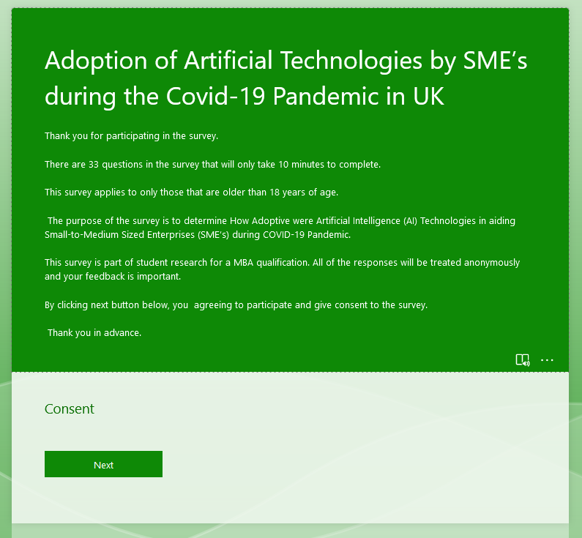

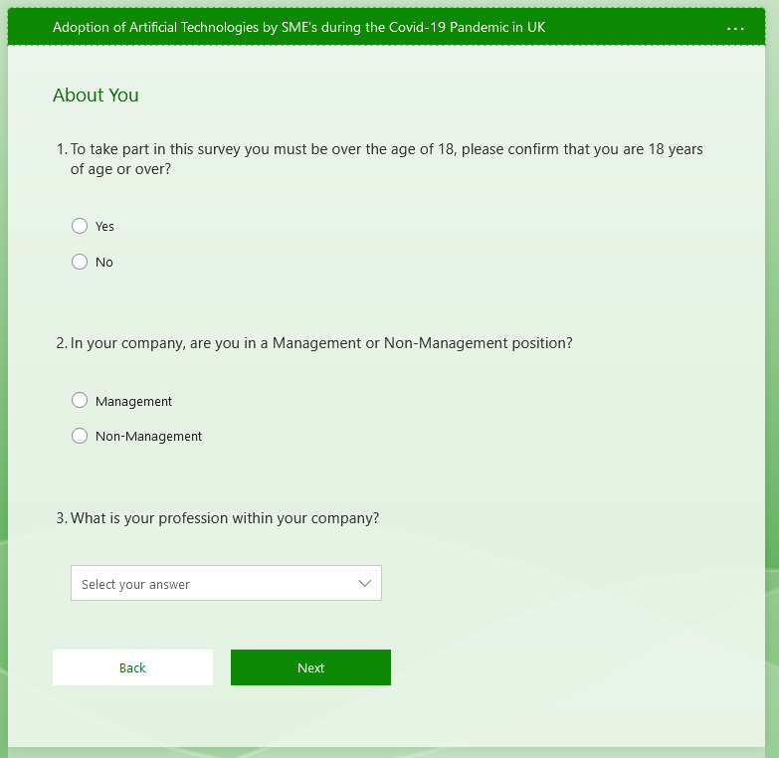

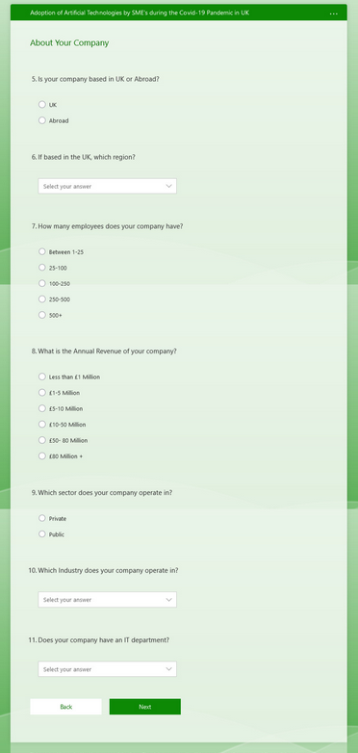

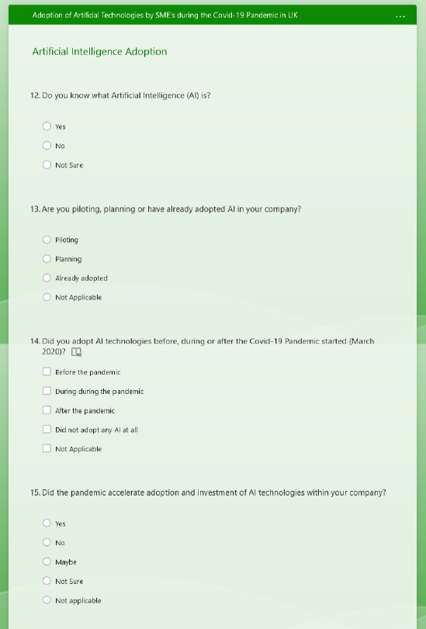

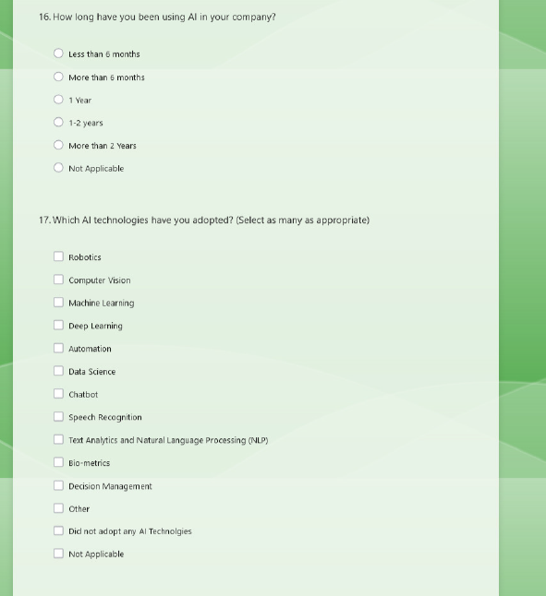

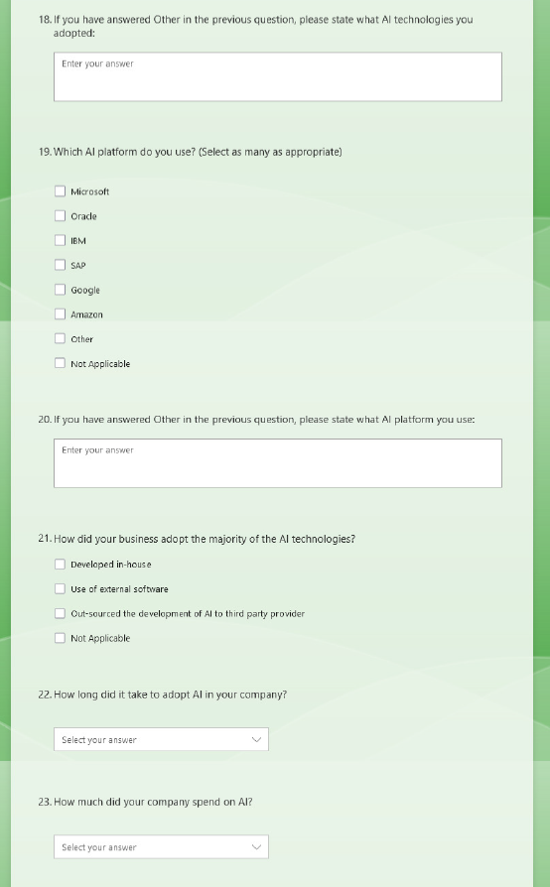

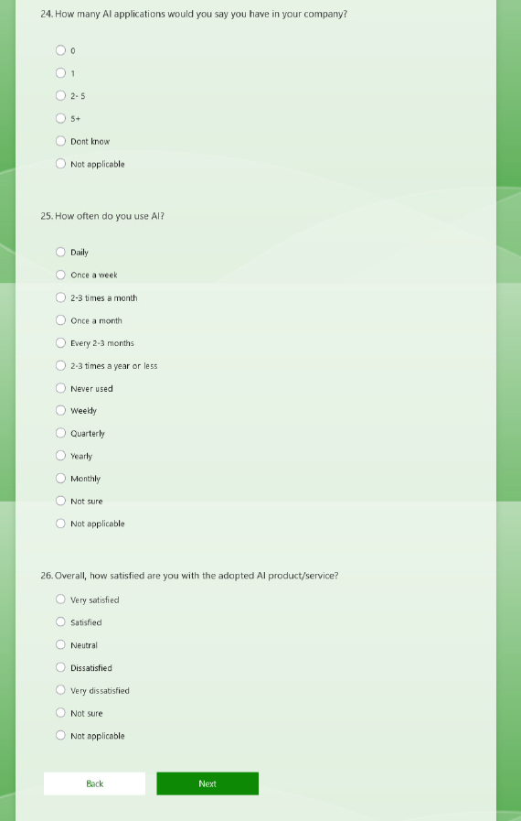

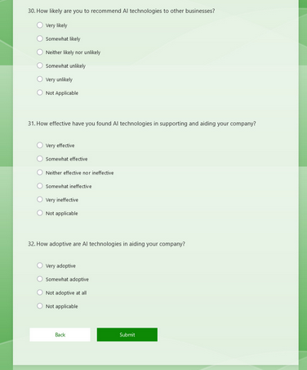

Survey Data Results
Confirm that you are 18 years of age or over to take part in survey? | Management or Non-Management position? | Profession | UK or Abroad? | Region | Employees | Annual Revenue | Private or Public | Industry | Does your company have an IT department? | Do you know what Artificial Intelligence (AI) is? | Are you piloting, planning or have already adopted AI in your company? | Did you adopt AI technologies before, during or after the Covid-19 Pandemic started? | Did the pandemic accelerate adoption and investment of AI technologies within your company? | How long have you been using AI in your company? | Which AI technologies have you adopted? (Select as many as appropriate) | Which AI platform do you use? (Select as many as appropriate) | How did your business adopt the majority of the AI technologies? | How long did it take to adopt AI in your company? | How much did your company spend on AI? | How many AI applications would you say you have in your company? | How often do you use AI? | Overall, how satisfied are you with the adopted AI product/service? | Do you anticipate further investment into AI by your company post covid? | Has the introduction of AI in your company improved efficiency? | Has your revenue increased since the adoption of AI in your organisation? | Has adoption of AI in your company decreased cost? | How likely are you to recommend AI technologies to other businesses? | How effective have you found AI technologies in supporting and aiding your company? | How adoptive are AI technologies in aiding your company?
Yes | Management | IT | UK | West Midlands | 25-100 | £10-50 Million | Private | Wholesale | Yes | Yes | Already adopted | During during the pandemic; | Yes | 1 Year | Machine Learning; | Microsoft; | Developed in-house; | More than a month | £10,000 – £20,000 | 2- 5 | Daily | Very satisfied | Yes | Yes | Yes | Yes | Very likely | Very effective | Very adoptive
Yes | Management | IT | UK | West Midlands | 100-250 | £50- 80 Million | Private | Wholesale | Yes | Yes | Already adopted | During during the pandemic; | Yes | 1-2 years | Machine Learning;Data Science; | Microsoft; | Developed in-house; | Less than 6 months | £10,000 – £20,000 | 2- 5 | Daily | Very satisfied | Yes | Yes | Yes | Yes | Very likely | Very effective | Very adoptive
Yes | Management | IT | UK | West Midlands | 100-250 | £50- 80 Million | Private | Wholesale | Yes | Yes | Already adopted | During during the pandemic; | Yes | 1-2 years | Machine Learning;Automation; | Microsoft; | Developed in-house; | More than a month | £50,000 – £100,000 | 2- 5 | Daily | Very satisfied | Yes | Yes | Yes | Yes | Very likely | Very effective | Very adoptive
Yes | Management | IT | UK | West Midlands | 250-500 | £80 Million + | Private | Wholesale | Yes | Yes | Already adopted | During during the pandemic; | Yes | 1-2 years | Machine Learning;Data Science; | Microsoft; | Developed in-house; | Less than 6 months | £10,000 – £20,000 | 2- 5 | Daily | Very satisfied | Yes | Yes | Yes | Yes | Very likely | Very effective | Very adoptive
Yes | Non-Management | IT | UK | West Midlands | 250-500 | £80 Million + | Private | Wholesale | Yes | Yes | Already adopted | During during the pandemic; | Yes | 1 Year | Machine Learning;Automation; | Microsoft;Amazon; | Developed in-house; | More than a month | £20,000 – £50,000 | 5+ | Daily | Very satisfied | Yes | Yes | Yes | Yes | Very likely | Very effective | Very adoptive
Yes | Management | Business | UK | West Midlands | 250-500 | £80 Million + | Private | Wholesale | Yes | Yes | Already adopted | During during the pandemic; | Yes | 1-2 years | Machine Learning; | Microsoft; | Developed in-house; | Less than 6 months | £20,000 – £50,000 | 5+ | Daily | Very satisfied | Yes | Yes | Yes | Yes | Very likely | Very effective | Very adoptive
Yes | Management | Business | UK | West Midlands | 100-250 | £80 Million + | Private | Retail | Yes | Yes | Already adopted | During during the pandemic; | Yes | 1-2 years | Computer Vision;Machine Learning;Data Science; | Microsoft;SAP; | Developed in-house; | More than a month | £20,000 – £50,000 | 5+ | Daily | Very satisfied | Yes | Yes | Yes | Yes | Very likely | Very effective | Very adoptive
Yes | Management | IT | UK | London | 250-500 | £50- 80 Million | Private | Retail | Yes | Yes | Already adopted | During during the pandemic; | Yes | More than 2 Years | Machine Learning;Data Science;Chatbot; | Microsoft; | Developed in-house; | Less than 6 months | £50,000 – £100,000 | 5+ | Daily | Very satisfied | Yes | Yes | Yes | Yes | Very likely | Very effective | Very adoptive
Yes | Management | IT | UK | West Midlands | 250-500 | £80 Million + | Private | Technology | Yes | Yes | Already adopted | During during the pandemic; | Yes | 1-2 years | Automation;Deep Learning;Machine Learning;Data Science;Chatbot; | Microsoft; | Developed in-house; | Less than 6 months | £20,000 – £50,000 | 5+ | Daily | Very satisfied | Yes | Yes | Yes | Yes | Very likely | Very effective | Very adoptive
Yes | Management | IT | UK | West Midlands | 250-500 | £80 Million + | Private | Wholesale | Yes | Yes | Already adopted | During during the pandemic; | Yes | 1-2 years | Machine Learning; | Microsoft; | Developed in-house; | Less than 6 months | £10,000 – £20,000 | 2- 5 | Daily | Very satisfied | Yes | Yes | Yes | Yes | Very likely | Very effective | Very adoptive
Yes | Management | IT | UK | West Midlands | 250-500 | £80 Million + | Private | Wholesale | Yes | Yes | Already adopted | During during the pandemic; | Yes | More than 2 Years | Machine Learning; | Microsoft; | Developed in-house; | Less than 6 months | £10,000 – £20,000 | 2- 5 | Daily | Very satisfied | Yes | Yes | Yes | Yes | Very likely | Very effective | Very adoptive
Yes | Management | IT | UK | London | 250-500 | £80 Million + | Private | Retail | Yes | Yes | Already adopted | During during the pandemic; | Yes | 1-2 years | Machine Learning; | Microsoft; | Developed in-house; | Less than 6 months | £10,000 – £20,000 | 2- 5 | Daily | Very satisfied | Yes | Yes | Yes | Yes | Very likely | Very effective | Very adoptive
Yes | Management | IT | UK | West Midlands | 250-500 | £80 Million + | Private | Retail | Yes | Yes | Already adopted | During during the pandemic; | Yes | 1-2 years | Machine Learning; | Microsoft; | Developed in-house; | Less than 6 months | £10,000 – £20,000 | 2- 5 | Daily | Very satisfied | Yes | Yes | Yes | Yes | Very likely | Very effective | Very adoptive
Yes | Management | IT | UK | West Midlands | 250-500 | £10-50 Million | Private | Technology | Yes | Yes | Already adopted | During during the pandemic; | Yes | More than 2 Years | Machine Learning; | Microsoft; | Developed in-house; | Less than 6 months | £10,000 – £20,000 | 2- 5 | Daily | Very satisfied | Yes | Yes | Yes | Yes | Very likely | Very effective | Very adoptive
Yes | Management | IT | UK | West Midlands | 250-500 | £80 Million + | Private | Technology | Yes | Yes | Already adopted | During during the pandemic; | Yes | 1 Year | Machine Learning; | Microsoft; | Developed in-house; | Less than 6 months | £10,000 – £20,000 | 5+ | Daily | Very satisfied | Yes | Yes | Yes | Yes | Very likely | Very effective | Very adoptive
Yes | Management | IT | UK | West Midlands | 250-500 | £80 Million + | Private | Technology | Yes | Yes | Already adopted | During during the pandemic; | Yes | 1-2 years | Machine Learning; | Microsoft; | Developed in-house; | Less than 6 months | £10,000 – £20,000 | 5+ | Daily | Very satisfied | Yes | Yes | Yes | Yes | Very likely | Very effective | Very adoptive
Yes | Management | IT | UK | West Midlands | 250-500 | £80 Million + | Private | Construction | Yes | Yes | Already adopted | During during the pandemic; | Yes | 1-2 years | Machine Learning; | Microsoft; | Developed in-house; | Less than 6 months | £10,000 – £20,000 | 2- 5 | Daily | Very satisfied | Yes | Yes | Yes | Yes | Very likely | Very effective | Very adoptive
Yes | Management | IT | UK | West Midlands | 250-500 | £80 Million + | Private | Construction | Yes | Yes | Already adopted | During during the pandemic; | Yes | 1-2 years | Machine Learning; | Microsoft; | Developed in-house; | Less than 6 months | £10,000 – £20,000 | 2- 5 | Daily | Very satisfied | Yes | Yes | Yes | Yes | Very likely | Very effective | Very adoptive
Yes | Management | IT | UK | West Midlands | 250-500 | £80 Million + | Private | Retail | Yes | Yes | Already adopted | During during the pandemic; | Yes | 1-2 years | Machine Learning;Data Science; | Microsoft; | Developed in-house; | Less than 6 months | £10,000 – £20,000 | 2- 5 | Daily | Very satisfied | Yes | Yes | Yes | Yes | Very likely | Very effective | Very adoptive
Yes | Management | IT | UK | West Midlands | 250-500 | £80 Million + | Private | Retail | Yes | Yes | Already adopted | During during the pandemic; | Yes | 1-2 years | Machine Learning;Automation; | Microsoft; | Developed in-house; | Less than 6 months | £10,000 – £20,000 | 2- 5 | Daily | Very satisfied | Yes | Yes | Yes | Yes | Very likely | Very effective | Very adoptive
Yes | Management | IT | UK | West Midlands | 250-500 | £80 Million + | Private | Wholesale | Yes | Yes | Already adopted | During during the pandemic; | Yes | 1-2 years | Machine Learning;Data Science; | Microsoft; | Developed in-house; | Less than 6 months | £10,000 – £20,000 | 2- 5 | Daily | Very satisfied | Yes | Yes | Yes | Yes | Very likely | Very effective | Very adoptive
Yes | Management | IT | UK | West Midlands | 250-500 | £80 Million + | Private | Wholesale | Yes | Yes | Already adopted | During during the pandemic; | Yes | 1-2 years | Machine Learning;Data Science; | Microsoft; | Developed in-house; | Less than 6 months | £10,000 – £20,000 | 2- 5 | Daily | Very satisfied | Yes | Yes | Yes | Yes | Very likely | Very effective | Very adoptive
Yes | Management | IT | UK | London | 250-500 | £80 Million + | Private | Wholesale | Yes | Yes | Already adopted | During during the pandemic; | Yes | 1-2 years | Machine Learning;Automation; | Microsoft; | Developed in-house; | Less than 6 months | £10,000 – £20,000 | 2- 5 | Daily | Very satisfied | Yes | Yes | Yes | Yes | Very likely | Very effective | Very adoptive
Yes | Management | IT | UK | London | 250-500 | £80 Million + | Private | Wholesale | Yes | Yes | Already adopted | During during the pandemic; | Yes | 1-2 years | Machine Learning;Data Science; | Microsoft; | Developed in-house; | Less than 6 months | £10,000 – £20,000 | 2- 5 | Daily | Very satisfied | Yes | Yes | Yes | Yes | Very likely | Very effective | Very adoptive
Yes | Management | IT | UK | London | 250-500 | £50- 80 Million | Private | Wholesale | Yes | Yes | Already adopted | During during the pandemic; | Yes | 1-2 years | Machine Learning;Data Science; | Microsoft; | Developed in-house; | Less than 6 months | £10,000 – £20,000 | 2- 5 | Daily | Very satisfied | Yes | Yes | Yes | Yes | Very likely | Very effective | Very adoptive
Yes | Management | IT | UK | West Midlands | 250-500 | £50- 80 Million | Private | Wholesale | Yes | Yes | Already adopted | During during the pandemic; | Yes | 1-2 years | Machine Learning; | Microsoft; | Developed in-house; | Less than 6 months | £10,000 – £20,000 | 2- 5 | Daily | Very satisfied | Yes | Yes | Yes | Yes | Very likely | Very effective | Very adoptive
Yes | Management | IT | UK | West Midlands | 250-500 | £50- 80 Million | Private | Wholesale | Yes | Yes | Already adopted | During during the pandemic; | Yes | 1-2 years | Machine Learning; | Microsoft; | Developed in-house; | Less than 6 months | £10,000 – £20,000 | 2- 5 | Daily | Very satisfied | Yes | Yes | Yes | Yes | Very likely | Very effective | Very adoptive
Yes | Management | IT | UK | West Midlands | 250-500 | £80 Million + | Private | Wholesale | Yes | Yes | Already adopted | During during the pandemic; | Yes | 1-2 years | Machine Learning; | Microsoft; | Developed in-house; | Less than 6 months | £10,000 – £20,000 | 2- 5 | Daily | Very satisfied | Yes | Yes | Yes | Yes | Very likely | Very effective | Very adoptive
Yes | Management | IT | UK | West Midlands | 250-500 | £80 Million + | Private | Wholesale | Yes | Yes | Already adopted | During during the pandemic; | Yes | 1-2 years | Machine Learning; | Microsoft; | Developed in-house; | Less than 6 months | £10,000 – £20,000 | 2- 5 | Daily | Very satisfied | Yes | Yes | Yes | Yes | Very likely | Very effective | Very adoptive
Yes | Management | IT | UK | West Midlands | 250-500 | £80 Million + | Private | Wholesale | Yes | Yes | Already adopted | During during the pandemic; | Yes | 1-2 years | Machine Learning; | Microsoft; | Developed in-house; | Less than 6 months | £10,000 – £20,000 | 2- 5 | Daily | Very satisfied | Yes | Yes | Yes | Yes | Very likely | Very effective | Very adoptive
Yes | Management | IT | UK | West Midlands | 250-500 | £80 Million + | Private | Wholesale | Yes | Yes | Already adopted | During during the pandemic; | Yes | 1-2 years | Machine Learning; | Microsoft; | Developed in-house; | Less than 6 months | £10,000 – £20,000 | 2- 5 | Daily | Very satisfied | Yes | Yes | Yes | Yes | Very likely | Very effective | Very adoptive
Yes | Management | IT | UK | London | 250-500 | £50- 80 Million | Private | Wholesale | Yes | Yes | Already adopted | During during the pandemic; | Yes | 1-2 years | Machine Learning; | Microsoft; | Developed in-house; | Less than 6 months | £10,000 – £20,000 | 2- 5 | Daily | Very satisfied | Yes | Yes | Yes | Yes | Very likely | Very effective | Very adoptive
Yes | Management | IT | UK | West Midlands | 250-500 | £80 Million + | Private | Wholesale | Yes | Yes | Already adopted | During during the pandemic; | Yes | 1-2 years | Machine Learning; | Microsoft; | Developed in-house; | Less than 6 months | £10,000 – £20,000 | 5+ | Daily | Very satisfied | Yes | Yes | Yes | Yes | Very likely | Very effective | Very adoptive
Yes | Management | IT | UK | West Midlands | 250-500 | £80 Million + | Private | Retail | Yes | Yes | Already adopted | During during the pandemic; | Yes | 1-2 years | Machine Learning; | Microsoft; | Developed in-house; | Less than 6 months | £10,000 – £20,000 | 5+ | Daily | Very satisfied | Yes | Yes | Yes | Yes | Very likely | Very effective | Very adoptive
Yes | Management | IT | UK | West Midlands | 250-500 | £80 Million + | Private | Wholesale | Yes | Yes | Already adopted | During during the pandemic; | Yes | 1-2 years | Machine Learning; | Microsoft; | Developed in-house; | Less than 6 months | £10,000 – £20,000 | 5+ | Daily | Very satisfied | Yes | Yes | Yes | Yes | Very likely | Very effective | Very adoptive

Project Management Gantt Chart

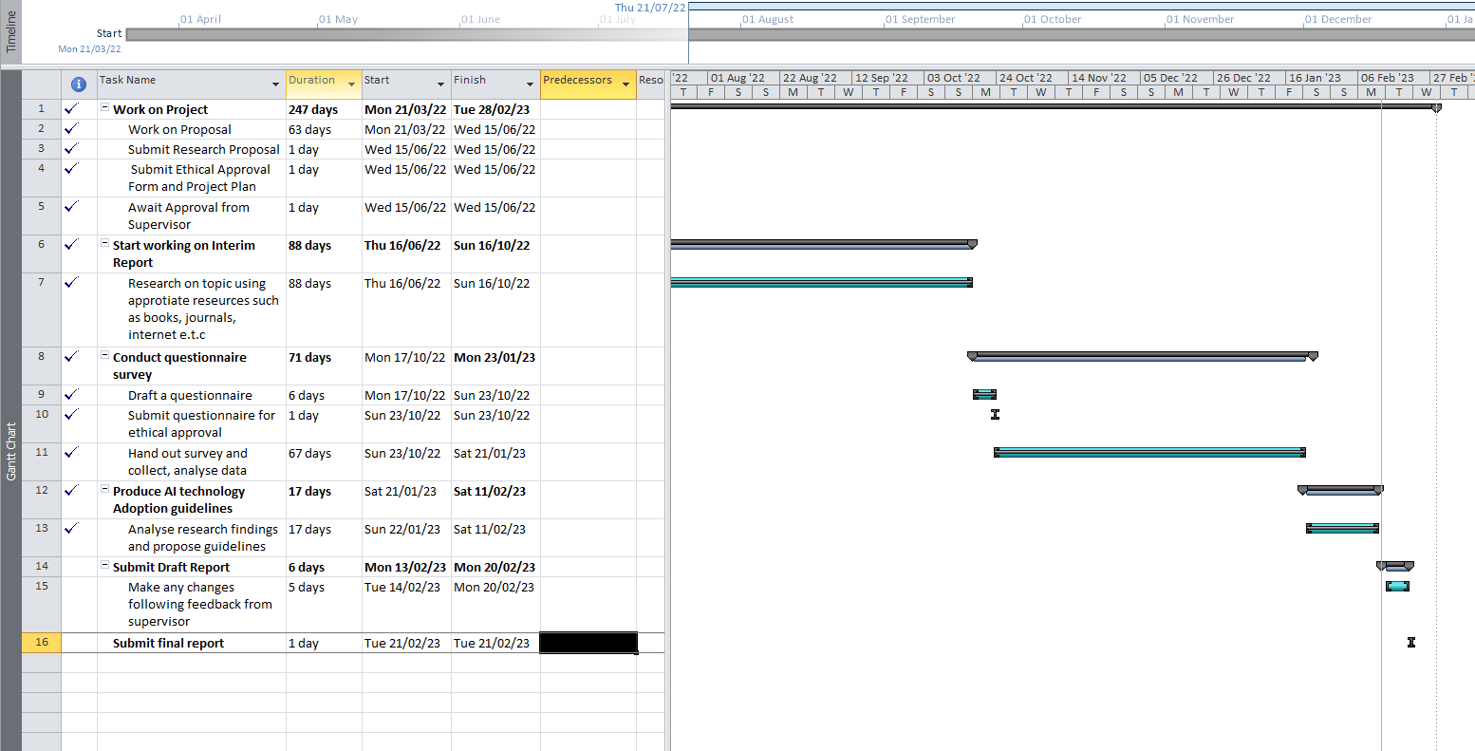
Source: Researchers Computation using Microsoft Project

Supervisor Logs
POSTGRADUATE TAUGHT DISSERTATION SUPERVISION RECORD

This form is to be used to record a summary of the outcomes of each formal meeting between the student and the dissertation supervisors for Part II of a Masters’ Programme.

Student Name: | Rehman Ismail | Student No: | 1908396
Programme of Study: | MBA (Online) | Campus: | Distance Learning
Faculty/School/Centre: | Business | Module Code: | BMMB7003D
Mode of study: | Full-time / Part-time | Method of study: | Campus based / Distance learning

Dissertation Title: | Project Title: Investigation into the use of Artificial Intelligence (AI) Technologies to Sustain Business’s during Covid-19 Pandemic  Academic Question: How Adoptive were Artificial Intelligence (AI) Technologies in aiding Small-to-Medium Sized Enterprises (SME’s) during COVID-19 Pandemic?
Dissertation Supervisor: | Dr .Roisin Mullins
Programme Director: | Dr.Alex Bell/ Dr. Glenn Behenna

SUPERVISION RECORD
Date of meeting | Type of meeting | Summary of outcomes | Student | Supervisor | Duration of meeting | Running total
01 February 2022 | Teams | Project Proposal Meeting | RI |  | 30 mins
21 March 2022 | Email | Project Proposal Update | RI
31 March 2022 | Email | Project Proposal Update | RI
13 May 2022 | Email | Project Proposal Update | RI
15 June 2022 | Email | Project Proposal Finalisation and Approval | RI
05 September 2022 | Email | Project Update | RI
21st September 2022 | Teams | Project Update | RI
21st September 2022 | Email | Project Update | RI
27 September 2022 | Email | Project Update | RI
03 October 2022 | Email | Project Update | RI
14 October 2022 | Email | Survey Review | RI
17 October 2022 | Email | Survey Review | RI
23 October 2022 | Email | Survey Approved for Go-live | RI
30 November 2022 | Email | Project Update- Data Analysis Stage | RI
04 January 2023 | Email | Project Update | RI
25 January 2023 | Email | Project Update- Ready to submit draft | RI
13th February | Email | Project Update- Ready to submit draft | RI
16th February | Email | Project Update – Feedback on Draft | RI
29th February | Email | Project Update – Project Submitted | RI
Notes on the Postgraduate Taught Dissertation Supervision Record
Record the date and type of meeting – e.g. face-to-face, video conference, telephone, email, letter
Note the outcomes agreed by both the student and the supervisor
Both the student and the supervisor should initial
Record the duration of the meeting
Update the running total for duration by adding the duration of the meeting to the previous running total

