By
Christopher James
Electronics 2
Evaluation and comparison of Brauns and Wallace tree multipliers

Contents
1. Introduction 2
2. Research 2
2.1 Brauns Multiplier 2
2.2 Wallace tree multiplier 2
2.3 Conclusion 3
2.4. VHDL 3
2.5 FPGA 4
3. Flowcharts 5
3.1 Brauns Multiplier 5
3.2 Wallace tree multiplier 8x8 6
4. Brauns multiplier code 7
5. Wallace tree multiplier code 20
6. Testing program – Brauns multiplier 29
6.1 AAXAA 29
6.2 FFXFF 30
6.3 11X11 31
6.4 8AX55 32
7. Wallace tree multiplier 33
7.1 FFxFF 33
7.2 AAxAA 34
7.3 11x23 35
7.4 41x53 36
7.5 Conclusion 36
8. Brauns and Wallace tree comparisons 37
8.1 Brauns 37
8.2 Wallace 41
8.3 Conclusion 45
References 46

Introduction
This report will compare both Brauns and Wallace multipliers using VHDL (VHSIC Hardware Description Language). To achieve this I will explore the multiplier techniques, advantages of both multipliers and the methodology behind the process of both types of multiplier.
I will show the results of my practical simulations, comparing the results of each multiplier to determine the advantages and disadvantages of both.

Research
Multiplication is vital to the functionality of digital systems where signal processing is required. Methods of quick hardware multiplication are important to achieve high efficiency and precision within equipment. Two separate methods of parallel multipliers are Brauns and Wallace tree.

Brauns Multiplier
Brauns multiplier (Carry-save multiplier), is a unique tool that can be used mainly for unsigned integer multiplication. Within its coding, partial product is created in parallel and then calculated using carry/save adders. The simplicity of this method makes it a suitable option for large scale integration (VLSI). MY simulations will show however, that it is not the most speed efficient, mainly due to an accumulation off carry delays. Brauns multiplier meets the requirements of many circuits, with it capable of carrying out parallel array multiplication over acceptable speeds. [1]
The structure of the Brauns multiplier consists of and array of AND gates and adders that have a regular and parallel layout. This predictable and methodical structure makes them well suited in hardware implementation. The multiplier begins by using AND gates to generate partial products by performing multiplication [2]. These partial products can then be aligned accordingly and summed using carry-save adders that are arranged systematically. Each row of adders will create a layer of partial products, with the carries moving across and the sums downwards. At the last layer, the final result is created.

2.2 Wallace tree multiplier
To combat the delays, the Wallace tree multiplier was created to increase the speed by reducing the amount of sequential add-on steps required to sum partial products. This is achieved via a complex and efficient hardware that uses layers of and gates, full and half adders to reduce the number of products as soon as it can, minimising the amount of memory used. The Wallace tree aims to reduce the summing layer by layer, ultimately reducing the amount of overall delay. This makes the Wallace tree multiplier suitable for higher speed applications. The drawback of this method is that it will have a more complicated coding process to create.
The Wallace tree method starts by generating all partial products using AND gates. Thes partial products are then grouped together into sets and reduced using full and half adders to compress the partial products as soon as possible. Instead of summing rows of product separately, the Wallace tree will organise the bits into columns depending on their bit position. It will then begin the reduction process layer by layer. This layered reduction will greatly reduce the amount of clock cycles required, speeding up the entire process as a whole[3].
By compressing the addition sections into a non-linear method, the Wallace tree multiplier is able to improve performance, making it highly suitable for high-speed arithmetic functions, making it ideal for digital signal processing and real time embedded systems implemented into the FPGA’s.
The downside to this method is that the structure is very complex and the need for careful organisation of signals makes it a longer and more difficult process, with greater possibilities for error.

2.3 Conclusion
Both Brauns and Wallace tree multipliers are used for high-speed calculations in digital systems, however they both differ in structure, performance and integration. Brauns multiplier follows a less complex structure, making it easier to implement. This is useful for applications where simplicity in design is important. It uses a fixed array of AND gates and carry-save adders to complete its design. Its simplicity, however, comes at the expense of increased delay time due to its sequential addition process.
The Wallace tree multiplier is designed specifically to increase the processing times of the calculations by carrying out reductions in parallel. Minimising the amount of addition layers using full and half adders will help to improve its efficiency as a whole. This makes it suitable for more high-performance applications. Its complex structure however makes is a more time intensive process to create, with larger possibilities of errors in the programming [4].
The choice between both methods is dependent on the circuit requirements. Braun is useful due to its simplicity and ease of implementation, whereas Wallace is ideal for high speeds and performance however at the cost of increased complexity.

2.4. VHDL
VHDL (VHSIC hardware design language) is a unique and powerful programming language that can be used to describe the structure and behavioural methods of digital circuits and systems, such as techniques used in programming FPGA’s (field programmable gate arrays). This allows the user to create detailed models of how the hardware will perform before physically building a system, which can be costly and time consuming [5].
VHDL is widely used when designing systems and equipment that require high accuracy and reliability. These include aerospace, automotive electronics, medical and telecommunication. IT will allow for precise and accurate timing and logic which is vital for safety sensitive or even performance critical applications.
There are many benefits to using VHDL:
- Allows simulation of specific software to me modelled before wasting time and money on physical hardware
- VHDL can be used to describe the concurrent system.
- Once a computational block has been built (such as my half/full adders) they can be reused in other projects, saving time on the coding.
- VHDL allows you to reduce the number of bugs within your coding early on, with unique typing and coding checks.
- Allows for highly structured and easier to read code.
- Supports modular design – You are able to create reusable components and then break the program down into more manageable blocks.
- Compatibility – VHDL is supported by the majority of major FPGA development tools such as Vivado.
- Testing – VHDL allows users to simulate their work and verify it to ensure it works correctly before carrying out programming on hardware, reducing overall development time and cost.
Although VHDL offers many advantages, it also comes with other disadvantages:
- For beginners, it can be difficult to learn and understand due to its coding and navigation methods.
- Writing simple designs such as AND gates require larger amounts of code.
Unlike other types of coding such as C or python, VHDL does not tell a computer what to do or how to function, instead, it tells a FPGA how it should behave. Using VHDL, you are able to write a description of behaviour using code and then use built in programs to synthesis the code and turn it into combinational logic such as and gates or NOT gates.
In comparison to other programming languages such as C, where you may write a program that will add two numbers, in VHDL, you will describe how the hardware will perform the addition, specifying how the logic will flow through the logic gates to get to the final result. This description is what is then synthesised into logic that will run on the FPGA.

2.5 FPGA
Field programmable gate arrays are flexible, digital devices that will allow the user to create custom hardware formations. Unlike other methods (e.g ASIC), a FGPA can be reprogrammed to perform a wide multitude of tasks. It is one of the most used languages when describing circuits performance. Combining FGPA and VHDL, a user is capable of designing, simulating and creating complicated hardware circuitry to a high level of accuracy and efficiency.

3. Flowcharts

3.1 Brauns Multiplier
The below flowchart shows the Brauns multiplier layout. To create the full circuit, each bit in one row is multiplied with every bit in the other row. (e.g. A0B1). Once complete on the first row, each bit is then shifted and then summed together again, eventually creating a final result of the multiplication.
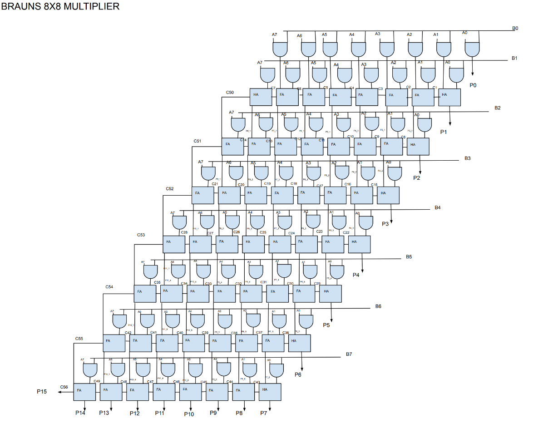
Figure 1 - Brauns multiplier 8x8

3.2 Wallace tree multiplier 8x8
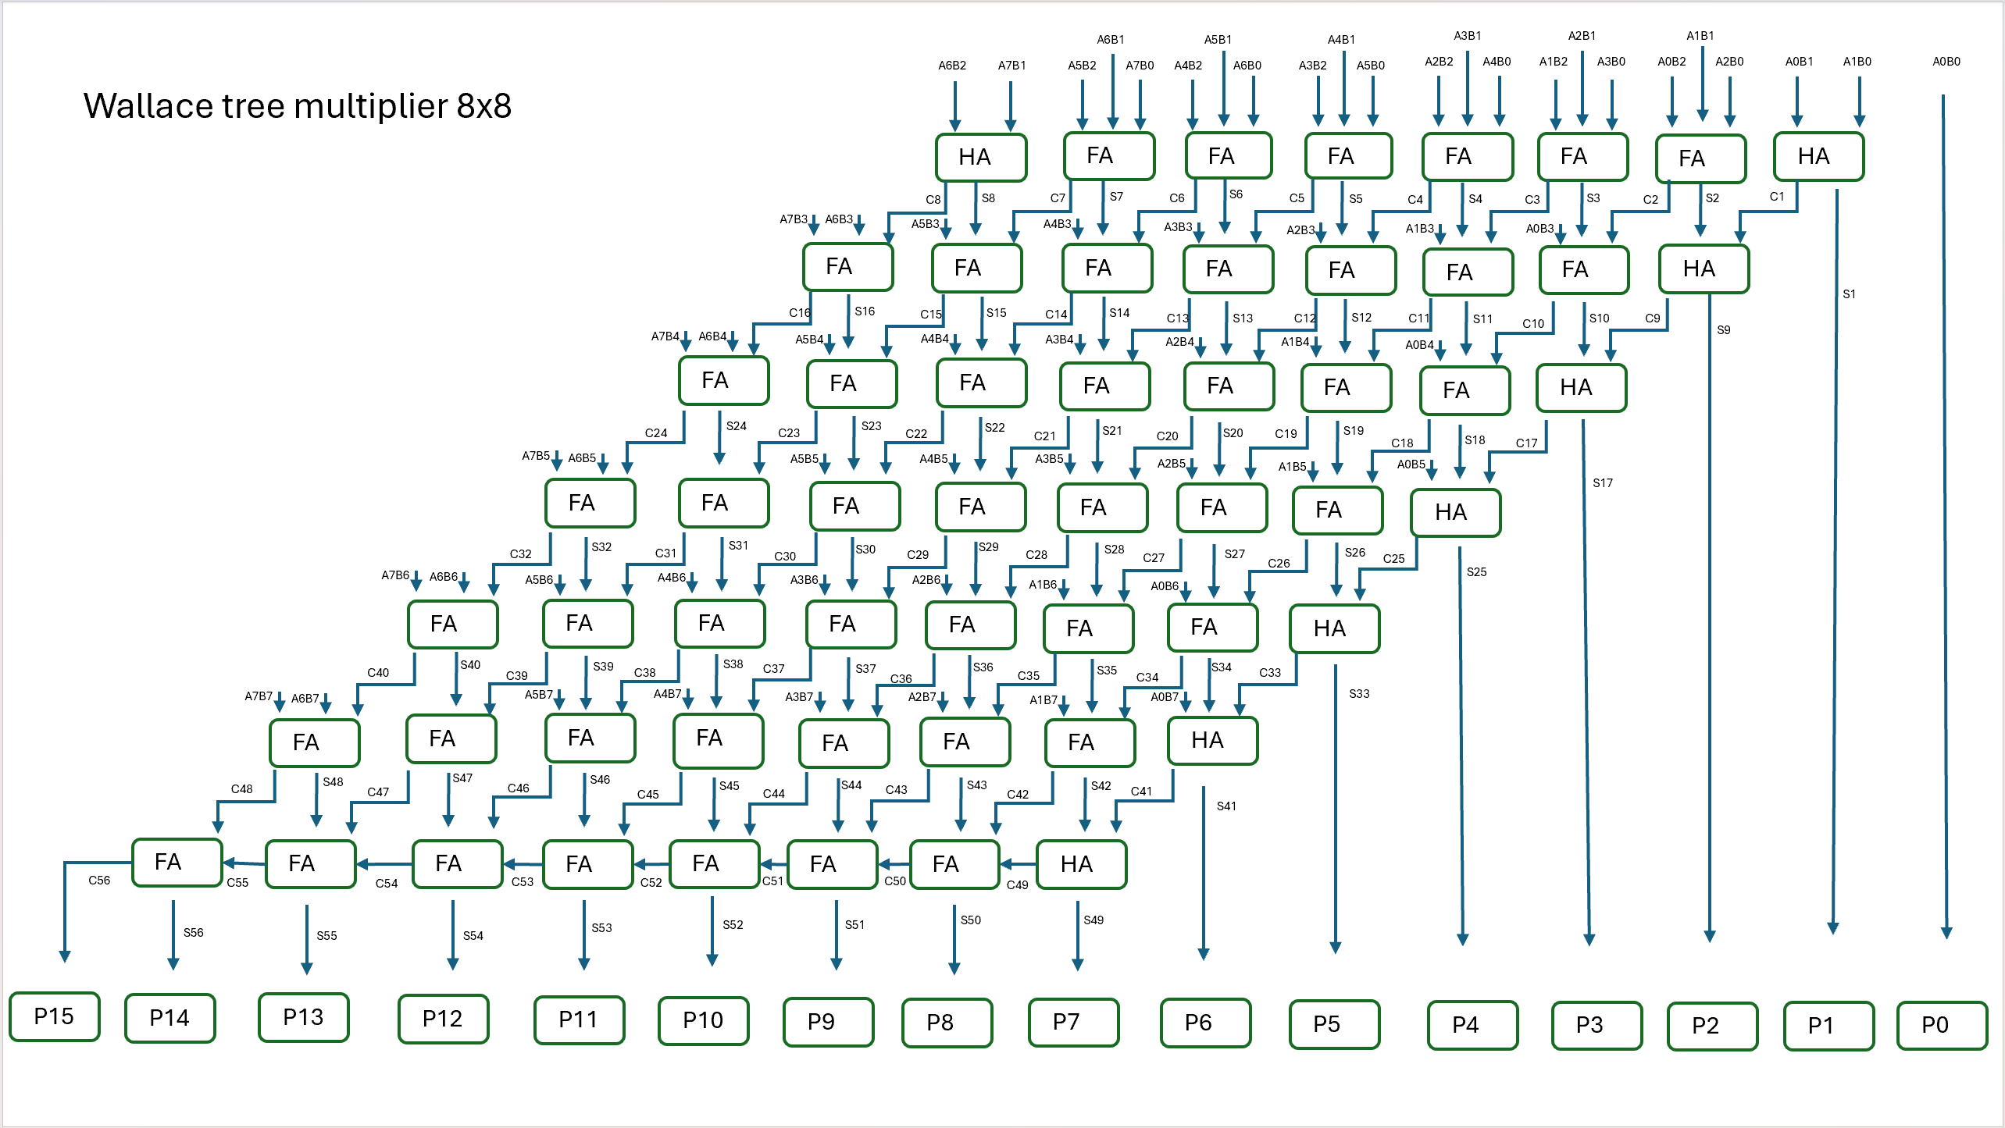
Figure 2 - Wallace tree multiplier 8x8

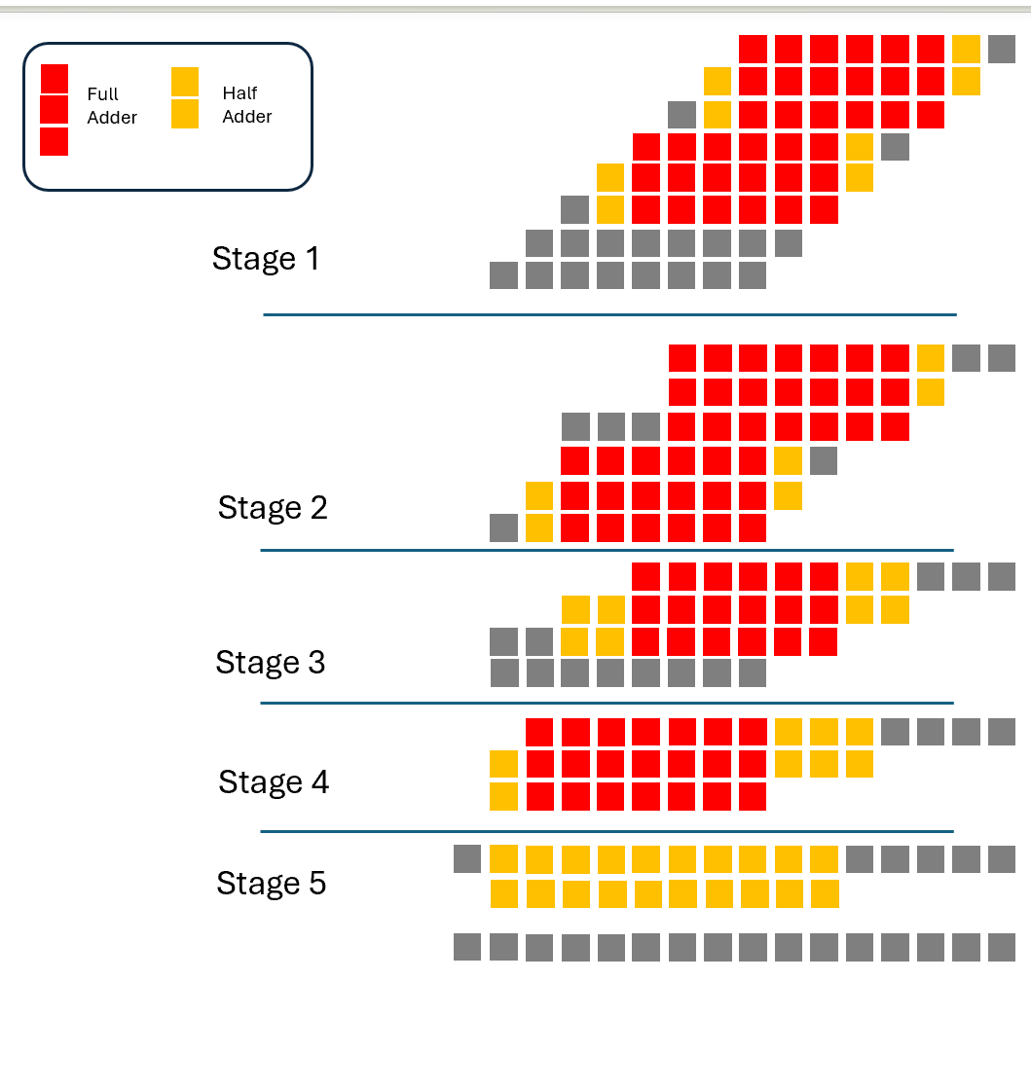
Figure 3 - Wallace dot diagram
Figure 3 demonstrates an 8x8 Wallace multiplier and shows its structure. This shows the placement of the full and half adders to generate partial products and carry out immediate calculations

4. Brauns multiplier code
-- Company:
-- Engineer:
--
-- Create Date: 20.03.2025 12:30:16
-- Design Name:
-- Module Name: Brauns - Behavioural
-- Project Name:
-- Target Devices:
-- Tool Versions:
-- Description:
--
-- Dependencies:
--
-- Revision:
-- Revision 0.01 - File Created
-- Additional Comments:
--
----------------------------------------------------------------------------------

library IEEE;
use IEEE.STD_LOGIC_1164.ALL;
use IEEE.STD_logic_arith.all;
use Ieee.std_logic_unsigned.all;

-- Uncomment the following library declaration if using
-- arithmetic functions with Signed or Unsigned values
--use IEEE.NUMERIC_STD.ALL;

-- Uncomment the following library declaration if instantiating
-- any Xilinx leaf cells in this code.
--library UNISIM;
--use UNISIM.VComponents.all;

entity Brauns is
Port ( A: in std_logic_vector (7 downto 0) ;
B: in std_logic_vector (7 downto 0);
P: out std_logic_vector (15 downto 0));
-- Port ( );
end Brauns;

architecture behavioral of Brauns is

signal A1B0 : std_logic;
signal A2B0 : std_logic;
signal A3B0 : std_logic;
signal A4B0 : std_logic;
signal A5B0 : std_logic;
signal A6B0 : std_logic;
signal A7B0 : std_logic;
signal A0B1 : std_logic;
signal A1B1 : std_logic;
signal A2B1 : std_logic;
signal A3B1 : std_logic;
signal A4B1 : std_logic;
signal A5B1 : std_logic;
signal A6B1 : std_logic;
signal A7B1 : std_logic;
signal A0B2 : std_logic;
signal A1B2 : std_logic;
signal A2B2 : std_logic;
signal A3B2 : std_logic;
signal A4B2 : std_logic;
signal A5B2 : std_logic;
signal A6B2 : std_logic;
signal A7B2 : std_logic;
signal A0B3 : std_logic;
signal A1B3 : std_logic;
signal A2B3 : std_logic;
signal A3B3 : std_logic;
signal A4B3 : std_logic;
signal A5B3 : std_logic;
signal A6B3 : std_logic;
signal A7B3 : std_logic;
signal A0B4 : std_logic;
signal A1B4 : std_logic;
signal A2B4 : std_logic;
signal A3B4 : std_logic;
signal A4B4 : std_logic;
signal A5B4 : std_logic;
signal A6B4 : std_logic;
signal A7B4 : std_logic;
signal A0B5 : std_logic;
signal A1B5 : std_logic;
signal A2B5 : std_logic;
signal A3B5 : std_logic;
signal A4B5 : std_logic;
signal A5B5 : std_logic;
signal A6B5 : std_logic;
signal A7B5 : std_logic;
signal A0B6 : std_logic;
signal A1B6 : std_logic;
signal A2B6 : std_logic;
signal A3B6 : std_logic;
signal A4B6 : std_logic;
signal A5B6 : std_logic;
signal A6B6 : std_logic;
signal A7B6 : std_logic;
signal A0B7 : std_logic;
signal A1B7 : std_logic;
signal A2B7 : std_logic;
signal A3B7 : std_logic;
signal A4B7 : std_logic;
signal A5B7 : std_logic;
signal A6B7 : std_logic;
signal A7B7 : std_logic;

signal C1 : std_logic; --P2
signal p2_1 : std_logic;

signal C2 : std_logic; --p3
signal P3_1 : std_logic;
signal C8 : std_logic;
signal P3_2 : std_logic;

signal C3 : std_logic; --p4
signal P4_1 : std_logic;
signal C9 : std_logic;
signal P4_2 : std_logic;
signal C15 : std_logic;
signal P4_3 : std_logic;

signal C4 : std_logic; --p5
signal P5_1 : std_logic;
signal C10 : std_logic;
signal P5_2 : std_logic;
signal C16 : std_logic;
signal P5_3 : std_logic;
signal C22 : std_logic;
signal P5_4 : std_logic;

signal C5 : std_logic; --p6
signal P6_1 : std_logic;
signal C11 : std_logic;
signal P6_2 : std_logic;
signal C17 : std_logic;
signal P6_3 : std_logic;
signal C23 : std_logic;
signal P6_4 : std_logic;
signal C29 : std_logic;
signal P6_5 : std_logic;

signal C6 : std_logic; --p7
signal P7_1 : std_logic;
signal C12 : std_logic;
signal P7_2 : std_logic;
signal C18 : std_logic;
signal P7_3 : std_logic;
signal C24 : std_logic;
signal P7_4 : std_logic;
signal C30 : std_logic;
signal P7_5 : std_logic;
signal C36 : std_logic;
signal P7_6 : std_logic;

signal C7 : std_logic; --p8
signal P8_1 : std_logic;
signal C13 : std_logic;
signal P8_2 : std_logic;
signal C19 : std_logic;
signal P8_3 : std_logic;
signal C25 : std_logic;
signal P8_4 : std_logic;
signal C31 : std_logic;
signal P8_5 : std_logic;
signal C37 : std_logic;
signal P8_6 : std_logic;
signal C43 : std_logic;

signal C50 : std_logic; --p9
signal P9_1 : std_logic;
signal C14 : std_logic;
signal P9_2 : std_logic;
signal C20 : std_logic;
--signal P9_3 : std_logic;
signal C26 : std_logic;
signal P9_4 : std_logic;
signal C32 : std_logic;
signal P9_5 : std_logic;
signal C38 : std_logic;
signal P9_6 : std_logic;
signal C44 : std_logic;

signal C51 : std_logic; --p10
signal C21 : std_logic;
signal P10_1 : std_logic;
signal C27 : std_logic;
signal P10_4 : std_logic;
signal C33 : std_logic;
signal P10_5 : std_logic;
signal C39 : std_logic;
signal P10_6 : std_logic;
signal C45 : std_logic;

signal C52 : std_logic; --p11
signal C28 : std_logic;
signal P11_4 : std_logic;
signal C34 : std_logic;
signal P11_5 : std_logic;
signal C40 : std_logic;
signal P11_6 : std_logic;
signal C46 : std_logic;

signal C53 : std_logic; --p12
signal C35 : std_logic;
signal P12_1 : std_logic;
signal C41 : std_logic;
signal P12_6 : std_logic;
signal C47 : std_logic;

signal C54 : std_logic; --p13
signal C42 : std_logic;
signal P13_1 : std_logic;
signal C48 : std_logic;

signal C55 : std_logic; --p14
signal C49 : std_logic;

signal C56 : std_logic; --P15

component Full_adder
Port ( A : in std_logic;
B : in std_logic;
Cin : in std_logic;
S : out std_logic;
Cout : out std_logic);
end component;

component half_adder
port (A : in std_logic;
B : in std_logic;
S : out std_logic;
Cout : out std_logic);
end component;

begin

A0B1 <= A(0) and B(1);
A0B2 <= A(0) and B(2);
A0B3 <= A(0) and B(3);
A0B4 <= A(0) and B(4);
A0B5 <= A(0) and B(5);
A0B6 <= A(0) and B(6);
A0B7 <= A(0) and B(7);
A1B0 <= A(1) and B(0);
A1B1 <= A(1) and B(1);
A1B2 <= A(1) and B(2);
A1B3 <= A(1) and B(3);
A1B4 <= A(1) and B(4);
A1B5 <= A(1) and B(5);
A1B6 <= A(1) and B(6);
A1B7 <= A(1) and B(7);
A2B0 <= A(2) and B(0);
A2B1 <= A(2) and B(1);
A2B2 <= A(2) and B(2);
A2B3 <= A(2) and B(3);
A2B4 <= A(2) and B(4);
A2B5 <= A(2) and B(5);
A2B6 <= A(2) and B(6);
A2B7 <= A(2) and B(7);
A3B0 <= A(3) and B(0);
A3B1 <= A(3) and B(1);
A3B2 <= A(3) and B(2);
A3B3 <= A(3) and B(3);
A3B4 <= A(3) and B(4);
A3B5 <= A(3) and B(5);
A3B6 <= A(3) and B(6);
A3B7 <= A(3) and B(7);
A4B0 <= A(4) and B(0);
A4B1 <= A(4) and B(1);
A4B2 <= A(4) and B(2);
A4B3 <= A(4) and B(3);
A4B4 <= A(4) and B(4);
A4B5 <= A(4) and B(5);
A4B6 <= A(4) and B(6);
A4B7 <= A(4) and B(7);
A5B0 <= A(5) and B(0);
A5B1 <= A(5) and B(1);
A5B2 <= A(5) and B(2);
A5B3 <= A(5) and B(3);
A5B4 <= A(5) and B(4);
A5B5 <= A(5) and B(5);
A5B6 <= A(5) and B(6);
A5B7 <= A(5) and B(7);
A6B0 <= A(6) and B(0);
A6B1 <= A(6) and B(1);
A6B2 <= A(6) and B(2);
A6B3 <= A(6) and B(3);
A6B4 <= A(6) and B(4);
A6B5 <= A(6) and B(5);
A6B6 <= A(6) and B(6);
A6B7 <= A(6) and B(7);
A7B0 <= A(7) and B(0);
A7B1 <= A(7) and B(1);
A7B2 <= A(7) and B(2);
A7B3 <= A(7) and B(3);
A7B4 <= A(7) and B(4);
A7B5 <= A(7) and B(5);
A7B6 <= A(7) and B(6);
A7B7 <= A(7) and B(7);

P0 : P(0) <= A(0) and B(0);

P1_0 : Half_adder port map (A => A1B0, B=>A0B1, S=> P(1), Cout=>C1);

P21 : Full_adder port map (A=>A2B0, B=>A1B1, Cin=>C1, S=>P2_1, Cout=>C2);
P2_0 : Half_adder port map (A=>A0B2, B=>P2_1, S=>P(2), Cout=>C8);

P31 : full_adder port map (A=> A3B0, B=> A2B1, Cin=>C2, S=>P3_1, Cout=>C3);
P32 : full_adder port map (A=>A1B2, B=>P3_1 , Cin=>C8, S=>P3_2, Cout=>C9);
P3_0 : half_adder port map (A=>A0B3, B=>P3_2, S=>P(3), Cout=>C15);

P41 : full_adder port map (A=> A4B0, B=> A3B1, Cin=>C3, S=>P4_1, Cout=>C4);
P42 : full_adder port map (A=>A2B2, B=>P4_1 , Cin=>C9, S=>P4_2, Cout=>C10);
P43 : full_adder port map (A=>A1B3, B=>P4_2 , Cin=>C15, S=>P4_3, Cout=>C16);
P4_0 : half_adder port map (A=>A0B4, B=>P4_3, S=>P(4), Cout=>C22);

P51 : full_adder port map (A=> A5B0, B=> A4B1, Cin=>C4, S=>P5_1, Cout=>C5);
P52 : full_adder port map (A=>A3B2, B=>P5_1 , Cin=>C10, S=>P5_2, Cout=>C11);
P53 : full_adder port map (A=>A2B3, B=>P5_2 , Cin=>C16, S=>P5_3, Cout=>C17);
P54 : full_adder port map (A=>A1B4, B=>P5_3 , Cin=>C22, S=>P5_4, Cout=>C23);
P5_0 : half_adder port map (A=>A0B5, B=>P5_4, S=>P(5), Cout=>C29);

P61 : full_adder port map (A=> A6B0, B=> A5B1, Cin=>C5, S=>P6_1, Cout=>C6);
P62 : full_adder port map (A=>A4B2, B=>P6_1 , Cin=>C11, S=>P6_2, Cout=>C12);
P63 : full_adder port map (A=>A3B3, B=>P6_2 , Cin=>C17, S=>P6_3, Cout=>C18);
P64 : full_adder port map (A=>A2B4, B=>P6_3 , Cin=>C23, S=>P6_4, Cout=>C24);
P65 : full_adder port map (A=>A1B5, B=>P6_4 , Cin=>C29, S=>P6_5, Cout=>C30);
P6_0 : half_adder port map (A=>A0B6, B=>P6_5, S=>P(6), Cout=>C36);

P71 : full_adder port map (A=> A7B0, B=> A6B1, Cin=>C6, S=>P7_1, Cout=>C7);
P72 : full_adder port map (A=>A5B2, B=>P7_1 , Cin=>C11, S=>P7_2, Cout=>C13);
P73 : full_adder port map (A=>A4B3, B=>P7_2 , Cin=>C17, S=>P7_3, Cout=>C19);
P74 : full_adder port map (A=>A3B4, B=>P7_3 , Cin=>C23, S=>P7_4, Cout=>C25);
P75 : full_adder port map (A=>A2B5, B=>P7_4 , Cin=>C29, S=>P7_5, Cout=>C31);
P76 : full_adder port map (A=>A1B5, B=>P7_5 , Cin=>C29, S=>P7_6, Cout=>C37);
P7_0 : half_adder port map (A=>A0B6, B=>P7_6, S=>P(7), Cout=>C43);

P81 : half_adder port map (A=>A7B1, B=>C7, S=>P8_1, Cout=>C50);
P82 : full_adder port map (A=>A6B2, B=>P8_1 , Cin=>C13, S=>P8_2, Cout=>C14);
P83 : full_adder port map (A=>A5B3, B=>P8_2 , Cin=>C19, S=>P8_3, Cout=>C20);
P84 : full_adder port map (A=>A4B4, B=>P8_3 , Cin=>C25, S=>P8_4, Cout=>C26);
P85 : full_adder port map (A=>A3B5, B=>P8_4 , Cin=>C31, S=>P8_5, Cout=>C32);
P86 : full_adder port map (A=>A2B6, B=>P8_5 , Cin=>C37, S=>P8_6, Cout=>C38);
P8_0: full_adder port map (A=>A1B7, B=>P8_6 , Cin=>C43, S=>P(8), Cout=>C44);

P91 : full_adder port map (A=>A7B2, B=>C50 , Cin=>C14, S=>P9_1, Cout=>C51);
P92 : full_adder port map (A=>A6B3, B=>P9_1 , Cin=>C20, S=>P9_2, Cout=>C21);
P93 : full_adder port map (A=>A5B4, B=>P9_2 , Cin=>C26, S=>P9_4, Cout=>C27);
P94 : full_adder port map (A=>A4B5, B=>P9_4 , Cin=>C32, S=>P9_5, Cout=>C33);
P95 : full_adder port map (A=>A3B6, B=>P9_5 , Cin=>C38, S=>P9_6, Cout=>C39);
P9_0 : full_adder port map (A=>A2B7, B=>P9_6 , Cin=>C44, S=>P(9), Cout=>C45);

P101 : full_adder port map (A=>A7B3, B=>C51 , Cin=>C21, S=>P10_1, Cout=>C52);
P102 : full_adder port map (A=>A6B4, B=>P10_1 , Cin=>C27, S=>P10_4, Cout=>C28);
P103 : full_adder port map (A=>A5B5, B=>P10_4 , Cin=>C33, S=>P10_5, Cout=>C34);
P104 : full_adder port map (A=>A4B6, B=>P10_5 , Cin=>C39, S=>P10_6, Cout=>C40);
P10_0 : full_adder port map (A=>A3B7, B=>P10_6 , Cin=>C45, S=>P(10), Cout=>C46);

P111 : full_adder port map (A=>A7B4, B=>C52 , Cin=>C28, S=>P11_4, Cout=>C53);
P112 : full_adder port map (A=>A6B5, B=>P11_4 , Cin=>C34, S=>P11_5, Cout=>C35);
P113 : full_adder port map (A=>A5B6, B=>P11_5 , Cin=>C40, S=>P11_6, Cout=>C41);
P11_0 : full_adder port map (A=>A4B7, B=>P11_6 , Cin=>C46, S=>P(11), Cout=>C47);

P121 : full_adder port map (A=>A7B5, B=>C53 , Cin=>C35, S=>P12_1, Cout=>C54);
P122 : full_adder port map (A=>A6B6, B=>P12_1 , Cin=>C41, S=>P12_6, Cout=>C42);
P12_0 : full_adder port map (A=>A5B7, B=>P12_6 , Cin=>C47, S=>P(12), Cout=>C48);

P131 : full_adder port map (A=>A7B6, B=>C54 , Cin=>C42, S=>P13_1, Cout=>C55);
P13_0 : full_adder port map (A=>A6B7, B=>P13_1 , Cin=>C48, S=>P(13), Cout=>C49);

P14_0 : full_adder port map (A=>A7B7, B=>C55 , Cin=>C49, S=>P(14), Cout=>C56);

P15_0 : P(15) <= C56;

end Behavioral;

5. Wallace tree multiplier code
----------------------------------------------------------------------------------
-- Company:
-- Engineer:
--
-- Create Date: 27.03.2025 16:50:10
-- Design Name:
-- Module Name: Wallace - Behavioral
-- Project Name:
-- Target Devices:
-- Tool Versions:
-- Description:
--
-- Dependencies:
--
-- Revision:
-- Revision 0.01 - File Created
-- Additional Comments:
--
----------------------------------------------------------------------------------

library IEEE;
use IEEE.STD_LOGIC_1164.ALL;

entity wallace is
Port ( A : in STD_LOGIC_VECTOR (7 downto 0);
B : in STD_LOGIC_VECTOR (7 downto 0);
P : out STD_LOGIC_VECTOR (15 downto 0));
end wallace;

architecture Behavioral of wallace is

component Full_adder is
Port ( A : in STD_LOGIC;
B : in STD_LOGIC;
Cin : in STD_LOGIC;
S : out STD_LOGIC;
Cout : out STD_LOGIC);
end component;

component Half_adder is
Port ( A : in STD_LOGIC;
B : in STD_LOGIC;
S : out STD_LOGIC;
Cout : out STD_LOGIC);
end component;

signal S2,S3,S4,S5,S6,S7,S8,S9,S10,S11,S12,S13,S14,S15,S16,S17,S18,S19,S20,S21,S22,S23,S24,S25,S26,S27,S28,S29,S30,S31,S32,S33,S34,S35,S36,S37,S38,S39,S40,S41,S42,S43,S44,S45,S46,S47,S48: std_logic;
signal C1,C2,C3,C4,C5,C6,C7,C8,C9,C10,C11,C12,C13,C14,C15,C16,C17,C18,C19,C20,C21,C22,C23,C24,C25,C26,C27,C28,C29,C30,C31,C32,C33,C34,C35,C36,C37,C38,C39,C40,C41,C42,C43,C44,C45,C46,C47,C48,C49,C50,C51,C52,C53,C54,C55: std_logic;

signal A1B0 : std_logic;
signal A2B0 : std_logic;
signal A3B0 : std_logic;
signal A4B0 : std_logic;
signal A5B0 : std_logic;
signal A6B0 : std_logic;
signal A7B0 : std_logic;

signal A0B1 : std_logic;
signal A1B1 : std_logic;
signal A2B1 : std_logic;
signal A3B1 : std_logic;
signal A4B1 : std_logic;
signal A5B1 : std_logic;
signal A6B1 : std_logic;
signal A7B1 : std_logic;

signal A0B2 : std_logic;
signal A1B2 : std_logic;
signal A2B2 : std_logic;
signal A3B2 : std_logic;
signal A4B2 : std_logic;
signal A5B2 : std_logic;
signal A6B2 : std_logic;
signal A7B2 : std_logic;

signal A0B3 : std_logic;
signal A1B3 : std_logic;
signal A2B3 : std_logic;
signal A3B3 : std_logic;
signal A4B3 : std_logic;
signal A5B3 : std_logic;
signal A6B3 : std_logic;
signal A7B3 : std_logic;

signal A0B4 : std_logic;
signal A1B4 : std_logic;
signal A2B4 : std_logic;
signal A3B4 : std_logic;
signal A4B4 : std_logic;
signal A5B4 : std_logic;
signal A6B4 : std_logic;
signal A7B4 : std_logic;

signal A0B5 : std_logic;
signal A1B5 : std_logic;
signal A2B5 : std_logic;
signal A3B5 : std_logic;
signal A4B5 : std_logic;
signal A5B5 : std_logic;
signal A6B5 : std_logic;
signal A7B5 : std_logic;

signal A0B6 : std_logic;
signal A1B6 : std_logic;
signal A2B6 : std_logic;
signal A3B6 : std_logic;
signal A4B6 : std_logic;
signal A5B6 : std_logic;
signal A6B6 : std_logic;
signal A7B6 : std_logic;

signal A0B7 : std_logic;
signal A1B7 : std_logic;
signal A2B7 : std_logic;
signal A3B7 : std_logic;
signal A4B7 : std_logic;
signal A5B7 : std_logic;
signal A6B7 : std_logic;
signal A7B7 : std_logic;

begin

A1B0 <= A(1) and B(0);
A2B0 <= A(2) and B(0);
A3B0 <= A(3) and B(0);
A4B0 <= A(4) and B(0);
A5B0 <= A(5) and B(0);
A6B0 <= A(6) and B(0);
A7B0 <= A(7) and B(0);

A0B1 <= A(0) and B(1);
A1B1 <= A(1) and B(1);
A2B1 <= A(2) and B(1);
A3B1 <= A(3) and B(1);
A4B1 <= A(4) and B(1);
A5B1 <= A(5) and B(1);
A6B1 <= A(6) and B(1);
A7B1 <= A(7) and B(1);

A0B2 <= A(0) and B(2);
A1B2 <= A(1) and B(2);
A2B2 <= A(2) and B(2);
A3B2 <= A(3) and B(2);
A4B2 <= A(4) and B(2);
A5B2 <= A(5) and B(2);
A6B2 <= A(6) and B(2);
A7B2 <= A(7) and B(2);

A0B3 <= A(0) and B(3);
A1B3 <= A(1) and B(3);
A2B3 <= A(2) and B(3);
A3B3 <= A(3) and B(3);
A4B3 <= A(4) and B(3);
A5B3 <= A(5) and B(3);
A6B3 <= A(6) and B(3);
A7B3 <= A(7) and B(3);

A0B4 <= A(0) and B(4);
A1B4 <= A(1) and B(4);
A2B4 <= A(2) and B(4);
A3B4 <= A(3) and B(4);
A4B4 <= A(4) and B(4);
A5B4 <= A(5) and B(4);
A6B4 <= A(6) and B(4);
A7B4 <= A(7) and B(4);

A0B5 <= A(0) and B(5);
A1B5 <= A(1) and B(5);
A2B5 <= A(2) and B(5);
A3B5 <= A(3) and B(5);
A4B5 <= A(4) and B(5);
A5B5 <= A(5) and B(5);
A6B5 <= A(6) and B(5);
A7B5 <= A(7) and B(5);

A0B6 <= A(0) and B(6);
A1B6 <= A(1) and B(6);
A2B6 <= A(2) and B(6);
A3B6 <= A(3) and B(6);
A4B6 <= A(4) and B(6);
A5B6 <= A(5) and B(6);
A6B6 <= A(6) and B(6);
A7B6 <= A(7) and B(6);

A0B7 <= A(0) and B(7);
A1B7 <= A(1) and B(7);
A2B7 <= A(2) and B(7);
A3B7 <= A(3) and B(7);
A4B7 <= A(4) and B(7);
A5B7 <= A(5) and B(7);
A6B7 <= A(6) and B(7);
A7B7 <= A(7) and B(7);

--first stage

P0 : P(0) <= A(0) and B(0) ;

ha11 : Half_adder port map(A=>A1B0,B=>A0B1,S=>P(1),Cout=>C1);
fa12 : Full_adder port map(A=>A2B0,B=>A1B1,Cin=>A0B2,S=>S2,Cout=>C2);
fa13 : Full_adder port map(A=>A3B0,B=>A2B1,Cin=>A1B2,S=>S3,Cout=>C3);
fa14 : Full_adder port map(A=>A4B0,B=>A3B1,Cin=>A2B2,S=>S4,Cout=>C4);
fa15 : Full_adder port map(A=>A5B0,B=>A4B1,Cin=>A3B2,S=>S5,Cout=>C5);
fa16 : Full_adder port map(A=>A6B0,B=>A5B1,Cin=>A4B2,S=>S6,Cout=>C6);
fa17 : Full_adder port map(A=>A7B0,B=>A6B1,Cin=>A5B2,S=>S7,Cout=>C7);
ha18 : Half_adder port map(A=>A7B1,B=>A6B2,S=>S8,Cout=>C8);

-- Second stage
ha21 : Half_adder port map(A=>S2,B=>C1,S=>P(2),Cout=>C9);
fa22 : Full_adder port map(A=>S3,B=>C2,Cin=>A0B3,S=>S10,Cout=>C10);
fa23 : Full_adder port map(A=>S4,B=>C3,Cin=>A1B3,S=>S11,Cout=>C11);
fa24 : Full_adder port map(A=>S5,B=>C4,Cin=>A2B3,S=>S12,Cout=>C12);
fa25 : Full_adder port map(A=>S6,B=>C5,Cin=>A3B3,S=>S13,Cout=>C13);
fa26 : Full_adder port map(A=>S7,B=>C6,Cin=>A4B3,S=>S14,Cout=>C14);
fa27 : Full_adder port map(A=>S8,B=>C7,Cin=>A5B3,S=>S15,Cout=>C15);
fa28 : Full_adder port map(A=>A7B2,B=>C8,Cin=>A6B3,S=>S16,Cout=>C16);

-- Third stage
ha31 : Half_adder port map(A=>S10,B=>C9,S=>P(3),Cout=>C17);
fa32 : Full_adder port map(A=>S11,B=>C10,Cin=>A0B4,S=>S18,Cout=>C18);
fa33 : Full_adder port map(A=>S12,B=>C11,Cin=>A1B4,S=>S19,Cout=>C19);
fa34 : Full_adder port map(A=>S13,B=>C12,Cin=>A2B4,S=>S20,Cout=>C20);
fa35 : Full_adder port map(A=>S14,B=>C13,Cin=>A3B4,S=>S21,Cout=>C21);
fa36 : Full_adder port map(A=>S15,B=>C14,Cin=>A4B4,S=>S22,Cout=>C22);
fa37 : Full_adder port map(A=>S16,B=>C15,Cin=>A5B4,S=>S23,Cout=>C23);
fa38 : Full_adder port map(A=>A7B3,B=>C16,Cin=>A6B4,S=>S24,Cout=>C24);

-- fourth stage
ha41 : Half_adder port map(A=>S18,B=>C17,S=>P(4),Cout=>C25);
fa42 : Full_adder port map(A=>S19,B=>C18,Cin=>A0B5,S=>S26,Cout=>C26);
fa43 : Full_adder port map(A=>S20,B=>C19,Cin=>A1B5,S=>S27,Cout=>C27);
fa44 : Full_adder port map(A=>S21,B=>C20,Cin=>A2B5,S=>S28,Cout=>C28);
fa45 : Full_adder port map(A=>S22,B=>C21,Cin=>A3B5,S=>S29,Cout=>C29);
fa46 : Full_adder port map(A=>S23,B=>C22,Cin=>A4B5,S=>S30,Cout=>C30);
fa47 : Full_adder port map(A=>S24,B=>C23,Cin=>A5B5,S=>S31,Cout=>C31);
fa48 : Full_adder port map(A=>A7B4,B=>C24,Cin=>A6B5,S=>S32,Cout=>C32);

-- Fifth Stage
ha51 : Half_adder port map(A=>S26,B=>C25,S=>P(5),Cout=>C33);
fa52 : Full_adder port map(A=>S27,B=>C26,Cin=>A0B6,S=>S34,Cout=>C34);
fa53 : Full_adder port map(A=>S28,B=>C27,Cin=>A1B6,S=>S35,Cout=>C35);
fa54 : Full_adder port map(A=>S29,B=>C28,Cin=>A2B6,S=>S36,Cout=>C36);
fa55 : Full_adder port map(A=>S30,B=>C29,Cin=>A3B6,S=>S37,Cout=>C37);
fa56 : Full_adder port map(A=>S31,B=>C30,Cin=>A4B6,S=>S38,Cout=>C38);
fa57 : Full_adder port map(A=>S32,B=>C31,Cin=>A5B6,S=>S39,Cout=>C39);
fa58 : Full_adder port map(A=>A7B5,B=>C32,Cin=>A6B6,S=>S40,Cout=>C40);

-- Sixth Stage
ha61 : Half_adder port map(A=>S34,B=>C33,S=>P(6),Cout=>C41);
fa62 : Full_adder port map(A=>S35,B=>C34,Cin=>A0B7,S=>S42,Cout=>C42);
fa63 : Full_adder port map(A=>S36,B=>C35,Cin=>A1B7,S=>S43,Cout=>C43);
fa64 : Full_adder port map(A=>S37,B=>C36,Cin=>A2B7,S=>S44,Cout=>C44);
fa65 : Full_adder port map(A=>S38,B=>C37,Cin=>A3B7,S=>S45,Cout=>C45);
fa66 : Full_adder port map(A=>S39,B=>C38,Cin=>A4B7,S=>S46,Cout=>C46);
fa67 : Full_adder port map(A=>S40,B=>C39,Cin=>A5B7,S=>S47,Cout=>C47);
fa68 : Full_adder port map(A=>A7B6,B=>C40,Cin=>A6B7,S=>S48,Cout=>C48);

--Seventh Stage
ha71 : Half_adder port map(A=>S42,B=>C41,S=>P(7),Cout=>C49);
fa72 : Full_adder port map(A=>S43,B=>C42,Cin=>C49,S=>P(8),Cout=>C50);
fa73 : Full_adder port map(A=>S44,B=>C43,Cin=>C50,S=>P(9),Cout=>C51);
fa74 : Full_adder port map(A=>S45,B=>C44,Cin=>C51,S=>P(10),Cout=>C52);
fa75 : Full_adder port map(A=>S46,B=>C45,Cin=>C52,S=>P(11),Cout=>C53);
fa76 : Full_adder port map(A=>S47,B=>C46,Cin=>C53,S=>P(12),Cout=>C54);
fa77 : Full_adder port map(A=>S48,B=>C47,Cin=>C54,S=>P(13),Cout=>C55);
fa78 : Full_adder port map(A=>A7B7,B=>C48,Cin=>C55,S=>P(14),Cout=>P(15));

end Behavioral;

6. Testing program – Brauns multiplier
To ensure that the simulation functioned correctly, I carried out multiple equations of different values across the hexadecimal spectrum to ensure that the final result would all be correct. I compared them to an online Hexadecimal calculator [6] to compare values.
To set my simulation, the clock was forced with a leading edge value = 0 and trailing edge value of 1. The constant values can then be set for the required values.

6.1 AAXAA

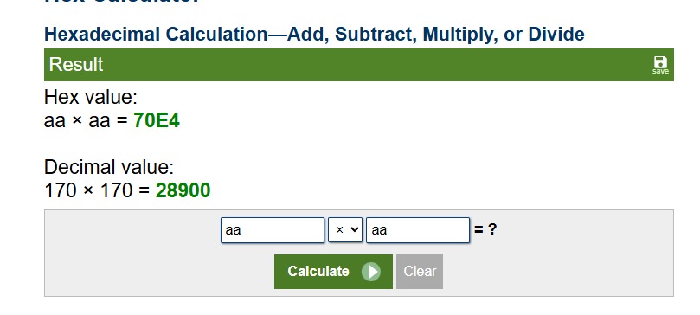
Figure 4 AAxAA expected result

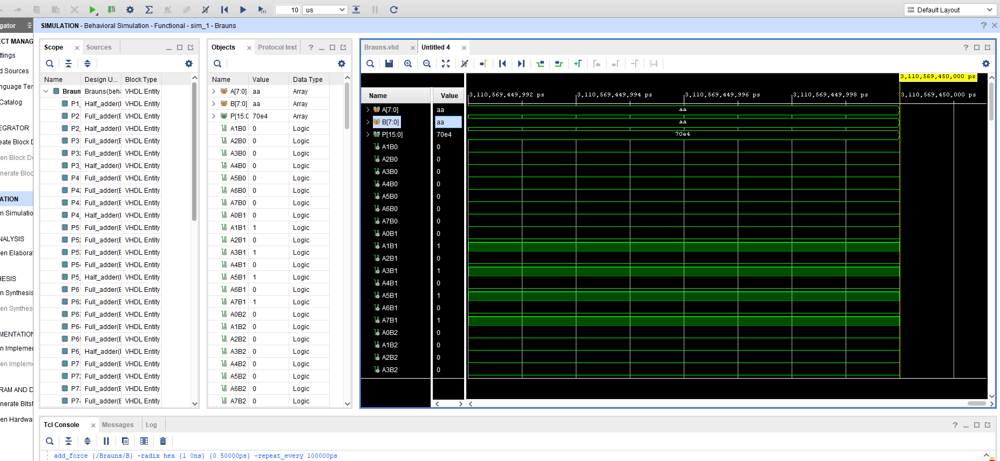
Figure 5 - AAxAA simulation

The simulation of AAxAA found in Figure 2 is identical to the expected result found in Figure 1. Both results showed the correct answer – 70E4.

6.2 FFXFF
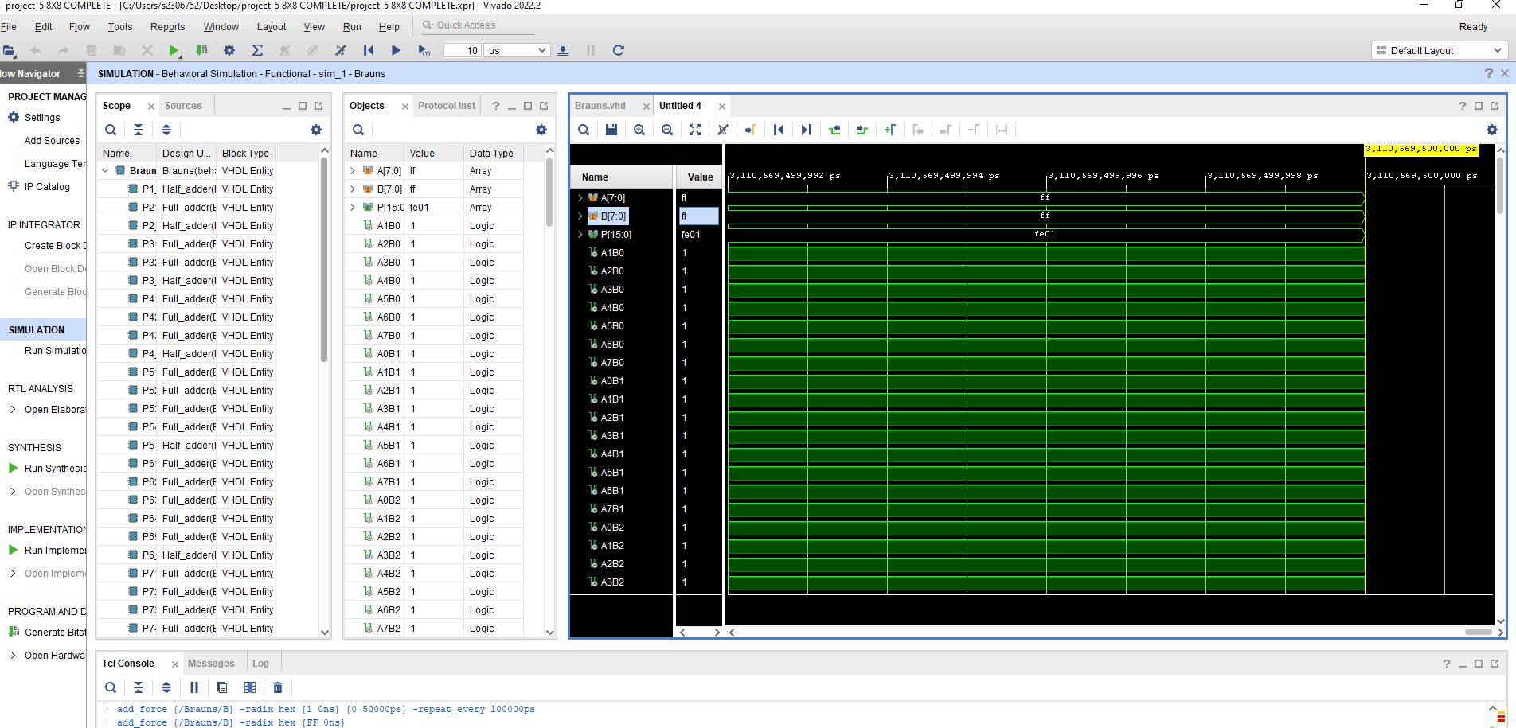
Figure 6 - Simulation results FFxFF

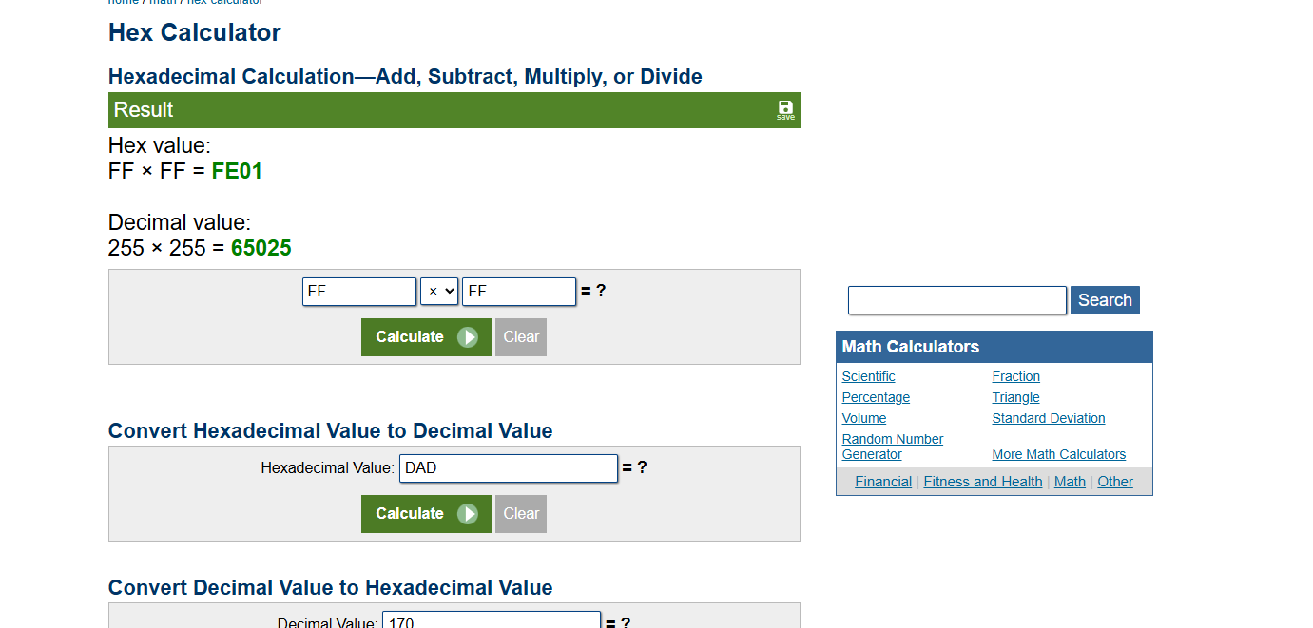
Figure 7 -expected FFxFF

Figure 4 shows that the expected results of FFxFF should be FE01. Figure 3 Confirms the accuracy of my simulation, also achieving the same result.

6.3 11X11

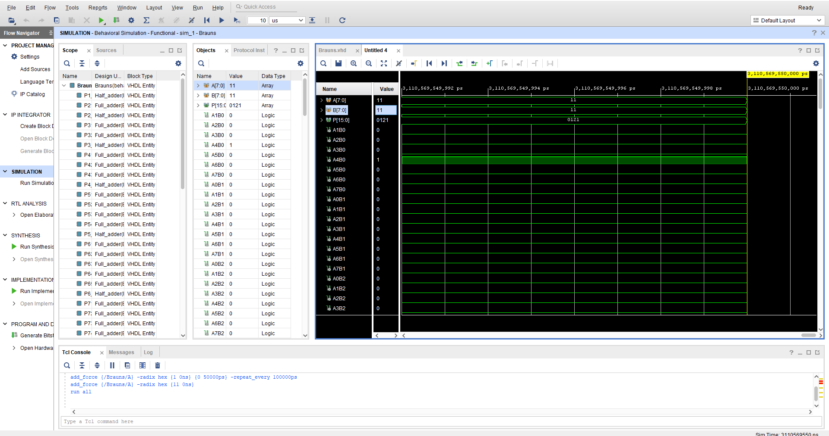
Figure 8 - 11x11 simulation

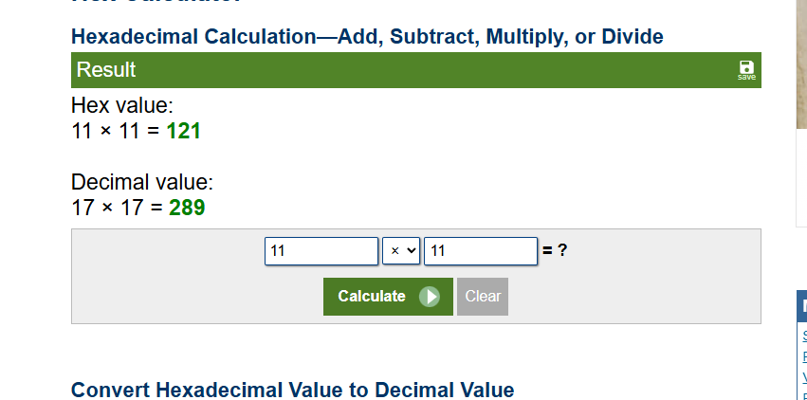
Figure 9 11x11 expected results
Carrying out the equation 11x11, Figure 6 shows that the expected result will be 121. My simulation shown in Figure 5 confirms that my simulation is correct.

6.4 8AX55
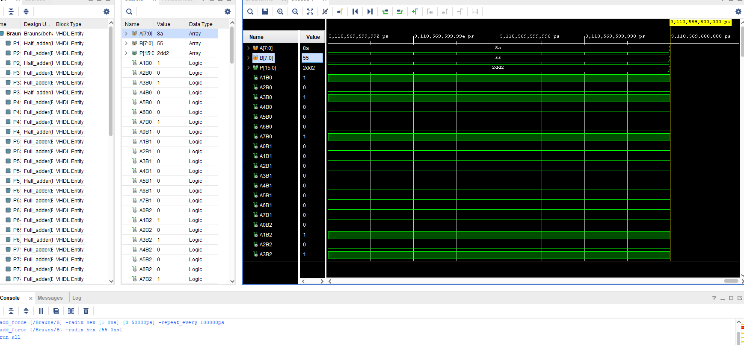
Figure 10 - 8ax55 simulation

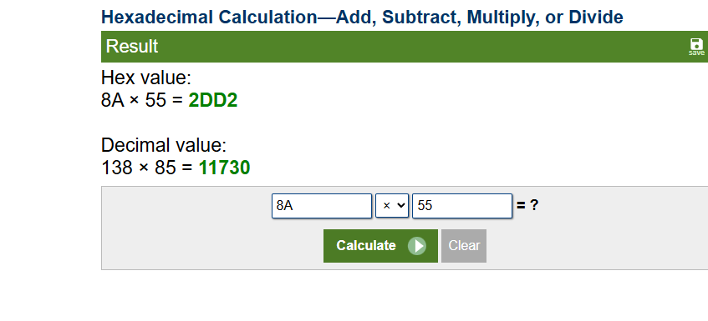
Figure 11 - 8A x 55 expected results
Once again my simulation in Brauns multiplier was correct. Figure 8 shows the expected result of 8Ax55 to be 2DD2. My simulation in Figure 7 confirms this.

7. Wallace tree multiplier

7.1 FFxFF
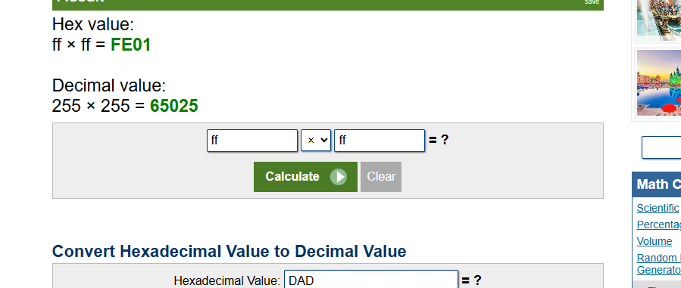
Figure 12 - FFxFF expected results
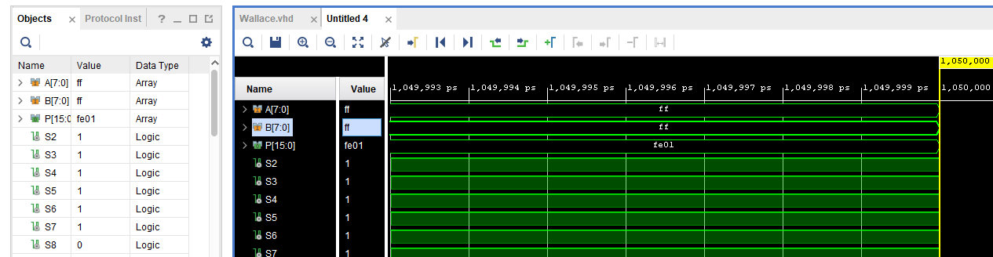
Figure 13 FFxFF Actual results
Using Wallace tree multiplier, I carried out another 4 multiplications to ensure that the coding worked correctly. As Figure 9 shows, the expected results of FFxFF should be FE01, my actual results seen in Figure 10 confirm this.

7.2 AAxAA
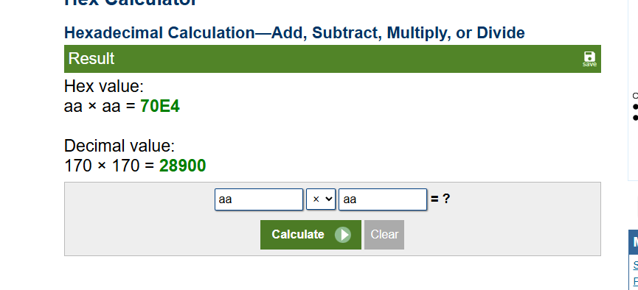
Figure 14 - AAxAA expected results
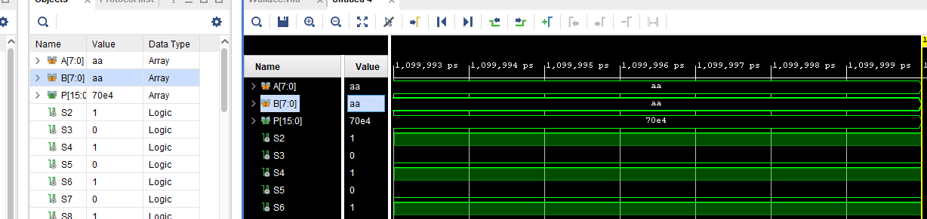
Figure 15 - Actual results
When carrying out the sum AAxAA, Figure 11 shows the answer to be 70E4. This is the same result using my Wallace tree multiplier seen in Figure 12.

7.3 11x23
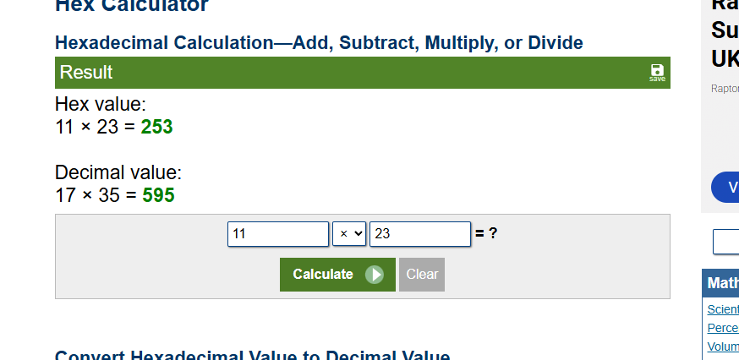
Figure 16 - 11x23 Expected results
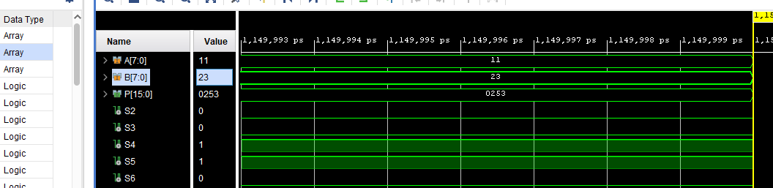
Figure 17 - 11x23 Actual results
To ensure clarity, I also carried out multiplications using smaller values, this aided in proving that the coding was correct throughout. Figure 13 shows the expected results to be 253, this matches with my actual results shown in Figure 14

7.4 41x53
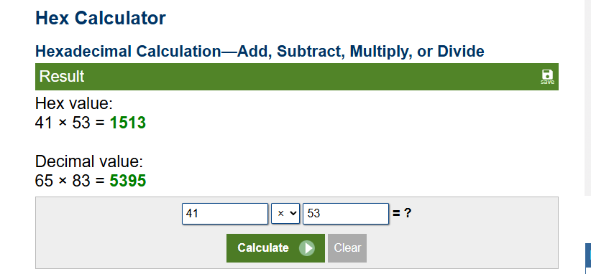
Figure 18 - 41x53 expected results

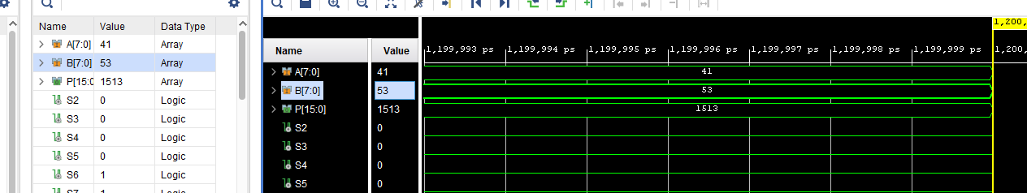
Figure 19 41x52 actual results

Finally, I carried out an equation in the middle of the spectrum, with 41x53 as an example. Figure 15 shows the expected results to be 1513. My actual results shown Figure 16 match this accurately.

7.5 Conclusion
My expected results and actual results matched correctly across all equations on both the Brauns multiplier and the Wallace tree multiplier. These simulations using the Vivado software proves that my coding was correct and they both function correctly with no issues.
The expected and actual results aligned consistently across all of the test cases with both the Brauns multiplier and the Wallace tree multiplier. These results, obtains via simulations in Vivado, confirm the correctness of my code and validate the functional accuracy of both different multiplier designs. There were no discrepancies or other issues seen during testing which shows the reliability of the implemented code.

8. Brauns and Wallace tree comparisons

8.1 Brauns
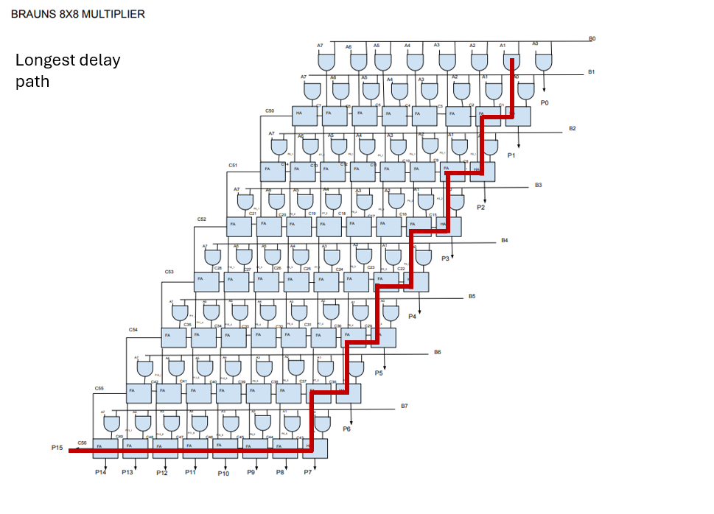
Figure 20 - Brauns Multiplier longest delay path
The longest delay path is shown in Figure 17. This is calculated using an AND gate delay 0f 1ns and a Full/half adder delay of 2ns. Following the longest delay path, this totals 41ns (20x Full or half adders and 1x AND gate delay).
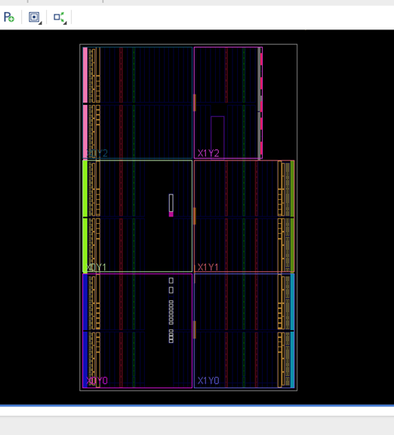
Figure 21
Figure 17 represents a graphical representation of how logic blocks are placed and routed within the FPGA. This is shown after carrying out the synthesis

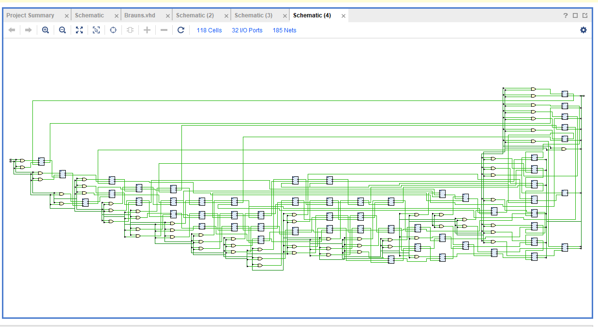
Figure 22 – RTL analysis
Figure 18 shows the schematic view of my Brauns design at the register transfer level (RTL). This can be generated after synthesis and before implementation. This image can help to verify that the design was synthesised as expected.

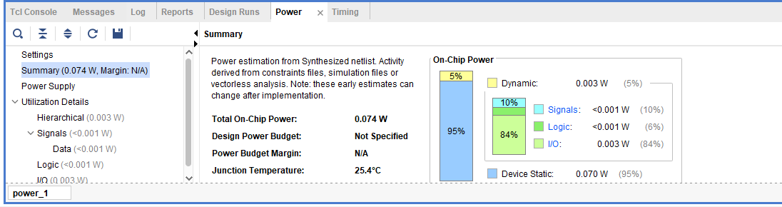
Figure 23 - Power usage
The power consumption of the brauns multiplier is shown in Figure 19. This shows power usage of 0.74kw

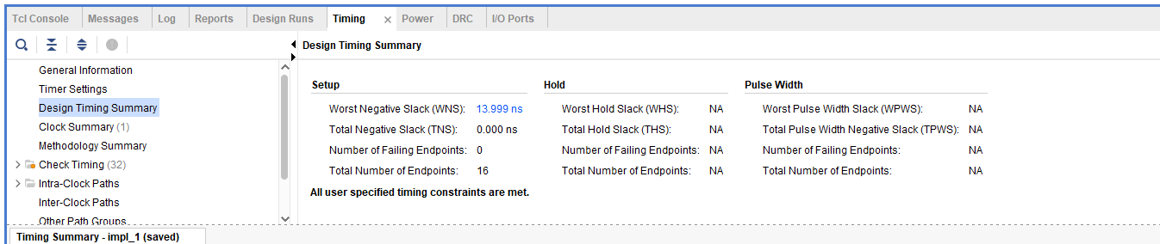
Figure 24 Timing summary
Figure 20 shows the overall timing summary of the worst negative stack. This value is measured at 13.999ns for Brauns multiplier

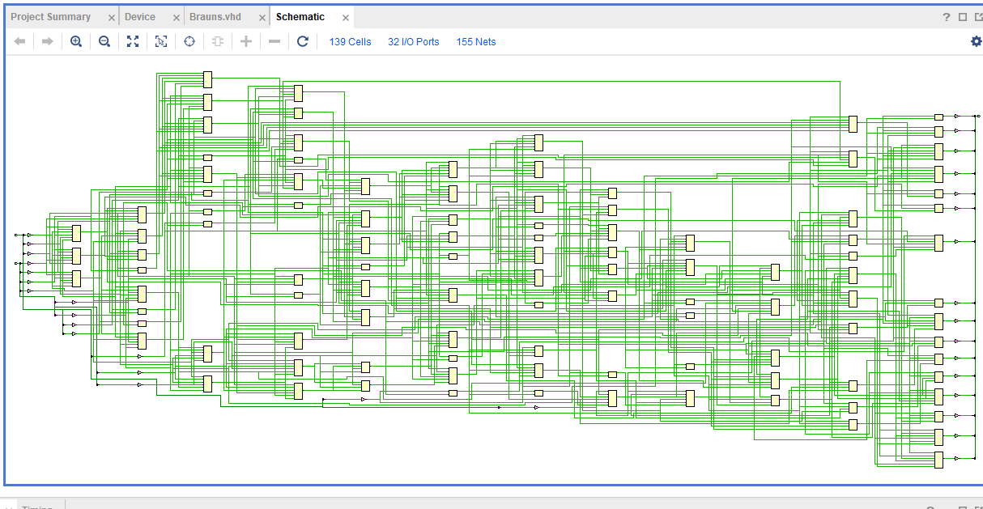
Figure 25
Figure 21 is a representation of Brauns multiplier schematic design

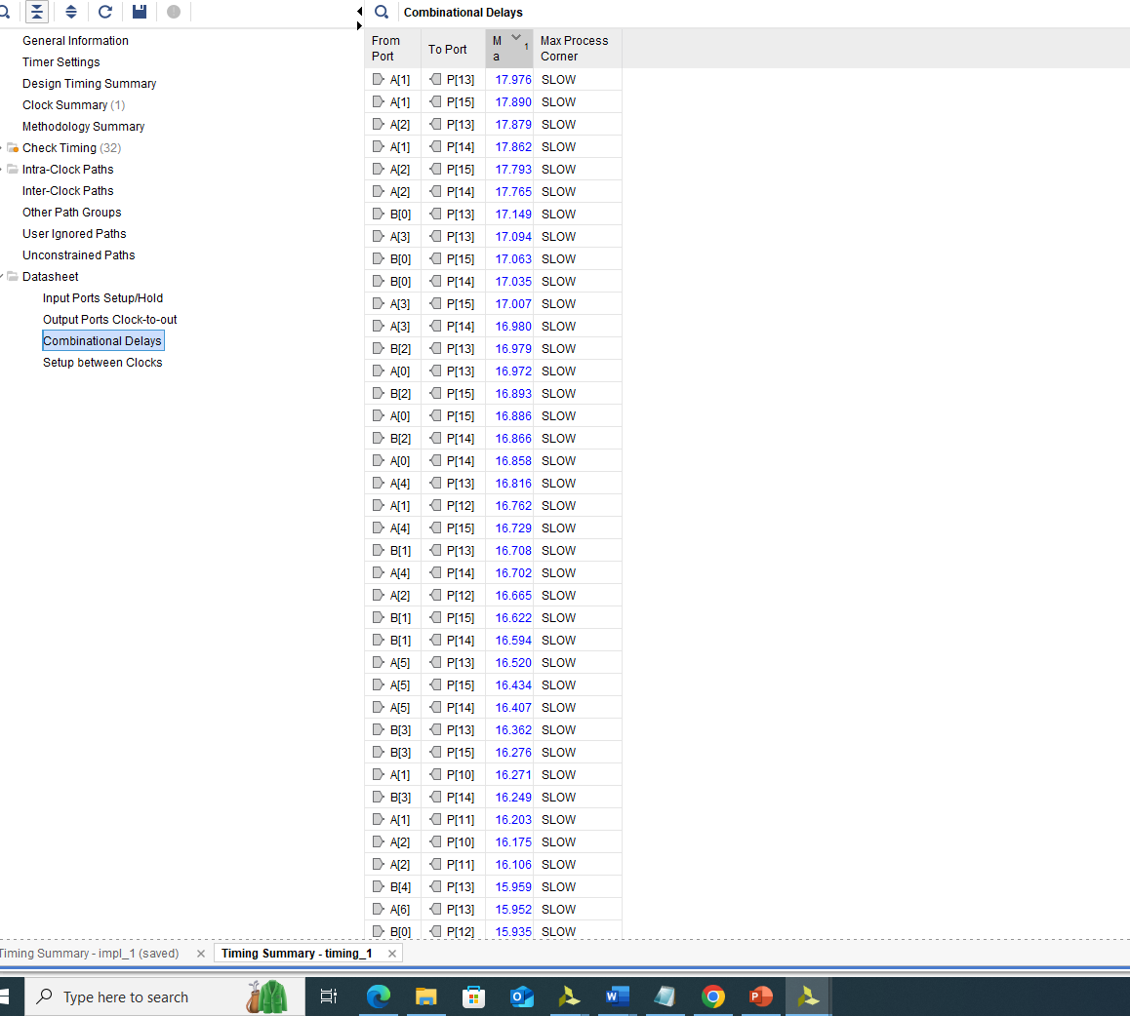
Figure 26 - Pin setting
Figure 22 diplays how I set the pins to imitate a Basys 3 FPGA board

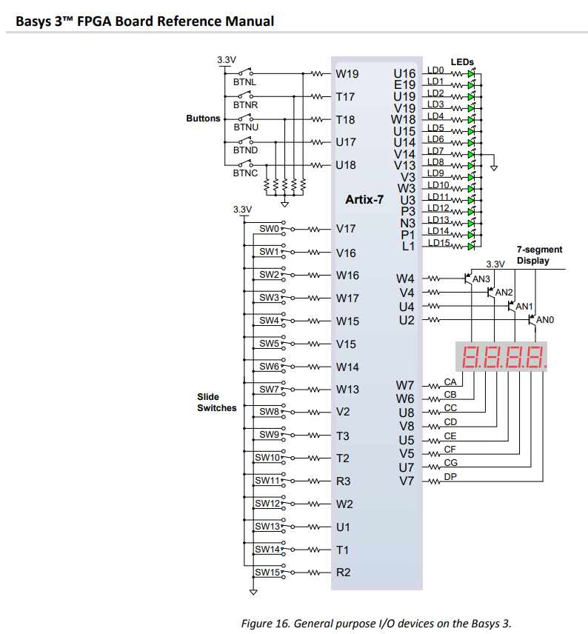
Figure 27 - Pin requirements
The pins used in Figure 22 were taken from the Basys 3 schematic displayed in Figure 23

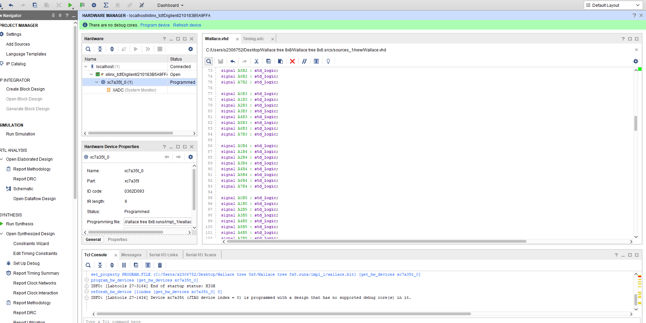
Figure 28 Timing
Figure 24 and Figure 25 is focused on the timing simulation/debugging phase after programming. It shows the timing behaviour across all of the pins.
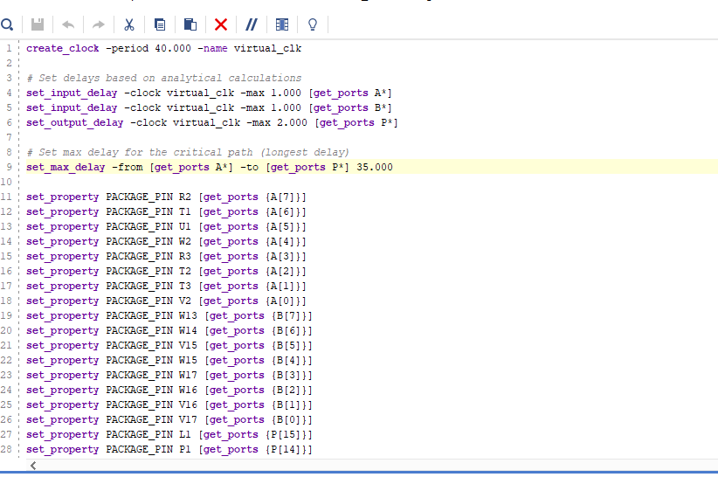
Figure 29
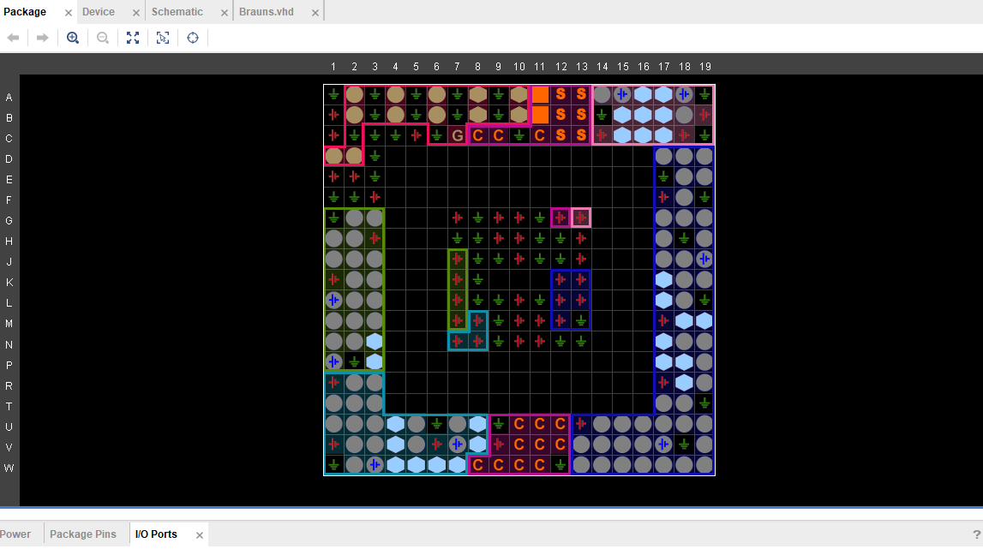
Figure 30
Figure 26 shows the i/o layout of brauns multiplier program. This shows how the design is mapped onto the FPGA fabric.

8.2 Wallace
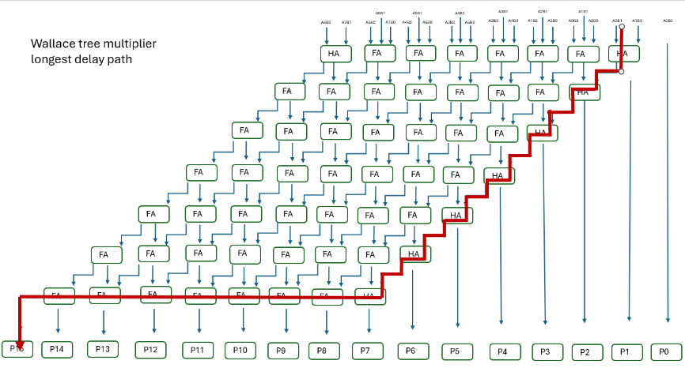
Figure 31 - Wallace tree longest delay timer
The longest delay of the Wallace tree multiplier is calculated using the same values as the Brauns. In this case, 14x Half/Full adders and 1 And gate = 29ns

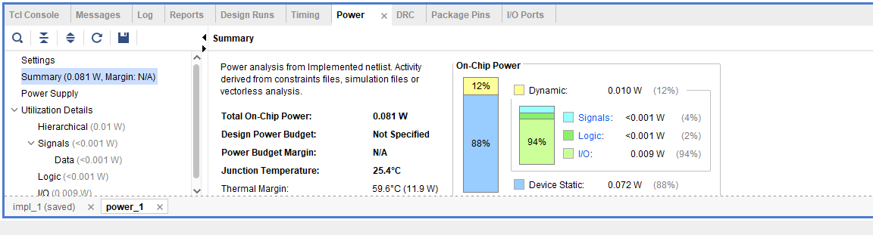
Figure 32 - Wallace tree power usage
Figure 27 shows the amount of power used in the Wallace tree multiplier. This is measured at 0.081W

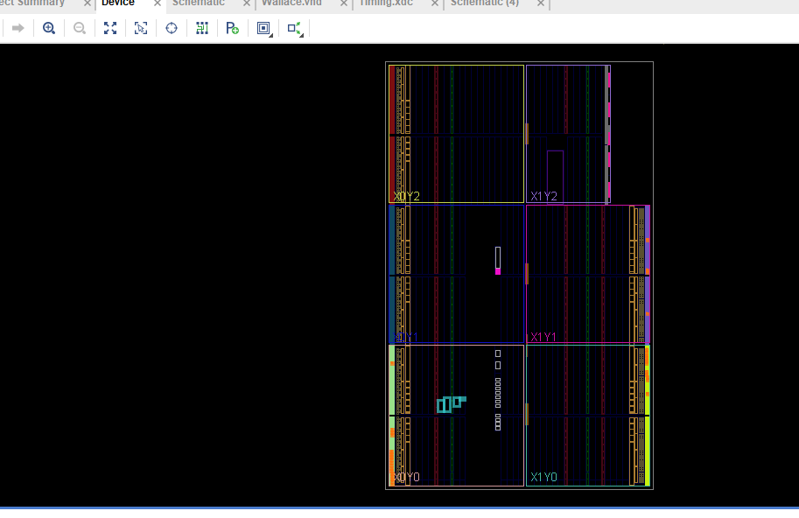
Figure 33
Figure 28 represents a graphical representation of how logic blocks are placed and routed within the FPGA

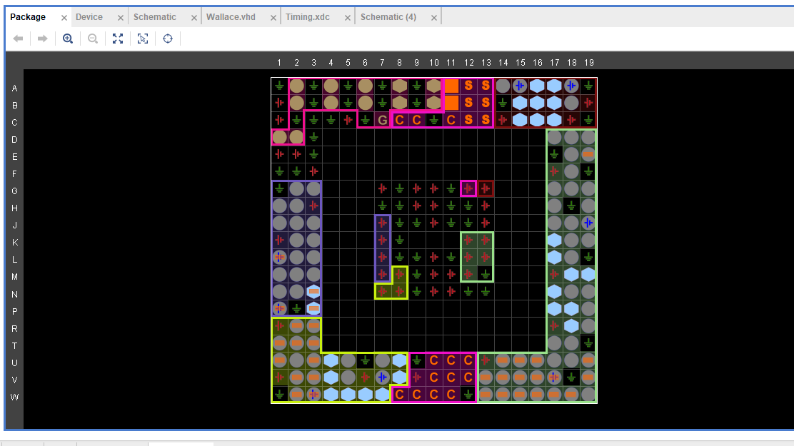
Figure 34
Figure 29 shows the i/o layout of the Wallace tree multiplier program. This shows how the design is mapped onto the FPGA fabric.

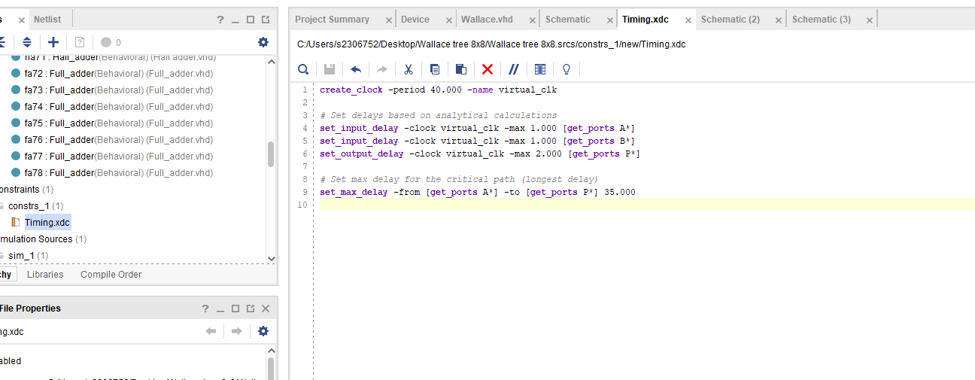
Figure 35
Figure 30 shows the parameters set for Wallace tree multiplier max clock speed period

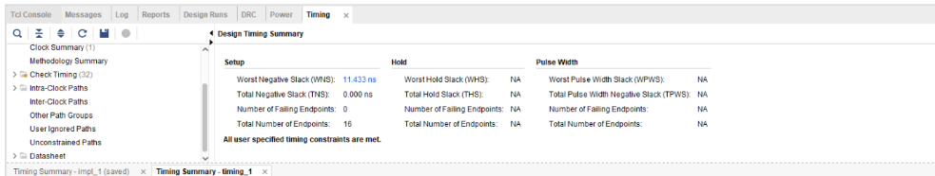
Figure 36
The worst negative stack of Wallace tree multiplier is shown in Figure 31. This value is 11.43ns

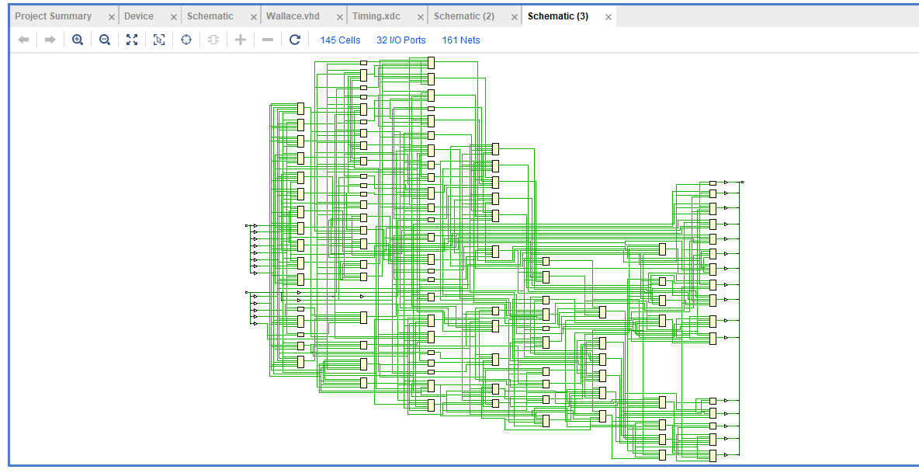
Figure 37
Figure 32 is a representation of Brauns multiplier schematic design

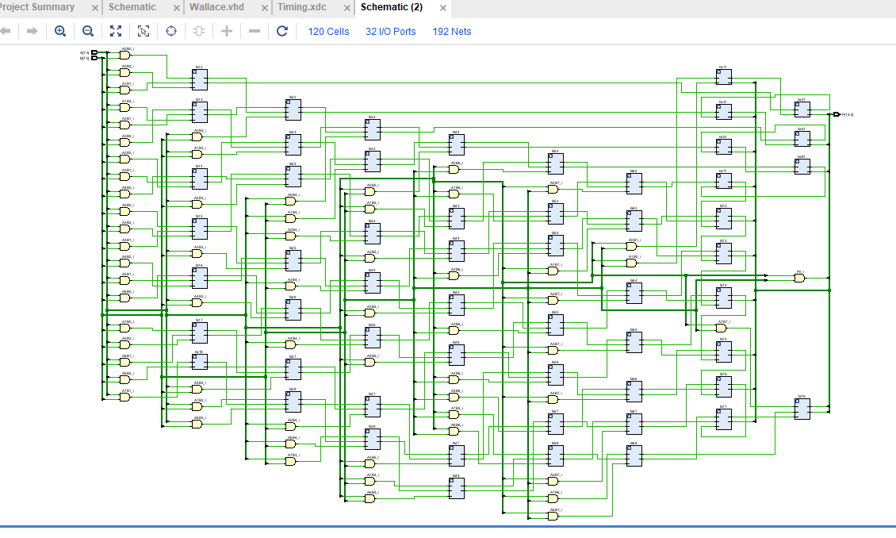
Figure 38
Figure 33 shows the schematic view of my Brauns design at the register transfer level (RTL).
Figure 39
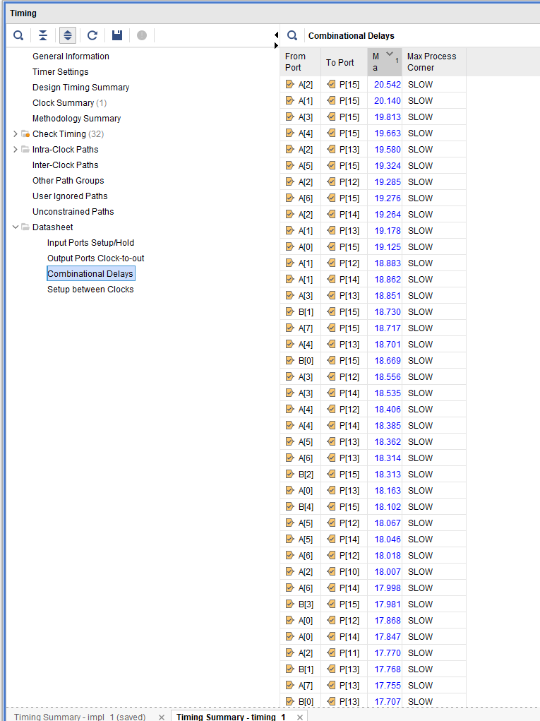
Figure 40
The pin layout was set in the Vivado software as shown in Figure 35. The pins were determined following the Basys 3 FPGA board reference manual (Figure 36).
Figure 41

8.3 Conclusion
The simulation that I have carried out using Brauns and Wallace tree multipliers have shown that the Wallace tree is the faster method for processing. The Wallace tree Multiplier was able to complete its worst negative stack in 11.4ns(Figure 31), whereas the Brauns multiplier would take 14ns for its worst negative stack (Figure 20).
The experiment confirms my initial statement that the Wallace tree multiplier is more energy intensive than Brauns. Wallace tree multiplier used 0.081w in my simulation of on-chip power (shown in Figure 27), compared to 0.074w shown in Figure 19.
With Both simulations connected to the Basys 3 board, I carried out the FFxFF equation with my program downloaded. The results matched both of my simulations that were carried out within the software
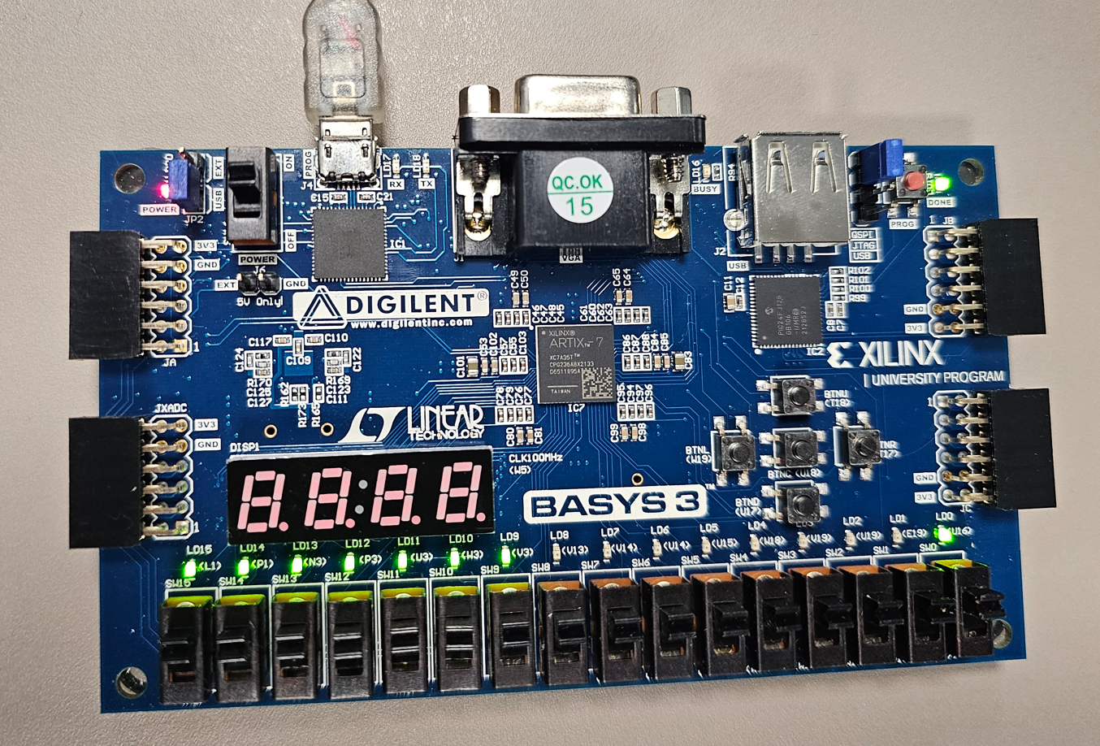
Figure 42 - Hardware test
The image above (Figure 37) shows the result of FFxFF with the correct LED light powered. The Answer is FE01, In Binary this would be F=all 4 lights on, E = first 3 lights on, 0 = 0 lights on and finally 1= just the light to the right on. This is how it successfully displays on the Basys 3 board.
Both Brauns and Wallace tree have proven to be suitable and efficient methods for multiplication operations. Brauns was much simpler to program and create and is suitable for more simple multiplication tasks. Wallace tree multiplier was more difficult and time consuming to code but it much more suited to simplifying more difficult multiplication processes, with the processing time much lower.
The longest delay path of both the Brauns and Wallace tree multipliers show that the Brauns multiplier (Figure 17) takes significantly longer to carry out the longest delay path compared to Wallace tree multiplier (Figure 28).
Both of the tasks have proven to have their advantages and disadvantages, with the type of task required an important factor in deciding which process you would use. Brauns multiplier is much more suited to smaller multiplication tasks, using less power, where Wallace tree multiplier is aimed at more difficult multiplications that require increased speed and performance, at the cost of increased power consumption.

References

[1] | P. M. Nair, “Design of 4-Bit Braun Multiplier,” Fossee, 2015. [Online]. Available: file:///C:/Users/jamesch/Downloads/4_bit_Braun_multiplier_with_Kogge_Stone_Adder.pdf. [Accessed 01 04 2025].
[2] | A. R, “Braun’s Multiplier Implementation using,” 09 2011. [Online]. Available: https://aircconline.com/vlsics/V2N3/2311vlsics17.pdf. [Accessed 06 04 2025].
[3] | D. M. RAVI, “Design and Implementation of Wallace Tree Multiplier using Higher,” 06 2016. [Online]. Available: https://www.ijvdcs.org/uploads/546213IJVDCS9984-85.pdf. [Accessed 04 2025].
[4] | M. GUDHIMETLA, “COMPARISON OF DIFFERENT TYPES OF MULTIPLIERS WITH,” 2020. [Online]. Available: https://www.digitalxplore.org/up_proc/pdf/315-150546881948-53.pdf. [Accessed 03 04 2025].
[5] | P. Kaushal, “VHDL - Understanding the Hardware Description Language,” 07 05 2022. [Online]. Available: https://www.copperpodip.com/post/vhdl-understanding-the-hardware-description-language. [Accessed 06 04 2025].
[6] | “Hexidecimal calculator,” [Online]. Available: http://calculator.net/hex-calculator.html. [Accessed 2025].

