Name: Cezar Bodnariu

Student Number: 1914623

Module Title: Managing People

Assignment Title: Critical Analysis

Module Lecturer’s Name: Olushoyi Richard Ashaye

INTRODUCTION

The following report will understand the concept and identify the main drivers ensuring employee engagement.

Furthermore, it would be evaluating the diagnostic tools/ parameters which effectively measure employee engagement.

Lastly, a proposition consisting of the necessary strategies ensuring diligent employee engagement would be constructed to identify the effective measures ensuring the retention of the concerned organisation’s labour force and their effective productivity.

Concept and drivers of employee engagement

The human resources (HR) concept of employee engagement refers to the level of motivation, enthusiasm and dedication driving an organisational employee’s engagement towards the firm’s production process. These employees are genuinely interested in their job profile and take the individual-level responsibility of contributing their exclusive productivity towards attaining the firm’s common goal. This further improves their performance daily, which constantly enhances the firm’s productivity. This proves, that the employee is dedicating their active diligence more towards enhancing their self-performance and interest over receiving just their monthly/ annual pay checks. Their constant organisational brainstorming scopes boost their interest and confidence in ensuring fine self-productivity daily (Albrecht et al., 2018).

Employee engagement ensures a firm’s overall success, which can be ensured through job satisfaction, punctuality in enhanced performance and pays scale provision, employee discipline and organisational decorum. Efficient communication is the driving force ensuring effective employee engagement and retention. The more their productivity improves, the more they get committed to abiding by and attaining the company's values and goals.
The managers play crucial roles in motivating their employees and ensuring their punctuality as well the engagement towards their assignment’s timely completion. This calls for resorting to clear communication across organisational hierarchies and the provision of rewards, incentives, promotions and feedbacks for commending incredible hard work. Other approaches involve recognising and appraising individual employees based on their professional engagement and warning those avoiding their regular responsibilities. This helps in either boosting their confidence or alerting them regarding their productivity’s shortcomings.

Official managers asserted the importance of employee engagement in the 1990s and this approach was widely welcomed by every organisation in the 2000s. However, it was difficult to measure and manage the same owing to the absence of valid parameters. Effective employee engagement ensured the boosting of the practitioner companies’ productivity and profitability (Osborne and Hammoud, 2017).
The basic characteristics of an engaged employee are (Stoyanova and Iliev, 2017):

- These personnel are well-aware of their job profiles and expectations and try to timely fulfil the same.
- They are driven towards the organisation’s productivity and success through their self-productivity and diligence (and how to work toward it).
- Their dedication drives their intense rational and emotional connection towards their respective organisation.

Depending on these parameters to measure employee engagement, individuals are enabled to track their organisation’s strengths and shortcomings at any point in time. This data enables these personnel to enhance the strengths and permanently evade the shortcomings to cultivate and nurture the organisation’s overall work culture.

Let’s take a note of the major factors driving effective employee engagement:

- Autonomy
This factor is crucial for motivating the productivity of individual employees for attaining better results. Possessing autonomous power over self-productivity empowers the individual employee to align their performance and efficiency as to organisation’s requirement(s) in a disciplined format. This further empowers employees to take their performance and scheduling decisions through their enhanced self-confidence. They are also empowered to track their performances. They further apply self-leadership attributes for resorting to effective time and task management skills (Shobe, 2018).

- Capacity
This refers to the individual employee’s capability regarding dealing with the pressure of completing their daily workload within the mentioned deadline. The employees’ must feel at ease while coping up with the pressure instead of feeling fatigued by exerting more physical, intellectual and emotional pressure towards its completion. Employees must know how to arrange their procured resources to finish their assignments by aligning them judiciously according to their requirements (Kwon and Kim, 2020).

- Co-worker Relationships
This drives employees’ motivation towards regularly attending their workplace while displaying effective punctuality traits that are beneficial for the organisation. Team members should bear mutual respect for and uplift each other at times of immense crises. This helps in the maintenance and retention of a positive vibe in the organisational setup, which is built on the grounds of human trust. This approach is most effective while performing group/ team tasks and must be enhanced by their respective leaders. Also, the organisation’s decorum must ensure intra-organisational integrity on the grounds of human rights (Makera et al., 2019).

- Fairness
The legitimate fairness in individual employee’s task(s) which boosts the organisation’s productivity and market reputation should be prominently enhanced so that managers and the organisation concerned can track and ensure its non-involvement in adopting productional malpractices. The managers track individual employees’ attendance, punctuality, timings of entering and leaving the corporate setup, the timely completion of their respective assignments and their clarity and authenticity as per the client’s requirements. There is no sympathy on the grounds of resorting to the misconducts from the employees’ end and if caught with proof, they are instantly subjected to heavy penalties or contract dissolution. Meanwhile, to boost authenticity and fairness in task completion, diligent employees are credited with rewards and incentives (Brohi et al., 2018).

- Feedback
Receiving adequate and helpful feedback helps employees understand whether they’re meeting expectations, where they’re having the most success, and how they can improve. Constructive feedback not only impacts engagement but can also strengthen employee-manager relationships (Albrecht et al., 2018).

- Goal Support
These refer to the required goal-oriented corporate knowledges and skills which helps them to timely achieve their daily organisational goals. The organisation must ensure individual employees’ empowerment in their respective fields of expertise (Osborne and Hammoud, 2017).

- Leader Availability
This highlights the employee’s connection with their team leaders, who must be a far-sighted, approachable, accessible, and empowered trouble-shooter, friendly and stern regarding the maintenance of the team’s and firm’s overall decorum. There must be clarity in team’s communications, and it must play a big role in boosting individual members’ confidence as well as empowerment towards task solving and instant troubleshooting. They must also track individual members’ team engagement and productivity (Stoyanova and Iliev, 2017).

- Leader Integrity
The team leader must ensure their respective team foundation’s integrity in terms of achieving the set targets, which must overshadow the existence of intra-team conflicts and differences (Stoyanova and Iliev, 2017).

- Meaning
Every employee must have a valid force/ reason/ meaning which drives their organisational labour and productivity within a particular field of expertise. This is the binding factor that connects the employee to both their tasks and the company at large and is the main source of their performance’s motivation.

- Professional Development
The various organisational skills, knowledge and related resources ensure these employees’ effective professional development by providing new scopes for their overall growth.

- Psychological Safety
Employees must feel safe at their work irrespective of their job profile's risk-quotient. They must feel free to pursue their real passion and fields of expertise without any fear of complexation or intimidation. Furthermore, many organisations are known for the timely provision of special employment schemes like employee media claims (for self and family), which ensures the company’s responsibility in contributing towards the respective employee’s self/ family crises on the grounds of health.

- Purpose
The organisation’s, as well as the individual’s vision and purpose behind establishing a reputed market image and contributing to the firm’s productivity, must be clear on a prior basis, failing which it's meant to fall apart.

- Role Clarity
For excelling in a certain field of expertise or before holding a certain organisational designation, employees must be aware of their job profile and the exact responsibilities expected from that position. The possession of the necessary skills and knowledge along with the aspirant’s graduation certificates and scholarly merits validate their qualification for the job role. However, they must also be fully aware of the company’s demands from their end along with the T&C’s (Ahmed et al., 2017).

- Relationship With Manager
Every modern organisation has separate managers representing its individual departments, who constantly track the employees’ diligence and punctuality towards the task’s accomplishment. Hence, these managers take charge of imparting the necessary knowledge regarding individual employees’ fields of expertise. To make the most of this resource and mentorship, employees must make efforts from their ends to assure the cordial establishment of an employee-manager relationship within the organisation’s premises.

- Rest
Employees must be enabled to take their respective off times from brief getaways and quick corporate breaks. It’s believed the human brain must be given some rest to restore the lost energy. Hence, organisations ensure the provision of half an hour/ maximum an hour’s breaktime to the employees so that they don’t feel fatigued quickly.

- Shared Values
It’s essential to share the same values and vision within the respective corporal setup, especially on the grounds of professionalism. Professional empathy calls for individual employees’ capability to relate to the organisation’s urgency towards a specific task’s efficient completion and align the same to every other colleague’s approach towards serving the organisational entity. Hence, following the common employee work attitude and approach standards ensure the derivation and validation of every employee’s mutual success on the grounds of mutual contribution (Meng and Berger, 2019).

- Utilization
This factor raises employees’ awareness regarding their talent’s inert potential along with the degree of its utility in achieving the company’s long-term success.

Diagnostic tools to measure employee engagement

- Employee Reward and Recognition Programs
This is the most-effective tool driving individual employees’ diligent engagement towards their assigned tasks since it acknowledges both their performance’s improvements as well as shortcomings. While the former gets rewarded, the latter gets penalised.

- Frequent Employee Surveys
Managers must constantly keep tracking individual employees’ participation and contribution towards the organisation’s productivity, attendance and punctuality as well as the ethical standards of their regular activities.

- Have Frequent One-On-Ones
Effective organisational productivity can be ensured through clear and effective professional communication at every level of the structured organisation. These help in keeping every single employee and manager updated regarding their colleague’s/ professional development or doubts that possess specific corporal importance towards controlling the organisation’s productivity.

- Conduct Exit and Stay Interviews
For hiring eligible employees, they interview and conduct entrance examinations for every like-minded job applicant willing to take up the designation’s offer. Through the display of their skills and knowledge, HR decides upon their final selection. Even when registered employee proceeds with their organisational resignation, they are interviewed by HR to learn about their issues, depending upon which these personnel decide to grant their leave or to retain them by altering certain organisational policies.

- Make Small Focus Groups
Small focus groups enable the firm to extract the limited personnel eligible for performing an exclusive task. These activities resort to expert skills that distinguish these small groups from the rest of the organisation’s functional groups. Hence, these personnel require specially focussed attention from managers concerned to proceed with their regular activities by learning new knowledge and skills.
- Measure Productivity Metrics and Retention Rate
Managers must resort to certain parameters of organisational importance that measures individual employees’ productive efficiency. This enables the organisation to learn about each organisational employees’ professional strengths and weaknesses, depending upon which they either try in retaining the force or letting go of the most ineffective personnel and then check up on their workforce’s retention.

Employee value proposition
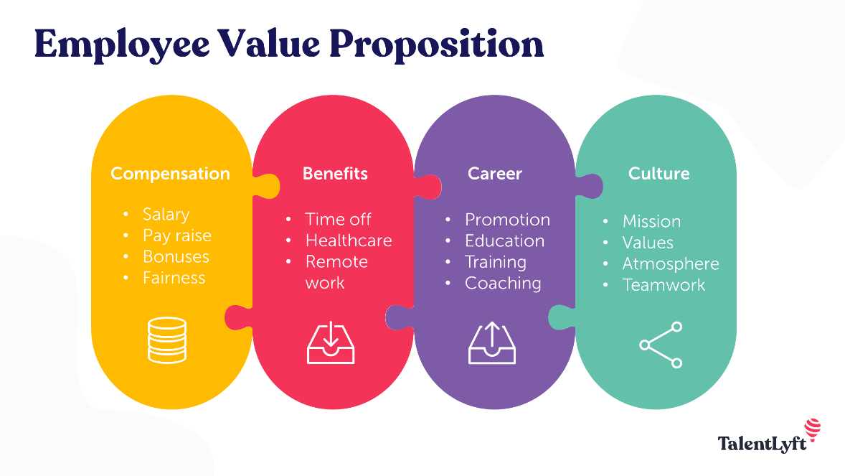

The proposed strategies ensuring the levitation and enhancement of employee engagement are:

- Compensation
- The firm must ensure the timely provision of every employee and authority’s daily/ monthly/ annual pay-scales without incurring any delay under non-emergency situations.
- Every diligent employee who is punctual, displaying consistency through improvised self-productivity and have excellently served the organisation over a stipulated time-period must be well-acknowledged and treated with a pay raise, incentives or even promotions.
- Provision of seasonal/ festive/ emergency bonuses also ensures employee engagement.
- Authorities must investigate the maintenance of professional fairness towards every task’s timely accomplishment to ensure fairness in the organisation’s employee engagement as well.

- Benefits
- Employees must be provided with standardised breaks regularly. Also, they must be facilitated with stipulated paid leaves and the annual calendar holidays of the respective nation of activation.
- Organisations must provide certain healthcare schemes for every single employee. Big MNCs provide special family mediclaims for every employee and even financially contribute towards meeting their or any of their family member’s hospital bills. Some organisations are even tied-up with renowned doctors/ hospitals so that unforeseen employee-related crises can be effectively dealt with on time.
- Keeping the recurrent COVID-19 crisis in mind, organisations must facilitate their employees to work from home or remotely from any accommodational indoor setup to avoid social contact. Hence, it must resort to effective communication tools to facilitate the smooth transfer of information.

- Career
- Individual employees must be promoted on a performance basis to retain and enhance their voluntary productivity.
- The authoritarian personnel must ensure the effective provision of employee-centric empowering knowledge and skills regarding their field of expertise.
- For imparting brand-new skills through the latest technology, the organisational authorities must regularly mentor the employees to ensure and enhance their productivity’s upliftment through their regular inculcation.

- Culture
- Every single employee must be well-aware of their organisation’s common vision and mission.
- They must abide by the organisational norms, values, ethics and decorum.
- The professional environmental must be amicable to co-ordinately drive each employee’s cordial communication and activities.
- Despite being divided into various departments for excelling in individual expertise skills, every department should practise effective intra-departmental and organisational coordination to ensure the firm’s collective functionality as a united team.

CONCLUSION

This report has emphasised the concept of employee engagement and has identified the main drivers ensuring the same.

Furthermore, it has evaluated the various diagnostic tools/ parameters which effectively measure employee engagement.

Lastly, a proposition consisting of the necessary strategies ensuring diligent employee engagement has also been constructed to identify the effective measures ensuring the retention of the concerned organisation’s labour force as well as their effective productivity and consistency.

REFERENCES

- Ahmed, U., Khalid, N., Ahmed, A. and Shah, M.H., 2017. Assessing moderation of employee engagement on the relationship between work discretion, job clarity and business performance in the banking sector of Pakistan. Asian Economic and Financial Review, 7(12), pp.1197-1210.

- Albrecht, S., Breidahl, E. and Marty, A., 2018. Organizational resources, organizational engagement climate, and employee engagement. Career Development International.

- Brohi, N.A., Abdullah, M.M.B., Khan, A.M., Dahri, A.S., Ali, R. and Markhand, K.H., 2018. Communication quality, job clarity, supervisor support and job satisfaction among nurses in Pakistan: The moderating influence of fairness perception. International Journal of Academic Research in Business and Social Sciences, 8(5), pp.1-6.

- Kwon, K. and Kim, T., 2020. An integrative literature review of employee engagement and innovative behavior: Revisiting the JD-R model. Human Resource Management Review, 30(2), p.100704.

- Makera, A.U., Nasidi, Y., Kamaruddeen, A.M. and Jemaku, I.M., 2019. Correlation between team and co-worker relationship and employee engagement. Journal of Advanced Research in Business and
- Management Studies, 14(1), pp.16-24.

- Meng, J. and Berger, B.K., 2019. The impact of organizational culture and leadership performance on PR professionals’ job satisfaction: Testing the joint mediating effects of engagement and trust. Public Relations Review, 45(1), pp.64-75.

- Osborne, S. and Hammoud, M.S., 2017. Effective employee engagement in the workplace. International Journal of Applied Management and Technology, 16(1), p.4.

- Shobe, K., 2018. Productivity driven by job satisfaction, physical work environment, management support and job autonomy. Business and Economics Journal, 9(2), pp.1-9.

- Stoyanova, T. and Iliev, I., 2017. Employee engagement factor for organizational excellence. International Journal of Business and Economic Sciences Applied Research (IJBESAR), 10(1), pp.23-29.

