

LOCATION: Swansea | LLEOLIAD: abertawe
LEVEL 5 | LEFEL 5
EXAMINATION PERIOD | CYFNOD ARHOLIADAU
may 2020 | mai 2020

MODULE CODE:
M5X02064: CAE & Stress analysis
TIME: 2 HOURS

answer THREE out of FOUR QUESTIONS

Equipment or materials required – None
Adnoddau neu ddefnyddiau sydd eu hangen – Dim

A formula sheet is provided for reference.

University approved calculators are permitted.

Assume ‘g’ = 9.81 m/s².

Question 1

- Given the diagram below, prove that the hoop stress is given by $σ_{h}=\frac{Pd}{2t}$
[3 marks]

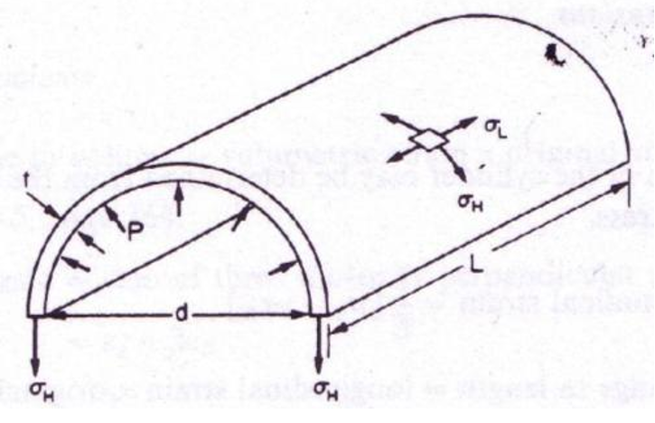

Force on half the cylinder F = P x projected area = PdL

Resistive force = 2 x $σ_{h}$ x L x t
Thus
PdL = 2$σ_{h}$Lt

$$σ_{h}=\frac{Pd}{2t}$$

- Explain why for a thin cylinder that this is the limiting factor. Relate this to the longitudinal stress seen in cylinders.
[2 marks]

The hoop stress is the maximum principle stress in thin cylinders. The minimum principle stress is the longitudinal stress which is half of this value.

- In an ocean where the salinity is 35psu and 15⁰C, using the below graph find the density of the sea water in m³/Kg.
[1 mark]

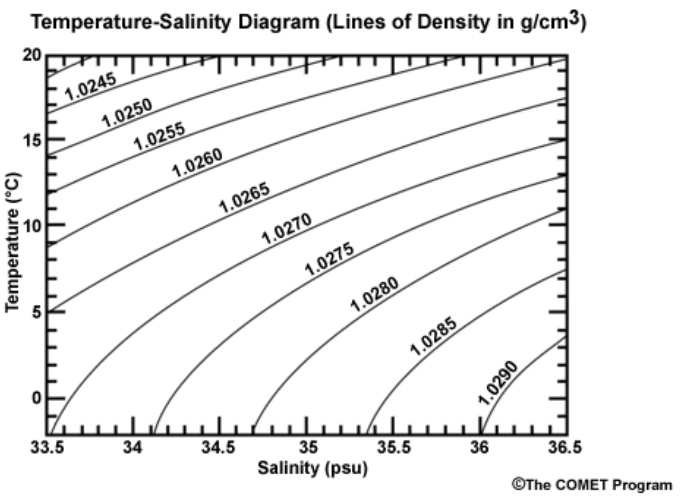
1026 m³/Kg from graph

- Given P=$ρ$gh were P is pressure, $ρ$ = density and h = height (or depth). In a submarine that can be considered to be a thin cylinder, 2m in diameter with a wall thickness of the outer skin of 2mm, find the depth that this submarine can dive to without exceeding the yield stress of the skin with a factor of safety of 2, (assume that the Yield stress of this material is 200MPa), in the ocean considered in (c). Assume that there is zero pressure inside the submarine.
[3 marks]

If there is a factor of safety of 2 then the max stress that should be seen in 100MPa.

Therefore assuming a vacuum in the sub, the max that can be seen outside is

P=$\frac{σ_{h}*2*t}{d}$ = $\frac{100e6 × 2 ×2e-3 }{2}$ = 2e5Pa

P=$ρ$gh $∴h=\frac{P}{ρg}=\frac{2e5}{1026*9.81}=19.9m$

- What depth does this increase to if the submarine is sealed with atmospheric pressure inside. (Assume that atmospheric pressure is 0.1MPa.
[2 marks]

If atmospheric pressure is 1e5Pa and the sub is sealed with atmospheric pressure in the sub then the pressure outside can be 3e5Pa, thus

P=$ρ$gh $∴h=\frac{P}{ρg}=\frac{3e5}{1026*9.81}=29.8m$

- If the inside of the submarine could be pressured to twice atmospheric pressure, what depth could the sub now dive to without exceeding the yield stress of the skin of the submarine?
[2 marks]

P=$ρ$gh $∴h=\frac{P}{ρg}=\frac{4e5}{1026*9.81}=39.7m$

- Comment on the values obtained in (d) (e) and (f).
[2 marks]

These values highlight the fact that if you pressure the inside of the submarine then you are able to dive deeper without exceeding the yield stress.

f) Discuss why the results considered in this question may differ to the real scenario.
[5 marks]

We have not considered items such as
- Joint efficiencies
- Hatches/openings
- Endcaps
- Reinforcements in the sub.

All of the above would potentially increase the stresses seen in the structure.

Question 2

- The design process can be split down into 5 tasks as shown in the below diagram. Identify and discuss each of these tasks
[15 marks]
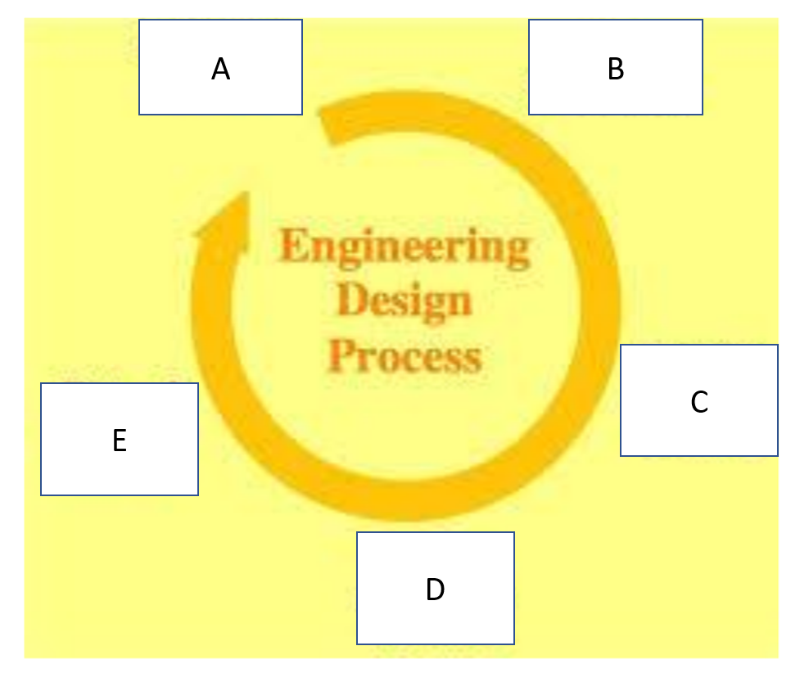
A – Define the problem
The solution to a design problem should begin with a clear, unambiguous definition of the problem. This definition may evolve through a series of steps or processes as a more complete understanding of the problem is developed.
- Identify and Establish the Need
- Develop a Problem Statement
- Establish Criteria for Success
B – Gather information
Before the team can proceed in the design process, it is necessary to collect all information that relates to the problem. Gathering relevant information can reveal facts about the problem that could necessitate in a redefinition of the problem. Information gathering for most design problems begins with asking the following questions. If the problem address a need that is new, then there are no existing solutions to the problem, so obviously some of the questions will not be asked.
- Search for Information Resources
C – Generate multiple solutions
The next step in the design process begins with creativity in generating new ideas that may solve the problem. Start with existing solutions to the problem and deconstruct them – find out what’s wrong with those solutions and focus on how to improve their weaknesses / limitations. Consciously combine new ideas, tools, and methods to produce a completely unique and novel solution to the problem; this process is often called ‘synthesis’. Solutions to engineering design problems do not magically appear. Ideas are generated when design teams are free to take risks and make some mistakes in the process. Brainstorming at this stage is often a team effort in which people from different disciplines are involved in generating multiple solutions to the problem.

D – Analyse and select a solution
Once the design team have conceived alternative solutions to the design problem, they must analyse those solutions and decide upon which solution is best suited for implementation. Analysis is the evaluation stage of the proposed designs. At this stage in the design process, it concerns the results of the design analysis, and is highly subjective, hence should be made by a team of experienced people.
- Analysis of design solutions
- Functional analysis
- Ergonomics
- Product safety and Liability
- Mechanical / Strength Analysis

E – Test and Implement a solution
This is the final phase of the design process, and refers to testing, construction, and manufacturing of the chosen solution to the design problem. The design team should consider several methods of implementation, such as prototyping and concurrent engineering, together with distinct activities that occur during implementation; e.g. documenting the design solution and applying for patents.
- Prototyping
- Concurrent Engineering
- Documentation
- Applying for Patents

- Discuss which of these steps could benefit from FEA and how these may be influenced by integrating this.
[5 marks]

- Step C could ultilise optimisation techniques to drive the conceptual designs
- FEA could then be used to assess these conceptual designs to help choose a solution (step D)
- before the detailed designs is assessed in step E.

Question 3

- Given the below diagram and the standard relationship for slope and deflections of beams of
$M_{xx}=\frac{EId^{2}y}{{dx}^{2}}$, prove that the deflection anywhere on the beam, y, may be given by the following relationship
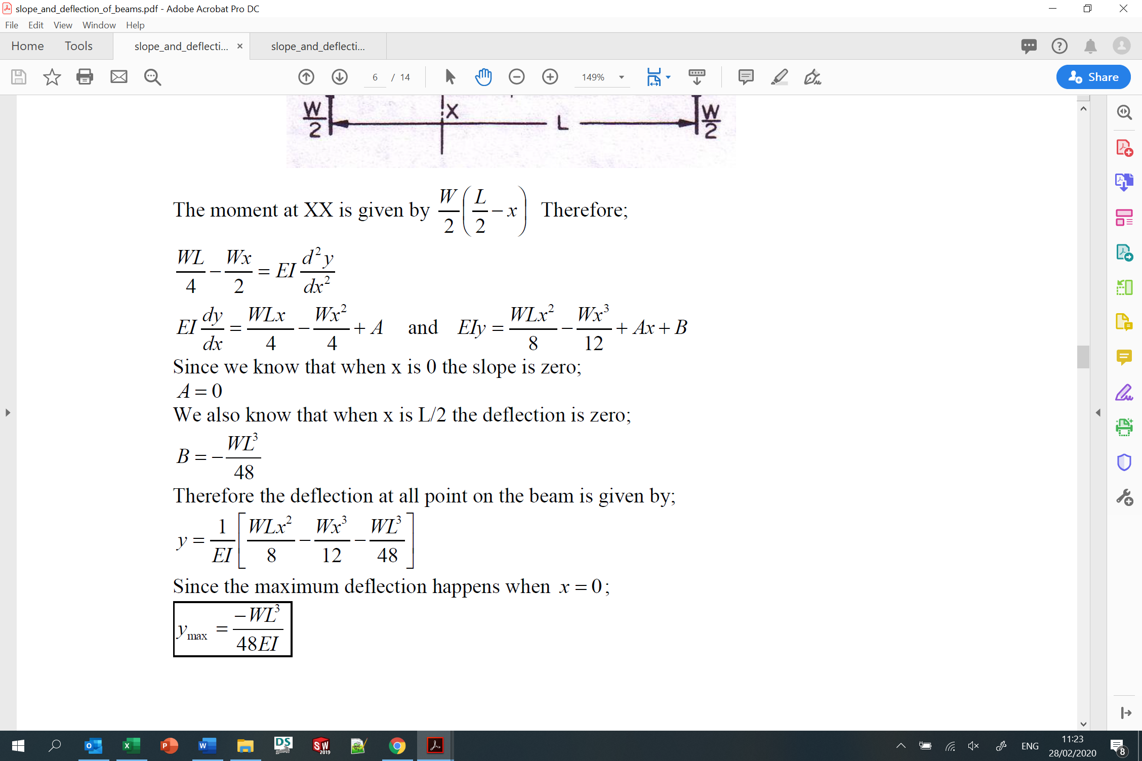
[8 marks]

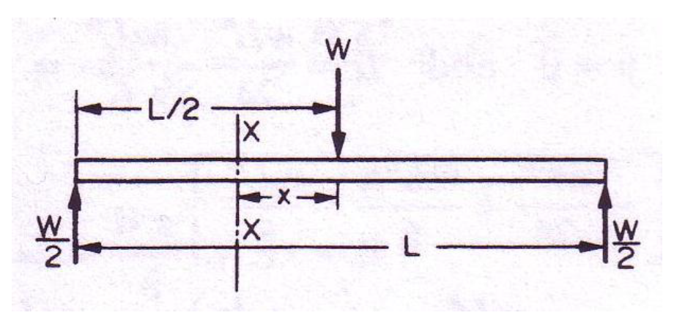

M_{xx} = $\frac{W}{2}\left(\frac{L}{2}-x\right)=\frac{WL}{4}-\frac{Wx}{2}$
Therefore
$$EI\frac{d^{2}y}{{dx}^{2}}=\frac{WL}{4}-\frac{Wx}{2}$$

$$EI\frac{dy}{dx}=\frac{WL}{4}x-\frac{{Wx}^{2}}{4}+A$$

$$EIy=\frac{WL}{8}x^{2}-\frac{{Wx}^{3}}{12}+Ax+B$$

Looking at the boundary conditions,
When x=0, $\frac{dy}{dx}=0$, thus A=0
When x = $\frac{L}{2}$, y = 0, thus,

$$EIy=\frac{WL}{8}x^{2}-\frac{{Wx}^{3}}{12}+Ax+B$$

$$0=\frac{WL}{8}{\left(\frac{L}{2}\right)}^{2}-\frac{w}{12}{\left(\frac{L}{2}\right)}^{3}+B$$
Thus
$$B=\frac{WL^{3}}{96}-\frac{WL^{3}}{32}$$
= $-\frac{WL^{3}}{48}$

Thus
$$y=\frac{1}{EI}\left(\frac{WL}{8}x^{2}-\frac{{Wx}^{3}}{12}-\frac{WL^{3}}{48}\right)$$

- Hence prove that the maximum deflection is given by
[2 marks]
is when x=0, therefore

- Consider the below section of damaged railway track. In order to ensure that a train may pass safely over this without derailment, the centre deflection must not exceed 10mm. The track may be considered to be simply supported at each end and the load (50kN) from the train wheel on each track may be considered as shown in the below figure. If the track is made from steel (E=200GPa) and the second moment of area of the track (I) is 40x10⁻⁶m⁴, what is the maximum safe span for the unsupported section of track?
[3 marks]

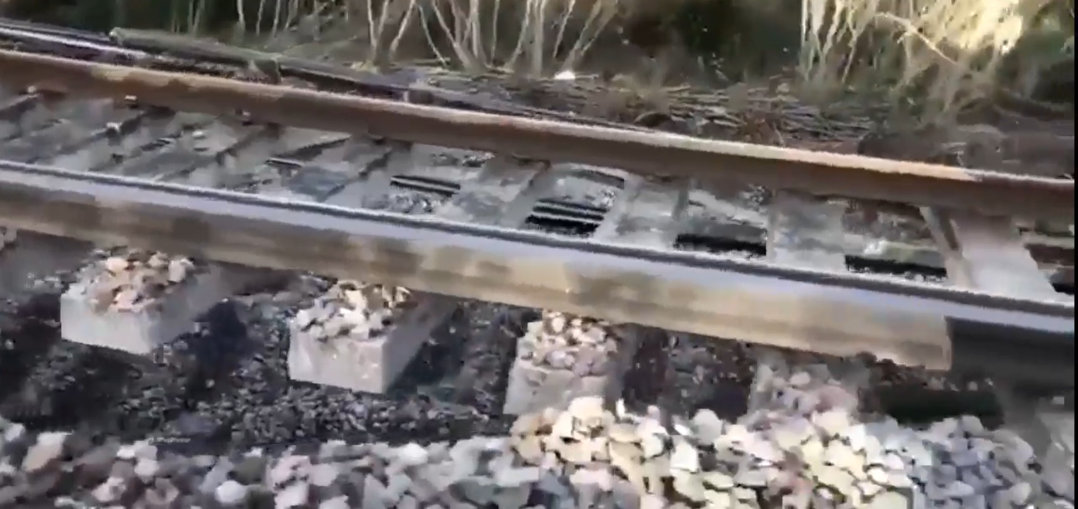

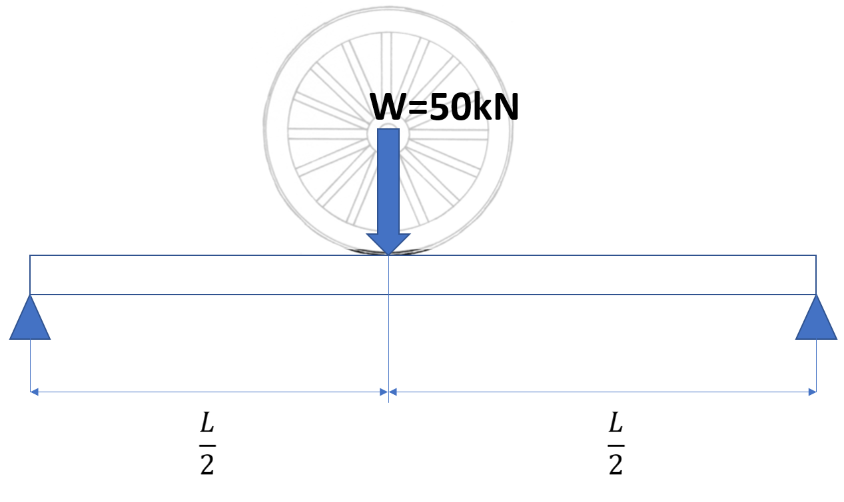
Therefore
$$L=\sqrt[3]{\frac{48EIy_{max}}{-W}}$$

$$L=\sqrt[3]{\frac{48×{200×10}^{9}×40×{10}^{-6}×-10×{10}^{-3}}{-50000}}$$

L = 4.25m
- Discuss why the results considered in this question may differ to the real scenario.
[6 marks]
Assumptions,
- The track is free to rotate at the ends (there will be some resistance to rotation from the track either side of the unsupported section).
- The movement is in the y direction only (there is no lateral displacement)
- The sleepers do not transmit any loading to the other track.
- The wheel applies a ‘point load’.
- There are no dynamic effects.
- The track is level and straight

- What else should be considered during analysis such as this?
[1 mark]
The yield stress of the track is not exceeded etc

Question 4

- By considering the element shown below that is subjected to shear stress only, prove that the direct stress ($σ_{θ}$) is given by the following expression given the relationship $cosθ sin$θ = $\frac{1}{2}sin2θ$

$$σ_{θ}=τ_{xy}sin2θ$$

[10 marks]
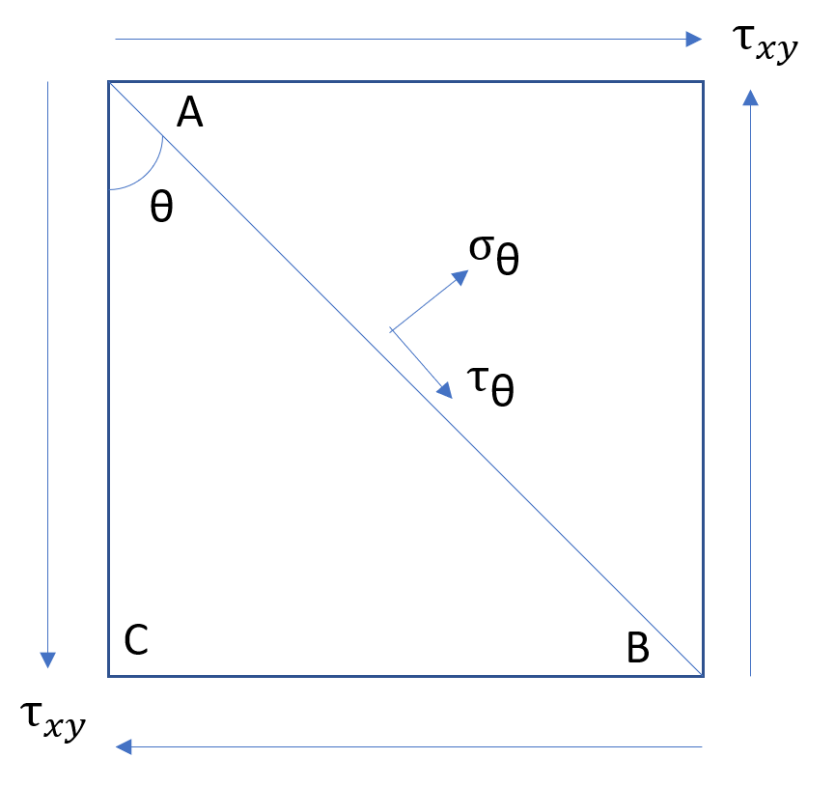
Resolving perpendicular to plane AB assuming that the part is in equilibrium, a freebody diagram can now be drawn with the forces.

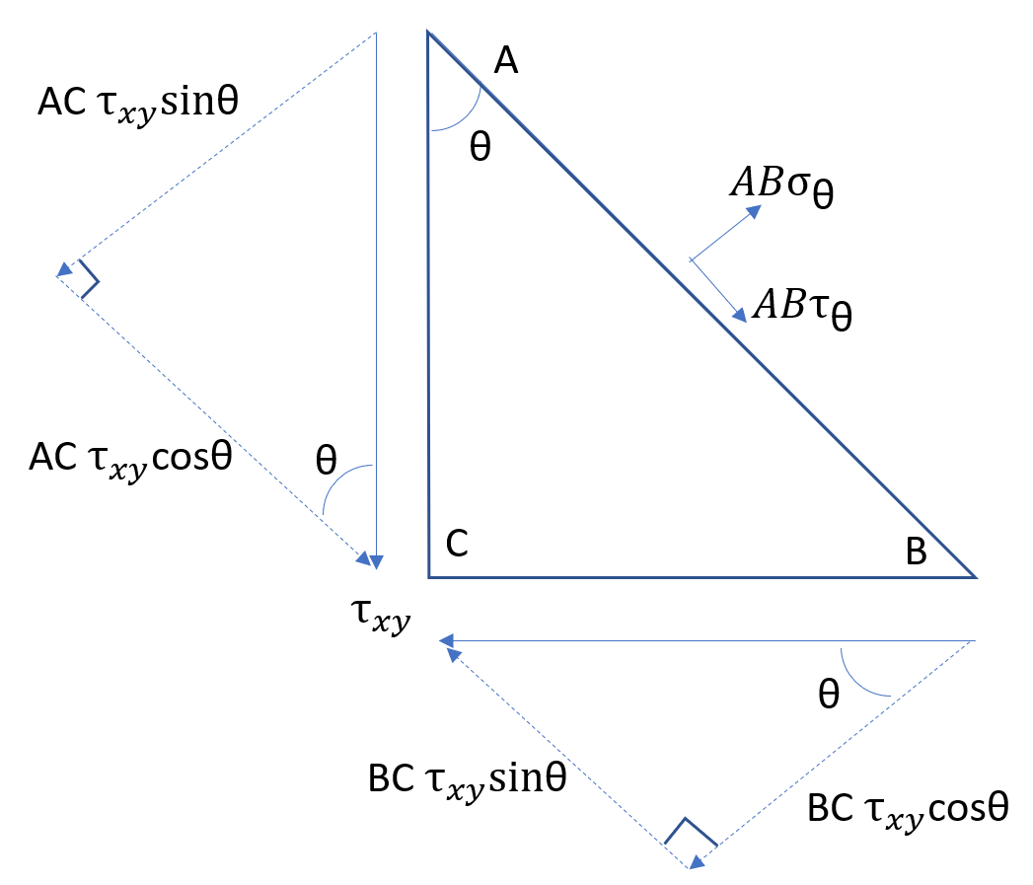
${ABσ}_{\text{θ} }$= AC $τ_{xy}sin$θ + BC $τ_{xy}$cosθ
Thus
$σ_{\text{θ} }$= $\frac{AC}{AB}$ $τ_{xy}sin$θ + $\frac{BC}{AB}$ $τ_{xy}$cosθ

Since (from the above diagram) $\frac{AC}{AB}=cosθ$ and $\frac{BC}{AB}=sinθ$

$σ_{\text{θ} }$= $cosθ$ $τ_{xy}sin$θ +$sinθτ_{xy}$cosθ

$σ_{\text{θ} }$= $2cosθ sin$θ $τ_{xy}$
Since $cosθ sin$θ = $\frac{1}{2}sin2θ$
$σ_{\text{θ} }$= $τ_{xy} sin2θ$

- Given the below situation where an element is subjected to a shear stress of 50MPa on the planes shown, calculate the direct stress seen on the plane AB.
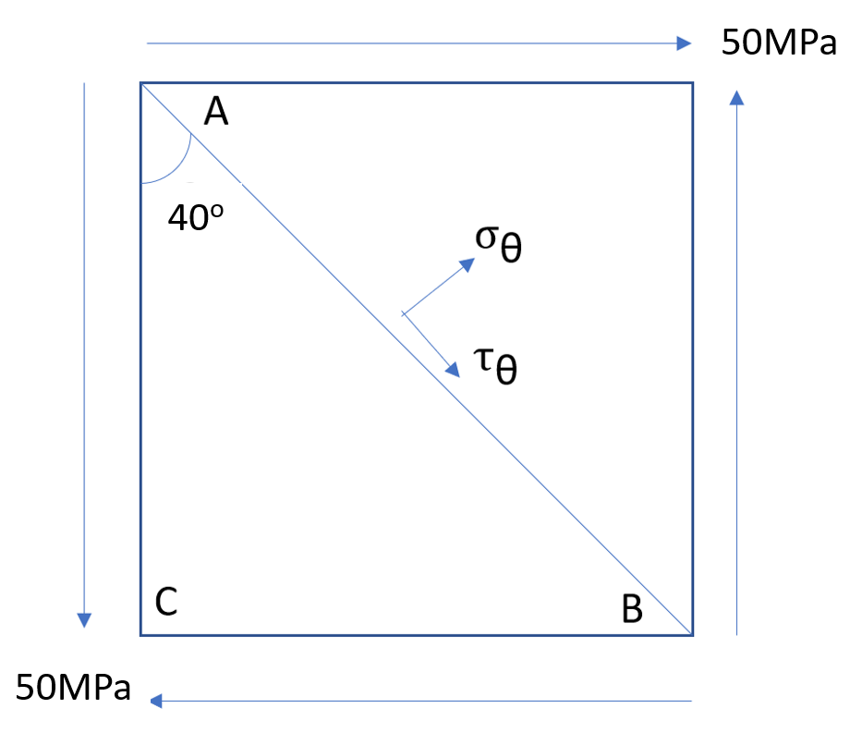
[3 marks]

$σ_{\text{θ} }$= $τ_{xy} sin2θ$ = 50 x 10⁶ x sin 80 = 49.2MPa

- Given the relationship $τ_{\text{θ} }$= $-τ_{xy} cos2θ$ calculate the shear stress on the plane AB.
[2 marks]

$τ_{\text{θ} }$= $-τ_{xy} cos2θ$ = -50 x 10⁶ x cos 80 = -8.7MPa

- Describe a situation where a piece of material may be assumed to be subjected to a shear stress only.
[2 marks]

This can happen when a shaft carries a torque only.

- Discuss why this is unlikely to happen.
[3 marks]

In reality this is not the case due to the self weight of the shaft. However, generally the direct stresses caused by the self weight are significantly less than the stresses caused by the torque so that the assumption made is reasonable.

Diwedd/End

