  Component One: Student Journal (learning log) 750 words +/- 10%  Contribution to Overall Module Assessment: 25% | Student No: | 2126985
 | Module Title: | Hotel Placement – Operating Hotel Facilities.
 | Module Code: | BMIH4006
 | Lecturer: | Daniel Payne
Introduction
Reflecting on my position in the housekeeping department at Premier Inn Tamworth provides a unique perspective into both my personal development and the actual application of theoretical topics. Using the Gibbs Model of Reflection, this journal seeks to investigate my experiences, feelings, evaluations, analyses, and subsequent conclusions and acts. This approach allows for a thorough grasp of the complexities involved in cleaning, emphasising its critical role in improving visitor satisfaction in the hotel industry.
Description:
During my time at Premier Inn Tamworth, I was given a variety of responsibilities that covered the fundamentals of housekeeping management. These included managing people, equipment, and supplies, preserving building finishes, fabrics, and furniture. My responsibilities ranged from providing direct guest service at the front desk, emphasising the value of first impressions and client contact, to maintaining the physical appearance of guest rooms. This experience exemplified the Maslow's Hierarchy of requirements, as articulated by Casado (2012), emphasising the foundational role of meeting basic employee requirements to develop a motivated and efficient team within housekeeping environments. Participating in activities such as bed making, front desk service, and guaranteeing room cleanliness, I implemented Casado's (2012) principles, emphasising the importance of addressing core operational requirements in housekeeping to develop a motivated workforce. This strategy highlights the importance of a well-organized and effective housekeeping service in improving visitor happiness and operational performance.
Feelings:
Initially, the rapid pace and numerous tasks of the cleaning crew at Premier Inn Tamworth prompted a mix of nervousness and excitement. It was difficult to manage time properly while also maintaining high levels of cleanliness and guest service. However, as I worked through these activities, my confidence increased. The gratification that came from seeing the actual influence of my work on guest experiences turned my initial concern into pride. Over time, the camaraderie among coworkers and favourable guest feedback fuelled my passion for hospitality, transforming problems into excellent learning experiences and strengthening my resilience and adaptability as also suggested by Jones (2010).
Evaluation
When evaluating my work, my attention to detail and capacity to swiftly adapt to new responsibilities stood out, considerably adding to overall guest contentment and operational efficiency in the housekeeping department as highlighted by Mullins and Dossor (2013). Supervisors praised my diligence and teamwork, highlighting the importance of these qualities in maintaining high levels of cleanliness and service. However, time management appeared as an area for development, particularly during peak periods when juggling several duties proved difficult. Constructive feedback on this front was invaluable, motivating me to build more effective task prioritisation and efficiency tactics. This feedback cycle was critical in improving my awareness of housekeeping's essential role in defining the guest experience, emphasising the significance of ongoing development and adaptation in this dynamic industry (Bridger, 2018).

Analysis
My practical experiences at the Premier Inn Tamworth, particularly in resource management and room cleanliness, were consistent with Fallon and Rutherford (2010) theoretical concepts, which highlight housekeeping's comprehensive role in efficiently managing personnel, equipment, and financial resources. The theoretical basis highlighted the fragile equilibrium between operational chores and strategic management in housekeeping, emphasising its importance to the hotel's overall success. Furthermore, Casado's (2012) description of the importance of meeting operational requirements to inspire the housekeeping crew was consistent with my own experiences, which showed that a well-supported and motivated team had a direct impact on guest satisfaction. These revelations not only expanded my awareness of housekeeping's critical role in the hotel business, but also demonstrated the department's strategic value in improving guest experiences and operational performance.

Conclusion
The placement at Premier Inn Tamworth taught me essential lessons about the importance of housekeeping in the hospitality sector. It addressed the importance of tedious attention to detail, effective resource management, and the influence of a motivated team on guest satisfaction. This event transformed my perception of housekeeping from a minor operation to a key component of hospitality quality. Professionally, it developed a deep appreciation for the complexity of hotel operations, which improved my problem-solving and time management abilities. Personally, it fostered a sense of pride and responsibility, emphasising the importance of each position in creating exceptional guest experiences and determining my career goals in hospitality management.

Action Plan

Specific | Measurable | Achievable | Relevant | Timebound
Enrol in a time management workshop by March 2024 to improve my capacity to prioritise activities efficiently while under pressure. | Aim for a 20% increase in work completion efficiency, as assessed by my supervisor during the next performance review. | Arrange bi-weekly feedback sessions with my mentor over the next six months to determine areas for professional development and track success. | Access and study at least two new theoretical materials on housekeeping management by May 2024, with an emphasis on innovative practices and sustainability in hospitals. | By July 2024, I plan to develop a project in my current role that utilises taught theories and feedback to improve visitor satisfaction, with the goal of increasing positive guest feedback about housekeeping by 10%.

Component Two: Health and Safety Guide
Contribution to Overall Module Assessment: 25%

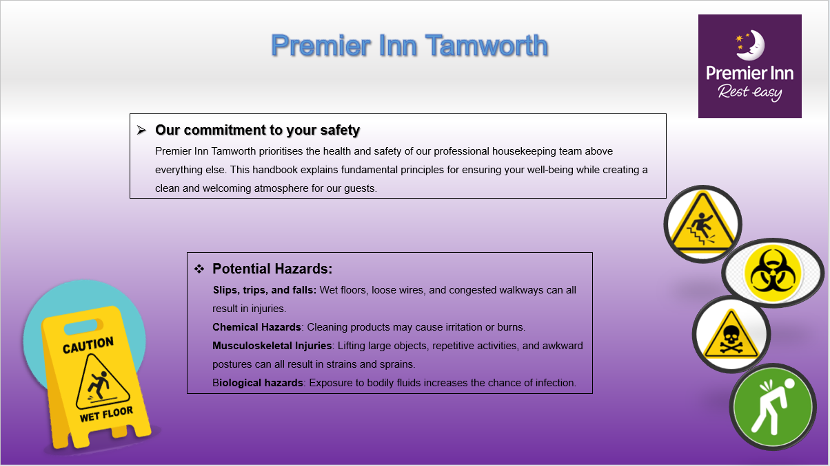

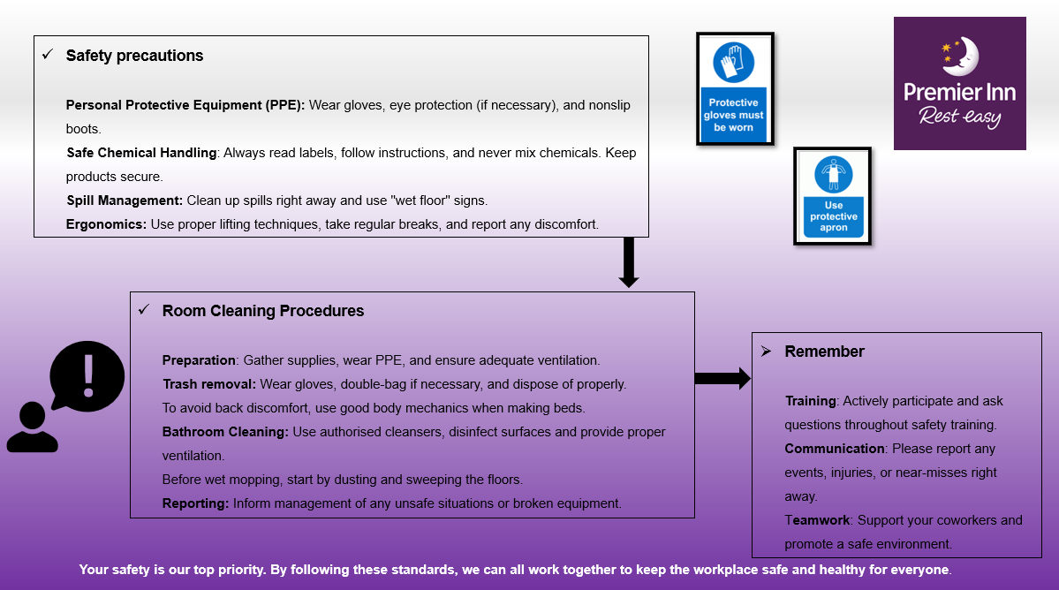

Reference List

- Bridger, E. (2018) Employee engagement: a practical introduction. 2nd ed. HR Fundamentals. London: CIPD and Kogan Page.
- Casado, M. (2012) Housekeeping Management. London: Wiley
- Fallon, M. & Rutherford, D. (2010) Hotel Management and Operations. London: Pearson
- Jones, T. (2010) Professional Management Housekeeping Operations. London: Wiley
- Leiter, M. P. and Bakker, A. B. (2010) Work Engagement : A Handbook of Essential Theory and Research. Hove [England]: Psychology Press.
- Mullins, L. and Dossor, P. (2013) Hospitality Management and Organisational Behaviour. 5th ed. Harlow: Pearson.
- Raghubalan, G. and Raghubalan, S. (2016) Hotel Housekeeping - Operations And Management. 3rd ed. India: Oxford University Press.

