
COMPONENT 2
Report: 6B20 Obsessive-Compulsive Disorder
Name | Sofia Jabeen | ID Number | 2309199
Programme | BSc Health and Social Care
Module | Psychological Classifications and Provisions
Module code | BMHP6029
Tutor’s Name | Kennedy Obohwemu
Word Count | 2059 Words

Table of Contents
Introduction -------------------------------------------------------------------------------------------5
1. Classification and Diagnosis of OCD in ICD-11----------------------------------------6
1.1 Classification---------------------------------------------------------------------------------------6
1.2 Diagnostic Criteria and Process -------------------------------------------------------------6
1.3 Critical Evaluation of OCD Diagnosis-------------------------------------------------------7
2.Treatment and Rehabilitation------------------------------------------------------------------7
2.1 Psychological Treatments of OCD-----------------------------------------------------------7
2.2 Medication------------------------------------------------------------------------------------------8
2.3 Novel Interventions-------------------------------------------------------------------------------9
2.4 Rehabilitation--------------------------------------------------------------------------------------9
2.5 Access the Effectiveness and Limitations of Approaches----------------------------10
3. Current Debate and Emerging Issues---------------------------------------------------10
3.1 Debate Concerning Classification----------------------------------------------------------10
3.2 OCD and Neurodivergence------------------------------------------------------------------10
3.3 Overdiagnosis and Underdiagnosis Controversy --------------------------------------11
3.4 Debate Regarding Treatments--------------------------------------------------------------11
3.5 Policy Implications------------------------------------------------------------------------------12
4. Recommendations -----------------------------------------------------------------------------12
Conclusion ------------------------------------------------------------------------------------------13
References -------------------------------------------------------------------------------------------14

List of Figures
Figure#1-------------------------------------------------------------------------------------------------5
Figure#2-------------------------------------------------------------------------------------------------7
Figure#3-------------------------------------------------------------------------------------------------8
Figure#4-------------------------------------------------------------------------------------------------11

List of Abbreviations

ACT = Acceptance and Commitment Therapy
ADHD = Attention-Deficit/Hyperactivity Disorder
ASD = Autism Spectrum Disorder
CBT = Cognitive Behavioral Therapy
ERP = Exposure and Response Prevention
DBS = Deep Brain Stimulation
ICBT = Inference-Based CBT
ICD = International Classification of Diseases
MH = Mental Health
NHS = National Health Service
OCD = Obsessive-Compulsive Disorder
OCI = Obsessive-Compulsive Inventory
OCRDs = Obsessive Compulsive and Related Disorders
PANDAS = Pediatric Autoimmune Neuropsychiatric Disorders Associated with Streptococcal infections
rTMS = Repetitive Transcranial Magnetic Stimulation
SSRIs = Selective Serotonin Reuptake Inhibitors
YBOCS = Yale-Brown Obsessive Compulsive Scale
WHO = World Health Organization

Introduction
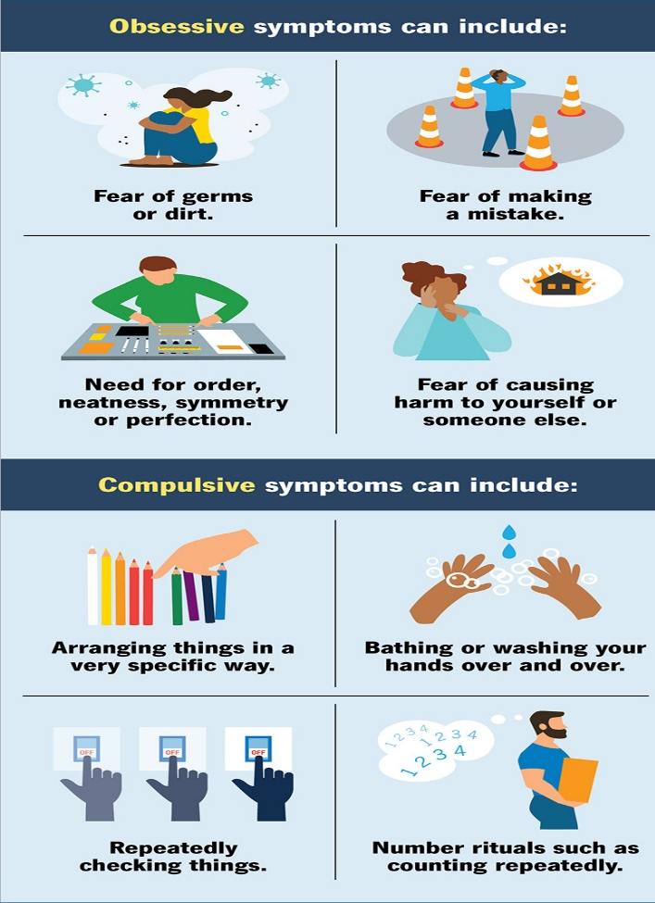
According to the WHO (2022), 6B20 obsessive-compulsive disorder is a chronic and often crippling mental health disorder which is characterized by the presence of obsessions and compulsions.
Figure 1: Symptoms of Obsession and Compulsion in OCD (Cleveland Clinic,2022).
Obsessions are defined as a recurrent and
persistent thoughts, perceptions urge, or images
that are experienced as intrusive and unwanted.
Compulsions are denoted as repetitive behaviours
that performed in response to obsessions.
Obsessive compulsive disorder significantly affects
Person’s social, educational, professional and
interpersonal functioning skills and globally
considered as a most disabling psychiatric ailment.
Its contemporary care research statista proposes
that 1-3 percent of world population is having this
disease and frequently coexist with depression,
anxiety, motor or vocal tics and other neurological
disorders(Abramowitz et al., 2026). The pinpoint cause of OCD is not fully known yet but several factors like cerebrum nonfunctionally which controls thinking and behaviour, stressful life events and PANDAS syndrome are the most common risk factors(Cleveland Clinic,2022).
Over the past two decade, classifications and understanding about OCD has evolved substantially. Previously, it was grouped with the category of anxiety and depression disorders but latterly ICD-11(International Classification of Diseases, 11th Revision) recognizes OCD as a OCRDs.This classification reflects that there is a significant advancement shown in the neurological, biological, psychological, and clinical research. However, there is still debate over classification, diagnosis, efficacy of therapy and the relationship between OCD and concepts such as neurodivergence.
This report critically discusses OCD through the perspective of ICD-11 classification and diagnostic methods, treatment and rehabilitation approaches, and current debates as well as conclusion gives recommendations to improve practice, policy and future research on OCD.
1. Classification and Diagnosis of OCD in ICD-11
1.1 Classification
World Health Organization has developed the International Classification of Diseases 11 Revision system in which OCD classifies within the broader categories of OCRDs which gives the specific disease diagnostic codes like:
- 6B20 Obsessive-Compulsive Disorder
- 6B21 Body Dysmorphic Disorder
- 6B22 Olfactory Reference Disorder
- 6B23 Health Anxiety Disorder
- 6B24 Hoarding Disorder
- 6B25 Body-Focused Repetitive Behaviour Disorders
- 6B25.0 Hair Pulling Disorder
- 6B25.1 Excoriation or Skin Picking Disorder
This classification reflects that ORCDs are having convergent clinical features such as persistent thoughts, repetitive behaviour, similarity in neurological processes and overlapping treatment strategies (Stein et al., 2019).
Crucially, ICD-11 refers this to disorder instead of illness or condition. This language aligns with a method of psychiatric grouping that determines clinically significant disruptions in demeanour, emotion regulation, or cognition that cause stress.
From the historical perspective, OCD was classified in ICD-10 as an anxiety disorder, but later research shows that it is different from anxiety disorder due to distinct neurobiological mechanisms, treatment responses, compulsive and co-occurrence of repetitive behaviour disorder. Therefore, ICD-11 established OCRDs as a separate diagnostic taxonomy to improve clinical resources and diagnostic accuracy (Stein et al., 2019).
1.2 Diagnostic Criteria and Process
As reported by ICD-11 classification, OCD is characterized by obsession and compulsion and its diagnosis require symptoms that causes significant distress to the patient, showing persistence over time, deskilling and social exclusion.
Hence, ICD-11 explained that the required symptoms should be in for 2 weeks before diagnosis reflecting proof that diagnosis criteria was redundant and possible delay in the intervention unlike the OCD-10 (Stein et al., 2019).
As far as its process is concerned, diagnosis should involve patient’s clinical interview in which mental healthcare professionals conduct comprehensive assessment, using standardised tools (OCI, Y-BOCS) which help in quantifying the symptom severity and treatment process.
1.3 Critical Evaluation of OCD Diagnosis
Whereas OCD has given its proper classification which helps in diagnosis, but certain challenges exist there.
Strengths | Challenges
Enhanced identification of related disorders. | Due to shyness, hidden symptoms restrain intervention.
Improved international consistency. | Frequently overlooks mental compulsions.
Inclusion of convectional clinical tags. | Heterogeneity influences interpretation.
Diagnosis of symptoms on a greater flexibility scale. | Lapses in diagnosis.

Studies indicates that many years ago patients experience delays in receiving accurate diagnosis and treatment which results worsening of symptoms and affected living standards (Abramowitz et al., 2026).
2. Treatment and Rehabilitation
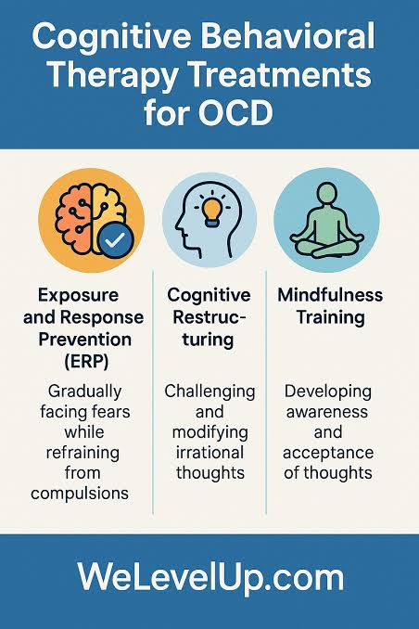
2.1 Psychological Treatments for OCD
Figure 2: CBT Treatments for OCD (Nikbakht, 2025).
Exposure and Response Prevention & CBT
- It typically delivered under the CBT model as CBT is an effective method to treat OCD.
- BUT ERP treatment method is much more widely accepted by the professionals as a gold standard which helps in gradually reduction in anxiety through inhibitory learning and habituation.
- Recent studies with evidence suggest that ERP is the best empirically supported treatment method of OCD for both young and adult people(Abramowitz et al., 2026).
- A huge metatheory exhibits that ERP surpassed deportment controls, waitlist controls, and in many cases pharmacological interventions (Steele et al., 2024). While CBT addresses perfectionisms, inflated accountability, maladaptive thoughts, beliefs and intolerance of uncertainty.
2.2 Medication
Pharmacological treatment includes the following medicines to recover the OCD:
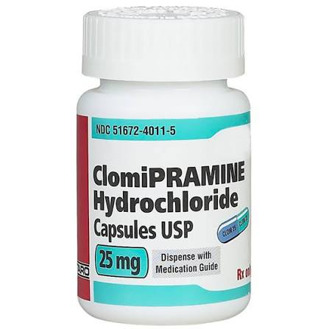
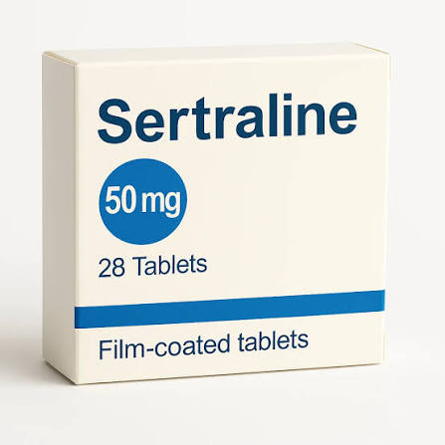
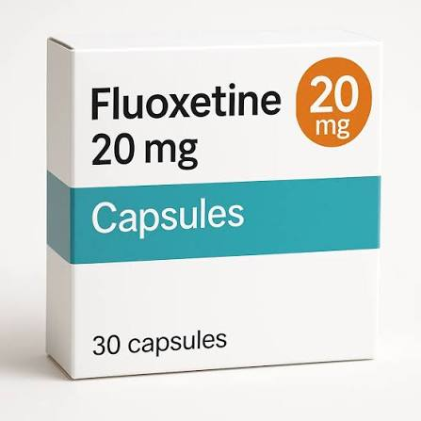
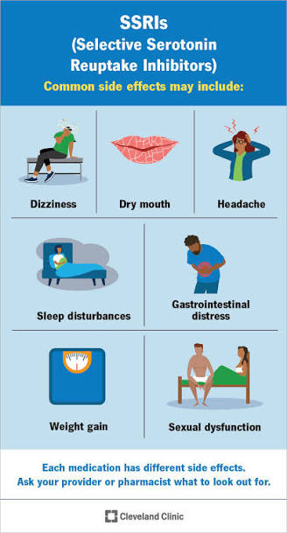
- SSRIs like sertraline, fluoxetine, escitalopram etc are effective which assist in lessens the obsessional thoughts and compulsion with having some side effects(Abramowitz et al., 2026).
Figure 3: SSRIs common side effects(Cleveland Clinic,2022).
2. Clomipramine is an effective medicine but
having severe side effects rather than SSRIs.
Research indicates that effective treatment by combining SSRIs and ERP gives brilliant outcomes as compared to the intervention alone(Steele et al., 2024).
2.3 Novel Interventions
Inference-Based CBT | Acceptance and Commitment Therapy | Neuromodulation | Psychedelic-Assisted Therapies
The disordered thought processes that underlie obsessions are the significant subject of I-CBT.  According to the Digital and Telehealth I treatment strategies,  remote ERP has showed effectiveness equivalent to face-to-face delivery, boosting accessible for underprivileged populations in remote areas who do not get advance treatment due to disparities  (Roh et al., 2023). | ACT provide support in acceptance of intrusive thinking and psychological flexibility with value-based demeanour actions(Roh et al., 2023). | It contains two strategical approaches rTMS and DBS which bring into practices while severe resistant cases need interventions(Elsouri et al., 2024). | Primarily, it was considered that these therapies are very promising in the treatment of OCD like psilocybin and ketamine are very effective. Therefore, still deep research needed to use this widely in the OCD intervention(Roh et al., 2023).

2.4 Rehabilitation
Rehabilitation means a recovery of patient from an illness by restoring his life quality, body functioning by leaving behind the adverse symptoms. Rehab measures are following:
- Professional Rehabilitation assist in returning back to the professional life either it is work or education.
- Social Rehabilitation helps in building the interpersonal skills and relationships and community inclusion.
- Family Mediation support in reducing enabling behaviour and enhanced intervention results.
- Sobriety Maintenance helps patients in learning self-management techniques, resilient and coping strategies as well as early warning signs of disease(Spencer et al., 2022).
2.5 Assess the Effectiveness and Limitations of these Approaches.
Effectiveness | Limitations
- ERP is the best intervention which reduces OCD symptom severity.  - SSRIs improve functioning by reducing obsessional thoughts and compulsive behaviour.  - Study demonstrates that combined treatments yield stronger outcomes.  - Digital and Telehealth expand access in remote areas for underprivileged people (Abramowitz et al., 2026). | - ERP can be emotionally exhausting.  - Incomplete remission of the symptoms is experienced by the 40%-60% patients.  - Notable dropout rates regarding treatment and medication reduces fidelity.  - Disparities in accessing to the disease specialist services (Abramowitz et al., 2026).

3. Current Debates and Emerging Issues
3.1 Debate Concerning Classification
One of the primary points of contention is whether OCD should be conceptualised dimensionally or as a separate disorder category. Supporters of dimensional methods argue that there is a spectrum of OCD symptoms which are still difficult to distinguish between anxiety disorders and OCD. Dimensional models may better capture symptom variety.
Conversely, categorical categorisation boosts diagnostic reliability and treatment planning for future interventions (Sanz Cortés, 2022).
3.2 OCD and Neurodivergence
OCD and neurodivergence has strong relationship in between because many patients of ASD, ADHD and TIC disorders are having OCD symptoms.
But still arguments exist by the researchers who says that repetitive behaviour in autism is sharply different from compulsions in OCD. Some said it should be understood through neurodiversity framework and diagnostic systems often pathologize natural neurodiversity. Several other says that OCD failed recognition leads to the limited treatment access and cause clinically significant distress. This debate also raised concerns related stigma, autonomy, dignity and service provision(Fineberg et al.,2007).
3.3 Overdiagnosis and Underdiagnosis Controversy
Overdiagnosis and Underdiagnosis controversy involves diagnostic accuracy if not recognised properly it may present significant clinical complications.
Some observers have suggested that OCD is being misused as a term to describe neatness or perfectionism due to overdiagnosis public awareness efforts and social media trends.
While on the other hand, underdiagnosis owing to the stigma and intolerance because it shows that many people have obsession with harm, sex and religion(Fineberg et al.,2007).
3.4 Debates Regarding Treatment
- Some critics condemned that eventually ERP is a dominate treatment model for OCD, but patient still does not happy to respond, show intolerance regarding treatment exercises and trauma informed adaptations may be compulsory. However, the rest two interventions like ICBT and ACT are emerging with new source to limit these challenges(Abramowitz and Houts, 2005).
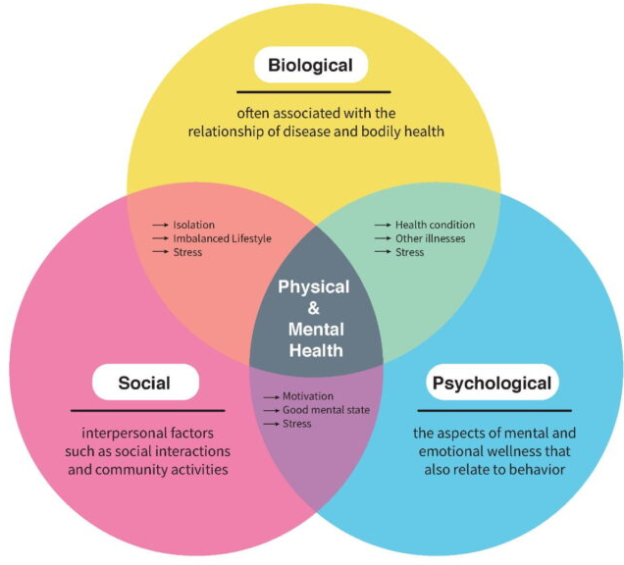
- Arguments related OCD conceptualization also exists like how it should be a neurobiological disorder, cognitive-behavioural condition or a biopsychosocial phenomenon (Moreau et al., 2025). So current studies with evidence reveal that incorporation of all factors in an integrated model explain it better; model name in biopsychosocial model.
Figure 4: Biopsychosocial Model(Hardie, 2021).

3.5 Policy Implications
Above mentioned debates are influenced by the following policy implication to increase recognition of neurodiversity which may encourage person centred care plans and inclusive service framework(Simpson and Reddy, 2014).
- Work on eligibility factors to support the disability.
- Prioritize fundings.
- New intervention models to do better service delivery.
- Workshops and training of professionals.
- Awareness campaigns for public service.
- Implementation of digital and telehealth in clinical sources.
- Work on research agendas.
4. Recommendations
Several recommendations are given below on the basis of evidence reviewed data:
Early Detection Enhancement: Improve long term results and lessen the functional impairment and disability due to which healthcare needs to increase the professional awareness, decrease diagnostic delays and expanding the screening programmes.
Improve Expertise Training: Due to many clinical unprofessionalism in OCD assessment and ERP delivery organization should held the training programmes by emphasizing identification of hidden compulsions, cultural diversity and competence, neuro diversity informed practices and differential diagnosis.
Enhanced Inclusivity to Evidence-Based Treatment Medications: To remove the socioeconomic and geographical disparities healthcare and government needs to do high investment in campaigning community mental health programmes, implementation of telehealth in ERP services and building specialist OCD clinics.
Adoption of Personalized Care Strategic Approaches: Futuristic practices should move beyond the uniform approaches. Care planning must into account the patient neurodevelopment profile, trauma antiquity, cultural setting, symptom subtype and above all patient’s preferences while designing the person-centred care plans.
Expand Research into Novel Treatment Modalities: For the implementation of novel treatment modalities in NHS controlled experiments on a large scale required before the implementation. So deep investigation needed relating neuromodulation, digits and telehealth MH interventions and psychedelic-assisted therapies.
Neurodiversity Paradigm Incorporation: For an effective treatment a balanced approach is necessary to reduce the stigma, and clinical practice should consider the patient perspective, patient strength alongside with its impairment and difference between diversity and pathology for treatment acknowledgement.
Conclusion
To conclude my report on Obsessive-Compulsive Disorder; I will summarise it as a complex and multifaceted MH disorder that significantly alter the daily body functioning and quality of life. It is introduced in the broader category of OCDRs by the classification of ICD-11 which reflects development in scientific research and clinical understanding. Medical markers putting stress on the presence of obsessions and compulsions which are accompanied by notable impairment and distress.
Novel treatment modalities specifically EPR and SSRIs have considerable empirical support in the OCD treatment approaches. In spite of that, many people are enabled to achieve full remission of the OCD symptoms requiring innovation of personalized care with approachable strategies. On the other hand, rehabilitation dimensions playing a crucial role in supporting long-term recovery and social Inclusion.
Current debates regarding classification, OCD and neurodiversity, overdiagnosis or underdiagnosis and emerging novel treatments demonstrate that undoubtedly OCD remains an evolving area of psychiatric research and practice setting. Futuristic innovations and regulations should prioritise earlier diagnosis, increased accessibility, individualised treatment plans, and meaningful inclusion of neurodiversity viewpoints in mental health practice. These developments have the potential to enhance results while guaranteeing that services continue to be inclusive, evidence-based, and sensitive to the many experiences of people who are suffering with OCD.

References
- Abramowitz, J.S. and Houts, A.C. eds., (2005). Concepts and Controversies in Obsessive-Compulsive Disorder. Boston, MA: Springer US. doi:https://doi.org/10.1007/b101087.
- Abramowitz, J.S., Abramovitch, A., McKay, D. and Draffin, A. (2026). Management of obsessive-compulsive disorder in adults. BMJ, 392, p.e083443. doi:https://doi.org/10.1136/bmj-2024-083443.
- Cleveland Clinic (2022). OCD (Obsessive-Compulsive Disorder): Symptoms & Treatment. [online] Cleveland Clinic. Available at: https://my.clevelandclinic.org/health/diseases/9490-ocd-obsessive-compulsive-disorder.
- Elsouri, K.N., Heiser, S.E., Cabrera, D., Alqurneh, S., Hawat, J. and Demory, M.L. (2024). Management and treatment of obsessive-compulsive disorder (OCD): A literature review. Cureus, [online] 16(5), p.e60496. doi:https://doi.org/10.7759/cureus.60496.
- Fineberg, N.A. et al. (2007) ‘Obsessive-Compulsive Disorder: Boundary Issues’, CNS Spectrums, 12(5), pp. 359–375. doi:10.1017/S1092852900021167.
- Hardie, M. (2021). Three aspects of health and healing: The biopsychosocial model in medicine. [online] Department of Surgery. Available at: https://surgery.wustl.edu/three-aspects-of-health-and-healing-the-biopsychosocial-model/.
- Moreau, A.L., Hansen, I. and Bogdan, R. (2025). A systematic review of structural neuroimaging markers of psychotherapeutic and pharmacological treatment for obsessive-compulsive disorder. Frontiers in Psychiatry, 15. doi:https://doi.org/10.3389/fpsyt.2024.1432253.
- Nikbakht, A. (2025). OCD Treatment: A Powerful Path To Recovery & Stability. [online] We Level Up Treatment Centers. Available at: https://welevelup.com/mental-health/ocd-treatment [Accessed 1 Jul. 2026].
- Roh, D., Jang, K.W. and Kim, C.-H. (2023). Clinical Advances in Treatment Strategies for Obsessive-compulsive Disorder in Adults. Clinical psychopharmacology and neuroscience : the official scientific journal of the Korean College of Neuropsychopharmacology, 21(4), pp.676–685. doi:https://doi.org/10.9758/cpn.23.1075.
- Sanz Cortés, A. (2022). Diagnostic and Statistical Manual of Mental Disorders, Fifth Edition, Text Revision (DSM-5-TR). American Psychiatric Association, 2022. https://doi.org/10.1176/ appi.books.9780890425787. Psicooncología, 19(2), pp.339–340. doi:https://doi.org/10.5209/psic.84045.
- Simpson, H.B. and Reddy, Y.C.J. (2014). Obsessive-compulsive disorder for ICD-11: proposed changes to the diagnostic guidelines and specifiers. Revista Brasileira de Psiquiatria, 36(suppl 1), pp.3–13. doi:https://doi.org/10.1590/1516-4446-2013-1229.
- Spencer, S.D., Stiede, J.T., Wiese, A.D., Goodman, W.K., Guzick, A.G. and Storch, E.A. (2022). Cognitive-Behavioral Therapy for Obsessive-Compulsive Disorder. Psychiatric Clinics of North America, 46(1). doi:https://doi.org/10.1016/j.psc.2022.10.004.
- Stein, D.J., Costa, D.L.C., Lochner, C., Miguel, E.C., Reddy, Y.C.J., Shavitt, R.G., van den Heuvel, O.A. and Simpson, H.B. (2019). Obsessive–compulsive disorder. Nature Reviews Disease Primers, [online] 5(1), p.52. doi:https://doi.org/10.1038/s41572-019-0102-3.
- Steele, D.W., Kanaan, G., Caputo, E.L., Freeman, J.B., Brannan, E.H., Balk, E.M., Trikalinos, T.A. and Adam, G.P. (2024). Treatment of obsessive-compulsive disorder in children and youth: A meta-analysis. PEDIATRICS, 155(3). doi:https://doi.org/10.1542/peds.2024-068992.
- World Health Organization (2022). International classification of diseases (ICD). [online] www.who.int. Available at: https://www.who.int/standards/classifications/classification-of-diseases.

