Statistical Analysis with Excel

Finding the mean, median, mode and standard deviation
After the data have been entered, place the cursor where you wish to have the mean (average) appear and click the mouse button. Select Insert Function from the FORMULAS tab. A dialog box will appear. Select AVERAGE from the Statistical category and click OK. (Note: If you want the Median, select MEDIAN. If you want the Mode, select MODE.SNGL. If you want the standard deviation, select STDEV.S)
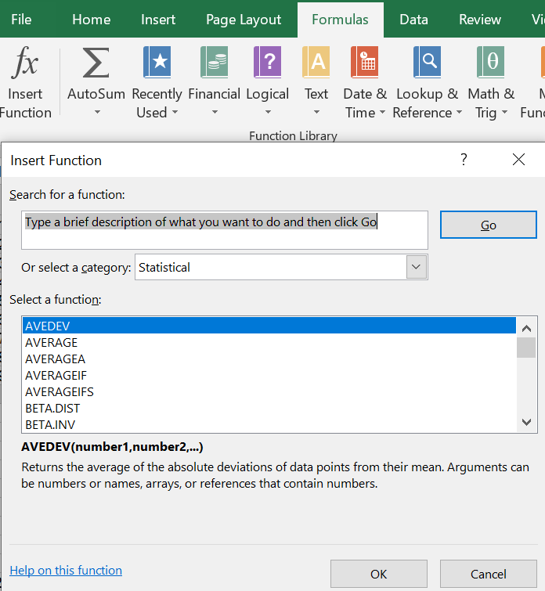

Creating Excel Pivot Tables (Frequency tables)
- Select the cells you want to create a PivotTable from
- Select Insert > PivotTable
- Under Choose the data that you want to analyze, select Select a table or range
- In Table/Range, verify the cell range.
- Select OK.
- Building out your PivotTable
  - To add a field to your PivotTable, select the field name checkbox in the PivotTables Fields pane.
  - To move a field from one area to another, drag the field to the target area.
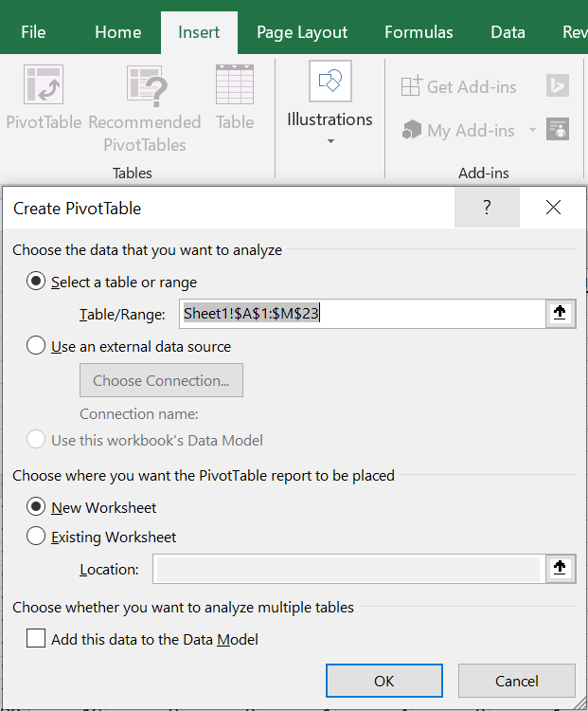 | 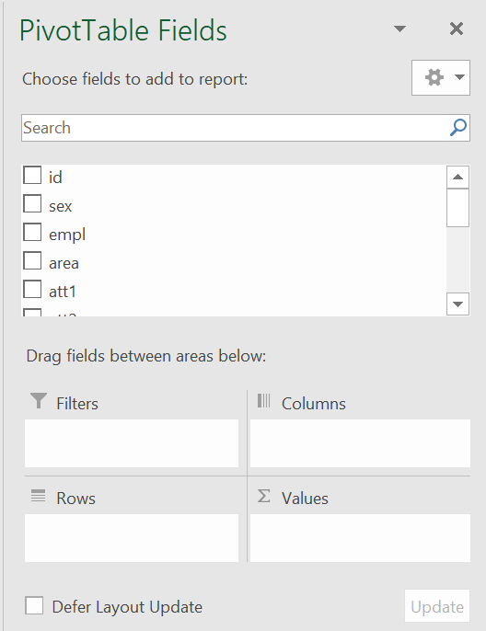

Calculating Pearson correlation coefficient with Excel
Select Insert Function from the FORMULAS tab. A dialog box will appear. Select PEARSON from the Statistical category and click OK.
- Click the array1 box and then move the cursor to the top of the first variable; then click and drag to the bottom of the column; click the “array1” box again to confirm your selection.
- Do the same for the second variable (array2).
Alternatively, click on an empty cell where you want the correlation coefficient to be entered. Then enter the following formula.
=PEARSON(array1, array2)

Using Pearson Correlation Coefficient Calculator
https://www.socscistatistics.com/tests/pearson/default2.aspx

P Value from Pearson (R) Calculator
https://www.socscistatistics.com/pvalues/pearsondistribution.aspx

Two-sample independent t Test
Select Insert Function from the FORMULAS tab. A dialog box will appear. Select T.TEST from the Statistical category and click OK.
- Click the array1 box and then move the cursor to the top of the first variable; then click and drag to the bottom of the column; click the “array1” box again to confirm your selection.
- Do the same for the second variable (array2).
- Specify the tails and the type of the test.
Alternatively, click on an empty cell where you want the correlation coefficient to be entered. Then enter the following formula.
=TEST(array1,array2,tails,type)
Where Array1: The first data set; Array2: The second data set
Tails: “1” for one-tailed test and “2” for two-tailed test
Type: “1” for paired T-Test, “2” for two-sample equal variance T-Test and “3” for two-sample unequal variance T-Test

Levene's Calculator- Equality of Variances
https://www.socscistatistics.com/tests/levene/default.aspx

Calculation of Cronbach’s alpha using Excel
This website contains an Excel spreadsheet that can be used to calculate Cronbach’s alpha. If you don't have SPSS in your computer, you can download the spreadsheet and enter your data into the appropriate columns. The Cronbach’s alpha will be computed and displayed on the “Results” worksheet.
http://languagetesting.info/statistics/excel.html

