An Investigation on how Technological Developments are changing the Tourism Industry. A Case Study on Virtual Reality

By Suzanne Escott – Sloan


Dissertation submitted as part of an International Travel and Tourism Management Degree
UWTSD Swansea
2019

DECLARATION 1

This work has not previously been accepted in substance for any degree and is not being concurrently submitted in candidature for any degree.

Signed................................................... Date......................................................

DECLARATION 2

The researcher is currently employed within the industry and as such an extra effort will be made to keep this dissertation free from subjective validation and bias.

Signed................................................... Date......................................................

STATEMENT 1

This dissertation is being submitted in partial fulfilment of the requirements for the degree of BA Accounting.

Signed.................................................... Date......................................................

STATEMENT 2

This dissertation is the result of my own independent work/investigation, except where otherwise stated. Other sources are acknowledged by footnotes giving explicit references. A bibliography is appended.

Signed................................................... Date......................................................

STATEMENT 3

I hereby give consent for my dissertation, if accepted, to be available for photocopying and for interlibrary loan, and for the title and summary to be made available to outside organisations.

Signed...................................................... Date.........................................................

STATEMENT 4

I hereby give consent for my dissertation, if accepted, to be available on the university’s IT system to those who have consent to use the system.

Signed...................................................... Date.........................................................

An Investigation on how Technological Developments are changing the Tourism Industry. A Case Study on Virtual Reality

By Suzanne Escott – Sloan



Dissertation submitted as part of an International Travel and Tourism Management Degree
UWTSD Swansea
2019

Acknowledgements

I would firstly like to thank my friends, family, and my dissertation supervisor Kathryn Flynn, for all of the support they have given me. The amount of hours spent in the library would not have been possible without the continuous encouragement and support provided by all of the above.

Although completing this document has quite frankly been painful, words cannot express my gratitude to my nan Pamela Escott, to my mum Wendy Escott-Sloan, and sister Charlie Escott-Sloan, who all encouraged me to stick at university during its ups and downs. I would further like to thank my dad Gary Sloan for his financial support. Finally, I would like to thank work colleagues at Ann Summers, Sin City and drum and bass for keeping me sane. This would not have been possible without the continued support from all of the above.

Table of Contents
Acknowledgements v
Abstract x
1. Introduction 1
1.1 Aims and Objectives 1
1.1. The Evolution of Tourism and Marketing 2
2. Review of Literature: 4
2.1. Tourism development and current trends 4
2.1.1 Tourist Motivation 5
2.1.2 Social Media 6
2.2. Marketing Developments 7
2.3. Technology 8
2.3.1. The Internet 9
2.3.2. Safety Online 10
2.4. Digitalisation 11
2.4.1. QR Codes 12
2.4.2. Virtual Reality (VR) 13
2.4.3. Current Usage of VR 14
2.5 Conclusion 15
3. Chapter Three - Methodology 17
3.1 Research Onion 18
3.1.1. Philosophy 20
3.1.2. Approach 21
3.1.3. Strategy 21
3.1.4. Choice 22
3.1.5. Time Horizon 22
3.1.6. Survey Design 22
3.1.7. Collection and analysis 24
3.3. Limitations 24
3.2. Reliability and Validity 25
3.4. Ethical Considerations 25
Chapter 4 – Data Analysis 27
4.1. Introduction 27
4.2. Main Findings 28
4.2.1 Questionnaire Analysis 28
4.3. Content Analysis 35
4.4. Cross Tabulation 35
4.5. Conclusion 36
Chapter Five - Conclusion 38
5.1. Recommendations 40
5.2. Areas of Further Research 42
Bibliography 43
Appendices 55
Appendix 1 - Ethics Form 55
Appendix 2 – Questionnaire 62
Appendix 3 -Participant Consent Form 64
Appendix 4 – Interview Question Layout 68
Appendix 5 – Maslow’s (1954) Hierarchy of Needs 70
Appendix 6 – Plog’s (1971) Classification Scheme 71
Appendix 7 - Matrix Table 73
Appendix 8 – Matrix Tablet Part 2 (Interviews) 74
Appendix 9 - Transcript of interview with supervisor from SimRace1 75
Appendix 10- Transcript of interview with the Wildlife Trusts marketing development manager. 78
Appendix 11- Transcript of interview with the supervisor of eGolf 81
Appendix – 12 One of many attempted emails for interview 83
Appendix 13 - Cover letter for participants of online survey. 84
Appendix 14 – Survey Consent 85
Appendix 15 – Online Survey Q2 86
Appendix 16 – Online Survey Q3 87
Appendix 17 – Online Survey Q4 88
Appendix 18 - Online Survey Q5 89
Appendix 19 – Online Survey Q6 90
Appendix 20- online Survey Q7 91
Appendix 21 – Online Survey Q8 92
Appendix 22 - Online Survey Q9 93
Appendix 23 – Online Survey Q10 94
Appendix 24 - Participants Demographics Q1 95
Appendix 25 – Participants Demographics Q2 96
Appendix 26 – Participants Demographics Q3 97
Appendix 27 - Thomas Cook Holiday Report 2019 98
Appendix 28 - Gantt Chart Time Management 99
Appendix 29 – Poon’s old and new tourism comparison (1993) 100

Table of Figures

Figure 3.1: The Research Onion. Source: (Saunders, et al, 2007)………...………...18
Figure 4.1: Graphic of answers to question 5……………………………………….….29
Figure 4.2: Graphic of answers to question 11…………………………………………30
Figure 4.3: Graphics of answers to question 10………………………………………..31
Figure 4.4: Condensed Matrix table on the topic of VR………………………………..32
Figure 4.5: Graphic of answers to question 7..…………………………………………36

Abstract
In an era where technological advancements are rapidly altering industries, tourism and marketing methods have needed to innovate and adapt in order to survive. The internet, online platforms, the introduction of comparison sites, QR codes, and the progression of the mobile phone, are but a few of technologies advancements which have directly impacted the tourism industry.

Marketing professionals such as, Edgell and Swanson (2013), Brown (2018), Singh (2004) and Gidley (2017) discuss the importance of technology and innovation when marketing. The new technology of virtual reality and its potential market usage within the tourism industry, has been predicted, assessed, and contested for years by both industry professionals and academics. As available choice and personalisation has developed, the typical tourist and their expectations and desires have changed. Furthermore, academics such as Maslow (1997) and Poon (1998) debate tourists needs, wants and inclinations. This dissertation aims is to investigate how technological developments are changing the tourism industry. For the purpose of this study the researcher focused particularly on the potential of virtual reality.

Introduction
  - Aims and Objectives

The aim of this dissertation is to investigate how technological developments are changing the tourism industry. To achieve this aim, the following objectives will be achieved:

- Critically appraise Virtual Reality and its current use in the tourism industry.

- Analyse the current tourism market usage potential and how this will impact on the industry and the consumer market.

- Provide recommendations for the future of technology and Virtual Reality with respect to the tourism industry.

To achieve the first objective, published literature and accredited websites will be critically evaluated. Furthermore, the researcher will look into the background of this new technology and its expected future developments. The first objective will be covered in a review of literature, which can be found in chapter two.

The second objective will be covered in chapters three and four. The research strategy adapts a triangulation design, whereby the use of interviews, surveys and a content analysis will be used to then form the analysis. This objective will be achieved from primary research in the form of surveys and interviews and responses to these will be analysed to fairly represent the data collected. Surveys and interviews will be used to assess both the consumers’ and industry professional’s perceptions of the market. The researcher will gather and compare relevant resources from areas including technology, tourism, marketing and the current usage of Virtual Reality. This will help the researcher achieve the second aim.

The third and final objective will be discussed in chapter five. The evident themes from the previous chapters will become the basis for the recommendations and predictions of the future of technology within the industry.

  - The Evolution of Tourism and Marketing

In order to meet the objectives of this dissertation study, context as to what tourism and marketing are must be established. Tourism ‘is but one of a range of choices or styles of recreation, expressed either through travel or a temporary short-term change of residence.’ (Wall, Mathieson 2006, P.11) The concept of travelling began in ‘Western Europe in the 17th century.’ (Walton, 2019) It is said that the Romans were the earliest tourists, with affluent British people joining by the 18th and 19th century (Waugh, 2009, P.587). Thomas Cook ‘introduced the first complete package tour in 1841, which included accommodation, transport and activity’ (Lickorish, Jenkins, 1997, P.17). Historically, the available choice and booking experience was very different for consumers. For example, in 1845 before the invention of computers and phones, Thomas Cook arranged packaged rail travel for 165,000 people with only a schedule, pen and paper for a system (Joyce, 2013). This was the first ever package deal and customers could not alter or personalise this experience.
Since then, the industry and technological developments have opened up more choice, thus tourists’ expectations and behaviours have changed. Thomas Cook now take ‘19 million customers on a variety of holidays each year’. (Thomas Cook, 2019)

Blythe (2006) cites Kolter who defines marketing as ‘an interface between the organisation and the outside.' Marketing is a process which aims to gain value from exchanges with customers. (Chernev, 2018) ‘Marketing as an approach to the conduct of modern business was developed in the early twentieth century in countries in the Western world with relatively free markets.’(Middleton et al, 2009, p.20) This concept began during the industrial revolution at a time where it became easier for consumers to purchase goods rather than make them for themselves. This created a need for producers, which then led to increasing competition. As a result of this, marketing techniques were used to promote what a producer had to offer. In the 1960’s many markets became highly competitive as a result of saturation, thus the need for direct marketing aimed towards gaining customers became an important requirement. (History Cooperative, 2018)

Technology has altered the way businesses interact with consumers, revolutionising traditional methods such as the use of billboards and leaflets. ‘The internet is a wider network that allows computer networks around the world to talk to one another’. (Sample, 2018) Guttentag (2008) as cited by (Buhalis & Law, 2008; Grønflaten, 2009) In the 1990’s the evolution of the internet meant companies began to market via this digital platform. During this time the first business to have a successful online marketing campaign was a pharmaceutical company named ‘Bristol-Myers Squibb’. (History Cooperative, 2018) In recent years, websites and search engines have become an increasingly more effective marketing tool, due to the amount of traffic they receive daily.

The marketing of services differs to the marketing of goods. Lumsdon states ‘there are five underlying principles which make marketing of services different, intangibility, perishability, heterogeneity, inseparability and the lack of ownership.’ (Lumsdon, 1997, P.28) An intangible product is ‘incapable of being perceived by the sense of touch, as incorporeal or immaterial things.’ (Dictionary, 2019) Due to the nature of tourism being an intangible product to market, showing a consumer what they are investing in can be more difficult. (Levitt, 1981) Marketing an intangible product is challenging as consumers cannot always see the direct benefits of the product. The UK travel and tourism industry only began to apply marketing concepts in the ‘1970’s, 50 years later than the USA’. (Holloway, 2004, P.8)

As society has developed so rapidly, it is fair to appreciate booking a holiday 30 years ago would have been very different. Due to limitations on internet usage, customers would have had to book their holidays with a travel agency or agent. The industry has developed and now consumers have moved to online platforms meaning marketing strategies have needed to change. Promotional methods such as billboards are outdated, and the use of social media or internet platforms is a more effective way to reach target audiences. (Baines, Fill, 2011) Technological advancements have changed the way travel companies trade, target, and communicate with their customers. Within this dissertation it is of the authors’ intention to critique and investigate how technological developments are changing the industry. Furthermore, the research will discuss the advantages and threats to these new technologies. The Literature Review will discuss digital marketing, consumer trends, security online, social media, QR codes, Augmented Reality, (AR) and Virtual Reality (VR).

2. Review of Literature:

2.1. Tourism development and current trends

Within the introduction of this dissertation the researcher discussed the origin and concepts of both tourism and marketing. Tourism as a service industry is a dynamic one, which fluctuates and changes based on consumer trends and current affairs. Naturally, this makes it important for the industry to be innovative and able to quickly adapt to changes.

The tourism industry started with a pen and paper, and has since developed a significant amount as mentioned earlier. Consumers now have the freedom of choice, multiple transport routes and new accessible destinations. A rise in tourism demand and increase in budget airlines have also made the travel industry more available as it has made the industry more accessible to a new demographic of customers. The Office for National Statistics cites the Civil Aviation Authority who state, ‘between 1996 and 2015 passenger numbers at UK airports increased by 85%, from 135 million to 251 million.’ (www.ons.gov.uk, 2017) Today the British tourism industry accounts for over 200,000 businesses (Visitbritian, 2019) and year on year travel is becoming more popular. A global study has shown that ‘46 million more overnight visitors travelled internationally in 2016 compared to 2015.’ (Smith, 2017) Furthermore, it is predicted that ‘by the year 2020, tourism will be the world’s largest industry.’ (Delener, 2010) The industry has and is continuing to develop at a rapid pace.

2.1.1 Tourist Motivation

An assessment of tourism motivational studies, has revealed influencing factors of a customer's motivations to purchase, include internal driving forces, external influencing factors and the buying situation. (Lumsdon, 1997, P.36) The internal driving force may be ones desire for a holiday, whilst the external influencing factors may be marketing, social media or deals used by travel companies to encourage sales. Consumer travel patterns have altered, with the rise of accommodation comparison and letting websites expanding choices for the consumers. In recent years the package holiday has dropped in popularity. This could be due to the fact people are able to save money by booking their flights, hotels and transfers separately. Kutschera (2018) cites Booking.com who discovered that ‘80% of customers prefer to self-serve in order to get the information that they need’. The research also showed that more people are now comfortable to research and book independently via their mobile device.

Poon’s (1998) comparison of the ‘old tourist’ and ‘new tourist’ demonstrates how the ‘new tourists’ desires, demographics, and motivations differ significantly from that of the ‘old tourist’. (See appendix 26, p.99) Past tourism was much easier with customers typically looking for packaged holidays in sunnier destinations. In comparison, the new tourist is much more complex. They want to be independent, unique and they want to travel responsibly. They may also be motivated to participate in cultural tourism or to capture the perfect holiday picture.

Motivation can be defined as a ‘desire or willingness to do something.’ (Oxford Dictionary, 2019) Studies have found that millennials would rather an experience over a materialistic good. (Eventbrite, 2019) A millennial refers to an individual who was ‘born in the 1980s, 1990s, or early 2000s.’(Cambridge Dictionary, 2019) This age group have exceptional digital skills, are usually searching for immersive authenticity and often participate in forms of volunteer tourism. (Yousaf, Amin, Santos, 2017, p.200) Plog’s (1971) classification scheme focuses on what motivates a tourist to travel based on their characteristics. Marketing preferences vary from one tourist to another and this may depend on where they lie on Plog’s classification scheme (see Appendix 6, page 71). Respectively, an ‘allocentric’ or ‘psychocentric’ individual has different motivations and will engage with different marketing. (Goeldner, 2016) For example, individuals with ‘allocentric’ characteristics may enjoy AR and VR technology as it is immersive and new. It is evident that there are many different types of tourists today, thus and their preferences in product taste differs. A tourism business’ marketing must adapt depending on the targeted demographic. For example, social media marketing may be better aimed at millennials whereas traditional methods may be better suited to older generations.

2.1.2 Social Media

Social media can be defined as the ‘collective of online communications channels dedicated to community-based input, interaction, content-sharing and collaboration.’ (Rouse, 2019) The current top four social networking sites include ‘Facebook, Twitter, Instagram and Snapchat (Alhabash & Ma, 2017). Currently social media has over 3.484 billion users worldwide, this figure is up 9% on the previous year (Chaffey, 2019). Alhabash and Ma (2017) cites (Duncan, 2016; Lang, 2015; Matthews, 2014) who stated, ‘Facebook remains popular among young adults, yet it is being abandoned by teens migrating to Instagram and Snapchat.’ Businesses need to remain up to date on what social media sites each demographic group use, as this will allow them to target their marketing effectively (Mitchell, 2005).

In addition, ‘Social media has brought a major revolution in the way travellers gather information,’ with review websites like TripAdvisor allowing consumers to gain information on hotels, locations and excursions (Conrady, Buck, 2012, p.131). An annual report released by Thomas Cook in 2018 revealed that over half of the millennials that were surveyed described social media as having an impact on what hotel they choose. Furthermore, the report stated that older generations admit it plays a part in their decision-making process along with hotel reviews.

Technology is becoming an increasingly integral part of a traveller’s experience and social media is an extremely influential marketing tool. ‘97% of marketers are currently participating in social media.’ (DeMers, 2014) When a customer posts a picture on Instagram of their experience, it can act as free promotion. Hence companies encourage customers to use their hashtag. (DeMers, 2014)

2.2. Marketing Developments

As discussed within the introduction, marketing is a process which aims to gain value from exchanges with customers. (Chernev, 2018) Traditional marketing methods include advertisements in newspaper articles or leafleting. (Burns et al, 2017) As the world has embraced the use of the internet, marketing methods have needed to go digital in order to reach consumers. ‘Digital marketing refers to any exchange processes conducted via electronic means. (Blythe, 2014, P.615) Although non-existent thirty years ago, digital marketing has become imperative to the industry. (Blythe, 2014, P.615) ‘In today’s tourism marketplace a destination without a website is unheard of, tourism promoters who are technically savvy in interactive marketing will outpace their less skilled competitors’. (Edgell & Swanson, 2013, P.228)

Marketing techniques have evolved due to the massive advancements in technology. Previously, consumers had to go to an agency to purchase a holiday, now ‘9/10 research their holiday online, and as many as 80% of people now book their holiday via the internet.’ (Travelweekly, 2012) Within tourism marketing, identifying what the consumer wants is crucially linked to a company’s success. If customers wish to browse and purchase online, businesses must follow and adapt to this consumer trend. Globally, billions of people use the internet to search for services or products, consumer buying behaviour has changed. (Chaffey, Chadwick, 2012, P.6)

eBusiness can be defined ‘as the use of digital tools for business functions and processes’. (Buhalis, 2003, P.345) eTourism is using digital tools in order to inform and communicate between businesses and tourists. eTourism allows tourism businesses to connect, communicate and to market to consumers through media electronically. (Page, 2015) Digital and interactive marketing is marketing using electronic technology which engages the market. (Baines, Fill, 2011) Within the tourism industry, this can take the form of third-party booking sites, online travel agents and social media sites. Online technology makes research simpler and customers more reachable. As tourists evolve the industry innovates to cater for what the consumer wants.

Furthermore, ‘sales and purchases are now facilitated and possible worldwide’. (Ismail, 2017) Whether such developments help or disrupt the industry has been widely contested. This advancement has offered travel companies extra exposure and accessibility for customers. The progression has led to more bookings for many companies; however, the rise of online bookings has affected travel agents. Bearne (2016) cites Rossini (analyst at Euromonitor International) who states ‘Traditional travel distribution in which high street travel agencies played a dominant role was revolutionised with online travel agencies and direct distribution through airlines and hotels’ websites acquiring a key role.’

Smaller businesses may struggle to fund the investment that would be required to develop an up to date website. ‘Innovate or die.’ (Brown, 2018) In a digitally dominated era, companies who do not innovate will decline and cease to exist. (Wall, 2014) Large voluntary or publicly owned businesses can access funding initiatives to use towards upcoming technology. Small private businesses have funding and budget restrictions and struggle to find the funding to keep up with technological advancements. (Wall, 2014)

2.3. Technology

Technology can be defined as ‘the application of scientific knowledge for practical purposes, especially in industry’. (Oxford Dictionaries, 2019) Innovation within technology has led to the advancement of many industries. Such advances include, smartphones, computers, virtual reality devices, and all ‘hallmarks of national progresses’ in their own right. (Linker, 2018, P.783)

Technology has developed rapidly in recent years and devices such as smart phones are making everything easier. Going on holiday used to start with a trip to a travel agency, however, technology now allows travellers to build and personalise their own holidays online. (Bearne, 2016) Hotel comparison websites such as Trivago and Expedia have altered the way customers book. Within the tourism industry, mobile devices can be used for browsing, booking, updating, holding boarding passes and check-ins. This is positive for the tourism industry as it offers consumers convenience through functions such as online check-ins, which can then reduce queues at check-in desks within airports. (Brunt, 2018) However, this technological advancement has led to a reduction in airport staff at check-in desks. For example, self-check-in desks are replacing people and have made many redundant. (Osborne, Fey, 2015)

Having said this, mobile boarding passes are an eco-friendly advancement, they are going ‘to reach number 1.5 billion by 2019’. (Samuely, 2019) Going paperless is convenient as customers do not need to worry about carrying or losing their ticket. However, not everyone is as technically advanced and some individuals prefer having a paper ticket. (Hanson, 2017) Although this advancement will not replace the paper ticket, it can save airport staff time as most customers will already have their boarding passes ready. Travel agency apps offer flight updates directly to consumers internet devices. (TUI, 2019) This update avoids confusion, if there are any changes on the day of travel, this function can quickly communicate new travel information and reduce stress for passengers within airports.

Travel agency websites allow customers to input specifications such as dates, locations, and types of holiday to filter their search. (Thomas Cook, 2019) 38% of Thomas Cook’s online bookings last year were made via smartphone. (Holiday Report, 2019) The search filter makes it easy for customers to browse relevant flights and hotels. This function also allows the company to monitor resort popularity and how many people are currently browsing. Live pricing is useful for marketing as prices can fluctuate and adapt based on demand and availability. This pricing system allows the business to maximise profits. (TUI, 2019)

2.3.1. The Internet
The progression of technology has altered the way tourists travel. (Vidal, 2018) Arguably, one of the biggest impacts on the industry was the rise in use of the internet. ‘The internet is the wider network that allows computer networks around the world to talk to one another’. (Sample, 2018) The amount of people using the internet rises yearly, in 2019 over 4.3 billion people used the internet worldwide. (Chaffey, 2019)

As a platform the internet has revolutionised how the industry operates. Guttentag (2008) as cited by (Buhalis & Law, 2008; Grønflaten, 2009) ‘Many tourists have adopted the Internet as a tool for seeking travel information’. For a large established businesses like Thomas Cook the internet acts as a positive marketing tool the company is able to facilitate sales via their website. Thomas Cook also have an established reputation and extensive online reviews for customers to see. This allows customers flexibility through opportunity to book 24/7. Furthermore, good reviews can encourage more customers to book enhancing sales. Similarly, the hotel chain, Marriott takes the majority of its booking via online websites either directly or via a third party comparison site. (Marriott, 2019)

The internet provides convenience and a way for businesses and consumers to communicate and trade. Through accessibility 24/7, trade can continue outside of retail or hotelier opening hours. But, the internet can be dangerous, fraudulent sites mimic legitimate sites and this can lead to consumers being a victim of fraud. (Action Fraud, 2019)

2.3.2. Safety Online

One segment of Maslow’s Hierarchy of Needs which can affect online bookings is the degree of safety and security. (Lumsdon, 1997, P.37) Safety and security is one of the tourism industry’s instabilities. Safety can be defined as ‘The condition of being protected from or unlikely to cause danger, risk, or injury’. (Oxford Dictionaries, 2019) Feeling safe online for consumers can mean to confidently book with a trusted site.

A survey of over 10,000 people revealed ‘nearly eight out of 10 people (77%) do not feel very safe when shopping online,’ furthermore, the survey revealed customers were becoming increasingly worried about internet safety. (Businesswire, 2014) This concern is founded, with just under 1 billion people were victim to cybercrime in 2017 a figure forecast to increase. (Bekker, 2018) Evidently, this affects the trust between the business and consumer online. Marketing and increasing customer equity requires trust. (Mitchell, 2005) Although travellers like personalisation, booking a package holiday in store provides security. (Brogy, M, 2017) Having said this, the Thomas Cook websites is ABTA Protected which mitigates risk and provides a degree of safety and security. (Thomas Cook, 2019) However, this does not make the site immune to cyber-attacks. To put the problem into perspective, ‘In 2016 5,826 cases of holiday booking fraud were reported to Action Fraud’ (Abta, 2019) Consumers are now becoming more wary as to whether online purchasing is trustworthy. IATA (2019) explain fraudulent websites are increasing within the travel industry, and fraudulent replica websites can damage the reputation of businesses and affect their online sales. If there is an increase in cyber-attacks customers may not feel safe enough to book with the company, thus cyber security directly affects the trust between the business and consumer.

2.4. Digitalisation

Kolter et al (2017) describes digitalisation as the process of data moving from analogue to digital form. Digitalisation is impacting and altering the way the tourism industry functions. A study by Marco et al (2018 cited by Abou-Shouk, Lim, & Megicks, 2013) contested that ‘the tourism industry has become the largest category of products and services sold over the Internet’. The Literature Review has already discussed the impacts of the internet, websites, social media and online safety on the industry. The next section aims to discuss newer innovations. With the introduction of QR codes and the ease of sharing links through the form of such coding, advertising directly to consumers has never been easier. This is because consumers no longer have the need to search for themselves. In the future more advances in technology are predicted to alter the tourism industry. (Conrady and Buck, 2012)

2.4.1. QR Codes

A QR code is a ‘Quick Response code that is the trademark for a type of matrix barcode.’ (Krishna, et al, 2013) QR codes have changed the way tourists travel by enabling tourists to have boarding passes on their phone. Furthermore, QR codes are being used in destinations such as Rio de Janerio where bar codes on sidewalks are used as tourist information points. (Telegraph, 2013) However, technological advancements move on very quickly and QR codes are predicted to soon be a thing of the past. As discussed in an interview with the telegraph, where Masahiro Hara the inventor of the QR code states, ‘the QR code doesn’t have long left of its use before new technological advancements make it obsolete’. (The Telegraph, 2014) Developments move on quickly and the life expectancy of new technology is short,
‘VR software currently full of promise seems to get old very, very, quickly’. (Champion, 2019) This is something that is agreed by academics.

Investing in technology which becomes out dated quickly is a major risk for small businesses who do not have the income nor funding levels of larger businesses. (Pickup, 2017) Even though QR codes have been successful within the industry, technology is constantly advancing so remaining up to date with the latest trends is a costly process which is essential for businesses within the industry.

2.3.2 Augmented Reality (AR)

A further digital advancement is Augmented Reality which is an adapted type of realism where the perception of an environment is changed, enhanced or altered from the original image. (Reality Technologies, 2019) Cadw used Augmented Reality by creating an app to help engage the younger generation’s interest in Welsh castles. The app hid baby dragons around the castles and the players had to find them using the apps in-built compass. This innovative idea helps historical sites gain authenticity and appeal to a younger generation. (CADW, 2016) Hotel chain Marriott used AR as an engagement strategy, the AR allowed guests to redecorate their rooms through their mobile phone via a QR code. (Hertzfeld, 2018) For the Marriott this was a temporary engagement tool which was launched in participating hotels. Thomas Cook use an AR app to improve their holiday brochures, via the app customers scan images from the brochure and see videos from the resort. (Davies, 2016)

2.4.2. Virtual Reality (VR)

Virtual Reality can be defined as ‘A three-dimensional, computer generated environment which can be explored and interacted with by a person.’ (Virtual Reality Society, 2017) Alternatively, Virtual Reality can be described as the ‘fragmentation of televisual public community accelerated by the development of virtual computer environments.’ (Mirzoeff, 2006, p.101) Virtual Reality puts the user in the scenario whereas Augmented Reality brings the area to life. Furthermore, Singh (2004) explains future tourism experiences will not require consumers to physically be at destinations as Virtual Reality technology can provide tourists with a similar experience but from home. Thomas Cook worked with VR companies ‘Catch’ and ‘Visualise’ to produce a ‘try before you fly’ Virtual Reality ‘fantasy flight’ experience which allows passengers to have a flight preview from within the store. (Promo Marketing, 2016) The marketing technique resulted in a 190% uplift in New York excursion bookings after consumers had tried the VR version of the holiday. (Visualise, 2018)

The more immersive VR becomes, the closer the industry gets to being able to mimic a holiday experience. Soon through the use of multi-sensory VR, a virtual holiday will be accessible ‘any time any place’ on demand from the comfort of a virtual tourist’s home. (Conrady, Buck, 2012, P.26)

The technologies convenience may also offer a resolution to tourism challenges such as over-tourism. Venice currently faces an over-tourism problem, in April 2018 ‘crowd-control gates were installed at pinch-points to distribute the flow of tourists.’ (Dickinson, Parker, 2018) This precaution was put into place in an attempt to mitigate overcrowding. If some individuals were to use a VR experience rather than to travel to the destination this would reduce visitor figures thus reducing congestion. This could be beneficial for areas which struggle from over tourism. (Weber, 2004) However, detrimental to areas which struggle and depend on visitors. ‘Wherever it is too dangerous, expensive or impractical to do something in reality, Virtual Reality is the answer.’(Virtual Reality Society, 2017) This quote insinuates that VR could be a substitute to physical travel, which could potentially offer a new level to the tourism market. This could provide an opportunity for those who are unable to travel due to age or illness. Furthermore, it could be said that the technology could allow virtual access to areas that cannot physically be visited, such as the Ni’ihau Island. (niihauheritage.org, 2009) However, based on the ‘emotional experience’ gained through the human senses when visiting a physical destination, it is not believed that VR can replace tourism. (Beck, 2018)

2.4.3. Current Usage of VR

Arcades worldwide use VR technology and sport leisure companies in Wales are already using the technology. Within Swansea, eGolf, an interactive golfing experience and SimRace1, a VR gaming and driving experience are both VR leisure-based businesses who have both began in the last five years. (Simrace1, eGolf, 2019) The VR industry is growing and ‘there are more than 3000 VR arcades spread across China’. (Steiber, 2017) The technology is integrating into worldwide industries other than its initial penetration of the gaming market. The Welsh Wildlife Trust Foundation also use VR experiences to promote their tourism excursions. (Welsh Wildlife Trust, 2019)

From a marketing point of view, one of the sectors biggest downfalls is the fact the service is intangible. Unlike tangible products, travel can be hard to market and its intangibility means customers cannot ‘try before they buy.’ (Levitt, 1981) However, new technologies are offering ways to overcome this. New VR technology trialled by Thomas Cook does exactly that. Customers can trial an excursion before they buy it. This new technology has the potential to alter the way travel companies market their services.

Champion (2019) cites Attenborough (2019) who states ‘The one thing that really frustrates you in a museum is when you see something fascinating, you don’t want to be separated from it by glass. You want to be able to look at it and turn it around.’ VR is being introduced to the Chinese leisure and tourism industry through the development of virtual museums (Digitalcrew, 2018). A new AR and VR app called ‘hold the world’ will allow users to virtually move, hold, and expand artefacts from London’s Natural History Museum (Pavid, 2018). VR can recreate an area where there are no surviving monuments. This has already been utilised and is used in Philadelphia. A 3D VR tour shows how the city would have looked (Amakawa, Westin, 2018). The new technology can help with the preservation of ancient artefacts.

VR is both an emerging and established market. ‘Global Virtual Reality revenues reached $7.17 billion in 2017 and are predicted to reach $75 billion by 2021’. (Roettgers, 2017) Gidley (2017) cites Economy Secretary Ken Skates, who explains Virtual Reality is currently being used as a marketing tool within in Wales to entice visitors to welsh attractions. Costing ‘£290,000, six Virtual Reality’ projects are being funded through Visit Wales’ Tourism Product Innovation Fund. (Gidley, 2017)
Implementing this technology is time consuming and expensive as the longevity of the technology is unpredictable which makes it a risky investment for smaller businesses. It can be used positively to showcase museum artefacts, a hotel room, or to promote an experience. The technology is being used as a marketing method for tourism boards and experiences, however, it is still in the introductory stage within the industry and so it if difficult to critique its success.

2.5 Conclusion

It is evident that marketing methods and technologies have changed, and are continuing to change, affecting the tourism industry. Mobile devices allow individuals to compare, research and book all their flights, accommodation and holidays. The ‘new tourist’ is more technologically advanced and seeks personalisation and although not always perceived as safe, booking online offers flexibility. Virtual Reality is currently being used as a marketing tool and is predicted to eventually be able to replicate a holiday. With technology enhancing the industry so rapidly, it is difficult to forecast the future of the industry resulting in these new advancements offering significant benefits to the industry but also posing risks.

3. Chapter Three - Methodology

Collis and Hussey (2003) describe research as a methodical process and investigation as the process by which the researcher gains knowledge. Furthermore, ‘it is a process of planning, acquiring, analysing and disseminating relevant data.’ (Cooper & Schindler, 2011, p.4) A research design is influenced by the research thesis and refers to the structure utilised to collect and analyse data. (Bryman, p.695) Within this chapter the researcher aims to address the second research objective of this thesis:

1. Critically appraise Virtual Reality and its current use in the tourism industry.

To achieve this objective published literature and accredited websites will be critically evaluated. Furthermore, the researcher will look into the background of this new technology and its expected future developments.

2. Analyse the current tourism market usage potential and how this will impact on the industry and the consumer market.

To achieve this, primary research in the form of surveys and interviews will be conducted and responses will be analysed to fairly represent the data collected. Surveys will be used to assess consumer’s perceptions of the market. Whereas interviews will offer insight into industry professional’s opinions.

3. Provide recommendations for the future of technology and Virtual Reality with respect to the tourism industry.

The aims and objectives will be met using a variety of data collection methods. This section aims to review the current literature on the topics in question. The researcher will gather and compare relevant resources from areas including technology, tourism, marketing and the current usage of Virtual Reality. This will help the researcher achieve the second aim.

Primary research can be defined as ‘techniques of original data collection or research direct from the target respondents’ (Doyle, 2011) whereas secondary research can be defined as ‘research using information that has already been compiled and formatted.’ (Oxford, 2019) Qualitative research has been defined as ‘dealing with meaningful phenomena’. (Alvesson, Deetz, 2000, p.194) Quantitative research is related ‘to what can be measured or quantified and qualitative research attempts to pick up the pieces of the unquantifiable, personal, in depth, descriptive and social aspects of the world’. (Winter, 2000) Aiming to assess both consumers and industry professional’s perceptions of the market. The researcher will be using Saunders, et al’s (2006) Research Onion to justify the research strategy selected.

3.1 Research Onion

Bryman and Bell (2007) highlight the importance of understanding the variety of research techniques available before conducting research, thus selecting the most appropriate technique. Saunders et al (2007) created the ‘Research Onion’ model to present the layers that need to be well thought out when conducting research. Based on this model, the researcher is using the inductive approach to build theory, and the deductive approach to gain a deeper understanding. The researcher is using both, as the topic has limited existing data due to the lack of opinion-based data.

Figure 3.1: The Research Onion. Source: (Saunders, et al, 2007)

Qualitative research in the form of interviews can provide in-depth detail from industry professionals. Quantitative research can be used to gauge a response from a large group. Cooper and Schindler (2011, P.163) “Qualitative research also helps to uncover new organizational phenomena; build and test theories of change.” (Silverman, 2004, P.423) Thus, the interviews conducted can probe for more detailed answers. To gain a variety of data, a triangulation approach was most suited for this study. The author has recorded and conducted three industry related interviews of which two were leisure attraction based and one which was more tourism based. The businesses included eGolf and SimRace1 as well as the Welsh Wildlife Trust, all of who already utilise Virtual Reality within their industry. The researcher intended to interview individuals from a retail and accommodation background to widen the industry perspectives gained. However, due to lack of response the researcher was unable to conduct these interviews. To compensate for the gaps, the researcher is conducting a content analysis of Thomas Cook and the Marriott’s current and future usage of technology in the industry.

‘A sample is a subset of a population. In a positivist study, a random sample is chosen to provide unbiased subset that represents the population.’ (Collis, Hussey, 2009, p.209) The researcher gathered further information through the collection of 100 surveys. Technological developments affect all members of society and the researcher planned to gain more survey responses from an older demographic group. However, given that the time left was under three months, a survey sample of roughly 100 participants and three interviews was the most realistic and feasible.

3.1.1. Philosophy

A philosophy has been defined as ‘The study of the fundamental nature of knowledge, reality, and existence, especially when considered as an academic discipline.’ (Oxford Dictionaries, 2019) ‘A research paradigm is a framework that guides how research should be conducted, based on people’s philosophies.’ (Collis, Hussey, 2009, p.55)

Saunders, et al., (2007) highlights that the two philosophies to consider are positivism and interpretivism. During this research qualitative data through interviews will take place of which interpretivism will be a philosophical base for this. Fisher, (2013) explains that interpretivism is concerned about constructing elements of study and considering human interests in research. In order to best satisfy the objectives that have been set, the researcher will utilise both quantitative and qualitative data through surveys and interviews. Furthermore, industry related case studies will be utilised to further enhance research. The explorations of opinions and perceptions is a vital part of what the researcher hopes to achieve. Thus, the study is using both interpretivism and positivism and the researcher’s philosophy can be defined as pragmatism. Using this philosophy, the researcher intends to gain new findings and a deeper understanding from both the tourist and the industry’s perspective.

3.1.2. Approach

‘Inductive research is a study in which theory is developed from the observation of empirical reality.’ (Hussey & Hussey, 1997, P.13) The inductive approach can be used to gain both quantitative and qualitative research. (Collis &Hussey, 2003, p.15).
The aim of this dissertation is to investigate how technology is influencing tourism, and how Virtual Reality is being utilised as a marketing tool for the industry. Given the aims and objectives of the research, the researcher finds an inductive approach most suitable.

3.1.3. Strategy

The aim of developing and gaining survey responses is to collect primary data which relates to technology and Virtual Reality within the tourism industry.
‘A survey is a structured method of asking the same questions in the same order, to different respondents, and creating a database of answers for analysis.’ (O’Gorman, Maclntosh, 2015, p.165)

The researcher published the survey online. Internet based surveys allow the researcher to gauge quick responses, suited to the researcher as the deadline lay eight weeks away. (Cohen, et al, 2011) The SurveyMonkey app allows the researcher to present the findings into graphs which will aid the analysis of findings. The purpose of this study is to represent fairly the consumers’ views on technology and the use of VR in the tourism industry. The purpose of conducting three interviews with individuals from the Welsh Wildlife Trust, Simrace1 and eGolf was to gather more in-depth primary data. Gathering information from public, private and voluntary businesses allowed the researcher look for different perceptions based on sector type.

3.1.4. Choice

The researcher is gaining primary data through interviews and surveys. This is to gain both general and industry professional’s perspectives. ‘The use of different research approaches, methods and techniques in the same study is known as triangulation.’ (Collis, Hussey, 2003, P.78) Although time consuming, both interviews and surveys are needed to investigate the research topic thoroughly.
‘Multi-methods' is defined as ‘the combination of a number of data collection methods in one piece of research’. (Saunders et al, 2003, p.482) Furthermore, using multiple methods can help with validity by ensuring the researcher avoids bias. The researcher is using interviews and surveys to gain a wide scope of information, whereas contacting and speaking to industry professionals is more specific, and the researcher felt interviews would have been more beneficial. This method allows the researcher to probe and gain more information from individuals with a higher amount of knowledge in this area. (Bryman, 2016, p.197)

3.1.5. Time Horizon

The time horizon or timeframe is ‘the period of time within which certain events are scheduled to occur.’ (Collins Dictionary, 2019)
Cooper and Schindler (2011) describe longitudinal studies as studies which are repeated over a set time scale and cross-sectional studies as taking place once. As a longitudinal design is ‘a study that takes places over a long period of time’, it was not possible for the researchers’ timescale. (Wilson, 2014, p.124)
‘A cross-sectional design involves the collection of data from a number of cases’. (Wilson, 2010, p.112) A cross-sectional design allows data to be ‘collected at a single point in time’. (Wilson, 2014, p125) The researcher chose a cross-sectional design as it was most feasible within the required time scale.

3.1.6. Survey Design

‘A survey is a method of data collection that compromises a set of questions designed to generate data suitable for achieving the objectives of a research project.’
(Wilson, 2010, p.148)

For this thesis, the survey contained multiple questions aimed to identify how comfortable the participant is with technology (See Appendix 2, page 62). The survey was compromised of 11 questions, designed to be simple and user friendly. It included tick boxes, open and closed questions. (Bryman, 2016, p.252) The questions within the survey asked individuals about how they book their holidays, what technologies they use, how safe they feel online and their awareness of VR. The survey also aims to gain information on the participant’s perception of VR. For example, the question ‘How interested would you be in trialling a VR experience of a holiday before purchasing the holiday’, aimed to find out if customers are interested in the technology, the question was ranked from very disinterested to very interested. The additional demographic questions within the survey may help the researcher to identify any patterns or correlations, which may relate to income, gender, or the age of the participant.

3.1.6.1. Pilot study

A pilot test is a practice or trial run of the survey questions used to identify problems with the design. (Vaus, 1996) As a final check before being released the survey was piloted by individuals from the industry’s background. Pilot studies can check a questionnaires wording, layout and questions sequences. (Veal, 2006) This helped the researcher avoid any ambiguous questions and checked for any errors. At this point strategic changes were made to the wording and ordering of questions.

3.1.6.2. Sampling

Bryman and Bell (2007) state a sample is the segment of society that is selected for investigation. The researcher will be conducting a convenient sample targeting a wide age demographic to gain varied perceptions. A convenience sample was chosen so the researcher could gauge responses from a range of participants. (Cooper, Schindler, 2011) The demographic questions on the survey allowed the researcher to analyse answers against the age of the participant. The researcher expected the responses to differ based on age. A convenience sample collects data from people who are available to participate. (Dudovskiy, 2012) The sample is not aimed at any set age group or demographic. In order to satisfy the time scale and to ensure the research is feasible, the sample size was made up of at least 100 participants. Due to the restricted time scale, the researcher aimed to gain 100 surveys.

3.1.7. Collection and analysis

3.1.7.1. Collection

There are numerous methods for the collection of data, these include focus groups, interviews, surveys and observations. (Bryman, 2016) The researcher decided that for this thesis, interviews and surveys were the most sufficient, reliable and feasible. The researcher has designed an online survey. By using an online platform, the researcher aims to collect and analyse all responses in one place.

3.1.7.2. Data Analysis

Data analysis is the stage whereby the researcher will apply statistical analysis techniques to the data that has been collected. (Bryman, 2016) The researcher needed to reduce the amount of data collected from transcribed interviews and condense it into overlapping or contrasting views. (Bryman, 2016, p.11)
The researcher intended to display their findings using statistical tests such as the Chi square test. ‘The Chi Square statistic is commonly used for testing relationships between categorical variables.’ (Statistics Solutions, 2019)

3.3. Limitations

The length of time allowed to conduct primary research does pose as a limitation for the investigators’ research. Although there is literature available on technology, as VR is still in its early stages there is limited research. To mitigate this potential problem, the researcher will utilise the published information on wider technologies and look at research on VR. Data collection, analysis and interviews can all be time consuming. Time management will be crucial during the investigation; thus, the researcher has designed a Gantt chart (See Appendix 28, Page 99).

3.2. Reliability and Validity

‘Validity means the ability to produce findings that are in agreement with theoretical or conceptual values.’ (Sarantakos, 1998, P.78) Furthermore, validity is associated with the honesty of the conclusions reached from the research gathered. (Bryman, 2016) A threat to the researcher’s validity was participant bias. (Gilbert, 2019) The researcher reduced participant bias by offering those who take part anonymity, this aimed to encourage them to answer truthfully, rather than feeling pressured to answer what they think the researcher wanted. Silverman cites Hammersley (1992), who states ‘reliability refers to the consistency with which instances are assigned to the same category by different observers or by the same observer on different occasions.’ The survey used both tick boxes and ranking systems for responses, allowing the researcher to categorise participant’s responses. This made answers measurable and comparable against one another, thus ensuring reliability.

3.4. Ethical Considerations

The survey was completed on a voluntary basis and interviews were conducted with industry professionals. Surveys did not require extensive personal information and respondents were kept anonymous. The researcher did not require the name nor address of any participants. Furthermore, at the start of the survey participants were required to confirm their consent. (Bryman, 2016, p.131) As no vulnerable groups were targeted the ethical risk of this study is minimal. The researcher avoided any invasions of privacy by asking if the person would like to remain anonymous prior to the survey. (Bryman, 2016, p.131) The conductor also checked whether the individual was comfortable with the conversation being recorded. The researcher
aimed to target a wide age group, however, no one under the age of 18 participated. Data collected during the study was held securely and kept confidential via a password protected system. The work adhered to the university ethics guidelines.

Chapter 4 – Data Analysis

The aim of this dissertation is to investigate how technological developments are changing the tourism industry. To achieve this aim, the following objectives will be achieved:

- Critically appraise Virtual Reality and its current use in the tourism industry.

To achieve this, objective published literature and accredited websites will be critically evaluated. Furthermore, the researcher will look into the background of this new technology and its expected future developments.

- Analyse the current tourism market usage potential and how this will impact on the industry and the consumer market.

To achieve this primary research in the form of surveys and interviews will be conducted, responses will be analysed to fairly represent the data collected. Surveys will be used to assess both consumers and industry professional’s perceptions of the market.

- Provide recommendations for the future of technology and Virtual Reality with respect to the Tourism Industry.

This section of the dissertation will conduct an analysis of the gathered data.

4.1. Introduction

The following chapter intends to address the researchers’ second objective:

•Analyse the current tourism market usage potential and how this will impact on the industry and the consumer market.

This chapter contains data collected from interviews conducted with representatives from eGolf, SimRace1 and the Welsh Wildlife Trust. The public’s perceptions have been gathered through the collection of surveys via an online platform. As discussed in chapter 3, the survey gathered 100 participants from a variety of demographics. The survey data collected has been analysed through methods via an online platform. Survey questions, and transcriptions of the three interviews can be seen in the appendices (Appendices 9-23, pages 75-94).

From the literature review the following themes were evident:

- Advancements in technology and social media have, and are, continuing to change the way the consumers travel. (Vidal, 2018) (Conrady & Buck, 2012) Furthermore, it is evident that tourist’s inclinations have changed and thus the industry has needed to adapt. (Poon’s, 1998) (Edgell & Swanson, 2013) (Plog, 1971)

- Businesses in the industry including travel agents such as Thomas Cook and Hoteliers such as Marriott are already using the technology as a marketing tool.

- Virtual Reality is a billion pound industry which is predicted for further growth. (Roettgers & Steiber, 2017) In the near future it is predicted that VR headsets will be able to mimic a holiday experience, offering consumers a holiday without leaving the comfort of their home (Conrady & Buck, 2012).

This summary of literature compared to the researchers’ findings will identify if the written literature and gathered findings are aligned.

4.2. Main Findings

4.2.1 Questionnaire Analysis

Following on from the data analysis collected from the interviews conducted with individuals from eGolf, SimRace1 and the Welsh Wildlife Trust (WWT), the researcher gained additional data through the collection of 100 surveys via online platform. This quantitative data was gathered to gain the public’s perspectives. The layout of the survey can be found in the (Appendix 2, page 62). The data collection through surveys supported the research, as it adds a quantitative element to the analysis, especially when looking at assessing safety and technology used within the tourism industry, from online browsing and booking to VR.

4.2.2.1. Quantitative Questionnaire Findings

In 2012, travel weekly stated ‘80% of people book their holidays online’. (Travelweekly, 2013) A number which was predicted to increase. When compared to the researcher’s findings, question two revealed that out of those surveyed 65% of participants book their holidays online. A further 12.62% indicated that they book their holidays both online and in store. Although, still a significant figure, this data suggests that a slightly lower amount than previously predicted actually book their holidays online. This data does reinforce that the public are technologically affluent as over half of those surveyed book their holidays online. Furthermore, question three revealed that 87.25% of those surveyed use a mobile phone or laptop daily. Within the literature review it was stated that ‘Social media has brought a major revolution in the way travellers gather information.’ (Conrady, Buck, 2012, p.131) The researcher’s survey revealed that over 80% of participants use technology for ‘researching a holiday destination’ and ‘comparing holiday prices’. Of course, it must be taken into consideration that over half the participants were under age 35. This demographic may have affected the findings.

4.2.2.2. Safety Online

Questions four and five looked at how safe participants feel online. For example, question five asked participants to indicate how they feel towards the below statement:

“How concerned are you about safety and security when making purchases online.’’

Figure 4.1: Graphic of answers to question 5
The results revealed that 53.4% of those surveyed are ‘very concerned’ about safety and security when making purchases online. Evidently, it could be assumed that safety may be why many customers still chose to book via an agency. The Literature Review discussed concerning statistics which prove online purchasing is not always safe.
4.2.2.3. VR

Figure 4.2: Graphic of answers to question 11
From the above diagram it can be seen that over half (67.32%) of those surveyed where either ‘interested’ or ‘very interested’ in trailing a VR experience of a holiday before purchasing it. Evidentially, there is interest from a consumer perspective to experience tourism related VR. From an industry perspective this could be seen as an engaging marketing opportunity which can make tourism a tangible marketing product.

Furthermore, when asked ‘Do you think that experiencing a travel destination in Virtual Reality could be useful in your travel planning?’ 63.36 % of participants thought this could be ‘quiet’ or ‘highly useful.’

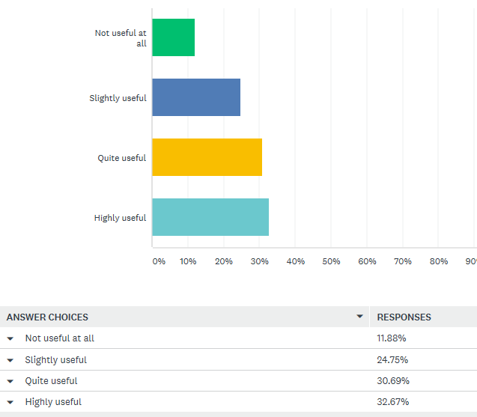

Figure 4.3: Graphics of answers to question 10
The data gathered from surveys supported much of the written literature. There is concern regarding internet safety and an interest for consumers to try the intangible product that is tourism. Technological advancements allowing tourism to become a tangible marketing product could completely alter the tourists booking experience, immersing the customer in a virtual pre-booking experience could enhance sales. The data collected suggests there is demand for a ‘try before you buy’ experience.

4.2.3.1. Qualitative Interview Analysis

The interviews were conducted in person or over the phone at an agreed suitable time for the participant, following a semi structured interview process and lasting approximately 20-30 minutes. Three industry related interviews were conducted with individuals from eGolf, SimRace1 and the Welsh Wildlife Trust. The interviews consisted of many open-ended questions so the researcher could gather detailed information. Any personal information from participants has been removed to remain confidential as agreed.

4.2.3.2. Digital Marketing

The interviews made it evident that digital marketing through social media platforms such as ‘Facebook,’ are used ‘to target specific audiences’ (Simrace1, 2019). Traditional advertising methods such as leaflet distribution yield less successful results due to the random nature of leaflet dropping. (Simrace1) All of those who were interviewed agreed digital online marketing was the most effective marketing method.

4.2.3.3. Virtual Reality

From the interviewee’s perspectives it is evident that VR is viewed positively and that it is predicted to be further used in other industries (Full Matrix table see Appendix 7, page 73).
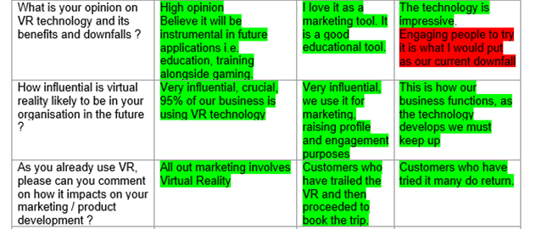
Figure 4.4: Condensed Matrix table on the topic of VR

4.2.3.4. VR holiday experiences as an influence

The aim of this question was to assess whether industry professionals see a potential for VR holiday experiences to influence customers to travel to a destination.

‘I am not convinced that people would book a family holiday on that basis. Going on holiday is something to look forward to, to explore, to discover…if anything VR may dampen people’s expectations as in at the end of the day it’s just another place your visiting’.
(SimRace1)

‘Yes very influential, we will continue to use it for marketing, raising profile and engagement purposes. I am awaiting funding to create more experiences’.
(WWT)
‘This could be a possible development if it is launched correctly. Its feasibility is questionable.’
(eGolf)

Interestingly, the above three extracts show the voluntary sector business (WWT) and private sector businesses (SimRace1, eGolf) have differing opinions. This could be due to the current success rate of the businesses or available funding. Participant two was very positive towards the idea, whereas one and three were unsure. This could be due to the available funding for their business type. As a public voluntary business, it is fair to suggest that WWT may have more funding opportunities than the private businesses.

The participant from SimRace1 believes VR experiences within tourism could actually dampen the real experience, due to the VR trip potentially enhanced and adapted for entertainment. It is fair to appreciate that marketing and adapting the experience may pose risk of misrepresentation of sale, having no realistic content could jeopardise the appeal of the actual experience. However, participant two is already using the technology and as a result has seen an increase in direct sales.

4.2.3.5. Future of VR

When asked about their views on the future of technology and VR, the interviewees responded:

‘Very positive view. We believe that VR in combination with mixed reality will lead to both being used in educational arenas such as schools, health and safety, healthcare and learning to drive. However not everyone feels comfortable in VR due to motion sickness that is the biggest drawback in regards to VR.’
(SimRace1)
‘I believe that it is going to continue to grow, I embrace new technology… I think more and more people will start to use it. I know Bridgend Tourism Team and Celtic Coasteering have both started using it. We used M7 to develop our VR’.
(WWT)
‘erm… well technology is moving at an epic pace… I imagine VR will only get more advanced’.
(eGolf)

The above extracts from interviews make it evident that industry related professionals do see VR further developing. It does however, have challenges. A greater technology could replace VR and many people do not like how intense the experience can be as explained by participant one. As previously stated in the Literature Review, theorists along with all interviewees see VR advancing in the future of technology this can impact smaller businesses negatively as they may not have the available funding to keep up with such advancements.

The researcher’s interviews findings, found that it was agreed that digital marketing methods are the most effective for the company they work for. The interviews highlighted some conflicted opinions with regards to VR’s ability to influence within the tourism industry.

4.3. Content Analysis

Industry leaders are already innovating and utilising the technology. Selected Thomas Cook stores are offering VR holiday sample experiences as a marketing technique in order to secure more bookings. Dunsby cites Ryan (2017) who states ‘VR allows customers to try before they buy, it’s more tangible than a brochure and the shop has outperformed compared with the previous year, VR has helped improve sales and our customer experience.’ After customers used the five minute taster of the holiday, ‘there was a 190% uplift in New York excursions’. (Visualise, 2019) The Company have also started using VR to showcase their hotel facilities. (Dunsby, 2017) Furthermore, the VR enticed customers into store rather than booking independently online. (Gerrard, 2017)

Most Marriott websites now offer customers a video tour of the facilities on the website. (Marriott, 2019) In 2015, the Marriott Hotel announced the release of the first ever VR hotel room experience, named ‘VRoom Service which allows guests to experience VR in their rooms.’ (Marriott, 2015) The VR room service allowed customers to travel from their room and allowed the hotel chain to provide something unique to its competitors. This was the ‘first-ever Virtual Reality travel experience.’ (Framestorevr, 2019) This reportedly ‘increased Marriott’s customer demand by 51%.’ (Christopher, 2018)

4.4. Cross Tabulation

The general public stated they were either interested or very interested in trialling a VR experience. This mirrored the interview participant’s positive views on VR. All of those who were interviewed agreed that digital online marketing was the most effective marketing method. This is not surprising considering over 85% of those surveyed within the questionnaire stated they use a phone and computer daily. (see Appendix 16 , page 87)

Within the survey questions, question seven’s results revealed the vast majority (over 85%) of participants were aware of Virtual Reality. This could be partly due to the demographics of the participants as just over half were under 35.
Figure 4.5: Graphic of answers to question 7
However, this contradicted the researcher’s interview’s findings. Within the interviews the participants stated they did not think the general public had awareness and understanding of VR due to it still being in its infancy stage.

‘I do not think the public are very aware, they have heard of VR but until they experience it they don’t understand how powerful it is.’
(WWT)
‘People have to understand first what VR is about, then progress can be made. However, the technology is still in it’s infancy.’
(SimRace1)
The interviewees believed the technology is so new that not many people are aware of it. However, it is evident that the public are becoming increasingly aware of this technology.

4.5. Conclusion

Within this chapter it can be seen that much of the research gathered mirrors that gained within the Literature Review. From the gathered data it is evident that the public and industry professionals both have an interest in the latest technology. Many marketing methods have moved online, thus many interactions between a business and customer now happen online. Safety and security online is a customer concern which affects the trust between the customer and business. The tourism marketing issue of intangibility may soon be an issue of the past thanks to technology’s developments. From the industry related interviews and the content analyse it has been proven that VR is being used as a successful marketing tool within the industry for companies such as Thomas Cook, Marriott and WWT, bigger businesses can afford to invest in the newest technology separating them from the competition. However, technological advancements are rapid and expensive. From the interviews it came across that smaller private businesses feel left behind, concerned about rapid advancements.

Chapter Five - Conclusion

This final chapter will evaluate whether the researcher achieved the first two objectives as well as will provide a decision as to whether technological developments are changing the tourism industry. Furthermore, the chapter will include areas the researcher could have delved deeper into, if the study was to be repeated. This chapter will cover the final objective by providing recommendations based on the research gained.

Objective one of this study was to critically appraise Virtual Reality and its current use in the tourism industry. This objective was achieved through the Literature Review, which assessed how VR is currently being used whilst exploring what avenues the technology may take in the future. Initially, the Literature Review focused on key interlinking themes of marketing, consumer trends, social media, digitalisation, safety and technology within the tourism industry. The research then funnelled down to a critical analysis of the industry’s current VR usage.

Researchers such as Chaffey and Chadwick (2012), Blythe (2014) Baines and Fill, (2011), Edgell and Swanson (2013), and Buhalis (2003) provide key theory on technology and marketing. Buhalis (2003) talks of eBusiness which involves the use of digital platforms for business. Furthermore, it was discussed that in a digitally dominated era, companies who do not innovate will decline and cease to exist. (Wall, 2014) During the Literature Review chapter, it became apparent that companies need to keep up to date and innovate to remain successful. Large companies such as Thomas Cook can afford to invest in the most up to date technological trends with little regard to the technology’s longevity. When marketing, a business must understand what social media platforms are trending and the demographics of their users in order to market effectively. Within the Literature Review, Poon (1998) discussed the progression of what the ‘new tourist’ wants. Technology and personalisation turned out to be a key part of enticing the new tourist.

Maslow’s (1954) ‘Hierarchy of Needs’ explores the need for safety and security. Within the Literature Review, it was evident that areas of new technology are not always safe. Cyber security, data protection and internet fraud statistics have the ability to sway consumer buyer behaviour. An upsurge in fake duplicate websites can break the trust between the consumer and business. (IATA, 2019) This could lead to consumers reverting back to booking at a physical travel agency for security purposes.

Augmented Reality and Virtual Reality are already being used within the industry and many of these projects are in the early introductory stages. Travel agencies like Thomas Cook have already used and seen success from VR technology, using it as a marketing tool. For example, the company saw a ‘190% uplift in New York excursions bookings after consumers had tried the VR version of the holiday’ (Visualise, 2018) As mentioned earlier. Furthermore, the technology is currently being used as a marketing tool within Wales, and is used globally to enhance museum and excursion experiences. (Visit Wales, 2018) Industry leaders in retail, leisure, and accommodation are all now using AR and VR technology within their marketing. The Marriott, Thomas Cook and London’s Natural History Museum have all recently used the technology to enhance the visitor experience. As QR codes are expected to be discontinued and replaced with a better alternative, the life expectancy of any new technologies is a concern. The technology is still new to the industry so to critique its success is difficult. Having said this, from the findings of the WWT interview and Literature Review within marketing the technology seems to be positively enhancing sales.

By conducting a thorough Literature Review and looking at relevant theory, the researcher gained a detailed insight into the impact of developments technology have on the tourism industry. This allowed the researcher to achieve the first objective. The analysis of the interviews revealed that digital marketing through social media platforms is used to target specific audiences. Individuals from eGolf, SimRace1, and the Welsh Wildlife Trust all agreed during interviews that digital online marketing was the most effective marketing method. The potential for VR usage within tourism was a controversial point, as the WWT participant was enthusiastic about the idea as their sector already does this. However, the other two participants were unsure if this had the potential to be successful. This was surprising as VR is the basis of both Simrace1 and eGolf’s products. This controversy may be due to the level of current successes for both of the private businesses and it is plausible that they may be under performing and thus may see the technology as a risk. Though the opposing views may be due to the businesses’ sector types and available funding. Simrace1 and eGolf are private businesses, whereas the WWT can access funding from companies such as Visit Wales.

The surveys brought a quantitative aspect to the research from the general public’s perspective. This allowed the researcher to compare if industry professionals, the public and written literature agree. People are browsing and buying online, yet the results revealed that over half of those surveyed were ‘very concerned’ about safety when making purchases online. The vast majority were aware and interested in Virtual Reality. The survey findings mirrored much of the written literature and interview findings. Though, there are mixed reviews on the outlook of VR as a developing technology. The public viewed it positively, however some of the gathered literature suggested that with advances it may replace physical tourism.

The content analysis of Thomas Cook and the Marriott gained a retail and accommodation perspective to the study. The information gathered added weight to the evidence of VR’s success and capabilities as a marketing tool. Statistics allowed the researcher to see figures on the technology’s success. Both companies have used the technology to their advantage and had positive outcomes, however, it must be considered that both businesses are established large scale companies.

Through the triangulation approach to research methodology the researcher was able to gain multiple perspectives and analyse technologies impact on the tourism industry. More specifically, the researcher could focus on VR as an up and coming development which evidentially is penetrating the market positively.

5.1. Recommendations

The third objective was to provide recommendations for the future of technology and Virtual Reality with respect to the tourism industry. Based on the findings of chapter four, key themes identified were marketing development, social media, technology and digitalisation, safety and security for consumers. The following recommendations have been proposed :

- Technology is always exceeded and replaced by newer innovations, as seen with QR codes. Financially, this means keeping up to date can be expensive and may not always pay off. Small scale private businesses struggle to get funding to keep up to date with new developments. Based on the quote ‘innovate or die’ (Brown, 2018), it is recommended that support is put into place for these businesses. Accessible pots of funding from areas like Visit Wales could reduce the amount of businesses that close due to being unable to innovate. Trending sites and social media platforms facilitated by the internet change as consumer motivations alter. It is probable that in ten years’ time social media sites such as Facebook, Instagram, and Snapchat will no longer be used. Support needs to be put in place for smaller companies to remain up to date with consumer trends and remaining up to date and not being left behind is a crucial part of remaining successful.

- Safety within the tourism industry is one of the sectors biggest threats. Online safety and security when purchasing is an increasing consumer concern. Companies can mitigate online safety concerns by remaining protected from cyber threats through partnerships with IATA and ABTA. To mitigate safety concerns whilst traveling, a new app by the airline company Lufthansa has been released. This app allows customers to track their luggage. (Global data, 2018) It is recommended that all travel companies design a similar App as this can help customers feel reassured.

- One of the tourism industry’s biggest marketing difficulties is that the product they provide is intangible. The survey research uncovered a want to try the experience before purchase. New VR technologies can offer a ‘try before you buy’ experience. This can mitigate one of tourism marketing’s biggest challenges. Based on the success of businesses that are already using the technology, it is recommended that leisure and tourism businesses use this technology to immerse customers.

- Through the use of small immersive clips, VR technology avoids replacing the holiday experience. Instead, it facilitates a “taster” experience to promote and market the real experience. This makes the technology beneficial for the industry. Future advancements could be more immersive by activating other senses, such as smell and touch. It is questionable as to whether this would be detrimental to the industry. VR missing out on senses of smell and touch is good for the industry, as it gives consumers reason to still travel to these destinations after trialling the VR experience. Within interviews, participant one talked of VR tarnishing the real experience as the VR clip may not fully represent the real holiday. It is foreseeable that exaggerating the experience for entertainment could lead to disappointment during the actual experience due to false advertising.

5.2. Areas of Further Research

The biggest limitation with this dissertation is the time scale. The researcher would have liked to gain 200 surveys, 100 from an older generation, and 100 for the younger, arguably more ‘tech savvy’ generation. The researcher believes the findings between the two age groups would have differed. The researcher also wanted to gain 6 interviews, 2 retail based, 2 hoteliers based and 2 leisure based. A follow up study could perhaps conduct more interviews from a range of business sector types, further increasing the depth, validity and reliability of the gathered research. The researcher looked into how businesses had successfully implemented VR technology. However, the researcher could look into a company for whom the technology did not work for, and thus compare both critically. As the technology is so new, many of the projects are in the introductory stages and a look back at the success a year later could provide data on the longevity of such technology. An example of this would be the London Museums app which was only introduced this year.

Bibliography

Abta. (2019). New report shows a growing number of people are falling victim to holiday booking fraud. Available: https://www.abta.com/news/new-report-shows-growing-number-people-are-falling-victim-holiday-booking-fraud. Last accessed 13/02/2019.
Action Fraud. (2019). Reporting fraud and cybercrime. Available: https://www.actionfraud.police.uk/reporting-fraud-and-cyber-crime. Last accessed 11/05/2019.
Alhabash, S Ma, M. (2017). A Tale of Four Platforms: Motivations and Uses of Facebook, Twitter, Instagram, and Snapchat among College Students? Social Media and Society. 3 (1), p2.
Alvesson, M Deetz, S (2000). Doing Critical Management Research. London: SAGE. p194.
Amakawa, J Westin, J. (2018). New Philadelphia: using augmented reality to. International Journal of Heritage Studies. 24 (3), p316.
Armstrong, G Kotler, P (2005). Marketing an introduction. Jersey: Pearson. p6.
Bailenson (2018). Experience on Demand. London: W.W. Norton & Company. P4.
Baines, P Fill, C (2011). Marketing. 3rd ed. Oxford: Oxford University Press. p606.
Bearne, S. (2016). How technology has transformed the travel industry. Available: https://www.theguardian.com/media-network/2016/feb/29/technology-internet-transformed-travel-industry-airbnb. Last accessed 04/12/2018.
Bearne, S. (2018). 'Airbnb is forcing everyone to up their game': how hotels are changing tack. Available: https://www.theguardian.com/business-to-business/2018/apr/11/airbnb-is-forcing-everyone-to-up-their-game-how-hotels-are-changing-tack. Last accessed 06/02/2019.
Beck, J. (2018). How will technological developments influence VR travel?. Available: http://www.virtual-reality-in-tourism.com/influence-technological-developments/. Last accessed 04/02/2019.
Bekker, S. (2018). Norton: Nearly 1 Billion Cybercrime Victims in 2017. Available: https://redmondmag.com/blogs/scott-bekker/2018/01/1b-cybercrime-victims-in-2017.aspx. Last accessed 20/04/2019.
Blythe, J (2006). Marketing. London: Sage. p6.
Blythe, J (2014). Principles & Practice of Marketing. 3rd ed. London: Sage. p.615.
Brogy, M. (2017). Why package holidays are the best, according to a fan . Available: https://www.independent.co.uk/travel/news-and-advice/package-holidays-2017-all-inclusive-resorts-full-board-drink-cheap-save-money-travel-budget-relax-a7678131.html. Last accessed 13/02/2019.
Brown, E. (2018). Innovate or Die: Why This Trendy Saying is Absolutely True. Available: https://www.businessmagazinegainesville.com/innovate-die-trendy-saying-absolutely-true/. Last accessed 30/03/2019.
Brunt, L. (2018). Six exceptional services to enjoy when flying with Etihad Airways. Available: https://www.telegraph.co.uk/travel/explore-abu-dhabi/exceptional-services/. Last accessed 10/05/2019.
Bryman, A (2016). Social Research Methods. 5th ed. Oxford: Oxford University Press. P10-695.
Bryman, A Bell, E (2007). Business Research Methods. 2nd ed. Oxford: Oxford. p179.
Buckley, J. (2018). Travel trends to watch in 2018: from millennial package holidays to responsible travel. Available: https://www.independent.co.uk/travel/news-and-advice/travel-trends-2018-where-to-go-millennials-package-holidays-responsible-tourism-kuellap-turkey-a8147736.html. Last accessed 04/02/2019.
Buhalis, D (2003). eTourism Information Technology for strategic tourism management. London: Prentice Hall. P345.
Burns, A.C., Veek, A., Bush, F. B (2017). Marketing Research. 8th ed. Harlow: Pearson. p35.
Business Wire. (2014). International Survey Reveals Majority of People Don’t Feel Safe When Shopping Online. Available: https://www.businesswire.com/news/home/20141125005210/en/International-Survey-Reveals-Majority-People-Don’t-Feel. Last accessed 20/04/2019.
Cambridge Dictionary. (2019). Millennial. Available: https://dictionary.cambridge.org/dictionary/english/millennial. Last accessed 10/05/2019.
Cameron, S Price, D (2009). Business Research Methods. London: Cipd. p1.
Cameron, S Price, D (2009). Business Research Methods. London: Cipd. p1.
Chaffey, D Chadwick, F (2012). Digital Marketing Strategy Implementation and Practice. 5th ed. Harlow: Pearson. p6.
Chaffey, D et al (2003). Internet Marketing. 2nd ed. Essex: Pearson. P4.
Chaffey, D. (2019). Global social media research summary 2019. Available: https://www.smartinsights.com/social-media-marketing/social-media-strategy/new-global-social-media-research/. Last accessed 10/05/2019.
Champion, E. (2019). Virtual reality adds to tourism through touch, smell and real people’s experiences. Available: http://theconversation.com/virtual-reality-adds-to-tourism-through-touch-smell-and-real-peoples-experiences-101528. Last accessed 23/04/2019.
Chernev, A (2018). Strategic Marketing Management. 9th ed. United States: Cerebellum Press. p5.
Chivers, T. (2013). The story of Google Maps. Available: https://www.telegraph.co.uk/technology/google/10090014/The-story-of-Google-Maps.html. Last accessed 07/12/2018.
Christopher, J. (2018). This Surprising Marketing Tactic Increased Marriott’s Customer Demand By 51%. Available: https://medium.com/swlh/this-surprising-marketing-tactic-increased-marriotts-customer-demand-by-51-fb15b09be712. Last accessed 06/05/2019.
Cohen, L et al (2011). Research Methods in Education. 7th ed. London: Routledge. p276.
Collins Dictionary. (2019). Definition of 'timeframe'. Available: https://www.collinsdictionary.com/dictionary/english/timeframe. Last accessed 12/03/2019.
Collis, J Hussey, R (2003). Business Research A practical guide for undergraduate and postgraduate students. 2nd ed. Hampshire: Palgrave. P15- 78.
Collis, J Hussey, R (2003). Business Research. 2nd ed. Hampshire: Palgrave Macmillan. p1.
Collis, J Hussey, R (2009). Business Research a practical Guide for Undergraduate &Postgraduate Students. 3rd ed. Hampshire: Palgrave. P55-209.
Conrady, R Buck, M (2012). Trends and Issues in Global Tourism. London: Springer. P26-131.
Coomes, K. (2018). What is AirBnb? Here’s all you need to know about being a guest or host. Available: https://www.digitaltrends.com/home/what-is-airbnb/. Last accessed 04/02/2019.
Cooper, C et al (2008). Tourism Principles and Practice. 4th ed. Essex: Pearson. p670.
Cooper, D Schindler, P (2011). Business Research Methods. 11th ed. London: Mc Graw Hill. P4-385.
Davies, P. (2016). Thomas Cook deploys augmented reality to enhance brochures. Available: http://www.travolution.com/articles/16330/thomas-cook-deploys-augmented-reality-to-enhance-brochures. Last accessed 11/05/2019.
Delener, N . (2010). Current trends in the global tourism industry: evidence from the United States. Journal of Global Business and Technology. 44 (5), p137.
DeMers, J. (2014). The Top 10 Benefits of Social Media Marketing. Available: https://www.forbes.com/sites/jaysondemers/2014/08/11/the-top-10-benefits-of-social-media-marketing/#1199c9701f80. Last accessed 04/05/2019.
Dickinson, G. Parker, K. (2018). Has tourism killed Venice? We visited during the busiest month of the year to find out. Available: https://www.telegraph.co.uk/travel/destinations/europe/italy/veneto/venice/articles/venice-tourism-crowds/. Last accessed 04/02/2019.
Digital Crew. (2018). How China is Using VR and AR Technology to Boost Tourism. Available: https://www.digitalcrew.com.au/blogs-and-insights/china-using-vr-ar-technology-boost-tourism/. Last accessed 07/02/2019.
Digital Crew. (2018). How China is Using VR and AR Technology to Boost Tourism. Available: https://www.digitalcrew.com.au/2018/05/01/china-using-vr-ar-technology-boost-tourism/. Last accessed 15/11/2018.
Doyle, C. (2011). Primary research. Available: http://www.oxfordreference.com/view/10.1093/acref/9780199590230.001.0001/acref-9780199590230-e-1379?rskey=kFZcfE&result=1364. Last accessed 05/05/2019.
Dunsby, A. (2017). How VR has given Thomas Cook Stratford a boost. Available: https://www.ttgmedia.com/news/features/how-vr-has-given-thomas-cook-stratford-a-boost-12158. Last accessed 14/04/2019.
Edgell, L D. Swanson R J. (2013). Tourism Policy and Planning. 2nd ed. London: Routledge. P288-289.
Evans, M. (2018). VR: The Brands That Are Imagining A New Commerce Reality. Available: https://www.forbes.com/sites/michelleevans1/2017/03/07/vr-the-brands-that-are-imagining-a-new-commerce-reality/#ca58ccb3b9d0. Last accessed 14/11/2018.
Event Brite. (2019). Millennials: Fuelling the Experience Economy. Available: https://www.eventbrite.com/blog/academy/millennials-fueling-experience-economy/. Last accessed 06/02/2019.
Fame Store VR. (2019). The Teleporter. Available: http://framestorevr.com/marriott. Last accessed 06/05/2019.
Fisher, C (2010) Researching and writing a dissertation: An essential guide for business students. London. Pearson. P9.
Fisher, C (2010) Researching and writing a dissertation: An essential guide for business students. London. Pearson. P14
Garrard, B. (2017). Virtual reality to the rescue for high street travel agent. Available: https://www.telegraph.co.uk/business/2017/04/02/virtual-reality-rescue-high-street-travel-agent/. Last accessed 06/05/2019.
Gerrard, B. (2017). Virtual reality to the rescue for high street travel agent. Available: https://www.telegraph.co.uk/business/2017/04/02/virtual-reality-rescue-high-street-travel-agent/. Last accessed 04/12/2018.
Gilbert, A. (2019). The extent of participant bias in research. Available: https://adamjamesgilbert.wordpress.com/2012/04/29/the-extent-of-participant-bias-in-research/. Last accessed 12/03/2019.
Global Data. (2018). Top 6 technology trends to watch out for in the travel and tourism industry in 2018. Available: https://www.globaldata.com/top-6-technology-trends-watch-travel-tourism-industry-2018/. Last accessed 07/05/2019.
Guttentag, D. (2008) Virtual reality: Applications and implications for tourism. Tourism Management. (Accessed: 29/03/2019)
Hanson, M. (2017). Older people can’t cope with new technology – but nobody cares. Available: https://www.theguardian.com/lifeandstyle/2017/apr/03/older-people-cant-cope-with-new-technology-but-nobody-cares. Last accessed 07/05/2019.
Hertzfeld, E. (2018). Marriott, Lifewtr join forces for augmented-reality art experience. Available: https://www.hotelmanagement.net/tech/marriott-lifewtr-join-forces-for-augmented-reality-art-experience. Last accessed 11/05/2019.
History Cooperative. (2018). The Evolution of Marketing – From Trade to Tech. Available: https://historycooperative.org/the-evolution-of-marketing-from-trade-to-tech/. Last accessed 09/05/2019.
Holloway, C J (2004). Marketing for Tourism. 4th ed. Harlow: Prentice Hall. p8.
Hudson, S (2003). Sport and Adventure Tourism. London: The Haworth Hospitality Press. P302-306.
Hussey, J. Hussey, R (1997). Business Research. Hampshire: Palgrave. p13
Hymas, C. (2018). A fifth of 16-24 year olds spend more than seven hours a day online every day of the week. Available: https://www.telegraph.co.uk/news/2018/08/11/fifth-16-24-year-olds-spend-seven-hours-day-online-every-day/. Last accessed [24/11/2018.]
IATA. (2019). Fake travel Sites. Available: https://www.iata.org/travelers/Pages/fraud.aspx. Last accessed 11/05/2019.
Ismail, N. (2017). Modern technology: advantages and disadvantages. Available: https://www.information-age.com/modern-technology-advantages-disadvantages-123465637/. Last accessed 29/03/2019.
Joyce, S. (2013). A brief history of travel technology - from its evolution to looking at the future. Available: https://www.phocuswire.com/A-brief-history-of-travel-technology-from-its-evolution-to-looking-at-the-future. Last accessed 23/04/2019.
Kolter, P Kartajaya, H Hooi, H. D (2017). Marketing for competitiveness : Asia to the world! in the age of digital consumers. Singapore: Singapore: World Scientific. p43.
Krishna et al. (2013). What is a 'QR CODE' and how does it work ?. Available: https://www.theguardian.com/notesandqueries/query/0,,-203896,00.html. Last accessed 07/02/2019.
Kutschera, S. (2018). Travel statistics to know about in 2018 and 2019. Available: https://www.trekksoft.com/en/blog/65-travel-tourism-statistics-for-2019. Last accessed 06/02/2019.
Levitt, T. (1981). Marketing Intangible Products and Product Intangibles. Available: https://hbr.org/1981/05/marketing-intangible-products-and-product-intangibles. Last accessed 30/04/2019.
Lickorish, L Jenkins, C (1997). An Introduction to Tourism. Oxford: Reed Educational and Professional Publishing. p17.
Linker, J. (2018). Technology. Early American Studies. 16 (4), p783.
Lumsdon, L (1997). Tourism Marketing. London: ITP. P28-38.
Marco, J Gomez, L Sevilla, C. (2018). Progress in information technology and tourism management: 30 years on and 20 years after the internet - Revisiting Buhalis & Law's landmark study about eTourism. 69, (1) p461.
Marriott Hotels. (2015). Marriott Hotels Introduces the First Ever In-Room Virtual Reality Travel Experience. Available: https://news.marriott.com/2015/09/marriott-hotels-introduces-the-first-ever-in-room-virtual-reality-travel-experience/. Last accessed 14/04/2019.
Marriott International. (2019). Take residence at Residence Inn. Available: https://www.residenceinn.marriott.com/tour/. Last accessed 14/04/2019.
Middleton, V et al (2009). Marketing in Travel and Tourism. 4th ed. London: Elsevier. p.20.
Mirzoeff, N (2006). Visual Culture. London: Routledge. p101.
Mitchell, A. (2005) Marketing: Building consumer trust is the secret of success. Marketing Week. (12).P35-37.
Nelson, K. (2017). Airbnb wants to use VR to let you tour your accommodations before you arrive. Available: https://www.digitaltrends.com/home/airbnb-augmented-reality-virtual-reality-news/. Last accessed 05/02/2019.
Ni`ihau Cultural Heritage Foundation. (2009). Ni‘ihau Today. Available: http://www.niihauheritage.org/niihau_today.htm. Last accessed 04/02/2019.
O'donnell, A. (2018). 8 Virtual Reality Travel Experiences That Will Blow Your Mind. Available: https://www.lifewire.com/virtual-reality-tourism-4129394. Last accessed 13/11/2018.
O'Gorman, K. Maclntosh, R (2015). Research Methods for Business & Management. 2nd ed. Oxford: Goodfellow Publishers. p165.
Ogweng, S. (2019). How Airbnb’s ‘Experiences’ Took Over Instagram. Available: https://skedsocial.com/blog/instagram-strategy-how-airbnb-experiences/. Last accessed 19/04/2019.
Osborne, M Fey, C. (2015). Will a robot take your job? Available: https://www.bbc.co.uk/news/technology-34066941. Last accessed 10/05/2019.
Oxford Dictionary . (2019). Motivation. Available: https://en.oxforddictionaries.com/definition/motivation. Last accessed 12/05/2019.
Oxford Dictionary. (2019). Definition of philosophy. Available: https://en.oxforddictionaries.com/definition/philosophy. Last accessed 12/03/2019.
Oxford Dictionary. (2019). Definition of technology in English. Available: https://en.oxforddictionaries.com/definition/technology. Last accessed 24/03/2019.
Oxford Index. (2019). secondary research. Available: http://www.oxfordreference.com/view/10.1093/oi/authority.20110803100451291. Last accessed 05/05/2019.
Page, J.S (2015). Tourism Management. 5th ed. London: Routledge. P14-15.
Pavid, K. (2018). Explore the Museum's collection with Sir David Attenborough. Available: http://www.nhm.ac.uk/discover/news/2018/march/explore-the-museum-with-sir-david-attenborough.html. Last accessed 23/04/2019.
Pembrokeshire Coast National Park Authority. (2013). Castell Henllys Interpretation Plan. Available at: https://museuminsider.co.uk/wp-content/uploads/2013/06/CH-Interpretation-Plan-Final-V2-13.03.25.pdf. (Accessed: 19/03/2019).
Pickup, O. (2017). Why are businesses slow to adopt new technology? . Available: https://www.telegraph.co.uk/business/ready-and-enabled/new-technology-adoption/. Last accessed 10/05/2019.
Poon, A (1998). Tourism, Technology and Competitive Strategies. Oxon: Cab International. P10.
Promo Marketing. (2016). Thomas Cook 360º VR fantasy flight. Available: https://www.promomarketing.info/thomas-cook-360o-vr-fantasy-flight/. Last accessed 01/02/2019.
Rayome, D. (2018). The 10 biggest breakthrough technologies of 2018... so far. Available: https://www.techrepublic.com/article/the-10-biggest-breakthrough-technologies-of-2018-so-far/. Last accessed [25/11/2018.]
Reality Technologies. (2019). The Ultimate Guide to Understanding Augmented Reality (AR) Technology. Available: https://www.realitytechnologies.com/augmented-reality/. Last accessed 29/01/2019.
Research Methodology. (2019). Convenience sampling. Available: https://research-methodology.net/sampling-in-primary-data-collection/convenience-sampling/. Last accessed 03/03/2019.
Roettgers, J. (2017). Virtual Reality Projected to become a $7 Billion Business This Year. Available: https://variety.com/2017/digital/news/virtual-reality-industry-revenue-2017-1202027920/. Last accessed 30/03/2019.
Rouse, M. (2019). Social Media. Available: https://whatis.techtarget.com/definition/social-media. Last accessed 08/05/2019.
Sample, I. (2018). What is the internet? 13 key questions answered. Available: https://www.theguardian.com/technology/2018/oct/22/what-is-the-internet-13-key-questions-answered. Last accessed 25/03/2019.
Samuely, A. (2019). Mobile boarding passes to number 1.5 billion by 2019: report. Available: https://www.retaildive.com/ex/mobilecommercedaily/mobile-boarding-passes-to-reach-1-5-billion-by-2019-report. Last accessed 10/05/2019.
Sarantakos, S (1998). Social Research. 2nd ed. London: Macmillan. p78.
Saunders, et al (2007). Research Methods for Business Students. 4th ed. Harlow: Prentice Hall. p102.
Saunders, M Lewis, P Thornhil, A (2003). Research Methods for Business Students. 3rd ed. Harlow: Pearson. p482.
Saunders, M., Lewis, P. & Thornhill, A. (2012) Research Methods for Business Students. 6th ed. London: Pearson. P14.
Saunders, M., Lewis, P. and Thornhill, A. (2007) Research Methods for Business Students. 6th Edition. London. Pearson. P107-217.
Scowsill, D. (2017). The future of Travel & Tourism. Available: https://medium.com/@WTTC/the-future-of-travel-tourism-865317bc23b1. Last accessed 10/11/2018.
Silverman, D (1993). Interpreting Qualitative Data Methods for Analysing Talk, Text and Interaction. London: SAGE. p145.
Silverman, D (2004), Qualitative Research Methods. 2nd Edition, Sage: London. P423.
Silverman, D (2004), Qualitative Research Methods. 2nd Edition, Sage: London. P423.
Singh, V.T (2004). New Horizons in Tourism Strange Experience and Stranger Practices. Oxfordshire: CABI Publishing. p12
Smith, A. (2017). We're travelling even more than ever, according to the World Tourism Organisation. Available: https://www.lonelyplanet.com/news/2017/01/19/travelling-world-tourism-organisation/. Last accessed 02/05/2019.
Sparkes, M. (2014). The QR code has a decade left to live. Available: https://www.telegraph.co.uk/technology/news/10911122/The-QR-code-has-a-decade-left-to-live.html. Last accessed 28/10/2018.
Stanley, M. (2015) Internet, Lodging. Leisure and Hotels. Available at: https://www.theguardian.com/business-to-business/2018/apr/11/airbnb-is-forcing-everyone-to-up-their-game-how-hotels-are-changing-tack. Accessed: 06/02/2019)
Statistics Solutions. (2019). Using Chi-Square Statistic in Research. Available: https://www.statisticssolutions.com/using-chi-square-statistic-in-research/. Last accessed 12/03/2019
Steiber, A. (2017). VR/AR in China: An Emerging Giant? Available: https://www.forbes.com/sites/charliefink/2017/12/19/vrar-in-china-an-emerging-giant/#a2b3c3275738. Last accessed 07/02/2019
Tapper, J. (2018). Airbnb lets may be unsafe, MPs warn. Available: https://www.theguardian.com/technology/2018/jul/14/airbnb-misuse-private-landlord-safety-risk-mps. Last accessed 06/02/2019.
Telegraph. (2013). Rio de Janeiro puts QR codes in its mosaic pavements. Available: https://www.telegraph.co.uk/news/worldnews/southamerica/brazil/9828570/Rio-de-Janeiro-puts-QR-codes-in-its-mosaic-pavements.html. Last accessed 07/02/2019.
Telegraph. (2018). Most important inventions of the 19th century. Available: https://www.telegraph.co.uk/technology/0/important-inventions-19th-century-pictures/first-computer/. Last accessed [25/11/2018.]
The Telegraph. (2017). Britons face being turned away from Spanish Airbnb apartments in crackdown on illegal letting. Available: https://www.telegraph.co.uk/news/2017/08/10/british-tourists-face-turned-away-rented-holiday-apartments/. Last accessed 06/02/2019
Thomas Cook Virtual Reality Holiday ‘Try Before You Fly’. Available: https://visualise.com/case-study/thomas-cook-virtual-holiday. Last accessed 06/05/2019.
Thomas Cook. (2018). 2018 Holiday Report. Available: https://scdn.thomascook.com/images/wcms/dam/tcuk/campaigns/campaigns2018/holidayreport2018/TCookHolidayReport2018.pdf?_ga=2.65848750.1086074446.1526285524-1437383557.1526285524. Last accessed 10/05/2019.
Thomas Cook. (2019). About Thomas Cook. Available: https://www.thomascook.com/about-us/. Last accessed 09/05/2019.
Thomas Cook. (2019). Holiday Report 2019. Available: https://www.brochure-store.co.uk/brochures/thomas-cook/tc_report_uk_apr_2019/contents/pages2. Last accessed 10/05/2019.
Thomas Cook. (2019). Holiday Search. Available: https://www.thomascook.com/. Last accessed 02/05/2019.
Travel Weekly. (2012). 80% booking holidays online, finds study. Available: http://www.travelweekly.co.uk/articles/41280/80-booking-holidays-online-finds-study. Last accessed 02/05/2019.
Travel Weekly. (2012). 80% booking holidays online, finds study. Available: http://www.travelweekly.co.uk/articles/41280/80-booking-holidays-online-finds-study. Last accessed 29/01/2019.
Trend, N. (2017). 10 ways Brexit could hit UK travellers. Available: https://www.telegraph.co.uk/travel/comment/what-would-brexit-mean-for-travellers/. Last accessed 29/03/2019.
TUI. (2018). Introducing the New-Look TUI App. Available: https://www.tui.co.uk/destinations/info/my-tui-app. Last accessed 07/12/2018.
TUI. (2019). Website Terms and Conditions. Available: https://www.tui.co.uk/destinations/info/website-terms-and-conditions. Last accessed 04/05/2019.
UNWTO. (2011). Technology in tourism. AM reports. 1 (3), p10-17.
Vaus, D (1996). Surveys in Social Research. 4th ed. London: UCL Press. p392.
Veal, A (2006). Research Methods for Leisure and Tourism. 3rd ed. London: Prentice Hall. P276.
Vidal, B. (2018). Tourism and Technology: How Tech is Revolutionizing Travel. Available: https://www.wearemarketing.com/blog/tourism-and-technology-how-tech-is-revolutionizing-travel.html. Last accessed 01/02/2019.
Virtual Reality Society. (2017). What is Virtual Reality? Available: https://www.vrs.org.uk/virtual-reality/what-is-virtual-reality.html. Last accessed 30/11/2018.
Visit Britain. (2019). Introduction to tourism. Available: https://www.visitbritain.org/introduction-tourism. Last accessed 02/05/2019.
Visualise. (2018). Thomas Cook Virtual Reality Holiday ‘Try Before You Fly’. Available: https://visualise.com/case-study/thomas-cook-virtual-holiday. Last accessed 28/10/2018.
Wall, G Mathieson (2006). Tourism Change, Impacts and Opportunities. London: Pearson. p11.
Wall, M. (2014). Innovate or die: The stark message for big business. Available: https://www.bbc.co.uk/news/business-28865268. Last accessed 20/04/2019.
Walton, J. (2019). Tourism. Available: https://www.britannica.com/topic/tourism. Last accessed 25/03/2019.
Waugh, D (2009). Geography: An Integrated Approach. 4th ed. Cheltenham: Nelson Thornes. p587.
Weber, F et al. (2017) Tourism destinations under pressure. Challenges and innovative solutions. Available at :https://static1.squarespace.com/static/56dacbc6d210b821510cf939/t/5906f320f7e0ab75891c6e65/1493627704590/WTFL_study+2017_full+version.pdf. (Accessed: 01/02/2019).
Welsh Government. (2016). Catch virtual Baby Dragons hidden around Wales's captivating castles. Available: https://cadw.gov.wales/fun/castles-alive/dragon-tales-and-games/catchvirtualbabydragonshiddenaroundwales/?lang=en. Last accessed 01/02/2019.
Welsh Wildlife Trust. (2019). Dolphin Dive and Fly like a Kingfisher!. Available: https://www.welshwildlife.org/uncategorized/dolphin-dive-fly-like-kingfisher/. Last accessed 11/05/2019.
Wilson, J (2010). Essentials of Business Research. London: Sage. P112-148.
Wilson, J (2014). Essentials of Business Research a guide to Doing Your Research Project. 2nd ed. London: Sage. P124-125.
Winter, G. (200) A Comparative Discussion of the Notion of 'Validity' in Qualitative and Quantitative Research. Available at: https://nsuworks.nova.edu/cgi/viewcontent.cgi?referer=http://scholar.google.co.uk/&httpsredir=1&article=2078&context=tqr/. (Accessed: 05/05/2019)
Yeoman, I et al (2012). 2050 Tomorrows Tourism. Bristol: Channel View Publications. P65-69.
Yousaf, A Amin, I Santos, A.J. (2017). Tourists’ Motivations to Travel : A Theoretical Perspective on The Existing Literature. Tourism and Hospitality Management. 24 (1), p200.

Appendices

Appendix 1 - Ethics Form

 |  |  | E3 FORM
APPLICATION FOR ETHICAL APPROVAL – BA level

CAIS AM GYMERADWYAETH MOESEGOL – Lefel BA

Mae'r ffurflen hon i'w chwblhau gan bob BA myfyrwyr. Rhaid i bob ffurflen gael ei ystyried gan diwtor y modiwl.  Dylai un copi o'r ffurflen yn cael ei roi ar y ffeiliau Gyfadran ac un copi cadw ar y ffeil myfyrwyr. |  | This form is to be completed by all BA students conducting research, projects or productions. This form should be completed by the student. All forms must be considered by the Module tutor. A copy of the form must be kept centrally and on the student file.
ADRAN 1 – MANYLION MYFYRIWR |  | SECTION 1 - STUDENT DETAILS
Enw Llawn  Full Name | Suzanne Escott-Sloan (P150466)
Ysgol/Cyfadran/  School/Faculty | UWTSD  School of Business |  |  | Rhif Myfyriwr Student Number | P150466
Cydlynydd prosiect / Tiwtor  Module Tutor/ Programme Co-ordinator | Caroline Jawad |  |  | Enw'r Gradd  Name of Degree | International Travel and Tourism Management
Teitl dangosol yr Traethawd Hir: |  |  |  | Indicative Title of Dissertation:
An Investigation into how technology is changing tourism. A case study on Virtual Reality.

ADRAN 2 – MANYLION CYFRANOGWYR / CYNULLEIDFA |  |  | SECTION 2 - PARTICIPANT / AUDIENCE DETAILS
Pwy yw’r cyfranogwyr arfaethedig? |  | Who are the intended participants? |  |  | Ydw / Yes | Na / No
Myfyrwyr / staff Y Drindod Dewi Sant |  | Students / staff of Trinity Saint David |  |  | /
Oedolion (dros oed 16 ac yn gymwys i gydsynio) |  | Adults (over the age of 16 and competent to give consent) |  |  | /
Plant a phobl ifanc dan oed |  | Children / legal minors |  |  |  | /
Cleifion neu gleientiaid gweithwyr proffesiynol |  | Patients or clients of professionals |  |  |  | /
Rhywun sy’n cael ei gadw yn y ddalfa neu y mae’r llys wedi cymryd cyfrifoldeb amdano |  | Anyone in custodial care or for whom the court has assumed responsibility |  |  |  | /
Aelod o unrhyw sefydliad lle mae’n bosibl bod angen i unigolyn arall hefyd gydsynio. |  | A member of any organisation where another individual may also need to give consent. |  |  |  | /
Eraill: Nodwch: / Others: please identify:

Nifer, Oed a Ffynhonnell y Cyfranogwyr  Rhowch fanylion yr demograffeg y cyfranogwyr / gynulleidfa. |  |  |  | Participant / Audience Number and Age  Provide details of the demographics of the participants / audience.
Nifer o Gyfranogwyr / yn y Gynulleidfa | Participant/ Audience number |  |  | Wide demographic aged 18+
Grŵp oedran y Cyfranogwyr/y Gynulleidfa | Participant/ Audience age group

ADRAN 3 – GWEITHGAREDD YMCHWIL |  |  | SECTION 3 – RESEARCH ACTIVITY
1. | Ydy’r prosiect yn cynnwys: | Does the project include: |  | Ydy / Yes | Nac ydy/No
Defnyddio holiadur neu offeryn ymchwil tebyg |  | Use of questionnaire or similar research instrument |  | /
Defnyddio prawf ysgrifenedig neu gyfrifiadurol |  | Use of written or computerised test |  |  | /
Cyfweliad (cysylltwch gwestiynau posibl) |  | Interview (attach provisional questions) |  | /
Dyddiaduron |  | Diaries |  |  | /
Arsylwi ar gyfranogwyr a hwythau'n ymwybodol o hynny |  | Participant observation with their knowledge |  |  | /
Arsylwi ar gyfranogwyr a hwythau ddim yn ymwybodol o hynny |  | Participant observation without their knowledge |  |  | /
Recordio fideo neu sain |  | Video or audio-taping |  | /
Mynediad i wybodaeth bersonol neu gyfrinachol heb gydsyniad penodol y cyfranogwyr |  | Access to personal or confidential information without the participants specific consent |  |  | /
Defnyddio unrhyw gwestiynau, ysgogiadau prawf, cyflwyniad y gallai rhai cyfranogwyr eu profi fel rhywbeth sy'n achosi niwed / tramgwydd corfforol, meddyliol neu emosiynol |  | Administration of any questions, test stimuli, presentation that may be experienced as physically, mentally or emotionally harmful / offensive |  |  | /
Cyflawni unrhyw weithredoedd allai achosi embaras neu effeithio ar hunan-barch |  | Performance of any acts which may cause embarrassment or affect self-esteem |  |  | /
Ymchwilio i gyfranogwyr sy’n ymwneud â gweithgareddau anghyfreithlon |  | Investigation of participants involved in illegal activities |  |  | /
Gweithdrefnau lle defnyddir twyll |  | Procedures that involve deception |  |  | /
Gweini unrhyw sylwedd, cyfrwng neu blasebo |  | Administration of any substance, agent or placebo |  |  | /
Dull arall o gasglu data neu fformat cyflwyno (esboniwch) |  | Other method of data collection or presentation format (please explain) |  |  | /

2. | Restru eich dull o gasglu data | List your method of data collection:
Primary Research through three industry related interviews. Collection of 100 Questionnaires, a mix of industry relevant and general public to gain a wide demographic. Secondary research to gain a background to the topic through new articles, websites and other relevant written theory.

3. | Risg Posibl:  (corfforol, seicolegol, cyfreithiol, cymdeithasol neu economaidd) | Potential Risk:  (physical, psychological, legal, social or economic)
A oes unrhyw risg bosibl i: |  | Is there any potential risk to: | Ydw / Yes | Na / No
A | Cyfranogwyr? | Participants? |  | /
B | Ymchwilydd? | Researcher? |  | /
C | BrifYsgol/Cyfadran? | University? |  | /

4. | Rheoli Risg:  Os oes, beth yw'r risg a sut y bydd yn cael ei reoli? | Management of Risk:  If yes, what is the risk and how will it be managed?

5. | Os ydych yn delio â phlant a / neu oedolion agored i niwed, rhaid i chi gyflwyno eich tystysgrif DBS i'ch tiwtor goruchwylio i'w cymeradwyo cyn i unrhyw gysylltiad â cyfranogwyr hyn. | If you are dealing with children and/ or vulnerable adults you must present your DBS certificate to your supervising tutor for approval before any contact with these participants.
 |  |  |  | Ydw / Yes | Na / No
A | Ydych chi wedi gwneud cais am dystysgrif DBS? |  | Have you applied for a DBS certificate? |  | N/A
B | A yw eich tiwtor weld a'i gadarnhau eich tystysgrif DBS? |  | Has your tutor seen and approved your DBS certificate? |  | N/A

6. | A fyddwch yn cael cydsyniad gwybodus ysgrifenedig gan eich cyfranogwyr? |  | Will you obtain written informed consent from your participants?
 |  |  |  |  |  | Ydw / Yes | Na / No
A | Os na fyddwch, pam hynny? |  |  | If no, why not? |  |  | N/A
B | Os byddwch, sut byddwch yn sicrhau cydsyniad gwybodus? |  |  | If yes, how will you secure informed consent? |  |  | N/A
Rhowch eglurhad / Please explain:
N/A

Cynhwyswch gopi o’r ffurflen gydsynio os ydych yn defnyddio un. |  |  |  | Please include a copy of the consent form if you are using one.

ADRAN 4 |  | SECTION 4
CEFNOGWYD /APPROVED |  | NIS CEFNOGWYD/  NOT SUPPORTED
Datganiad  Mae'r wybodaeth a gynhwysir yma yn gywir, hyd eithaf fy ngwybodaeth a’m cred. Rwyf wedi ceisio dynodi unrhyw risgiau a phroblemau sy’n gysylltiedig â’r prosiect / ymchwil neu gynhyrchiad ac rwyf yn cydnabod f’ymrwymiadau innau a hawliau’r cyfranogwyr. |  |  | Declaration  The information contained herein is, to the best of my knowledge and belief, accurate. I have attempted to identify any risks and issues related to the project/research or production and acknowledge my obligations and the rights of the participants.
Llofnodau  Dylai'r ffurflen hon gael ei chwblhau a'i llofnodi gan y myfyriwr a'r Cydlynydd y prosiect /Twitor |  |  | Signatures  This form should be completed and signed by the student and the Module tutor/Programme Co-ordinator.
Myfyriwr / Student  Suzanne Escott-Sloan |  |  |  |  | Dyddiad: / Date:15/11/2018
Cydlynydd y prosiect /Twitor  Project co-ordinator / Tutor |  |  |  |  | Dyddiad: / Date:

Appendix 2 – Questionnaire


 | Cyfranogwr Rhif Adnabod:  Participant Identification Number: | P150466
CWESTIYNAU CYFWELIAD SAMPL | SAMPLE INTERVIEW QUESTIONS
TEITL Y PROSIECT: / PROJECT TITLE:
An Investigation into how technology is changing the tourism industry. A case study on Virtual Reality.

1 | Please indicate how you book your holidays :  -Online  -Via a retail store  -Both  -Other (please state)
2 | Please tick the forms of technology you use on a daily basis :  -Computer/Laptop/Desk top monitor  -Phone  -Tablet/ iPad  - Printer  - Gaming Console ( Playstation/ Xbox)  - Other (please specify)
3 | In general how concerned are you about security on the internet?  -Not at all concerned  -A little concerned  -Somewhat concerned  -Very concerned  -I know I should be concerned, but I am not.
4 | How concerned are you about safety and security when making purchases online ?  -Not at all concerned  -A little concerned  -Somewhat concerned  -Very concerned  -I know I should be concerned, but I am not.
5 | Tick the boxes that apply to you. I use technology for :  -Researching a holiday destination  -Comparing holiday prices  -Checking reviews on sites, such as TripAdvisor  -Social media, holiday related browsing i.e. Instagram  - Independently booking a hotel, flights, or a holiday
6 | Are you aware of Virtual Reality?  -Yes  -No
7 | Have you seen Virtual Reality used in an tourism related environment? If yes, please describe where and when.
8 | If you were to experience a travel destination or services in advance through Virtual Reality, do you think it would encourage your decision to travel there?  -Yes  -No  -Maybe
9 | Do you think that experiencing a travel destination in Virtual Reality could be useful in your travel planning?  -Not useful at all  -Slightly useful  -Quite useful  -Highly useful
10 | How interested would you be in trialling a VR experience of a holiday before purchasing the holiday?  -Very disinterested  - Disinterested  - Neither interested nor disinterested  -Interested  -Very interested
11 | Select the gender which best describes yourself :  -Male  -Female  -Other  -Prefer not to say
12 | Please select the age group which best suits you:  -Under 18  -18-24  -25-34  -35-44  -45-54  -55-64  -65-74  -75+
13 | Please indicate your socioeconomic group :  -Pupil / Student  -Part-time employment  -Full time employment  -Unemployed  -Self employed  -Pensioner

Appendix 3 -Participant Consent Form

 | Cyfranogwr Rhif Adnabod:  Participant Identification Number: | P150466
FFURFLEN GANIATÂD CYFRANOGIAD | PARTICIPATION CONSENT FORM
TEITL Y PROSIECT: / PROJECT TITLE:
An Investigation into how technological developments are changing the tourism industry . A case study on Virtual Reality.

Name of Researcher: Suzanne Escott- Sloan
Please initial box

1. I confirm that I have read and understand the information sheet dated 07/04/2019 for the above study. I have had the opportunity to consider the information, ask questions and have had these answered satisfactorily.
X

2. I understand that my participation is voluntary and that I am free to withdraw at any time, without giving any reason.
X

3. I understand that any information given by me may be used in future reports, articles or presentations by the research team.
X

4. I understand that my name will not appear in any reports, articles or presentations.
X

5. I agree to take part in the above study.
X



Gina Gavigan _______________________

Name of Participant Date : 8 April 2019 Signature

_________________________ ________________
Researcher Date Signature

You may decline to participate in this study. You may end your participation in this study at any time. If you decide to remain anonymous, maintaining your anonymity will be a priority and every practical precaution will be taken to disguise your identity. If you prefer anonymity, there will not be any identifying information on audiotapes or transcripts of this or any interview. No-one will hear any audiotapes or see any transcripts without your prior consent. All materials generated from this or any interview will remain confidential.

When completed, please return in the envelope provided (if applicable). One copy will be given to the participant and the original to be kept in the file of the research team at: PLACE:

ENW A CHYFEIRIAD YR YMCHWILYDD | NAME & ADDRESS OF RESEARCHER  Suzanne Escott-Sloan  C22 Room E Saint David’s,  Swansea, Wales, SA1 2EA

 | Cyfranogwr Rhif Adnabod:  Participant Identification Number: | P150466
FFURFLEN GANIATÂD CYFRANOGIAD | SAMPLE PARTICIPANT INFORMATION SHEET
TEITL Y PROSIECT: / PROJECT TITLE: An Investigation into how technology is changing tourism. A case study on Virtual Reality.

*THIS FORM IS TO BE AMENDED AND ADAPTED AS NECESSARY

Dear Participant:

My name is Suzanne Escott-Sloan and I am studying in the School of Tourism Business Campus.

I would like to invite you to participate in my research project. This project will be researching how technology is changing tourism and aims to look at VR.

*Attached to this letter is a short questionnaire developed by Suzanne Escott -Sloan which will assess technology in tourism. I believe your opinions will be extremely helpful to me.

Through your participation in the questionnaire and/or interviews, I hope to ascertain more primary research on the topic with more in depth knowledge.

All questionnaires will be kept strictly confidential to the researchers involved and at NO time will individual questionnaires be released to the general public. This gives you a chance to express your views on your programme a confidential and anonymous forum and still be able to make a difference. Your participation in this study is completely voluntary so you can withdraw from the questionnaire at any stage.

Our questionnaire should take about 5 minutes to complete, but there is no time constraint. There are also no right or wrong answers. Attached to this letter along with the questionnaire is a consent form. As this is a new project, your feedback is also important to us and we would be much obliged if you could also complete the feedback sheet along with the questionnaire. We understand that your time is at a premium but your opinions are very valuable to us.

After careful and precise analysis of the data obtained from this questionnaire, I will be happy to provide you with a copy of the findings at your request. The results of this questionnaire will hopefully enhance my understanding of the use of technology in the tourism industry and will be stored on a laptop. The results of the research will be fed back to the research report.
We thank you in advance for your time and participation. If any questions do arise, feel free to contact me at your convenience.

ENW A CHYFEIRIAD YR YMCHWILYDD | NAME & ADDRESS OF RESEARCHER  Suzanne Escott-Sloan  C22 Room E Saint David’s,  Swansea, Wales, SA1 2EA

Appendix 4 – Interview Question Layout

1. What specific digital marketing tools do you currently use? (Give details - types / level of usage……)

2. What key differences are there between your usages of digital marketing tools over other marketing methods? eg; level of impact…… (Justify your answer)

3. What age group would you say is your primary product target market and why? Does this influence your marketing strategies?

4. What is your opinion on VR Technology - - (Benefits / Disbenefits)

5. How influential is Virtual Reality likely to be in your organisation in the future?
Please explain why:

6. If already using VR, comment on how it impacts on your marketing / product development?

7. How influential do you think customers’ experiencing a travel destination or service in advance via Virtual Reality, could be in the future, to encourage their decision to travel there?

8. How interested the general public are in engaging with technology (VR)? (Do you expect this interest to increase/ decrease)

9. What are your views on the future of technology and VR ?

Appendix 5 – Maslow’s (1954) Hierarchy of Needs

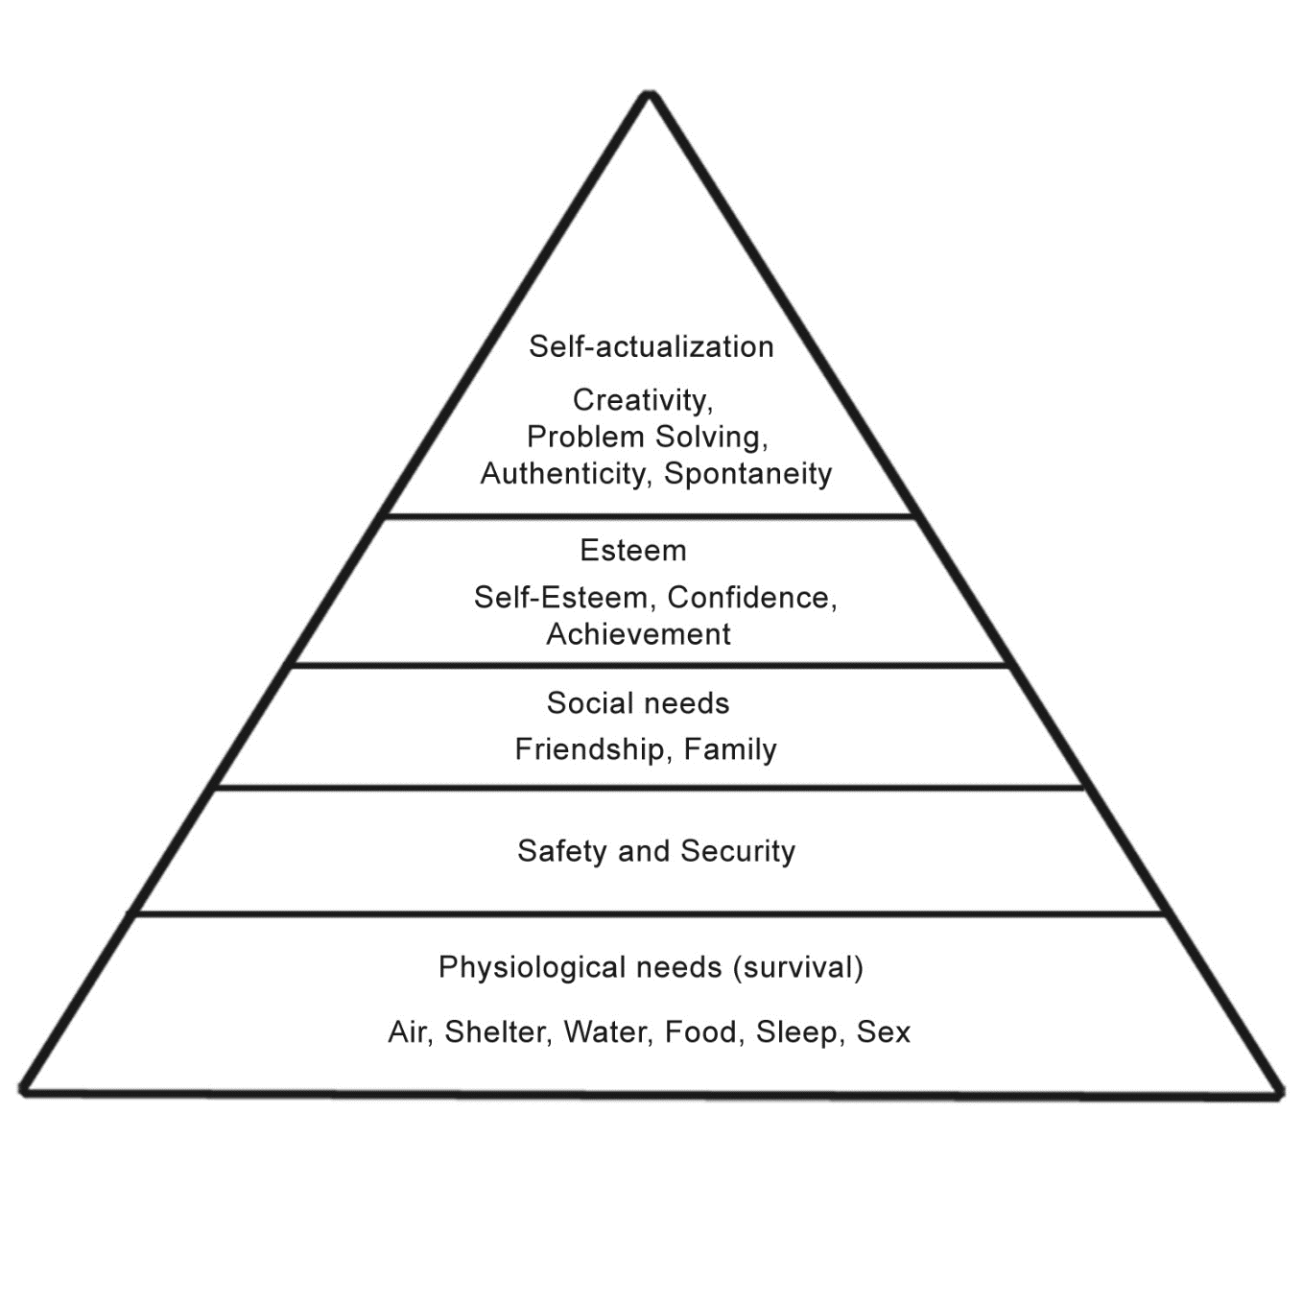

Appendix 6 – Plog’s (1971) Classification Scheme

Appendix 7 - Matrix Table

The below matrix table demonstrates the key similarities and contradictories from the answers given by participants during interviews. The interview questions are displayed on the left with the response and participant on the right.

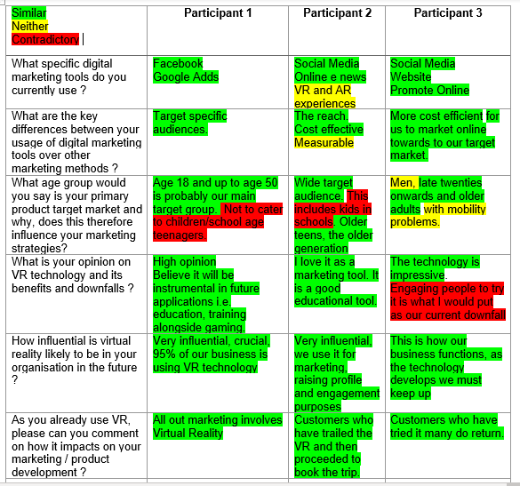

Appendix 8 – Matrix Tablet Part 2 (Interviews)

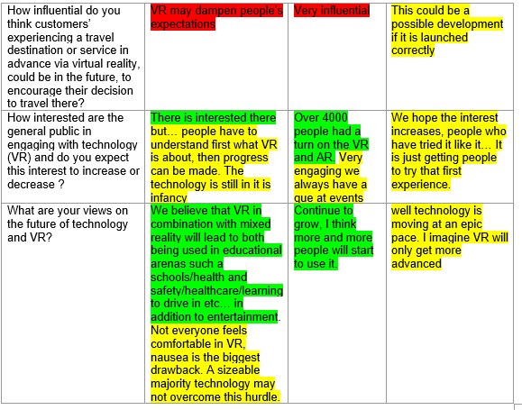

Appendix 9 - Transcript of interview with supervisor from SimRace1
Interviewer (I)
Participant (1)

(I)Firstly thank you so much for letting me conduct this informal interview you, I will now start with the interview questions. What specific digital marketing tools do you currently use? Please can you give details, types and level of usage?

(P1) Right well, overwhelmingly we use Facebook… sometimes, but rarely, we use google ads.

(I)Ok, what key differences are there between your usages of digital marketing tools over other marketing methods? For example the level of impact.

(P1) Yes so with Facebook we can target specific audiences. Erm… whereas, traditional advertising methods, such as leaflets distributions … yield less successful results due to the random nature of leaflet dropping.

(I)Yes, ok. What age group would you say is your primary product target market and why, does this therefore influence your marketing strategies?

(P1) Age 18 and up to age 50 is probably our main target group. Erm… We tend not to cater to children/school age teenagers. To be honest our area of business is niche, and tends to follow what we do which is motorsport/motorsport simulation… I think targeting other groups may yield some results erh, however, our strategy is to build up repeat custom, which for us generally works.

(I)What is your opinion on VR Technology, with regards to its benefits and disbenefits?

(P1)We have a very high opinion and believe it will be instrumental in future applications such as education, training alongside gaming.

(I)How influential is Virtual Reality likely to be in your organisation in the future?

(P1)Very influential… it is crucial, 95% of our business is using VR technology. Without we wouldn’t exist and without it in the foreseeable future would be detrimental to our success.

(I)As you already use VR, please can you comment on how it impacts on your marketing / product development?

(P1) Yes sure, all out marketing involves the use of Virtual Reality - the hurdle to cross is to explain to someone in a brief advertisement what Virtual Reality is all about. Doing that is quite difficult as you have to experience it to understand it.
(I)How influential do you think customers’ experiencing a travel destination or service in advance via Virtual Reality, could be in the future, to encourage their decision to travel there?

(P1) Interesting question… we’ve looked into this. Erm.. I think it may help, but to be honest I am not convinced that people would book a family holiday on that basis. Going on holiday is something to look forward to, to explore, to discover… if anything VR may dampen people’s expectations as in at the end of the day it’s just another place your visiting. I am trying to sit on the fence with regards to this but I don’t see VR replacing travel.

(I)Ok, do you think alternatively VR could be used as an excursion marketing tool within tourism?

(P1) Erm… potentially yes.

(I)Ok, how interested are the general public in engaging with technology (VR) and do you expect this interest to increase or decrease.

(P1) I think there is interested there but… people have to understand first what VR is about, then progress can be made. However, the technology is still in it’s infancy… and we expect in the future when the technology has advanced that every home will have VR in them in combination with mixed reality.

(I)Erm ok that is actually really interesting, you have kind of answered my next question, what are your views on the future of technology and VR?

(P1) Yes haha I have a very positive view. We believe that VR in combination with mixed reality will lead to both being used in educational arenas such a schools/health and safety/healthcare/learning to drive in etc… in addition to entertainment. Erm… having said this, not everyone feels comfortable in VR, nausea is the biggest drawback. A sizeable majority technology may not overcome this hurdle.

(I)Thank you for taking part that concludes my questions. Is there anything further on the topic that I haven’t questioned which you would like to add?

(P1) Erm… I think we have covered it. Best of luck with your dissertation… I will forward the ethics form over to you. If you think of any more questions drop me an email, I will do my best to get back to you.

(I)Thank you so much for your time.

Appendix 10- Transcript of interview with the Wildlife Trusts marketing development manager.

Interviewer (I)
Participant (2)

(I)Hi Gina, Its Suzanne calling. How are you?

(P2) Hi Suzanne, thank you for your call I am very well thank you. How are you?

(I)I am great thank you so much for agreeing to take part, I really appreciate you giving up your time. I will now start with the interview questions… What specific digital marketing tools do you currently use? Could you please can you give details, types and level of usage.

(P2) Yes so we currently have two Virtual Reality experiences, Dolphin Dive, and Flight of the Kingfisher. These are 2 minute experiences, 360 degree with real life footage… erm to do this we received funding from Visit Wales’ product innovation fund… We also use Augemented reality with our sea whales AR reality group experience. Other digital tools we use include Social media, online e news.

(I) Ok great. What key differences are there between your usage of digital marketing tools over other marketing methods?

(P2) Ok so, the majority of what we do is digital because of the reach… erm, its cost effective and… more measurable, and I can see a greater return on investment. Things online I can see a direct link back on what engagement it got. So this method is better for me.
(I)What age group would you say is your primary product target market and why? Does this influence your marketing strategies?

(P2) Erm… to be honest, we have a wide target audience. This includes kids in schools, they love the VR. Older teens, the older generation

(I)What is your opinion on VR Technology and its benefits and disbenefits?

(P2)Oh gosh love it, I am a bit of a technology geek. I love it as a marketing tool, when we developed ours we made it clear it must link back to a bookable product. It is a good educational tool. The Dolphin dive experiences links back to an experience we run which takes visitors to see the dolphins… It offers a taster experience to make people want to go here. It is also great for events, a wow factor engagement tool, wherever we go we always have a que of people, it is great for kids education. Been using this as a taster for the last two years. First charity in wales to use VR for visitor engagement.

(I) How influential is Virtual Reality likely to be in your organisation in the future, please explain why.

(P2) Yes very influential, we will continue to use it for marketing, raising profile and engagement purposes. I am awaiting funding to create more experiences.

(I) As you already use VR, can you comment on how it impacts on your marketing and product development?

(P2) We have had feedback from customers who have trailed the VR… and then proceeded to book the trip. We have also seen an increase in visitor numbers on the website.

(I) How influential do you think customers’ experiencing a travel destination or service in advance via Virtual Reality, could be in the future, to encourage their decision to travel there?

(P2) Yes it is going to be very influential… erm… I have seen Thomas Cook use it now instead of their travel broachers. I think as long as the experience is limited to a taser session, to wet the appetite. Rather than giving the full experiences… I think it will be very influential, living it before you go abroad. I think it will only keep going and I hope the tourism industry jumps on the band wagon as a way foreword to promote wales.

(I) How interested are the general public are in engaging with technology (VR) ? Also do you expect this interest to increase or decrease?

(P2) erm yeah… at a road show tour last year, over… 4000 people had a turn on the VR and AR. Very engaging we always have a que at events. I do not think the public are very aware, they have heard of VR but until they experience it they don’t understand how powerful it is. At events people have then gone to book the excursion they have experienced. You get the odd one or two who don’t like it but, generally 90% are more than happy with VR.I have got some statistics from the road show I can share with you, 86% of people rated the VR experience as excellent.

(I) What are your views on the future of technology and VR?

(P2) I believe that it is going to continue to grow, I embrace new technology… I think more and more people will start to use it. I know Bridgend Tourism Team and Celtic Coasteering have both started using it. We used M7 to develop our VR.

(I)Ok, thank you for taking the time to speak to me, is there anything else you would like to add that I may have missed?

(P2) No I think we have just about covered it. Erh… yes so if you think of anything else you need, please do not hesitate to contact me.

(I)Ok great, thank you again for your time.

Appendix 11- Transcript of interview with the supervisor of eGolf

Interviewer (I)
Participant (3)

(I)Firstly thank you so much for taking part, I really appreciate you giving up your time. I will now start with the interview questions. What specific digital marketing tools do you currently use? Please can you give details, types and level of usage.

(P3) Yes, we have a website, we promote online.

(I)Ok, what key differences are there between your usage of digital marketing tools over other marketing methods?

(p3)It is more cost efficient for us to market online towards to our target market.
(I) Ok… What age group would you say is your primary product target market and why? Does this influence your marketing strategies?

(P3) erm… the nature of the business tends to attract men in their late twenties onwards and older adults with mobility problems.

(I) What is your opinion on VR Technology and its benefits and downfalls?

(P3) The technology is impressive, however engaging people to try it has been difficult that is what I would put as our current downfall… erm, the technology is very new.

(I) Ok, how influential is Virtual Reality likely to be in your organisation in the future?

(P3) This is how our business functions, as the technology develops we must keep up.

(I) If already using VR, comment on how it impacts on your marketing and product development?

(P3) yes… so we do. Erm…customers who have tried eGolf generally seem to enjoy the experience, many do return.

(I)How influential do you think customers’ experiencing a travel destination or service in advance via Virtual Reality, could be in the future, to encourage their decision to travel there?

(P3) This could be a possible development if it is launched correctly. Its feasibility is questionable. Erh, It is costly… time consuming, so this probably will not come about for a few years.

(I)How interested are the general public in engaging with technology and VR and do you expect this interest to increase or decrease in the future.

(P3) We hope the interest increases, people who have tried it like it… It is just getting people to try that first experience.

(I)What are your views on the future of technology and VR?

(P3) erm… well technology is moving at an epic pace… I imagine VR will only get more advanced.

(I)Ok thank you, is there any other information you think I may have missed which you would like to add?

(p3) No that is all thank you.

Appendix – 12 One of many attempted emails for interview


Dear Alice
I hope you don't mind me emailing,
I have been passed on your details from Gina Gavigan.
I am a third year student currently completing my dissertation which relates to technology, marketing and the use of VR within the tourism industry. I am wondering if I would be able to conduct an informal interview with yourself to gather a bit more research.
I understand you must be busy and I appreciate your time,
Hope to hear back from you,
Suzanne

Appendix 13 - Cover letter for participants of online survey.

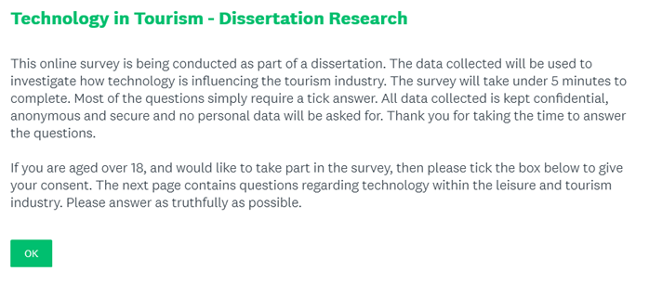

Appendix 14 – Survey Consent

Appendix 15 – Online Survey Q2

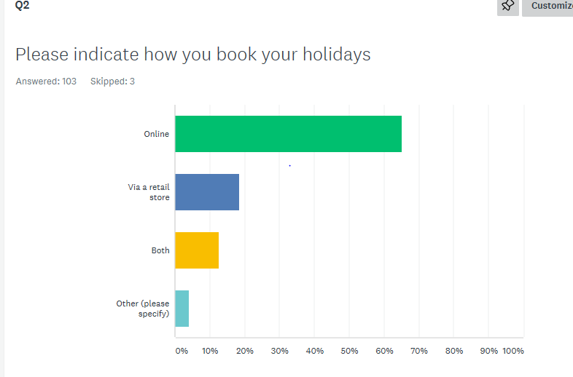

Appendix 16 – Online Survey Q3

Appendix 17 – Online Survey Q4
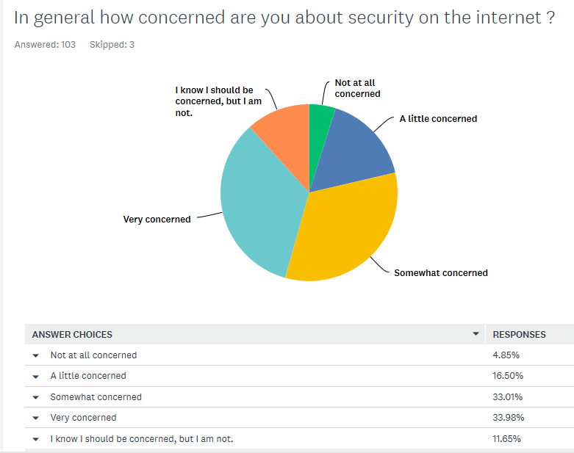

Appendix 18 - Online Survey Q5
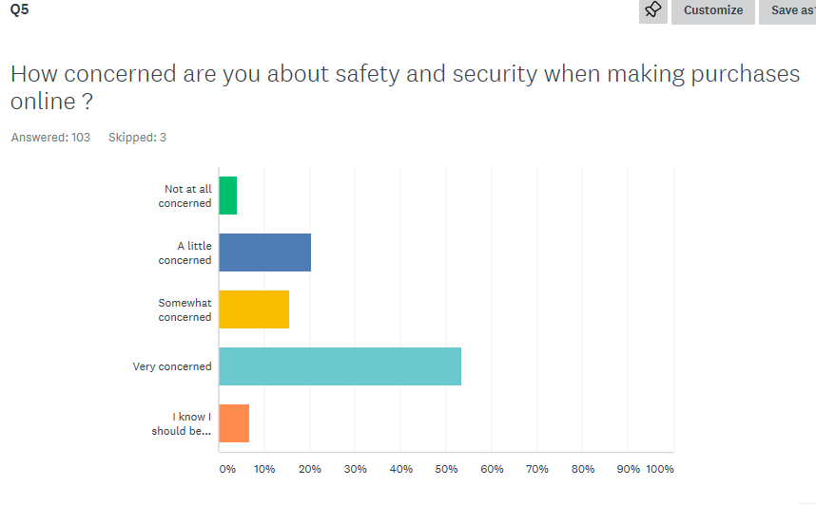

Appendix 19 – Online Survey Q6

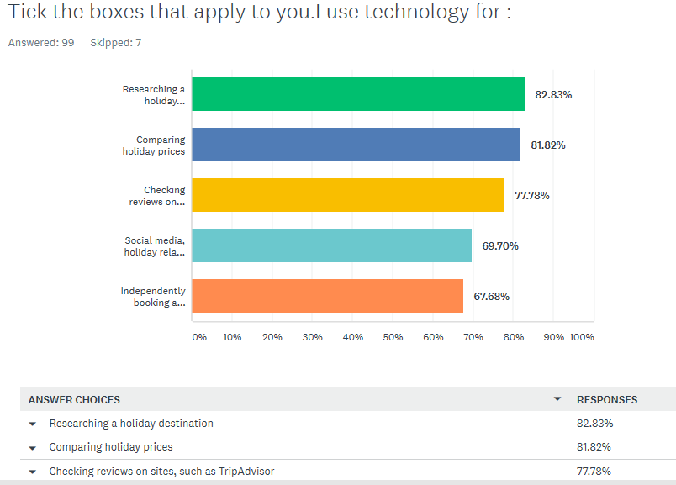

Appendix 20- online Survey Q7

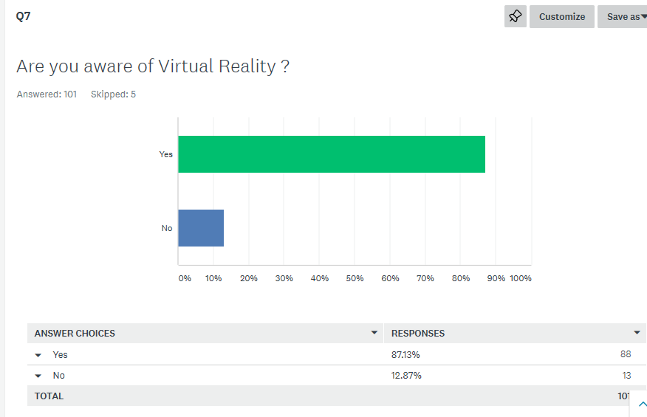

Appendix 21 – Online Survey Q8

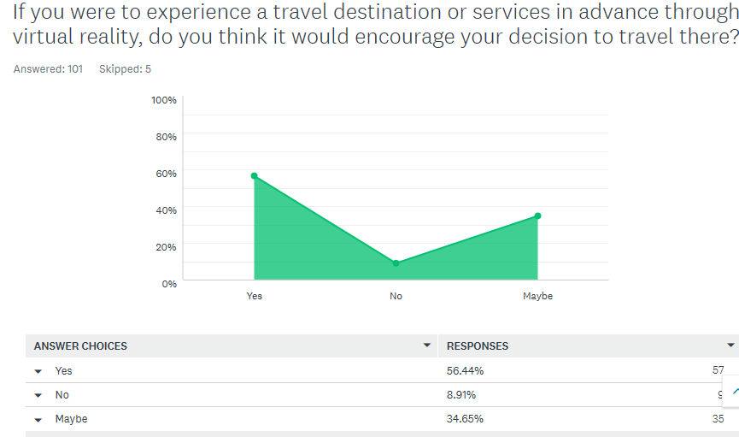

Appendix 22 - Online Survey Q9

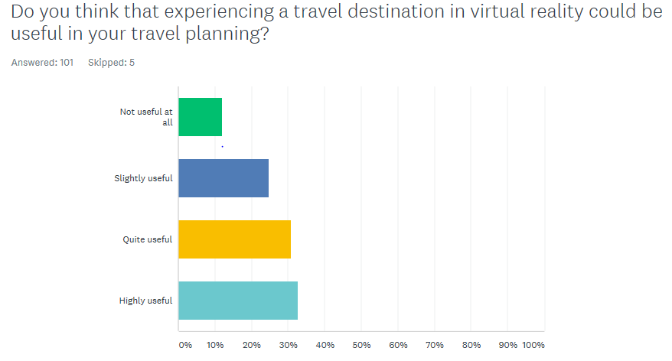

Appendix 23 – Online Survey Q10

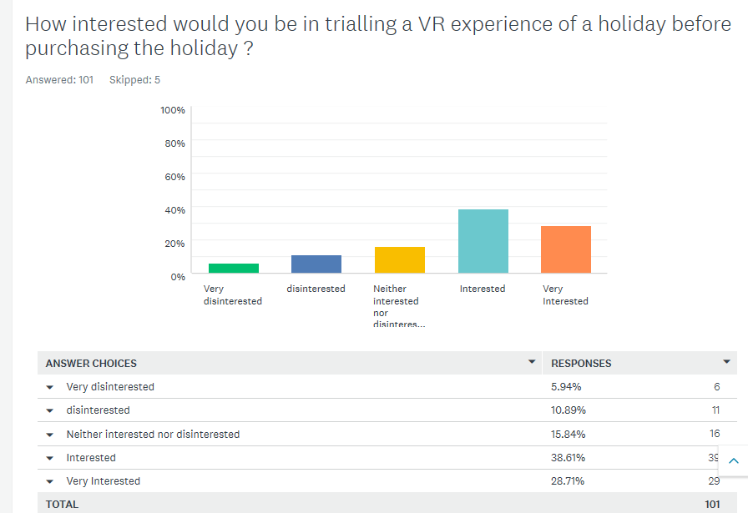

Appendix 24 - Participants Demographics Q1
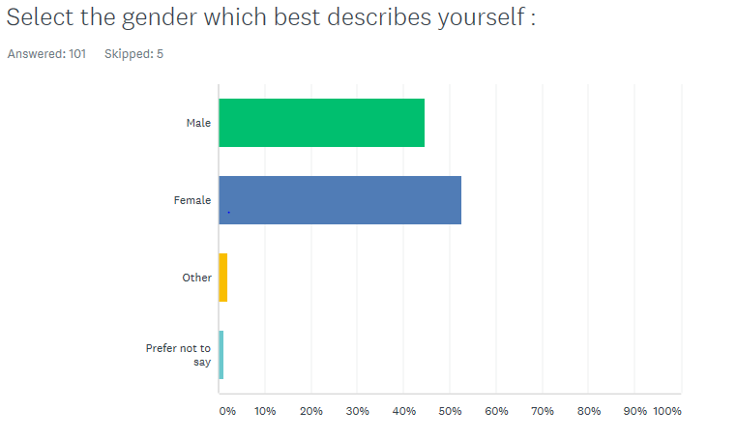

Appendix 25 – Participants Demographics Q2
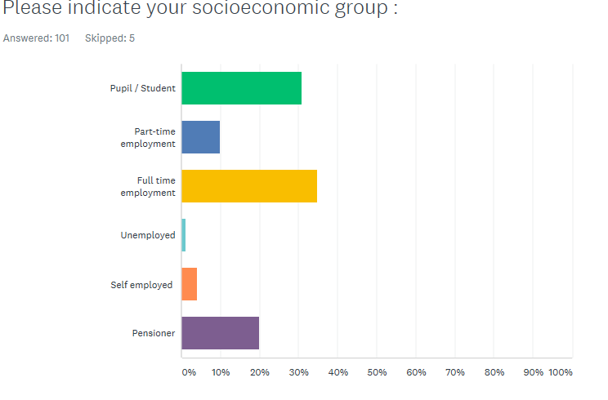

Appendix 26 – Participants Demographics Q3

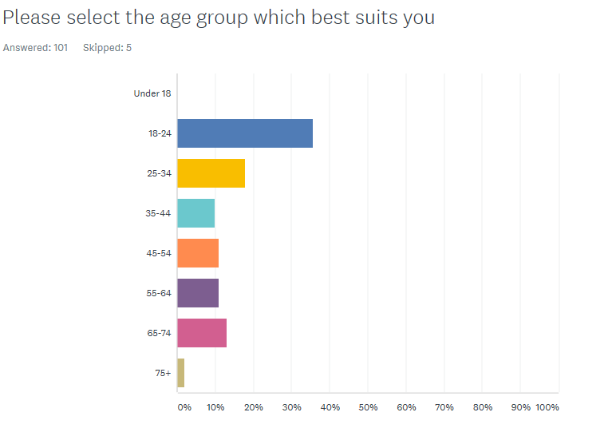

Appendix 27 - Thomas Cook Holiday Report 2019

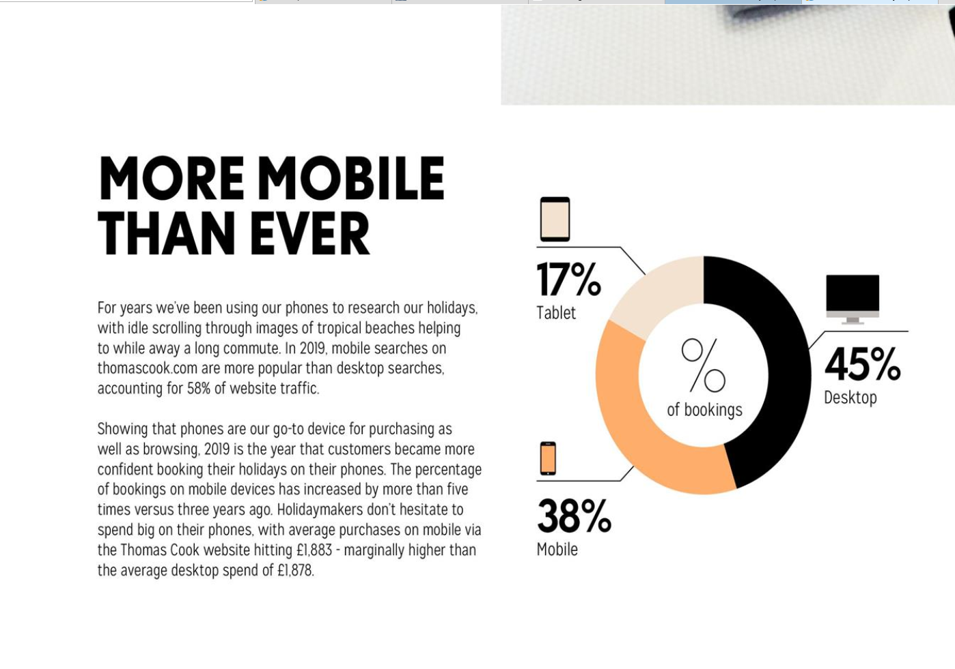

Appendix 28 - Gantt Chart Time Management
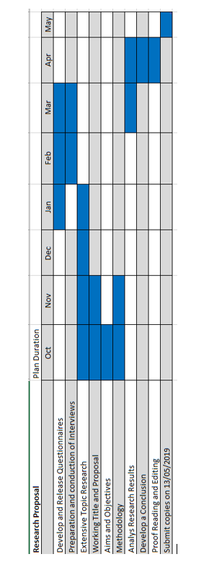

Appendix 29 – Poon’s old and new tourism comparison (1993)


