Nikita Temple
1811156
Research Proposal

An investigation into the factors that impact employment opportunities for former offenders in South Wales.

Table of Contents

Introduction
  - Rationale
  - Aims and objectives
  - Background and Literature Review

2. Research Design
2.2 Research approach
2.3 Research Strategy
2.4 Research Choices
2.5 Data analysis and collection
  - Ethical Risk

Resource Planning
  - resources
  - Time management
  - Gantt Chart

References

1.1 Introduction

This dissertation is to provide an insight into if companies in Wales employ individuals with a criminal record. Investigate into the crime rate in Wales and the percentage of recidivism. An investigation will be made into the education system provided in prisons and how this helps the convicts become employable after serving their sentence. The findings of this research will show an understanding of how many companies are willing to give convicts a second chance.

Rational

There are studies on companies employing individuals with a criminal record and there is research available to access. However there exist a paucity in academic literature. There is no research focusing on PLC companies in South Wales. An investigation is being made into this to see if there are employment possibilities for former offenders in South Wales and if the reason for recidivism is to do with the individuals not being able to get a job because of their criminal record.

Only 17% of former offenders succeed in getting a job after being released from prison. Former offenders finding a job on release are up to 9% less likely to reoffend. As 75% of employers in the UK will not employ a candidate because of a previous conviction, this likely the reason for recidivism.
(Minisrty of Justice, 2018)

Aims and objectives

- Carry out a comprehensive literature review of exact literature factors that impact employment of former offenders.
- Conduct primary research in the form of qualitative research, interviews with staff with recruitment responsibilities within an organisation.
- Make recommendations to both prison services and plc organisations.

Background and Literature Review

Working with prisoners and former offenders and offering them training and employment opportunities makes good business sense, as well as helping them get their lives back on track. It allows businesses to see opportunities and employ talented, highly motivated people who they may not have considered before. Employers have many concerns about employing an ex offender however 49% of businesses survey said that reliability is the main reason why they would not be considering employment.
(Minisrty of Justice, 2018)

One of the main websites that will be used for this literature review is the government website (GOV.co.uk) This is a reliable source, as it gives access to all legislations to do with discrimination, rehabilitation and employment. This website will provide information about DBS checks and what rights employers have not to employ someone with a criminal record. This information is accurate and up to date and will give a clear understanding and answers to this investigation.

Research Design

The research onion explains detailed stages of the research process. Please find diagram of the onion is figure 2.1.

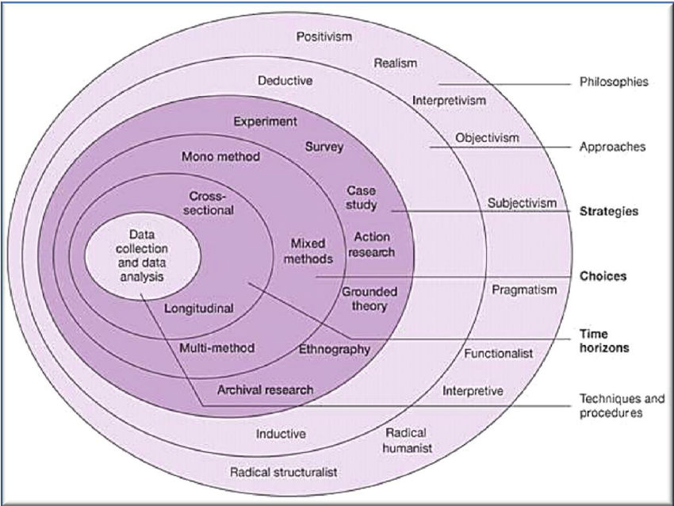

figure 2.1 – The Research Onion (Saunders et al, 2007)

2.1 - Philosophies

The choice of a specific research philosophy is impacted by practical implications. There are important philosophical differences between studies that focus on facts and numbers. Interpretivist will be the choice of philosophy for this dissertation as the collection of primary research will be completed in the form of interviews, this will then go forward to interpreting the data collected.
(Research Methodology, 2018)

2.2 – Research Approaches
Inductive research approach is all through the identification of a pattern when observing qualitative data and interpretation of the findings. This approach has been chosen as a research approach as this has a lot to do with qualitative data which will be used in the dissertation by interviews.

2.3 Research Strategy

A Research Strategy is a step-by-step plan of action, it gives direction to your thoughts and efforts, enabling you to conduct research systematically and on schedule to produce quality results and detailed reporting. This will help you become focused and improve on quality and save money. (Jenny, 2014)
A survey is a collection of data from a popular choice of a group of individuals. I will use this in this dissertation. The benefits of using a survey is that it easy to analyse and it allows individuals to feel more candid with their responses. To get accurate data people need to be honest with their answers. Surveys provide more honest responses than other types of research methodology. If confidentiality is made clear to the individual they are more likely to answer honestly. (SurveyMethods, 2017)

The research will facilitate semi structured interviews. Interviews will be administered to a manager of three public limited companies in Wales to see if they would employ a former convict with a criminal record to add to my research and investigation.

  - Research Choices

Research choice will be Mono Method as this dissertation will be using qualitative data through the use of interviews. Qualitative research is a research strategy that usually emphasize words rather that quantification in the collection of data analysis. This research strategy is intuitivist, constructionist and interpretivist but these three are not always used together. (Bryman, 2003)

  - –Time Horizon
Cross sectional time horizon choice as researching a specific cohort. Collecting the data will not take a long time and this process will be focusing on something specific.

2.6 Techniques and procedures

The techniques used in this dissertation will be data collection and data analysis.

  - Data analysis and collection

The collection of data analysis will be collected through interviewing individuals. This will then be transcribed and analysed. To analyse the data an appropriate software will be used for example NVIVO. This software is reliable and helps keep all findings organised. The data will then be kept in a password protected document.

  - Ethical Risk

Interviews will be completed by managers to get their professional opinion on employing former convicts with a criminal record. Some individuals will not be conformable answering all questions due to the topic sensitivity as questions are about former offenders.

The participants will be informed about the study and their consent will need to be given before proceeding. Ensuring that all data collected is kept safe and following the General Data Protection Regulations Law (GDPR). All information will be kept confidential and safe. This will be done by not disclosing the information to anyone and keeping the information on password protected documents. The manager and the companies name will not be mentioned in the dissertation they will be listed as Company A and manager A to protect their identity.

Resource and Planning

3.1 Resources
The resources for this dissertation are important, the resources to be used in this dissertation will be websites, books, journals, interviews, reports and articles. These will be researched though the university online library, google and other search engines which access is available to at all times.

  - Time management

Time is very important to this dissertation. I need to ensure that I am organized and meet all deadlines. Researching into this topic and identifying all the legislations and legal rights of companies will take time. Collecting data using surveys and interviews will take time to create, organize and complete.

  - Gantt Chart

The Gantt Chart will be used in this study to ensure that all deadlines are met. The Gantt Chart helps with organisation and will give a timescale for tasks and activities that need to be completed. Shown below in figure 3.1

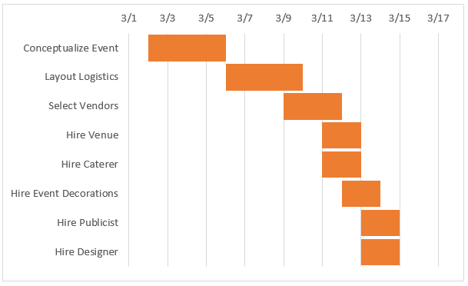

(Smart sheet, 2018)

Bibliography
Bryman, A., 2003. Business Research Methods. New York : Oxford University Press .
Jenny, 2014. Clearly define your research strategy. [Online]
Available at: https://www.mackenziecorp.com/phase-2-clearly-define-research-strategy/
[Accessed 14 November 2018].
Minisrty of Justice, 2018. Employing Prisoners and ex- offenders. [Online]
Available at: https://www.gov.uk/government/publications/unlock-opportunity-employer-information-pack-and-case-studies/employing-prisoners-and-ex-offenders
[Accessed 13 November 2018].
Research Methodology, 2018. Research Philosophies. [Online]
Available at: https://research-methodology.net/research-philosophy/
[Accessed 18 November 2018].
Saunders et al, 2007. The Research Onion. [Online]
Available at: https://www.researchgate.net/figure/The-research-onion-Saunders-et-al-2012_fig2_282912642
[Accessed 13 November 2018].
Smart sheet, 2018. Gantt Chart. [Online]
Available at: https://www.smartsheet.com/blog/gantt-chart-excel-b
[Accessed 19 November 2018].
SurveyMethods, 2017. Benefits and weaknesses of survey research. [Online]
Available at: https://surveymethods.com/blog/benefits-and-weaknesses-of-survey-research/
[Accessed 14 November 2018].

