

Name: Azhda Ali
Student ID: 2436859
Module Code: BMHP5023
Module: Introduction to Physiology
Assignment Title: Case Study Report - Asthma in adolescents
Lecturer: Robert Nartowski

Submitted on: 28/06/2026

Asthma in Adolescents

Introduction 3
Anatomy and Physiology 3
Pathophysiology and Impact 5
Monitoring and Data Use 6
Evidence-Based Lifestyle Recommendations 7
Conclusion 8
Reference List 10

Asthma in Adolescents

Introduction
Asthma is a chronic disease of the airways characterised by ongoing inflammation, fluctuating airflow limitation and symptoms such as wheeze, cough, chest tightness and breathlessness. It affects a significant number of adolescents in the UK and remains a major cause of avoidable GP visits and emergency admissions. Around 1.1 million children and adolescents in the UK live with asthma, making it one of the most common long-term conditions seen in primary care (NICE, 2024).
During adolescence, asthma can become harder to manage due to lifestyle changes, increased independence and greater exposure to irritants. Factors such as smoking, vaping, crowded settings, irregular use of preventer inhalers and respiratory infections can intensify airway inflammation and raise the likelihood of flare-ups (NICE, 2024; GINA, 2025). Non-behavioural factors including atopy, family history, obesity, indoor allergens and air pollution also influence asthma severity in young people (GINA, 2025).
This report is based on a case study involving adolescents attending a GP-based asthma clinic who are experiencing worsening symptoms linked to smoking, vaping and exposure to crowded environments. The aim is to provide clear, evidence-based information that helps them understand how the respiratory system functions, how irritants affect lung health and why monitoring tools such as peak-flow meters are essential for safe self-management.
The report examines normal respiratory processes, explains how breathing and oxygen transfer occur, describes how irritants disrupt airway function, highlights the value of regular monitoring, and presents lifestyle measures supported by clinical evidence. Demonstrates how understanding respiratory physiology and using routine monitoring data supports safer asthma management in adolescents.

Anatomy and Physiology
The respiratory system supplies oxygen to the body and removes carbon dioxide. The respiratory tract consists of the upper passages (nose, mouth, pharynx and larynx) and the lower passages (trachea, bronchi and bronchioles). Within the lungs are many alveoli, which provide the surface for oxygen and carbon dioxide exchange (Ross and Wilson, 2018).
Air passes through the nose or mouth and moves into the trachea, which is held open by C-shaped cartilage rings. The trachea splits into two main bronchi that further divide into increasingly smaller bronchioles inside the lungs. At the end of the bronchioles are groups of alveoli—small air sacs with very thin walls, surrounded by capillaries. This single-cell barrier enables movement of oxygen and carbon dioxide between the alveolar air and the bloodstream (Peate and Nair, 2011).

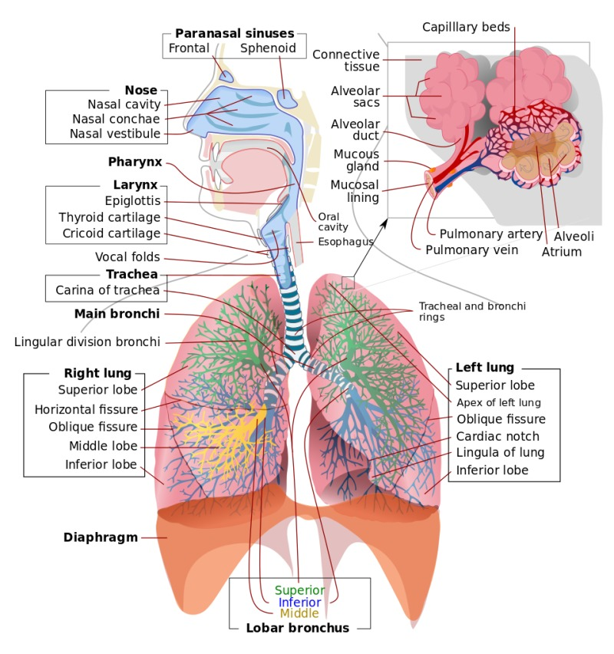
Figure 1: Structure of the respiratory system (NCBI, 2026).

The airways are lined with ciliated epithelial cells and goblet cells. Goblet cells produce mucus that traps dust, allergens and microbes, while the cilia move this mucus upwards towards the throat. This protective mechanism is important for adolescents with asthma, as irritants such as smoke and vaping aerosols can damage the cilia and increase mucus production. In healthy airways, smooth muscle remains relaxed and the airway lining is thin, allowing air to move freely. In asthma, the airway wall thickens, smooth muscle contracts more and mucus production increases, narrowing the lumen and reducing airflow (Kuruvilla, Lee and Lee, 2019).
When inhaling, the diaphragm tightens and drops, and the external intercostal muscles raise the ribcage, expanding the chest cavity and pulling air into the lungs. Expiration is naturally passive; the diaphragm relaxes and the lungs recoil. During exercise or respiratory distress, accessory muscles such as the sternocleidomastoid and abdominal muscles assist breathing (Tucker and Foulston, 2015).
Gas exchange happens by diffusion: oxygen passes from the alveoli into the capillary blood, while carbon dioxide travels from the blood into the alveoli to be breathed out. At the cellular level, oxygen diffuses from capillaries into tissues to support metabolism, and carbon dioxide produced by cells returns to the blood to be transported to the lungs (Ross and Wilson, 2018). Small changes such as swelling or mucus can reduce airflow, explaining why adolescents with asthma experience wheeze and breathlessness.
For the adolescents in the case study, knowing how air travels through the bronchi and alveoli helps them understand why irritants like smoke and vaping aerosols make breathing harder.

Pathophysiology and Impact
Asthma is an inflammatory disorder of the airways. In adolescents, exposure to irritants such as cigarette smoke, vaping aerosols and respiratory infections can trigger inflammation and worsen symptoms. When irritants reach the airways, immune cells like eosinophils and mast cells release substances such as histamine and leukotrienes, which trigger bronchoconstriction, swelling of the airway lining and excess mucus production (Kuruvilla, Lee and Lee, 2019). This causes the bronchi and bronchioles to become narrower, reducing the ease with which air can flow in and out of the lungs. These mediators contribute to oedema and thickening of the basement membrane, known as airway remodelling, which further restricts airflow (Jackson, 2019).
Smoking exposes the airways to harmful substances like tar, carbon monoxide and oxidants, which injure the airway lining and increase oxidative stress. In adolescents with asthma, smoking is strongly associated with reduced lung function, more frequent symptoms and poorer response to inhaled corticosteroids (BTS/NICE/SIGN, 2024). Vaping is also a significant irritant. E-cigarette aerosols contain nicotine, propylene glycol and ultrafine particles that inflame the airways. Research shows that vaping increases airway hyper-responsiveness and the risk of exacerbations (Wills et al., 2021). Although both smoking and vaping irritate the airways, smoking introduces a wider range of toxic chemicals that cause long-term structural damage, while vaping tends to produce more acute irritation (Wills et al., 2021). Viral infections typically trigger short-term but intense inflammation, making them one of the most common causes of acute exacerbations in adolescents (Jackson, 2019).
Respiratory infections heighten bronchial sensitivity, increase mucus production and intensify inflammation, making the airways more reactive to other triggers (Jackson, 2019). This can rapidly worsen airflow obstruction and lead to acute attacks. When the airways narrow, ventilation–perfusion mismatch occurs, meaning some alveoli receive adequate blood flow but insufficient airflow, reducing oxygen levels in the blood (hypoxaemia). Adolescents may experience breathlessness, wheezing, coughing, difficulty speaking and use of accessory muscles. These symptoms reflect the increased effort required to move air through inflamed and constricted airways. Further narrowing forces adolescents to recruit accessory muscles, increasing the work of breathing and contributing to fatigue.
Understanding these physiological changes helps adolescents recognise why irritants worsen their asthma and why avoiding them is essential for maintaining good respiratory health. This explains why the adolescents in the case study experience worsening symptoms when smoking or vaping, as these irritants directly increase inflammation and airway narrowing.

Monitoring and Data Use
Routine monitoring is an important part of asthma management, especially for adolescents who may underestimate symptoms or delay seeking help. Peak expiratory flow (PEF) offers a measurable way to assess how narrowed the airways are. A peak-flow meter shows how fast someone can exhale, and lower values suggest tighter airways and poorer asthma control (BTS/NICE/SIGN, 2024).
Tracking peak flow over time helps identify early deterioration before symptoms become severe. Asthma action plans often use a colour-coded system, with green showing stability, amber signalling caution, and red indicating the need for urgent medical help. Adolescents who understand their peak-flow zones can respond quickly by adjusting medication or seeking help. However, peak-flow readings are effort-dependent and can vary if technique is incorrect or results are not recorded, which may limit accuracy (Reddel et al., 2022).
Routine data also includes symptom diaries, inhaler use, exposure to triggers and responses to medication. Recording this information helps adolescents recognise patterns, such as worsening symptoms after vaping or during viral infections. It also supports shared decision-making between young people, families and healthcare professionals (Reddel et al., 2022). For example, if a patient’s peak flow drops into the amber zone and their diary shows increased vaping, the practice nurse can adjust their action plan and provide targeted cessation support.
From a health and social care perspective, routine data is essential for safe and effective care. It allows professionals to monitor progress, evaluate treatment effectiveness, identify risks and tailor care plans. In primary care, peak-flow trends, inhaler use and symptom frequency are recorded in electronic systems and used to guide medication reviews and identify high-risk patients. Being familiar with their monitoring results enables adolescents to manage their condition more effectively. In the case study, regular peak-flow tracking highlights early declines in control associated with smoking, vaping or exposure to crowded settings.

Evidence-Based Lifestyle Recommendations
Lifestyle adjustments are an important part of managing asthma and can help improve control and reduce flare-ups. Evidence-based recommendations include behavioural and environmental strategies that support respiratory health and reduce airway inflammation.
Smoking cessation: Stopping smoking improves lung function and reduces airway inflammation. Healthcare professionals should routinely ask adolescents about smoking and offer support, including referral to NHS cessation services (Right Decisions, 2024). Smoking cessation reduces exposure to tar, carbon monoxide and oxidants, allowing the airway epithelium to recover and improving responsiveness to inhaled corticosteroids.
Vaping cessation: Although sometimes perceived as safer, vaping is not harmless for people with asthma. Stopping vaping reduces airway irritation and improves symptom control (Wills et al., 2021). Adolescents may find cessation challenging due to peer pressure, nicotine dependence and the belief that vaping is less harmful, meaning behavioural support and motivational interviewing are essential components of effective intervention (SIGN, 2024).
Avoiding respiratory infections: Adolescents should practise good hand hygiene, avoid close contact with unwell individuals and maintain regular use of preventer inhalers to reduce baseline inflammation. Viral infections are major triggers for asthma attacks and can rapidly worsen airway obstruction (SIGN, 2024).
Trigger avoidance: Reducing exposure to allergens such as dust mites, pollen, mould and pet dander can help prevent symptoms. Improving ventilation and reducing indoor dampness also support respiratory health (Guarnieri and Balmes, 2014). These measures reduce allergen-induced inflammation and help stabilise airway sensitivity.
Healthy weight and physical activity: Obesity is linked to poorer asthma control and a weaker response to treatment. Keeping a healthy weight through balanced eating and regular physical activity can support better lung function, lower inflammation and improve overall wellbeing (GINA, 2025).
Adherence to inhaled therapy: Poor inhaler technique and inconsistent use of preventer inhalers are common in adolescents. Regular review of inhaler technique using teach-back methods helps ensure medication is delivered effectively (BTS/NICE/SIGN, 2024). Improved adherence reduces airway inflammation and prevents exacerbations.
Education and self-management: Personalised asthma action plans improve control and reduce hospital admissions. Adolescents should understand their triggers, medication purpose and how to respond to worsening symptoms (SIGN, 2024). Education empowers young people to recognise early warning signs and take appropriate action.
These lifestyle changes reduce airway inflammation, improve airflow and enhance the effectiveness of preventer inhalers, supporting long-term respiratory health. These recommendations directly support the adolescents in the case study, helping them reduce irritant exposure and improve asthma control.

Conclusion
As a chronic inflammatory illness, asthma can influence adolescents’ health in many ways, especially when lifestyle risks such as smoking, vaping or exposure to infections are part of their daily environment. Explaining the structure and function of the respiratory system enables young people to recognise how asthma affects their breathing and why irritants trigger inflammation, bronchoconstriction and worsening symptoms. Mechanical respiration, gas exchange and airway protection mechanisms all play essential roles in maintaining healthy lung function, and these processes are disrupted during asthma exacerbations.
Routine monitoring, including peak-flow measurement and symptom tracking, provides objective data that supports early intervention and safer self-management. Adolescents who understand their respiratory data are better equipped to recognise deterioration, follow their asthma action plans and make informed decisions about their health. This highlights the importance of routine data within health and social care, as it guides treatment reviews, identifies risks and supports personalised care planning.
Evidence-based lifestyle recommendations—such as smoking and vaping cessation, trigger avoidance, maintaining a healthy weight and adhering to inhaled therapy—can significantly improve asthma control and reduce the risk of severe exacerbations. These changes directly reduce airway inflammation, improve airflow and enhance the effectiveness of preventer inhalers, supporting long-term respiratory health.
Health professionals play a vital role in educating adolescents, supporting behaviour change and promoting effective self-management. As practice nurses, providing clear explanations, reviewing inhaler technique and using personalised action plans are essential responsibilities in helping adolescents achieve stable asthma control and develop confidence in managing their condition.

Reference List

BTS/NICE/SIGN (2024) BTS/NICE/SIGN Joint Guideline on Asthma: Diagnosis, Monitoring and Chronic Asthma Management. Thorax, 80(7), pp. 1–25.
GINA (2025) Global Strategy for Asthma Management and Prevention: 2025 Update. Available at: https://ginasthma.org (Accessed: 16 June 2026).
Guarnieri, M. and Balmes, J.R. (2014) ‘Outdoor air pollution and asthma’, The Lancet, 383(9928), pp. 1581–1592.
Jackson, D.J. (2019) ‘The role of respiratory infections in asthma development and progression’, The Lancet Respiratory Medicine, 7(10), pp. 846–856.
Kuruvilla, M.E., Lee, F.E. and Lee, G.B. (2019) ‘Understanding asthma phenotypes, endotypes, and mechanisms of disease’, Clinical Reviews in Allergy & Immunology, 56(2), pp. 219–233.
Marieb, E.N. and Hoehn, K. (2019) Human Anatomy and Physiology. 11th edn. Harlow: Pearson.
NCBI (2026) Respiratory System Diagram. National Center for Biotechnology Information. Available at: https://www.ncbi.nlm.nih.gov/books/NBK459258/figure/article-17308.image.f1/ (Accessed: 25 June 2026).
NICE (2024) Asthma Pathway NG244: Asthma in Adolescents. Available at: https://www.nice.org.uk (Accessed: 16 June 2026).
Peate, I. and Nair, M. (2011) Fundamentals of Anatomy and Physiology for Student Nurses. Chichester: Wiley-Blackwell.
Reddel, H.K. et al. (2022) ‘Self-management and monitoring of asthma: A systematic review’, Journal of Allergy and Clinical Immunology, 150(3), pp. 627–639.
Right Decisions (2024) Asthma in Adolescents – SIGN 244. Available at: https://rightdecisions.scot.nhs.uk (Accessed: 16 June 2026).
Ross, J. and Wilson, K.J. (2018) Anatomy and Physiology in Health and Illness. 13th edn. Amsterdam: Elsevier.
SIGN (2024) Asthma: Diagnosis, Monitoring and Chronic Asthma Management (SIGN 245). Edinburgh: SIGN.
Tucker, L. and Foulston, J. (2015) An Introductory Guide to Anatomy & Physiology. 5th edn. London: EMS Publishing.
Wills, T.A. et al. (2021) ‘E-cigarette use and respiratory health: A systematic review’, Annals of the American Thoracic Society, 18(8), pp. 1465–1475.

