

Design Thinking and Innovation
Written portfolio for Deliveroo

Student name: Elis-Andreea Tanko
Student ID: 2134085
Lecturer name: Rexon Nting
Module code: LCLM 6002
Contents
Introduction 3
Key Consumer & Industry Trends 4
Part 1 — Innovation & Customer Journey Analysis 8
Deliveroo’s Innovation Approach 8
Application of Innovation Ambition Matrix 10
Deliveroo Customer Journey Mapping 12
Part 2 — New Digital Transformation Initiative 16
Proposed Initiative: AI-Powered Predictive Delivery System (PPDS) 16
NEW Enhanced Customer Journey Map 17
How the Proposed Initiative Adds Value 19
Conclusion 21
Reference 22

Introduction
London-based Deliveroo is one of the most popular technology-based food delivery platforms in the UK that grew out of a business founded by Will Shu and Greg Orlowski in 2013 (Deliveroo, 2022).
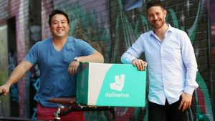
Figure 1: Will Shu and Greg Orlowski, founders of Deliveroo. Source: TechRound (2020).
The company was created as a result of uncomplicated idea, that consumers required to receive food of high quality and in a short period of time, but the market did not have an effective infrastructure that could satisfy the needs. Deliveroo filled this gap by establishing an exceptionally localized logistics management and collaborating with restaurants that had not delivered before (TechRound. 2020). It currently serves hundreds of towns and cities in the UK, with thousands of riders, and has a vast network of restaurant and grocery partners.
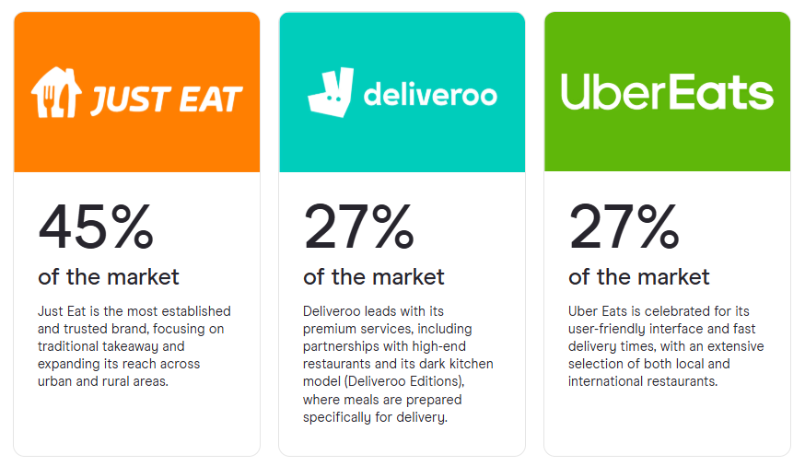
Figure 2: UK food delivery market share. Source: Zego (2024)
Deliveroo is extremely appropriate to investigate innovation and customer journeys since the business model is based solely on digital touchpoints, service design and never-ending innovation. All the customer journey steps, such as the app discovery, ordering, and tracking and after sale services, are mediated by technology (Deliveroo, 2022).

Key Consumer & Industry Trends
The online food delivery market in the UK has shifted away of a niche convenience to a mainstream consumption behavior . According to the latest estimates of the UK online food delivery services, it is estimated that the sector generated approximately USD 30.5 billion in 2024, and it is expected to increase to over USD 30.5 billion by 2035 at a current projected growth rate of approximately 7-8 per annum (Grand View Research, 2024).
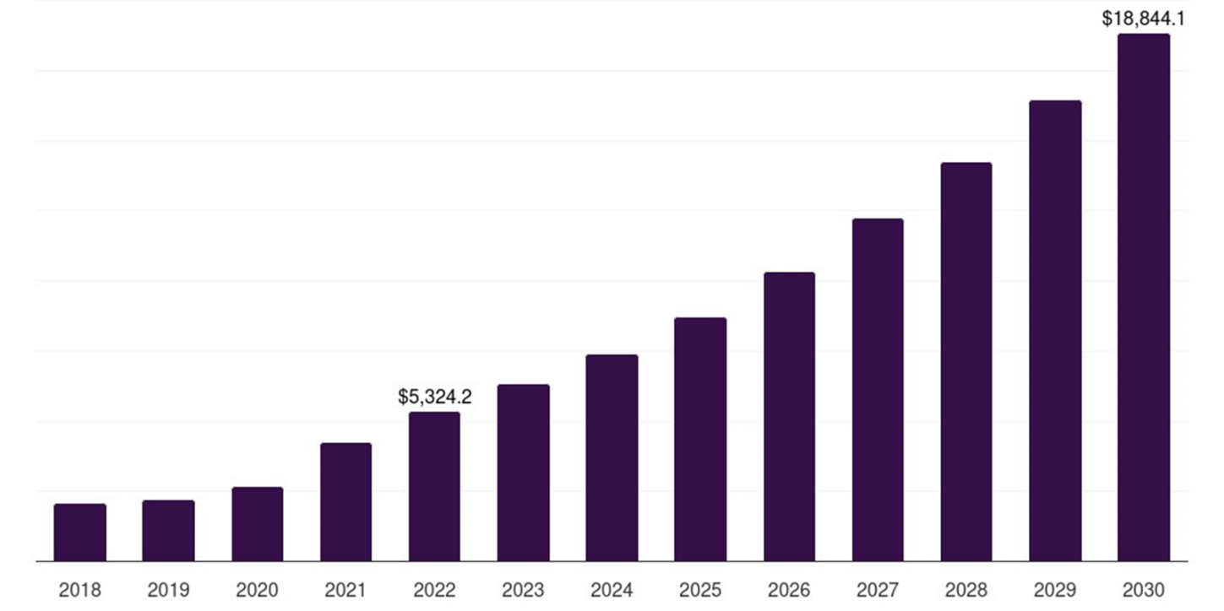
Figure 3: Projection of UK online food delivery services market. Source: Grand View Research (2024).
The Euromonitor (2025) shows that the value of UK consumer food-service delivery/take-out fulfilment has increased across. A market size with reference to Global Delivery Takeaway Food alone is estimated at USD 98 Billion in 2023 and is projected to surpass USD 280 Billion in 2033 (Spherical Insights, 2023).
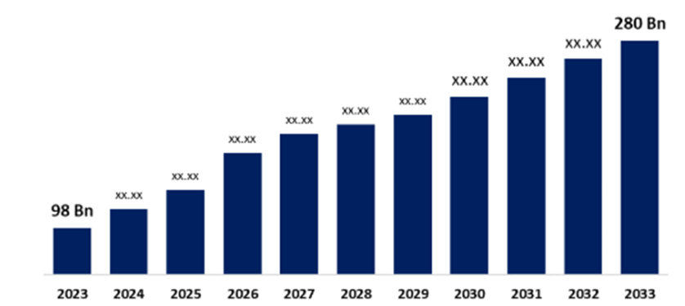
Figure 4: Forecasts of global delivery takeaway Food Market. Source: Spherical Insights (2023).
This robust and continued growth implies that platforms like Deliveroo, Uber Eats and Just Eat are integrated into daily consumption habits and do not constitute the occasional treat services. One of the driving forces towards this increase is an extreme change towards buying on convenience. Consumers in big cities who are time-strapped are making the process of cooking and shopping a thing of the past by using on-demand services (Liu, 2024).
Stated by Zego (2024), the UK food delivery market is projected to hit GBP3.8 billion by 2024, and the compound annual growth rate (CAGR) of it is approximated at around 15.2% in the next five years. Besides, Zego states that the portion of the UK meal-delivery market that will be active users is 63.7 percent by 2024 and the average Gen Z buyers have 4.5 food-delivery orders monthly (Zego, 2024). In addition, Euromonitor (2025) points out that Generation Z is bringing more innovations as the generation expects seamless digital experiences, customised services, and sustainable measures in the food delivery market.
The competitive landscape is changed operationally by the emergence of dark kitchens and hyperlocal logistics. Deliveroo has also launched Editions sites delivery-only kitchens that enable restaurants to expand their catchment areas without high street premises and Deliveroo to focus orders and make the most of these (Hotel & Catering, 2023). It is backed by a hyperlocal three-sided marketplace theory that closely links the local consumer, riders and merchants to cut back the fulfilment duration. In the case of Deliveroo, data-driven siting decisions and dark kitchens are not just cost innovations but also strategic tools that can help to create a more refined customer experience by enhancing availability, menu variety and delivery speed within a particular micro-market (Hotel & Catering, 2023).
Simultaneously, digital personalisation has been turned into a new standard requirement. Other retailers like Tesco use loyalty data to provide highly personalised deals and behavioural prompts through Clubcard. Food delivery services apply analogous data-driven suggestions modules- showing favored foods, offering time-of-day offers, and packaging items to boost the value of the basket (Deliverect, 2025). In the case of Deliveroo, higher personalisation is becoming pivotal to make its app experience more distinctive, create less decision malaise and higher order frequency as rival apps will likely provide restaurant coverage almost identical to its offer (Soy.club, 2025).
Nevertheless, the sustainability issues have increased because of this growth. Online delivery also adds to the waste of packaging and other transport emissions. According to the UK parliamentary research, food waste is estimated at 10.7 million tonnes in 2021, and the hospitality and food services are a considerable source of this waste (Malik et al., 2024). The UK consumer research shows that there is a high concern about recyclability of packaging and plastic use. It is also in the case of online meal delivery that higher CO emissions per tonne delivered are recorded than in some other on-demand segments of logistics (Allen et al., 2021).
The intensity of competition in UK is very high and dynamic. Just Eat, Deliveroo and Uber Eats are dominating the market with estimates indicating that about 45% of the market is being held by Just Eat, 27% by Uber Eats and 27% by Deliveroo with the shares varying by segment and data source (Zego, 2024). It is not only the rival aggregators who are becoming more and more competitive but also supermarkets and quick-commerce players who are ready to provide one-hour grocery delivery, like Morrisons Morrisons Now service. More recently, the DoorDashs purchase of GBP2.9 billion of Deliveroo is an indicator of the further consolidation of the UK ecosystem and the entry of such strong world forces (Deliveroo, 2022).
Lastly, regulatory and socio-political risks influence the risk profile of the industry. In 2023, a landmark case in an UK Supreme Court ruling stated that when using Deliveroo riders, there is no employment relationship between them and their client and that any collective bargaining is limited but reinforced their flexible contractor business (Fletcher and Davies, 2023). Still, the discourses of gig-economy conditions, algorithmic management, and data protection are becoming more heated. In the context of Deliveroo, it implies that the innovations in its customer experience and operation model would have to become more aligned with the demands to be fair, transparent and socially responsible, and not only efficient and growing (Deliveroo, 2022).

Part 1 — Innovation & Customer Journey Analysis

Deliveroo’s Innovation Approach
The platform business model is the basis of Deliveroos innovation strategy, in which value is created through coordinating customers to interact with each other through dependences (Gibson, 2024). Deliveroo is a three-sided market that allows customers, riders and restaurants to connect and therefore it is a new type of innovation that removes friction in transactions, enhances algorithmic coordination and increases the variety in the services.

Figure 5: platform business model for Deliveroo. Source: Author’s contribution.
It can be associated with the perspective that platform-based businesses do not compete only with products but with optimisation of the ecosystem (Jacobides et al., 2018). Using the Theory of Ecosystems, Deliveroo gains a better competitive edge by actively responsible of how interdependencies between parties work out, so that restaurants benefit due to higher demand, riders benefit due to optimal allocation, and customers benefit due to a well-intentioned, customized services. In this way, Deliveroo does not innovate alone but coordinates a coordinated ecosystem, however, in which the benefits of innovations in a single component of the network (such as algorithmic routing or dark-kitchen availability) are beneficial to all participants, creating positive feedback loops and platform stickiness.
Another key element of the innovation capabilities of Deliveroo is a rider optimisation algorithm, Frank, that is based on machine learning to assign orders and delivers better routing. The concept of algorithmic optimisation is reflective of process innovation, which enhances efficiency and consistency of service (Tidd and Bessant, 2021). Incremental digital innovation, such as enhanced mapping, ETA prediction, and real-time tracking, is also meant to minimize uncertainty on the part of the customer, which is a critical component of service-dominant industries (Emiliana and Efawati, 2025).

Figure 6: Deliveroo’s Editions (dark kitchens). Source: Deliveroo (2023).
With geospatial demand analytics, Editions enable restaurants to expand new local areas and invest less capital, as well as optimize Deliveroos order density and logistical control (Deliveroo, 2022). The same thing applies to service innovation through Deliveroo Plus, a subscription service offered by the company (Pang et al., 2022). Customers Customer lock-in Subscriptions increase repeat usage, customer lifetime value, which is congruent with CRM and customer loyalty theory (Boadu, 2019).
The adjacent-market innovation of diversification of Deliveroo into quick commerce via Deliveroo Hop is one way to use already existing logistical resources to cater to the immediate needs of consumers as they began to expect more (Deliveroo, 2022).

Application of Innovation Ambition Matrix
Nagji and Tuff (2012) created the Innovation Ambition Matrix, which classifies organisational innovations as core, adjacent and transformational activities. The portfolio of Deliveroos includes all three horizons, which is a sign of a well-considered and diversified approach to innovations.
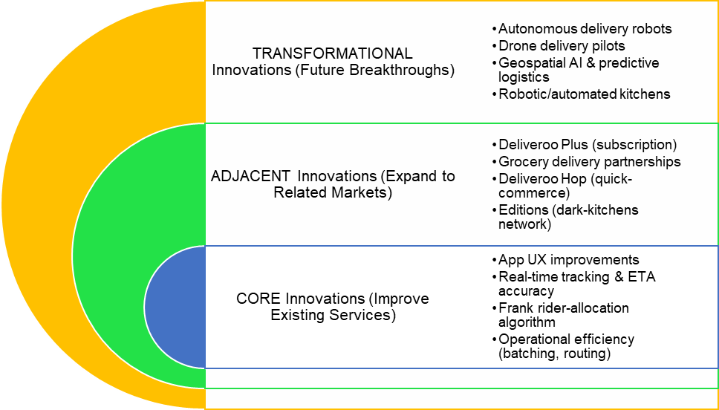
Figure 7: Innovation Ambition Matrix of Deliveroo. Source: Own Contribution.

Core Innovations: Efficiency improvements in the existing model
Core innovations aim at making some minor improvements that would enhance the existing service model of Deliveroos. These are the optimisation of the App UX, better order tracking, and the betterment of the Frank algorithm, which makes delivery time shorter and more reliable (Purificato, 2021). Incremental innovation is important in ensuring the sustenance of competitive advantage in service-based markets.
The rider batching and demand heat-mapping operational tools and real-time mapping upgrades used by the Deliveroos satisfy continuous improvement logic, which is outlined in the literature on lean operations (Deliveroo, 2022).

Adjacent Innovations: Expanding to related markets
Direct competitors use the platform capabilities of Deliveroos to fulfill new customer needs. The aspect of modularisation of services and stronger engagement with the customer, as demonstrated in the case of Deliveroo Plus as the subscription model, is consistent with the theory of relationship-marketing. The growth of Deliveroos grocery delivery and rapid-fulfilment model with Deliveroo Hop is consistent with the digital retailer transformation to immediacy and convenience of the omnichannel (Deliveroo, 2022).
Switching to Editions (dark kitchens) proves the new value propositions to restaurants by reducing barriers to entering new locations, in line with the reconfiguring of business models (Deliveroo, 2022).

Transformational Innovations: Future-oriented breakthroughs
Transformational innovations are the ones that are radically different and may need new technologies, new markets, or new cost systems. Deliveroos tries with autonomous delivery robots, drone delivery pilot, and geospatial AI are such initiatives, which have a high level of uncertainty and potential (The Futures Vault, 2025). These innovations leverage the new trends in digital mobility and automated logistics in the last mile- a sector identified as being susceptible to disruption. The possibility of introducing robotic kitchen technologies in the future is another indication of the exploration of AI-enabled production systems and the possibility of redefining the operational scalability in delivery-only settings.

Deliveroo Customer Journey Mapping
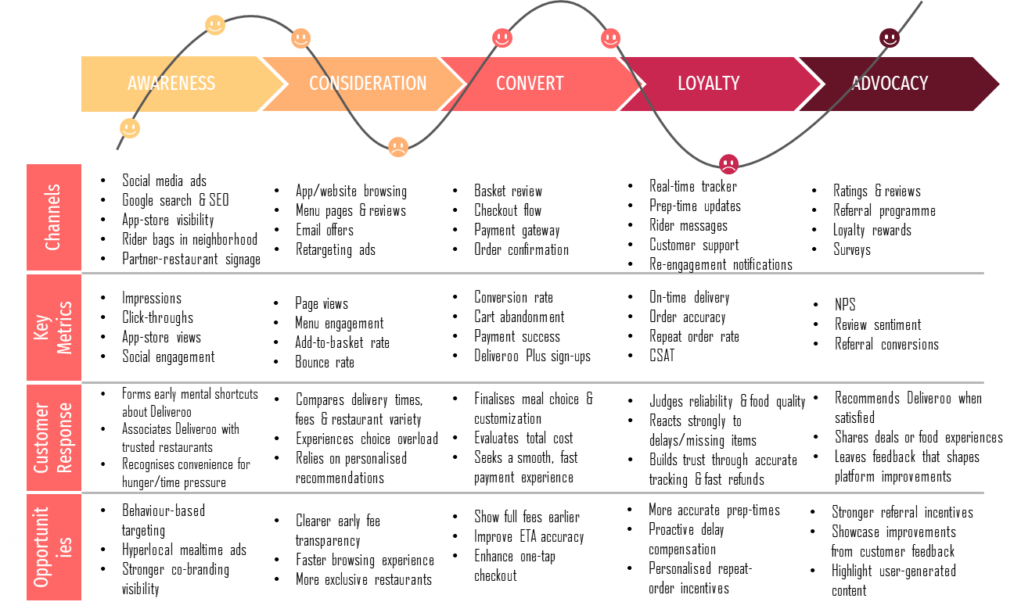
Figure 8: Customer journey map of Deliveroo. Source: Own Contribution.

Awareness: Discovering Deliveroo
The customer journey will start as soon as people learn about Deliveroo as a food-delivery provider. According to the model of Hayes and Downies (2024), the next step is early exposure, in which a customer searches and creates the first mental shortcuts. The level of awareness is formed on the basis of both digital and physical stimuli like social media advertising, the appearance of the app in the application store, the appearance of branded rider bags in the streets (Deliveroo, 2022). Collaborations with established chains are powerful associative messages, which makes Deliveroo a fast and trustworthy option at the time of hunger or lack of time.
Hypothetically, this phase is reminiscent of stimulus-attention models, which denote that brands are competing with each other to gain cognitive presence in the jammed digital spaces. Repeated touchpoints and hyperlocal marketing are the methods used by Deliveroo to raise mental availability. Co-branding with well-known restaurants like Wagamama and Nandos has the good impact of brand transfer which minimizes uncertainty and builds credibility.

Consideration: Evaluating Deliveroo’s Suitability
After customers become aware of the presence of Deliveroo as an alternative, they transition into the consideration stage, the same stage as in the education and excitement stage outlined by Hayes and Downie (2024). At this stage, patrons evaluate how Deliveroo can satisfy their short-term demands by comparing the time to receive the orders, prices, the selection of restaurants, offers, food quality and ratings, which they typically contrast with other rivals such as Uber Eats and Just Eat (Lord et al., 2022).
Customers face limited rationality behaviourally: the abundance of restaurants stimulates cognitive overload which slows down decision-making (The PFD Food, 2025). Deliveroo minimises this by making a personalised recommendation in accordance with behaviour and location, with selections of Popular Near You, Recommended for You or Order Again (Soy.club, 2025). This is indicative of choice architecture theory, which attempts to reduce friction and simplify difficult decisions. The theory of service design underlines the need to be clear to the user, such as clear pricing, navigations, legible menus and the correct ETAs (Morelli et al., 2020).

Convert: Completing the Order
The convert stage is the main point of transaction during which customers decide, personalize products, fill in delivery information and finalize payment (Hayes and Downie, 2024). Being a crucial point of conversion, a customer is very sensitive to friction. The CX theory emphasizes the fact that this is the stage requiring the utmost level of clarity, trust, and usability (Grigoreva, 2018).
Deliveroo also facilitates easy conversion with a one-tap checkout option, digital wallets such as Apple Pay and Google Pay, stored address and secure payment. Frustration though is usually experienced when fees of services or delivery are realized late into the process. As a result of behavioural economics, the presentation of fees later in date decreases trust and decreases the likelihood of conversion (Faure and Luth, 2011). In part, Deliveroo Plus also solves this issue as it lowers the delivery costs and increases predictability in prices, promoting the use of a subscription.

Loyalty: Experiencing and Reinforcing the Relationship
It is the loyalty that is developed in service fulfilment and the direct post-purchase experience, including restaurant preparation, rider assignment, tracking, delivery, and issue resolution (McKinsey and Company, 2020). This phase captures fundamental dimensions of SERVQUAL, such as reliability, responsiveness, assurance and empathy, which play a significant role in satisfaction when it comes to on-demand delivery (Sugiarto and Octaviana, 2021).
Deliveroos real-time monitoring and perceived control, which is a primary factor in service quality, are minimized (Pang et al., 2022). The manner in which ecosystem coordination theory is demonstrated through restaurant, rider and platform coordination is through efficient coordination between the parties involved in the ecosystem, i.e. the creation of value which is created through the smooth coordination of interdependent actors. Proper ETAs, pleasant rider experience and right orders enhance satisfaction and promote a repeat. Deliveroo builds loyalty by offering quick refunds, credits, promotions and re-engagement messages are personalised, which reinforce the habit and raise the retention of customers in the long term.

5. Advocacy: Recommending Deliveroo to Others
Advocacy is the ultimate level of involvement, as satisfied clients spread their good experiences among other people (Hayes and Downie, 2024). This step is consistent with the theory of Net Promoter Score (NPS), which emphasizes that satisfied customers become even more probable to become brand promoters. Deliveroo promotes advocacy by providing referral bonuses, rating prompts, requesting reviews, and sharing meal deals with others on social media.
The reinforcement of behaviour is also a powerful factor wherein rewarding the patron with a personalised offer, points, or loyalty perks, Deliveroo will be more prone to recommendation by the customer (Garcia Gomez et al., 2006). Customer feedback loops - surveys, in-app ratings and issue-solved follow-ups reinforce the sense of being heard in customers and lead to emotional loyalty (Soy.club, 2025).

Part 2 — New Digital Transformation Initiative

Proposed Initiative: AI-Powered Predictive Delivery System (PPDS)
The suggested technological change program in Deliveroo is a machine learning-based Predictive Delivery System (PPDS), which is set to make operations more reliable, efficient in resource distribution, and provide more precise Estimated Time of Arrival (ETAs) (Pudwell, 2017). PPDS combines machine learning models, geospatial analytics, real-time monitoring of restaurant workload, weather data, past delivery patterns, rider availability and live traffic conditions to make accurate forecasts along the end-to-end delivery chain. Instead of going by customary estimates or average preparation times, PPDS methodically forecasts the delivery lifecycle with the aid of dynamic constantly updated data to algorithmically simulate the lifecycle - kitchen preparation, rider assignment, and route optimisation.
This new program is directly related to one of the most long-term pain points of Deliveroos, which are PIN inaccuracy and service inconsistency as the main factors of customer dissatisfaction. According to the customer journey mapping above, delays, poor preparation schedules and irregular arrival of riders are also some of the issues that result in loss of customer confidence. Food delivery is a time sensitive service and time reliability has a strong influence on customer expectations.
Delivery systems that are predictive are becoming core to real-time platform-based businesses (Nweje and Taiwo, 2025). Theoretical underpinnings are based on the idea of operations management, which involves predictive analytics to decrease uncertainty and increase the responsiveness of supply chains, and platform ecosystem theory, in which value is co-created by synchronous interactions between customers, restaurants, and delivery riders. The PPDS program is a history of innovation at Deliveroos: like Editions (dark kitchens), Deliveroo Hop (quick commerce), and the Frank routing algorithm, it aims to move the company towards smarter, predictive logistics (Deliveroo, 2022).
PPDS would consist of three core components
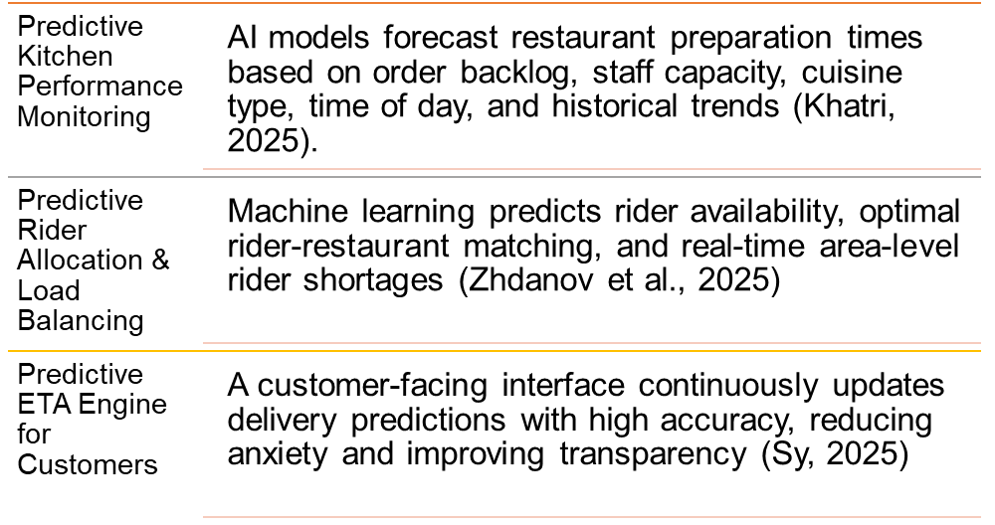
Figure 9: Three core components PPDS. Source: Own Contribution.

NEW Enhanced Customer Journey Map
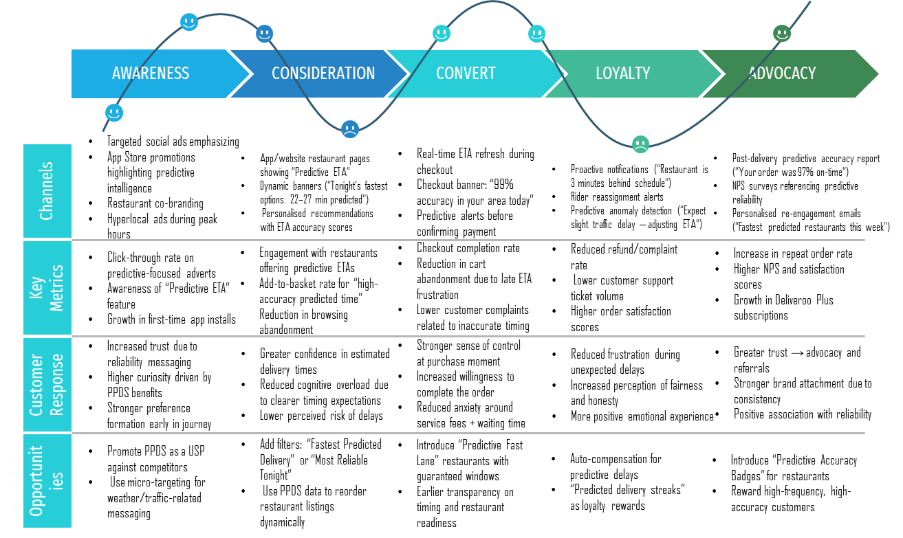
Figure 10: Enhanced customer journey map of Deliveroo (Based on PPDS). Source: Own Contribution.
During the Awareness phase, PPDS gets integrated into the brand identity of Deliveroos, and the marketing communications change to rely on reliability claims, including predictive ETA accuracy. This makes Deliveroo an innovative technological alternative to the competition, generating preliminary anticipations of accuracy and reliability.
Predictive intelligence allows less cognitive overload during the time of Consideration, due to more precise information about the time of delivery, restaurant preparedness and traffic congestion (Akter, 2025). The customers who can assess the meal options are more confident due to the minimization of uncertainty, which is one of the primary psychological obstacles of the decision-making process (Chua et al., 2020). Predictive time badges and dynamic recommendations are both available, and affects choice architecture by causing customers to be nudged towards more reliable and fast alternatives.
The advantages of improved transparency are the greatest in the Convert stage. Checkout with real-time updates of the ETA alleviates anxiety and allows avoiding such negative emotional reactions to uncertainty in waiting time as van Riel et al., (2012). Ahead of payment alerts assist customers to make a better decision, which is more likely to process orders. Setting the expectations at this stage makes post purchase dissonance smaller and indirectly makes the rate of complaints lower.
During the Loyalty stage, PPDS adds a proactive communication tool to notify customers that there has been a reassignment of a rider, or the kitchen is delayed or there has been a problem in traffic before the problem got out of hand. Such responsiveness is associated with SERVQUAL concept and reinforced trust, which leads to easier service relationships (Sugiarto and Octaviana, 2021).
Lastly, the Advocacy phase employs the predictive accuracy reports and customised re-engagement messages in order to strengthen the reliability of the services. Satisfied customers who experience good delivery times regularly would not have problems referring to others to Deliveroo. When predictive reliability comes to define the brand, the system not only does not worsen the repeat purchase behaviour but also increases the customer lifetime value and platform stickiness in the long term (Ali and Shabn, 2024).

How the Proposed Initiative Adds Value

Operational Improvement
Predictive Powered Delivery System (PPDS) changes the dynamics of the work of Deliveroos so that the coordination processes turn into the proactive optimisation. Based on real-time machine-learning data, PPDS predicts bottlenecks beforehand and changes the allocation of riders, the timing and delivery routes of the restaurants respectively (Verbytskyi, 2023). Once a restaurant is full capacity, the system changes ETAs, then orders are not dispatched to wait idle riders or creates reroutes orders with nearby Editions locations. It minimizes the discrepancy between order volume and the supply of riders, and enhances the efficiency of the fleet (Chen et al., 2025). The predictive accuracy also reduces the errors like premature dispatch, unnecessary trips and ineffective routing as well.

Customer Experience Enhancement
The perception of predictability, control, and transparency in food delivery are the main factors that define customer satisfaction (Ali et al., 2025). PPDS empowers each of the three dimensions by offering constantly changing ETAs on the basis of real-time variables like traffic routes, kitchen traffic and rider placements. This generates more realistic expectations and there is a lot of lessening of frustration in the waiting period. SERVQUAL principles of reliability and responsiveness are replicated through real-time predictive notifications, including notifying the user when a restaurant is behind schedule or when a rider is reassigned (Bhattacharjee et al., 2023). Open communication builds confidence and minimizes fear, which promotes repeatability and increases loyalty in the long term. PPDS enhances emotional and functional elements of the service experience by providing customers with a better idea of what is going on and why.

Cost Reduction
The operational expenses of Deliveroos are extremely determined by the inefficiency of riders, batching mistakes, and customer complaints reimbursement. The PPDS minimises these costs through the reduction of idle rider time and enhancing the process of order preparation and pick-up coordination (Sorooshian et al., 2022). Timely service minimizes refund claims of cold food, long queues or service error. More effective batching and routing enhance the volume of deliveries per hour, which is cost-effective and does not require a greater sum of labour in the course of delivery.

Conclusion
As has been established in this report, Deliveroo functions in a rapidly changing and intensely competitive online delivery sector, in which innovativeness and client focus are necessary to maintain the long-term benefit. The trend analysis in the industry indicates an upward trend in demand of convenience, speed and transparency and the heightening expectations of customers influenced by technology-driven competitors. The current innovation approach of Deliveroos which represents Editions kitchens, subscription and algorithmic optimisation exemplifies a solid ground, yet also provides the insight of further digital transformation to fill the inherent experience gaps.
The core service of the proposed AI-Powered Predictive Delivery System (PPDS) is a strategically aligned solution, as it can increase the accuracy, reliability and transparency of the service delivered by Deliveroos core service. With predictive intelligence, Deliveroo would be able to move beyond a reactive delivery model to an active ecosystem orchestration that would enhance operational accuracy among restaurants, riders, and customers all at the same time. This is in line with the design thinking principles of providing solutions to real identified pain points of the user but is also technologically viable and operationally feasible.
The improved customer journey map shows how PPDS reinforces every step, such as the awareness and consideration to conversion, loyalty and advocacy, by alleviating uncertainty, improving trust, and enhancing emotional satisfaction. As a strategy, PPDS sustains various aspects, allowing penetrating the market by focusing on the customer experience, developing the product by introducing new AI opportunities, developing the market by creating a lower perception of risk by new user groups and diversifying the product by preparing the groundwork on more extensive logistic innovations.

Reference
Akter, M. (2025). IMPACT OF PREDICTIVE MACHINE LEARNING MODELS ON OPERATIONAL EFFICIENCY AND CONSUMER SATISFACTION IN UNIVERSITY DINING SERVICES. ASRC Procedia: Global Perspectives in Science and Scholarship, 01(01), pp.376–403. doi:https://doi.org/10.63125/5tjkae44.
Ali, A.J., Yusof, R., Mok, H.S., Basim, M.F., Ahmad, M.N.B.N., Saadin, M.Z.B., Yusrin, M.A.D.B. and Kee, D.M.H. (2025). Examining Customer Satisfaction Drivers in Online Food Delivery: Evidence from Malaysia. International Journal of Accounting & Finance in Asia Pasific, 8(3), pp.478–496. doi:https://doi.org/10.32535/ijafap.v8i3.4225.
Allen, J., Piecyk, M., Cherrett, T., Juhari, M.N., McLeod , F., Piotrowska , M., Bates, O., Bektas, T., Cheliotis, K., Friday, A. and Wise, S. (2021). Understanding the transport and CO2 impacts of on-demand meal deliveries: A London case study. Cities, [online] 108, p.102973. doi:https://doi.org/10.1016/j.cities.2020.102973.
(JECO), [online] 21(1), pp.1–22. doi:https://doi.org/10.4018/JECO.323655.
Boadu, A.A.K. (2019). Customer Relationship Management and Customer Retention. SSRN Electronic Journal. doi:https://doi.org/10.2139/ssrn.3472492.
Chai, C. and Tan, C.C. (2020). BRAND MANAGEMENT THROUGH STIMULUS-ORGANISM-RESPONSE (SOR) INTEGRATIVE EFFORTS 1. [online] Available at: https://www.researchgate.net/publication/347977321_BRAND_MANAGEMENT_THROUGH_STIMULUS-ORGANISM-RESPONSE_SOR_INTEGRATIVE_EFFORTS_1.
Chen, J.-F., Wang, L., Sang, H., Wu, C.-G. and Wang, J. (2025). A Prior and Posterior Order Postponement Framework for the On-Demand Food Delivery Problem. IEEE Transactions on Intelligent Transportation Systems, [online] 26(10), pp.14879–14895. doi:https://doi.org/10.1109/tits.2025.3575482.
Chua, B.-L., Karim, S., Lee, S. and Han, H. (2020). Customer Restaurant Choice: an Empirical Analysis of Restaurant Types and Eating-out Occasions. International Journal of Environmental Research and Public Health, [online] 17(17), p.6276. doi:https://doi.org/10.3390/ijerph17176276.
Deliverect. (2025). Deliverect | How Data Analytics is Revolutionizing the Online Food Ordering Industry. [online] Available at: https://www.deliverect.com/en/blog/trending/how-data-analytics-is-revolutionizing-the-online-food-ordering-industry.
Deliveroo (2022). DELIVEROO LAUNCHES FIRST ‘HOP’ RAPID GROCERY DELIVERY SERVICE IN BRIGHTON AND HOVE. [online] deliveroo.co.uk. Available at: https://deliveroo.co.uk/more/news-articles/hop-brighton.
Emiliana, R. and Efawati, Y. (2025). Strengthening E-commerce Customer Satisfaction through Delivery Service Transparency. International Journal Administration, Business & Organization, 6(1), pp.112–124. doi:https://doi.org/10.61242/ijabo.25.350.
Euromonitor. (2025). 1 in 5 consumers chose foodservice delivery over dine-in in…. [online] Available at: https://www.euromonitor.com/newsroom/press-releases/july-2025/1-in-5-consumers-chose-foodservice-delivery-over-dine-in-in-2024.
Fletcher, C. and Davies, H. (2023). Supreme Court confirms Deliveroo riders are not ‘in employment’ (via Passle). [online] Passle. Available at: https://thelens.slaughterandmay.com/post/102iu4e/supreme-court-confirms-deliveroo-riders-are-not-in-employment.
Gibson, K. (2024). Traditional vs. Platform-Based Business Models: 4 Key Differences. [online] Business Insights Blog. Available at: https://online.hbs.edu/blog/post/platform-based-business-models.
Grigoreva, S. (2018). Moments of Truth in Customer Journey Mapping - UXPressia Blog. [online] UXPressia Blog. Available at: https://uxpressia.com/blog/moments-of-truth-customer-journey.
Hotel & Catering (2023). DELIVEROO LAUNCHES FIRST EDITIONS SITE IN ABU DHABI. [online] Hotel & Catering. Available at: https://hotelandcatering.com/news/deliveroo-launches-first-editions-site-in-abu-dhabi.
Liu, Z. (2024). Transformations in Consumer Buying Behavior: Investigating How Online Shopping Platforms. Advances in Economics, Management and Political Sciences, 109(1), pp.181–186. doi:https://doi.org/10.54254/2754-1169/109/2024bj0135.
McKinsey & Company (2020). Creating Value through Transforming Customer Journeys. [online] McKinsey & Company. Available at: https://www.mckinsey.com/~/media/mckinsey/industries/public%20and%20social%20sector/our%20insights/customer%20experience/creating%20value%20through%20transforming%20customer%20journeys.pdf.
Morelli, N., de Götzen, A. and Simeone, L. (2020). An Approach to Service Design. Springer Series in Design and Innovation, pp.9–26. doi:https://doi.org/10.1007/978-3-030-56282-3_2.
Pang, X., Shang, Y. and Song, J. (2022). An Analysis of Deliveroo’s Operation Strategy and Food Takeaway Industry. [online] www.atlantis-press.com. doi:https://doi.org/10.2991/aebmr.k.220307.023.
Purificato, I. (2021). Behind the Scenes of Deliveroo’s Algorithm: in the Blindness of ‘Frank’ its Discriminatory Potential. Italian Labour Law e-Journal, [online] 14(1), pp.169–194. doi:https://doi.org/10.6092/issn.1561-8048/12990.
Soy.club. (2025). Deliveroo: The art of building loyalty and triggering orders. [online] Available at: https://www.soy.club/blog-articles/deliveroo-the-art-of-building-loyalty-and-triggering-orders.
Spherical Insights. (2023). Delivery Takeaway Food Market Size, Growth, Forecasts to 2033. [online] Available at: https://www.sphericalinsights.com/reports/delivery-takeaway-food-market.
TechRound. (2020). Startup Profile: Deliveroo. [online] Available at: https://techround.co.uk/startups/startup-profile-deliveroo/.
The Futures Vault (2025). Autonomous Delivery: From concept to reality — GDR. [online] GDR. Available at: https://gdruk.com/inspire/autonomous-delivery-from-concept-to-reality/.
The PFD Food (2025). The Psychology of Menu Design: How to Influence Customer Choices. [online] PFD Foods. Available at: https://www.pfdfoods.com.au/news/the-psychology-of-menu-design-how-to-influence-customer-choices.
Zego (2024). UK Food Delivery Market Statistics (2024). [online] Zego. Available at: https://www.zego.com/food-delivery-statistics/.

