BMSW4003
Digital Skills and Research Methods
Student’s ID: 1919046
Ekaterina Hristova

Lecturer: Dr. Olusoyi Ashaye

Word Count:2,118
Contents
Introduction 3
Research background 3
Project Aim 3
Project Objectives 3
Questions for primary-data collection 4
Methodology 5
Research Onion 5
Scope 6
Data analysis 7
Primary data-analysis 7
Secondary data analysis 13
Conclusion and Recommendations 14
References 15

Table of Figures
Figure 1: Research Onion…………………………………………………………………….5

Introduction

Research background
The Covid19 has pushed the classes of the colleges and the Universities which would be taken through Microsoft Team. The newly-developed ways of learning by the students could be a different experience both with positive and negative impacts (Stewart & Lesage, 2020). Most people have been frightened of the scenarios of death-toll across the UK and there has been digital learning pressure from the universities to the students which would be the reason for being stressed among the students. No doubt on the tool of VLE Moodle to enhance the creative and continuous learning for the students so that they might lose a year for nothing from an education perspective, but the appropriateness of its credibility has been questionable among many students (Kerel, 2020). From this point, the research on the impact of VLE over the students' learning has been depicted to clarify the subject goal and expansion of the class schedule under this medium (Jovaba, 2018). For that, 10 students from the University of Wales Trinity Saint David London Campus are being taken over online by finding their Email in the pandemic session to have the primary data collection over the topic.

Project Aim
It is a generalizing query-solving project on the impact of Virtual Learning Environment for the students particularly from the University of Wales Trinity Saint David London Campus.

Project Objectives
- This would try to justify the impact of the Virtual Learning Environment over the students learning experience.
- This research would try to get authentic and confidential data from the students of the University of Wales
- The analysis would allow the teachers and the administration to get a better view of what student’s jurisdiction have been overtime on VLE
- Showing the results using graphs and recommending the gist from the analysis.

Questions for primary-data collection
QUESTIONNAIRE
1 | Do you feel comfortable withthe Virtual Learning Environment? (Close Ended).  a. Yes b. No
2 | Do you try to follow-up course on Moodle (VLE)? (Close Ended)  a. Yes b. No
3 | Do you rateMoodle (VLE) system learning above 8 out of 10? (Close Ended)  a. Yes b. No
4 | Do you enjoy learning alone with the help of VLE Moodle? (Close Ended)  a. Yes b. No
5 | Do you get motivated through the communication with the teacher virtually after assessing the quiz and exam-paper? (Close Ended)  a. Yes b. No
6 | Do you believe Moodle and VLE has created an opportunity to be a better student? (Close Ended)  a. Yes b. No
7 | Do you like getting feed-back over VLE? (Close Ended)  a. Yes b. No
8 | Do you recommend to the juniors to use Moodle resources and information tools to cut a good-result? (Close Ended)  a. Yes b. No
9 | Whatis the important part of Using VLE Moodle? (Open Ended)
10 | What are the changes would you prefer in VLE Moodle (if any)? (Open Ended)

Methodology

Research Onion
The prerequisite for a greater process of research has been clarifying the methodology. The research has been different from the discussion point of view as per the demand and requirement of the research-topic. This topic has been about the qualitative data with the impact of Virtual Learning Environment (VLE) for the students particularly(Flick, 2015). Primary-research and the secondary-research are two ways to conclude the impact of the VLE on the student's learning-experiences.
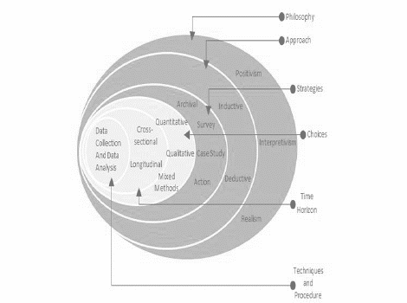
Figure 1: Research Onion
Source: (Hamburg, 2017)
- Research Philosophy: The idea of this research would be met through the Positivism as research-philosophy(Migel, 2013). This would lead to primary-data collection with our developed questionnaires which would be presented under the diagram and excel sheets.
- Research Approach: The deductive learning would be taken as per the need of showing the importance of digital skills for the students through using the VLE Moodle.
- Strategy: There have been several strategies to keep pace with the research objectives of finding the student's records over the VLE and its usefulness among them(Eresh, 2020). The 10 different students of the Trinity Saint David London Campus would have been picked to send the questionnaires for keeping this a secret and they are promised to be as confidential participants too.
- Choice: The previous portion has just mentioned the idea of choosing primary-data research with the qualitative data preserving through MS Excel(KALAYCI, 2015). This has been a small-scale research with the Optimity of finding the core results using a statistical tool in Microsoft Excel.
- Techniques and procedures: The respondents are mainly from the same university with their approval to give an honest opinion over the VLE as all of them are currently students in different semesters. Using the online medium of Email, the questionnaire has been sent so that the Covid19 would not make any stoppage(Li, 2020). The virtual responses are being added to the excel sheet over each question to get the shape and diagrams for the research. Finally, the result would be declared under the analysis.
- Sampling: Hence, the technique would be sampling as the data set is being below 30 respondents and the research has been qualitative with data-collection through the primary research.

Scope
The VLE has been serving the students so to the teachers with the management techniques of the assessment and the communication-hack under the same platform. The support from the authority and academicians would be appreciated even in the corona time for Trinity Saint David London Campus due to the collaboration of them on the analysis of the courses and the resource-sharing over VLE(Carl, 2020). This research can be showing the actual mental-reflection of the students of this campus over the helpful use of VLE in the learning applications.

Data analysis

Primary data-analysis
The virtual responses are being added to the excel sheet over each question to get the shape and diagrams for the research. Finally, the result would be declared under the analysis.
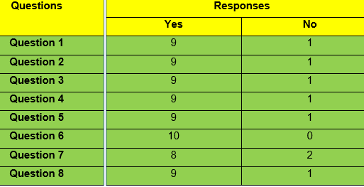
Question-1
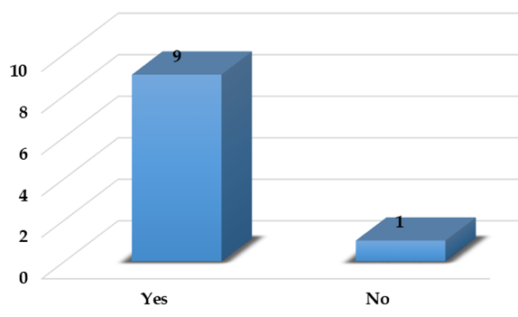
Almost 90% has given their vote on the positive answer, yes, which would be emerging numbers to admit that the sample has been having a good time in VLE Moodle to get education by themselves.

Question-2
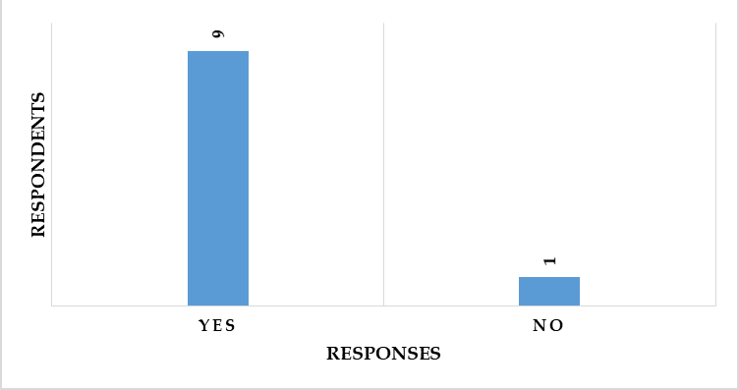
Again the positivity has been spread among Generation Z to learn from digital media and places to get accustomed to the process happily and solely. 90% has given their consent that the exams are being taken in the Trinity campus as the students are being more sincere to this topic and VLE is the solution for the students.
Question-3
90% of the participants from the sample have given a unanimous point of 8 out of 10 and their vote on the positive answer proved that the services are taken cordially and happily by the sample size. VLE Moodle provided education and information over time connecting the students to catch up with the class even though they might miss one or many due to some reasons. Again, taking help from teachers would be genuine to acknowledge.

Question-4
The case of the improvisation of learning things from the limited distance and as students are in the home for a year, there has been no other way around to learn except learning by self. The business in a study of them would be less stressed as 90% has admitted that VLE would be more effective to teach for the learning.
Question-5
Almost 90% has given their vote on the positive answer, yes, which would be emerging numbers to admit that students are being motivated as all the resources of the course and the guidelines by the teachers are digitally given and stored with individual passwords.

Question-6
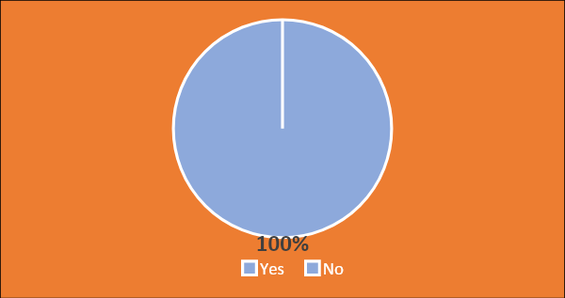
The result for this question has been phenomenalas 100% of the respondents of the Trinity campus had taken the belief that using the VLE as the partner in learning would have made them greater in shape to perform in the exam(Eresh, 2020). Moreover, using the resources than ever-before in Covid19 has been remarkable among the students to get back into life through virtual learning.
Question-7
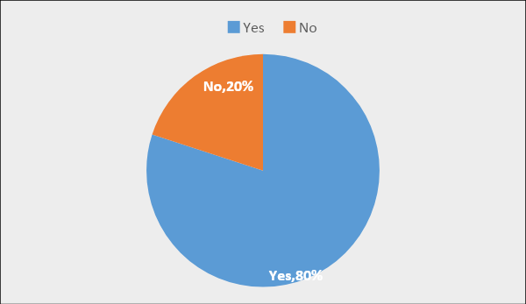
80 percent of total participants have given the vote in positive that they loved to get feedback with structured and written-manner from teachers as those things would be taken from the VLE.VLE Moodle provided education and information over time connecting the students to catch up with the class even though they might miss one or many due to some reasons.

Question-8
This has been a very useful question to ask the respondents as they are seniors in different majors in the University and have been experienced to face exams. 90% of them suggested using VEN to get a good figure in the exam and they would suggest it to their juniors too (Jovaba, 2018). That proves the sanity and user-friendliness of the Moodle.
Question-9 and Question-10
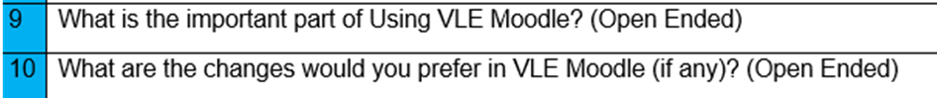
The answer would be an intellectual one from the respondents but categorizing all the responses. This has been found that busy students would save time through the Digital platform and using the resources with unconditional access to the resources. No negative comments are found in the confidential open-ended question. The biggest need that has been fulfilled by the Service of Moodle in this University is its up-to-date academic information and resources of different varieties to look up the needs for free at any time to create the assignments(Hamburg, 2017). In the final question, some suggestions are being asked to provide if students of the sample think which would vigorous and plentiful to cut even better performance in the exam and secure efficiency in the time-management.

Secondary dataanalysis
As this topic has been about the qualitative data with the impact of Virtual Learning Environment (VLE) for the students particularly. Primary-research and the secondary-research are two ways to conclude the impact of the VLE on the students' learning-experiences(Carlesen, 2020). Even in the Corona-time, the lectures are not being missed and the concept of having the resources at quick need before any quiz and exam have been easily found (Chris, 2020). Two traits of the VLE, actively assistant to the weak students and huge-storage for resources offering two-way communication, are being acknowledged while researches on this topic by researchers (Cooper & Schindler, 2016). VLE is a one-stop solution for the students to get data and follow-up the class in the normal days as well as in corona season (Stewart and Lesage, 2020). Even in the Corona-time, the lectures are not being missed and the concept of having the resources at quick need before any quiz and exam have been easily found. VLE and its effective use has been unique and profitable for both parties and being more content with the results (Flick, 2015). The sample has been having a good time in VLE Moodle to get an education by themselves to have the proper education on the exams. Therefore, the usefulness in strategic education and superlative communication with the teachers through the Moodle to participate in the assessment test(KALAYCI, 2015). As an expectation, an additional emergency call to the professors would be really helpful if permission would be earned according to the research papers need.

Conclusion and Recommendations
Even in the Corona-time, the lectures are not being missed and the concept of having the resources at quick need before any quiz and exam have been easily found. The impact of the Virtual Learning Environment over the student's learningexperience has been found with enormous positivity that has been arising through the user compatibility and 90% or more Yes response from the analysis part(Li, 2020). As authentic and confidential data from the students of the University of Wales has been adjusted in the analysis part, there has been no chance to have any discrepancies with the sample-hesitation.The analysis would allow the teachers and students to get even more confidence to get accustomed to the digital; platform to complete the class. Moreover, VLE has performed for the administration to get a better view of what student’s jurisdiction has(Kerel, 2020) been overtime on VLE. Few recommended things would be added to the whilst list from this small-scale research that is being added hereunder.
- Showing the results using graphs and recommending the gist from the analysis of the exam report would be added to the student profiles so that it would be a yardstick to push the students for better learning(Stewart & Lesage, 2020).
- The students suggest to take the class on the VLE and upload it to its storage so that anyone can have that.
- Virtual Learning Environment for the students particularly from the University of Wales Trinity Saint David London Campus would be impactful if the deadlines of the assessment would be highlighted over time and SMS to the phone would be (Migel, 2013) sent accurately like an app.

References
Carl 2020. How To Boost Digital Skills Through Learning & Development. Available from: https://digitalmarketinginstitute.com/blog/how-to-boost-digital-skills-through-learning-development (Accessed: 13 November 2020).
Carlesen 2020. The Importance of Training and Development in the Workplace. Available from: https://2020projectmanagement.com/resources/project-management-training-and-qualifications/the-importance-of-training-and-development-in-the-workplace (Accessed: 13 November 2020).
Chris 2020. 8 Benefits of Virtual Learning Environments (Importance of Virtual Classrooms). Available from: https://funtech.co.uk/latest/benefits-virtual-learning-environments-classrooms (Accessed: 13 November 2020).
Cooper, D. & Schindler, P. 2016. Business research methods. McGraw-Hill Irwin, Boston.
Eresh 2020. Virtual Learning. Available from: https://www.wikijob.co.uk/content/interview-advice/competencies/core-competencies (Accessed: 13 November 2020).
Flick, U. 2015. Introducing research methodology. Sage Publications, London.
Hamburg, I. 2017. Digital Skills For Eco-Innovative Entrepreneurship. Advances in Social Sciences Research Journal. 4 (14).
Jovaba, R. 2018. The number of virtual learning environment and their effective using impact on students’ information literacy. Journal of Advances in Humanities and Social Sciences. 4 (2).
KALAYCI, S. 2015. Students’ Attitudes Towards Collaborative Tools In A Virtual Learning Environment. EDUCATIONAL PROCESS: INTERNATIONAL JOURNAL. 4 (1-2). pp. 71-86.
Kerel 2020. How Virtual Learning is Transforming K-12 Education. Available from: https://online.campbellsville.edu/education/virtual-learning-transforms-education/ (Accessed: 13 November 2020).
Li, L. 2020. 12 Ways Technology Can Increase Workplace Productivity. Available from: https://www.tinypulse.com/blog/12-ways-technology-can-increase-workplace-productivity (Accessed: 13 November 2020).
Migel, S. 2013. Evaluating students’ perception of a three-dimensional virtual world learning environment. Knowledge Management & E-Learning: An International Journal. pp. 323-333.
Stewart, N. & Lesage, F. 2020. SEARCHING FOR TASKS: TASK-ORIENTATION AND THE PROCESSUALITY OF DIGITAL SKILLS. AoIR Selected Papers of Internet Research.

