

East meets West
Beauty Parlour

Three Year Business Plan

May 2023

Name: Mehwish Nawaz

Student I.D: 2021045

Module: managing enterprise BMSW4011

3rd July 2023

contents

Private & Confidential

Qatar Foundation
[Type the company address]
[Type the phone number]
[Type the fax number]
[Pick the date]

3.0 PROJECT SCOPE 3
1. Product/Service Proposition: 3
2. Name of Business/Owner(s) and Type of Business Ownership: 3
3. Mission Statement/Aim and Objectives of the Business: 3
4. Location 3
5. Human Resources: 4
6. Marketing Activities: 4
7. Financial Resources: 4
8. Strengths, Weaknesses, Opportunities, and Threats (SWOT Analysis): 4
4.3 CASH FLOW 6

Introduction

According to tv choice every business needs the business plan. A all-business primes has the same structure, because they all have to answer the same fundamental questions and what’s the business try to do, how to business going to produce its product and what’s the business needs to get going and how is the money going to work. (a tv choice production, 1997).

East meets West Beauty Parlour is the trading name of East meets West Beauty Parlour Ltd (EWBP). EWBP is a unique beauty parlour project focused on providing quality, health focused beauty treatments for the residents of Cardiff.

Overview

Established as a start-up project by Mehwish Nawaz in 2023, EWBP has is aiming to be a local hub for clients from the wider Cardiff geography and beyond. EWBP recently acquired a leasehold of the current premises at 121 Albany Road consisting of a small retail unit customised to offer beauty treatments.

This business plan sets out the 3-year strategy for the project from 2023. To achieve the project’s strategic objectives and be fit for purpose, the new facility requires a comprehensive remodelling, there is a specific focus within this business plan on how and when this will be achieved.

- Product/Service Proposition:

East Meets West Beauty Parlour aims to provide quality, health-focused beauty treatments for the residents of Cardiff (Sellan, 2016). EWBP services will include a wide range of beauty treatments such as facials, massages, body treatments, manicures, pedicures, waxing, and makeup application. It will prioritize the use of natural and organic products to promote holistic well-being and cater to the increasing demand for eco-friendly beauty solutions (Kosta, 2023).

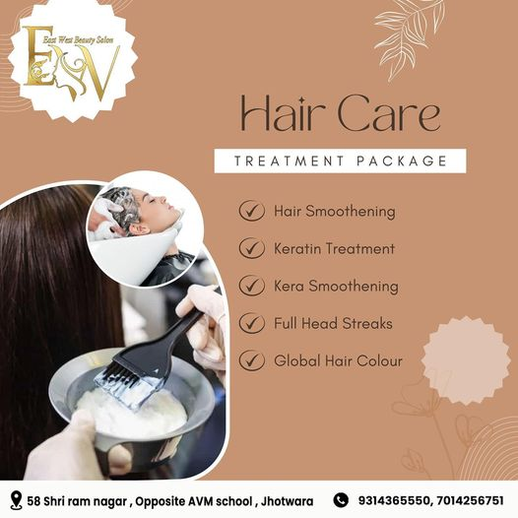

2. Name of Business/Owner(s) and Type of Business Ownership:
The business name is East meets West Beauty Parlour, and it is owned by a partnership consisting of two individuals: Sarah Smith and Lisa Johnson are qualified beauty therapists.

3. Mission Statement/Aim and Objectives of the Business:
Provide exceptional beauty treatments that promote natural beauty, and holistic well-being, and enhance the confidence of the clients (Hennigan, 2020). EWBP strive to create a relaxing and welcoming environment where individuals can indulge in self-care and discover their inner and outer radiance.
Aim and Objectives:
- Deliver outstanding customer service: EWBP aim to provide a personalized and memorable experience to every client, ensuring their satisfaction and loyalty (Tait, 2023).
- Stay updated with industry trends and techniques: EWBP will continuously invest in training and development to offer the latest beauty techniques, products, and services (Barge, 2018).
- Establish a reputable brand: EWBP aim to become the premier beauty parlour in Cardiff, known for the quality treatments, exceptional customer service, and commitment to eco-friendly practices (Shelby, 2022).

4. Location
EWBP is located on Albany Road. Albany Road in Cardiff is a prime location for a beauty therapy-type business. Albany Road already has many hairdressers, but there seems to be a lack of beauty parlours for ladies. Albany Road is a central location with a large footfall (Salon Management, 2016).
The leased premises consist of 2000 square feet including a small office space, storage area and a large retail front.
To operate East meets West Beauty Parlor and provide quality beauty treatments, a range of essential equipment will be required. This includes facial steamers, massage tables, waxing stations, manicure and pedicure stations, sterilization equipment, salon chairs, hairdressing tools, mirrors, and lighting fixtures. Additionally, equipment and supplies will be carefully selected to ensure they meet industry standards, enhance the customer experience, and contribute to the overall functionality and aesthetics of the beauty parlor.

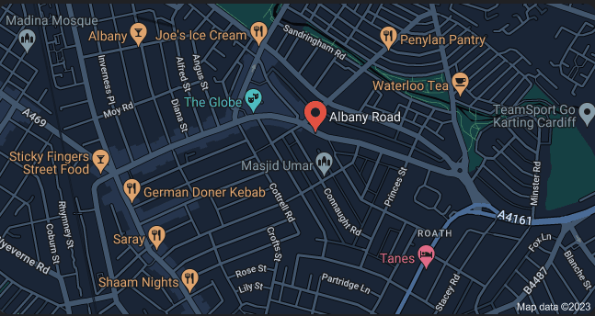

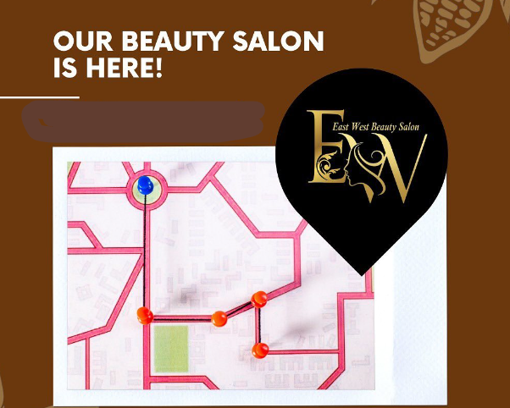

5. Human Resources:
In the initial phase, the plan is to hire the following individuals:
- Beauty Therapists: They will be responsible for providing high-quality services to the clients, including facials, massages, body treatments, manicures, pedicures, waxing, and makeup application (Sarmiento, 2023).
- Receptionist/Administrative Staff: One receptionist/administrative staff member who will handle various tasks such as appointment bookings, client inquiries, and managing administrative responsibilities (Salon Proactive, 2021).

6. Marketing Activities:
The marketing and promotional activities will include the following:
- Social Media Marketing: EWBP will create and maintain active profiles on popular social media platforms such as Instagram, Facebook, and Twitter. Through these channels, it will share informative content, beauty trends and engage with the audience through contests, giveaways, and interactive posts (Lister, 2022).
- Collaborations and Partnerships: These collaborations can include sponsored posts, guest blogs, and joint events to increase brand visibility and reach a wider audience (Meevo, 2023).
- Referral Program: EWBP will incentivize the existing clients to refer their friends and family to the beauty parlour by offering special discounts or rewards for successful referrals (Salon marketing, 2019).
- Loyalty Programs: This program may include discounts, exclusive offers, and VIP perks to encourage customer loyalty and retention.

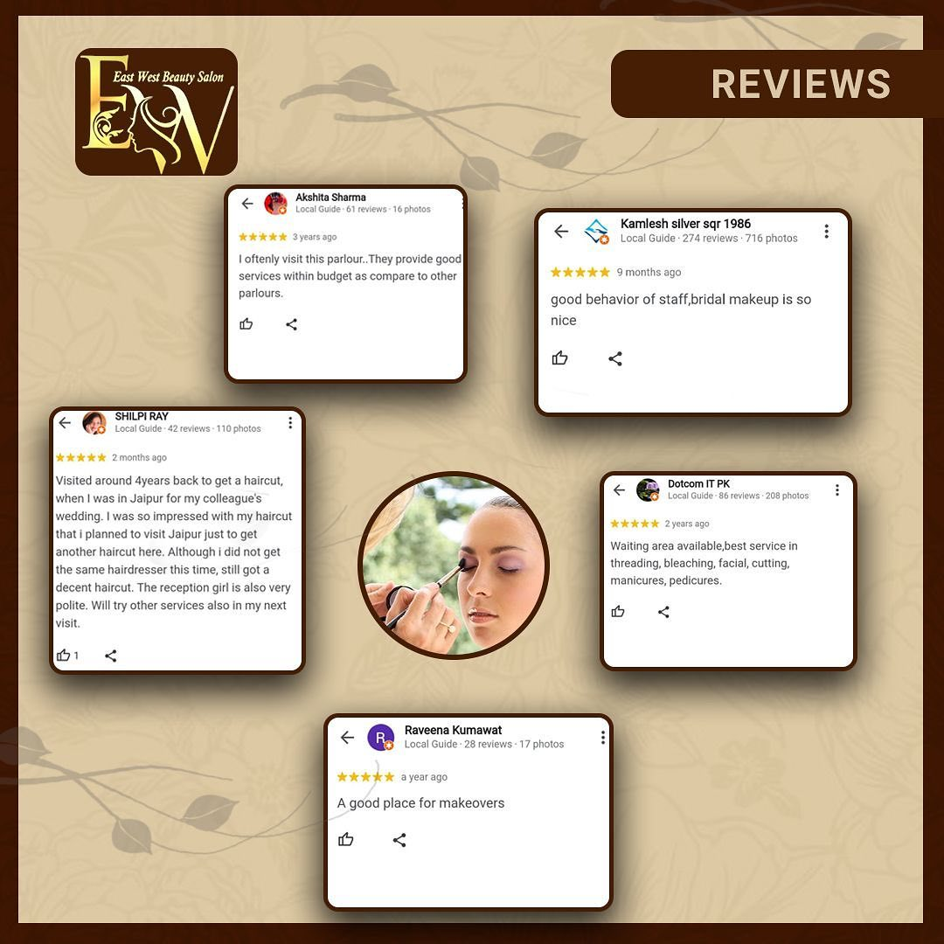

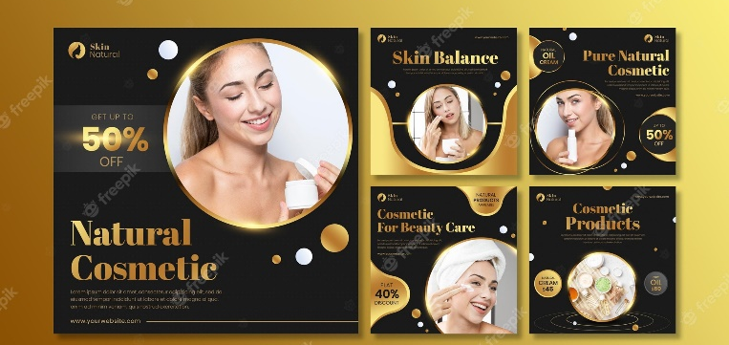

7. Financial Resources:
The business sources of finance for East meets West Beauty Parlour include the following:
- Personal Investment: The owners, Sarah Smith, and Lisa Johnson, will contribute personal savings and investments to fund the initial setup and operational costs of the beauty parlour.
- Bank Loan: EWBP will seek a small business loan from a reputable bank to cover the remaining capital requirements for facility remodelling, equipment purchase, and initial marketing expenses. The parlour has conducted thorough financial projections and ensured the loan repayment plan is realistic and feasible within the projected cash flow.
- Potential Investors: EWBP may explore the possibility of attracting potential investors, such as family and friends, who share the vision and can provide additional financial resources to support the growth and expansion of the business.

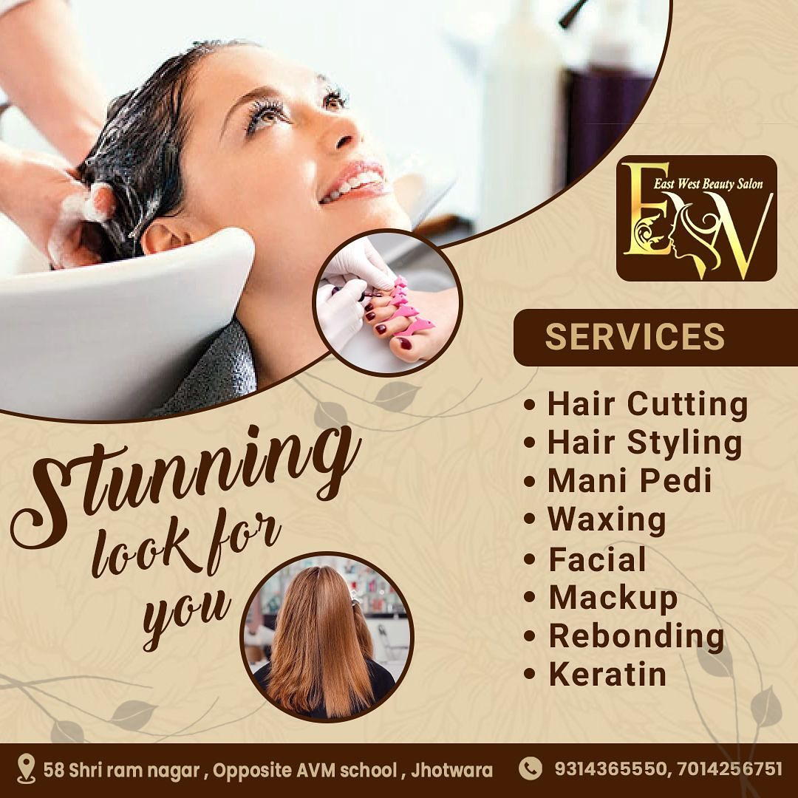

8. Strengths, Weaknesses, Opportunities, and Threats (SWOT Analysis):
Strengths:
- Skilled and Passionate Team: The team of beauty therapists is highly skilled, experienced, and passionate about providing exceptional service to clients. Their expertise ensures that the treatments meet the highest standards.
- Strategic Location: Being in Cardiff, a vibrant and diverse city, provides us with access to a large customer base. The demand for beauty treatments is high in this area, presenting a significant opportunity for business growth (Karam, 2023).

Weaknesses:
- Limited Brand Awareness: As a new beauty parlour, the brand awareness might be initially limited. It will be crucial to invest in marketing and promotional activities to establish ourselves in the market.
- Recruitment and Retention of Skilled Staff: Finding and retaining skilled beauty therapists can be a challenge in a competitive industry. EWBP must implement effective recruitment strategies and provide a positive work environment to attract and retain talent.

Opportunities:
- Growing Market: The beauty industry continues to grow, driven by increasing consumer interest in beauty and wellness. This presents an opportunity for East meets West Beauty Parlour to tap into a growing market and attract a steady flow of customers.
- Rising Demand for Health-Focused Treatments: The trend towards natural and holistic beauty treatments is gaining momentum. By focusing on health-focused beauty treatments and using organic products, this can capitalize on this growing demand.

Threats:
- Intense Competition: The beauty industry is highly competitive, with numerous existing beauty parlours and spas in the area. EWBP will need to differentiate ourselves through the unique value proposition, exceptional service, and innovative marketing strategies.
- Economic Factors: Economic downturns or recessions can impact consumer spending on non-essential services, including beauty treatments. This should be prepared to adapt the pricing strategies and offerings during such periods (IC, 2020).

Key Strategic Objectives

EWBP has established ambitious but realistic strategic objectives by 2026. These are predicated on achieving the first objective – securing the required capital to fund the building upgrade works required to make the premises fit for purpose. It is envisioned that equity shall be secured from personal funds.

EWBP aims to become the primary destination in Central Cardiff and for beauty services; continuing to provide a wide variety of highly valued services to clients from Cardiff and beyond.

A snapshot of the projected cash flow statement as follows:

2.0 STRATEGIC OBJECTIVES

By period:

Short term (2023) | Medium term (2024) | Long term (2025)
- Secure Personal funding of £50,000 | - Complete all building remodelling and refurbishment | - Increase regular revenue streams
- Initiate Refurbishment of premises | - Initiate phase 2 of project implementation – new service streams and reinstatement/scaling up of existing steams. | - Further comprehensive Marketing Plan
- Initiate Marketing plan | - Increase number of employees
- Employ 1 employee | - Achieve consistent and regular revenue streams
- Open for business

CASH FLOW

References

A Tv choice production. (1997). How to do a business plan. https://video.alexanderstreet.com/embed/how-to-do-a-business-plan (accessed 30th May 2023).
IC. (2020). 7 beauty salon risks. [Online] Insurance Choice. Available at: https://www.insurancechoice.co.uk/blog/2020/01/7-beauty-salon-risks [Accessed: June 07, 2023].
Karam, I.J. (2023, January 13). Beauty Salon SWOT Analysis: Strengths, Weaknesses, Opportunities & Threats. [Online] Business and Plans. Available at: https://businessandplans.com/beauty-salon-swot-analysis-strengths-weaknesses-opportunities-threats/ [Accessed: June 07, 2023]
Salon marketing. (2019, November 6). Marketing Strategies for Salons & Spas. [Online] Get Timely. Available at: https://www.gettimely.com/the-source/salon-marketing/marketing-strategies-for-salons-spas/ [Accessed: June 07, 2023]
Meevo. (2023). 50 Salon Marketing Ideas to Elevate Your Business. [Online] Meevo. Available at: https://www.meevo.com/blog/50-salon-marketing-ideas/ [Accessed: June 07, 2023].
Lister, M. (2022). 17 Hair-Raising Salon Marketing Ideas. [Online] Mary Lister. Available at: https://www.marylister.com/hair-raising-salon-marketing-ideas/ [Accessed: June 07, 2023].
Salon Proactive. (2021). HR Salon Management: The five employee needs. [Online] Salon Proactive. Available at: https://www.salonproactive.com/en/hr-salon-management-the-five-employee-needs/ [Accessed: June 07, 2023].
Sarmiento, B. (2023). Role of Human Resource Officers in A Salon's Employee Retention. [Online] Zoya. Available at: https://www.zoyya.com/blog/role-of-human-resource-officers-in-a-salons-employee-retention#:~:text=So%20what%20do%20human%20resource,can%20provide%20to%20your%20clients. [Accessed: June 07, 2023].
Salon Management. (2016). Choosing the perfect location for your salon. [Online] Salons Direct. Available at: https://www.salonsdirect.com/blog/choosing-the-perfect-location-for-your-salon/#:~:text=Being%20situated%20in%20a%20well,make%20sure%20it's%20well%20lit. [Accessed: June 07, 2023].
Shelby, E. (2022). 5 Long-Term Business Goals for a Salon or Beauty Business. [Online] Startup Mindset. Available at: https://startupmindset.com/5-long-term-business-goals-for-a-salon-or-beauty-business/ [Accessed: June 07, 2023].
Barge, K. (2018). Objectives for Hair Salons and Spas. [Online] Bizfluent. Available at: https://bizfluent.com/objectives-for-hair-salons-and-spas.html [Accessed: June 07, 2023].
Tait, H. (2023). 5 Examples of Effective Hair Salon Goals and Objectives. [Online] Shortcuts. Available at: https://www.shortcuts.co.uk/five-examples-of-effective-hair-salon-goals-and-objectives/#:~:text=Increase%20retail%20products%20sales&text=Your%20objectives%20could%20be%3A,relevant%20products%20during%20their%20service [Accessed: June 7, 2023].
Sellan, F. (2016). What Is Your Salon's Unique Selling Point? [Online] LinkedIn. Available at: https://www.linkedin.com/pulse/what-your-salons-unique-selling-point-frank-sellam/ [Accessed: June 07, 2023].
Appointy. (2021). How To Write the Perfect Salon Business Plan for Your Salon in Just 7 Simple Steps. [Online] Appointy Blog. Available at: https://blog.appointy.com/2021/07/16/salon-business-plan/ [Accessed: June 07, 2023].
Kosta, K. (2023). Free Hair and Beauty Salon Sample Business Plan. [Online] Bplans. Available at: https://articles.bplans.com/hair-and-beauty-salon-sample-business-plan/ [Accessed: June 7, 2023].
Hennigan, C. (2020). Wellness trends impacting the beauty industry. [Online] Mintel. Available at: https://www.mintel.com/beauty-and-personal-care-market-news/wellness-trends-impacting-the-beauty-industry/ [Accessed: June 07, 2023].

