
CORPORATE SOCIAL RESPONSBILITY
Sustainability within McDonalds

LUIza mcconnell
P146656
University of Wales Trinity Saint David

Table of Contents
Executive Summary ………………………………………………………………………………………………………………………..2
Introduction ……………………………………………………………………………………………………………………………………3
What is Corporate Social Responsibility ………………………………………………………………………………………….3
Archie Carroll’s CSR Pyramid …………………………………………………………………………………………………………..3
Triple Bottom Line ……………………………………………………………………………………………………………………..…..4
What is Sustainability ……………………………………………………………………………………………………………………..4
Sustainability in McDonalds ………………………........................................................................................5
Environmental Sustainability …………………………………………………………………………………………………………. 5
Social Sustainability …………………………………………………………………………………………………………………………5
Economic Sustainability …………………………………………………………………………………………………………………..5
Milton Friedman’s Shareholder Theory …………………………………………………………………………………………..6
Edward Freeman’s Stakeholder Theory …………………………………………………………………………………………..6
Stakeholder Mapping for McDonalds …………………………………………………………………………………………… 7-8
Challenges faced by McDonalds ……………………………………………………………………………………………………..8
Conclusion ………………………………………………………………………………………………………………………………….…..9
Recommendations for McDonalds ……………………………………………………………………………………………….…9
References ………………………………………………………………………………………………………………………………….…10

Executive Summary
This report shows the ways in which McDonalds is using CSR in ways to allow them to become a more sustainable and ethical business. It looks at what CSR is and the ways in which McDonalds use Archie Carroll’s CSR Pyramid to assess their social responsibilities. It also looks at how McDonalds looks at the triple bottom line to see at which points they are sustainable. It also looks at sustainability within McDonalds and what actions they are taking in order to be sustainable. It also includes Edward Freeman’s and Milton Friedman’s theory and how McDonalds have applied it to themselves. It also looks at challenges which McDonalds faces such as employee minimum wages and recyclable materials within their restaurants. Finally, there are recommendations made in order to help McDonalds with the challenges they face.

Introduction
In this report I will be carrying out research in to the concept of CSR and sustainability for McDonalds. I will be looking at and analysing what CSR is and using Archie Carroll’s CSR Pyramid in order to analyse what McDonalds currently do towards in conjunction to these responsibilities. I will then be looking at the triple bottom line and also applying that McDonalds. I will then look at Freeman and Friedman’s theories and how they can be applied to McDonalds and the way in which they run. Finally, I will be looking at what challenges McDonalds is faced with and then making some of my own recommendations to overcome these.
Main Body
What is Corporate Social Responsibility?
Corporate Social Responsibility (CSR) purpose is to make sure that companies are carrying out their business in an ethical manner. It is a business approach which ensures that organisations must be mindful of their social, economic and environmental impacts, in addition to their consideration of human rights. By having a consideration of human rights, businesses look to be ethical in order to avoid any negligence. (The University of Edinburgh, 2017)
CSR looks at various areas such as; working conditions, environmental impacts, human rights, economic contribution, and so on. There are always different ways in which CSR can be viewed. There is Edwards Freeman’s stakeholder theory and Milton Friedman’s shareholder theory.
Archie Carroll’s CSR Pyramid is a framework which consists of four responsibilities which must be met in order for businesses to ensure they meet their social responsibilities. These four responsibilities are; Philanthropic, Ethical, Legal and Economic, as seen below in Figure 1.
Figure 1: Carroll’s CSR Pyramid
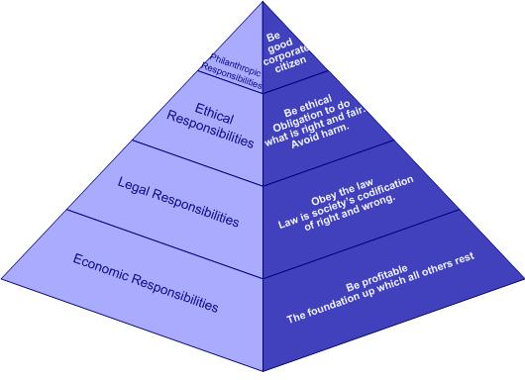
Source: (Dudovskiy, 2012)
Triple Bottom Line
The Triple Bottom Line is a CSR framework which consists of three factors, which are; People, Profit and Planet. As seen in Figure 2.
The triple bottom line diagram was created by Venn Elkington (1997) in order to allow organisations to see at which point they are able to be sustainable when looking at the other areas around the centre. The organisation must ensure that they are able to explain their actions for profit, which would be to make a return for their shareholders. They must also take in to account the people, both the employees of the organisation and others who may be effected by the organisation and finally the planet, which is one of the main factors in this diagram, as it ensures that the raw materials and actions which are carried out by the organisation are sustainable and how they affect the environment as a whole. (Elkington, 1997)
Figure 2: Triple Bottom Line Diagram
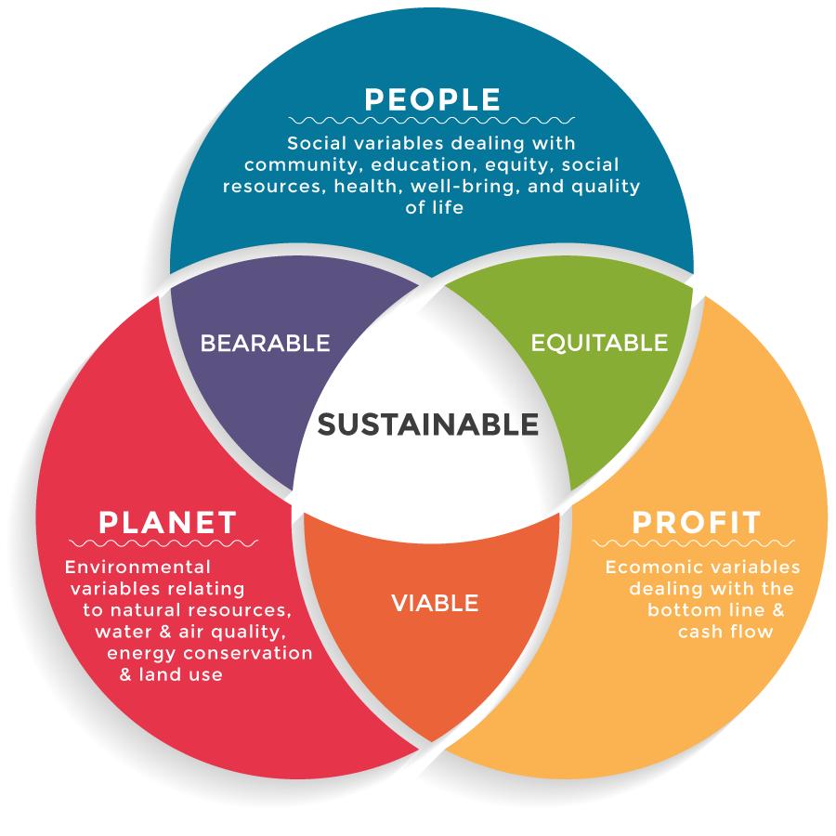
Source: (The Economist, 2009)

What is Sustainability?
Business sustainability is described as managing the triple bottom line, whereby companies must manage their social, financial and environmental risks as well as their obligations and opportunities. These three impacts can also be referred to as – people, profit and planet.
Business sustainability means that organisations must obey to the principles of sustainable development. The World Council for Economic Development, described sustainable development as the development which “meets the needs of the present without compromising the ability of future generations to meet their own needs”. In order to industrial development to be sustainable, they must address issues which come in the macro level, which studies the behaviour of individuals and firms and they interactions. These include; economic efficiency, environmental accountability and social equity. (Financial Times, n.d.)
It has been said that businesses whom are sustainable are able to attract and retain employees are greater ease whilst experiencing less financial and reputational risk. They are also able adapt easier to any environmental changes.

Sustainability in McDonalds
“We believe it’s important for everyone to help protect and preserve the environment for future generations, and we’re always looking for ways to reduce, reuse and recycle in our restaurants and across our whole business.” – McDonalds
Environmental Sustainability
McDonald’s wish that by 2025, that all of their packaging will be renewable and recyclable. Together with their suppliers and employees, the company will make several changes in order to help and have an impact on the community in which they serve. Currently, their sustainable packaging dates back to 25 years ago where they created a partnership with Environmental Defence Fund (EDF) where they stopped using polystyrene boxes, which helped them drastically reduce their environmental impact by minimising solid waste. Which shows that McDonalds has put CSR in to place, as they are responsible for ensuring that they do not pollute air or water and using only biodegradable and/or recycling materials. (Corporate.mcdonalds.com, n.d.)
Social Sustainability
In regards to social responsibilities, McDonalds set up the Ronald McDonald foundation in 1974. This not-for-profit organisation was set up in order to help support families of sick children around the world by providing things such as family rooms, support systems and so on. McDonalds have provided vital resources for this charity, they have made a number of contributions and helped with volunteering. They have also done marketing promotions and placed money boxes in their restaurants to help raise money. In turn McDonalds have helped raise over $300 million for the Ronald McDonald foundation and also built 14 Ronald McDonald houses in the UK. (Rhmc.org, n.d.)
Economic Sustainability
McDonalds have economic responsibilities as they set out to achieve profits and to grow successfully on an international scale. Currently, records show revenues of $5.75bn in the last three months after completing the sale of their Asian stores. This has created a 10% loss compared to last year. (BBC News, 2017)

Milton Friedman’s Shareholder Theory
Milton Friedman (1970) believes that the management’s main responsibility for the business is to maximise the profits of the organisation and their shareholders. Friedman believes that organisations should solely act upon the interests of their shareholders, as they do not have a moral responsibility for their actions, thus meaning they do not have to act in an ethical manner. (Friedman, 1970)
It has been questioned by Becker (2012) whether big organisations, such as McDonalds, should focus on sustainability or whether they should just focus on profit maximisation as Friedman has said. The reason for this being that they believe that these organisations already provide a number of benefits to both the society and economy in terms of things such as; employment and so on. It is also believed by Husted and De Jesus Salazar (2006), that it is better for the organisation to focus on their profit maximisation as opposed to putting their efforts and money in to focusing on sustainability. The reason for this being that in their opinion, trying to be sustainable is a waste of money, time and resources. (Becker, 2012)
Like Friedman, McDonalds also believe in profit maximisation as they pay their employees minimum wage in order to keep costs down. However not to the extent in which Friedman does, as they believe in increasing their profits whilst still doing what they can in order to be sustainable and act ethically.
Edward Freeman’s Stakeholder Theory
However, in conjunction to Friedman’s theory, Edward Freeman (2010) believes that organisations should not only focus on the needs of their shareholders, as there are also other parties who aid towards the profit and reputation of an organisation, a good example being its customers. Below in Figure 3, is Freeman’s Stakeholder model. However, here it does not show who would be an organisations primary and secondary stakeholders. Due to there being a number of stakeholders whom are able to effect a company’s reputation, a firm is able to look at primary and secondary stakeholders, in a map which was also created by Freeman. This allows organisations to be able to discover which stakeholders have the most power and therefore being their top priority. (Carroll & Buchholz, 2000).
McDonald’s has three main stakeholders which are; their customers, suppliers and employees. However, they also engage with a larger range of audiences who share common interests in the community in which they operate.

Figure 3: Freeman’s Stakeholder Model
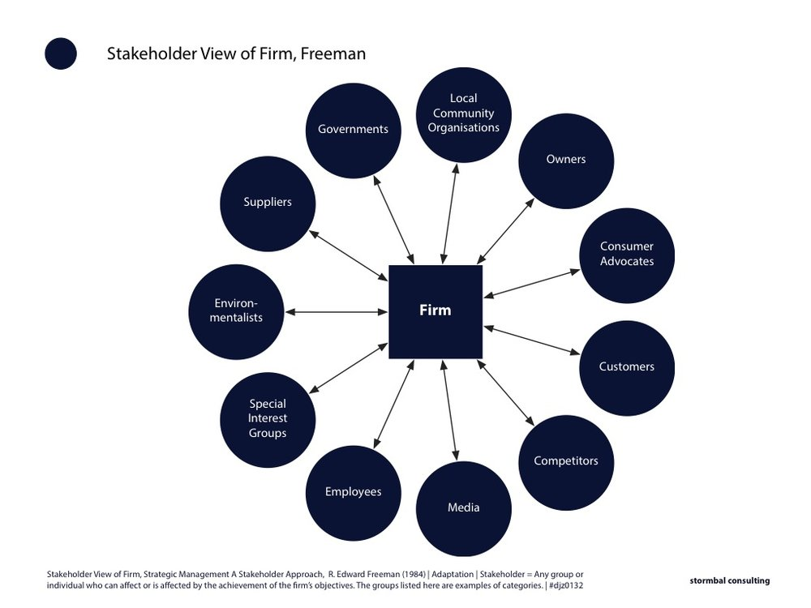
Source: (Stormbal Consulting, 2016)

Figure 4: Freeman’s Stakeholder Model for McDonalds

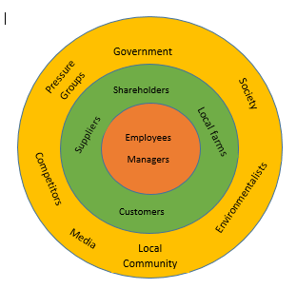

Figure 5: Stakeholder Mapping for McDonalds

Keep Satisfied  Government | Manage Closely  Managers  Shareholders  Customers
Monitor  Competitors | Keep Informed  Suppliers  Pressure Groups  Employees  Local Community

Figure 5, shows McDonalds’ stakeholder mapping based on that of Freeman. In this model the stakeholders are divided up in to four sectors; those to monitor, to keep informed, to keep satisfied and to manage closely. However, it is important that organisations carry out research on its stakeholders before placing them under certain categories. It is questioned where on this grid organisations should place its customers. In figure 5 above, the customers of McDonalds have been placed as a high power and high interest stakeholder.
Rangan Et Al (2015), believes that with the help of sustainability and not just stakeholders, that organisations are able to benefit themselves whilst also upholding their reputation and adding value to the supply chain.

Challenges Faced by McDonalds
There are many challenges which are faced by McDonalds, however, one of their main challenges would be the disposal of their waste as this is something which all organisations must focus on globally as it is one of the main factors which is affecting the environment. McDonalds long-term goal is to not send any waste to landfill and to try and recycle the most that they can. McDonalds already currently recycle all the cardboard which they use in over 95% of their stores, and as of 2012, they also started recycling their kitchen milk bottles.
McDonalds have also redesigned their sandwich boxes which in turn now saves over 423 tonnes of material annually. Not only this, but they have also ensured that things such as their napkins, bags and cup carriers are made from 100% recycled material and in turn these changes have meant that now 80% of McDonalds packaging comes from renewable and recycled sources. (McDonalds, 2012)
Most of McDonalds’ employees work on a zero hour contract whilst getting paid just above the minimum wage. In 2015, McDonalds announced that they would slowly start raising the wages of their employees with the hopes of paying them $10 an hour by 2016. The CEO of McDonalds has agreed that by raising the wages of his employees, the company’s performance is also increased and evidence has shown that this wage raise has helped to boost corporate profits. (McDonalds, 2013)

Conclusion
To conclude, it is clear to see that sustainability is an important factor which all organisations must take in to account in all aspects of their business. The way in which a business carries out its CSR can have a knock on effect on both their profit and reputation and also their competitive advantage. McDonalds are not the best they can be when it comes to sustainability but they have improved significantly over the past couple of years in order to become more environmentally friendly. If McDonalds are able to take all of their stakeholders in to account and show themselves being socially, environmentally and economically responsible they will achieve profit maximisation, brand reputation and a competitive advantage. McDonalds hope that by doing this it will help them to grow and succeed in today’s society.

Recommendations for McDonalds
In relation to McDonalds lowering the pollution of domestic waste, I would recommend implementing a colour scheme recycling system which would allow customers to easily recycle McDonalds’ packaging. An example of this could be a small green stripe on their cups to show that they should be thrown in the green bin and a red stripe on their lids to show that they are recycled in another bin. By making this process more fun for its customers, it will increase the number of customers choosing to recycle and in turn would help McDonalds lower their landfill waste and carbon footprint.
Regarding the stigma which is around McDonald’s minimum wage, another recommendation which I would make, would be to increase the wages across all restaurants. It will help them to retain their staff, gain both internal and external reputation, increase their competitive advantage and also in time, maximise their profit.

References
BBC News. (2017). McDonald's Serves Up Surge in Sales. [online] Available at: http://www.bbc.co.uk/news/business-41728541 [Accessed Jan. 2018].
Becker, C. (2012). Sustainability Ethics and Sustainability Research. 1st ed. Netherlands: Springer Netherlands.
Carroll, A. and Buchholtz, A. (n.d.). Business & Society: Ethics and Stakeholder Management. 4th ed. United States of America: Dave Shaut, pp.39-40.
Corporate.mcdonalds.com. (n.d.). More Sustainable McDonald's Packaging and Customer Recycling :: McDonald’s. [online] Available at: http://corporate.mcdonalds.com/mcd/sustainability/planet/packaging-and-recycling.html [Accessed Jan. 2018].
Crane, A. and Matten, D. (2016). Business Ethics. 4th ed. Oxford, p.48.
Dudovskiy, J. (2012). Carroll’s CSR Pyramid. [online] Research Methodology. Available at: https://research-methodology.net/carrolls-csr-pyramid-and-its-applications-to-small-and-medium-sized-businesses/ [Accessed Jan. 2018].
Elkington, J. (1997). Cannibals with Forks: The Triple Bottom Line of 21st Century Business. Makato: Capstone Publishers.
Lexicon.ft.com. (n.d.). Business Sustainability Definition. [online] Available at: http://lexicon.ft.com/Term?term=business-sustainability [Accessed Jan. 2018].
Miller, E. (2016). The Secret Recipe for McDonald’s Rising Profits? Better Wages.. [online] Jobs With Justice. Available at: http://www.jwj.org/the-secret-recipe-for-mcdonalds-rising-profits-better-wages [Accessed Jan. 2018].
Rmhc.org. (n.d.). Ronald McDonald House Charities. [online] Available at: https://www.rmhc.org/ [Accessed Jan. 2018].
Stormbal Consulting. (2016). Stakeholder view of firm, Freeman. [online] Available at: https://www.stormbal.com/100/stakeholder-view-of-firm-freeman [Accessed Jan. 2018].
The Economist. (2009). Triple Bottom Line. [online] Available at: http://www.economist.com/node/14301663 [Accessed Jan. 2018].
The University of Edinburgh. (2017). What is corporate social responsibility?. [online] Available at: https://www.ed.ac.uk/careers/your-future/options/occupations/csr/what-is-csr [Accessed Jan. 2018].
What makes McDonald's. (2012). Do you have a sustainable receylcing policy in place?. [online] Available at: http://www.mcdonalds.co.uk/ukhome/whatmakesmcdonalds/questions/environmental-impact/environment-policy/do-you-have-a-sustainable-receylcing-policy-in-place.html [Accessed Jan. 2018].
What makes McDonald's. (2013). I would like to know what your environmental issues are?. [online] Available at: http://www.mcdonalds.co.uk/ukhome/whatmakesmcdonalds/questions/environmental-impact/environment-policy/i-would-like-to-know-what-your-environmental-issues-are.html [Accessed Jan. 2018].

