ACDB5021 – Systems Engineering Taguchi Experiment

Samuel Hawkins¹

¹ UWTSD IQ Campus, Waterfront, IQ Campus University of Wales Trinity, Swansea SA1 8EW, UK; 2216506@student.uwtsd.ac.uk

Contents
1. Abstract 1
2. Introduction 2
3. Method and Apparatus 3
4. Experimental Data 4
5. Interpretation of Results 4
6. Conclusion & Reflection 7
References 9
Annex 10

Table of Figures
Figure 1 - Implementing Taguchi [2] 2
Figure 2 – Catapult [1] 2
Figure 3 - L8 Orthogonal Array [5] 3
Figure 4 - Band Front Position 5
Figure 5 - Band Anchor Position 5
Figure 6 - AB Interaction 5
Figure 7 - Stop Position 5
Figure 8 - Pull Back 6
Figure 9 - BC Interaction 6
Figure 10 - Operator 6

Table of Tables

Table 1 - Array Populated [Annex A] 4
Table 2 - Firing Results [Annex A] 4
Table 3 - Key Factor Test [Annex A] 7
Table 4 - Confirmation Test [Annex A] 7

Abstract

Through understanding and carrying out a Taguchi experiment, it has been determined that the Front Anchor Position and Pull Back Position are the key control factors that affect the performance of the catapult and through careful evaluation, the best parameters have been found to achieved the desired results whilst reducing noises.

Introduction

  - The aims of this report will be to outline the key control factors when operating a catapult using the Taguchi testing method and then show how it relates to systems engineering.

  - Taguchi is a statistical approach to design experiments in a way that optimises processes and improves output quality by reducing the variation in external factors, AKA noise. Implemented through the approach in figure 1. [1]

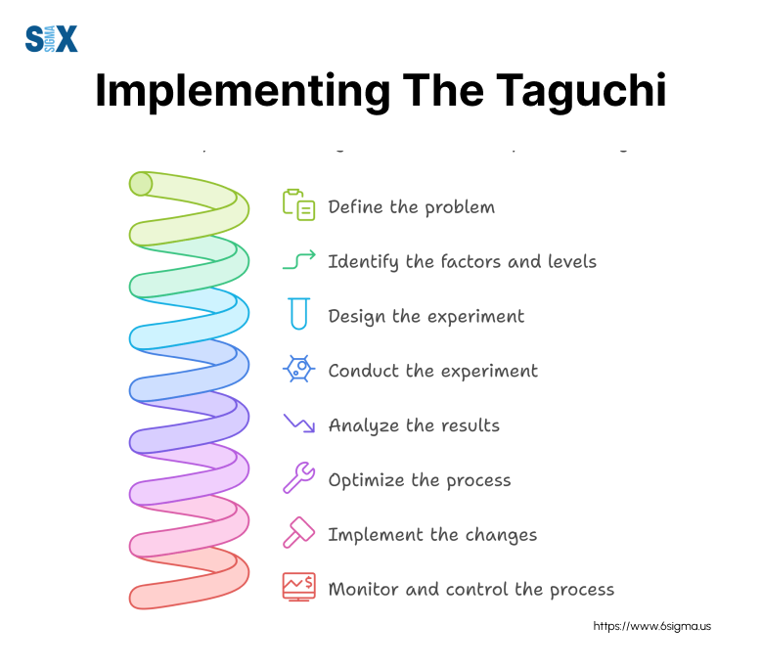
Figure 1 - Implementing Taguchi [2]
  - To demonstrate the effect of noises, a catapult experiment will be set up where settings will change, and the distance of the catapult launch will be measured. See figure 2.

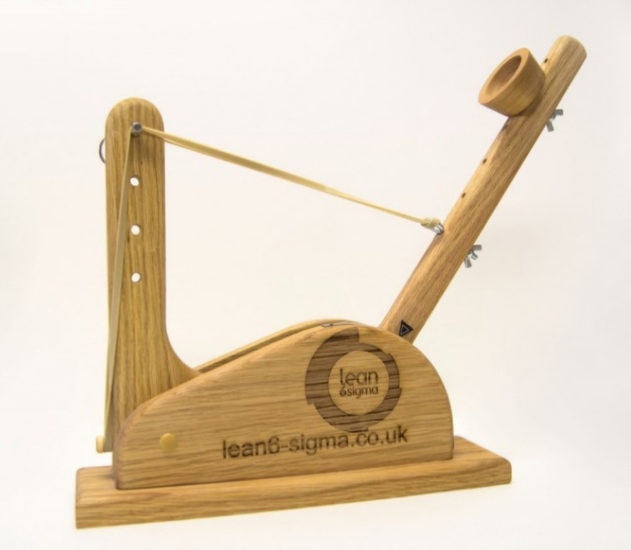
Figure 2 – Catapult [1]
  - A control factor is set by the designer as part of the experiment. [2]

  - Noises that come from the environment like wind speed, temperature and more cannot be controlled and so must be compensated for through control factors.

  - A level is the value to which the control factor is set. In most cases this is low or high, light or heavy, deep or shallow. [3]

  - The experiment is a combination of these factors that form the array. This allows for every combination of the factors to be tested instead of one at a time.

Method and Apparatus
  - To carry out this experiment, first the response and factors must be identified, this would be the launched distance of the of the ball from the catapult. The factors are:

  - Band Front Position
  - Band Anchor Position
  - Stop Position
  - Pull Back Scale
  - Operators
  - 1,2 Interaction
  - 2,4 Interaction

  - To understand the effect of control factors, they were incorporated into a L8 Orthogonal array that has 7 factors at 2 levels. See figure 3. This was then populated with the correct high and low values as seen in figure 4. [4]

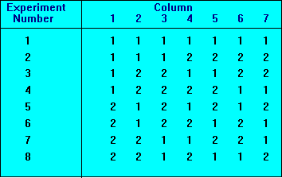
Figure 3 - L8 Orthogonal Array [5]

Table 1 - Array Populated [Annex A]
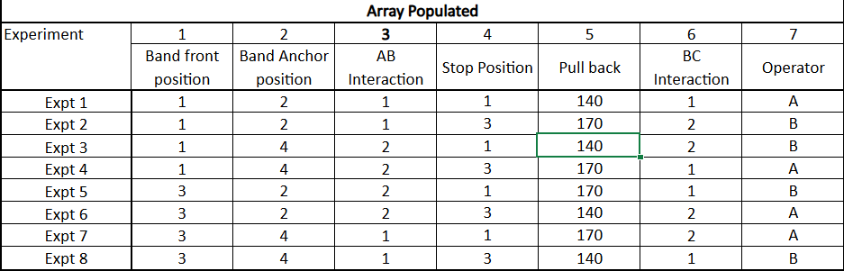

Experimental Data

  - From carrying 8 experiments with 7 factors at 2 levels, their effect can be determined from the range the catapult launches the ball. To ensure reliable results, each experiment was conducted three times. Results from the firings can be seen in table 2. Any outliers would be recorded and investigated.

Table 2 - Firing Results [Annex A]
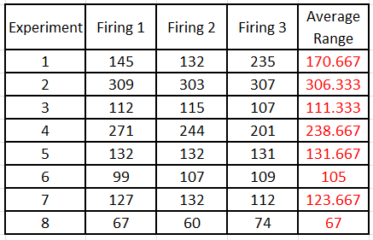

  - It can be seen from the results captured in table 2 that experiment 3 produced the best result with its combination of control factors. However, these may not be the best overall factors when trying to achieve a particular distance.

Interpretation of Results

  - The following graphs capture the results of each control factor averaged across the number of respective experiments they are involved in. See Annex A for catapult graphs.

Figure 4 - Band Front Position

Figure 5 - Band Anchor Position

Figure 6 - AB Interaction

Figure 7 - Stop Position

Figure 8 - Pull Back

Figure 9 - BC Interaction

Figure 10 - Operator

  - These graphs show that control factors Front Position (Figure 4) and Pull Back (Figure 8) deviate massively in relation to their levels, whereas the remaining factors have a very tight grouping and so deviation is less. As such these present the greatest noise to the experiment and are the key factors.

  - As a result of this, these two key factors have been taken and used in a second round of experiments to determine which level is optimal and which one introduced the greatest noise. As such, the other factors have been fixed:

Fixed

Anchor Position = 2
Stop Position = 3
Operator = B

Changing

Front position

Level 1 = 1
Level 2 = 3

Pull Back position

Level 1 = 140
Level 2 = 170

Table 3 - Key Factor Test [Annex A]
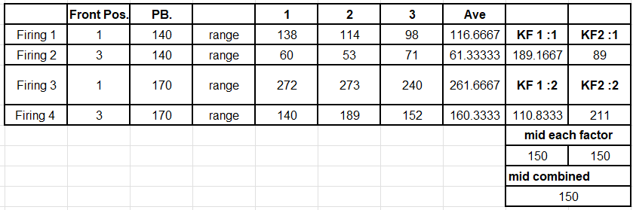
  - The results from this test have shown that average for both control factors to be 150.

  - Finally, confirmation trials were carried out to determine if the key control factors identified were correct. With a better understanding of how the key control factors introduce noise into the experiment, alterations were changed with the goal to reduce noise achieving a set target of 150. Through selecting the following values and repeating the firing 3 times, the average result is 132.33. This has demonstrated that the noises have been reduced through careful testing and selection. See table 4 below.

Table 4 - Confirmation Test [Annex A]

Conclusion & Reflection

  - In conclusion, after multiple tests, firings and permutations of factors and levels it has been determined that Front Anchor Position and Pull Back Position are they two key factors as these have been adjusted as seen in table 4 to produce more accurate results.

  - Taguchi has shown advantages like reducing experimentation as the efficiency allowed for optimisation to occur with fewer tests. By understanding the key control factors, products can be made more robust and have better quality.

  - In addition, it can be seen that Taguchi can be used across a wide range of disciplines, industries and processes making it a useful tool in systems engineering to effectively test and evaluate a system or process.

  - However, there are limitations with the methods ability to understand complex interaction as saturated array can fail to analyse high order interactions between factors.

  - As such, when it comes to doing this again, to understand how effective Taguchi Testing methodology is, a comparison study can also be conducted simultaneously using Response Surface Methodology (RSM) as this has been found to be more effective at providing more in-depth and accurate results and can process the high order interactions. [8]

References

[1] | K. Ballantyne, R. van Oorschot and R. Mitchell, “Reduce optimisation time and effort: Taguchi experimental design methods,” Forensic Science International: Genetics Supplement Series, vol. 1, no. 1, pp. 7-8, 2008.
[2] | S. Sigma, “The Guide to the Taguchi Method: A Robust Quality and Efficient Experimentation,” Six Sigma, [Online]. Available: https://www.6sigma.us/process-design/taguchi-method/. [Accessed 27 April 2025].
[3] | L. 6. Sigma, “Lean 6 sigma training aids and downloads,” Lean 6 Sigma, 03 August 2016. [Online]. Available: https://www.lean6-sigma.co.uk/training-aids/. [Accessed 27 April 2025].
[4] | Libretexts, “14.1: Design of experiments via Taguchi methods - orthogonal arrays,” Engineering LibreTexts, 11 March 2023. [Online]. Available: https://eng.libretexts.org/Bookshelves/Industrial_and_Systems_Engineering/Chemical_Process_Dynamics_and_Controls_(Woolf)/14%3A_Design_of_Experiments/14.01%3A_Design_of_Experiments_via_Taguchi_Methods_-_Orthogonal_Arrays. [Accessed 27 April 2025].
[5] | M. Hisam, A. Dar, M. Elrasheed, M. Khan, R. Gera and I. Azad, “The versatility of the Taguchi Method: Optimizing experiments across diverse disciplines - journal of statistical theory and applications,” Journal of Statistical Theory and Applications, vol. 23, no. 4, pp. 365-389, 2024.
[6] | A. Pereira, E. Martins and M. Lopes, “Taguchi method application in the pilot production phase-A case study,” Procedia Manufacturing, vol. 51, pp. 1069-1075, 2020.
[7] | U. o. York, “Orthogonal Arrays (Taguchi designs),” University of York, [Online]. Available: https://www.york.ac.uk/depts/maths/tables/orthogonal.htm. [Accessed 27 April 2025].
[8] | C. Romelin, Zahedi and B. Nusantara, “Comparative Analysis of Response Surface Methodology (RSM) and Taguchi Method: Optimization Hydraulic Ram Pump Performance,” Operations Research Forum, vol. 5, no. 4, p. 85, 2024.

Annex

Annex A – Catapult Spreadsheet

