
Master of Business Administration
LCMB7035 - Dissertation

THE IMPACT OF ARTIFICIAL INTELLIGENCE ADOPTION ON OPERATIONAL EFFICIENCY IN UK MID-SIZED RETAIL BANKS

Student Name: Yousaf Ali
Student ID:2430960

Abstract
The introduction chapter presented the research study through its examination of how Artificial Intelligence transforms banking operations to improve efficiency. Furthermore, it has highlighted the research problem together with its urgent need for a solution while showing the study's purpose and research objectives and questions. Last but not least, this chapter has defined its research boundaries while showing the existing limitations of AI adoption theories that apply to UK mid-sized retail banks.
The chapter used a systematic literature review method to study how mid-sized retail banks in the UK implement Artificial Intelligence to improve their operational efficiency. The chapter explained the research design, search strategy, databases, keywords, and screening procedures applied to identify relevant academic studies. The researchers established inclusion and exclusion criteria which enabled them to select sources that maintained both reliability and relevant content. The PRISMA framework was used to ensure transparent screening procedures while researchers used thematic analysis to identify main patterns and themes in the literature. The methodology established a systematic research approach which enabled researchers to examine existing evidence and verify authentic research results.
Artificial intelligence adoption is considered a transformative force in UK mid‑sized retail banking, concerning operational efficiency and organisational performance. Evidence from the thematic analysis reveals that technologies such as robotic process automation, machine learning, and generative AI enhance cost reduction, service speed, and fraud detection while improving decision accuracy. However, the findings also highlight challenges related to employee acceptance, regulatory compliance, and resource constraints. Trust, ease of use, and perceived usefulness influence adoption success, supported by leadership and organisational readiness. Despite short‑term efficiency gains, sustainability depends on transparent governance and strategic integration. Overall, AI adoption drives operational transformation, but its long‑term impact requires balanced alignment between technological innovation, human factors, and regulatory frameworks.
The thematic synthesis highlights that the productivity paradox, where initial costs of implementation outweigh short-term efficiency gains, disproportionately impacts smaller institutions that do not benefit from economies of scale in their use of AI. A major barrier is employee resistance, fuelled by fears of job displacement and obsolescence of skills, which can be overcome through training programmes and transparent change management. But consumer trust still depends on explainable AI systems, strong data privacy protection and clear regulatory supervision, especially under frameworks such as the UK GDPR and FCA guidelines. Attitude mediates the relationship between perceived usefulness and actual acceptance, highlighting the importance of affective and evaluative responses to AI beyond functional benefits.
Apart from these, organisational culture and top management support play a significant role in the success of adoption, pointing to the fact that technology alone is not enough without strategic alignment. Future research should focus on longitudinal studies about the development of trust over time, and cross-country comparisons considering different regulatory environments. In practice, banks will have to invest in reskilling, ethical AI governance and hybrid human-AI operating models to sustain long-term efficiency gains while maintaining stakeholder confidence.

Acknowledgement
I would like to acknowledge with gratitude my debt of thanks to all the people for their advice and encouragement. I would especially want to convey my thankfulness to my professor, who has guided and assisted me whenever I needed any help during the study. I am grateful to the authors and scholars whose published works provided the foundation of this systematic literature review, giving the evidence and perspectives necessary for meaningful analysis. Finally, I would like to thank my peers and family members who have given me immense support during the conduct of the entire research study

Table of Contents
Chapter 1: Introduction 10
1.1 Introduction 10
1.2 Background of the Research Topic 10
1.3 Gap in the Literature 11
1.4 Urgency or Timeliness of the Topic 12
1.5 Aim and Objectives 13
1.6 Research Questions 14
1.7 Scope of the Review 14
1.8 Structure of the dissertation 15
1.9 Chapter Summary 15
Chapter 2: Methodology of the Literature Review 16
2.1 Chapter Introduction 16
2.2 Search Strategy 16
2.3 Databases and Sources 16
2.4 Keywords and Search Terms 17
2.5 Time Frame of Literature 18
2.6 Inclusion and Exclusion Criteria 18
2.6.1 Inclusion Criteria 18
2.6.2 Exclusion Criteria 19
2.7 Screening Process (PRISMA Approach) 19
2.8 Quality Assessment of Studies 20
2.9 Analytical Method: Thematic Analysis 21
2.10 Chapter Summary 21
Chapter 3: Thematic Review 23
3.1 Chapter Preface 23
3.2 Thematic Analysis 23
3.3 Research Gaps 42
3.4 Theoretical Framework 44
3.5 Chapter Conclusion 45
4. Discussion 46
4.1 Chapter Preface 46
4.2 Integration of Findings 46
4.3 Comparison Between Studies 48
4.4 Theoretical Implications 50
4.5 Identification of Gaps 52
4.6 Conceptual Framework 52
4.7 Chapter conclusion 54
Chapter 5: Implications 55
5.1 Chapter Preface 55
5.2 Theoretical Implications 55
5.2.1 Refining the framework 55
5.2.2 Academic contribution 56
5.3 Practical & Managerial Implications 57
5.3.1 Strategic recommendations 57
5.3.2 Policy & industry impact 57
5.3.3 Action plan 58
5.4 Research Implications 58
5.4.1 Limitations 58
5.4.2 Future research agenda 59
5.5 Chapter Summary 59
Chapter 6: Conclusion 60
6.1 Answering the Research Questions 60
6.2 Research Contributions 60
6.3 Limitations 61
6.4 Recommendations and Future Research 61
References 63
Appendices 71
Appendix 1: AI in customer service 71
Appendix 2: Jiangsu Bank’s Non-Performing Loan (NPL) Rate 72
Appendix 3: Classification of Consumer Behaviours on Performance Expectancy (PE) and Effort Expectancy (EE) toward Technology Innovation 73
Appendix 4: Search Strategy 74

List of Figures
Figure 1.1: AI in banking 6
Figure 1.2: Dissertation structure 10
Figure 3.1: Annual AI patents in the field of banking 17
Figure 3.2: Key benefits of AI/ML adoption 17
Figure 3.3: Key benefits of AI/ML adoption 18
Figure 3.4: Agentic AI is Redefining Risk, Fraud, and Customer Service in Banking 19
Figure 3.5: Impact of AI in payment 22
Figure 3.6: Applications of artificial intelligence in the banking sector 24
Figure 3.7: AI Chatbots in Banking 27
Figure 3.8: Customer satisfaction by AI Chatbots 28
Figure 3.9: Risks and benefits of Gen-AI to financial firms 29
Figure 3.10: Future AI adoption in banks 30
Figure 3.11: Future AI adoption in banks 34
Figure 3.12: Challenges of AI adoption in banks 35
Figure 3.13: DoI 37
Figure 3.14: TAM 37
Figure 4.1: Conceptual Framework 47

List of Tables
Table 2.1: Inclusion Criteria 19
Table 2.2: Exclusion Criteria 19
Table 5.1: Action plan for retail banks 58

Chapter One: Introduction

1.1 Introduction
The study investigates how Artificial Intelligence (AI) implementation affects operational performance in mid-sized retail banks across the United Kingdom. The study first establishes its research foundation before identifying primary research gaps in current literature and demonstrating the topic's research value and immediate relevance. The chapter further presents the research aim, objectives, and questions that guide the investigation. The study defines its research boundaries before presenting a summary of the dissertation's organisation.

1.2 Background of the Research Topic
Artificial Intelligence (AI) has become a revolutionary element that transforms international banking operations through its impact on financial institutions' banking functions and service delivery systems. Financial institutions use AI technologies, which include machine learning and natural language processing, and robotic process automation, to automate their regular banking tasks, which helps them create better fraud detection systems, develop chatbots for customer service, and make decisions based on data analysis. AI has the potential to generate up to $1 trillion in additional value annually for the global banking industry, which proves its importance for strategic business operations (Biswas et al., 2020). The adoption of AI in banking has accelerated rapidly in recent years. The data shows that 85% of financial institutions currently use or plan to use AI solutions by 2025, which indicates that digital transformation has become a major trend (RGP, 2025). The 86% adoption rate of AI by European banks for compliance and risk management and customer service operations shows that these technologies have become standard practice (Precedence, 2025). Banking organizations will achieve 20% to 30% operational cost reductions through AI-driven automation, which will also enable them to process data faster and more accurately (Harris, 2024).
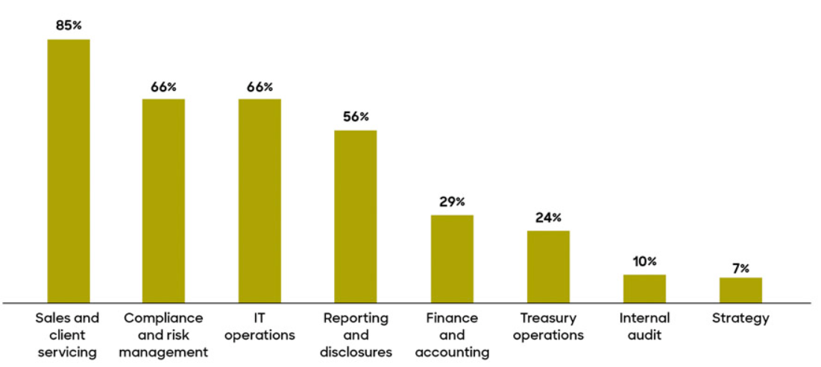

Figure 1.1: AI in banking
(Source: UK Consultancy, 2024)
Retail banking requires institutions to achieve high operational efficiency because it needs to process numerous transactions while maintaining accuracy and security, and following all regulatory requirements. Banks use AI technology to improve their operational processes through reduced employee mistakes and increased efficiency of their assets. The automated systems can complete loan application processing within minutes instead of requiring multiple days, which results in better service delivery and higher customer satisfaction. Mid-sized retail banks throughout the United Kingdom have started to implement AI technologies because there is a need to keep their competitive edge in the changing financial environment. According to UK Finance, digital banking usage in the UK has increased by over 75% in recent years, further driving the need for AI adoption (FIS, 2025). Bank competition has intensified because fintech companies and major digital banks use their advanced technology systems to deliver quicker and tailored customer experiences. AI technology transforms banking operations through its ability to create efficient systems that improve organizational response capabilities and enhance the customer experience. The implementation of these advantages in UK mid-sized retail banks needs more investigation, according to current research findings.

1.3 Gap in the Literature
Existing literature on AI in banking largely focuses on large multinational institutions and fintech firms while UK mid-sized retail banks remain underexplored. The research has identified limited evidence about AI adoption effects on operational efficiency at this scale which includes cost-to-income ratios and process automation outcomes and workforce implications. The existing research base lacks studies about mid-sized banks which encounter implementation problems because of their legacy systems and resource shortages. The UK context needs more longitudinal studies and comparative research because current research fails to explain how strategic initiatives create long-term efficiency gains.

1.4 Urgency or Timeliness of the Topic
The banking industry currently lacks sufficient empirical research that demonstrates how Artificial Intelligence (AI) affects the operational productivity of mid-sized retail banks in the United Kingdom. The financial sector shows growing interest in AI implementation but the sector still lacks methods to assess its impact in this particular situation. Around 48% of AI initiatives in financial services fail to move beyond pilot stages, indicating challenges in achieving tangible operational benefits (S&P Global, 2025). The banks successfully improved their operational efficiency through AI implementation, even though it spent large amounts of money on AI technology. The existing gap between full technology adoption and actual measurement of performance results leads to operational difficulties because mid-sized banks lack the same resources that larger banks possess.
The effectiveness of AI adoption remains unclear, which creates a major problem for mid-sized retail banks. The banks need to make investment choices that involve high risk because it possesses fewer financial and technological resources when compared to larger institutions. The research shows that only 25 % of banks achieve high operational efficiency through AI implementation after making substantial investments (Dalvinder Kular 2025). The organization faces challenges that become more difficult because of governmental requirements concerning data protection and compliance. Without performance outcomes, AI implementation leads to two problems, which involve wasting resources and creating employee pushback. Organisations need to assess whether Artificial Intelligence investments actually improve their operational efficiency because this evaluation supports their strategic decision-making process. The solution enables mid-sized retail banks to control their resource distribution while decreasing their implementation risks and creating long-term performance gains.
The issue has become more urgent because digital transformation in financial services has developed at an accelerated speed. Banks need to implement AI solutions because their customers now expect them to deliver banking services that are both rapid and highly personalised, and continuous and effortless. The financial industry now adopts new technologies at a faster rate because of the competitive threats that fintech startups and technologically superior banks present. UK regulatory agencies support innovation through their digital requirements while maintaining their strict compliance rules, which force banks to implement digital systems. The financial services sector has experienced urgent needs because digital transformation processes have developed at high speed. Banks need to adopt AI technology because customers now demand both immediate service and personalized banking solutions. UK Finance reports that digital banking usage in the UK has grown by more than 57% in 2024, which creates more pressure on banks to modernize their operations (UK Finance, 2024). Strict regulatory requirements and rising competition from fintech firms are forcing companies to implement AI technology at an accelerated pace. Mid-sized retail banks need to evaluate AI technology because it uses without understanding its impact on their operations, which has created an urgent requirement for assessment.
The study seeks to fill the existing research gap through its empirical study of AI adoption patterns and their impact on operational efficiency in UK mid-sized retail banks. The research will assess how AI technologies affect essential performance measurements, which include cost savings and service delivery speed, and operational productivity. The research will investigate how employees view AI systems because human attitudes toward technology control successful implementation results. The research will provide a complete framework that demonstrates how mid-sized retail banks can use AI technology to improve their operational efficiency, thus benefiting both academic research and practical business operations.

1.5 Aim and Objectives
Aim
To investigate how the adoption of Artificial Intelligence affects the efficiency of operations of UK mid-sized retail banks.
Research Objectives
- To examine the present extent of Artificial Intelligence implementation in the operational processes of UK mid-sized banking institutions dealing with retailing.
- To assess the impact of Artificial Intelligence technologies on the efficiency of operations, the reduction of costs, the increase in the speed of services, and productivity.
- To investigate how employees perceive, accept, and attitude towards the implementation of Artificial Intelligence in operational activities in retail banking.
- To determine the organisational, technological, and regulatory issues that influence the successful implementation of Artificial Intelligence in the operations of UK retail banks.

1.6 Research Questions
- How is the adoption of Artificial Intelligence in the existing operational processes in UK mid-sized retail banking institutions?
- What are the organisational, technological, and regulatory issues to the successful adoption of Artificial Intelligence in the operations of UK mid-sized retail banks?

1.7 Scope of the Review
The review explores how UK mid-sized retail banks use Artificial Intelligence to enhance their operational performance. The study investigates four areas, which include automation and cost reduction, service delivery speed, and staff acceptance of new technologies. Existing theories such as TAM, RBV, and TOE provide partial explanations of AI adoption. The study fails to demonstrate how employee behaviour and organisational dynamics and operational efficiency work together in their complete interactive relationship. The study does not include any research evidence that specifically applies to UK mid-sized retail bank

1.8 Chapter Summary
The chapter presents an overview of research studies which examine how Artificial Intelligence implementation affects operational efficiency in mid-sized retail banks across the United Kingdom. The document begins with background information which explains existing research gaps before showing how the subject matter relates to the research. The chapter establishes the research aim and research objectives through the development of research questions while it defines the study boundaries. The study provides a complete overview of the dissertation through its established research objectives. In the upcoming chapter, the literature review will be presented with the help of sources and arguments.

Chapter Two: Methodology of the Literature Review

2.1 Chapter Introduction
The chapter provides an overview of the research methods which were employed to conduct a systematic literature review about Artificial Intelligence (AI) adoption and its impact on operational efficiency in UK mid-sized retail banks. The study used structured processes to identify and select academic studies which were needed for analysis because these processes provided rigorous and transparent methods to verify study findings. The chapter describes the search strategy which includes databases and keywords and defines the inclusion and exclusion criteria and screening processes which follow the PRISMA framework. Thematic analysis serves as the primary analytical method because the study provides valid reasons for its selection. The chapter establishes a strong foundation which enables researchers to produce trustworthy and objective findings through their selected literature.

2.2 Search Strategy
This research applies a systematic literature review (SLR) strategy to have a well-structured, clear and repeatable process of identification and examination of scholarly material pertinent to the study. The SLR method fits the study since it allows in-depth coverage of the existing knowledge and it allows for reducing bias when selecting studies. A systematic approach guarantees that only quality and relevant evidence is incorporated since the field of Artificial Intelligence in banking is developing at a rapid pace and is getting more complex (Paramesha, Rane and Rane, 2024). The search strategy was designed in accordance with the objectives of the research with priority on the concept of Artificial Intelligence adoption, efficiency of operations and retail banking. Before the search was conducted, a pre-set protocol was established to be consistent. The search was refined AND organised with the help of the use of the Boolean operator. The operator was used to bring together the key concepts and the search results and OR was used to bring in the synonyms and other terminologies. The NOT operator was selectively applied to remove irrelevant subject areas. It was an iterative search process starting with broad searches and limited using various filters like subject area, publication type and relevance. This guaranteed the ultimate dataset being exhaustive with the research questions which enabled a rigorous and unbiased literature review.

2.3 Databases and Sources
Multiple high-quality academic databases were used to conduct the literature search, to cover extensive sources and to make it reliable. The main databases were Scopus, Web of Science, Business Source Premier, ScienceDirect and Emerald Insight. These databases have been chosen because they are well indexed on peer-reviewed business, finance, information systems and management journals which are related to the topic of the research. The primary databases utilised were Scopus and the Web of Science as they offer access to high-impact journals and allow advanced filtering facilities as well as guarantee inclusion of credible and widely-cited studies (Hassan et al., 2025). The researchers found Business Source Premier useful in sourcing banking, management and strategic literature and could be very relevant in the analysis of operational efficiency in retail banking. The inclusion of ScienceDirect can be attributed to the broadness with which it covers technological and analytical research in the field of Artificial Intelligence and automation (De, Ramírez and Romero, 2023). Emerald Insight was chosen because of its nature of specialisation in organisational behaviour, operations management and service innovation. Scholar Google was employed as an additional source to find more relevant studies and trace the citations and only articles that were peer reviewed and determined by this platform were considered. This multi-database strategy guaranteed a strong and in-depth data source in accordance with the study's aims.

2.4 Keywords and Search Terms
The choice of keywords and search terms relied on the research aim and objectives and they were aligned with the most important concepts of Artificial Intelligence, operational efficiency and retail banking. The keywords used were formulated with the help of the first scoping exercise which included the reading of the relevant literature and thinking over the terminology that is frequently used in the field (Christou, Parmaxi and Zaphiris, 2024). The main keywords were the following like Artificial intelligence, AI, machine learning, intelligent automation and robotic process automation. These were paired with operational terms like operational efficiency, productivity, performance and reduction of costs. Specific terms including retail banking, financial services and banking operations were used in order to make them relevant in context (Hanafizadeh and Amin, 2022). Broadening the search and finding variations of terminology was done by including synonyms and related terms via the use of Boolean operators such as Artificial Intelligence OR machine learning OR automation coupled with banking OR financial services and operational efficiency OR productivity. The sample search terms were (Artificial Intelligence or machine learning) AND (retail banking) AND (operational efficiency). The keywords were further narrowed down to get rid of irrelevant search results and boost accuracy. Filters such as subject area and publication type were used to make sure that the final list of studies was top-quality, relevant and answered the research questions directly.

2.5 Time Frame of Literature
The publications that were incorporated in this review were mainly limited to those released in the previous years (2015-2025). The time frame set was chosen to reflect the latest and most topical changes in the adoption of Artificial Intelligence in the banking industry (Herrmann and Masawi, 2022). The time is associated with a wave of digital transformation when financial institutions started to use AI technologies in their operations more. The swift development of AI-powered technologies, such as machine learning, predictive analytics and automation solutions, has already had a major impact on the way banks work over the last ten years (Sabapathy, 2025). It is in accordance with the growing use of digital banking services and regulatory changes in the UK banking environment. All necessary studies to support theoretical frameworks and establish conceptual grounds were published before 2015. The studies have been of significance in the understanding of well-known paradigms of technology adoption and organisational performance (Hasani et al., 2023). This approach is balanced in that the review managed to accommodate both the current evidence and the ground theories to bring a complete grasp on the effect of Artificial Intelligence on operational efficiency in UK mid-sized retail banks.

2.6 Inclusion and Exclusion Criteria

2.6.1 Inclusion Criteria
Criteria | Description
Peer-reviewed sources | Only peer-reviewed journal articles, academic books and book chapters were included to ensure reliability, validity and scholarly credibility of the evidence used in this systematic literature review.
Publication period | Studies published between 2015 and 2025 were prioritised to reflect recent advancements in Artificial Intelligence and its application in banking operations and efficiency improvement.
Relevance to topic | Literature directly addressing Artificial Intelligence adoption, operational efficiency, digital transformation and banking or financial services was selected to align with research objectives.
Language and context | Only English-language studies relevant to UK banking or comparable financial systems were included for consistency.

Table 2.1: Inclusion Criteria
(Source: Self-made)

2.6.2 Exclusion Criteria
Criteria | Description
Non-academic sources | Blogs, news articles, company websites and non-peer-reviewed materials were excluded to maintain academic rigour and ensure the use of credible and validated scholarly evidence.
Irrelevant subject areas | Studies not related to Artificial Intelligence, operational efficiency or banking were removed to maintain focus and relevance to the research questions.
Duplicate records | Duplicate studies identified across databases were excluded during the screening stage to avoid repetition and bias in the analysis.
Limited access or scope | Conference abstracts without full texts and studies focusing only on technical algorithms without organisational relevance were excluded from analysis.

Table 2.2: Exclusion Criteria
(Source: Self-made)

2.7 Screening Process (PRISMA Approach)
The PRISMA (Preferred Reporting Items to Systematic Reviews and Meta-Analyses) framework was used to conduct the screening process, promoting transparency and replicability. This was a process of four major steps including identification, screening, eligibility and inclusion. In the process of the identification stage, many studies were retrieved in the chosen databases based on predefined search strings. These were exported to records and merged into one dataset. Those studies that had duplicate records were eliminated and titles and abstracts were screened to exclude obviously irrelevant studies at the screening phase. All studies were evaluated with respect to the inclusion and exclusion criteria to identify their relevance to the research objectives. Studies without enough evidence or not in line with the research focus were not included at this phase. The last step is the inclusion phase where a narrowed-down list of high-quality studies was chosen to analyse. This was done to ensure that the utilisation of this process only included relevant and credible literature. PRISMA flow diagram is included in the appendix that visually shows the number of studies that were identified, screened, excluded and included to further improve the transparency and trustworthiness of the methodology. The eligibility check included a comprehensive full-text screening of the rest of the articles.
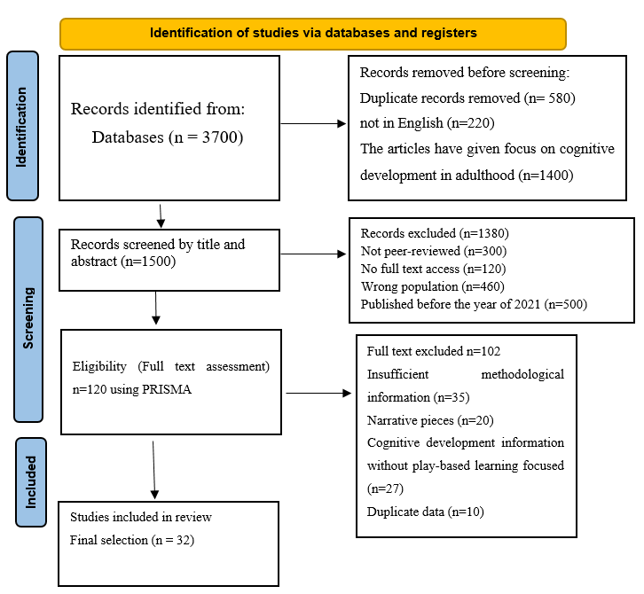

Figure 2.1 PRISMA Diagram
(Source: Self-Developed)

2.8 Quality Assessment of Studies
A professional quality evaluation procedure was used to gauge the plausibility, relevance and vigour of the chosen publications. This move made sure that the evidence on the findings of the literature review was made by high quality and reliable evidence. A set of preset criteria of methodological rigour, relevance and theoretical contribution was used to evaluate each study. Publication quality was assessed on the basis of their publication in peer-reviewed journals and agreed-upon rating systems of established academic pressures like ABS or ABDC. Articles that are found in the top-class journals were of the first priority because of the scrutinising mechanisms undertaken. The methodological soundness was evaluated based on the transparency of the research design, methods of data collection and analytical procedures in every study (Oyekunle and Boohene, 2024). The contribution of the theory was taken into account whether the study had meaningful contributions to the existing frameworks/being new perspectives. The evaluation of studies was based on the effectiveness in terms of the adoption of Artificial Intelligence, its operational efficiency or the productive organisational results in the banking segment (Bueno et al., 2024). This made sure that the review was based on valid and high-impact research which increased the validity and reliability of the discoveries.

2.9 Analytical Method: Thematic Analysis
Thematic analysis on the basis of the framework by Braun and Clarke (2006) was used to analyse the selected literature since it is a systematic and adaptable method of identifying, analysing and interpreting patterns within the qualitative data. The approach is suited to systematic literature review because it allows the synthesis of various academic studies into coherent themes retaining analytical rigour. There were six phases in the analysis. The initial stage was the familiarisation with the data and all the chosen works were reread multiple times to attain an overview of the main arguments, findings and theoretical contributions. The preliminary notes were taken to understand repetitive thoughts about the adoption of Artificial Intelligence and efficiency in the banking business. The second stage consisted of the generation of the first codes and the relevant aspects of the data were identified and systematically assigned labels. The concepts used in the codes were the benefits of automation, reduction of costs, efficiency of the services, acceptance of employees and impediments to implementation. The fourth phase was dedicated to the review of themes whereby each theme had to be internally coherent and distinguishable from others. The fifth stage included the identification and naming of themes where the themes were succinctly defined and associated with the research goals including the improvements in the operational performance, organisational challenges and the factors of strategic adoption. The last step was the production of the analysis where the themes were interpreted regarding the research questions.

2.10 Chapter Summary
The chapter shows a systematic and clear approach to review existing literature about AI implementation in banking. The study establishes its research framework through a structured search method which applies PRISMA screening together with specific inclusion and exclusion guidelines to extract relevant research materials. The review process gains better coverage through multiple academic databases because thematic analysis allows researchers to extract valuable insights from their research results. The research validity and reliability receive support from these methodological choices. The chapter delivers a robust research framework which will support the forthcoming thematic analysis and result interpretation. In the next chapter, the thematic review will be conducted with the help of the secondary sources, and creation of themes based on the requirements of the objectives.

Chapter Three: Thematic Review

3.1 Chapter introduction
This chapter dwells on the thematic analysis concerning AI adoption in UK mid-sized retail banking institutions. 4 key themes have been formed, followed by the development of sub-themes with critical analysis. The incorporation of AI technologies is demonstrated, with a focus on efficiency gains, cost reduction, fraud detection, and productivity improvements. Besides, the analysis also considers employee perceptions, acceptance, and adaptation to AI-driven workflows, along with organisational, technological, and regulatory challenges. This chapter also contains a brief section of theoretical discussions and a literature gap.

3.2 Thematic Analysis
Theme 1.1: Artificial Intelligence Adoption and Its Impact on Operational Processes in UK Mid-Sized Retail Banking Institutions
Sub-theme I: AI-Driven Financial Performance Enhancement
There is an inextricable connection between AI adoption and financial performance in banking. The adoption of AI, particularly Robotic Process Automation and Machine Learning (ML), has been paramount in enhancing back office processes, such as loan processing, compliance checks, and customer onboarding. In this context, as opined by Bahoo et al. (2024), the main AI applications include predictive or forecasting systems, early warning systems, and big data analytics or text mining, along with ML technologies, such as Support Vector Machine or SVM. Moreover, AI applications in cryptocurrency markets need to be developed with regard to their wider applications. Besides, this study highlights that at the retail level, advanced random forests are able to detect credit card fraud based on customer
financial behaviour and spending patterns. Thus, by leveraging predictive modelling and real-time data monitoring, mid-sized retail banks could minimise risks while maintaining compliance. The geographic concentration of the AI-powered retail banking features is of immense relevance, where the US and China benefit from AI-driven economic returns.
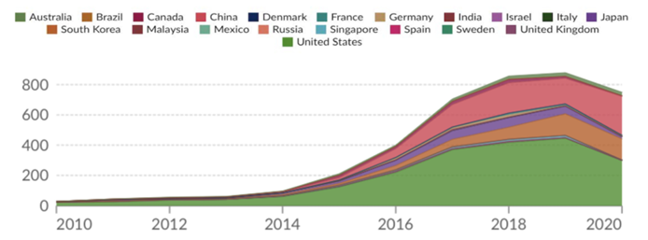

Figure 3.1: Annual AI patents in the field of banking
(Source: Emmanuel et al., 2024)
Apart from these, the role of AI technology innovation helps in boosting the financial performance of banks, catering to the concept of transformational banking. Emmanuel et al. (2024) commented that the ‘Banking and finance AI technology innovation’ or BFAITI has a positive effect on banks’ return on assets (ROA). At the same time, the economic growth is also bolstered through such AI-powered banking systems. On the contrary, higher NPL is negatively associated with the profitability and ROA of banks, and it particularly affects banks with lower capital. In contrast, this study highlights the lagged effects in banks when AI is implemented. This is evident as the initial AI investment enhances performance, whereas prolonged exposure leads to diminished returns, and its effects may be realised later. In this context, AI may not be able to detect inaccuracies. Conversely, the study of Bahoo et al. (2024) sheds light on deep neural networks with an accuracy rate equal to 68%.
Sub-theme 1.2: Automation, Fraud Detection, and Cost Reduction, Operational Gains through AI and Machine Learning
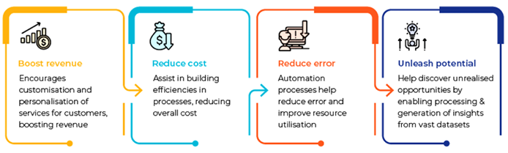

Figure 3.2: Key benefits of AI/ML adoption
(Source: Polireddi, 2024)
Operational gains are evident through the adoption of AI technologies, through automation of routine tasks, fraud detection capabilities, and associated cost reductions. According to Polireddi (2024), AI and ML are helpful for bank managers as they are relieved from routine cognitive tasks, allowing them to focus on strategic priorities. Moreover, approximately $447 billion was saved by AI in banking till 2023, which could rise up to $1 trillion by the end of 2030. In addition, accurate credit scoring automation is also fostered through ML by using non-traditional data. On the other hand, the reduction of operational costs is carried out by AI-powered chatbots that handle customer queries, card locking, and overdraft alerts to reduce the human support system (Polireddi, 2024). As a result, the extent and impact of AI in UK banks are known. However, AI work involves cleaning and preparing data, which might be complex for risk and fraud detection. As approximately $762 million has been lost in 2021 by fraudulent banking transfers, fraud detection is crucial. Besides, by 2027, $450 billion could be the global AI spending, where the retail banking sector contributes approximately 13%, followed by a generation of around 15% profit, positively impacting their revenue (Manta et al., 2024).
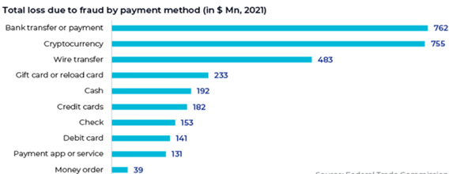

Figure 3.3: Key benefits of AI/ML adoption
(Source: Polireddi, 2024)
Apart from these, agentic AI plays a vital role in retail banking to make autonomous decisions and fraud probability estimation, which are beneficial in the banking sector. Besides, AI virtual assistants, such as State Bank Intelligent Assistant (SIA) and Luvo of Royal Bank of Scotland (RBS), are AI-based customer service assistants (Inala and Somu, 2024). Besides, autonomous decision-making is also provided by agentic AI, followed by enhanced customer support [Refer to Appendix 1]. On the other hand, Manta et al. (2024) claimed that AI algorithms reduce human error in data processing, transaction handling, and risk assessment, leading to increased reliability and accessibility. Additionally, AI increases the speed of banking transactions and data analytics, which are essential in the financial sector. In a recent survey, 80% of retail banking executives believe generative AI is a major advantage, but only 6% implemented it, which indicates a gap in its execution (Manta et al., 2024). At the same time, 53% of the retail banking executives feel unprepared for the AI adoption within their organisation.
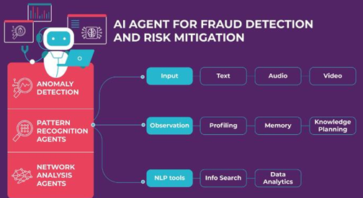

Figure 3.4: Agentic AI is Redefining Risk, Fraud, and Customer Service in Banking
(Source: Inala and Somu, 2024)
Sub-theme 1.3: Service Speed, Cross-Border Intermediation, and Digital Inclusion Through AI
Other than routine automation and cost reduction, AI adoption is expanded into operational efficiency gains through enhanced service speed, cross-border financial intermediation (CBFI), and digital inclusion. From the studies of Iqbal et al. (2026), it is found that CBFI has been significantly boosted through AI and FinTech. For instance, the valuation of AI in the mid-sized banking market was valued at $17.8 billion in 2023, which is forecast to reach $64.3 billion by 2030, with a CAGR of 20.5%. Conversely, higher GDP growth is associated with lower CBFI, which suggests that economic inertia is linked to the acceleration of digital transformation. Machine learning models, such as XGBoost, delivered F1-scores of 0.86–0.91 and AUCs of 0.88–0.91 for CBFI, which validates the predictive power of AI, FinTech, and inclusion metrics. Consequently, as opposed by OMOTOSHO (2025), in emerging economies, nearly 25% of adults are unbanked, where informal workers, women, and rural dwellers are most affected by conventional methods. Therefore, the banks of such economies need to pay attention to this aspect to maintain equality.
AI-driven credit scoring systems have a significant impact on financial inclusion, where AI adoption increases access to credit for underserved populations. Moreover, AI systems use mobile payment history, utility bills, social media activity, and geolocation data to create credit profiles for those who yet possess formal financial histories. The study of OMOTOSHO (2025) indicates that the coefficient for the financial sector development or FSD (β4 = 0.28, p = 0.012) shows that well-developed financial systems enhance the positive effects of AI on inclusion. In contrast, inflation (coefficient = –0.12, p = 0.023) reduces credit access, indicating macroeconomic instability and reduced purchasing power. For example, in Kenya, M-Pesa integrated AI credit scoring, followed by an increase in microloan access for informal workers by 50%, whereas fintechs like Tala and Branch have overcome rural access barriers through AI-driven credit scoring.
Sub-theme 1.4: Various Trends on AI and Banking Efficiency
AI and ML play essential roles in financial services, particularly post-pandemic. As viewed by Vuković et al. (2025), ‘Explainable AI’ or XAI is an emerging service which gained prominence in heightening consumer trust by making AI algorithms more interpretable. Besides, Robotic Process Automation (RPA) is also significant in back-office banking operations, which reduces operational costs while improving efficiency. Kalyani and Gupta (2023), on the other hand, discussed the importance of customer-oriented services, credit scoring, and fraud detection through AI. At the same time, there are applications of AI and ML in predicting recovery rates on non-performing loans, providing a significant area of future benefits. In these ways, AI positively impacts cost reduction, service speed, and productivity. However, despite all its benefits, which are an improvement of operational efficiency or financial operations, the gap remains regarding the mechanism through which long-term financial performances are achieved.
AI and ML are being rapidly used in the banking sector, where a high level of performance is required. This includes customer segmentation, credit evaluation, and e-banking. Besides, mobile banking has been effective, where AI has reached more customers, followed by an enhancement of customer experiences. Furthermore, the convenience of banking, risk management, and back-end operations is being made more intelligent through blockchain and ML. Besides, RPA also caters to secure payment options, which are essential in the era of cyber-attacks. In contrast, the study of Vuković et al. (2025) sheds light on the regulatory challenges of these AI technologies because of their cross-border and pervasive nature. In the same way, Bahoo et al. (2024) commented on the issue of human oversight, where challenges persist in the form of interpretation and evaluation of the AI-generated outputs before accepting, rejecting or modifying. The 2008 financial crisis was caused by a lack of oversight, inadequate risk assessment and the complexity of financial products. In addition, the 2010 Flash Crash is an example of inadequately regulated AI-driven systems, resulting in sudden and severe market disruptions.
Theme 2: Drivers and Outcomes of AI Adoption for Operational Efficiency in Banking: From Cost Reduction to Operational Efficacy
Sub-theme 2.1: Operational Efficiency Gains through Automation, Chatbots, and Fraud Detection
Automation of routine and high-frequency tasks can be considered the most direct pathway through which artificial intelligence enhances operational efficiency in the banking sector. Based on the study of Doumpos et al. (2023), it is seen that fraud detection, credit scoring, and customer service automation are the most common and mature applications in the banking system, which comprises ensemble methods, SVMs, and NNs. Here, ensemble methods, such as random forest and XGBoost, outperform individual tasks and reduce biases in banking operations, along with robust credit risk and banking distress prediction. At the same time, AI is applied to customer churn prediction, satisfaction with ATM cash management and fintech-driven lending. On the contrary, Raghavan (2022) mentioned that the chatbot’s interaction cost is lowered to $0.39 through chatbots from $1.03, which is required in manual customer service, leading to a 62% cost saving. Besides, utility bill payments and loan interest management are carried out by automation, leading to higher operational efficiency. Thus, based on the above discussion, it is seen that automation and chatbots play a vital role in terms of fraud detection and cost savings.
Blur masking is another important feature of automation, which protects sensitive customer information while fostering analytics. The ANOVA and t-tests performed in the study of Raghavan (2022) confirm that chatbots outperform humans for existing services (cost savings), whereas humans outperform chatbots for new products (revenue generation). For these reasons, automation needs to be carefully used in terms of developing new products. Gen AI can add approximately $200–$340 billion annually to global banking, representing 2.8–4.7% of total industry revenues, leading to productivity gains (McKinsey & Company, 2024). About 70% of banks adhered to Gen AI use for their production efficiency in their operational units, where a central team has been allocated. However, in some cases, it can be difficult to implement gene across various business units of banks because different units can possess multiple levels of functional development on gen AI, where general AI talent scarcity is also a major concern. Hence, AI, through automation, chatbots, and advanced fraud detection, enhances operational efficiency and reduces costs in banking.
Sub-theme 2.2: Service Speed, Real-Time Transactions, and Digital Inclusion as Efficiency Gains
Beyond routine automation, AI enhances operational efficiency through accelerated service speed, real-time transaction processing, and expanded digital inclusion. Lakmali (2023) stated that UK banks use chatbots to handle routine tasks, such as balance checks, mini-statements, and wire transfers, while reducing wait times. Moreover, AI reduces compliance process time by 80%, followed by improving accuracy and reducing manual processes. As a result, by the end of 2023, UK banks using AI expect to save up to $20 billion on infrastructure costs, which could enable them to reinvest in other digital services (Lakmali, 2023). AI streamlines the auditing process as it provides accessible digital material, enabling effective error detection before making any transaction. ML and predictive analytics aid payment systems in processing transactions instantly to reduce delay and improve customer experience. ML and predictive analytics aid payment systems in processing transactions instantly to reduce delay and improve customer experience. For example, NLP-powered chatbots handle customer queries, account updates, and transaction requests in real time, which eliminates waiting periods (Kagalwala et al., 2025).
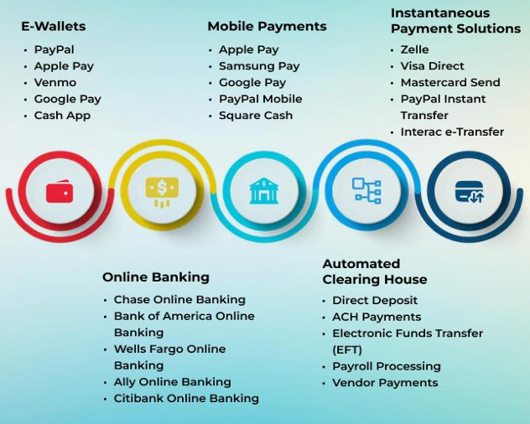

Figure 3.5: Impact of AI in payment
(Source: Kagalwala et al., 2025)
AI plays a vital role in digital payment systems, where e-wallets, online banking, automated clearing house and mobile banking are included. Additionally, AI-driven biometrics, such as fingerprint, facial, and voice recognition, replace slow, manual authentication methods, leading to faster and more secure transactions. AI enhances the speed and security of digital wallets because it fosters instant peer-to-peer transfers and contactless purchases. Chatbots automate over 80% of customer interactions, where AI is expected to solve the majority of customer queries within 5-10 years to enable instant and convenient services (Jingrong et al., 2023). Along with it, through coding acceleration, virtual expert and effective content generation, Bank marketing and customer communication are carried out through gen AI, which ultimately bolsters service speed. In contrast, Jiangsu Bank’s ‘Moonlight Treasure Box’ speeds up risk assessment, where AI-powered tools integrate facial recognition, voiceprint recognition, and NPL to provide real-time credit scoring and fraud prevention. Jiangsu Bank’s NPL rate dropped to 0.94% (a 0.14 percentage point improvement) due to real-time AI risk monitoring [Refer to Appendix 2]. Thus, it signifies the role of AI in fraud detection and accelerated service delivery.
Sub-theme 2.3: The Productivity Gain: Short-Term Costs versus Long-Term Efficiency in Banks
Despite the benefits, there can be a contradiction regarding long-term efficiency and short-term gain through AI. As claimed by Kikuchi (2026), despite productivity, there exist systematic risks when adopting AI in the banking system. Banks that adopt AI experienced a 428 basis point drop in their return on equity or ROE, where an adequate upfront cost is required for data scientist cloud infrastructure and system integration. Moreover, banks that incur massive investments may experience a reduced net income, and this can lower their future competitive advantages. This indicates that short-term gain of banks can precede long-term efficiency. As opposed by Turksen et al. (2024), 90% of European banks have been fined for AML-related offences, where complex AI models are avoided by these banks due to regulatory scrutiny. Furthermore, regulators need transparency and interpretability, where complex models such as DNN are black boxes, because these make them risky for compliance purposes, despite their accuracy advantages. In this context, in-house development of AI is preferred over third-party, where banks develop and maintain AI systems internally to ensure rapid error correction and lower their dependency on external vendors. However, this requires IT teams and a high upfront cost.
While the integrity of AI is considered, there are adequate examples regarding the consequences of weak Monitoring systems of AI implementation. For example, NatWest was fined £264.8 million, Danske Bank faced ~$2 billion in fines, HSBC $1.9 billion, and Standard Chartered $1.1 billion, due to inadequate AML controls. EU AI Act, on the other hand, imposes additional compliance costs because of due diligence and customer data processing. As a result, due to stringent requirements, such as transparency, human oversight and data governance, fines are a major challenge. However, about 90% of banks at a recent McKinsey forum have some centralised gen AI function, enabling them to allocate resources and manage operational risk. Therefore, although AI adoption in banking provides long-term efficiency and risk management improvements, high upfront costs, regulatory constraints, and compliance risks can lower short-term financial performance. For these reasons, careful governance and strategic implementation are essential.
Sub-theme 2.4: Systemic Risk, Spillover Effects, and the Hidden Costs of AI-Driven Efficiency
Although retail banks generate efficiency games at the individual Bank level, systemic risk is present, which can lower the stability of the banking sector. As per the view of Doumpos et al. (2022), agent-based modelling simulates the way AI-driven decisions by one bank, such as credit tightening, can propagate through interbank services, which have hidden pathways for cascading failures. At the same time, deep learning and network models are used to predict systemic crises, but these methods, too, can create risk assessments across different institutions. In contrast, Turksen et al. (2024) highlighted that complex AI models, such as DNN, are more accurate, but these are less transparent. However, as regulators need to transfer in C and explainability, banks are forced to implement simpler and less efficient rule-based systems. The study adopted an interview, where a respondent claimed that banks, lacking internal IT teams, such as 12,000 staff for large banks, are unable to adopt in-house AI development (Turksen et al., 2024). As a result, these banks rely on third-party black boxes to increase vendor concentration risk.
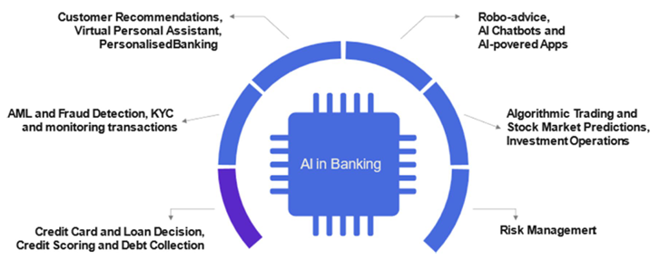

Figure 3.6: Applications of artificial intelligence in the banking sector
(Source: Doumpos et al., 2022)
Other than these, systemic risk and spillovers remain critical challenges for banks. As large banks are able to deploy AI systems into their operations, there is a disproportionate burden on mid-sized and smaller banks with fewer employees. In addition, productivity gains from the adoption of similar architectures, such as GPT-4 or common vendors, make the financial system vulnerable to common technical vulnerabilities or different adversarial attacks (Kikuchi, 2026). In this context, regulators require a new supervisory framework that is focused on AI model diversity and the operation and resilience of the implemented AI infrastructure. On the contrary, the study of Doumpos et al. (2022) demonstrated a ‘Monte Carlo simulation’ for systemic vulnerabilities, where correlated credit scoring can be incorrect. Conversely, banks that prefer human oversight for suspicious transactions adhere to an ‘augmented intelligence’ program, which may add labour costs but lower hidden risks.
Theme 3: Understanding User Acceptance of AI in Banking: The Interplay of Perceived Usefulness, Ease of Use, Trust, and Organisational Support
Sub-theme 3.1: Consumer Perceptions of AI Intelligence, Performance, and Effort in Banking Acceptance
The acceptance of AI in banking is significantly moderated by consumers’ perception of the AI systems, the performance benefits they offer and the effort required to use them. According to Chow et al. (2024), the perceived level of AI’s intelligence (PERCEAI) is a key factor, where AI intelligence is measured across four levels, namely mechanical, analytical, intuitive, and empathetic, influencing users’ acceptance of virtual banking services. Users are willing to put in extra effort if they perceive high performance value from AI technology, where the complexity of AI is ignored. Moreover, anthropomorphism of AI is a critical factor which makes it more acceptable because AI devices show human-like characteristics such as free will and consciousness, making users feel more comfortable and willing to interact with them. On the other hand, Osman et al. (2025) commented that although employees recognise that AI is useful, it is sometimes rejected by other factors such as their attitude or social pressure, which are not favourable. At the same time, the usefulness is a direct factor of acceptance because employees accept AI when they find the technology user-friendly and require minimal effort to operate and learn.
In retail banking, AI-driven self-service is pivotal for enhanced customer experience outcomes. In this regard, as opined by Zungu et al. (2025), personalisation is the most valued feature of AI because bank employees prefer self-service, which understands their specific needs, followed by offering recommendations. Customers, on the other hand, appreciate AI-based self-service, which is easily accessible and simplified without requiring employee assistance. However, in retail banking, visual appeal, such as the aesthetic design of AI banking interfaces, shapes, style and visual attractiveness, does not affect customer satisfaction or engagement. In contrast, Chow et al. (2024) opposed this view by emphasising virtual banking on customer involvement, where customers actively interact with AI interfaces, which looks attractive. Additionally, the same study highlights the importance of effortlessness, which is the minimal effort required to be incorporated in AI use and implementation, which is not required in traditional technology adoption. Therefore, acceptance of AI in retail banking is characterised by consumers’ perceptions of its intelligence, usefulness, and ease of use, where higher perceived performance and human-like interaction enhance adoption.
Sub-theme 3.2: The Role of Trust, Privacy, Cybersecurity, and Perceived Risk in Fostering Consumer Attitudes Toward AI Chatbots
Trust and security concerns are pivotal factors of consumer acceptance of AI-powered retail banking services, particularly for chatbot and self-service technologies. As per the view of Karri et al. (2025), trust is a major challenge for AI chatbot eruption because customers hesitate to share clandestine financial information with chatbots due to concerns about data theft. The study identified data privacy risk, lack of transparency and unauthorised access as key barriers to AI adoption and customer acceptance of chatbots in retail banking. However, the same study mentioned that fraud detection capabilities of chatbots enhance trust when they analyse transaction patterns, detect anomalies and alert users to suspicious activities. Zungu et al. (2025) opposed this view because it indicates that chatbots are prominent AI applications that assist customers in real time by solving their queries, helping with transactions, and resolving common banking issues. In this way, chatbots reduce the workload for human agents in banks. As a result, AI-based chatbots create new opportunities and possibilities for customer computer interaction, customer experience improvement and cost reduction to employee expenses, which are the critical benefits.
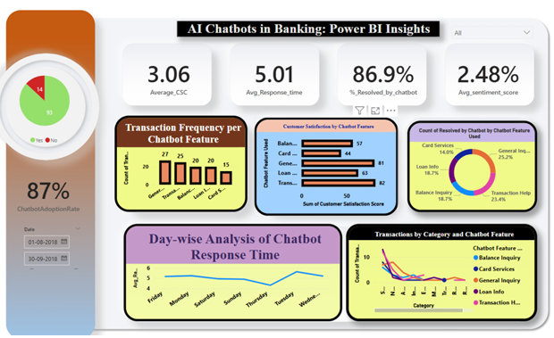

Figure 3.7: AI Chatbots in Banking
(Source: Karri et al., 2025)
Time is an important factor which affects customer trust because if customers spend too much time using AI services, this worsens their experiences. For this reason, retail bank managers need to prioritise transparent security and personalised services to bolster customer trust, followed by fostering brand loyalty and retention (Zungu et al., 2025). At the same time, ethical AI practices and governance are needed, where a robust governance framework must be implemented across retail banking. Furthermore, ‘Hybrid human-AI models’ reduce such risks, where AI chatbots are combined with a human support system, and they will be able to solve emotional queries (Karri et al., 2025). While AI chatbots offer efficiency, cost reduction, and enhanced customer experience in retail banking, their widespread acceptance depends on addressing trust, security, and ethical concerns through transparent practices, robust governance, and the integration of hybrid human-AI support systems.
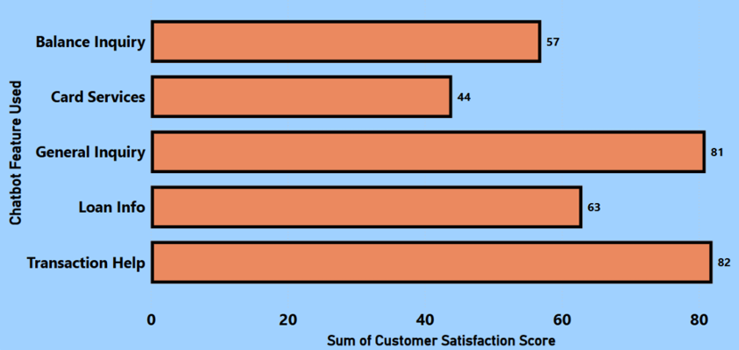

Figure 3.8: Customer satisfaction by AI Chatbots
(Source: Karri et al., 2025)
Sub-theme 3.3: Employee Perceptions of AI Usefulness, Ease of Use, and Subjective Norms in the Workplace
The successful adoption of AI in banking depends not only on consumer acceptance but also on employees, where trust is present in AI systems. Based on the study of Osman et al. (2025), the perceived usefulness of AI is not enough because employees must recognise that AI needs to be useful. Here, the attitude of employees plays an essential role, because the feelings of employees about AI determine their perceptions of usefulness, and use of use followed by acceptance. Besides, leadership commitment is crucial because transparent communication from management about the AI initiative and leadership support strengthen employees’ perception of the benefits of AI. Dubey et al. (2025), on the other hand, shed light on cost optimisation through productivity, which is a key benefit of gen AI and is useful for coding tasks. In addition, routine task automation is effective because employees are freed for higher-value work, such as involving data preparation, which is also time-consuming. Conversely, this study also indicated the perceived risks of gen AI, such as breach of content, lack of reliability, accountability and traceability.
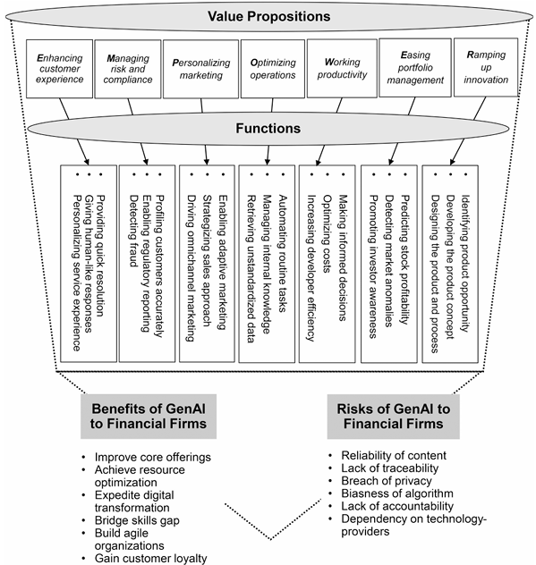

Figure 3.9: Risks and benefits of Gen-AI to financial firms
(Source: Dubey et al., 2025)
While workplace norms are considered, a lack of player accountability could result in resistance to adoption if employees’ express uncertainty. For this reason, training programs are required for employees, which should emphasise benefits and organisational gains. On the contrary, AI agents, which are powered by genAI, can organise workflows and use digital tools to enhance employee productivity and trust (Giovine et al., 2024). The credit workflow in retail banking is embraced by Copilot Credit Manager, which is highly effective. The same study highlights that customer engagement is driven by personalised, omnichannel, and multimodal experiences, where AI and digital twins enhance customer interaction quality. Besides, there is a strong AI-powered decision-making layer, including AI orchestration, copilots, and specialised agents, such as fraud detection, risk analysis, and customer servicing, which improve efficiency, automate workflows, and enable predictive analytics across banking operations. Henceforth, the successful implementation of AI in banking relies on building employee trust, supportive leadership, and effective training.
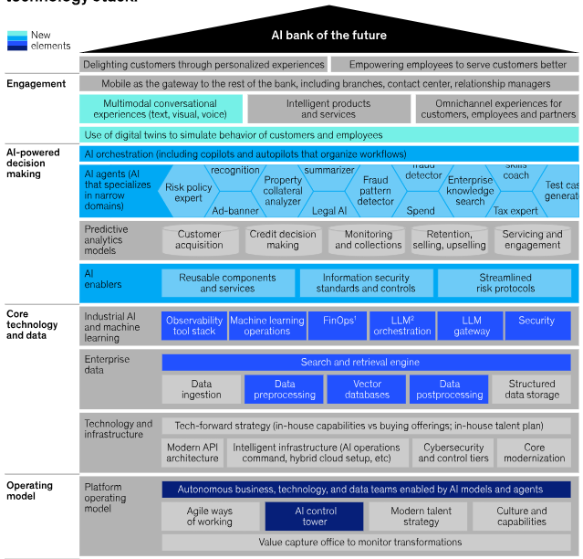

Figure 3.10: Future AI adoption in banks
(Source: Dubey et al., 2025)
Sub-theme 3.4: The Mediating Role of Attitude in the Relationship Between Perceptions and AI Acceptance
The attitudes of consumers and employees play a vital role in mediating AI acceptance and their perceptions. Attitude is considered the strongest predictor of acceptance because feelings of employees about AI in terms of their emotional and evaluative judgement are required regarding AI usefulness. A supportive organisational culture can foster a positive attitude because collaboration or innovation is present, and employees are able to develop a favourable attitude toward AI adoption. From the studies of Liu et al. (2023), customers’ willingness to participate in service creation through their attitude towards self-service could enhance retail banking efficiency. This signifies that customers’ positive attitude and behaviours toward intelligent channels are more important than traditional technology of retail banks. Moreover, traditional self-service channels such as ATMs and CRS still benefited from favourable and positive consumer attitudes, which is a significant factor for efficiency. Chow et al. (2024) opposed this view as attitudes of customers and their trust are lowered by cybersecurity issues. The two-by-two matrix indicates that functionality failure and job placement failure lead to technology rejection among customers and employees, respectively [Refer to Appendix 3].
Apart from these, it is found that unlike manufacturing industries, where Technology enhances adoption in banking services, consumer attitude and demand for convenience drive technological innovation. In 2017, intelligent channel consumer participation was the most important factor in bank efficiency, and it directly impacts banking performance (Liu et al., 2023). The study of Chow et al. (2024) demonstrated that experienced users have a more favourable attitude toward AI intelligence, which increases its acceptance, followed by an enhancement in online banking frequency. In essence, attitudes of both consumers and employees are paramount, of AI acceptance in banking, where positive perceptions enhance engagement and efficiency, while concerns such as cybersecurity risks and system failures can hinder adoption.
Theme 4: Consumer and Employee Concerns About AI in Banking, such as Trust, Privacy, Ethics, and Regulatory Challenges
Sub-theme 4.1: Consumer Trust, Privacy, and Security Concerns in AI-Driven Banking Services
The adoption of artificial intelligence in banking is significantly hindered by consumers’ persistent concerns about trust, data privacy, and security, which lower the perceived benefits of efficiency and convenience. In this context, as stated by Bello et al. (2025), Data privacy laws restrict automatic decision-making because, under the UK GDPR, Article 22 prohibits reliance on automatic systems for decision-making, which requires human oversight in fraud detection. Besides, there are regulatory sandboxes which must be followed by banks, including data protection and customer rights. In addition, the PSD2 authentication requirements may hinder seamless AI operations because of strong customer authentication rules, which may interrupt the AI-powered fraud screening system. In contrast, a lack of data quality may hinder AI adoptions because AI systems produce results which are based on the provided data, and incomplete or poor-quality data may lead to cybersecurity issues (Ali and Shah, 2024). At the same time, customer readiness can affect adoption if users have distrust of AI-driven security measures, such as biometric authentication, which can be challenging for retail banks.
Data privacy and security are the main concerns in AI adoption. The most important thing is that accountability for automotive decisions is not clear. This happens when AI makes a decision which is harmful to a customer, and it is difficult to determine who is responsible, such as the bank, the developer or the algorithm (Rijudan et al., 2024). Furthermore, machine learning algorithms operate as a black box phenomenon, which sometimes makes it difficult to understand how a decision is reached. As a result, AI system failures are termed as ‘black swan’ occurrences, showing the limitations of AI systems. On the other hand, Bello et al. (2025) claimed that cross-border data sharing restrictions can limit fraud intelligence because it is difficult to maintain data transparency across institutions, which reduces the effectiveness of AI fraud detection. The study, however, shed light on the black box AI models, which lack transparency and security. Despite the potential efficiency gains of AI in banking, there are concerns over data privacy, regulatory constraints, lack of transparency, and accountability, affecting its adoption.
Sub-theme 4.2: Employee Acceptance of AI and the Roles of Perceived Usefulness, Ease of Use, and 4.6 Conceptual Framework Norms
The successful adoption of artificial intelligence in banking depends on employee approval, which is carried out by perceptions of usefulness, ease of use, and social influences within the workplace. In this regard, as viewed by Kovačević et al. (2025), ML integration adds complexity to traditional banking systems as it requires employees to develop new skills and adapt to new ways of working, which can affect employee acceptance. Moreover, the shortage of cybersecurity experts can affect AI deployment, and banks can struggle to find employees who can manage and secure AI systems. Along with it, adversarial attacks can lower employee confidence, where data can be manipulated, and trust in technology can be diminished in banks. Despite user acceptance, Ghandour (2021) claimed that AI-driven automation could make some skills obsolete, leading to employee resistance and dissatisfaction. Besides, proactive change management is necessary regarding user acceptance, which can affect employees. At the same time, transparency in AI decision-making could build trust, where employees need to understand the integration of AI systems. Along with it, human touch cannot be fully replaced, because the roles of human bankers cannot be replaced, as close customer contact and employee satisfaction must be fostered.
AI literacy training is related to job changes, where training programs could help employees understand AI and reduce concerns. This can lead to a reduction in job displacement. However, clear communication is required with employees, where banks need to transparently communicate regarding the augmentation of AI, rather than replacing human workers (Inala and Somu, 2024). Besides, more scrutiny is required in retail banking because of its customer-facing nature. Ghandour (2021), on the other hand, highlighted demographics, where younger employees may adapt more easily because they are more tech-savvy than older employees. At the same time, employees must be educated about the vulnerability of AI, such as data poisoning or evasion attacks (Kovačević et al., 2025). This will be helpful as they can use AI systems more responsibly. Therefore, providing proper training to employees can be a good opportunity in the retail banking sector. Thus, the successful adoption of AI in banking relies on employee acceptance, where skills readiness, trust, transparency, and effective training ensure technological advancement.
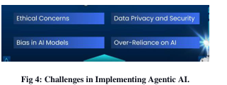

Figure 3.11: Future AI adoption in banks
(Source: Inala and Somu, 2024)
Sub-theme 4.3: Ethical Challenges of Generative AI in Banking: Bias, Transparency, and Accountability
The introduction of gen AI in banking incorporates ethical challenges, concerning algorithmic bias, lack of transparency, unclear accountability, and consumer and employee trust. According to Doddipatla et al. (2024), data bias in loan approval analysis assessments is a major ethical concern in retail banking, which might lead to unfair lending decisions. The study also signifies the importance of black box problems in making certain decisions. When customer trust is lower due to unfair or unexplainable decisions by AI, customers lose confidence in the bank, and this can have lasting reputational and financial consequences. At the same time, both regulators and customers are affected by the lack of AI transparency in banking, leading to adverse outcomes. Contradictorily, Rijudan et al. (2024) commented on the ethical risks provided by third-party AI vendors, and ethical frameworks must include fairness, transparency, and accountability, where banks need to establish clear governance structures at every stage of AI development and deployment.
Government regulation is paramount to building public trust because, without clear rules on AI ethics, data use, and accountability, customers may remain sceptical of banking services, which can lower their adoption. Rijudan et al. (2024) emphasise the importance of AI model cards to enhance transparency. Additionally, the same study prioritised the necessity of human oversight, which can ensure that humans can retain ultimate control in banking. On the other hand, Doddipatla et al. (2024) come up with the importance of stakeholder collaboration for responsible AI. Banks need to engage with regulators, technology providers, and customer advocates to develop necessary policies where a balance is maintained between innovation and customer protection. This can be helpful to enhance consumer trust and transparency in banking services. On a similar note, Inala and Somu (2024) opined that reskilling of existing employees must be a strategic priority in banks where they can reskill current staff AI programmers to bridge the skills gap. However, traditional banking rules such as risk analyst, trader, wealth advisor and business analyst must not be displaced, which can lower operational efficiency in banks.

Regulatory Complexity and Compliance Burden

Employee Resistance

Lack of Transparency

Algorithmic Bias and Unfairness

Data Privacy and Security Risks

Figure 3.12: Challenges of AI adoption in banks
(Source: Author)
Sub-theme 4.4: Organisational and Regulatory Barriers to AI Adoption in Banking
The adoption of artificial intelligence in banking is hindered by organisational-level barriers, which comprise a lack of top management support, resource constraints, skill gaps, and an uncertain regulatory environment. From the studies of Rijudan et al. (2024), high implementation and maintenance costs in AI infrastructure deductive systems and skill talent can affect budget allocation, leading to a delay in adoption. There are skill gaps and talent shortages in the banking system, where a lack of data scientists, AI specialists, and cybersecurity experts creates organisational barriers in the development and management of AI systems. This is related to a lack of organisational readiness, which includes weak change management, poor leadership support and an absence of a clear AI strategy. These are the main obstacles to the successful implementation of AI in banking. In contrast, Kovačević et al. (2025) imprinted that there are concerns over job displacement, increased complexity due to AI adoption and a lack of understanding, which can reduce employee acceptance of AI initiatives. Besides, incomplete and inconsistent data could reduce the effectiveness of such AI models, and this increases operational risks within the banking system. Therefore, data quality issues and employee resistance are the key concerns which need attention. On the contrary, Doddipatla et al. (2024) opined that meeting regulatory requirements, such as audit documentation and reporting, may increase operational costs and slow this innovation. Stringent regulatory requirements, although essential for ensuring compliance and accountability, can impose additional operational burdens that may hinder innovation and slow the pace of AI adoption in retail banking.

3.3 Research Gaps
Despite sufficient literature on the adoption of AI in the banking sector, some key gaps still remain. For instance, the literature emphasises research on large global banks and developed markets, with an under-representation of mid-sized retail banks and emerging markets. This is especially concerning in the UK, where mid-sized banks have distinct challenges associated with legacy technology, financial resources, and regulatory burdens compared to large banks and fintech start-ups. Moreover, there is a clear gap in the literature towards technological and operational efficiency benefits, with little focus on employee attitudes, trust and acceptance of AI. While some research has examined consumer perceptions, there is very little research on employees, who interact with AI systems every day, and their concerns about job loss, skills mismatch and resistance to AI automation.
Apart from these, most studies typically use cross-sectional designs, which only reveal short-term impacts of AI. There is no study on how consumer and employee attitudes change over time as AI systems develop. Furthermore, the impact of regulatory complexity on the pace of AI adoption is unclear, particularly how regulatory complexities across countries affect global banks. Finally, little research addresses the mediating role of organisational culture and top management support in AI acceptance, with most studies examining individual rather than institutional and psychological determinants of AI adoption.

3.4 Theoretical Framework
Diffusion of innovation theory (Dol)
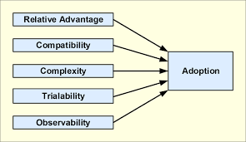

Figure 3.13: DoI
(Source: Al Hadwer et al., 2021)
DoI explains the spread of AI technologies within the banking sector, which comprises relative advantage, compatibility, complexity, trialability, and observability. In UK mid-sized retail banks, AI provides relative advantages in fraud detection, cost savings, and service speed (Emmanuel et al., 2024). Compatibility is also fostered as it is integrated with existing workflows, such as credit scoring and customer service automation (Polireddi, 2024). However, complexity is a major barrier, because many banking executives expressed concerns about its implementation, despite acknowledging the benefits of generative AI. Trialability is seen in many important projects, such as AI-driven credit scoring, whereas observability is fostered in efficiency gains. In these ways, the speed and spread of technology across retail banks are understood through DoI.
Technology Acceptance Model (TAM)
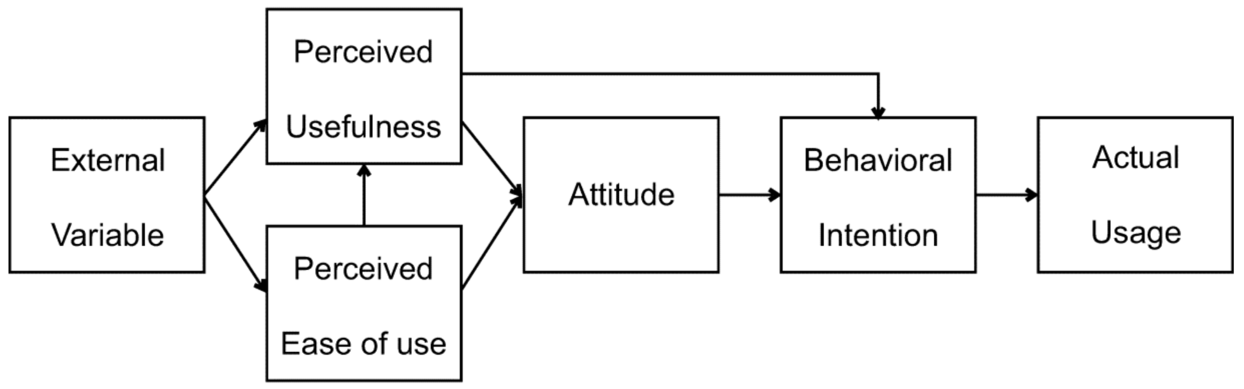

Figure 3.14: TAM
(Source: Iqbal et al., 2026)
TAM focuses on perceived usefulness and ease of use as determinants of technology adoption. In banking, perceived usefulness is rife because AI heightens productivity, reduces costs, and improves customer service (Iqbal et al. 2026). AI remains of immense value to the employees when it automates routine tasks, whereas customers appreciate chatbots and virtual assistants for real-time support (Inala and Somu, 2024). Ease of use is pivotal because complex systems require rigorous training, where any gap in training can hinder their adoption. At the same time, the attitude of employees is paramount as employees’ attitude of self-service, and customers’ attitude of convenience are of immense relevance. Additionally, the behavioural intention of both customers and employees plays a vital role, while retail banks foster AI or ML. Trust and transparency are inextricably related to acceptance of technology, where perceived risks, organisational support and leadership communication strengthen positive attitudes, which relate to TAM’s emphasis on behavioural intention.
Technology-Organisation-Environment (TOE) Framework
The TOE framework demonstrates AI adoption in banking by evaluating technological capabilities, organisational readiness, and environmental pressures. Technological factors include the availability of advanced AI tools such as predictive analytics, fraud detection algorithms, and RPA (Bahoo et al., 2024). Organisational factors are leadership commitment, employee training, and resource allocation. In this regard, banks with strong managerial support and adequate IT infrastructure are equipped with strong technological support, and they can leverage AI for financial performance. Environmental factors include regulatory requirements, competitive pressures, and customer expectations. For instance, explainable AI has been essential to meet transparency demands and regulatory scrutiny across banking (Vuković et al., 2025). In these ways, internal and external factors are provided through the TOE framework, and this illustrates that successful AI adoption depends not only on technological capability but also on organisational culture and regulatory aspects. In contrast, regulatory and compliance-related issues are present as environmental barriers, whereas employee resistance and lack of transparency are organisational barriers. Lastly, cybersecurity, bias, data privacy and security issues are obstacles in terms of technology.

3.5 Chapter Conclusion
The thematic analysis discussed that AI adoption enhances operational efficiency in UK mid-sized retail banks through automation, fraud detection, and improved service delivery. Despite offering significant benefits, the success of AI relies on employee acceptance, organisational readiness, and regulatory compliance. Henceforth, a balance is required between technological innovation and trust, transparency, and governance to ensure fruitful outcomes. In essence, AI is pivotal in retail banking, whereas strategic implementation and supportive organisational culture are required to maximise its efficiency.

Chapter Four: Discussion

4.1 Chapter Introduction
The discussion synthesises the results of the study on AI adoption in UK mid-sized retail banks. The discussion contextualises the findings with evidence from the literature and thematic analysis to answer the research questions. It offers a critical examination of the impact of AI technologies on operational efficiency, cost reduction, service speed and employee acceptance, taking into account the organisational and regulatory challenges. This section examines the consistencies and inconsistencies between the empirical evidence and the existing frameworks, such as DoI, TAM and TOE, by contrasting different studies and theoretical perspectives. The discussion finally synthesises these insights to explain the transformative but complex nature of AI integration in the banking operations.
.
4.2 AI Adoption in Operational Processes
The initial research question focused on the level of adoption of AI in processes. Through a thematic analysis, it was found that AI solutions, including robotic process automation (RPA), machine learning (ML) and agentic AI, are being integrated into banking operations. Examples from Bahoo et al. (2024) and Polireddi (2024) included its use for fraud, credit scoring, compliance and onboarding. These insights confirm that AI is extensively adopted but varies across banks. Some banks have successfully adopted AI and are using it in daily operations, whereas others are still at the pilot stage, showing the diffusion issues in Emmanuel et al. (2024). The mix of findings indicates AI adoption is a technological and strategic activity that needs to align with the organisation’s readiness and regulatory framework. This addresses the research question by showing that AI adoption is already impacting operational processes, although at different levels and speeds.
Operational Efficiency, Cost Reduction, and Productivity
The second question of the study was to understand the efficiency gains. The thematic analysis revealed that AI implementation results in cost reduction, speed of service delivery and productivity. Polireddi (2024) estimated that, by 2023, AI saved $447 billion worldwide and is expected to reach $1 trillion by 2030. In the UK, robotic process automation and chatbots in customer support decreased costs and sped up transactions. Manta et al. (2024) supported these claims by demonstrating that AI algorithms minimise human error in data analysis and risk management, improving accuracy. However, there is a dichotomy of opinions in the study, where different views are present. Although AI investments initially increase efficiency, extended use can result in lower returns. In summary, the findings confirm AI adoption improves efficiency, but with the caveat that this is dependent on the approach taken and ongoing management. Therefore, the findings confirm that AI adoption could enhance efficiency, where a specific and strong managerial approach is pivotal
Employee Perceptions and Acceptance
The third question is related to employees’ attitudes towards AI adoption. In this regard, a mixed opinion is seen in the thematic analysis. Kalyani and Gupta (2023) reported that employees appreciate the benefits of AI in automating tasks, but concerns remain regarding trust, transparency and fears of job loss. Inala and Somu (2024), on the other hand, noted the successful use of AI assistants like RBS’s Luvo to enhance customer experiences and save time. However, surveys cited in Manta et al. (2024) revealed that 53% of retail banking executives are not ready to adopt AI, suggesting organisational resistance. From the evidence, it appears that employee acceptance depends on perceptions of usefulness, ease of use and organisational support, as the TAM demonstrates. Acceptance arises from favourable perceptions, while resistance originates from perceived complexity and uncertainty. This integration highlights that human factors, as much as technological advances, are key to the success of AI in banking.
Organisational, Technological, and Regulatory Challenges
The fourth question is focused on the challenges of adopting AI. The thematic analysis highlighted organisational, technological and regulatory challenges. Kovačević et al. (2025) noted that banks with weak finances find it difficult to invest in AI initiatives, while Vuković et al. (2025) stressed the importance of explainable AI for transparency. Iqbal et al. (2026) showed that regulations can lower the use of AI. Omotosho (2025) further noted that instability affects credit availability, and it can lower the potential of AI‑powered inclusion. The analysis demonstrates that although AI is effective, its use is limited by organisational, technological and regulatory factors. These issues are aligned with the ‘Technology-Organisation-Environment’ model, which stresses the importance of internal and external factors. The integration shows that for AI to be successfully adopted, it is important to have the right technology, organisation and regulatory environment.
Unified Answer to Research Questions
The thematic findings offer a proper answer to the research questions of the study. AI usage in mid‑sized UK retail banks is widespread but not uniform, with the presence of technological advances and organisational and regulatory constraints. Efficiency improvements include cost, speed of service delivery and productivity, but there are concerns about long‑term sustainability. Besides, employee attitudes are paramount, because the adoption is moderated by trust, usability and organisational factors. Organisational preparedness and compliance with regulatory and legislative requirements are also key factors in adoption. These insights show that AI adoption is a complex phenomenon that enhances operational efficiency but also introduces complexities. This synthesis meets the research questions by demonstrating the impact of AI on efficiency, employee perceptions and organisational factors in UK mid‑sized retail banks

4.3 Integration of Findings
This section integrates the findings to demonstrate the impact of artificial intelligence adoption on operational efficiency in mid‑sized retail banks in the UK. This chapter brings together the evidence from the thematic analysis, linking it to the research question and objectives, and critically synthesises the findings in the light of previous studies and theories. The analysis reveals that AI adoption is not a one‑dimensional technological advancement but a multi‑dimensional initiative that affects operational processes, operational efficiency, employee attitudes and organisational issues

4.4 Comparison Between Studies
The first research question was about the extent of AI implementation in the operational process of UK retail banks. Bahoo et al. (2024) and Polireddi (2024) highlighted the importance of AI in fraud detection, credit scoring, and compliance automation. Both of these studies emphasise big data analytics or text mining, along with ML technologies, such as SVA for risk management. Emmanuel et al. (2024) and Manta et al. (2024) shed light on different features, such as the pace of adoption, AI algorithms that reduce human error in data processing, and transaction handling. However, all these authors agreed on the same aspect of the reliability and credibility of AI adoption in risk analysis and risk management. Manta et al. (2024) also showed evidence that only 6% of the retail banks have been able to implement AI into their operations. Thus, while Bahoo and Polireddi mentioned that AI adoption has become widespread across banks, according to Manta, many banks are yet to incorporate the same due to partial integration. At the same time, methodological differences are writ large. For instance, the study of Bahoo and Polireddi is based on quantitative data, whereas Emmanuel and Manta adhered to survey data.
The second research question deals with the impact of Artificial Intelligence on banking efficiency. Polireddi (2024) and Manta et al. (2024) agreed that AI adoption provides cost savings and productivity gains, where a global saving of $447 billion was mentioned by Polireddi. Manta, on the contrary, highlights reductions in human error and transaction delays. In contrast, Omotosho (2025) focused on financial inclusion in emerging economies, which indicates that AI improves access to credit, but it may be vulnerable to macroeconomic volatility. As a result, this comparison shows that there is a dichotomy between short‑term efficiency benefits and long‑term outcomes. Lakmali (2023), on the other hand, indicated that the UK banks can save up to $20 billion on infrastructure costs, while adopting AI, which can be invested elsewhere. Raghavan (2022), on a similar note, discussed the role of AI chatbots, which leads to a 62% cost saving. Thus, these studies underscore the importance of AI adoption in retail banks.
Turksen et al. (2024) contradicted this view, where it was mentioned that 90% of European banks have been fined for AML-related offences. This study, therefore, opposed the view of previous studies, as the challenges of AI and regulatory issues are mentioned, which negatively impacted many European banks. Kikuchi (2026) also deals with the systemic risks, where banks that adopted AI experienced a 428 basis point drop in their return on equity or ROE, followed by a significant investment in cloud infrastructure and system integration. At the same time, systematic risks, spillover issues, and the complexity of AI models, such as DNN, are also discussed. Therefore, it can be stated that despite numerous benefits, certain challenges deter banks from adopting AI into their organisation.
The third research question is about employee perception, acceptance and their attitude. Kovačević et al. (2025) agreed that AI’s usefulness is recognised by employees, whereas concerns about trust, transparency, and job displacement are also demonstrated. Chow et al. (2024) viewed anthropomorphism as a crucial feature of AI, which is more acceptable because AI devices show human-like characteristics such as free will and consciousness, where users feel comfortable in using it. Zungu et al. (2025) shed light on the personalisation features provided by AI, which are valued by employees as they prefer self-service, as it understands their specific needs, followed by offering recommendations. Chow et al. (2024), on the other hand, indicated the importance of virtual banking, which is convenient for customers as they actively interact with AI interfaces. As a result, a positive attitude and acceptance of customers toward AI incorporation in banks are shown by these studies.
From the study of Zungu et al. (2025), it is seen that chatbots assist customers in real time by solving their queries, helping with transactions, and resolving common banking issues. Similarly, Karri et al. (2025) also showed the same opinion on the use of AI chatbots because they offer efficiency, cost reduction, and enhanced customer experience in retail banking. On the contrary, Osman et al. (2025) opposed these views, as feelings and trust of employees sometimes plummet, concerning AI adoption, which has a negative influence on AI adoption. Additionally, Chow et al. (2024) highlighted the issues related to data privacy and cybersecurity in the banking sector. This is a severe issue because of clandestine data theft of customers, as security-related issues are on the rise. Hence, a mixed opinion is found based on these studies, where negative attitudes are rife, along with a higher acceptance rate among the employees and customers.
The last research question was about the organisational, technological, and regulatory issues to the successful adoption of AI in UK mid-sized retail banks. In this context, Bello et al. (2025) commented on data privacy issues, where Article 22 of the UK GDPR prohibits reliance on automatic systems for decision-making, along with cybersecurity and authentication issues. Thus, this study discusses the technological pressures implemented by AI adoption in retail banks. Kovačević et al. (2025), on the other hand, provided insight into employee acceptance and skill development, which are required in AI adoption. Ghandour (2021), on a similar note, revealed that AI adoption may obsolete skills among employees, which may lead to employee resistance and dissatisfaction. Therefore, the studies of Kovačević and Ghandour justified the organisational barriers in AI adoption, where skill loss and employee resistance can take place.
Apart from these, Doddipatla et al. (2024) shed light on the presence of ethical bias after AI implementation in retail banking, which could lead to unfair lending decisions. Similarly, Rijudan et al. (2024) commented on the ethical risks provided by third-party AI vendors, which may lower transparency, fairness and accountability. Thus, these 2 studies are similar in terms of providing ethical challenges in AI implementation. Conversely, Doddipatla et al. (2024) opined that stakeholder collaboration is a critical factor. Hence, banks need to realise that without proper coordination among stakeholders, such as regulators, technology providers, and customer advocates, robust AI policies cannot be developed. Contradictorily, Rijudan et al. (2024) opposed AI model cards that could enhance transparency in case of any challenge. However, the same study highlighted high implementation and maintenance costs in AI infrastructure as crucial barriers to AI adoption. Henceforth, based on all the above studies, it is seen that AI implementation in retail banks includes multiple challenges, which need to be alleviated to run operations. In this way, the third research question, where most of the studies showed similar views.

4.5 Theoretical Implications
Diffusion of Innovation (DoI)
The findings of the study supported DOI’s emphasis on relative advantage, compatibility, complexity, trialability, and observability. The study of Emmanuel et al. (2024) and Polireddi (2024) indicated that AI adoption has a relative advantage, including fraud detection, cost savings, and service speed. Furthermore, both costumes and employees receive the same benefits. Besides, compatibility is also evident as AI is incorporated into existing workflows, such as credit scoring and compliance checks. However, there are challenges, in the form of gen-AI unpreparedness and skills gap, despite its potential benefits. These are aligned with the principles of DoI. Trialability is also seen in different projects, such as AI‑driven credit scoring in emerging markets (Omotosho, 2025). In addition, observability is fostered through efficiency gains in banks, where transactions are enhanced, followed by a reduction in fraud losses. At the same time, the complexities of AI integration are also seen in theme 4, where organisational, technological and regulatory barriers are conferred. Henceforth, it can be seen that DoI is a highly relevant framework to understand the details of AI adoption in retail banks.
Technology Acceptance Model (TAM)
The findings of the study are highly related to the core aspects of TAM, which comprises perceived usefulness and ease of use as determinants of technology adoption. Employees and customers perceive AI as useful because tasks are automated, costs are reduced, and an improved service delivery across the retail banking sector (Iqbal et al., 2026; Inala and Somu, 2024). Chatbots and AI assistants such as RBS’s Luvo demonstrate high perceived usefulness because customer support is enhanced, along with a reduction in workload among employees. Ease of use, however, has been a challenge in retail banks due to a skills deficit. In addition, AI systems require training for the employees, which can reduce the adoption rate. On the other hand, trust, transparency, and organisational support are the positive factors regarding TAM. Kalyani and Gupta (2023) opined that employees sometimes resist AI adoption when they do not have significant confidence in AI’s reliability. As a result, these factors signify that TAM can be incorporated, where trust and governance are present.
TOE Framework
The TOE framework is relevant to the findings of the study, which shows that successful AI adoption depends on technological capability, organisational readiness, and external pressures. For instance, technological factors include advanced AI tools such as predictive analytics and fraud detection systems, which enhance efficiency and reliability (Bahoo et al., 2024). Organisational readiness, on the other hand, is demonstrated by the support of leaders, employee training, and IT infrastructure. Thus, banks with strong managerial support and sufficient resources can leverage AI effectively, and they can also outcompete their rivals. Environmental pressures, however, are significant in the UK context, where customer expectations and UK GDPR are pivotal elements. In this regard, Vuković et al. (2025) indicated the importance of explainable AI to meet transparency issues, whereas Iqbal et al. (2026) shed light on the obstacles of regulatory frameworks, particularly in CBFI. Hence, based on the above discussion, it can be seen that the TOE framework is supported by the findings.

4.6 Identification of Gaps
This study identifies multiple gaps in the literature on AI adoption in the banking sector. First, existing studies have focused primarily on multinational banks or fintech companies, overlooking the mid‑sized retail banks in the UK. This is noteworthy because mid‑sized banks have unique characteristics, such as legacy IT systems and financial and human resource limitations, which influence the speed and success of AI implementation. Second, although research like Bahoo et al. (2024) and Polireddi (2024) report efficiency benefits, there is little evidence about the long‑term viability of these benefits. The thematic analysis identified reduced returns and systemic risk, which are not well addressed in the literature. Third, there is a lack of focus on employee and organisational culture in AI adoption models. At the same time, past research on this topic has not addressed the future potential of AI adoption across mid-sized banks. This research addresses these gaps to provide new insights on the impact of AI on the operational efficiency of mid‑sized retail banks, a significant gap in the research.

4.7 Conceptual Framework

Applications of AI
Gen AI
RPA
ML
Predictive Analytics
AI Adoption and Operational Efficiency in UK Mid‑Sized Retail Banks
Operational Efficiency
Cost Reduction
Speed
Fraud Detection
Employee and Consumer Acceptance
Ease of Use
Perceived Usefulness
Trust

Organisational Challenges
Regulatory Compliance
Capital Limitations
Transparency
Security
Efficiency Gains
Short‑Term Performance
Financial Inclusion
Automation
Sustainable AI Integration in UK Mid‑Sized Retail Banks
Operational Transformation
Marketing improvement
Digitalisation
Financial stability

Figure 4.1: Conceptual Framework
(Source: Author)

4.8 Chapter conclusion
The discussion concluded that AI adoption has a significant effect on improving the operational efficiency of UK mid-sized retail banks through automation, predictive analytics and improved service delivery. However, it can only work if the organisation is ready, employees trust it, and it abides by regulations. The comparative and theoretical analysis shows that AI provides visible short-term benefits, but sustainable efficiency requires strategic governance and transparent integration. The findings add human and institutional dimensions to previous theories, showing that technological innovation alone cannot ensure long‑term performance. In conclusion, the adoption of AI is both a challenge and an opportunity and needs to be aligned in a balanced way between technology, people and policy.

Chapter Five: Implications

5.1 Chapter Introduction
This chapter explores the broader implications of the study’s results, which are applied to practical, actionable implications for managers, policy makers, and scholars. It improves on current frameworks, recommends concrete actions and points out future research areas to sustainably integrate AI in mid-sized retail banks in the UK.

5.2 Theoretical Implications

5.2.1 Refining the framework
Refining the Diffusion of Innovation (DOI) Theory
The study extends DOI theory by showing that, in addition to the classic factors of relative advantage, compatibility, complexity, trialability, and observability of the innovation, regulatory pressure and constraints on organisational resources and legacy system limitations also influence the diffusion process in mid-sized banks. The results indicate that while DOI’s diffusion process assumes that innovations are diffused because of the perceived benefits of adopting them, current findings suggest that mid-sized banks identify this relative advantage, but are delayed by compliance considerations, capital restrictions, and risk aversion. For instance, in the UK, new capital rules set by the BoE affected the mid-sized UK banks in 2024 (Hills, 2024). However, in 2025, the BOE set the threshold at 25 billion-40 billion pounds ($87.35 billion), which eased capital requirements for midsize banks (White, 2025). As a result, the complexity of AI adoption could be minimised.
Extending the Technology Acceptance Model (TAM)
The findings also enhance the TAM by highlighting the need for perceived usefulness and ease of use as two important but not enough determinants of AI acceptance in banking. Thematic analysis revealed that the factors of trust, transparency, and perceived fairness have a significant impact on employee and consumer acceptance. For instance, workers might recognise the benefits that AI brings in terms of saving time, but hesitate to adopt it because they fear losing their jobs, or they do not understand how decisions are being made. Similarly, while customers might be open to speedier service, they might be suspicious of AI decision-making if they do not have the context. With these findings in mind, it is clear that TAM needs to be modified to incorporate affective and ethical aspects in the context of the adoption of AI in financial services.
Strengthening the Technology-Organisation-Environment (TOE) Framework
The findings provide strong support for the validity of the TOE framework, but some elements of the framework would benefit from being further developed and refined. Key factors in adoption are technological readiness, organisational capacity, and environmental pressures. However, it has been observed that mid-sized banks also experience conditions that are organisationally different, such as smaller innovation budget, outdated IT systems and restricted capital investment, which exacerbate the effects of environmental stress, such as consumer expectations and regulatory compliance. This is evident as UK mid-sized banks aim to spend £3.3 billion in core banking systems in 2026, as the system is considered a ‘bottomless pit of wasted resources’ to meet digital expectations (Shibli, 2025). The study builds on TOE by showing the active role environmental factors play in influencing organisational strategy. The regulatory landscape, including UK GDPR and FCA guidelines, directly influences the rate, extent, and impact of AI use. The question then is whether regulatory intensity should be added as a separate sub‑dimension of the environmental dimension in TOE for financial institutions.

5.2.2 Academic contribution
The conceptual framework developed in this study is useful as an academic contribution as it incorporates the technological, organisational, human and regulatory aspects into one model specifically developed for the context of mid-sized retail banks in the UK. Theories that already exist, like the DOI, TAM, and TOE, explain specific facets of the AI adoption but do not address all three factors of operational efficiency, employee acceptance, and organisational constraints. The model bridges that gap by depicting the interaction between AI applications (Generative AI, RPA, machine learning, predictive analytics) and efficiency outcomes and acceptance factors, driving operational transformation. One of the main contributions is the dual pathway structure, which highlights the efficiency benefits and organisational challenges of adopting AI technologies. It undermines the linear thinking model of conventional adoption theories and views on AI as a process that is both beneficial and constrained. Further, the model highlights the need for technology readiness, trust, user-friendliness, regulatory adherence, and organisational readiness to successfully incorporate sustainable AI into their business operations.

5.3 Practical & Managerial Implications

5.3.1 Strategic recommendations
Prioritising AI investments for operational efficiency
Organisations need to prioritise AI tools that have clear cost-saving, speed and efficiency benefits, and accuracy benefits, like RPA tools for back-office automation, ML tools for fraud detection, and chatbots for customer service. These areas are identified as the ones that provide the highest efficiencies.
Strengthening organisational readiness through capability building
One of the study’s key findings is that employee resistance and a lack of AI literacy pose significant challenges. Continual training, reskilling initiatives and open communication among managers should be used to enhance confidence and mitigate the fear of losing jobs. Hybrid human‑AI models should be emphasised to reassure employees that AI augments rather than replaces human roles.
Modernising legacy systems to support scalable AI integration
Mid-sized banks are hindered in their ability to fully leverage AI by legacy infrastructure. Adopting a phased approach towards modernisation is key, such as moving to the cloud, integrating with APIs, or incrementally replacing parts of the system. This simplifies implementation and will have long-term benefits of scalability.
Embedding ethical AI governance into operational processes
Managers need to establish governance processes to make AI decision-making processes explainable, fair and accountable (Birkstedt et al. 2023). Having clear guidelines for data usage, model validation, and human oversight helps build trust on the part of stakeholders.

5.3.2 Policy & industry impact
Strengthening regulatory clarity and support for AI innovation
Guidelines for AI Compliance, AI Explainability, and Data Governance should be made more explicit. Complex regulations are hard to interpret for smaller banks, and slow their adoption
Promoting industry‑wide standards for ethical and transparent AI
The results indicate that consumers’ confidence is based on transparency. Industry groups should create standardised frameworks for AI systems to be explainable, assess risks and consistently handle data protection between institutions.
Fostering collaboration between banks, fintech, and regulators
Mid-sized banks do not have to develop all the advanced AI features on their own, as they can gain access via partnerships. Collaborative ecosystems also heighten more knowledge sharing and less overlap of effort.

5.3.3 Action plan
Best Practices | Application
Adopting phased AI implementation | Begin with low‑risk, high‑impact use cases, such as RPA in back‑office tasks and chatbots for customer service, before moving to complex systems. This reduces risk and builds confidence.
Establishing cross‑functional AI governance committees | Creating oversight teams including IT, compliance, risk, and operations to manage ethical, technical, and organisational dimensions of AI adoption.
Implementing continuous monitoring systems | Tracking AI performance, detecting bias, and ensuring compliance with UK GDPR and FCA guidelines. Monitoring ensures accountability and reliability.
Integrating human oversight into critical AI decisions | Maintaining human review in sensitive areas such as lending, fraud detection, and customer service to safeguard fairness and trust.
Developing transparent communication strategies | Educating customers about AI‑driven processes, explaining decision logic, and highlighting benefits to build trust and acceptance.
Aligning AI initiatives with organisational strategy | Ensuring AI investments support long‑term goals (efficiency, customer satisfaction, compliance) rather than short‑term experimentation.

Table 5.1: Action plan for retail banks
(Source: Author)

5.4 Research Implications

5.4.1 Limitations
One of the major limitations of the study is its reliance on secondary data. As a result, organisational dynamics, employee experiences, and customer perceptions are not fully known. Additionally, the geographic focus was on the UK, which hindered the generalisability of the study. Besides, regulatory frameworks, cultural attitudes, and technological readiness of other regions are also not fully understood. The results were impacted as a comparison with other regions was not possible. Furthermore, adequate data on mid-sized retail banks in the UK was not available.

5.4.2 Future research agenda
Future studies need to include the evolution of AI, concerning trust and employee acceptance in retail banks, which includes the dynamic relationship between perceived usefulness and sustained adoption. Besides, comparative research is required, where information on different bank sizes and geographies would be included. In addition, hybrid human-AI operating models need to be incorporated, which could explore how a balance is made between automation and human oversight to achieve efficiency. Moreover, studies on ethical AI governance can assess factors, such as explainability, transparency, and compliance frameworks.

5.5 Chapter Summary
The chapter illustrated, validated, and enriched theoretical models of the DOI, the TAM, and TOE by adding regulatory, organisational, and human factors in the context of UK mid-sized retail banks and the adoption of AI. It offered practical guidance for managers from a phased implementation, ethical governance, and clear communication perspective and drew out policy implications for regulators. The conceptual framework provided a fresh idea for academic research focusing on two avenues for efficiency gains and organisational issues. Lastly, it discussed the limitations of the studies conducted as well as future scopes for research, such as the need for longitudinal research, comparison studies, and hybrid human-AI studies.

Chapter Six: Conclusion

6.1 Answering the Research Questions
The primary research question was how the adoption of AI influences operational efficiency in UK mid‑sized retail banks. The study provides a clear answer, as AI adoption enhances efficiency by reducing operational costs, which includes minimising expenses, accelerating services, and improving fraud protection systems. The level of adoption indicates that mid‑sized banks are increasingly bringing into their operations technologies like RPA, ML and PA, and gen-AI, although there is not uniform implementation across all types of banks due to legacy systems and funding constraints. The effect of such impact is a substantial difference in efficiency, a measurable reduction in costs and speed of service, but achieving sustainability requires clear governance and strategies.
The results show that the dimensions that affect the acceptance of the tool are trust, ease of use, and perceived usefulness, while the elements that because resistance are the fear of job loss and lack of knowledge about AI. Key factors that influence adoption outcomes include organisational and regulatory issues, such as UK GDPR and FCA compliance, resource limitations and transparency issues. Together, these findings validate that AI implementation is infusing transformation into operations, but also underscore the need for a balanced approach to integrating technology, people, and governance to ensure sustainable gains in efficiency. Hence, 4 research questions of the study have been addressed.

6.2 Research Contributions
The study makes a valuable contribution to the academic literature as well as to the practical business of banking. Academically, it builds on the DoI theory by highlighting the importance of regulatory intensity and organisational resource constraints on diffusion, while adding to the TAM theory with the addition of trust, transparency, and leadership support as mediators of acceptance. Moreover, it refined the TOE theory by emphasising the role of environmental pressure as a key determinant of adoption in regulated industries. The study also proposes a new conceptual framework that combines technological applications, outcomes, human acceptance, and organisational considerations into a two-pathway model leading to achieving sustainable AI integration. It offers a new perspective for researchers studying AI adoption as much as a process, but as an ongoing interaction between efficiency and challenges.
Implementing strategies, such as staged implementation, ethical AI governance policies, transparent communication, and a human-AI hybrid model, can be introduced in a practical sense, providing managers with concrete action points. Policymakers obtain insights into the need for better guidance in the regulatory space, industry-defined best practices for explainable AI and co-operative ecosystems among banks and fintech. The results show the need to focus on the long-term strategy of the organisation when developing AI projects, rather than short-term experiments.

6.3 Limitations
Some limitations must be noted to provide context for the results. Limitations in the study include the use of a systematic literature review of peer-reviewed sources, resulting in a lack of incorporation of real-time organisational dynamics and the lived experience of employees and customers. Focus on the UK mid-sized retail banks restricts generalisability to other settings, such as large multi-national banks, or institutions in other regulatory settings. The time frame covered in the literature reviewed (2015 to 2025) shows some recent developments, but it can be outdated based on the rapid evolution of AI technologies. Besides, multiple articles of the study did not include retail banks. UK due to the scarcity of information. Moreover, such reliance on published studies has the risk of publication bias; that is, a successful implementation is more likely to be reported than a failed one.

6.4 Recommendations and Future Research
Based on the gaps identified, scholars and practitioners are recommended to take up several next steps. In this context, the relationship between the changes of trust, acceptance, and efficiency in AI-supported banking needs to be explored through longitudinal studies. Comparative studies would make it clear how specific characteristics of the bank, such as regulation and resource availability, affect adoption results as a function of bank size and geography. Empirical research on hybrid models of human-AI operation could delve into the ways in which banks need to balance human oversight and automation to operate efficiently while demonstrating fairness and accountability. Research on the governance of ethical AI should examine the extent to which explainability, transparency and compliance systems are being applied in real-world deployments, such as via GDPR and FCA guidance in the UK. At the same time, quantitative methods must be adhered to in future research so that the perspective of employees across UK mid-sized retail banks regarding AI adoption.
Apart from these, managers need to focus on investing in AI technologies that offer efficiency gains, alongside ethical governance mechanisms for practice, while prioritising impactful benefits. Regulatory clarity can be strengthened, while innovation can be fostered through abiding by industry standards on explainable AI, by policymakers. For banks, aligning investments in AI with strategic priorities is essential. The goal is to invest in AI to support sustainable long-term plans, not just for short-term trials and experiments. The recommendations provide a way for the academic community and industry practice to keep progressing, concerning the complexities of AI adoption. AI integration offers an opportunity and a challenge to UK mid-sized retail banks. While it has the added benefit of transforming price reduction, service delivery speedup, and fraud detection, collaboration requires employee trust, organisational readiness, and regulatory compliance. The study has shown that adopting sustainable AI will need a comprehensive approach, involving a combination of technological, human and institutional factors.

References
Al Hadwer, A., Tavana, M., Gillis, D. and Rezania, D. (2021). A systematic review of organizational factors impacting cloud-based technology adoption using technology-organization-environment framework. Internet of Things, 15, p.100407
Ali, A. and Shah, M. (2024). What hinders adoption of artificial intelligence for cybersecurity in the banking sector. Information, 15(12), 760. https://doi.org/10.3390/info15120760
Bahoo, S., Cucculelli, M., Goga, X. and Mondolo, J. (2024). Artificial intelligence in Finance: a comprehensive review through bibliometric and content analysis. Artificial intelligence in Finance: a comprehensive review through bibliometric and content analysis, [online] 4(2).
BELLO, A.D., OGUNTOLA, O.B., AJIBADE, A.T., AKINDOLANI, A., AYOOLA, O. and BELLO, A.M. (2025) AI-Driven Fraud Detection in UK Digital Payment Systems: Challenges and Solutions.
Birkstedt, T., Minkkinen, M., Tandon, A. and Mäntymäki, M. (2023). AI governance: themes, knowledge gaps and future agendas. Internet Research, 33(7), pp.133-167
Biswas, S. et al. (2020) AI in banking: Can Banks Meet the challenge? , McKinsey (Accessed 31 March 2026)
Bonsu, M.O.A. and Guo, Y. (2026) Do Big Data Applications and Financial Innovation Lead to Enhanced Banking Performance? Evidence From the United Kingdom. International Journal of Finance & Economics
Bueno, L.A., Sigahi, T.F.A.C., Rampasso, I.S., Leal Filho, W. and Anholon, R. (2024). Impacts of digitization on operational efficiency in the banking sector: Thematic analysis and research agenda proposal. International Journal of Information Management Data Insights, 4(1), p.100230.
Chow, C. S. K., Zhan, G., Wang, H. and He, M. (2023). Artificial intelligence (AI) adoption: An extended compensatory level of acceptance. Journal of Electronic Commerce Research, 24(1), 84-106.
Christou, E., Parmaxi, A. and Zaphiris, P. (2024). A systematic exploration of scoping and mapping literature reviews. Universal access in the information society
Dalvinder Kular (2025) Only 25% of financial institutions ready for AI era, says BCG, FStech
De, J., Ramírez, A. and Romero, J.R. (2023). Artificial intelligence to automate the systematic review of scientific literature. Computing
Dinesh Kumar Nuthi (2025) How Intelligent Automation is Reshaping the Banking Industry in 2025, Straive
Doddipatla, L., Ramadugu, R., Sharma, S. T. R. and Yerram, R. R. (2024). Ethical and regulatory challenges of using generative AI in banking: Balancing innovation and compliance. Educational Administration: Theory and Practice, 30(3), 2848-2855
Doumpos, M., Zopounidis, C., Gounopoulos, D., Platanakis, E. and Zhang, W. (2023). Operational research and artificial intelligence methods in banking. European journal of operational research, 306(1), pp.1-16. https://doi.org/10.1016/j.ejor.2022.04.027
Dubey, S.S., Vivek Astvansh and Kopalle, P.K. (2024). EXPRESS: Generative AI Solutions to Empower Financial Firms. Journal of Public Policy & Marketing
Emmanuel, B.G., Appiah, M., Gyamfi, B.A., Acheampong, T. and Naeem, M.A. (2024). Transforming banking: Examining the role of AI technology innovation in boosting banks financial performance. International Review of Financial Analysis, 96
FIS Research Shows (2025) Banks Must Educate As They Innovate: Over A Third Of UK Consumers Say Financial Services AI Is Moving Too Fast, Financial IT
Ghandour, A. (2021). Opportunities and challenges of artificial intelligence in banking: Systematic literature review. TEM journal, 10(4), 1581-1587
Giovine, C., Lerner, L., Thomas, R., Singh, S., Kakulavarapu, S. and Chung, V. (2024). Extracting Value from AI in banking: Rewiring the Enterprise. [online] McKinsey & Company
Hanafizadeh, P. and Amin, M.G. (2022). The transformative potential of banking service domains with the emergence of FinTechs. Journal of Financial Services Marketing
Harris, H. (2024) How much does AI save a company?, Rand Group
Hasani, T., O’Reilly, N., Dehghantanha, A., Rezania, D. and Levallet, N. (2023). Evaluating the adoption of cybersecurity and its influence on organizational performance. SN Business & Economics, 3(5)
Hassan, M., Nafees, A.A., Shraban, S.S., Paul, A. and Mahin, H.D. (2025). Application of machine learning in intelligent transport systems: a comprehensive review and bibliometric analysis. Discover Civil Engineering, 2(1)
Herrmann, H. and Masawi, B. (2022). Three and a half decades of artificial intelligence in banking, financial services, and insurance: A systematic evolutionary review. Strategic Change, 31(6)
Hills, S. (2024). How new capital rules could affect the UK’s mid-tier banks and the economy
Inala, R. and Somu, B. (2024) Agentic AI in Retail Banking: Redefining Customer Service and Financial Decision-Making. Journal of Artificial Intelligence and Big Data Disciplines, 1(1)
Inala, R. and Somu, B. (2024). Agentic AI in Retail Banking: Redefining Customer Service and Financial Decision-Making.
Journal of Artificial Intelligence and Big Data Disciplines, 1(1)
Iqbal, M.S., Iqbal, S. and Rana, A. (2026). AI adoption and FinTech integration in dual banking systems: Impacts on cross-border financial intermdiation and POS infrastructure. Finance Research Open, 2(2)
Jingrong, H. (2024). AI-Driven Digital Transformation in Banking: A New Perspective on Operational Efficiency and Risk Management. Information systems and economics, 5(1)
Kagalwala, H., Paruchuri, S., Josyula, H.P., Kumar, P.A. and Al Said, N. (2025) AI-powered FinTech: Revolutionizing digital banking and payment systems. Journal of Information Systems Engineering and Management, 9.
Kalyani, S. and Gupta, N. (2023). Is artificial intelligence and machine learning changing the ways of banking: a systematic literature review and meta analysis. Discover Artificial Intelligence, 3(1), 41.https://doi.org/10.1007/s44163-023-00094-0
Kamalnath, V., Lerner, L., Moon, J., Sari, G., Vik Sohoni and Zhang, S. (2023). Capturing the full value of generative AI in banking. [online] McKinsey & Company.
Karri, S.B., Gawali, S., Rayankula, S. and Vankadara, P. (2025). AI Chatbots in Banking: Transforming Customer Service and Operational Efficiency. Frontiers in Artificial Intelligence and Applications
Kikuchi, T. (2026). The Innovation Tax: Generative AI Adoption, Productivity Paradox, and Systemic Risk in the U.S. Banking Sector. [online] arXiv.org.
Kovacevic, A., Radenkovic, S.D. and Nikolic, D. (2024). Artificial intelligence and cybersecurity in banking sector: opportunities and risks. [online] arXiv.org
Lakmali, M.A.D. (2024). The Use of Artificial Intelligence Technology to Improve the Efficiency of the Banking Sector in the United Kingdom. Independent research project, Metropolia University of Applied Sciences, Helsinki, Finland
Liu, D., Fang, H., Tang, Y., Salmi Mohd Isa and Tang, J. (2023). Intelligent Technology Solutions and Banking Efficiency: The Impacts of Institutional Innovation and Consumer Participation. SAGE open, 13(2)
Manta, A.G., Bădîrcea, R.M., Doran, N.M., Badareu, G., Gherțescu, C. and Popescu, J. (2024). Industry 4.0 Transformation: Analysing the Impact of Artificial Intelligence on the Banking Sector through Bibliometric Trends. Electronics, 13(9), pp.1693–1693
McKinsey & Company (2024). The Future of AI in banking: threats or challenge for the modern banking system
OMOTOSHO , M.A. (2025). EXPLORING THE ROLE OF AI-DRIVEN CREDIT SCORING SYSTEMS ON FINANCIAL INCLUSION IN EMERGING ECONOMIES
Osman, Z., Alwi, N.H., Husin, S.A. and Razak, N.S.A. (2025). Embrace, Evolve, & Excel: Artificial Intelligence-Driven Transformational Acceptance in the Commercial Banking Sector. International Journal of Academic Research in Business and Social Sciences, 15(8), pp.814-831

Oyekunle, D. and Boohene, D. (2024). Digital transformation potential: The role of artificial intelligence in business. International Journal of Professional Business Review: Int. J. Prof.Bus. Rev., [online] 9(3), p.1
Paramesha, M., Rane, N. and Rane, J. (2024). Artificial intelligence, machine learning, deep learning, and blockchain in financial and banking services: a comprehensive review. SSRN Electronic Journal
Polireddi, N.S.A. (2024). An effective role of artificial intelligence and machine learning in banking sector. Measurement
33, pp.101135–101135
Precedence Research (2025) AI Agents in Financial Services Market Size to Hit USD 6.54 Billion by 2035, Precedenceresearch.com. Precedence Research . Available at: https://www.precedenceresearch.com/ai-agents-in-financial-services-market.(Accessed 31 March 2026)
Raghavan, P. (2022) Adaptive AI Chatbots: Personalisation Through Real-Time Behavioural Analytics in Banking.
Research, (2025) Banks Must Educate As They Innovate: Over A Third Of UK Consumers Say Financial Services AI Is Moving Too Fast
RGP, (2025) Striking the Balance Between Innovation and Regulation , Global consulting and project execution for business transformation
Ridzuan, N. N., Masri, M., Anshari, M., Fitriyani, N. L. and Syafrudin, M. (2024). AI in the financial sector: The line between innovation, regulation and ethical responsibility. Information, 15(8), 432
S&P Global (2025) AI and banking: Leaders will soon pull away from the pack | S&P Global
Sabapathy, G. (2025). AI-Powered Advanced Analytics: Transforming Data into Strategic Insights. Journal Of Multidisciplinary, [online] 5(8), pp.416–422
Shibli, A. (2025). UK banks to spend £3.3bn on legacy systems in 2026
Turksen, U., Benson, V. and Adamyk, B. (2024). Legal implications of automated suspicious transaction monitoring: enhancing integrity of AI. Journal of Banking Regulation, 25
UK Consultancy (2024) AI in banking could yield $1 trillion revenue improvements, www.consultancy.uk.
UK Finance (2024) Over half of UK adults now use mobile wallets
Vuković, D.B., Dekpo-Adza, S. and Matović, S. (2025). AI integration in financial services: a systematic review of trends and regulatory challenges. Humanities and Social Sciences Communications, [online] 12(1)
White, L. (2025). Bank of England eases capital requirements for midsize banks.
Zungu, N.P., Hayford Amegbe, Hanu, C. and Asamoah, E.S. (2025). AI-driven self-service for enhanced customer experience outcomes in the banking sector. Cogent Business & Management, 12(1).

.

Appendices

Appendix 1: AI in customer service
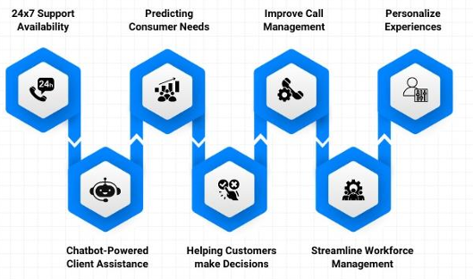
(Source: Inala and Somu, 2024)

Appendix 2: Jiangsu Bank’s Non-Performing Loan (NPL) Rate
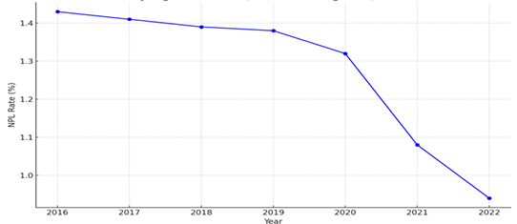
(Source: Jingrong et al., 2023)

Appendix 3: Classification of Consumer Behaviours on Performance Expectancy (PE) and Effort Expectancy (EE) toward Technology Innovation
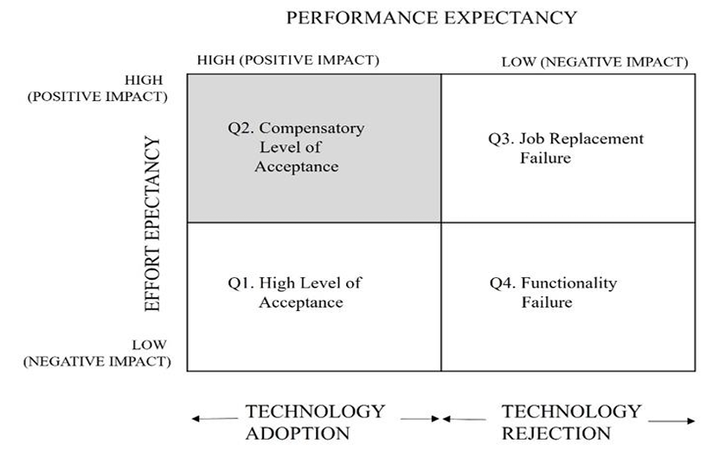
(Source: Chow et al., 2024)

Appendix 4: Search Strategy
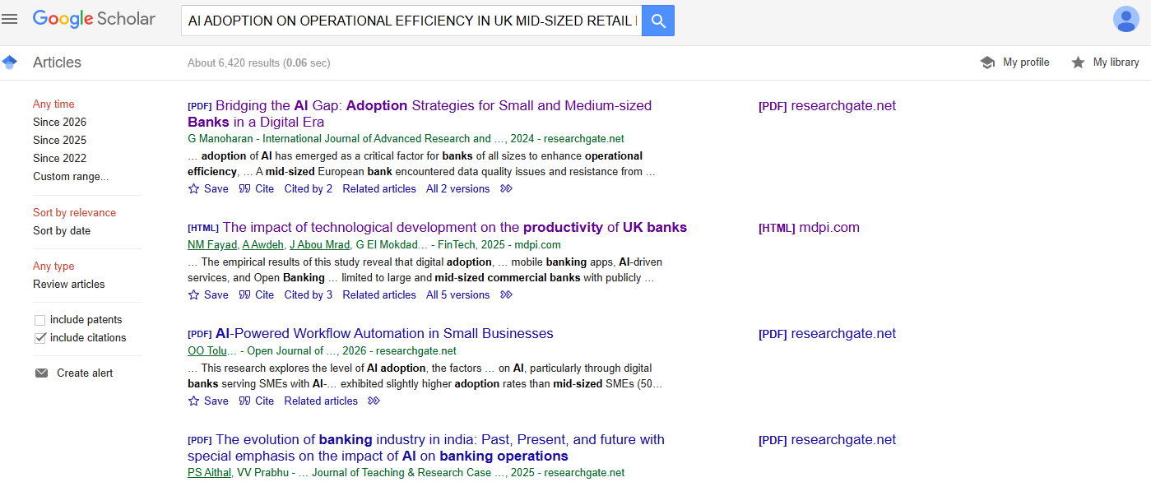
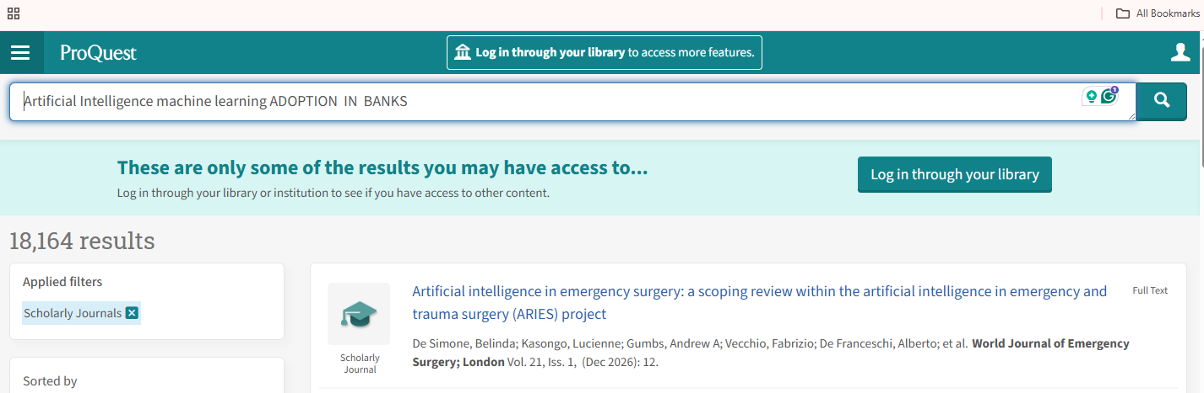
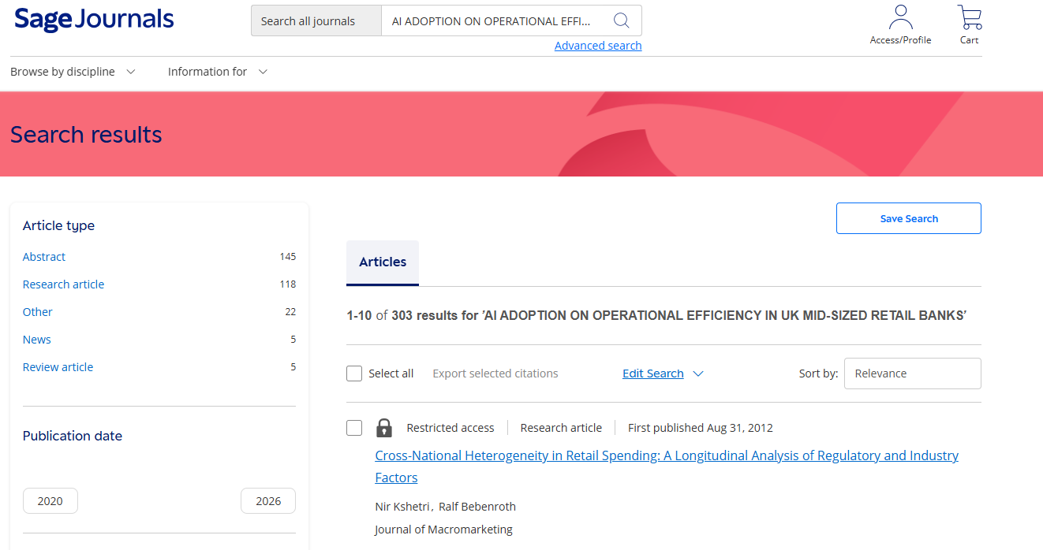
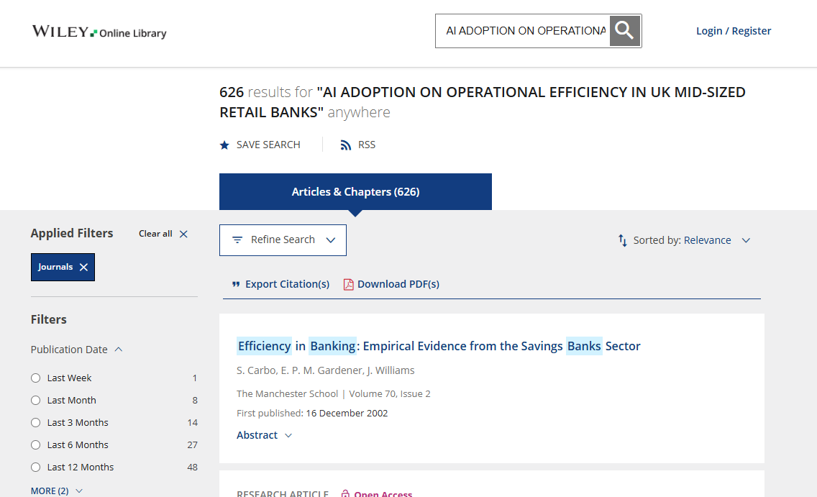
(Source: Author)

