The fourth industrial revolution: Trends

Smart factories
The Fourth Industrial Revolution fosters "smart factories", which are production environments where facilities and logistics systems are organised with minimal human intervention.
The technical foundations on which smart factories are based are cyber-physical systems that communicate with each other using IoT. An important part of this process is the exchange of data between the product and the production line. This enables more efficient supply chain connectivity and better organisation within a production environment.
Within modular structured smart factories, cyber-physical systems monitor physical processes, create a virtual copy of the physical world, and make decentralised decisions. Over the internet of things, cyber-physical systems communicate and cooperate with each other and with humans in synchronic time both internally and across organizational services offered and used by participants of the value chain.

Artificial intelligence
Artificial intelligence (AI) has a wide range of applications across all sectors of the economy. It gained prominence following advancements in deep learning during the 2010s, and its impact intensified in the 2020s with the rise of generative AI, a period often referred to as the "AI boom". Models like GPT-4o can engage in verbal and textual discussions and analyze images.
AI is a key driver of Industry 4.0, orchestrating technologies like robotics, automated vehicles, and real-time data analytics. By enabling machines to perform complex tasks, AI is redefining production processes and reducing changeover times. AI could also significantly accelerate, or even automate software development.

Some experts believe that AI alone could be as transformative as an industrial revolution.[43] Multiple companies such as OpenAI and Meta have expressed the goal of creating artificial general intelligence (AI that can do virtually any cognitive task a human can),making large investments in data centers and GPUs to train more capable AI models.

Robotics
Humanoid robots have traditionally lacked usefulness. They had difficulty picking simple objects due to imprecise control and coordination, and they wouldn't understand their environment and how physics works. They were often explicitly programmed to do narrow tasks, failing when encountering new situations. Modern humanoid robots, however, are typically based on machine learning, and in particular reinforcement learning. In 2024, humanoid robots are rapidly becoming more flexible, easier to train, and versatile.

Predictive maintenance
Industry 4.0 facilitates predictive maintenance, due to the use of advanced technologies, including IoT sensors. Predictive maintenance, which can identify potential maintenance issues in real time, allows machine owners to perform cost-effective maintenance before the machinery fails or gets damaged. For example, a company in Los Angeles could understand if a piece of equipment in Singapore is running at an abnormal speed or temperature. They could then decide whether or not it needs to be repaired.

3D printing
The Fourth Industrial Revolution is said to have extensive dependency on 3D printing technology. Some advantages of 3D printing for industry are that 3D printing can print many geometric structures, as well as simplify the product design process. It is also relatively environmentally friendly. In low-volume production, it can also decrease lead times and total production costs. Moreover, it can increase flexibility, reduce warehousing costs and help the company towards the adoption of a mass customisation business strategy. In addition, 3D printing can be very useful for printing spare parts and installing it locally, therefore reducing supplier dependence and reducing the supply lead time.

Smart sensors
Sensors and instrumentation drive the central forces of innovation, not only for Industry 4.0 but also for other "smart" megatrends, such as smart production, smart mobility, smart homes, smart cities, and smart factories.
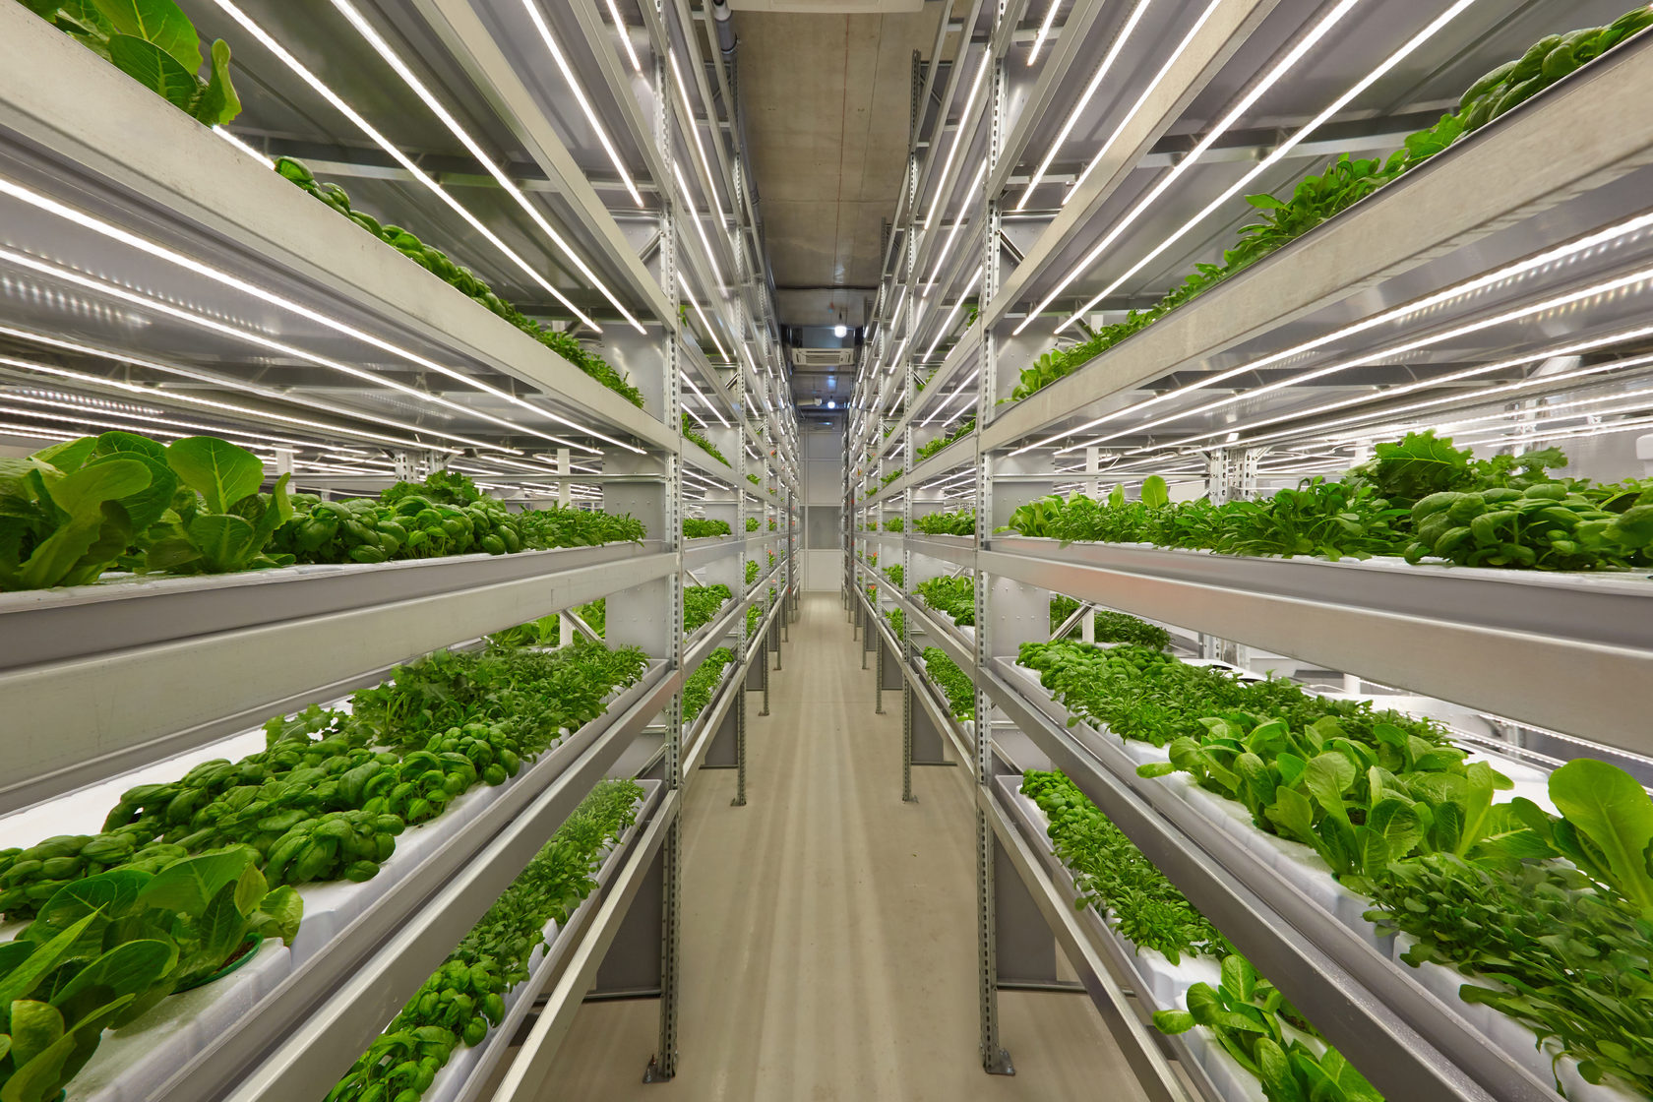
Figure 1 A hydroponic vertical farming, which relies on sensors.
Smart sensors are devices which generate the data and allow further functionality from self-monitoring and self-configuration to condition monitoring of complex processes. With the capability of wireless communication, they reduce installation effort to a great extent and help realise a dense array of sensors.
The importance of sensors, measurement science, and smart evaluation for Industry 4.0 has been recognised and acknowledged by various experts and has already led to the statement "Industry 4.0: nothing goes without sensor systems."
However, there are a few issues, such as time synchronisation error, data loss, and dealing with large amounts of harvested data, which all limit the implementation of full-fledged systems. Moreover, additional limits on these functionalities represent the battery power. One example of the integration of smart sensors in the electronic devices, is the case of smart watches, where sensors receive the data from the movement of the user, process the data and as a result, provide the user with the information about how many steps they have walked in a day and also converts the data into calories burned.

Text from: Forth industrial revolution on Wikipedia (https://en.wikipedia.org/wiki/Fourth_Industrial_Revolution), licensed under Creative Commons Attribution-ShareAlike 4.0 License

