Designing an Automatic Traffic Light Controller for a Four- Junction Road
Evidence Provided



Nathan Evans
Electrical and Electronic Engineering / Electronics 1
Submitted to: Jenifer Prince Devaraj
UWTSD – Waterfront Campus
16/04/24

Contents Page:

The following report will demonstrate competence in the following areas.

 | Page Number
- Introduction | 3-4
- Background Research | 4-5
- Circuit Diagram | 5-12
- Flowchart/Pseudocode | 13-14
- Testing/Simulated output results | 15
- Conclusion | 16-17
- Reference List | 18

The work of this report completed under the supervision of (Jenifer Prince Devaraj) I declare that this report is the product of my own work and is not being submitted for any other degree.

N. Evans

Introduction
Efficient traffic management is crucial in urban environments to guarantee 2 things, the seamless movement of automobiles and the safety of pedestrians. See for more information about the importance of traffic management [1]. Achieving these goals requires the incorporation of sophisticated electronics. With the use of proteus [2] virtual software and C programming complied using MikroC [3], the student will be creating and executing an advanced 4-way traffic management system in this assignment.

First, in order to provide thorough traffic control, they want to strategically place four traffic signal lights on either side of the route, in a cross like formation. These signal lights, which control junctions and dictate traffic flow, will be the backbone of the system.
In addition, they want to install a set of seven-segment monitors on both sides of the road to improve safety levels of their traffic control system. Meaning, in addition to enabling exact timing of traffic signal changes, these displays will function as a countdown or count up mechanism for both pedestrians and vehicles. [4] Has in depth analysis of the implementation of a pedestrian count up/down system.
In order to minimise traffic congestion and maximise traffic flow, their system will be set up to automatically switch traffic lights every ten seconds. This steady cycle will support the seamless flow of cars across the crossroads, reducing the chance of traffic jams. [5] Offers a list of tips to reduce traffic management
In addition, they have implemented a delay of ten seconds after a complete cycle for a pedestrian crossing phase to display the importance of pedestrian safety. In order to give pedestrians a safe way to cross the crossing, during this phase the traffic signals will be turned off to ensure no cars enter the junction.

The goal in putting this efficient traffic management system into place is to make the junction safer and more effective while demonstrating how electronics and programming can be used to solve real-world problems. With C code and extensive testing in virtual software, they aim to create a solid and dependable solution that can be expanded upon and customised to various urban settings.

Background research
When approached with the task of building a functioning 4-way traffic light design, the students understood the importance of the initial background research phase. This will ensure that there is enough data and information in the bank to proceed with the design and implementation. The background research was split into individual sections as seen below. [6] Helped the Student understand why background research is important.
- PIC Microcontroller - The microcontroller is the brains of to any comprehensive embedded system, allowing multiple functions to be simulated in unison, in a user friendly manner, with the option of endless tweaks and updates to the traffic light system. [7] Meaning the students have full control over what is coded into the microcontroller with the benefit of tweaking code if needed. The PIC 16F877A was chosen primarily for its number of pins in each tri state, allowing the design to be neatly presented and easy to work with.
- Traffic Signal Lights - Traffic signal lights are essential components of any traffic control system. These lights use a combination of red, amber, and green to show when it's safe for cars to halt, get ready to stop, or cross at a junction. The traffic signal lights' ensure that there is synchronisation, controlling traffic and reducing congestion. They are an essential part of traffic control.

- 7-Segment Displays - 7 segment displays are electronic display devices that show numerical digits. They are frequently used to represent countdowns, time, and numerical data. These displays show numerical characters 0 through 9. Seven-segment displays are perfect for incorporating into traffic control systems to give drivers and pedestrians real-time information on the traffic flow status.

- Pedestrian crossing LED’s - Two simple led’s were installed on each section of the junction. This notifies the pedestrians on when it is safe to cross the junction.

- Traffic Flow Optimisation - A key traffic management tactic is effective traffic flow optimisation. Traffic engineers, around the globe, utilise intelligent traffic signal control techniques, including adaptive or fixed time traffic signal control, to manage vehicle flow across junctions, reduce wait times, and improve overall traffic efficiency. Congestion is lessened and traffic flow is smoothed out when signal timings are periodically adjusted in response to traffic volume and patterns. While this was not implemented into the design, it is important to note for future updates. [8] talks about the global issue of traffic management and the steps taken to tackle the issue.

- Pedestrian Safety Measures - One of the top priorities for the students was making sure that pedestrians are safe at junctions. Comprehensive traffic management systems must include designated pedestrian crossing periods when all vehicle traffic is stopped to provide safe passage for walkers. The danger of accidents will be considerably decreased by implementing scheduled crossing times and clear signals for pedestrians.

Overall, the project intends to create a comprehensive traffic management system that incorporates traffic signal lights, 7-segment displays, and pedestrian safety measures by combining these fundamental ideas and technology. They want to build a workable and flexible system that prioritises safety and efficiency while addressing the challenges of urban traffic management. They achieve this by using Proteus and C programming.

Your circuit design(s), relevant diagrams
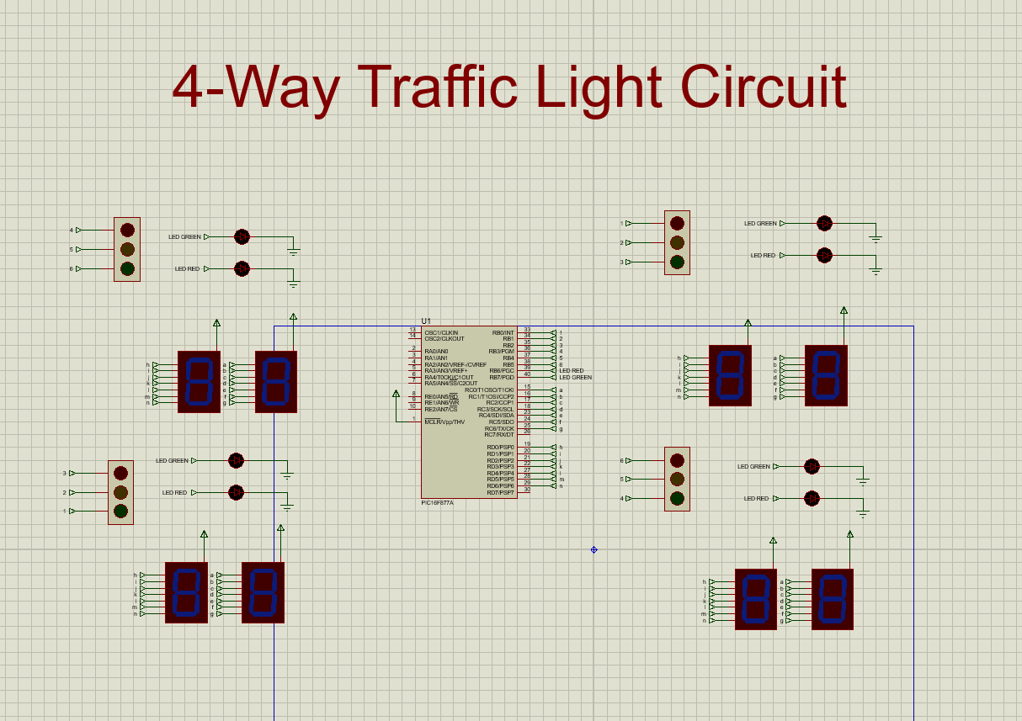
FIGURE(1) – A full diagram of the operational circuit design

The above circuit design shows the 4 way traffic circuit switched off. A PIC microcontroller situated in the middle acts as the brains of the circuit, surrounded by 4 traffic light circuits acting as a common junction. 7 segment displays for pedestrian crossing was also added.

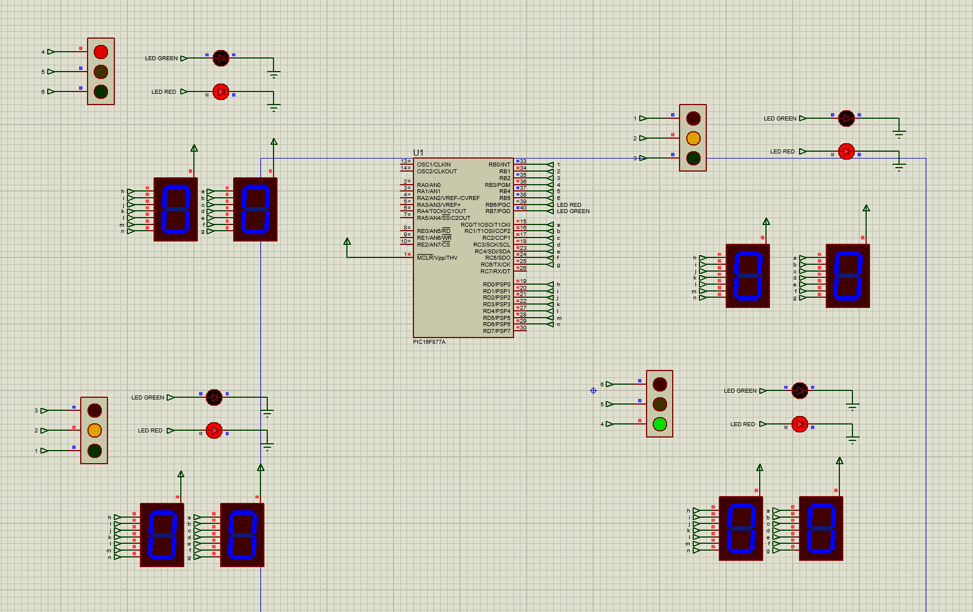

Figure (2) Shows the first signal of the traffic phase

Figure 2 shows the circuit in its first phase of traffic initiation. The circuit is functioning as intended as no only one light is shining green at one given time. The pedestrian crossing LEDS are also shining red indicating it is not safe to cross.

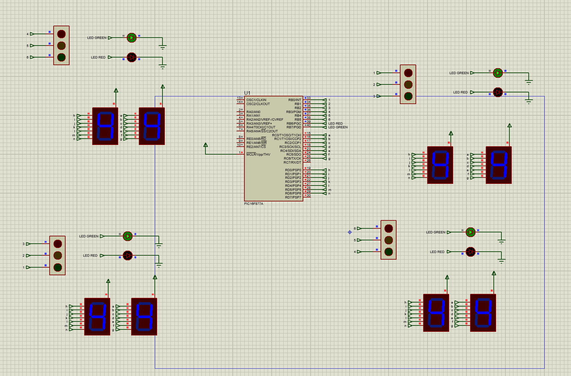

Figure (3) Shows the pedestrian crossing phase

Figure 3 shows the final phase, showing all traffic lights turned off with a green pedestrian LED, indicating the junction is safe to cross. The 7 segments can also be seen counting notifying pedestrians how long they have left to cross the road.

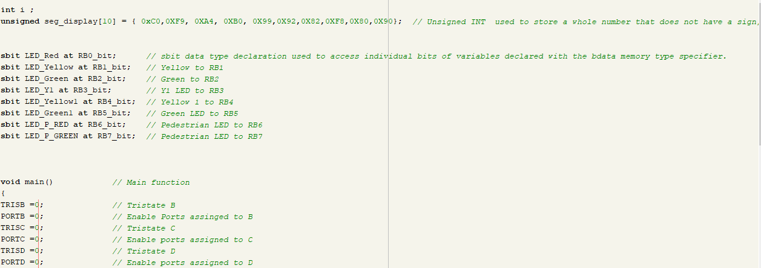
Figure (4) - Code

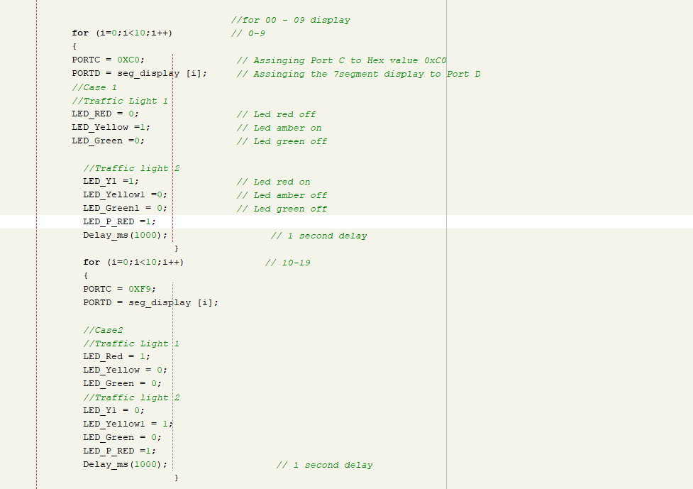

Figure (5) - Code

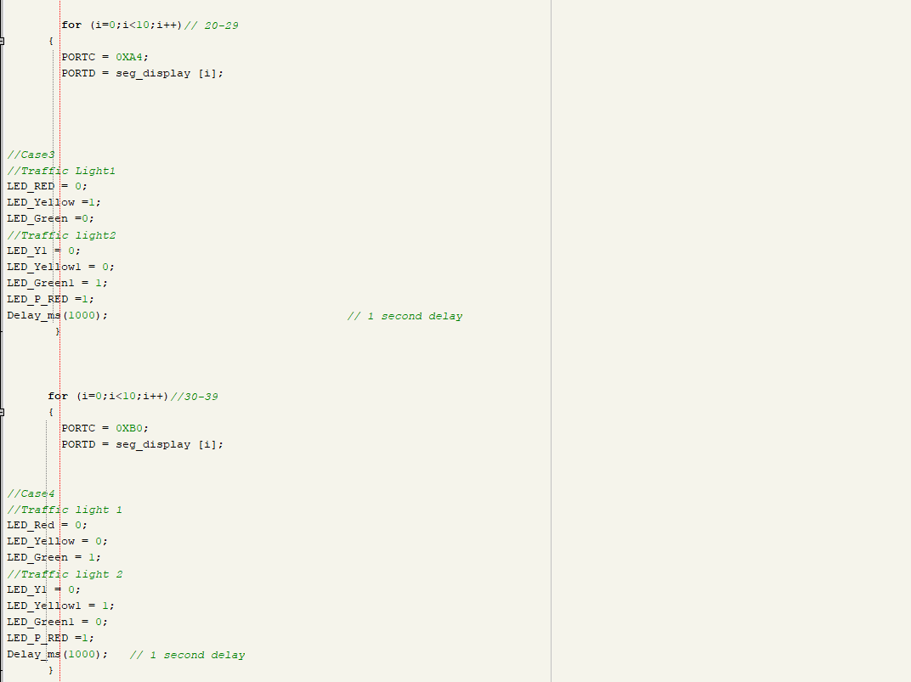
Figure (6) – Code

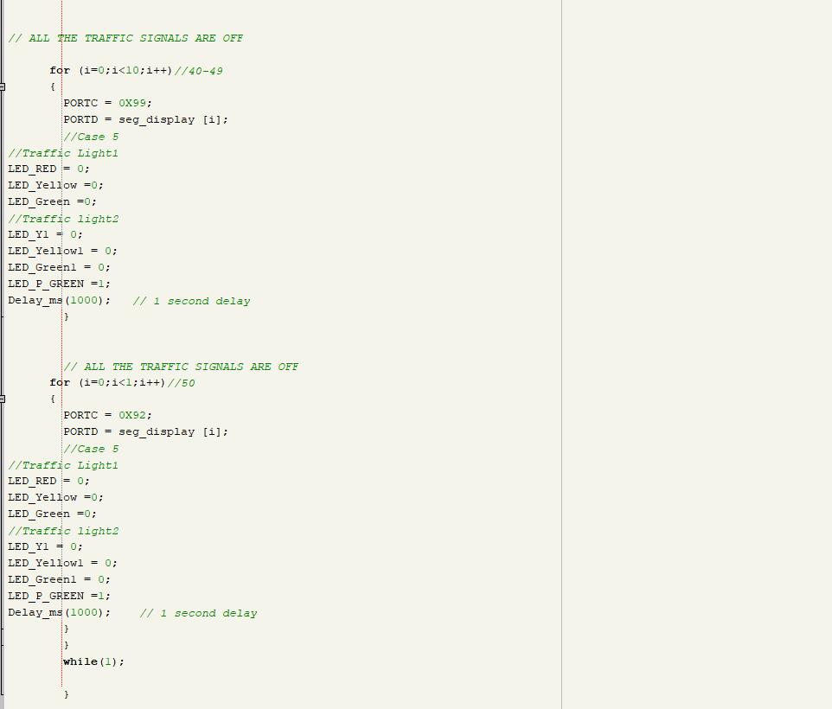
Figure (7) – Code

flowchart/pseudocode showing the system operation
- Initialize variables:
- seconds between each traffic signal phase = 10 // 10 seconds for cars to proceed
- pedestrian_time = 10 // Duration for pedestrian crossing phase
- signal_cycle_time = 40 // Total signal cycle time
- countup_time = 50 // Initial countdown time for 7-segment displays
- Initialise Tristate on PIC

- Main Loop:
- Loop Forever:
- // Traffic Signal Control
- Pedestrain crossing LEDS set to red
- Begin count to 50
- Phase 1 of traffic flow
- Count to 9
- 1 second delay
- Phase two of traffic flow
- Count to 19
- 1 second delay
- Phase 3 of traffic flow
- Count to 29
- 1 second delay
- Phase 4 of traffic control
- Count to 39
- 1 second delay
- All lights off
- Pedestrian leds turn to green
- Count to 50
- End

Pseudocode is a standard in the engineering field. It is a detailed step by step analysis of code in the case. The pseudocode is describing what the code is doing in words.

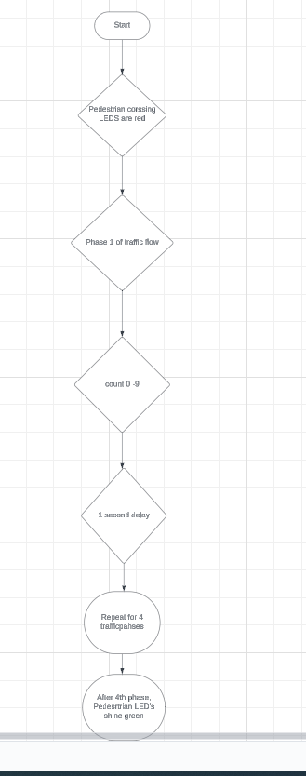

Figure (4) Shows a flow chart of the 4 traffic phases

Much like pseudocode, a flowchart can be used for visual learning and understanding, into the codes functions.

Details Of Testing , Simulated Outputs and Results

The objective of testing was to verify the functionality of the traffic light control system and ensure that it operates according to the specified requirements.

Testing Scenarios & Simulated Outputs:

The students decided to test each aspect of the system:
- Traffic light sequencing - This was tested to ensure each light was displaying – RED,AMBER,GREEN. The sequence order is crucial for a functioning traffic system.

- Transition between different signal phases -This was tested to ensure while one section is green, 2 sections were red, meaning the traffic must come to a stop, and the remaining section was amber indicating to the drivers they must brace themselves to proceed.

- Pedestrian crossing phase - This was tested pure observation. The students observed the synchronisation between all of the traffic signals being shut off and the 7 segment displays beginning their count to 10 which indicates the pedestrian crossing phase.

All of the testing phase was observed on Proteus, and the results were then recorded via screenshots as seen on the previous sections of the report. They show, synchronization of traffic lights, timing of signal changes, and coordination of pedestrian crossings.

Results:

- Traffic Light Sequencing - The traffic lights transitioned smoothly between green, yellow, and red states, with appropriate timings.

- Pedestrian Crossing Phase - The pedestrian crossing phase activates reliably after each signal cycle, providing a safe crossing for pedestrians.

- 7-Segment Displays - The 7-segment displays accurately count with the appropriate timings.

- Overall System Behaviour - The system operates as expected, maintaining predictable traffic flow, and ensuring pedestrian safety.

By following this testing plan and observing the simulated outputs, the students can assess the performance of the traffic light control system and validate its compatibility with the appropriate requirements.

Conclusion:
In conclusion, the development and simulation of the traffic light control system have demonstrated the potential to effectively manage traffic flow and ensure pedestrian safety. Through the implementation of sequential signal cycles, coordinated traffic light sequencing, and pedestrian crossing phases, the system has shown promising performance in regulating car movement at 4 way junctions.
The integration of 7-segment displays for counting purposes enhances the system's usability and provides clear visual cues for pedestrians. Additionally, the simulation results have confirmed the system's ability to synchronize signal changes and maintain smooth traffic flow, contributing to a safer and more efficient urban environment.

Recommendations for Future Work:
While the current version of the traffic light system is fluid and works efficiently, there are several updates that show major potential for future work and improvement. These include:

- Real world Testing - The student concluded that conducting real world testing of the system to validate its performance in an actual traffic environment, will provide valuable insights into real world challenges and allow for further tweaking of the systems.

- Traffic Sensors – The incorporation of sensors, such as vehicle detection sensors and pedestrian detection systems, to enhance the system's responsiveness and adaptability. Sensor data can be used to dynamically adjust signal timings and prioritize traffic flow based on demand.

- Versatile Control Algorithms – This would be important to allow for the exploration of the implementation of adaptive traffic control algorithms that can dynamically adjust signal timings based on real time traffic conditions. Adaptive control algorithms have the potential to further optimize traffic flow and minimize congestion. For example, if there is heavy traffic, the transition phase between green lights should be extended.

- Remote Connectivity – The student decided to investigate the integration of remote connectivity features to enable communication between traffic light systems and centralized control centres. This will facilitate centralized monitoring and management of traffic flow, allowing for proactive interventions and optimization strategies. [9] Goes into more depth about smart connectivity

- User friendly Interfaces – The development of user friendly interfaces for configuration and monitoring of the traffic light control system. The implementation of This intuitive technology will allow engineers and administrators to work more efficiently when servicing the traffic systems.

By addressing these areas of future work, the traffic light control system can evolve into a more sophisticated and adaptive solution when future updates are ready to commence. Capable of meeting the evolving demands of urban traffic management. Additionally, continued collaboration with traffic engineers, urban planners, and stakeholders will be essential to ensure the system's relevance and effectiveness in real world applications.

Reference List
[1] Lpt, “The importance of a traffic management plan: Enhancing safety and minimizing congestion,” Traffic Management London, https://trafficmanagement.london/2023/08/17/the-importance-of-a-traffic-management-plan-enhancing-safety-and-minimizing-congestion/#:~:text=Traffic%20management%20plans%20play%20a,for%20both%20drivers%20and%20pedestrians.
[2] “Circuit simulation software,” Circuit Simulation Software with SPICE, https://www.labcenter.com/simulation/
[3] “Mikroc Pro for pic,” MIKROE, https://www.mikroe.com/mikroc-pic
[4] Pedestrian countdown at Traffic Signals, https://content.tfl.gov.uk/PCaTS-Note-2-Overview-Presentation.pdf
[5] “7 tips to help cities reduce traffic congestion,” LYT, https://lyt.ai/blog/on-the-road/how-to-reduce-traffic-congestion/
[6] By:Susan Neuman, “Building background knowledge,” Reading Rockets, https://www.readingrockets.org/topics/background-knowledge/articles/building-background-knowledge#:~:text=Put%20simply%2C%20the%20more%20you,comprehension%20(Hirsch%2C%202003)..
[7] “What are the benefits of using a PIC microcontroller for computer hardware projects?,” How PIC Microcontrollers Can Enhance Your Hardware Projects, https://www.linkedin.com/advice/0/what-benefits-using-pic-microcontroller-computer-n4gee#:~:text=One%20of%20the%20main%20advantages,compile%2C%20and%20debug%20your%20code.
[8] Author links open overlay panelErwin Walraven a et al., “Traffic flow optimization: A reinforcement learning approach,” Engineering Applications of Artificial Intelligence, https://www.sciencedirect.com/science/article/pii/S0952197616000038
[9] Rob Lauer Director of Developer Relations Blues Wireless, R. Lauer, D. of D. Relations, and B. Wireless, “Machine Learning for Smart City Traffic Management,” Blues, https://blues.com/use-cases/ml-for-smart-city-traffic-management/#:~:text=Smart%20City%20Traffic%20Management%20with%20the%20IoT&text=Networks%20of%20sensor%2Denabled%20devices,understand%20usage%20and%20predict%20patterns.

