Dissertation on Britvic
Author: S.O. Fatubarin



Student Name: Sunday Fatubarin

Student Number: 1710948

Course: MBA Marketing

Year: 2018/2019

Supervisor’s Name: Tushara Balendran

Submission Date: 30/06/2020



 |  |  |  | E2 FORM
APPLICATION FOR ETHICAL APPROVAL – MA level

CAIS AM GYMERADWYAETH MOESEGOL – Lefel MA

CEFNOGWYD /  APPROVED |  |  | A GYFEIRIWYD /  REFERRED |  |  | NIS CEFNOGWYD/  NOT SUPPORTED
Mae'r ffurflen hon i'w llenwi gan bob myfyriwr MA cynnal ymchwil, prosiectau neu gynyrchiadau. Dylai'r ffurflen hon gael ei chwblhau gan y myfyriwr mewn ymgynghoriad â thiwtor y modiwl. Rhaid i bob ffurflen gael ei ystyried gan y Pennaeth Ysgol/Cyfadran / Gyfadran. Rhaid i bob ffurflen gael ei gyflwyno i Fwrdd y Gyfadran Moeseg. Bydd y ffurflen yn cael ei adrodd i'r Pwyllgor Moeseg y BrifYsgol/Cyfadran os anarferol a / neu y tu allan arfer arferol. |  |  |  | This form is to be completed by all MA students conducting research, projects or productions. This form should be completed by the student in consultation with the module tutor. All forms must be considered by the Head of School/Faculty. All forms must be presented to the Faculty Ethics Board. The form is only to be reported to the University Ethics Committee if it is unusual and/or falls outside of normal practice.
ADRAN 1 – MANYLION MYFYRIWR SECTION 1 - STUDENT DETAILS

Enw Llawn  Full Name | Sunday Olayinka Fatubarin
Ysgol/Cyfadran/ Cyfadran  School/Faculty | London Business School |  |  |  | Rhif Myfyriwr  Student Number |  | 1710948
Tiwtor y Modiwl/ Cydlynydd Rhaglen  Module Tutor/ Programme Co-ordinator |  | Tushara Balendran |  |  | Enw'r Gradd  Name of Degree |  | MBA
Teitl dangosol yr Traethawd Hir: |  |  |  |  | Indicative Title of Dissertation:
Aligning sustainability concept and stakeholder view of the firm with holistic marketing concept into the culture of the firm can drive performance up and thus giving the firm a competitive advantage – Case study of Britvic

ADRAN 2 – GWEITHGAREDD YMCHWIL |  | SECTION 2 – RESEARCH ACTIVITY
Ydy’r prosiect yn cynnwys: | Does the project include: |  | Ydy / Yes | Nac ydy/No
Defnyddio holiadur neu offeryn ymchwil tebyg (atodwch gopi drafft) | Use of questionnaire or similar research instrument (attach draft copy) |  | Yes
Defnyddio prawf ysgrifenedig neu gyfrifiadurol | Use of written or computerised test |  |  | No
Cyfweliad (cysylltwch gwestiynau posibl) | Interview (attach provisional questions) |  |  | No
Dyddiaduron | Diaries |  |  | No
Arsylwi ar gyfranogwyr a hwythau'n ymwybodol o hynny | Participant observation with their knowledge |  |  | No
Arsylwi ar gyfranogwyr a hwythau ddim yn ymwybodol o hynny | Participant observation without their knowledge |  |  | No
Recordio fideo neu sain | Video or audio-taping |  |  | No
Mynediad i wybodaeth bersonol neu gyfrinachol heb gydsyniad penodol y cyfranogwyr | Access to personal or confidential information without the participants specific consent |  |  | No
Defnyddio unrhyw gwestiynau, ysgogiadau prawf, cyflwyniad y gallai rhai cyfranogwyr eu profi fel rhywbeth sy'n achosi niwed / tramgwydd corfforol, meddyliol neu emosiynol | Administration of any questions, test stimuli, presentation that may be experienced as physically, mentally or emotionally harmful / offensive |  |  | No
Cyflawni unrhyw weithredoedd allai achosi embaras neu effeithio ar hunan-barch | Performance of any acts which may cause embarrassment or affect self-esteem |  |  | No
Ymchwilio i gyfranogwyr sy’n ymwneud â gweithgareddau anghyfreithlon | Investigation of participants involved in illegal activities |  |  | No
Gweithdrefnau lle defnyddir twyll | Procedures that involve deception |  |  | No
Gweini unrhyw sylwedd, cyfrwng neu blasebo | Administration of any substance, agent or placebo |  |  | No
Dull arall o gasglu data neu fformat cyflwyno (esboniwch) | Other method of data collection or presentation format (please explain) |  |  | No

Os 'Na' wedi cael ei dicio ym mhob blwch, dylai'r ffurflen gael ei llofnodi gan Bennaeth yr Ysgol/Cyfadran / Gyfadran a'r canlyniad a adroddwyd i'r Pwyllgor Moeseg ar ddiwedd y semester.  Os 'Ydw' wedi cael ei dicio mewn un neu fwy o'r blychau, rhaid i'r myfyriwr gwblhau'r ffurflen hon a'i chyflwyno i diwtor y modiwl. Rhaid i'r ffurflen wedyn yn cael ei ystyried yn y Bwrdd Moeseg Gyfadran cyn dechrau ar unrhyw waith ymchwil. | If ‘No’ has been ticked in each box, the form should be signed by the Head of School/Faculty/Faculty and the outcome reported to the Ethics Committee at the end of the semester.  If Yes has been ticked in one or more boxes, the student must complete this form and submit it to the module tutor. The form must then be considered at the Faculty Ethics Board prior to the start of any research.
Llofnodau  Os nad oes unrhyw faterion moesegol sylweddol, dylid ffurflen hon gael ei chwblhau a'i llofnodi gan y myfyriwr a'r goruchwyliwr ac yna llofnodi gan Bennaeth yr Ysgol/Cyfadran. | Signatures  If there are no significant ethical issues, this form should be completed and signed by both the student and the supervisor and then signed by the Head of School/Faculty.
Myfyriwr / Student |  | Dyddiad: / Date:
Cydlynydd y prosiect / Tiwtor  Project co-ordinator / Tutor  Arolygwr / Supervisor |  | Dyddiad: / Date:
Pennaeth Ysgol/Cyfadran / Head of School/Faculty |  | Dyddiad: / Date

ADRAN 3 – MANYLION Y PROSIECT / YMCHWIL / CYNHYRCHIAD |  |  | SECTION 3 – PROJECT / RESEARCH / PRODUCTION DETAILS
1. |  | Braslun o’r prosiect | Project outline
2. |  | Disgrifiad  Rhowch fraslun cryno o’r prosiect, heb unrhyw jargon, ac yn cynnwys beth bydd angen i’r cyfranogwyr ei wneud. Esboniwch unrhyw dermau technegol neu derminoleg sy'n benodol i'r ddisgyblaeth (Uchafswm 300 o eiriau.) | Description  Provide a brief outline, free from jargon, of the project including what participants will be required to do. Explain any technical terms or discipline specific terminology (Max 300 words.)
3. |  | Dulliau Arfaethedig:  Rhowch fraslun o'r dulliau casglu data neu o natur yr amser mewn ymarferiadau (hyd at 500 o eiriau). | Proposed Methods:  Outline how the data will be collected or the nature of rehearsal time (up to 500 words).
5. |  | Lledaenu Gwybodaeth / Cynulleidfa:  Rhestrwch i bwy y rhoddir neu y dangosir copi o’r canlyniadau neu adroddiad / cyflwyniad terfynol. | Dissemination of Information / Audience:  List to whom a copy of the results or final report / presentation will be given or shown.
6. |  | Lleoliad y Prosiect:  Nodwch bob lleoliad lle y cesglir data neu y cynhelir ymarferiadau / cynhyrchiad. | Location of Project:  Identify all locations where data will be collected or rehearsals/ production will take place.
7. | Cymeradwyaeth Arall: Oes angen cael cymeradwyaeth unrhyw sefydliad arall cyn cychwyn neu gwblhau’r prosiect? Os felly, gan bwy ac a ydy wedi'i sicrhau eisoes? |  | Other Approvals: Is there a requirement for approval from any other organisation / institution prior to starting or completing the project? If so, by whom and has it been obtained?

ADRAN 4 – MANYLION CYFRANOGWYR / CYNULLEIDFA |  |  | SECTION 4 - PARTICIPANT / AUDIENCE DETAILS
Pwy yw’r cyfranogwyr arfaethedig? |  | Who are the intended participants? |  |  | Ydw / Yes | Na / No
Myfyrwyr / staff Y Drindod Dewi Sant |  | Students / staff of Trinity Saint David |  |  |  | No
Oedolion (dros oed 16 ac yn gymwys i gydsynio) |  | Adults (over the age of 16 and competent to give consent) |  |  | Yes
Plant a phobl ifanc dan oed |  | Children / legal minors |  |  |  | No
Cleifion neu gleientiaid gweithwyr proffesiynol |  | Patients or clients of professionals |  |  |  | No
Rhywun sy’n cael ei gadw yn y ddalfa neu y mae’r llys wedi cymryd cyfrifoldeb amdano |  | Anyone in custodial care or for whom the court has assumed responsibility |  |  |  | No
Aelod o unrhyw sefydliad lle mae’n bosibl bod angen i unigolyn arall hefyd gydsynio. |  | A member of any organisation where another individual may also need to give consent. |  |  |  | No
Eraill: Nodwch: / Others: please identify:

Nifer, Oed a Ffynhonnell y Cyfranogwyr  Rhowch fanylion yr demograffeg y cyfranogwyr / gynulleidfa. |  |  |  | Participant / Audience Number and Age  Provide details of the demographics of the participants / audience.
Nifer o Gyfranogwyr / yn y Gynulleidfa | Participant/ Audience number |  |  | 9
Grŵp oedran y Cyfranogwyr/y Gynulleidfa | Participant/ Audience age group |  |  | Over 18 years

ADRAN 5 – RISGIAU YN PROSIECT | SECTION 5 – RISKS IN PROJECT
Bydd y diffyg ateb cadarnhaol i bob un o'r cwestiynau hyn yn arwain at y gofyniad eglurhad a gallai arwain at oedi yn eich ymchwil. Dim neu Dim NID yn dderbyniol. | A lack of a positive answer to all of these questions may result in the requirement of further explanation and a delay in your research. None or Nil is not acceptable.

Risg Posibl:  (corfforol, seicolegol, cyfreithiol, cymdeithasol neu economaidd) |  |  |  | Potential Risk:  (physical, psychological, legal, social or economic)
A oes unrhyw risg bosibl i: |  |  |  | Is there any potential risk to: |  |  |  | Ydw / Yes |  | Na / No
A | Cyfranogwyr? |  |  | Participants? |  |  |  |  |  | No
B | Ymchwilydd? |  |  | Researcher? |  |  |  |  |  | No
C | BrifYsgol/Cyfadran? |  |  | University? |  |  |  |  |  | No
2 | Rheoli Risg:  Os oes, beth yw'r risg a sut y bydd yn cael ei reoli? |  |  | Management of Risk:  If yes, what is the risk and how will it be managed?
3 | Os ydych yn delio â phlant ac oedolion sy'n agored i niwed a ydych wedi gwneud cais am dystysgrif DRS? | If you are dealing with children and vulnerable adults have you applied for a DRS certificate?

ADRAN 6 – MONITRO, ADBORTH A CHYFRINACHEDD |  |  | SECTION 6 - MONITORING, FEEDBACK AND CONFIDENTIALITY
1. | Monitro:  Os ydych yn sylwi ar unrhyw ymddygiad sy'n groes Cod y BrifYsgol/Cyfadran Ymarfer, unrhyw ganllawiau a gyhoeddir gan y gymdeithas broffesiynol priodol neu weithred anghyfreithlon. Amlinellwch eich strategaeth adrodd. |  |  |  |  | Monitoring:  Should you observe any behaviour that contravenes the University’s Code of Practice, any guidelines published by the appropriate professional association or is illegal outline the strategy of your reporting action.
 |  |  |  |  |  |  | Ydw / Yes |  | Na / No
A wnewch chi roi gwybod am unrhyw ymddygiad sydd yn erbyn Cod Ymarfer y BrifYsgol/Cyfadran neu sy'n anghyfreithlon? |  | Will you report any behaviour that is against the University’s Code of Practice or is illegal? |  |  |  |  | Yes
A ydych yn darparu adborth i'r cyfranogwyr? |  | Will feedback be provided to participants? |  |  |  |  |  |  | No
A fyddwch yn dogfennu'r 'caniatâd i gymryd rhan yn y prosiect' |  | Will you be documenting the ‘consent to participate in the project’ |  |  |  |  | Yes
ADRAN 7 – STORIO, DIOGELWCH A MYNEDIAD I DDATA |  |  |  | SECTION 7 - DATA ACCESS, STORAGE AND SECURITY
 |  |  |  |  |  |  | Ydw / Yes |  | Na / No
1. | Ydych chi'n gyfrifol am storio a diogelwch y data eu casglu? |  | Are you responsible for the storage and security of the data collected? |  |  |  | Yes
2. | Sut y bydd y data yn cael ei storio? |  | How will the data be stored?  Electronically
3. | Mynediad i Ddata:  Pwy fydd yn cael mynediad at y data? A oes unrhyw amodau i gael mynediad? |  |  |  | Data Access:  Who will have access to the data? Are there are any conditions to access? Author
4. | Cyfrinachedd / Anhysbysrwydd:  Rhestrwch y dulliau a fydd yn cael eu defnyddio i sicrhau cyfrinachedd ac anhysbysrwydd y cyfranogwyr. |  |  |  | Confidentiality / Anonymity:  List the methods that will be used to ensure the confidentiality and anonymity of participants.  By destroying the data once the research is completed

ADRAN 7 – DATGANIAD |  | SECTION 7 - DECLARATION
Rhaid i’r adran hon gael ei chwblhau gan bob parti perthnasol cyn y gellir cyflwyno’ r cais i’r Bwrdd Moeseg Gyfadran. |  | This section must be completed by all concerned parties before it can be submitted to the Faculty Ethics Board.
Datganiad  Mae'r wybodaeth a gynhwysir yma yn gywir, hyd eithaf fy ngwybodaeth a’m cred. Rwyf wedi ceisio dynodi unrhyw risgiau a phroblemau sy’n gysylltiedig â’r prosiect / ymchwil neu gynhyrchiad ac rwyf yn cydnabod f’ymrwymiadau innau a hawliau’r cyfranogwyr. |  | Declaration  The information contained herein is, to the best of my knowledge and belief, accurate. I have attempted to identify any risks and issues related to the project/research or production and acknowledge my obligations and the rights of the participants.
Llofnodau  Dylai'r ffurflen hon gael ei chwblhau a'i llofnodi gan y myfyriwr a'r goruchwyliwr lofnodi ac yna gan Bennaeth yr Ysgol/Cyfadran/ |  | Signatures  This form should be completed and signed by both the student and the supervisor and then signed by the Head of School/Faculty
Myfyriwr / Student  Sunday Fatubarin |  |  | Dyddiad: / Date:  30/06/2020
Cydlynydd y prosiect / Tiwtor  Project co-ordinator / Tutor  Arolygwr / Supervisor  Tushara Balendran |  |  | Dyddiad: / Date: 30/06/2020
Pennaeth Ysgol/Cyfadran / Head of School/Faculty |  |  | Dyddiad: / Date
Rhaid i bob cais am ymchwil ar sail cyfweliadau gynnwys y dogfennau canlynol: | All interview based research applications must provide the following pro-forma documents:
1. Ffurflen gydsynio ddrafft  2. Sampl o’r cwestiynau a ofynnir  3. Taflen wybodaeth am yr ymchwil sy'n esbonio'n glir ddiben y prosiect, y deilliannau disgwyliedig a'r rheini y dangosir y canlyniadau iddynt. | - A draft consent form  - A sample of the questions that will be asked  - An information sheet on the research that clearly explains what the project is, what the expected outcomes are and who the results will be shown to.

DYCHWELWCH I'R GYFADRAN MOESEG CYDLYNYDD

PLEASE RETURN TO THE FACULTY ETHICS CO-ORDINATOR
.

Cadeirydd y Pwyllgor Moeseg Gyfadran /Chair of the Faculty Ethics Committee Dyddiad: / Date:

ABSTRACT
Marketing concept has been fraught with controversy as to the conceptual basis and the evolution of the concept. Given the fact that the definition of marketing has evolved over time to reflect the changing environment which has necessitated the AMA – American Association of Marketing – to change their definition every five years to address and reflect these changes.
While the definition of what constitutes marketing keeps evolving, the conceptual basis is not keeping pace with the evolution of marketing practice.

Thus, in order to achieve effective performance and efficient operations at the firm, it is vital for the firm to align the ‘sustainability and ‘stakeholder concepts’ decision taken at the strategic level of the firm with their holistic marketing concept’s decision taken at the tactical level of the firm.

The research aim to find out the marketing concept adopted at Britvic in the United Kingdom and to see if it does align with the stakeholder view of the firm. Capitalistic system of government otherwise known as free market economy comes in different variants based on the importance attached to the social and ethical issues by each country.

In order to conduct this research and draw inference from the study, the research adopts the interpretive research philosophy together with an inductive reasoning approach, which enables the researcher to gather valuable insights from this study.

The research strategy uses the case study approach. The data collection method includes only primary data gathered by way of surveys and interviews.

The findings of the study revealed that Britvic have a high degree of sustainability practises embedded in their activities.

Keywords: Sustainability concept, Sustainability development, Shareholder concept, Stakeholder concept, Holistic marketing concept.

ACKNOWLEDGEMENT
Wow, I owe all the staffs of the University of Wales TSD a big thank you.

Most especially, I would like to thank my dissertation supervisor, Tushara Balendran and the head of the business school Dr Gladius David Kulothungan for their support throughout the dissertation.

I am highly grateful to Bart Plange for his understanding and encouragement towards the successful completion of the project.

My son Olumayowa Fatubarin was of great help as well.

Most importantly, I thank the all-mighty creator for seeing me through to the completion of this project despite enormous challenges encountered during the project.

Hope to see you again at University of Wales.

God bless you all

Sunday Y Fatubarin

TABLE OF CONTENTS
Abstract ………………………………………………………………………………..16
Acknowledgements ……………………………………………………………………17
Chapter 1: Introduction ...............................................................................................19
1.1 Background of the researched company …………………………………...22
1.2 Research topic ……………………….....…………………………………..22
1.3 Research problem statement ……………………………………………… 22
1.4 Research rationale .........................................................................................22
1.5 Research scope …………………..................................................................23
1.6 Background to the research issue …………………………………………..24
1.7 Research aim…..............................................................................................25
1.8 Research objectives ….……………………………………………………..25
1.9 Research questions.........................................................................................25
1.10 Research dissertation structure ....................................................................26
1.11 Summary …………………………..………………………………………27
Chapter 2: Literature Review.......................................................................................27
2.1 Introduction …..............................................................................................27
2.2 The rationale for this research study …………….…………………………28
2.3 Theories and concepts affecting this research ……………………………..30
2.4 Sources of materials for reviewing the literature ……………………….….30
2.5 Criteria for reviewing the literature ………………………………………..30
2.6 Structure of the literature review …………………………………………..30
2.7 Britvic legal and regulatory framework in the United Kingdom ………30
2.7.1 Shareholder theory ……………………………………………………31
2.7.2 Agency principle ………………………………………………….…..32
2.7.3 Fiduciary duties ………………………………………………..….…..33
2.7.4 Appraisal and criticism of the shareholder theory …………………….33
2.7.5 Appraisal and criticism of the agency principle ………………………34
2.7.6 Appraisal and criticism of the fiduciary duties concept ………………34
2.8 Ideal conceptual framework ………………………………………….........34
2.8.1 Stakeholder theory ……………………………………………………35
2.8.2 Sustainability concept …………………………………………………36
2.8.3 Appraisal and criticism of the stakeholder theory…….………………..37
2.8.4 Appraisal and criticism of the sustainability concept ………………….37
2.9 Marketing, marketing concepts and marketing orientations ……………38
2.9.1 Production concept and its criticism …………………………………...39
2.9.2 Product concept and its criticism ………………………………………39
2.9.3 Sales concept and its criticism ………………………………………….40
2.9.4 Marketing concept and its criticism …………………………………….40
2.9.5 Societal marketing concept and its criticism ……………………………40
2.9.6 Holistic concept and its criticism ……………………………………….40
2.9.7 Criticism of definition of marketing and all the marketing concepts …..42
2.10 Analysis and evaluation of various theoretical and conceptual underpinnings .42
2.11 Synthesis and reconciliation of different theories and concepts ………………43
2.12 Summary and implications for further research ……………………………….43
Chapter 3: Research Methodology ….............................................................................43
3.1 Introduction ......................................................................................................43
3.2 Research methodology aim ..............................................................................44
3.3 Research methodology objectives …................................................................44
3.4 Research types according to its purpose ……………………………………...44
3.5 Research methodology structure ......................................................................45
3.6 Research philosophical paradigm and its components .....................................46
3.6.1 What is ontology? ………………………………………………………47
3.6.2 Researcher’s ontological perspective …………………………………...48
3.6.3 What is epistemology? ………………………………………………….48
3.6.4 Researcher’s epistemological perspective ……………………….……...49
3.6.5 What is axiology? …………………………………………..……………49
3.6.6 Researcher’s axiological perspective ………………………….……..….49
3.6.7 What is methodology? ……………………………………………………49
3.6.8 Researcher’s methodological perspective ………………………………...50
3.7 Research philosophical paradigms …………………………………………50
3.7.1 Positivism ……………………………………………………………..51
3.7.2 Realism …………………………………………………………..…...51
3.7.3 Interpretivism ………………………………………………………...52
3.7.4 Pragmatism …………………………………………………………...52
3.7.5 Choice and justification of research paradigm for this study ………...53
3.8 Research strategy …………………………………………………………...53
3.8.1 Experiments ..........................................................................................53
3.8.2 Action research .....................................................................................53
3.8.3 Surveys .................................................................................................53
3.8.4 Case study ............................................................................................54
3.8.4.1 Research population ………………………………………….54
3.8.4.2 Research sample ……………………………………………..54
3.8.4.3 Purposive sampling ………………………………………….55
3.8.4.4 Research validity and reliability ……………………………..56
3.8.4.5 Research replicability, and generalisability ………………….56
3.8.5 Choice and justification of research strategy for this study..................56
3.9 Research approach ………………………………………………………….57
3.9.1 Data collection ……………………………………………………….57
3.9.1.1 Qualitative method ………….. ……………………..………..57
3.9.1.2 Quantitative method ………………………………..………...57
3.9.2 Data analysis…………………………………………. …….………..58
3.9.2.1 Inductive research approach .. ……………………………….58
3.9.2.2 Deductive research approach……………………….…………59
3.9.3 Choice and justification of research approach for this study ..……….59
3.10 Time horizon ………………………………………………………………60
3.11 Ethical considerations .................................................................................60
3.12 Limitations of this research methodology ………………..….....................61
3.13 Summary ………………..………………………………………….……..61
Chapter 4: Analysis and discussion of research findings …………………………..61
4.1 Introduction ……………………………………………………………………61
4.2 Quantitative analysis of close-ended questions ………………………………..61
4.3 Qualitative analysis open and closed-ended questions ………………………..67
4.4 Aanlysis of sustainability questions …………………………..……………….70
4.5 Analysis of stakeholder questions ……………………………………………..71
4.6 Summary ………………………………………………………………………72
Chapter 5: Conclusions ……….…………………………….............................................72
5.1 Introduction …………………………………………………………………….72
5.2 Linking with the first research objective ……………………………………….73
5.3 Linking with the second research objective …………………………………….73
5.4 Linking with the third and fourth research objectives …………………………..75
5.5 Summary ………………………………………………………………………..75
Chapter 6: Recommendations ……………………………………………………………75
6.1 Introduction …………………………………………………………………….75
6.2 Future areas of academic recommendations ……………………………………76
6.3 Business recommendations …………………………………………………….76
6.4 Limitations of this research …………………………………………………….78.

Chapter 1: Introduction
The purpose of this introductory chapter is to introduce the scope, the depth and the context of the research topic. This paper does not seek to solve all the issues raised by this particular study, but to provoke thoughts and to generate different ideas on how to proactively embed sustainability mindset into every functions of the firm, most especially, ‘the marketing function.’ The importance of listening and satisfying stakeholders needs cannot be over-emphasised in this era of globalisation and social media connectivity

The food and drink industry in the United Kingdom like any other industry has a degree of regulations that govern their trading activities, the purpose of which is to protect the consumers from consuming bad products.
This research focuses on the way that Britvic plc can deliver increased performance and gain competitive advantage for the firm by dovetailing sustainability concept into its corporate culture and decision-making processes when conducting its marketing activities.

  - Background of the researched company
Britvic plc is one of the leading soft drinks manufacturing company in the United Kingdom with operations spanning the Republic of Ireland, France and Brazil.
The company has a broad range of drink portfolio such as Robinsons, Tango, Drench, J2O.
Britvic has a strategic agreement with Pepsi Co of America to produce and sell Pepsi Co drinks such as 7Up, Pepsi, SoBe and Mountain.
Britvic is listed on the London Stock Exchange under the code BVIC and has a market capitalisation of £2.35 billion as at 10th May 2019.
  - Research topic
The case for the embedding of sustainability concept into the marketing activities of the firm in the United Kingdom – Case study of Britvic.
1.3 Research problem statement
Most scholars have implicitly positioned customers as the stakeholder group of most interest to marketing research and practice (Day 1994). The tendency by firms to be driven by customer demands at the expense of other stakeholders is the driving force behind this project.
Thus, the purpose of this study is to explore the alignment or misalignment of sustainability concept and stakeholder view of the firm with the holistic marketing practice in Britvic.
1.4 Research rationale
According to Nielsen (2016) “Global Corporate Sustainability Report,” up-and-coming consumers - namely, Millennials and Generation Z - are the most willing to pay extra for goods they perceive to be sustainable; almost three-quarters of these respondents said so. But they are not alone. About half of ‘Baby Boomers’ also said they’d pay more for sustainable products, up 7 percentage points from the previous year.”

Decision making at different levels of the firm has a direct bearing on the importance attached to the ‘marketing function’ in every firm. Whittington et al., (2014) posits that there are three levels of decision-making in most firms which is depicted in the model below in Figure 1.1 namely:
1. The Strategic level,
2. The Tactical level and
3. The Operational level.
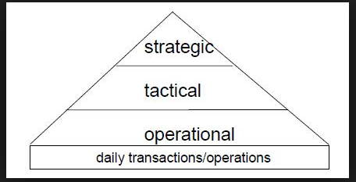
Figure 1:1 Decision-making level (adapted from Whittington et al 2014)
There is a need for Britvic to align and synchronise decisions, taking at the three levels so that effective and efficiency performance can be achieved.
Despite the cultural trend for companies to incorporate into their corporate culture the sustainability concept and stakeholder perspective of the firm, this paper explores how Britvic plc is faring in the quest to imbibe these two concepts into their decision-making framework when carrying out their marketing activities.
1.5 Research scope
“The nature of business and management research is that it transcends many academic disciplines. Therefore, it generates ideas that relates to practice and fulfil specific requirement. Thus, there is a need for the research to have practical relevance and implications” (Saunders et al, 2012)
Given the nature of business research, it cuts across several disciplines like law, ethics and marketing. Therefore, the scope of this research is wide and it encompasses various concepts and principles that shape the capitalistic system of government, as practised in the United Kingdom.
There are various theories, principles and concepts that are relevant to this research inquiry and would be employed to shed lights on this research. These are namely:
- Sustainability concept
- Stakeholder concept
- Shareholder concept
- Marketing concepts
- Corporate social responsibility – CSR
- Agency principle
- Fiduciary duties
- Stewardship concept

For this study, the core concepts that are covered are the sustainability concept and the stakeholder concept. The two concepts are operationalised below by asking the following research questions. See the section on research questions 1.6 below.
The author thinks the all-pervading concept that applies in every country, to all firms irrespective of the economic system at the current moment, is the “sustainability concept.”
Firm-specific concepts that operate at the strategic level of the firms are shareholder concept and the stakeholder concept of free market economy.
In this research paper, the focus is to explore the alignment of the shareholder/stakeholder concept taken at the strategic level with the holistic marketing concept taken at the tactical level of the firm.
Given the growing importance that consumers are now attaching to the issue of sustainability. Thus, the relevance of stakeholders’ engagement and stakeholders’ value have been brought to the fore in marketing and management context. Most firms are now reporting about their stakeholders in order to show that they are carrying out their activities in a sustainable way.

Twenty first century has brought about globalisation enabled by internet technology whereby events around the world can be seen instantly by various multi-media applications. This means that the increase in negative externalities created by these corporation’s operations in different parts of the world can be viewed by everyone with the potential for reputational damage to the firms involved.

Thus, this empowerment avail to the consumers and the public means that the corporations have lost the power to control the narratives of events through their powerful public relations and advertising agents, thereby increasing the pressure on them to take notice of the effects that their production activities are having on the people and the environment.

There is no doubt that the story of business and the concept of shareholder being the dominant paradigm needs to change to the concept of stakeholder in order to be relevant to the 21st century environment. These changes have been going on for some time, as information and internet technology has driven globalization, thereby creating a different operating environment for business.
The field of business and marketing has evolved over the years as the capitalistic system of running business enterprises becomes more entrenched in the society, coupled with the sophistication and increasing awareness of the consumers regarding their legal rights.
1.6 Background to the research issue
Business research is a systematic process of detailed planning, acquiring relevant data, processing and analysing the data, and deriving knowledge from the data to enable well-informed decision making that mobilize necessary resources and deploy those resources to appropriate action in order to achieve set business objectives and business performance for the organisation.
In the United Kingdom, the economy is purportedly run on the basis of free market economy albeit with a degree of government intervention. This literally means that the market forces are allowed to prevail in the economy within the framework of the regulatory environment.
Thus, most of the companies in the United Kingdom subscribe to the notion of corporations run on the basis of capitalist set-up otherwise known as shareholder concept of the firm.
This state of affairs gives rise to the birth of a corporation whereby the concept of limited liability for a corporation as well as separate legal entity concept was born. Thus, a corporation or company primary motive is to maximise wealth for those who risk their capital in the company. This state of affairs, which some referred to as shareholder concept has come to dominate and pervade the business state of affairs in the Western economy, most especially the Anglo-phone countries.
The increase industrialisation of most of the developing economies coupled with the degradation of the environment makes this position to be untenable. This necessitates the concept of stakeholders.
1.7 Research aim
The research aim is to explore how embedding stakeholder and sustainability concepts into its marketing activities can drive up performance and invariably give Britvic a competitive advantage over its competitors.
This research carries out an exploratory case study of a United Kingdom soft drink manufacturing company, Britvic, in order to find out what perspective of free market economy operates within the firm and also to find out which of the marketing concept dominates their marketing activities.
This research was necessary given that most organisations purport to carry out “holistic marketing concept” within the context of traditional view of company that is, the shareholder perspective of company which is an anomaly.
This research shows how the alignment of sustainability concept into that misalignment of this view pervades most organisations when they purport to carry holistic marketing concept in their marketing activities.
1.8 Research objectives
The primary research objectives are:
- To find out the prevailing view of the firm that dominates the company.
- To find out the importance attached to sustainability in the company.
- To find out the marketing concept that is operative in the company.
1.9 Research questions
The purpose of research questions is to unpack the research issue aforementioned that is “embedding sustainability concept into the marketing activities of Britvic in order to drive its performance and leverage it as a source to gain competitive advantage over its competitors
- What is the prevailing view of the firm that dominates the company?
- What is the importance attached to sustainability in the company?
- What is the marketing concept that is operative in the company?
These questions would be explored by a mixed method of questionnaires and interviews to research sample participants.
1.10 Research dissertation structure
The research structure is presented in a way to enable good understanding of the logical flow of arguments in the dissertation. Thus, the paper is structured into six chapters, as depicted in the Figure 1.1 below.

Figure 1:2 Dissertation structure

Chapter 1: Introduction
The first chapter deals with the introduction and explains the aim, the objectives, the scope, and the raison-d’etre for carrying out this research.
Chapter 2: Literature review
The second chapter delves into the review of various academic literature spanning the business, accounting, marketing and economics disciplines. Textbooks and peer-reviewed articles from leading academics in their fields are reviewed, analysed, evaluated and synthesised together in order to find an area of disagreement or consensus.
Chapter 3: Research methodology
The third chapter deals with the research methodology employed for this study. It also deals with the appraisal of other methodological traditions and justification, description and limitations of the methodology deployed for this research paper.
Chapter 4: Analysis and discussion of research findings
The fourth chapter presents the research findings and analyse these findings in order to shape future direction of further studies.
Chapter 5: Conclusion
The sixth chapter draws conclusion from the research findings.
Chapter 6: Recommendations
The seventh and the final chapter presents recommendations ranging from academic to best practice that could be adopted. Also, the methodological limitations of the study are presented.
1.11 Summary
The introductory chapter brought into forth the research trajectory that the researcher intends to follow during the course of this project. This was to ensure that focus was maintained, and distraction or drift was eliminated so that research questions posed at the beginning was answered and research objectives were fulfilled at the end of the project. The next chapter reviews relevant, appropriate literature in order to further understand the subject matter.
Chapter 2: Literature Review
2.1 Introduction
The aim of a literature review is to present an objective and critical summary of published literature in the field under research. “A good literature review is comprehensive, critical and contextualised, in other words, it provides the reader with a theoretical base which may include a survey of published works that pertain to your investigation, and an analysis of that work.” This view is supported by Hofstee (2006). It presents the past, present and future thinking of the research under consideration.
Given that this research study spans across several academic disciplines namely: business, marketing, economics, and law, thus, there are various theoretical underpinnings and conceptual frameworks that are brought from these disciplines and are discussed in the literature review. These theories and concepts are espoused, analysed, criticised, and evaluated in order to synthesise and try to draw a new understanding from them.
Given the scope of this research study, this literature review has sourced its materials from major academic writings, peer-reviewed journals, textbooks, and major landmark reports. These are examined and reviewed vis-à-vis their relevance to the research topic. The chapter then, tries to pull together these theoretical perspectives, conceptual debates, previous research perspectives in order to gain an understanding of the researched subject.
Webster and Watson (2002) posit that “a review of prior, relevant literature is an essential feature of any academic project. An effective review creates a firm foundation for advancing knowledge. It facilitates theory development, closes areas where a plethora of research exists, and uncovers areas where research is needed.”

Therefore, in this context, the aim is to explore and compare the practice of holistic marketing concepts viz-a-viz sustainability and stakeholder concepts at Britvic and to argue for how the integration and alignment of these two concepts into its marketing practices can give Britvic a competitive edge and improved performance over its rivals.

2.2 The rationale for this research study
Most forward-looking, strategically thinking firms should have come to the conclusion that the old paradigm embodied in the “economic model of the firm” which in this literature review is referred to as “shareholder theory of the firm” that pervades virtually all the Western capitalist economies is not fit for the 21st century. There are various reasons why “shareholder theory of the firm” is no longer tenable in the 21st century some of which are discussed below. The word “firm’ would be used interchangeably to mean the corporation, company or MNC. This is important as sustainability concept and stakeholder theory could not be operationalised in the present environment given the entrenched nature of shareholder theory in all the companies in the United Kingdom.

The growth of multi-national corporations (MNCs) and the increase divergence of ownership and control of MNCs means that the Directors who manage the company become much more powerful and influential than the legal owners (the shareholders). This situation invariably led to some Directors feathering their own nests at the expense of the shareholders thus failing in their “fiduciary duties” to the corporation.

These unfortunate situations led to the collapse of big MNCs like Polly Peck, BCCI, Barings Bank, Enron, Bear Stearns, Northern Rock and Lehman Brothers to name a few.

Aside from the Directors failing in their fiduciary duties to the corporation, the big MNCs have also been involved in creating negative externalities for the environment which have created virtually irreversible damage to the environment. Some of these are destruction of the ozone layer, increase in global warming which invariable has led to unpredictable weather events, fracking for oil which has increased the earthquake events and the recent global COVID-19 global pandemic.

These aforementioned events have led to the agitations by concerned people around the world, most especially the millennials generation, Gen Z to demand action on the part of the world leaders to rethink and change their policies towards these powerful MNCs and call them to order.
Several reports have been commissioned by various research bodies like Accenture, which support the untenable position of the “shareholder theory of the firm.” One report articulates that “company should be pro-active and incorporate sustainability culture into the strategic fabric of their business. “Whether sustainability is a passing trend, company stands to benefit by embedding the concept into their corporate culture because in the long-run, ecological sustainability will become the norm sooner or later. Governments and policy makers will make ecological sustainability compulsory, thus if an organisation is a first-mover they will then acquire competitive advantage” (Porter & Kramer 2006; Porter & van der Linde 1995).
This is further corroborated by another report published by Accenture titled “A new era of sustainability: UN Global Compact-Accenture CEO study 2010,” This report focused on the top 250 CEO in the world and asked questions about the issue of sustainability. Lacy et al. (2010) report that 93% of CEOs believe that sustainability issues will be critical to the future success of their business.
According to the Figure 2.1 below, over 90% of CEO interviewed from different parts of the world save “middle east and north Africa” agreed that sustainability issues are important or very important to the future success of their business.
This is further supported by the work of (Bonini et al 2007) who agreed that environmental sustainability has grown in its importance and conclude that business executives expect environmental concerns to become the most important issue which has the greatest impact on shareholder value in the future.
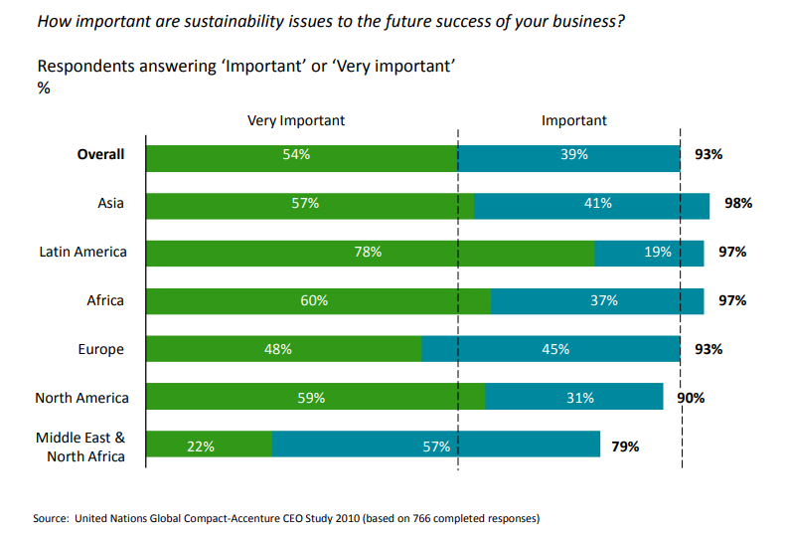
Figure 2.1 – CEO’s importance of sustainability vis-à-vis future success of the firm
Fig 1 above shows that 70% of the CEOs are already incorporating sustainability strategy into their company’s core strategy than they do five years ago, see below Figure 2.2.
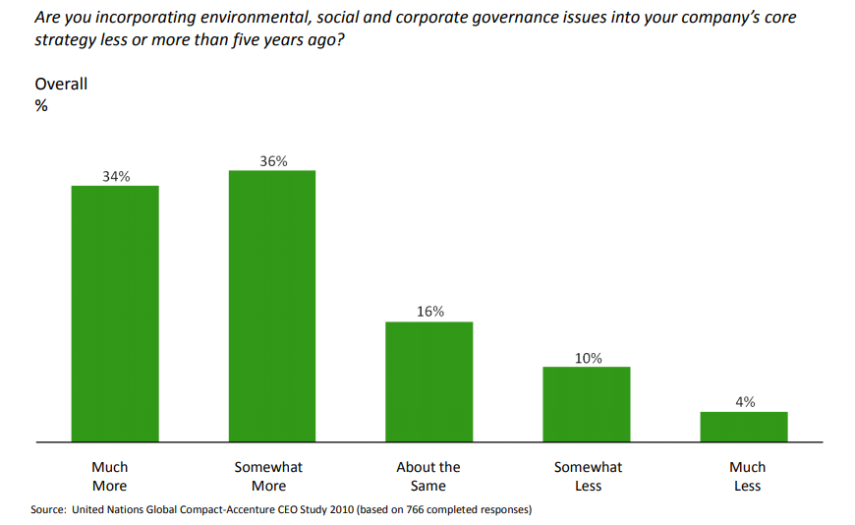
Figure 2.2 – CEO opinion of the strategic importance of sustainability
2.3 Theories and concepts affecting this research
In this research study, there are several theories, concepts that impact this study but given the time constraint, only the most relevant theories and concepts are discussed in this paper namely: sustainability concept, stakeholder concept, shareholder theory, agency (principle) theory, fiduciary duties and marketing concepts.

2.4 Sources of materials for reviewing the literature
The materials for this literature review was derived from three major sources namely:
- Google scholar - citations
- UWTSD library database
- Snowballing the major authorities in the field
The criteria used to arrive at the materials is discussed in the next topic.
2.5 Criteria for reviewing the literature
The works of major authorities in the business, economics and marketing fields are collected and reviewed for relevance. These major authorities like Milton Friedman, Robert Freeman, Philip Kotler, Michael Jensen, Thomas Donaldson, David Aaker, Peter Drucker, Stephen Ross, Barry Mitnick.
The author of this research then used a method called snowballing whereby these authors landmark publications which are relevant to this research are reviewed, and the bibliography and references sections are analysed and reviewed for their relevance to the research study.
2.6 Structure of the literature review
The theoretical and conceptual underpinnings that inform the legal and regulatory frameworks in which a firm operates currently – that is to say “where we are concepts” are discussed firstly.
Therefore, the shareholder theory, agency principle and fiduciary duties are discussed in order to set the tone for the other concepts that this research study tries to show that its alignment and integration with the holistic marketing concept that form the current understanding of the firm has the potential to transform Britvic and give Britvic competitive advantage among its competitors.
Secondly, “where we should be concepts” are discussed. These concepts are stakeholder theory and sustainability concept. Obviously, the “how to get there” will be discussed in the recommendations part of this dissertation.
Thirdly, marketing and marketing concepts, especially holistic marketing concept are discussed and juxtaposed with sustainability concept to show how marketing’s principles could be leverage to communicate this pro-active stance about sustainability to the public and to show that Britvic’s first-mover advantage will give it competitive advantage among its competitors.
2.7 Britvic legal and regulatory framework in the United Kingdom
The theory and concepts that presently shape Britvic legal and regulatory environment are shareholder theory, agency principle and fiduciary duties. Great efforts have been made to inculcate the “ideal (alternative) conceptual situation that is espoused in this study, into Britvic. Nevertheless, the pervasive nature of the shareholder theory and the Company Acts make it virtually impossible to get to the ideal situation. These forward-thinking and inclusive concepts like sustainability and stakeholder concepts will continue to be an attachment to the entrenched concept of “shareholder theory.”
- the present conceptual situation at Britvic is reviewed.
- the ideal conceptual situation at Britvic is espoused
2.7.1 Shareholder theory
In this paper, the word “firm” means “incorporated business”. The word “firm” would be used interchangeably with “company,” “corporation.” Incorporating a business is a legal process that is involved in the birthing of a new company in the United Kingdom.
The importance of this theory to this research study cannot be over-emphasised. In a market economy like the United Kingdom, the shareholders are adjudged to own the company, therefore, the company is predominantly an instrument of its owners to add value to his/her wealth. This is premised on the fact that they invest their risk capital into the company which they could lose in case of liquidation (winding up), which means they are only left with the residual value if any. In other words, the shareholder carries the highest risk among all other people with interests in the firm.
The legal framework of a firm recognises the ‘entity concept,’ which means that the firm is a legal entity on its own and are legally separate from the legal owners (the shareholders). The implication is that the firm can sign contracts with another party on its own right as well as incur debt on its own identity without the shareholders consent. This complex relationship is brought about by the fact that the shareholders delegate the decision-making powers to the management (the Directors) who control and run the company on behalf of the shareholders.
The shareholders are not liable for the debts of the firm and their liability for the firm’s debts are only limited to the unpaid share price, unless if a shareholder has offered his/her personal guarantees. Also, the assets of the firm are not assets of the shareholders, given the legal separation mentioned earlier.
Thus, according to shareholder theory, among the various interested parties or people with stakes in the firm, shareholders have unequalled primacy, and hence, the firm exists to maximise shareholders value alone. The firms are just the instruments of creating economic value for those who risk their capital in the firm. The rationale behind this argument is that shareholders are not just the beneficiaries of the company's financial success, they are the arbiter who determine management's financial power.” Thus, under this approach, pursuit of profits and social responsibility were mutually exclusive Greenwood (2001).
This view, that profits and social responsibility are mutually exclusive is confirmed by Friedman (1970) who is of the view that “there is one and only one social responsibility of business is to use its resources and engage in activities designed to increase its profits.”
The input-Output model of the firm is shown below in Fig 2.3 and states that the shareholders invest their risk capital, the suppliers invest their resources (raw materials) into the company while the employees invest their labour into the firm in order to deliver useful products to the consumers. However, the financial resources invested in the firm by the investors (shareholders) grants them the instrument of ownership. Obviously, this is the state of affairs at Britvic as the shareholders own the company and decision-making power is delegated to the Executive Directors who run the company and report to the shareholders at the annual general meeting (AGM).
Agency principle is discussed next as it explains the legal separation of ownership and control and the implication of shareholding power of the owners on the firm and the Directors who control the firm.
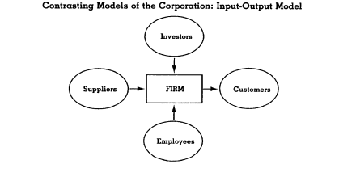
Figure 2.3: Shareholders concept of the firm
2.7.2 Agency principle
The importance of this principle to this research study is that it reinforces the “shareholder theory” by recognising only the “shareholders” as the “principal of the firm” and the Directors who run the company as “agents of the firm” who work primarily for the benefit of the shareholders.
The agency theory came about as a result of the separation of ownership and control in the firm as mentioned earlier. The shareholders are the owners of the firm, while the management (Directors) are the ones who control the firm. This gulf between the two have increased due to the enormous growth in the power of the firm (MNCs) and the fact that the shareholders are becoming increasingly dispersed and diffused and becoming less influential in the MNCs that they supposedly own, while on the other hand, the power of the Directors who run the MNCs has grown enormously. This conflict and friction between the shareholders and the management (the Directors) who run the company led to the emergence of this agency principle.
The agency theory is premise on the assertion that the shareholders (the principal) entrust an asset (the firm) to the management (the Directors) to look after. Invariably, this relationship of trust now impose the highest duty in law “fiduciary duties” on the Directors to look after this asset (the firm) and to compel the Directors to work always in the best interests of the shareholders at all times and not to put their interests ahead of the corporations interests. This relationship between the shareholders and the Directors and the company is depicted in Fig 2.4 below. This is the present situation at Britvic, which clearly shows the endemic nature of shareholder theory of the firm as the “agency principle” is the consequence of this theory.
The concept of fiduciary duties is discussed in the next topic as it legally substantiates and validates the relationship among the firm, the Shareholders and the Directors.

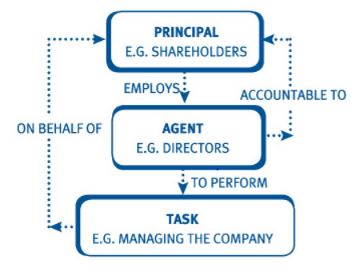
Fig 2.4 Agency relationship – culled from ACCA
2.7.3 Fiduciary duties
The entrusting of the assets of the firm to the Directors to manage and control by the shareholders bring about the legal concept of fiduciary duties. Thus, the firm’s management (the Directors) are said to have fiduciary duties towards the shareholders as a group (not individual shareholders) who are recognised as the owners of the company. According to one of the principal advocates of shareholder theory “these fiduciary duties come from the fact that the corporate Directors are employees of the owners of the business.” Milton Friedman (1970). A fiduciary duty is the highest standard of care at either equity or law and shareholders are the exclusive beneficiaries of these corporate fiduciary duties
Given the fact that the firm has various stakeholders who all have vested or various interests in the firm, only the shareholders are given the prime position and recognition that the firm’s management has fiduciary duties towards.
However, the father of stakeholder theory, Robert Freeman, (2017) sees it in the same light as the author of this dissertation that “the Directors bear an implicit fiduciary duties to the stakeholders and to the firm as an abstract entity.”
Thus, the Directors must act in the interests of the stakeholders and the corporation as their agent, and it must act in the interests of the corporation to ensure the going concern of the firm and also safeguard the long-term stakes of each group of stakeholders Mele (2009).

2.7.4 Appraisal and criticism of the shareholder theory
The conceptual framework of the firm grants unequalled primacy to the “shareholders” among all the other groups who have interests (the stakeholders) in the firm.
This ignorance of the other stakeholders’ interests is the major shortcoming of this shareholder “input-output model.” Even, the government (one of the stakeholders) that create the legal and regulatory enabling atmosphere for the firm to thrive is ignored in this model of the firm.
The conventional assumption that pursuit of profits is the preeminent management concern, which Jensen (2002) calls the “single-valued objective” of a corporation is not fit for purpose and not sustainable in the 21st century global economy.
2.7.5 Appraisal and criticism of the agency principle
The notion that agency is owed to the shareholders, is premise on the assertion that the resource of money (financial resources) that the shareholders contribute is much more important than the other resources contributed by the other stakeholders like suppliers who give their goods on credit terms, the labour resources contributed by the employees, the environmental resources whose raw materials resources are being depleted, but cannot vocalise its concern are deliberated ignored. This shows that the shareholder theory is untenable for the 21st century and the need for the “sustainability concept and the stakeholder theory” to be used as the building framework for firms in the 21st century. The Directors who run the company should have multiple agencies to other stakeholders because the other stakeholders contribute resources to the company.
2.7.6 Appraisal and criticism of the fiduciary duties concept
The omission of other stakeholders and the elevation of the shareholders as the sole people whom the Directors have “fiduciary duties” to is problematic, given that the company is unable to achieve its objectives without the inputs from the other stakeholders, most especially the environment from where the resources are derived from and is not remunerated for it. This is corroborated by Mele, 2009 who says “the concept of managerial capitalism based on the notion that managers have a duty to shareholders should be replaced with the concept that managers bear a fiduciary relationship to stakeholders.”
The next topic discusses the two concepts that the author is of the view should form the bedrock of the corporate environment for the 21st century relationship with the firm.
2.8 Ideal conceptual framework
The ideal conceptual framework, given the rationale upon which the literature review is based upon, should be sustainability concept and stakeholder concept. The model proposed by the author is depicted below in Fig 2.5 which shows sustainability concept as the bedrock of any marketing activities in Britvic.
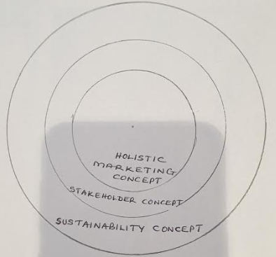
Figure 2.5 - Author
The next topic delves into stakeholder theory.
2.8.1 Stakeholder theory
Stakeholders are defined as “those who can affect or are affected by the firm’s operational activities” Freeman (1984). “Stakeholder theory is a framework used in the academic circle to conceptualise and understand the issues concerning corporate social and ethical responsibilities” (Wijnberg, 2000).
This definition in my view is all-encompassing as it highlighted one of the rationales for this study that MNCs have created negative externalities for both human beings, animals, unborn generation and the environment that these externalities are affecting everyone and the environment most especially.

Stakeholders have been classified in various ways, but in the model of stakeholders as shown below in Fig 2.6, stakeholders are classified as internal or external.

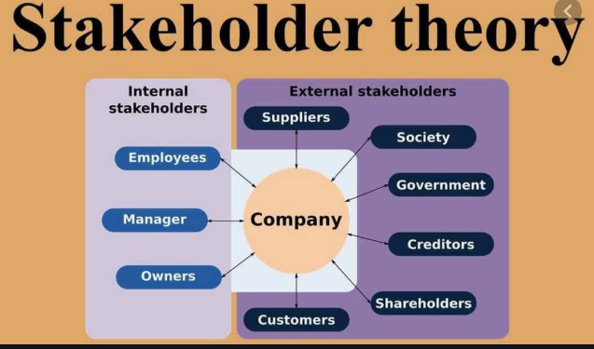
Figure 2.6 Stakeholder theory showing two-way relationship between the firm and the stakeholders
2.8.2 Sustainability concept
In a report published by Brundtland (1987), sustainability is shown to involve three areas – planet, people, profit – and refers to the development that is fair and equitable, in other words the development that meets the needs of the present generation without compromising or limiting the ability of the future generations to meet their own needs. Sustainability timeline is depicted in the Figure 2.7 below.
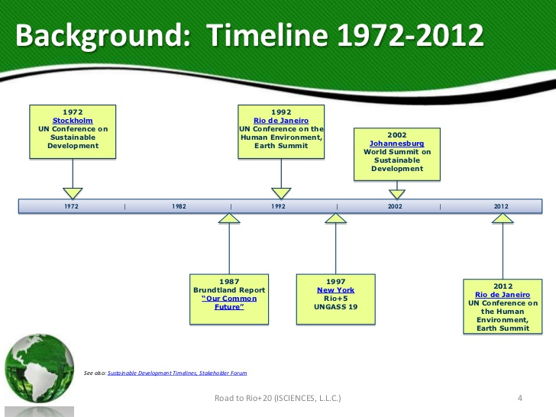
Figure 2.7: Sustainability timeline
(Source : https://www.civilsdaily.com/primer-to-environmental-issues/)
Sustainability concept is not against firms making profits, but profits should only be made if the process of making the profit does not lead to the detriment of the people and the planet. Britvic is a model in this regard as it focuses on the reduction of calorie content available in its drinks (see Fig 2.8). Britvic is continually innovating to achieve this objective. This is the “people” component of sustainability that firm should take into consideration when designing their products.
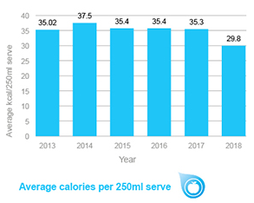
Figure 2.8: Britvic corporate website
2.8.3 Appraisal and criticism of the stakeholder theory
Firstly, the stakeholder ignores the complexity of the network of relationship among various stakeholders. The Figure 2.6 above only shows the relationship between various stakeholders and the firm and does not take this into consideration.
Secondly, the stakeholder theory ignores some stakeholders may belong in several groups at the same time which complicates how to balance interest of stakeholders in different groups and how to balance the interests of stakeholders in multiple groups.
Thirdly, this lack of a clear-cut empirical relationship between social responsibility and the bottom line is perceived by some executives and students as evidence that it is irrelevant for successful corporate performance, perhaps even antithetical to it.
Stakeholder concept has been criticised for focusing on the technique rather than theory, and, for not providing enough theoretical basis for describing firm behaviour or the behaviour of internal and external stakeholders.
Another problematic issue is the instruments of ownership that the shareholders have to show ownership of financial resources in the firm. How can the stake that the society has in the firm be quantified in monetary terms? Obviously, the employees can be given share options like the Directors based on the number of years worked or other performance metrics as they deemed fit.
2.8.4 Appraisal and criticism of the sustainability concept
Sustainability concept has been criticised for being too vague and impractical. Some have criticised it the term for being provocative and the inclination to narrow global problems to environmental issue.
Some have criticised it for difficulty in having a single concept to operationalise sustainability concept. The author believes that a big idea like sustainability concept cannot be operationalised by a single question but several questions.
2.9 Marketing, marketing concepts and marketing orientations
This section briefly discusses the definition of marketing, the various marketing concepts (orientations) with emphasis on holistic marketing concept.
According to the 2017 definition by AMA – American Marketing Association – “Marketing is the activity, set of institutions, and processes for creating, communicating, delivering, and exchanging offerings that have value for customers, clients, partners, and society at large.”
Given the history of marketing, marketing has not been given its proper place among the other academic disciplines and the AMA has not helped in this aspect by their three-yearly changing definition of marketing. Also, the lack of solid conceptual and theoretical bases means the practice of marketing always is ahead of theory of marketing.
The fact that marketing practice has always been in the forefront of marketing thought is depicted below in Fig 2.9 which shows the marketing orientation and the rationale or the factor that drives them Drummond, (2005).

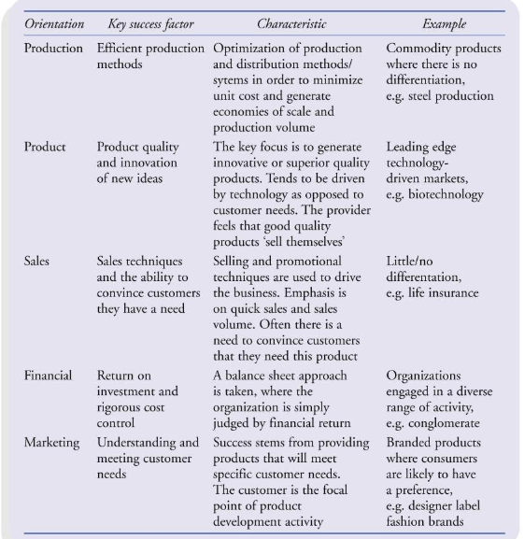
Figure 2.9: Culled from Marketing orientation by Drummond 2005
2.9.1 Production concept and its criticism
The production concept has its primary focus is on ‘unit production cost.’ The objective of this concept is to minimise cost as low as possible. These mean that getting “cheap labour” or even child labour, pressing the supplier of raw materials by dictating the prices at which they sell their raw materials. The focus of “production concept” was about just churning out products in the expectation that customers have no choice but to buy these products, given their cheap selling prices (Kotler and Armstrong, 2008).
This production concept was widely practised at the advent of the industrial revolution in the 18th century up till close to the end of the 20th century where little thought was given to the by-products generated by the non-biodegradable wastes left at the useful end of the products and are thrown into the environment. It is glaring that this concept is not fit for the present age as the level of wastes dumped into the environment is unsustainable.
2.9.2 Product concept and its criticism
The product concept focuses on product features and is premised on the idea that customers are willing to pay extra money for good quality and extra product features. According to Drummond (2005) “the manufacturer feels that good quality products sell itself.” This was the dominant concept at the beginning of 20th century and continued to 1930s (Fullerton, 1988).
This focus on the product at the expense of the customers and other stakeholders can lead to ‘marketing myopia’ (Levitt, 1960).
2.9.3 Sales concept and its criticism
The Sales concept focuses primarily on the firm. It is about achieving quick sales and sales volume which is driven by selling and promotional techniques (Drummond, 2005). It is a concept that aims to achieve higher profit through selling, promotion and pushing of goods to the customers without consideration of the customers’ needs. This involves usage of sharp practices and pressure-selling techniques to convince the customers to buy these products. The drive to achieve higher profits meant unsustainable practices are deployed to achieve higher sales at the detriment of the customers and the societies. This concept is contrary to sustainability concept as most of the products find their way to the bins and constitute environment waste.
2.9.4 Marketing concept and its criticism
The Marketing Concept is a concept that is premised on four components namely: target market, integrated marketing, customer needs and profitability. It maintains that the key to achieving its corporate objectives of being more efficient and effective in its selling activities than its competitors is to design, produce, and communicate customer value to its selected target customers. Marketing concept differs from the sales concept as it focuses its attention on the customers. The marketing concept started to dictate marketing orientation in the 1950s up until 1980s (Pride and Ferrell, 2008).
Actually, the marketing concept’s primary focus on the customers and indirectly on the firms bottom line is detrimental to the environment and other stakeholders. This shows clearly that the concept is not fit for this globalised age where harms done to the environment by MNCs can be seen by billions through the social media.
2.9.5 Societal marketing concept and its criticism
Societal marketing concept suggests that firms marketing activities should not only consider the needs of the consumers but also consider the society, laws and the environment while designing its activities. Any marketing activities which are economically profitable but socially harmful are strictly restricted under societal marketing concept. The marketing should not adopt an irresponsible behaviour towards the society. The increasing popularity of societal marketing aspect can be well understood by the larger evidences of MNCs corporate social irresponsibilities demonstrated by incessant pollution and environmental degradation.
The criticism of the societal marketing concept lies in the fact that it does not take into consideration the potential conflicts that could arise among different stakeholders. For example:
- Which interest is more paramount between customers’ interests and the societal sustainability interest?
- Which interest do you prioritise most among the firm’s interest, the customers interest and the societal interest?
2.9.6 Holistic marketing concept and its criticism
Holistic marketing concept suggests that the marketer’s responsibility is not restricted to the customers, but it extends to the society in general. It takes into consideration customers value and societal value.
Holistic marketing concept framework is depicted below in Figure 2.10. It shows that marketing activities should be approached from every conceivable angle, by taking the views of all the stakeholders into consideration. Thus, the main components of holistic marketing concept are:
- relationship marketing;
- integrated marketing;
- inside omnipresent marketing and
- socially responsible marketing
Relationship marketing is about building lifelong relationships with the customers and hopefully turned them to advocates of the firm’s products or services. The emphasis is on customer acquisition, customer retention and customer satisfaction at Britvic.
Integrated marketing is about being pro-active and trying to fulfil changing customer tastes. This involves alignment of various firm’s communication modes to make sure that they work in unison and carry the firm’s message to the customers with no contradiction.
Inside omnipresent marketing also referred to as “internal marketing” by some authors involves the shaping of employees thought to focus on the customer needs. This also involves using technology to understand the communication channels that the customers use to interact with the firm and using the same mode to design a product that caters for the prospective customers.
Socially responsible marketing is premised on the idea that a socially responsible firm should ask – what is in the best interest of the environment and the society in both short term and long-term? This part of holistic marketing concept ties with the idea of sustainability concept as the environment should be the basis of any decision-making including marketing in the firm.
The Achilles’ heel of holistic marketing concept is the focus on one stakeholder – the customers – as the central point on which the communication is based. This is contrary to the premise of this study as the planet should form the basis on which any strategy is based.
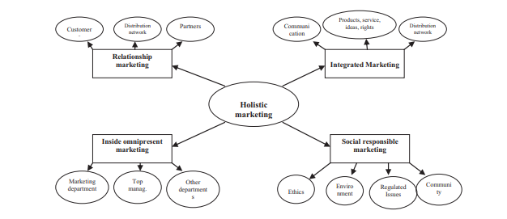
Figure 2.10: Holistic marketing – culled from Drummond
2.9.7 Criticism of definition of marketing and marketing concepts
“The official definition of marketing by the AMA adopted in 2004 ignores marketers' moral responsibility for the socioecological conditions of the world” Mick (2007)
This criticism of AMA stance of 2004 definition demonstrates this lack of conceptual basis shows that marketing reacts to marketing practice and take its cues from practice before coming up with new definition.
AMA is missing an enormous opportunity, at a critical time in the socioecological history of life on earth, to elevate the focus and scope of marketing to a higher ground for which the public, marketing professionals, and marketing students are yearning Mick (2007).
Time is running out for halting the dominance of micromarketing and its narrow management orientation, which Bartels (1983) criticized 25 years ago for having limited concerns with duties or responsibilities.
Instead, much greater emphasis must be given to a macro-marketing orientation. It characterizes the marketing system as a complex set of multi-layered, near-and-far relationships in which the choices and actions of market participants have long-term consequences beyond their firms, partners, and customers (Mittelstaedt, Kilbourne, and Mittelstaedt 2007).
The seeds of wisdom are planted in the macro-marketing perspective, and we need to nourish them for the benefit of all those affected by marketing Mick (2007)

2.10 Analysis and evaluation of various theoretical and conceptual underpinnings
The shareholder theory of the firm is not fit for the 21st century global environment. This is corroborated by this statement “the old rationale of the company’s existing to serve the interest of the shareholders just doesn’t work anymore. The Global Financial Crisis of 2008 brought this point home, but the changes have been going on for some time” (Freeman, 2013).
It has been shown that companies can derive a lot of goodwill and good reputation by leveraging their corporate social responsibility reports
2.11 Synthesis and reconciliation of different theories and concepts
Shareholder theory is embedded in the legal and regulatory framework of Western capitalist economy like that of United Kingdom where Britvic is situated which makes it problematic to change as this is the bedrock on which capitalism rests. The paradigm shift from shareholder view of the firm to stakeholder view of the firm has the potential to collapse the capitalism. The political class who will be tasked with this decision may be hamstrung by powerful interest groups.
Despite the trend for firms to try to adopt best practice like CSR, corporate governance, stakeholder idea, sustainability ideas. These have all been done as an addendum to their corporate reporting but not as something that form the basis of the decision-making framework.
Stakeholder relationships have long been a touchstone of corporate sustainability. “Companies of different sizes need to take account of their stakeholders and manage differing, and sometimes conflicting interests. The goal is to have relationships that create sustainable, high performance organisations – not only economically and financially sound, but socially and environmentally sound as well (Sloan, 2009)
The relationship the firm has with various stakeholders has been a subject of several debates. Given the changing environment and the negative effect many of the MNCs are having on the environment, especially when these MNCs are operating in the developing world where environmental standards are lacking or non-existent. The tendency for the MNCs to lower their home country standards and descend to the lower standards of the developing world and engage in practices which would be frown upon by their home countries.
The fiduciary duties that the Directors have to the “shareholders” should be extended to all the other stakeholders which should be a fair thing to do given that all the other stakeholders provide resources to the firm in order for it to survive as a going concern.
2.12 Summary and implications for further research
All the concepts and theories described above save sustainability concept ignore or make expedient or incidental attention to the environment. This has always been the premise of this paper that the decision-making framework at the firm should have its root in the sustainability concept. In order for holistic marketing to be truly holistic, it must have sustainability concept as its bedrock on which other components of holistic marketing concept flows from.

Chapter 3: Research Methodology
3.1 Introduction
Research methodology has a philosophical connotation and is all-encompassing as it is a system of methods – methodology is systemic in nature – as it shows the input data that was gathered for the research, how the data was processed, and the output that was obtained from the research. The output was compared with the ideal outcome or expectations. Thus, this chapter outlined the specific actions taken by the researcher to study this research subject, and justification for the use of certain methods, procedures and techniques in order to draw out the knowledge from the research subject.
3.2 Research methodology aim
The aim of the methodology chapter is to explain thoroughly the importance of methodology in the research process and to explain the methodology employed by the researcher for this study and to allow the reader to critically assess this research’s overall feasibility, reliability and validity.
3.3 Research methodology objectives
This is a primary research, and the data required for the study of the research subjects was gathered by way of survey and interview. Sources of evidence come from primary data collected during the duration of the research. Given the exploratory nature of the research, interviews were conducted where the research participants were allowed to express their opinions freely.
The main research objectives of this study are:
- To find out the prevailing view of the firm that dominates the company.
- To find out the importance attached to sustainability in the company.
- To find out the marketing concept that is operative in the company.
3.4 Research types according to its purpose
Basically, there are two types of research according to the purpose namely:
- Fundamental or basic research
- Applied research
These two extremes of research are depicted in the research continuum diagram below (Fig 3.1).
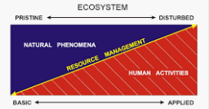
Figure 3.1: Research continuum ‘Adapted from Stokes 1997’
Fundamental research, also known as basic or pure research has its primary goal to widen the scope and depth of knowledge in the particular research area without necessarily having an immediate application to solve business problems, thus it is altruistic in nature. This is corroborated by Bentley et al., 2015 who stated that “basic research, or research undertaken with a primary purpose of the advancement of knowledge for its own sake, has traditionally been fundamental to university missions and their public funding.”
Applied research sets out to be relevant to solve a specific business issue. Thus, making the research findings of applied research to be valuable and thus applicable to address specific business issue. However, Irvine and Martin (1984) identified the rise of another type of research called “strategic research”, which combines academic excellence of basic research with future end goal of practical business application. “It is carried out with the expectation that it will produce a broad base of knowledge likely to form the background to the solution of recognised current or future practical problems” (Irvine and Martin 1984).
This study on Britvic falls into the applied and strategic research ecosystem because it is designed to provoke further academic enquiries as well as being able to be used for solving future business issues.
3.5 Research methodology structure
The research structure adopted for this study follows the research onion model articulated by Saunders et al., 2016. Research methodology process is likened to the peeling of onion from the outermost skin until you get to the inner core. This is depicted in the Figure 3.2 below.
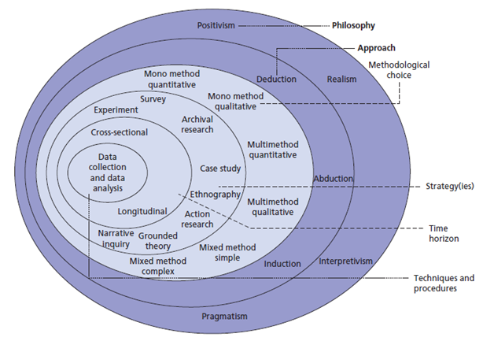

Figure 3.2: Research Onion (Saunders et al., 2016)

Research methodological structure adopted for this study is shown below:
Methodological structure | Research choice for this study
Research philosophy | Intepretivism
Research approach | Inductive
Research design | Exploratory - Case study
Research method choice | Qualitative and Quantitative
Research strategy | Survey and Interview
Sampling technique | Purposive sampling
Time horizon | Cross-sectional
Data collection | Primary
Data analysis | Quantitative and Qualitative

Figure 3.3: Methodological structure adopted for this study

The research methodological structure deployed for this study is arrived at after consideration of the research onion process depicted above in (Figure 3.2) of conducting research by Saunders et al (2016).
The research onion model is analysed below to show its appropriateness and justification for its usage in this research context.
The research onion is still very relevant, appropriate, suitable and important as it shows the progress that the research process follows and also useful for its adaptability and flexibility (Bryman, 2012).
3.6 Research philosophical paradigm and its components
A research philosophical paradigm is defined as a “set of common beliefs and agreements” shared by researchers regarding “how problems should be understood and addressed” (Kuhn, 1962/2012). The term 'paradigm' is defined as "a loose collection of logically related assumptions, concepts, or propositions that orient thinking and research or the philosophical intent or motivation for undertaking a study” (Cohen & Manion 2018).
A research paradigm has been described as an established worldview, a whole framework of beliefs or set of common beliefs, values and methods within which a research takes place. It is within this worldview that the researcher tries to carry out his/her work and seeks answers to research questions.
Guba (1990) argues, “a research paradigm is mainly characterised by its ontological, epistemological and methodological dispositions.” This is analogous to (MacNaughton et al. 2001) who provide a definition of research paradigm, as “consisting of three elements: a belief about the nature of knowledge, a methodology and criteria for validity.”

Other authors have also added another dimension to it called the ‘axiological viewpoint’ (Heron and Reason, 1997). This is attested to by Lincoln and Guba (1985), who say “a paradigm consists of four elements namely epistemology, ontology, methodology and axiology.”
Thus, research paradigm is a boxed way of doing research and is philosophical in nature Therefore, this is an established or specific way of perceiving the world or belief held by group of researchers that inform the way they conduct a research in their subject discipline.
Invariably, this worldview is subjective in nature and is a function of the environment that shape the researcher and the researched. Research paradigm is described as boxed in the sense that it stays the same unless there is a ‘paradigm shift’ that rocks the foundation of the paradigm.
Thus, the research philosophical paradigm is made up of four components below namely:
- Ontological component,
- Epistemological component,
- Axiological component and;
- Methodological component

The relationship between the four components of research paradigm is depicted below in Fig 3.4 where the axiology sits at the base and interacts with other three components. This is important as axiology perspective which is a function of our value system, religious beliefs and cultural situations form the lens through which we see the world.

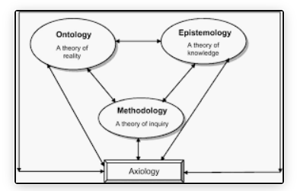
Figure 3.4: Research paradigm components – culled from Qualitative research by (Klenke, 2016)

3.6.1 What is ontology?
Ontology is the nature and study of reality (Hudson and Ozanne, 1988). Ontology “deals with the nature of existence of a particular phenomenon. Reality’s continuum ranges from “single reality to “multiple realities” called relativism.

“The common sense view of our experience of the world is that we perceive it more or less as it really is; that is to say, the world and everything in it exists ‘out there’ independently of our experience of it. This view is known as ‘realism’, and in its simplest form it states that we can obtain accurate and direct knowledge of objects in the world (including people) through our senses.”

the properties of objects appear to change over time, then either the objects really are changing or else we do not perceive the world directly and cannot rely entirely on our senses to provide us with accurate knowledge about the external world.

The choice of the research methods and methodologies we use to gain knowledge about the world depends to a large extent on what we consider to be our relationship to ‘reality’ – that is, to what extent we perceive the world as it really is. This is to some extent an ontological issue in so far as it is concerned with the question of ‘being’.

3.6.2 Researcher’s ontological perspective
This researcher believes there is no single reality and the reality is not limited to our five senses but multiple and contextually bound. Given the nature of this research study which involves capturing different participants emotions, feelings. Therefore, reality of a given situation is multi-dimensional, thus the researcher’s view of ontology tends to “relativism ontology” which purports that there are multiple realities and these realities are subjective in nature and are a function of the context in which the research is taken place.
3.6.3 What is epistemology?
Epistemology is “the nature and study of knowledge and is described as the relationship between the researcher and the reality (research subjects) or how the reality of a phenomenon or event is captured or known.” (Carson et al., 2001). This means gathering of knowledge and understanding about Britvic is captured through the research participants

Epistemology basically describes the relationship between the researcher and the research subjects (participants). It is about uncovering this knowledge about the research subjects that is external to the researcher and therefore learn about the reality of the research subjects. Epistemology tends to answer the following questions:
- What is knowledge?
- How do we uncover knowledge?
- How do we discover new things?
Researcher have distinguished between two types of knowledge namely:
- a priori knowledge.
- posteriori knowledge.
Priori knowledge is knowledge gained prior to sense experience of the events. This knowledge is very common in the scientific field like mathematics, chemistry physics and biology. Due to the inaccessibility of the ‘priori knowledge’ to sense perception, the researcher has to use intuition, reasoning and hunch in order to uncover this knowledge. For example, most of us use remote control that uses IR (infra-red) rays to control their television system, but none of us have ever seen infra-red rays. The de-facto existence (reality) of IR cannot be denied, despite being unable to perceive it with our senses.
Posteriori knowledge on the other hand is the knowledge gained after perceiving and experiencing the events with our senses. This kind of experiential knowledge tend to have more credibility and validity compared to a priori knowledge.
This research study will be making use of knowledge derived mainly from interacting with the research subjects.
3.6.4 Researcher’s epistemological perspective
The author believes that epistemological perspective is a function of the researcher’s background and worldview. The researcher is of the opinion that knowledge of event is not limited to perception of the event by our five senses. Knowledge can be obtained by reasoning about a phenomenon or experiencing it. Thus, knowledge is both priori and posteriori in nature depending on the context in which the research is taking place.
The research participants may not be willing to give information that may compromise their job security, thus knowledge of Britvic through these research subjects may not reflect the real situation at Britvic.
3.6.5 What is axiology?
The word ‘axiology is a compound word, made up of two words, with its etymological origin in Greek, axios and logos – axios means ‘worth’ or ‘value’ and the word ‘logos’ means ‘logic’ or ‘theory,’ thus “axiology’ is nature and the study of theory of value.” (Biedenbach et al, 2016).

“Axiology deals with the nature of value and captures the value question of what is intrinsically worthwhile. The fourth defining characteristics of a research paradigm, axiology, puts in issue "values of being, about what human states are to be valued simply because of what they are" (Heron & Reason, 1997).

Axiology puts into the paradigm the issue of values and beliefs which form the contextual basis of the philosophical paradigm in a research in which the research subjects are humans. Thus, it is impossible to separate the context from the research setting. Both the researcher and the research subjects (Britvic employees) have their different values and belief system which governs the lens in which they see life.

3.6.6 Researcher’s axiological perspective
This researcher’s axiological perspective is that values, beliefs, customs cannot be divorced from a research as it is implicit in the sub-conscious mind of the researcher when carrying out the research. This state of affairs makes qualitative research method very complex.
3.6.7 What is methodology?
Methodology is a broad term that “refers to the research design, research methods, research approaches and research procedures used in investigating the research subject in order to find out something about the research subject Keeves (1997).”
Thus, methodology can be depicted as a system of methods used to depict the flow of information about the research subject which is depicted below in Figure 3.5. This shows how the information is gathered, processed and the knowledge gathered is communicated to the research audiences. Given this systemic nature of methodology, it means methodology has three parts to it:
- Input
- Process
- Output

Figure 3.5: Systemic nature of methodology – Author
3.6.8 Researcher’s methodological perspective
Given the nature of this research study involving gathering information from research participants who are human beings characterised with their different complex emotions, sentiments, mood swings, beliefs, and values. The researcher believes in the use of questionnaires that is made up of both closed and open questions and to reduce the influence of the researcher on the research subject, the researcher used the service of a third party. Also interviews were carried out among the pre-selected research participants.
3.7 Research philosophical paradigms
These philosophical paradigms form various ways of understanding social reality and the nature of knowledge and it offers us a way of classifying these body of complex beliefs and world views. Generally, research philosophy has many branches related to a wide range of disciplines. Within the scope of business studies, there are four main research philosophies (Saunders et. al 2016). This research explores these four main philosophical paradigms of research methodology namely and relate it to this research study:
- Positivism
- Realism
- Pragmatism
- Interpretivism

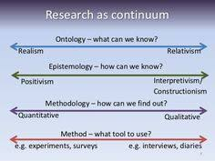

Value-free AXIOLOGY Value-laden
(objective) (subjective)

Figure 3.6: Continuum of components of research philosophical paradigm – culled from Pinterest -the axiology part added by the author)

3.7.1 Positivism
The components of research paradigm is depicted in Figure 3.6 above. Positivism paradigm is at the extreme end of the continuum for ontology, epistemology, methodology and axiology. Positivists ontological perspective is that of single reality, that can be obtained objectively. The quest for objectivity which they believe reduces bias therefore increases the replicability of the study by other researchers drive positivism. Positivist researchers remain detached from the research subjects by creating a wide berth between the researcher and the researched, which is important in reducing bias and remain emotionally neutral in order to differentiate between reason and feeling (Carson et al., 2001).

The positivist ontology believes that the world is external (Carson et al., 1988) and that there is a single objective reality to any research phenomenon or situation regardless of the researcher’s perspective or belief (Hudson and Ozanne, 1988).

Positivists stress the importance of making a distinction between fact and value judgement. Thus, positivist researchers seek objectivity and use consistently rational and logical approaches to research (Carson et al. 2001).

The positivists approached the study of people in the same way that scientists approached the study of inanimate materials. Unfortunately, human beings are way too complex to deploy positivism paradigm in this study, therefore not suitable for this research.

3.7.2 Realism
Realism as a research philosophical paradigm is of the view that the “reality” of any physical material object exists in the external world independently of the human thought or mind. It holds that the perception of any material world by any of the human senses is real and therefore its concrete reality can be proven, for example, looking at a traffic light can be perceived with the eyes and can be touched with the hand which acts as a proof of this “concrete reality” and not just an “abstract concept” like visualising in the mind the flow of electrons in a metal.
The subject of research is Britvic who are being studied through the research participants, who are the employees of the firm. These research participants are human beings loaded with emotions, mood swings, various knowledge and understanding that are subject to change depending on the time and setting.
3.7.3 Interpretivism
Interpretivists avoid rigid structural frameworks such as in positivist research and adopt a more personal and flexible research structures (Carson et al., 2001) which are receptive to capturing meanings in human interaction (Black, 2006) and make sense of what is perceived as reality (Carson et al., 2001).
The position of interpretivism in relation to ontology and epistemology is that “interpretivists believe the reality is multiple and relative” (Hudson and Ozanne, 1988). Lincoln and Guba (1985) explain that “these multiple realities also depend on other systems for meanings, which make it even more difficult to interpret in terms of fixed realities” (Neuman, 2000).
Interpretivism research paradigm is on the other extreme end of the research continuum in terms ontology and epistemology and methodology – see Figure 3.6. Interpretivists utilizes qualitative methods to understand research subjects, as it attempts to capture reality of the research subjects by means of interacting with the researched and try to capture feelings, emotions and passions that the research participants exhibit during the research process. Due to this interaction between the researcher and the research participants, there is a high degree of bias, which invariably reduces replicability and validity of the study.
Interpretivism is highly qualitative in nature, and it involves a high degree of subjectivity on the part of the researcher and the research subjects, but nevertheless does not necessarily dismiss quantitative methods as a method of data analysis.
Some authors prefer to discuss the interpretive framework in terms of 'knowledge claims' (Creswell, 2003); epistemology or ontology; or even research methodologies (Neuman, 2000) rather than referring to paradigms.

Therefore, “the goal of interpretivist research is to understand and interpret the meanings in human behaviour rather than to generalise and predict causes and effects” (Neuman, 2000; Hudson and Ozanne, 1988).
3.7.4 Pragmatism
This philosophical school of thought has its origin in the United States of America in the early 20th century. it is premised on the notion that a true belief should be useful and worthwhile. In other words, research is undertaken to solve problems. The proof of the pudding of research is thus to proffer solutions to everyday issues.
3.7.5 Choice and justification of research philosophical paradigm for this study
Given the exploratory nature of this research, the purpose of which is to gain an understanding of the research subject (Britvic) through the research participants (the employees of Britvic), by interacting and experiencing the research participants.

Given these four components of research paradigm above Figure 3.6 as the research involves complex issues of getting information from various research participants (humans) who have entrenched beliefs, changing feelings, emotions and also with different ontological, epistemological and axiological views of lives, thus, the most suitable and justified research paradigm appropriate to this study is “Interpretivism” research paradigm.

Individual research participant interpretation of views about Britvic is based on their knowledge and understanding of the firm from their own unique perspective. Given these characteristics of Interpretivism, this is the research paradigm most appropriate and employed in this study as it is the most suitable to gain knowledge of happenings at Britvic.
3.8 Research strategy
The research strategy refers to the overall design strategy that the researcher employed to integrate the different components of the research study in a coherent and logical way, thereby, ensuring the effective address the research questions. It constitutes the blueprint for the collection, measurement, and analysis of data.
In terms of the design of research projects, this suggests that direct observation of the world does not guarantee valid and reliable data, and so our methods of data collection have to take into account the fact that seeing is not always believing
For the purposes of this article we define case studies as “an exploration of a “bounded system” bounded by time and place or a case (or multiple cases) over time through detailed, in-depth data collection involving multiple sources of information rich in context” (Creswell, 1998)
3.8.1 Experiments
Experiments is one of the research strategies that has its philosophical basis in positivism. Therefore, it is mostly suited to natural sciences enquiry where those experiments involve the manipulation of variables and occur in a controlled environment like a laboratory. This is not suitable for achieving the research objectives of this study.
3.8.2 Action research
Action research has its philosophical basis pragmatism and encompasses the use of controlled group for data collection (Saunders et al., 2012). This type of strategy is normally carried out during the course of an occupation as it is practically oriented, the purpose of which is to improve the work procedures and modus operandi of an operation. This is not suitable for achieving the research objectives of this study.
3.8.3 Surveys
Surveys has its philosophical stance in positivism. Surveys involve the sending out of questionnaires to research participants. Surveys are mostly used to collect large amount of data form large population. It can also involve the use of in-depth interviews, content analysis, observation and so on (De Vaus, 2002). This is not suitable for this study.
3.8.4 Case study
Case study is described as “an enquiry that investigates a contemporary phenomenon in detail within real-life context, when the boundaries between the phenomenon and the context are not clear-cut” (Yin, 2009).
It is best applied to a research which is explorative, explanatory, or descriptive and tends to ask the questions of what happened, why did it happen, and how did it happen? (Yin, 2006)
Case study research is a strategy that is used to describe a research context where the researcher does not intend to manipulate research variables or events, that is where the research involves the studying of the research subject within the context of political, socio-economic and organisational scenario. This is the most suitable strategy for this study given the attributes of case study which fit perfectly to achieving the research objectives.
3.8.4.1 Research population
The research population is the whole population, which is all the employees of Britvic. In this research, it is not practical to get the inputs from the whole population due to the enormous cost involve and the fact that most of the employees may not be suitable due to the fact some of them are agency staffs. Thus, due to cost and practicalities, research sample were purposively identified, and information was collected from them.
3.8.4.2 Research sample
The research sample is the part of the population selected for the study. According to the figure 3.7 below, Kumar, 1999 identifies three types of sampling namely:
- Random/Probabilistic sampling
- Non-random/Non-probabilistic sampling
- Mixed sampling
Type of sampling
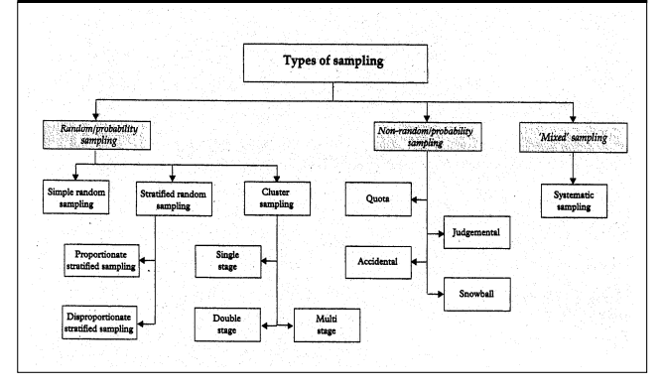
Figure 3.7 Type of sampling – culled from Kumar, 1999
Probabilistic sampling is the sampling technique used to generate unbiased samples from the population by using mathematical method where every sample of the population has an equal chance of being selected. Thus, the samples selected for research are true representatives of the population. This is not suitable for this study as the researcher has no access to the population at Britvic.
Mixed sampling is the sampling technique adopted for a research where the researcher makes use of random sampling at one stage and combine with systematic selection of sampling at another stage of the research. This is not suitable for this research given the scope and time-constraint on this research.
Non-probabilistic sampling is the sampling technique where the researcher uses personal informed judgement to select research samples rather than randomly selecting the samples from the population. It is practically impossible to carry out probabilistic sampling at Britvic due to the interruption that it may cause for the research participants. Also, non-probablistic sampling has advantages of being cost effective and time effective. This is commonly used in qualitative data of data collection. The researcher uses one of the non-probablistic method called purposive sampling for this Britvic study which is discussed next.
3.8.4.3 Purposive sampling
Purposive sampling is a non-probablistic sampling technique, also referred to by various names such as expert sampling, judgmental sampling, selective sampling, or subjective sampling. It is a sampling technique where the researcher uses his/her own judgment to choose the samples from the population to participate in the research study. The researcher uses his sound judgement to select the Britvic employees who are in the strategic positions to answer the questions that is posed by the research study. Purposive sampling “is a technique commonly used in qualitative research for the identification and collection of information-rich cases for the most effective use of limited resources” (Patton, 2002).
3.8.4.4 Research validity and reliability,
The research carried out on Britvic is valid and reliable. Great efforts were made at the initial stage and during the course of the research to ensure that data collection methods and the integrity of the data are maintained during and after the research. For example, the questionnaires were sent to the research participants to cross-check the information before they were processed by the researcher.
3.8.4.5 Research replicability, and generalisability
Saunders et al. (2007) describes generalisability, “the extent to which the research findings of a phenomenon can be adapted to other research settings.”
The replicability and generalisability of a research are functions of several things which are inherent in the philosophical paradigm, methodological approach and data interpretation adopted for the research. Given the case study and cross-sectional approach adopted for this research, this reduces the replicability of this research on Britvic. Given that the research participants are subject to change another employment, the generalisability is greatly undermined.
3.8.5 Choice and justification of research strategy for this study
This research uses case study as it is the most suitable to address the research subject and the research participants. Given the contextual-based of this research of Britvic, this is the most suitable strategy to enable the researcher to get rich picture of event at Britvic. Case study allows for the prospect for a holistic approach to research without the interference of too many variables (Gummesson, 2007).
3.9 Research approach
Research approach basically consists of data collection method and data analysis method, as depicted in the Figure 3.7 below.
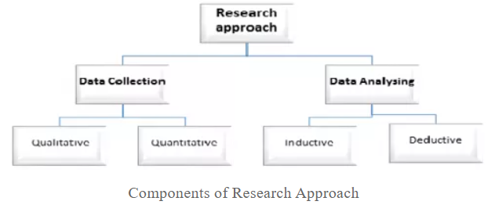
Figure 3.7: Components of research approach – culled from Project Guru

Research approach is a function of the philosophical assumptions and research paradigm adopted for this research study. Given that “Interpretivism” was the research paradigm adopted for this study, this philosophy invariably influenced the ‘data collection method’ and the ‘data analysis method.’
3.9.1 Data collection
There are several ways of collecting data for research, for example, surveys, field observation, questionnaires, experiments and interviews, but the most important attribute that should not be compromised during data collection stage is the integrity of the data. The criteria used to select data collection instruments was namely:
- Ease of accessing the research participants
- Cost of administering the data
- Scope of data
- Balancing objectivity and subjectivity issues in collection of data.
Thus, the data collection instruments used in this research study are questionnaires and telephone interviews. The limitations suffered by these mode of data collections are that the data collected are not easy to summarise, compare and generalise because these data are made up of human stories that are laden with passions, emotions and sentiments.
Questionnaires was chosen as it is a fast way of reaching the research subject and is cheap to administer and also brings a high level of objectivity as the researcher is not present when it is being filled by the research subjects. The questions are a mixture of open and closed questions, which allows research participants to input their opinions.
Telephone interviews was adopted as it reduces subjectivity and bias which could have been brought into the interviewing process by the researcher. Also, it was chosen so that chance of being rejected for face-to-face interviews are reduced, given the busy nature of the participants at the strategic positions in the firm.
3.9.1.1 Qualitative method
“Qualitative method of data collection is multi-method in focus as it employs an interpretive, naturalistic approach to its research subject. Thus, it involves studying things in their natural settings attempting to make sense of or interpret phenomena in terms of the meanings people bring to them.” (Lincoln 2004). This perceived advantage of allowing research participants opinions, invariably brings an element of bias and subjectivity into the research, which jeopardises reliability, validity, and replicability.
Qualitative makes use of open-ended questions that factors in research participants individual inputs. Qualitative method allows for the opinions of the research participants to decipher their own interpretation of realities (Bryman et.al, 2011).
The disadvantage of qualitative method is that any translation of research participants opinions into numerical data inevitably entails a reduction and irretrievable loss of meaning.
3.9.1.2 Quantitative method
Quantitative method approach to data collection is a “formal, objective and systematic process in which numerical data are used to obtain information about the world” (Burns and Grove 2008).
Also, Shields and Twycross (2003) suggest that “at the most basic level, quantitative methods to data collection are used when something needs to be measured, while qualitative method to data collection are used when a phenomenon needs to be described and investigated in some depth and often, the two methods are used in conjunction to provide measurements for comparison and evaluation and to give an in-depth explanation of the meaning of an idea.”
The advantage of quantitative method is the usage of formalised and objective way of obtaining information from the research participants. As a result of these, reliability, validity and replicability are enhanced and greatly improved.
3.9.2 Data analysis
As Albert Einstein is famously reported to have said, ‘Everything that can be counted does not necessarily count, everything that counts cannot necessarily be counted.’ Generally, this is the situation with qualitative data analysis as it is complex in nature given the non-numeric nature of these data.
There are several ways of analysing data., but the two most important are deductive approach to data analysis and deductive approach to data analysis as shown in the diagram below Figure 3.8 namely:
- Inductive research
- Deductive research

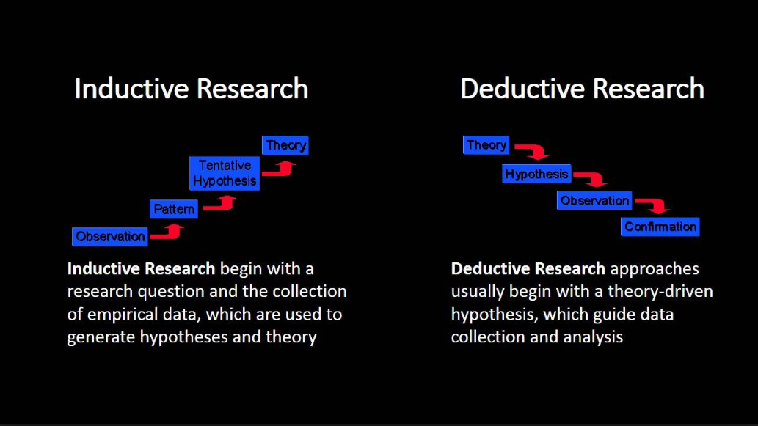
Figure 3.8: Research approach - culled from
3.9.2.1 Inductive research approach
Inductive approach to research data analysis involves making observations about a phenomenon and developing theory based on the findings which is the purview of social sciences as it seeks to understand on a deeper and more personal level (Dilthey, 1976).
Inductive approach works from specific to general, that is, it starts by gathering various data about the research subject and trying to find a theme or pattern from which it tries to generate a tentative hypothesis in order to build a theory as shown in Figure 3.8 above. Thus, inductive approach involves synthesis of different ideas loaded in deep meanings, to develop a theory.
Given the qualitative nature of inductive process, its ontological stance owes its existence to multiple realities where the subjective nature of those realities are socially constructed and these are functions of the axiological stance that is value system grounded in personal bias, belief, religion, culture, etc.
The epistemological stance of inductive process is that there is a close interaction between the researcher and the subject of the research. Inductive research approach concentrates its efforts on exploring a new and an unexplained phenomenon from an entirely new perspective (Saunders et. al., 2016). This is the approach that is employed for data analysis in the research of Britvic as it is the most suitable, given the explorative study of the research.
The advantage of the inductive approach is that it is rich and loaded with meanings that can be extracted by using various coding system like NVIVO, Atlas.ti.
The disadvantage is that it is loaded with bias, given the subjective nature of the data collection method which invariably makes it difficult to generalise or replicate the study even in the same setting.
3.9.2.2 Deductive research approach
Deductive approach to research basically involves testing of hypothesis after making objective observations or on a hunch. The aim of deductive approach is to ensure objectivity and replicability of research experiments.
Deductive approach works from general to specific, that is, it starts with a hypothesis or theory and try to disprove it. Thus, it is mostly used in the physical sciences to explain phenomena in terms of cause and effect.
Given that quantitative nature of deductive process, its ontological stance owes its existence to single reality where the objective nature of the reality is grounded in numerical data.
The epistemological stance of deductive process is that there is a no close interaction between the researcher and the subject of the research.
The axiological stance of deductive process is the researcher’s values and belief system have no bearings on the research and the research subject, thus increasing objectivity and reducing bias considerably. The disadvantage of the approach is that it is limited to studying natural phenomena that are devoid of feelings and emotions.
3.9.3 Choice and justification of research approach for this study
Given the interpretivism philosophical paradigm adopted for this research, the research approach employed for this study is ‘inductive approach’ due to the fact the research is exploratory in nature and tries to find out the practice of holistic marketing within the framework of sustainability and shareholder concepts. Thus, the inductive research is the most suited for this research as it involves works from building up different pieces and try to make sense of it for further studies.
3.10 Time horizon
Time horizon is the timeframe during which the research takes place. Saunders 2009 identifies two types of study based on the time horizon namely:
- Longitudinal study and
- Cross-sectional study
Longitudinal study involves the conduct of a research over a long period of time. This means the researcher interacts with the research subject over a long period of time which allows detail information to be gathered from the research process. This is not suitable for the study of Britvic as only limited time can be had with the research participants.
Cross-sectional study is used to get snapshot of events from research participants at a given time. It is a cheap way to gather initial information about the research participants to allow for further studies to be conducted in the future. The disadvantage of cross-sectional study is the insufficient information provided as it only provides a snapshot of events at Britvic.
In this study, given the short time frame, the cross-sectional study was deployed for the study at Britvic as being the most suitable.
3.11 Ethical consideration
Given that the research being conducted in the United Kingdom, the researcher has been guided by the Data Protection Act and the General Data Protection Regulation (GDPR). Also, the researcher has followed the guidance of the British Economic Social and Research Council (ESRC) in order to ensure that research participants data are collected, processed and analysed fairly and ethically.
The researcher has followed six principles of DPA and GDPR which state that the data must be:
- Be processed lawfully, fairly and transparently.
- Be kept to the original purpose
- Be minimal (collect what is required)
- Have the accuracy upheld
- Be removed if they are no longer needed
- Be kept confidential and their integrity maintained.
Researcher must also have a legal basis for processing the data collected from the research participants. There are six legal grounds according to DPA, of which the researcher has to meet one of the six grounds. The researcher has fulfilled the requirements of the three of them which are namely:
- Consent of the data
- Carried out in the public interest or in the exercise of official authority
- Legitimate interest pursued by the data controller.
The researcher sought the consent of the research participants by disclosing the purpose of the study and the entire research process. The research participants were also told how their anonymity and privacy would always be maintained, so as to ensure no harm is done to them during and after the research process is completed. They were told they could withdraw from the research at any times and confidentiality of disclosed information would always be maintained .
3.12 Limitations of this research methodology
The limitations of this research are lack of replicability and generalisability due to the inherent nature of the case study approach adopted for this research which involves the cross-sectional approach. Another factor is the limited resources available to conduct the research all combine to limit the research.
3.13 Summary
This chapter has shown the methodological structure adopted for this study from the research philosophical paradigm to the data analysis and interpretation for this study. The next chapter deals with the analysis of research findings conducted on Britvic.

Chapter 4: Analysis and discussion of research findings
4.1 Introduction
This chapter presents the findings and in-situ analysis and discussion of the research on how sustainability and stakeholder concepts embedded within holistic marketing concept can drive Britvic’s performance, and also bring competitive advantage to the firm. Given the limited access to this Directors of Britvic, this research had to use the combination of questionnaires and telephone interviews research strategies to access the research participants.
This research was conducted on the ten management staffs of Britvic who volunteered to take part in the study. These employees worked at the middle and higher management levels of the company, thus, they were in a knowledgeable position to articulate the tactical and strategic position of the firm which justified the reason for purposively sampling these participants among the Britvic population.
The telephone interview was specifically selected and targeted at the Britvic employees who were in these positions to answer the conceptual questions posed by the research study.
The survey questions were mostly quantitative and close-ended in nature while the telephone interviews were combination of open close-ended questions.
Thus, these informed the structuring of this chapter into four sections namely:
- Section 4.1 introduces the chapter.
- Section 4.2 deals with the “quantitative analysis” of the close-ended questions.
- Section 4.3 deals with the “qualitative analysis” of the open and close-ended questions.
- Section 4.4 deals with the operationalising of sustainability concept.
- Section 4.5 deals with the operationalising of stakeholder theory.
- Section 4.6 presents the summary of the chapter.
4.2 Quantitative analysis of close-ended questions
This section reports on the demographical variables employed for this study. These are the research participants’ gender, age, work experience, income, management level and educational level.

Analysis of gender in Britvic
Q1. What is your gender?
Table 4.1: Britvic gender survey
Age-range | Number of research subjects | Total number of research subjects | Percentage
Female | 5 | 10 | 50.0
Male | 5 | 10 | 50.0
Total | 10 | Total | 100%

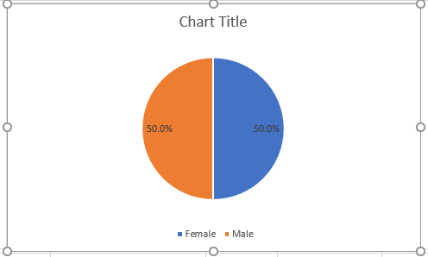
Figure 4.1: Britvic gender chart
Discussion of gender group in Britvic
The table and figure above – Table 4.1 and Figure 4.1 showed that there was an equal gender representation within Britvic employees among those surveyed during the research. This was good for Britvic as it showed compliance with laws and regulations and best practice regarding gender representation. This was a sustainable best practice at Britvic.

Analysis of age group in Britvic
Q2. Which age group do you belong to? “ONS harmonised standard 3 criteria” – see Appendix 1 for the whole group.
Table 4.2: Britvic age group
Age-group | Number of research subjects | Total number of research subjects | Percentage %
25 - 34 | 1 | 10 | 10.0
35 - 44 | 2 | 10 | 20.0
45 - 54 | 5 | 10 | 50.0
55 - 64 | 2 | 10 | 20.0
Total | 10 | Total | 100%

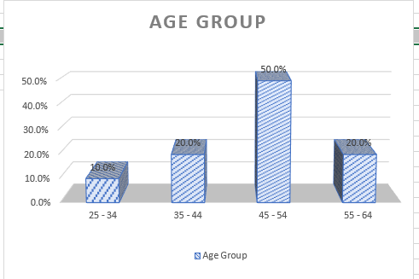
Figure 4.2: Britvic age group chart
Discussion of age group in Britvic
The importance of age could not be over-emphasised as so many important information could be gleaned from such data, such as maturity level, life experiences and the generation grouping that the research subjects belong to. The table and chart above – Table 4.2 and Figure 4.2 showed the distribution of age-group that Britvic employees surveyed belong to.
The Figure 4.2 above showed that half of the employees (50%) surveyed belong to age group 45 to 54 years old, while 20% of those Britvic employees surveyed belong to both 35 to 44 years old and 55 to 64 years old groups. The other 10% belong to 25 to 34 years old group.
Given the fact that this was non-probablistic sampling, the generalisation of the demographic structure would not be totally valid.
Analysis of work experience in Britvic
Q3 How long have you been working at Britvic?
Table 4.3: Work experience
Number of years | Number of research subjects | Total number of research subjects | Percentage %
1 - 4 | 1 | 10 | 10.0
5 - 7 | 3 | 10 | 30.0
8 - 10 | 5 | 10 | 20.0
Over 10 | 1 | 10 | 40.0
Total | 10 | Total | 100%

Figure 4.3: Britvic work experience chart
Discussion of work experience in Britvic
The graph showed that 50% of the sampled employees have been in the employment of Britvic for more than eight years which as stated that could be regarded as being happy at work. This is good as having constant turnover of staffs do not augur well for any firm, as new staffs would need to be trained and would be subject to learning curve which invariably would slow down the operation of Britvic.
Analysis of income bracket in Britvic
Q4. What is your income bracket?
Table 4.4: Income bracket
Age-range | Number of research subjects | Total number of research subjects | Percentage %
£35,000 to £49,999 | 1 | 10 | 10
£50,000 to £74,999 | 7 | 10 | 70
£75,000 to £99,999 | 2 | 10 | 20
Total | 10 | Total | 100%

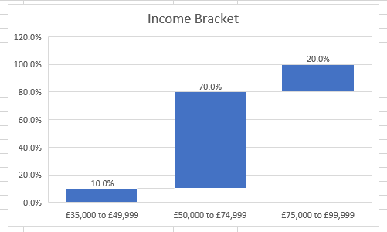
Figure 4.4: Britvic income bracket chart
Discussion of income bracket in Britvic
Based on the sampled date, the median and mode income bracket was between £50,000 and £74,999 which made Britvic one of the best places to work in the UK. However, given the purposive samples used for this study, it could not be generalised to the whole Britvic work population.

Analysis of management level in Britvic
Q5. Please tick the management level you belong to.
Table 4.5: Management level
Management level | Number of research subjects | Total number of research subjects | Percentage %
Strategic (corporate) level | 2 | 10 | 20.0
Tactical (business) level | 7 | 10 | 70.0
Operational level | 1 | 10 | 10
Total | 10 | Total | 100%

Figure 4.5: Britvic management level chart
Discussion of management level at Britvic
As shown in Table 4.5 and Figure 4.5, 70% of the management staffs sampled worked at the tactical level of the firm while 20% worked at the strategic level while one worked at the operational level of the firm. The fact that there were so many at the middle management level was a good thing as the tactical level was the conduit point for both strategic and operational staffs to communicate with each other.
Analysis of educational level in Britvic
Q6. Educational level
Table 4.6: Educational level
Educational level | Number of research subjects | Total number of research subjects | Percentage %
Professional | 2 | 10 | 20.0
Graduate | 7 | 10 | 70.0
Postgraduate | 1 | 10 | 10.0
Total | 10 | Total | 100%

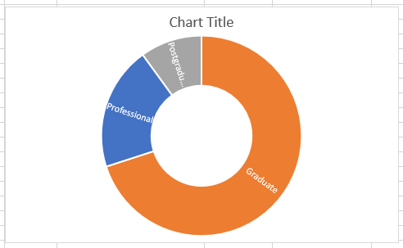
Figure 4.6: Britvic educational level chart
Discussion of educational qualifications among the sampled participants
The findings showed that 70% of the sampled participants were graduates, 20% had professional qualifications while 10% had a postgraduate qualification. The importance of good qualified employees bodes well for the future of Britvic.
4.3 Qualitative analysis of open and closed-ended questions
Q7. Among these groups, with regards to Britvic, please tick in terms of importance and give the reason why in short sentence.
Table 4.7: Analysis of stakeholders importance in Britvic
 | Most important | Agree | Neutral | Disagree | Strongly disagree
Employees | 2
Directors (Management) | 3
Shareholders |  | 5
Local community
General public
Government
Environment
Creditors
Suppliers
Customers

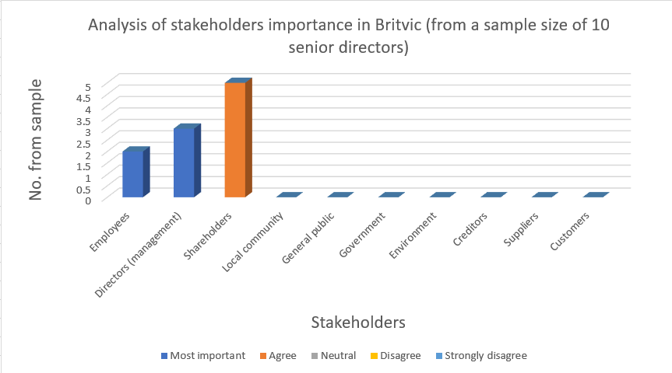
Discussion of stakeholders importance at Britvic
From the findings it was found that 50% of those sampled ranked the shareholders as the most important among the stakeholders. One of the respondents cited the reason for choosing for selecting the answer was based on the fact that they are the owners of the firm, some said that they have the capability to fire them at the AGM. Some said they are responsible and report to them to them 30% ranked the directors as the most important among the stakeholders

Q8. Among these groups, with regards to Britvic, please tick in terms of power and give the reason why in short sentence.
Table 4.8 Analysis of stakeholders’ power in Britvic
 | Most important | Important | Neutral | Not important | Least important
Employees
Directors (Management) |  | 4
Shareholders | 6
Local community
General public
Government
Environment
Creditors
Suppliers
Customers

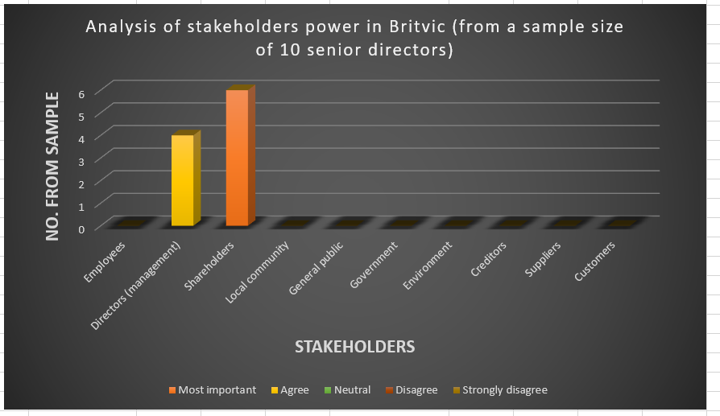
Figure 4.8 Analysis of stakeholders’ power at Britvic
Discussion of stakeholders’ power at Britvic
This was a surprising finding because 60% of those sample were of the opinion that the shareholders were the most important while 40% said the directors were “important.” When asked to elaborate, most said because they control what happened at Britvic and the shareholders had no clue what happened at the firm on a daily basis.

Q9. Which issue is the most important for this 21st century and why?
Table 4.9 Analysis of the most important issue in the 21st century
 | Most important | Important | Neutral | Not important | Least important
Unemployment
Crime
Global warming | 2
Obesity | 5
Environment | 3
Profit

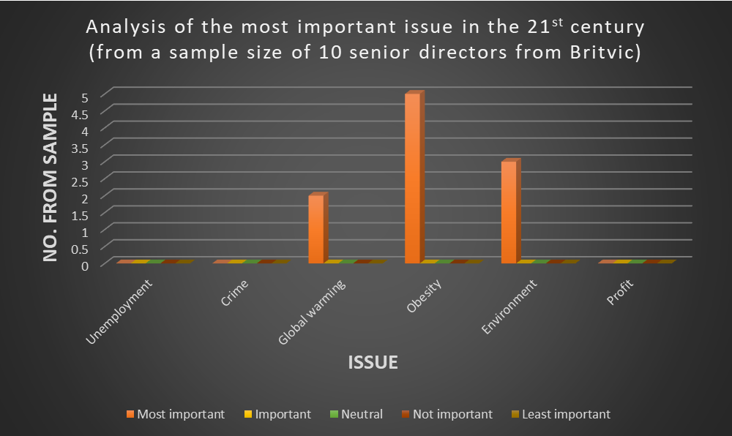
Analysis of question 4.9
The findings from the study showed that 50% of the respondents said that obesity was the most important issue. This was highly interesting given that sugar has been found to be one of the contributary factors for obesity epidemic in the UK. 30% of the respondents said that the environment was the most important issue of the 21st century. The remaining 20% said that global warming was the most important issue in the 21st century. These showed the importance attached to sustainability issues at Britvic.
4.4 Analysis of sustainability questions
The questions used to operationalise sustainability concept is displayed below in Figure 4.1. However, to reduce bias, sustainability (in red) was not appended to the questions. The purpose of the questions is to answer the second research objective which is to find out the importance attached to sustainability in Britvic.

 |  | QUESTIONS | Justification in the Literature Review | Reference
SUSTAINABILITY CONCEPT | Q1 | What initiatives do you do in-house to look after your waste? | Managing waste at the firm is a demonstration of the embedded in the fabric of the company. | Porter and Kramer 2006  Porter and Van der Linde 1995  Lacy et. al 2010  Bonini et. al 2007
SUSTAINABILITY CONCEPT | Q2 | Are you satisfied with your job?
SUSTAINABILITY CONCEPT | Q3 | Who should make decision about obesity issue?
SUSTAINABILITY CONCEPT | Q4 | Do you carry out checks on your suppliers? | Sourcing raw materials from unethical suppliers can affect a firm negatively. | (Porter & Kramer 2006; Porter & van der Linde 1995).
SUSTAINABILITY CONCEPT | Q5 | Will you still be working for the same firm in two years, five years? | Demonstrates contentment on the part of the employees which can be used to operationalise sustainability concept.
Figure 4.1 Operationalising sustainability concept at Britvic.
These questions were derived from the literature review.
4.5 Analysis of stakeholder questions
The questions used to operationalise stakeholder theory is displayed below in Figure 4.2. However, to reduce bias, stakeholder (in red) was not appended to the questions. The purpose of the questions is to answer the first research objective which is to find out the prevailing view of the firm that dominates in Britvic.

 |  | QUESTIONS | Justification in the Literature Review | Reference
STAKEHOLDERS THEORY | Q1 | Which stakeholders are actively considered when the company is designing their marketing campaigns?
STAKEHOLDERS THEORY | Q2 | How do you manage the conflict of interests among the groups identified?
STAKEHOLDERS THEORY | Q3 | Do you consult the consumers about the reduction of sugar in your product or do you take the advice from the scientific data?
STAKEHOLDERS THEORY | Q4 | What is your employment prospect good bad fair excellent?
STAKEHOLDERS THEORY | Q5 | Which age group does your product serve?
Figure 4.2 Operationalising stakeholder theory at Britvic

4.6 Summary
This chapter discussed the findings from the research and analysed the various questions posed to the research participants.
The broad-spectrum nature of the research questions, that is quantitative and qualitative questions allowed the researcher to understand and gleaned important information from the study.
The next chapter draws conclusions from the research findings and analysis.

Chapter 5: Conclusions
5.1 Introduction
This study was carried out with the sole purpose of trying to find out how Britvic can embed and align sustainability and stakeholder concepts with the holistic marketing concept, thus positioning itself to gain improved performance and competitive advantage over its competitors.
The research objectives were namely:
- To find out the prevailing view of the firm that dominates the company.
- To find out the importance attached to sustainability in the company.
- To find out the marketing concept that is operative in the company.
This chapter presents the conclusions from the research findings by answering the research objectives stated above. Furthermore, it delves further by linking the conclusions from the findings with the research objectives vis-à-vis the research participants. set out at the start of the study.
Firstly, it was found that the “shareholder theory of the firm” was practised at Britvic. This was expected as attested to in the introduction that legal and operating environment in the United Kingdom entrenched this economic view of the firm which granted the ownership of the firm to the shareholders.
One of the strategic goals mentioned in the company’s website as shown in Figure 6.1 below addressed only the shareholders by promising to “deliver consistently superior returns for shareholders.” This confirmed the primacy of the shareholders as the most important stakeholder that the firm’s efforts are geared to fulfil.
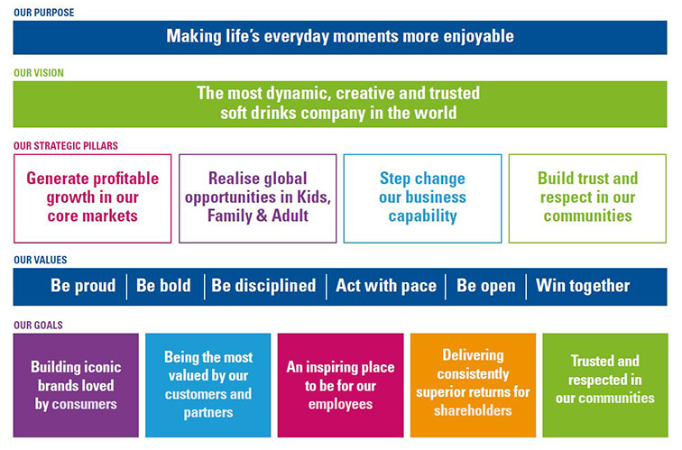
Figure 6.1 Britvic purpose, vision, values, goals dashboard – culled from the Britvic website.

The conclusion chapter is structured thus:
Section 5.2 presents the linkage between the first research objective and research findings.
Section 5.3 presents the linkage between the second research objective and research findings.
Section 5.4 presents the linkage between the third and fourth research objective and research findings.
Section 5.5 presents the summary of the chapter.
5.2 Linking the conclusion viz-a-viz the first research objective
The first research objective is to find out the prevailing view of the firm that dominates the company.
From the research carried out, it was found out that the only those employees who understood the differences and the significance of the two concepts , that is shareholder concept’ and the stakeholder concept’ view of the firm are the employees of Britvic who worked at the strategic level and the tactical level of the firm.
This further correlated to the level of education of these particular groups of people. The employee who worked at the operational level seemed to lack understanding of the significance of the impact that differentiation has on the orientation of the company.

5.3 Linking the conclusion viz-a-viz the second research objective
The second research objective is to find out the importance attached to sustainability in the company.
Based on the research findings, the concept of sustainability was only understood by the employees of Britvic who are operating at the strategic level of decision-making level within the company, the employees at the tactical level only have a vague view of the concept and one even said that sustainability was an academic issue, and therefore not relevant to the way things are done at Britvic. The staff at the operational level did not have a clue as to the significance of the sustainability concept. But when I shed more lights on the issues related to sustainability, they became animated on the telephone to the defence of Britvic as to how they are already leading the way in the adoption of several issues regarding sustainability ranging from lowering of sugars and calories in their drink to sustainable sourcing of their raw materials from ethical suppliers who share their principles. One of the managers referred me to their website where I could see the efforts being made to embed sustainable practices in the way operations are carried out at Britvic. I went through the website to confirm this assertion – see Figure 5.1 below. Another manager said, “sustainability culture is in our DNA.” Another manager pointed the fact that 99% of their products are exempt from the sugar levy which demonstrated the importance attached to the issue of obesity at Britvic.
Figure 5.1: BRITVIC INFOGRAPHIC ON SUSTAINABILITY
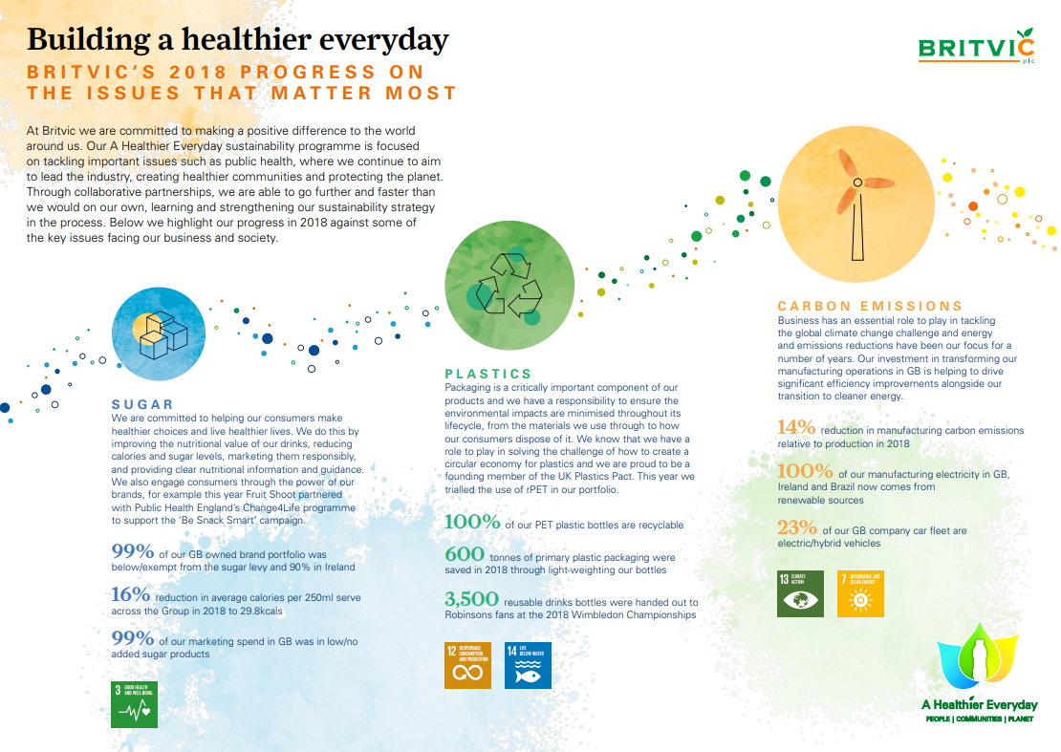
Source: https://www.britvic.com/~/media/Files/B/Britvic-V3/documents/pdf/sustainability-infographic-2018.pdf

5.4 Linking the conclusion viz-a-viz the third and fourth research objectives
The third objective is to find out the marketing concept that is operative in the company.
The fourth research objective is to find out whether stakeholders are taking into consideration when Britvic is designing their marketing campaign.
From the research conducted on Britvic, the elements of holistic marketing concept are already in practice at Britvic. There is a pro-active statement and third-party auditing framework in place to ensure that all stakeholders are continuously engaged to inform marketing campaigns.
The research found out that virtually all the stakeholders identified by the research were factored into their decision-making framework when Britvic designs their marketing campaigns. Although, the holistic marketing concept is not truly holistic as the issue of environmental sustainability is only an appendage among the elements and used as just performance measurement to appraise against environmental regulatory standards.
5.5 Summary
This chapter concludes the findings from the research and analysed the various questions posed to the research participants.
The broad-spectrum nature of the data collection method used, that is quantitative and qualitative questions allowed the researcher to understand and gleaned important information from the study.
Britvic has been pro-active in the importance attached to the issue of sustainability and it has made great strides to inculcate the ideas of sustainability concept into fabric of the firm, however, there is structural limitation imposed by the present legal and regulatory environment under which it operates which still gives primacy to the shareholders as the most important stakeholder in an incorporated firm in the UK.
Lastly, this research found out that most of the elements of holistic marketing were in operation at Britvic without necessarily calling it by the name.
Given the limited scope of this research and the constraint of the shareholder theory view of the firm under which Britvic operates, nevertheless, efforts are made by Britvic to engage with all its stakeholders through various programmes posted on their websites
Britvic should continue to engage with all its stakeholders, especially the demographic group that mostly consumes its products. This can take the form of sponsorship of local events, charitable activities and other activities serving the public interests. These activities have the potential to enhance goodwill and reputation in the community.

The next and final chapter presents recommendations from the research findings and analysis.
Chapter 6: Recommendations
6.1 Introduction
The purpose of this chapter is to suggest a few practical recommendations based on the research findings and to suggest areas for further future academic studies. The chapter is split into two, the first deals with the academic recommendations and the second deals with practical business advice.
6.2 Future areas of academic recommendations
There are several future areas that could be looked into most especially the issue of balance among the three elements of sustainability namely: profit, people, and planet. Profit is made for people who are just passengers on this planet. The premise of this paper has always been to put the planet as the bedrock of sustainability so that other passengers may enjoy this planet. This ties in with stakeholder theory which values all stakeholders and not just the shareholder who are presently recognised by the law as the owners of the firm. The revisiting of the company law, vis-à-vis the extension of fiduciary duties to all the stakeholders is another future area for research.
6.3 Business recommendations
This section uses the Robert Anthony hierarchy (Anthony, 1965) of decision-making framework as a basis for its practical recommendation given the research findings established from the study of Britvic. The hierarchy envisions a firm information hierarchy as being split into three areas namely:
- Strategic level
- Tactical level
- Operational level
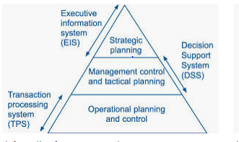
Source: Anthony hierarchy - culled from Kaplan

Most of the literature on strategic management have pointed out that it is of utmost importance for a firm like Britvic to have a strategic alignment and a strategic fitness between its external environment and its internal corporate environment, in order to have a sustainable competitive advantage over its competitors.
Britvic’s external environment is basically made up of two areas: the political, economic, social, technological, ecological and legal (PESTEL) environment and stakeholder analysis, while the internal environment is the firm resources and competencies.
In order for Britvic to achieve its strategic objective, Britvic has to continually have system in place to scan and process the environment and also, to be able to pro-actively deploy the recommendation from its internal researchers about the expectations and the trend in the environment so as to stay ahead of its competitors. Britvic should listen to what the Gen Z and millenials are saying to the issue of environment and be much more pro-active towards this end.
Powerful communication channel
Given that most marketing-related decisions are made at the tactical level, thereby showing the priority attached to the marketing function at Britvic. The marketing-related decision making should be situated at the strategic level of the company as it constitutes a powerful communication channel for a firm that should be used to communicate its green and sustainability credentials to the public.
Britvic can use this green credential to partner with powerful environment groups to maximise its reach to the public. This is corroborated by (Mendleson et al.,1995) who stated that “strategic alliances with environmental groups can assist manufacturers of consumer goods to overcome these problems, as well as provide other advantages, including increased access to environmental information, increased access to new markets, publicity and reduced public criticism and education of consumers about key environmental issues relating to a firm's product.”
Targeted training and seminar
The lack of knowledge and understanding on the part of the employee who worked at the operational level of the firm can be addressed by giving them basic educational training to these employees who work at the operational level to ensure that they grasp the basic concepts of how firms operate in the United Kingdom. The idea is not turn them to Accountants but to show legal and regulatory environment in which a firm operates.
Additionally, Britvic should organise educational seminar on a timely basis for all the employees at various levels of the decision-making hierarchy so as to ensure that goal-congruence is achieved in all areas of their operational, management and strategic activities. The employees should be well versed about the firm’ strategic vision, mission, purpose, position, culture value and ethics of the firm.
Dovetailing sustainability into its value chains network
Given that sustainability development ideas is being driven by the new generation of consumers – the Gen Z and the “millennials” - Britvic should ensure that all the firms connected to its value chain buys into the sustainability idea in order to have a truly sustainability development idea realised in the firm. Suppliers of raw materials and packages should be made to buy into this idea in order to have a fully sustainable products supplied to the customers.
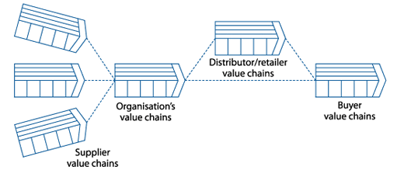
Figure 6.x Value Chain Networks – culled from Kaplan

Sustainability as a source of critical success factor (CSF)
Critical success factors (CSFs) are performance requirements that are fundamental to an organisation's success. In this context CSFs should thus be viewed as those product features that are particularly valued by customers. This is where the organisation must outperform competition (Johnson et al., 2012). It was shown that the millennials, Gen Z (the future generations) take the issue of environment and sustainable development into consideration. These valued areas could be exploited by Britvic, using this as a source of CSF. Britvic already has good sustainable practices in place that should be communicated via social media to these generations which are the greatest consumers of its products. There is also, a growing crop of savvy consumers, not only Gen Z, who are environmentally sensitive and who are immersed in knowledge about the impact of human activities on the environment.
Britvic should have processes in place in order to scan the environment in order to ascertain these changing consumer preferences and social preferences. Britvic should have the systems in place to capture these new changes in consumer tastes and preferences.
6.4 Limitations of this research
Aside from the personal issues encountered by the researcher, the study was limited by other various issues. Firstly, there was not enough time to carry out an in-depth study of the research subjects due to cost, job, and time-constraint.

BIBLIOGRAPHY / REFERENCES

Ackerman, F., Stanton, E.A., Hope, C. & Alberth, S. (2009) ‘Did the Stern Review underestimate US and global climate damages?’ Energy Policy, 37(7), pp.2717–2721.

Anshen, M. (1955) ‘Fundamental and applied research in marketing.’ Journal of Marketing, 19(3), pp.233–244.

Anthony, R.N. (1965) Planning and control systems: a framework for analysis. Boston: Division of Research, Graduate School of Business Administration, Harvard University. Boston: MA.

Baker, M.J. & Saren M. (2010) Marketing Theory a Student Text. 2nd edn. Los Angeles: SAGE.

Baltruks, D. (2016) ‘The Complementarity of the Irish and British Liberal Market Economies and Skilled EU Migration Since 2004 Compared to the Swedish Coordinated Market Economy.’ Journal of International Migration and Integration, 17(2), pp.507–520.

Bartels, R. (1983) ‘Is Marketing Defaulting Its Responsibilities?’ Journal of Marketing, 47(4), pp.32–35.

Beem, E. (1965) ‘Research Methodology in Business.’ Journal of Marketing Research, 2(2), pp.205.

Bentley, P., Gulbrandsen, J. & Kyvik, M. (2015) ‘The relationship between basic and applied research in universities.’ Higher Education, 70(4), pp.689–709.

Beverland, M. & Lindgreen, A. (2010) ‘What makes a good case study? A positivist review of qualitative case research published in Industrial Marketing Management, 1971–2006.’ Industrial Marketing Management, 39(1), pp.56–63.

Biedenbach, T. & Jacobsson, M. (2016) ‘The Open Secret of Values: The Roles of Values and Axiology in Project Research.’ Project Management Journal, 47(3), pp.139–155.

Blau, P.M. (1970) ‘A Formal Theory of Differentiation in Organizations.’ American Sociological Review, 35(2), pp.201–218.

Blythe, J. & Martin, J. (2016) Essentials of marketing. 6th edn. Harlow: Pearson.

Blythe, J. (2013) Principles and practice of marketing. 3rd edn. London: SAGE.

Bocatto, E. & Perez-de-Toledo, E. (2018) ‘Finding Hard Evidences for the Soft Rhetoric of the Stakeholder Theory.’ American Journal of Management, 18(1), pp.61–75.

Bogle, J.C. (2009) ‘The Fiduciary Principle No Man Can Serve Two Masters.’ Journal of Portfolio Management, 36(1), pp. 15-25.

Bondy, K., Moon, J. & Matten, D. (2012) 'An institution of corporate social responsibility (CSR) in multi-national corporations (MNCs): form and implications.' Journal of Business Ethics, 111(2), pp.281-299.

Bonini, S., Hintz, G. & Mendonca, L. (2008) ‘Addressing consumer concerns about climate change.’ The McKinsey Quarterly, (2), pp.52.

Brower, J. & Mahajan, V. (2013) ‘Driven to Be Good: A Stakeholder Theory Perspective on the Drivers of Corporate Social Performance.’ Journal of Business Ethics, 117(2), pp.313–331.

Brundtland, G.H. (1987) Our Common Future: Report of the World Commission on Environment and Development, Geneva, UN-Document A/42/427. http://www.un-documents.net/wced-ocf.htm

Brunswick, G. (2014) ‘A Chronology of The Definition of Marketing.’ Journal of Business & Economics Research (Online), 12(2).

Bryman, A. (2012) Social research methods. 5th edn. Oxford: Oxford University Press.

Bryson, J.M. (2004) ‘What to do when Stakeholders matter.’ Public Management Review, 6(1), pp.21-53.

Burchill, C.S. (1970) Multi-National Corporations. Queen's Quarterly, 77(1), pp. 3.

Burns, R.B. (2000) Introduction to research methods. 4th edn. London: SAGE.

Carroll, A. & Buchholtz, A. (2014) Business and Society: Ethics, Sustainability, and Stakeholder Management. 9th edn. New York: South-Western College Publishing

Clement, R.W. (2005) ‘The lessons from stakeholder theory for U.S. business leaders.’ Business Horizons, 48(3), pp.255–264.

Cohen, L., Manion L. & Morrison, K. (2018) Research Methods in Education. 8th edn. San Francisco: Routledge

Conlon, G. (2013) ‘The Evolution of Marketing.’ DM News, 35(6), pp.44-46, 48-49.

Coombes, P. & Nicholson, J. (2013) ‘Business models and their relationship with marketing: A systematic literature review.’ Industrial Marketing Management, 42(5), pp.656–664.

Crane, A. & Ruebottom, T. (2011) ‘Stakeholder Theory and Social Identity: Rethinking Stakeholder Identification.’ Journal of Business Ethics, 102(1), pp.77–87.

Creswell, J.W., (2013) Qualitative inquiry and research design: choosing among five approaches. 3rd edn. Los Angeles: SAGE Publications.

Das, K. (2009) ‘Relationship marketing research (1994-2006).’ Marketing Intelligence & Planning, 27(3), pp.326-363.

Davidson, C. & Tolich, M. (2012) ‘Getting Started: An Introduction to Research Methods. 2012.’ New Zealand Sociology, 27(1), pp.190.

Day, G. S. (1994) ‘The Capabilities of Market-Driven Organizations.' Journal of Marketing, 58(4), pp.37-52.

Deng, X., Kang, J-K. & Low, B-S. (2013) ‘Corporate social responsibility and stakeholder value maximization: Evidence from mergers.’ Journal of Financial Economics, 110(1), pp.87–109.

Derry, R. (2012) ‘Reclaiming Marginalized Stakeholders.’ Journal of Business Ethics, 111(2), pp.253–264.

Dibb, S., Simkin, L. & Pride W.M. (2006) Marketing: Concepts and Strategies. 5th European edn. UK: Houghton Mifflin.

Dimmock, M. (2019). "Defining generations: Where Millennials end and post-Millennials begin." Pew Research Center.

Domegan, C. (2010) ‘The history of marketing thought: a teaching reflection.’ Journal of Historical Research in Marketing, 2(4), pp.457–466.

Donaldson, T. & Preston, L. (1995) ‘The Stakeholder Theory of the Corporation: Concepts, Evidence and Implications.’ The Academy of Management Review, 20(1), pp.65-91.

Dresner, S. (2008) The principles of sustainability. 2nd edn. London: Earthscan.

Drummond, G. & Ensor, J. (2005) Introduction to marketing concepts. Oxford: Elsevier Butterworth Heinemann.

Dul, J. & Hak, T. (2008) Case study methodology in business research [e book]. Oxford: Butterworth-Heinemann.

Dunfee, T.W. (2008) Stakeholder Theory. The Oxford Handbook of Corporate Social Responsibility

Egels-Zandén, N. & Sandberg, J. (2010) 'Distinctions in descriptive and instrumental stakeholder theory: a challenge for empirical research.’ Business Ethics, 19(1), pp.35–49.

El-Ansary, A., Shaw, E. & Lazer, H. (2018) ‘Marketing’s identity crisis: insights from the history of marketing thought.’ AMS Review, 8(1), pp.5–17.

Elkington, J., (1994) ‘Towards the sustainable corporation: Win-win-win business strategies for sustainable development.’ California management review, 36(2), pp. 90.

Elkington, J. (1994) ‘Books of note -- Environmental Marketing: Positive Strategies for Reaching the Green Consumer by Walter Coddington.’ Environment, 36(5), pp. 25.

Enyinna, O. (2013) ‘Is stakeholder theory really ethical?’ African Journal of Business Ethics, 7(2), pp.79–86.

Eppler, M.J., Hoffmann, F. & Pfister, R. (2011) Rigor and Relevance in Management Typologies: Assessing the Quality of Qualitative Classifications. 1st edn. St. Gallen: University of St. Gallen.

Fabio, L.O. & Kelle, P. (2018) ‘The ethical gap of firms’ marketing practices.’ Journal of Organizational Change Management, 31(1), pp.118-134.

Farrington, J. & Kuhlman, T. (2010) ‘What is Sustainability?’ Sustainability, 2(11), pp.3436–3448.

Felix, R., Rauschnabel, P.A. & Hinsch, C. (2017) ‘Elements of strategic social media marketing: A holistic framework.’ Journal of Business Research, 70(C), pp.118–126.

Ferrary, M. (2009) ‘A Stakeholder's Perspective on Human Resource Management.’ Journal of Business Ethics, 87(1), pp.31–43.

Ferrell, O.C. (2013) ‘From Market Orientation to Stakeholder Orientation’, Journal of Public Policy & Marketing, 29(1), pp.93-96.

Fisch, C. & Block, J. (2018) ‘Six tips for your (systematic) literature review in business and management research’, Management Review Quarterly, 68(2), pp.103–106.

Freeman, R.E. (1984) Strategic Management: A Stakeholder Approach. Boston, MA: Pitman.

Freeman, R.E. & Dmytriyev, S. (2017) ‘Corporate Social Responsibility and Stakeholder Theory: Learning From Each Other.’ Symphonya Emerging Issues in Management, (1), pp.7-15.

Freeman, R.E., Gilbert, E. & Hartman, D. (1988) ‘Values and the foundations of strategic management.’ Journal of Business Ethics, 7(11), pp.821–834.

Freeman, R.E., Wicks, A. & Parmar, B. (2004) ‘Stakeholder Theory and The Corporate Objective Revisited’, Organization Science, 15(3), pp.364-69.

Freeman, R.E, and Moutchnik, A. (2013) ‘Stakeholder Management and CSR: Questions and Answers.’ Uwf (UmweltWirtschaftsForum), 21(1), pp.5-9.

Freudenreich, B., Lüdeke-Freund, F. & Schaltegger, S. (2019) ‘A Stakeholder Theory Perspective on Business Models: Value Creation for Sustainability.’ Journal of Business Ethics, pp.1–16.

Friedman, M. (1970) The social responsibility of business is to increase its profits. New York Times Company [online], Available at: http://umich.edu/~thecore/doc/Friedman.pdf [Accessed 5 March 2019].

Fullerton, R.A. (1988) ‘How Modern Is Modern Marketing? Marketing's Evolution and the Myth of the “Production Era”.’ Journal of Marketing, 52(1), pp.108–125.

Giddings, B., Hopwood, B. & O'Brien, G. (2002) ‘Environment, economy and society: fitting them together into sustainable development.’ Sustainable Development, 10(4), pp. 187.

Goodpaster, K. (1991) Business Ethics and Stakeholder Analysis. Business Ethics Quarterly [online] Available at: https://www.jstor.org/discover/10.2307/3857592?sid=21106271952373&uid=2&uid=4&uid=3738032 [Accessed 28 December 2018].

Gorry, G. & Morton, M. (1989) ‘A Framework for Management Information Systems.’ Sloan Management Review, 30(3), p.49.

Gosling, L. (2010) ‘The 'stakeholder' concept re-explained.’ Investment Week, p.54.

Greenwood, M. (2001) ‘The importance of stakeholders according to business leaders.’ Business and Society Review, 106(1), pp.29–49.

Hasnas, J. (2013) ‘Whither Stakeholder Theory? A Guide for the Perplexed Revisited.’ Journal of Business Ethics, 112(1), pp.47–57.

Heath, J. (2009) ‘The Uses and Abuses of Agency Theory.’ Business Ethics Quarterly, 19(4), 497-528.

Heath, J. & Norman, W. (2004) ‘Stakeholder Theory, Corporate Governance and Public Management: What can the History of State-Run Enterprises Teach us in the Post-Enron era?’ Journal of Business Ethics, 53(3), pp.247–265.

Helfman, T. (2006) ‘Land ownership and the origins of fiduciary duty.’ Real Property, Probate and Trust Journal, 41(3), pp.651-661.

Heron, J. & Reason, P. (1997) ‘A participatory inquiry paradigm.’ Qualitative inquiry, 3(3), pp.274-294.

Hodgkinson, G.P., Herriot, P. & Anderson, N. (2001) ‘Re‐aligning the stakeholders in management research: lessons from industrial, work and organizational psychology.’ British journal of Management, 12, pp.41-48.

Hofstee, E. (2006) Constructing a Good Dissertation A Practical Guide to Finishing a Master’s, MBA or PhD on Schedule. South Africa: Sandton.

Hopwood, B., Mellor, M. & O'Brien, G., (2005) ‘Sustainable development: mapping different approaches.’ Sustainable Development, 13(1), pp. 38.

Hunt, S. (2010) ‘Doctoral seminars in marketing theory.’ Journal of Historical Research in Marketing, 2(4), pp.443–456.

Husted, B.W. & Allen, D.B. (2007) ‘Strategic Corporate Social Responsibility and Value Creation among Large Firms: Lessons from the Spanish Experience.’ Long Range Planning, 40(6), pp.594–610.

Jackson, R.W. & Wood, C.M. (2013) ‘The Marketing Environment: A New Paradigm.’ Academy of Marketing Studies Journal, 17(1), pp. 35-50.

Jahn, J. & Brühl, R. (2018) ‘How Friedman’s View on Individual Freedom Relates to Stakeholder Theory and Social Contract Theory.’ Journal of Business Ethics, 153(1), pp.41–52.

Jarratt, D & Ceric, A (2015) ‘The Complexity of Trust in Business Collaborations’, Australasian Marketing Journal (AMJ) 23 (1) pp.2-12. Available at: https://reader.elsevier.com/reader/sd/pii/S1441358214000780?token=509E7E8EE89599825EA033BDE4729BF378089FFC16545EB3517C9A7E7050663BD588373CEC538DC684A905789B2F28AD. [Accessed on 01 May 2019].

Jawahar, I.M. & Mclaughlin, G.L. (2001) ‘Toward a Descriptive Stakeholder Theory: An Organizational Life Cycle Approach.’ The Academy of Management Review, 26(3), pp.397-414.

Jensen, M.C. (2002) ‘Value Maximization, Stakeholder Theory, and the Corporate Objective Function.’ Business Ethics Quarterly, 12(2), pp.235–256.

Jensen, T. & Sandström, J. (2011) ‘Stakeholder Theory and Globalization: The Challenges of Power and Responsibility.’ Organization Studies, 32(4), pp.473–488.

Keeves, J.P. (1997) Educational research, methodology and measurement : an international handbook. 2nd edn. Oxford: Pergamon.

Key, S. (1999) ‘Toward a new theory of the firm: a critique of stakeholder "theory".’ Management Decision, 37(4), pp.317–328.

Kumar, V., Rahman, Z. & Kazmi, A.A., (2016) 'Stakeholder identification and classification: a sustainability marketing perspective: MRN.’ Management Research Review, 39(1), pp. 35-61.

Konkolewsky, H-H. (2004) ‘Protecting People, Planet And Profit.’ The Safety & Health Practitioner, 22(5), pp. 36-38.

Harrison, J. & Wicks, A. (2007) Managing for Stakeholders: Survival, Reputation, and Success, a Caravan book.

Harrison, J., Wicks, A., Parmar, B. & De Colle, S. (2010) Stakeholder Theory: The State of the Art. Cambridge, New York: University Press.

Jensen, M.C. (2002) ‘Value Maximization, Stakeholder Theory, and the Corporate Objective Function.’ Business Ethics Quarterly, 12(2), pp.235–256.

Johnson, G., Whittington, R & Scholes, K. (2012) Fundamentals of Strategy. 2nd edn. Harlow: Financial Times Prentice Hall.

Jones, B. & Tadajewski, M. (2015) ‘Origins of marketing thought in Britain.’ European Journal of Marketing, 49(7-8), pp.1016-1039.

Jones, T. & Wicks, A. (1999) ‘Convergent stakeholder theory. Academy of Management.’ The Academy of Management Review, 24(2), pp.206–221.

Junarsin, E. (2012) ‘Potential Advantages and Challenges in International Business Strategy: A Case Study.’ Journal of Global Business Issues, 6(1), pp.21–28.

Kaler, J. (2003) ‘Differentiating stakeholder theories.’ Journal of Business Ethics, 46(1), pp.71–83.

Kaplow, L. (2014) Market Definition, Oxford University Press.

Ketola, T. (2008) ‘A Holistic Corporate Responsibility Model: Integrating Values, Discourses and Actions.’ Journal of Business Ethics, 80(3), pp.419–435.

Key, S. (1999) ‘Toward a new theory of the firm: a critique of stakeholder "theory".’ Management Decision, 37(4), pp.317-328.

Kilic, T. & Kalkan, F. (2017) ‘The Extreme-capitalist Face of Corporate Social Responsibility and the Stakeholder Theory.’ Revista de Cercetare si Interventie Sociala, 57, pp.202-215.

Klenke, K. (2016) ‘Philosophical Foundations: Qualitative Research as Paradigm", Qualitative Research in the Study of Leadership.’ Emerald Group Publishing Limited, pp.3-29.

Kotler, P. & Armstrong, G. (2012) Principles of marketing. 14th edn. Boston: Pearson Prentice Hall.

Krishna, V. (2014) ‘The fiduciary duty of directors.’ Bottom Line, 30(6), pp. 19.

Kuhn, T.S. & Hacking, I. (2012) The structure of scientific revolutions. 4th edn. Chicago: The University of Chicago Press.

Kvidahl, M. (2017) ‘Spotlighting sustainability.’ Snack Food & Wholesale Bakery, 106(1), pp.34–37.

Lacy, P. & Hayward, R. (2011) ‘A new era of sustainability in emerging markets? Insights from a global CEO study by the United Nations Global Compact and Accenture.’ Corporate Governance, 11(4), pp.348–357.

Lagrosen, S. & Svensson, G. (2006) ‘A seminal framework of marketing schools: revisited and updated.’ Journal of Management History, 12(4), pp.369–384.

Lancaster, G.A., Reynolds, P. & Institute of Management (1995) Marketing. Oxford: Butterworth-Heinemann in association with the Institute of Management.

Laplume, A.O., Sonpar, K. & Litz, R.A. (2008) ‘Stakeholder Theory: Reviewing a Theory That Moves Us.’ Journal of Management, 34(6), pp.1152–1189.

Lather, P. (1991). Getting smart: Feminist research and pedagogy with/in the postmodern. New York, NY: Routledge.

Lewin, C. & Somekh, B. (2011) Theory and methods in social research. 2nd edn. London: SAGE.

Lim, W.M. (2016) ‘A blueprint for sustainability marketing.’ Marketing Theory, 16(2), pp.232–250.

Lindborg, H.J. (2013) ‘Stake Your Ground: Unearthing the origins of stakeholder management’, Quality Progress. < http://asq.org/quality-progress/2013/06/career-corner/stake-your-ground.html

Lopatka, J. (2011) ‘Market Definition?’ Review of Industrial Organization, 39(1), pp.69–93.'

Lopez-Corredoira, M. (2008) ‘What is research? Against the Tide.’ A Critical Review by Scientists of How Physics and Astronomy Get Done, pp. 219–225.

Luu, T.T. (2012) ‘The linkages among leadership, trust, and business ethics.’ Social Responsibility Journal, 8(1), pp. 133-148.

Lyra, F.R., Barbosa De Souza, M.J., Verdinelli, M.A. & Lana, J. (2017) ‘Corporate social responsibility: comparing different models.’ Social Responsibility Journal, 13(4), pp.728–742.

Mackenzie, N. & Knipe, S. (2006) ‘Research Dilemmas: Paradigms, Methods and Methodology.’ Issues in Educational Research, 16(2), pp.193–205.

MacNaughton, G., Rolfe, S. A. & Siraj-Blatchford, I. (2001) Doing Early Childhood Research: International perspective on theory and practice. Australia: Allen & Unwin.

McArdle, K., Hurrell, A. & Muñoz Martinez, Y. (2013) ‘What makes teachers good at what they do? The axiological model. In J. McNiff (Edn.).’ Value and virtue in practice-based research, (pp. 79–92).

Maignan, I., Ferrell, O.C. & Ferrell, L. (2005) ‘A stakeholder model for implementing social responsibility in marketing.’ European Journal of Marketing, 39(9-10), pp.956-977.

Martin, B.R. and Irvine, J. (1984) Foresight in science: picking the winners. Pinter.

Mathevet, R, (2018) ‘The concept of stewardship in sustainability science and conservation biology.’ Biological Conservation, 217, pp.363–371.

Mele, C., Pels, J. & Storbacka, K. (2015) 'A holistic market conceptualization.’ Journal of the Academy of Marketing Science, 43(1), pp.100–114.

Mele, D. (2009) ‘The View and Purpose of the Firm in Freeman’s Stakeholder Theory.’ Philosophy of Management, 8(3), pp.3–13.

Mele, D. (2014) ‘Management Ethics: Placing Ethics at the Core of Good Management.’ Business Ethics Quarterly, 24(1), pp.142–143.

Mendleson, N. & Polonsky, M. (1995) ‘Using strategic alliances to develop credible green marketing.’ The Journal of Consumer Marketing, 12(2), pp.4–18.

Merriam, S.B. (Ed.). (2002). Qualitative research in practice: Examples for discussion and analysis. San Francisco: Jossey-Bass.

Mick, D.G. (2007) ‘The End(s) of Marketing and the Neglect of Moral Responsibility by the American Marketing Association.’ Journal of Public Policy & Marketing, 26(2), pp.289–293.

Miles, S. (2017) ‘Stakeholder Theory Classification: A Theoretical and Empirical Evaluation of Definitions.’ Journal of Business Ethics, 142(3), pp.437–459.

Mitnick, Barry M., Origin of the Theory of Agency: An Account by one of the Theory's Originators (Accessed: 30/05/2019). Available at SSRN: https://ssrn.com/abstract=1020378 or http://dx.doi.org/10.2139/ssrn.1020378

Mittelstaedt, J.D., Kilbourne, W.E & Mittelstaedt, R.A. (2006) ‘Macromarketing as Agorology: Macromarketing Theory and the Study of the Agora.’ Journal of macromarketing, 26(2), pp.131–142.

Morgan, R. (1996) ‘Conceptual foundations of marketing and marketing theory.’ Management Decision, 34(10), pp.19–26.

Morgan, R.M., Parish, J.T. & Deitz, G. (2016) Handbook on research in relationship marketing. Paperback edition. Cheltenham, UK: Edward Elgar Publishing.

Mulcahy, T. (2015). ‘Book Review: Managing and Sharing Research Data: A Guide to Good Practice.’ Journal of Official Statistics, 31(4), pp.817-819.

Naro, G. & Denis, T. (2011) ‘The Role of the Balanced Scorecard in the Formulation and Control of Strategic Processes.’ Journal of Applied Accounting Research, 12(3), pp.212-33.

Nicolau, I. (2013) ‘The Evolution of the Marketing Concept.’ Knowledge Horizons Economics, 5(3), pp.154-156.

Ntongho, R.A. (2016) ‘Culture and corporate governance convergence.’ International Journal of Law and Management, 58(5), pp.523-544.

Onwuegbuzie, A. & Leech, J. (2005) ‘Taking the “Q” Out of Research: Teaching Research Methodology Courses Without the Divide Between Quantitative and Qualitative Paradigms.’ Quality and Quantity, 39(3), pp.267–295.

Oruc, I. & Sarikaya, M. (2011) ‘Normative stakeholder theory in relation to ethics of care.’ Social Responsibility Journal, 7(3), pp. 381-392.

Palmer, R., Lindgreen, A. & Vanhamme, J. (2005) ‘Relationship marketing: schools of thought and future research directions.’ Marketing Intelligence & Planning, 23(2-3), pp.313–330.

Patton, M. Q. (1990) Qualitative evaluation and research methods. 2nd

edn. Newbury Park, CA: Sage.

Polkinghorne, D.E, (2005) ‘Language and meaning: Data collection in qualitative research.’ Journal of Counselling Psychology, 52(2), pp.137–146.

Porter, M. & Kramer, M. (2006) ‘Strategy & Society: The Link Between Competitive Advantage and Corporate Social Responsibility.’ Harvard Business Review, 84(12), pp.78–85, 88.

Porter, M. & Van der Linde, C. (1995) 'Green and competitive: Ending the stalemate.’ Harvard Business Review, 73(5), p.120.

Potter, W. J. (1996) An analysis of thinking and research about qualitative methods. Mahwah, New Jersey: Erlbaum.

Preston, L. E. & Donaldson, T. (1999) ‘Stakeholder Management and Organizational Wealth.’ Academy of Management Review, 24(4), pp.619–620.

Price, L.G. (2011) ‘The concept of fiduciary duty as a basis for corporate ethics.’ Journal of Business, Society & Government, 3(1), pp.21–31.

Pride, Ferrell & Ferrell, O. C, (2008) Marketing 14th edn., Boston: Houghton Mifflin.

Purnell, L. & Freeman, S. (2012) ‘Stakeholder Theory, Fact/Value Dichotomy, and the Normative Core: How Wall Street Stops the Ethics Conversation.’ Journal of Business Ethics, 109(1), pp.109–116.

Purvis, B., Mao, Y. & Robinson, D. (2018) ‘Three pillars of sustainability: in search of conceptual origins.’ Sustainability Science, 14(3), pp.681-695.

Queen, P. (2015) ‘Enlightened Shareholder Maximization: Is this Strategy Achievable?’ Journal of Business Ethics, 127(3), pp.683–694.

Ragheb, A., El-Shimy, H. & Ragheb, G. (2016) ‘Green Architecture: A Concept of Sustainability.’ Procedia - Social and Behavioral Sciences, 216(C), pp.778–787.

Rausch, A. (2011) ‘Reconstruction of decision-making behaviour in shareholder and stakeholder theory: implications for management accounting systems.’ Review of Managerial Science, 5(2), pp.137–169.

Reidenbach, R.E. (1991) ‘A Conceptual Model of Corporate Moral Development.’ Journal of Business Ethics, 10(4), pp.273–285.

Reidenbach, R., Oliva, T. & Miller, J., (1981) 'General Living Systems Theory and Marketing: A Framework for Analysis/A Commentary on ''General Living Systems Theory and Marketing: A Framework for Analysis''.’ Journal of Marketing, 45(4), pp.30–37.

Rusconi, G., Signori, S. & Strudler, A. (2012) ‘Stakeholder Theory(ies): Ethical Ideas and Managerial Action.’ Journal of Business Ethics, 109(1), pp.1–2.

Sachdeva, J.K. (2009) Business research methodology. Mumbai [India]: Himalaya Publisher. House.

Sanjari, Mahnaz, (2014) ‘Ethical challenges of researchers in qualitative studies: the necessity to develop a specific guideline.’ Journal of Medical Ethics & History of Medicine, 7(14), pp.1–7.

Saunders, M. & Bezzina, F. (2015) ‘Reflections on conceptions of research methodology among management academics.’ European Management Journal, 33(5), pp.297–304.

Saunders, M., Lewis, P., & Thornhill, A. (2016) Research Methods for Business Students 6th edn. London: Pearson.

Schein, E.H. (2010) Organizational culture and leadership. 4th edn. San Francisco: Jossey-Bass.

Schiller, B. (2011) ‘Academia strives for relevance.’ Financial Times, 25, p.13.

Screpanti, E. (1999) ‘Capitalist Forms and the Essence of Capitalism.’ Review of International Political Economy, 6(1), pp.1–26.

Sen, B.A. & Taylor, R. (2007) ‘Determining the information needs of small and medium-sized enterprises: a critical success factor analysis.’ Information Research, 12(4), pp.329.

Shaw, E. (2011) ‘A comment on the relationship between the history of marketing thought and the development of marketing theory.’ Marketing Theory, 11(4), pp.491-494.

Singh, A. (2013) ‘A Study of Role of McKinsey's 7S Framework in Achieving Organizational Excellence.’ Organization Development Journal, 31(3), pp.39–50.

Sinha, D. (1963) ‘Phenomenology and Positivism.’ Philosophy and Phenomenological Research, 23(4), pp.562–577.

Sloan, P. (2009) ‘Redefining Stakeholder Engagement: From Control to Collaboration. The Journal of Corporate Citizenship, 36, pp.25-40. Available at: https://www.jstor.org/stable/pdf/jcorpciti.36.25.pdf?seq=1#page_scan_tab_contents [Accessed on 15 May 2019].

Smith, R.L (1971) ‘Old Testament concepts of stewardship.’ Southwestern Journal of Theology, 13(2), p.7.

Smudde, P.M. & Courtright, J.L. (2011) ‘A holistic approach to stakeholder management: A rhetorical foundation.’ Public Relations Review, 37(2), pp.137–144.

Stake, R.E. (1995) The art of case study research. London: Sage Publications Ltd.

Stewart, J. (2009) DBA Introduction to Research Methods. Leeds Metropolitan University, Leeds

Stieb, J. (2009) ‘Assessing Freeman’s Stakeholder Theory.’ Journal of Business Ethics, 87(3), pp.401–414.

Stock, J., (2002) ‘Marketing myopia revisited: Lessons for logistics.’ International Journal of Physical Distribution & Logistics Management, 32(1), pp.12–21.

Swales, J. & Feak, C.B. (2004) Academic writing for graduate students: essential tasks and skills. 2nd edn. Ann Arbor: University of Michigan Press.

Tamilia, R.D. (2009) ‘An overview of The History of Marketing Thought’, Journal of Historical Research in Marketing, 1(2), pp.346–360.

Tamilia, R.D. (2011) ‘Reflections on the history of marketing thought and theory development’, Marketing Theory, 11(4), pp.507–512.

Thomas, J., Harrison, J. & Felps. W. (2018) ‘How Applying Instrumental Stakeholder Theory Can Provide Sustainable Competitive Advantage’, The Academy of Management Review, 43(3), pp.371-391.

Tse, T. (2011) ‘Shareholder and stakeholder theory: after the financial crisis’, Qualitative Research in Financial Markets, 3(1), pp.51–63.

Vaziri, J. & Beheshtinia, M.A. (2016) ‘A holistic fuzzy approach to create competitive advantage via quality management in services industry (case study: life-insurance services)’, Management Decision, 54(8), pp.2035–2062.

Webster, J. & Watson, R. (2002) ‘Analyzing the past to prepare for the future: Writing a literature review’, MIS Quarterly, 26(2), pp.13.

Wettestad, J. (1988) ‘The Brundtland Report: Strengths and weaknesses’, International Challenges, 8(1), pp.27–31, 47.

Wheeler, D. and Elkington, J. (2001) The end of the corporate environmental report? Or the advent of cybernetic sustainability reporting and communication. Business Strategy and the Environment, 10(1), pp. 1-14.

Whittington, R., Scholes, K., Angwin, D. & Regnér, P. (2014) Exploring strategy. Pearson.

Wicks, D. (2017) ‘The Coding Manual for Qualitative Researchers (3rd edition)’, Qualitative Research in Organizations and Management, 12(2), pp.169–170.

Wicks, A. & Parmar, B. (2004), ‘Stakeholder Theory and “The Corporate Objective Revisited’, Organization Science, 15(3), pp.364–369.

Wijnberg, N. (2000) ‘Normative Stakeholder Theory and Aristotle: The Link Between Ethics and Politics’, Journal of Business Ethics, 25(4), pp.329–342.

Wood, P. (1986) The stewardship concepts of J B Gambrell. Baptist History and Heritage, 21(1), p.48.

Wooliscroft, B. & Lawson, R. (2010) ‘Teaching the history of marketing theory’, Journal of Historical Research in Marketing, 2(4), pp.467–478.

Wu, M. (2013) ‘Towards a Stakeholder Perspective on Competitive Advantage’, International Journal of Business and Management, 8(4), pp.20-29.

Yin, R.K. (2014) Case study research: design and methods. 5th edn. Los Angeles, California: SAGE.

Yin, R.K. (2013) ‘Validity and generalisation in future case study evaluations’, Evaluation, 19(3), pp.321–332.

Yin, R.K. (1982) ‘Studying Phenomenon and Context Across Sites’, American Behavioural Scientist, 26(1), pp.84–100.

Zagorna, T.O. & Stasiuk, O.M. (2012) ‘The holistic marketing concept’, Marketing ì Menedžment Innovacìj, 3(2), pp.32–38.

Zugic. J. (2016) ‘A holistic approach to marketing in Montenegrin banks’, Marketing (Beograd. 1991), 47(3), pp.227–239.

Appendices
Appendix 1
Survey Questions
SECTION 1
Q1: What is your gender?
Female
Male
Other
Q2: Which age group do you belong? Age classification according to ONS “harmonised standard 3”
16 – 24
25 – 34
35 – 44
45 – 54
55 – 64
65 - 74
75 - 84
Q3: How long have you been working at the company?
Under 1 year
Over 1 year to under 2 years
Over 2 years to under 5 years
Over 5 years to under 8 years
Over 8 years to under 10 years
Over 10 years
Q4: What is your salary bracket? Please tick the appropriate box
Less than £20,000 per annum
£20,000 to £34,999
£35,000 to £49,999
£50,000 to £74,999
£75,000 to £99,999
£100,000 and over
Q5: Please tick the management level that you belong to.
Strategic (corporate) management level
Tactical (business) management level
Operational level management level

Q6: What is the highest degree or level of education you have completed?
GCSE or equivalent
A Level
Professional qualification
Graduate
Postgraduate
Doctorate

Interview Questions
SUSTAINABILITY
What is the importance attached to sustainability in the company?

 |  | QUESTIONS | Justification in the Literature Review | Reference
SUSTAINABILITY CONCEPT | Q1 | What initiatives do you do in-house to look after your waste? | Managing waste at the firm is a demonstration of the embedded in the fabric of the company. | Porter and Kramer 2006  Porter and Van der Linde 1995  Lacy et. al 2010  Bonini et. al 2007
SUSTAINABILITY CONCEPT | Q2 | Are you satisfied with your job
SUSTAINABILITY CONCEPT | Q3 | Who should make decision about obesity issue?
SUSTAINABILITY CONCEPT | Q4 | Do you carry out checks on your suppliers?
SUSTAINABILITY CONCEPT | Q5 | Will you still be working for the same firm in two years, five years

 | Mostly agree | Agree | Neutral | Disagree | Strongly disagree
Employees
Directors (Management)
Shareholders
Local community
General public
Government
Environment
Creditors
Suppliers
Customers

STAKEHOLDER
What is the prevailing view of the firm that dominates the company?
 |  | QUESTIONS | Justification in the Literature Review | Reference
STAKEHOLDERS THEORY | Q1 | Which stakeholders are actively considered when the company is designing their marketing campaigns?
STAKEHOLDERS THEORY | Q2 | How do you manage the conflict of interests among the groups identified?
STAKEHOLDERS THEORY | Q3 | Do you carry out checks on your suppliers?
STAKEHOLDERS THEORY | Q4 | What is your employment prospect good bad fair excellent?
STAKEHOLDERS THEORY | Q7 | Which age group does your product serve?

Among these groups, with regards to Britvic, please tick in terms of IMPORTANCE
 | Most important | Agree | Neutral | Disagree | Strongly disagree
Employees
Directors (Management)
Shareholders
Local community
General public
Government
Environment
Creditors
Suppliers
Customers

- Among these groups, with regards to Britvic, please tick in terms of POWER
 | Most important | Important | Neutral | Not important | Least important
Employees
Directors (Management)
Shareholders
Local community
General public
Government
Environment
Creditors
Suppliers
Customers

Among these groups, with regards to Britvic, please tick in terms of INTEREST
 |  | Most important | Important | Neutral | Not important | Least important
STAKEHOLDERS | Employees
STAKEHOLDERS | Directors (Management)
STAKEHOLDERS | Shareholders
STAKEHOLDERS | Local community
STAKEHOLDERS | General public
STAKEHOLDERS | Government
STAKEHOLDERS | Environment
STAKEHOLDERS | Creditors
STAKEHOLDERS | Suppliers
STAKEHOLDERS | Customers

Which issue is the most important for this 21st century?
 | Most important | Important | Neutral | Not important | Least important
Unemployment
Crime
Global warming
Obesity
Environment
Profit

Appendix 2
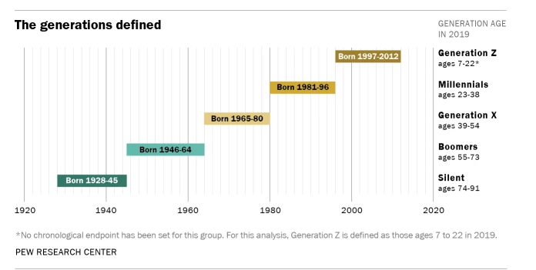
Figure BBB:

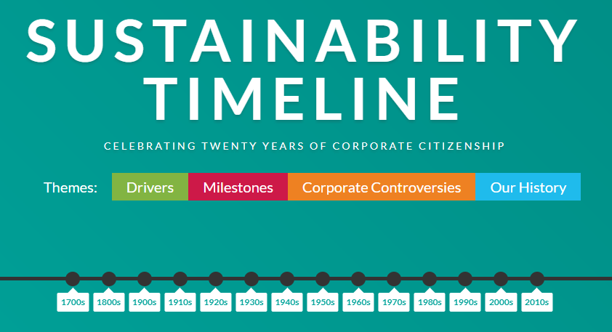
Source: https://corporate-citizenship.com/sustainability-timeline/

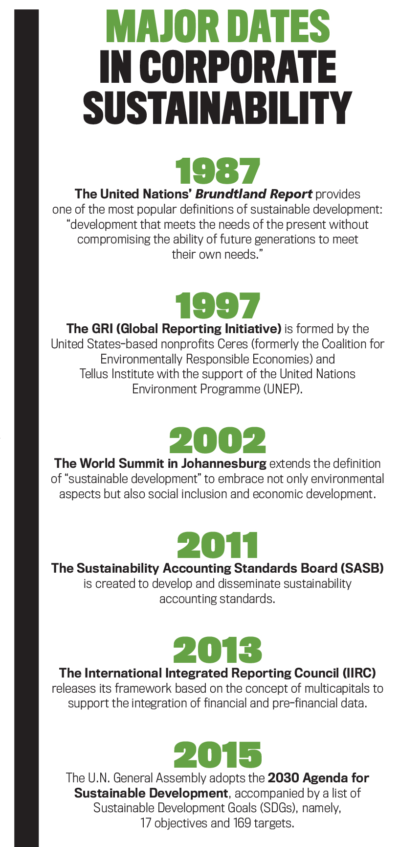
Source: https://sfmagazine.com/post-entry/september-2017-sustainable-development-goals/

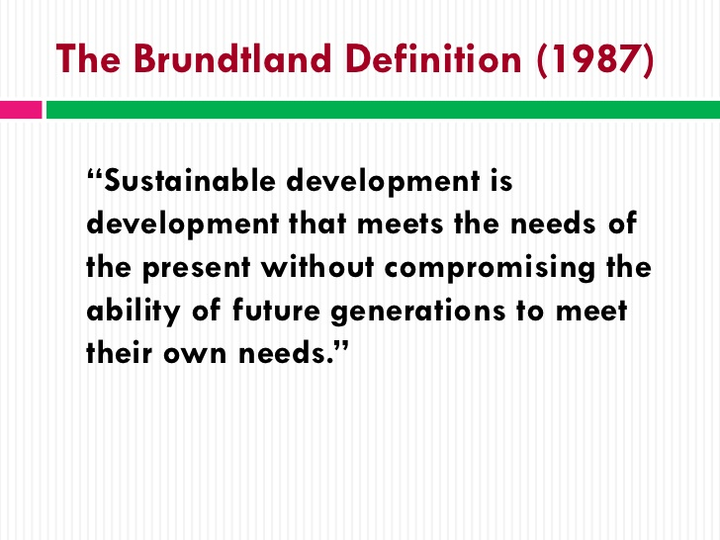
Source : https://www.slideshare.net/EOTOWorld/sustainable-development-webinar-series-12326815/7

The timeline of the environmental conservation concept
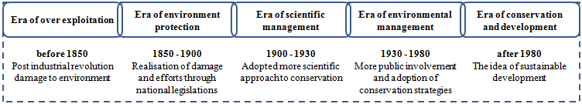
Source : https://www.researchgate.net/figure/The-timeline-of-the-environmental-conservation-concept_fig2_326015946

BRITVIC INFOGRAPHIC ON SUSTAINABILITY
Source: https://www.britvic.com/~/media/Files/B/Britvic-V3/documents/pdf/sustainability-infographic-2018.pdf

