Explain why teacher subject knowledge is important in relation to teaching Language and Mathematics in primary schools in Wales. (3000 Words)

Teacher subject knowledge isn’t spoken about enough. It is an important aspect for us as it “rests on teachers understanding the subjects they are teaching …... guiding their pupils into the different ways of knowing that subjects provide.” Subject knowledge: leading teaching (National College for Teaching and Leadership, no date). This also brings to light that teachers not only need adequate knowledge in the subject, they need to be able to take that knowledge and present it in a variety of different ways. They do this in order to maximise understanding, whereas practitioners, we use a variety of learning theories to present and portray knowledge to our students. The more knowledge a teacher has the more confident they are likely to be in teaching that area. Mathematics and language are key areas of learning for our students. It provides a platform for all other subjects to be based on, it is in our everyday learning making it very important. It is clear that, teacher subject knowledge is of high importance in mathematics and language, as the (Welsh Government, 2019) has made it clear to be able to be a primary school teacher in Wales you need the minimum of a B at GCSE English Language and Mathematics.
During my PTE, I witnessed a variety of learning theories through the teaching of mathematics and language. Through both key stages finding that teacher subject knowledge is a key element to the success of teaching. I will evidence this through my explanation of my observations and teaching experiences. My main focus for mathematics will be looking at the skill “make a sensible estimate of measurement in length, height, weight and capacity that can be checked using standard measures” (A.) Welsh Government, 2015), in relation to a foundation phase year two class, age ranging between six and seven. Closely looking at the aspect of the “use standard units to measure: – length, height and distance: metres, half metres or centimetres” (A.) Welsh Government, 2015). This is a skill I had experience in solely teaching not observing. I taught a lesson solely on measuring in metres. Having prior knowledge of measuring in metres, meant further research wasn’t needed. Having a firm understanding meant I could deliver the lesson with confidence and coherence.
Language will be focusing on the strand of writing, with a small reference to the strand of speaking, looking at the skill to “use the characteristic features of an increasing range of continuous and non-continuous texts in their writing, using imagination where appropriate” (B.) Welsh Government, 2015). This is based on a Year four and five Class. This is a skill I both taught and observed. This allowed me to broaden my experiences and take note of how best to deliver a language lesson that is new to the children. This would ensure my subject knowledge is being added to, also, as I would be experiencing other practitioners’ ways of teaching language. Allowing me to have a breadth of subject knowledge to make my own decisions during my lessons. Although my subject knowledge was of basic understanding, the skill I had to teach required me to do some research, as initially I wasn’t that confident. I knew all the characteristics of a news paper report, but was uncertain how to transfer my knowledge to a class room of children and have the right resources for the lesson. I conducted research as language is highly regarded in the school environment with pressure to constantly improve a child’s language skills.
During PTE, my experience of mathematics in a primary school setting was different to most. The school I was placed did not use the standard Welsh curriculum to cover all skills on the mathematics curriculum. Instead, they used ‘Singapore Maths’, I had never heard of this approach to learning before. The textbook states “The focus of the series is on teaching to mastery. This research-based approach emphasises problem solving and utilises pupil’ core competencies to develop relational understanding of mathematical concepts” (Ben Har, 2015). All teachers in the school were trained in this approach, to ensure their subject knowledge was of a certain standard before teaching this approach to mathematics. Having never heard of the ‘Singapore Maths’ approach I was at a disadvantage. My subject knowledge in this area was very poor. I had to ensure I asked vital questions to the class teacher, in order to be clear, I was teaching effectively. This lowered my confidence in teaching this area. However, (Lyakhova and Tanner/ Yr Athrofa Institute of Education, 2018) said “form of practitioner research has long been recognised as being particularly effective in developing teachers’ knowledge and understanding of learning and teaching.” This is important as it shows having a firm subject knowledge leads to effective teaching. But, to achieve this research must be undertaken.
Having a firm teacher subject knowledge in an area such as mathematics allows for a teacher to be much more confident, adventurous and exciting in their teaching. The lessons flow much more easily. This is something I struggled with having not been trained in the Singapore Maths approach.
Furthermore, due to my lack of teacher subject knowledge in this area, I decided to research into the ‘Singapore Maths’ approach ready for me to teach my skill with purpose. Finding out that the programme is based on established theories. The main outset of the curriculum of ‘Singapore Maths’ “is an amalgamation of global ideas delivered as a highly effective programme of teaching methods and resources. The approach is based on recommendations from notable experts such as Jerome Bruner, Richard Skemp, Jean Piaget, Lev Vygotsky and Zoltan Dienes. (What is Singapore Maths-Maths No Problem, 2019)
I found that “Bruner proposed the spiral curriculum: a teaching approach in which each subject or skill area is revisited in intervals at a more sophisticated level each time.” (What is Singapore Maths -Maths No Problem, 2019) Spiral curriculum is an approach I was familiar with, unfortunately I wasn’t able to implement into any of my lessons due to a shortage of time. But I think that this is a credible approach to use in the teaching of mathematics as it allows for a stage of progression in a child’s learning, ensuring they are reaching expected targets and beyond, in a time that suits their individual needs.
My opinion of the Singapore Maths approach was open, I was open to learn and to improve my teacher subject knowledge. “The National Curriculum Review Committee and OFSTED have all emphasised the pedagogy and heuristics developed in Singapore” (What is Singapore Maths -Maths No Problem, 2019). Knowing credible sources have backed this method shows if your subject knowledge of this is firm, then your teaching of mathematics in a primary classroom setting will be effective. Following research, I came across the idea presented by Zoltan Dienes “The idea is that you vary the lesson through a series of examples that deal with the same problem or topic.” (What is Singapore Maths- Maths No Problem, 2019) The idea of using a series of examples is a major positive for many children who struggle with mathematics, as they should find a method in the few that will be more natural to them than others. But, a negative to this would be those students with additional learning needs who cannot cope with change. They will struggle to cope and understand that there is more than one method to learn and complete a task. This is where teacher subject knowledge would be of use to know more than one method. But, also to know the children in your class, and those who would not cope with learning more than one method straight away. I can clearly see why the school highly commend this approach as it provides a wide range of benefits for all types of children. However, this teaching method could become ineffective if the teacher’s subject knowledge isn’t strong or consistent resulting in the detrimental learning to the children.
Whilst on PTE, I taught a range of lessons on the topic of measurement. Looking at the skill of measuring, and in detail the “use standard units to measure: – length, height and distance: metres, half metres or centimetres” (A.) Welsh Government, 2015). My first lesson was measuring in metres, see appendix 1. For this I made practical use of the outdoors. I felt this was the best way to enrich my lesson from previous knowledge of outdoor learning. The opportunities to be able to teach maths outdoors are limitless, making it much more memorable and exciting. I chose to complete the lesson outdoors as it makes in more relatable to real life situations, I know this from my subject knowledge. As when I think of a metre, I think of something physical, so by taking the lesson outdoors it allowed me to put the lesson into context, this was beneficial for many children to observe. Lee and Pound would agree stating “wonderful world of mathematics to be found in nature and in constructed buildings and artefacts, we encourage children to see mathematics as relevant to them and their world” (Lee and Pound, 2011 p.101).
The lesson also showed aspects of the connections model by Haylock and Cockburn, see figure 1. By implementing all the components of the connections model into the lesson I ensured a more secure understanding of the skill of measuring. “The more connected are our experiences, the more secure and the more useful is the learning.” (Haylock and Thangata, 2007).

Figure 1.
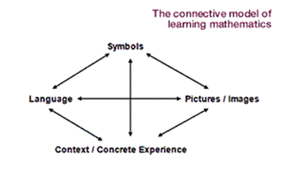
All components coincide to allow for better understanding, this is a proven theory. My knowledge of this theory helped me to convey my lesson well, alongside my subject knowledge, it meant the lesson was delivered with confidence. I felt my lesson had a specific context, making it a success. I believe I achieved this through my subject knowledge and taking my own style into the mathematics lesson coinciding with the use of ‘Singapore Maths’. (Lyakhova and Tanner/ Yr Athrofa Institute of Education, 2018) would agree in saying “specific contexts with particular students, who bring their own prior knowledge and beliefs to the situation.”. If my subject knowledge in this area was not secure it could mean the lesson failing. Without having researched into the ‘Singapore Maths’ approach, my lesson could have been delivered and taught completely wrong. The children may not have grasped the skill of the lesson well and this would have meant having to revisit the skill. This would be wasting time that we do not have in a school environment. Having a firm subject knowledge means that there is likely for error and makes more time to go into detail for that skill, and not having to revisit the basics. Having gaps in basic knowledge of skills can be detrimental to a child’s development, delaying them in their learning. However, I felt by implementing the connections model into my lesson it left me with a successful lesson. With the skill of measuring being understood by most well and some just beginning to understand. It is important to show more than one method to a child and include a variety of ways for all styles of leaners to grasp the skill.
Language shows just as much importance for a need for teacher subject knowledge. (Smith and Dawes, 2014, p. 89) says “need to be passionate about the subject, have a good understanding of it yourself”. If you do not have a substantial grounding of teacher subject knowledge in language it will be hard to engage the children in learning. (Smith and Dawes, 2014, p. 89) agree and say as practitioners we need to “be aware of the range of teaching and learning styles and strategies in order to vary your approach and ensure that children are engaged in their learning.”.
There is a key emphasis on language in our primary curriculum in Wales. Without these fundamentals, children’s futures could be affected. Language supports a child on “how we understand the world around us” (Smith and Dawes, 2014, p. 89). Without the skills of a language a child’s life can prove very difficult. “English lies at the heart of learning in the primary classroom- it is the bridge that links learning across a range of contexts” (Smith and Dawes, 2014, p. 107).
(Donaldson, 2015), would agree in saying “sound understanding of their essential components supported by developmentally appropriate teaching and learning”. He is saying that teachers need to be firm in their understanding in order to teach appropriately. Looking forward to the future with a change of curriculum in Wales, literacy is going to be the core of it. As practitioners we need to “develop high levels of competence in these aspects and have frequent opportunities to develop, extend and apply them across the curriculum”. (Donaldson, 2015) The importance of teacher subject knowledge is stressed by Donaldson, we must have a firm understanding in particular to literacy and numeracy, in order to apply these skills in a cross curricular approach and ensure maximum understanding from the children.
Initially observing a language-based lesson in the classroom setting of a key stage two class was very beneficial. I was able to notice what techniques the teacher was implementing into the lesson through the strand of writing. I was able to notice this as I have a firm understanding of teacher subject knowledge in teaching language in a primary school setting. Without the initial backing of my teacher subject knowledge I wouldn’t be able to analyse the techniques of the classroom teacher and use them in my lessons. It is important when training as a teacher to observe, as “The role of teacher training is to introduce the methodological choices available and to familiarise trainees with the range of terms and concepts” (Mann, no date). Without observation, student teachers would not have an understanding of how to base their future lessons. This ensures a good chance of the use of different subject techniques for learning in the lesson.
Whilst observing my class teacher, he planned a shared write task for the class. This was an idea I had never seen implemented into a classroom environment before. It is a good technique to use in a class where there are a wide range of abilities. (A.) Medwell et al. 2011, p.119) would agree “Draw child’s attention to …… thought processes during production of writing”. Some children find it hard to write creatively and factually, so having the thought process demonstrated to them of writing is very beneficial. This was a skill I carried through to my lesson see appendix 2. I demonstrated the use of role play and how I wanted them to complete the task. When looking at the strand of speaking this was a class that struggled more than most, so the methods which I used had to be very explanatory, it had to be demonstrated and explained more than once for them to achieve the skill. During my lessons I would ensure I looked at all the children and put them into groups or pairs accordingly. For example, “pairing with a more able child” (A.) Medwell et al. 2011, p.139). This can help a child as they can relate to another pupil much more than a teacher. Having a different point of call can be beneficial, as they may understand the child’s explanation better than a teacher. As (A.) Medwell et al. 2011 p.139) say “in shared or guided reading or writing, children may learn as much from the performance of other children as they do from direct teaching by the teacher”. This can be transferred into any lesson and any skill. Once you know your subject knowledge and your class well, the way you implement tasks and how pair and group will be much more effective and smooth running. Being able to implement subject knowledge in a cross curricular approach is how the new curriculum Donaldson has presented us is going to work. Starting now will ensure the maximum benefits when the curriculum is fully implemented in 2021.
My experience of teaching a mixed year 4 and 5 class language, was based on the strand of writing. I also incorporated speaking into much of my lessons. I chose to do this because many of the children in the class were not able to write independently. The use of voice allowed them to express their knowledge. I felt this was important to provide the opportunity as a practitioner for all to be able to access the lesson, this will improve confidence in language. I noticed the range of ability within my class was very broad. I planned for this during my lessons see appendix 3 and 4. Where I have demonstrated, I can plan for variety of learners with varying needs. Differentiation was a wide spectrum in my class. Ranging from independent learners to some students having difficulty in speaking and writing, even down to the formation of letters. I believe the idea of the differentiation of children all begins at home. Due to their initial interaction with the use of language. (B.) Medwell et al. 2011, p.22) “Children derived their own rules from the language surrounded them”. This shows a child’s experiences of language at home are carried through to school, and as practitioners it is our duty to correct any language errors a child may have. This is where a strong teacher subject knowledge is required. Modelling is key to implementation; the children will emulate their peers and significant others. This theory is supported by Pavlov. Where the children will be conditioned in a behaviourist approach. They do as they know.
To conclude teacher subject knowledge is a vital part of effective teaching. “Chomskyan position and stressed the importance of the adult’s input to child’s development” (B.) Medwell et al. 2011, p.22). It is important to understand the concepts of teaching, in order to teach effectively. Understanding theories and teaching strategies allows for purposeful teaching. Being able to accommodate a variety of learners due to your experience and subject knowledge is useful in a primary setting. Especially in today’s society where the range of needs are so diverse. This will ensure optimum chance for students to meet expected targets and levels.
To add to this the use of mathematics and language in a cross curricular approach will soon be implemented in the new curriculum set by Donaldson. Meaning a lack of subject knowledge in these areas not only effect mathematics and language but the entire curriculum. Teachers are perceived to be the key of a child’s academic success, “abilities and skillset, knowledge and enthusiasm are crucial in determining the success or otherwise, of the children they teach” (Enser, (2018), Maintaining your subject knowledge). This again stresses the importance of the need for excellent teacher subject knowledge.
Looking back to my subject knowledge whilst on PTE, it was varied. I believe a strength of mine was my willingness to research anything I was uncertain about. However, I did find my weakness to be in not feeling confident when faced with uncertainties. This is something I have reflected upon and found a teacher’s subject knowledge is never exhausted. It is said it is good to have “regular immersion in your subject” (Tait, 2016). Showing that there is always room for improvement, as research to improve your teacher subject knowledge is a valued part of teaching and learning.
Word count (excluding reference list and title): 3230
References:
- A.) Medwell, J. et al (2011) Teaching Theory and Practice 5th ed. Exeter: Learning Matters
- A.) Welsh Government (2015) Curriculum for Wales: Foundation Phase Framework, Cardiff. Available at: https://gov.wales/sites/default/files/publications/2018-02/foundation-phase-framework-revised-2015.pdf (Accessed on: 19th April 2019)
- B.) Medwell, J. et al. (2011) Knowledge and Understanding 5th ed. Exeter: Learning Matters
- B.) Welsh Government (2015) Curriculum for Wales: Programme of Study for English, Key Stages 2–4, Cardiff. Available at: https://learning.gov.wales/docs/learningwales/publications/150717-nc-english-en-v3.pdf (Accessed on: 19th April 2019)
- Ban har, Dr.Y (2015). Maths- No Problem!: Singapore Maths . United Kingdom: Shing Lee.
- Donaldson, G. (2015) Successful Futures. Available at: https://gweddill.gov.wales/docs/dcells/publications/150225-successful-futures-en.pdf Accessed on: 27th April 2019
- Enser, M. (2018), Maintaining your subject knowledge. Available at: https://impact.chartered.college/article/enser-maintaining-subject-knowledge/ (Accessed on: 29th April 2019)
- Haylock, D. and Thangata, G. (2007), Key Concepts in Teaching Primary Mathematics: SAGE Publications. Accessed on: 22nd April 2019
- Lyakhova, Dr S. and Tanner. Dr. H. (2018) New approach to maths a key part of the equation. Available at: http://athrofa.cymru/2016/11/22/new-approach-to-maths-a-key-part-of-the-equation/ (Accessed on: 26th April 2019)
- Mann, S. (no date) ‘The language teacher’s development’ Available at: https://warwick.ac.uk/fac/soc/al/people/mann/mann_s/stateof.pdf Accessed on : 26th April 2019
- Maths No Problem (2019) What is Singapore Maths. Available at: https://mathsnoproblem.com/en/mastery/what-is-singapore-maths/ (Accessed on: 24th April 2019)
- National College for Teaching and Leadership (no date). Subject knowledge: leading teaching. Available at: http://www.inspiringleaderstoday.com/ILTMaterials/LEVEL3_LIT-v4.0-2014_08_08-11_54_0/leading-and-improving-teaching/lit-s4/lit-s4-t05.html (Accessed on: 22nd April 2019)
- Pound, L & Lee, T (2011). Teaching Mathematics Creatively. London: Routledge.
- Smith, D. and Dawes, L. (2014) Subject Teaching in Primary Education. London: SAGE Publications
- Tait, P. (2016) ‘The importance of great teaching on children’s success’’ Available at: https://www.telegraph.co.uk/education/educationopinion/12201014/The-importance-of-great-teaching-on-childrens-success.html (Accessed on: 29th April 2019)
- Welsh Government (2019) Minimum entry requirements for Initial Teacher Education (ITE), Available at: https://gov.wales/initial-teacher-education-ite (Accessed on: 22nd April 2019)

Appendices
- Maths lesson on metres
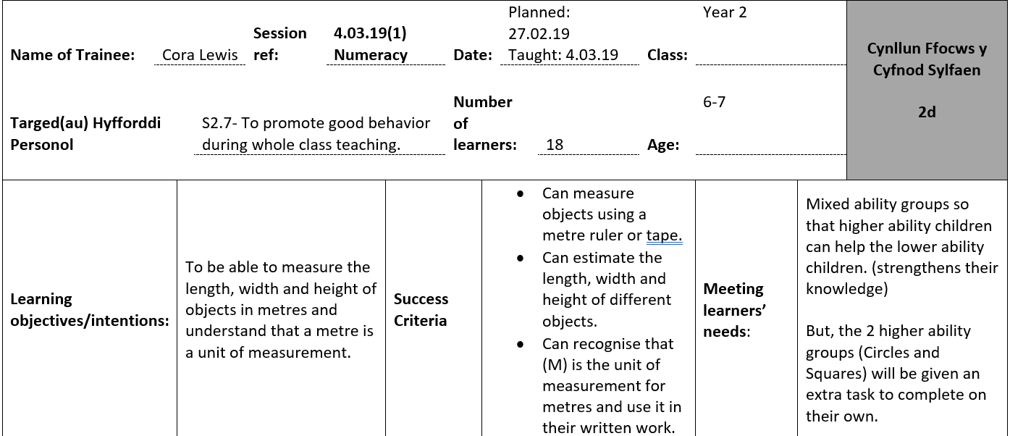
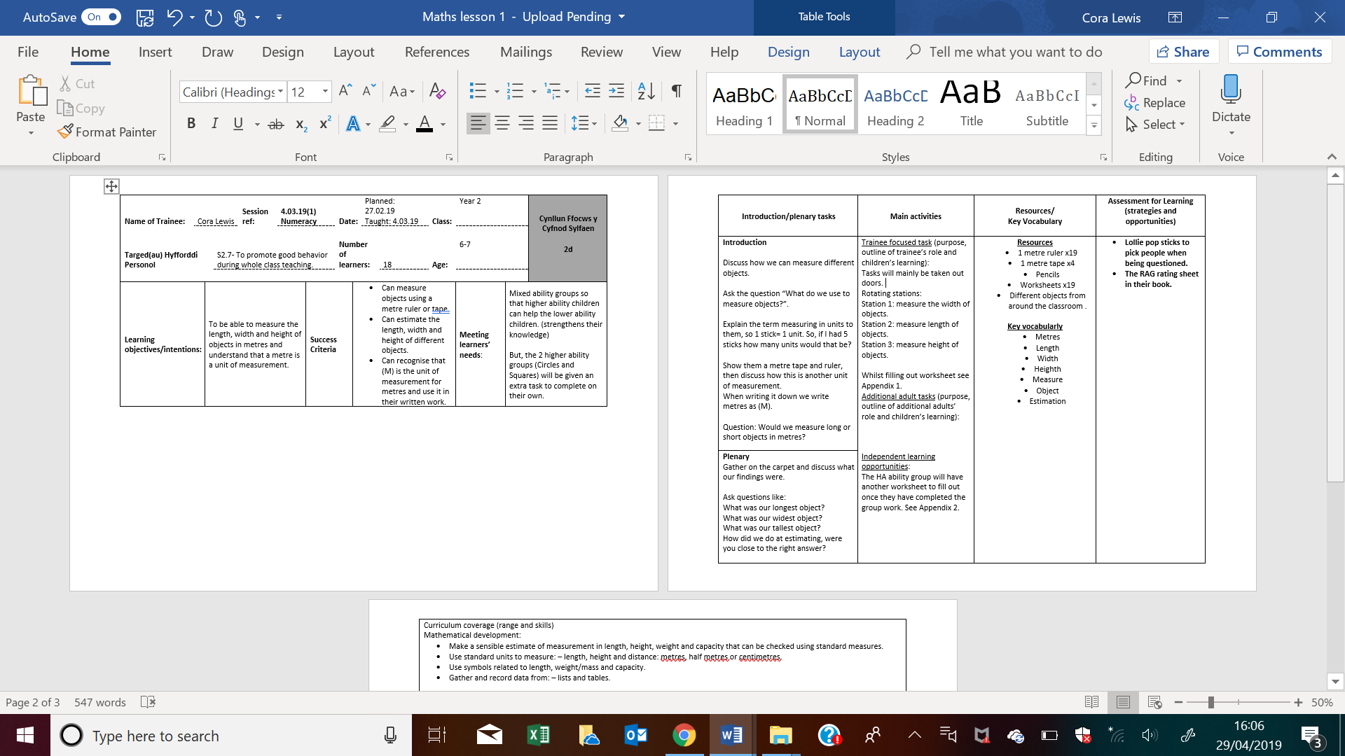
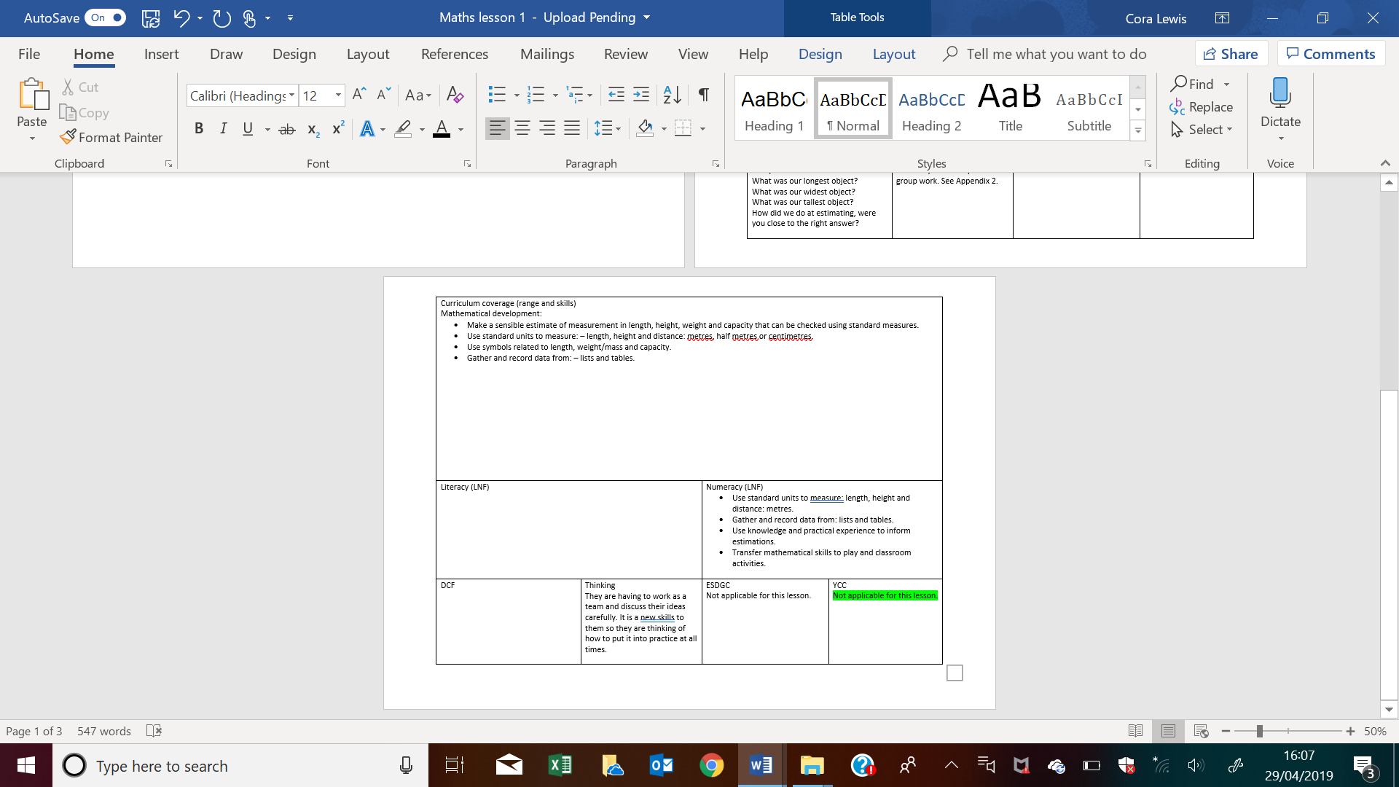
- Language lesson 1

- Language lesson plan 2

- LA sheet


