

University of Wales Trinity St David
School of Engineering

Anti-Lock Braking Systems

Corey Davies
(1702838)

Motorsport Engineering HND/BSC

02/01/2019

Emissions Control & Diagnosis
(M5X02202)

Contents Page:

Introduction… (Page 3)

Research… (Page 3-7)

Methodology/Written report… (Page 8)

Results… (Page 9-10)

Analysis… (Page 11-12)

Conclusions… (Page 13)

References… (Page 13)

Recommended further reading… (Page 13)

Introduction
The purpose of this assignment is to research and review various diagnostic techniques used on the two types of ABS systems and also to compare the two systems. There are two test rigs each dedicated to an ABS system which need to be tested as a group in the given appointed time. Once the rigs have been tested a written service report of the outcomes of the tests will need be done with particular reference to the procedure, test readings e.g. signal waveforms and safe working practices.
Research
ABS stand’s for Anti-lock Braking System. The purpose of an ABS system is to allow braking while steering and also to improve heavy braking under extreme conditions and as well as slick or loose surfaces. An example of these conditions is, wet or icy conditions and gravel surfaces where braking with ABS is dramatically improved in these conditions or environments.
Until the 1970s, all automotive braking systems in consumer vehicles were standard friction brakes that worked by a pedal that applied pressure to brake pads and in turn squeezed against a disc or a metal drum to bring the wheels to a stop. These brakes were susceptible to locking up on wet or snowy roads causing the vehicle to skid into an uncontrollable slide. It was once part of driver’s education to learn how to pump the brakes in order to maintain control of the front wheels and prevent a slide. Some more experienced drivers would argue that braking without ABS is much better as the braking distance may be less with diver aid rather than ABS intervention. Also, some drivers complain about ABS intervention when it’s not needed (false activation) e.g. driving over a bumpy road. As Stated by (Phillips, Sean 2019): https://www.liveabout.com/proper-braking-abs-vs-non-abs-3234376
False activation incidents involve the ABS modulator taking over braking or intervening to restore vehicle stability. The user may feel feedback in the brake pedal like a pulsation or sudden drop. Some may also experience a drop-in power or the vehicle may suddenly pull in one direction. As Stated by (Markel, Andrew 2016): https://www.brakeandfrontend.com/false-abs-esc-activation-causes-and-cures/
The first mass-produced Anti-lock Braking Systems (ABS) were introduced in 1985. By 2008, almost every passenger vehicle came standard with ABS. Next, electronic stability control (ESC) became a mandated safety for the 2012 model year.
The ABS system consists of:
- Wheel speed sensors – A speed sensor is used to determine the acceleration or deceleration of the wheel.
- Brake components e.g. disc, pads and drum brakes.
- A hydraulic motor (Pump) – The pump in the ABS system is used to restore the pressure to the hydraulic brakes after the valves have released it. After the valve releases the pressure supplied by the user, the pump is used to restore the desired amount of pressure to the braking system. The controller will modulate the pumps status in order to provide the desired amount of pressure.
- Valves - There is a valve in the brake line of each brake controlled by the ABS. On some systems, the valve has three positions:
In position one, the valve is open; pressure from the master cylinder is passed right through to the brake.
In position two, the valve blocks the line, isolating that brake from the master cylinder. This prevents the pressure from rising further should the driver push the brake pedal harder.
In position three, the valve releases some of the pressure from the brake.
- Electronic Brake Control Module (EBCM) – The ECBM is an Electronically Controlled Unit (ECU) in the car which receives information from each individual wheel speed sensor. If a wheel loses traction, the signal is sent to the EBCM. The EBCM will then limit the brake force and activate the ABS modulator which activates the valves on and off.
Anti-lock braking systems use different variations depending on the type of brakes in use. They can be differentiated by the number of channels: that is, how many valves that are individually controlled and the number of speed sensors. As Stated by (Alexander Kolbe, Bernd Neitzel, Norbert Ocvirk, and Max Seiermann 1990): https://saemobilus.sae.org/content/900208/
Another difference in ABS systems is that some are "integral" and others are "nonintegral. “Integral systems, which are found mostly on older full-size passenger car applications, combine the master brake cylinder and ABS hydraulic modulator, pump and accumulator into one assembly. Integral systems do not have a vacuum booster for power assist and rely instead on pressure generated by the electric pump for this purpose. The accumulators in these systems can contain over 2700 psi. The accumulator must be depressurized prior to doing any type of brake repair work by pumping the brake pedal 40 times while the key is off.
Nonintegral ABS systems, which are sometimes referred to as "add-on" systems, are used on most of the newer vehicles. Nonintegral ABS systems use a conventional master brake cylinder and vacuum power booster with a separate hydraulic modulator unit. Some also have an electric pump for ABS braking (to reapply pressure during the ABS hold-release-reapply cycle), but do not use the pumps for normal power assist. As Stated by (Carley, Larry 2000): https://www.absfixer.com/All_about_abs.php
The two types of ABS systems given to research and compare are:
- Teves MK IV ABS
- Bosch ABS 2EH
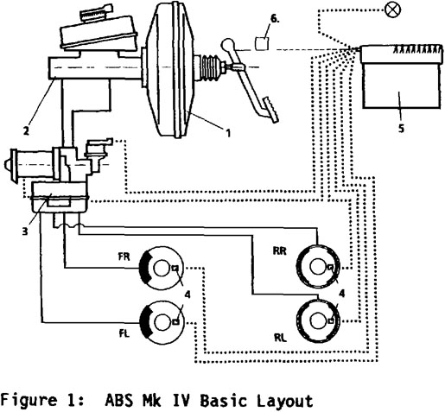
The Teves MK IV is a 3 channel 4 Wheel Speed Sensor (WSS) ABS System. The Teves ABS system has a WSS dedicated to each wheel and also a channel so the EBCM may monitor the speeds of each wheel individually and apply the braking force where it detects a wheel accelerating or decelerating.
The Teves MK 20 is an improved version of the Teves MK IV which is a 3 channel and 4 WSS ABS system. Which permits individual control of the front wheels and joint select-low control of the rear wheels unlike the improved Teves MK 20 with updated smaller control systems and of lighter construction. The ABS sensors remained the same throughout production.
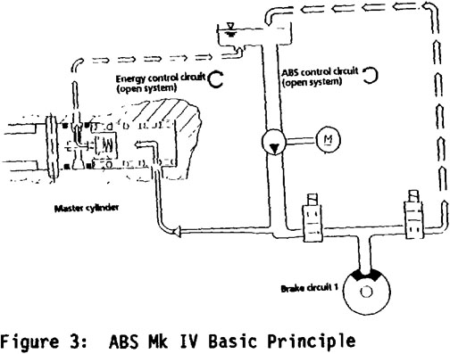
The design objectives for the Teves MK IV system like any other ABS system was to fulfil the basic functionals requirements of:
- Vehicle stability
- Vehicle steerability under braking
- Stopping distance
The main hydraulic components of the system are:
- 1) Brake actuation unit, consisting of a vacuum booster
- 2) ABS Tandem master cylinder
- 3) Separate hydraulic control unit
- 4) Wheel speed sensors (WSS)
- 5) Electronic controller (modulator)
- 6) A device to measure the brake pedal position
The Bosch 2EH is a 3 channel 4 Wheel Speed Sensor (WSS) ABS System. The Bosch ABS system has a WSS dedicated to each wheel and a channel each for the front two wheels and one channel for the rear wheels.
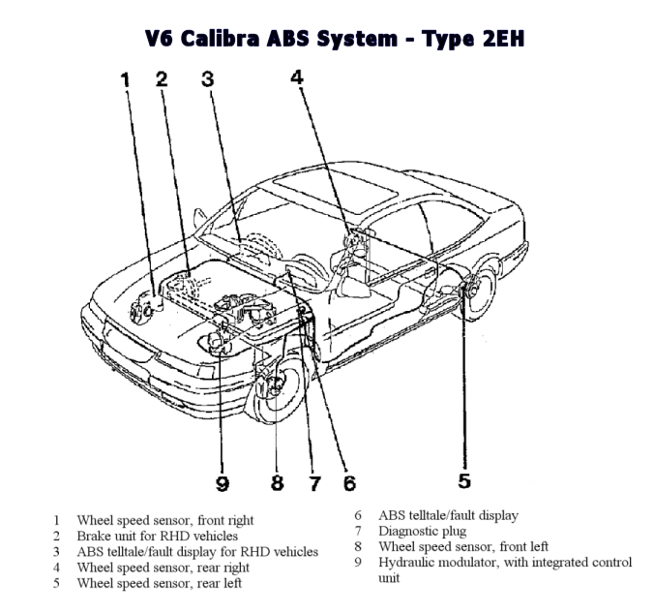
Here’s a diagram of the Bosch 2EH system of a V6 Calibre. Same as the Teves system the purpose of the Bosch 2EH ABS system was to fulfil basic function requirements such as vehicle stability, vehicle steerability and stopping distance.

Comparison
The Teves MK IV and Bosch 2EH are both a 3 channel and 4-wheel speed sensor ABS system. The Teves system has an integrated Traction Control System (TCS) and the Bosch 2EH ABS system does not which is an added bonus for the Teves system giving an added advantage over the Bosch 2EH ABS system.
Teves MK IV Advantages:
- Low cost, as its an improvement upon the MK II Teves ABS system
- Simple and robust design
- Meets the needs of the current safety requirements
- The possibility to improve upon the system with other possible added functions
- A proven durable & reliable system.
Teves MK IV Disadvantages:
- Corrosion
- Wear & Tear
- ABS/WSS Sensor (Common fault)

Bosch 2EH Advantages:
- Meets the needs of the current safety requirements
Bosch 2EH Disadvantages:
- Overly complex
- ABS/WSS Sensor (Common fault)

On-Board Diagnostics
On-board diagnostics (OBD) is a reference to a vehicles self-diagnostic system. OBD gives the user of the vehicle or a professional repair technician access to the vehicles systems. The amount of diagnostic information available via OBD has varied widely since its first introduction in the early 1980s of on-board vehicle computers. Early versions of the OBD would simply just illuminate Malfunction Indicator Lamp (MIL) and would not provide any information or specifics of the fault compared to the newer and improved OBD-II. The reason behind these was to encourage motor vehicle manufacturers to design reliable emission control systems.
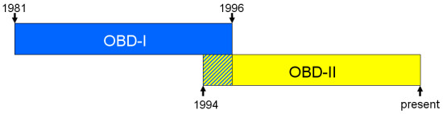

OBD-II was an improvement over OBD-I in both capability and standardization. The OBD-II standard specifies the type of diagnostic connector and its pinout, the electrical signalling protocols available and the message format. OBD-II standardization was prompted by emission requirements, and though only emission-related codes and data are required to be transmitted through it, most manufacturers have made the OBD-II Data Link Connector the only one in the vehicle through which all systems are diagnosed and programmed. OBD-II Diagnostic Trouble Codes are 4-digit, preceded by a letter: P for engine and transmission (powertrain), B for body, C for chassis, and U for network. As stated by (N/A): https://www.obdsol.com/knowledgebase/on-board-diagnostics/what-is-obd/
EOBD was introduced in January 2000 in response to the euro 3 emissions standards and applies to passenger vehicles as well as light utility petrol vehicles. As of 2003 it also applies to passenger vehicles with diesel engines. The legislation does not specify the specific methods of monitoring a module or component, what is important is that the module is monitored, with the system checking for:
- Deviations from a set-point
- Considerable increase of pollutants
- Damage to the engine or catalytic converter

The introduction of EOBD has produced the following consequences for vehicle manufacturers:
- Standardised diagnostic system with fault code memory in each vehicle
- Unrestricted access to emission relevant systems over a standardised interface
- Error scan tools
- Uniform fault codes
- Free availability of all data required for maintenance, diagnosis and repairs.

There is often confusion as to the use of the different terms such as OBD and EOBD. A distinction must be made between the respective exhaust gas standards and the laws governing on-board diagnosis. OBD I and OBD II refer to the American requirements for a diagnostic system.

EOBD is the European version of the American OBD II.

As stated by (N/A): http://www.partinfo.co.uk/articles/123

Diagnosing an ABS System Fault
To a diagnose an ABS fault first the technician must be wearing the appropriate (PPE) personal protective equipment such as overalls, boots and safety glasses or goggles if necessary, but for diagnosing a fault on an ABS system this will be sufficient enough. There are many ways and procedures to diagnosing an ABS fault. First thing to do is confirm the fault of the vehicle using your eyes and ears and whether an ABS light is illuminated, if the fault seems to be more mechanical a visual inspection will be needed and wouldn’t go amiss. Although the usual fault with an ABS system is a faulty or defective wheel speed sensor as it is an important instrument to the ABS system giving the EBCM the information it needs to detect whether a wheel is accelerating or decelerating. Usually the diagnostic process is aided with an OBD tool compatible with what on-board system the vehicle is using. In our case OBD-II which is a much better system compared to its predecessors. The scan tool will allow the technician or user to scan the vehicles module relating to the ABS system or to scan all the modules including the engine and powertrain as well as various other systems. Making it a much shorter process of diagnosing a vehicles fault, whether the fault code is relating to a wheel speed sensor which typically is the case or the modulator. In some case’s a poor battery can be at fault and can cause various faults and unusual symptoms, which is why this is the very first thing to check when beginning to diagnose a fault on an ABS system or any other system in that case because it’s the power source of all auxiliary systems. A healthy battery should show about 12-12.5 volts. Using the OBD-II scan tool, scan the vehicles ABS system to retrieve a Diagnostic trouble code (DTC). This will help locate and provide information on where the fault is coming from. Depending on what fault code is retrieved there’ll be different procedures for this example let’s use a wheel speed sensor fault.
Diagnostic chart

Methodology/Written Report
The methodology used to complete the analysis of the two ABS systems was a full system operation test on the test rigs provided. Then some background research on ABS systems and the two ABS Systems given to review as well as ABS operation and diagnosis process of ABS faults. The appropriate Personal Protective Equipment (PPE) was used when testing the ABS systems on the rigs.
Once the appropriate PPE was worn. We began with visual inspection of the two ABS systems on the rig. First system to test was the Bosch 2EH ABS system, we choses members of our group then to perform different tasks such as someone to record the data, operating the rig and someone to use the multi-meter and select the correct pins. We then proceeded to test the battery voltage with a multi-meter ensuring that the battery is healthy. After testing the battery, we then checked the operation of the ABS on the rig to ensure its working properly and that ABS intervenes. After testing the battery, we then decided to do a static voltage check of all 15 pins on the Bosch 2EH system with the ignition off and the ignition on.
We then moved onto the Teves MK IV ABS system and with the same process tested the battery, ensured proper operation of the ABS and did a static voltage check of all the pins with the ignition on and off. We also decided to test the resistance of a wheel speed sensor to ensure correct operation using the auto-data guidelines to ensure it was within tolerance and operating within the guidelines which according to the auto-data sheet which says 11000ohm approx. the sensor was in perfect working order. After all static checks were done on the Bosch and Teves ABS systems we decided to use the oscilloscope to get some scope patterns of the various ABS components.
Tools & Equipment used in the completion of this task:
- Multi-meter
- Oscilloscope
- Overalls/lab coats
- Boots
- Test rigs

Results

Bosch 2EH
Bosch 2EH Pin numbers:
1 - ABS warning lamp actuation
2 – N/S/R WSS (Ground)
3 –
4 – N/S/R WSS Signal
5 – O/S/F WSS (Ground)
6 – O/S/R WSS Signal
7 – N/S/F WSS (Ground)
8 –
9 - Brake light switch feed
10 – O/S/F WSS Signal
11 –
12 – Serial data wire
13 – N/S/F WSS Signal
14 – O/S/R WSS (Ground)
15 – Diagnostic excitation lead
Pins | V – Ignition off | V – Ignition on | V - Operation
1 | 0 | 12.32 | 12.12
2 | 0 | 0.22
3 | 0 | 0
4 | 0 | 0.33
5 | 0 | 0.22
6 | 0 | 0.33
7 | 0 | 0.22
8 | N/A
9 | 0 | 12.29 | 12.16 (During ABS, See scope)
10 | 0 | 0.33
11 | N/A
12 | 0 | 11.09
13 | 0 | 0.33
14 | 0 | 0.22
15 | 0 | 0

4 Pin plugs
Pins | V – Ignition off | V – Ignition on
1 | 0 | 12.49
2 | 0 | 12.08
3 | 0 | 12.1
4 | 0 | 0

Solenoids
Pins | V – Ignition off | V – Ignition on
1 | 0 | 12.47
2 | 0 | 12.47
3 | 0 | 12.47

2 Phase solenoids (2 for front, 1 for rear)

Wheel Speed Sensor (WSS) – 1100ohms (Resistance value of coil winding)

Teves MK IV (10 Solenoids)
*No external wires from controller to ABS values
*Three Channel
*With ignition switched on, signals are sent to the warning lamp to check operation
*Sensor generate an A/C signal (Applies to both systems)
*Single phase solenoids

Pins | V – Ignition off | V – Ignition on
1 | 2.31 | 2.32
2 | 2.35 | 2.36
3 | 0 | 0
4 | 0 | 0
5 | 0 | 0
6 | 0 | 0
7 (Permanent Live) | 12.77 | 12.75
8 (Earth) | 0 | 0.01
9 (Ignition Live) | 0 | 12.7
10
11
12 | 2.32 | 2.33
13 (Switch) | 10.9 | 10.97
14
15
16 | 0 | 12,69
17
18
19 | 2.33 | 2.34
20
21
22
23
24 (Earth) | 0 | 0
25 (Permanent Live) | 12.7 | 12.7

Pulse Generators | Pins
 | 18 and 17
 | 28 and 19
 | 11 and 20
 | 10 and 18

Analysis
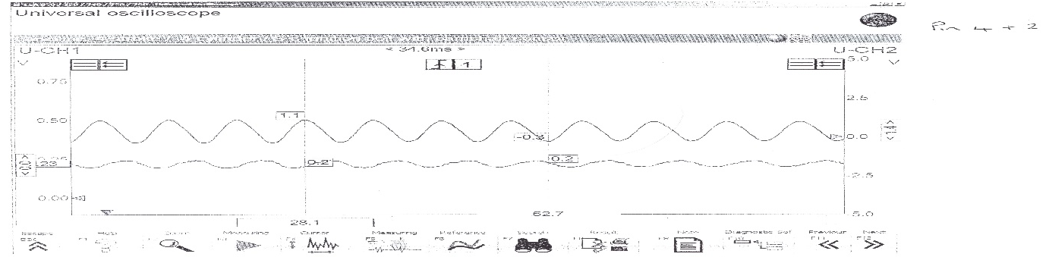
Bosch 2EH Oscilloscope Analysis

Pin 4 and 2 on the ECU connection of the Bosch 2EH System relates to a Wheel speed sensor and more specifically the nearside front. Being an inductive type sensor (passive) it produces an alternating current (AC) voltage which is generated in the speed sensor coil by magnetic lines of force fluctuating as the tone wheel passes by the magnetic sensor.
“The output of the wheel speed sensor can vary from vehicle to vehicle due to: winding type, air gap, magnetic strength of sensor, metal properties of the tone wheel and tone wheel speed”. As Stated by: (Identifix Inc, 2011)
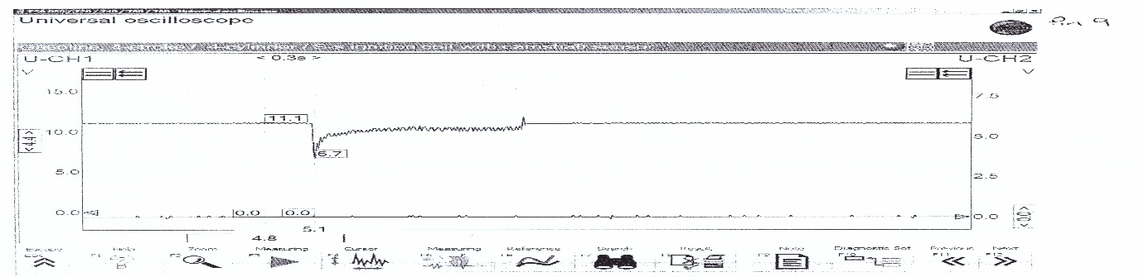
The oscilloscope diagram above shows the nearside front WSS with the rig on operating at about 0.5 volts.

The oscilloscope diagram above shows the operation of Pin 9 which is a brake light switch feed. In this diagram you can see a current draw as soon as the brake switch/button is applied from 11.1 volts down to 6.7 volts. The reason why the current draw was so much is the brake module was drawing current as soon as the switch turned on. You can see the brake switch feed slowly return to its applied current draw because the abs modulator is no longer in operation.
Using the Oscilloscope machine and setting the correct parameters and also using a team mate, one to press the brake switch/button on the rig and another to press freeze on the machine to hopefully capture the brake light switch activation.

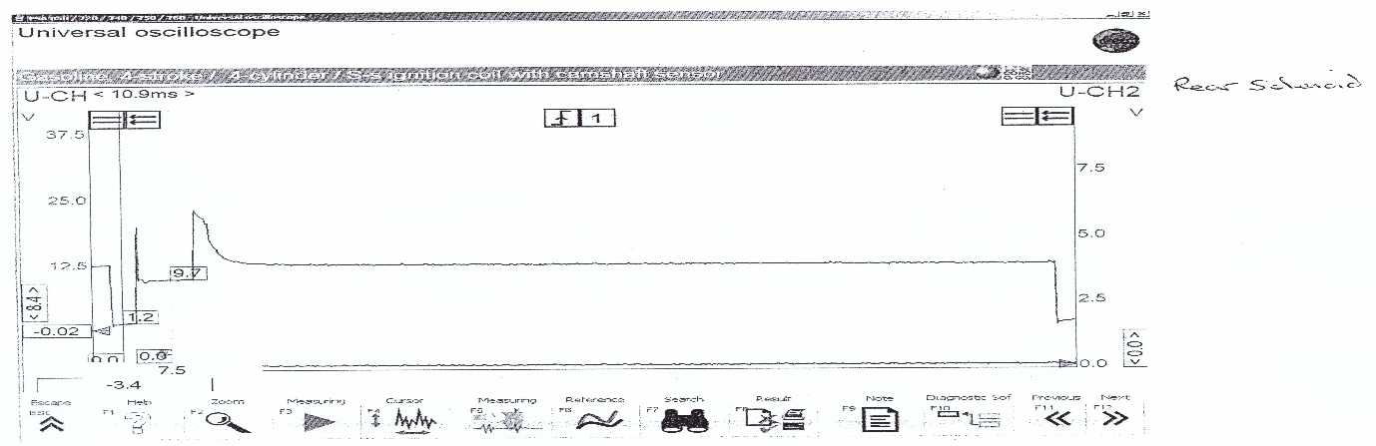
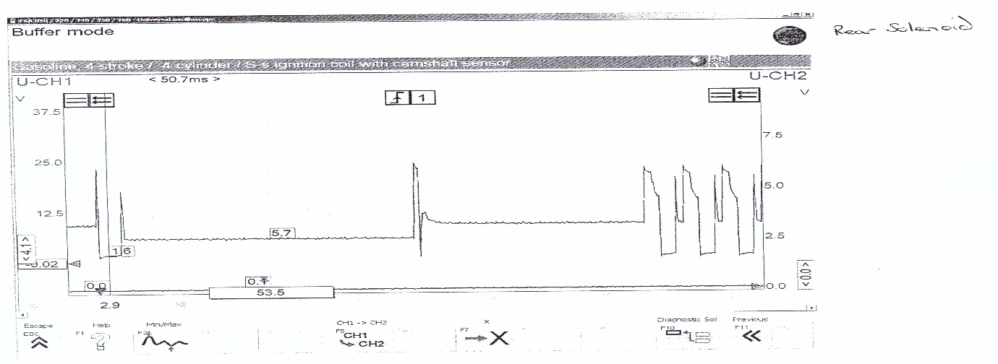
Rear solenoid on the Bosch 2EH ABS system which is a 2 Phase solenoid. A solenoid has a resistance between 2 and 8 ohms. On some units, it is impossible to access the individual solenoids which is very much the case, however you can test the operation of the solenoids through an oscilloscope like the image above.

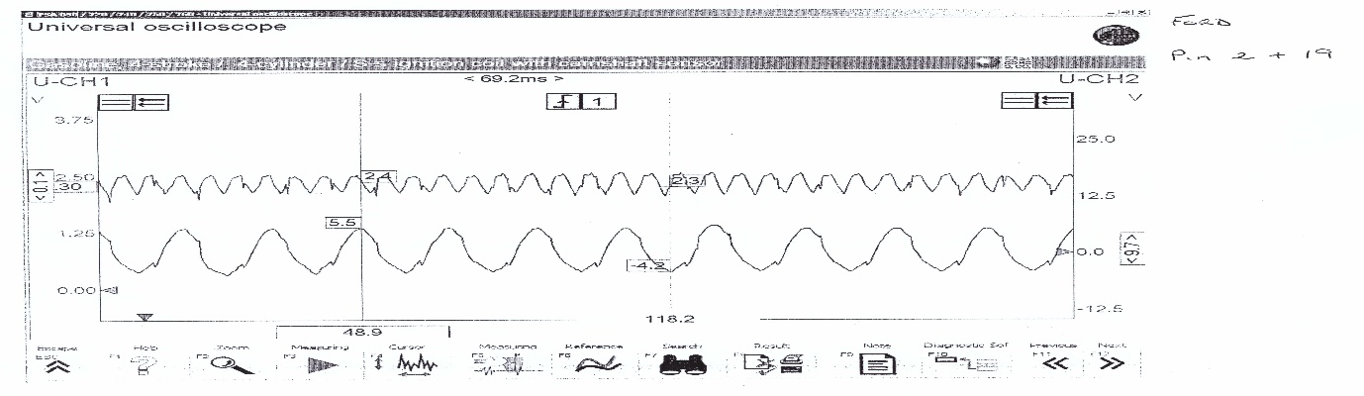
Teves MK IV (Analysis)
On the Teves MK IV system we tested pins 2 and 19 which is the ground and signal for an ABS/WSS sensor. From the image above, you can see that the waveform isn’t exactly smooth and is quite rugged which could be the fault of a faulty tone ring sensor with a missing tooth or a faulty ABS sensor from contaminants like dirt and corrosion (wear and tear). The signal may also be different to the previously analysed Bosch wheel speed sensor as this is an older system.

Conclusions
From gathered research and preliminary testing on the two ABS systems I can conclude that the Teves MK IV is a much better ABS system over the Bosch 2EH due to its basic design & reliability. Also, its ability to be improved upon is a great addition given an ever-changing law to the emission standards which require different legislation with tighter constraints on the emissions, also a lot of manufacturers that use the Bosch system are considering to the Teves ABS system.

References
K, Alexander, N, Bernd, O, Norbert and S, Max. (1990), ‘Teves MK IV Anti-Lock and Traction Control System’, [Online]. Available: https://saemobilus.sae.org/content/900208/ [Accessed Date – 02/01/2020]
R, Eric. (2005), ‘ABS System & Fault Finding’, [Online]. Available at: http://www.fordscorpio.co.uk/abssystem.htm [Accessed Date – 02/01/2020]
P, Sean. (2019), ‘Proper Braking Technique: ABS vs. Non-ABS’, [Online]. Available at: https://www.liveabout.com/proper-braking-abs-vs-non-abs-3234376 [Accessed Date - 02/01/2020]
M, Andrew. (2016), ‘False ABS, ESC Activation Causes and Cures’, [Online]. Available at: https://www.brakeandfrontend.com/false-abs-esc-activation-causes-and-cures/ [Accessed Date – 02/01/2020]
W, Mathew. (2018),’ ABS Brakes and the Facts’, [Online]. Available at: https://www.liveabout.com/abs-brakes-and-the-facts-281470 [Accessed Date – 02/01/2020]
N/A. (N/A),’ TEVES ATE MK20/MK25 - System Overview’, [Online]. Available at: https://blackbox-solutions.com/help/SM043.html [Accessed Date – 02/01/2020]
N/A. (N/A),’What is OBD?’, [Online]. Available at: https://www.obdsol.com/knowledgebase/on-board-diagnostics/what-is-obd/ [Accessed Date – 02/01/2020]
N/A. (N/A),’V6 Calibra ABS System’, [Online]. Available at: https://www.clubcalibra.net/v6calibra/abs/v6calibra_abs_system.htm [Accessed Date – 02/01/2020]
A, Aymen. (2011),’ An Antilock-Braking Systems (ABS) Control: A Technical Review,’ [Online]. Available at: https://file.scirp.org/pdf/ICA20110300007_19573346.pdf [Accessed Date – 02/01/2020]
N/A. (N/A),’V6 Calibra Traction Control’, [Online]. Available at: https://www.clubcalibra.net/v6calibra/tc/v6calibra_TC_system.htm [Accessed Date – 02/01/2020]
N/A. (N/A),’ OBD and EOBD Systems Explained’, [Online]. Available at: http://www.partinfo.co.uk/articles/123 [Accessed Date – 02/01/2020]
Identifix Inc. (2011),’ Passive vs active’, [Online]. Available at: https://www.moderntiredealer.com/article/311840/passive-vs-active [Accessed Date - 06/01/2020]

Recommended further reading
https://file.scirp.org/pdf/ICA20110300007_19573346.pdf

