University of Wales Trinity Saint David
Wales Institute of Science & Art



Analyse and simulate a mechanical energy recovery system
Stress Analysis & Dynamics (ACMA5010)

Owen Bell
2316885
17th November 2025
Word Count: 2628
Contents
1 Flywheels Through History 3
2 Kinetic Energy Recovery Systems (KERS) 6
3 Experimental Calculations 9
4 Conclusion 15
5 Bibliography 16

Figure 1 - Potters Wheel (Genta, 2014) 3
Figure 2 - Benz Three Wheeled Vehicle (Genta, 2014) 4
Figure 3 - Flywheel Geometry and K Factors (Bolund, Bernhoff and Leijon, 2007) 5
Figure 4 - BESS x FESS Table, (Magdalena Stephan, de Andrade Jr. and Gonçalves Sotelo, 2008) 7
Figure 5 - Power and Energy Density of BESS and FESS, (Magdalena Stephan, de Andrade Jr. and Gonçalves Sotelo, 2008) 7
Figure 6 - Stored Energy Re-accelerated Velocity Plot 11
Figure 7 - Flywheel Angular Velocity against Diameter Plot 13

Table 1 - Variables/Conversions (Stored Energy Re-accelerated) 11
Table 2 - Calculated Values (Stored Energy Re-accelerated) 11
Table 3 - Variables/Conversions (Flywheel Angular Velocity against Diameter) 13
Table 4 - Calculated Values (Flywheel Angular Velocity against Diameter) 13

Equation 1 - Mph to m/s conversion 9
Equation 2 - Kinetic Energy 9
Equation 3 - Stored Energy 10
Equation 4 - Moment of Inertia 10
Equation 5 - Kinetic Energy (Angular Velocity) 10
Equation 6 - Angular Velocity Rearranged 10
Equation 7 - Rad/s to RPM Conversion 10
Equation 8 - SUVAT (Equation 1) 12
Equation 9 - SUVAT (Equation 1 Rearranged) 12

Flywheels Through History
A flywheel is typically a heavy wheel which requires a lot of force applied to be spun around and are considered one of the “most popular energy storage systems and one of the oldest systems” around according to Mousavi G et al. (2017) explaining that the flywheel which is a mechanical energy storage solution “saves kinetic energy in a high-speed rotational disk connecting to a shaft of an electrical machine and regenerates the stored energy into the network when necessary”. Plaum et al. (2020), expands on this stating that flywheel energy systems use power smoothing “for frequency regulation is performed for high frequency changes in power flow by charging the energy storage system when there is an excess of power and discharging when there is a deficit of power”.

As mentioned by Mousavi G et al. (2017), flywheels have been used throughout history with one of the earliest examples being “the potters wheel which were built from wood” according to Genta, (2014) dating back to 3500 and 3000BC shown in figure 1. Genta, (2014) further discussed how the potter wheel was used with “a lump of clay placed in the centre of the wheel” and being spun by the hand or foot of the potter or of one of their assistants and the lump of clay could be shaped by hand”.
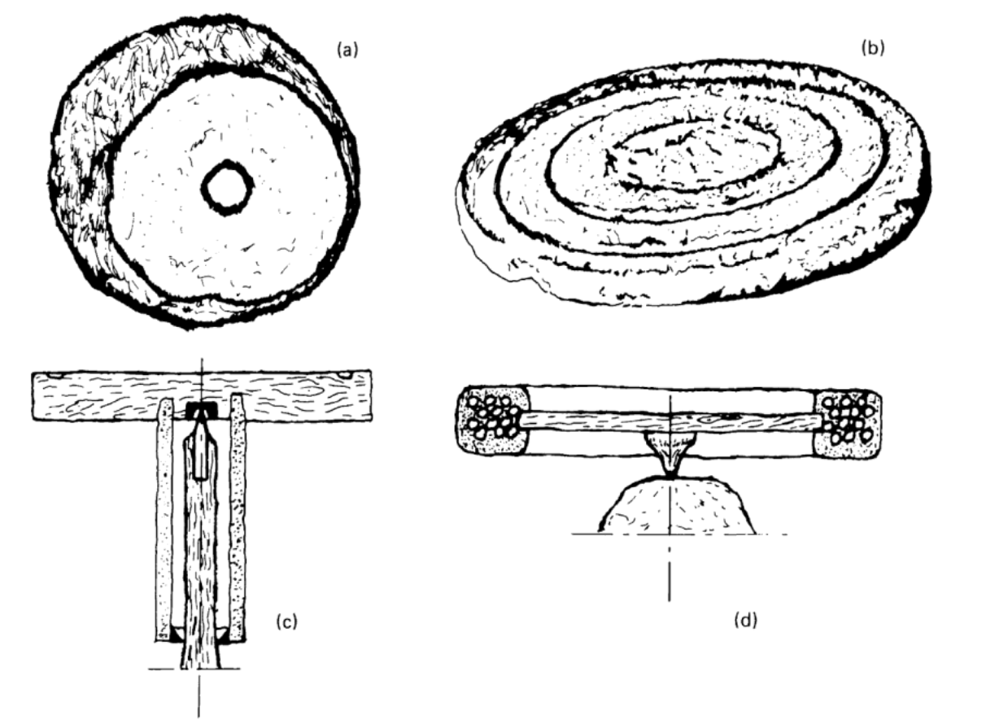
Figure 1 - Potters Wheel (Genta, 2014)
Progressing through history to the 18th century, Amiryar and Pullen (2017) stated that the “developments in cast iron and the production of iron resulted in the production of flywheels in one complete piece, with greater moment of inertia for the same space” making flywheels far more effective enabling greater forces to be applied. Furthermore, following the industrial revolution with the development of the steam engine “very large flywheels were built for the largest engines” with “cast iron, and later cast steel, was largely employed” to manufacture them and “spokes were curved to decrease their radial stiffness, thus reducing the stresses from contraction in cooling and consequently bending in the rim” (Genta, 2014). The curving of a flywheel’s spokes can be observed in the first three-wheeled vehicle built by Benz in 1885 see figure 2, where “the designer chose a disc-type flywheel, which became common for all high-speed machinery” (Genta, 2014).
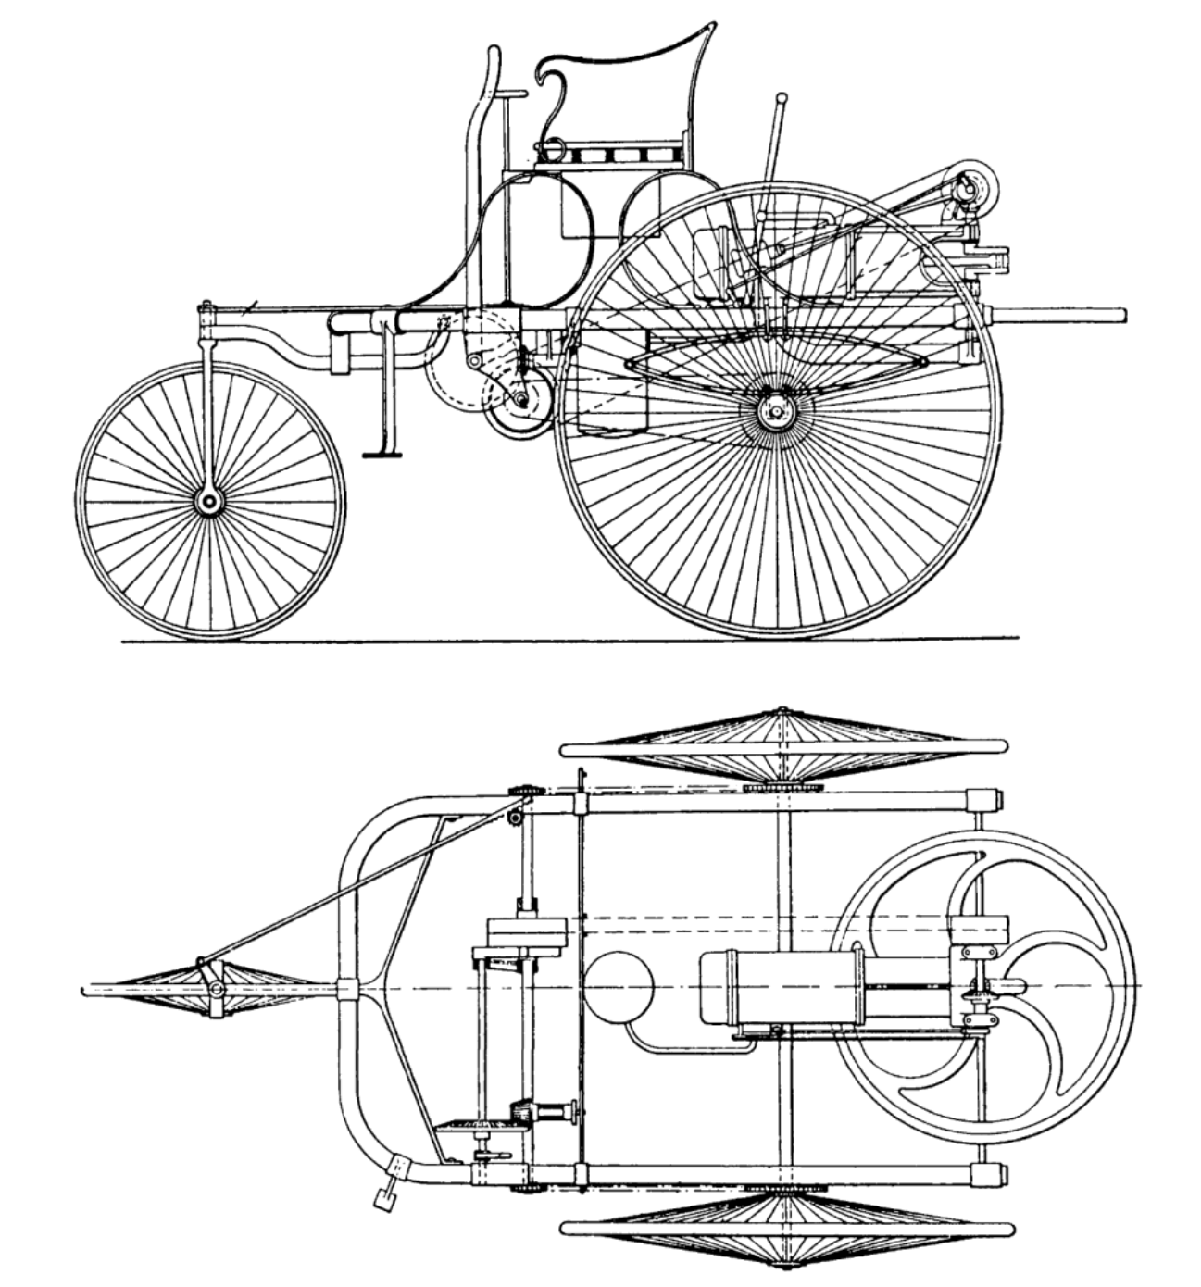
Figure 2 - Benz Three Wheeled Vehicle (Genta, 2014)
Eventually a variety of flywheel shapes and designs had been developed and according to both Bolund, Bernhoff and Leijon (2007) and Amiryar and Pullen (2017) it wasn’t until the early 20th century for “flywheel shapes and rotational stress were thoroughly analysed” with some of the analysis displayed in figure 3.
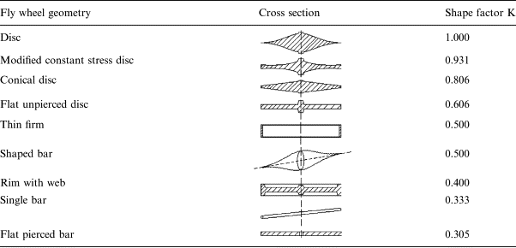
Figure 3 - Flywheel Geometry and K Factors (Bolund, Bernhoff and Leijon, 2007)
After this research was concluded in the 1970s according to Bolund, Bernhoff and Leijon, (2007) “flywheel energy storage was proposed as a primary objective for electric vehicles and stationary power backup” which was closely followed by the development of “fibre composite rotors and in the 1980s magnetic bearings” (Bolund, Bernhoff and Leijon, 2007) ultimately making flywheels a competitive option for energy storage. This leads into the modern day where Choudhury (2021), believes the demand for “an eco-friendly, cost-effective, reliable and durable energy storage systems” has resulted in flywheels becoming the preferred system for off-grid energy storage and regenerative braking.

Kinetic Energy Recovery Systems (KERS)
A Kinetic Energy Recovery System (KERS) is a type of flywheel system commonly found in a vehicle braking system. KERS “is based on the principle of regenerative braking” which is when “a mechanism reduces the vehicles speed, converting the kinetic energy into another useful form of energy” (Mathews, 2013). However, to utilise KERS which can convert wasted energy into additional power there are design considerations required for “the bearings, control system, housing environment, transmission and the flywheel” (Eltaweel and Herfatmanesh, 2024). Eltaweel and Herfatmanesh (2024) elaborate on these considerations stating that:
- The bearings - “must balance factors such as durability, cost, volume, and compatibility with low-pressure operation to ensure optimal performance and longevity”
- The transmission - “defining attributes include high power density to ensure rapid operation during acceleration or deceleration, a high energy density for maximum energy storage, and high efficiency to minimise energy losses”
- The housing environment – “primary functions include serving as the interface between the flywheel and the vehicle, maintaining vacuum tightness for optimal operational conditions, and providing a robust protective barrier that can contain any fragments in the event of a rotor failure” and “must be able to withstand the high-speed impact of projectiles generated during a catastrophic rotor failure”
- The flywheel – “selection of materials used and the optimisation of the flywheel geometry, to maximise specific energy storage, guided by the stress limits that the materials can withstand”

Additionally, considerations are outlined by Eltaweel and Herfatmanesh (2024), for if a Continuously Variable Transmission (CVT) being “cost-effectiveness, low weight, and ease of control”. Failing to consider these factors could results in excessive stress being applied to components and an increased likelihood of failure, an imbalanced mass around the axis of rotation increasing vibrations in the system and wear alongside a poor vacuum seal compromising the systems effectiveness to convert energy and the safety with the housing environments unable to withstand the potential rotor failure.
Some advantages that a flywheel provides compared to a more traditional energy storage system such as a chemical battery are that the flywheel is capable of delivering “substantial amount of power within seconds, boasting an efficiency range of 90%-95%” (Ji et al., 2024). Furthermore, Ji et al. (2024), state that due to the flywheels “robust performance its lifetime extends beyond 20 years with the possibility for hundreds of thousands of cycles, mainly because of its independence from extended charging and discharging cycles” and claims in comparison to a chemical battery “flywheels exhibit a power density five to ten times greater”. This is reiterated by Bolund, Bernhoff and Leijon (2007) who added flywheels use “environmentally friendly materials and has a low environmental impact” compared to other energy storing units.
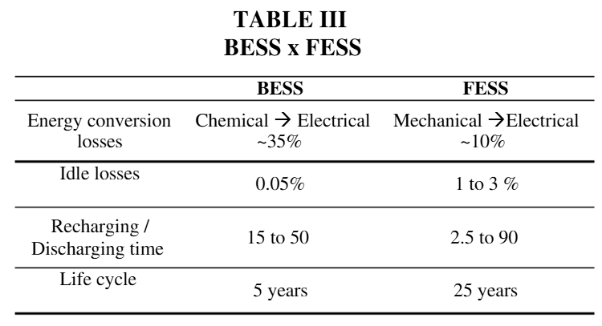
Figure 4 - BESS x FESS Table, (Magdalena Stephan, de Andrade Jr. and Gonçalves Sotelo, 2008)
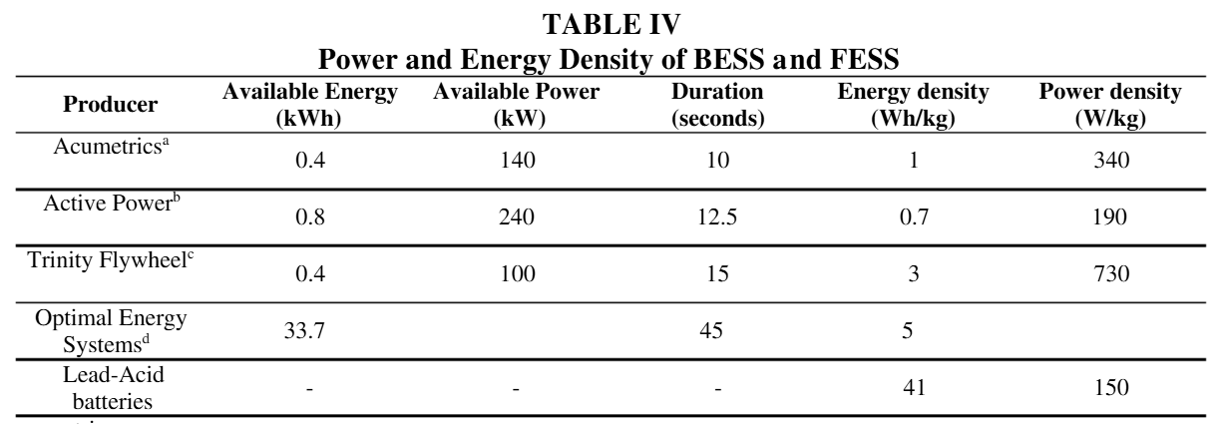
Figure 5 - Power and Energy Density of BESS and FESS, (Magdalena Stephan, de Andrade Jr. and Gonçalves Sotelo, 2008)
Moreover, work by Magdalena Stephan, de Andrade Jr. and Gonçalves Sotelo (2008) in figure 4 displays that the flywheel energy storage system (FESS) has 5 times the lifecycle and an energy recharge and discharge time over 5 times less than the battery energy storage system (BESS) demonstrating that the FESS is a more efficient and environmentally friendly energy storage system with only 10% of energy lost compared to the 35% from the BESS. Additionally in figure 5, it shows that FESS provide greater power density with the Trinity flywheel providing nearly 5 times more than the Lead-Acid battery highlighting that FESS is a better choice for a compact lightweight energy storage system supporting the statements made from Ji et al (2024) and Bolund, Bernhoff and Leijon (2007).

Experimental Calculations
In this section of the report experimental calculations are performed for a hybrid vehicle which has been fitted with a mechanical KERS system where a flywheel is used to store energy which can be recovered during the vehicles braking phase. The KERS engages with a CVT which controls the energy transfer between the KERS and drivetrain of the vehicle. The CVT can also supply the recovered energy back to the vehicle’s drivetrain during re-acceleration.

The vehicle specification for these calculations are:
- Gross Mass of 2,080 kg
- Initial braking speed of 55 mph
- Re-acceleration occurs from rest using only the stored KERS energy

The KERS flywheel specifications are:
- Mass of 6.5 kg
- External diameter of 300 mm
- Maximum rotational speed of 50,000 rpm
- Combined efficiency of 80% (braking and acceleration)
- Enclosure is vacuum sealed
- Geometry can be analysed as a ‘thin ring’ design

Based on the specifications above and equations 1 & 2 seen below, converting mph into m/s using equation 1 55 mph becomes 24.59 m/s. using this converted value and using equation 2 the calculated kinetic energy (KE) of the vehicle before braking is 628.85 kJ with m noted as the mass and v as the velocity.
$$v= \frac{1609.34}{1}×\frac{1}{3600}$$
Equation 1 - Mph to m/s conversion
$$KE = \frac{1}{2} mv^{2}$$
Equation 2 - Kinetic Energy
The amount of energy stored in the flywheel during braking from 55 mph to rest is 503.08 kJ, found using equation 3 seen below.
$$Stored Energy=Total KE ×Efficiency$$
Equation 3 - Stored Energy
To determine the rotational speed of the flywheel after braking equation 4 needs to be used to first find the moment of inertia (I) of the flywheel which is 0.14625 kg/m² where r is the radius of the flywheel.
$$I=mr^{2}$$
Equation 4 - Moment of Inertia
Now that the moment of inertia has been calculated the angular velocity (ω) can be found rearranging equation 5 to get equation 6.
$$KE= \frac{1}{2}Iω^{2}$$
Equation 5 - Kinetic Energy (Angular Velocity)
$$ω= \sqrt{\frac{2KE}{I}}$$
Equation 6 - Angular Velocity Rearranged
Substituting the previous values for kinetic energy and moment of inertia the angular velocity can be found in radians per second being 2622.92 rad/s, to convert this into rpm equation 7 is required giving the flywheels angular velocity as 25,047 rpm.
$$RPM=\frac{Radians per Second ×60}{2π}$$
Equation 7 - Rad/s to RPM Conversion
Assuming that the stored energy from the KERS flywheel is used to re-accelerate the vehicle from rest the vehicles final speed is calculated to be 21.99 m/s or 49.19 mph by taking the stored energy value previously calculated and rearranging equations 1 & 2 to find the velocity and convert from m/s to mph.

To understand the effect that braking speed has on the vehicles final speed after re-accelerating using only the stored energy from the KERS system we can plot the results for when braking is applied at speeds between 20 mph – 60 mph displayed in figure 6 based on the data shown in tables 1 & 2 seen below.

Figure 6 - Stored Energy Re-accelerated Velocity Plot
Variables/Conversion
Vehicle Mass (kg) | 2080
mph to m/s | 0.45
m/s to mph | 2.24
Efficiency | 80.00%
Flywheel Mass (kg) | 6.5
Flywheel Diameter (m) | 0.3
Flywheel Radius (m) | 0.15
Moment of Inertia (kg/m²) | 0.14625
rad/s to rpm | 9.549296586
rpm to rad/s | 0.104719755

Table 1 - Variables/Conversions (Stored Energy Re-accelerated)
Calculated Values
Initial Velocity (mph) | Initial Velocity (m/s) | Kinetic Energy (J) | Kinetic Energy Stored braking to rest (J) | Angular Velocity (rad/s) | Angular Velocity (rpm) | Final Velocity (m/s) | Final Velocity (mph)
20 | 8.94 | 83137.07 | 66509.66 | 953.69 | 9107.11 | 8.00 | 17.89
25 | 11.18 | 129901.68 | 103921.34 | 1192.12 | 11383.89 | 10.00 | 22.36
30 | 13.41 | 187058.42 | 149646.73 | 1430.54 | 13660.67 | 12.00 | 26.83
35 | 15.65 | 254607.29 | 203685.83 | 1668.97 | 15937.45 | 13.99 | 31.30
40 | 17.88 | 332548.30 | 266038.64 | 1907.39 | 18214.23 | 15.99 | 35.78
45 | 20.12 | 420881.44 | 336705.15 | 2145.81 | 20491.01 | 17.99 | 40.25
50 | 22.35 | 519606.71 | 415685.37 | 2384.24 | 22767.79 | 19.99 | 44.72
55 | 24.59 | 628724.12 | 502979.30 | 2622.66 | 25044.57 | 21.99 | 49.19
60 | 26.82 | 748233.66 | 598586.93 | 2861.08 | 27321.34 | 23.99 | 53.67
Table 2 - Calculated Values (Stored Energy Re-accelerated)
Reviewing figure 6, it shows a proportional relationship between the speed before braking and the final speed after re-accelerating when using only the stored energy of the flywheel. The effect of increasing the speed before braking is that the final speed after re-acceleration would also increase. Another observation which can be made from the plot is that the final speed of the vehicle is less than the initial speed prior to braking displaying that the flywheel cannot recover all the initial speed but can recover the majority with roughly 89.45% of the initial speed regained.

To find the re-acceleration of the vehicle using the stored energy in the KERS when braking occurred at 60 mph and it reaches the final speed in 6.5 seconds, equation 8 is needed.
$$v=u+at$$
Equation 8 - SUVAT (Equation 1)
It is known that the final velocity (v) when braking occurs at 60 mph is 23.99 m/s from table 2 and that the initial velocity (u) is 0 as the vehicle is accelerating from rest. By rearranging equation 8 for acceleration (a) we get equation 9 seen below where t stands for time.
$$a=\frac{v-u}{t}$$
Equation 9 - SUVAT (Equation 1 Rearranged)
Substituting the values into equation 9 the vehicle is found to accelerate at 3.69 m/s² to reach its final velocity of 23.99 m/s in 6.5 seconds when only re-accelerating using the stored energy from the KERS flywheel.

Another KERS system is developed for a smaller vehicle which has a gross mass of 1,510 kg and a smaller flywheel mass of 4.5 kg. To identify the effect the diameter of the flywheel has on its rotational speed data was plotted as shown in figure 7 where the diameter of the flywheel varied from 120 mm to 240 mm accompanied by tables 3 & 4 which display the variables, conversions and calculated values used to plot figure 7.

Figure 7 - Flywheel Angular Velocity against Diameter Plot
Variables/Conversions
Vehicle Mass (kg) | 1510
mph to m/s | 0.45
m/s to mph | 2.24
Efficiency | 80.00%
Flywheel Mass (kg) | 4.5
rad/s to rpm | 9.549296586
rpm to rad/s | 0.104719755
Initial Velocity (mph) | 60
Initial Velocity (m/s) | 26.82
Kinetic Energy (J) | 543188.86
Kinetic Energy Stored braking to rest (J) | 434551.09
Table 3 - Variables/Conversions (Flywheel Angular Velocity against Diameter)
Calculated Values
Flywheel Diameter (m) | Flywheel Radius (m) | Moment of Inertia (kg/m²) | Angular Velocity (rad/s) | Angular Velocity (rpm)
0.12 | 0.06 | 0.02 | 7324.50 | 69943.81
0.14 | 0.07 | 0.02 | 6278.14 | 59951.84
0.16 | 0.08 | 0.03 | 5493.37 | 52457.86
0.18 | 0.09 | 0.04 | 4883.00 | 46629.21
0.20 | 0.10 | 0.05 | 4394.70 | 41966.29
0.22 | 0.11 | 0.05 | 3995.18 | 38151.17
0.24 | 0.12 | 0.06 | 3662.25 | 34971.91
Table 4 - Calculated Values (Flywheel Angular Velocity against Diameter)
Analysing figure 7, there is a non-linear negative correlation between the diameter of the flywheel and the angular velocity the flywheel achieves when braking begins at 60 mph to rest with the angular velocity dropping as the flywheel increases in diameter at a decreasing rate. This is displayed with the flywheels angular velocity dropping by 1,046.36 rad/s when the diameter increased from 0.12 m to 0.14 m whereas the angular velocity when the diameter changed from 0.22 m to 0.24 m dropped 332.93 rad/s showing that the effect of increasing the flywheels diameter will reduce the angular velocity the flywheel achieves until the flywheel reaches a certain size where the reduction in the angular velocity is negligible.

Conclusion
To conclude, flywheels have been used throughout history for a variety of task with some of the earliest documented versions being used for sculpting such as the potters wheel to being used for transportation during the industrial revolution to modern day off-grid energy storage and regenerative braking after research and technological advancements. The KERS flywheel provides an alternative to traditional energy storage solutions such as chemical batteries providing a more environmentally conscious option with a longer lifecycle, providing a higher power density and less energy lost.

Moreover, the experimental work carried out showed how a KERS flywheel used for regenerative braking can effectively recover roughly 89.45% of the Kinetic Energy during braking with more energy stored the greater the speed of the vehicle. Furthermore, the experimental work displayed that increasing the flywheels diameter resulted in the angular velocity of the flywheel to decrease at a decreasing rate the bigger the flywheel became. However, the results observed were under the following assumptions:
- The vehicle motion was only linear
- The moment of inertia acted through the centre of the flywheel and that the mass was evenly distributed
- The system experienced no losses from air resistance, heat energy, etc apart from the 80% efficiency during braking or acceleration
- The braking and acceleration were uniform

By making these assumptions if the same experiments were to be conducted properly the results would be marginally different to the answers obtained in this report.

Bibliography
Amiryar, M. and Pullen, K. (2017). A Review of Flywheel Energy Storage System Technologies and Their Applications. Applied Sciences, [online] 7(3), p.286. doi:https://doi.org/10.3390/app7030286.
Bolund, B., Bernhoff, H. and Leijon, M. (2007). Flywheel energy and power storage systems. Renewable and Sustainable Energy Reviews, [online] 11(2), pp.235–258. doi:https://doi.org/10.1016/j.rser.2005.01.004.
Choudhury, S. (2021). Flywheel energy storage systems: A critical review on technologies, applications, and future prospects. International Transactions on Electrical Energy Systems, [online] 31(9). doi:https://doi.org/10.1002/2050-7038.13024.
Eltaweel, M. and Herfatmanesh, M.R. (2024). Enhancing vehicular performance with flywheel energy storage systems: Emerging technologies and applications. Journal of Energy Storage, [online] 103(B), p.114386. doi:https://doi.org/10.1016/j.est.2024.114386.
Genta, G. (2014). Kinetic Energy Storage. [online] Google Books. Available at: https://books.google.co.uk/books?hl=en&lr=&id=LKXpAgAAQBAJ&oi=fnd&pg=PP1&ots=FWOWYx-4oX&sig=E1LEPo9IsD_HnOqehYuJ69SBeDk&redir_esc=y#v=onepage&q&f=true [Accessed 5 Nov. 2025].
Ji, W., Hong, F., Zhao, Y., Liang, L., Du, H., Hao, J., Fang, F. and Liu, J. (2024). Applications of flywheel energy storage system on load frequency regulation combined with various power generations: A review. Renewable Energy, [online] 223, p.119975. doi:https://doi.org/10.1016/j.renene.2024.119975.
Magdalena Stephan, R., de Andrade Jr., R. and Gonçalves Sotelo, G. (2008). Third Generation Of Flywheels: A Promising Substitute To Batteries. Eletrônica de Potência, [online] 13(3), pp.171–176. doi:https://doi.org/10.18618/rep.2008.3.171176.
Mathews, T. (2013). (PDF) FLYWHEEL BASED KINETIC ENERGY RECOVERY SYSTEMS (KERS) INTEGRATED IN VEHICLES. ResearchGate, [online] 5(9). Available at: https://www.researchgate.net/publication/267038288_FLYWHEEL_BASED_KINETIC_ENERGY_RECOVERY_SYSTEMS_KERS_INTEGRATED_IN_VEHICLES [Accessed 8 Nov. 2025].
Mousavi G, S.M., Faraji, F., Majazi, A. and Al-Haddad, K. (2017). A Comprehensive Review of Flywheel Energy Storage System Technology. Renewable and Sustainable Energy Reviews, [online] 67, pp.477–490. doi:https://doi.org/10.1016/j.rser.2016.09.060.
Plaum, F., Haring, T., Ahmadiahangar, R. and Rosin, A. (2020). Power Smoothing in Smart Buildings using Flywheel Energy Storage. IEEE 14th International Conference on Compatibility, Power Electronics and Power Engineering (CPE-POWERENG), [online] pp.473–477. doi:https://doi.org/10.1109/cpe-powereng48600.2020.9161458.

