Student Name: Zara Evelyn Cousins
P Number: 1902667
Programme of Study: Illustration
Module: M4X01560

Tasks in the order I received them:
Task One: Jon Pugh- Reflective Writing= 479 words
Task Two: Ryan Moule- Semiotic analysis of an image = 516 words
Task Three: Julia Lockheart- Manifesto= 534 words

Task One: Reflective Writing (Jon Task)
A reflection of Takashi Murakami’s work “Panda and Panda Cubs” (2015).
Murakami has been described as “The Warhol of Japan” by many (however the source of this names’ origin is unknown) for his “art-as-business approach” and for “developing a new form of Pop Art, aptly titled Neo-Pop” (The Art Story). In an interview, Murakami discusses his work and how his own movement “Superflat” came about, with its ‘visual philosophy’ being drawn from a Japanese painter of the Edo period Jakuchū Itō. Murakami self-proclaims himself as “a geek for Japanese animation stuff and also the American sci-fi stuff” (Museum of Contemporary Art Chicago, 2017). A very common character of his, ‘Mr.DOB’ “combines features of Japanese and Hong Kong animation with aspects of American cartoon characters, notably Mickey Mouse” (Siegel and Mattick, 2004, p. 150) a perfect example of Murakami’s love to combine Japanese style with Western inspirations. The term “Superflat” is a reference to “both to the flattened compositions that lacked one point perspective of historical Japanese artistic movements such as Nihonga, as well as to the flattening (or merging) of art and commerce” (The Art Story)

Japanese people accept that art and commerce will be blended;
and in fact, they are surprised by the rigid and pretentious
Western hierarchy of ‘high art’. In the West, it certainly is
dangerous to blend the two because people will throw all sorts
of stones. But that’s okay- I’m ready with my hard hat.

- Murakami (Anna Niederlander (2018) Takashi Murakami the, ‘Warhol of Japan’.)

My initial impression of Murakami’s art was that of a very bold and colourful cartoon style with many details, some being very subtle, and shapes that leads your eye through the image, trying to take in everything. After looking deeper into his work my opinion hasn’t necessarily changed, but rather, been added to. Using a very recognisable style, associated with japan the ‘anime/manga’ look and merging it with Western influences such as Andy Warhol or Western cartoons, Murakami creates bright and eye-catching works, some of which could even be considered psychedelic. They commonly including his Mr.DOB character that both acts as an art persona, representing him as an artist while also providing a familiar character to those who know him. ‘Panda and Panda Cubs (2015) is a perfect example of this. Using the same template as Mr.DOB, he created these panda characters that combined a cute yet creepy aesthetic, in combination with the very cartoony skulls that they sit on. I personally love this combination, a strange harmony of cute and creepy, eye catching and bright, simple yet busy with details. I can now see the resemblance to more cute characters from popular Japanese manga and anime such as Doraemon as well as a nod to the ‘chibi’ art style that consists of similar proportions or large heads in proportion to the bodies that creates this cute character style.
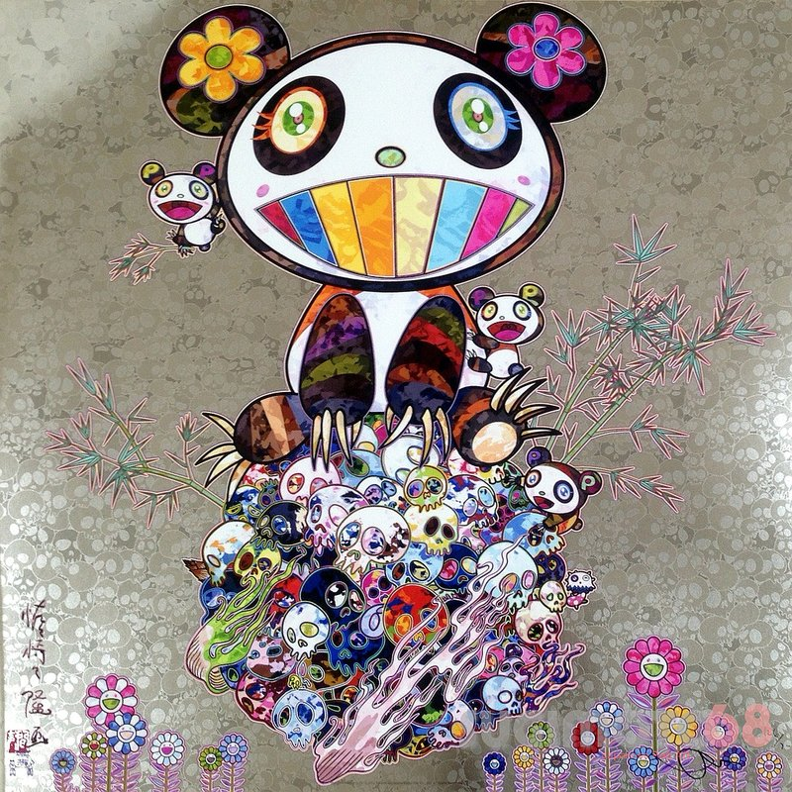

Bibliography

- Anna Niederlander (2018) Takashi Murakami the, ‘Warhol of Japan’.
Available at:
http://www.hasta-standrews.com/features/2018/11/3/takashi-murakami-the-warhol-of-japan#:~:targetText=Takashi%20Murakami%20once%20said%20that,artist%20in%20the%2021st%20century.
(Accessed: 19 December 2019)
- Coldwell, Paul and Carmarthenshire College (2010). Printmaking: A Contemporary Perspective. London, UK: Black Dog Pub.
- Livingstone, Marco (2000) Pop Art: A Continuing History. London: Thames & Hudson.
- Museum of Contemporary Art Chicago (2017) Takashi Murakami [video]. Available at: https://www.youtube.com/watch?v=-YPOWBQAd1M (Accessed: 19 December 2019)
- Siegel, Katy., and Paul. Mattick (2004) Money. London: Thames & Hudson. Art Works.
- The Art Story (unknown) Takashi Murakami Artworks
Available at: https://www.theartstory.org/artist/murakami-takashi/artworks/
(Accessed: 19 December 2019)
- The Art Story (unknown) Takashi Murakami Available at:
https://www.theartstory.org/artist/murakami-takashi/
(Accessed: 19 December 2019)

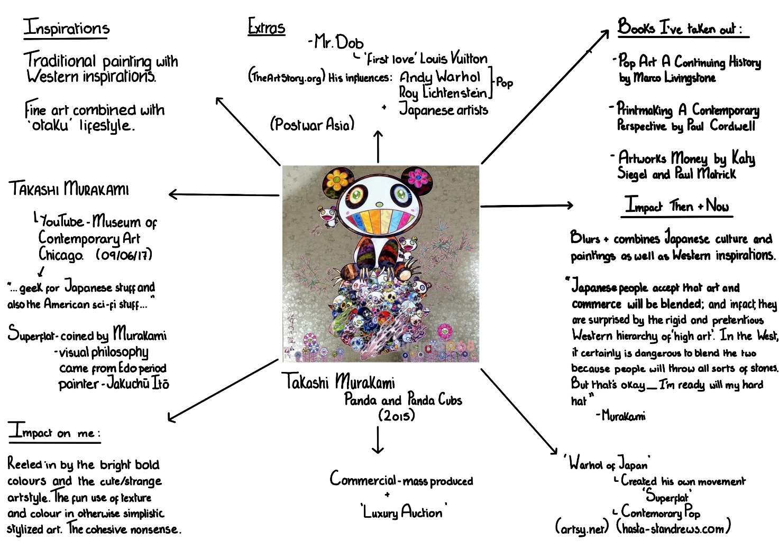

Task Two: Semiotic analysis of an image. (Ryan Task)
What is semiotics? Otherwise known as Semiology, is “the study of signs and sign- using behaviour” (The Editors of Encyclopaedia Britannica, 2019). Ferdinand de Saussure defined it as “the life of signs in society” (The Editors of Encyclopaedia Britannica, 2019). It became a versatile method of explaining different phenomena in the 19th going on 20th Century because of the studies of Ferdinand de Saussure and a man named Charles Sanders Pierce. Semiotics allows someone to look at an image, and break down the meanings behind different objects, colours and what the overall message of something is, or what is trying to be conveyed. This is my semiotic analysis of an art work by YBA artist, Marc Quinn as a part of his ‘All about Love’ series, more specifically the piece titled: Breathe.
This image shows an artwork, a sculpture, featuring the use of some kind of casting method, of a pair of figures. One figure is being embraced from behind by the other with their hands resting on the chest. Both casted figures are headless and only one of them has had there form casted all the way down to the feet where the sculpture has been secured by a metal post on top of a wooded cargo box. The sculpture is an overall ivory colour. Although this image is simple, it is intended to imply aspects of love, be it good or bad. For a photographer, for example, they may only see the husk of a cast of two people on a post, but for artists every little detail could be connected to the theme of love. The materials listed for the mould on Marc Quinn’s website say, “glass reinforced polyester and biresin polyurethane”; glass reinforced polyester is literally “a polyester material reinforced with the addition of glass fibre (also commonly known as fibreglass)” (Hambleside Danelaw Building Products, 2019) which can “produce durable, lightweight yet rigid moulds with high degrees of detail capture” (Brooks, 2005, p.99). The symbolic attribute could be that love can make you feel lightweight, as if you’re floating and if you’re relationship is strong, you will know many details about one another. However, despite its strength, fibreglass can be easily broken if hit at high impact and shatter and if not properly maintained can degrade. Love, if not maintained can fall apart, shatter even. For some it could feel like they’ve been hit at high impact. The mould of the figures is incomplete and while this was probably a demoulding factor, it could loan itself to represent the shell that we all have and coming out of it and opening up to those we love and the headless bodies could symbolize how some love can cause people to think irrationally, no logic all heart. The colour of this cast could revolve around the concept that love is pure, like how in Christianity you wear white wedding dresses to symbolize pureness while the pose could resemble the feeling of being close to one another and with the hands enclosing the chest, helps to bring the name of the piece to light ‘Breathe’.

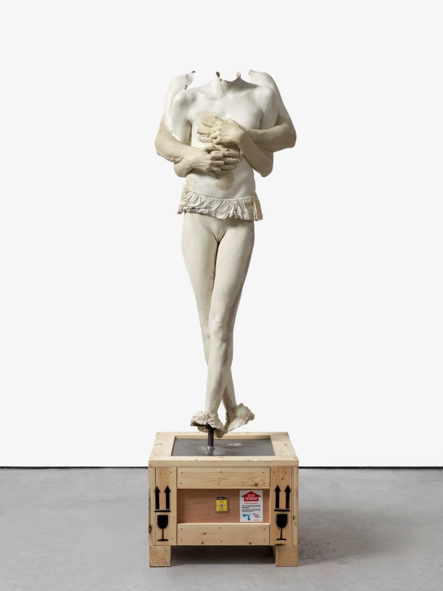

Bibliography
- Adams, Brooks and Royal Academy of Arts (2000). Sensation: Young British Artists from the Saatchi Collection. London: Thames & Hudson.
- Baldwin, John (1967). Contemporary Sculpture Techniques Welded Metal and Fiberglass. Reinhold.
- Brooks, Nick (2005) Mouldmaking and Casting: A Technical Manual. Ramsbury: Crowood.
- Costache, Irina Dana (2012). The Art of Understanding Art. Chichester: Wiley-Blackwell.
- Ellis, Patricia and Saatchi Gallery (2003). 100: The Work That Changed British Art. London: Jonathan Cape in Association with the Saatchi Gallery.
- Hambleside Danelaw Building Products (2019) Glass Reinforced Polyester (GRP). Available at: https://www.hambleside-danelaw.co.uk/materials/glass-reinforced-polyester-grp/
(Accessed on: 24 December 2019)

Niells Materials (2018) Biresin G27 | SikaAxson. Available at: https://www.neillsmaterials.co.uk/product/biresin-g27/

(Accessed on: 24 December 2019)
- O'Toole, Michael (1994). The Language of Displayed Art. London: Leicester UP.
- The Editors of Encyclopaedia Britannica (2019). Semiotics. Available at: https://www.britannica.com/science/semiotics
(Accessed: 22 December 2019)
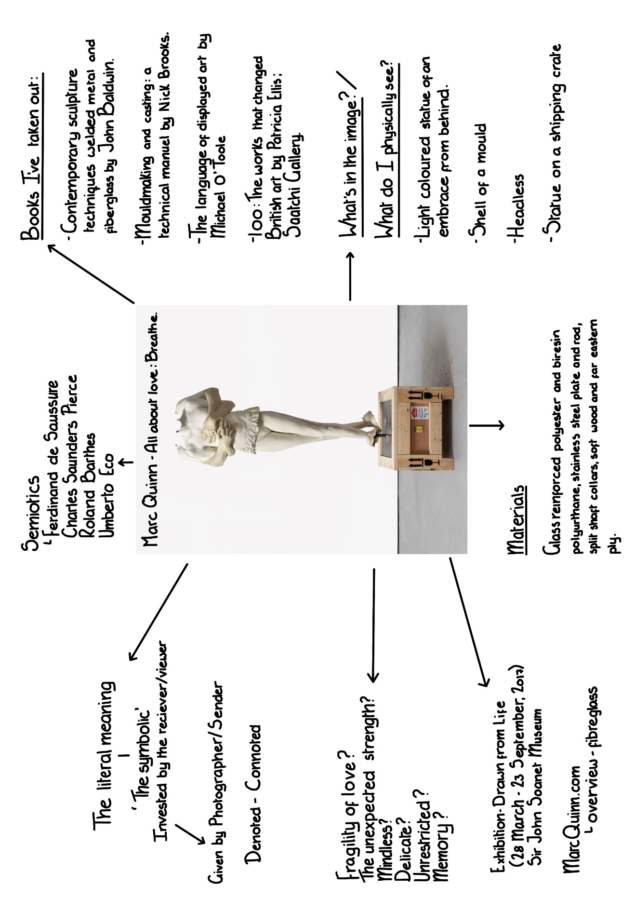

Task 3 Manifesto (Julia Task)
- I believe that all art doesn’t have to have a hidden meaning.
- All art should be accepted so long as it came from the heart and makes the artist happy and express themselves.
- I believe galleries should do more to create an inviting atmosphere rather than stiffness and strictness.
- Anyone who shows an interest in art, no matter the age, should be encouraged rather than be told that it’s just a hobby.
- Inspiration is inspiration, not matter how controversial the topic.
- No interpretation of art is wrong even if your response is different to the creators.
- Mistakes are okay. Everything is valid on the path to growth.
- “Beauty is in the eye of the beholder” (Margret Wolfe Hungerford, 1878), not everyone will like or appreciate your work, but it shouldn’t derail your creativity.

Keywords/Phrases and Images
- Hidden Meaning
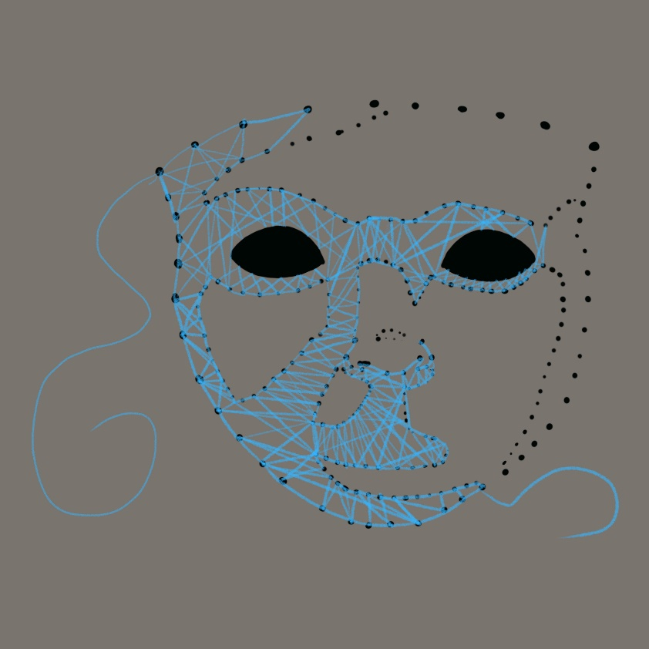

-My interpretation of a hidden meaning
- I believe that all art doesn’t have to have a hidden meaning.
Creatives have played with hidden meanings for centuries trying to use objects and colours to convey emotion, make statements on situations like politics or society. From paintings to performances to story-telling, not everything is always what it appears and sometimes they’re not always serious. A common modern-day synonym to hidden meaning is “Easter Eggs”. Coined by Steven Wright in the 1980s, the term “Easter egg” refers to “messages and jokes that creators intentionally hide in various forms of entertainment media.” (Bradley, 2018). Not only do these provide messages, doing it in the “Easter Egg” (Wright, 1980s) way, its less in your face and more subtle. It’s for this reason, such things have worked well in movies, especially when trying to add adult humour to children’s movies in order give the parents more entertainment. Just for fun.
2. Interpretation
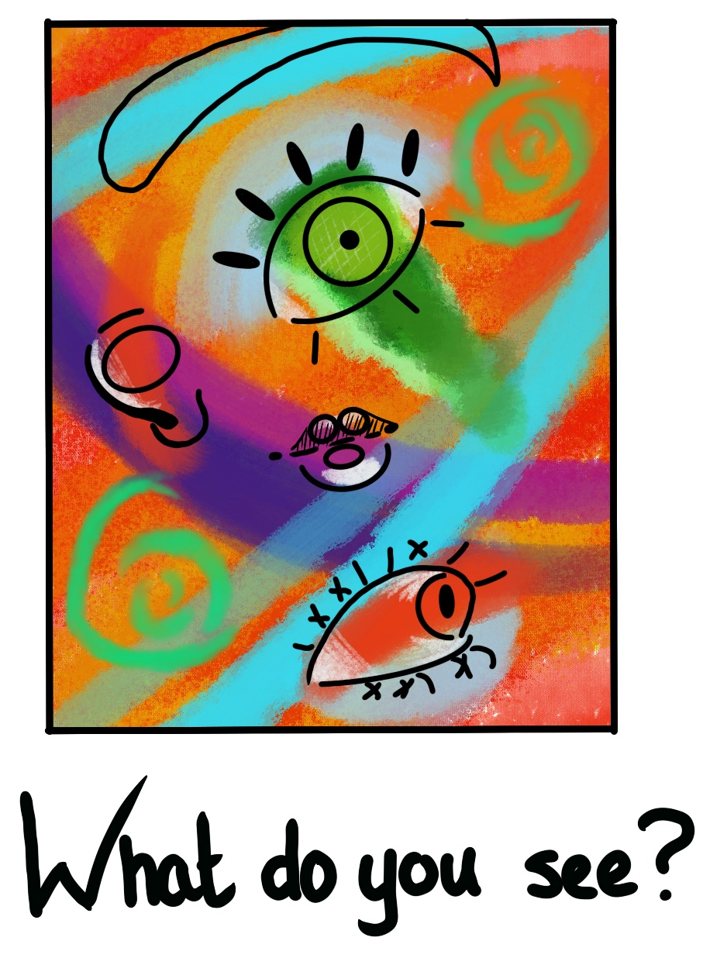

- My piece to represent interpretation
“What do you see”
- No interpretation of art is wrong even if your response is different to the creators.
If you look up the word ‘interpretation’ you would get a few examples of what its meaning from “an explanation of the meaning of another's artistic or creative work; an elucidation” and “the rendering of a dramatic part, music, etc., so as to bring out the meaning, or to indicate one's particular conception of it” (Dictionary.com, 2019). To sum up what ‘interpretation’ means, it is the understanding or association an individual has, to something like an artwork or performance. Interpretation is subjective and in the creative industry, there is very rarely a wrong interpretation of something. A painting may be made by a painter for them to create a visual representation of how they feel, for example, sadness or grief. If someone else was to look at the painting, they may see the artists emotions through the painting but someone else may see something different, maybe anger or even rebirth. Interpretation can have parallels to things like semiotics as you analyse an image or performance, trying to figure out what is being said and how.

3. “Beauty is in the eye of the beholder” (Margret Wolfe Hungerford, 1878)
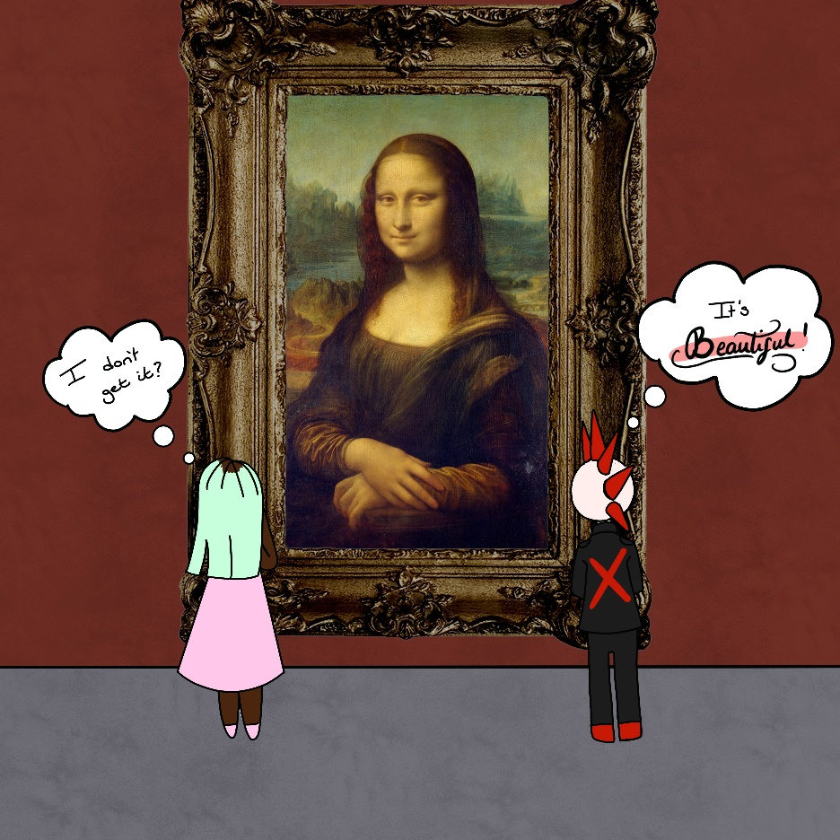

- My artwork to represent the difference in opinion.
9. “Beauty is in the eye of the beholder” (Margret Wolfe Hungerford, 1878), not everyone will like or appreciate your work, but it shouldn’t derail your creativity.
A very common phrase. One I have heard and used many times over my lifetime but never knew the origin of. While is exact origin is unknown, variations of this phrase have been used as far back as 3rd Century BC by the Greeks but the version that we know today was first used by Margret Wolfe Hungerford in her book ‘Molly Bawn’ in 1878. (Bloomsbury International, 2014). This phrase is used to explain how every individual sees something differently. Something that one person may consider beautiful, another may consider ugly. Someone else may see unbridled emotion in one image and another individual my just see an image, nothing special. While the previous key word may refer also to how we see things, this one looks more to how everyone has a different standard to what they consider beautiful and not whereas interpretation is the expression of what one this could mean either to yourself or for another. A personal example of where I would use this phrase is when I view artwork by Mark Rothko. For me, I do not see or understand the supposed beauty in his work, but others do. There was even a BBC news article about his most expensive piece “Mark Rothko's Orange, red, yellow has been sold for $86.9 million (£53.8m) - the highest price ever fetched by a piece of contemporary art at auction.” (BBC, 2012).

Bibliography
- Baseman, Gary (2004). Dumb Luck. San Francisco, Calif. London: Chronicle; Hi Marketing.
- BBC News (2012). Mark Rothko work sold for record $86.9m at auction
Available at: https://www.bbc.co.uk/news/world-us-canada-18001432
(Accessed on: 02 January 2020)

Bradley, Bill (2018) The Guy Who Coined The Term 'Easter Egg' Just Realized It Was A Thing.

Available at: https://www.huffingtonpost.co.uk/entry/the-guy-who-coined-the-term-easter-egg-didnt-know-it-became-a-thing_n_5abe6e2de4b0a47437aaabe1?ri18n=true&guccounter=1&guce_referrer=aHR0cHM6Ly9jb25zZW50LnlhaG9vLmNvbS8&guce_referrer_sig=AQAAAAHhKQAafTsBj3F7IbufgNPRdDAWqK3NbS0hnD6RdLZ-dZ-wZLDl4-yNaAS538y22so3dEcqN5CZBfosVJZcd9T4DZkxcqGJAMJ7l-1fxryC0nqMZcum-7iQmXKGu9PvRkI6_sXbn-bG9fFfiIQWJkgFtzFxCgOtpIgcwTQa8r-c

(Accessed on: 30 December 19)
- Caws, Mary Ann (2001). Manifesto: A Century of Isms. Lincoln: U of Nebraska.
- Dictionary.com (2019) Interpretation.
Available at: https://www.dictionary.com/browse/interpretation?s=t
(Accessed on: 02 January 2020)
- Jeffreys, Sheila (2005). Beauty and Misogyny: Harmful Cultural Practices in the West. London: Routledge. Women and Psychology.
- Laurel Suval (2018) Hidden Meanings in Children’s Fairy Tales.
Available at: https://psychcentral.com/blog/hidden-meanings-in-childrens-fairy-tales/
(Accessed on: 30 December 2019)
- Quality English School in Central London Bloomsbury International (2014) “Idiom of the week. Beauty is in the eye of the beholder origin and meaning”
Available at: https://www.bloomsbury-international.com/student-ezone/idiom-of-the-week/100-beauty-is-in-the-eye-of-the-beholder/
(Accessed on: 02 January 2020)
All images to represent the keywords/phrase were made by myself.
In the “Beauty is in the eye of the beholder” I used a photograph of Leonardo da Vinci’s ‘Mona Lisa’ (1503).

