
MBA- Masters of Business Administration
LCMB7003
STRATEGIC MANAGEMENT
Strategic Analysis of the company APPLE
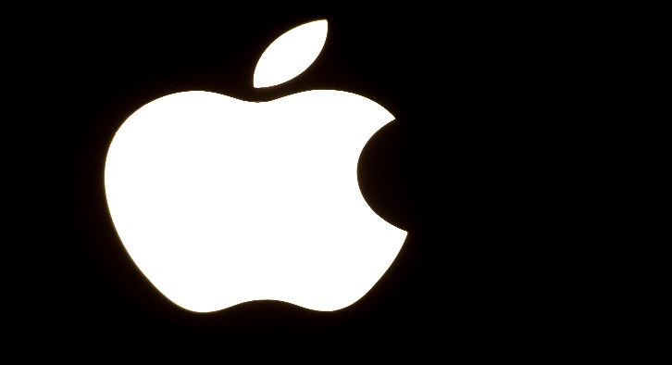

STUDENT NAME: APARNA SHARATH EZHAVA
STUDENT ID: 2210726

TABLE OF CONTENTS
1.INTRODUCTION…………………………………………………………………………………...3
2.BACKGROUND…………………………………………………………………………………….4
2.1. MISSION AND OBJECTIVES………………………………………………………………….4
3.MACRO ENVIRONMENT ANALYSIS…………………………………………………………...5
3.1. PESTEL ANALYSIS…………………………………………………………………………….5
4. MICRO ENVIRONMENT ANALYSIS……………………………………………………………6
4.1 INDUSTRY LIFE CYCLE………………………………………………………………………..7
4.2 PORTER’S INDUSTRY FIVE FORCES ANALYSIS…………………………………………8
5.INTERNAL ANALYSIS…………………………………………………………………………...10
5.1 APPLE’S STRATEGIC RESOURCES AND CAPABILITIES……………………………...10
5.2 VALUE CHAIN ANALYSIS…………………………………………………………………….11
5.2.1. PRIMARY ACTIVICTIES……………………………………………………………………11
5.2.2 SECONDARY ACTIVICTIES………………………………………………………………..11
5.3 VRIO ANALYSIS OF DISTINCTIVE RESOURCES AND CAPABILITIES………………12
5.4 SWOT ANALYSIS………………………………………………………………………………13
6. STRATEGIES TO SUSTAIN COMPETITIVE ADVANTAGE.............................................14
7.GROWTH STRATEGIES………………………………………………………………………...15
8.GREEN STRATEGY AND CSR…………………………………………………………………16
9. CONCLUSION……………………………………………………………………………………17
10. RECOMMENDATION………………………………………………………………………….17
11. REFERENCES………………………………………………………………………………….19

1.INTRODUCTION

The corporate headquarters of the international technology giant Apple Inc. are in Cupertino, California. Steve Jobs, Steve Wozniak, and Ronald Wayne created it in 1976. Apple creates, develops, and markets personal computers, online services, and consumer products. The iPhone, iPad, Mac, Apple Watch, and Apple TV are some of its most well-known products.
The success of Apple can be attributed in part to its strategic management style. The business has a history of using technology to develop distinctive goods and experiences that appeal to its devoted clientele. Apple is a pioneer in the technology sector thanks to its creative design ethos and emphasis on integration and simplicity. Its ecosystem of apps and services is built to function harmoniously together and provide a consistent user experience across various devices.
Apple's success hasn't, however, been without obstacles. The corporation competes in a fiercely competitive and evolving market for technology, and it must constantly innovate to stay one step ahead of its competitors. Apple is fiercely rivalled by other tech behemoths like Samsung, Google, and Microsoft. These businesses are always looking to differentiate themselves through the development of new goods and services. As consumers want more and more socially conscious and environmentally friendly products, Apple must also address these issues. The business has worked hard to establish itself as a pioneer in environmental sustainability and has put in place a number of initiatives to lessen its carbon impact. Apple must constantly evaluate its strategic management style in order to keep its competitive advantage. The business's decision-making procedures must take into account elements including market trends, consumer preferences, and technology improvements. It must be ready to modify its tactics and product offerings in order to satisfy shifting consumer needs.
A review of Apple Inc.'s strategic management in this situation may be able to shed light on the company's current prospects, threats, and areas of strength and weakness. Informing decision-making procedures and identifying potential areas for improvement will help Apple preserve its competitive advantage going forward. In conclusion, Apple Inc. is a multinational technological corporation that, according to its strategic management philosophy, has become one of the most valuable businesses in the world. Because of its dedication to innovation, integration, and simplicity, the company has been able to develop distinctive goods and experiences that resonate with its devoted consumer base. Apple must continue to use strategic management to solve continuing issues like competition, social issues, and environmental problems. In order to sustain its competitive edge in the future, Apple will need to make decisions that are supported by a strategic management study of the company's existing position.

2.BACKGROUND

The worldwide technology business Apple Inc. was established in Cupertino, California, on April 1, 1976. The corporation had about 147,000 employees worldwide as of September 2021. Apple has historically enjoyed strong financial performance, with notable revenue growth and profitability. The business made $274.5 billion in revenue and $57.4 billion in profit in 2020. Apple's broad range of goods and services, together with its great brand awareness and devoted client base, have all contributed to the company's financial success. The United States, Europe, Greater China, Japan, and the rest of Asia-Pacific make up Apple's main operational markets. The Americas accounted for over 46% of the company's sales in 2020, followed by Europe with 23%, Greater China with 20%, and the rest of Asia Pacific with 11%.
Apple's success can be ascribed to its creative approach to product development and design as well as its focus on delivering an excellent user experience. The company's product line includes wearable technology, PCs, tablets, cell phones, and accessories. In addition, Apple has increased the number of services it offers, such as Apple Pay, iCloud, Apple Music, and the App Store. Apple has received praise for its dedication to corporate social responsibility in addition to its financial success. Through the utilisation of renewable energy, recycling initiatives, and a reduction in carbon emissions, the corporation has made substantial steps to lessen its influence on the environment. Additionally, Apple has been working to enhance the labour practises in its supply chain, including boosting transparency and ensuring that workers have fair working conditions.
One of the most expensive corporations in the world, Apple has a market valuation of almost $2.2 trillion as of May 2023. Despite its success, Apple has had difficulties lately, such as heightened scrutiny of its commercial practises and antitrust concerns around its App Store fees. These difficulties emphasise the necessity of continual strategic management initiatives for Apple to survive in a technological environment that is rapidly changing.

2.1 MISSION AND OBJECTIVES

Mission Statement
Apple’s mission statement is “to bring the best user experience to its customers through its innovative hardware, software and services.”
Objectives:
Apple's goals are consistent with its mission statement and centre on giving its consumers the best user experience while maximising shareholder profit. Among Apple's primary goals are
1.Innovation: Apple's array of products, which features cutting-edge technology and design, clearly demonstrates its dedication to innovation. The company places a strong emphasis on innovation in order to give its consumers the finest user experience and keep a competitive advantage in the industry.
2.Quality: Apple strives to deliver the finest user experience, and this goal extends to the calibre of its goods and services. The business is dedicated to creating top-notch goods that not only3. meet but also beyond the expectations of its clients.
3.Customer satisfaction: Customer happiness is extremely important to Apple, and the company strives to offer a consistent user experience across all of its products and services. The company's retail locations, which offer customers a distinctive shopping experience and access to experienced employees, demonstrate its focus on customer happiness.
4.Financial Performance: Apple's great financial performance reflects its goal of maximising shareholder value. The company's diversified array of goods and services, along with its emphasis on operational effectiveness, enable it to consistently generate revenue growth and profitability.

3. MACRO ENVIRONMENT ANALYSIS

Macro analysis is a strategic management tool used to look at external issues, such as political, economic, social, technological, environmental, and legal concerns, that may have an impact on a company's operations. Macro analysis can help Apple Inc. understand how these outside variables might affect the company's capacity to meet its strategic goals. Apple can detect potential risks and opportunities in the external environment by performing a macro analysis, which can guide its decision-making procedures and aid it in remaining competitive in the market.
3.1 PESTEL ANALYSIS

POLITICAL FACTORS:
Due to its international operations, Apple is impacted by a variety of political variables. The company's operations may be impacted by political unpredictability, alterations in governmental laws, and trade policies. For instance, considering that China is one of Apple's key markets, the current trade tensions between the US and China may have an effect on the company's operations.

ECONOMIC FACTORS:
Apple's business operations may be impacted by economic variables including inflation, unemployment rates, and exchange rates. Consumer buying patterns and the status of the global economy also have an impact on the organisation. In the event that consumers limit their spending during recessions, Apple's sales may suffer.

SOCIAL FACTORS:
Apple's business operations may be impacted by social issues like demographics, cultural fads, and customer behaviour. The demand for Apple's products, for instance, may vary when consumers shift their preferences towards environmentally friendly goods.

TECHNOLOGICAL FACTORS:
In the technology sector, technological elements are crucial, and Apple is no exception. To stay competitive in the market, the organisation must consistently innovate and make investments in new technologies. Technology's quick development may also have an effect on Apple's operations.

ENVIRONMENTAL FACTORS:
Apple has taken tremendous steps to lessen its influence on the environment, and it has set a target of becoming carbon neutral by 2030. Environmental legislation and consumer demand for eco-friendly items may have an impact on the company's operations.

LEGAL FACTORS:
Apple is governed by a number of legal principles, including antitrust laws, data privacy laws, and intellectual property rules. The operations and profitability of the company is impacted by changes to these laws and regulations.

4.MICRO ENVIRONMENT ANALYSIS
A strategic management tool called micro environment analysis looks at the internal elements and stakeholders that can have an impact on a company's operations. Customers, suppliers, competitors, staff, and shareholders are a few of these variables. Businesses can better understand their own strengths and weaknesses as well as possibilities and dangers in the market by analysing the micro environment. A company's decision-making processes can be guided by the knowledge gathered from a micro environment study, which can also assist in the development of successful growth and success plans.
Customers:
The quality and design of Apple's goods are highly valued by the company's devoted consumer base. Apple must constantly change to satisfy the requirements and desires of its customers because consumer preferences and behaviours can have an impact on the company's operations.
Suppliers:
Apple's supply chain is essential to the business's operations, and it depends on a global supplier network to provide the parts for its products. To guarantee a consistent supply of components and prevent any operations disruptions, the company must efficiently manage its relationships with suppliers.
Competitors:
Apple competes against a wide spectrum of rivals, including Samsung, Huawei, and Google, in a highly competitive market. To keep its market share and profitability, the business must consistently innovate and set itself apart from its rivals.

Employees:
The success of Apple depends on its people; thus, the business has put in place a number of measures to entice and keep outstanding personnel. To encourage innovation and creativity, the organisation must maintain a supportive workplace culture and make sure that all employees are engaged and motivated.
Shareholders:
Apple's operations and decision-making processes are significantly influenced by its stockholders. The business must strike a balance between its long-term strategic aims and objectives and the interests of its shareholders. (Apple Inc. (2021).)

4.1. INDUSTRY LIFE CYCLE
The industry life cycle model is a practical resource for comprehending the phases of growth that an industry experiences over time. The model consists of four stages in general: introduction, growth, maturity, and decline.
In the case of Apple Inc., the business has experienced many stages of the industry life cycle throughout its history.
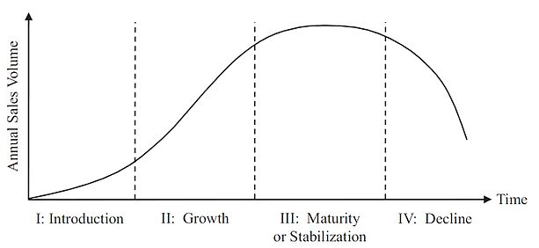
The Product Life-cycle

Introduction:
With the debut of the Apple I and Apple II computers in the late 1970s, Apple entered its introduction phase. When the business was established in 1976, it served a specialised market, mainly selling computers to early adopters and hobbyists.
Growth:
With the introduction of the Macintosh computer in the 1980s, Apple saw substantial development as personal computers gained popularity. In this phase, Apple also expanded the scope of its product offering with the 2001 launch of the iPod, which completely altered the music sector.

Maturity:
With the introduction of the iPhone and iPad in the early 2010s, Apple matured and cemented its position as a dominant force in the tech sector. At this point, Apple concentrated on preserving its market share and growing its product line-up by developing new iterations of its current goods.

Decline:
Although Apple has not yet reached the decline stage, the smartphone and tablet sectors are becoming increasingly saturated and competitive. However, Apple has persisted in innovation and market expansion, particularly in areas like wearable technology and services, which might serve to delay the company's maturity period.
In general, the industry life cycle model is a useful resource for comprehending Apple's corporate development and place in the tech sector. Managers can better comprehend the opportunities and challenges that lie ahead by identifying the stage of the industry life cycle that a company is in and developing suitable strategies to handle them. (Grant, R. M. (2016).)

4.2. PORTER’S INDUSTRY FIVE FORCES ANALYSIS

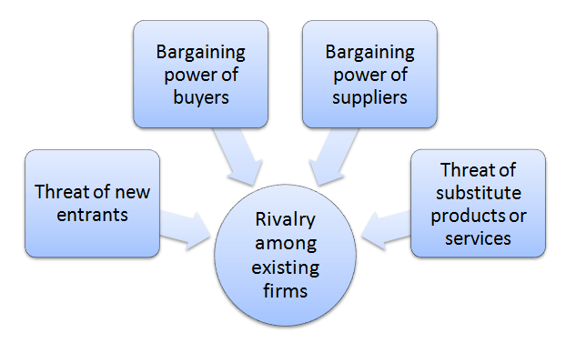
source: Internet
A strategic tool that may be used to evaluate an industry's attractiveness and competitiveness is Porter's Five Forces model. The model incorporates five forces that can have an effect on a company's profitability and market competitiveness.

1.Threat of new entrants:
Due to the requirement for a sizable initial capital commitment, access to technology, and economies of scale, the entrance barrier into the technology industry is quite high. However, the business also has a lot of potential for growth and high earnings, which could draw new players to the market.

2.Bargainning power of suppliers:
Due to the limited number of suppliers that can offer the high-quality materials and components needed for Apple's products, Apple's suppliers have a moderate amount of bargaining power. However, due to the volume of orders it places, Apple has considerable purchasing power, which may be used to bargain with its suppliers for cheaper pricing and more favourable terms.

3.Bargainning power of buyers:
Due to the availability of alternatives and simplicity of switching to competitors' products, Apple's customers enjoy a strong negotiating position. However, this power can be tempered by Apple's high brand recognition, devoted client base, and distinctive goods.

4.Threat of substitute products:
Due to the high rate of innovation and the availability of substitute items that can carry out comparable functions, the threat of substitute products is significant in the technology sector. Apple's emphasis on innovation and distinction, though, can lessen the effect of this influence.

5.Rivalary among existing competitors:
The presence of multiple big businesses, including Samsung, Google, and Microsoft, has led to intense competition among already-existing rivals in the technology sector. However, Apple can sustain its competitive position in the market because to its distinctive products, strong brand image, and emphasis on innovation.
Overall, Porter's Five Forces model can be helpful for comprehending the technological industry's competitive environment as well as the potential chances and obstacles that Apple may encounter. Apple can create effective tactics to raise its competitiveness and profitability in the market by analysing these forces. (Porter, M. E. (2008))

5.INTERNAL ANALYSIS
A company's internal analysis identifies strengths and weaknesses that could affect its competitive position in the market by assessing its internal resources, capabilities, and competencies. The following are some crucial areas of internal analysis for Apple:

5.1 APPLE’s STRATEGIC RESOURCES AND CAPABILITIES
Strategic competencies and resources at Apple are key elements that have fuelled the company's success and competitive advantage. These tools and abilities consist of:

Design and innovation:
Apple's success has been greatly influenced by its capacity to create cutting-edge products. The corporation places a high priority on design, as evidenced by the iPhone, iPad, and MacBook, among other products. Apple's design skills have enabled it to stand out from the competition and develop a distinctive value offer for its customers.
Brand image and reputation:
Apple's reputation and brand image are vital assets that have given the business a competitive edge and a following of devoted customers. The company's emphasis on quality and design has contributed to the improvement of its brand image, making it synonymous with superior and cutting-edge goods.

Intellectual property:
Apple enjoys a competitive advantage thanks to its vast portfolio of patents and trademarks. With the use of these intellectual property assets, Apple is able to safeguard its ideas and stop rival companies from copying its designs.

Supply chain management:
Apple can easily manufacture and deliver its products thanks to a well-established supply network. The company's supply chain capabilities have assisted it in ensuring prompt product delivery and reducing costs.

Human resources:
Apple's highly qualified and driven personnel is a strategic asset that has aided the business in developing new products and innovating. Employees are encouraged to think beyond the box by the company's innovative and creative culture.

5.2 VALUE CHAIN ANALYSIS

Value chain analysis is a tool for determining a company's main activities and supporting functions, as well as how they provide value to the company's goods and services. As a result, it covers every phase of the lifespan of the product or service, from design to production and distribution. Companies can perform a value-chain analysis to identify each stage (or link) in the chain and look for methods to improve it in order to increase profit margins or gain a competitive advantage
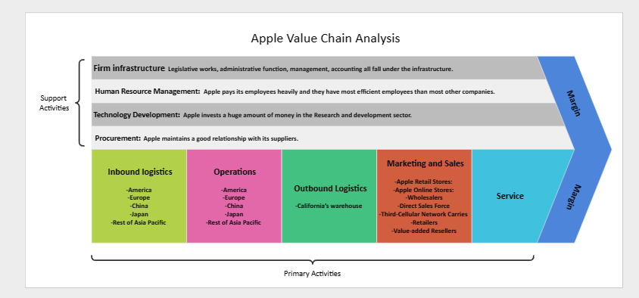
source: Internet
5.2.1 PRIMARY ACTIVICTIES
The company's primary activities in its value chain include inbound logistics, operations, outbound logistics, marketing and sales, and service. Inbound logistics involves the procurement of raw materials and components needed for manufacturing, Purchasing the supplies and parts needed for production is a part of inbound logistics. Inbound logistics deals with the storage, shipping, and distribution of finished goods to customers and retail channels, whereas outbound operations include the production, assembly, and testing of Apple's products. Advertising and promoting Apple products as well as running retail businesses like the Apple Store are examples of marketing and sales activity. Finally, service operations include maintenance, repair, and customer support.

5.2.2 SECONDARY ACTIVICTIES

Apple's secondary activities include procurement, technology development, human resource management, and infrastructure. Procurement involves the sourcing of raw materials and components for primary activities. Technology development involves research and development of new products and the improvement of existing products. Human resource management includes recruitment, training, and development of employees to support primary activities. Finally, infrastructure refers to the development and maintenance of physical and technological systems to support primary activities, such as manufacturing facilities and supply chain management.
Apple can find opportunities for operation improvement to add more value for its consumers through its value chain analysis. For instance, the business's investment in R&D has enabled it to produce ground-breaking new products, like the iPhone and iPad, which have aided in boosting sales and expanding its market share. Similar to this, Apple's focus on customer care and support has contributed to the development of a devoted customer base and brand value.

5.3 VRIO ANALYSIS OF DISTINCTIVE RESOURCES AND CAPABILITIES
A four-pronged review of an organization's resources and long-term success indicators is provided by the VRIO Framework. It emphasizes Value, Rarity, Imitability, and Organization as its four key objectives. These categories make up the foundation of the VRIO architecture and are crucial to comprehend while examining a company for success indicators

Value:
The distinguishing assets and skills of Apple include its powerful brand identity, cutting-edge product design, and ecosystem of included goods and services. These tools and talents help the business stand out from rivals and develop a devoted customer base, which adds significantly to the value it offers.
One of the most valuable brand names in the world, for instance, is Apple. The ability of the business to draw in and keep customers is greatly impacted by its associations with quality, innovation, and luxury. Furthermore, Apple's expertise in product design is widely regarded and has helped the corporation succeed in producing creative and user-friendly devices.
Rarity:
Apple's unique assets and skills are comparatively uncommon in the sector. For instance, rivals find it difficult to imitate the company's brand image and product design talents. Over the years, Apple has made considerable investments in R&D to create these resources and capabilities, and its ability to keep its inventive edge gives it a significant competitive advantage.
Imitability:
Even if Apple's unique assets and skills are challenging to duplicate, reproduction is a possibility. Competitors may try to imitate Apple's style of design or develop comparable integrated environments. However, Apple has an advantage in keeping its innovation edge thanks to its investment in R&D and its huge patent portfolio.
Organization:
Apple's unique assets and skills are arranged in a way that makes it possible for the corporation to make efficient use of them. To make sure that new goods are not only aesthetically pleasing but also practical and user-friendly, for instance, the company's product design and engineering teams collaborate closely. Additionally, Apple's massive retail and customer support activities help to sustain its integrated ecosystem.

The VRIO status of Apple's unique assets and abilities is "valuable, rare, difficult to imitate, and organised." This helps the business's ability to keep developing and providing value to its consumers while also giving it a major competitive advantage within the sector. (Apple Inc. (2022).)

5.4 SWOT ANALYSIS

Strength:
Apple has a powerful brand that is well-known all over the world. The business has been successful in cultivating a reputation for creating products of exceptional quality and originality that people clamour for (Chernev, 2018). Furthermore, Apple has a sizable and devoted consumer base that is eager to pay top dollar for its goods. The company's ability to constantly offer innovative items that meet or exceed consumer expectations has resulted in a base of devoted customers.

Weakness:
Because Apple's products are frequently more expensive than those of its rivals, they may not appeal to buyers who are price conscious (Chernev, 2018). Apple also faces supply chain risks because a small number of major suppliers account for a sizable portion of its component purchases. A disruption at one of Apple's crucial suppliers would affect the company's ability to manufacture its goods.

Opportunities:
In developing nations like India, where there is a sizable and expanding middle class, Apple has potential to increase its business (Chernev, 2018). Apple may also keep adding new products to its line-up and providing users with fresh services. For instance, the business just unveiled a streaming service and a credit card. These additional services could assist the business in reducing its reliance on the sale of hardware products and diversifying its sources of income.

Threats:
In the technological sector, Apple is up against fierce competition, especially from firms like Samsung and Huawei (Chernev, 2018). Furthermore, customer tastes can change quickly, which might make it challenging for Apple to hold onto its market share. Finally, geopolitical risks like trade conflicts and tariffs may hinder Apple's ability to conduct business in some regions.

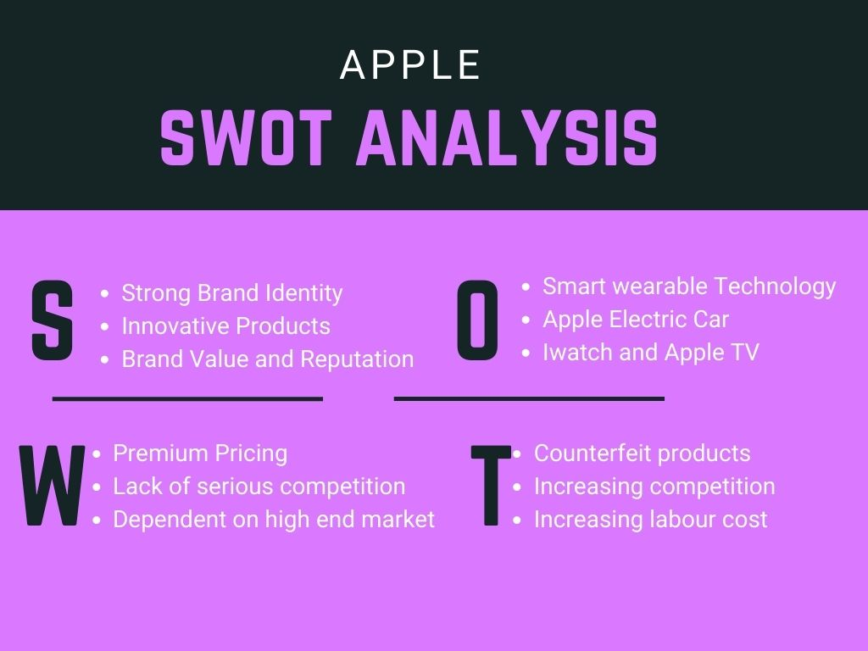

source: Internet

6.STRATEGIES TO SUSTAIN COMPETITVE ADVANTAGE

Apple Inc. uses a combination of Porter's generic strategies to maintain its competitive advantage in the market.

Differentiation strategy:
Apple's goods stand out from those of its rivals thanks to their superior user experience, quality, and design. Design and user interface are given a lot of importance by the company, which gives its goods a distinctive look. With the support of this tactic, Apple has been able to preserve its position as the market leader in technology while charging a premium for its goods. For instance, the designs and functionalities of the iPhone, iPad, and MacBook are unique and not present in any other goods on the market (Porter, 1985).

Focus strategy:
Targeting particular market segments and developing goods and marketing that are suited to their unique requirements are key components of Apple's focus approach. To meet the needs of various user types, the corporation, for instance, offers various iPhone, iPad, and MacBook models. Each device also has a particular marketing campaign from Apple that promotes its special qualities and advantages. This tactic has assisted Apple in retaining its core clientele and boosting sales (Porter, 1985).
Apple has been able to hold onto its position as the market leader and preserve its competitive edge in the technology sector thanks to a combination of differentiation and focus techniques. Customer loyalty and a strong brand image have been developed through the company's focus on design, quality, and user experience. Additionally, it has been able to efficiently reach particular market segments and address their needs thanks to its customised marketing strategy (Chen & Huang, 2019).
7. GROWTH STRATEGIES

Ansoff analysis is a strategic planning method that aids in finding corporate expansion prospects. It offers a framework for evaluating various business expansion strategies that a corporation could employ. The Ansoff matrix examines market penetration, market development, product development, and diversification as the four growth strategies.

Market penetration:
Apple has successfully increased its market share in the technology sector by using market penetration. To appeal to its current consumer base, the corporation has continuously launched updated versions of its products, including the iPhone and MacBook. As a result, Apple has been able to increase its market share and hold onto its position as the industry leader.

Market development:
Apple has also entered new international markets as part of its market development initiatives. By tailoring its products and marketing techniques to the regional markets, the corporation has successfully entered new markets like China and India. Apple has been able to grow its user base and income by entering new areas.

Product development:
Apple has a proven track record for product development and innovation. To meet the evolving requirements of its customers, the business frequently introduces new and improved goods, such as the Apple Watch and Air Pods. Apple has been able to set itself apart from rivals and keep its competitive advantage by creating new goods.

Diversification:
Although Apple's primary concentration is on its core technology items, the business has recently expanded its product line. Apple has increased its presence in the services sector with the help of products like iCloud, Apple Pay, and Apple Music. In a sector of technology that is continuously changing, Apple has been able to boost its revenue streams and reduce risk thanks to this diversification.

Apple has successfully applied a variety of Ansoff techniques to maintain its growth and maintain its position as the market leader in technology. Apple has been able to sustain a competitive advantage and position itself for future success by focusing on innovation and evolving with the markets. (Singh, P., & Srivastava, N. (2018))

8.GREEN STRATEGY AND CSR

Green strategy:
Apple Inc. has adopted several green strategies to promote sustainability and reduce its environmental impact. The utilisation of renewable energy in its operations is one of its most significant tactics. According to the company's commitment, all of its facilities will be powered by renewable energy, such as solar, wind, and geothermal energy (Apple Inc.2022). By focusing on energy-efficient technologies and procedures, such as using recycled materials in its products and minimising packaging waste, Apple has also worked to reduce its carbon footprint.
Apple's promotion of sustainability throughout its supply chain is another important initiative. With objectives to cut greenhouse gas emissions, preserve water, and enhance working conditions, the firm has set high environmental and social criteria for its suppliers (Apple Inc., 2022). Apple also takes part in industry-wide programmes like the Responsible Minerals Initiative and the Responsible Business Alliance that support sustainable sourcing.
Apple has also made efforts to advance innovative and sustainable product design. Like the MacBook with Retina display, which consumes 30% less energy than earlier versions (Apple Inc., 2022). The firm has also produced products with features that encourage energy conservation and prevent waste. Additionally, Apple has created recycling programmes for its goods, enabling users to send back outdated technology for reuse or ethical recycling.

CSR:
Companies are required to contribute to the social, environmental, and economic development of the areas in which they operate as part of corporate social responsibility (CSR), an important component of contemporary business practises. One such business that has proven a strong commitment to CSR is Apple Inc. The company's basic principles of innovation, quality, and design, which are incorporated into its products, services, and corporate culture, serve as the foundation for its CSR projects.
The sustainability of the environment, ethical sourcing, and employee welfare are the main focuses of Apple's CSR programmes. The corporation has set challenging goals to become carbon neutral by 2030 and reduce its carbon footprint. Additionally, it has committed to switching its operations and supply chain to 100% renewable energy. To reduce waste, Apple has included energy-efficient design elements in its products and scaled back the size and weight of its packaging. A recycling programme has also been put in place by the business to collect and repurpose materials from its goods.
Apple's responsible sourcing programmes are aimed at ensuring that the materials used in its products are obtained in an ethical and sustainable manner. The business has created a thorough code of conduct for suppliers that details the standards it has for them, including the defence of human rights, secure working conditions, and ethical environmental practises. A supplier responsibility programme that Apple has put in place checks suppliers' adherence to business standards and offers assistance and training to help them become more efficient.
Apple's extensive employee benefits programme, which includes health and wellness programmes, educational and professional development opportunities, and competitive compensation packages, reflects the company's dedication to the welfare of its workers. The organisation has made considerable expenditures in training programmes to advance the skills and talents of its employees. It has also adopted policies to support diversity and inclusion in its workforce.
Numerous stakeholders and business associations have praised Apple's CSR efforts. The business came in top on Fortune's Change the World list and second on Barron's list of the most sustainable businesses in 2020. The Environmental Protection Agency and the Carbon Disclosure Project have commended the corporation for its efforts to lessen its carbon footprint and switch to renewable energy.

9.CONCLUSION

The Apple Company is a preeminent technology firm that has maintained its market advantage through cutting-edge products, well-placed resources, and unique abilities. According to the PESTEL analysis, the organisation operates in a dynamic macroenvironment that poses a variety of possibilities and risks. Although the company faces fierce industry competition, its solid brand reputation and devoted client base provide it a competitive edge. This was discovered by the Porter's Five Forces analysis.
According to an internal analysis, Apple has a good organisational culture, a productive supply chain, and a solid financial standing. The VRIO research revealed that the company has organised, valuable, uncommon, and inimitable resources and competencies that give it a long-term competitive edge. The value chain analysis showed that the organisation places a high priority on product design and innovation.
The Ansoff Matrix demonstrated how Apple grows its business by entering new markets using a market development strategy. According to the examination of Porter's Generic Strategies, Apple employs a differentiation strategy to provide a distinctive product that stands out from rivals. In order to reduce its environmental effect and improve its corporate social responsibility, the company has also adopted green and sustainable practises in its operations.
In conclusion, Apple's strategic analysis demonstrates that the business has a solid basis for success and a clear plan for long-term growth. To sustain its competitive advantage, the business must continuously innovate and adjust to changes in the market and overall environment. By doing this, Apple may prosper and continue to rule the technology sector for many more years.

10. RECOMMENDATIONS

Based on the strategic analysis of Apple inc. the following recommendations can be considered;
- Diversification: To meet changing consumer needs, Apple Inc. should keep expanding its product portfolio. The business might think about entering new markets and rolling out new items like wearable technology or smart home appliances.
- Innovation: To keep its competitive edge, Apple Inc. should continue to prioritise innovation. The business can spend more money on R&D in order to release novel and distinctive items.
- Sustainable practices: To lessen its impact on the environment, Apple Inc. should keep implementing and promoting sustainable practises in its operations. The business might think about putting money towards waste reduction, promoting eco-friendly behaviours, and investing in renewable energy sources.
- Customer Centricity: Apple Inc. should keep putting its emphasis on offering outstanding customer service. The business may think about upgrading its customer service offerings and rolling out more specialised goods and services.
- Strategic Partnerships: To increase its capabilities and reach, Apple Inc. should continue to get into strategic collaborations with other businesses. The business may think about forming alliances with businesses operating in developing markets or in fields in which it lacked particular competence, like cloud computing or artificial intelligence.
By putting these suggestions into practise, Apple Inc. will be able to maintain its position as one of the world's top technology businesses while also remaining one step ahead of its rivals and accommodating customers' changing wants.

REFERENCES

Apple Inc. (2021). Annual Report 2020. Retrieved from https://www.apple.com/newsroom/pdfs/FY20-Fourth-Quarter-Results.pdf

Apple Inc. (2021). Environment. Retrieved from https://www.apple.com/environment/

Apple Inc. (2021). Form 10-K for the fiscal year ended September 26, 2020. Securities and Exchange Commission. https://www.sec.gov/ix?doc=/Archives/edgar/data/320193/000032019320000096/aapl-20200926.htm

Apple Inc. (2021). Mission Statement. https://www.apple.com/about/

Apple Inc. (2021). People. Retrieved from https://www.apple.com/people/

Apple Inc. (2021). Supplier Responsibility. Retrieved from https://www.apple.com/supplier-responsibility/

Apple Inc. (2022). Environmental responsibility report. Retrieved from https://www.apple.com/environment/pdf/Environmental_Responsibility_Report_2022.pdf

Apple Inc. (2022). Form 10-K Annual Report for the Fiscal Year Ended September 25, 2021. U.S. Securities and Exchange Commission.

Barney, J. (1991). Firm resources and sustained competitive advantage. Journal of management, 17(1), 99-120.

Barney, J. B., & Hesterly, W. S. (2015). Strategic management and competitive advantage: Concepts and cases. Pearson.

Barron's. (2020). Most Sustainable Companies. Retrieved from https://www.barrons.com/articles/the-100-most-sustainable-companies-51580972235

Carbon Disclosure Project. (2021). CDP Scores. Retrieved from https://www.cdp.net/en/scores-2020

Chen, Y., & Huang, H. (2019). Apple Inc.'s Sustainable Competitive Advantage: Analysis of Its Business Strategies. Journal of Business Research-Taiwan, 67(1), 1-10

Chernev, A. (2018). Strategic marketing management (8th ed.). Cerebellum Press.

Fortune. (2020). Change the World. Retrieved from https://fortune.com/change-the-world/

Grant, R. M. (2016). Contemporary strategy analysis: Text and cases edition. John Wiley & Sons.

Hill, C. W., & Jones, G. R. (2012). Strategic management theory: An integrated approach. Cengage Learning.

Hill, C. W., Jones, G. R., & Schilling, M. A. (2020). Strategic management: theory: an integrated approach. Cengage Learning.

KPMG. (2020). Sustainable supply chain management. Retrieved from https://home.kpmg/content/dam/kpmg/xx/pdf/2020/12/sustainable-supply-chain-management.pdf

Kulkarni, P. (2015). Understanding the industry life cycle and implications for corporate strategy. Journal of Business and Management, 17(1), 1-10.

Porter, M. E. (1985). Competitive Advantage: Creating and Sustaining Superior Performance. Free Press.

Porter, M. E. (2008). The five competitive forces that shape strategy. Harvard Business Review, 86(1), 25-40.

Singh, P., & Srivastava, N. (2018). Ansoff matrix, environment, and growth – an interactive triangle. Journal of Advances in Management Research, 15(1), 1-10.

Statista. (2021). Market capitalization of Apple from 2006 to 2021 (in billion U.S. dollars).

