Student Name: Ann Dineen
P Number: 1903613
Programme of Study: Documentary Photography
Module: Ways of Perceiving (ADAD4019)

Word count: 1496

Curation
Isolation Exhibition.
I started this task with several ideas of themes I would use, however with the onslaught of the corona virus and ‘lockdown’, with the closure of university all learning went online. I was then mainly confined to my own home, the idea of looking at artists or photographers who thrived in isolation became more relevant. I started researching exhibitions on the theme of isolation and artists who have thrived in that environment.
The title of my exhibition is simply called ‘Isolation’ I will be looking at the very new Banksy painting, ‘The Game Changer’. Rebecca Horn’s sculpture ‘In the Triangle’, Barbara Ess, photograph ‘The Fire Escape’. Freda Kahlo, painting ‘Me and My Parrots’. Edvard Munch, painting ‘Separation’. All these pieces were created by the artists whilst isolated in some way, which brings them all together within the exhibition.
I am going to use the floor plans provided of The Mission Gallery as I feel the space is ideally suited to the pieces of art I have selected and also reflects the theme, The mission Gallery began life as St Nicholas Church in 1868, so would have been intended as a place for worshippers to go to pray and contemplate and to be alone. The art pieces are not huge so would sit within the space.

The Oxford English Dictionary (2020) defines the word ‘Isolation’ as ‘The act of separating

somebody/something; the state of being separate’ this is certainly a concept we all understand

at this moment in time. We are currently living through a pandemic the likes of which we have never experienced before. We find ourselves confined to our home with restrictions on how and when we are allowed to leave the house and even then we must keep our distance from others, we are not allowed to visit family and friends, we cannot travel to favourite destinations or take holidays, for some people this total isolation can have a negative impact on their mental health, there are many articles and pieces of research looking at this very idea in particular Courtin, E. Knapphttps. M research into Social isolation, loneliness and health in old age: a scoping review (2015) found evidence to that fact. It was important to me to look at the positives from this situation, we can either sit back and do nothing or we can use the time to be creative. Sometimes out of adverse situations people produce their best work.
With the idea that we are all now experiencing isolation in some form or other at this time we can all understand or at the very least appreciate how an artist would feel when creating work whilst isolated, whether that be their own choice or forced upon them is it on us now.
I have drawn on the ideas from Hans Ulrich Obrist ‘Ways of Curating’ (2015) in particular looking for a link or commonality between the pieces I have chosen for my exhibition. Whilst they have been painted, made or photographed in different periods of time they all reflect the same theme.

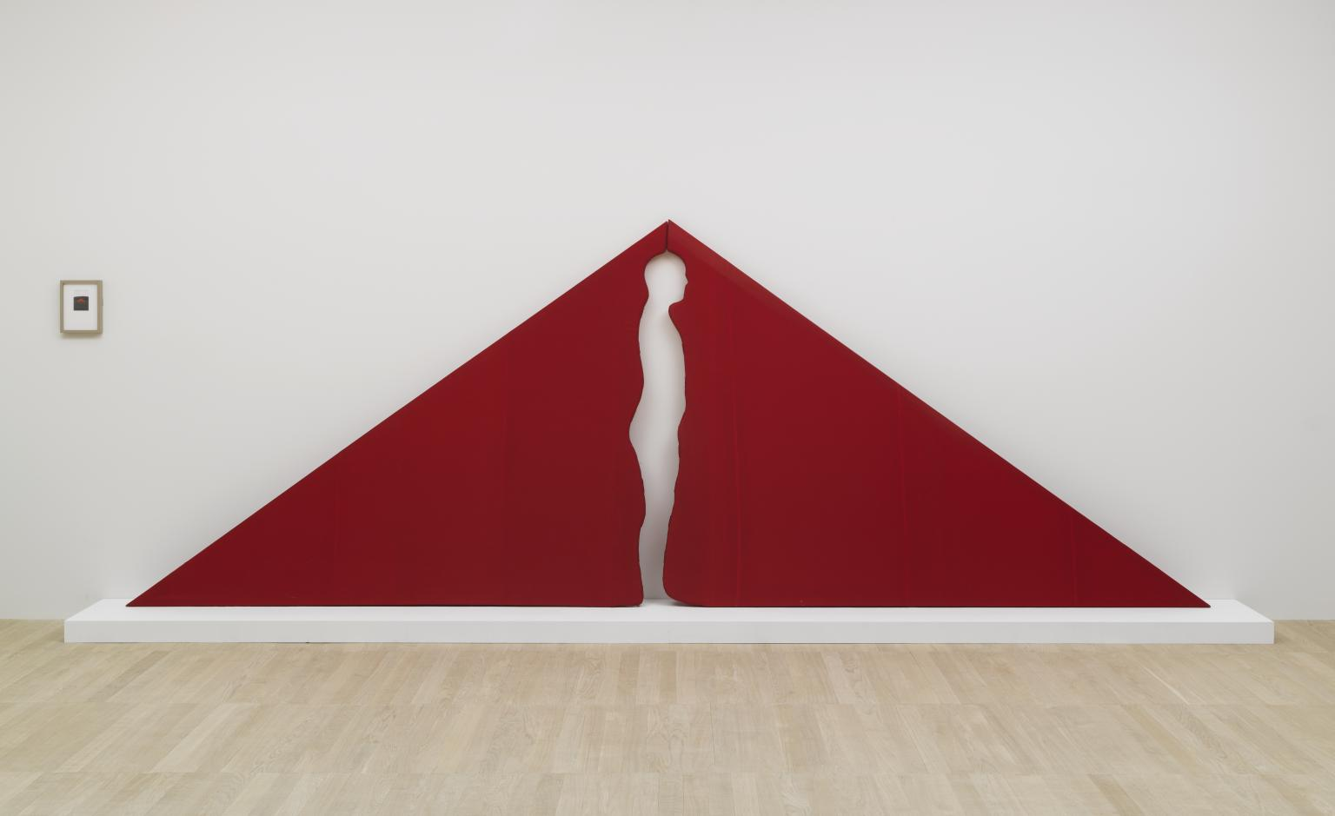
Fig 1.

My first piece of art is the sculpture by Rebecca Horn ‘In the Triangle (1973) she was artist born in 1944 who had been confined to Psychiatric Hospitals during her early twenties after suffering from severe lung poisoning while working unprotected with polyester and fibreglass at Hamburg’s Academy of the Arts. Her work was born out of that time and focuses on challenging society and institutions view of the human shape.
In the Triangle It’s a large two-dimensional triangle made with fabric. A person stands within the triangle so that their head sticks out from its apex while the sides extend in front and behind so that the body is entirely concealed within the fabric. The wearer is transformed into a geometric shape.
In the exhibition I image this piece placed at the rear of the building in the arched area and sitting horizontally to the walls so that it dominates the area, so that the viewer gets a full view of the piece before entering the room. I also feel it invites the viewer to be part of sculpture, it appears to encourage you to try it on, or to pass through the shape.

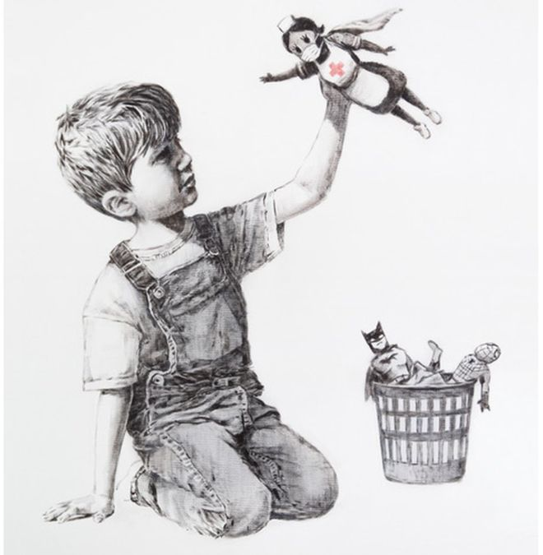
Fig 2.

As you enter the mission gallery, I plan on placing my next piece of art, Banksy. ‘Game Changer’ (2020) on the wall between the two doors. This is Banksy’ second piece of work created during lockdown, the first one was of rats running amok in his bathroom, he captioned it with ‘My wife hates it when I work from home’ Gompertz, W. (6th May 2020) BBC news in reference to the hordes of people who unable to go into work are forced to work from home, I could have used this piece but felt the ‘Game Changer’ better reflected the theme and sums up the mood at this time. The artwork first appeared in the foyer of Southampton General Hospital in May 2020 and is particularly relevant to the time frame as it depicts a young child discarding the usual superhero toys for a doll dressed as an NHS nurse. It was intended as a thankyou to the staff from the artist and I’ve included this piece as I feel it reflects todays mantra of clapping for our carers and I feel that the viewer will instantly recognise this piece and understand its value in reflecting the current climate. I also feel it is a departure from the artists usual anti-establishment style and appears to have brought out a feeling of unity and hope which I hope the viewer will gain from this.

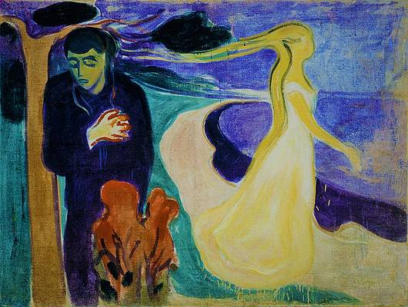
Fig 3.

As you move round the gallery on the left hand wall, I intend to place Edvard Munchs’ ‘Separation’ (1896) this painting depicts a couple appearing to go their sperate ways, to be separated from each other. As an artist Munch often produced work of intense phycological themes the most famous being ‘The Scream’ (1893) which depicts the character clutching their face and has often been explained as an emotive response to Munchs’ own inner demons and feeling s of anxiety. During this pandemic many people have been separated from family, friends and loved ones, forced to communicate purely through technology. The painting shows the sadness of the man being separated from his partner and I feel this will resonate with the viewer.

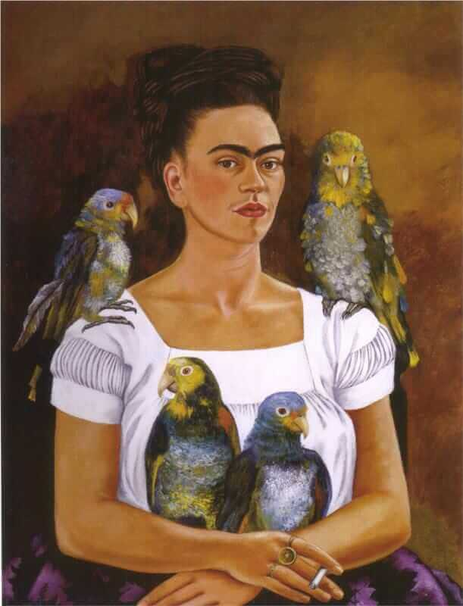
Fig 4.

On the opposite wall to this I plan to place Freda Kahlo ‘Me and My Parrots’ (1941) the painting is a self portrait of the artist, who at the time of creating this whilst she was married to Diego Rivera, himself the Chief artist of Mexico, however at this time they lived separately. Kahlo took up painting whilst recovering from an accident that broke her pelvis and left her in considerable pain. She used a mirror attached to the canopy of her bed, many of her pieces were self-portraits, of which she painted around 60 self-portraits. Again, I felt out of that isolation she developed a talent for art and maybe had it not been for that time where a person is forced to keep themselves occupied that may never have happened. It certainly fits in to the theme.

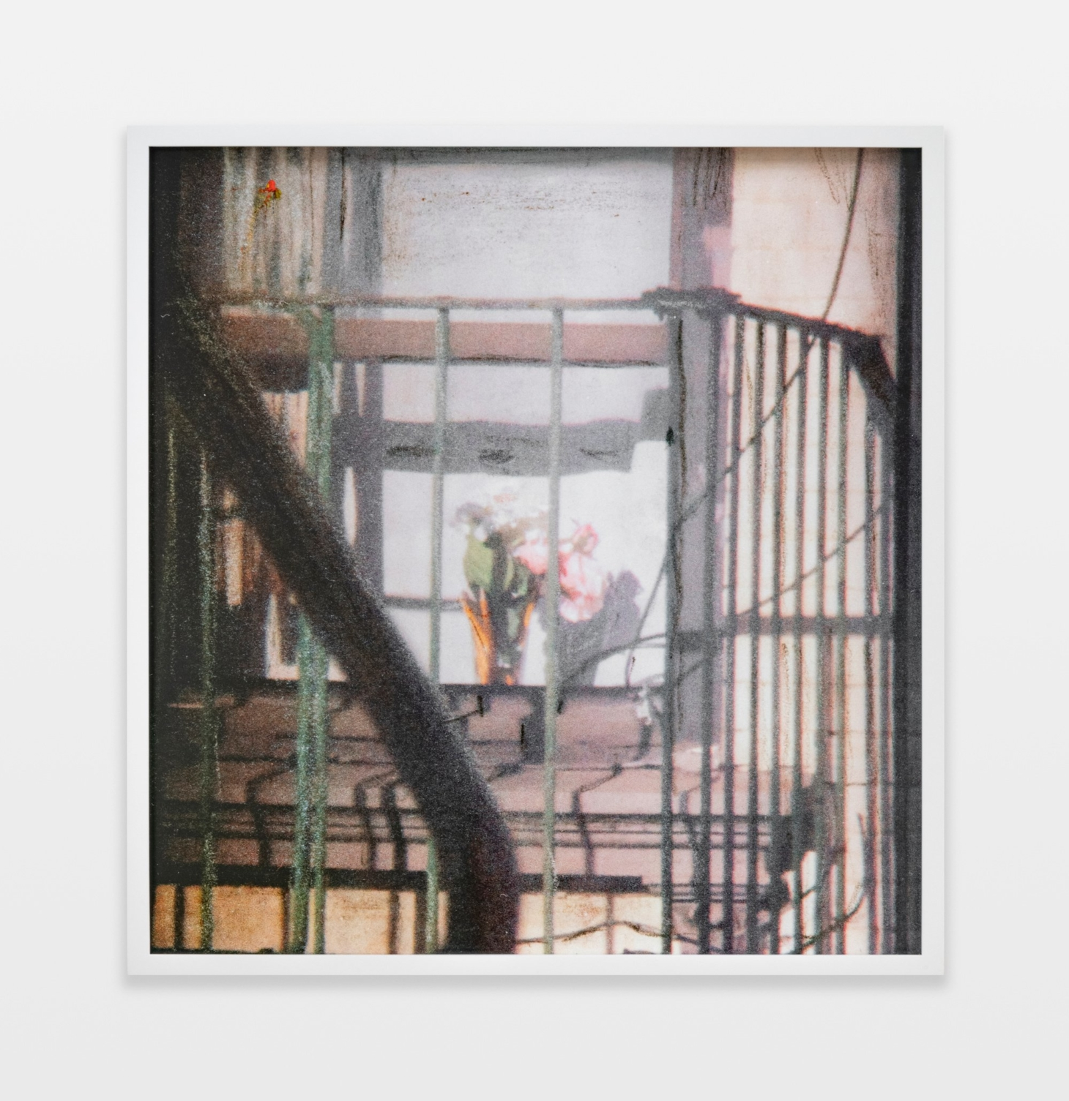
Fig 5.

Continuing around the gallery I would place a photograph by Barbara Ess ‘Fire Escape’ (2018/19) in the alcove to the left, I feel this is a fitting place for a small piece of artwork about confinement. Barbara Ess is well known for her use of the pinhole camera and she manages to capture seemingly mundane views in very artistic way. This image although a photograph has a very arty feel to it, no doubt as it started life as a small print which she then enhanced with silver, white and black crayons. This image was part of a series of images called ‘Shut In’. Ess was isolated in her New York apartment for over a month and as she couldn’t continue to work as she would normally, she began photographing her surroundings, it was the fact she was stuck in her apartment that she had the time to notice things around her, things that would normally seem mundane she noticed the way the fire escape was lit and how it changed as the light moved and thus she began photographing these items. This particular piece I feel fits the theme perfectly as we are all sitting in our homes looking out at the moment.

Fig 6
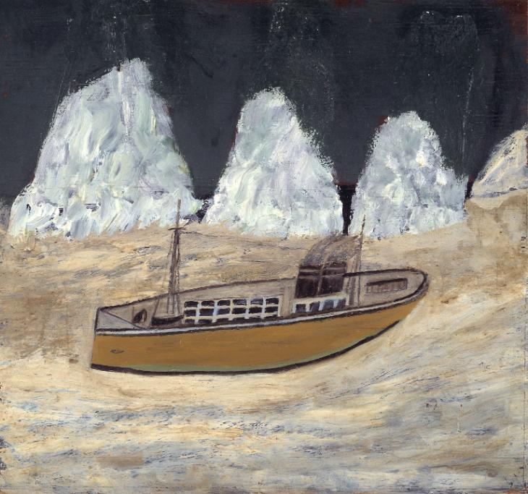

My last painting by the artist Alfred Wallis Voyage to Labrador. (1935–6) and would hang in the opposite alcove. I chose this painting as some artists choose to isolate themselves in order to create art rather than circumstance force it upon them. The artist here would often spend long periods of time in his home not going out and would paint from memory. So I feel it is fitting to end with a piece of art created in isolation but through choice.

Bibliography

Obrist, H U. (2015) ‘Ways of Curating’

https://www.oxfordlearnersdictionaries.com/definition/english/isolation

https://www.thelancet.com/action/showPdf?pii=S2215-0366%2820%2930168-1
Courtin, E. Knapphttps. M. (2015) Social isolation, loneliness and health in old age:
a scoping review. www.onlinelibrary.wiley.com/doi/full/10.1111/hsc.12311
Gompertz, W. (6th May 2020) New Banksy artwork appears at Southampton hospital
https://www.bbc.co.uk/news/entertainment-arts-52556544
https://www.tate.org.uk/art/artworks/wallis-voyage-to-labrador-t00220

Fig 1.
Rebeccxa Horn. ‘in the triangle’ (1973)
Fig 2.
Banksy. ‘Game Changer’ (2020)

Fig 3.

Munch, E. ‘Separation’ (1896)

Fig 4.
Kahlo, F. ‘Me and my parrots’
Fig 5.
Barbara Ess, ‘Fire Escape’(2018/2019)
Fig 6.

Alfred Wallis. ‘Voyage to Labrador’ (1935–6)

Plan

