
Module code: BMBM6016 | Module: Strategic Marketing

STRATEGIC MARKETING AUDIT: GREGGS PLC



Name: Zihao Xiong (Enzo)
Student number: 2405686
Lecturer: Gwyneth Jones
Submission Date: 2025.03.28
Words account: 2714
University of Wales Trinity Saint David

Executive Summary
Greggs PLC has successfully transformed from a traditional bakery chain into a prominent food-on-the-go retailer in the UK market. This strategic marketing audit critically evaluates Greggs' market positioning through systematic application of theoretical frameworks including PESTEL, Porter's Five Forces, VRIO, Value Chain Analysis, and SWOT.
The analysis reveals that Greggs has established competitive advantages through its value proposition, vertically integrated supply chain, and strategic store expansion. Despite facing significant economic headwinds including inflation and rising operational costs, Greggs continues to leverage its brand equity and operational efficiency to drive growth. While digital transformation and sustainability initiatives have strengthened its market position, intensifying competition and evolving consumer preferences present ongoing challenges. This report concludes with strategic recommendations to enhance Greggs' sustainable growth trajectory and market resilience.

Executive Summary 2
1. Introduction 4
2.1 Macro-Environmental Analysis (PESTEL) 4
2.1.1 Political Factors 4
2.1.2 Economic Factors 5
2.1.3 Social Factors 5
2.1.4 Technological Factors 5
2.1.5 Environmental Factors 5
2.1.6 Legal Factors 5
2.2 Micro-Environmental Analysis 6
2.2.1 Porter's Five Forces Analysis 6
2.2.2 Competitive Analysis (See Appendix D for price comparison table) 7
2.2.3 Customer Analysis 7
3. Internal Environment Analysis 7
3.1 VRIO Framework Analysis 7
3.2 Value Chain Analysis 8
3.3 Core Competencies 8
4. SWOT Analysis 9
4.1 Strengths 9
4.2 Weaknesses 10
4.3 Opportunities (See Appendix H for store distribution map) 10
4.4 Threats 10
4.5 Strategic Implications 11
5. Strategic Recommendations 11
5.1 Enhance Value Proposition Through Strategic Pricing and Product Innovation 11
5.2 Accelerate Digital Integration Across Customer Journey 12
5.3 Optimize Location Strategy for Changing Consumer Behaviour 12
5.4 Strengthen Supply Chain Resilience and Sustainability 13
5.5 Evolve Brand Positioning for Broader Appeal 13
6. Conclusion 13
Reference 15
Appendices 21
Appendix A: Analytical Frameworks Description 21
PESTEL Analysis 21
Porter's Five Forces 21
VRIO Framework 21
Value Chain Analysis 21
SWOT Analysis 21
Appendix B: Expanded PESTEL Analysis 22
Appendix C: Detailed Porter's Five Forces Analysis 24
Appendix D: Competitor Price Comparison 26
Appendix E: Complete VRIO Analysis 27
Appendix F: Expanded Value Chain Analysis 30
Appendix G: Expanded SWOT Analysis 34
Strengths 34
Weaknesses 35
Opportunities 37
Threats 39
Appendix H: Greggs Store Distribution Map 41

1. Introduction
Founded in 1939, Greggs has evolved from a traditional Tyneside bakery into the UK's leading bakery food-on-the-go retailer (MOMIN, 2022). Following its London Stock Exchange listing in 1984, the company has experienced significant expansion, now operating approximately 2,600 stores nationwide (Newman, 2025).
This audit critically analyses Greggs' strategic position within the UK fast food and bakery retail sector, evaluating external and internal environments to assess competitive advantages and strategic orientation.
The analysis employs PESTEL analysis, Porter's Five Forces, VRIO Framework, Value Chain Analysis, and SWOT analysis to provide a comprehensive assessment of Greggs' strategic marketing position. (See Appendix A for framework descriptions)

2.1 Macro-Environmental Analysis (PESTEL)
The PESTEL framework systematically analyses macro-environmental factors influencing organizational strategy through examination of Political, Economic, Social, Technological, Environmental, and Legal dimensions. (See Appendix B for expanded analysis)

2.1.1 Political Factors
The UK government's 2024 budget increased employers' National Insurance contributions from 13.8% to 15%, imposing "tens of millions of pounds" in additional costs (Davey, 2024). Greggs' commitment to maintain growth plans despite these pressures demonstrates strategic resilience compared to competitors who warned of inflation and job losses (Fish and Powell, 2025).

2.1.2 Economic Factors
Despite cost inflation of approximately 9% (Walsh, 2022), Greggs has demonstrated countercyclical resilience with its value proposition attracting cost-conscious consumers during economic downturns. This resulted in 2024 sales exceeding £2 billion for the first time despite challenging market conditions (Newman, 2025).

2.1.3 Social Factors
Health consciousness has driven expansion of the "Balanced Choice" range, now representing 10% of sales (Kollewe, 2016), while the 2019 vegan sausage roll launch drove sales above £1 billion for the first time (Vegconomist, 2023). YouGov data revealing 57% of customers are aged 40+ has prompted strategic youth-targeting initiatives (Shakespeare, 2020).

2.1.4 Technological Factors
Digital transformation has significantly enhanced Greggs' business model, with app-based transactions increasing from 12.5% of sales in 2023 to over 20% by 2024 (Newman, 2025). Partnerships with delivery platforms like Just Eat have expanded market reach beyond physical locations (Fish, 2024).

2.1.5 Environmental Factors
Greggs has committed to becoming net zero by 2040, ahead of UK government targets (Greggs, 2023), achieving a 10% reduction in manufacturing food waste since launching The Greggs Pledge (Dennis, 2023).

2.1.6 Legal Factors
While National Living Wage increases add cost pressure, CEO Currie observed this could simultaneously benefit Greggs by increasing consumer spending capacity (Carroll, 2025), highlighting the complex implications of legal factors on business performance.
Critical Evaluation: The PESTEL analysis reveals Greggs' remarkable strategic agility in a challenging environment, particularly in converting social trends into product innovations and potential threats into opportunities. However, the framework's limitations include its descriptive nature and interconnected impacts across categories. For Greggs, this necessitates balancing rising costs with consumer price sensitivity while leveraging social shifts for product development.

2.2 Micro-Environmental Analysis

2.2.1 Porter's Five Forces Analysis
Porter's Five Forces framework evaluates competitive intensity by analysing supplier and buyer power, threats of new entrants and substitutes, and competitive rivalry to identify sustainable competitive positions. (See Appendix C for detailed analysis)
Threat of New Entrants (Moderate): Greggs' vertically integrated supply chain provides substantial defense against new entrants (Oakley, 2024), though regional players can still establish footholds in specific markets.
Bargaining Power of Suppliers (Low to Moderate): In-house manufacturing capabilities and strategic forward purchasing significantly diminish supplier bargaining power, though certain commodity price fluctuations remain challenging (Walsh, 2022).
Bargaining Power of Buyers (Moderate): Individual consumers have limited bargaining power, but collective price sensitivity significantly influences Greggs' strategic decisions, necessitating careful price-value balancing (Hotten, 2022).
Threat of Substitutes (High): Diverse alternatives including coffee chains, fast-food restaurants, and supermarket meal deals create a complex competitive landscape with low switching costs (Isla, 2024).
Competitive Rivalry (High): The food-to-go sector exhibits intense competitive rivalry, though Greggs has effectively differentiated through value leadership (Carroll, 2025) in a market where "consumers are increasingly focused on value" (Innes and Carroll, 2023).
Critical Evaluation: This analysis reveals Greggs has established effective competitive buffers through vertical integration despite operating in a highly competitive market with significant substitution threat. Its limitations include the framework's static nature and emphasis on competition over collaboration. For Greggs, the strategic imperative is continued strengthening of its value proposition and operational distinctiveness in a market with minimal switching costs.

2.2.2 Competitive Analysis (See Appendix D for price comparison table)
Greggs maintains competitive advantage primarily through price positioning, with a regular flat white priced at £1.95 versus Costa's £3.85 and Pret's £4.05 (Brown, 2024). This value leadership, combined with convenience and consistent quality, provides significant differentiation despite Greggs facing competition from premium alternatives like Pret A Manger focusing on "fresh, natural ingredients" (Isla, 2024).
The competitive landscape extends to fast food restaurants, though Greggs claimed in 2024 to have "dethroned McDonald's to become Britain's most popular breakfast spot" (Fish, 2024). Supermarkets present growing competition through expanded food-to-go offerings, though Greggs has strategically converted some competitors into partners through store-in-store arrangements with retailers including Tesco and Sainsbury's (Oakley, 2024).

2.2.3 Customer Analysis
Greggs targets broad customer segments seeking convenient, affordable food options. Demographic concentration among older consumers has prompted initiatives to attract younger consumers without alienating the core customer base (Shakespeare, 2020).
Buying behaviour has evolved with digital transformation, with app usage growing to over 20% of transactions (Newman, 2025). Changes in work patterns have created demand for extended daypart offerings, with evening sales becoming "the fastest-growing part of the day" (Newman, 2025).

3. Internal Environment Analysis

3.1 VRIO Framework Analysis
The VRIO framework evaluates resources and capabilities based on Value, Rarity, Imitability, and Organizational support to identify sustainable competitive advantages. This framework was applied to Greggs' resources, identifying key advantages in brand reputation, store network, integrated supply chain, and operational efficiency. (See Appendix E for complete VRIO analysis)
Critical Evaluation: The VRIO analysis reveals Greggs possesses several resources meeting all four criteria, particularly its integrated supply chain and operational efficiency. Limitations include the subjective nature of evaluating "rareness" and "imitability" and emphasis on existing rather than future capabilities. For Greggs, this necessitates continued investment in distinctive attributes while developing new competencies, especially in digital engagement.

3.2 Value Chain Analysis
Porter's Value Chain framework disaggregates an organization into strategically relevant activities to understand cost behaviours and differentiation sources by examining both primary and support activities. (See Appendix F for expanded analysis)
Primary Activities: Greggs' sophisticated inbound logistics capabilities contribute significantly to operational efficiency, while manufacturing excellence in multiple production facilities delivers scale and automation advantages. The company's vertically integrated approach to outbound logistics enables optimization of delivery routes while controlling costs. Marketing capabilities have successfully driven customer engagement, with the app representing "over 20% of total sales" (Newman, 2025).
Support Activities: Greggs maintains a "substantial net cash position" providing flexibility for investment (Oakley, 2024). Human resource management emphasizes employee development and profit-sharing, with Currie describing the employee bonus program as "absolutely sacred" (Davey, 2024). Technology investments include implementation of "a future-proof, security-centred software-defined wide area network" (O'Halloran, 2022).
Critical Evaluation: The Value Chain analysis reveals Greggs has created distinctive value through vertical integration and operational excellence, enabling competitive pricing while maintaining superior margins. Limitations include category overlap and challenges quantifying individual activities' value contributions. For Greggs, this highlights opportunities to enhance value creation through digitalization, particularly in marketing and service activities.

3.3 Core Competencies
Core competencies are distinctive capabilities spanning multiple business units that provide market access, contribute significantly to customer benefits, and resist competitor imitation. This framework helps identify unique competitive capabilities and strategic investment priorities.
Analysis reveals four distinctive core competencies driving Greggs' competitive advantage:
Cost-Efficient Value Delivery: Greggs' operating margins at "9.5 per cent... is more than double the margins of Tesco" (Oakley, 2024), demonstrating superior ability to deliver appealing products at competitive prices while maintaining sustainable margins.
Responsive Product Innovation: The vegan sausage roll exemplifies Greggs' ability to identify emerging trends and develop products that generate transformative commercial success by combining market insight with efficient implementation (Foudy, 2024).
Strategic Location Network Management: Greggs has developed sophisticated capabilities in site selection and format development, with Brown (2024) noting that "smaller units cost less to rent, brand and need fewer staff to operate, allowing Greggs to open in new locations quickly."
Multi-Channel Customer Engagement: The company has built differentiated capability in engaging customers across physical, digital, and hybrid channels, with app-based transactions reaching "over 20% of total sales" (Newman, 2025) while physical expansion continues.
Critical Evaluation: This analysis reveals how Greggs' interconnected competencies support its market success, particularly how operational efficiency enables value positioning. Limitations include challenges objectively determining true competencies versus temporary advantages and potential overemphasis on existing capabilities. For Greggs, this underscores the importance of enhancing these competencies while developing new capabilities in sustainability and personalization.

4. SWOT Analysis
The SWOT framework synthesizes internal and external assessments by evaluating Strengths, Weaknesses, Opportunities, and Threats, providing an organized approach to understanding competitive position and creating a foundation for strategy development. (See Appendix G for expanded analysis)

4.1 Strengths
- Strong Brand Reputation and Recognition - Resonating with UK consumers through values of quality, affordability, and unpretentious service
- Vertically Integrated Supply Chain - Providing "cost advantage and competitive edge over its rivals" (Oakley, 2024)
- Value Proposition and Price Competitiveness - Creating clear differentiation while attracting price-conscious consumers
- Extensive Store Network - Providing unmatched accessibility through approximately 2,600 stores (Newman, 2025)
- Product Innovation Capabilities - Consistently identifying and responding to consumer trends
- Digital Engagement - With the Greggs app now representing "over 20% of total sales" (Newman, 2025)

4.2 Weaknesses
- Limited Menu Diversity - Potentially limiting appeal to certain customer segments
- Regional Brand Strength Variations - With stronger presence in northern regions than southern areas
- Store Size Limitations - Many locations "designed for quick visits" limiting dine-in opportunities (Brown, 2024)
- Vulnerability to Input Cost Inflation - Despite vertical integration
- Evening Daypart Underdevelopment - Despite growth potential
- Technology Infrastructure Still Evolving - As evidenced by the 2024 payment system glitch (Krishnan, 2024)

4.3 Opportunities (See Appendix H for store distribution map)
- Digital Expansion and Personalization - Leveraging growing customer data assets
- New Location Formats - With capacity to nearly double the UK store count (Davey, 2024)
- Extended Dayparts - Particularly evening trade, which is "growing quickly" (Oakley, 2024)
- Strategic Partnerships - Building on successful collaborations with retailers
- Sustainability Leadership - Converting environmental initiatives from compliance into competitive advantage
- Product Category Expansion - Building on success in breakfast sales where Greggs holds "nearly 20 per cent" market share (Oakley, 2024)

4.4 Threats
- Intense Competition - From diverse players creating "an increasingly promotional fast-food environment" (Fish, 2024)
- Changing Consumer Preferences - Requiring continuous adaptation to health and ethical consumption trends
- Economic Pressures - With Currie citing "low" consumer confidence (Newman, 2025)
- Rising Operational Costs - With expected "input cost inflation in 2025 to be around 6%" (News, 2025)
- Supply Chain Disruptions - Despite vertical integration
- Technological Disruption and Cybersecurity Risks - As digital channels become more central to operations
Critical Evaluation: The SWOT synthesis reveals how Greggs can leverage distinctive strengths against identified opportunities, particularly using its store network and digital capabilities to support expansion into new formats and dayparts. Limitations include the subjective nature of categorization and challenges prioritizing factors of varying strategic significance. For Greggs, this necessitates balanced initiatives exploiting strengths (value proposition and operational efficiency) while addressing critical weaknesses (evening daypart development) against intensifying competition.

4.5 Strategic Implications
Key strategic imperatives emerging from the SWOT analysis include: balanced growth and margin management amid rising costs; digital transformation acceleration; location strategy refinement focused on transport hubs and convenience; brand evolution to appeal to broader demographic segments; deeper sustainability integration; and supply chain resilience building through capacity expansion and technology adoption.

5. Strategic Recommendations

5.1 Enhance Value Proposition Through Strategic Pricing and Product Innovation
- Tiered pricing strategy - Develop clear "good, better, best" options within product categories. This approach aligns with Carroll's (2025) observation that Greggs' value leadership has been crucial to its market differentiation during economic pressure.
- Menu extension into premium dayparts - Accelerate evening menu development with higher-margin options. With evening sales identified as "the fastest-growing part of the day" (Newman, 2025), this represents a significant revenue opportunity.
- Healthier options expansion - Build on the "Balanced Choice" range success. Kollewe (2016) notes this range already accounts for 10% of sales, demonstrating proven consumer demand.
As Riley (2025) observes, when "consumer spending habits are in flux," businesses must "recalibrate their offerings" through "innovating their product lines and rethinking their pricing structures."

5.2 Accelerate Digital Integration Across Customer Journey
- Personalization engine development - Leverage app usage data to create increasingly tailored offers. With app usage increasing from 12.5% to over 20% of transactions in just one year (Newman, 2025), this represents a significant engagement opportunity.
- Omnichannel integration - Fully connect digital and physical customer experiences. Jefferson (2021) identifies this "two-pronged focus on digital innovations, coupled with releasing in-demand products" as central to Greggs' resilience.
- Operational technology enhancement - Implement advanced forecasting systems, building on Greggs' existing investment in "a future-proof, security-centred software-defined wide area network" (O'Halloran, 2022).
Taylor (2023) observes that "technology needs to make [customer service] easier and more efficient without compromising on quality," highlighting the balance required between digital advancement and service quality.

5.3 Optimize Location Strategy for Changing Consumer Behaviour
- Transport hub and convenience focus - Prioritize expansion in travel locations and roadside sites. Davey (2024) confirms Greggs' strategic shift toward "petrol forecourts, retail parks and transport sites," which should be accelerated.
- London penetration strategy - Develop a targeted approach to increase central London presence. Oakley (2024) specifically identifies significant opportunity "to open many shops in central London where the company is significantly underrepresented."
- Format diversification - Expand drive-through and smaller footprint formats. Brown (2024) notes that Greggs' smaller units "cost less to rent, brand and need fewer staff to operate," providing flexibility for efficient expansion.
Felinah (2025) highlights Greggs' use of "geospatial data and AI" in "strategic placement" of stores based on "patterns of human movement and consumption," suggesting sophisticated location intelligence capabilities.

5.4 Strengthen Supply Chain Resilience and Sustainability
- Manufacturing automation acceleration - Increase investment in automated production technologies. Davey (2024) reports that Greggs "is leaning more on robots to keep costs down," a necessary response to rising labour costs.
- Sustainability initiative expansion - Extend eco-shop elements across the store estate. Dennis (2023) documents Greggs' achievement in reducing "manufacturing food waste by 10%" since launching The Greggs Pledge.
- Supplier collaboration enhancement - Develop deeper partnerships with key suppliers. This addresses Walsh's (2022) observation about challenges in "sourcing dairy products, cereals and protein" during inflationary periods.
Uwemedimo (2024) notes that Greggs' new Derby facility already incorporates sustainability features including "an onsite shared energy centre... that recycles heat from refrigeration plants."

5.5 Evolve Brand Positioning for Broader Appeal
- Regional tailoring enhancement - Develop more regionally adapted product offerings. This addresses Felinah's (2025) analysis of Greggs' uneven store distribution across regions.
- Age-segment targeting refinement - Create tailored marketing approaches for different demographic segments. Shakespeare (2020) documented how initiatives helped increase "consideration scores among 18 to 34 year olds" by 7.3 points.
- Quality perception elevation - Selectively highlight product quality credentials. Gilliland (2019) noted Greggs has successfully "shake[n] off its outdated and 'stodgy' image, and carve a new reputation as a rival to modern and desirable coffee brands."

6. Conclusion
Greggs has successfully transformed from a traditional bakery chain into a modern food-on-the-go retailer with a distinctive market position built on value, convenience, and consistent quality. The company's vertically integrated business model provides significant competitive advantages in manufacturing efficiency, cost control, and supply chain management.
Despite challenging economic conditions, Greggs has demonstrated remarkable resilience, with annual sales exceeding £2 billion for the first time in 2024 (Newman, 2025). This performance reflects both the enduring appeal of Greggs' value proposition and the effectiveness of its strategic execution.
Looking forward, Greggs faces a complex external environment presenting both significant challenges and substantial opportunities. By leveraging its core strengths in operational efficiency and value delivery while addressing opportunities in digital transformation, location diversification, and sustainability leadership, Greggs can continue its growth trajectory despite market challenges.
As Riley (2025) observes, "when consumer behaviour shifts, agility in product and pricing strategy can make all the difference." Greggs' blend of traditional values and forward-looking innovation positions it well to navigate future challenges while capitalizing on emerging opportunities.

Reference
- Brown, M. (2024). How Greggs won the high street food wars. [online] Times Money Mentor. Available at: https://www.thetimes.com/money-mentor/income-budgeting/how-greggs-makes-money-selling#app-success [Accessed 11 Mar. 2025].
- Carroll, N. (2025). Greggs pledges to ‘meet the headwinds’ of 2025 with value offering. [online] Marketing Week. Available at: https://www.marketingweek.com/greggs-meet-headwinds-value/ [Accessed 11 Mar. 2025].
- CILT(UK). (2024). Greggs set to increase supply chain capacity. [online] Available at: https://ciltuk.org.uk/News/Latest-News/ArtMID/6887/ArticleID/37523/Greggs-set-to-increase-supply-chain-capacity.
- Cresswell, K. (2024). How small businesses can be more Greggs - Kings Hill Marketing Consultancy. [online] Kings Hill Marketing Consultancy. Available at: https://kingshillmarketing.co.uk/how-small-businesses-can-be-more-greggs/ [Accessed 11 Mar. 2025].
- Davey, J. (2024). Greggs’ growth story won’t be derailed by UK budget, CEO says. Reuters. [online] 25 Nov. Available at: https://www.reuters.com/world/uk/greggs-growth-story-wont-be-derailed-by-uk-budget-ceo-says-2024-11-25/ [Accessed 11 Mar. 2025].
- Dennis, P. (2023). Greggs reduces manufacturing food waste by 10%. [online] Circular Online. Available at: https://www.circularonline.co.uk/news/greggs-reduces-manufacturing-food-waste-by-10/ [Accessed 11 Mar. 2025].
- Felinah, D. (2025). How Many Greggs Are in England? All You Need to Know About UK’s Top Bakery Chain. [online] Xmap.ai. Available at: https://www.xmap.ai/blog/how-many-greggs-are-in-england [Accessed 11 Mar. 2025].
- Fish, I. (2024). Greggs rules out price rises after sales slow. [online] Thetimes.com. Available at: https://www.thetimes.com/business-money/companies/article/greggs-rules-out-price-rises-after-sales-slow-j7t2pdkwx [Accessed 11 Mar. 2025].
- Fish, I. and Barnett, J. (2025). Food prices forecast to rebound 4.2% as levy and wage rises bite. [online] Thetimes.com. Available at: https://www.thetimes.com/business-money/economics/article/food-prices-forecast-to-rebound-42-percent-as-levy-and-wage-rises-bite-0xjc72bkr [Accessed 11 Mar. 2025].
- Fish, I. and Powell, E. (2025). UK retail shares fall on fears over economy and rising costs. [online] Thetimes.com. Available at: https://www.thetimes.com/article/df9be535-3f8d-4744-a914-307673960235 [Accessed 11 Mar. 2025].
- Foudy, M. (2024). A Successful Digital Marketing Campaign – Gregg’s vegan sausage roll! [online] London Marketing Set. Available at: https://www.londonmarketingset.co.uk/a-successful-digital-marketing-campaign-greggs-vegan-sausage-roll/ [Accessed 11 Mar. 2025].
- Gilliland, N. (2019). What has contributed to Greggs’ high street success? [online] Econsultancy. Available at: https://econsultancy.com/what-has-contributed-to-greggs-high-street-success/ [Accessed 11 Mar. 2025].
- Greggs (2023). Behind the Scenes of our ‘Shop of the Future’ - Eco-Shops. [online] corporate.greggs.co.uk. Available at: https://corporate.greggs.co.uk/news/behind-the-scenes-of-our-eco-shop [Accessed 11 Mar. 2025].
- Greggs (2025). The Greggs you know and love is working towards a greener future. [online] @GreggsOfficial. Available at: https://www.greggs.com/news/the-greggs-you-know-and-love-is-working-towards-a-greener-future [Accessed 11 Mar. 2025].
- Hotten, R. (2022). Greggs turns up heat on rivals as sales recover from slowdown. [online] Thetimes.com. Available at: https://www.thetimes.com/article/4fa333d6-43e9-11ed-abc9-d0d53e948d21 [Accessed 11 Mar. 2025].
- Innes, M. and Carroll, N. (2023). Greggs praises ‘strategic progress’ amid ‘challenging’ conditions. [online] Marketing Week. Available at: https://www.marketingweek.com/greggs-strategic-progress-sales/ [Accessed 11 Mar. 2025].
- Isla (2024). Greggs Competitors and Alternatives. [online] Greggs Menu Prices. Available at: https://greggsmenus.co.uk/greggs-competitors/ [Accessed 11 Mar. 2025].
- Jefferson, M. (2021). Greggs sharpens digital focus as it refreshes five-year strategy. [online] Marketing Week. Available at: https://www.marketingweek.com/greggs-digital-transformation/ [Accessed 11 Mar. 2025].
- Kollewe, J. (2016). Greggs says healthier options bolstered sales. [online] the Guardian. Available at: https://www.theguardian.com/business/2016/mar/01/greggs-says-healthier-options-boosted-sales#comments [Accessed 11 Mar. 2025].
- Krishnan, A. (2024). Greggs Glitch What Retailers Can Learn. [online] Elearn College. Available at: https://elearncollege.com/business-and-management/greggs-glitch-what-retailers-can-learn/ [Accessed 11 Mar. 2025].
- MOMIN, A. (2022). Greggs plc PESTLE Analysis 2022. [online] pestleanalysis.com. Available at: https://pestleanalysis.com/greggs-plc-pestle-analysis/ [Accessed 11 Mar. 2025].
- Mouka, M. (2025). How Greggs’ ‘tough’ year serve up business lessons - The CFO. [online] The CFO. Available at: https://the-cfo.io/2025/03/05/how-greggs-tough-year-serve-up-business-lessons/ [Accessed 11 Mar. 2025].
- Mws.ltd.uk. (2025). Greggs to Boost Production with Major Expansion in the Midlands. [online] Available at: https://www.mws.ltd.uk/greggs-to-boost-production/ [Accessed 11 Mar. 2025].
- Nawal Abdisamad (2025). Greggs issues big menu update at all 2,000 stores and customers will be thrilled... The Sun. [online] doi:https://doi.org/1087360.jpg?1736421099.
- Newman, J. (2022). Rising sales are baked in at Greggs to beat inflation. [online] Thetimes.com. Available at: https://www.thetimes.com/article/dfd41902-4f0b-11ed-b120-ca4f3ffbcdc5 [Accessed 11 Mar. 2025].
- Newman, J. (2025). Greggs shares drop on sales slowdown. [online] Thetimes.com. Available at: https://www.thetimes.com/article/930642b8-9dd2-42e5-bb34-c48a1bc9cd70 [Accessed 11 Mar. 2025].
- News, A. (2025). Greggs shares fall 12% as flags margin hit and stodgy start to 2025. [online] MorningstarUK. Available at: https://www.morningstar.co.uk/uk/news/AN_1741083766173447500/greggs-shares-fall-12-as-flags-margin-hit-and-stodgy-start-to-2025.aspx [Accessed 11 Mar. 2025].
- O’Halloran, J. (2022). Greggs bakes SD-WAN into shops of the future. [online] ComputerWeekly.com. Available at: https://www.computerweekly.com/news/252520726/Greggs-bakes-SD-WAN-into-shops-of-the-future [Accessed 11 Mar. 2025].
- Oakley, P. (2024). Why Greggs still has a lot to offer. [online] Investorschronicle.co.uk. Available at: https://www.investorschronicle.co.uk/content/15142313-db6f-5c9d-8aa6-0109e989209e [Accessed 11 Mar. 2025].
- Pankhurst, I. and OBrien, L. (2025). Growing UK bakery chain fans say is ‘better than Greggs’. [online] Surrey Live. Available at: https://www.getsurrey.co.uk/whats-on/food-drink-news/growing-uk-bakery-chain-fans-31078395 [Accessed 11 Mar. 2025].
- Riley, G. (2025). Rolling with the Punches: Greggs’ Response to Inflation and Consumer Confidence. [online] Tutor2u.net. Available at: https://www.tutor2u.net/economics/blog/rolling-with-the-punches-greggs-response-to-inflation-and-consumer-confidence [Accessed 11 Mar. 2025].
- Sentance, R. (2023). How Greggs has balanced tech transformation with customer excellence. [online] Econsultancy. Available at: https://econsultancy.com/greggs-tony-taylor-digital-transformation-customer-excellence/ [Accessed 11 Mar. 2025].
- Shakespeare, S. (2020). Greggs gifts Stormzy VIP card to tap into younger market | YouGov. [online] yougov.co.uk. Available at: https://yougov.co.uk/consumer/articles/28097-greggs-gifts-stormzy-vip-card-tap-younger-market [Accessed 11 Mar. 2025].
- StockOpine (2024). Baking Success: Greggs’ Growth Strategy beyond the Sausage Roll. [online] www.stockopine.com. Available at: https://www.stockopine.com/p/greggs-growth-strategy [Accessed 11 Mar. 2025].
- Taggart, E. (2025). Lower consumer confidence bites into sales at Greggs. [online] Thetimes.com. Available at: https://www.thetimes.com/article/59a8f5e0-26b5-4a5b-b5eb-f3edc37e50d1.
- Uwemedimo, E. (2024). Greggs invests in frozen manufacturing and logistics facility to propel business growth. [online] Logistics Manager. Available at: https://www.logisticsmanager.com/greggs-invests-in-frozen-manufacturing-and-logistics-facility-to-propel-business-growth/ [Accessed 11 Mar. 2025].
- Vegconomist. (2023). The Vegan Sausage Roll Phenomenon, How it Changed the Game For Greggs, and Who Followed - vegconomist - the vegan business magazine. [online] Available at: https://vegconomist.com/food-and-beverage/meat-and-fish-alternatives/vegan-sausage-roll-changed-game-for-greggs/.
- Walsh, D. (2022). Inflation puts heat on Greggs sausage rolls. [online] Thetimes.com. Available at: https://www.thetimes.com/article/inflation-puts-heat-on-greggs-sausage-rolls-flrnnqjzf [Accessed 11 Mar. 2025].
- Walton, J. (2024). Greggs aims to boost production capacity with new facility. [online] Foodservice Equipment Journal. Available at: https://www.foodserviceequipmentjournal.com/greggs-boosts-production-capacity/ [Accessed 11 Mar. 2025].

Appendices

Appendix A: Analytical Frameworks Description

PESTEL Analysis
The PESTEL framework is a strategic analysis tool that examines the macro-environmental factors affecting an organization. It provides a comprehensive view of the external business environment by analysing six key dimensions: Political, Economic, Social, Technological, Environmental, and Legal factors. This systematic approach helps organizations identify how external forces may impact their strategy, performance, and long-term viability.

Porter's Five Forces
Developed by Michael Porter, this framework analyses competitive intensity and industry attractiveness by examining five key forces: the threat of new entrants, bargaining power of suppliers, bargaining power of buyers, threat of substitute products or services, and competitive rivalry among existing firms. The model helps organizations understand industry structure and identify positions where they can leverage competitive advantage.

VRIO Framework
The VRIO framework evaluates an organization's internal resources and capabilities based on four criteria: Value (does it provide competitive advantage?), Rarity (do competitors possess it?), Imitability (is it difficult for competitors to imitate?), and Organization (is the firm organized to exploit the resource?). This analysis helps identify sustainable competitive advantages by systematically assessing which internal attributes contribute to superior performance.

Value Chain Analysis
Porter's Value Chain disaggregates a firm into strategically relevant activities to understand the behaviour of costs and potential sources of differentiation. It examines both primary activities (inbound logistics, operations, outbound logistics, marketing and sales, service) and support activities (firm infrastructure, human resource management, technology development, procurement) to identify where value is created or lost.

SWOT Analysis
The SWOT framework synthesizes insights from both internal and external analyses by evaluating an organization's Strengths, Weaknesses, Opportunities, and Threats. This widely-used strategic planning tool provides an organized approach to understanding a company's competitive position and creates a foundation for strategy development by identifying how internal capabilities can be leveraged against external market conditions.

Appendix B: Expanded PESTEL Analysis

Political Factors
The political landscape presents significant challenges for Greggs, particularly through regulatory changes and taxation policies. The UK government's 2024 budget increased employers' National Insurance contributions from 13.8% to 15%, imposing "tens of millions of pounds" in additional costs (Davey, 2024). Despite this financial pressure, CEO Roisin Currie maintained that growth plans would continue uninterrupted, demonstrating strategic resilience amid political uncertainty.
This proactive stance contrasts with other retailers who warned that similar tax increases would lead to inflation and job losses (Fish and Powell, 2025). Greggs' ability to navigate these political headwinds while maintaining growth ambitions reflects sophisticated political risk management that could provide competitive differentiation in a constrained market.

Economic Factors
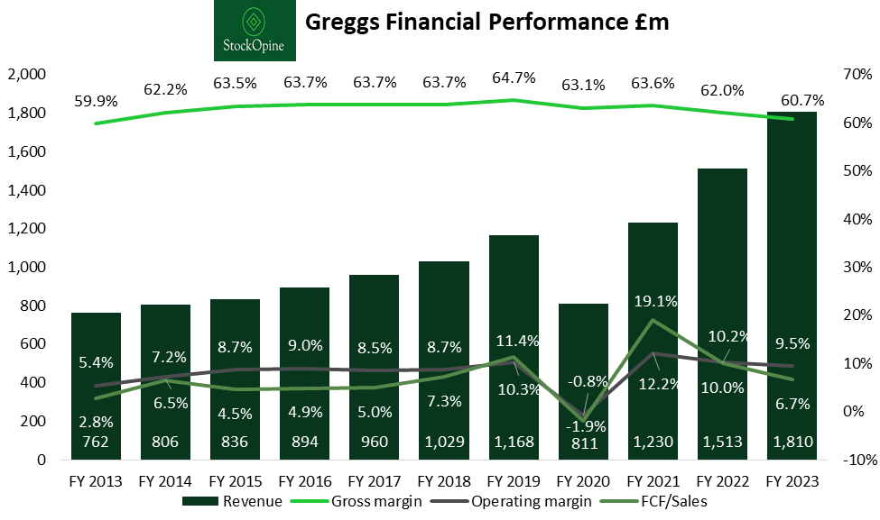
Source from StockOpine (2024)
Economic conditions present both challenges and opportunities for Greggs' market position. The cost-of-living crisis, persistent inflation, and wage pressures have significantly impacted both operational costs and consumer spending patterns. Greggs has faced cost inflation of approximately 9%, primarily driven by increases in ingredients, energy costs, and packaging (Walsh, 2022), necessitating price adjustments including raising its iconic sausage roll price by 24% over three years to £1.30 (Taggart, 2025).
Critically, Greggs has demonstrated countercyclical resilience during economic downturns, with its value proposition attracting cost-conscious consumers. This economic adaptability is evident in the company's 2024 performance, with sales exceeding £2 billion for the first time despite challenging conditions (Newman, 2025). However, the British Retail Consortium's projection of food price inflation exceeding 4% in 2025 (Fish and Barnett, 2025) suggests continuing margin pressure, requiring ongoing strategic price-value balancing.

Social Factors
Changing consumer preferences have significantly influenced Greggs' product strategy and market positioning. Health consciousness has driven expansion of the "Balanced Choice" range of products under 400 calories, which now accounts for approximately 10% of total sales (Kollewe, 2016). More notably, the rise of veganism catalyzed transformative product innovation, with the 2019 launch of Greggs' vegan sausage roll driving sales above £1 billion for the first time (Vegconomist, 2023).
Demographic analysis reveals potential market expansion opportunities, with YouGov data indicating that 57% of Greggs' customer base is aged 40 and over (Shakespeare, 2020). This has prompted targeted marketing initiatives to attract younger consumers, including collaborations with cultural influencers and fashion retailers (Shakespeare, 2020; Brown, 2024). The success of these initiatives reflects Greggs' capacity for demographic adaptation, though maintaining relevance across diverse consumer segments presents an ongoing strategic challenge.

Technological Factors
Technology has become increasingly central to Greggs' business model, with significant investments in digital transformation enhancing both customer experience and operational efficiency. The company's mobile app and loyalty scheme have become key drivers of customer engagement, with app-based transactions increasing from 12.5% of sales in 2023 to over 20% by the end of 2024 (Newman, 2025).
Digital ordering capabilities have expanded Greggs' market reach through partnerships with food delivery platforms including Just Eat and Uber Eats (Fish, 2024), capturing additional revenue streams and dayparts. However, increased technological dependence introduces new vulnerabilities, as evidenced by a 2024 payment system glitch that temporarily affected customer transactions (Krishnan, 2024). This incident highlights the critical importance of technological resilience as digital channels become increasingly central to Greggs' business model.

Environmental Factors
Environmental sustainability has evolved from peripheral concern to strategic priority for Greggs, reflecting both regulatory pressures and changing consumer expectations. The company has committed to becoming net zero by 2040, a decade ahead of the UK government's target (Greggs, 2023), establishing a "Net Zero Taskforce" to guide its sustainability efforts.
Tangible progress is evident in several metrics, including a 10% reduction in manufacturing food waste (as a percentage of sales) since launching The Greggs Pledge in 2021 (Dennis, 2023). The 2022 opening of an "Eco-Shop" testing multiple sustainability methods (Greggs, 2023) demonstrates practical commitment to environmental leadership. These initiatives not only address regulatory compliance but potentially create competitive differentiation through sustainability credentials that increasingly influence consumer preferences.

Legal Factors
The legal environment significantly impacts Greggs' operations, particularly regarding food safety, employment, and nutritional information requirements. As a food retailer, Greggs faces stringent regulatory oversight, requiring registration with local environmental health departments and compliance with the Food Safety Act (MOMIN, 2022).
Employment legislation, particularly regarding minimum wage increases, directly affects Greggs' operational costs given its approximately 25,000 employees. While the National Living Wage increase for 2025 adds cost pressure, Currie observed that this could simultaneously benefit Greggs by providing additional consumer spending capacity (Carroll, 2025), highlighting the complex, sometimes contradictory implications of legal factors on business performance.

Appendix C: Detailed Porter's Five Forces Analysis
Threat of New Entrants (Moderate)
The bakery and food-to-go sector presents moderate barriers to entry, with significant capital requirements for achieving comparable scale to Greggs. The company's vertically integrated supply chain provides substantial defense against new entrants (Oakley, 2024), though regional players can still establish footholds in specific markets, as demonstrated by Coughlans Bakery's growth to 31 stores (Pankhurst and OBrien, 2025).
The franchise model potentially lowers barriers, with Greggs itself operating 514 franchised stores (StockOpine, 2024). This dual threat environment requires Greggs to maintain both scale advantages against large entrants and local relevance against regional specialists.
Bargaining Power of Suppliers (Low to Moderate)
Greggs' vertical integration significantly diminishes supplier bargaining power, with in-house manufacturing capabilities reducing external dependencies. The company employs strategic forward purchasing to mitigate pricing volatility for externally sourced commodities (Cresswell, 2024), while its £2 billion annual sales volume provides substantial leverage in supplier negotiations.
However, certain essential ingredients remain subject to market-wide price fluctuations, as evidenced by challenges in "sourcing dairy products, cereals and protein" during inflationary periods (Walsh, 2022). This selective vulnerability necessitates continued supply chain optimization and relationship management to maintain cost advantages.
Bargaining Power of Buyers (Moderate)
Individual consumers have limited bargaining power, but collectively, customer price sensitivity and preference volatility significantly influence Greggs' strategic decisions. The company's success depends on maintaining value perception, reflected in CEO Currie's emphasis on ensuring value for money when implementing even small price increases (Hotten, 2022).
Digital platforms have marginally enhanced consumer bargaining power through increased price transparency and choice. With app-based transactions now representing over 20% of sales (Newman, 2025), customers can more easily compare offerings and access loyalty incentives, potentially increasing price sensitivity despite switching costs.
Threat of Substitutes (High)
Greggs faces substantial competition from diverse substitutes including coffee chains, fast-food restaurants, supermarket meal deals, and independent cafes. These alternatives compete on different dimensions including price, quality, convenience, and health positioning, creating a complex competitive landscape (Isla, 2024).
This threat is amplified by low switching costs for consumers, who can easily select different options based on location, preference, or price. Greggs' value proposition provides some insulation, with price points significantly below many competitors (Brown, 2024), but maintaining distinctiveness amid proliferating alternatives remains challenging.
Competitive Rivalry (High)
The food-to-go sector exhibits intense competitive rivalry characterized by market saturation, limited product differentiation, and price sensitivity. Greggs competes directly with other bakery chains, coffee shops, fast-food restaurants, and supermarket offerings, all targeting similar consumer spending.
Greggs has strategically positioned itself through value leadership (Carroll, 2025), effectively differentiating in a market where "consumers are increasingly focused on value" (Innes and Carroll, 2023). However, smaller competitors like Coughlans Bakery gaining favourable consumer perceptions (Pankhurst and OBrien, 2025) indicate that quality-focused alternatives can challenge Greggs' market position despite its scale advantages, requiring constant competitive vigilance.

Appendix D: Competitor Price Comparison
Direct Competitors
Chain | Regular flat white coffee price | Bacon roll or similar variation price
Greggs | £1.95 | £2.90
McDonalds’ | £1.99 | £3.29
Costa Coffee | £3.85 | £4.19
Pret | £4.05 | N/A
Source from (Brown, 2024)
Greggs faces direct competition from bakery chains and food-to-go specialists targeting similar customer needs. Subway competes through customizable sandwiches and wraps but with higher customization and generally higher prices than Greggs (Isla, 2024). Pret A Manger positions itself as a premium alternative focusing on "fresh, natural ingredients" (Isla, 2024), while regional chains like Coughlans Bakery compete on product quality despite limited scale (Pankhurst and OBrien, 2025).
Greggs maintains competitive differentiation primarily through price positioning, with direct comparisons showing significant advantages—a regular flat white priced at £1.95 versus Costa's £3.85 and Pret's £4.05 (Brown, 2024). This value leadership, combined with convenience and consistent quality, provides meaningful competitive differentiation despite limited product distinctiveness.
Indirect Competitors
The competitive landscape extends to businesses satisfying similar consumer needs through different formats. Coffee chains like Costa and Starbucks have expanded food offerings while maintaining beverage focus (Isla, 2024). Fast food restaurants compete particularly in breakfast and value meals, though Greggs claimed in 2024 to have "dethroned McDonald's to become Britain's most popular breakfast spot" (Fish, 2024), indicating successful category competition against larger international chains.
Supermarkets present growing competition through expanded food-to-go offerings, particularly premium options like M&S Food's "top-quality food like ready meals, sandwiches, salads, and bakery items" (Isla, 2024). Interestingly, Greggs has strategically converted some competitors into partners through store-in-store arrangements with retailers including Tesco, Sainsbury's, and Primark (Oakley, 2024), demonstrating coopetition capabilities that extend its reach while mitigating direct competition.

Appendix E: Complete VRIO Analysis

Valuable Resources and Capabilities
Brand Reputation and Recognition
Greggs has established a powerful brand that resonates with UK consumers as a trusted provider of affordable, quality food. This brand value is reflected in market performance, delivering "total returns to shareholders of 480 per cent over the past decade compared with 90 per cent for the FTSE All-Share index" (Oakley, 2024). The brand's unpretentious positioning creates authenticity that distinguishes Greggs from competitors, with Brown (2024) noting that "Greggs takes its food seriously... but not itself," creating emotional connections beyond transactional relationships.
Strategic Store Network
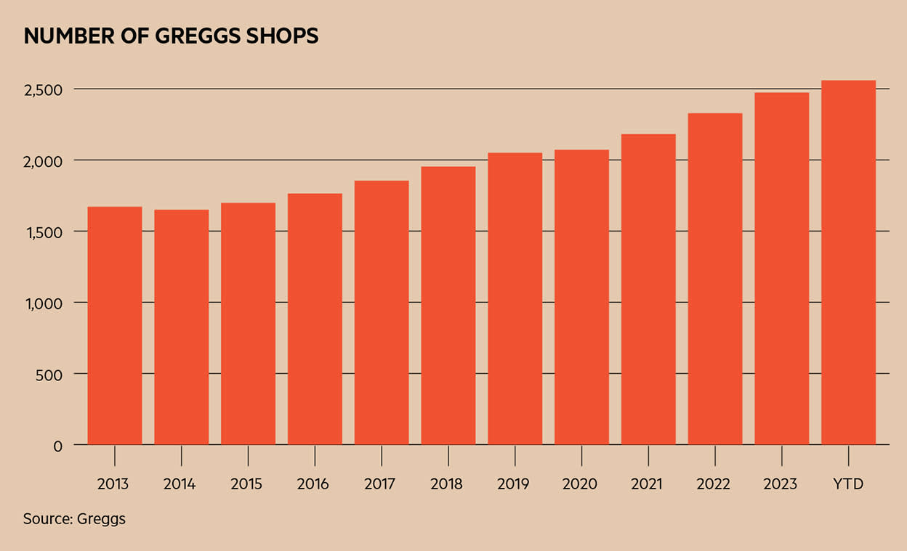
Source: Adapted from Oakley (2024).
With approximately 2,600 stores nationwide (Newman, 2025), Greggs' extensive store network provides superior market coverage and customer accessibility compared to many competitors. The strategic distribution of locations across high streets, transportation hubs, retail parks, and other formats creates multiple consumer touchpoints, with Currie highlighting substantial remaining growth potential within the UK market (Davey, 2024). This physical presence delivers competitive advantages in brand visibility, convenience, and operational leverage that digital-only competitors cannot match.
Product Development Capabilities
Greggs has demonstrated sophisticated product development capabilities, consistently introducing innovations aligned with market trends and consumer preferences. The company's ability to identify emerging opportunities is exemplified by the vegan sausage roll, which "changed the game for Greggs" by tapping into growing plant-based demand (Vegconomist, 2023). This development process combines market insight with efficient implementation, enabling Greggs to refresh its range while maintaining operational simplicity, a critical capability in the fast-moving food retail sector.

Rare Attributes
Vertically Integrated Supply Chain
Greggs' particular implementation of vertical integration provides a rare combination of cost efficiency and quality control within the food-to-go sector. Unlike competitors that rely heavily on external suppliers or in-store preparation, Greggs "makes most of its food products at its in-house manufacturing sites and has a very well-invested supply chain of distribution centres and delivery vehicles" (Oakley, 2024). This integration spans manufacturing through distribution, providing control advantages that few competitors can match without comparable investment and operational scale.
Unique Market Positioning
Greggs occupies a distinctive position bridging traditional bakery heritage with modern food-on-the-go concepts. This hybrid positioning allows Greggs to attract customers from multiple market segments without being directly comparable to either traditional bakeries or international fast-food chains. The company has reinforced this unique position through strategic communications that maintain a "humorous and decidedly British tone of voice" (Gilliland, 2019), creating cultural resonance that international competitors struggle to replicate.

Difficult to Imitate Features
Operational Efficiency and Scale
Greggs has developed operational systems and economies of scale that competitors would find challenging to replicate quickly. The company's manufacturing facilities demonstrate scale advantages, such as the Newcastle site's new production line that can make "up to four million more savoury items... each week, from its current 10 million" (Davey, 2024). These efficiency advantages, refined over decades, represent an imitation barrier requiring significant time and capital investment for competitors to overcome.
Customer Loyalty and Brand Affinity
The emotional connection Greggs has established with UK consumers represents an intangible asset particularly difficult for competitors to replicate. The company has cultivated this through consistent quality, value, and strategic marketing that resonates with British cultural identity. This brand loyalty has been formalized through the Greggs app, which now accounts for "over 20% of total sales" (Newman, 2025), creating both tangible repeat purchase behaviour and intangible affinity that insulates Greggs from competitive incursions.

Organizational Support
Strategic Leadership and Culture
Greggs' management systems, company culture, and training programs provide essential organizational infrastructure to leverage its valuable resources effectively. Taylor (2023) describes Greggs' "fabulous culture" as the company's "secret sauce," evidenced by high employee retention and internal promotion. This cultural strength enables consistent service delivery across thousands of stores and supports strategic execution during both stable and turbulent market conditions.
Investment in Digital Infrastructure
Greggs has made significant organizational investments in technology infrastructure to support its evolving business model. O'Halloran (2022) reports Greggs' implementation of "a future-proof, security-centred software-defined wide area network (SD-WAN) solution" to support digital transformation. This investment reflects organizational commitment to enabling enhanced capabilities in customer service, operational efficiency, and data-driven decision making, providing the technical foundation for strategic digital initiatives.

Appendix F: Expanded Value Chain Analysis

Primary Activities
Inbound Logistics
Greggs has developed sophisticated inbound logistics capabilities that contribute significantly to operational efficiency and cost control. The company employs forward purchasing of key commodities to manage volatility, with Cresswell (2024) noting that "the group looks ahead and negotiates forward prices for its three main production cost areas: food, packaging and energy." This proactive approach helped Greggs maintain profitability despite 9% inflation in 2022 (Walsh, 2022).
The company is expanding logistics infrastructure with "a new frozen manufacturing facility in Derby and a new national distribution centre in Kettering/Corby" (CILT(UK), 2024). These facilities will incorporate advanced technologies including "automated robotic shop order picking and distribution solutions" (Walton, 2024), representing significant advancement in logistics capabilities that should enhance both efficiency and resilience.
Operations
Manufacturing excellence represents a core strength in Greggs' value chain, with multiple production facilities characterized by scale, efficiency, and increasing automation. The company's centralized production model differs from competitors like Pret A Manger that prepare food on-site, with Brown (2024) noting that Greggs' approach "means it doesn't need to budget for kitchen equipment in each of its stores and it can benefit from the savings of producing its food in bulk." This model enhances consistency and reduces in-store labour requirements, creating structural cost advantages in an increasingly competitive market.
The company is increasing automation to address labour cost pressures, with Davey (2024) reporting that Greggs "is leaning more on robots to keep costs down." The recent commissioning of a fourth production line at its Newcastle facility demonstrates this focus on operational enhancement through technology adoption (Mws.ltd.uk, 2025), a strategic imperative in a high-labour-cost environment.
Outbound Logistics
Greggs' outbound logistics system efficiently moves products from manufacturing facilities to stores, with the company maintaining its own delivery fleet rather than outsourcing. This integrated approach enables optimization of delivery routes and frequencies while controlling costs, with Brown (2024) noting that this strategy allows Greggs "to build a fleet of vehicles geared for long-term savings."
The company is expanding distribution capacity through facility redevelopment and technology adoption. CILT(UK) (2024) reports that Greggs is "redeveloping distributions centres in Birmingham and Amesbury adding increased logistics capacity for 300 shops by the end of 2024," while new facilities will incorporate "advanced logistics for frozen storage and fully automated robotic shop order picking" (Uwemedimo, 2024). These investments should enhance both efficiency and product availability, critical factors in maintaining customer satisfaction.
Marketing and Sales
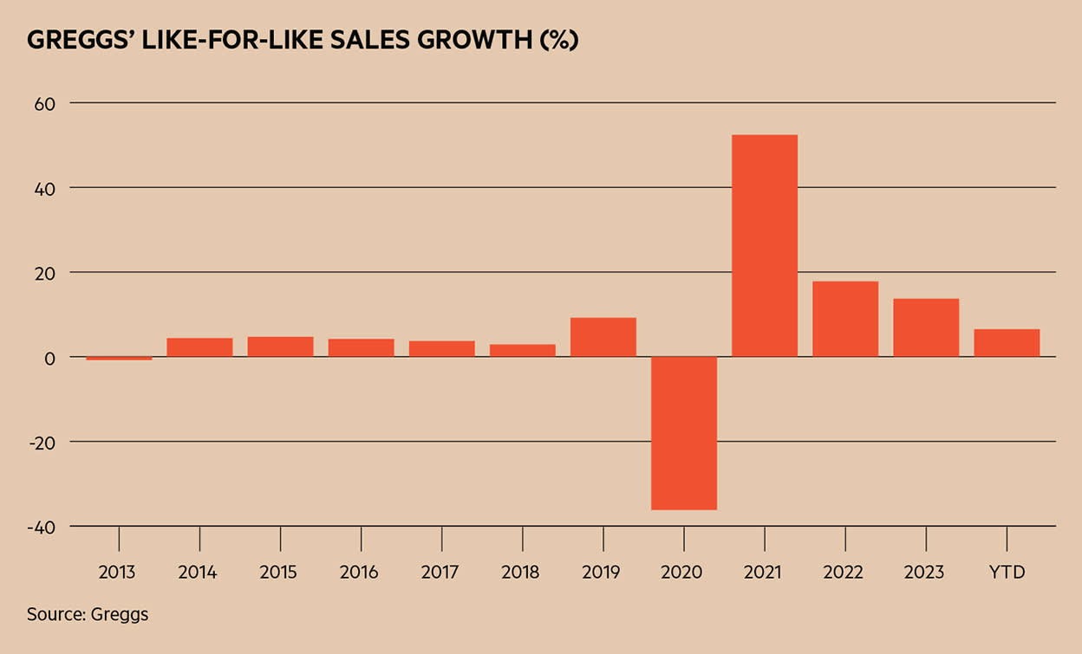
Source from Oakley (2024)
Greggs has developed distinctive marketing capabilities that successfully build brand awareness and drive customer engagement across diverse channels. The company's loyalty program, delivered through its mobile app, has become a significant sales driver, with app usage in "just over 20 per cent of transactions... up from 12.5 per cent in 2023" (Newman, 2025). This digital engagement provides valuable customer data while encouraging repeat purchases through rewards.
The company's marketing demonstrates particular strength in generating publicity through creative campaigns and social media engagement. The vegan sausage roll launch exemplified this capability, with Foudy (2024) describing how Greggs "released a parody video mimicking Apple's product launch style" and maintained "an engaging and humorous tone in their social media posts." This distinctive brand voice has helped establish connection with consumers beyond functional product attributes.
Service
Greggs' service model emphasizes speed, consistency, and accessibility across its extensive store network. In-store service facilitates quick transactions with "warm, personable customer service" (Taylor, 2023), though the introduction of digital ordering channels has created new service challenges requiring training and system adaptations to maintain quality across channels.
The company has extended service hours to capture additional dayparts, with Oakley (2024) reporting that "more than 1,200 of its shops are currently open until 7pm or later." This temporal extension complements delivery services through partnerships with aggregators, providing additional customer convenience. Physical store environments have been modernized to support the service model, with Gilliland (2019) noting investments in creating "a more modern and streamline design, emphasising its 'on-the-go' aspect."

Support Activities
Firm Infrastructure
Greggs' organizational structure and management systems provide a solid foundation for its operational activities. Leadership continuity combined with strategic adaptation has characterized the company's approach, with current CEO Roisin Currie maintaining growth ambitions despite economic challenges, affirming that "the business remains confident in the growth opportunity in front of us" (Newman, 2025).
Financial management has been conservative yet growth-supportive, with Greggs maintaining a "substantial net cash position" providing flexibility for investment and shareholder returns (Oakley, 2024). This fiscal discipline has enabled continued expansion despite economic turbulence, creating advantageous positioning during market downturns.
The company operates with clear governance structures and planning processes, exemplified by its publicly stated five-year strategy targeting doubled sales by 2026 (News, 2025). This strategic clarity provides framework for operational decision-making while signaling confidence to stakeholders.
Human Resource Management
Greggs' human resource management emphasizes employee engagement, development, and fair compensation across its workforce of approximately 25,000 people. Employee retention and development are notable strengths, with Taylor (2023) observing that "many employees who enter the business stay on and rise through the ranks of the organisation." This long-term approach supports knowledge retention and cultural continuity, providing competitive advantage in service consistency.
The company's compensation practices include profit-sharing, with Currie describing the employee bonus program (currently 10% of profits) as "absolutely sacred" (Davey, 2024). This approach aligns individual incentives with organizational performance while supporting employee engagement. Training programs ensure consistent service delivery across the store network, with particular attention to technology adoption to support operational excellence.
Technology Development
Technology increasingly underpins Greggs' operations, with significant investments in digital systems enhancing both efficiency and customer experience. The company doubled "the size of its tech teams" during the COVID-19 pandemic, reflecting belief that "technology would be an enabler for workers on the shop floor" (Taylor, 2023).
Digital infrastructure investments include implementation of "a future-proof, security-centred software-defined wide area network (SD-WAN) solution" (O'Halloran, 2022) supporting in-store technology and digital ordering. Customer-facing technology development has prioritized the Greggs app, combining loyalty rewards, nutritional information, and ordering functionality, with the company building this application in-house to enable custom solutions for challenges like real-time inventory management.
Manufacturing technology investments focus on automation to enhance productivity and address labour costs, with Davey (2024) noting increased reliance on robotics. These investments address structural cost pressures while improving production consistency, supporting both efficiency and quality objectives.
Procurement
Greggs' procurement function balances cost management with quality control, emphasizing reliable inputs at predictable prices. Forward purchasing of key commodities mitigates inflation risks, with Hotten (2022) noting that this approach helped maintain performance despite market volatility.
Supplier relationships balance cost control with quality standards, leveraging the company's scale for purchasing advantage while ensuring consistent inputs. Sustainability considerations increasingly influence procurement decisions, with packaging modifications supporting the removal of "130 tonnes of plastic from its business operations each year" (Dennis, 2023), demonstrating integration of environmental objectives into purchasing practices.

Appendix G: Expanded SWOT Analysis

Strengths
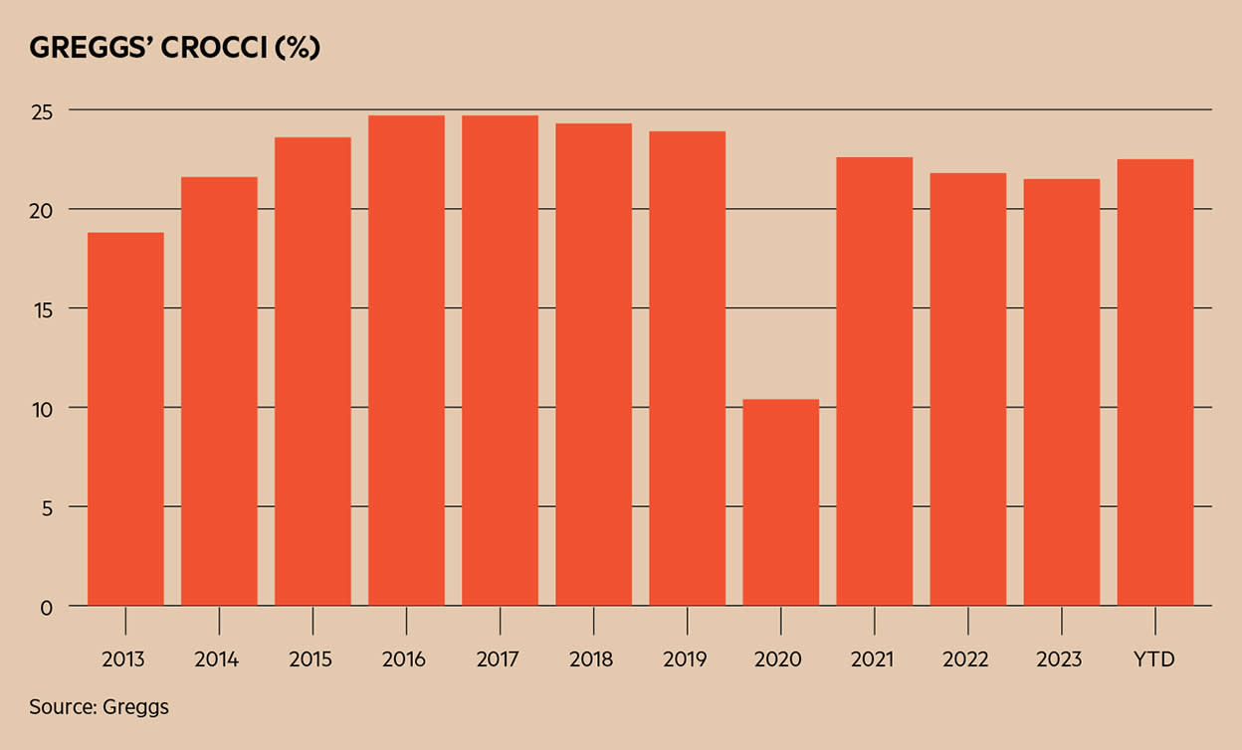
Greggs Cash Return on Capital (GROCCI)- Source from Oakley (2024)
Strong Brand Reputation and Recognition
Greggs has established a powerful brand resonating with UK consumers through values of quality, affordability, and unpretentious service. This brand strength drives customer preference and supports premium positioning relative to some competitors despite Greggs' value focus. The brand's emotional connection with consumers provides resilience during economic challenges and competitive pressure.
Vertically Integrated Supply Chain
Greggs' control over manufacturing and distribution creates significant operational advantages, described by Oakley (2024) as "a very well-invested supply chain... which gives it a cost advantage and competitive edge over its rivals." This integration enables consistent quality, efficient production, and responsive inventory management, supporting both value positioning and margin protection.
Value Proposition and Price Competitiveness
Greggs has crafted a distinctive value proposition centred on affordable, quality food-on-the-go options that particularly appeals during economic downturns. The significant price advantage versus competitors like Pret A Manger and Costa Coffee (Brown, 2024) provides clear differentiation while attracting price-conscious consumers. This positioning has proven sustainable even during inflationary periods, demonstrating resilient margin management.
Extensive Store Network
With approximately 2,600 stores nationwide (Newman, 2025), Greggs' extensive and diverse retail network provides unmatched accessibility. Strategic expansion beyond traditional high streets into "petrol forecourts, retail parks and transport sites" (Davey, 2024) has created multiple consumer touchpoints, delivering advantages in visibility, convenience, and operational leverage that enhance competitive positioning.
Product Innovation Capabilities
Greggs consistently demonstrates strong product innovation, successfully identifying and responding to consumer trends with items like the vegan sausage roll that drove "sales above £1 billion for the first time" (Vegconomist, 2023). This development process combines market insight with efficient implementation, enabling Greggs to refresh its range and appeal to changing preferences while maintaining operational simplicity.
Digital Engagement and App Success
Investments in digital capabilities have created strong customer engagement platforms, with the Greggs app now representing "over 20% of total sales" (Newman, 2025). This digital ecosystem combines loyalty rewards, ordering functionality, and customer data collection, supporting both revenue growth and operational efficiency while providing valuable consumer insights for strategic decision-making.

Weaknesses
Limited Menu Diversity Compared to Competitors
Despite menu expansion, Greggs' food range remains narrower than some competitors, potentially limiting appeal to certain customer segments. The operational simplicity of focusing on bakery products and sandwiches benefits margins but may constrain growth in some markets. Brown (2024) notes that Greggs' flagship items are "easy to produce" and "cheap to make," reflecting potential limitations in premium positioning.
Regional Brand Strength Variations
Brand recognition and store density vary significantly across the UK, with stronger presence in northern regions than southern areas, particularly London. Oakley (2024) identifies significant opportunity "to open many shops in central London where the company is significantly underrepresented." This regional imbalance constrains potential market penetration in high-value geographic segments.
Store Size Limitations
Many Greggs locations are relatively small, designed primarily for takeaway rather than dine-in service. Brown (2024) observes that "often Greggs' shops are designed for quick visits" and "regularly set-up to funnel their footfall out of their stores." While supporting operational efficiency, this model restricts dine-in opportunities and potentially limits average transaction values compared to competitors offering more extensive seating.
Vulnerability to Input Cost Inflation
Despite vertical integration, Greggs remains exposed to commodity price fluctuations and inflationary pressures. Walsh (2022) reports sourcing challenges for "dairy products, cereals and protein" during inflationary periods. The company's value positioning limits ability to pass all cost increases to consumers, creating margin vulnerability during sustained inflationary environments that requires constant optimization.
Evening Daypart Underdevelopment
Despite progress in extending trading hours, evening sales represent a relatively small portion of total revenue. Oakley (2024) notes that "evening sales are still a small portion of Greggs' overall sales," indicating underdeveloped market opportunity. Established competitors in evening food occasions create adoption barriers despite Greggs' efforts to expand temporal reach.
Technology Infrastructure Still Evolving
While Greggs has invested significantly in technology, some systems remain less mature than digital-native competitors. The payment system glitch in 2024 that "temporarily hampered the ability of some stores to accept customer payments" (Krishnan, 2024) highlighted potential vulnerabilities as digital channels become increasingly central to operations, requiring continued investment in system reliability.

Opportunities
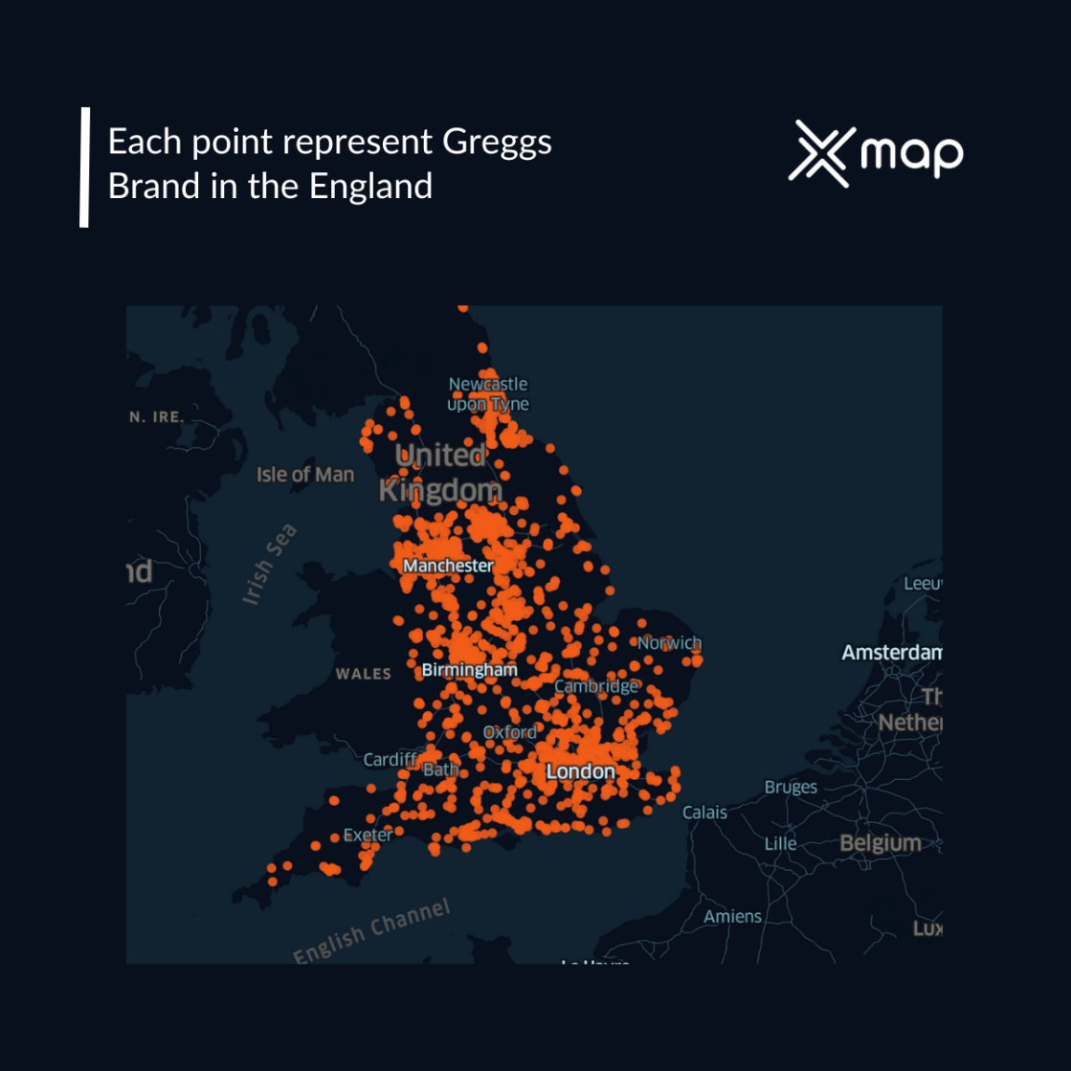
The distribution map of Greggs stores across England (Felinah, 2025)
Digital Expansion and Personalization
Significant opportunity exists to further develop Greggs' digital ecosystem, enhancing customer engagement and driving incremental revenue. With app usage already representing over 20% of sales (Newman, 2025), customer data can support increasingly personalized experiences. Jefferson (2021) notes potential for "pre-ordering or 'click-and-collect'" to "improve availability of its standard menu, as well as offering personalised choices" where customers can adapt ingredients to their preferences.
New Location Formats and International Expansion
Continued expansion into non-traditional locations presents substantial growth potential. Currie has identified "scope for a store estate of over 4,500" in the UK alone based on analysis of underrepresented areas (Davey, 2024). This ambitious target represents nearly double the current store count, indicating significant domestic runway before market saturation.
International expansion represents a longer-term opportunity, with Currie confirming that "expansion overseas was being considered" (Davey, 2024). Though cautioning that "there's no rush" given domestic growth potential, international markets could provide new growth vectors once UK expansion approaches saturation, particularly given the successful template established in the domestic market.
Extended Dayparts, Particularly Evening Trade
The evening food market represents significant growth opportunity, with Greggs already experiencing evening sales "growing quickly and at a faster rate than its overall same-store or like-for-like sales" (Oakley, 2024). Nearly half of Greggs stores now trade past 7pm (Brown, 2024), providing physical infrastructure for daypart expansion.
Menu development specific to evening occasions could accelerate this trajectory, capitalizing on different consumption patterns and potentially higher average transaction values. Newman (2025) notes that "pizza perform[s] strongly" through the day and into evening, suggesting product platforms that could support this daypart extension while maintaining operational simplicity.
Strategic Partnerships and Co-Branding
Greggs has demonstrated success with strategic partnerships, including store-in-store arrangements with retailers like Tesco, Sainsbury's, and Primark (Oakley, 2024). These collaborations provide access to new customer segments and locations while sharing occupancy costs, creating efficient expansion vectors.
The fashion collaboration with Primark, which drove "a 21.4% buzz increase" according to YouGov BrandIndex (Innes and Carroll, 2023), demonstrated potential for co-branding initiatives to generate publicity and consumer engagement beyond traditional marketing channels. Similar creative partnerships could strengthen brand relevance particularly among younger demographic segments.
Sustainability Leadership
Growing consumer interest in environmental sustainability creates opportunity for differentiation through sustainability leadership. Greggs has established ambitious targets, committing to become "net zero by 2040" (Greggs, 2023) and achieving tangible progress in reducing "manufacturing food waste by 10%" since launching The Greggs Pledge (Dennis, 2023).
The "Eco-Shop" concept testing multiple sustainability methods (Greggs, 2023) provides platform for environmental innovation that could enhance brand perception among increasingly eco-conscious consumers. Converting sustainability initiatives from compliance requirements to competitive advantages represents significant opportunity in a market where environmental credentials increasingly influence consumer choice.
Product Category Expansion
Adjacent product categories aligned with Greggs' brand positioning and operational capabilities present expansion opportunities. The company has demonstrated success in category development, becoming "the UK market leader in breakfast sales with a share of nearly 20 per cent" (Oakley, 2024) and establishing strong positions in hot drinks.
Further category development in healthier options, premium coffee, or expanded meal solutions could drive incremental sales while leveraging existing infrastructure. Sentiment analysis indicates willingness to consider Greggs for more dayparts and occasions (Sentance, 2023), providing growth potential through increased share-of-wallet from existing customers.

Threats
Intense Competition in Food-To-Go Sector
The UK food-to-go market features intense competition from diverse players including coffee chains, quick-service restaurants, supermarkets, and emerging specialty concepts. Isla (2024) identifies numerous competitors including "Pret A Manger, Subway, Costa Coffee, KFC, and Marks & Spencer Food," creating constant pressure on pricing, innovation, and market share.
Competitive intensity is increasing, with Peel Hunt analysts noting "an increasingly promotional fast-food environment" (Fish, 2024) that pressures margins across the sector. Maintaining distinctive positioning amid this competitive landscape requires continuous enhancement of value proposition and operational excellence.
Changing Consumer Preferences and Health Trends
Evolving consumer attitudes toward nutrition, health, and ethical consumption present both opportunity and threat. While Greggs has responded with healthier options and vegan products, ongoing preference shifts require continuous adaptation. Health-focused competitors like Pret A Manger, which "focuses on fresh, natural ingredients" (Isla, 2024), may be better positioned for some health-conscious segments.
The challenge lies in balancing health-oriented innovation with Greggs' core value proposition and operational model. As consumer preferences fragment, maintaining broad appeal while addressing specific dietary trends becomes increasingly complex, requiring sophisticated product development and marketing approaches.
Economic Pressures and Consumer Spending Constraints
Macroeconomic challenges threaten both consumer spending and operating margins. Newman (2025) reports that Currie cited "low" consumer confidence leading to customers "saving more than spending." Shore Capital analyst Clive Black warned that "there are warning lights out there that mean we are less optimistic at the start of 2025 than we were before the budget" (Fish and Powell, 2025).
While value positioning provides some insulation, sustained economic pressure could reduce discretionary food spending. Riley (2025) notes that "as real disposable incomes face competing pressures from energy bills and mortgage payments, demand for non-essential purchases like sausage rolls becomes more price elastic," creating vulnerability despite Greggs' value credentials.
Rising Operational Costs
Multiple factors are driving cost increases, particularly minimum wage rises and employers' National Insurance contributions. Fish and Barnett (2025) report that the British Retail Consortium expects "food prices will rise by an average of 4.2 per cent in the second half of the year," while National Insurance increases will cost "tens of millions of pounds" (Davey, 2024).
These structural cost increases present margin challenges that pricing alone cannot fully address. News (2025) reports that Greggs expects "overall input cost inflation in 2025 to be around 6%," requiring continuous efficiency improvements to maintain profitability while preserving value perception.
Supply Chain Disruptions
Despite vertical integration, Greggs' supply chain remains vulnerable to external disruptions from factors like extreme weather, political instability, or transportation constraints. MOMIN (2022) notes that post-pandemic, Greggs' "supply chain is still not what it used to be before the virus hit us all. Their stock is often left short which drives away customers and hence profits."
Future disruptions could impact product availability and customer satisfaction. While investments in supply chain capacity and resilience partially mitigate this risk, the complexity of modern food supply chains creates inherent vulnerability requiring constant vigilance and contingency planning.
Technological Disruption and Cybersecurity Risks
Increasing reliance on digital systems exposes Greggs to both technological disruption and cybersecurity threats. The payment system glitch experienced in 2024 (Krishnan, 2024) illustrates operational vulnerabilities that could affect customer service and sales. As digital channels become more central to Greggs' business model, the potential impact of system failures or security breaches increases.
Krishnan (2024) notes that businesses like Greggs are "deeply dependent upon complex networks of digital systems" which offer benefits but create risks when "a critical system component malfunctions." Maintaining technological resilience while pursuing digital innovation represents a significant ongoing challenge.

Appendix H: Greggs Store Distribution Map
The distribution map of Greggs stores across England (Felinah, 2025)

