MODULE NAME: MARKETING FUNDAMENTALS
MODULE CODE: LCBB4004
LECTURER’S NAME: TUSHARA BALENDRAN
STUDENT NAME: LEYLA ALIYEVA
STUDENT ID NO: 2123647
ASSESSMENT 1

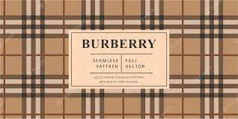
Burberry

Blog

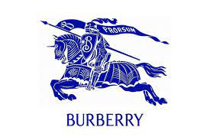

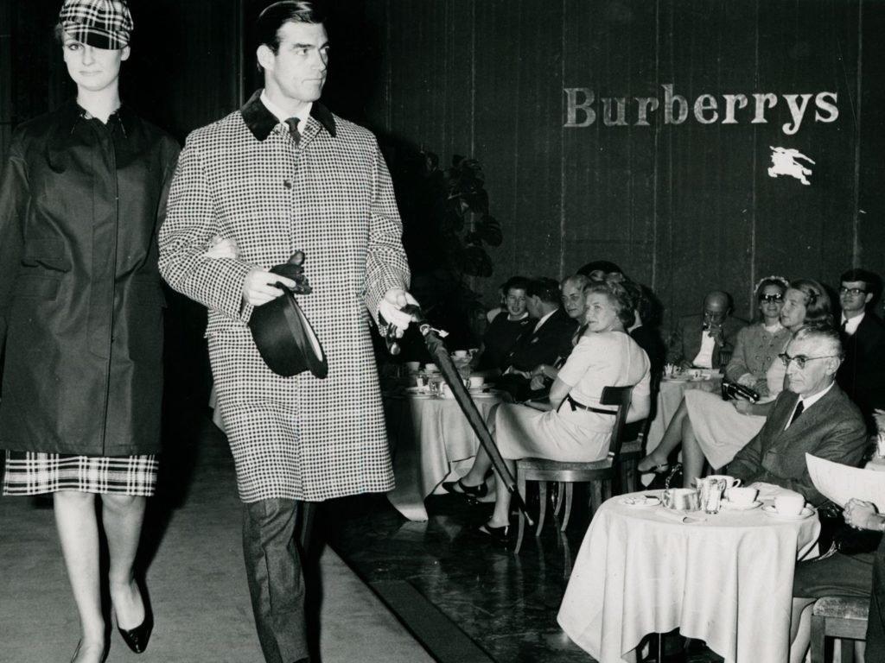
History of Burberry
In the field of clothing and fashion industry Burberry is an illuminated name which provides quality products to its customers with a variety of brands. At the age of just 21 years Thomas Burberry, a man with an innovative and prudent mind established the company in Basingstoke. Persuaded by a significant thought to design and make clothing for the UK people who would feel comfortable using the clothes in the UK environment Burberry approached to open the company in 1856. The company is especially distinguished for making trench coats. Besides, there are footwear and leather accessories which are also made by the company. In the year 1870, the company proceeded to produce a variety of outdoor clothes which would be suitable for the UK people to use in the rainy atmosphere.
In 1888, Thomas got a patent for inventing gabardine which is at the same time waterproof and breathable (Burberry, 2023a). In 1912, another design of Burberry clothing came front in the name of Tielocken with quality features (Weston, 2022). Besides London, the company extended its business in the Haymarket which was designed by Walter Cave in 1913. The company got a significant milestone when Burberry was granted by Queen Second Elizabeth as a reliable water proofer. Gradually the company develops its export service throughout the world by expanding its business. During the decades of 1970 or 80s, the company moved faster to make agreements with global manufacturers by maintaining a strict protocol to produce a variety of British clothes for men, women and children (Penny, 2023). The products were distributed from different retail stores across the world and the own houses of Burberry. In 1990, the company was permitted to get a warrant from the Prince of Wales as an excellent clothing company.
In the recent past, Burberry's business operations motivated the whole youth and LGBTQ community throughout the world by promoting their Rainbow check. In 2017, Burberry made a collaboration with RCA for the promotion of sustainable business materials. Thus, Burberry becomes a significant name in the clothing industry by transcending its dynamic business journeys (Broeke and Maoul, 2018).

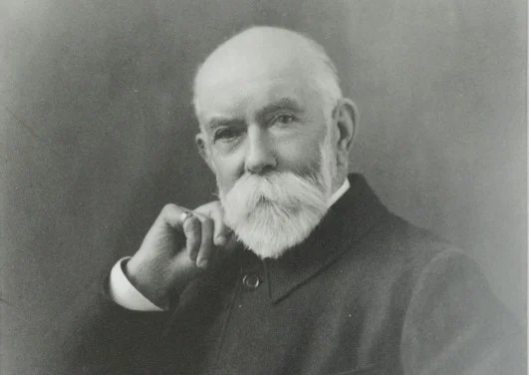

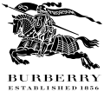




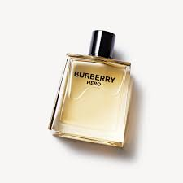
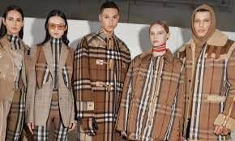
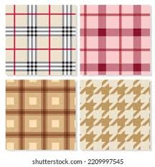
The Logo
The beginning of the 20th century witnessed the introduction of the logo of the company for which a public competition was arranged and then the logo named Equestrian Knight originated. In 1909, the logo was registered as a trademark. In 1999, a new logo for the company Burberry was sketched by Fabien Baron, a well-known art director.
The heritage-company Burberry by making a vision of being one of the most impressive luxurious clothing brands in the UK aims to provide sustainable products for its consumers. The management team of the company always fosters creativity and innovation in their daily business operation through a proper monitoring and motivation strategy for their employees (Burberryplc, 2023).

Mission and Vision

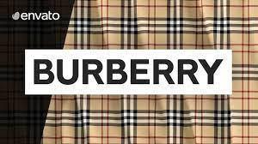
Segmentation-
Burberry is a globally acclaimed company dealing with qualified garments. Being an internationally reputed company, it touches the hearts of the global customer. The company continues to grow its business beyond the border and there is an increasing buying behaviour of the international customer specially for the people of upper class educated society which belongs to psychographic segmentation. People of various countries retain the same buying behaviours and choice of Burberry products. Thus the company accomplishes its segmentation strategy by utilising the buying behaviours of consumers across the world who enjoy the classic products of the company (Embapro, 2022). So, its advertising costs have been reduced by going forward to collaborate with other international business ventures. It helps the company to promote various ranges of products for its customers by maintaining its quality features (Wang, 2023).

Description of the segmentation, targeting and positioning strategies of Burberry-

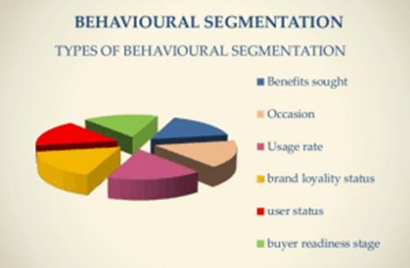
Advantages
It helps the vintage company to extend its business across the world regardless of different political structures and cultures. It also benefits the company to accelerate its brand reputation throughout the whole world which gives the company the advantage of growing its sales across a wide number of people from different countries. It provides the company executives to work more with international collaboration by building an everlasting relationship with them. This the company develops its market segmentation strategy to reach the company a global recognition (Sendpulse, 2023).
Disadvantages
The disadvantages of psychographic segmentation may be faced by the company due to various reasons. Sometimes, this segmentation can mislead the business to collect accurate data. Besides, due to the qualitative and quantitative market research process, it can be costly to get the necessary information (Chipeta, 2020).


Targeting -
The business heads of the company think to fix their customers between the age of 20-45. Celebrity women in different fields who can hold highly disposable income are the target customers of the company. Through influential celebrity women, they can market their brands properly. With vintage luxury products, the company can grab the attention of its potential customers who are the contributors to ameliorating the brand reputation of the company. A recent study shows a figure which proves the accelerating figure of Burberry's female audiences. The result presents that there are 43.15% male audiences and 56.85% female audiences which is a sure indication that the company is better identified and justified with its female inclination (Brighton, 2023). There are three types of strategies.
Differentiated Targeting
Advantage: I helped to adapt to the changes in the industry, product demand and the overall market.
Disadvantage: The cost of market research, management and marketing.
Undifferentiated Targeting
Advantage: it is cost-effective in terms of a long-term strategy.
Disadvantage: Changes in the business environment affect consumer preference and prices which decrease the rate of customer retention.
Concentrated Targeting
Advantage: The effectiveness of the campaigns and marketing strategies could be known and personalised marketing can be done.
Disadvantage: There is a high level of customer dependence.
Burberry follows this strategy

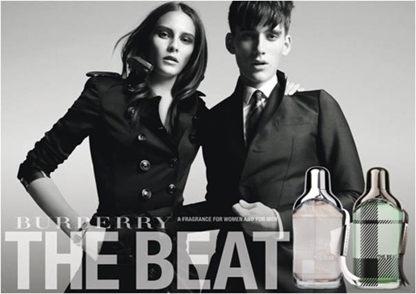

Advantages
Though the company targets women, it likes to focus on differentiated marketing. As the fashion industry continues to grow with its huge demand globally, celebrities are the key instruments by which leading companies like Burberry can promote their variety of quality products to the world market (Similarweb, 2023).
Disadvantages
Without good management techniques the differentiated targeting strategy can not be successful. It needs a huge management team with a variety of campaigning tasks which are labour, time and money-consuming. Each segment of targeting requires various resources (Hofacker, 2022).
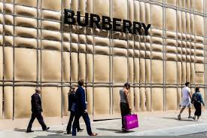

Positioning-
Burberry is a sparkling name in the corporate universe. It is one of the best luxurious fashion and clothing companies in the world. With its motto of luxurious functionality, the company has acquired a fixed place in the minds of its customers. By targeting global customers, it continues to grow its brand image in the large scene of the world. The company continues to influence its potential customers through their fashion products which play a significant impact in building up its marketing strategies in a broader circle. Indeed, the international market is now very fast forward to satisfy various types of customer needs. It is very important to mention here that the company is experienced enough to understand the present competitive market in the UK by retaining the quality of their products which has given them competitive advantages to survive in the growing fast fashion atmosphere of the UK and beyond the boundaries of the UK (Cpp-luxury, 2018).

Advantages
Through the continuation of keeping the quality of its fashion products, the company strives to go further from its acquired reputation and recognition. No doubt the rising fashion industry across the globe has given fashion-based business industries like Burberry a permanent position in the fashion industry.
Disadvantages
In the luxurious positioning strategy, the luxury companies like Burberry can go through a variety of problems like shortages of resources which is an evil message for the well-being of the broader social aspect. In many cases, luxury brands create dissatisfaction in society (Walls, 2023).

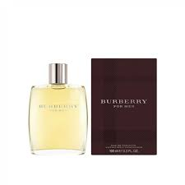
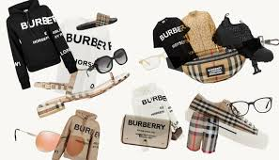
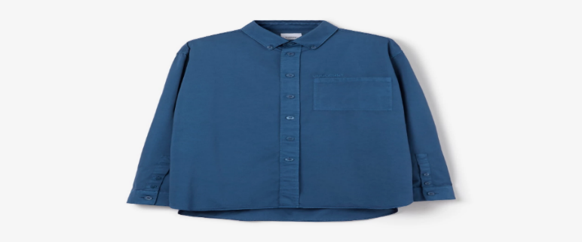
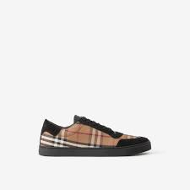
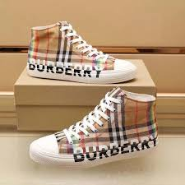
Current marketing mix strategies of Burberry

Burberry is a globally reputed fashion company that caters high-quality products to its customers with premium pricing. The various dimensions of products with numerous designs have led the company to accept the premium pricing strategy by satisfying different levels of customers (Burberryplc, 2023).

Our Products
Being a global leader in the fashion world the company Burberry wants to cater for a variety of products including clothing, accessories, fragrance, bags, shoes etc (Weavabel, 2023).

Embroidered Logo Cotton Twill Shirt
Quality
The product is one of the best ones which is greatly accepted by the UK and global people. The shirts are very comfortable to wear, and it maintains their quality in their embroidery work.
Features
This quality product is featured with a button-down collar with dyed cotton which gives the customers a sense of comfort while wearing. This product is for men.
Benefits
The quality product has satisfied the potential customers of the business organization which can lead the company to attract more customers.
Packaging
Burberry is a company with a strong heritage which provokes them to maintain luxury packaging (Weavabel, 2023).

Leather and Check Cotton Sneakers
Quality
The Burberry product regarding leather and check cotton sneakers provide premium quality to the users. There is a beautiful mixture of leather with classic Burberry check. The unique quality of the product grabs the attention of the potential customers of the company.
Features
This product is featured with supple leather and cotton panels of Burberry check. With its best innovative features, the product attracts its customers.
Benefits
The company has been able to build up its growing level of brand reputation by increasing its competitive advantages through this classic product.
Packaging
Burberry follows recycled packaging for its shoe products. By maintaining a standard quality its packaging is done to serve its customers (Burberry, 2022b).

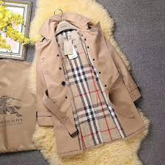
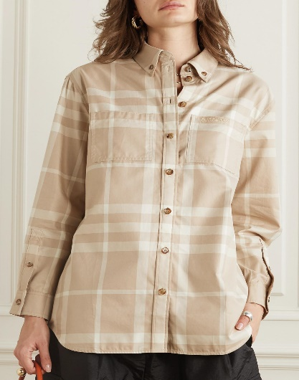
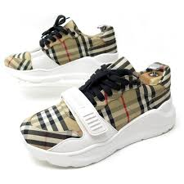
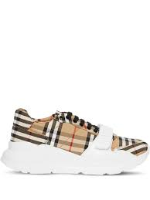

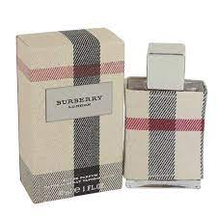
Pricing Strategy
As the fashion company provides qualified luxury products, it maintains a premium pricing strategy for its products. The people from the elite class of society belong to Burberry's potential customer zone. So, they are consistent to retain their premium pricing rates for their products. The global competitive market condition leads the company to set this pricing strategy (Burberry, 2023b).

Leather and Check Cotton Sneakers
£420 is determined in the UK as the price of the Leather and Check Cotton sneakers of Burberry. The price of the product is $820 in America (Burberry, 2023d).
Pricing Strategy
Being a luxurious clothing brand the company delivers high quality of products using a premium pricing strategy.
Embroidered Logo Cotton Twill Shirt
The company has fixed £650 in the UK for the high-quality shirt. In the USA the price of the shirt is fixed at $910 (Burberry, 2023c).
Pricing Strategy
The company uses a premium quality of pricing strategy for the product. Higher standard of product has provoked the company to follow this pricing strategy.

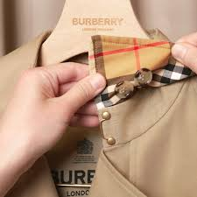

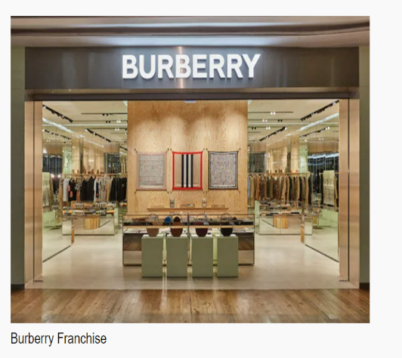
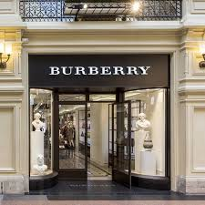
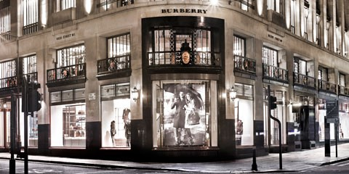
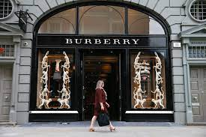
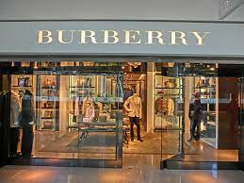
121 Regent Street London
The above-mentioned address indicates one of Burberry's stores which is available on all days of the week. The time of the store from Monday to Saturday is 11:00-20:00 (Burberry, 2023e).
Burberry Charlotte in North Carolina
There are also various stores in the United States. Burberry Charlotte is one of them which is situated in North Carolina (Burberry, 2023f).

Indirect channel

Burberry is also expanding its global market through Burberry Franchise by which the global franchises will get opportunities to gain profit in their business. The new business entrepreneurs with higher aspiration to make their business profitable are welcome to be registered for Burberry Franchise (Burberryfranchise, 2022).

Direct channel

The globally recognised company has more than five hundred stores across the world. With the motto of being one of the best brands in the world, the company has tied its business with global dealers and franchises to sell its products. Across the world, there are different reputed stores from which the products of the company are sold. Besides, different types of digital shopping stores are also available to sell the products of the company. The present number of Burberry stores across the world is 218. The number of franchise stores is 38 and the outlets are 38 (Sabanoglu, 2022).

Locations of Burberry
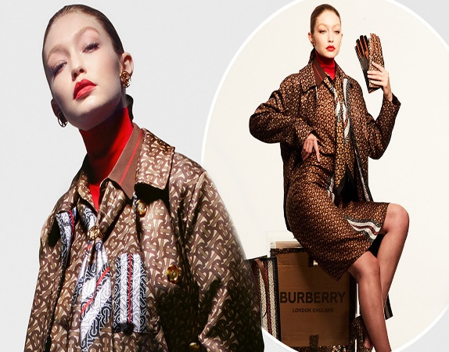

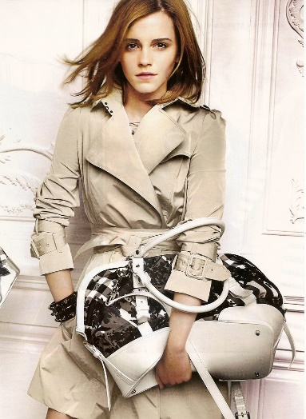
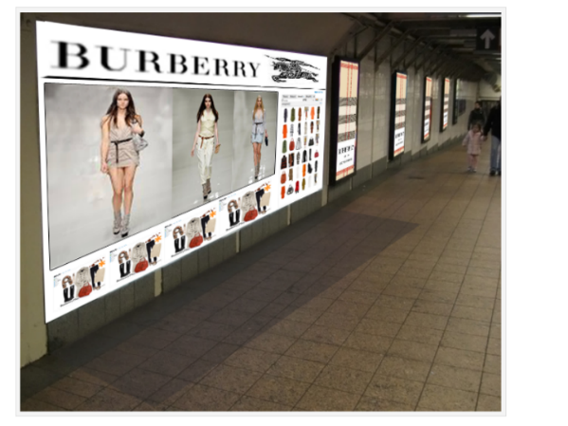
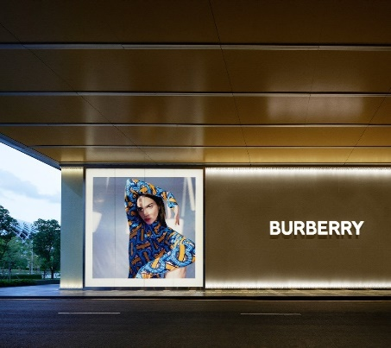
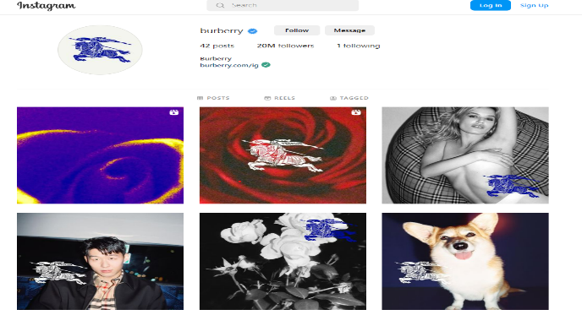
Being close to celebrities or leading public figures of the world the company has unique promotional strategies by which the reputed magazines play an instrumental role to promote Burberry products. Therefore, the company follows influencer marketing. The celebrated actress Emma Watson and Gigi Hadid promotes the advertising campaign in favour of Burberry.

The luxury products of the company are promoted through leading digital platforms. Facebook is one of the key platforms through which the company promotes its variety of quality products. TV campaigns are also used by them to promote their products. With an increasing number of fans, the company has reached to gain ten million of Facebook fans. The company uses this social media tool to enhance its promotion and marketing strategy (Baker,2020).

It focuses on grabbing potential customers across the world. The company spends 60% of its budget on the promotional marketing strategy.

Our Promotional Strategies

Facebook: https://www.facebook.com/Burberry/
Twitter: https://twitter.com/burberrycorp
Instagram: https://www.instagram.com/burberry/?hl=en
YouTube: https://www.youtube.com/user/Burberry
LinkedIn: https://www.linkedin.com/company/burberry/

References

Baker, R. (2020) Burberry dedicates 60% of marketing spend to digital, Marketing Week. Marketing Week. Available at: https://www.marketingweek.com/burberry-dedicates-60-of-marketing-spend-to-digital/ (Accessed: March 23, 2023).
Brandburberry (2011) Assignment 4: Burberry Marketing Program, On Burberry... Available at: https://brandburberry.wordpress.com/2011/10/20/assignment-4-burberry-marketing-program/ (Accessed: March 27, 2023).
Brighton (2023) Oscillate, Burberry Target Audience | Oscillate. Available at: https://blogs.brighton.ac.uk/creativecollab/2020/11/11/burberrys-target-audience/#:~:text=Highly%20dominated%20by%20women%20with,wealthy%20and%20tourist%20attractive%20cities (Accessed: March 23, 2023).
Broeke and Maoul (2018) How Burberry became Britain's most important brand, British GQ. British GQ. Available at: https://www.gq-magazine.co.uk/article/how-burberry-became-britains-most-important-brand (Accessed: March 23, 2023).
Burberry (2022b) Men's Shoes: Men's casual & formal footwear: Burberry® Official, Burberry India. Available at: https://in.burberry.com/mens-shoes/#/sneakers/ (Accessed: March 23, 2023).
Burberry (2023) History, burberry Corporate Website. Available at: https://www.burberryplc.com/en/company/history.html (Accessed: March 24, 2023).
Burberry (2023a) Our history, Burberry. Available at: https://in.burberry.com/c/our-history/ (Accessed: March 23, 2023).
Burberry (2023c) Leather and vintage check cotton sneakers in black/archive beige - women: Burberry® Official, Burberry United States. Available at: https://us.burberry.com/leathervintage-check-cotton-sneakers-p80381841 (Accessed: March 23, 2023).
Burberry (2023d) Embroidered logo cotton twill shirt in muted Navy - men: Burberry® Official, Burberry United Kingdom. Available at: https://uk.burberry.com/embroidered-logo-cotton-twill-shirt-p80700371 (Accessed: March 23, 2023).
Burberry (2023e) Burberry 121 regent street, Burberry United Kingdom. Burberry. Available at: https://uk.burberry.com/stores/regent-street-store/ (Accessed: March 23, 2023).
Burberry (2023f) Burberry 4400 Sharon Road, Charlotte: Burberry® Official, Burberry 4400 Sharon Road, Charlotte | Burberry® Official. Available at: https://us.burberry.com/store-locator/nc/charlotte/4400-sharon-road (Accessed: March 23, 2023).

Burberry (2023g) Embroidered logo cotton twill shirt in muted Navy - men: Burberry® Official, Burberry India. Available at: https://in.burberry.com/embroidered-logo-cotton-twill-shirt-p80700371 (Accessed: March 24, 2023).
Burberry (2023h) Leather, suede and house check cotton sneakers in optic white - men: Burberry® Official, Burberry United States. Available at: https://us.burberry.com/leather-suedehouse-check-cotton-sneakers-p80241251 (Accessed: March 24, 2023).
Burberryfranchise (2022) Home, BURBERRY FRANCHISE. Available at: https://burberryfranchise.com/ (Accessed: March 27, 2023).
Burberryplc (2023) Our purpose, burberry Corporate Website. Available at: https://www.burberryplc.com/en/company/our-purpose.html#:~:text=Our%20vision%20is%20to%20be,and%20value%20for%20our%20stakeholders (Accessed: March 27, 2023).
Chipeta, C. (2020) Psychographic segmentation: Advantages and limitations, Conjointly. Available at: https://conjointly.com/blog/psychographic-segmentation-advantages-limitations/ (Accessed: March 27, 2023).
Cpp-luxury (2018) Burberry shifts strategy towards ultra-luxury positioning, CPPLUXURY. Available at: https://cpp-luxury.com/burberry-shifts-strategy-towards-ultra-luxury-positioning/ (Accessed: March 23, 2023).
Deasi, G. (2021) 10 powerful behavioral segmentation methods to understand your customers, Pointillist. Available at: https://www.pointillist.com/blog/behavioral-segmentation/ (Accessed: March 24, 2023).
Embapro (2022) Burberry Group (United Kingdom) marketing segmentation, targeting, differentiation, positioning solution, embapro.com. Available at: https://embapro.com/frontpage/marketingstpcoanalysis/17979-burberry-group (Accessed: March 23, 2023).
Fashionnetwork (2023) Louis Vuitton and Burberry vie for pole position in luxury brand social media rankings, FashionNetwork.com. Available at: https://uk.fashionnetwork.com/news/louis-vuitton-and-burberry-vie-for-pole-position-in-luxury-brand-social-media-rankings,950452.html (Accessed: March 24, 2023).
Highsnobiety (2023) Is this the end of luxury's sans-serif logo era?, Highsnobiety. Available at: https://www.highsnobiety.com/p/burberry-new-logo-trend/ (Accessed: March 24, 2023).
Hofacker, M. (2022) What is differentiated marketing, concentrated, and undifferentiated marketing?, Referral Rock Blog. Available at: https://referralrock.com/blog/differentiated-concentrated-undifferentiated-marketing/ (Accessed: March 27, 2023).
Lovesales (2023) Burberry Sale, LoveSales.com. Available at: https://www.lovesales.com/burberry (Accessed: March 27, 2023).

Penny, D. (2023) The very British history of Burberry, Harper's BAZAAR. Harper's BAZAAR. Available at: https://www.harpersbazaar.com/fashion/designers/a42991152/burberry-british-history/ (Accessed: March 23, 2023).
Pous, T. (2023) Fresh faces: 13 young celebrity ad campaigns, Time. Time. Available at: https://style.time.com/2012/10/23/fresh-faces-13-young-celebrity-ad-campaigns/slide/emma-watson-for-burberry-2009/ (Accessed: March 24, 2023).
Regentstreetonline (2023) Burberry, Burberry - Regent Street, London. Available at: https://www.regentstreetonline.com/directory/burberry (Accessed: March 24, 2023).
Sabanoglu, T. (2022) Burberry's number of stores worldwide by Outlet Type 2022, Statista. Available at: https://www.statista.com/statistics/439282/burberry-number-of-stores-worldwide-by-outlet-type/ (Accessed: March 23, 2023).
Sendpulse (2023) Home, SendPulse. Available at: https://sendpulse.com/support/glossary/cross-marketing (Accessed: March 23, 2023).
Similarweb (2023) Burberry.com Traffic Analytics & Market Share | similar web. Available at: https://www.similarweb.com/website/burberry.com/ (Accessed: March 23, 2023).
Theluxurytrendz (2023) Theluxurytrendz.in, TheLuxuryTrendz. Available at: https://theluxurytrendz.in/burberry-lining-maroon-premium-box-pack-shirt-theluxurytrendz.html?color=0 (Accessed: March 24, 2023).
Walls, P. (2023) 35 Pros & Cons of starting a luxury brand (2023) - starter story, Starter Story RSS. Starter Story. Available at: https://www.starterstory.com/ideas/luxury-brand/pros-and-cons (Accessed: March 27, 2023).
Wang, J., (2023), February. Research on the Market Positioning Analysis and STP Strategy of Marvel Enterprises. In 2022 4th International Conference on Literature, Art and Human Development (ICLAHD 2022) (pp. 647-654). Atlantis Press.
Weavabel (2023) The most iconic packaging design in the fashion industry, Weavabel. Wearable. Available at: https://www.weavabel.com/blog/the-most-iconic-bespoke-packaging-designs-in-the-fashion-industry (Accessed: March 23, 2023).
Weston, S., (2022). The Changing Face of Burberry: Britishness, Heritage, Labour and Consumption. Bloomsbury Publishing.
Wordpress (2023) Burberry target audience, Burberry Experiences. Available at: https://burberry2017.wordpress.com/blog/ (Accessed: March 24, 2023).

