ENTREPRENEURSHIP
(LCBB5001)

Assessment 2
Business Plan: "Health and Harmony Inc."
( 2000 w.)

Student name: Lecturer name:
Angela Celac (2023256) John-Paul Okeke

Submission date:
02.09.2022

Table of Contents
Introduction 3
Business Description 3
Industry Analysis 4
Operations and Management Plan 6
Marketing Plan 10
Financial Plan 11
Market Research 12
Conclusion 12
References 14

Introduction
Usability of macro and micro economy analysis has been elaborated in this report to analyse and enhance the understanding level behind the business establishment chances and prospects in the scenario of the UK. With reference to trends and operations management, the researcher has understood the intersectionality behind collaborative functioning in business processes. The overall planning and projection done as per the ideal of this business is the main concern behind establishment of proper concepts of revenue stream and income functions. Lastly, planned financing as the main outcome behind entrepreneurship has been fluently reiterated in this report to state the validation behind execution of product projection through management.
This report is all about development of a business plan. The name of the plan is "Health and Harmony Inc.". Here, prime focus would include business and legal considerations of the functional schemas followed by business appropriate positioning within the industry structure. Thereafter, a vivid discussion on product functional schema through discussion of the revenue stream. Organisational structure would be mentioned with an elaboration upon structural strategic contribution behind the project aforementioned. Lastly, this report would focus on a budgetary analysis of the project finances that would enhance functional capacity on the overall wider market structure of the product offered here.

Business Description
The business name is "Health and Harmony Inc.". Products to offer include an "AI-based cycle" and a relaxing AI-oriented Swivel Chair. The cycle would be operated through solar and kinetic energy to provide backup for quick destination routing for users. Secondly, a "Swivel relax easy chair" that is also AI-driven to enhance relaxation structure to people sitting in it in the midst or after day work for periodic relaxation. The business is focused on the UK customer market. Here, target population for the cycle is age group between 17 to 49 years of unisex population (Gov.uk, 2021). For the relaxing chair, age group is between 15 to 75 years unisex population. The cycle and chair this business has to offer would also be made of recycled materials to ensure minimal to no "greenhouse gas emission" in UK using a "closed loop supply chain" (Alarcón et al. 2021). The frame of the cycle can be made of plastic and wood structures (District, 2019). The mission statement is to provide health and wellness to all age groups in the UK irrespective of age. The business would have property consideration based on "UK enterprise act" along with CMA authority regarding investments (Lopes et al. 2020). The patient's tenure needs to be renewed every 20 years. As opined by Newman (2022), This business would function under general partnership along with personal liability to corporate taxes and insurance concerns. Price of the cycle is settled as 500 GBP, and the chair is priced at 1000 GBP.

Industry Analysis
Threat of New Entrants
No threat. Although there is the context of solar panel powered bicycles, New entry in this business plan is still not registered in UK business scenario (Toll, 2018). A bicycle and a chair powered by AI through solar cell to ensure customer satisfaction that too at considerable cheap pricing automatically places no threat chances to the business. However, for the chair AI and IoT functions that have been discussed during research, no company has utilised previous functions to introduce their products at such fewer prices as mentioned above (Miyachi et al. 2018). Therefore, it is evident that facilitating two wellness products would place a new business trend in the UK.
Supplier Bargaining Power
High. The utilisation of AI in UK is adopted by more than four lakh business setups (Gov.uk, 2022). It is also seen that 13 big organisational functions in the UK have planned to systematically implement AI mechanisms in their end products and services.
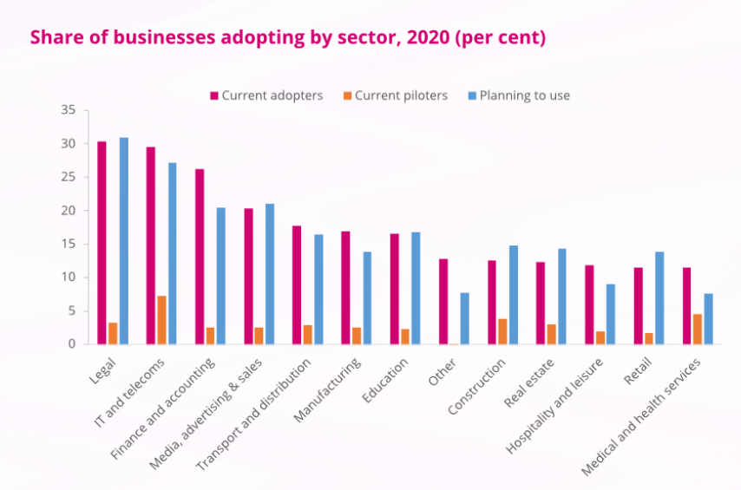
Figure 1: Utilisation measurement of AI in UK landscape
(Source: Gov.uk, 2022)
In addition, the need for solar power in UK scenario has also witnessed a 36% increase in 2021 when compared with 2020 (Solarfeeds.com, 2022). Solar cell energy utilisation in the UK has been predicted to enlist over 5% CAGR contribution on the business scale.
Internal Rivalry
Nill. Although there are competitors in the UK market manufacturing bicycles or easy chairs, the business "Health and Harmony Inc." like a business presentation based on AI in devices, the count of AI and IoT functions might be a normalised approach in health and wellness-oriented devices across UK and the globe. As opined by Özdemir (2019), Intel has already presumed to incorporate more than 200 billion artificially powered devices in 2020.
Threat to Substitutes
Nill. The effect of substitution would not affect this business at present. As opined by Keller (2021), the design "Eames Lounge Chair" is the best-suited design that can be provided to the AI powered easy chair for elderly population. Here, the design similarity doesn't provide an immediate substitution effect for other brands due to lack of affordable design and product. A similar concern applies to the cycle also.
Customer Bargaining Power
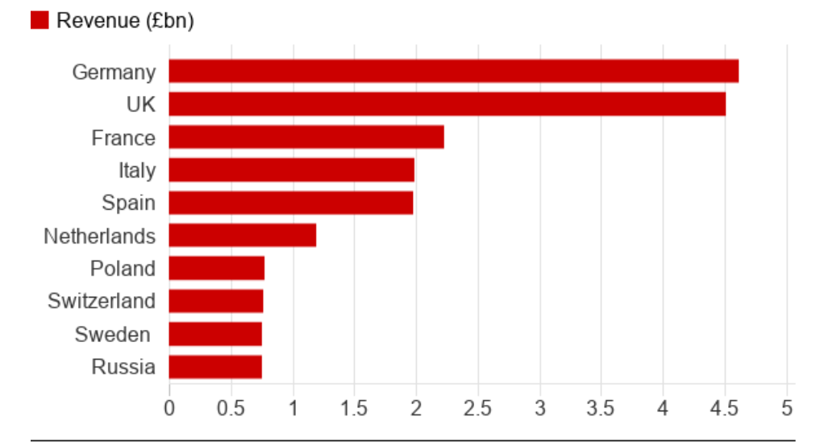
Figure 2: Fitness projection in Europe
(Source: Jones, 2018)
Nill. Here, the entire UK market would directly opt for the proposed product. Bicycle affordability in UK is ranked at 42% with 1.4 billion GBP yearly spending (Johnson, 2021). Similarly, 2.5 million people in UK have reported of constant back pain (Medserena, 2018). As opined by Campbell (2021), 57% population index has reflected negative results Concerning sleeping trouble in the UK. Therefore, a positive position is expected for this business in UK.

Operations and Management Plan
The revenue stream considering this business of AI based solar cell oriented Easy chairs and cycle in the UK would be operational in two main ways concerning "Subscription based Lease" and "Direct asset sell" (Curley, 2021). Here, it can be said that the business model would focus both on rental function through monthly, quarterly, half yearly and annual or direct sales for the cycles. While, for the easy chair, rental service would not be accepted.
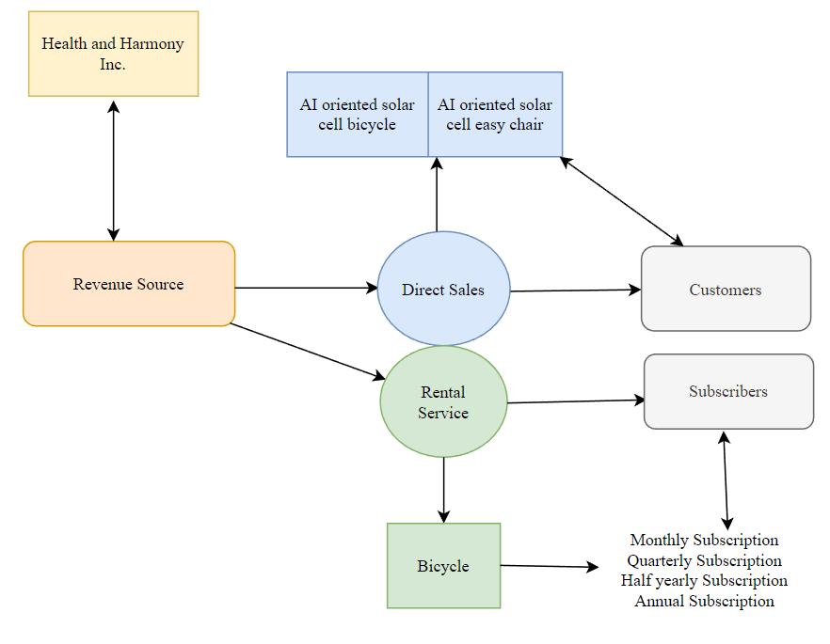
Figure 3: Projected Revenue Stream of Health and Harmony Inc.
(Source: Self Developed)
It is already clear from this projection placed above in Figure 3 that sales and presentation of the business through subscription-based marketing would be the chosen business process of the company. Already, it has been established that the type of innovation under business outcome that the company has planned to operate in the UK is like a showcasing that usually happens to product prototypes. Thereafter, the pricing of the products is also less. As opined by Fontanella (2022), a constant economy flow through subscription-based revenue generation would be helpful for the business to gather occupational and operational income. Inventory holds maximum concern in this business as already stated about usage of refurbished and recycled products in the production and manufacturing of the chairs and cycles. Hence, considering the “subscription-based model”, it can be said that “predictive warehouse management” through estimation of operational status is a positive function to ensure functional profits for the business.
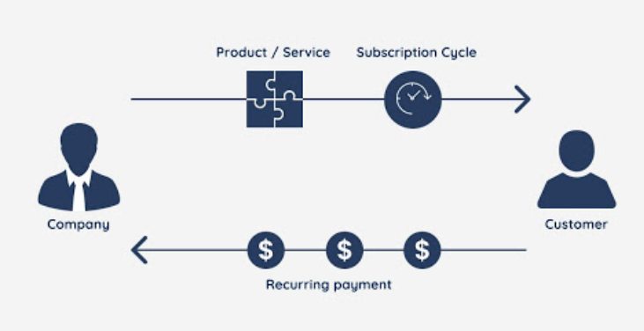
Figure 4: Functional axis of subscription process of business
(Source: Fontanella, 2022)
Here, the organisational structure of the business is placed through a hierarchical structure diagram below
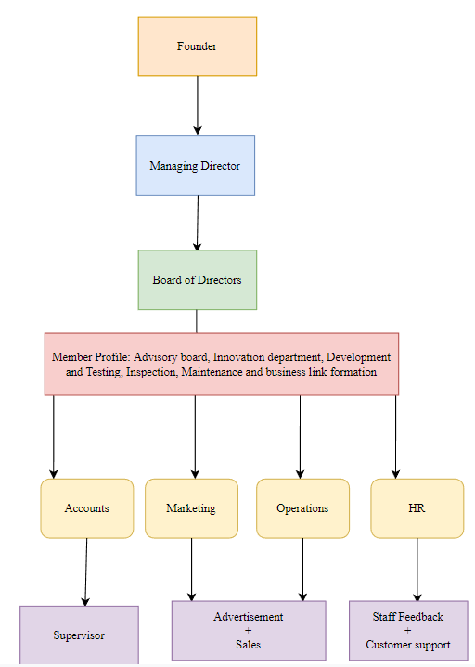
Figure 5: Hierarchical structure of management team
(Source: Self Developed)
The business is headed by a founder to establish the idea within UK. Thereafter, the business would be controlled by a managing director to ensure benefit and loss management through daily inspection (Editorial Team, 2022). Thereafter, the managing director is responsible to note the operations of management with additional directorial board setup. Under this structure, accounts, marketing operations and HR function. Hence, proper supervision of sales, marketing, manufacturing, advertisement and time-based subscriptions would also be running in this above chosen structure. It can be said that the uniqueness of hierarchical contribution in this business lies on 3 final levels of supervision, feedback and selling functions on permanent and advertisement-based levels of ensured trust and functional loyalty. Here, profiling includes distribution, stakeholder management in local and regional levels. Accounts and marketing department is liable for business expansion, operations department is liable for accountability in daily operations and management of stocks and inventories. As opined by Gordon (2022), the formation of above hierarchical structure is found relevant because of the six major functional profiling as is stated in Figure 5.
The best suited legal structure is general partnership (Pathwaylending.org, 2022). Under this proper formulation about business processes, actions and strategic measurements would help the organisation. Here, the distribution of concerns along with the management would also be simple because of dealing with Artificial intelligence, recycled materials and solar power. These three concerns are very popular in the UK context. The other options are Sole Partnership, Limited liability concerns and corporations. These three structures are either too short or are risky because of no cover plan because of liability risks within the business structure. According to Showers (2022), by accepting the legal terminology of general partnership over others, the “Health and Harmony Inc.” would gain quick status within the market with the help of special trade benefits and leading help from search functions as well.

Marketing Plan
Product: Here, the product is to manufacture a cycle using recycled materials operated through AI control, kinetic force and solar cells. In addition, an easy chair is also in the list that would be manufactured by recycled materials, using AI controls and using solar cells to power the chair for massage and relaxation.
Price: The cycle is priced at 500 GBP and the massage chair is priced at 1000 GBP.
Place: The business concerning these two products would be operated, manufactured and marketed within the UK. Distribution would be inbounded within the country on a regional basis.
Promotion: According to Atreya (2020), using online event based promotion and by arranging for rental services as test samples would be the best suited promotional strategy. Through proper distribution of invitations and content based information into the public domain, the percentage of people who are generally into health and wellness would visit the distribution centres of the products. Thereby, through in hand testing and collecting results through direct gamification, the feedback section can ensure proper response collection to understand the points of differentiation in between the competitive landscape as per the observed strategies.

Financial Plan
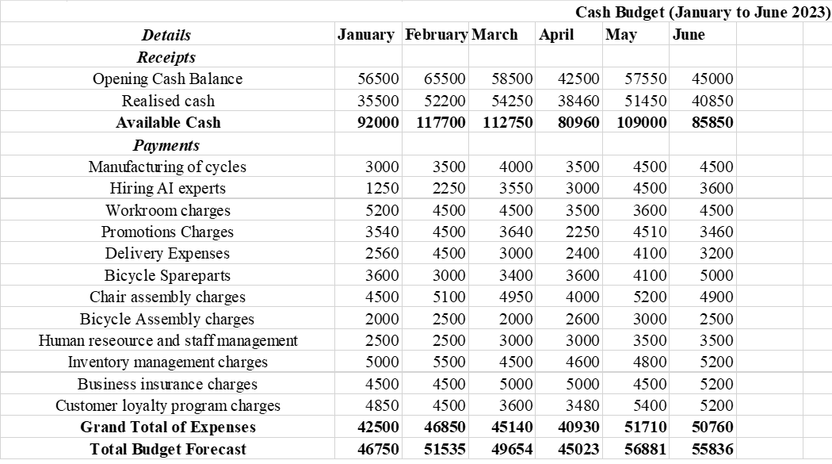
Figure 6: Cash Budget Preparation
(Source: Self Developed)
As reflected in this cash budget, the money The money used in this cash budget is used over 12 integral business functions starting from manufacturing and hiring of experts to arranging for customer loyalty concerns. Sustainably, the cash budget projection has been evaluated in this chart in a period of 6 months starting from January to June 2023. As opined by Ali (2020), financial forecasting in real terms would be helpful for ensured financial sustainability with the help of calendar-based resource allocation by evolving the rigid processes of payments calculation into flexible target dynamism through alteration of internal controlling variables.

Market Research
Political: Positive. Lesser official surveys happen in UK from the time of the Covid-19 pandemic. Country wise tension and mismanagement are generic post 2020 (Davies et al. 2021). Political stabilituy score as per business establishment is 75% (Ons.gov.uk, 2022).
Economic: Positive. In 2022, economic rank of UK is 72.7. Its global ranking in economic freeness is recorded as 24th in the entire global scenario (Heritage.org, 2022). Under top 45 countries, UK ranks 17th in economic viability.
Social: Positive. Labour freedom in UK is recorded as 62.1 points (Heritage.org, 2022). Total population is 68 million (Countrymeters.info, 2022). Male to female ratio is 49.2% to 50.8%.
Technological: Positive. Major technical developments in UK in 2022 scenario are Blockchain improvements, AI integration (Harveynash.co.uk, 2022). Besides that, blockchain, and “XaaS service integration” in human life.
Legal: Neutral. Implementation of “National Security Merger law”, “Corporation tax rates” and increase in national living wages in the UK would be mandatory for fluent operations and expansion of businesses (Duckworth, 2021). National security concern is the main highlighted cause here.
Environmental: Positive. Innovative business with a cultural mindset through decisive approach of businesses are identified positive factors towards customer's acceptance of new businesses in the UK (Assets.publishing.service.gov.uk, 2019). Start-ups are also preferred by the public because of rapid business promising rate through progression.

Conclusion
It can be said that the business plan named “Health and Harmony Inc.” would be successful in the UK context considering the fact of proper inclusion and implementation of solar power and artificial intelligence at large. Healthcare and wellness are the two valid factors that have ensured functional positivism towards proper placement of the business model in UK’s scenario using the models like PESTLE analysis, Porter’s 5 Forces and 4P’s of marketing. Proper budget fixation is also a major prospect that has been identified in this report as a coining mechanism into no rivalry or competition within the market. Besides that, absence of implementation and realisation of healthcare concern in a start-up business scenario in UK has also been the core focus in this research to identify majoritarian issues of public problems faced due to age. Lastly, an elaborated financial projection has also helped the reporter to understand functional usability of the budget behind investment and actual concerns in the business operations.

References
Alarcón, F., Cortés-Pellicer, P., Pérez-Perales, D. and Mengual-Recuerda, A., 2021. A reference model of reverse logistics process for improving sustainability in the supply chain. Sustainability, 13(18), p.10383. DOI: https://doi.org/10.3390/su131810383
Ali, R., 2020. The Why Behind Financial Forecasting. Oracle NetSuite. Available at: https://www.netsuite.com/portal/resource/articles/financial-management/importance-financial-forecasting.shtml [Accessed 22 July 2022].
Assets.publishing.service.gov.uk, 2019. BUSINESS BASICS: ATTITUDES TO ADOPTION. Available at: https://assets.publishing.service.gov.uk/government/uploads/system/uploads/attachment_data/file/838473/attitudes-to-adoption.pdf [Accessed 22 July 2022].
Atreya, R., 2020. 11 Unique Health And Wellness Marketing Ideas You Can’t Ignore. Vantage Fit. Available at: https://blog.vantagefit.io/health-wellness-marketing-ideas/ [Accessed 22 July 2022].
Campbell, D., 2021. More than half of young people have trouble sleeping – NHS. Theguardian.com. Available at: https://www.theguardian.com/society/2021/sep/30/more-than-half-of-young-people-have-trouble-sleeping-nhs-says [Accessed 22 July 2022].
Countrymeters.info, 2022. United Kingdom (UK) Population. Available at: https://countrymeters.info/en/United_Kingdom_(UK) [Accessed 22 July 2022].
Curley, E., 2021. 8 revenue stream examples for your business. Glofox.com. Available at: https://www.glofox.com/blog/revenue-stream-examples/ [Accessed 22 July 2022].
Davies, B., Lalot, F., Peitz, L., Heering, M.S., Ozkececi, H., Babaian, J., Davies Hayon, K., Broadwood, J. and Abrams, D., 2021. Changes in political trust in Britain during the COVID-19 pandemic in 2020: integrated public opinion evidence and implications. Humanities and Social Sciences Communications, 8(1), pp.1-9. DOI: https://doi.org/10.1057/s41599-021-00850-6
District, M. (2019). Sustainable bikes made of recycled plastic, bamboo and wood. MaterialDistrict. Available at: https://materialdistrict.com/article/bikes-recycled-plastic-bamboo-wood/ [Accessed 22 July 2022].
Duckworth, H., 2021. Make sure you’re prepared for new laws coming in 2022. [online] Haroldduckworth.co.uk. Available at: https://haroldduckworth.co.uk/make-sure-youre-prepared-for-new-laws-coming-in-2022/ [Accessed 22 July 2022].
Editorial Team, I., 2022. Hierarchical Structures: Definition, How it Works and Examples. Indeed Career Guide. Available at: https://uk.indeed.com/career-advice/career-development/hierarchical-structure [Accessed 22 July 2022].
Fontanella, C., 2022. What’s a Subscription Business Model & How Does It Work? Hubspot. Available at: https://blog.hubspot.com/service/subscription-business-model#:~:text=In%20a%20subscription%20model%2C%20customers [Accessed 22 July 2022].
Gordon, J., 2022. Team Management Profile - Explained. [online] The Business Professor, LLC. Available at: https://thebusinessprofessor.com/en_US/management-leadership-organizational-behavior/team-management-profile-explained [Accessed 22 July 2022].
Gov.uk, 2021. Walking and cycling statistics, England: 2020. Available at: https://www.gov.uk/government/statistics/walking-and-cycling-statistics-england-2020/walking-and-cycling-statistics-england-2020#:~:text=Factors%20influencing%20cycling%20rates [Accessed 22 July 2022].
Gov.uk. (2022). AI activity in UK businesses: Executive Summary. Available at: https://www.gov.uk/government/publications/ai-activity-in-uk-businesses/ai-activity-in-uk-businesses-executive-summary#:~:text=In%202020%2C%20the%20432%2C000%20companies [Accessed 22 July 2022].
Harveynash.co.uk, 2022. 2022 Technology Trends to watch. Available at: https://www.harveynash.co.uk/latest-news/2022-1/2022-technology-trends [Accessed 23 July 2022].
Heritage.org, 2022. United Kingdom. Available at: https://www.heritage.org/index/country/unitedkingdom#:~:text=The%20United%20Kingdom [Accessed 22 July 2022].
Johnson, G.-R., 2021. Cycling statistics 2019. Finder UK. Available at: https://www.finder.com/uk/cycling-statistics [Accessed 22 July 2022].
Jones, L., 2018. Saving pounds: The rise of the budget gym. BBC News. 16 July Available at: https://www.bbc.com/news/business-44766250 [Accessed 22 July 2022].
Keller, H. (2021). Wait, What’s an Eames Chair? And 49 Other Iconic Chairs, Explained. Housebeautiful.com. Available at: https://www.housebeautiful.com/design-inspiration/g30750815/chair-types-styles-designs/ [Accessed 22 July 2022].
Kelley, J., 2020. How Your Supply Chain Changes When Migrating to a Subscription Pricing Model. Supply and Demand Chain Executive. Available at: https://www.sdcexec.com/warehousing/article/21195550/oracle-how-your-supply-chain-changes-when-migrating-to-a-subscription-pricing-model [Accessed 22 July 2022].
Lopes, S., Eccles, R., Horton, A., Williamson, R., Dixon, A., Sekine, Y., Heap, N., Rink, A., Giles, C. and Green, N. (2020). Practical Law UK Signon. Thomsonreuters.com. Available at: https://uk.practicallaw.thomsonreuters.com/5-500-5090?transitionType=Default&contextData=(sc.Default)&firstPage=true [Accessed 22 July 2022].
Miyachi, T., Iga, S. and Furuhata, T., 2018. Rolls of facilitator in collaborative active learning for relaxing life. Procedia Computer Science, 126, pp.1415-1423. DOI: https://doi.org/10.1016/j.procs.2018.08.113
Newman, S., 2022. 8 legal considerations when setting up a business. Small Business UK. Available at: https://smallbusiness.co.uk/8-legal-considerations-when-setting-up-a-business-2560686/ [Accessed 22 July 2022].
Ons.gov.uk, 2022. Trust in government, UK - Office for National Statistics. Available at: https://www.ons.gov.uk/peoplepopulationandcommunity/wellbeing/bulletins/trustingovernmentuk/2022 [Accessed 23 July 2022].
Özdemir, V., 2019. The big picture on the “AI turn” for digital health: the internet of things and cyber-physical systems. OMICS: A Journal of Integrative Biology, 23(6), pp.308-311. DOI: https://doi.org/10.1089/omi.2019.0069
Pathwaylending.org, 2022. 4 Most Common Business Legal Structures. Available at: https://www.pathwaylending.org/news-and-blog/news/business-legal-structures/ [Accessed 22 July 2022].
Solarfeeds.com, 2022. Solar Power Statistics in the United Kingdom 2021. Available at: https://www.solarfeeds.com/mag/solar-power-statistics-in-united-kingdom-2021/ [Accessed 22 July 2022].
Stowers, J., 2022. How to Choose the Best Legal Structure for Your Business. Business News Daily. Available at: https://www.businessnewsdaily.com/8163-choose-legal-business-structure.html [Accessed 22 July 2022].
Toll, M., 2018. This solar powered electric bicycle went 12,800 km in 64 days! Electrek. Available at: https://electrek.co/2018/09/27/solar-powered-electric-bicycle-journey/ [Accessed 22 July 2022].

