Module title & code
Managing Guest service
BMIH6003

Student Name : Alina Grigore
Student ID: 2127560
Contents
Introduction 1
Reflection on Experience and Personal Development 2
Critical Analysis of Work-Based Skills and Technical Knowledge 2
Reflection on Organisational Issues 4
Conclusion 6
Action Plan 7
References 8

Introduction
Cardiff Marriott Hotel has guest service operations in its basic operations which play an important role in maintaining guest satisfaction in terms of service quality using consistent service quality in all departments such as Reception, Housekeeping, Leisure Club, Meetings & Events. Together these departments work to have a seamless guest experience (Mariott, 2024).
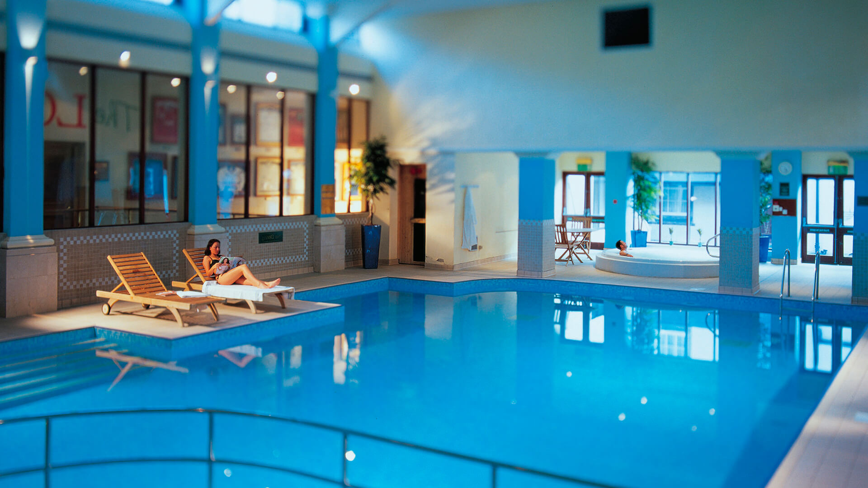
Figure: Marriott Leisure Club (Marriott Lifestyle, 2019)
The key objective from my placement experience in Cardiff Marriott Hotel:
- Discover how to predict guest needs, handle complaints and resolve issues quickly to keep high satisfaction levels
- Deliver insight into how day-to-day operations are structured and kept running to satisfy daily guest service requirements
- Understand the tools and metrics used to improve service and understand where to improve

Reflection on Experience and Personal Development
The Cardiff Marriott Hotel guest services gave me valuable hands-on experience working in a supervisory role in placement. I have seen when observing a supervisor addressing different situations, I need to put technical knowledge and work-based skills together and provide high-quality service. Guest interactions require adaptability, quick problem-solving, and empathy, and all of those things are necessary for guest satisfaction and engagement.
It allowed me to confirm my understanding of good communication and teamwork in a frenetic environment. Moreover, clear communication also prevents misunderstandings so the whole team can work towards and collaborate without overlooking issues and managing them in real time (Casado 2011). In these situations, the academic concepts like conflict resolution and prioritization applied in real-world situations became apparent.
Looking back on my vocational journey I realise that my skill set is a result of my time on industrials and my academics. As I had these experiences, I learned a lot of resilience, I learned I could be adaptable, and I learned attention to detail, which are all important when I am doing guest service. Amongst other personal qualities, I have learned that bridging technical skills with personal qualities is equally about expertise and equally about the more personal aspects of client connections.

Critical Analysis of Work-Based Skills and Technical Knowledge
In the hospitality industry, work-based skills and technical knowledge are the foundation for meeting and exceeding guest service expectations (Wood, 2013). During my placement experience, I came across many critical skills and knowledge areas that directly influenced how service was delivered.
Work-Based Skills: Work Based Skills in guest service operations are the kind of skills which are developed and used through practical application in the workplace (Testa and Sipe, 2012). They are important skills for interacting with guests and performing each duty.
- Effective communication: During busier times, clear communication between staff and the supervisory team is important (O’fallon and Rutherford, 2020). I saw, for example, how a supervisor relayed guest needs to the housekeeping staff, so rooms were prioritized as guests wanted. This skill not only helps to increase operational efficiency but more importantly to make sure guests feel heard and treated like valued customers. The delays and dissatisfaction would result without clear communication (Baker et al., 1996).
- Conflict resolution: Another important work-based skill is conflict resolution. I saw a supervisor just whip a guest complaint when a guest complained that a room service order had been delayed. The problem was dealt with adequately by the supervisor in a professional fashion, an apology was made sincere and a time resolution was set, with a free service top-of-the-range replacement. This showed how quickly problems can be resolved into good for guests that would otherwise turn bad.
Technical Knowledge: In guest service operations, technical knowledge is defined as the particular, frequently industry-based, knowledge and expertise that support the efficient functioning of hotel or hospitality services. This consists of knowing systems, tools and processes used in the industry, such as reservation software, property management systems (PMS), billing systems, guest communication platforms and quality control protocols (Johnston and Clark, 2009)
- Reservation systems: Reservation systems help in terms of technical knowledge to manage guest expectations (Vasadze, Mosashvili and Duruli, 2018). Being able to look at the booking software allowed the supervisor to look at room availability, make adjustments to bookings, and deal with guest concerns about overbooking. The technical proficiency of these systems guarantees that operations shall run smoothly and reduce errors, to guest satisfaction.
- Knowledge of service standards: In addition, it was of paramount importance to know the service standards. Consistent, high-quality service was ensured by training staff using the supervisors’ ability to apply established service standards. Sticking to the check-in and check-out protocols, limit wait times and improve the guest experience.

Reflection on Organisational Issues
The Kolb’s Experiential Learning Cycle model is a four-stage model. Concrete experience, reflective observation, abstract conceptualization and active experimentation are the elements of this framework (Morris, 2020).
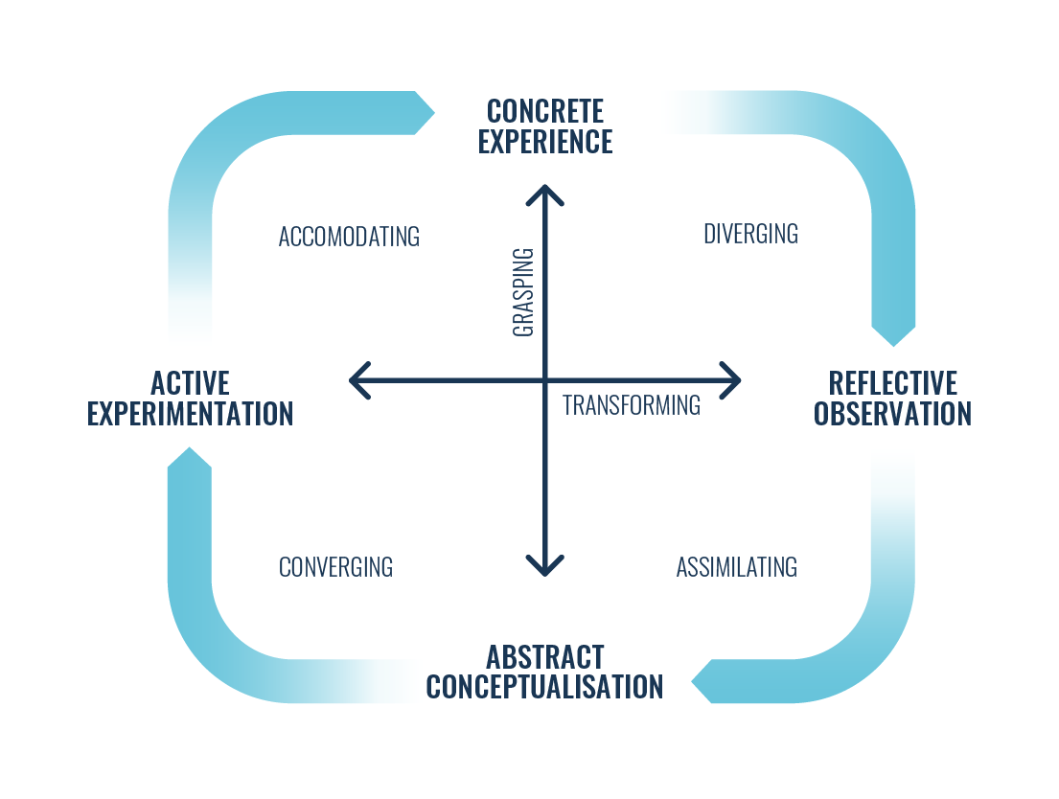
Figure: Kolb’s Experiential Learning Cycle (Morris, 2020)
By reflecting on my placement experience in Cardiff Marriott Hotel, there was once a guest who was not satisfied with their room because of cleanliness. This situation can be analyzed using Kolb’s cycle:
- Concrete Experience: The meaning of it is direct participation in an event or a situation (Konak, Clark and Nasereddin, 2014). In my experience, the guest reported the issue of an unclean room and the supervisor was handling the complaint. The supervisor apologized and moved them to an immediate room.
- Reflective Observation: It is considered as an experience and the look at the other perspectives. I thought about how the situation affected department performance. Operational delays occurred because staff had to quickly reassign housekeeping resources that were mixed up in the room. A potential lack of future loyalty was at risk because of the satisfaction of the guest
- Abstract Conceptualization: It is all about forming an idea or theory from observed reflections (Wijnen-Meijer et al., 2022). From my experience, I understood that prior issues like these can be prevented with proactive quality checks. This type of theory supports this with a theory like Total Quality Management (TQM), which focuses on continuing improvement of processes to maintain high standards.
- Active Experimentation: This involves applying these ideas to future situations. Rather, I would suggest that a more rigorous system of quality control checks be used before guest check-ins. Those could be things like assigning a senior staff member to inspect rooms walk through them, and feed that back to housekeeping immediately.

Conclusion
The placement experience gave me a deeper understanding of what guest service standards are, as well as more refined and practical and technical knowledge about managing guest expectations and operational details. Now, I understand that good communication and problem-solving ahead of time are all essential in managing service quality. In the future, I will continue to train guest service management systems, planning to resolve guest issues and boosting teamwork and leadership abilities to improve guest experiences.

Action Plan
Task | Action | Methods | Duration
Conflict Resolution | Improve skills in responding to guests' complaints calmly and effectively for guests' satisfaction. | Enroll on some online courses and read different books | Within 2 months
Time Management | Practice how to prioritize their tasks in a fast-paced environment. | Read real-time cases on this topic | Ongoing
Technical proficiency with Reservation and PMS systems | Learn the competence of using hotel reservation and property management systems to make guest checking-in and out processes better. | Enroll on some online courses and get help from expertise | Within 2 months

References
Baker, S., Bradley, P., Huyton, J. and Baroch, H. (1996). Principles of Hotel Front Office Operations.
Casado, M.A. (2011). Housekeeping Management, 2nd Edition. Wiley Global Education.
Johnston, R. and Clark, G. (2009). Service operations management : improving service delivery. Harlow, Essex, England ; New York: Financial Times/Prentice Hall.
Konak, A., Clark, T.K. and Nasereddin, M. (2014). Using Kolb’s Experiential Learning Cycle to improve student learning in virtual computer laboratories. Computers & Education, [online] 72(1), pp.11–22. doi:https://doi.org/10.1016/j.compedu.2013.10.013.
Marriott (2024). Family Friendly Hotel in Cardiff | Cardiff Marriott Hotel. [online] www.marriott.com. Available at: https://www.marriott.com/en-us/hotels/cwldt-cardiff-marriott-hotel/overview/.
Marriott Lifestyle (2019). Marriott UK Fitness Lifestyle. [online] UK Fitness. Available at: https://www.marriottlifestyle.co.uk/ [Accessed 12 Nov. 2024].
Morris, T.H. (2020). Experiential Learning – a Systematic Review and Revision of Kolb’s Model. Interactive Learning Environments, [online] 28(8), pp.1064–1077. doi:https://doi.org/10.1080/10494820.2019.1570279.
O’fallon, M.J. and Rutherford, D.G. (2020). Hotel Management and Operations. Hoboken, N.J.: Wiley.
Testa, M.R. and Sipe, L. (2012). Service-leadership competencies for hospitality and tourism management. International Journal of Hospitality Management, 31(3), pp.648–658. doi:https://doi.org/10.1016/j.ijhm.2011.08.009.
Vasadze, M., Mosashvili, I. and Duruli, T. (2018). Hotel Guest Service Technology. Economics World, 6(3). doi:https://doi.org/10.17265/2328-7144/2018.03.003.
Wijnen-Meijer, M., Brandhuber, T., Schneider, A. and Berberat, P.O. (2022). Implementing Kolb´s Experiential Learning Cycle by Linking Real Experience, Case-Based Discussion and Simulation. Journal of Medical Education and Curricular Development, [online] 9(2), pp.1–5. Available at: https://journals.sagepub.com/doi/full/10.1177/23821205221091511.
Wood, R.C. (2013). Key Concepts in Hospitality Management. SAGE.

