

Management Accounting for Managers
Student Name:
Student ID:

Executive summary
The context has shed light on the crucialness of the management accounting, and elaborated on the cost evaluation of the company Tesla. It has illustrated its business model and also depicted the budgeting and monetary planning approaches. Various financial and non-financial factors exist that impact the performance indicators of the company, such as Tesla. Revenue, profitability operating income are some of the principal financial components that measure the performance of the company. Promotion and brand visibility are two non-monetary aspects that indicate the overall performance of the company. Strategic expansion initiatives of the company and the context of sustainability and ethical consideration have been focused on in the report.

Table of Contents
Introduction 4
Presenting the cost analysis and business model 5
Revenue model of Tesla 5
Discussion of the major key cost structures 6
Describing the budgeting and financial planning 8
Role of budgeting in Tesla’s operations 8
Highlighting the changes in the operating expenses 8
Performance measurement and decision-making context 10
Denoting the key financial and non-financial performance index of Tesla 10
Discussion of the major strategic expansion decision of the company 11
Sustainability and ethical consideration of the company 12
Integration of sustainability in the financial decision-making 12
Ethical consideration in pricing and cost management of the company 12
Conclusion 14
References 15

Introduction
One of the renowned organisations is Tesla, which is known for its automotive and clean energy. It was founded in 2003 and has become the largest electric vehicle (EV) manufacturer and energy solutions firm at an international level (Tesla, 2025a). The company mainly designs, manufactures and sells various models of electric vehicles, such as Model S, 3, X, Y and also energy storage systems such as Powerwall and solar energy products. Operations of the association are situated in different countries, including China, Europe, the U.S. and beyond. This company mainly operates with gigafactories, software developments, battery research and development and also direct-to-customer sales models. According to observations, management accounting holds utmost crucialness in the capital-intensive and technology-driven competitive sector. It can guide Tesla in conducting specified and informed decision-making. There are tools such as variance analysis, cost distribution, budgeting and forecasting that allow the management to conduct capital investment, pricing tactics, control costs, and expand capacity. Tesla is observed to operate with increased variable and fixed costs, where this management accounting guides to measure the profitability by model, potential distribution of resources and track performance over budgets. The following context will assess the revenue and cost structure of the company and define the ways budgeting and expense trends influence the internal and external decisions.

Presenting the cost analysis and business model

Revenue model of Tesla
The organisation is observed to operate with a multisegmented and vertically integrated model that involves various revenue streams such as automotive sales, regulatory credits and others. Their growth tactics are identified by prioritising scaling vehicle deliveries, upliftment of the revenue shares and expansion of the energy businesses. Such areas are conducted by the company as it retains control over its manufacturing, distribution and services for achieving margins in multiple stages. Some of the areas of revenue streams of the company are addressed in the following.
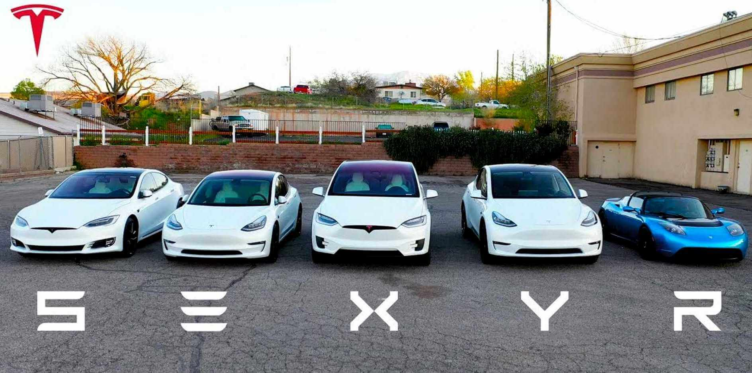
Figure I: Different models of Tesla
Source: (Tesla, 2025a)
Automotive sales: It is considered one of the major components of revenue generation, which is collected through the sale of EVs; however, it has currently faced a significant drop (Roush & Antonio Pequeño IV, 2025).
Regulatory credits: The organisation sells the emissions or the zero-emission credits to other automakers that comply with the regulatory requirements.
Energy generation and storage: A significant amount of revenue is generated from the solar systems, such as panels, roofs, and also from the battery storage systems for various purposes, including commercial, residential, and utility customers.
Services and other: This involves the vehicle servicing, upgradation of the software, such as the self-driving subscriptions (Tesla, 2025b). Apart from that, it also contains sales from the used vehicles, contracts from the warranty and maintenance contracts and other ancillary products.
Software and subscription revenue: This includes the autopilot upgrades and the premium connectivity.

Discussion of the major key cost structures
Fixed Costs
This refers to the costs that remain constant with the production levels; however, Tesla is more identified with operating semi-fixed cost that combines certain fixed expenses along with variable costs (Accounting Tools, 2025). Such costs involve the factory or plant principal investments and depreciations, such as the gigafactories, assembly plants and also the battery manufacturing facilities that require high capital costs and depreciation or maintenance. There are also software, design, and research development expenses that include the salaries of the engineering, autonomous driving, and battery research teams. Apart from that, it contains the general administrative charges such as the legal, compliance, quality assurance and the regulatory teams (Tesla , 2025c). Sales and the infrastructure expenses are one of the major expenses, as there are significant costs for owning service centres, managing the charging networks, tools and equipment, utility aspects and also power and facility management.
Variable Costs
This defines the expenses that fluctuate along with the level of production of an association (BBC, 2025). For Tesla, these costs involve the direct components and materials such as battery cells, electric motors, wiring and also direct labour such as the assembly line workers. Apart from that, expenses regarding the logistics, packaging and shipping also vary according to the units that are produced by the company. Sales commission, discounts to customers and other promotional costs are other major variable costs for the company. There is an utmost requirement for margin management as Tesla operates at a significantly variable cost. The difference between the available cost and the revenue per vehicle offers the contribution margin that must be able to cover those fixed costs and then generate profit.

Describing the budgeting and financial planning

Role of budgeting in Tesla’s operations
This respective factor is critical for Tesla for the alignment of the strategic objective, such as new model development, and scaling gigafactories. The continuous capitalisation towards the new factories, plants and capacity expansions the capital budgeting is essential (Liukkonen, 2021). On the contrary, the operating budget helps in managing the business units and geographies, and the cash flow budgeting is responsible for planning cash flows, debt servicing and managing the requirement of working capital. Apart from that, the sensitivity analysis allows them to operate uninterruptedly in the volatile market, multiple forecasting, and there is performance monitoring that allows them to conduct corrective actions.

Highlighting the changes in the operating expenses
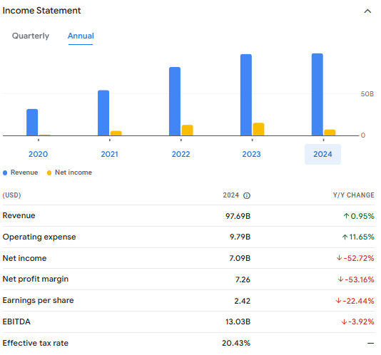
Figure II: Income Statement of Tesla
Source: (Google, 2025)
The aforementioned statement describes that the organisation has experienced a major hike in their operating expenses, which shows a 11.65% hike from the previous year. These expenses are mainly referred to the costs that are incurred for the daily operations, and for Tesla, it involves research and development, and selling and administration. According to reports, the entity operated with continuous upward trends in such areas, as it was 8.77 billion USD in 2023, which increased to 9.97 billion in 2024 (Google, 2025). Such changes describe the continuous investment of the company that leads to moderate expense growth.
Discussing the managerial decisions
Several decisions are observed to be conducted by the company as it has initiated to reduce the workforce for cost-cutting (Waldersee, 2024). They have also identified to focus on their efficiency through increasing their production, which relatively allows them to decrease the per unit overhead. The company might also delay the massive projects and intend to invest in higher return areas. Significant control and the optimisation of the research and development are the major areas for successful management.
Portraying the macroeconomic factors
The reduced consumer demand or the stricter credit conditions are responsible for the decreased sales growth; thus, Tesla might constrain operating cost growth (Roush & Antonio Pequeño IV, 2025). There is also significant inflation and various supply pressures present that automatically lead to cost hikes. Apart from that, the margins are also pressured due to the price level fluctuations. It also involves the regulatory costs that is greatly impacted by the changes in the regulations, trade tariffs and others that increase the compliance and legal costs.

Performance measurement and decision-making context

Denoting the key financial and non-financial performance index of Tesla
Financial performance index
Revenue: Revenue of the company is a key financial performance indicator that looks at the volume of sales made by the company in an accounting year. Tesla, a large EV-making company of the globe, earns billions of dollars in revenue, and based on the growth of sales, their overall growth in the global market is measured. For example, the company has earned 97.69 billion dollars of revenue in 2024, which is marginally more than its previous year's growth (Tesla, 2025d). This makes a significant difference in the perception of stakeholders about the company.
Cost of revenue: Revenue is achieved by incurring some costs, and a variety of costs are involved in the total cost of revenue of the company. This is an essential indicator of performance measurement of the company as it implies the cost controlling efficiency and paves for a higher profitability margin. $ 80.24 billion has been the cost of revenue of the company in 2024, which is more than its previous year (Yahoo, 2025). Such an inflated cost of revenue may put stress on the profitability performance of the company.
Gross margin: The gross profit of Tesla is a highly significant performance metric to measure the efficiency of cost control and the ability of the firm to remain profitable from the core operation (Tesla, 2025d). A decrease in gross margin has been noticed for the company in 2024 from 2023, and such a fall can be interpreted as a relatively poor condition of cost control by the management. A high gross margin also strengthens the foundation on the basis of which further improvement in the operation is derived.
Non-financial performance indicators
Promotion: Promotional performance and the loyalty of the customers to the company a major non-financial metrics to analyse the performance of the company (Mitchell, 2021). The company has used tools such as referral programs and collaboration with influencers and has transformed the sales growth. Such polices and qualitative aspects need to be focused on to evaluate the growth of the overall performance of the company.
Brand visibility: A Strong brand presence of the company can be considered as a major non-financial metric to analyse their performance growth and presence among the customers. The owner of the company has a wide presence in the digital sphere across the globe, and such a personal brand transforms the overall growth of the company immensely.

Discussion of the major strategic expansion decision of the company
Cost cutting
A recent drop in the sales of the company has compelled the management to curtail the expenses, and that has raised some other issues for the company as well (Sherman, 2025). The objective of the company to make affordable cars has created issues such as the delivery of products, and has ultimately shrunk the profits. In this context, the vitality of the financial performance indicators in long-term strategic decision-making is established.
Pricing strategy
Looking at the outcome of the financial and non-financial indicators, the company mostly follows a floating pricing policy, which is quite unique among the car-making companies of the globe (Trudell, et al., 2023). The pricing of some models of the cars of company is below industry average, and by approaching such a flexible pricing policy, the company can be ahead in the competition in the market.

Sustainability and ethical consideration of the company

Integration of sustainability in the financial decision-making
Energy efficiency in operation
The principal objective of the company is to mitigate the emission of carbon in the atmosphere and promote the growth of Electric vehicles. In 2024, 32 million metric tons of carbon emissions have been avoided by customers using their cars. Such a huge contribution to the sustainable environment creation can be a part of financial as well as operational decisions (Tesla, 2024). Role in the mitigation of traditional energy emissions is a suitable integration of finance of the company.
Supply chain sustainably
The initiatives of the company in making the supply chain sustainable can be the integration of finance in it. Its introduction of the electric giga train in Germany will promote green transportation and mitigate traffic congestion (Hargreaves, 2024). Such moves of the company have enhanced the scalability of sustainable transportation to improve the global supply chain of the company.

Ethical consideration in pricing and cost management of the company
Ethics in pricing
The pricing policy of a company is an interesting point to derive the profitability growth and ensure the long-term success in the market (Nagle et al., 2023). Dynamic pricing and ensuring the trust of the customers have been the pricing strategy of the company, which has able them to emerge as a unique brand in the market and capitalise on the competitive nature of the EV market.
Ethical consideration in cost management
The supply chain sustainability has been a major example of the ethical cost decision-making of the company. Its green transportation concept in Germany and the value of such trains in the international supply chain can be an instance of key integration of ethics and cost aspects.

Conclusion
The report has deeply focused on the managerial accounting aspects of Tesla, a leading EV manufacturing company. It has covered a detailed analysis of the cost and revenue model of the company. Automotive sales are the primary revenue stream of the company and have contributed most of the sales amount in recent years. Increasing operating expenses have been an issue for the company, and the employee reduction has been an action of the company to tackle such issue. Consumer demand and inflation pressure are two key factors that have been found in the case of Tesla. The cost hike has been found in the annual accounting report of the company, and in order to mitigate so, Tesla is advised to control the costs and minimise the additional expenditures. As far as the global impression of the company is concerned, it needs to improve the quality and affordability of its products. Along with that, the sustainability actions are advised to continue.

References
Accounting Tools, (2025). Fixed cost definition. [Online] Available at: https://www.accountingtools.com/articles/fixed-cost [Accessed 5 October 2025].
BBC, (2025). Costs. [Online] Available at: https://www.bbc.co.uk/bitesize/guides/z2h78mn/revision/2 [Accessed 5 October 2025].
Google, (2025). Tesla Inc. [Online] Available at: https://www.google.com/finance/quote/TSLA:NASDAQ?authuser=0 [Accessed 5 October 2025].
Hargreaves, L., (2024). Tesla: Transforming Supply Chain Sustainability. [Online] Available at: https://supplychaindigital.com/articles/tesla-transforming-supply-chain-sustainability [Accessed 5 October 2025].
Liukkonen, A., (2021). Capital budgeting plan for case company.
Mitchell, B., (2021). What Business Leaders Can Learn From Elon Musk’s Marketing Strategies. [Online] Available at: https://www.forbes.com/councils/forbescommunicationscouncil/2021/10/25/what-business-leaders-can-learn-from-elon-musks-marketing-strategies/ [Accessed 5 October 2025].
Nagle, T.T., Müller, G. and Gruyaert, E., (2023). The strategy and tactics of pricing: A guide to growing more profitably. Routledge.
Roush, T. and Antonio Pequeño IV, (2025). Tesla Posts Sharpest Revenue Slump In Over 10 Years After Historic Sales Drop. [Online] Available at: https://www.forbes.com/sites/tylerroush/2025/07/23/tesla-expected-to-post-profit-decline-after-historic-sales-drop/ [Accessed 4 October 2025].
Sherman, N., (2025). Tesla pledges to make cheaper cars as problems mount. [Online] Available at: https://www.bbc.com/news/articles/cqjq51vvello [Accessed 5 October 2025].
Tesla, (2024). Impact Report. [Online] Available at: https://www.tesla.com/impact [Accessed 5 October 2025].
Tesla, (2025a). About Us. [Online] Available at: https://www.tesla.com/en_in/about [Accessed 4 October 2025].
Tesla, (2025b). Full Self-Driving (Supervised) Subscriptions. [Online] Available at: https://www.tesla.com/support/full-self-driving-subscriptions [Accessed 4 October 2025].
Tesla, (2025c). Tesla Maintenance Costs: A Comprehensive Breakdown. [Online] Available at: https://www.tesla.com/learn/tesla-maintenance-costs-comprehensive-breakdow [Accessed 5 October 2025].
Tesla, (2025d). SEC Filings. [Online] Available at: https://ir.tesla.com/sec-filings#groups=annualquarterlyreports&list_id=tcl-list-1&page=0 [Accessed 5 October 2025].
Trudell, C., Randall, T. & Hull, D., (2023). Tesla keeps tweaking prices. Elon Musk has reasons. [Online] Available at: https://fortune.com/2023/05/13/tesla-prices-elon-musk-strategy/ [Accessed 5 October 2025].
Waldersee, V., (2024). Tesla laying off more than 10% of staff globally as sales fall. [Online] Available at: https://www.reuters.com/business/autos-transportation/tesla-lay-off-more-than-10-its-staff-electrek-reports-2024-04-15/ [Accessed 5 October 2025].
Yahoo, (2025). Tesla, Inc. (TSLA). [Online] Available at: https://finance.yahoo.com/quote/TSLA/key-statistics/?guccounter=1&guce_referrer=aHR0cHM6Ly93d3cuZ29vZ2xlLmNvbS8&guce_referrer_sig=AQAAAKaWBAK5fwDSzydXXSOIlpspGLb4ot116E9V78uOeehhdWfczV8_lt4qiGLVF0ToX3cVFkXwIV15RjlfduJilMe35u-arQ81aWhL0TiOoYpjkIxse1LQPVHJ1 [Accessed 5 October 2025].

