John Muir Award Project Presentation

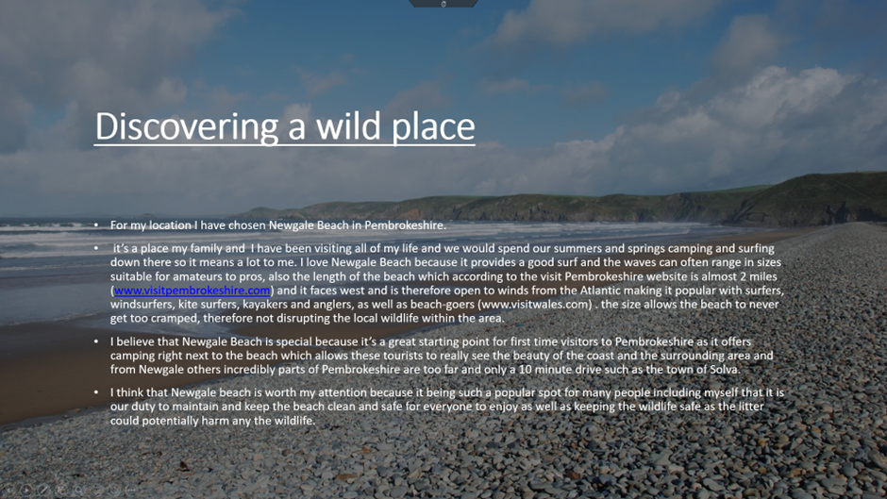

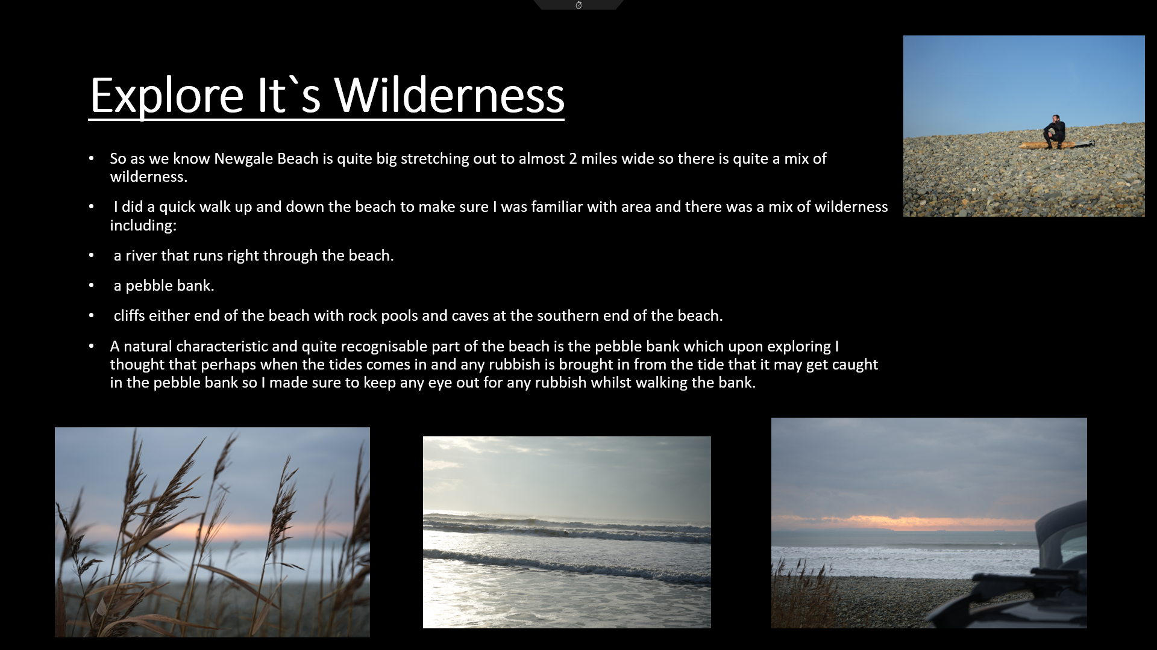

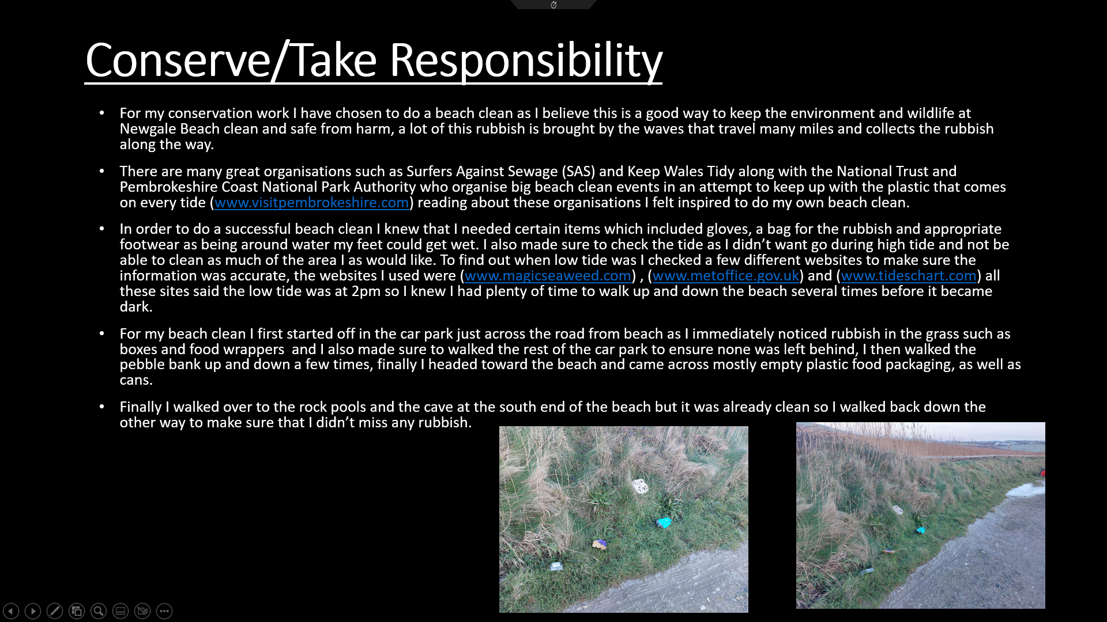
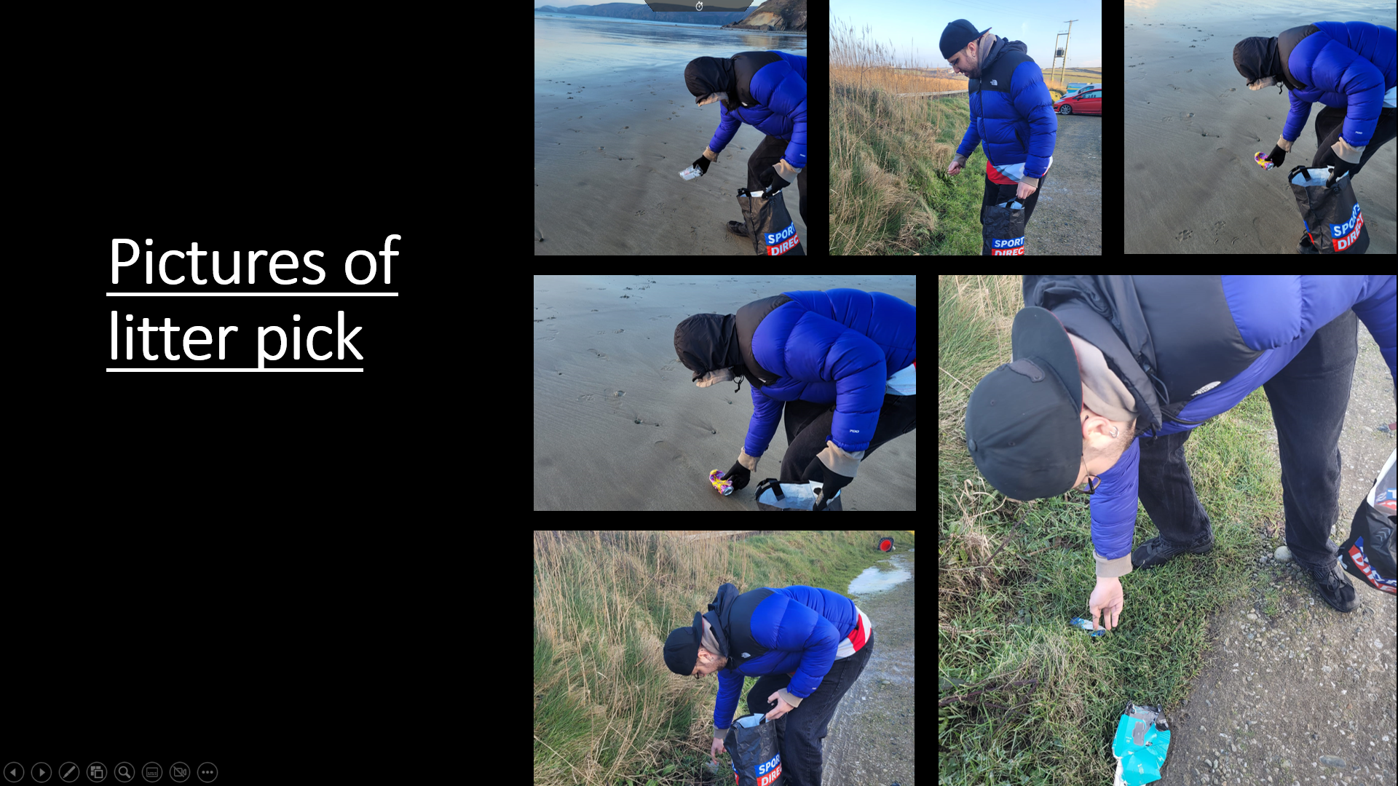

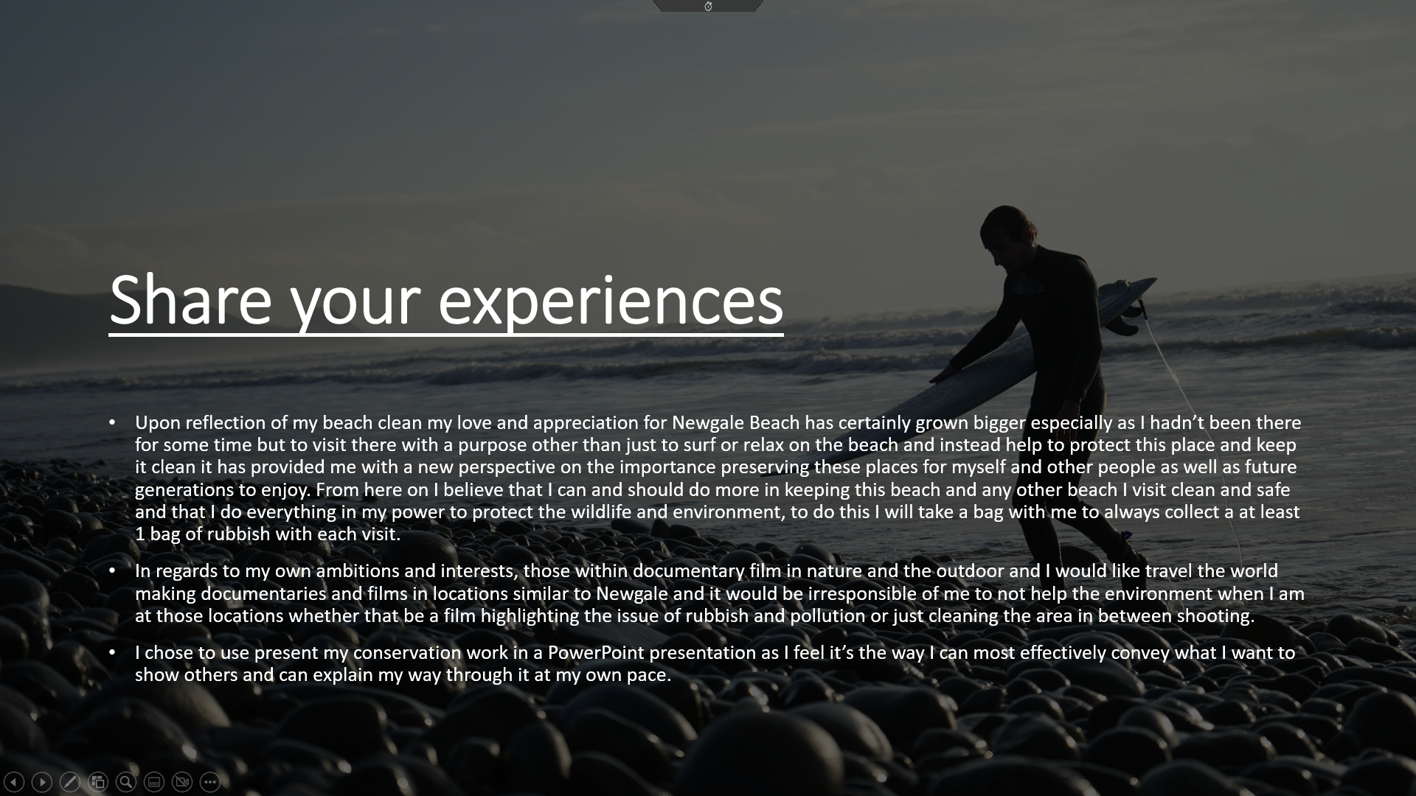

Reference list

Get newgale Sands Beach's Tide Times - Tideschart.com (no date). Available at: https://www.tideschart.com/United-Kingdom/Wales/Pembrokeshire/Newgale-Sands-Beach/ (Accessed: December 12, 2022).

Home (no date) VisitWales. Available at: https://www.visitwales.com/attraction/beach/newgale-beach-1443766 (Accessed: December 12, 2022).

How to beach clean (no date) Visit Pembrokeshire. Available at: https://www.visitpembrokeshire.com/articles/how-to-beach-clean (Accessed: December 12, 2022).

Newgale (Pembrokeshire) Beach Forecast and Tide Times (2022) Met Office. Available at: https://www.metoffice.gov.uk/weather/specialist-forecasts/coast-and-sea/beach-forecast-and-tide-times/gchqgr1gx#?date=2022-12-16 (Accessed: December 12, 2022).

Newgale Beach (no date) Visit Pembrokeshire. Available at: https://www.visitpembrokeshire.com/explore-pembrokeshire/beaches/newgale (Accessed: December 12, 2022).

Newgale tides - updated high &amp; low tide newgale tide time charts - magicseaweed (no date) Magicseaweed.com. Available at: https://magicseaweed.com/Newgale-Surf-Report/35/Tide/ (Accessed: December 12, 2022).

