
Skills for the Workplace
Module Assignment Submission
Student Name: | Callum Jennings
Student Number: | 2007363
Module No: | BMSK4007
Module Title: | Digital Skills and Personal Branding

Statement of Confirmation of Authenticity
By the act of making this submission, the student declares that this is the work of the student named above. The work has not, in whole or in part, been knowingly presented elsewhere for assessment, or where assessment has been built on a previous assessment, this has been identified. Where materials have been used from other sources it has been properly acknowledged. If this statement is untrue, the student acknowledges that an assessment offence has been committed.
Attention is drawn to the plagiarism and unfair practice policies of both the University and of ILM.
Permission for ILM to use this script
ILM uses learners’ submissions – on an anonymous basis – for assessment standardisation. By submitting, both the centre and the learner agree that ILM may use this script on condition that identifying information is removed. However, if you are unwilling to allow ILM use this script, please refuse by ticking the box: □

Table of Contents
Introduction. 3
What has been the impact of 21st Century Technologies on the modern workplace? 3
Evaluate the appropriate use of modern technologies and social media in the workplace generally. 3
Explore the use of modern technologies and social media in own workplace. 5
How can Personal branding help YOU? 5
Your LinkedIn Profile to promote your Personal Brand. 6
Evaluate the value of other social media platforms to enhance networking and career prospects. 10
Examine the impact of Personal Branding on your own employability. 11
Discuss personal and professional security and safety online. 12
Conclusion 12
Appendix 1 14
Appendix 2 15
References 16

Introduction.
Throughout this assignment I will be discussing the overall use of modern technologies and social media, and how they are both used in the workplace. Going through I will discuss which social media platforms are used and which are most common. There will be multiple screenshots and descriptive text on my LinkedIn profile, which is one the main talking points of this assignment. Following on after this discussion, is a section on how personal branding can either help advertise myself or a business whether that be in a good or bad light. Closing out this assignment I will be discussing the importance of safety and security and how different they are between personal and professional needs.

What has been the impact of 21st Century Technologies on the modern workplace?

It would be easy to say that the 21st century has been the era of technology. Constant new trends have been created in order to make our social and workplace lives easier and more efficient. The 21st century will be remembered for its technological advancements. Technology affects all aspects of our lives, most of all the workplace. The workplace environment used to rely on fax machines, surface mail and telephones in the past, however, modern technology has pushed the boundaries on communication bringing us various chat software tools such as, Email and SMS. Furthermore, with the ever-changing global condition, Covid-19 has forced companies to allow the majority of their workforce to work remotely or from home. This epidemic has once again helped us see the ever-expanding technologies now move towards remote video conferencing, bringing us programs such as ZOOM and Microsoft Teams, contacting clients and employees from around the city and the world has never been easier. With these new and highly advanced technology systems, we are seeing the older generations adapt to the constant change in technology that is being used in their place of work, while the newer and younger generation of employees have been brought up with the surge of ever advancing technology, it allows companies to train new employees faster with the help of online training that can be done from within the workplace or remotely from home by using online training courses and with the help of Microsoft computer programs such as, Word, PowerPoint, Excel and Office.

Evaluate the appropriate use of modern technologies and social media in the workplace generally.

Social media within smaller and larger companies is used differently. Larger corporate companies would use social media as a modern-day communication tool, using it to communicate not only with potential cliental, but with employees who may not have direct contact with their managing directors. Managing directors use social media to help hear the views and opinions of employees. By monitoring their employee’s social media accounts, top level management can help eradicate the feeling of not being heard. Smaller companies with limited members of staff would not normally use social media as a means of communication within the company, as the smaller numbers of employees allows for more personal and one to one verbal communication. The smaller companies however would use social media as an advertisement tool and help promote the company, using platforms such as, Twitter, Facebook, and LinkedIn.
Along with social media, modern technologies in the workplace are used every day and constantly. As stated previously, video conferencing has become a major aspect within many companies, allowing various teams to have a more personal conversation and meeting in comparison to a standard phone call to people all around the world.
There are many pros and cons to having and using social media in the workplace. Here are a few that I found in an article. Reddy, C. (2017) Social media in the Workplace: Top 21 Pros and Cons

Pros:
- Engagement from upper management can help strengthen employees.
- Increase in productivity.
- Help analyse data from the company.
- Advertisement.
- Helps to let employees know about work ethics.
- Online training classes.
- Branding.
Cons:
- Increased need for cyber security.
- Potential misuse of Social Media.
- Potential damage to company brand.
- Harassment and bullying.
- Misleading information.

Explore the use of modern technologies and social media in own workplace.

Modern technology and social media are used in every company worldwide in some aspect. The company I work for uses a vast amount of modern technology such as, state of the art 4K resolution tablets for engineering drawings, chemical element testing machines used to help distinguish the amount of certain chemical elements within any material and top of the line software installation systems capable of updating fifty too sixty laptops and tablets at a time. In terms of social media, my company mainly uses LinkedIn, while also having accounts on Facebook and Twitter, using it as a tool of communication for partners and potential clientele around the globe. Our Human Resources department also uses LinkedIn as a form of recruitment for potential employees. Using LinkedIn as a recruitment tool allows not only my employer but all companies a slightly better insight into someone’s life from a business perspective, as supposed to using Facebook or Twitter, which would allow recruitment teams the ability to see what potential employees do in a more social aspect of their lives. After discussing with my manger, he explained to me that due to Covid-19, the annual trade show known as CES (Consumer Electronics Show) was held virtually this year and was being broadcasted through all social media accounts linked with the company I work for such as, Facebook and Twitter, allowing all of our customers globally to interact and watch the show at the same time and safely from their homes. With the company I work for continuously expanding, the need for Social Media usage within the company increases. More employees and more customers mean that the use of multiple Social Media platforms will play a critical role in continuous communication, whether that communication is advertisement on offers, deals and new products to customers, or general and need to know information that needs to be received by the employees.

How can Personal branding help YOU?

Personal branding is the same as a business or company marketing a product, however a personal brand is essentially marketing yourself. Doing this allows for a lot of benefits such as, increased trust, credibility and it explains why you do what it is you do. Personal branding allows you to be yourself, overtime building your own image to be the person you want to be without any false pretences. When developing a personal brand, it helps to know your weak points and your strengths, you can do this by creating an action plan using SWOT analysis (Humphreys, 1960) for example,

My S.W.O.T. Analysis

Weakness –
- Math
- Lack of patience
- Organisation
- Stubborn
Strengths –
- Leadership
- Confidence
- Caring
- Willing to learn.

Conversion strategies
Matching strategies
Opportunities –
- University degree
- Full time employment
- I can drive.
Threat –
- Recently unemployed
- Failure
- Covid-19
- Housing economics
- Disorganisation

Conversion strategies

Once all strengths and weaknesses have been identified, self-confidence builds, knowing that you have something to offer that is valuable to someone will also help build self-esteem. Building a personal brand will help grow a social following which will in turn help secure a better job, sell more products and secure potential future customers.

Your LinkedIn Profile to promote your Personal Brand.

Here is a breakdown of my LinkedIn profile. The images had to be broken down due to overall size of the image.
These are multiple screen shots from my LinkedIn profile along with a brief description and explanation.
The profile picture I have chosen shows me in a smart and confident image, giving my profile a more professional look.


The background behind my profile picture is one of my favourite quotes and also now the mantra I live by it reads ‘He who has a why, can bare almost any how.’ When reading or hearing this, it drives me to be and to do my best in everything I try to accomplish.
I designed this banner myself as I feel is represents me and what I wish to base my future business and companies on. It looks professional and is neat and clean with minimalistic colours and lines.
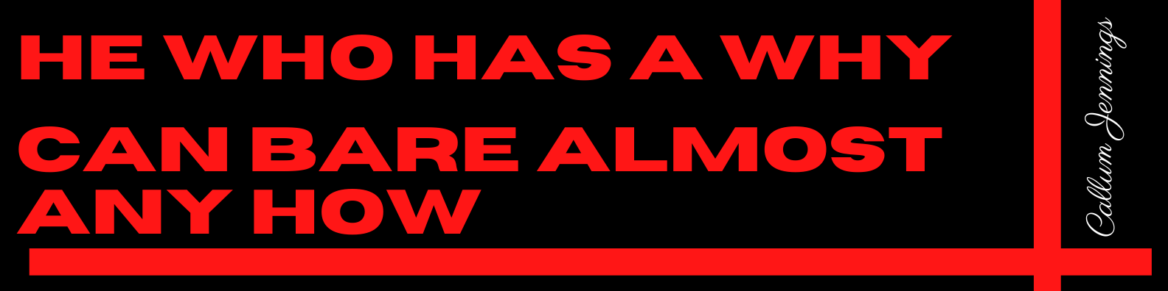

Underneath my profile photo is my job title and the area in which I currently live in and alongside it is my highest form of educational qualifications. Following that is a selection of jobs I am open to trying along with past experience.

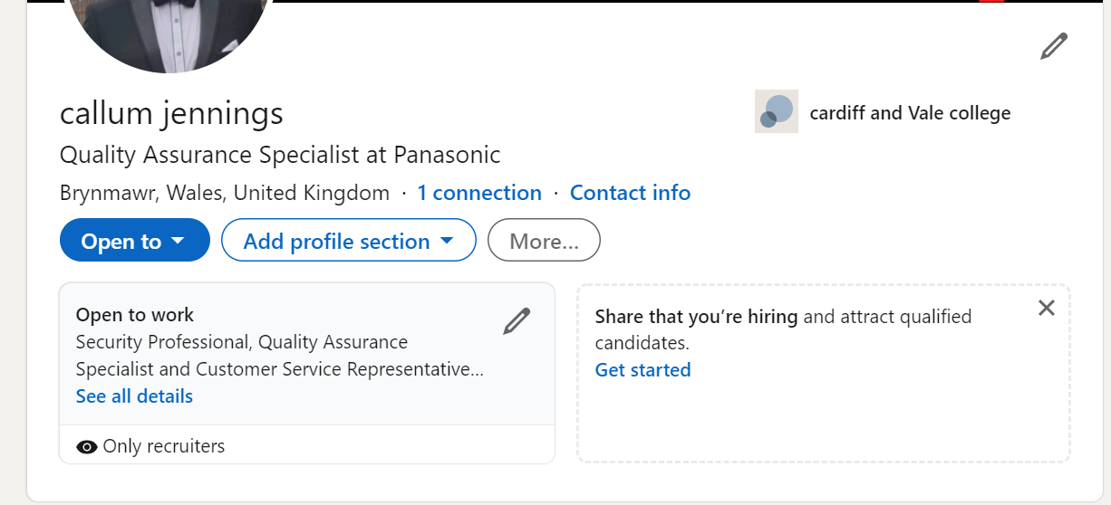

The next section is a short paragraph explaining my work ethic and what kind of job positions a excel in. As LinkedIn is used as an online Social Media platform but with a CV, this section is used as a cover letter, so that potential employers get a brief yet descriptive insight into what kind of person they are hiring.

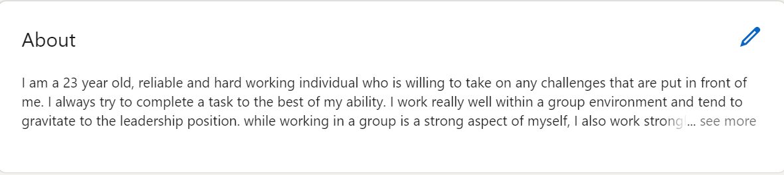

The section that follows is all about my previous job experiences and past education.
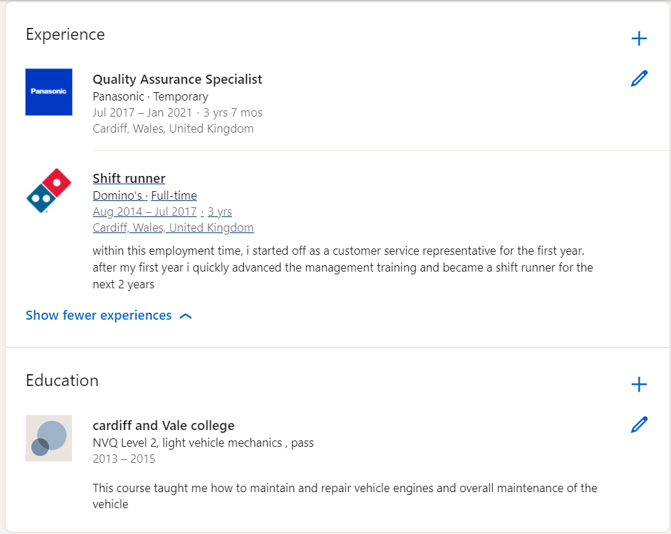

Here is the overall view of my LinkedIn page. I think it looks smart presentable and professional, I believe this page advertises me in a positive light, overall, I am happy with how it looks and sounds.

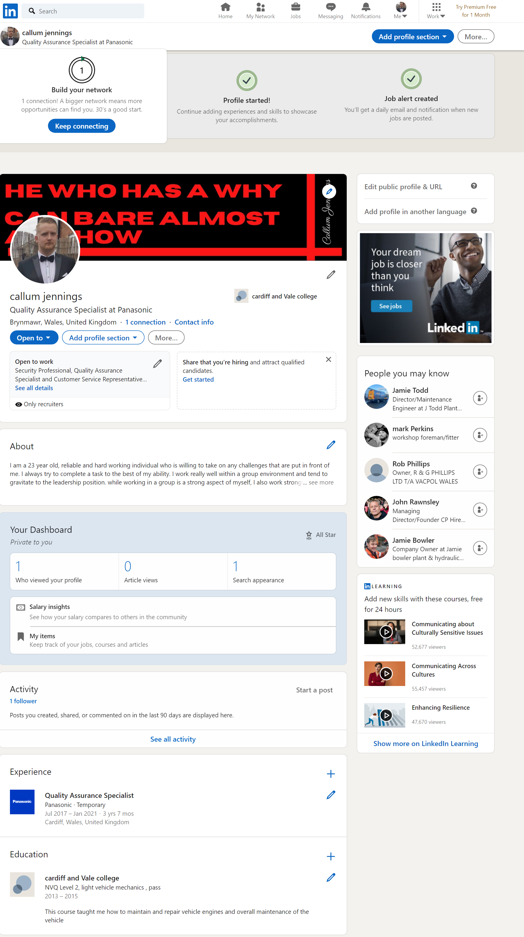

Evaluate the value of other social media platforms to enhance networking and career prospects.

While LinkedIn is the pinnacle of Social Media in the workplace, many other formats and Social Media platforms are used. Facebook is one of the other Social Media platforms, although not used by many companies, it does have its benefits. Hines, K. (2015) 7 ways Facebook can help your business, explains that if a company is using Facebook, there are certain ways it can be utilised to help boost certain aspects of your company such as advertisement, audience engagement and reviews. Overall Facebook has many aspects that a company can use to enhance networking and career prospects. Similar to this is Twitter, with options to set up polling, giving customers and audience the chance to be heard and have an active input on the company. Just like Facebook, Twitter gains funding from AD placement, giving people and companies the chance to pay and have their own personal brand advertised for everyone to see. Instagram started off a picture sharing platform but quickly grew and developed into a video, picture, and marketing tool. Small and large companies now use this platform along side self employed people to actually show the product they are advertising as supposed to just telling them. Doing this offers a much higher chance of gaining a higher volume of potential clientele and employees. One major downside to Instagram which does not happen to Facebook, is that Instagram requires constant, multiple times a day posting and advertising, due to the high volume of other large companies and small business owners also using this platform. Instagram has now also become the home of Influencers. Influencers are essentially young entrepreneurs trying to sell their own personal brand. They make a living from using themselves as advertisements, charging companies to promote their product.
Thompson, N. (2020) The Best Social Media Platforms for Business: Your Ultimate Guide is an article based on all Pros and Cons of each Social Media platform and gives an overall review on it impact to a company, negative or positive.

Examine the impact of Personal Branding on your own employability.

Personal branding plays a vital part in your own employability. If you are to be highly regarded, trustworthy, credible, and skilful, it will promote yourself in a better light, meaning, that without personal branding, rival companies, potential employers/employees, and potential clientele will not know if the service that you are providing will live up to their expectations. Personal branding creates an image, an overall image of what kind of company or person that you are. Without personal branding, it would become impossible to further yourself or the company you are running or working for.

Discuss personal and professional security and safety online.

Safety and security are incredibly important whether it be personal or professional.
The GDPR is an acronym for General Data Protection Regulation. ICO, (2018) introduction to data protection. Personal and professional security both cover the same principles, valuable information needs to be protected. Both types of security will use the same methods also, such as passwords and pin codes. Personal security has increased exponentially with fingerprint readers on mobile phones, along with face ID and retina scans. Professional security however is slightly different. Professional security has things such as employee information, payroll numbers and personal contact details that they are legally required to keep confidential, under the GDPR act.

Conclusion

This final part of my assignment is where I will be discussing my overall views on everything stated above broken-down section by section. Firstly, modern technologies in the workplace. I feel modern technology will only become more and more advanced as the years go on. The advancement that we have seen in the last ten to fifteen years has been amazing, from the introduction of email all the way up to video conference calling and everything in between has made our modern-day workplace easier and more efficient than ever. Social media use in the workplace is something I believe we all need to become accustom to. Technology and social media will now and always play a vital role in any company, small, large, or even more so self-employed entrepreneurs. I believe if used correctly social media usage in a work environment will have an extremely positive affect in recruitment, advertisement, and employee satisfaction. I love the idea of personal branding, creating a positive image for yourself and the company you are representing is a vital aspect of any companies’ success. After creating a LinkedIn profile, it has become clear to me how the overall design and image of a webpage that advertises either myself or a company has a direct effect on how successful the webpage, myself or the company will become. Going through all the various platforms of social media and finding which ones can be used as an advantage to my personal brand or to a company’s overall image was interesting. Already being well informed with many social media platforms did help but to now know which social media platforms cover all aspects of personal branding and which do not will definitely help in the future. The final part of the assignment covered safety and security in a professional and personal aspect and briefly covered the GDPR Act.

Appendix 1

Appendix 2

References

Reddy, C. (2017) Social Media in the Workplace: Top 21 Pros and Cons - WiseStep
SWOT analysis (Humphreys, 1960) What is a SWOT Analysis? Definition, example and template | toolshero
Hines, K. (2015) 7 Ways Your Facebook Page Can Help Your Business : Social Media Examiner
Thompson, N. (2020) The Best Social Media Platforms for Business: Your Ultimate Guide (optinmonster.com)
ICO (2018) Guide to the General Data Protection Regulation - GOV.UK (www.gov.uk)

