
APPENDIX GA36d

LEVEL 7 ASSESSMENT SPECIFICATION

Student name: | Joshua Bryan | Student ID number: | 1803100
Programme: | Secondary PGCE
Module: | Curriculum Development and Enhancement
Module code: | ECSP7002 | Contribution to Overall Module Assessment (%): | 100%
Lecturer: | Helen Denny | Internal Verifier:
Assignment Title: | Research Study including Ethics Form | Word count (or equivalent): | 10.000 words in total including an Ethics form (to be given in on January 11th 2019)
Submission deadline: | May 13th 2019 | Return date of provisional marks & written feedback: | June 10th 2019
Submission method: | All written assessments, where practical and possible, must be submitted via Turnitin unless otherwise instructed by the Lecturer. (Please DO NOT put this assessment specification into Turnitin or it will match many similarities with other students’ submissions.)  Alternative submission method (if applicable):  Late submission of the assessment will result in a late penalty mark. Penalties for late submission: Up to one week late, maximum mark of 50%. Over one week late, 0%. Only the Extenuating Circumstances Panel may approve a change to submission dates.
Academic honesty / referencing: | Academic honesty is required. In the main body of your submission you must give credit to authors on whose research and ideas your work is based. Append to your submission a reference list that indicates the books, articles, etc. that you have used, cited or quoted in order to complete this assessment.
Strategies to improve scientific literacy with regards to QER and PISA questions
Introduction
Upon reading the Estyn report of 2014, it was found that school X is a mixed ability school, from the ages of 11-16. The school is located within the local authority of Neath Port Talbot and currently has a total of 774 pupils, decreased from 811 pupils that the school reportedly had in 2008 when previously inspected by Estyn (2008). The percentage of pupils that receive FSM (Free School Meals) shown to be approximately 21%, which is above the national average of 17.7%. The school is positioned within the Port Talbot area, with the catchment coming from the Bryn, Cwmafan and Pontrhydfen and the East side. The class this research was undertaken on was a mixed ability year 8 class, including MAT and ALN students. This research was undertaken to test whether the use of inference squares is effective for formulating answers for the PISA-style questions. These styles of questions are difficult for pupils due to the large amounts of numeracy that is demanded, the pupils must read over information given in the questions and usually involve them reaching a conclusion based on this evidence and knowledge they already have on the topic area. Some of these questions often require the pupils to give reasoning for their answers, the volume of information found in these questions usually overwhelm students and hence, is the reason for this research project to test if this form of scaffolding can aid pupils in answering these questions.
Literature Review
To begin this literature review, PISA (Programme for International Student Assessment) tests will be discussed, including what they are, their overall purpose and the areas that may potentially lead to its failings. Each country takes part in these tests, hence the results of the most recent Wales test, as well as looking at how the welsh educational systems have started to improve these results. There is a variation of PISA results, these will be discussed regarding socioeconomic disadvantage, gender and whether there was a variation between schools. The use of scientific literacy will then be debated as this has been suggested to be a key aspect of answering these styles of questions. Finally, the use of inference squares, used as a form of scaffolding to aid pupils in the answering of PISA-style science questions will be discussed.
PISA assessments are a type of test that are undertaken worldwide, these have been developed with the aim to assess a variety of core skills that 15-year-old pupils should possess throughout the world. These tests are provided by the Organisation for Economic Co-operation and Development (OECD), with the aim to compare different education systems on an international scale (OECD, 2019). In total there are three different PISA assessments, including reading, mathematical literacy and scientific literacy all of which are undertaken by a range of students from selected schools from all countries participating every three years (OECD, 2017). The aim of this is to gauge how each country is teaching their pupils to master crucial subjects so they become prepared situations in real-life (OECD, 2019). The most recent PISA test took place during 2018, however the results for these are still to be determined and are scheduled to be released on 1st December 2019.
A total of 90 countries take part in the PISA assessments worldwide (OECD, 2019). This is beneficial as it allows for a large sample size of data on each education system that take part in this assessment, which reduces any errors and hence improves the validity of these results. This data is primarily used for the comparison of different education systems of each country, which can aid in the improvement of teaching and learning worldwide. This is achieved by all poor performing countries adapting their educational systems using that of the high performing countries, leading to an improved educational system worldwide (Education Council, 2006). To test whether a countries system has improved, they can compare their results with previous years. Not only can the PISA tests do this, but also discover and explore gaps in achievement due to a variety of factors including socioeconomic circumstances and gender (Koretz, 2009).
This wide use of PISA test results does not come without its criticism. It has been suggested that the PISA takes the importance away from other areas of education that are essential, such as civic, moral and physical pupils progress (Andrews et al, 2014). This is due to the emphasis on areas such as mathematics, reading and the natural sciences, which allows all countries to be compared to, and hence is the areas that a lot of countries will push to compare positively (Stajn, 2014; Eivers, 2010). This has already been observed within Wales, with the welsh government ensuring more time and money is put into maths, numeracy, English and science when compared to other subjects (ERW, 2019) Another issue arising from the use of these tests is that it focusses more on reading literacy and less on content and familiarity issues (Kirsch et al., 2002). As previously mentioned, PISA have assessment rounds which occur in three year cycles, concerns by how often these occur have arisen because it appears a short-term fix is put in place for the next round of the cycle (Andrews et al., 2014), hence suggesting that conditions are put in place only for the next cycle, then forgotten about until that cycle comes back again. No long-term changes have been introduced, which should be the aim of these PISA tests, to improve the education systems in countries worldwide (Bybee, 2008: Auld & Morris, 2016). It has also been suggested that the way in which OECD’s scaling model cannot deal with the comparison of all the countries, and that if the errors in this model are not corrected, then the PISA ranking may lose all credibility (Kreiner, 2011). This is due to a variety of errors being overlooked when ranking these countries.
As was previously mentioned, one of the main aspects that a pupil is examined on using the PISA tests is their scientific literacy and hence will be discussed in further detail. Scientific literacy can be defined as the scientific knowledge of an individual and how they can use that to explain scientific phenomena, identify scientific questions and make evidence-based conclusions about any issues related to science (Bybee, 2008). It has become essential to not just PISA tests, but to all of society, as it empowers all citizens to make decisions about their personal lives as well as in the participation of public policies that may very well impact their own lives, it may therefore be said that scientific literacy is central to science education (Bybee, 2008; Sadler & Zeidler, 2009). It must be noted that pupils are either less or more scientifically literate and are not either scientific literate or illiterate. Pupils can demonstrate that they are more scientific literate by making predictions to formulate explanations with higher precision. PISA are four core areas that are involved in scientific literacy, including responding with an interest and motivation in science. Secondly, demonstrating competence when identifying, explaining and using evidence. The third is understanding the natural world around them, that includes technology with the foundation of scientific knowledge of science itself and the natural world. The last core principle is for the pupils to recognise real-life situations that involve both science and technology (Bybee, 2008). All four of these are linked, as shown in Figure 1 below.
The OECD have stated that due to the challenges that the world faces such as, disease control, ensuring sufficient food and water, and adapting to climate change are the main reasons that society requires ‘well educated scientists’ to aid in research and innovation to meet these challenges.
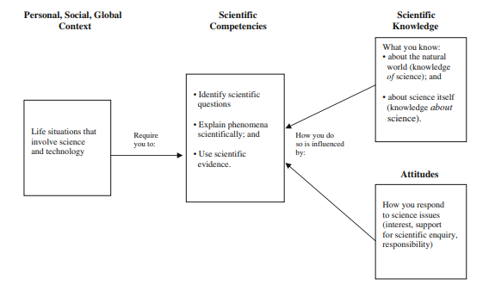
Figure 1: The link between the four different principles of scientific literacy.

Communication is a large aspect of scientific literacy and is an important skill that people require throughout their lives, as it allows learners to transfer information about issues within science (Norris & Phillips, 2003). However, it has been implied that the needs of scientific literacy may not be met, even though it is a very targeted area within schools and PISA tests. When pupils reach adulthood, the real-life scenarios tend to involve a much more in-detail breadth of knowledge than is usually found in a school and hence this use of scientific literacy within schools does not have as great an effect as once thought (Deboer, 2000).
The PISA tests been discussed in detail, the results of Wales will now be looked at, to see what pupils achieved during the most recent test results of 2015. In December 2016 it was announced that Wales had the lowest PISA test score within the UK, with the lowest results being within science. The Welsh Government have become highly committed to raising these standards, however due to the focus of the LNF (Literacy & Numeracy Framework) and DCF (Digital Competency Framework) that of science has been somewhat lacking (Jones, 2017). In 2015 the mean science score for the PISA test was 485 (Jerrim & Shure, 2016), which is low when comparing it to the other countries making up the United Kingdom. England had the highest score of 512, Northern Ireland had 500 and Scotland had 497. The OECD average was 493 (as shown in figure 2 below), this implies that Wales is not only the worst in the UK but is also lower than the average throughout the world. This is a large decrease in comparison to the other countries and hence is the reason the welsh government are aiming to promote scientific literacy. Figure 1 also shows the mean PISA test scores for science throughout the various years the test was undertaken, Wales has a high score above the OECD average during the 2006 results, whereas in 2009 this dropped, ever since then it has steadily decreased. The mean science score is currently more than 20 points higher that Wales in over 18 countries, with a further being at least 10 points clear of Wales (Jerrim & Shure 2016), showing how poorly Wales’ performance was during the last PISA test.
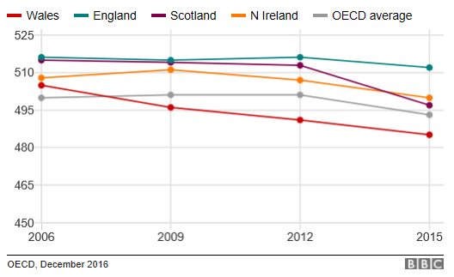
Figure 2: The mean PISA results for Science in the United Kingdom in comparison to the OECD mean which takes all countries into consideration (Hume, 2015).
As mentioned previously, the Welsh Government are aiming to improve these results through a focus on scientific literacy (Learning.gov.wales, 2012). They are using variety of different strategies to improve this score. One of the most known and widespread examples is the importance of science at KS4, the Government have ensured that pupils take at least 2 qualifications in science, which is used as a measure of the school performance as a whole. There has also been a large push on including scientific literacy within lesson and schemes of work (SoW) to allow plenty of practice in a variety of different contexts while preparing for their examinations. This is due to the inclusion of the scientific literacy assessment found within the WJEC examinations (Qualifications Wales, 2019). The examination board are including this style of questions to emphasise what is found in the PISA tests. This should hopefully not only increase the results of future PISA assessments but also GCSE results within Wales (Welsh Government, 2017).
The Welsh Government has also been providing schools with examples of PISA-styled questions to use within the classroom to again give the pupils practice answering these styles of questions as many pupils struggle with the amount of writing that are found within these questions, as well as some of the key vocabulary that is required to answer the questions.
Although the results for Wales have been decreasing since 2009, there is a natural variation not just in Wales, but within schools, genders and students within different socioeconomic conditions (González de San Román & De La Rica, 2012). There is an expected gap between pupils with the strongest science skills and those with the weakest. This gap can be worked out when looking over the 10th percentile and taking that away from the 90th, the 90th percentile was worked out to be 602 and the 10th was 368. This gives an equality gap of 235 which is lower than that of a lot of other countries, as well as lower than the OECD average of 247 (Jerrim & Shure, 2016). Hence, looking over this data suggests that there is greater equality amongst 15-year olds in Wales’ science test scores in comparison to other countries around the world, however the overall low score of the science results for Wales play at least a slight part in this (Jerrim & Shure, 2016). This difference may also be down to variation, both the variation within a school itself, and between different schools may have had caused this achievement gap between stronger and weaker pupils (Learning Wales, 2012). This variation between schools in low in Wales, due to the large number of comprehensive schools found throughout Wales which contain a variety of pupil’s ability (Jerrim & Shure, 2016). However, the natural variation within a school is a different story altogether, the PISA science scores of each pupil is widely different and takes account for this large range of variation in Wales between pupils. This must be reduced within the future, as currently those that have managed to reduce this equality gap have improved results overall (Reynolds, 2007).
There is little to no evidence that suggests that there is any difference in science test scores between pupils of different gender. However, there is a gap in PISA scores when looking at pupil socioeconomic status. The socioeconomic hindrance of pupils is measured by looking at what pupil are eligible for free school meals (FSM), with school X having a high 21% FSM (Estyn, 2014), higher than the average of 17.7%. This is crucial as the results from the PISA science assessments show a very positive correlation between achievement in the science PISA test, and FSM eligibility (Micklewright et al, 2012). Jerrim & Shure stated that those who were not eligible for the FSM had an average of 489 points in their science assessment, in comparison to the pupils that were eligible for FSM with a score of 446. This may only seem like a small number; however, this 43-point difference can be matched to over a years’ worth of additional schooling which shows how much of an impact this would have (Jerrim & Shure, 2016). Although this would have a large impact, under 10% of the variation between and within schools was suggested to be due to socioeconomic issues (Learning Wales, 2012). One of the large reasons for the performance gap between those with and without FSM may be due to the poor attendance associated with FSM pupils (Cook et al., 2014). Good attendance has been associated to a strong science PISA test performance, and hence, poor attendance would be linked to a weak test as a result (Lepkowska, 2015).
The issue with using FSM is that some academics believe that it an unreliable measure of poverty, as not all pupils who are eligible for FSM claim it, due to the status that comes attached (Sutherland, 2016). Others suggest that the people who work and are poor need to be accounted for as these tend to move in and out of employment (Coughlan, 2017) and may be on the line for FSM, where they fall just short of being eligible for it. Even those this is the case, FSM is still widely used as a gauge to how much poverty is within an area.
Now the literature review will finish on what pupils seem to struggle with when answering the PISA science assessment, and what could be used to counter this problem. The questions found in the PISA test have large amounts of essential reading, as well as literacy demanding to be able to access the question (Welsh Government, 2013). Problem solving is another aspect that many pupils struggle with, as these questions require the to interpret, infer and evaluate. To counter these issues and improve the results of Wales as a whole, a variety of supporting strategies can be used (OECD, 2014). An example of these support strategies was used during this research project and involves the use of an inference square.
Inference squares are one strategy that aims to improve and help the way pupils answer PISA style questions. The inference square used during this research is attached in the appendix. The inference square is made of three boxes, the first of which involves the pupils writing down what the question is about and what it is telling them when reading through the information given, as well as any key words the question is using such as describe, explain etc. The second box requires the pupil write down what information they already know about the questions (background information) this allows activate any prior knowledge they have, which is an essential part to answering these questions (Welsh Government, 2012). The third and last box gets the pupils to write any conclusions, using the two boxes they have already completed, and allow them to answer the question fully. As this is a form of scaffolding, it must be ensured that pupils do not become to reliant on this strategy to improve results.
School Policy and Practice
School X does not currently have any aims that directly link to improving the results in the PISA tests, however there are two policies that the school do have that would indirectly improve these results. In the science department improvement plan (DIP) there are two main priorities, which are to improve the standard of pupils’ scientific literacy and extended writing. The reason scientific literacy is already being incorporated into the KS4 SoW is due to the requirement of pupils to be scientific literate when completing their WJEC GCSE examinations (Qualification Wales, 2016), as previously discussed in the literature review above. At KS3, the school has also started to put measures in place to improve scientific literacy, allowing it to become easier when reaching KS4, however this was only started within the last two years and hence it is not known if this has yet improved any standards.
The improvement of extended writing is an area which the school focusses on thoroughly in all subjects, all chances that extended writing can be incorporated are taken, this will help with QER questions in KS4 examinations, as well as PISA questions as writing needs to be fluent and logical when answering the questions.
As mentioned above, there is a large gap between FSM and non-FSM, the school has a plan in place named the equality plan. This aims to reduce any achievement gaps between FSM and non-FSM pupils, and any gaps between genders. The school uses a targeting system, in which they select pupils by analysing achievement data to look for pupils that are underachieving and create groups that can have intervention to help the pupils improve. The school always pushes for a high attendance to improve pupils, and as previously mentioned that greater attendance has a strong correlation to greater achievement (Lepowska, 2015). All pupils have an attendance target of 95%, and those that fall below this have a form of intervention to find out why this has happened and what the school can do to help. Furthermore, all pupils that have 100% attendance are given prizes at the end of the year, to encourage pupils to aim for a high attendance.
Lastly, the school have a large emphasis on the LNF (Literacy & Numeracy Framework) into the SoW, as is expected by the Welsh Government (2014). The aim of this is to thread the LNF throughout all subject areas, allowing pupils to obtain and develop skills and to practice these skills in a variety of different contexts, other than their original subject areas. This is crucial not just as aid in the pupils’ examination, but their PISA tests as well. Pupils need to have highly developed and higher order literacy and numeracy to complete any PISA assessments to a high standard in a bid to improve the results of Wales as a whole.

Methodology & Ethics
This research project will consist of using one year 8 class and has been chosen due to the variety of pupils’ ability, with many of whom will find difficulty answering PISA style questions and hence are a good selection to use a form of intervention with, in this case the use of inference squares. However, some pupils may not find these inferences useful as they are competent answering these questions without any scaffolding required. The aim of this research is to understand and assess the effectiveness of inference squares being used to aid pupils in answering PISA style questions. A pre- and post-test was chosen to see how well this type of scaffolding can be used by the pupils. One of the main advantages of pre- and post-tests was because the data that is collected is quantitative, which can be easily used to indicate how well pupils are doing in each question (Creswell & Creswell, 2017), allowing for comparisons of each pupil’s competencies. All results are based upon the scores achieved during the test, instead of using opinion that many other research methods do, as this allows a much more effective and accurate representation of pupil progression of the competencies that are being tested.
There are many advantages to using this method, however there are disadvantages as well. As previously known, the questions used in the PISA style test need to be very carefully chosen, so the same questions were used for the pre- and post-test. This allows for a direct comparison between the test before and after intervention, however this could cause problems as the pupils would have read the question for the first test and hence may cause issues when completing the post-test (Cresswell & Cresswell, 2017). Another issue that may arise from using this type of testing is that if a pupil is absent for either the pre- or post-test, it will affect the data that is collected from the tests (Long Beach City College, 2013) and hence, it will be made sure that any pupils that missed one of the tests, will be removed from the data collection to avoid any issues. The pre- and post-tests were completed on different days due to time constraints and therefore there was a high chance of a pupil missing one of the two tests. Another issue is if the pre-test scores were at a low then it may lower the validity of data collection as if an improvement was made in the post-test, it may just be down to this low performance in the first test (Long Beach City College, 2013). Lastly, the tests were carried out over two lessons, it must be noted that the second lesson used for the post-test was undertaken during the last lesson of the day and hence, some pupils were slightly reluctant to answer the questions to the best of their ability.
The questions used in this research project were PISA-style questions that were obtained from the school itself, as they had a set of their own questions which linked to areas that pupils had already covered in class, allowing them to have prior knowledge (Appendix). During the first lesson, around 15 minutes were spent explaining what the research entailed, to allow the pupils to understand what was required of them and to know that they had a choice if they wanted their data used in this research as in line with the guidelines outlined by BERA (2011), none of the pupils decided to pull out of this data collection. However, all pupils were required to partake in the test and intervention as part of a normal school day, furthermore, a letter was sent home to parents explaining was this research entailed, shown in the appendix.
The PISA-style questions were given to the class in the first lesson with no support provided, this allows a fair test when comparing the data collected during the post-test, the pupils are a total of 30 minutes to complete this test. The questions were broken up into seven parts, from a) to g), the total marks that could be reached was 15. Although the class were given the full question, the two parts that the data is focussed on is part e) and g), as this required pupils to write extended answers and would hence benefit more with the use of an inference square in the post-test. Part e) was worth the most marks, with a maximum of 4, and part g) had the second highest with a maximum of 3. Both parts assessed the pupils’ use of scientific literacy, quality of extended writing and use of scientific evidence.
During the second lesson, the results were not given back to the pupils, to ensure they were not able to go home and revise an improved answer, this is to make these results more valid. The next lesson, the inference square was given to the pupils printed out, was explained and were given time to use the inference square on a practice question before using it on their post-test. It was made sure that it was carefully explained so all pupils understood how to use this type of scaffolding. Once the data from both tests was collected, the results could be compared to assess the effectiveness of the inference squares when answering these PISA style questions. Furthermore, a direct comparison can be made to the gender gap, and to evaluate the usefulness of this type of scaffolding for each gender.
The relevant ethical routes were followed, ensuring all data that was collected was strictly confidential, with no pupils’ names being used. All data that was collected is stored on a password encrypted USB stick to ensure safeness and no one but myself has access to. An ethics form was submitted to the university ethics board to ensure the research was ethically allowed to be carried out, no problems came about and hence, all research was safe and ethical.
Evaluation
In this section, the findings of this research will be evaluated. This will start with looking over the pre- and post-test data together, then looking over specific questions from each of the tests to see the competencies that pupil may or may not have improved on. Lastly a graph comparing gender will be discussed to see if there was any correlation.
Upon looking at the data, at a first glance it is clear to see that the post-test was more successful, as the bar is clearly higher. The pupils had a percentage of around 26, which may seem low, however the test was difficult as they are in the style of PISA questions and as this class was a year 8 class, pupils were not at the age of 15. The post-test was a higher 40% which gives an improvement of 14% compared to that of the pre-test. As previously noted, both tests were kept the same, so it can be said that there was an improvement which may be due to the use of the scaffolding used during this research, however this cannot be clearly stated without looking into the results in more detail. The post-test was undertaken during the last lesson of the day, so being able to see a clear improvement does indicate that the inference square must have had a positive impact on the pupils.
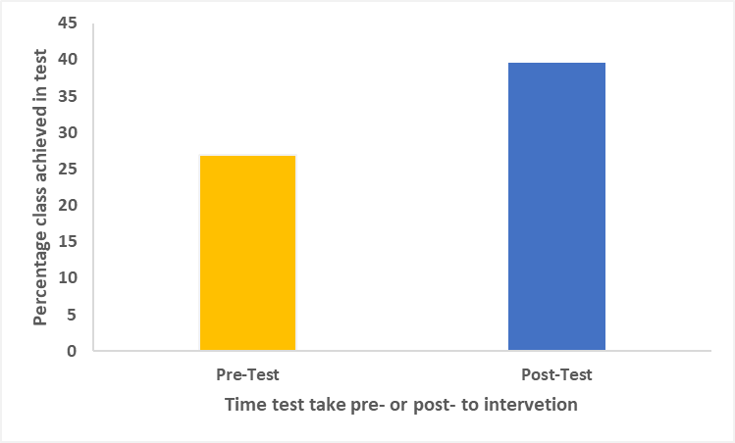
Figure 3: A graph showing the overall percentage of the class for both the pre-test and the post-test.

Now the results of just the pre-test will be examined in detail, to see what competencies pupils struggled with the most. A total of 28 pupils took part in this study, the graph below (Figure 4) shows how well pupil did on question e) of the PISA style test, as noted earlier on, only part e) and f) will be discussed in detail as these required the use of comparisons, scientific literacy and literacy. Part e) of the question assessed the explaining phenomena scientifically and the interpretation of scientific data competencies and is shown in the figure below. It had pupils read over four statements, in which they needed to write whether they agree or disagree and their reason for this answer (as shown in appendix 2). Looking at the data in figure 4, its clear to see that over half the class (21) had a score of 0, which is indicates that either pupils did not understand what the question was asking of them, or they had no previous knowledge on the matter. Three pupils had a score of 1, which is better than 0, but is still low. Four pupils had achieved a score of 2, one pupil managed to get obtain a score of 3 and lastly no pupils managed to reach the maximum score of 4.

When comparing this to the post-test results, it shows that only six pupils achieved a score of 0 when completing this question using the inference square, which indicates that less people completely failed this question. This question required the pupils to use information they were given and use previous knowledge to make conclusions and provide evidence. Eight pupils managed to achieve a score of 1, eleven reached a score of 2, again one had a score of 3 and lastly two pupils had the maximum score of 4, which is a large improvement from the pre-test where no pupils reached this score. Looking at this information implies that the inference squares were used by the pupils effectively, as no information was given to the pupils about this question meaning the use of the inference square was an effective form of scaffolding. The standard deviation for both the pre-test and post-test were 7.81 and 3.72 respectively, as this is over 1, it suggests that there is a high variation, corresponding to the high variation of PISA results found throughout schools (Jerrim & Shure, 2016).
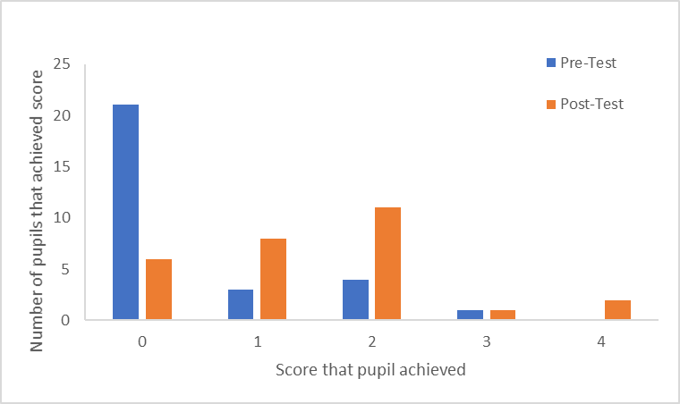
Figure 4: Graph displaying how many pupils achieved a score ranging from 0-4, with 0 being the worst and 4 being the maximum to reach, this is for question 1, part e).

As discussed, part g) was also used as one of the key aspects of this test, due to pupils needing to come to conclusions using information given in the question and knowledge they should already have (use of scientific evidence and interpreting data and evidence scientifically competencies). This question required pupils to think about why other cities closely monitored London when introducing their congestion charge and explain why they think these countries did this. Many pupils found this question difficult as implied by the results shown in Figure 5. These results paint a similar picture to that of part e), with a large number of pupils having lower scores, and when moving up the scores, the number of pupils achieving these decreasing. A high 22 pupils had a score of 0 in the pre-test, which is over 75% of the class, the other 6 pupils had a score of 1. This is quite poor as the question was out of a maximum score of 3, with no pupils reaching the top score. Pupils seemed to find this question difficult due to the high level of skill required to pick out information and answer the question interpreting it. It can clearly be stated that pupils did worse in the pre-test (as shown in Figure 5).

The post-test saw a great difference in results, a much lower eight pupils had a score of 0, with now a total of 13 pupils getting a score of 1, this may seem lower, however this s much improved from that of the 6 pupils that achieved this in the previous test. Six of the remaining seven pupils had a score of 2, seeing a 600% increase in the number of pupils reaching this score. One pupil managed to gain a score of 3, the maximum mark, which is a great improvement from the pre-test. This data does suggest that although not all pupils managed to reach to a better score, the majority did and with some vastly improving. It can hence be implied that the use of inference squares in part g) did seem to aid the pupils and improve their results.
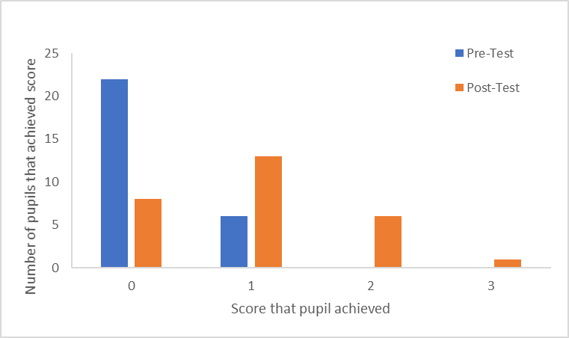
Figure 5: The number of pupils that achieved a score of between 0-3, for both the pre- and post-test for part g)

The achievement gap between males and females can now be looked at using figure 6 as shown below. During the pre-test, males seemed to achieve a higher percentage of around 27 whereas the females had 26%, although this is small, this is normally found in the opposite with girls usually having a higher score than the boys. However, when looking at the data from the post-test, the females have improved to a higher standard than that of the males, with males having 34% and females reaching a score of 39%. The girls improved by a large 13% in comparison to the boys 7%, this would hence suggest that females were able to use the scaffolding more effectively, which resulted in the greater improvement. It must be noted than there were more females than male, this shouldn’t have a great effect on the results however this could cause some variation. This variation will also be caused by the small sample size, as only one class of 28 pupils were used. The pre-test results do fall in line with what Jerrim & Shure (2016) found in their paper, with there being very little difference of significance between males and females.
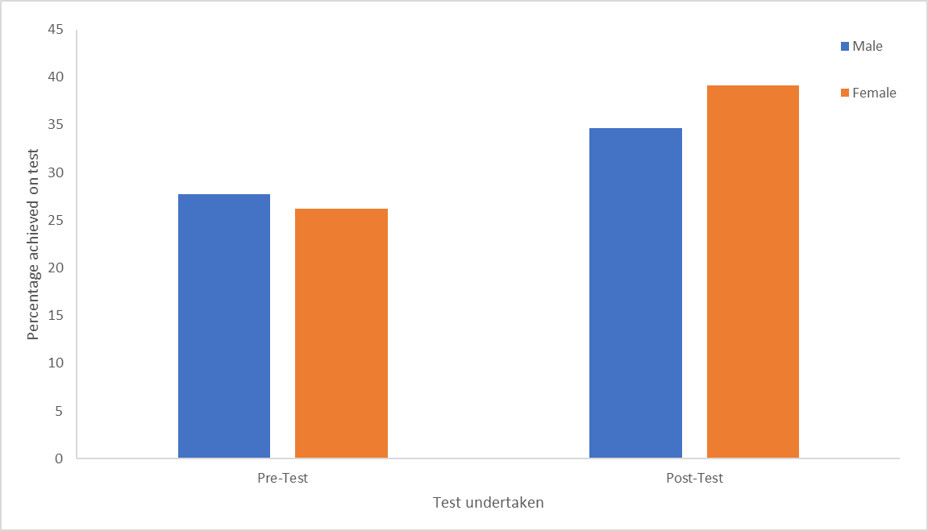
Figure 6: The difference in percentage achieved on the pre- and post-test between both males and females.
As previously shown for the whole class, the results for the two parts of the test will be examined in detail, however this will be shown for males and females to view how both genders did in the different competencies within the pre-test. Looking at the data, it is clear to see that on the pre-test, males achieved a much higher score in both part e) which was assessing the pupils’ competency in explaining phenomena scientifically and the interpretation of scientific data and also part g) which looked at how pupils could answer questions with the use of scientific evidence and interpreting data and evidence scientifically. Males did achieve a higher percentage overall when answering the questions, however the question on a whole was answered poorly with males getting 14% out of the 100% that can be reached.

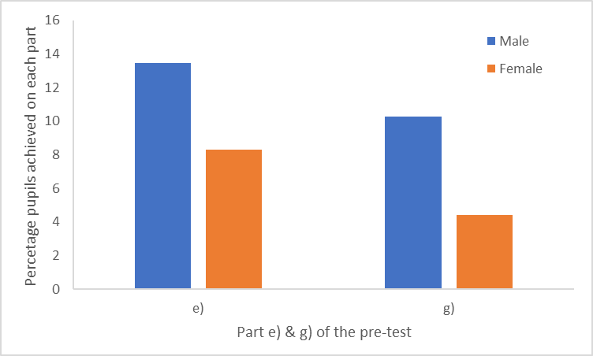
Figure 7: The allocation of marks to both part e) and g) for each gender (males being blue and females being orange).

Although both genders answered part e) and g) poorly, they greatly improved after the use of an inference square in the post-test, as shown by figure 7. The males managed to each 40% in part e) and 38% in part g), whereas the females who again did have lower results than the males had 33% in part e) and 29% in g). However, females had shown the greatest increase in results suggesting that females find the inference square an effective and useful scaffolding tool and have hence improved their results. This data goes against what Jerrim and Shure (2016) found when looking at the PISA results and may suggest that school X has a large achievement gap between males and females.
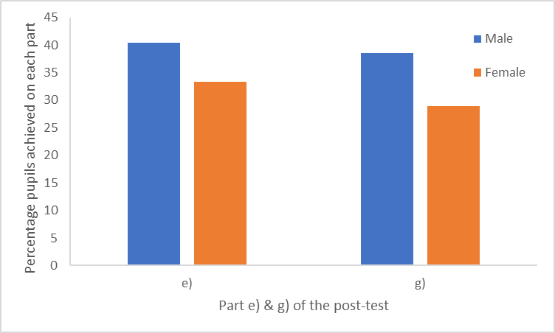
Figure 8: The allocation of marks to both part e) and g) for each gender (males being blue and females being orange).

Pre- and post-testing worked rather well for this research project, this is because the data that was collected from this method was quantitative (Creswell & Creswell, 2017). This as shown above allowed for a detailed and thorough breakdown of how pupils managed with and answered questions that were linked with specific competences. This has also clearly displayed how effective an inference square can be when used properly and how this improves how pupils answer these different competencies that are assessed in PISA or PISA styles questions (OECD, 2009). The use of a control class may have further demonstrated the effectiveness of this form of scaffolding as this class could have not use the inference square and then a direct comparison could have been used to see how useful these actually are, however this would have required more time and further ethical permission to ensure the pupils were not disadvantaged for tests in the future.
Lastly, as previously mentioned the pupils who sat these PISA style question tests were in year 8 and are hence one year younger than they would normally undertake the PISA tests (OECD, 2017). This would suggest that these pupils are at a disadvantage of two whole years’ worth of education meaning that these would have a lower overall level of knowledge and scientific literacy, large aspects of these PISA tests. The research could have been improved of a year 10 class had been used instead, however this was not an option as all year 10 pupils were finishing off the curriculum for their examination at the end of the year.

Conclusion
The conclusion aims to initially outline what information is given by the data from the testing, looking at how effective or ineffective the inference squares were when aiding pupils in answering PISA style questions. The two questions that were predominantly focussed on assessed two competencies, so it will be useful to see whether the inference squares helped improved these key skills. This can then be compared to literature to see whether other author’s have found similar or dissimilar findings. The last part of this conclusion will discuss the use of FSM for any future research.
Upon looking at all the results, it is clear to see that the use of inference squares was an effective and useful form of scaffolding for this year 8 class, with their results improving of 15% from the pre-test to the post-test. This does suggest that the inference squares help pupils learn, in particular the competencies that are linked with these questions (Felix, 2016). However, it must be noted that this was an increase from 25% to 40% so although there was an improvement, both the tests were completed poorly, as overall the class didn’t manage to reach the 50%. The pre-test was undertaken so poorly, that the increase that was seen in the post-test may have been by chance (Casas.org, 2019). This increase in the post-test was not due to any lower-performing pupils dropping out of the post-test (Felix, 2016) as this was controlled by removing any pupils that did not sit both tests. The post-test was completed to a higher standard, and as both tests were the same it is implied that some pupils used the inference squares effectively, although as there was no control class, it is not clear how much of this was due to the same questions being used.
One of the competencies being assessed in this research project was the use of evidence in a scientific nature. Figure 4 shows the scores of pupils when completing part e) of the tests, this question assessed this competency and it can clearly be seen that there was an overall increase in the results. This provides evidence to suggest that the inference squares aided pupils when they required to give scientific evidence as it gives a platform for pupils to work from. The other competency assessed was being able to interpret scientific data, which was in part g) of the test, figure 5 shows the results for this question. Again, it clearly shows an improvement from the pre-test and provides further evidence showing how effective this form of scaffolding can be to improve and develop these skills required in the PISA tests (OECD, 2016). The third competency involving evaluating and designing an enquiry of a scientific nature was not assessed in this research; however, this could have been examined if other questions would be added to the test, meaning only then the PISA-style competencies would be fully researched, and hence reducing any errors rising from pupil’s performance.
Using this research, it was also possible to look over how gender impacts the ability to effectively answer PISA style questions. The conclusion from the results is that during the pre-test, the males had higher results than that of the females, however after the intervention was used, the females had a greater improvement in the post-test. This is the opposite of what Jerrim & Shure (2016) found as these found that there were no differences in the ability to answering PISA styles question between different genders. However, when looking at the two parts of the test that assessed the competencies, it was clear to see that Males were higher in both the pre- and post- tests, which still goes against what Jerrim & Shure (2016) found. Although a study that was undertaken by Louis & Mistele (2012) and Shiel et al, (2010) found that there was a significant achievement gap, which favoured boys within science. There were more girls in the class used in this research and therefore may suggest that with equal males in the testing, this may have pushed the results even further in the favour of the males. This was a mixed ability class, which could have impacted these results, in the future it may be viable to specifically chose pupils that have similar scientific literacy and content knowledge levels, and half of each gender to fully compare the effectiveness of the inference square. It is understandable that the males would be able to use this more effectively as males are notoriously known for not reading information given to them in a question due to attitude (Ameyaw & Anto, 2017), hence using this scaffolding gives them the tools to pick out the key information that they would have previously missed.
The results that were collected from this research have a vast amount of ways in which it could improve, as previously mentioned all three competencies could have been used to test the pupils on all of them instead of two. This could assess the ways in which the use of inference squares in all three competences, therefore being able to fully realise the effectiveness of this scaffolding. The research could have incorporated multiple schools, hence increasing the sample size of this research, as one class is simply not enough to give a definite answer to whether inference squares are effective for PISA tests, the use of control classes could then be used to compare the results with and without the scaffolding. This would dramatically reduce sampling errors, helping improve the validity of this research (Mcgahee & Tingen, 2009; Charter, 1999).
One aspect that was not assessed throughout this research was considering FSM eligibility of the pupils that were in the sample of this study. It was decided that this research could not delve into this area due to ethical constraints given by BERA (2011), as more data would be required from the pupils, meaning more permission would needed to be granted from the pupils’ guardians and therefore was not used in this study. However, it would be intriguing to compare the results of the pupils with that of their FSM status, as this would be used to study any difference between the results and a variation that follows (Jerrim & Shire, 2016; Ameyaw & Anto, 2017; Knowles & Evans, 2012).

Limitations and future development
The aim of this section is to discuss in detail any limitations of this study. To begin this, the use of the PISA-style questions will be evaluated. In this research, the use of these questions was PISA style, not questions directly from the PISA tests. The lack of these questions is also another issue as there was overall a lack of data, as although the results did imply that the inference squares were an effective scaffolding method, it is not possible to understand if this improvement was all due to the inference square (Pereyra & Kotthoff, 2011). In addition to this, an increase in the sample size could have drastically improved the reliability of the data, as more schools could have been involved, as well as some classes acting as a control to test whether there were other factors that may have caused any improvement in the post-test. This would also aid in the comparison between males and females and would also allow the use of the 4 group-design created by Soloman (Braver & Braver, 1988) which would help reduce errors arising from the tests.
A second limitation from this study is due to the pupils not using the inference squares, as although these were given to the pupils and were thoroughly explained, not all pupils seemed to use them, and it was not possible to know which pupils did use this scaffolding or not. This causes difficulty when looking at the effectiveness of the inference squares as this improvement may have been to pupils either trying harder during the post-test, or simply pupils underperforming in the pre-test which could be a possibility as the scores for the pre-test were poor. In future investigations, it could be made clearer that the use of inference squares would have to be compulsory to ensure all pupils use them. However, even though some pupils did not fill in inference square sheets that were printed off, they may still have used the prompts on the sheet to aid them in answering the questions.
The last limitation that is worth noting is the use of a year 8 class to complete this research. It is well-known that it is year 10 pupils that usually sit the PISA tests and hence the pupils in this study were disadvantaged of two years of education which may have also impacted the results. If a year 10 class had been used, it may have provided more reliable results, or even better using multiple year groups to see the difference in the competencies in science between the year groups. Each year group could also have a control class to provide a greater comparison in the effectiveness of inference squares as a form of scaffolding.
Throughout the conduction of this research, I have developed my teaching which has aided me in the fulfilment of the QTS standards that are required to obtain qualified teacher status (Welsh Government, 2009). The scaffolding that was provided for the post-test demonstrates differentiated teaching as pupils that required it benefited from using it, I also met S3.2.4 as I was able to meet the needs of all learners. My knowledge of the curriculum has also increased, specifically the scientific literacy aspect of the curriculum which is required from pupils in their GCSE examinations (Qualifications Wales, 2016) satisfying the QTS standard S2.1.As this research was based on pre and post testing, results of the pupils test scores were recorded and the progress was saved to see how well pupils could answer PISA-style questions, therefore satisfying the S3.2.6 QTS standard. Lastly the use of resources and the required lesson planning needed for the PISA style questions and the inference square itself have assisted me in meeting S3.1.2 and S3.1.3.

References
Ameyaw, S. and Anto, S.K., 2017. Gender Variation in Reading Habits in Schools in Moland: A Case study of Asantekwaa SDA Junior High School. European Journal of Education Studies.
Andrews, A. et al, 2014 ‘OECD and Pisa tests are damaging education worldwide – academics’ [www] https://www.theguardian.com/education/2014/may/06/oecd-pisa-tests-damagingeducation-academics (date accessed: 14 April 2019)
Auld, E. and Morris, P., 2016. PISA, policy and persuasion: Translating complex conditions into education ‘best practice’. Comparative Education, 52(2), pp.202-229.
BERA, 2011. ‘ETHICAL GUIDELINES FOR EDUCATIONAL RESEARCH’ [www] https://www.bera.ac.uk/wp-content/uploads/2014/02/BERA-Ethical-Guidelines-2011.pdf (date accessed: 31 March 2017).
Bybee, R.W., 2008. Scientific literacy, environmental issues, and PISA 2006: The 2008 Paul F-Brandwein lecture. Journal of Science Education and Technology, 17(6), pp.566-585.
Casas.org, 2019. Pre- & Post Testing. [online] Available at: https://www.casas.org/training-and-support/testing-guidelines/pre--post-testing [Accessed 24 April. 2019].
Charter, R.A., 1999. Sample size requirements for precise estimates of reliability, generalizability, and validity coefficients. Journal of Clinical and Experimental Neuropsychology, 21(4), pp.559-566.
Creswell, J.W. and Creswell, J.D., 2017. Research design: Qualitative, quantitative, and mixed methods approaches. Sage publications.
DeBoer, G.E., 2000. Scientific literacy: Another look at its historical and contemporary meanings and its relationship to science education reform. Journal of Research in Science Teaching: The Official Journal of the National Association for Research in Science Teaching, 37(6), pp.582-601.
Education Council, 2006. ‘Benefits of Participation in International Studies of Student Achievement’. [www]http://www.educationcouncil.edu.au/site/DefaultSite/filesystem/documents/Reports%20and%20publications/Archive%20Publications/Measuring%20and%20Reporting%20Student%20Performance/B enefits_of_International_Studies_May_06.pdf (date accessed: 07 April 2019)
Eivers, E., 2010. PISA: Issues in implementation and interpretation. The Irish journal of education, 38, pp.94-118.
Estyn, 2014. ‘School X Estyn Inspection’. [www] School X Estyn Inspection (date accessed: 12 April 2019)
Felix, A., 2016. Using Pre/Post-Testing to Evaluate the Effectiveness of Online Language Programs. Journal of Second Language Teaching & Research, 4(1), pp.176-193.
González de San Román, A. and De La Rica, S., 2012. Gender gaps in PISA test scores: The impact of social norms and the mother's transmission of role attitudes.
Harlen, W., 2001. The assessment of scientific literacy in the OECD/PISA project.
Hume, C., 2016. ‘Pisa: Wales still worst in UK in world education tests. [www]. http://www.bbc.co.uk/news/uk-wales-38208738. (date accessed: 09 April 2019).
Jones, V., 2017. After PISA: Real approaches to science in Wales. Primary Science, (148), pp.9-11.
Koretz, D., 2009. How Do American Students Measure Up?: Making Sense of International Comparisons. The Future of Children, 19(1), pp.37-51.
Knowles, E. and Evans, H., 2012. PISA 2009: How does the social attainment gap in England compare with countries internationally?.
Kreiner, S., 2011. Is the foundation under PISA solid?: A critical look at the scaling model underlying international comparisons of student attainment. Copenhagen: Department of Biostatistics, University of Copenhagen.
Kirsch, I., Long, J. D., Lafontaine, D., McQueen, J., et al., 2002. Reading for Change: performance and engagement across countries. Paris, OECD.
Learning Wales, 2012. ‘Improving schools’. [www]. http://learning.gov.wales/docs/learningwales/news/121025improvingschoolsen.pdf (date accessed: 25 April 2019)
Lepkowska, D, 2015. ’10 Evidence-based teaching strategies for maths and science’. [www] http://www.sec-ed.co.uk/best-practice/evidence-based-teaching-strategies-for-maths-and-science/ (date accessed: 18 April 2017).
Louis, R.A. and Mistele, J.M., 2012. The differences in scores and self-efficacy by student gender in mathematics and science. International Journal of Science and Mathematics Education, 10(5), pp.1163-1190.
McGahee, T.W. and Tingen, M.S., 2009. The use of the Solomon four-group design in nursing research. Southern Online Journal of Nursing Research, 9(1), pp.77-84.
Micklewright, J., Schnepf, S.V. and Skinner, C., 2012. Non‐response biases in surveys of schoolchildren: the case of the English Programme for International Student Assessment (PISA) samples. Journal of the Royal Statistical Society: Series A (Statistics in Society), 175(4), pp.915-938.
Nieswandt, M. and Bellomo, K., 2009. Written extended‐response questions as classroom assessment tools for meaningful understanding of evolutionary theory. Journal of Research in Science Teaching: The Official Journal of the National Association for Research in Science Teaching, 46(3), pp.333-356.
Norris, S.P. and Phillips, L.M., 2003. How literacy in its fundamental sense is central to scientific literacy. Science education, 87(2), pp.224-240.
OECD, 2009. ‘Take the Test sample Questions from OECD’s PISA Assessments’ [www] https://www.oecd.org/pisa/pisaproducts/Take%20the%20test%20e%20book.pdf (date accessed: 23 April 2019)
OECD, 2016. ‘How does PISA assess science literacy?’ [www] http://www.oecdilibrary.org/docserver/download/5jln4nfnqt7len.pdf?expires=1493060700&id=id&accname=guest&checksum=9405666BF8262078FFD8603090BB E479 (date accessed: 24 April 2019).
OECD, 2017. ‘What is PISA?’ [www] http://www.oecd.org/pisa/aboutpisa/ (date accessed: 24 April 2019)
OECD, 2017. ‘Scientific Question Categories’. [www] http://www.oecd.org/pisa/test/scientificquestion-categories.htm (date accessed: 22 April 2019).
Pereyra, M.A., Kotthoff, H.G. and Cowen, R., 2011. PISA under examination: Changing knowledge, changing tests, and changing schools. In PISA Under Examination (pp. 1-14). Brill Sense.
Reynolds, D, 2007 ‘Schools learning from their best. The within-school variation project.’ Research Report. London: National College for Teaching and Leadership.
Rivard, L.P. and Straw, S.B., 2000. The effect of talk and writing on learning science: An exploratory study. Science education, 84(5), pp.566-593.
Sadler, T.D. and Zeidler, D.L., 2009. Scientific literacy, PISA, and socioscientific discourse: Assessment for progressive aims of science education. Journal of Research in Science Teaching: The Official Journal of the National Association for Research in Science Teaching, 46(8), pp.909-921.
Shiel, G., Moran, G., Cosgrove, J. and Perkins, R., 2010. A Summary of the Performance of Students in Ireland on the PISA 2009 Test of Mathematical Literacy and a Comparison with Performance in 2003. Report to the Department of Education and Skills. Dublin: Educational Research Centre.
Štrajn, D, 2014. ‘The PISA Syndrome: Can we Imagine Education without Comparative Testing?’ Solsko Polje, 25(5), pp. 13-27,147-149,169.
Stewart, W., 2013. Is Pisa fundamentally flawed?. The Times Educational Supplement Scotland, (2327), p.16.
Welsh Government. (2009). ‘Becoming a Qualified Teacher: Handbook of Guidance (2009)’. [www].
http://gov.wales/docs/dcells/publications/090915becomingateacheren.pdf (date accessed: 06 May
2019).
Welsh Government, 2017. Programme for international student assessment (PISA): analysis of 2015 results. https://beta.gov.wales/programme-international-student-assessment-pisa-analysis-2015-results (Accessed on 12 April 2019).
Welsh Government, 2019. Our National Mission: A Transformational Curriculum. [www] https://gov.wales/sites/default/files/consultations/2019-01/consultation-document-transformational-curriculum.pdf

Appendix
Appendix One- Inference squares pupils were provided with during post-test
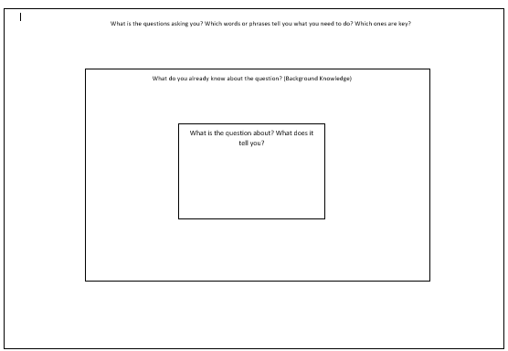

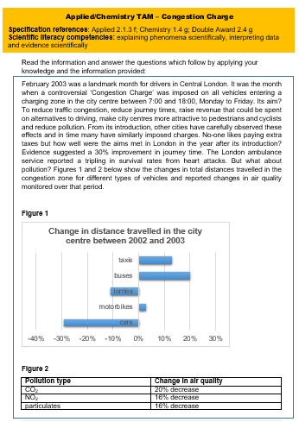
Appendix Two- Pre-test and post-test questions


