HOW CONFIDENT THE STUDENTS ARE TO COLLABORATE ONLINE?

FARHAT AZHAR
2213611

LCHS4002
Research Report
Chuen Leung
14 November 2022

How Confident the Students are to Collaborate Online?
Introduction
Students' knowledge and their sense of confidence can both benefit from the classroom application of collaborative learning methodologies in an effective manner (Stover & Holland, 2018). The most effective way to learn is in a group environment. In Ancient Greece, philosophers, teachers, and other intellectuals met regularly to discuss new ideas and share their knowledge. The culture of working together persists even if the modes of communication available to us now couldn't be more dissimilar. Collaborative student activities, whether in pairs or larger groups, can have a positive impact on the amount of knowledge that is retained. Nevertheless, the desire for working in groups is something that must be learned. When students are allowed to study in groups under the appropriate circumstances, it has the potential to boost both their self-confidence and their drive. This is especially true when it comes to the process of presenting and responding to questions. According to the findings of the research, the academic performance of students is improved when they are provided the chance to collaborate. In addition, kids who have a history of performing poorly benefit from working in groups that have members from a variety of different kinds of backgrounds (Riches, 2022).
Group projects and conversations help students to learn. Social constructivism and contextual learning emphasize student cooperation. It's aligned with learning as participation, where students become involved group members. Challenges in communication, especially with difficult or missing group members, practical challenges involving leadership and punctuality, and reliance on other students' scores all contribute to students' negative perceptions of group work. Studying remotely or online creates obstacles to group collaboration. Students have trouble collaborating with strangers. Online students sometimes feel they can do homework alone. Students want control over their studies and social time. This may discourage online collaboration. Students must value their work, therefore group activities should be enjoyable and assignments should be relevant (Donelan & Kear, 2018).
Research Design
Research questions
- How do students feel about working on group assignments together online?
- What do students find challenging, discouraging, or annoying about online group projects?
- How can we make sure that student group projects are both interesting and evaluated fairly?
- What are the biggest challenge or difficulties of teachers during online projects?
Research Method
In this research, the primary research method will be used to conduct a survey. Different types of questions will be asked about collaborative learning and the online study of students. Questions will be close-ended. The approach of doing research using surveys is frequently considered to be a straightforward one. On the other hand, it is not difficult to survey low quality rather than one of high quality and genuine worth, and this is true of any research methodology or approach. The point of this study is to provide a checklist of recommended practices for conducting survey research and generating reports on the findings.
This guide is created to assist a rookie researcher in creating survey work of a quality high enough to ensure that the results would be considered seriously. It was written to assist a novice researcher in producing survey work. After providing the reader with a concise introduction of the method at the beginning of the essay, the author then moves on to walk the reader through the processes of data collection, analysis, and reporting in a step-by-step fashion. It is not intended to be a how-to guide for carrying out surveys; that is not its purpose. A standardized method is utilized throughout the data collection process. The employment of a questionnaire will be the method that is employed to carry out this research.
Ethical Consideration
Participants in scientific experiments are shielded from any dangers that could be present. At every point in time, research participants are handled with the utmost respect. All of the participants must first provide their informed permission before the research may begin. The confidentiality of the participants is maintained under all circumstances. To an adequate degree, safeguards have been put in place to guarantee the confidentiality of the study's data. Everyone who contributes to the study, including individual participants, will have their right to remain anonymous respected. In no way have the goals and objectives of the study been manipulated or exaggerated in any manner, nor has there been any attempt to do so purposefully.
It is disclosed whether there is a potential conflict of interest, as well as the sources of funding and other kinds of links. Every contact that is in any way related to the research is conducted in an open and trustworthy manner. Dishonesty in any of its myriad forms is expressly forbidden, as is the presentation of results derived from source data in a manner that is tainted by bias. Kindness and compassion are essential components of conducting research in this area, both toward the humans and the animals who participate. Participants in this survey will not be put in any potentially hazardous circumstances. This research did not make use of any data that was already gathered by other researchers and included in their work.
Results
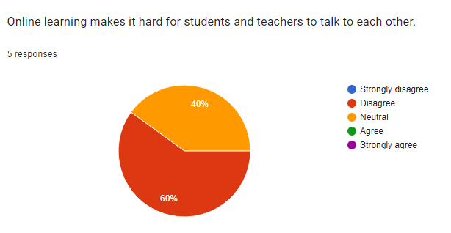
This shows that 60% of all disagreed with this statement while 40% are neutral.
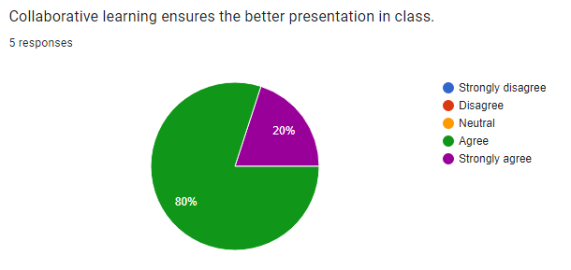
It shows the most positive results. 80% of participants agreed with collaborative learning and 20% of participants strongly agreed.
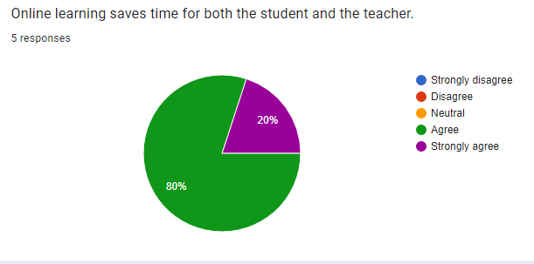
Almost all the participants think that online learning saves their time as compared to physical classes. So, 80% of all agreed while 20% strongly agreed.

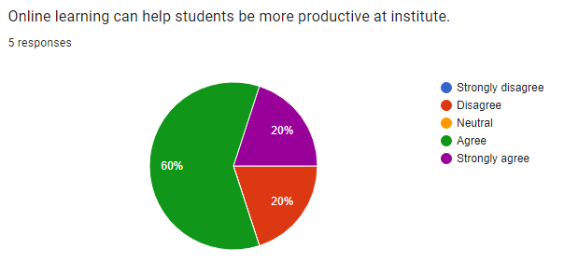
Some participants are not agreed with this statement. Almost 20% of all disagreed with it. In contrast, 60% of participants agreed while 20% strongly agreed.

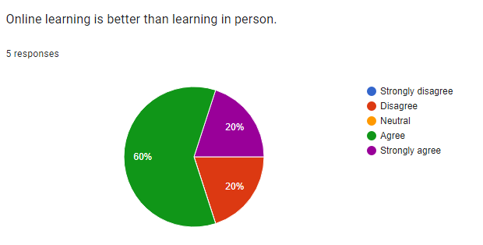
Some people in the group disagree with this assessment. A majority agree with it, while almost 20% strongly disapprove. 60% of respondents, on the other hand, agree, with 20% even strongly agreeing.
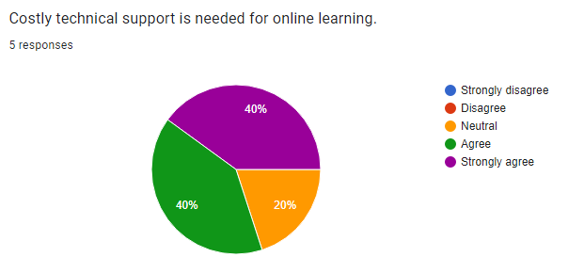
It shows that 40% of people strongly agreed while the same percentage of people agreed. While 20% of people remain neutral.
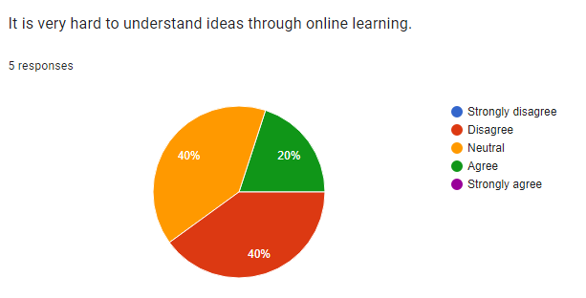
It shows almost negative results that 40 % of people disagreed with it while 40% remains neutral.
Only 20% of people agreed to it.
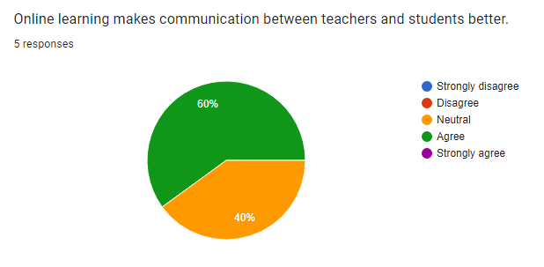
More than half, almost 60% of participants agreed with this while 40% of participants are neutral about it.

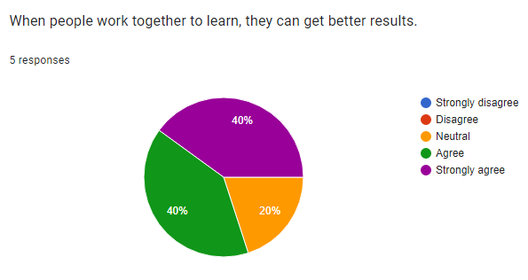
Most people believe that they get better results from online learning. So, 40% of participants strongly agreed while the same percentage of participants agreed. 20% of participants are neutral.
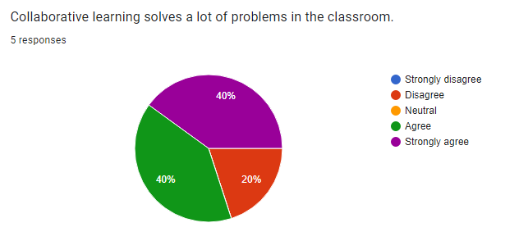
40% of people agreed and also 40% of people strongly agreed, but 20% of peoples shows negative result.
Discussion
One strategy to boost both the quality of student's learning experiences and the effectiveness of delivery is to use collaborative learning, which encourages high levels of student participation (Magana, et al., 2018). The focus of this study is collaboration in an online learning environment, whereas the majority of earlier research on collaborative learning has focused on settings where participants may interact in person. Online interactions and face-to-face interactions are very different from one another in several ways.
Online interactions may involve less communication than face-to-face interactions since there are no nonverbal cues to read (Behrens & Kret, 2019). Because so much online communication is asynchronous, getting a response can take a long time. As a result, the players could encounter both advantages and disadvantages. There may be a trade-off between the lack of spontaneity that comes with a seminar group seated at a single table and the potential for more time for thought and the development of a thoughtful answer.
The assessment of the student's participation in the online dialogues demonstrates that productive teamwork is achievable within the parameters of this environment. There are some significant differences, but there are also some similarities between the collaborative behaviors reported by Johnson & Johnson (1996) in face-to-face scenarios and those identified in this study. Johnson & Johnson found that employees were more likely to collaborate when they were in the same room together. One of these characteristics is the lack of "challenge and explain" interaction cycles, which are thought to be an indicator of good exchanges in face-to-face courses but do not occur in online learning environments.
One more significant difference between face-to-face and asynchronous online interactions is the prominence of planning activities within group interactions. The intensity of these planning activities appears to be connected to communication constraints imposed by the scarcity of effective real-time interaction support technologies. This is an important distinction.
It is equally important to have challenging tasks assigned to groups as it is to have the appropriate technology. The incorporation of a challenging project that necessitates group effort is another factor that helps the efficiency of collaborative online learning. (Campbell, et al., 2020). This offers a subject on which the group may concentrate.
It must be difficult for the group to understand that cooperation is required to complete it for it to be effective. The group project must be substantive, challenging, and pertinent. Importantly, it must be a task that the group cannot complete alone. This increases collaboration among the team and fosters a healthy dependency within the online community.
Conclusion
The students' sentiments regarding the online group project after completion were largely positive, even though it was difficult. To illustrate these students' and tutors' viewpoints, the research has supplied extensive, in-depth qualitative data. Hopefully, this will help to enhance online group projects in the future, which will raise student accomplishment and happiness in turn.
The research is flawed because it is based on a small sample of students and teachers who voluntarily participated in the study. Likely, the students who participated in the study were also the ones who showed the most interest in the collaborative assignments. The results of the sample do not exactly reflect those of the entire cohort. The people who took part in this study gave the impression that they were aware of the significance of the activities they had accomplished and that they liked the process. However, there were difficulties and annoyances brought on by aspects of the web development platform as well as the collaborative nature of the task.
A significant source of frustration was the limitations that were imposed by the module team to ensure that students of all different ability levels could complete the assignment. The findings of this research point to the fact that encouraging students to participate to their full potential is an essential component of successful online group projects. When students take part in the activities, they have a far higher chance of perceiving them as satisfying and bringing about improved outcomes. If the other students in the class opt out of participating, they will be up against several difficult obstacles.
According to this survey, online collaborative learning proves beneficial for students. They get a better understanding and results from it. One of the major concerns is as it saves time. A productive collaborative group activity gives students a sense of belonging and gives them a shared active role and responsibility within their formed groups (Herrera-Pavo, 2021). Online students who are enrolled in well-designed learning environments get valuable knowledge, advance their higher-order thinking skills, and start to form an eLearning community where cooperative group projects are welcomed.
Research has shown that there are several benefits to participating in collaborative online group activities, such as establishing expectations and serving as a model for group norms. Participating in collaborative group activities is a good place to get the ball rolling on the process of establishing an online sense of community support. Students can quickly become acquainted with one another through the use of activities designed specifically for this purpose. In addition, the presence of this kind of task will inspire the collaborative group to arrange meetings, make deadlines, and communicate via email to finish the project efficiently and on time. There are many different types of challenging group projects, some examples of which are an online learning course, a group paper, or a group presentation (Ayu, 2020). These are all excellent choices for difficult group assignments for an online collaborative group.

References
Ayu, M., 2020. Online learning: Leading e-learning at higher education. The Journal of English Literacy Education: The Teaching and Learning of English as a Foreign Language, Volume 7(1), pp. 47-54.
Behrens, F. & Kret, M., 2019. The interplay between face-to-face contact and feedback on cooperation during real-life interactions. Journal of Nonverbal Behavior, Volume 43(4), pp. 513-528.
Campbell, A., Layne, D., Scott, E. & Wei, H., 2020. Interventions to promote teamwork, delegation, and communication among registered nurses and nursing assistants: An integrative review. Journal of Nursing Management, Volume 28(7), pp. 1465-1472.
Donelan, H. & Kear, K., 2018. Creating and collaborating: students’ and tutors’ perceptions of an online group project. International Review of Research in Open and Distributed Learning.
Herrera-Pavo, M., 2021. Collaborative learning for virtual higher education.. Learning, Culture and Social Interaction, Volume 28, p. 100437.
Magana, A., Seah, Y. & Thomas, P., 2018. Fostering cooperative learning with Scrum in a semi-capstone systems analysis and design course. Journal of Information Systems Education, pp. 75-92.
Riches, A., 2022. Collaborative learning – a quick guide to using it with confidence. [Online]
Available at: https://www.teachwire.net/news/collaborative-learning-a-quick-guide-to-using-it-with-confidence/
Stover, S. & Holland, C., 2018. Student Resistance to Collaborative Learning. International Journal for the Scholarship of Teaching and Learning, p. 8.

Appendix
- Online learning makes it hard for students and teachers to talk to each other.
- Strongly agree
- Agree
- Neutral
- Disagree
- Strongly disagree
- Collaborative learning ensures better presentation in class.
- Strongly agree
- Agree
- Neutral
- Disagree
- Strongly disagree

- Online learning saves time for both the student and the teacher.
- Strongly agree
- Agree
- Neutral
- Disagree
- Strongly disagree

- Online learning can help students be more productive at the institute.
- Strongly agree
- Agree
- Neutral
- Disagree
- Strongly disagree

- Online learning is better than learning in person.
- Strongly agree
- Agree
- Neutral
- Disagree
- Strongly disagree

- Costly technical support is needed for online learning.
- Strongly agree
- Agree
- Neutral
- Disagree
- Strongly disagree

- It is very hard to understand ideas through online learning.
- Strongly agree
- Agree
- Neutral
- Disagree
- Strongly disagree

- Online learning makes communication between teachers and students better.
- Strongly agree
- Agree
- Neutral
- Disagree
- Strongly disagree

- When people work together to learn, they can get better results.
- Strongly agree
- Agree
- Neutral
- Disagree
- Strongly disagree

- Collaborative learning solves a lot of problems in the classroom.
- Strongly agree
- Agree
- Neutral
- Disagree
- Strongly disagree

