University of Wales Trinity Saint David

Academic and Employability Skills

Assignment 2

Student’s Name: Abdul Alim
ID: 1706728

Teacher’s Name: Peter Allen

Table of Contents
Introduction 1
Task 1 2
A paper on explaining how the learning in the module has helped you develop both your academic and employability skills and reflect also on any skills gaps and suggest ways you might improve on these gaps 2
Recommendations 7
Conclusion 8
Reference 9

Introduction

The main focus of the assignment is to increase the academic and employability skills of the students as well as the employees. Employability skills are first required by the employees when they go for the recruitment process. Employability skills are those important skills that are needed for doing the job tasks perfectly (Loehr, and Schwartz 2013). Every employees recruited fora job after completing graduation when he has enough employability skills which are essential for the job. Academic and employability skills both are important in the context of the job. Academic skills are learned from the educational institutes and some employability skills are also learned from there. But most of the employability skills are learned when a person enters into his job life. Every job task teaches him about how to increase the skill on that particular issue. Day by day he learns about the essential employability tasks. This study helps me to learn some employability skills that I can use in my job tasks. I was facing some skill gaps which lag be behind in my workplace and I was in the confusion that what I should do in a particular situation. After completing this module I have learned those employability skills and this assignment will discuss that how to gain those employability skills that are necessary for prospering as an employee.

Task 1

A paper on explaining how the learning in the module has helped you develop both your academic and employability skills and reflect also on any skills gaps and suggest ways you might improve on these gaps

Academic and employability skills both are essential requirements for getting a job and being a good employee for a particular organization. As a student, I can learn the academic skills from my graduate school. There are many skills that will help me in my workplace. Basically, education institute teaches us academic skills and we learn most of the employability skills when we go to the job place as an employee.

Academic skills: academic skills are those individual skills which I have learned from my educational organization. Throughout my graduation journey, I have learned some basic skills which are also necessary when I go for my job. The academic skills are the habit of learning, time management, learning strategies etc. All those skills are helpful because when I go for my job life I have to learn how to complete a task which is given by the boss. I also have to manage the time. I need to go to the officeat the particular time and I have to complete the task in a particular period. The educational institution teaches us how to learn quickly and effectively. We have to seat for our exams for some hours that teaches us to manage the time for a particular task (Loehr, and Schwartz 2013).

Figure 1: Ways of learning academic skills
Source: (Rode, 2017)

The academic skills help us to understand the job task in the workplace because we learn the theory of the job in our educational school. I have learned about the how to research a matter and evaluate the information which can be found from this research process. The theoretical knowledge also can be learned by preparing assignments which is our class task. All of the tasks of the educationalinstitutions have helped me to learn how to improve my work and be an eligible candidate in the labor market (Rode, 2017)

Employability skills: The word employability means creating value creating works and getting paid for that works. At the same time, an employee can learn about how to complete that work in an effective way which will help him to complete the work in future in a most efficient way.

The employability skills a set of achievements, understanding and personal attributes that makes individuals more likely to gain employment and to be successful in their chosen occupations (Peter Knight & Mantz Yorke, 2011). Employability skills must be occupied by the people who want to participate in the labor market. They have to ensure the employer that they possess the capability of being effective in the workplace.
As an employee, I have learned some employability skills which have made me more capable and experienced in my workplace. Those skills are discussed in this section.

Communication skill: Communication skills are very important for the employee to survive in the workplace. No task can be completed without communicating with others. In the workplace a cask is given to a group and communication is very much needed to complete it successfully. To learn the communication skills I can start it from my education life. Networking is a good method for learning this skill. Communication with a large number of people, try to listen what they want to say and understanding it is very important in learning this skill. Besides, I have to learn how to speak clearly and reading, writing In English so that I can make my job task easily. Learning another language is also important because an employee may need to communicate with a different type of client for completing the task. Knowing other language paves the way to communicate with people from other culture (Loehr, and Schwartz 2013).

Teamwork skill: In the workplace, some tasks are done in a group. Some tasks are so important and big that it is authorized by a group not a single employee. So, in this case, an employee has to know how to work with a team because the thinking and opinion of the member of the team are not same and it creates conflict between the members. Ultimately the task is not completed successfully which is not good news for the organization. As an employee, I have to learn to work with the members irrespective of age, gender, race etc. The future planning, budgeting, goal and vision setting is done with the teamwork so I have to listen to everyone’s opinion about a particular thing and agree upon a mutual decision (Loehr, and Schwartz 2013).

Problem solution skill: Problem-solving skill is important employability skill because it is necessary for being as an employee. An employee is recruited by an employer to solve some work-related task of an organization. So, at the time of recruitment, the employer is very much careful about choosing the person who has high problem-solving skills. For being skilled in this manner I have to be good at solving the mathematics, analytical ability, financial measurements which I have learned as my academic skills. I have to know how to develop creative and innovative idea for solving the task so that it can be unique and bring success to the organization.

Planning and organizing skill: Knowing how to plan and organization task is very important because it is needed when an employee starts to solve a task. For doing anything proper planning and organizing are needed which helps as a guideline for completing a task successfully (Cherniss and Goleman, 2011). To learn this skill, I have to know to select the time period for the task and divide it in a small task so that the big task can be completed easily. After that, I have to identify the elements that are needed to complete the task and take the initiative to collect them for the accomplishment of the task.

Initiative and Enterprise skill: This skill is essential for completing the actual task. After planning and organizing, I have to take initiatives to complete the task. For that reason, I have to contact the top management and show them the total work plan about how I will compete it and how much time will be needed. After that, I have to make them ensure the benefits the organization will get after completion of the work. After that, the top management will allocate the resources for the task. Completing a task is a new challenge so I have to adapt the new situation and try to learn about the new aspects of how to complete the task in an effective and efficient manner.

Self-management skill: Self-management are those issues that are related to the individual employee of an organization. All the employees are from different background so their way of behavior manner are different. But the workplace has some particular rules and regulations which must be abide by the employees.

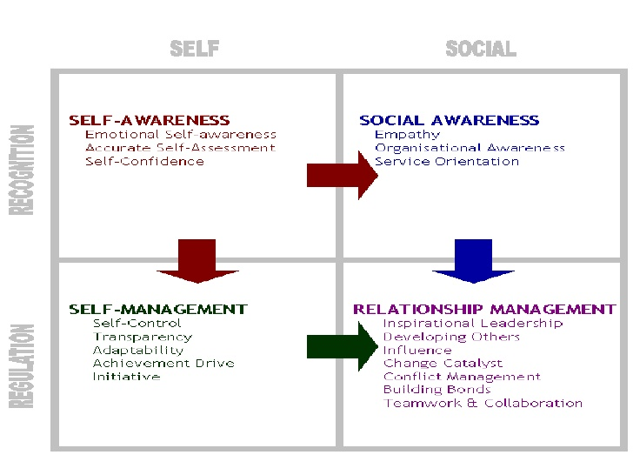
Figure 2: Self management process
Source: (Cialdini, 2017).
To gain the self-management skill I have to be aware of myself. What makes me happy, enthusiastic; upset should be clearly known to me so that it will help me to control my behavior in a particular situation. Besides, I have to be socially aware in the workplace. I have to know about my fellow colleagues and try to make a good relationship with them which will help me to do my task in an easy way (Yukl, 2012).

Technology skill: No organization can run without technology. Technology is a must to complete to organizational tasks. So, the employer of organization always tries to recruit the person who is technologically sound. The person who has more knowledge about the latest technology and the technological ways of completing a task is always preferred by the organization (Cialdini, 2017). . To acquire the knowledge I have to be aware of the new technology coming in the market and basic IT knowledge so that I can perform well in my workplace. I can learn the technological knowledge from my student life and do a course on Microsoft word, excel, access, power point presentation etc. I can also be focused on presentation skills and public speaking to be a good employee in my workplace.

Recommendations

Like me, every student lacks some skill gap in their workplace which makes an obstacle for them to shine in their careen life. Some recommendations can be provided to reduce the skill gap and being an eligible employee the job.

The employees who are recruited newly for an organization are from different background. Some are from disadvantaged background and minority groups. So, they cannot cope with the regular advantaged employees. The organization should arrange employability skills training for them so that they can learn and ensure the equity of the workplace which ultimate increase the success of that organization. Besides, the educational institute should launch special courses so that the students can learn the skills from early life and do not face any trouble in the real job environment. The students also focus on the personal quality like-honesty, loyalty, punctuality, integrity that is very much needed for success in career life.

Conclusion
This assignment has taught us how the employability skills help us in our job life. Academic and employability skills are very much important for the employee of an organization. An employer also tries to ensure that the employees who are being recruited in his organization will have more employability kills than the other employees of the other organizations because the employees are the vital element for the success of a particular organization. So, the employees with high employability skills have the opportunity to get the job in that organization than the others who are less skilled. Now it is the responsibility of the educational organization to focus on the employability skills of would be graduates because after completing the graduation every student has to compete in the labor market to find a desired job in the desired organization. Only high employability skills can help the students to find their expected jobs.

Reference
Cherniss, C, and Goleman, D.(2011). The Emotionally Intelligent Workplace. San Francisco: Jossey-Bass
Cialdini, R. 2017. Influence: the psychology of persuasion Revised Edition. London: Harper Collins
Cialdini, R.(2017). Influence: the psychology of persuasion Revised Edition. London: Harper Collins
Eliot, G. (2016). The mill on the Floss. New York: Open Road Integrated Media.
Employability skills for the future. (2012). Canberra: Dept. of Education, Science and Training.
Harrison, R. (2009). Learning and development 5th edition. London: Chartered Institute of Personnel and Development.
Hind, D. and Moss, S. (2011). Employability skills. Sunderland: Business Education.
Loehr, J, and Schwartz, T. (2013). The power of full engagement. New York: Simon & Schuster
Nathaniel Branden. (2015). 6 pillars of self-esteem. London: Random House
Rode, J Arthuad-Day et al. (2017).A time-lagged study of emotional intelligence and salary. Journal of vocational behavior. 101 p77-89 Available through Anglia Ruskin
Silverman, M.(2013). Supporting workplace learning: a background paper for IES research network members. Brighton: The Institute for Employment Studies [Online] Available athttp://www.employment-studies.co.uk/system/files/resources/files/mp22.pdf details
Yukl, G. (2012)Leadership in organizations 8th Edition. Essex: Pearson

