Effective Team work and communication

Krishnakumari Perara

Submission Front Sheet
Student Name | Krishnakumari Perera
Student Number | 1808756
Course title | Certificate of Higher Education in Skills for the Workplace
Level | 4
Group | 2
Assignment title | BMSK4002- Effective Team Work and Communication
Module Leader Name | Sylvia Hoffman
Word Count | 2013

Table of Contents
Introduction | 3
Importance of communication at work place | 3
Shannon and Weaver Model | 3
Communication guidelines | 5
Verbal Communication | 7
Conclusions | 8
References and Bibliography | 9

Introduction
Communication is a process which allows or enables the flow of information between the sender and receiver. This method helps to create an understanding between the sender with respect to what they agree on and what they intent to do. Good communication skills is one of the most effective and essential tool at work place as it helps to increase the level of productivity and it allows to create and maintain a strong working relationship between the employees and employer at every levels within the organisation,(John et al, 2010).
Importance of communication at work place
Effective communication determines the success of the business there are three main reasons why communication is so important at work place. it act as a medium in delivering the vital message to the employees with respect to changes within the business operation and management this includes changes of policies, working conditions, type of technology used at work to reduce work load etc. it helps to improve the employee commitment to the organisation as it conveys the message about the achievements of the organisation and the benefits that the employees will get from organisations achievement. The last and foremost important thing is it helps to build the trust and confidence and motivates the workforce for their own benefit and for the betterment of the organisation,(Michael,2012).
Shannon and Weaver Model
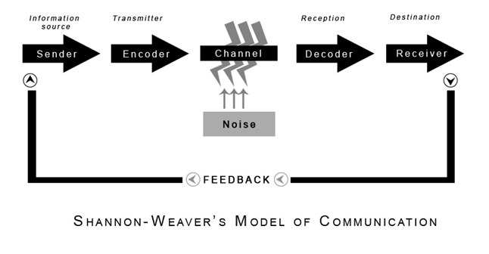
Figure 1 Shannon Weaver Model of Communication
Communication is a two way process. Every business has different methods and strategy to communicate its needs and wants to its employees. Shannon and Weaver model is one of the most effective models of communication which is wide practice in most of the business. This model helps to ascertain the need for effective communication, how to effectively send and receive messages within the communication pathway and it also focuses on how the organisation can constantly improve the ways and means with which it will communicate with its employees at every levels of the organisation. This method relies on six different elements within the communication pathway and how these elements will influence and impact the flow of information. The elements of the model are source, encoding, media or channel, receiver, decoding and feedback effects,(Michael,2012).
- Source Effect- it depends on four attributes they are credibility, attractiveness, expertise and similarity. It is the origin or the source where the information is originally coming from, how creditable and trustable the information is eg: message from the CEO, how attractive the message it can have both positive and negative effect depending on the nature of information eg: pay rise and bonuses. New plan of action for marketing and sales strategy delivered by sales manager and finally the message should be within the group be it is managers or team leaders who has the ability to reach and influence the target group to carry out the tasks,(Michael,2012).
- Encoding Errors- Encoding is the process through which the message sent from the source is converted into a form of signal which the receiver can understand. Some of the common encoding errors in communication process are lack of understanding of the target audiences needs and wants, underestimating the capabilities of the target audience, making assumptions which are contrary to the faith, interest and believes of the target group, method and medium chosen to deliver the message, these errors can prevent the organisation from getting the desired decoded message. A typical work scenario for encoding error is pay cuts, downsizing of the business and introduction of technology. All these can have a profound impact on the target group as it will affect their livelihood. Hence these changes should be carefully thought and right source and encoding methods should be used before the message is delivered to the target audience,(Michael,2012).
- Channel and Decoding- this is the medium through which the message gets sent to the target group and it is one of most important component in the communication pathway. The communication channel can be both verbal and non-verbal forms. And decoding is the process by which the communicated message is perceived by the receiver. In both channelling and decoding both verbal and non-verbal forms of communication is used. Verbal form communication is voice based communication this includes face to face communication, team meetings and briefings, telephone calls, video conferencing etc. while non-verbal form of communication are body movements, posture, eye contact, paralanguage and facial expression,(Michael,2012).
- Communication guidelines- Irrespective of the channel of communication be its verbal or non-verbal there should be some guidelines for communication within the organisation. The message or the information sent should be clear and meaningful when sending these kind of message and attention should be made to the culture, language and attitude of the people,(John et al, 2010).
- There should be a focus on the meaning of the message conveyed and how the message will be received by the target group.
- They employees should be encourage to provide honest feedback and suggestions about the communicated message as this will allow to improve the means of delivering the message and it will help to check the efficiency of the communication process used.
- When the messages are getting delivered they should be clear from the personal view point and there should not be any confusion.
- Emotional effects of the communication should be taken into consideration hence appropriate behavioural norms should be used when communicating the message to the target audience.
- The message should be simple and clear and avoiding jargons will prevent things from getting over complicated,(John et al, 2010).
- Using simple language and where there is a need to use technical language should be used when delivering the message to the employees. Eg: marketing and sales strategy.
- Avoiding the uses of language which is racist and sexist nature is very important.
- Open questions and use of body language should be used to promote and encourage people to interact and contribute to the organisation function.
- One of the key aspect is maintaining the confidentiality of the communicated message, hence both employer and employees should know their boundaries with respect to confidentiality.
- Over emphasis and unnecessary criticism should be avoided during the communication.
- Decoding the message- decoding the message involves listening, understanding and seeking clarification,(John et al, 2010).
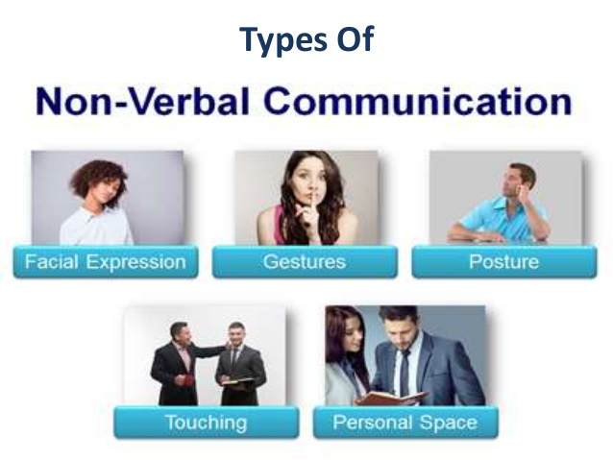
Figure 2 Non-Verbal Communication
- Listening is a very important and most useful communication tool as it helps to ascertain how well the message has been received by the target audience. Unlike hearing listening requires understanding of the message eg: employee’s dispute and issues related to work environment. Hence effective listening skills are very vital for team work and some of the attributes of good listening skills includes having an open communication channel for the flow of information which allows the employees to come forward with their concerns,(John et al, 2010).
- Having an open mind when addressing the problems and issues be it is personal or professional.
- Avoiding distraction, not being judgmental or trying to come to conclusion before getting all the facts should be avoided.
- Should give the freedom for the employee to express and not to predict what the person is trying to convey.
- Should not stereotype or prejudice the speaker and should not dwell on one or two points while making judgements,(John et al, 2010).
- Listening helps to overcome the difference between employer and employees, it gives an opportunity for the employees to express their views about the nature of work and what are the things that can be done to improve and promote better work culture.
- Verbal Communication- most widely used once are face to face interaction, telephone calls, team briefing and meetings. These forms of communication allows to understand how the person feels about the conveyed message and take necessary actions.
- Understanding- it is essential to know the message delivered is understandable and it is understood by the target audience. eg; health safety at work, information governance and data protection. In verbal conversation such as face to face to meeting, team meetings and presentation it is always a good practice to encourage the employees to ask question or asking them questions as this will help to ascertain how well the message has been reached and understood by the target group. In non-verbal communication encouraging employees to provide feedback, understanding facial expression and body language will help to understand how well the message has been understood by the employees. The method of communication and communication channel should be based on the level of understanding of the target group,(John et al, 2010).
- Seeking Clarification- it is part of listening and understanding. It is good practice to clarify things to make sure the message is fully understood. Hence asking question will give the confidence that the message has been understood. Effective question is one of the important skills in team work within the organisation. Hence questioning should aim to obtain information, it should help to start and build a conversation, it should allow to test the level of understanding of the person, it should encourage people to take part in conversation, it should create interest and should help to seek support and agreeing to the points of the argument. There are two different type of questioning namely open and closed end questions. Closed end questions mostly result in one or two word answers and it has limited scope. While open end question has a broad scope as it gives opportunity to express the view point of the employee in relation to the question which can be taken for discussion,(John et al, 2010).
- Responsiveness- the communicator should be responsive and should choose the channel and medium of communication based on the needs and wants of the audience. hence knowing the target groups knowledge and level of understanding should be used as a tool before the information is delivered.
- Eye Contact- among non-verbal communication it is one of the most important one and it serves three purposes. It helps to give and receive feedbacks, eg: during oral presentation lack of eye contact indicates the lack of interest. It allows people to make them aware of their turn to speak, in the context of the presentation person delivering speech will make eye contact with the next speaker to indicate its their turn to speak. It helps to convey the message about relationship between two people eg: facial expression can to know if a person likes the other person or don’t likes as they tent to avoid eye contact,(John et al, 2010).
- Facial Expression- ‘face is the index of mind’ face convey so much information about how a person feels. While presenting or in a team meeting with colleagues or with investor facial expression can convey the message about how confident the person with the topic they are presenting.
- Body language- body language of the person is one of the important communication tool as it conveys the level of comfort and confidence of a person. Some of the common body language are gesture, posture etc. the body movements can be used emphasise things, It reflects the emotions and attitude of a person, it can allow the employer to know the feeling of the employees and employees to the customer. There are several different type of body movement they are emblems, illustrators, affect display, regulators, and adaptors. Emblem it’s a gesture conveying word eg: showing traffic signs, illustrator gesture with one word eg moving the head to indicate you agree to something. Affect display facial gesture to show how u feel eg anger and sadness. Regulators is a gesture which gives feedback such as head nods. Adaptor is a gesture that shows restlessness and the need for some physical needs,(John et al, 2010).
- Posture- this shows the emotions, attitude and intention of people. There are many forms of posture the most widely discussed are open and closed as they reflect on the confidence of the individual, status and receptivity of the person. Closed postures are normally used to convey the lack of interest while open postures are used to convey openness, interest and willingness to listen to a person.
Conclusions
The above mentioned communication tools and strategies are very important in work place in order to build a good working relationship between the management and the employees. Hence it is very important that the management relies on the right methods and channels to communicate with the employees which will help the management to address the needs of the employees.

References and Bibliography
Michael Armstrong,(2012). Armstrong’s handbook of Human resource management practice. 12nd Ed, KOGAN PAGE, London.UK. ISBN:978 0 7494 6551 3
Michael Armstrong,(2014). Armstrong’s handbook of Human resource management practice. 13th Ed, KOGAN PAGE, London.UK. ISBN:978 0 7494 6965 8
John Bevan, Helen Coupland-Smith, Rob Dransfield, John Goymer, Catherine Richards,(2010). Business Book 1 Level 3, Pearson Education Limited, Harlow,UK, ISBN:978 1846906 34 3
Web Reference
Michael Page, The importance of good communication, https://www.michaelpage.co.uk/advice/management-advice/development-and-retention/importance-good-communication, [Accessed on 8th January 2019]
Shannon Weaver Model of Communication, https://communicationinlibraries.wordpress.com/2013/12/07/shannon-weaver-model-of-communication/, [Accessed on 8th January 2019]

