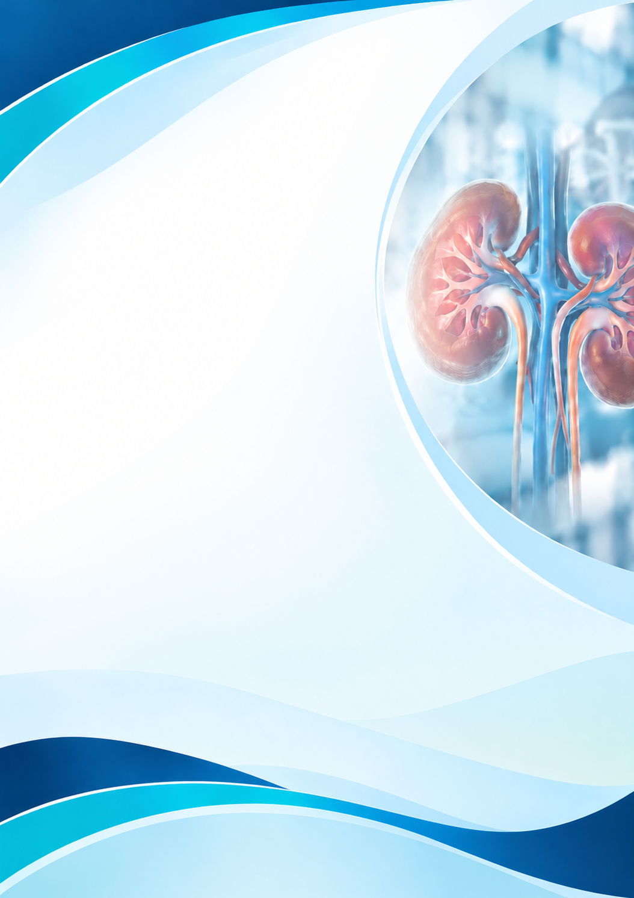
Information Booklet
of Long-term Condition Management

Focus Condition:
Chronic Kidney Disease (CKD)

Student Name: Nazia Sabrina Haroon
Student ID Number: 2208947
Programme: MSc Public Health and Social Care in Practice
Module: Community Care and Management of Longer-term Conditions
Module Code : LCHS7003
Lecturer : Dr Aishat Bakre

MSc Public Health and Social Care in Practice
Module: Community Care and Management of Longer-term Conditions (LCHS7003)

Contents
Understanding Chronic Kidney Disease (CKD) 0
How Common Is Chronic Kidney Disease (CKD)? 0
What Causes Chronic Kidney Disease (CKD) and Who Is at Risk? 0
How Does Chronic Kidney Disease (CKD) Affect People? 1
Physical impacts 1
Psychological impacts 2
Social impacts 2
Critical evaluation 2
Impact on Families and Carers 3
Emotional and psychological impacts 3
Financial and social impacts 3
Critical evaluation 3
Treatment and Management in the NHS 3
Medicines and lifestyle management 4
Managing complications 5
Dialysis and kidney transplantation 5
Critical evaluation 5
Models for Better Long-Term Care 1
UK Model: House of Care Model: 1
International Model: Chronic Care Model 0
Critical comparison 0
Policy and Current Healthcare Priorities 0
National healthcare priorities 0
Local healthcare priorities 0
Critical evaluation 1
Living Well and Self-Management 1
Healthy lifestyle and daily care 1
Emotional wellbeing and support 1
Critical evaluation 2
Recommendations and Looking Forward 2
Early diagnosis and prevention 2
Person-centred and coordinated care 2
Education and emotional support 2
Future care and end-of-life planning 2
Conclusion / Key Messages 3
References: 4

Understanding Chronic Kidney Disease (CKD)
Chronic Kidney Disease (CKD) is a long-term condition in which the kidneys become damaged or cannot filter waste and extra fluid from the blood properly (NHS, 2023). The kidneys also help control blood pressure, maintain healthy bones and support red blood cell production (Kidney Care UK, 2023a).
Aim of the Booklet
This booklet aims to explain CKD, its causes, effects and treatments, while highlighting the importance of early diagnosis, personalised care and self-management. It also explores healthcare models, NHS policies and support available to patients and families.

WHAT IS CKD?
CKD is diagnosed when reduced kidney function or signs of kidney damage continue for at least three months (National Kidney Foundation, 2024).
The international KDIGO (2024) guidelines classify CKD into five stages, using kidney function and urine protein levels to assess its severity.
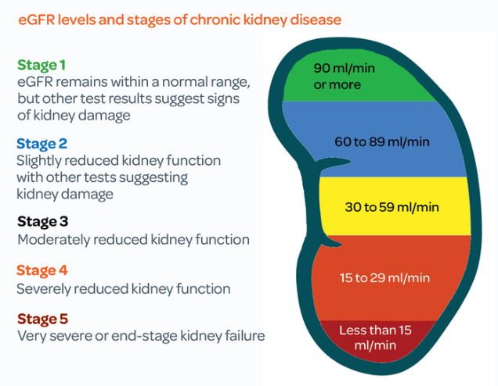
Figure 1:eGFR levels and stages of chronic kidney disease (Kidney Care UK, 2024b).

Early detection through blood tests measuring estimated glomerular filtration rate (eGFR) and urine tests measuring albumin-to-creatinine ratio (ACR) is therefore important. However, KDIGO (2024) warns that one abnormal test cannot always confirm CKD because temporary kidney problems may produce similar results. Repeated testing and individual risk assessment are essential.

How Common Is Chronic Kidney Disease (CKD)?
According to the GBD 2023 Chronic Kidney Disease Collaborators (2025), approximately 788 million adults were living with CKD globally in 2023.
In the UK, approximately 7.2 million people are estimated to have CKD, representing more than one in ten adults (Kidney Research UK, 2023). However, many people remain unaware of their condition because early-stage CKD often has no obvious symptoms.
The burden of CKD is not shared equally. Older adults and people living with diabetes or hypertension face greater risks. However, access to testing, early diagnosis and specialist care also influences how kidney disease affects different communities (KDIGO, 2024).
Although global and UK estimates demonstrate the scale of CKD, comparisons require caution because studies use different populations and diagnostic methods. Kovesdy (2022) also highlights the importance of age and other population differences when interpreting CKD prevalence.

What Causes Chronic Kidney Disease (CKD) and Who Is at Risk?
Chronic Kidney Disease (CKD) develops when the kidneys become damaged over time and gradually lose their ability to filter waste from the blood. The two main causes are diabetes and high blood pressure. Diabetes can damage the kidneys' small blood vessels, while uncontrolled blood pressure places additional strain on them (KDIGO, 2024). Agarwal et al. (2022) found that finerenone improved cardiovascular and kidney outcomes in people with CKD and type 2 diabetes. This shows why diabetes-related kidney disease requires careful management, although the treatment findings cannot be applied to every cause of CKD.
Other causes include inflammation of the kidneys, inherited conditions such as polycystic kidney disease, repeated kidney infections and long-term urinary obstruction (National Institute for Health and Care Excellence (NICE), 2021a).
Risk factors can be divided into modifiable and non-modifiable factors. Modifiable risks include smoking, obesity, poorly controlled diabetes and high blood pressure. Non-modifiable risks include increasing age, family history and certain inherited conditions (KDIGO, 2024). People from some ethnic minority backgrounds may also experience a higher burden of CKD, although social inequalities and unequal access to healthcare can contribute to these differences (Kidney Research UK, 2023).
IMPORTANT TO REMEMBER
Importantly, not everyone with these risk factors will develop CKD.
KDIGO (2024) emphasises that individual risk depends on kidney function, urine albumin levels and other health conditions. Therefore, focusing only on lifestyle choices may overlook genetic and social influences.
Early detection is important for people at increased risk of CKD. NICE (2021a) recommends blood tests to measure kidney function (eGFR) and urine tests to check for albumin (ACR). However, one abnormal result does not always confirm CKD, so repeat testing and appropriate follow-up are necessary (KDIGO, 2024).

How Does Chronic Kidney Disease (CKD) Affect People?
Chronic Kidney Disease (CKD) affects more than kidney function. It can influence a person's physical health, emotional wellbeing and social life. However, the effects vary depending on disease severity, other health conditions and access to treatment (KDIGO, 2024).

Physical impacts
People with CKD may experience tiredness, swelling, poor appetite, disturbed sleep and difficulty concentrating (Fletcher et al., 2022). As kidney function declines, complications such as anaemia, bone problems and cardiovascular disease become more common (NICE, 2021a).
PATIENT WELLBEING
These symptoms can reduce independence and make everyday activities difficult.
Fletcher et al. (2022) found that people with CKD experience a substantial symptom burden and reduced health-related quality of life. However, the severity of these problems varies between patients, showing why individual symptom assessments are important.
However, early-stage CKD often causes no noticeable symptoms, meaning some people remain unaware of their condition until it progresses (NHS, 2023).

Psychological impacts
Living with CKD can create anxiety, uncertainty and fear about future health (Palmer et al., 2013). Research by Palmer et al. (2013) found that depression is common among people with CKD, particularly those receiving dialysis. More recent evidence from Adejumo et al. (2024) also identifies depression as an important concern among people with CKD. However, differences in patient populations and depression assessment methods mean that prevalence estimates should be interpreted cautiously.
However, emotional difficulties should not automatically be attributed to CKD, as financial pressures and existing mental health conditions may also contribute.

Social impacts
CKD can affect employment, relationships and participation in community activities. Hughes et al. (2025) examined how participation in everyday life is measured among people with CKD. Their review highlights the importance of assessing outcomes that matter to patients, rather than focusing only on kidney function.
Frequent hospital appointments, tiredness and treatment schedules may limit working hours and social opportunities. People receiving dialysis may experience greater disruption because treatment requires regular attendance or substantial time at home (KDIGO, 2024).
Importantly, these difficulties are not experienced equally. People with lower incomes, limited transport or poor access to specialist services may face additional barriers. Therefore, medical treatment alone cannot address every challenge associated with CKD.

Critical evaluation
Although dialysis and other treatments can prolong life, they may also create physical and emotional burdens. This demonstrates the need to balance clinical outcomes with patients' preferences and quality of life. NICE (2021b) supports shared decision-making, while KDIGO (2024) emphasises individualised care. Combining medical treatment, psychological support and social assistance is therefore essential to improve overall wellbeing.

Impact on Families and Carers
Chronic Kidney Disease (CKD) affects not only patients but also their families and unpaid carers. As the condition progresses, family members may need to help with medication, hospital appointments, daily activities and emotional support. These responsibilities can become particularly demanding when patients require dialysis or experience reduced independence (KDIGO, 2024).

Emotional and psychological impacts
Family members may experience stress, anxiety and uncertainty about their loved one's health. A systematic review by Hoang et al. (2018) found that caring for people receiving dialysis can negatively affect carers' quality of life. However, the impact varies depending on the patient's condition, family relationships and available support.

Financial and social impacts
Carers may reduce their working hours or leave employment to provide care, creating financial difficulties. Regular hospital visits and caring responsibilities can also limit social activities and personal time. Kidney Care UK (2024a) highlights the importance of practical and financial support for people affected by kidney disease.

Critical evaluation
Although family involvement can improve emotional support and treatment management, excessive reliance on unpaid carers may increase stress and inequality. Families with limited income or support networks may experience greater difficulties.
SUPPORTING CARERS
Therefore, involving relatives in care decisions should not mean transferring professional responsibilities to them.
NICE (2021a) supports personalised care, while KDIGO (2024) emphasises shared decision-making. Healthcare professionals should assess carers' needs, provide clear information and offer appropriate support. This approach can protect carers' wellbeing while improving patients' quality of life.

Treatment and Management in the NHS
Chronic Kidney Disease (CKD) cannot usually be cured, but NHS treatment can slow its progression, manage complications and improve quality of life. Treatment depends on kidney function, the underlying cause and the patient's individual needs. NICE (2021a) recommends regular monitoring and personalised care rather than using the same treatment for everyone.

Medicines and lifestyle management
Controlling blood pressure and diabetes is essential. Medicines such as angiotensin-converting enzyme (ACE) inhibitors or angiotensin receptor blockers (ARBs) can protect kidney function, particularly in patients with increased urine protein. Sodium-glucose co-transporter-2 (SGLT2) inhibitors may also reduce kidney disease progression in eligible patients (KDIGO, 2024). The EMPA-KIDNEY Collaborative Group (2023) found that empagliflozin reduced the risk of kidney disease progression or cardiovascular death in a broad group of patients with CKD. This provides strong clinical evidence supporting SGLT2 inhibitors, although treatment suitability still depends on individual patient characteristics. Longer-term follow-up by the EMPA-KIDNEY Collaborative Group (2025) also showed continuing kidney benefits after the original trial treatment period. However, follow-up findings do not mean that every patient will experience the same level of benefit.
Similarly, Heerspink et al. (2020) demonstrated that dapagliflozin reduced important kidney and cardiovascular risks in patients with CKD. Together, these trials support SGLT2 inhibitors, although clinical trial results must be considered alongside NHS prescribing guidance and patient eligibility.
Perkovic et al. (2024) also found that semaglutide improved kidney-related outcomes in people with type 2 diabetes and CKD. However, this evidence applies to a particular patient group and should not be generalised to everyone with kidney disease.
Similarly, Sarafidis et al. (2023) found that finerenone may provide cardiovascular and kidney benefits for people with stage 4 CKD and type 2 diabetes. However, the findings come from a subgroup analysis, so they should be interpreted cautiously and cannot be applied to all CKD patients.
Lifestyle changes, including stopping smoking, reducing salt intake, exercising and maintaining a healthy weight, can support kidney health. Nevertheless, lifestyle advice alone is insufficient for advanced CKD and should not replace medical treatment (NICE, 2021a).

Managing complications
The NHS also provides treatment for complications such as anaemia, fluid retention and bone disorders. Patients may receive iron treatment, medicines or dietary advice from specialist renal teams. Regular blood and urine tests help professionals assess treatment effectiveness and identify deterioration (NHS, 2023).

Dialysis and kidney transplantation
People with advanced kidney failure may require dialysis or transplantation. Haemodialysis filters blood using a machine, while peritoneal dialysis uses the lining of the abdomen.

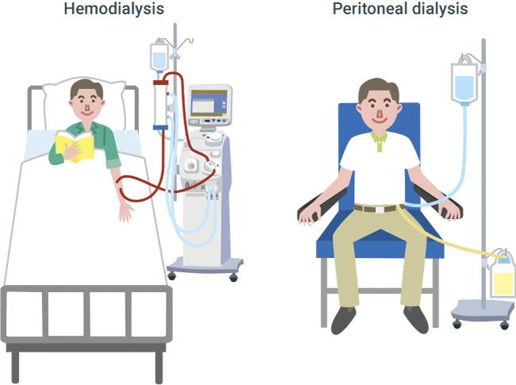
Figure 2:Comparison of haemodialysis and peritoneal dialysis (Bay Biosciences, 2025).

Kidney transplantation can provide better long-term outcomes for suitable patients, but surgery, lifelong medication and organ availability create limitations (NICE, 2018). Schoot et al. (2022) reviewed functional, psychological and quality-of-life outcomes among older adults receiving kidney replacement therapy. Their findings highlight why survival alone is not enough to judge treatment success; independence and quality of life also matter.

Critical evaluation
Although dialysis can sustain life, frequent treatment may restrict employment, travel and family activities. Transplantation may improve independence, but it is unsuitable for some patients. Therefore, clinical effectiveness must be balanced against treatment burden and personal preferences.
NICE (2018) recommends shared decision-making when choosing renal replacement therapy or conservative management.
TREATMENT CHOICE
Conservative kidney management focuses on symptom control and quality of life without dialysis. It should be presented as an active care option, not an absence of treatment.
Overall, effective NHS management requires coordinated care between GPs, nephrologists, renal nurses, dietitians and patients. Combining evidence-based treatment with psychological support and personalised decisions can improve outcomes while respecting individual circumstances.

Models for Better Long-Term Care
Managing Chronic Kidney Disease (CKD) requires more than medical treatment. Effective care should consider patients' physical, emotional and social needs. Two useful approaches are the House of Care Model (UK) and the Chronic Care Model (international).

UK Model: House of Care Model:
The House of Care Model supports personalised care for people with long-term conditions. It places patients at the centre of care planning and encourages shared decisions between patients and healthcare professionals. The model also highlights the importance of coordinated services and organisational support (Year of Care Partnerships, n.d.).
For CKD patients, the model can help GPs, kidney specialists and nurses develop individual care plans, monitor kidney function and discuss treatment preferences. Patients can also receive support with medicines, diet and everyday activities, helping them manage their condition more confidently (NICE, 2021a).
A key strength of the model is that it encourages patients to take an active role in their care. However, effective implementation requires trained professionals, sufficient consultation time and accessible services. Patients facing language, financial or health literacy barriers may need additional support to participate equally (Year of Care Partnerships, n.d.; NICE, 2021a).
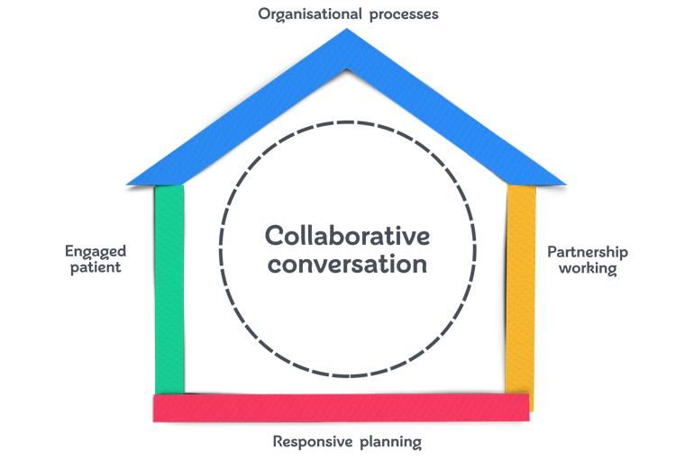
Figure 3:The House of Care Model for personalised long-term condition management (British Heart Foundation, n.d.).

International Model: Chronic Care Model
The Chronic Care Model, developed by Wagner et al. (2001), focuses on improving long-term condition management through coordinated healthcare teams, patient education, planned follow-up and clinical information systems.
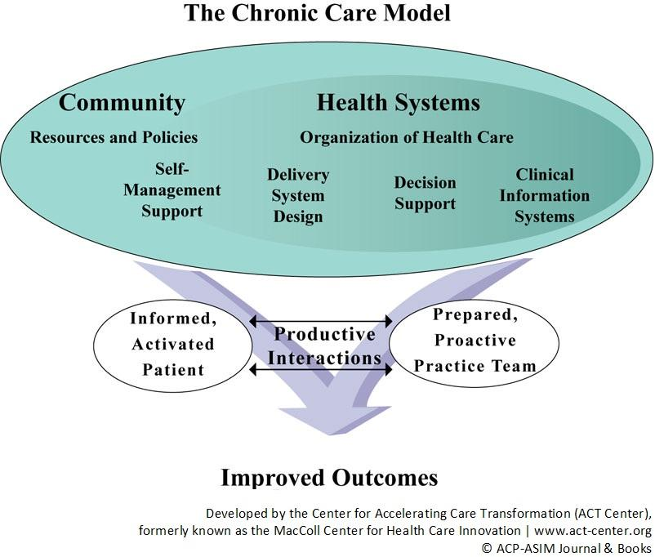
Figure 4:The Chronic Care Model showing six key components that support effective long-term condition management and improved patient outcomes (ACT Center, n.d.).

Table 1:Application of the Chronic Care Model to Chronic Kidney Disease (CKD) Management (Wagner et al. 2001).
Chronic Care Model Component | Application to CKD
Self-management support | Help patients understand medication, diet, blood pressure and kidney tests.
Delivery system design | Coordinate GP appointments, renal nursing and specialist follow-up.
Decision support | Use NICE and KDIGO guidance to support evidence-based treatment.
Clinical information systems | Use records and reminders to monitor eGFR, ACR and appointments.
Healthcare organisation | Ensure services support coordinated long-term kidney care.
Community resources | Connect patients with kidney charities, financial advice and local support.

For CKD, this could involve GPs, kidney specialists, nurses and dietitians working together to monitor kidney function and prevent complications. The model encourages proactive care rather than waiting until patients become seriously unwell.
However, its effectiveness depends on resources, communication and access to services. People facing poverty, language barriers or limited digital access may not benefit equally from structured care programmes.

Critical comparison
Both models support patient involvement and coordinated care, but their priorities differ. The House of Care Model places greater emphasis on individual choice and shared decisions, whereas the Chronic Care Model focuses on improving healthcare organisation and ongoing disease management.
KEY COMPARISON
Personalised care without coordinated services may create fragmented treatment, while structured care without patient involvement may overlook individual needs.
Therefore, combining both models could improve CKD management by supporting early intervention, continuity of care and informed patient choices (KDIGO, 2024).

Policy and Current Healthcare Priorities

National healthcare priorities
The NHS Long Term Plan emphasises prevention, earlier diagnosis and better management of long-term conditions (NHS England, 2019a). For CKD, this supports regular kidney testing for people with diabetes or high blood pressure. However, prevention programmes depend on adequate funding, staffing and patient engagement.
The NHS England Core20PLUS5 approach aims to reduce healthcare inequalities among disadvantaged populations (NHS England, 2023). Although CKD is not one of its five original adult clinical priorities, the framework is relevant because diabetes, hypertension and unequal healthcare access contribute to kidney disease.

Local healthcare priorities
Integrated Care Systems (ICSs) bring together NHS organisations, local authorities and community services to improve population health (NHS England, 2022). For CKD, local partnerships can support GP monitoring, specialist referrals and community education.
However, implementation may vary between areas because of differences in workforce capacity, resources and local population needs.

Critical evaluation
NICE (2021a) provides evidence-based recommendations for CKD assessment and management, including identifying high-risk patients and monitoring kidney function. Nevertheless, guidelines alone cannot guarantee improvement if patients face long waiting times, language barriers or difficulties accessing appointments. Stewart et al. (2024) identified barriers to effective CKD detection and management in UK primary care. Their findings suggest that publishing national guidance is not sufficient without improving its implementation in everyday practice.
National policies provide a clear direction, but their effectiveness depends on how well they are implemented locally. Therefore, stronger collaboration between primary care, renal specialists and community organisations is necessary. Targeted screening, accessible information and equitable access to treatment could improve CKD outcomes while reducing avoidable health inequalities.

Living Well and Self-Management
Living with Chronic Kidney Disease (CKD) requires ongoing self-management to protect kidney function and maintain quality of life. Self-management means helping patients understand their condition, make informed decisions and take an active role in their care (KDIGO, 2024).

Healthy lifestyle and daily care
Patients are encouraged to follow a balanced diet, reduce salt intake, remain physically active and stop smoking.
DAILY KIDNEY CARE
Taking prescribed medicines and attending regular blood and urine tests are equally important.
However, dietary advice should be personalised because patients with advanced CKD may need specific restrictions on potassium, phosphate or fluid intake (NICE, 2021a).

Emotional wellbeing and support
Patients may experience anxiety, tiredness or uncertainty about their future. Support from family members, healthcare professionals and kidney charities can improve confidence and help reduce feelings of isolation (Kidney Care UK, 2023b).
Nevertheless, relying entirely on patients to manage their condition may disadvantage those with limited health literacy, financial difficulties or poor access to healthcare.

Critical evaluation
Self-management can improve treatment adherence and encourage early recognition of complications. However, its effectiveness depends on patients receiving clear information, practical resources and professional support. KDIGO (2024) emphasises shared decision-making, while NHS England (2019b) promotes personalised care.
Therefore, effective CKD management should combine individual responsibility with accessible NHS services, regular monitoring and appropriate emotional support. This approach can help patients maintain independence without placing unrealistic expectations on them.

Recommendations and Looking Forward

Early diagnosis and prevention
The NHS should improve early detection by offering kidney function and urine tests to people at increased risk, particularly those with diabetes or high blood pressure. However, testing alone is not enough without timely follow-up, appropriate treatment and accessible healthcare. NICE (2021a) supports regular monitoring, while KDIGO (2024) emphasises personalised risk assessment.

Person-centred and coordinated care
GPs, kidney specialists, nurses and community services should work together to develop personalised care plans. KDIGO (2024) supports shared decision-making, but limited staffing and resources may affect implementation.

Education and emotional support
Patients and families should receive clear information about medicines, diet and available support. Education must also consider language barriers, financial difficulties and different levels of health literacy (NHS England, 2019b).

Future care and end-of-life planning
FUTURE CARE PLANNING
For advanced CKD, patients should have opportunities to discuss dialysis, transplantation, conservative kidney management and future care preferences.
Advance care planning allows patients to discuss and record their wishes for future treatment and care, including what matters most to them if their health deteriorates (NICE, 2021b). For people with advanced CKD, these discussions may include dialysis decisions, symptom management, preferred place of care and family involvement (NICE, 2018; NICE, 2019). Planning should begin early enough for patients to make informed choices and should be reviewed when their circumstances change (NICE, 2021b).
NICE (2018) supports informed treatment choices, including supportive care when appropriate Verberne et al. (2021) reviewed the benefits and limitations of conservative kidney management compared with dialysis. Their findings support considering both survival and quality of life, although differences between patient groups make direct comparisons difficult.
Similarly, Yang et al. (2025) found that evidence comparing dialysis and conservative kidney management in older adults remains uncertain. Therefore, patients should receive balanced information rather than being encouraged towards one treatment based on survival expectations alone.

Conclusion / Key Messages
Chronic Kidney Disease (CKD) is a serious long-term condition affecting millions of people worldwide. Early diagnosis, appropriate treatment and regular monitoring can slow disease progression and improve quality of life (KDIGO, 2024). However, CKD affects more than physical health, creating emotional, social and financial challenges for patients and families. NICE (2021a) highlights the importance of personalised treatment and ongoing support. Although NHS services provide effective care, inequalities in access remain a concern. Therefore, better prevention, coordinated healthcare, patient education and shared decision-making are essential to support people living with CKD and improve long-term outcomes.

References:
Adejumo, O.A., Edeki, I.R., Oyedepo, D.S., Falade, J., Yisau, O.E., Ige, O.O., Adesida, A.O., Palencia, H.D., Moussa, A.S., Abdulmalik, J. and Noubiap, J.J. (2024) ‘Global prevalence of depression in chronic kidney disease: a systematic review and meta-analysis’, Journal of Nephrology, 37(9), pp. 2455–2472. https://doi.org/10.1007/s40620-024-01998-5.
Agarwal, R., Filippatos, G., Pitt, B., Anker, S.D., Rossing, P., Joseph, A., Kolkhof, P., Nowack, C., Gebel, M., Ruilope, L.M. and Bakris, G.L. (2022) ‘Cardiovascular and kidney outcomes with finerenone in patients with type 2 diabetes and chronic kidney disease: the FIDELITY pooled analysis’, European Heart Journal, 43(6), pp. 474–484. https://doi.org/10.1093/eurheartj/ehab777.
Bay Biosciences (2025) What is dialysis? Available at: https://baybiosciences.com/what-is-dialysis/ (Accessed: 10 October 2026).
British Heart Foundation (n.d.) House of Care framework. Available at: https://www.bhf.org.uk/for-professionals/healthcare-professionals/innovation-in-care/person-centred-care-and-the-house-of-care/the-bhf-house-of-care-programme/the-house-of-care-framework (Accessed: 16 October 2026).
Buur, L.E., Madsen, J.K., Eidemak, I., Krarup, E., Lauridsen, T.G., Taasti, L.H. and Finderup, J. (2021) ‘Does conservative kidney management offer a quantity or quality of life benefit compared to dialysis? A systematic review’, BMC Nephrology, 22, article 307. https://doi.org/10.1186/s12882-021-02516-6.
Center for Accelerating Care Transformation (ACT Center) (n.d.) The Chronic Care Model. Available at: https://www.act-center.org/application/files/1616/3511/6445/Model_Chronic_Care.pdf (Accessed: 16 October 2026).
EMPA-KIDNEY Collaborative Group (2023) ‘Empagliflozin in patients with chronic kidney disease’, New England Journal of Medicine, 388(2), pp. 117–127. https://doi.org/10.1056/NEJMoa2204233.
EMPA-KIDNEY Collaborative Group (2025) ‘Long-term effects of empagliflozin in patients with chronic kidney disease’, New England Journal of Medicine, 392(8), pp. 777–787. https://doi.org/10.1056/NEJMoa2409183.
Fletcher, B.R., Damery, S., Aiyegbusi, O.L., Anderson, N., Calvert, M., Cockwell, P., Ferguson, J., Horton, M., Paap, M.C.S., Sidey-Gibbons, C., Slade, A., Turner, N. and Kyte, D. (2022) ‘Symptom burden and health-related quality of life in chronic kidney disease: a global systematic review and meta-analysis’, PLOS Medicine, 19(4), e1003954. https://doi.org/10.1371/journal.pmed.1003954.
GBD 2023 Chronic Kidney Disease Collaborators (2025) ‘Global, regional, and national burden of chronic kidney disease in adults, 1990–2023, and its attributable risk factors: a systematic analysis for the Global Burden of Disease Study 2023’, The Lancet. https://doi.org/10.1016/S0140-6736(25)01853-7.
Heerspink, H.J.L., Stefánsson, B.V., Correa-Rotter, R., Chertow, G.M., Greene, T., Hou, F.-F., Mann, J.F.E., McMurray, J.J.V., Lindberg, M., Rossing, P., Sjöström, C.D., Toto, R.D., Langkilde, A.-M. and Wheeler, D.C. (2020) ‘Dapagliflozin in patients with chronic kidney disease’, New England Journal of Medicine, 383, pp. 1436–1446. https://doi.org/10.1056/NEJMoa2024816.
Hoang, V.L., Green, T. and Bonner, A. (2018) ‘Informal caregivers’ experiences of caring for people receiving dialysis: a mixed-methods systematic review’, Journal of Renal Care, 44(2), pp. 82–95. https://doi.org/10.1111/jorc.12235.
Hughes, A., Ju, A., Cazzolli, R., Howell, M., Caskey, F.J., Elliott, M.J., Farragher, J., Greenwood, S., Levin, A., Manera, K., Sluiter, A., Teixeira-Pinto, A., Trimarchi, H., Wang, B., Guha, C., Wu, R. and Jauré, A. (2025) ‘Patient-reported outcome measures for life participation in patients with chronic kidney disease: a systematic review’, Clinical Kidney Journal, 18(1), sfae341. https://doi.org/10.1093/ckj/sfae341.
Kidney Care UK (2023a) Facts about your kidneys. Available at: https://kidneycareuk.org/kidney-disease-information/about-kidney-health/facts-about-your-kidneys/ (Accessed: 14 October 2026).
Kidney Care UK (2023b) Managing stress and anxiety. Available at: https://kidneycareuk.org/kidney-disease-information/living-with-kidney-disease/managing-anxiety/ (Accessed: 16 October 2026).
Kidney Care UK (2024a) Financial support. Available at: https://kidneycareuk.org/get-support/financial-support/ (Accessed: 7 October 2026).
Kidney Care UK (2024b) Understanding your CKD blood and urine test results. Available at: https://kidneycareuk.org/kidney-disease-information/treatments/patient-info-understanding-your-ckd-blood-and-urine-test-results/ (Accessed: 10 October 2026).
Kidney Disease: Improving Global Outcomes (KDIGO) (2024) KDIGO 2024 clinical practice guideline for the evaluation and management of chronic kidney disease. Available at: https://kdigo.org/guidelines/ckd-evaluation-and-management/kdigo-2024-ckd-guideline/ (Accessed: 6 October 2026).
Kidney Research UK (2023) Kidney disease is a public health emergency that threatens to overwhelm the NHS, major new report reveals. Available at: https://www.kidneyresearchuk.org/2023/06/05/kidney-disease-is-a-public-health-emergency-that-threatens-to-overwhelm-the-nhs-major-new-report-reveals/ (Accessed: 9 October 2026).
Kidney Research UK (2026) Undiagnosed chronic kidney disease endangers millions of lives. Available at: https://www.kidneyresearchuk.org/2026/06/03/undiagnosed-chronic-kidney-disease-endangers-millions-of-lives/ (Accessed: 12 October 2026).
Kovesdy, C.P. (2022) ‘Epidemiology of chronic kidney disease: an update 2022’, Kidney International Supplements, 12(1), pp. 7–11. https://doi.org/10.1016/j.kisu.2021.11.003.
National Institute for Health and Care Excellence (NICE) (2018) Renal replacement therapy and conservative management (NG107). Available at: https://www.nice.org.uk/guidance/ng107 (Accessed: 5 October 2026).
National Institute for Health and Care Excellence (NICE) (2019) End of life care for adults: service delivery (NG142). Available at: https://www.nice.org.uk/guidance/ng142 (Accessed: 16 October 2026).
National Institute for Health and Care Excellence (NICE) (2021a) Chronic kidney disease: assessment and management (NG203). Available at: https://www.nice.org.uk/guidance/ng203 (Accessed: 8 October 2026).
National Institute for Health and Care Excellence (NICE) (2021b) End of life care for adults: quality statement 2 – advance care planning. Available at: https://www.nice.org.uk/guidance/qs13/chapter/Quality-statement-2-Advance-care-planning (Accessed: 16 October 2026).
National Kidney Foundation (2024) Stages of chronic kidney disease (CKD). Available at: https://www.kidney.org/kidney-topics/stages-chronic-kidney-disease-ckd (Accessed: 14 October 2026).
NHS (2023) Chronic kidney disease. Available at: https://www.nhs.uk/conditions/kidney-disease/ (Accessed: 14 October 2026).
NHS England (2019a) The NHS Long Term Plan. Available at: https://www.england.nhs.uk/long-term-plan/ (Accessed: 6 October 2026).
NHS England (2019b) Universal personalised care: implementing the comprehensive model. Available at: https://www.england.nhs.uk/publication/universal-personalised-care-implementing-the-comprehensive-model/ (Accessed: 9 October 2026).
NHS England (2022) Integrated care systems. Available at: https://www.england.nhs.uk/commissioning/who-commissions-nhs-services/ccg-ics/ (Accessed: 7 October 2026).
NHS England (2023) Core20PLUS5 infographic – Adult. Available at: https://www.england.nhs.uk/publication/core20plus5-infographic/ (Accessed: 12 October 2026).
Palmer, S., Vecchio, M., Craig, J.C., Tonelli, M., Johnson, D.W., Nicolucci, A., Pellegrini, F., Saglimbene, V., Logroscino, G., Fishbane, S. and Strippoli, G.F.M. (2013) ‘Prevalence of depression in chronic kidney disease: systematic review and meta-analysis of observational studies’, Kidney International, 84(1), pp. 179–191. https://doi.org/10.1038/ki.2013.77.
Perkovic, V., Tuttle, K.R., Rossing, P., Mahaffey, K.W., Mann, J.F.E., Bakris, G., Baeres, F.M.M., Idorn, T., Bosch-Traberg, H., Lausvig, N.L. and Pratley, R. (2024) ‘Effects of semaglutide on chronic kidney disease in patients with type 2 diabetes’, New England Journal of Medicine, 391, pp. 109–121. https://doi.org/10.1056/NEJMoa2403347.
Sarafidis, P., Agarwal, R., Pitt, B., Wanner, C., Filippatos, G., Boletis, J., Tuttle, K.R., Ruilope, L.M., Rossing, P., Toto, R., Anker, S.D., Liu, Z.-H., Joseph, A., Ahlers, C., Brinker, M., Lawatscheck, R. and Bakris, G. (2023) ‘Outcomes with finerenone in participants with stage 4 CKD and type 2 diabetes: a FIDELITY subgroup analysis’, Clinical Journal of the American Society of Nephrology, 18(5), pp. 602–612. https://doi.org/10.2215/CJN.0000000000000149.
Schoot, T.S., Goto, N.A., van Marum, R.J., Hilbrands, L.B. and Kerckhoffs, A.P.M. (2022) ‘Dialysis or kidney transplantation in older adults? A systematic review summarizing functional, psychological, and quality of life-related outcomes after start of kidney replacement therapy’, International Urology and Nephrology, 54, pp. 2891–2900. https://doi.org/10.1007/s11255-022-03208-2.
Stewart, S., Kalra, P.A., Blakeman, T., Kontopantelis, E., Cranmer-Gordon, H. and Sinha, S. (2024) ‘Chronic kidney disease: detect, diagnose, disclose—a UK primary care perspective of barriers and enablers to effective kidney care’, BMC Medicine, 22, article 331. https://doi.org/10.1186/s12916-024-03555-0.
Wagner, E.H., Austin, B.T., Davis, C., Hindmarsh, M., Schaefer, J. and Bonomi, A. (2001) ‘Improving chronic illness care: translating evidence into action’, Health Affairs, 20(6), pp. 64–78. https://doi.org/10.1377/hlthaff.20.6.64.
Yang, J.W., Natale, P., Kim, S., Kim, M., Jeon, M.S., Yi, D., Hong, Y.A., Chung, S., Park, W.Y., Hyun, Y.Y., Kwon, S.H., Shin, S.J., Park, D.A., Kim, J., Jung, J.H., Strippoli, G.F.M. and Lee, J.Y. (2025) ‘Conservative kidney management versus dialysis for stage 5 chronic kidney disease in older people’, Cochrane Database of Systematic Reviews, 12, CD015151. https://doi.org/10.1002/14651858.CD015151.pub2.
Year of Care Partnerships (n.d.) The Year of Care House. Available at: https://www.yearofcare.co.uk/implementation/the-year-of-care-house/ (Accessed: 16 October 2026).

