Assignment 1
Games architecture and mechanics
BSc Computing (Games Development)
Jarrad Scott (2404449)
2025
Table of Contents
Introduction 2
Part 1 3
Euler 3
Runge-Kutta 3
Advantages & Disadvantages 4
Other Methods 4
Verlet 4
Midpoint 4
Part 2 5
Code Implementation 5
Forces 5
Euler 6
RK4 6
csvWriter 7
Test Plan / Harness 8
Results 12
Adjustment Effects 12
References 12

Introduction
Numerical integration techniques are used to approximate solutions for things including integration or computations where exact solutions are impractical or impossible. There are a variety of methods including Euler, Runge-Kutta, Verlet, etc.

Part 1

Euler
Euler’s method is a simple equation used for solving differential equations [1]. For first-order equations, it is given as ￼, where $y_{\left(n\right)}$ is the current point, $\frac{dy}{dt}$ being the rate of change, $∆t$is the time step, and $y_{\left(n+1\right)}$ is the next / estimated point [2]. $y$ in this can be a variable like position, with $\frac{dy}{dt}$being velocity.

To use Euler’s for solving a second-order or higher differential equation, it can be substituted down to a set of first-order equations, allowing the method to be implemented [3]. A second-order equation could include position, velocity, and acceleration, with velocity being the first derivative of position, and acceleration being the first derivative of velocity. $\frac{d^{2}y}{dt^{2}}$.

Runge-Kutta
Runge-Kutta is a family of numerical integration methods, but the main one is RK4, which is often known as “the Runge-Kutta method”. It calculates intermediate steps within time steps to increase accuracy.

A classic way to show the four approximations, would be as follows [4]:

$$k_{1}=f\left(y\left(t_{0}\right),t_{0}\right)$$
$$k_{2}=f\left(y\left(t_{0}\right)+k_{1}⋅\frac{h}{2},t_{0}+\frac{h}{2}\right)$$
$$k_{3}=f\left(y\left(t_{0}\right)+k_{2}⋅\frac{h}{2},t_{0}+\frac{h}{2}\right)$$
$$k_{4}=f\left(y\left(t_{0}\right)+k_{3}⋅h,t_{0}+h\right)$$
For a more physics-based view, if $f\left(p,v\right)$ were to represent acceleration, with position and velocity, the steps could be shown as:
$$k_{1}=f\left(p,v\right)$$
$$k_{2}=f\left(p+0.5⋅k_{1}⋅∆t,v+0.5⋅k_{1}⋅t∆\right)$$
$$k_{3}=f\left(p+0.5⋅k_{2}⋅∆t,v+0.5⋅k_{2}⋅t∆\right)$$
$$k_{4}=f\left(p+k_{3}⋅∆t,v+k_{3}⋅t∆\right)$$

To update velocity and position would be as follows:
$$v_{new}=v+\frac{Δt}{6}\left(k_{1}^{v}+2⋅k_{2}^{v}+2⋅k_{3}^{v}+k_{4}^{v}\right)$$
$$p_{new}=p+\frac{Δt}{6}\left(k_{1}^{p}+2⋅k_{2}^{p}+2⋅k_{3}^{p}+k_{4}^{p}\right)$$

Advantages & Disadvantages
Euler’s method has some core advantages in that it is simpler, being easier to implement, and can run quite fast. However, it also has the drawback where if the time step is too large, there could be numerical instability introduced [5].

RK4 on the other hand has the primary benefits of its accuracy as a result to the fourth order nature, and it has more stability than Euler due to damping that is induced. However, RK4 will be more demanding due to it using that four approximations process, and that it still has some amounts of instability, depending on the situation [6].

Both still have their own places, Euler being used when speed takes utmost precedence, and RK4 where the accuracy and stability is the main concern.

Other Methods

Verlet
The Verlet methods are higher order integration methods allowing for more accuracy while maintaining an element of simplicity in its implementation. It is unique in how it chooses to calculate position with acceleration, as opposed to velocity from acceleration, then position from velocity, as in other methods [7].
The calculation would be $p_{n+1}=2⋅p_{n}-p_{n-1}+a⋅∆t^{2}$, and if a velocity were needed it would be $v_{n+1}=\frac{\left(p_{n}-p_{n-1}\right)}{dt}$.
This method does have a disadvantage in assuming that timesteps are constant, so any variation can cause inaccuracies. In gaming this mainly sees use for projectile trajectories, particle systems, cloth simulations, and similar [7].

Midpoint
Midpoint is the name given to a second order Runge-Kutta method. With RK2 / Midpoint, the concept is that the derivative at the midpoint of the time step is more accurate than the derivative at the beginning or end [8].
With$\frac{dy}{dt}=f\left(y,t\right)$, the calculations for the midpoint method are as follows [9]:
$$k_{1}=∆tf\left(y_{n},t_{n}\right)$$
$$k_{2}=∆tf\left(y_{n}+\frac{k_{1}}{2},t_{n}+\frac{k_{1}}{2}\right)$$
$$y_{n+1}=y_{n}+k_{2}$$

This results in higher accuracy compared to something such as Euler's but still is overall a simple implementation.

Part 2

Code Implementation
My code implementation was made to utilise a function for the simulations and use a class holding a CSV file writer to output the data from the simulation. In the main function, deltaTime is defined so that it can be passed to any of the functions. Then, the menu is output to the console, and awaits user input, looping until the user runs a simulation or quits the program. This is shown below:
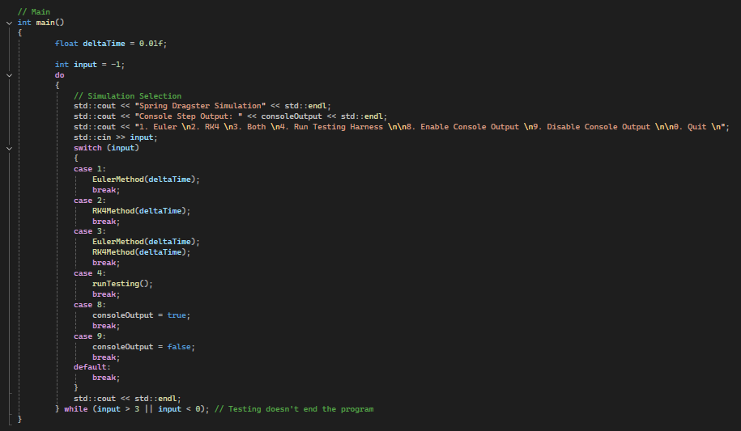

Forces
The below screenshot shows my functions for the tractive and drag forces calculations. For the getTractiveForce() function, it will check if distance < 6m and then return either 1.2(16-distance), or 0 if the distance was greater than 6m. For getDragForce(), it checks if the velocity is above 0, if it is it returns the result of the drag force formula using the constants declared at the beginning of the .cpp file, rolling resistance coefficient, mass, gravity, drag coefficient, air density, the frontal area of the vehicle, and also using the velocity. The code is shown below:
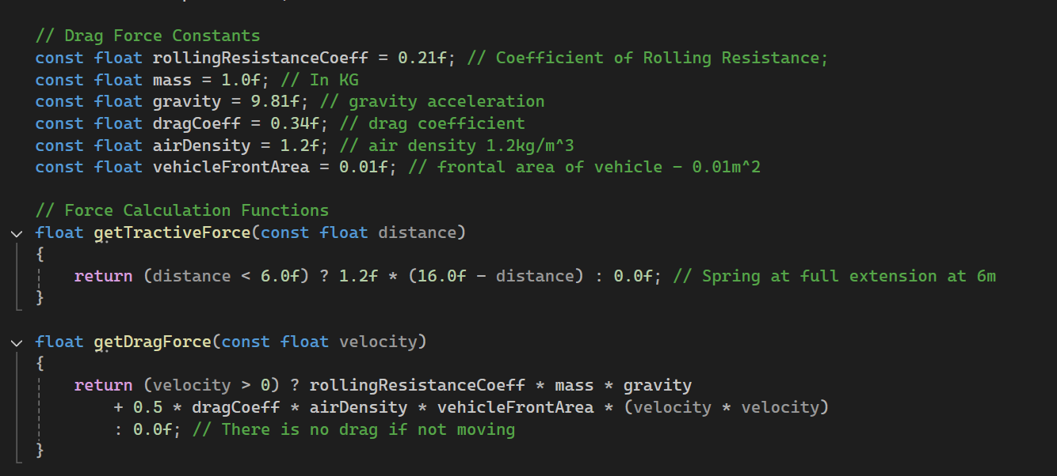

Euler
For the Euler implementation, the csvWriter class is utilised and setup with the path for the file, ensuring it opened before continuing, otherwise stopping the simulation. Then the starting data is declared, and the headings are output to the if enabled. A variable to track the steps is also created.

A do while loop ensures that the code runs at least once as velocity stating at 0 could cause the code to exit before the simulation begins otherwise. To get the acceleration, the forces values are retrieved with their functions, then it runs the formula (tractive force – drag force)/mass, and then the velocity and distance get updated using the results. The step is then output to console if enabled and wrote to the CSV file, and the step counter gets incremented.

This loop continues until velocity is equal to or less than 0, which would mean that the car stopped, so the simulation can end. After the loop finishes, it outputs the total step count, and the path to the CSV. The code is shown below:
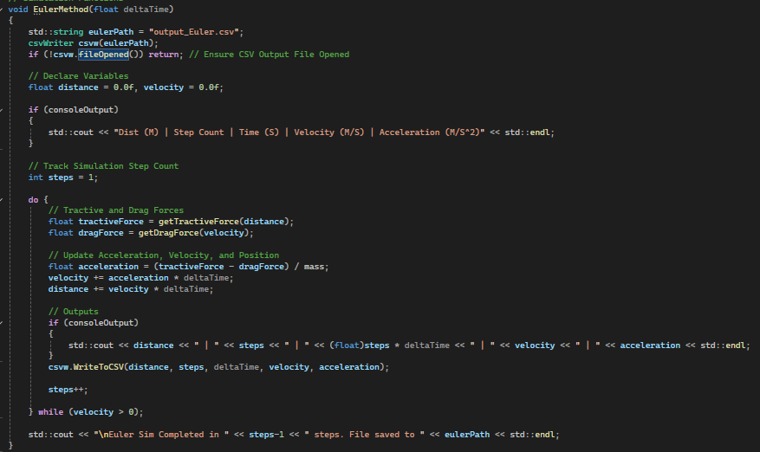

RK4
RK4 starts the same as Euler, defining the file path, creating the csvWriter, ensuring the file opened correctly, the initial variables, outputting the headings, then declares the step count. It then would begin the actual RK4 process.

The RK4 process starts with retrieving the forces for k1, using the initial distance / velocity, before setting k1_dist to initial velocity, and k1_vel to the acceleration calculation. Then it moves on to k2, where dist_k2 is set to distance+0.5*deltaTime*k1_dist, and the same is done for vel_k2, replace distance variables with velocity counterparts. The process then repeats for the rest of k2, then for k3 and k4 with updated variables.

The main difference is that, in k4, dist_k4 / vel_k4 does not do “+0.5*deltaTime”, but instead does distance+ deltaTime * k3_dist. After this, we apply the results, updating velocity and position with += (deltaTime/6) * (k1+2*k2+2*k3+k4), using either the vel or dist variable depending on which is updating. For logging purposes, the acceleration being applied is also calculated. We then handle the outputs similarly to Euler’s.
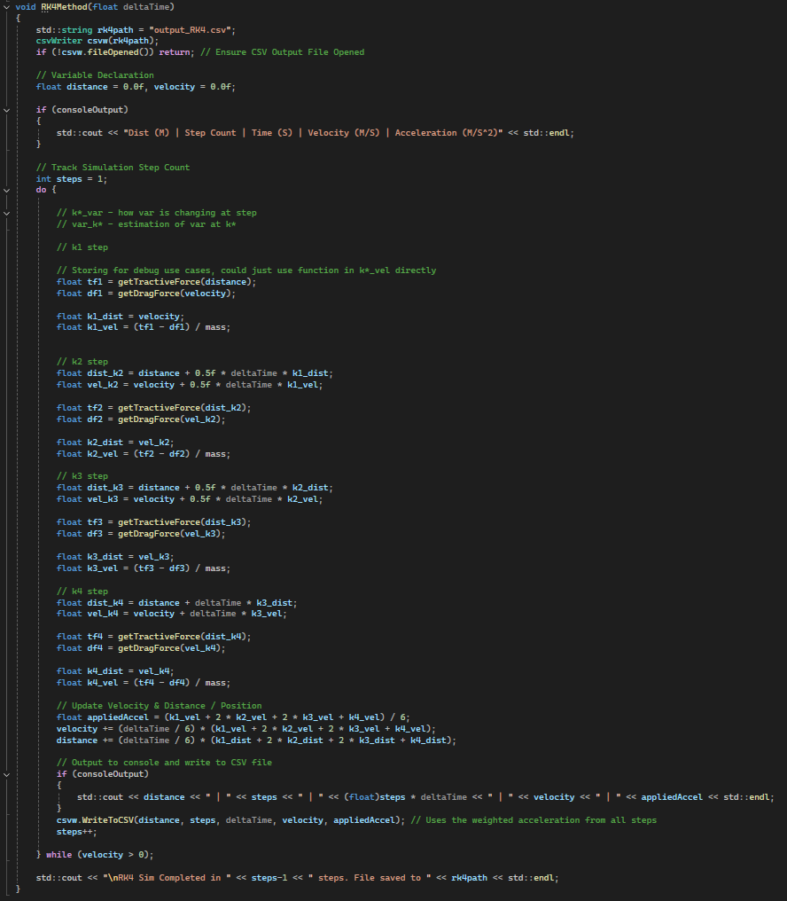

csvWriter
I utilised an inline class to implement an easy to use .csv exporter for the simulation data. The constructor takes a string variable for the path as a parameter and will attempt to open a file stream to that path and checks if it is open to write the heading to the file. If not open it outputs an error for logging purposes, updating a book that can be accessed via a method. There is one other method, this being the method to write the data to the file. Below is the entire csvWriter.h file.
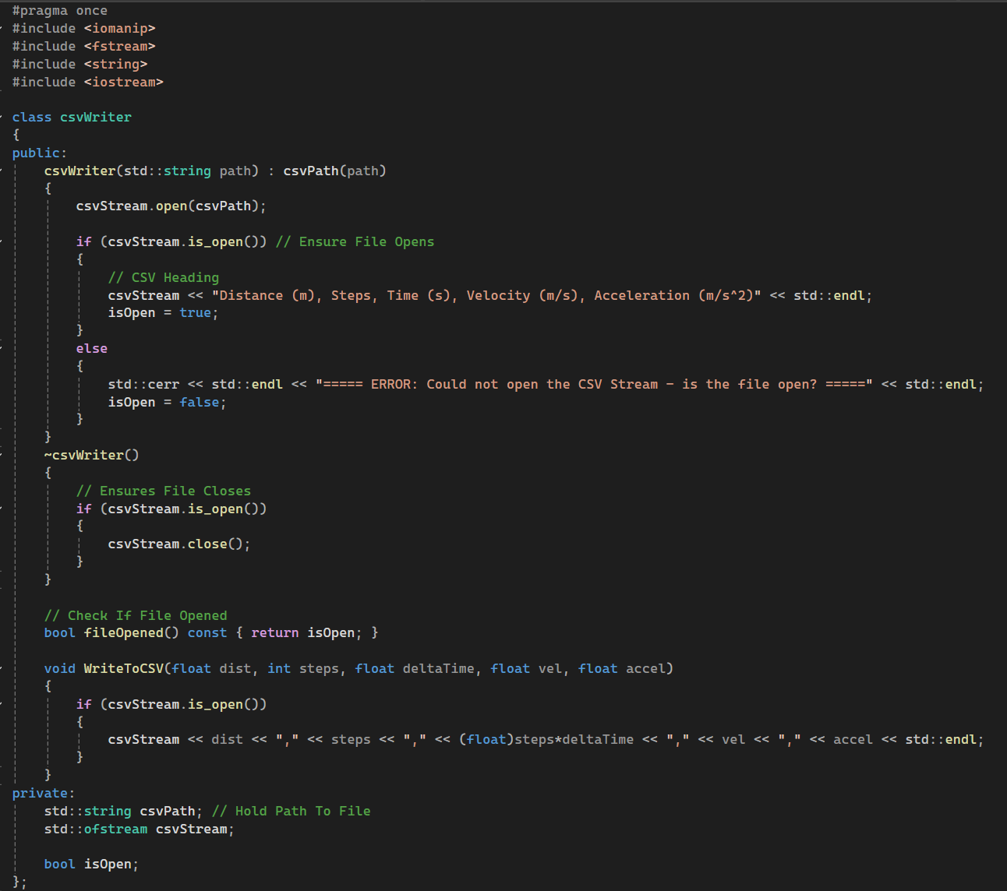

Test Plan / Harness
Below is the test plan made for this simulation, to test a variety of the aspects and ensure they work accordingly. Any calculation-based test shall be done via the test harness, so that it can be done automatically. The rest shall be done manually, as it is easier and simpler.
Test | Expected Result | Outcome
Input 1 in the menu | Runs Euler simulation | Runs Euler simulation
Input 2 in the menu | Runs RK4 simulations | Runs RK4 simulations
Input 3 in the menu | Runs both simulations | Runs both simulations
Input 4 in the menu | Loops back over | Loops back over
Input 0 in the menu | Closes program | Closes program
Tractive forces calculation where distance = 0.0 | Tractive force = 19.2 | Test Harness Pass
Tractive forces calculation where distance = 4.0 | Tractive force = 14.4 | Test Harness Pass
Tractive forces calculation where distance = 7.0 | Tractive force = 0.0 | Test Harness Pass
Drag force calc where velocity = 0.5 | Drag force = 2.06061 | Test Harness Pass
Drag force calc where velocity = 0.0 | Drag force = 0.0 | Test Harness Pass
Drag force calc where velocity = 10.0 | Drag force = 2.2641 | Test Harness Pass
Euler step where distance = 0.0, velocity = 0.0, and deltaTime = 0.01 | Acceleration = 19.2  Velocity = .192  Distance = .00192 | Test Harness Pass
Euler step where distance = 5.0, velocity = 1.0, and deltaTime = 0.1 | Acceleration = 11.13786  Velocity = 2.113786  Distance = 5.2113786 | Test Harness Pass
Euler step where distance = 6.5, velocity = 10.0, and deltaTime = 0.01 | Acceleration = -2.2641  Velocity = 9.977359  Distance = 6.59977359 | Test Harness Pass
RK4 step where distance = 0.0, velocity = 0.0, and deltaTime = 0.01 | Acceleration = 17.4826535  Velocity = 0.174828654  Distance = 0.00089132 | Test Harness Pass
RK4 step where distance = 5.0, velocity = 1.0, and deltaTime = 0.1 | Acceleration = 11.05255197  Velocity = 2.105255197  Distance = 5.155423961 | Test Harness Pass
RK4 step where distance = 6.5, velocity = 10.0, and deltaTime = 0.01 | Acceleration = -2.263638535  Velocity = 9.977363615  Distance = 6.59988681 | Test Harness Pass
Steps output to console with consoleOutput = true | All steps are output to the console | All steps are output to the console
Steps do not output to console with consoleOutput = false | No steps are output, leaving just the simulation complete message | No steps are output, leaving just the simulation complete message
CSV Files create, open, and output correctly | File gets each step output into a formatted CSV | File gets each step output into a formatted CSV

When implementing the test harness, I encountered one issue, and that was floating point precision, resulting in the comparison of results and the expectations failing, even when they were nearly the same. To fix this, I researched implementing tolerances and using epsilon [10]. While there is no one size fits all solution, I implemented a tolerance of 1e-5, allowing the checks to pass and still catch errors. The test harness functions take the calculations from the other functions and add extra parameters for the expected result and any test data, and for the numerical integration methods, only one time step worth of code is run. Below is the test harness code in full:
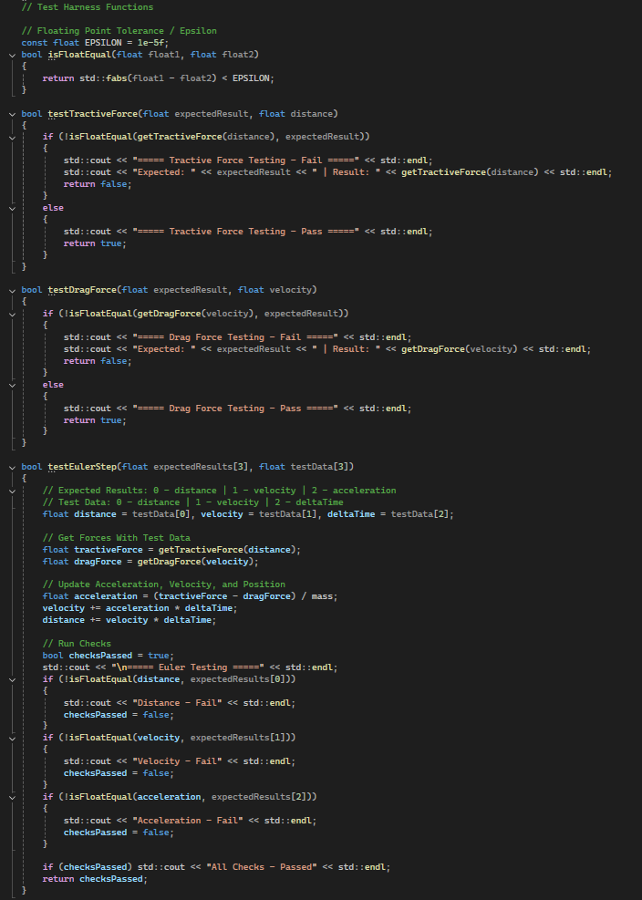
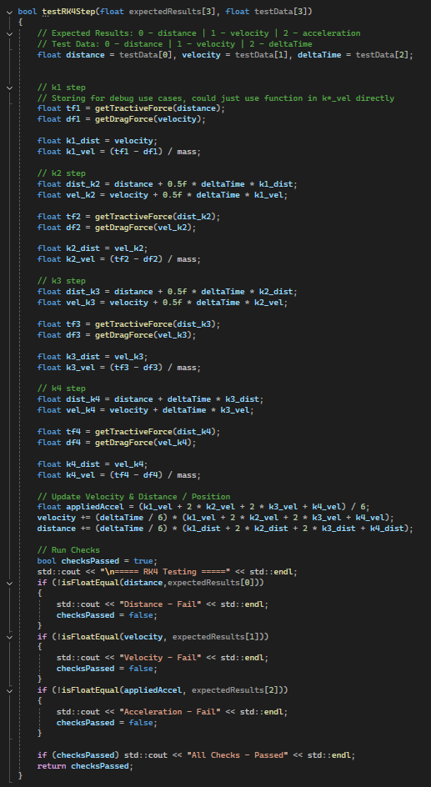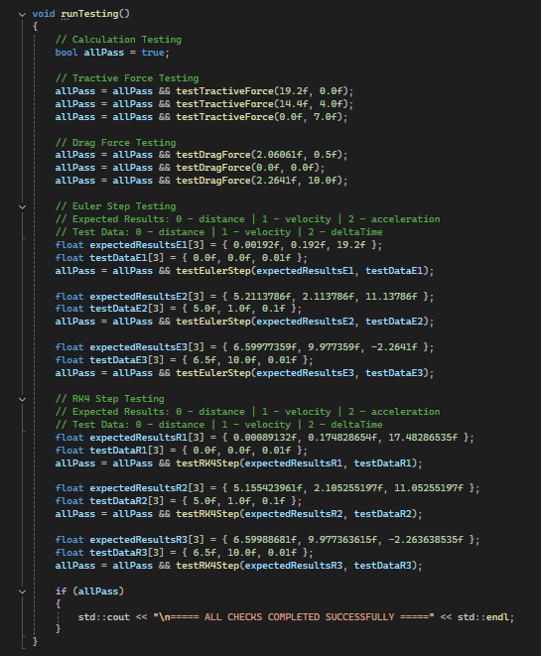

Results
After running the simulation with both Euler’s method and RK4, the results displayed the patterns expected. For both methods, the dragsters acceleration starts high, then slowly decreases as tractive force decreases and drag forces increase from velocity. After hitting 6 metres travelled, the tractive force ceases completely, and acceleration decreases instantly as only drag is being applied.

As shown on the graphs below, distance forms a slightly waved curve, where the curve is initially steeper, then plateaus, following the change in velocity. Velocity has an almost linear curve for both its increase and decrease. Acceleration gradually decreases, until distance hits 6m, where the acceleration instantly swaps to a negative value, indicating deceleration.
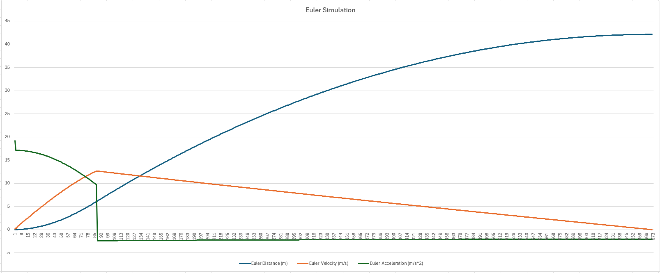
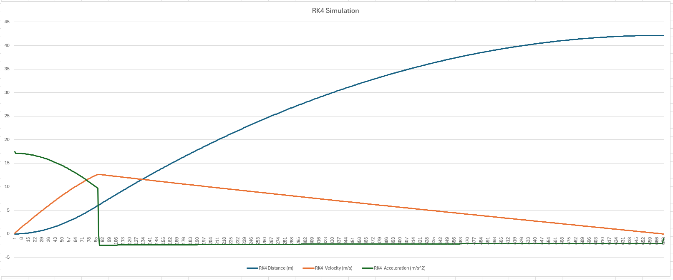
When looking solely at the graphs and attempting to compare the two implementations, they appear almost identical. This is even more noticeable after putting the two into one graph:
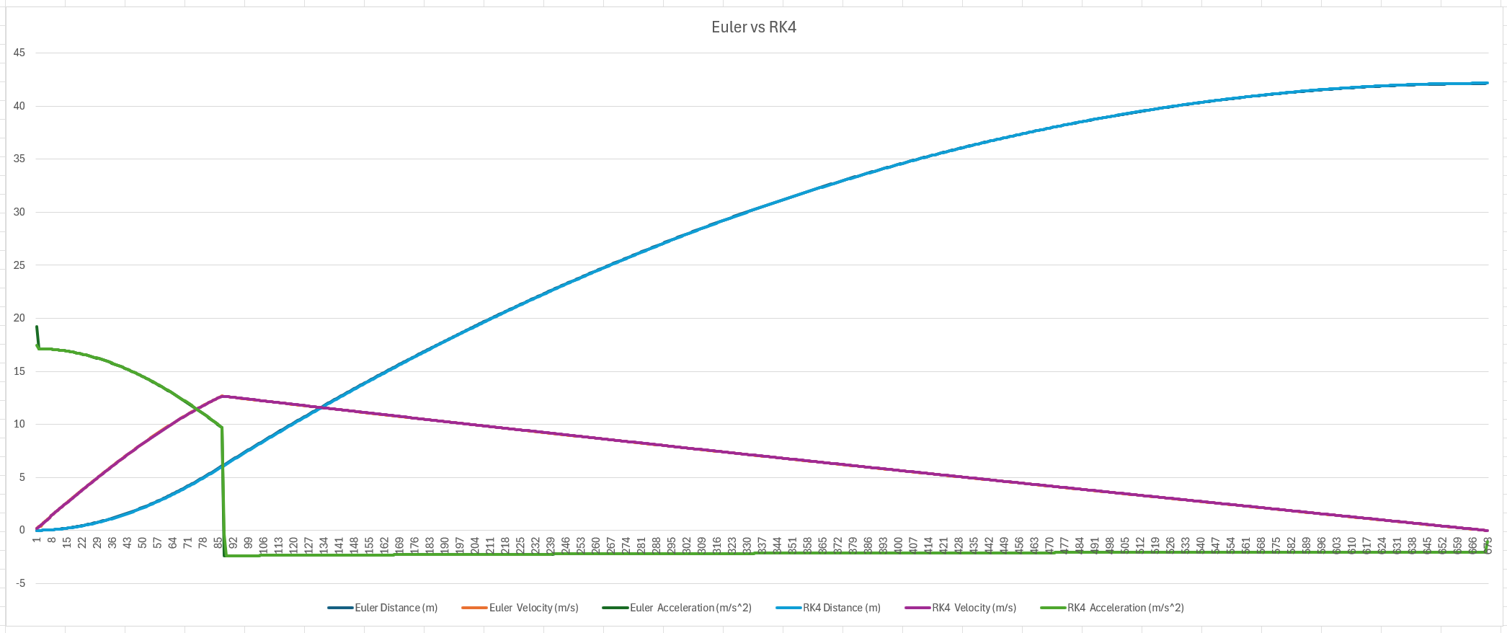
With this extra view to compare the two, it confirms how similar they are, albeit with some minor differences. One main notable comparison occurs at both the beginning and end of the graphs. At the beginning of the simulation, step 1 displays a spike in acceleration, which is larger in Euler than RK4. The reasoning behind this is likely that velocity is 0 so no drag force applies, making it pure tractive force. In RK4 however, using its intermediate estimations smooths out the data, including some drag, resulting in a more accurate value at the initial step. At the end, RK4 also has one extra step in comparison to Euler, likely due to intermediate estimations coming closer to velocity being 0 for one or more of the estimations.
When examining the data, the differences become more noticeable. One notable difference is that RK4 starts off by having slightly lowered distance and velocity, but RK4 gets a higher velocity at step 88, being 12.6496m/s, with Euler’s being 12.641m/s. Looking at distance, RK4 has a lower distance up until step 472, where it and Euler meet at the exact same distance. After this, RK4 keeps increasing and ends up higher than Euler.
To compare the two, these results show that both are usable and give relatively accurate data with a delta time of 0.01. RK4 does show some improvements, especially the beginning and end of the simulation where acceleration forces have a large change in the next or upcoming step.

Adjustment Effects
I chose to adjust the constants of mass, air density, and the rolling resistance. I individually set mass to 2kg, air density 0.5kg/m^3, and the rolling resistance to 0.125. The results were mostly the effects expected from those changes. When doubling mass, the acceleration decreased, as there was more drag force on the vehicle, so overall reducing velocity and position as well for both Euler and RK4, finishing at 22.35m average compared to the regular 42.14m average. Below are graphs with the data from the drag change:
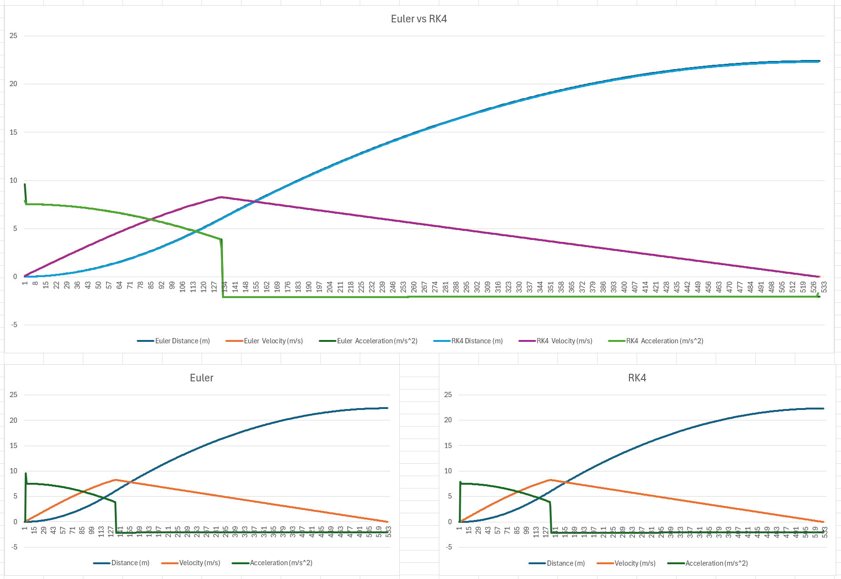
Next, I tested changing the air density. My expectation was with less air density, air resistance would reduce and thus drag reduced, allowing for velocity to last longer. However, this performed almost normal, with the RK4 simulation finishing at 43.863m compared to the normal 42.1647m. The graphs are below:
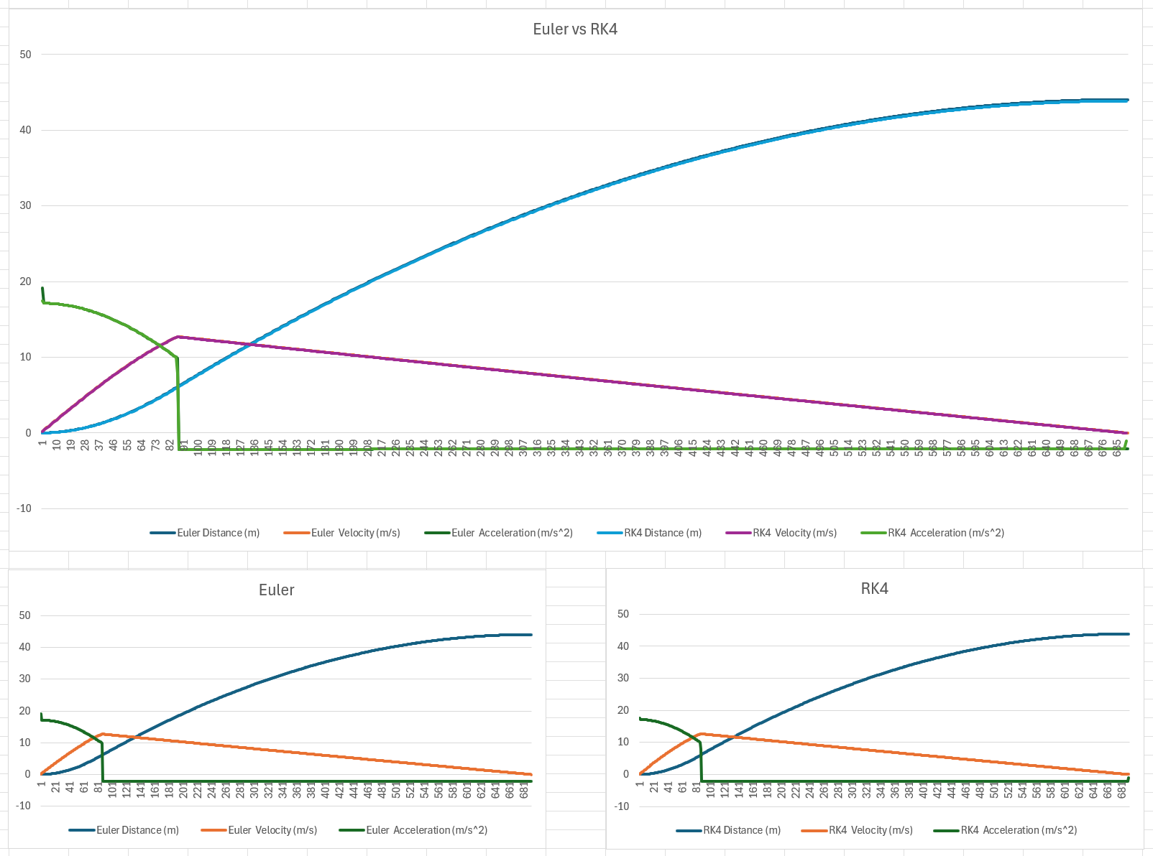
Finally, I tested the rolling resistance coefficient at 0.125, anticipating that less rolling resistance would increase velocity and position due to the reduction of drag forces. This resulted in 1000 total steps compared to the normal 670. RK4 had distance finish at 67.0538m, a large increase from the original 42.1647m. Below is the graph:
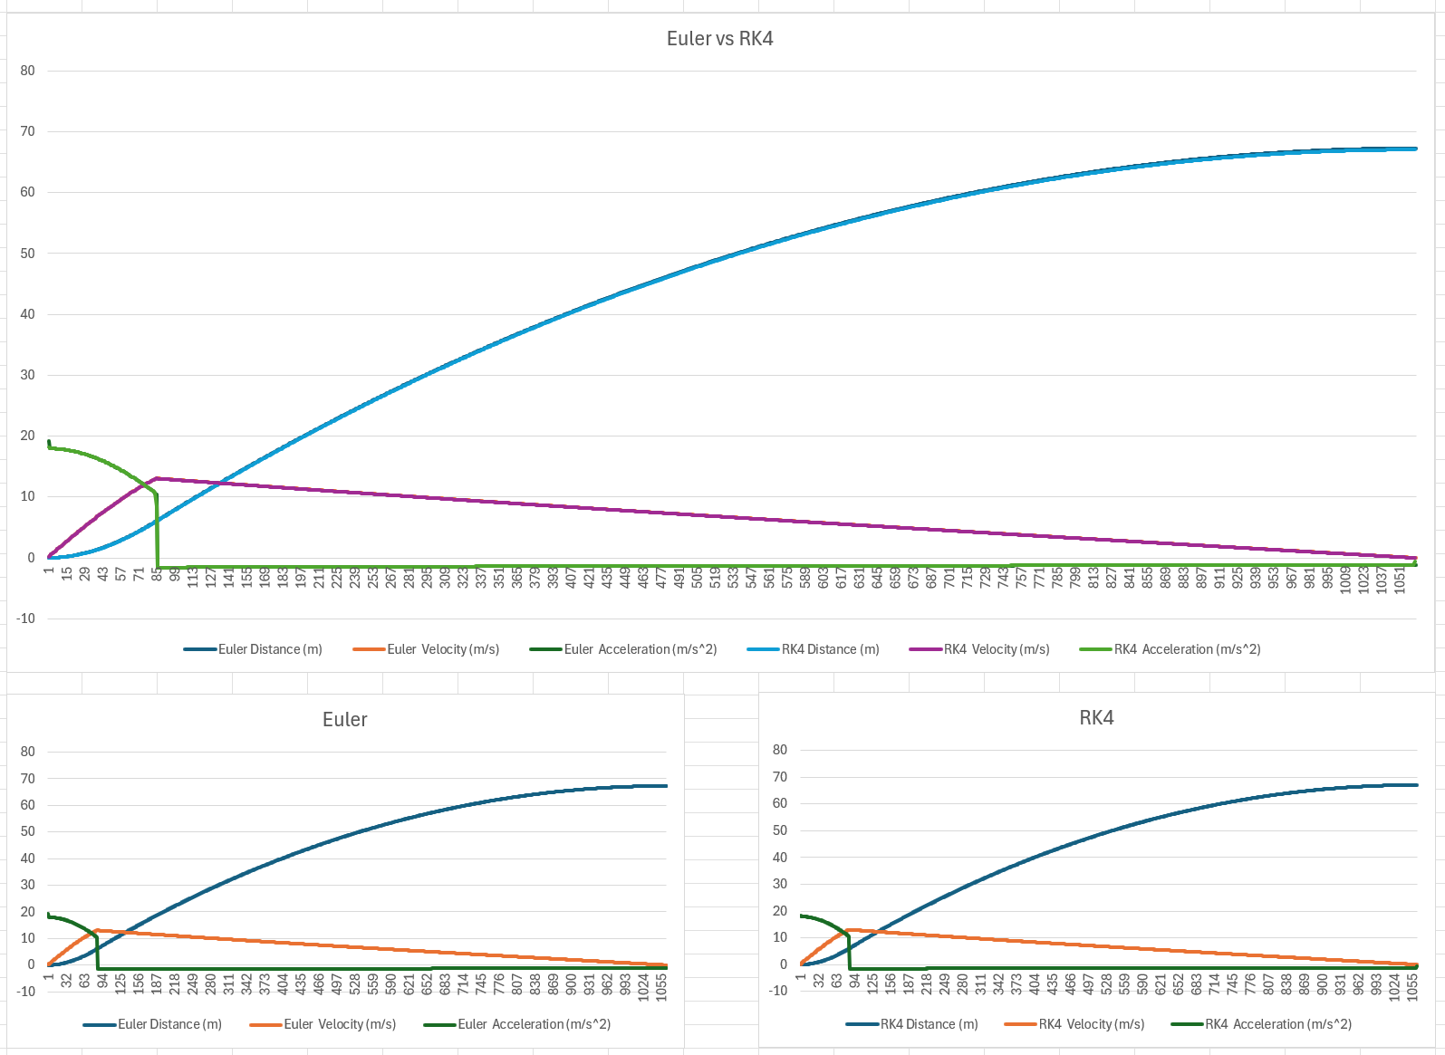

References
[1] "Euler Method for solving differential equation." geeksforgeeks. https://www.geeksforgeeks.org/dsa/euler-method-solving-differential-equation/ (accessed 11 November).
[2] "Forward Euler - an overview | ScienceDirect Topics," Accessed: 11 November, 2025, [Online]. Available: https://www.sciencedirect.com/topics/engineering/forward-euler
[3] C. DeTar, "Higher Order Systems," 1 January 2008. Accessed: 12 November, 2025, [Online]. Available: https://web.physics.utah.edu/~detar/phys6720/handouts/ode/ode/node7.html
[4] E. Cheever, "Fourth Order Runge-Kutta," Accessed: 13 November, 2025, [Online]. Available: https://lpsa.swarthmore.edu/NumInt/NumIntFourth.html
[5] "Forward Euler Method - an overview | ScienceDirect Topics," Accessed: 13 November, 2025, [Online]. Available: https://www.sciencedirect.com/topics/mathematics/forward-euler-method
[6] G. Conrad, "Answer to "Pros and cons of different integrators"", Game Development Stack Exchange, https://gamedev.stackexchange.com/a/33835 (accessed 13 November, 2025).
[7] "Numerical Integration in Games Development", Understanding Games Development, https://jdickinsongames.wordpress.com/2015/01/22/numerical-integration-in-games-development-2/ (accessed 16 November, 2025).
[8] "Physics Tutorial 2: Numerical Integration Methods," Accessed: 17 November, 2025, [Online]. Available: https://research.ncl.ac.uk/game/mastersdegree/gametechnologies/previousinformation/physics2numericalintegrationmethods/2017%20Tutorial%202%20-%20Numerical%20Integration%20Methods.pdf
[9] "2nd order Runge-Kutta (RK2)," 1 October 2021. Accessed: 17 November, 2025, [Online]. Available: https://www.ctcms.nist.gov/~langer/oof2man/RegisteredClass-RK2.html
[10] B. Dawson, "Comparing Floating Point Numbers, 2012 Edition", Random ASCII - tech blog of Bruce Dawson, https://randomascii.wordpress.com/2012/02/25/comparing-floating-point-numbers-2012-edition/ (accessed 27 November, 2025).

