Dissertation proposal

An Investigation into the Correlation between mental illness and crime in South Wales: Are individuals with poor mental health more likely to be involved with crime?
What are the impact factors of mental illness related crime for response policing in the geographical area of South Wales?

Introduction - Research Background
The correlation between Mental illness and crime is well documented nationally and internationally and at present very much in the public eye. Noted by Dr Julian (2017) In recent years, mental health has received increased attention in the media, with some celebrities coming forward to share their personal stories in the hopes of encouraging others to speak up and seek assistance, while Prince Harry, Prince William and the Duchess of Cambridge, Kate Middleton, formed the foundation ‘Heads Together’ in 2016 with the aim of bringing mental health issues to the forefront of the public eye. While mental health concerns are now more widely recognised and understood, there is still a great deal of stigma associated with them, which is largely due to a lack of understanding. In general, it is now more common knowledge that it is prevalent in most societies and not just limited to the region of South Wales.
According to Patel & Saxena (2014) At least 10% of the world's population suffers from one of a variety of mental illnesses; in 2010, 700 million people were diagnosed with a mental illness. Mental diseases account for 7.4% of the global burden of disease in terms of impairment, according to the 2010 Global Burden of Disease Study. (Fig 1).
The dissertation Research background will consist of the historical synthesis between mental illness and the police service leading into a modern view of the questions asked in this research dissertation with a concentrated effort on the geographical location of South Wales, UK, with the research intending on answering the questions, objectives and aims.

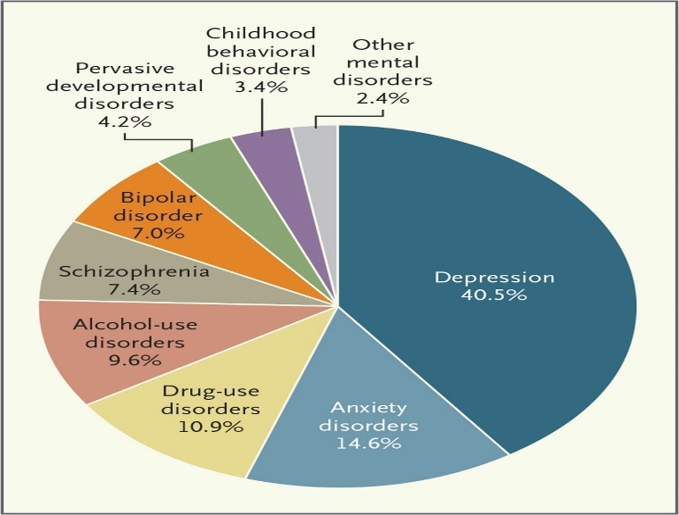
(Fig 1) Proportions of Global Disability-Adjusted Life-Years Associated with Mental Disorders Accounted for by Various Types of Disorders.

Research Rationale
The purpose and objective of this dissertation is to attempt to answer these questions:
- An Investigation into the Correlation between mental illness and crime in South Wales: Are individuals with poor mental health more likely to be involved with crime?
- What are the impact factors of mental illness related crime for response policing in the geographical area of South Wales?
The justification of this research is that crime related mental illness and its influence and consequences on individuals are slowly being acknowledged and issues on the variety of different types of mental illnesses are being brought to the fore front in South Wales. Individuals affected by mental illness are often perceived to be involved with crime either as being involved as an offender or the victim, either way police contact is inevitable. With response policing often being the first point of contact, the police service is regularly in contact with individuals who are suffering from mental illness and I propose it will be an interesting research topic to conduct.

Research Methodology
In an article explained by Professor Nordquist (2019) he states there are two broad techniques to research that are well acknowledged, however they may overlap. Simply put, quantitative research entails systematic data collection and analysis, whereas qualitative research entails "the studied use and collection of a variety of empirical materials," which can include "case studies, personal experience, introspection, life storey, interviews, artefacts, [and] cultural texts and productions".
Research, as cited by Jamshed (2014), can be seen and understood as a methodical effort to analyse, investigate, and reconstruct reality, theories, and applications. The approach to solving the research problem is reflected in the research methodologies. Depending on the situation, the research approach could be a mix of qualitative and quantitative, or it could be qualitative or quantitative on its own.
On this basis and to avoid any bias, it is intended to use a mixture of quantitative evidence in the form of Numerical data and academic research information collected from all open literature sources available. This may result in majority of the research for the dissertation being of a quantative nature. Qualitative research methods to be used in the proposed dissertation, with evidential usage in such forms as questionnaires and surveys to response officers working throughout the geographical area of South Wales, UK.
Also proposed within the research dissertation is the intention of obtaining a testimonial Interview of an individual that may have been involved in crime and suffers with a mental illness. According to Clifford (2020) Qualitative interviewing is a technique for acquiring specific information on how individuals perceive, comprehend, and explain life events. Interviews provide more detail and depth than a normal survey, allowing researchers to learn how people interpret and narrate events in their life. Furthermore, interviews can be adapted to the interviewee's specific knowledge and experience
This review will help to asses and evaluate the aims and objectives set within the dissertation proposal and identify any gaps that can help towards identifying and resolving any issues and lead to potential rectification.

The objective of this investigation is to research if individuals with mental health illnesses are more likely to be involved in crime and if so as a victim or offender and what are the impact factors of mental illness related crimes for response police departments and officers. The college of policing (2016) notes that in response to persistent concerns in the care and management of people with mental ill health and vulnerabilities, as well as those with learning disabilities or difficulties, a number of national reports have been prepared. These papers examine the use of imprisonment, police custody, and criminal justice systems in dealing with such people from the moment they come into contact with the police. Reports such as the HMICFRS; Policing and mental health: Picking up the pieces (2018) suggests that how well the police services of the 43 forces across England and Wales protect the vulnerable and support victims while effectively responding and supporting individuals with mental health problems. I propose it to be an interesting subject to focus on these issues in the geographical location of South Wales.

Reliability and Validity
To provide a neutral and impartial perspective across the study, a variety of research approaches will be used. It's wise to note that qualitative research methods like interviews are essential for acquiring a thorough understanding of the subject matter, but they might be affected by personal prejudice. As a result, great effort will be made to ensure that the questions asked are not leading questions and that a sample of interviewees is chosen.
Questionnaires and surveys are important for acquiring quantitative data and obtaining general agreement. The questionnaires and surveys will be sent to officers that are part of response policing departments. This is expected to provide a foundational understanding of the historical, existing and future concepts of individuals with mental health related crime incidents. This is required to support the research dissertation. However, caution must be exercised because questionnaires are frequently the reflection of how someone is feeling at the time.
The research's validity will be evaluated in conjunction with existing academic research in order to draw comparisons and identify research needs in this field.

Resource and Time Management
According to APM Body of Knowledge written by Bird (2018) The term "resource management" refers to the process of collecting, assigning, and managing resources for a project, such as people and their skills, funds, technology, materials, machines, and natural resources. Internal and external resources are employed effectively, on schedule, and within budget, thanks to resource management. Resources can be accessed either from within the host organisation or from other sources.
Because time is restricted owing to job and family obligations, it is necessary to estimate a timeframe for conducting research and analysis. As a result, a planned programme has been developed to track progress in terms of time management.
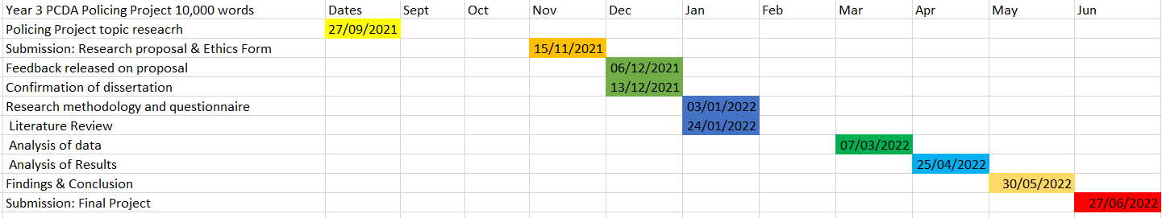
As a result of living and working in the area South Wales, it has been recommended to use the available resources and to team up with mental health institutes, welfare and wellbeing teams within the police service and surrounding communities. This will be in addition to the UWTSD's online resources and internet access. It will be necessary to conduct a thorough study of academic and national research on the correlation of mental health, its involvement and links to crime and response policing. Any further expenses will be funded personally which may include travelling expenses, resource items, such as paper surveys and any other additional items.
References
Patel & Saxena . (2014). Transforming Lives, Enhancing Communities — Innovations in Global Mental Health. Available: https://www.nejm.org/doi/10.1056/NEJMp1315214#article_references. Last accessed 28/10/2021.
Nordquist. (2019). Research in Essays and Reports Glossary of Grammatical and Rhetorical Terms. Available: https://www.thoughtco.com/research-essays-and-reports-1692048. Last accessed 28/10/2021.
College of Policing. (2016). Mental health Introduction and strategic considerations. Available: https://www.app.college.police.uk/app-content/mental-health/introduction-and-strategic-considerations/#portraying-mental-health-in-the-media. Last accessed 8th Nov 2021.
Jamshed, S. (2014). Qualitative research method-interviewing and observation. Available: https://www.ncbi.nlm.nih.gov/pmc/articles/PMC4194943/#ref11. Last accessed 12th Nov 2021.
Clifford, S. (2020). TIPSHEET – QUALITATIVE INTERVIEWING. Available: https://dism.duke.edu/files/2020/05/Tipsheet-Qualitative_Interviews.pdf. Last accessed 12th Nov 2021.
Bird, K. (2018). What is resource management?. Available: https://www.apm.org.uk/blog/what-is-resource-management/#comments. Last accessed 12th Nov 2021.
Julian. (2017). 5 British Celebrities That Have Helped to Raise Mental Health Awareness. Available: https://dr-julian.com/latest-news/5-british-celebrities-that-have-helped-to-raise-mental-health-awareness/. Last accessed 12th Nov 2021.

