  - The Attention Economy: Why Millennials and Gen Z Choose YouTube Content Over Traditional Television

Dissertation Research Proposal
Samuel Charles Dymock-Brown
1706575
2093 Words


Table of Contents
1. Introduction 3
1.1 YouTube 3
1.2 Background and Literature Review 3
1.3 Rationale 4
1.4 Aims and Objectives 5
2. Research Design and Methodology 6
2.1 Philosophy 7
2.2 Sample 8
2.2.1 Data Analysis and Collection 8
2.2.2 Qualitative Analysis 8
2.2.3 Collection Method 9
2.3 Limitations 9
2.4 Ethical Risk 10
3.0 Resources and Planning 11
3.1 Resources 11
3.2 Timescale 11
3.3 Gantt Chart 12
Bibliography 13

1. Introduction
This dissertation aims to analyse the attention economy and how Gen Z and Millennials have adapted to use their time watching online videos on platforms such as YouTube and Netflix, over traditional television. Previous studies have been conducted to show a greater insight into what YouTube is and how the platform has risen to the leading online video platform on the internet (Arthurs, et al., 2018), few exist to determine the reasons to why the latest generations have turned to the modern online video channels over traditional television.

1.1 YouTube
‘YouTube is the second most-trafficked website in the world with over a billion unique visitors each month (YouTube, 2019).’
YouTube is a video sharing platform that allows you to upload content onto your customized YouTube Channel, which lists videos that you or others create. YouTube features comment threads on your channel and videos that you can manage, and a counter that allows you to keep track of who is watching your videos. In turn, the ability to assess how many views a content creator gets allows monetisation once a certain threshold is reached. The eligibility criteria for monetisation is a minimum of 4000 watch hours and at least 1000 subscribers within the previous annum, after these figures are reached a content creator is then eligible to apply for monetisation of their channel, for a fair income.

1.2 Background and Literature Review
As something that is famously known, the founding of YouTube was in February 2005 by three employees from PayPal. With the platform being live for no more than two years, Google paid out a staggering fee of $1.65 Billion (Marshall, 2006). Since the point of launch, there were new competitors based on user generated content, such as MySpace and Facebook. While many social media platforms proved to be ephemeral, YouTube has continued to expand at a rapid pace, becoming the second most visited website on the internet, with creators from YouTube breaking into the mainstream world such as Logan Paul and KSI (Arthurs, et al., 2018). Now with television views declining and the recent generations being so used to using technology and growing up with the revolutionary technology, it has been expected for the online world to overtake the mainstream world. Whilst researching, not many articles can be found around the topic, with the articles revolving around hardware products replacing the television instead of how websites with online video are taking over the video world (Greer & Ferguson, 2015).

1.3 Rationale
Where there are studies around the topic of the attention economy with the social media links being to Instagram and blogging on YouTube, Flickr and LiveJournal within the literature, there are a number of sources that do not find the reasoning as to why the consumers are using their attention towards YouTube videos and online video rather than using it towards mainstream television. Video blogging, also known as vlogging has also been a popular topic for Gen Z with no literature being created to show why the vlogging and YouTube community continues to grow at a rapid pace. Due to no literature being created at the current time, this is why the researcher is interested in studying and researching the given topic. The figures for these two contrasting viewing platforms is intriguing for me and the reasoning behind the choices of viewing and why the figures for YouTube are astonishingly higher than television views.

1.4 Aims and Objectives
The aim of the study being undertaken is to critically analyse the attention economy and why YouTube viewing figures are higher than traditional television within the millennial and Gen Z generations. The objectives are as follows
- To critically analyse viewing figure trends over the last 30 years and viewer motivations to provide context for this research.
- To conduct primary research in the form of one to one interviews to address reasoning as to why viewers choose online video to traditional television.
- To synthesise extant literature to primary research to provide recommendations for television to reach out to the younger audiences and generate a higher viewership.

2. Research Design and Methodology
Research can be defined as,
‘People undertake research in order to find things out in a systematic way, thereby increasing their knowledge.’ (Jankowicz, 1995)
There are many forms of research, within my research I will refer to many methods. Primary and secondary research is something I will use a lot of, where primary data involves the collection of original data by the researcher, secondary research is based on data that has been collected by somebody else (Hox & Boeije, 2005) The two most used data collection research philosophies are positivism, which is quantitative research which includes numerical data, and phenomenology which is qualitative research and this is made up of non-numerical data (Bryman, 2006).
Understanding the gathering of the research methods available to the researcher is a vital part in the selection of the most appropriate method for specific research, this establishes a well thought out practice implementing methods properly (Bryman & Bell, 2007) The amount of pathways available to the research is illustrated within the Research Onion (Saunders, et al., 2009)

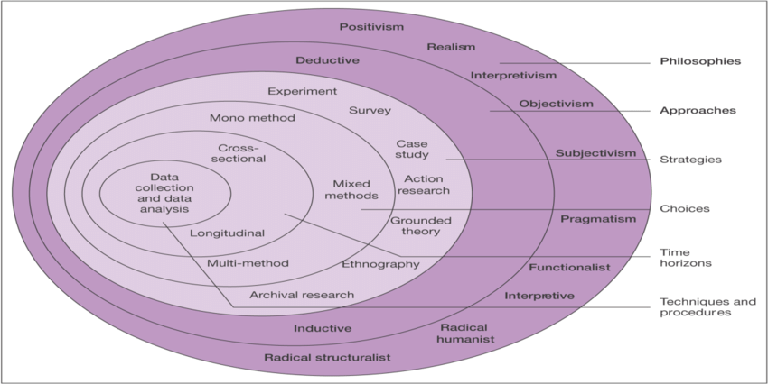
Figure 2.1: The Research Onion. Source: (Saunders, et al., 2009)

The core of the onion shows data collection and analysis, and this will be addressed by the researcher. The approach will be gathering qualitative data during my primary research in the form of interviews with millennials and Gen Z individuals. As this wouldn’t allow a large scale finding the interviews will allow an in depth analysis of how the two generations have adapted over the years.

2.1 Philosophy
Within the research world, there are two stand out philosophies which are undertaken, these two philosophies are known as Positivism and Phenomenology. Positivism requires quantitative research whereas phenomenology requires qualitative data. This study will use the phenomenology research philosophy due to the qualitative primary research methods being used for the data collection.

2.2 Sample
Purposive sampling will be used to collect data during this study. The definition for this sampling technique is as follows:
‘A type of non-probability sampling in which the researchers judgment is used to select the sample members based on a range of possible reasons and premises’. (Saunders, et al., 2012)
In this study, the researcher will use their personal judgment to actively select participants that are involved within the millennial and Gen Z generations as this sample will have the highest understanding towards the YouTube and Television areas due to upbringing with the technology. The sample size will be made up from four participants as this will allow data to be collected from two individuals from each generation for a clear understanding of how each works. The sample will be inclusive of ages between eighteen and twenty-three for Gen Z and between twenty-four and forty-two.

2.2.1 Data Analysis and Collection

2.2.2 Qualitative Analysis
Qualitative data is in non-numerical form (Bryman, 2006) which is popular within phenomenology studies as it shows a wider variety of answers for the researchers. The data within this study will be qualitative from the researchers primary research with the secondary research being mainly quantitative as the figures needed for the study have already been calculated. After the interviews have taken place the researcher will transcribe them which in turn allows the researcher to consolidate the data into a summary. This can then be used to gain an insight into the trends and patterns which can then be used for future studies between traditional media and YouTube content creators.

2.2.3 Collection Method
This research will conduct four interviews using one-to-one question and answer style. The researcher will create numerous questions for the interviewer to conduct the questions for the interviewee. The questions will aim to find out the exact reasoning behind the choices for people within the millennial and Gen Z categories allowing for a fluid interview with potentially, accurate data. The interviewees will consist of two millennials along with two from Gen Z, these will be chosen by the researcher so the interviewees are up to date on the current trends of the television and YouTube world. The use of interviews will enable the researcher to gather exact data for respondents, who will hopefully demonstrate a pattern of behaviour in the motivating factors between watching traditional television and watching YouTube content.

2.3 Limitations
There will be typical limitations for the researcher to counter throughout the study in terms of a limited time-frame to conduct primary research and access to resources. The sample that the researcher will be using may not be a thorough representation of the wider population, but this will be the most effective sample to implement within the study for the given timeframe. The researcher of this study will attempt to mitigate these issues by creating a Gantt chart to provide an efficient timescale for each area of the study, ultimately improving time management.

2.4 Ethical Risk
The ethical risk of the research being undertaken is minimal, there is no vulnerable population used within the interviews so there will be no risk of initiating a trigger point or causing offence to anyone. All data that is collected will remain confidential and held securely on a password protected software within a password protected account. All respondents will be kept anonymous with all participation in voluntary and over the age of eighteen.

Resources and Planning
Along the timeframe of the study, various resources will be used to gain a greater understanding of the subject are and aid in meeting the aims and objectives of the research. Planning is a critical element of any research study to ensure the study is carried out successfully and to a high standard.

3.1 Resources
As well as using primary data for the study the researcher will also use secondary data to allow the development of the researchers understanding of the subject area, these sources will also be included in the literature review. This secondary data will be accessed through numerous ways including the university’s online library, physical books from the library, academic journals and reports along with the internet to find credible websites. Primary data will be collected through interviews with four chosen individuals, the researchers IT equipment and software will be used to analyse the data.

3.2 Timescale
Gantt charts are a very popular method when keeping track of time within research projects by allowing help for researchers in planning and coordination, and allowing specific tasks to be tracked all within an illustrated timetable (Saunders, et al., 2009). The Gantt which follows is will provide a visual representation of tasks which need to be completed by the researcher within the appropriate timeframe. This is so deadlines will be met with no issues and the full research projects will be submitted by the deadline.

3.3 Gantt Chart

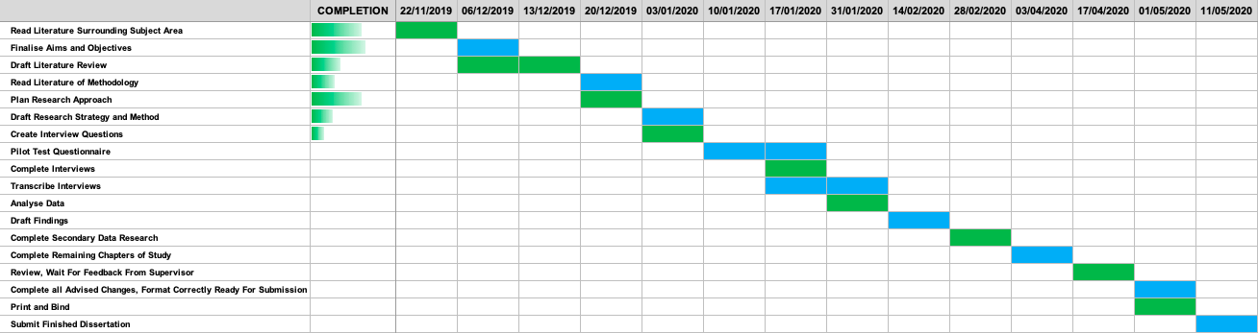

Bibliography
Arthurs, J., Drakopoulou, S. & Gandini, A., 2018. Convergence: The International Journal of Research into New Media Technologies. Researching YouTube, 24(1), pp. 3-15.
Arthurs, J., Drakopoulou, S. & Gandini, A., 2018. Journal of Research into New Media Technologies. Researching YouTube, Volume 24, pp. 3-15.
Bryman, A., 2006. Qualitative Research. Integrating Quantitative and Qualitative Reaseach: How is it done?, 6(1), pp. 97-113.
Bryman, A. & Bell, E., 2007. Business Research Methods. 2nd Edition ed. Oxford: Oxford University Press.
Greer, C. F. & Ferguson, D. A., 2015. Convergence: The International Journal of Research into New Media Technologies. Tablet computers and traditional television viewing: Is the iPad replacing TV?, 21(2), pp. 244-256.
Hox, J. J. & Boeije, H. R., 2005. Data collection. Primary versus Secondary, pp. 593-599.
Jankowicz, A. D., 1995. Business Research Projects. Illustrated ed. Pennsylvania : Springer US.
Marshall, M., 2006. Venture Beat. [Online]
Available at: https://venturebeat.com/2006/10/09/they-did-it-youtube-gets-bought-by-gooogle-for-165b-in-less-than-two-years/
[Accessed 12 November 2019].
Saunders, M., Lewis, P. & Thornhill, A., 2009. Research Methods for Business Students. 5th Edition ed. Harlow: Pearson.
Saunders, M. N. K., Lewis, P. & Thornhill, A., 2012. Research Methods for Business Students. 6th Edition ed. Harlow: Pearson.
YouTube, 2019. YouTube. [Online]
Available at: https://www.youtube.com/about/press/
[Accessed 11 November 2019].

