

Module – ACCA4019
Analysing and Solving Problems
Assessment Component 1 – Assignment

Prepared by:
Beniamin Markiewicz – 2513687

Lecturer:
Dr Semih Yumusak

Contents
Problem Deconstruction 3
Variables: 3
IPO Chart: 3
MoSCoW Method: 4
Solution: 5
Flowchart: 5
Pseudocode: 10
1. “SpecialRoomCount” 11
2. “RegularRoomCount” 11
3. “TimeTravel” 11
Reflection and Justification: 13
References 14

Problem Deconstruction

The set task is to create a solution to a problem that a college has regarding its classroom allocation and time spent travelling between classrooms. The first step to creating a solution is to identify variables that will be needed to create an IPO (Input, Process and Output) chart, which will be an important step forward in this task [1], which will allow for making sure that every component is in place [2].

Variables:
The variables that were identified are:

1) StudentNumber- Student’s number will be used to properly identify a student identity instead of using names to avoid confusion in the case that many students have the same name. It is also important to note that the staff of the college will be included in this list to avoid creating a separate category and simplify the process of assigning individuals to classrooms. The system will automatically fetch student’s name from the database and display it.
2) SpecialRoomCount- will be used to count how many special classrooms are available to assign one student to a given room. It is important to note that it is separate to the variable named “RegularRoomCount” to simplify the solution.
3) RegularRoomCount- will be used to check how many regular rooms are available at the given time for a student.
4) ClassroomName- will be used as an output to show which classroom was the student assigned to. The system will automatically fetch data from the college’s database to get the name of the room and display it.

IPO Chart:
The variables will be then transferred to an IPO chart, which is demonstrated in the table below:
Inputs | Processes | Outputs
StudentNumber | SpecialRoomCount > 0 | StudentName
 | RegularRoomCount > 0 | ClassroomName
 | TimeTravel > 5

MoSCoW Method:
In order examine the problem and create a solution the most helpful technique is the “MoSCoW Method” which allows to identify which elements must be included, should be included, could be included and would not be included at this time, but could be added later [3].
Must be included:
- The system must be always connected to the college’s database so that the student number entered by the user will be matched to the correct name.
- The program must prompt the user to decide whether a special room is required to correctly assign a classroom to a student.
Should be included:
- If the user does not remember the student’s number, there should be an option that will allow the user to enter the name of the student instead.
- There should be a second category for the staff instead of it being merged with the student category.
Could be included:
- a display screen could be attached to see which student is assigned and which is not, also to show which classrooms are available and which are full.
Will not be included in this current version:
- personalization features such as, how long is the list of classrooms available on the display screen.
- a separate version of the program that is adjusted to students where they can be assigned to classrooms by putting their student identification close to the scanner that is mounted next to the screen.

Solution:
In this section the solution to the problem will be outlined and presented in a flowchart along with a description and a pseudocode to demonstrate the logical steps that must be taken for the program to execute correctly.

Flowchart:
Using a flowchart to outline the program will ensure the correct logical order of the program that is being presented [4]. The flowchart that is presented in the figure below is the main process of the program, which consists of three different subprocesses that will allow the program to efficiently assign students and staff to the correct classroom. The three subprocesses were named:
- SpecialRoomCount
- RegularRoomCount
- TimeTravel

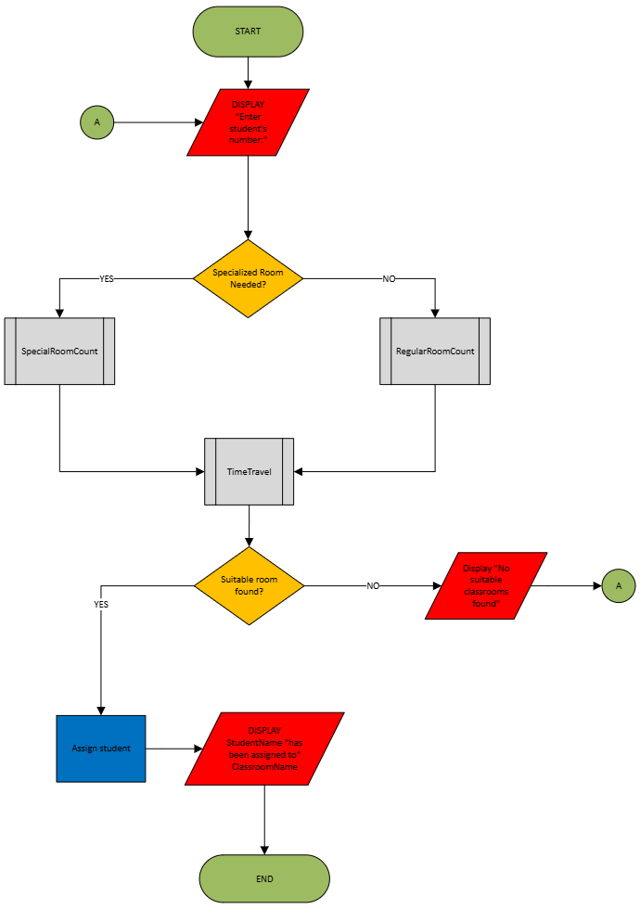
Figure 1 Flowchart- Main Process
The first step of the main program is to ask the user to input the student number of the student that they wish to assign to a classroom. This is done by the command “DISPLAY Enter student’s number”. Like previously mentioned student numbers will be use instead of names to simplify the process of assigning classrooms. The second step is to confirm if the person assigning students wishes to find a special room or a regular room with a “YES” and “NO” question, depending on the user’s answer the program will perform a different process.
If the user chooses “YES” as the answer the program will perform a subprocess named “SpecialRoomCount”, which is shown in the figure below:

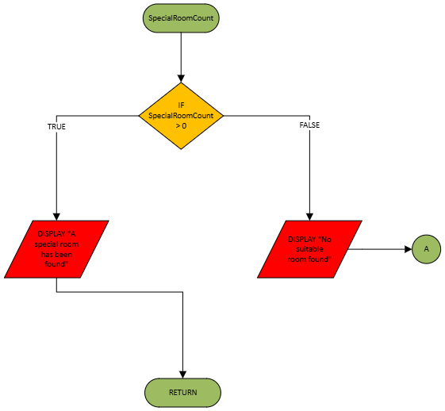
Figure 2: “SpecialRoomCount” Subprocess

This subprocess determines if there are any special rooms available. The first step is done by the “IF SpecialRoomCount > 0 “ command, this indicates to the program that if there is more than 0 special rooms it will display a “A special room has been found”, if instead there is no special rooms available the program will display a message saying “No suitable room found” and will return to the start of the program indicated by the “A” character in a green circle. If the “IF” command is true, then the program will return to the main process and continue.
If the question was answered with “NO” then the program will perform a different subprocess named “RegularRoomCount” which is detailed in the figure below:

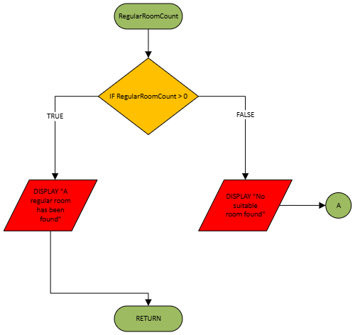
Figure 3 “RegularRoomCount” Subprocess

“RegularRoomCount” is very similar to the previous one to simplify the design, first the condition is set that if the number of regular rooms is higher than 0 then the program will display a message with the command “DISPLAY “A regular room has been found” after which the program will return to the main process and continue. However, if the “IF RegularRoomCount > 0” condition is false then the program will display the message “No suitable room found and return to the start of the main process.

The “TimeTravel” subprocess is where the program determines if the travel time from one classroom to another will take more than five minutes, which can be viewed in the figure below:

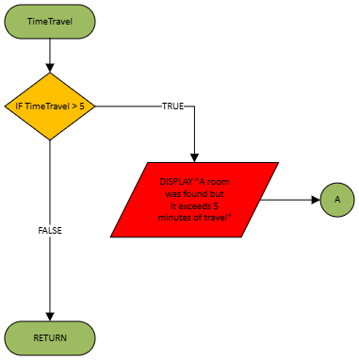

Figure 4 “TimeTravel” Subprocess

The program will determine if the travel time exceeds 5 minutes with the condition “IF TimeTravel > 5”, if it does, then the program will display a message with the command “DISPLAY A room was found but it exceeds 5 minutes of travel” and return to the start of the main program. However, if the condition is set to false by the program, then the process will continue.

The next step in the main process is to determine if a suitable room was found if “YES” then the program will automatically assign a student and then display a message with the command “DISPLAY StudentName “has been assigned to” ClassroomName”, which will display the student name that the program fetched from the database of the school and the classroom name along with it. After that the program will end and the user can assign another student.

Pseudocode:
Using pseudocode will allow for a more detailed outline of the code than the flowchart that will be later translated into a proper code [5].
The pseudocode for this program is detailed below:

BEGIN
DISPLAY "Enter student's number:"
INPUT StudentNumber
IF SpecializedRoomNeeded (StudentNumber) = YES THEN
CALL SpecialRoomCount
ELSE
CALL RegularRoomCount
END IF
CALL TimeTravel
IF SuitableRoomFound = YES THEN
CALL AssignStudent (StudentNumber, ClassroomName)
DISPLAY StudentName " has been assigned to " ClassroomName
ELSE
DISPLAY "No suitable classrooms found"
END IF
END

It is important to note that the subprocess named “AssignStudent” will be handled by an external system outside of the program therefore it is not included in the flowchart.

Below are pseudocodes for 3 subprocesses detailed in the flowchart:

1. “SpecialRoomCount”
PROCEDURE SpecialRoomCount
IF SpecialRoomCount > 0 THEN
DISPLAY "A special room has been found"
ELSE
DISPLAY "No suitable room found"
GO TO A
END IF
RETURN
END PROCEDURE

2. “RegularRoomCount”
PROCEDURE RegularRoomCount
IF RegularRoomCount > 0 THEN
DISPLAY "A regular room has been found"
ELSE
DISPLAY "No suitable room found"
GO TO A
END IF
RETURN
END PROCEDURE

  - 3. “TimeTravel”
CALL TimeTravel
IF TimeTravel > 5 THEN
DISPLAY "A room was found but it exceeds 5 minutes of travel"
ENDIF
RETURN
END PROCEDURE

For the sake of clarity and to show clear examples of subprocesses, this pseudocode was split into sections as shown above.
A layout and description of the commands used in the sections of the pseudocode shown:
- “CALL”: This command is used to bring up the subprocess that are already written, instead of writing a single process a subprocess can be written and then executed with this command.
- “PROCEDURE”: This command is used to create a subprocess followed by the name of the subprocess and write it in pseudocode which then can be executed later in the program.
- “END PROCEDURE”: This command is used to signify the end of the subprocess.
- “IF” and “ENDIF”: This command is used to set a condition that must be set to either true or false, depending on the answer the program will perform a different action. And command “ENDIF” signifies the end of the condition.

Reflection and Justification:
The techniques that was best suited for this task, when it comes to deconstruction of the problem, was the “MoSCoW Method” which allowed to see what was clearly needed for the task and to outline the main features that the program will contain. This method was also useful to control which features would not be present at the current version of the program that was outlined and which features would be added later.
Another useful tool for this work was the IPO chart which aided in identifying clear variables that the program would be working with. It allowed for efficient allocation of variables in both the flowchart and the pseudocodes, and it also allowed for focusing on the variables that were clearly outlined instead of asking additional question about the task.
There were many assumptions made when writing a solution for this task, one of the most important is the assumption that the program would be connected to a college’s database. This allowed for abstracting certain sections of the solution instead of taking every detail into consideration. One of the problems with this approach is that the solution may not be as detailed as it could be, due to oversight of certain details and making too many assumptions about the program’s behaviour.
Another limitation of this solution is that the program is too simple, it could be improved in several places, for example, instead of the program ending there could be a question asked if the user wants to assign another student. Another improvement is that the program could feature a more robust assigning process such as, more decisions regarding user choice, or to simplify the process of finding a suitable classroom by converting two subprocesses “SpecialRoomCount” and “RegularRoomCount” into one subprocess where all rooms all included and based on the user’s inputs that room is chosen.
In conclusion there are many improvements that could be made to this solution as it does not cover all problems outlined in the task, and some processes could be simplified to provide more clarity and enhance the user’s experience.

References
[1] T. N. Mohd Aris, "AN AGENT-BASED CONCEPTUAL MODEL FOR
COMPUTATIONAL PROBLEM SOLVING," University Putra Malaysia, Faculty of Computer Science and Information Technology, Accessed: 25 Mar 20262026. [Online]. Available: https://www.researchgate.net/profile/Teh-Mohd-Aris
[2] Adobe Experience Cloud Team. "Learn how to use the input-process-output (IPO) model." business.adobe.com. Accessed: 25 Mar 2026. [Online]. Available: https://business.adobe.com/uk/blog/basics/learn-about-the-input-output-model
[3] K. S. Ahmad, et al., "Fuzzy_MoSCoW: A fuzzy based MoSCoW method for the prioritization of software requirements", 2017 International Conference on Intelligent Computing, Instrumentation and Control Technologies (ICICICT), pp. 433–437. [Online]. doi: 10.1109/ICICICT1.2017.8342602.
[4] K. Charntaweekhun and S. Wangsiripitak, "Visual Programming using Flowchart", 2006 International Symposium on Communications and Information Technologies, pp. 1062–1065. [Online]. doi: 10.1109/ISCIT.2006.339940.
[5] G. G. Roy, "Designing and Explaining Programs with a Literate Pseudocode," vol. 6, no. 1, pp.1, March 2006, doi: 10.1145/1217862.1217863. Available at: https://dl.acm.org/doi/epdf/10.1145/1217862.1217863

