

Student name: Ismihan Bozyigit
Student ID: 2513136

Module name: Introduction to Health and Social Care
Module code: LCHS4003
Lecturer name : dr.Eleni Koutsogeorgou-Andreou

Table of Contents

Task 1: Community Mental Health Services…………………………………….……………..3

About the Services………………………………………………..………………………..….………….3

History of the Services………………………………………………………..…………………….…...3

How is Works Today……………………………………………………………….……………….……..3

The Challenges to Community Mental Health Services………………….……..….…....3

Way is the Matters………………………………………………………………………………………….3

Task 2: Ambulance Services in the UK.…….........................................................4

References………………………………………………………………………………………………………………5

History of the Service
In the past, people with mental health problems were not cared for properly. Many were stigmatised simply because others did not understand their condition. This meant they could not get the help they needed. Change was necessary because public health matters. A healthy society means a better future for everyone. Over time, new ideas about mental health care began to spread. In 1959, the Mental Health Act was introduced in the UK. This law encouraged care in the community rather than in hospitals. During the 1960s and 1970s, many large psychiatric hospitals closed. New community teams were formed to support people in their own neighbourhoods. By the 1990s, community mental health teams had become the main way of helping people with serious mental illness.

Community Mental Health Services
Ismihan Bozyigit
Introduction to Health and Social Care
2513136@student.uwtsd.ac.uk

Community Mental Health Services
 Community Mental Health Services help people with mental health problems. Instead of going to hospital, people can get help close to where they live. This could be at a health centre, at home, or somewhere else in the community. These services help people with different problems. Some have depression or anxiety. Others have more serious conditions like schizophrenia. The goal is to help them live a normal life. A team of professionals works together. This team may have a psychiatrist, a psychologist, a nurse, or a social worker. They support each person in different ways. Because care is given in the community, patients can stay near their family and friends. It also helps people feel less ashamed. They get help just like someone would for a physical illness.

Staff Shortages
Staff shortages are another big problem. There are not enough doctors, nurses, or psychologists. This means patients get less time and less help. It also makes the whole process longer. This affects both patients and their families. Staff also have too much work. When staff are overworked, they cannot give good care. This puts more pressure on everyone. Because of staff shortages, patients miss out on therapy and regular check-ups. Their condition may not be watched properly. Small problems can become bigger over time.
If this problem is not solved, a healthy society cannot be built. This also affects children as they grow up. Mental health is not just a personal issue. It is a public health issue. Investing in staff means investing in the future.
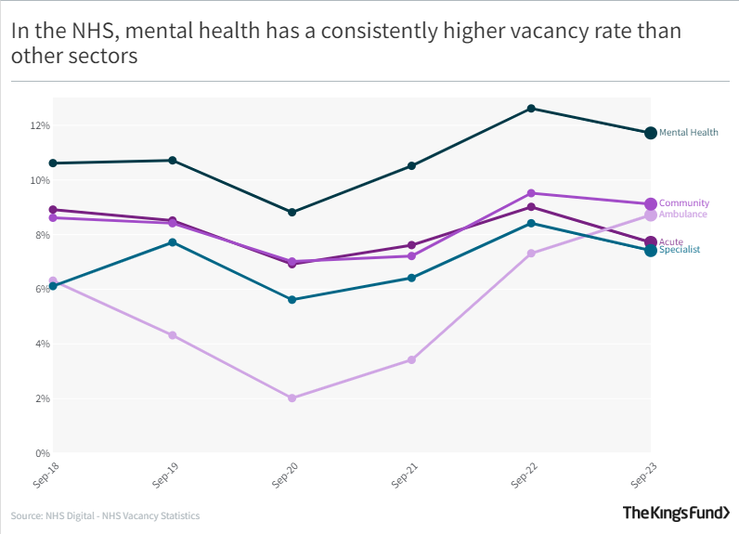

The problem of Waiting
When people have mental health problems, they often need help quickly. But long waiting times make this very hard. While they wait, their mental health can get worse. They may feel more anxious, depressed, or hopeless. Some people lose contact with friends and stop going to work or school. Daily tasks can become too difficult. This affects not just the person, but also their family. Relationships can suffer. Some people may end up in crisis and need emergency help. This could have been avoided with earlier support. Time is very important in mental health. The sooner someone gets help, the better their chances of recovery. Early treatment can stop problems from becoming more serious. That is why long waiting times are such a big problem.
Why This Matters
Community mental health services mean a society where people are mentally well. This is not just about treating illness. It is about helping everyone feel better and live more peacefully. When people are mentally healthy, they can work better, build stronger relationships, and help their communities.
This situation must be reviewed. More staff should be trained in this field. Staff shortages and long waiting times are serious, but they can be solved with the right investment. Training more psychologists, psychiatrists, and nurses means more people can get help when they need it.
Public health is not just about treating those who are ill. It is also about improving life for healthy people. Mental health services help create a society where people feel supported and valued. This benefits everyone. Investing in mental health means investing in the future. A mentally healthy society is stronger, more caring, and more hopeful. In the end, looking after mental health is looking after each other.
Reference
- BBC News (1999) The origins of community care. Available at: http://news.bbc.co.uk/2/hi/health/229517.stm (Accessed: 19 March 2026).
- Care Quality Commission (2026) Monitoring the Mental Health Act in 2024/25: Staffing. Available at: www.cqc.org.uk (Accessed: 19 March 2026).
- Centre for Mental Health (2025) Mental health services in the UK in 2025: what the latest NHS Benchmarking survey tells us. Available at: www.centreformentalhealth.org.uk (Accessed: 19 March 2026)
- The King's Fund (2023) NHS vacancy statistics: Mental health vs other sectors. Available at: www.kingsfund.org.uk (Accessed: 20 March 2026).
How It works Today
These services help people who cannot cope on their own. Care is given in different places. Some people go to clinics or health centres. Others are visited at home by nurses or support workers. The team includes different professionals. Psychologists and psychiatrists are part of the team. They also work with nurses, occupational therapists, and social workers. Together, they give different kinds of support.
People can get help in many ways. Most are referred by their GP. Some people can refer themselves. Others get help through school, college, or university. Hospitals, crisis teams, or social workers can also refer someone. There is also a 24/7 mental health helpline. You can call NHS 111 and select option 2. This means people can get help from wherever they are.


Ambulance Services in the UK

The ambulance service is an important part of the NHS in the United Kingdom. It answers millions of emergency and non emergency calls every year. The ambulance service began in London in 1897. At that time, horse drawn carriages took patients with infectious diseases to hospital. This was the first organised ambulance service in the country. When the NHS was set up in 1948, local councils had to provide ambulances. However, they only took patients to hospital no treatment was given during the journey. A big change came in 1966 after the Millar Report. It recommended that ambulance staff should be trained in emergency help like oxygen and CPR. This was an important turning point for the service. Ambulances started to become more like healthcare vehicles rather than just transport. During the 1970s, responsibility moved from local councils to the NHS. This made the service more professional and consistent across the whole country (Burns, 2020).

Today, the ambulance service is far more advanced than it used to be. Ambulance services now include paramedics, emergency technicians, and support staff who all work together as a team. Paramedics are highly trained and can now give injections, prescribe some medicines, and even perform small procedures at the scene. The service has also become more specialised over time, with separate teams for mental health crises, falls in older people, and end-of-life care. So when someone calls for help, they are much more likely to get the right kind of support quickly. This has improved patient outcomes in many cases (Centre for Mental Health, 2025). However, ambulance staff are facing serious problems. Demand has risen sharply in recent years. By the end of 2024, over 664,000 adults with severe mental illness were receiving community support. This puts more pressure on crews who often have to respond to mental health emergencies. Staff shortages make this worse. Vacancy rates are around 11% in community services and 14% in inpatient services. This means there are simply not enough paramedics to answer all calls quickly. As a result, waiting times have grown significantly. For non urgent cases, patients may wait weeks for follow-up appointments. In some areas, autism assessments can take nearly two years. Long waiting times can make people feel helpless, especially in emergencies (House of Commons, 2025).
The ambulance service also improves daily life in many ways. Through telephone advice, control room staff give instructions while an ambulance is on its way. They also try to keep patients calm, because panic can lead to mistakes. For example, they can teach someone how to do CPR or stop severe bleeding. This means help starts immediately and can save lives. Home based care is another important service. Many elderly or chronically ill people find it hard to travel to hospital. Community visits for regular check-ups or treatment at home help them stay independent and avoid unnecessary hospital stays.
The service also supports people during mental health crises. Specialist teams attend calls involving distress, offer immediate help, and direct people to the right services. This can prevent situations from getting worse and ensure proper care sooner. Finally, knowing that the ambulance service is available 24 hours a day gives people a sense of security. In my view, it is one of the most important parts of the NHS because it is always there when people need it most (Centre for Mental Health, 2025).
References

- Burns, T. (2020) 'Community-Based Mental Health Care in Britain', Consortium Psychiatricum, 1(2), pp. 14-20.

- Centre for Mental Health (2025) Mental health services in the UK in 2025. Available at: www.centreformentalhealth.org.uk (Accessed: 19 March 2026).

- House of Commons Health and Social Care Committee (2025) Community Mental Health Services: Fourth Report of Session 2024-26. London: House of Commons.

