Managing Internationally
Assignment one
IKEA globalisation Strategy
In China and U.S.A.
Student number: 1301060
Student name: Joel Morgan

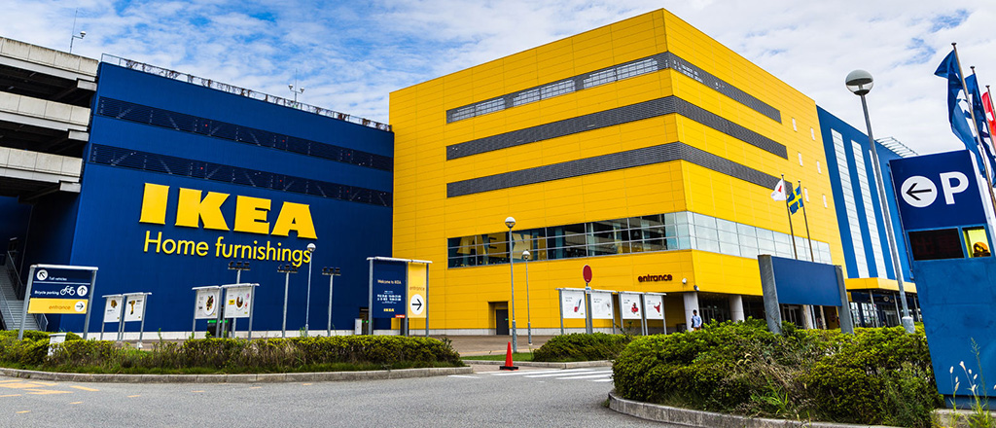
Figure 1. IKEA store front

Table of contents
- Executive Summary – P.3

- Introduction – P.4

- IKEA Strategies in China – P.5

- IKEA Strategies in USA – P.5

- Mode of entry: China - P.6

- Mode of Entry: USA – P.6

- Organisational Structure – P.7

- Political, Economic and Legal Factors – P.8

- Forces of Globalisation – P.9

- Conclusion – P.9

- References – P.10 – P.11

- Appendix – P.12

Executive Summary
This report will analyse IKEA and how it has used its already successful strategies from the western community to gain a competitive advantage in an international market, focussing specifically on China and the USA. Analysing what strategies were used in both countries and why they were used also to see if they were successful with them or not. Looking at the cultural effects that influence the company’s strategies and whether IKEA adapt to this or maintain a global standardisation. Considering the entry mode of IKEA in both China and USA, why they entered the market in that mode. To follow, a in depth look at the organisational structure of the company and the political, economical and legal factors that influenced IKEA’s strategies. Analysing the key drivers in globalisation, followed with a conclusion to sum the findings up.

Introduction
IKEA, the international furniture and household goods company from Sweden produce and sell some of the most modern and stylish furniture at affordable prices in comparison to their competitors. IKEA was founded by Ingvar Kamprad in 1943. Ingvar started off the brand IKEA by selling simple utensils such as pens, wallets and watches by going to the customer at their own home. Flat-pack (DIY) Furniture was then later introduced “It all started with a flat-pack table. When a leaf-shaped, three-legged collapsible side table went on sale in Sweden in the 1950s, it sparked a home furnishings revolution and propelled Ikea.” (Anderson, 2015)

Figure 1.1. (zigzoe, 2014) shows key figures from 2014 of the IKEA brand.

IKEA Strategies in China
IKEA had to adjust its marketing strategy from catalogue to digital marketing when it arrived in China as it learned that the digital market was emerging faster in China, creating the internet as a marketing method. Along with the store location strategy having to adapt to the culture as public transport is widely used in China “IKEA entered the Chinese market by learning from their mistakes and continuously adapt themselves to the changing environment. Not many companies have the ability to go through trial and errors because it is very costly when mistakes are made.” (Federico, 2016). The internet has been a key strategy for IKEA in recent times. IKEA were a little later to the ecommerce scene in comparison to some “Today, its website, Ikea.com, is a key driver of income, with e-commerce sales rising by 40pc last year. There were 1.5bn visits to the website last year – and 716m people visited its 315 stores” (Anderson, 2015)
Despite the expansion, IKEA are still willing to be sustainable by producing more energy than they use says the country manager of Sweden at the time of 2012 and moved up to group chief executive in 2013 Peter Agnefjall “that despite Ikea’s rapid expansion plans, the company works hard to make sure sustainability is still a core mission of the company” (Agnefjall, 2015) “The firm has 700,000 solar panels on its stores and invests in wind turbines. By the end of this year, all its lighting ranges will convert to LED bulbs, which are more energy-efficient.” (Anderson, 2015) These will make it much more attractive to enter new countries to expand the brand as it shows that the company is aware of being sustainable to its surrounding area.

IKEA Strategies in USA
The disappointing opening performance by IKEA in the US market realised that their standardised products would have to be more flexible and adapt to the culture in a different country. They have adapted a new strategy going from global strategy to a translational one for their stores with a balanced, strategic focus. IKEA has a new approach to their US market they are operating in and their global market overall by reducing standardisation of activities and take into their views the scale both economies scale and scope. IKEA has completely redesigned its strategy, reconfiguring their products to fit the consumer needs in the US market. IKEA’s head office in Sweden is calling the shots over its subsidiaries in the US market, however the stores in the US market are given freedom to adapt to the culture in the market they are in with their knowledge of the region to tailor it to an experience that will satisfy the US customers.
IKEA have created a store that provides family’s and especially in the USA a place to spend their time all day, creating a memorable experience. This allows customers to return to shop at the store again and again as a blogger Gus Lubin of business insider describes his experience in a Brooklyn store of IKEA creating a plan by having the showroom sucking you in to then feel obliged to purchase for the lengthy time spent wandering around, Lubin touches on the fact the different experience of an IKEA store layout allows you to not think before purchasing “By the time you get to the marketplace you feel licensed to impulse purchase” (Lubin, 2014)

Mode of entry: China
IKEA entered the market in China and USA in different ways, opening their first store in china in 1998 in Beijing with the first U.S. store opening 13 years prior to this, 1985. Lumpkin and Dess define a mode of entry as “The essential act of entrepreneurship is new entry. New entry can be accomplished by entering new or established markets with new or existing goods or services.” (Lumpkin and Dess, 1996). The mode of entry; a joint venture with a local partner was the only effective way to set up business in china during the time that IKEA ventured into the country due to many restrictions for new businesses such as not being able to enter through wholly own subsidiaries. IKEA later into their venture in the Chinese market bought out their subsidiaries and had wholly owned subsidiaries as it could maintain full control with no restrictions “foreign firms have an incentive to choose a wholly owned subsidiary over a joint venture. This is because by doing so they can avoid the risk of the unwanted dissemination of their pro-prietary assets to the joint venture partners and of the failure to fully appropriate the rent generated by the assets transferred to their subsidiaries” (Teece, 1981).
Mode of Entry: USA
When IKEA entered the USA, it did so through wholly owned subsidiaries as there were no laws in place where a foreign company couldn’t take their new business only with a joint venture unlike China. Due to the dollar’s strength IKEA decided on the U.S. market back in 1985 “The dollar's strength in recent years, which made imports more attractively priced here, contributed to the company's decision to finally enter the United States.” (New York times, Grunson, 1986). IKEA entered the United States with wholly owned subsidiaries along with their global image. The mode of entry into the USA was not a success though, despite it working in China. IKEA struggled to bring their concept of furniture across to the USA leading to IKEA creating more questions for themselves on how to design their stores to accommodate with the culture of the country leading to a transitional/adaptive strategy needed.

Organisational Structure
The organisational structure of IKEA is not seen as your hierarchical structure as that is not how Swedish companies conduct their business. It is a very approachable and equality structure which is much different to many companies “Everyone is on a first-name basis and sits side by side at Ikea desks, naturally, in an open floor plan at the company’s U.S.” (Kowitt, 2016) A company president in the U.S. stores Lars Petersson deals with hands on experiences in the company such as finding mechanicals for transportation of heavy equipment on site, “Hierarchy is not a big Swedish thing,” (Petersson, 2016) The IKEA culture discourages people to work many hours on end like companies in America such as Facebook, their beliefs are that if you have to work excessively over your time then you’re doing something wrong, with the company offering 24 days of paid time off and sick days, it brings the more relaxed Swedish culture to the U.S. hard working culture ““Here, if you can’t do your job successfully in a reasonable amount of time, you’re doing something wrong.” (Petersson, 2016)
IKEA have adjusted to their markets meaning their structure is willing to adapt to the local culture despite the outlay of each store being very similar “Most of the operations, management of the stores, design and manufacture of furniture is run by a trust, INGKA Holding, headquartered in Delft, Holland. While most of the designs of IKEA products are made in Sweden, manufacturing has been outsourced to China and other Asian countries.” (Loeb, 2012).

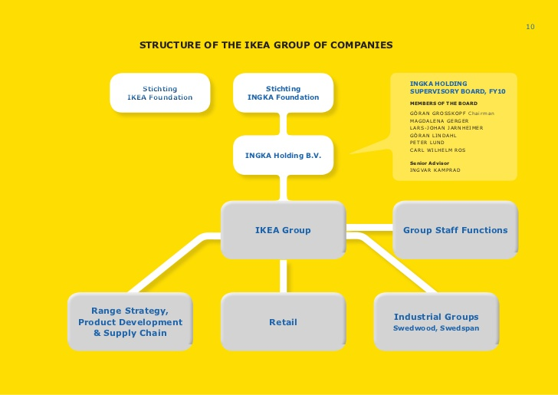

Figure 1.2 (clanyoohoo.es, 2015) Organisational structure of IKEA hierarchy

Political factors
IKEA need to be aware of political factors affecting their business in these countries they have expanded to as each country has different political states, not all will be as stable as Sweden, there are three factors as a PESTLEanalysis editor refers to “Changes in the government policy make up the political factors. The change can be economic, legal or social. It could also be a mix of these factors.” (PESTLEanalysis, 2015)
IKEA’s strategy with the product ‘malm’ had issues, which had raised awareness due to 6 reported deaths with toddlers and due to the malm unit, leading to the Chinese government calling out IKEA on this issue and the news getting out to other countries and IKEA decided to recall millions of the units in China and stating that it was priority to resolve the problem with the Chinese market research group senior advisor stating this was an example of poor protecting of its brand image “This is a great case of a company technically following the letter of the law but doing a poor job of protecting its brand image,” (Cavender, 2016).
IKEA faced a change of strategy due to a political issue in the USA with their beds, the European size was in cm and Americans do not measure in those units but also the average size of an American bed is bigger than a European one leading to a change and adapt to the culture after the issue had widespread around the country “It expected no problems selling its beds and bedding despite the fact that all the items were produced for the European market, where everything was made to metric measure.” (Hirst, 2014)
Economic factors
IKEA decided to expand to China due to a fast growth in GDP. Economic factors must be considered with the strategy IKEA implemented, from pricing of products to store expansion by examining the international economy down to the local, which presents opportunities but also the bottom line must be aware of here “Different types of taxation and other duties can also hit your bottom line hard, so a deep understanding of the fiscal environment is essential to prepare viable financial forecasts.” (Smith,2018)
IKEA had examined the market of China and decided that the strategy they would utilise would be the low-cost labour for manufacturing creating a strategy that would benefit their sales by expanding in a new region without high costs of labour within the country and no need to import due to high tariffs “In countries like China and India popular for their low-cost yet skilled labor, offers the company high profit margin. That is the main reason why IKEA opened a manufacturing firm in China, improving the low-cost strategy of the corporation.” (businessenvironment, 2014)

Legal factors
IKEA like most furnishing companies must comply with many legal regulations to be able to expand to new regions such as China and U.S.A. Which would contain an international agreement along with a local one as well for the area it would be setting up in China or America. China have regulations that require protection to property and import tariffs which causes a barrier for entry for companies like IKEA from Europe. Governments also prefer towards home grown companies over foreign ones, IKEA must beware of this issue in China and U.S.A.

Forces of globalisation
There are multiple drivers of globalisation of globalisation such as trade flows, capital flows, acceleration of growth and GDP “the relative success of globalisation is evident in terms of increased foreign trade and capital flows, acceleration of growth rates and rising real per capital GDP in those countries that have opened up their economies more to the rest of the world” (Nirav, 2012). The main driver of globalisation has been the ease of communication, through Technology.
IKEA have now integrated augmented reality with their app, without having to purchase it or leave the house “The company announced new initiatives, that will enable customers to use interactive technologies like AR and VR in their shopping. For example, customers could project a piece of furniture onto their living room using AR, and then buy it online. No visits to an Ikea-store needed.” (Turula, 2017)
IKEA can utilise technology by holding meetings over the internet with its Swedish head office to head of management in stores in the U.S. or China at an instant with no time being taken up by travelling, discussing operations through skype for business calls “With proper technology in place, executives can save time and money by holding meetings over the Internet instead of at corporate headquarters.” (Kokemuller, 2017)

Conclusion
Following the findings of this report, it is evident that IKEA capitalised on the U.S. and Chinese market it entered by getting to know the local areas culture to suit their global customer’s different needs to the European market it came from. IKEA did this by using a transitional strategy, adapting to the culture and tailoring products to other regions. IKEA’s preferred entry method is through wholly owned subsidiaries as it allows the company to maintain their brand just as it is in their native countries, however IKEA had to enter China through a joint-venture due to the Chinese law in 1998. IKEA entering these new markets and taking their brand globally has allowed the company to become the biggest furniture company in the world today, aiding them to gain the competitive advantage and continue to expand to new regions such as their new project, India.

Word count = 2165

References
Agnefjall, P. (2015). How Ikea spread the flat-pack revolution across the world. Available: https://www.telegraph.co.uk/finance/newsbysector/retailandconsumer/11380881/How-Ikea-spread-the-flat-pack-revolution-across-the-world.html. Last accessed 20th March 2018.

Anderson, E. (2015). How Ikea spread the flat-pack revolution across the world. Available: https://www.telegraph.co.uk/finance/newsbysector/retailandconsumer/11380881/How-Ikea-spread-the-flat-pack-revolution-across-the-world.html. Last accessed 20th March 2018.
Federico. (2016). IKEA in China: Big Furniture Retail Adapts to the Chinese Market. Available: http://daxueconsulting.com/ikea-in-china/. Last accessed 16th March 2018.
Grunson, L. (1986). IKEA VENTURE IN U.S. A HIT. Available: https://www.nytimes.com/1986/03/22/business/ikea-venture-in-us-a-hit.html. Last accessed 20th March 2018.
Hirst, Arlene. (2014). How Ikea Became America's Furniture Selling Powerhouse. Available: https://www.curbed.com/2014/10/8/10038294/how-ikea-became-americas-furnitureselling-powerhouse. Last accessed 20th March 2018.
Kokemuller, N. (2017). Why Is Technology Important in Business? Available: https://bizfluent.com/about-6320228-technology-important-business-.html. Last accessed 20th March 2018.
Kowitt, B. (2016). At Ikea, Everybody Is Equal. Available: http://fortune.com/2016/03/10/ikea-corporate-culture-best-companies/. Last accessed 18th March 2018.

Loeb, W. (2012). IKEA Is A World-Wide Wonder. Available: https://www.forbes.com/sites/walterloeb/2012/12/05/ikea-is-a-world-wide-wonder/#7a88539d27b9. Last accessed 19th March 2018.

Lubin, G. (2014). This Heat Map Reveals The Secret To IKEA's Store Design. Available: http://www.businessinsider.com/this-heat-map-reveals-the-secret-to-ikeas-store-design-2014-1?IR=T. Last accessed 20th March 2018.

Lumpkin and Dess. (1996). Internationalisation strategies. Available: https://www.slideshare.net/febi85/entry-mode-strategies. Last accessed 18th March 2018.
Luo, C. (2017). Swedish Giant IKEA Late to Ecommerce But Goes Full Blown Digital. Available: https://ecommerceiq.asia/eiq-brand-series-ikea-ecommerce/. Last accessed 16th March 2018.
Mamady. (2014). PEST analysis of IKEA. Available: http://businessenvironment2.blogspot.co.uk/2014/11/pest-analysis-of-coca-cola.html. Last accessed 20th March 2018.

Nirav, S. (). What are the Driving Forces of Globalisation?. Available: http://www.preservearticles.com/2012012821959/what-are-the-driving-forces-of-globalisation.html. Last accessed 20th March 2018.

PESTLEanalysis. (2015). Political Factors Affecting Business. Available: http://pestleanalysis.com/political-factors-affecting-business/. Last accessed 20th March 2018.

Petersson, L. (2016). At Ikea, Everybody Is Equal. Available: http://fortune.com/2016/03/10/ikea-corporate-culture-best-companies/. Last accessed 18th March 2018.
Teece. (1981). The Choice between Joint Venture and Wholly Owned Subsidiary: An Institutional Perspective. Available: https://www.researchgate.net/profile/Shige_Makino/publication/247824564_The_Choice_Between_Joint_Venture_and_Wholly_Owned_Subsidiary_An_Institutional_Perspective/links/59e2f364a6fdcc7154db41f6/The-Cho. Last accessed 20th March 2018.
Turula, T. (2017). IKEA is transforming into a full-fledged tech company – starting with its new Apple and Amazon partnerships. Available: https://nordic.businessinsider.com/ikea-just-announced-its-bold-future-plans--and-its-a-giant-leap-away-from-wrenches-and-flat-packs-2017-6/. Last accessed 20th March 2018.

Appendix

Figure 1 http://knowledge.wharton.upenn.edu/wp-content/uploads/2017/10/ikea.jpg

Figure 1.1 https://www.ikea.com/ms/en_US/this-is-ikea/company-information/index.html

Figure 1.2 http://www.clanyoohoo.es/foro/viewtopic.php?f=12&t=11409

