

Module Assignment Submission
Student Name: | Charles Uzor
Student Number: | 1809185
Module No: | BMSK 5101
Module Title: | Developing Workplace Critical Thinking
Lecturer: | Dr Kumar

Statement of Confirmation of Authenticity
By the act of making this submission, the student declares that this is the work of the student named above. The work has not, in whole or in part, been knowingly presented elsewhere for assessment, or where assessment has been built on a previous assessment, this has been identified. Where materials have been used from other sources it has been properly acknowledged. If this statement is untrue, the student acknowledges that an assessment offence has been committed.
Attention is drawn to the plagiarism and unfair practice policies of both the University and of ILM.

Contents
Introduction: 3
Company Background: 3
Critical thinking: 4
Belief: 7
Attitude: 7
Values: 8
Management Theories: 10
Management by Objectives: 12
Recommendations 13
R. E. D Model Theory on Critical Thinking: 13
Recognise Assumptions: 13
Evaluating Arguments: 13
Draw Conclusions: 13
Conclusion 13
References: 14
Bibliography 14

Introduction:
The purpose of this report is to review Lyreco UK’s organisational structure to identify what management theories they are using. Critically evaluate the organisations business processes with reference to culture, belief, attitudes and values. This report will attempt to show the benefits the values systems brings to the organisations and the potential challenges it could cause in relation to employee productivity. This report will suggest management theories to counter these challenges and make recommendations to support its findings.

Company Background:
Lyreco UK is a family owned business located in the northern part of United Kingdom. Owned by the Gaspard family the organisation was founded in France in 1921, and currently operational in 16 countries spanning 4 continents. The organisation employs over ten thousand employees worldwide, with over forty-five percent of their work force locate in the United Kingdom.
Lyreco’s business operation is sales B2B based, providing a truly single source platform where its customers can purchase all their office product needs. Lyreco’s business operation is built on developing a sustainable relationship with its internal and external customers. The organisations aim is to deliver memorable experience whenever it makes contacts with a customer, hence places service excellence at the core of its operations.
In striving to achieve service excellence the organisation developed a culture demanding excellence in all areas of the business both internal and external. This is known in the organisation as best practice approach. A culture which requires every member of the organisation to always seek to apply the best and most efficient approach, when conducting affairs of the organisation. The best practice culture within the organisation, has become integra to the organisations operational policies and is core to it business operational values.
Lyreco’s operates cross border business which requires servicing customers with similar international operations and delivering required services at varied global locations. The business model requires that Lyreco operate a fluid and dynamic business operation that can be adapted in environments where their services are required, without compromising its business ethics and values.
In operating a business which other organisations depend on to function, high levels of operational efficiency are required in other to remain relevant and competitive. This therefore demands that effective communication and critical thinking be applied at all levels of its business operation. The organisations have developed a system that trains its staff and managers and helps them to develop critical thinking skills as part of its business development strategy, in other to achieve the service levels and efficiency it demands as part of its best practice culture.

Critical thinking:

Critical thinking is the process of actively looking to understand or analyse information, using reasoning, evaluating evidence and logically processing your own thought process. Critical thinking involves applying sets of questions or evaluations to situations in other to gain better understanding of what is really going on. Critical thinking allows for one to learn to recognise their own limitation, how to identify others limitation, and know when to apply evaluating questions in other to correctly assess a situation. Critical thinking requires for one to be sceptical and objective when analysing information or dealing with a situation, not automatically accepting the first thing you hear, read or see, without trying to understand the same information from a neutral perspective.
According to Tom Chatfield (2018) critical thinking is setting out actively to understand what is going on by using reasoning, evaluating evidence and thinking carefully about the process of thinking itself.
It’s about asking about ways in which different material may or may not be useful or important (Chatfield, 2018)
Paul Elder in his article “critical thinking framework” describes critical thinking as a mode of thinking about any subject, content, or problem in which the thinker improves the quality of their thinking by skilfully taking charge if the structures inherent in thinking and imposing intellectual standards upon them (Paul R, 2010).
Critical thinking is correctly developed or applied when accuracy, clarity, precision, depth, relevance, significance, logical or breadth, known as intellectual standards are applied to purpose, inference, questions, concepts, points of views, implications or assumptions known as reasoning, which leads to developing perseverance, empathy, humility, autonomy, fair-mindedness, courage, integrity and confidence in reasoning, known as intellectual trait, (Paul R, 2010).
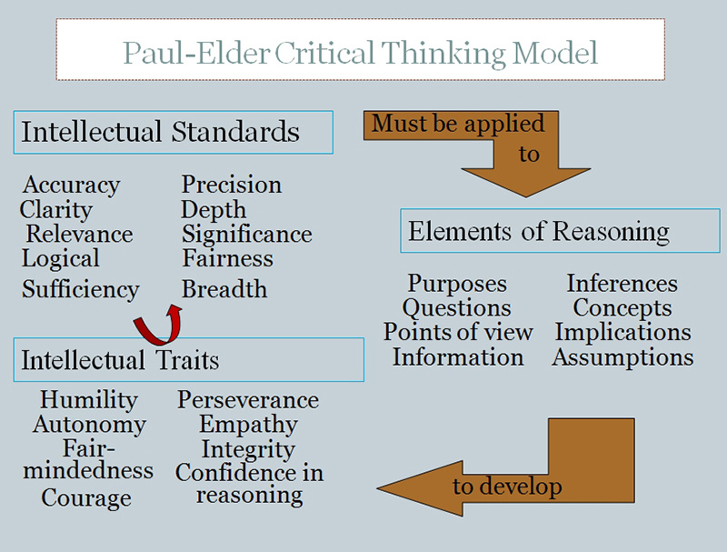
Source: (R, 2010). Louisville.edu

Critical thinking skills is an invaluable skill for any individual to have, both in their private and professional life. This skill demonstrates a level of intellectual ability and aptitude necessary to effectively carry out any academic or business function within an organisation. Critical thinking when applied correctly encourages or promotes accurate and efficient decision-making processes.
In modern day highly competitive business environment, where cost reduction and business efficiency is highly demanded, applying critical thinking to all aspects of an organisations business activities will help the organisation improve their decision making processes, identify weaknesses in the business model and efficiently adapt their operations in their chosen markets.
Critical thinking can be affected by various factors such as individual personality, cultural upbringing, personal bias and learning styles. The unreflective thinker with fixed beliefs and unaccepting ambiguities, the thinker unwilling to ask for feedback, the thinker open to uncertainties and the thinker willing to seek acceptance of feedback and open to alternative thinking are all different stage of critical thinking. These factors however can be realigned when open mindedness is adopted in thinking.
Lyreco has incorporated the development of critical thinking skills as part of employee training and development programme. This is because it has identified critical thinking as the most important skills for its members to have if it’s to achieve its business objective of becoming the most efficiently run and profitable office supply company. Developing critical thinking skills within the organisation will allow for it staffs to understand why and how different functions of the organisation work, why the function operates in a certain way and how it ties to the organisation’s objectives.
Critical thinking encourages effective communication. Every workplace process is highly dependent on communication, whether internal or external, information is constantly flowing in all directions to ensure business functions and activities are executed. Incorrect or poorly communicated information, can have serious negative consequences to an organisation’s productivity. According to Goodwins and Sommervold, “ communication errors can occur anywhere in the process, and preventing errors, providing a clear, concise message and knowing the intended audience are key skills of effective communication” Goodwins & Sommervold 2012, (Mitashree, 2018).
Effective communication in a workplace is extremely important as it encourages teamwork, creativity, and efficiency. These are some of the key requirements organisations demand and use to develop their business culture, belief, values and ultimately form the organisations business goals and objectives.
Analysing situations, thinking thoroughly, using problem solving techniques, is equally as important in effective communication. As a benefit to workplace communication, critical thinking demands that certain processes be completed before final communications is carried out, these steps are, preparation, incubation, validation, and elaboration. (Kumar, 2015), (Mitashree, 2018). Information must be correctly prepared ensuring intended audience is considered, logically arranged, and rechecked for accuracy, cross-referenced with alternative to ensure understanding.
The fields sales teams at Lyreco, who have face to face meetings with their customers, building relationships to increase sales, must be able to apply critical thinking to their work to fully understand their customers business operations, why they order certain product types, frequency of orders, quantities and delivery requirements, and must be able to effectively communicate these to all areas of Lyreco’s business operations in other to achieve synergy within the business operations.
This will lead to a seamless operation from order point to delivery, meaning that things like the right stock levels are maintained, correct products are available for the customers. this in turn will eliminate other hidden business processing costs such as returns or redelivery which can significantly impact the organisations operational efficiency.
Critical thinking is also an important process in decision making in a workplace. In every aspect of a business operation, people are constantly making decisions, either as result to changes to the business or as part of innovations all geared towards achieving the business objectives. Situations like this can becomes stressful for all concerned, as bad or wrong decisions usually have consequences to the business. Applying critical thinking while facing these daily decisions, will remove uncertainties associated with generalising, and improve skills required to evaluate and isolate assumptions, enabling decision makers to arrive at appropriate and most suitable decisions.
Employees sometimes find themselves in unfavourable situations in workplace, that sometimes lead to conflicts. Applying critical thinking can help in resolving such situations as it will aid the manager’s or employees to identify the root cause of the conflicts, allowing for more permanent or long-lasting solutions to be reached. Croome, in his article states that if logic and imaginations work together, problem solving becomes enjoyable and more creative (Croome, 1999)
Critical thinking is essential in development workplace innovation. Innovation and new ideas are very important for any organisation’s survival. Ability for managers and employees in general to think out of the box or think differently from a set process and practices, can lead to development of new ideas. “Receiving and processing thoughts, ideas, hunches, concerns and even flashes of inspiration from unknown sources within our consciousness may form building blocks of much great creative capacity for a business” (Daniell, 2006). Considering new ideas from inspirational sources can instigate curiosity which can lead to evaluation of existing ideas and in turn help develop new approach or processes. (Mitashree, 2018)
Critical thinking has its short comings as it can be somewhat bureaucratic, especially when speed in decision making is required. This is common in organisations operating a hierarchy or tall structure where levels of authority are applied to decision making. New ideas of business agility can somewhat be delayed while decisions are being scrutinised at the deferent levels of the decision-making process.

Belief:

Belief can be said to be an internal feeling people hold that help support their way of life. Anderson Silva defines belief as an internal feeling that something is true, even though that belief maybe unproven or irrational. (Silva, 2009). Beliefs can be hereditary or stem from how an individual is raised or cultural background. Belief can also be developed as a result of religion or other practices. Belief can influence people’s perception of situations and how they relate or communicate with others. It is considered rude to shake people’s hand on first contact in Japan, whereas same is perfectly acceptable in England. Calling someone by their first name in a business environment is considered unprofessional in certain organisations, where the use of sir and madam is more acceptable, while the use of first name demonstrates a level of trust and acceptability in another organisation. Different beliefs stem from cultural background and in most instances is shaped by the pre-historic beliefs.
Many organisations have their belief which form part of their organisational culture. Some organisations belief in the standard professional approach, where the use of Sir/ madam and other formal introductions when communicating is deemed essential. While others believe in more informal approach once the initial introduction is made, using only first names when addressing each other. This is viewed as being personable as it is believed that efforts have been made to remember the other person’s name, suggesting that interest had been developed. This is particularly common in sales and marketing environments when the use of customers first name is believed to help gain customers attention when delivering a sales pitch.

Attitude:

Attitude is the way an individual express themselves or displays their emotions. Attitude can be considered negative or positive depending on how and when the emotions are displayed. Attitude can be displayed by words or behaviour and in most cases is characterised by a person’s communication style. Cultural beliefs and behaviours can influence or impact a person attitude. Someone can develop a negative attitude towards another due to religious belief and cultural differences. Attitude can also be shaped by experience and upbringing. One can develop a phobia for something or situation, if their experience of that situation was undesirable. A culture where pleasantries are exchanged in the morning between two or more people meeting or seeing each other for the first time, is deemed to be positive in certain cultures, and the individual concerned are perceived to have positive attitude. While individual not expressing such pleasantries in similar circumstance are perceived to have negative attitude. In most professional environments it expected that individual manage their emotions and communications styles in manners in which they are not viewed as being negative, in other to minimise the risk of conflict in the workplace. This invariably forms part of most organisations culture and values, on how they relate and communicate within their environment. Many organisations look out for treats of attitude when recruiting, this is done through individual communications style, appearance, body language and views. This is deemed important, as organisations want to recruit people with the right attitude in other not to upset the balance of their staff teams.

Values:

Values is a measure of worth or importance a person attaches to something or a reflection of how they live their lives (Silva, 2009). Values influence our behaviours and is often shaped by our beliefs. Value can be a collection of similar ideas or ideologies which are important to the ways we live our life. In an organisational setting a value system can be a collection of view, beliefs and cultures that shape the organisational ethic and code of operations. This can be influenced by factors such as location, employees and other stakeholders with interest in the organisation. An example will be a company located in Dubai will adopt the idea of giving it employees off on Fridays as it values the belief that Friday is a holy day in their culture.

Values, beliefs and attitude are all interrelated and can be directly linked to our culture and background. These cannot be thought in a workplace, but rather organisational values are shaped to adapt to its culture and values which forms it code of Ethics.
Lyreco has a set of Value systems which has shaped its internal and external work practices and culture. These are passion, excellence, respect and agility. These set of values are embedded in every aspect of the organisations operations and drummed into every employee, so much so that it forms a way of life for the everyone connected with the organisation.
Every employee develops a passion for their work as they own the process of developing that aspect of the operations. They are measured and recognised for the success or failure of their work and individual development plans as set based on the development and improvement of their work. This encourages innovation, passion and ownership in individual work as employee feel important part of the organisation.
Excellence; Lyreco developed a best practice approach to all aspect of the organisation’s operations. The best practice requires all employees to develop an attitude of getting it right first-time round. This requires the employees to apply critical thinking and other forms of evaluations to their work to ensure they get it right from the onset. This allows for the organisation to attain and maintain a service level of 99.5% which is critical for efficiently running the business. The best practice culture although works well from the organisation’s perspective, creates a pressured environment for employees. Individual personality styles are different and most individuals although good at their jobs, struggle with keeping up with the pressured working environment, and end up leaving the organisation. This create a different set of issues for the organisation as it staff retention rate remains unstable.
Respect; Every employee or customer must be treated with respect regardless of their position in the organisation. Within the organisation, everyone is on first name bases, from CEO to the cleaners. Everyone wears a name badge at work and is encouraged to address each other by their first name. This includes customers and suppliers visiting the organisations. This creates a family culture environment, where everyone feels respected and valued.
Agility: In its drive to achieve business operational efficiency, Lyreco drives business agility as part of its business strategy. Response times to enquiries and business changes is restricted to a maximum of twenty hours. As part of its service proposition, Lyreco promises to respond to any enquiry internal or external within twenty-four hours of receiving the enquiry. In one of its service propositions, the organisation promises to make an order free if the order is not delivered the next working day, provided the order is fully received by 3pm the day before, huge statement to make and requires high levels of accuracy to maintain this service proposition.
This has led to developing a workplace culture where reaction time to any business activity changes is treated with utmost professionalism and urgency to ensure desire result is achieved. This strategy also applies to internal communications, employees expect to receive responses from their line managers within the same time frame, meaning that the organisation views and treats all its stakeholders the same.
This culture has created a business environment where everyone is made to feel an important part of the processes and made to value their contribution towards the organisation success.

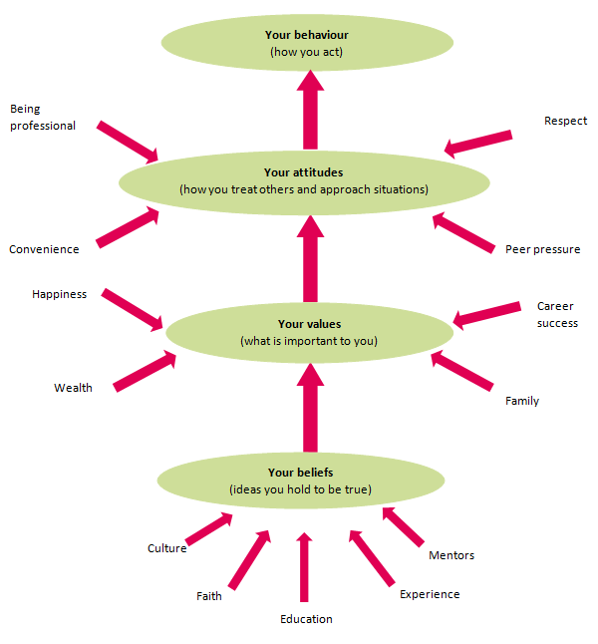
Source: (Unknown, 2019)
The above diagram demonstrates the interrelated links between belief, values, attitude and behaviour, various elements that supports individual development of these attributes and how these form individual overall behavioural patterns. How each can positively or negatively affect an organisational productivity if it does not adopt recognised systems or management theories.

Management Theories:

Several management theories and studies exist and have been to use to understand how and why organisations operate in certain ways. Management theory are used to view business operation from systems perspective in other to fully understand how the different functions interrelate to achieve the desired objective.
Management is defined as the organisation and structuring of a business activity to achieve a desired objective. It includes bringing together all aspect of a business requirement, creating policy, implementing controls, organising processes geared towards achieving set business objective.
Management theories on the other hands are studies of business activities as systems to understand how their functions interact with each other and their environments. Flood and Jackson defines a system as a complex and interlinked network of parts exhibiting synergetic properties-the whole being greater than the part. The collection of interrelated parts acting together to achieve some goal which exist in the environment. (Flood, 1991).
The idea of views business functions as systems led to the development of scientific management theory. The process of approaching various aspects of organisations using scientific methods such as research, management and analysis. The theories developed from this has meant that organisational business functions are viewed form varied aspects to better understand how best to apply the functions to achieve better efficiency. Organisations implement management theories to improve productivity and service quality.

Management theories can be broken into four main types to cover areas that make up an organisation’s functions.
- Human relations; focuses on managing aspects of human behaviour, team dynamics and social systems within an organisation.
- Scientific management; apply a systematic approach to organisational activities, following recognised scientific methods.
- Contingency theory: focuses on managing actions based on current situation and trends.
- Systems theory: managing actions that recognise how different systems affect employee
Organisations adopt theories that complement their business activity. Depending on the organisations structure and business, most of the management theories will apply to every organisation.
One of the most common management theories was the Frederick Taylor scientific management theories, developed in 1880, this theories analyses workflow in other to improve efficiency from the aspect of labour productivity. (Anon., 2019). The four principles at the core of this theory is are:
- Analysing the workflow processes to scientifically to determine the one best way to complete the job or task
- Hire the right person for the job and train them to work to maximum efficiency
- Monitor worker progress and provide instruction and pay accordingly
- Split the workload between management and labour to achieve maximum efficiency.
Frederick Taylor (1911) management theory was popular in that its core concern was on productivity and output but does not fully apply to Morden day organisations. The suggestion that workers will become more productive if they are paid in line with how productive they are, is an aspect which have been superseded by other management theories.
Individuals are motivated by different factor, though financial rewards remain the initial driver to employment versus completing the set objective, some individuals are not motivated by money or financial rewards, rather other factors such and recognition and ownership becomes the driving factor for increased productivity and output.
Elton Mayo management theory (1924) states that employees are motivated by far more rational factors such as attention and fellowship than by monetary rewards or by other environmental factors such as lighting, humidity and location. (Dininni, 2019). Elton mayo’s theory brings the human relations aspect to productivity and focuses on collaborations within organisation to effect production output. The theory concludes that teams within organisations that have the highest norms and most cohesiveness will be the most successful. The theory encourages teamwork as it finds that team members motivate each other towards achieving the set goals.
Many organisations still adopt aspect of the Frederick Taylor scientific theory, but often adopt other theories in other to achieve a more balanced work environment.
Lyreco being a sales and distribution company, operates a hierarchical or tall structure. All aspects of the organisations business functions are well defined and headed by a division manager, with clear reporting line and functional organisation objectives. The organisation is split into four main divisions, Administration, sales, marketing and distribution. Each divisions role is linked to organisations objective and are targeted accordingly. The sales force is the biggest division in the organisations and comprises of twenty teams made of ten individuals specifically recruited for targeted geographical territories.
The sales teams are targeted based on the number of operational businesses in their geographical territories and are paid commission on achieving the monthly sales targets. The sales team is required to win a specific number of new business each month while ensuring they retain existing customers.
This process demonstrate that Lyreco has adopted and implemented a recognised management theory, as there is clear distinction in its operations and function. However, its management style will be different in other part of the organisation as the function’s objectives are slightly different from that of the sales force and therefore require different management style;

Management by Objectives:

Management by objectives is the process of setting objectives in an organisation to give a clear sense of direction to the employees. It defines roles and responsibilities for the employees and encourages them to become innovative towards their future work (Juneja, 2019).
Lyreco can be said to adopt this management theory. Especially within the sales force division. This system sets out clear objectives and expectations for every member of the sales force, training and supports are designed specifically towards supporting the sales teams to achieve the specific objectives. There is a clear relationship between the employee’s roles and the organisations objectives. Employees have ownerships of their roles and in turn develop a feeling of loyalty to the organisation. There is clear and effective communication between the organisation and employees, this promotes effective objectives distribution as well as a feel-good factor within the organisation.
Management by objectives although appears to suit Lyreco business operations, its without its limitations. The precise design of the theory creates a tendency for prevailing organisational culture and working conditions to be ignored. In extreme circumstance, employees are sometimes used as machines, because the organisation is so focused on achieving set objectives. This invariably creates an unhealthy working condition where unhealthy competitions and nasty politics become the norm.

Recommendations

R. E. D Model Theory on Critical Thinking:
Many of the challenges Lyreco can potentially face from using some of the adopted management systems and theories can be addressed by implementing the RED Model critical thinking method as part of mitigating approach to counter these challenges. The RED model method of critical thinking encourages managers to become better at dealing with situation and arriving at correct solutions.

Recognise Assumptions:
many statements are made and assumed to be true even when there is little or no evidence to support the statements. Recognising assumption allows managers to distinguish the facts from opinion and isolate the relevant information from the rest, by identifying information gaps on the statements. This is also achieved by seeking other people view of the same information to qualify your understanding before reaching a decision.

Evaluating Arguments:
Arguments as forceful statements made with the intention to persuade one to believe or succumb to a view or opinion. Ability to evaluate such statements is important and requires managers to be objective and critical in evaluating such statements. Patterns are often identified, and emotion and fact can be separated once this is achieved.

Draw Conclusions:
Arriving at the right conclusion requires following identified fact and evidence logically. Following a logical approach removes any room for generalisation but rather sticks to the generated fact when reaching a decision.

Conclusion

Culture is a way of life developed as a result of beliefs and values, attitudes and behaviors are ways in which we communicate our values and beliefs. All which form part of our human behavioral style are important in personal and professional lives. Organizations must strive to get the right balance when recruiting, ensuring the employ individuals with similar values and beliefs to encourage improved workplace communication. Where this is not always possible in todays marketplace, due to laws and policies prohibiting such, organizations must adopt recognized management theories that will support their adopted culture, value and operational ethics, to ensure they achieve their business set objectives in the most effective and efficient manner.

References:

Bibliography
Anon., 2019. Lumenlearning.com. [Online]
Available at: https://courses.lumenlearning.com/wm-introductiontobusiness/chapter/scientific-management-theory/
[Accessed 1 december 2019].
Anon., . Paul-Elder Critical Thinking Framework. [Online]
Available at: http://louisville.edu/ideastoaction/about/criticalthinking/framework
[Accessed 26 11 2019].
Chatfield, T., 2018. Critical Thinking. 1st ed. london: sage.
Croome, D., 1999. creating the productive workplace. creating the productive workplace.
Daniell, M., 2006. the element of strategy. A pocket guide to the essence of successful business strategy.
Dininni, J., 2019. Buisness.com. [Online]
Available at: https://www.business.com/articles/management-theory-of-elton-mayo/
[Accessed 1 december 2019].
Flood, T. a. J. M., 1991. critical system thinking. critical system thinking.
Goodwin, M. &. S. C., 2012. Crativity, critical thinking and communciation,. strategies to increase students skills.
Juneja, P., 2019. management study guide. [Online]
Available at: https://www.managementstudyguide.com/management-by-objectives.htm
[Accessed 1 december 2019].
Kumar, S. &. L. P., 2015. communication skills. communication skills for proffessionals.
Mitashree, T., 2018. organisation culture commnuication and conflicts. Roles of Creative thinking as an imperative tool in communicationat workplace, 22(2), p. 2.
Paul R, E. L., 2010. The Miniature guide to critical thinking concepts ad tools. foundation for critical thinking.
Paul, R. a. E. L., 2010. The Miniature guide to Critical Thinking Concept and tools. foundation of critical thinking.
R, P., 2010. louislville.edu. [Online]
Available at: www.louisville.edu
[Accessed 21st NOVEMBER 2019].
Silva, A. &. D., 2009. Beliefs, Attitude and Values. PHSE Strategies and Skills.

